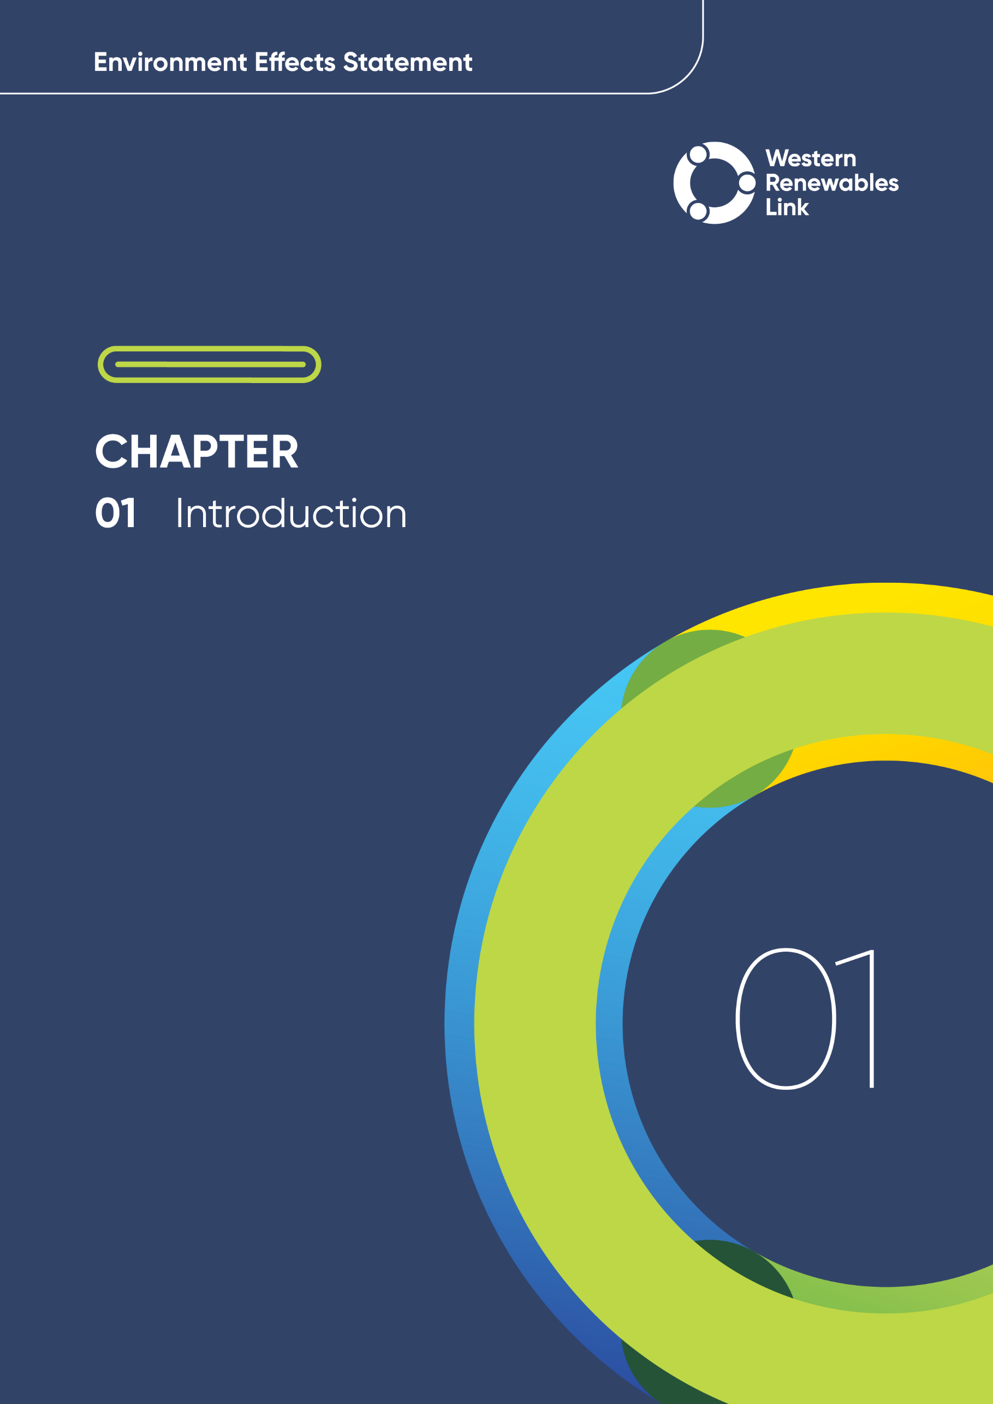

# Introduction

The proposed Western Renewables Link (the Project) is a new 190 kilometre (km) overhead high-voltage electricity transmission line that will enable renewable energy distribution from Bulgana in western Victoria to Sydenham in Melbourne’s north-west.

Renewable energy sources such as wind and solar are crucial for Victoria’s electricity generation as the state transitions to clean, net zero emissions energy sources to combat climate change. Generating more of Victoria’s electricity from renewable sources will support the reliability of Victoria’s electricity supply, reduce electricity prices and decrease emissions from electricity generation.

The Project is included on the Commonwealth National Renewable Energy Priority List (Priority List). The Priority List consists of priority renewable energy projects across Australia that have been determined to be important to support Australia’s transition to net zero emissions by 2050. The Commonwealth, State and Territory governments have collaborated to create the Priority List and will support the projects by providing coordinated support for regulatory planning and environmental approval processes for identified priority projects. The Project will involve major economic investment in western Victoria, creating additional jobs during construction and operation, and stimulating further investment in renewable energy generation projects and associated ventures.

Western Victoria is an important renewable energy generation region. However, the current energy network needs an upgrade to increase transmission network capacity and facilitate efficient connection of renewable electricity with all Victorians. The Project will make this possible by adding a new link to the transmission network. An upgraded, efficient network will also enable Victoria to make an orderly transition to renewable energy and give the renewable energy sector the confidence and certainty needed to invest in new projects.

This chapter provides an overview of the Project and sets out the purpose and structure of the Environment Effects Statement (EES).

## Project overview

The Project is designed to reduce congestion on the existing electricity transmission network in western Victoria by increasing the capacity of the transmission network.

The Project consists of a new overhead double circuit 500 kilovolt (kV) transmission line, approximately 190km long, from near Bulgana in Victoria’s west to Sydenham in Melbourne’s north-west. The Project includes the following works:

* Construction and operation of a new overhead double circuit 500kV transmission line from a new terminal station near the existing Bulgana Terminal Station to the Sydenham Terminal Station
* Construction and operation of a new terminal station near Bulgana
* Expansion of the existing Bulgana Terminal Station and connection to the proposed new terminal station near Bulgana via a single circuit 220kV transmission line connection, comprising paired single circuit towers
* Connection works at the Sydenham Terminal Station including the modification of a bay and a bay extension with associated infrastructure
* Upgrade of Elaine Terminal Station, through the diversion of an existing line
* Protection system upgrades at connected terminal station sites.

Construction is planned to commence in late 2026 and take approximately two years to complete.

Figure 1.1 provides an overview of the Project’s key features. The Project location is shown in Figure 1.2. A detailed description of the Project is provided in **Chapter 6:** **Project description**.

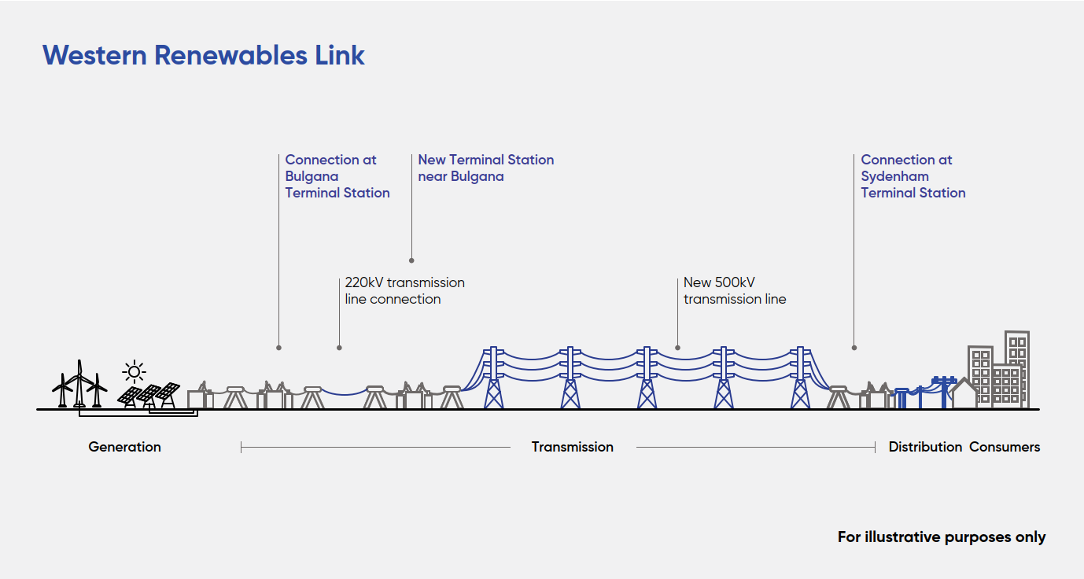

Figure . Western Renewables Link Project overview

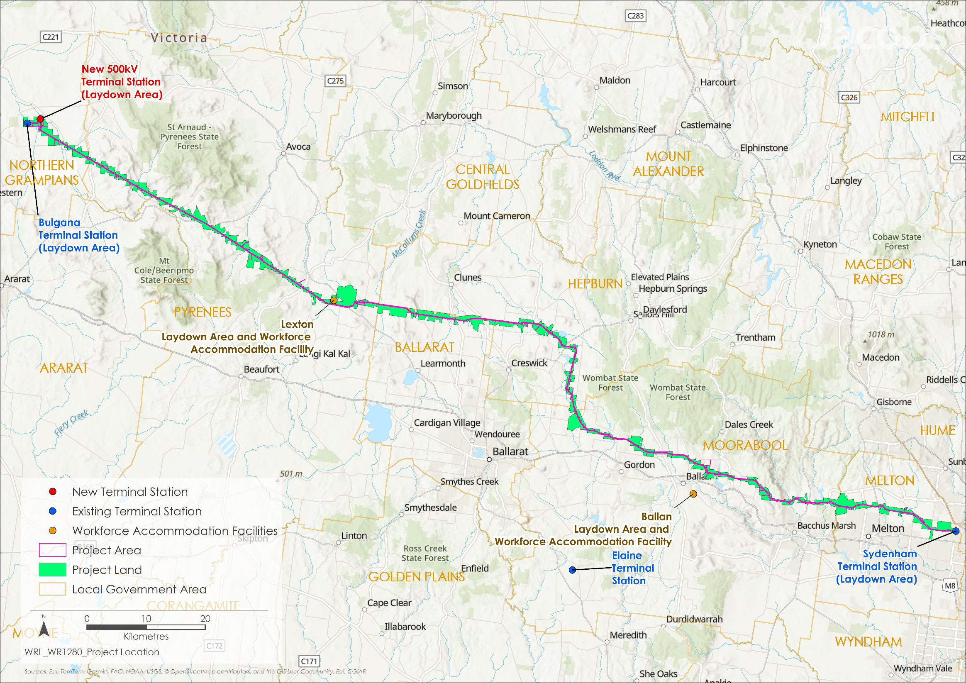

Figure . Project location

## Project need

Australia’s energy system is changing rapidly from a reliance on large-scale centralised power stations to geographically dispersed renewable energy generation. This has been realised in Victoria where the energy landscape continues to evolve, driven by the retirement of coal generators in the Latrobe Valley with the introduction of new large-scale renewable energy resources and consumer-led investment in solar power. With these investments, Victoria is on-track to meet its revised target of having 65 per cent of electricity generated from renewable energy sources by 2030.

The Australian Energy Market Operator (AEMO) develops an Integrated System Plan (ISP) to identify where new transmission, generation and storage is needed across the National Electricity Market (NEM). The ISP is developed every two years in consultation with industry, government, and energy consumers. In response to the recommendation in the 2017 Independent Review into the Future Security of the NEM for the creation of renewable energy zones, as part of the ISP process, AEMO identified a number of Renewable Energy Zones (REZs) which are areas that not only have abundant renewable energy resources, such as wind and solar, but are also appropriate for development from a land use and environmental perspective. The 2020 ISP provides an actionable roadmap for eastern Australia’s power system and included declaration of the Western Victoria REZ which is of relevance to the Project Area. Other REZs in proximity to the Project include South West REZ to the south and Murray River REZ to the north.

With the development of the REZs, western Victoria has become a renewable energy generation hub given the good to excellent quality of its wind resources (AEMO, 2023b). The Victorian Government worked with AEMO to identify network investments to support the timely and efficient development of REZs. The Victorian Renewable Energy Zones Development Plan identified potential near-term projects to reduce existing constraints and support the connection of Victoria’s pipeline of renewable energy projects. This included minor network augmentation works, projects to strengthen the system and larger augmentation projects.

* Western Victoria is an important renewable energy generation region.   
  However, the energy that can be created through these proposed projects is not supported by the existing transmission infrastructure.

AEMO has reported that existing and committed renewable generation within this REZ exceeds 1 Gigawatt (GW) of new renewable energy generation sources in the connection pipeline (AEMO, 2023a). However, renewable generators are increasingly facing transmission bottlenecks due to the thermal and physical limits of the region’s existing transmission network. These bottlenecks limit power transmission out of the region into the wider network, which hinders a generator’s ability to supply competitively priced electricity to the market. As a result, a more expensive electricity source is required to be dispatched to the system, impacting electricity costs to consumers over the long term (AEMO, 2021a). Further, a failure to undertake an upgrade may result in inefficiencies in the state’s transmission network which will impact electricity reliability and increase prices to consumers over the long term.

The electrification of transport, households and industry will more than double demand for electricity in the NEM by 2050, reaching over 410 terra-watt hours per year. This presents a key challenge as Australia-wide, coal-fired generation capacity is retiring two to three times faster than anticipated, creating supply reliability risks. Without transmission infrastructure that supports the flow of energy from Victoria’s REZs to consumers, the operation of renewable energy generators will continue to be constrained, and Victoria will become reliant on interstate electricity supply to meet demand.

As part of the 2020 ISP, and subsequent ISP updates, AEMO has identified the Project (formerly the Western Victoria Transmission Network Project) as one of several anticipated network projects Australia-wide that are needed to ‘unlock’ the nation’s renewable energy potential, noting that it will upgrade transmission capacity in Victoria, reduce network congestion and improve the productivity of existing assets (AEMO, 2020; AEMO, 2023c; AEMO, 2023d). AEMO determined that the Project is within an optimal development path for the NEM and essential to expand generation capacity to the Western Victoria REZ (AEMO, 2021a; AEMO, 2023d), and was included on the optimal development path as part of the 2024 ISP.

In May 2023, an order was issued by the Minster for Energy and Resources under the *National Electricity (Victoria) Act 2005* (NEVA) that proposed changes to the Project to facilitate connection to the Victoria to New South Wales West (VNI West) project. VNI West is a 500kV double circuit transmission line that will provide a direct link between the New South Wales and Victorian high voltage electricity grids. This connection will significantly strengthen the reliability and security of the Victorian transmission system by providing access to replacement dispatchable capacity across the NEM as coal retires. The new 500kV terminal station near Bulgana has been proposed to provide this connection.

As a result of enabling connection of new generation sources in western Victoria, the Project will unlock significant amounts of clean energy. This will increase the capacity to transmit renewable energy across the NEM to help maintain network reliability and security through greater geographic diversity and increased capacity, as well as putting downward pressure on electricity prices. The Project is designed to provide over 3,000MW of network capacity to the NEM. Additionally, by easing the existing transmission network constraints, AEMO has modelled that the Project will enable an extra 1,460MW of output from the western Victorian region, which will help secure Victoria’s electricity supply.

## Project objectives

The Project objectives were developed by AEMO and the AusNet group as a guide for the development of the Project having regard to the Western Victorian Regulatory Investment Test for Transmission (RIT-T) and reinforced by the NEVA Order of May 2023.

The Project objectives are to:

* Maintain the security and reliability of the transmission network for customers by:
  + Increasing electricity transmission capacity in western Victoria to minimise the congestion constraining current and future electricity generation in the region
  + Ensuring the Project complies with the power system security requirements of the National Electricity Rules.
* Create opportunities for strategic development of the NEM by:
  + Increasing electricity transmission capacity, thereby facilitating more efficient connection and dispatch of electricity generation in and from the region
  + Enabling future transmission network expansion from Victoria to New South Wales.
* Deliver infrastructure which realises a net market benefit for Victorians by:
  + Delivering the Project in a timely and cost-efficient manner
  + Delivering transmission infrastructure which, by increasing capacity, facilitates the further development of renewables in western Victoria, encouraging further investment in the industry and associated economic growth.

## Proponent

AusNet group, which comprises AusNet Pty Ltd and each of the entities it owns and controls, is the largest diversified energy network business in Victoria, owning and operating three regulated networks – electricity distribution, gas distribution and the state-wide electricity transmission network, including the existing western Victoria transmission network. With headquarters located in Melbourne, AusNet group employs around 1,300 people to service 1.6 million consumers.

AEMO, as the National Transmission Planner for the NEM, manages the electricity and gas systems and markets across Australia and is also responsible for the planning of the Victorian transmission network. AEMO’s ownership is shared between government and industry, with a primary role to promote the efficient investment in, and efficient operation and use of, gas and electricity for the long-term interests of Australian consumers in relation to price, quality, safety, reliability and security. This includes maintaining secure electricity and gas systems, managing electricity and gas markets, and leading the design of Australia’s future energy system.

In 2017, AEMO conducted a RIT-T assessment to determine the technical and economic viability of increasing transmission network capacity to address current limitations in the western Victoria transmission network. AEMO consulted with industry, government, consumers and interested stakeholders to consider a range of options to meet this need. The Project was identified as the most viable option (out of five credible options in the Project Specification Consultation Report (AEMO, 2017)) as it will have a net economic benefit for all those who produce, consume and transport electricity in the market.

In late 2019, following a competitive tendering process, AusNet Transmission Group Pty Ltd (a licensed transmission entity that is part of the AusNet group) was engaged by AEMO to undertake design, planning, approvals, construction and operation for the Project. AusNet Transmission Group Pty Ltd is working closely with industry, government and communities to deliver this critical Victorian energy project.

At the time when AusNet Transmission Group Pty Ltd was engaged to deliver the Project, ‘Mondo’ was the name of the AusNet group’s commercial business division and is referred to in the Project’s scoping requirements (DTP, 2023a). However, AusNet Transmission Group Pty Ltd is the entity delivering the Project and is the proponent.

For more information on AusNet group, AusNet Transmission Group Pty Ltd and the Project, visit: <https://www.ausnetservices.com.au/electricity/transmission-network> and <https://www.westernrenewableslink.com.au/>.

### Health, Safety, Environment and Quality Policy

AusNet group’s commitments to health and safety, high quality environmental and asset management, and the principles of sustainable development are detailed in its management systems.

The Health and Safety, Environment and Quality (HSEQ) Management System is a framework under which AusNet group’s HSEQ Policy and supporting processes are implemented, certified to the appropriate Australian and international standards and compliant with:

* ISO 45001:2018 Occupational health and safety management system
* ISO 14001:2015 Environmental management system
* [A blue and green text on a black background

  Description automatically generated](https://urldefense.com/v3/__https:/www.ausnetservices.com.au/safety/our-safety-commitment__;!!B5cixuoO7ltTeg!DG78Yk3eAX9NxjeGBchIwSMmss9ou56aryzDTDhKHSg8CgJ5QhXgHmCkzQYkh-UHhpgPwhFvc7sFw7btkDIPIwhgHwvtoQ$)ISO 9001:2015 Quality management system.

Safety is a core value at AusNet group. A ‘missionZero’ strategy is embraced in the company’s strong safety leadership, safe behaviour, safe workplace environments and continual improvement to management systems.

### Environment and Sustainability

AusNet group is committed to working safely, sustainably and with excellence. AusNet group’s environmental management system minimises environmental risks associated with activities and sites, so far as reasonably practicable, in line with the General Environmental Duty.

AusNet group is subject to a range of environmental laws and regulations as well as Project- and site-specific environmental permits and approvals, issued both by Commonwealth and State government.

There are no current or past environmental law proceedings under a Commonwealth, State or Territory law for the protection of the environment or the conservation and sustainable use of natural resources against AusNet group.

AusNet group recognises the importance of sustainability in operations and finances and is committed to minimising adverse impacts on the environment, communities, cultures and economies. AusNet group’s goal is to create a positive impact and use sustainability as a measure of success, guiding their decision-making process.

AusNet group operates its business considering the role that it can play in achieving a sustainable future. AusNet group considers global issues such as climate change, reducing inequality, promoting human rights, and addressing social change. Both local and global perspectives are taken into consideration, aligning their purpose, strategy, values, and priorities with the United Nations' Sustainable Development Goals and The Paris Agreement. More information is provided on the AusNet group website at <https://www.ausnetservices.com.au/sustainability>.

## Environment Effects Statement

### Requirement for an EES

The *Environment Effects Act 1978* (Environment Effects Act) sets out the process under which the Victorian Minister for Planning may require the proponent of a project to prepare an EES where works undertaken as part of that project have the potential to have a significant effect on the environment.

The Project was originally referred to the former Minister for Planning under the Environment Effects Act on 9 June 2020 by AusNet Transmission Group Pty Ltd and it was determined that an EES was required. On 11 August 2023, a new referral was accepted to reflect changes to the Project which excluded the construction of a new terminal station adjacent to the existing Sydenham Terminal Station. On 22 August 2023, the Minister for Planning determined that an EES was required for the Project due to the potential for a range of significant environmental effects. The reasons for the decision are:

* The area of interest for the project supports significant environmental values, including native vegetation and ecological values; residential and agricultural and other land uses; heritage values, visual and landscape values and other social values, potential aggregate impacts on which are of at least regional significance.
* Multiple alignment and design alternatives for the project within the area of interest require rigorous and transparent assessment and refinement in relation to opportunities for avoidance and / or minimisation of potentially significant effects to inform both project and statutory decision-making.
* An EES process will provide a robust, transparent and integrated framework through which:
  + the project’s potential environmental effects can be rigorously assessed, including in the context of the comparative effects of feasible siting, alignment, design and operational alternatives for key components of the project; and
  + the effectiveness and acceptability of proposed measures to avoid, minimise, manage and offset environmental effects and related risks can be evaluated / examined.
* An EES responds to community interest in project siting, alignment and design alternatives by providing appropriate opportunities for public input.
* The construction of a new Sydenham Terminal Station is excluded from this decision as that is excluded from the referral and is no longer proposed as part of the Project.

The Minister for Planning identified broad key matters and environmental risks that the EES should investigate and document:

* alternative corridors, alignments, site locations, designs or other options for the planning, construction or operation of the project
* potential effects on biodiversity, including loss, degradation or fragmentation of habitat
* effects on Aboriginal and historic cultural heritage values
* impacts on visual and landscape values
* other effects on land uses and the community.

### Purpose of the EES

The EES process is the highest level of environmental assessment in Victoria.

The Ministerial guidelines for assessment of environmental effects under the Environment Effects Act, Eighth edition, 2023 provide the following definition of ‘environment’:

It includes the physical, biological, heritage, cultural, social, health, safety and economic aspects of human surroundings, including the wider ecological and physical systems within which humans live.

The EES process is designed to be rigorous and transparent, with opportunities for input from interested parties and the wider public. The EES process has facilitated the investigation of feasible alternative project designs and corridor alignments to avoid and mitigate impacts to human health and the environment, informed the wider community about the Project, and sought and responded to feedback from the public and stakeholders.

AusNet Transmission Group Pty Ltd implemented the WRL EES Consultation Plan (AusNet, 2025a) to keep the public and stakeholders informed of the EES process, the Project and associated investigations, and to provide opportunities for input and engagement. A detailed description of the Consultation Plan is provided in **Chapter 7: Community and stakeholder engagement**. The EES Consultation Plan was prepared by AusNet Transmission Group Pty Ltd in accordance with the requirements of the Ministerial Guidelines under the Environment Effects Act and the EES Consultation Plan Advisory Note (DELWP, 2018) and published online, accessible here: <https://www.westernrenewableslink.com.au/assets/resources/EES-Consultation-Plan-May-2025.pdf>.

As part of the consultation process, the Department of Transport and Planning (DTP) convened an agency-based Technical Reference Group (TRG) to advise DTP and AusNet Transmission Group Pty Ltd on a range of matters related to the EES and the statutory approvals process. Victorian Government agencies; local government; Water Authorities, Catchment Management Authorities (CMA); and Registered Aboriginal Parties were invited to participate on the TRG. The TRG is discussed in further detail in **Chapter 7: Community and stakeholder engagement.**

While the potential environmental effects of the Project could be assessed and managed through a range of separate statutory processes, an EES ensures the Project is rigorously investigated as part of a comprehensive and integrated assessment process before any statutory approval decisions are made.

The EES is not an approval process in and of itself; rather, it provides an assessment of the environmental effects of a project by the proponentand its technical specialists to inform the Minister for Planning to make an assessment of the acceptability of a project’s environmental effects. It also assists statutory decision-makers to make informed decisions regarding approvals and consents.

This EES and associated technical reports have been prepared to address the Commonwealth and State assessment processes.

### Scoping requirements and evaluation objectives

The EES scoping requirements set out the matters to be investigated, assessed and documented in the EES for the Project.

Draft scoping requirements for the EES were publicly exhibited for a period of 15 business days, which concluded on 27 November 2020. Notice of the exhibition of the draft scoping requirements was published on the former Department of Environment, Land, Water and Planning (DELWP) website and via advertisements in major and local newspapers.

After considering public submissions, the former Minister for Planning issued the scoping requirements in December 2020. The scoping requirements established the evaluation objectives for the investigations conducted as part of the EES.

Following the new EES decision by the Minister for Planning in 2023, updated final EES scoping requirements were approved. This EES has been prepared in accordance with the final scoping requirements issued in 2023.

The scoping requirements include evaluation objectives that identify desired outcomes in the context of key legislative and statutory policies and the potential adverse environmental effects of the Project. The scoping requirements and evaluation objectives set up a framework to guide the integrated assessment of these potential effects. The evaluation objectives for the Project are shown in Table 1.1.

Table . Evaluation objectives

| Evaluation objectives |
| --- |
| Biodiversity and habitat: Avoid, and where avoidance is not possible, minimise potential adverse effects on protected native vegetation and animals (particularly listed threatened species and their habitat and listed ecological communities), as well as address offset requirements consistent with state and Commonwealth policies. |
| Cultural heritage: Avoid, or minimise where avoidance is not possible, adverse effects on Aboriginal cultural heritage and historic heritage values. |
| Landscape and visual amenity: Avoid, or minimise where avoidance is not possible, and manage potential adverse effects on landscape and visual amenity. |
| Land use and socioeconomic: Avoid, or minimise where avoidance is not possible, adverse effects on land use, social fabric of the community, businesses including farming and tourism, local and state infrastructure, aviation safety and to affected and neighbouring landowners during construction and operation of the project. |
| Community amenity, safety, roads and transport: Avoid, or minimise where avoidance is not possible, adverse effects for community amenity, health and safety, with regard to construction noise, vibration, dust, lighting, waste, greenhouse gas emissions, transport network, operational noise, fire risk management and electromagnetic radiation. |
| Catchment values and hydrology: Maintain the functions and values of aquatic environments, surface water and groundwater quality and stream flows and prevent adverse effects on protected beneficial uses. |

## Subject matter of the EES

This EES provides details of the following aspects of the Project:

* Design, including Project alternatives comprising siting of terminal stations and transmission line corridor options, full and partial undergrounding options and other design options
* Construction, operation and decommissioning of the transmission line and terminal stations
* Environmental impacts
* The proposed Environmental Management Framework, including Environmental Performance Requirements (EPRs).

The EES is an iterative process, designed to identify ways to avoid, minimise or manage adverse environmental effects through the preparation of technical reports. Baseline investigations and technical assessments conducted for this EES have led to refinements in the Project’s design, construction method and recommended EPRs to address identified issues and avoid or mitigate adverse environmental effects.

### Design and Project alternatives

As discussed in Section 1.4, AEMO engaged AusNet Transmission Group Pty Ltd to deliver the Project. Detailed designs have been developed and considered by AusNet Transmission Group Pty Ltd throughout the course of the EES, incorporating results from technical investigations, matters raised by the Project’s TRG, landholder, community and stakeholder input, and consideration of constructability and technical aspects. A key part of the design development was consideration of alternative designs, corridors and routes and other aspects, including undergrounding. The final design will be completed following assessment of the Project by the Minister for Planning.

The process undertaken to develop the Project design (including determining the Proposed Route and infrastructure options) is described in **Chapter 5: Project development**. The Project description is provided in **Chapter 6: Project description** and the plans shown in **Attachment VI: Map book**.

The Project design will be further refined as the detailed design progresses following the conclusion of the EES process to address statutory approvals (if granted). The detailed design will be required to meet the EPRs and follow the change management process set out in **Chapter 29: Environmental Management Framework**.

### Construction, operation and decommissioning

**Chapter 6: Project description** details the Project’s design, infrastructure components, construction activities, operational and maintenance activities, and decommissioning requirements to enable assessment of the potential environmental effects.

AusNet Transmission Group Pty Ltd will build, own, operate and maintain the new infrastructure required for this Project. Decommissioning of the Project will be the responsibility of the network planner at that time.

### Environmental impact assessment

A detailed environmental impact assessment has been conducted, incorporating 20 individual technical reports, to address the EES scoping requirements. A risk-based approach informed the development of these reports, enabling the environmental effects of and responses to potential impacts to be adequately assessed, with a focus on those matters that pose a higher risk of adverse effects. Assessment of the potential environmental impacts of the Project has been informed by describing existing (or baseline) conditions and values for each evaluation objective (see Table 1.1), identifying key issues and risks through a risk screening process, engaging with communities and stakeholders, and undertaking an impact assessment.

Assessment of effects considered values in the Project Area and the potential for the Project to impact on nearby environmental, social, economic and cultural heritage values. The technical specialists also considered potential cumulative impacts of the Project in combination with other activities in the broader area / region.

These assessments will be considered by an independent Inquiry and Advisory Committee, who will provide advice to the Minister for Planning who will make a final assessment of the Project’s environmental effects.

The approach for the environmental impact assessment is described in **Chapter 4: EES assessment framework and approach**. The technical reports (**Technical Reports**) are attached to this EES and summarised in **Chapters 8 to 28**. Separate to the EES technical reports, an undergrounding impact assessment has been conducted and the findings included in **Attachment II: Assessment of feasibility for an underground 500kv transmission line for Western Renewables Link**.

### Environmental Management Framework

The Environmental Management Framework provides a governance framework for the management of environmental impacts to meet statutory requirements for the Project. This includes EPRs that specify the environmental outcomes that the Project must achieve to reduce potential adverse effects during construction, operation and decommissioning of the Project. The EPRs are intended to minimise the Project’s risk of harm to human health and environment to the extent reasonably practicable, having regard to the predicted environmental effects and the practical delivery of the Project. The Environmental Management Framework, including the EPRs, will be given effect through the proposed Incorporated Document to be introduced into the Northern Grampians, Pyrenees, Ballarat, Hepburn, Moorabool and Melton Planning Schemes.

AusNet Transmission Group Pty Ltd and its contractors will be responsible for the implementation of the EPRs and contractual arrangements for the Project will include requirements for contractors to adhere to specified EPRs.

The proposed Environmental Management Framework and EPRs are presented in **Chapter 29: Environmental Management Framework.**

## Matters not addressed in the EES

Works that are not considered capable of having a significant effect on the environment are not addressed in this EES. These include:

* Investigations, testing and surveying land associated with designing the Project
* Works required to identify existing services / utilities and third-party assets
* Works at existing terminal stations where no planning permit is required.

Construction of a new terminal station adjacent to the existing Sydenham Terminal Station comprises a separate project which does not form part of this EES.

## Project approvals

In addition to the requirement for an EES, specific statutory approvals are required under the relevant legislation as outlined in this section. Details of the applicable legislation and approvals process are provided in **Chapter 3: Legislative framework and approvals requirements**.

### Commonwealth approval

Under the *Environment Protection and Biodiversity Conservation Act 1999* (EPBC Act), the Commonwealth Minister for the Environment and Water can use the bilateral assessment agreement between the Commonwealth and Victoria to inform the decision under the EPBC Act, given the EES process is accredited to assess impacts on matter of national environmental significance under this agreement.

The EPBC Act provides the legal framework to protect and manage designated ‘matters of national environmental significance.’ Under the EPBC Act, if the Commonwealth Minister for the Environment and Water decides that a project potentially could have a significant impact on a matter of national environmental significance, the project becomes a ‘controlled action’ that must be assessed and approved by the Commonwealth Minister before it can proceed.

AusNet Transmission Group Pty Ltd referred the Project to the Commonwealth Government of Australia under the EPBC Act in July 2020. A delegate for the Minister for the Environment determined on 2 September 2020 that the Project is a ‘controlled action’ and requires assessment and approval under the EPBC Act. This decision was re-confirmed in a variation approval on 20 November 2024. The referral decision stipulates that the Project is a ‘controlled action’ due to its potential to have a significant impact on listed threatened species and ecological communities (sections 18 and 18A of the EPBC Act). Under the bilateral assessment agreement between the Commonwealth and Victoria, the EES process is accredited to assess impacts on these species and communities for the purposes of the EPBC Act. The process to assess the Project’s potential impacts on matters of national environmental significance is provided in **Chapter 27: Matters of National Environmental Significance**.

### Victorian approvals

The Project will require approvals under Victorian legislation, including the following principal and secondary approvals:

##### Principal approvals

* Planning Scheme Amendment (PSA) to the Northern Grampians, Pyrenees, Hepburn, Ballarat, Moorabool and Melton Planning Schemes under the *Planning and Environment Act 1987* (Planning and Environment Act). Following completion of the EES process, AusNet Transmission Group Pty Ltd intends to request that the Minister for Planning prepare an amendment via the Group of Councils Planning Scheme Amendment (GC PSA) which allows for the simultaneous amendment of the six affected planning schemes under the Planning and Environment Act.
* Cultural Heritage Management Plans under the *Aboriginal Heritage Act 2006*.

##### Secondary approvals

* Permit to remove protected flora on public land under the *Flora and Fauna Guarantee Act 1988*
* Consent under the *Heritage Act 2017* to impact on any sites on the Victoria Heritage Register and / or Victorian Heritage Inventory and to impact on archaeological relics (non-Aboriginal archaeological relics more than 50 years old)
* Consent under the *Road Management Act 2004* from the coordinating road authority for works on, in or under a road reserve
* A licence under the *Water Act 1989* to construct, alter, operate or decommission works on, over or under a waterway
* Potential authorisation to relocate wildlife under the *Wildlife Act 1975*
* An Oversize Overmass Permit under the *Heavy Vehicle National Law Application Act 2013* for transport of materials on Victorian roads
* Permit to work under the *Rail Management Act 1996* for works to install and / or maintain electricity lines required within five metres of VicTrack assets.

## Structure of the EES

The EES is structured into four principal sections: Summary Report, Main Report, Technical Reports and Attachments, including the EES Map Book (refer to **Attachment VI: Map book**). The structure of the EES is shown in Figure 1.3.

The structure and content of the EES aligns with the evaluation objectives set out in the scoping requirements (see Section 1.5.3).

Figure 1.3 EES structure

