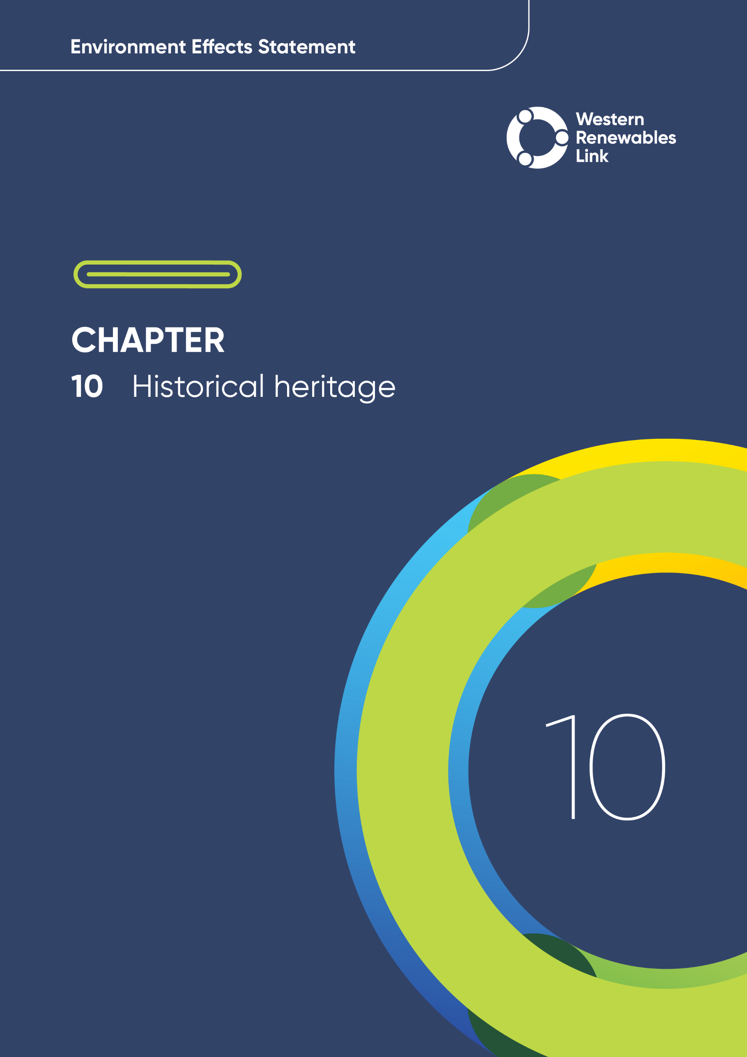

# Historical heritage

This chapter provides an overview of the potential historical heritage impacts associated with the construction, operation and decommissioning of the Project. This chapter is based on **Technical Report C: Historical Heritage Impact Assessment**.

Historical heritage considers the tangible expression of Australia’s history since the arrival of non-indigenous settlers. Encompassing values associated with historical settings, places and objects, historical heritage is important to the people who live and work in the western Victorian community, contributing to their sense of history and identity, and may also have significance at a state, national or world heritage level. Areas of historical heritage are present within or near the Project, including the Former Darley Military Camp and parts of the Victorian Goldfields.

## Evaluation objective

The scoping requirements identify the following evaluation objective relevant to historical heritage:

Evaluation objective

*Avoid, or minimise where avoidance is not possible, adverse effects on Aboriginal cultural heritage and historic heritage values.*

In response to this evaluation objective, impacts of the Project on historical heritage values were assessed, and measures to avoid, minimise or manage potential impacts have been identified. These measures are discussed throughout this chapter and have informed the development of Environmental Performance Requirements (EPRs). EPRs set out the environmental outcomes to be achieved through the implementation of mitigation measures during construction, operation and decommissioning to avoid, minimise and manage identified impacts. Cumulative impacts associated with relevant future projects were also assessed.

Further information on how the Project has been designed to avoid and minimise impacts is provided in **Chapter 5: Project development** and **Chapter 6: Project description**.

Other aspects covered in the Environment Effects Statement (EES) evaluation objective and relevant to historical heritage are addressed in **Chapter 9: Aboriginal cultural heritage.**

## Method

This section summarises the method adopted in **Technical Report C: Historical Heritage Impact Assessment**, which was informed by **Chapter 4: EES assessment framework and approach**. The key steps in assessing the impacts associated with historical heritage included:

* Defining a study area appropriate for historical heritage as presented in Figure 10.1. This included the Project Land, broken into eastern and western geographical areas, plus a 2km wide corridor that extends 1km on each side of the Proposed Route, and significant places where the visual presence of the Project may have the potential to impact the historical setting of those places.
* Reviewing applicable Commonwealth and Victorian legislation, and relevant local, state and national standards, guidelines and policies.
* Conducting a desktop review to determine the existing historical heritage conditions including:
  + Heritage places on lists and registers
  + Unregistered and previously unidentified places

The following data sources and reference standards were reviewed:

* + Statutory and non-statutory registers, including:
  + Victorian Heritage Register (VHR)
  + Victorian Heritage Inventory (VHI)
  + D-listed VHI
  + Heritage Overlays (HO)
  + National Heritage List (NHL)
  + Commonwealth Heritage List (CHL)
  + National Trust of Australia (Victoria) Register
  + Register of the National Estate
  + Local Government heritage studies and reports
  + Aerial photography, Google Street View, and current and historical photographs
  + Historical heritage information provided by the community and other study discipline teams.
* Preparing a land use history of the Project Area of the potential historical heritage places and archaeological sites.
* Consulting with the relevant regulatory authorities and key stakeholders including Heritage Victoria, local councils, the National Trust, the Victorian Goldfields World Heritage Listing Organising Team and the community, and reviewing the pins dropped by community members onto the Project’s Social Pinpoint online mapping tool, which identified locations, features and values of importance.
* Conducting field investigations and targeted site inspections/walkovers.
* Recommending extension of heritage protections where desktop and fieldwork identify relevant sites/places.
* Conducting a risk screening process to identify the key issues during construction, operation and decommissioning for investigation within the technical report.
* Identifying and assessing the potential impact towards known, unregistered and previously unidentified historical heritage places during construction, operation and decommissioning. These impacts were evaluated according to the following ratings, in relation to the extent, magnitude and duration of the impacts:
  + Nil: No detectable impact on the heritage values of a heritage place or heritage object.
  + Low: Detectable impact on the heritage values of a heritage place or object with no reduction on those heritage values.
  + Moderate: Detectable impact on the heritage values of a heritage place or object with some reduction on those heritage values.
  + High: Detectable impact on the heritage values of a heritage place or object with a significant reduction on those heritage values.
  + Severe: Complete loss of a heritage place or object.
* Identifying relevant future projects that could lead to cumulative impacts when considered together with the Project (refer to **Chapter 4: EES assessment framework and approach** for the full cumulative impact assessment method).
* Developing EPRs in response to the impact assessment to define the required environmental outcomes that the Project must achieve through the implementation of mitigation measures during construction, operation and decommissioning. Measures to reduce the potential impacts were proposed in accordance with the mitigation hierarchy (avoid, minimise, manage, rehabilitate and offset) and have informed the development of EPRs. Alternative mitigation measures could be implemented to comply with the EPRs based on the specific site conditions, available resources, and the Principal Contractor’s expertise.
* Following application of mitigation measures that would comply with the EPRs, determining residual impacts associated with the construction, operation and decommissioning of the Project, and evaluating their significance.

Figure . Historical heritage study area

Victorian Heritage Register (VHR), Victorian Heritage Inventory (VHI) and Heritage Overlays (HO)s

The VHR registers and provides legal protection for approximately 2,400 heritage places and objects including buildings, structures, gardens, and shipwrecks that are of state significance to the history and development of Victoria. These places and objects are recognised for their role in the state’s heritage.

In contrast, the VHI lists all known historical (non-Indigenous) archaeological sites in Victoria. The 6,800+ sites are places that contain physical evidence, or the potential for evidence, which is 75 years old or more, and demonstrates past historical activities.

HOs protect places with heritage significance to a local area and are part of local planning schemes.

## Existing conditions

This section summarises the existing conditions for historical heritage according to the following key heritage place types:

* Heritage places on lists and registers
* Unregistered and previously unidentified places.

### Heritage places on lists and registers

The study area contains several historical heritage places, including archaeological sites (e.g., former gold mines and diggings) and buildings and structures (e.g., historical homesteads and precincts, churches, residences, mills, bridges and dry-stone walls). Reflecting the nature and location of human activity since non-Indigenous settlement, the largest numbers of historical heritage places are situated at and around the townships of Creswick, Bacchus Marsh and Melton.

As summarised in Table 10.1, there are 62 inclusions of historical heritage places or archaeological sites in statutory and non-statutory lists and registers across the study area. The location of these recognised historical heritage places or archaeological sites is mapped in Appendix A of **Technical Report C: Historical Heritage Impact Assessment**.

Table . Register search summary of the study area

| Register | No. of places |
| --- | --- |
| Victorian Heritage Register | 1 |
| Victorian Heritage Inventory | 20 |
| Heritage Overlays | 34 |
| National Trust of Australia (Victoria) | 4 |
| Register of the National Estate | 2 |
| Australia’s tentative World Heritage List | 1 |
| **Total** | **62** |

Note: Although 62 registrations have been identified the actual number of individual registers places is 51. This is due to 11 of these places being included in more than one register.

### Unregistered and previously unidentified places

Ninety individual unregistered or previously unidentified potential historical heritage places were identified within the study area. Many of these places were unknown to relevant statutory authorities and, as a result, had not formally been assessed or registered. Inclusion of these locations in the impact assessment helped identify places that may have potential heritage significance but are not currently included in any register. These were identified through examination of a variety of sources, summarised in Table 10.2. The location of these unregistered and previously unidentified places is mapped in Appendix A of **Technical Report C: Historical Heritage Impact Assessment**.

Table . Summary of previously unregistered and unidentified potential historical heritage places

| Source | No. of places |
| --- | --- |
| Heritage Studies | 16 |
| Aerial imagery | 43 |
| Social Pinpoint Data (Online mapping tool) | 21 |
| Landholder provided | 3 |
| Land use history | 3 |
| Identified during site inspection | 4 |
| **Total** | **90** |

Note: **Technical Report C: Historical Heritage Impact Assessment** identified and assessed 137 individual heritage places and archaeological sites. The total number of places in Table 10.1 and Table 10.2 does not account for places listed in more than one register or previously unregistered places that have subsequently been added to a register. Of the 90 unregistered places that were identified, 11 were subsequently incorporated into six new VHI places, that are also recorded in Table 10.1.

## Construction impacts

This section outlines the key issues identified through the risk screening process and associated potential impacts during the construction of the Project. The key issues and impacts identified for historical heritage are discussed according to their potential physical and visual impact on historical sites and settings.

Additionally, this section provides an overview of the detailed investigations and assessments conducted to inform the impact assessment. It also highlights the historical heritage places identified during these investigations, which now have statutory protection.

### Significance and impact assessment

Where available, statements of significance or heritage study citations were used to inform the impact assessments. However, the majority of places that were identified and assessed in the impact assessment were previously unidentified, unregistered or included in a local HO with no available citation. In these cases, where there was no determined physical impact, the visual impact of the Project was assessed against an understanding of the place’s historical setting, and how the visibility or proximity of the Project would affect the ability to discern or understand that historical setting.

The consideration of visual impact in the historical heritage impact assessment differs from that in **Technical Report D: Landscape and Visual Impact Assessment** (i.e., determining the extent to which the transmission line will be visible from a place)**,** and instead solely focussed on the potential for impact on the heritage significance or the understanding of the historical setting of a place. For instance, although a transmission tower may be visible from, or in proximity to, a heritage place, it does not necessarily mean that the visibility of the tower will have a detrimental impact on the setting of the place as it relates to heritage significance or historical understanding of that place. The presence of the tower may impede on a subjective aesthetic appreciation of the setting of a place, but this is different to the tower impacting the understanding of the place's cultural heritage significance or historical setting.

Factors considered in determining whether the Project will have a detrimental visual impact on the heritage significance of a place include whether the visual presence of the transmission line interrupts a view line that can be shown to be integral in the design or placement of a heritage place, or that the transmission line interrupts or intersects the created setting of the heritage place (e.g. a garden or parkland). Another factor considered is where the relationship between a number of structures is interrupted or intersected by the transmission line. While these visual interruptions may be aesthetically unfavourable, they may not disrupt the understanding of the heritage significance of the place or the contribution of the setting to the place’s significance.

### Detailed investigations and assessments

Further detailed investigations and research was undertaken for 20 of the 137 identified places, either due to the potential for archaeological disturbance, or in the case of the Berry Deep Leads Mining Landscape (ID:44) and Glenpedder Homestead (ID:98), to assess the potential for detrimental visual impact on heritage significance or the understanding of historical setting. The detailed investigations allowed for a better understanding of their context histories, possible heritage significance and archaeological potential. Detailed assessments were undertaken for the places listed below, and these can be found in the Appendices of **Technical Report C: Historical Heritage Impact Assessment**:

* Berry Deep Leads Gold Mining Landscape (ID:44): Appendix B
* Seven Hills Estate Tile Drainage System (ID:56): Appendix C
* Haydens Hill Gold Mining Landscape (ID:91): Appendix D
* Glenpedder Homestead (ID:98): Appendix E
* Darley Military Camp (ID:112): Appendix F
* Former Joel Railway Station (ID:02): Appendix G
* Three Trees Site (ID:27): Appendix G
* 1900 Well (ID:33): Appendix G
* Historic Pear Tree and Former Homestead (ID:38): Appendix G
* Potential Chinese Market Gardens (ID:40, ID:41 & ID:42): Appendix G
* Stone Drains Built by Chinese Workers (ID:53 & ID:58): Appendix G
* Birch Brothers Homestead No.2 (ID:61): Appendix G
* Settler Grave Sites (ID:97A): Appendix G
* Gray/Pike Homestead (ID:97B): Appendix G
* Pattinson/Lidgett Dairy (ID:103A): Appendix G
* Oaklands (ID:107): Appendix G.

### Extension to heritage protections

Eleven places within the study area were identified during site inspections, aerial imagery analysis, and reviews of the Project’s Social Pinpoint online mapping tool, as potentially reaching the threshold for inclusion in the VHI. Archaeological site cards for these 11 places were submitted to Heritage Victoria. Some of these new VHI listings combine multiple heritage places into a single archaeological site after historical research revealed that they are historically linked. Of the 11 site cards that were submitted to Heritage Victoria, five new places were added to the VHI. Additionally, an update to the existing Darley Military Camp (see Figure 10.2) listing was made as result of the assessment.

Figure . Remains of a chimney at Darley Military Camp

The Darley Military Camp housed up to 4,200 personnel between 1940 and 1946. During this period, it was home to a variety of military units including the Militia, Training Battalions, the Australian Women's Army Service, the Australian Army Medical Women's Service, the Australian Army Nursing Service, the Royal Australian Army Medical Corps, U.S. Marines and colonial troops from the Dutch East Indies.

(Source: M. Zweep, 2024)

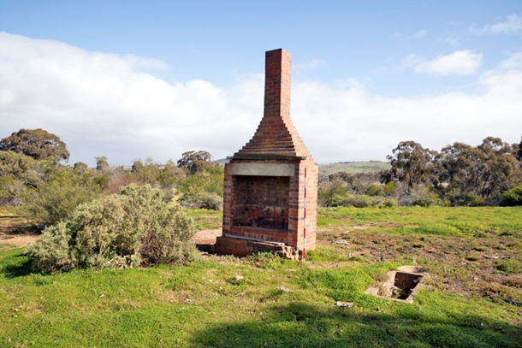

### Potential physical and visual impacts on historical sites and settings

The Project largely avoids physical impact to heritage places. Of the 137 historical heritage places identified in the historical heritage study area, 20 places were identified as potentially experiencing some form of physical impact (consisting of 2 severe, 3 moderate-severe, 2 high, 5 moderate, 5 low and 3 nil potential impacts). The location of heritage places within the study area which are potentially subject to physical impacts are shown in Figure 10.3 and Figure 10.4. Project construction at new and existing terminal station sites or laydown areas are not located on any identified heritage places or archaeological sites and will not impact any statutory, identified, or unlisted historical heritage places.

To mitigate potential physical impacts to 19 of the places, the detailed design and construction of the Project will be refined to avoid and minimise the impacts so far as reasonably practicable in consultation with Heritage Victoria, local councils, and other relevant statutory authorities (EPR HH1). This includes re-aligning or relocating Project infrastructure away from heritage places where practicable and monitoring potentially impacted places during construction to confirm effectiveness of protection measures. The physical impact to one place (Algerian Oak ID:64A) is unable to be mitigated due to vegetation clearance requirements and the disruption to the Project and surrounding landowners.

In addition, prior to commencement of works that will physically impact non-archaeological heritage places (including trees), archival place recording of these places and their settings will be undertaken to create a permanent record for future study and research (EPR HH2). These place recordings will be undertaken to a high degree of accuracy and details will inform repairs or reinstatement that may be required to these places should physical impacts occur. Where applicable, an appropriately qualified arborist will be engaged to protect and monitor trees which contribute to the historical heritage value of a place.

Archaeological places in the VHI directly impacted by the Project will require a consent or a consent exemption from Heritage Victoria (EPR HH3). A condition of a consent may include further archaeological investigations (such as test excavation or monitoring) and the capture of archaeological data will mitigate the impact on the site by revealing information about the place reducing A consent may require the development of an Archaeological Management Plan to avoid, minimise, and manage disturbance of archaeological sites and values impacted by the Project. The consent may also require additional archaeological investigations to be undertaken. These additional archaeological investigations and the archaeological data collected will mitigate the impact by revealing information about the place. These investigations may also reveal additional archaeological deposits which may not be directly impacted by the Project, but must be protected, as appropriate, from impact (EPR HH1 and EPR HH4).

To avoid and minimise impacts to historical heritage places during construction, the Project’s Construction Environmental Management Plan (CEMP) will include measures to mitigate impacts (EPR EM2). The magnitude and extent of impacts to historical heritage places will be reduced through the erection of physical barriers and marked exclusion zones around heritage fabric, to avoid accidental impacts to these places (EPR HH4). Furthermore, historical heritage awareness training must be provided to all construction workforce personnel, highlighting areas and aspects of historical heritage sensitivity within the Project Land (EPR HH4).

The enforcement of speed, width and weight limits on vehicles carrying goods and equipment on all roads and bridges, including historical bridges, will be established within the Traffic Management Plans (EPR T1). Alternative routes will be designated for vehicles and loads that exceed safe limits. Additionally, care will be taken to prevent impact to historical heritage through collisions, Project traffic, construction machinery and activities (EPR HH4). Following the application of these mitigation measures, potential physical impacts (consisting of 2 severe, 3 moderate-severe, 2 high, 5 moderate, 5 low and, 3 nil potential impacts) to 20 of the known historical heritage places have been reduced to low or nil (consisting of 15 low and 5 nil residual impacts). The physical impact to one place (Algerian Oak ID:64A) is unable to be mitigated against. However, with regards to the wider landscape and as an example of its kind, the loss of the tree is considered to be a low impact.

During Project construction, there is the potential for discovery of previously unidentified historical archaeological sites during ground disturbing works. These sites will be subject to the provisions of the *Heritage Act 2017* (Heritage Act) including notification to Heritage Victoria when a new site is found. Work must cease if any archaeological material is discovered during construction (EPR HH4) and the Principal Contractor must implement the unexpected finds protocol (EPR HH3) to avoid impact as far as practicable. This includes implementing procedures to cease work if archaeological material is discovered. Following the application of these mitigation measures, physical residual impacts to potential historical heritage places are low or nil.

All historical heritage places were also assessed for the potential of visual impacts from the Project. The residual visual impact from the Project on heritage significance or setting of all places in the study area is low to nil.

Particular consideration was given to the Former Berry Deep Leads Mining Landscape, Glenpedder Homestead and former Darley Military Camp in response to stakeholder feedback and concerns about the potential impact of the Project on these places. The residual impact for physical impacts for these places was assessed as being low or nil.

Berry Deep Leads Mining Landscape (ID:44)

The Berry Deep Leads Mining Landscape, near Allendale and Smeaton, is situated within a wider area that is the subject of the proposed United Nations Educational, Scientific and Cultural Organisation (UNESCO) serial nomination of the Victorian Goldfields to the World Heritage List (WHL). This nomination is being led by the Victorian State Government through Heritage Victoria, and will include a number of heritage places, archaeological sites, Aboriginal cultural heritage sites and broader stand-alone gold mining landscapes across the State that convey the history of the gold rushes of Victoria and their global repercussions. This area, near Allendale and Smeaton, is densely populated with mining sites, particularly those associated with the Former Berry Deep Lead System, the Colony’s richest deep alluvial gold system in the late 19th century. These mining sites date from the 1870s to the beginning of the 20th Century, and some are individually included on the VHR, VHI and the HO of Hepburn Shire.

A detailed significance and impact assessment of the place was undertaken in anticipation of the landscape’s inclusion in the bid to nominate the Victorian Goldfields to the World Heritage List. The assessment determined that although the Project will be a highly prominent addition to the landscape, it will not have detrimental physical or visual impact on the significance or the understanding of the landscape from a historical heritage perspective.

The Project will not be visible from all visual points across the cultural landscape, and where it is visible, its prominence may be reduced by various factors, including the location and orientation of the viewer, topography, distance and scale, and the degree to which other features in the landscape have the ability to obscure or reduce the visibility of the Project. In instances where the Project is visible, the significant landscape elements that contribute to the cultural landscape will still be visible, and the heritage significance of the landscape will still be able to be understood. Following application of mitigation measures, both the potential and the residual impact on the Former Berry Lead Mining Landscape is low.

The landscape was included as part of the Victorian Goldfields addition to Australia’s Tentative World Heritage List, as part of the Creswick and Deep Leads Landscape component of the bid, in January 2025. However, a formal nomination to the WHL is still to be made, and how the significance of the landscape may be presented in the nomination is still to be formally defined. This may vary from what has been included on the Tentative List.

Algerian Oak (ID:64A)

The tree is believed to be around 130 years old. It is a large tree, in good condition and is approximately 16m high. The tree was added to the National Trust’s Register of Significant Trees in June 2023 and was assessed by the National Trust as being of regional significance. Algerian Oaks can be found throughout Victoria in many parks and gardens and are not particularly rare. The register of Significant Trees includes 14 other Algerian Oaks, amongst these are a number of specimens that are better examples of the species. Algerian Oak trees are included in heritage overlays throughout the state and some notable examples are included in the VHR such as the Federal Oak in the Parliament House Gardens (VHR H1317) and in the Woodend Avenue of Honour (VHR H2066). The tree is located directly under the proposed transmission line. The tree’s removal will be required to comply with the Code of Practice for Electric Line Clearance under the Electricity Safety (Electric Line Clearance) Regulations.

The loss of this tree is one that cannot be mitigated. It is not possible to retain the tree in its current position, and it is too old, large and well established to consider relocating. It would not be possible to alter the alignment of the transmission line through this area without causing major disruption to the Project and surrounding landowners and transferring potentially greater environmental or heritage impacts elsewhere.

The impact on the tree itself is defined as severe as it constitutes the loss of the tree. However, in broader terms, with regard to the landscape, and as an example of its kind, the loss of the tree is considered to be a low impact. It is recommended that the tree be recorded in accordance with EPR HH2 prior to its removal.

Glenpedder Homestead (ID:98)

Glenpedder homestead comprises a single storey freestone dwelling and stables. The dwelling appears to date from the mid-nineteenth century. The stables are located a short distance to the south-east of the dwelling and comprise a single story ‘C’ shaped freestone building with two minor gabled wings. The property occupies an undulating plateau above an escarpment that leads to Pykes Creek Reservoir on the southern boundary. The place occupies a small portion of what was originally a squatting run of 15,000 acres known as the Cupumnimnip Run. The run was initially taken up by Sir John Lewes Pedder, the first Chief Justice of Van Diemen’s Land, who in 1836 became an ‘overstraiter’ absentee speculator, having sent a flock of sheep across Bass Strait to Port Phillip. Pedder applied for a formal lease for the full 15,000 acres in 1848. The place was most likely built by Thomas Hamilton, possibly from the mid to the latter part of the 1850s when he assumed ownership of the property.

Glenpedder Homestead was cited in the Moorabool Shire Heritage Study – Stage 1, 2010, under the themes of exploring, surveying and mapping, farming and agriculture, and building homes in the Shire. Its integrity and condition are not noted. It was added to the Moorabool Planning Scheme as place HO37.

The Glenpedder Homestead is located outside the study area, approximately 1.4km away from the nearest tower and transmission line. The upper portions of proposed towers are likely to be seen from the place’s house and garden. Views from the house and garden to the south will therefore be impacted to some degree by the transmission line. However, while views from within this location take in the pastoral land from the associated house and garden, they do not directly contribute to the appreciation of setting of the house in the landscape. It is expected that the transmission line will be generally obscured by topography and its presence minimised by distance when viewed from the house, and as such would not impact on the heritage setting of the house. As such, both the potential and residual impacts to Glenpedder were assessed as low.

The Former Darley Military Camp (ID:112)

The place comprises remnant structures of former Darley Military Camp (ID: 112) which was constructed and operated during World War II (dated 1940-1946). The Camp was a major receival site for troop mustering near Melbourne and over the course of the war also accommodated US troops enroute to the Pacific theatre. The Camp also accommodated Dutch East India Troops and trained nurses.

The Camp originally comprised a group of 15 Hutment areas, each comprising of barracks, mess huts, officers and non-commissioned officers messes, latrines and wash house. The remnant structures include chimneys, and the concrete slabs of the camps more substantial structures and subsurface features associated with the sewage system and other services. There is a high probability of occupational and construction deposits. After the war, the Camp was converted to a motorcycle racetrack, which incorporated the Camp’s road system, much of which is still present today.

Project construction has the potential to have a high impact at the former Darley Military Camp due to the potential to damage archaeological remains, if not managed properly. Mitigation measures will include locating access tracks to less sensitive areas on the Camp (EPR HH1), implementing procedures to manage archaeology and minimising impacts to remnant features and archaeological deposits of the Camp that are in proximity to any Project works, such as the erection of physical barriers and the establishment of marked exclusion zones (EPR HH1, and EPR HH4). A consent or a consent exemption from Heritage Victoria for disturbance within the VHI curtilage will be required and the conditions included in the consent will further mitigate impacts to the place (EPR HH3). Following the application of these mitigation measures the residual impact has been reduced from high to low.

Figure . Historical heritage places potentially subject to physical impacts (Map 1 of 2)

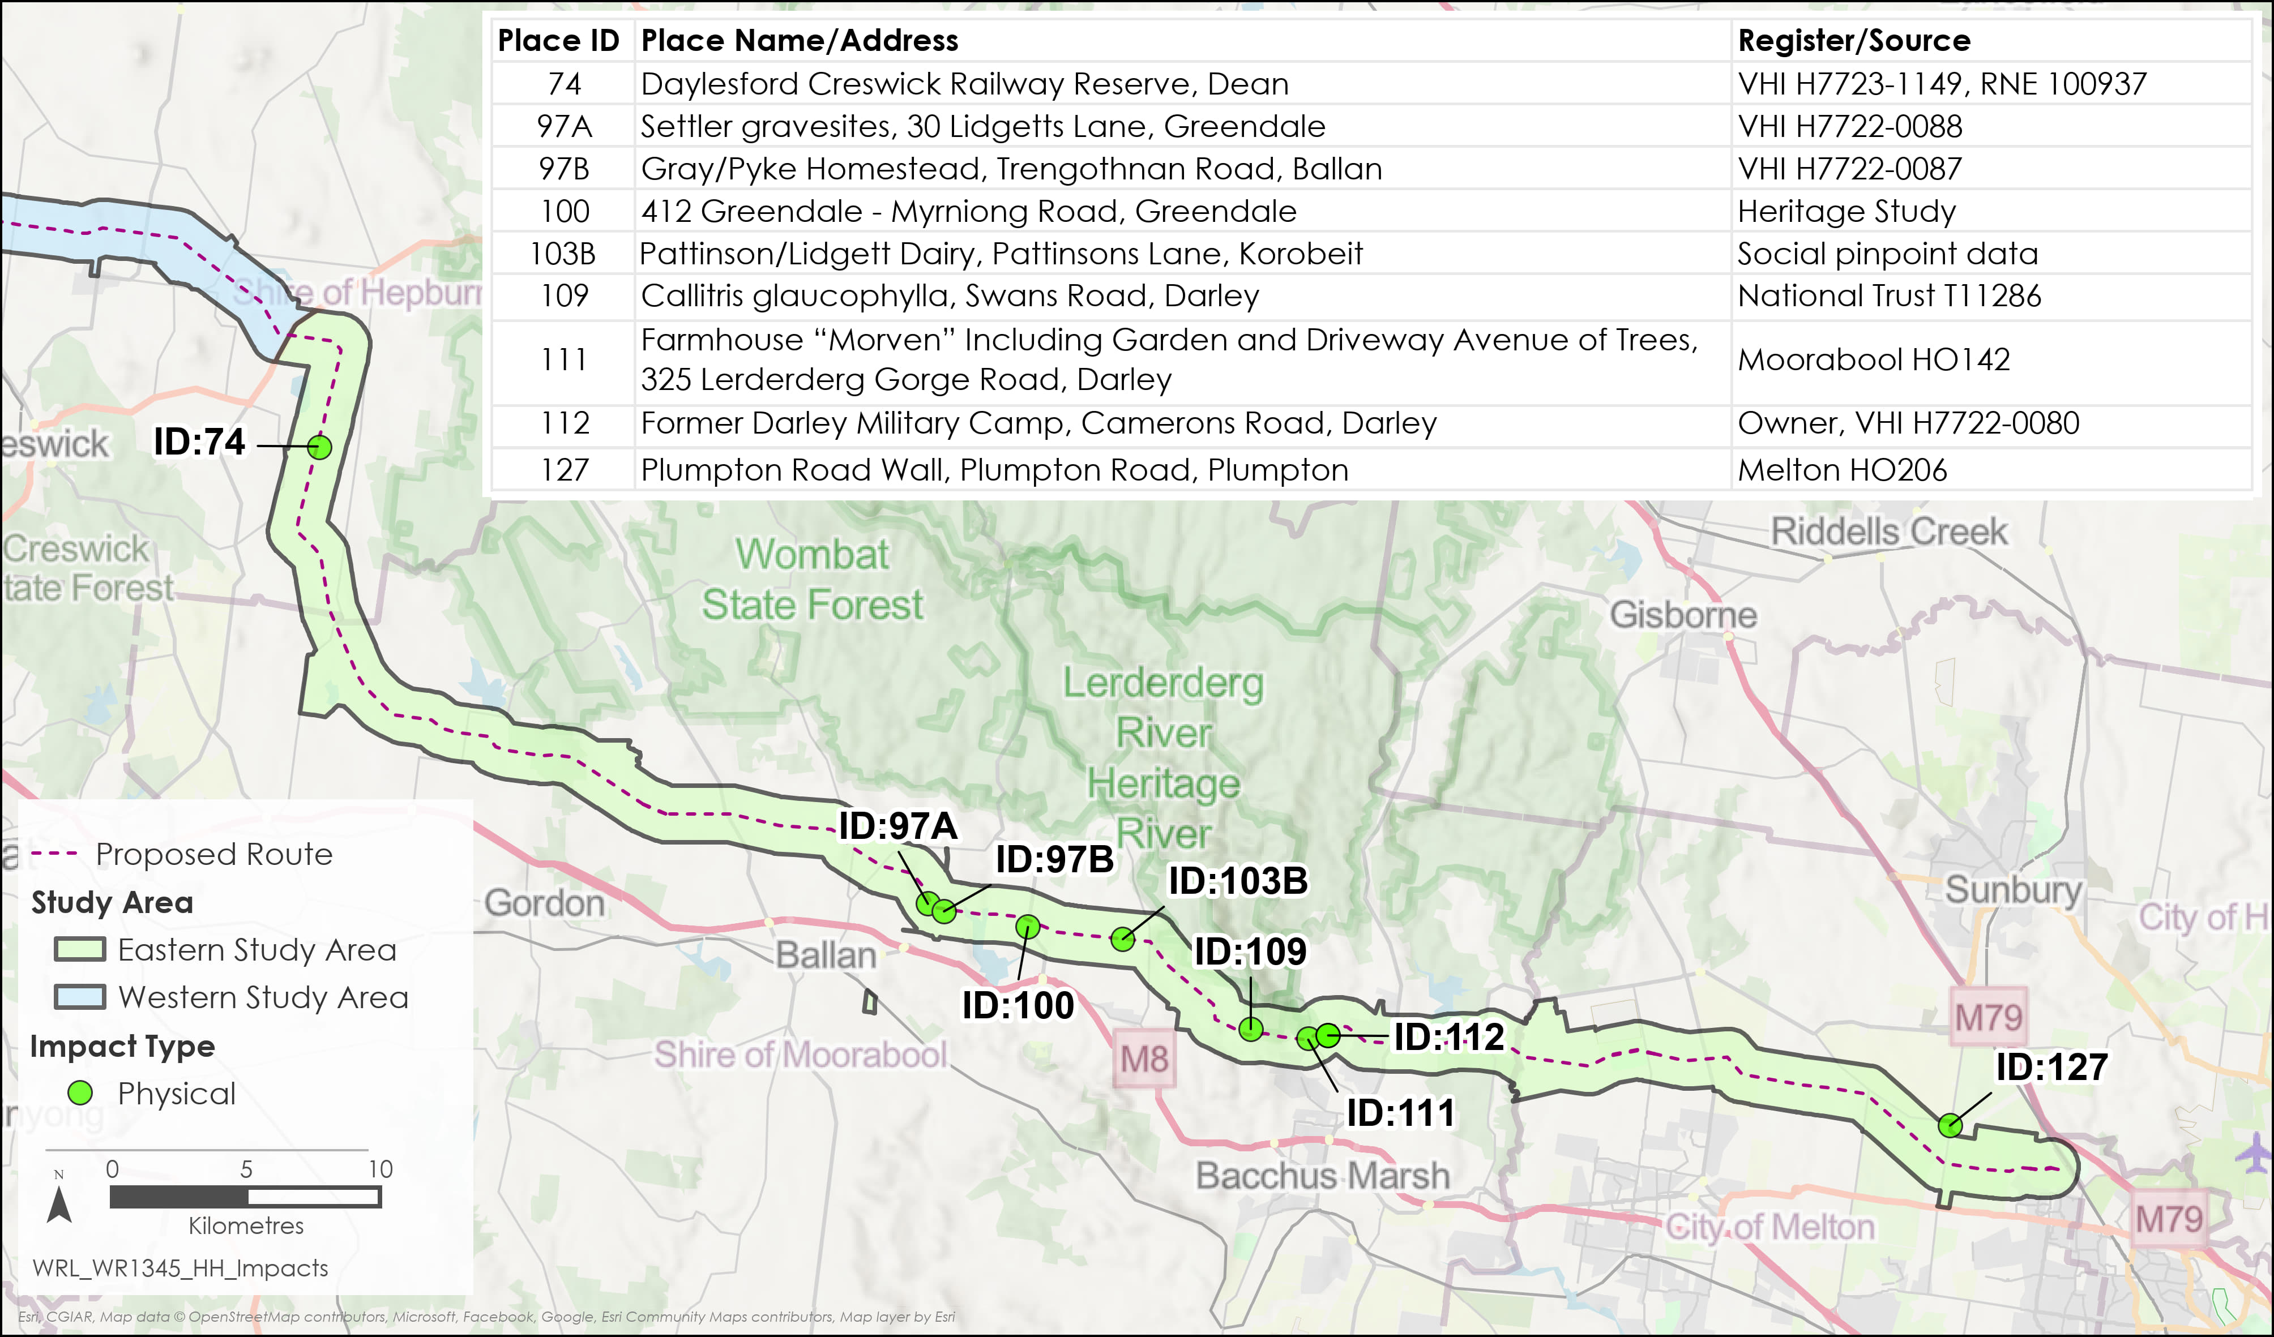

Figure . Historical heritage places potentially subject to physical impacts (Map 2 of 2)

## Operation impacts

This section outlines the key issues identified through the risk screening process and associated potential impacts during the operation of the Project. The key issues and impacts identified for historical heritage are the potential physical and visual impact on historical sites and settings. Operation of the Project is not expected to cause physical impact on heritage places due to the nature of the operational works.

### Potential physical and visual impacts on historical sites and settings

The Project is not expected to cause additional physical impact during operation, as such, further impacts to heritage places beyond the impacts incurred during the construction stage are unlikely.

During operation, works will primarily comprise of vegetation clearance in areas already disturbed during the construction stage. The likelihood of discovering and impacting historical heritage places or archaeological sites during operation is negligible, as no further earthworks or ground disturbance is expected to be undertaken. However, if ground works were to occur outside of the study area, additional heritage and archaeological assessments will be required. In the unlikely event that an archaeological site is discovered during the Project’s operation, works will cease and the site will be reported as soon as practicable to Heritage Victoria in accordance with the Heritage Act. In addition, any ground disturbance during the operation of the Project that impacts known, or unknown, archaeology is subject to the provisions of the Heritage Act.

The visual impacts from the Project outlined in Section 10.4.4 are likely to remain unchanged throughout operations. The presence of the Project will not compromise any historical relationships between a place and its setting to the degree that the understanding of the relationship is compromised. In instances where the Project is visible, the landscape and the elements and features that contribute to the landscape’s significance will remain and will continue to be seen through and beyond the Project’s infrastructure. As such, the overall residual visual impact from the Project on the understanding of the heritage significance or setting of all historical heritage places in the study area is low.

## Decommissioning impacts

The Project is unlikely to cause any further impact to any heritage place during decommissioning beyond what would have already occurred during the construction stage. As such, the impacts relating to historical heritage are assessed to be the same as for the construction stage.

Any further ground disturbing activities are most likely to occur in areas that have already been disturbed as part of the construction stage. If ground works are to occur outside of the construction footprint during decommissioning, additional assessments would need to be undertaken to identify and manage any impacts to heritage places, in accordance with the Decommissioning Management Plan (EPR EM11) which would include mitigation measures for historical heritage.

Decommissioning will return any areas affected by the Project back to their original condition and there would no longer be visual impacts from the presence of the transmission line and towers. This would be a benefit to historical heritage places such as the former Darley Military Camp and Glenpedder Homestead.

Based on this, residual impacts are expected to be low or nil for historical heritage during the Project’s decommissioning.

## Cumulative impacts

Cumulative impacts have been assessed by identifying relevant future projects that could contribute to cumulative impacts on historical heritage values, considering their spatial and temporal relationships to the Western Renewables Link Project.

No projects were identified as potentially causing further cumulative impact to the significance, setting or archaeological values of any of the places, landscape or archaeological sites as the relevant future projects are not physically or visually near any of the historical heritage places identified and assessed in the study area.

## Environmental Performance Requirements

Potential impacts identified through **Technical Report C: Historical Heritage Impact Assessment** have informed the development of EPRs for the Project. EPRs set out the environmental outcomes to be achieved through the implementation of mitigation measures during construction, operation and decommissioning. While some EPRs are performance based to allow flexibility in how they will be achieved, others include more prescriptive measures that must be implemented. Compliance with the EPRs will be required as a condition of the Project’s approval. Table 10.3 details the proposed EPRs developed for historical heritage.

Table . Environmental Performance Requirements

| EPR code | Requirement |
| --- | --- |
| EPR HH1 | **Design and construct to avoid and minimise impacts on heritage**   1. Undertake design and construction planning to avoid, and where avoidance is not possible, minimise impacts so far as reasonably practicable on the known heritage values of heritage places in consultation with the relevant statutory authority. 2. Prior to commencement of works that have the potential to (directly or indirectly) impact any heritage places, structures or features, develop and implement measures to protect heritage places, structures or features as appropriate from impact during the construction works. Such measures may include, but not be limited to, the erection of physical barriers, the implementation of marked exclusion zones and or the monitoring of the place during works. These mitigation measures are to be developed and implemented, in consultation with the relevant statutory authority, in a manner that is responsive to the specific circumstances of the heritage place the nature of the Project works occurring there. |
| EPR HH2 | **Undertake archival place recording**   1. Prior to commencement of works involving the demolition or modification of non-archaeological heritage places (including trees), undertake archival place recording of these places and their settings to create a permanent record for future study and research. 2. The means by which the recording is to be undertaken will be determined by the type and nature of the place but must include the measurement of the place and archival photographic recording as the primary means of recording and documentation. Other means to augment and support the place recording should also be considered and applied where possible. These may include, but not be limited to, techniques such as aerial (drone) photography, photogrammetry, 3D scanning, LiDAR, rectified photography and site survey. 3. Archival photographic recording must be undertaken in accordance with Heritage Victoria’s specification for the archival photographic recording of heritage places or alternative applicable Heritage Victoria guidelines. |
| EPR HH3 | **Manage historical archaeological sites**   1. As required by the *Heritage Act 2017*, apply for consents for Victorian Heritage Inventory (VHI) sites and permits for Victorian Heritage Register (VHR) places where direct impacts are proposed. 2. Prepare documentation required to comply with consents and permits obtained for the Project, which may include an Archaeological Management Plan detailing measures to avoid, minimise, mitigate and manage disturbance of archaeological sites and values affected by the Project. The Archaeological Management Plan may include requirements for background historical research, excavation methodology, research design, reporting and artefact management, artefact conservation, and analysis. 3. Undertake archaeological investigations in accordance with the Guidelines for investigating historical archaeological artefacts and sites (Heritage Victoria 2015) and any conditions of consents or permits obtained for the Project. |
| EPR HH4 | **Avoid and minimise impacts to historical heritage during construction**   1. To avoid and minimise impacts to historical heritage during construction, the Construction Environmental Management Plan (CEMP) (EPR EM2) must include: 2. An unexpected finds protocol that specifies measures to manage unidentified historical archaeological sites and values discovered during construction. The management protocol must be consistent with the requirements of the *Heritage Act 2017* and include procedures for ceasing work if human remains or archaeological sites, values or objects are discovered, notifying Heritage Victoria of the find, obtaining consent to deal with the find, and dealing with the find in accordance with the consent. 3. Measures to manage historical heritage impacts including physical barrier protection and/or exclusion zones to manage unplanned effects. 4. Details around training and awareness in relation to historical heritage places and obligations (e.g., Project induction, toolbox talks and staff inductions). |

Other EPRs contribute to a reduction in the magnitude, extent, and duration of impacts for historical heritage values. Additional EPRs related to historical heritage include:

* EPR EM2 – Develop and implement a Construction Environmental Management Plan
* EPR EM11 – Develop and implement a Decommissioning Management Plan
* EPR T1 – Develop and implement a Traffic Management Plan.

Refer to **Chapter 29: Environmental Management Framework** for full detail of these EPRs.

## Summary of residual impacts

With the application of the EPRs, residual impacts associated with historical heritage are considered to be low to nil:

* Residual impacts to historical sites and settings during construction are low to nil. Of the 137 places identified, potential physical impacts were identified at 20 places consisting of 2 severe, 3 moderate-severe, 2 high, 5 moderate, 5 low and 3 nil potential impacts. Through application of the EPRs, residual physical impacts have been reduced to low or nil (15 low, 5 nil) for 20 of the known historical heritage places. A physical impact remains to one place (Algerian Oak ID:64A) that is unable to be mitigated against due to vegetation clearance requirements. Avoiding the tree would require a realignment of the Project, causing wider disruption to the Project and surrounding landowners as a result. However, with regards to the wider landscape, and as an example of its kind, the loss of the tree is considered to be a low impact. AusNet will work with Heritage Victoria and local councils to avoid and minimise impacts on heritage sites (EPR HH1), including measures such as the erection of physical barriers and exclusion zones around heritage sites, and historical heritage awareness training for construction workforce personnel (EPR HH4). Additionally, archival place recording will be undertaken for non-archaeological heritage places (including trees) subject to physical impacts to create a permanent record for future study and research (EPR HH2). The Project will apply for and abide by consents or permits needed for the disturbance of heritage places (EPR HH3), and where required by a consent or permit an Archaeological Management Plan will be developed and implemented to avoid, minimise, and manage disturbance of archaeological sites and values.
* The Project is unlikely to cause any further ongoing impact to any heritage place during operation, beyond what would have already occurred during the construction stage. While the transmission line will be visible from historical heritage places within the Project Area (including the Berry Deep Leads Mining Landscape and Glenpedder Homestead), it is understood that this alone will not impact the significance of these places, the historical relationship between a place and its setting, or visitor’s ability to understand the historical setting. Therefore, the Project’s residual visual impact on the understanding of the heritage significance for all places within the study area will be low.
* Impacts to historical heritage during decommissioning will be managed in accordance with the Decommissioning Management Plan (EPR EM11) and therefore, residual impacts will be low or nil.

With the implementation of measures to comply with EPRs, it is considered that the Project meets the historical heritage aspects of the evaluation objective “*to avoid, or minimise where avoidance is not possible, adverse effects on Aboriginal cultural heritage and historic heritage values”*.

