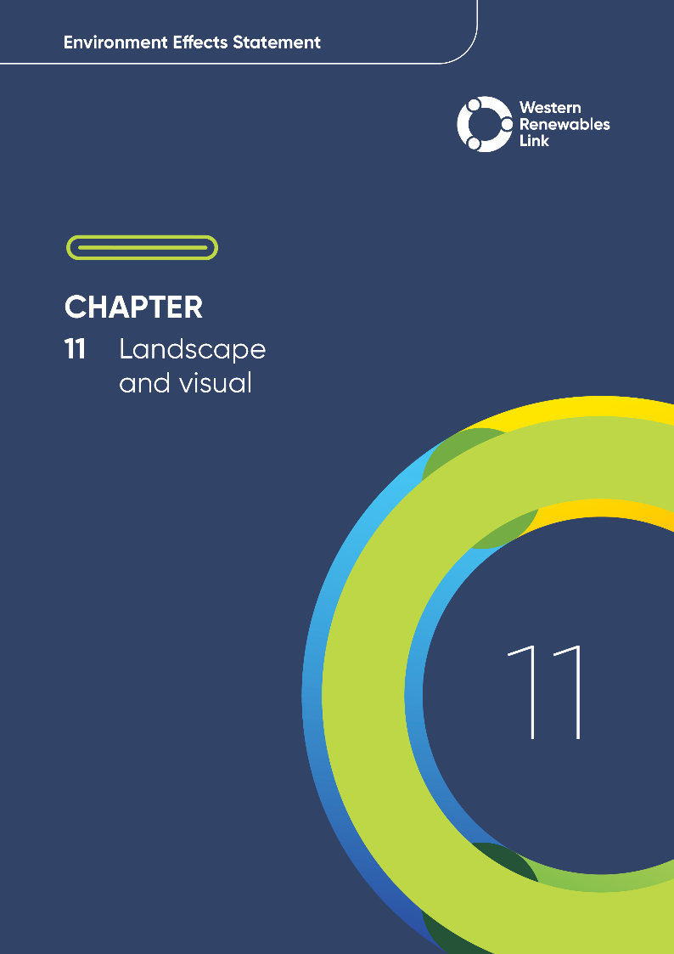

Landscape and visual
- What are landscape and visual impacts?
Landscape impacts relate to changes to features such as topography, vegetation and land use that that may be brought about by a project which alter the character of an area.
Visual impacts refer to changes to views of the landscape, that may impact people’s visual experience and enjoyment of an area.
This chapter provides an overview of the potential landscape and visual impacts associated with the construction, operation and decommissioning of the Project. This chapter is based on Technical Report D: Landscape and Visual Impact Assessment.
Landscape and visual values refer to the importance placed on the aesthetic qualities and character of a landscape, including how it is viewed and experienced by people. The Project spans landscapes of varied character and visual conditions including highly modified landscapes with a low sensitivity to change, as well as landscapes valued for their natural features, cultural features and values, amenity, biodiversity and recreational uses. Impacts to the landscape and visual values of significant landforms may occur due to the Project, both along and in combination with other visually conspicuous developments within the region.

Evaluation objective
Evaluation objectives
Avoid, or minimise where avoidance is not possible, and manage potential adverse effects on landscape and visual amenity.
Avoid, or minimise where avoidance is not possible, adverse effects for community amenity, health and safety, with regard to construction noise, vibration, dust, lighting, waste, greenhouse gas emissions, transport network, operational noise, fire risk management and electromagnetic radiation.
The scoping requirements identify the following evaluation objectives relevant to landscape and visual values:
In response to these evaluation objectives, impacts of the Project on landscape and visual values were assessed and measures to avoid, minimise or manage potential impacts have been identified. These measures are discussed throughout this chapter and have informed the development of Environmental Performance Requirements (EPRs). EPRs set out the environmental outcomes to be achieved through the implementation of mitigation measures during construction, operation and decommissioning to avoid, minimise and manage identified impacts. Cumulative impacts associated with relevant future projects and existing nearby developments were also assessed.
Further information on how the Project has been designed to avoid and minimise impacts is provided in Chapter 5: Project development and Chapter 6: Project description.
Other aspects covered in the Environment Effects Statement (EES) evaluation objectives and relevant to landscape and visual values are addressed in the following EES chapters:

- Chapter 9: Aboriginal cultural heritage
- Chapter 13: Bushfire
- Chapter 17: EMI and EMF
- Chapter 18: Air quality
- Chapter 19: Noise and vibration
- Chapter 20: Transport
- Chapter 23: Contaminated land
- Chapter 26: Greenhouse gas.

Method
This section summarises the method adopted in Technical Report D: Landscape and Visual Impact Assessment, which was informed by Chapter 4: EES assessment framework and approach. The key steps in assessing the impacts associated with landscape and visual values included:
- Defining a study area appropriate for assessing landscape and visual values as discussed in the information box below and presented in Figure 11.2. The study area included the Project Land and the surrounding area within 9.2km of the Proposed Route. Beyond this distance, the Project would be a small object in the background of views and difficult to discern. The potential landscape and visual impacts of the Project on the public domain were assessed by considering views from public locations throughout the study area. The potential impacts of the Project on the private domain were assessed from locations within 2km of the Proposed Route, this being the distance within which Project towers have the potential to be highly visible and can dominate the landscape.
- Reviewing applicable Commonwealth legislation, and relevant local, state, national and international standards, guidelines and policies. This included local planning schemes, spatial data layers, reports, strategies and masterplans. This step assisted in the selection of Public Realm viewpoints and locations that were assessed.
- Landscape Character Units
Landscape Character Units are defined by physical and natural attributes.
Characteristics that assist in defining the landscape character units include geology, topography, vegetation, drainage patterns, and land use.
- Defining four distinct regional-scale landscape character areas (see Section 11.3.1) based on similar landscape features and viewing patterns, land use, zoning, and vegetation (based on identified Landscape Character Units). These regional landscape character areas were used to structure the technical report, and the operational impacts discussed in Section 11.5.
- Conducting a desktop review to determine the existing landscape and visual conditions including Landscape Character Units, features and sensitivity, as well as existing prominent energy infrastructure. Google Earth, Google Earth Street View and VicPlan Aerial Imagery were used to identify sensitive viewpoints and existing energy infrastructure within the study area.
- Consulting with key stakeholders including landholders, engaging with local Councils including Ballarat City Council, Melton City Council, Hepburn Shire Council, and Moorabool Shire Council, and reviewing the pins dropped by community members onto the Project’s Social Pinpoint online mapping tool which identified locations, features and values of importance.
- Conducting field investigations and site inspections across the study area, and dwellings where access had been granted.
- Conducting a risk screening process to identify the key issues during construction, operation and decommissioning for investigation within the technical report.
- Selecting viewpoints to assess the Project’s visual impacts, which included significant locations and landscapes, locations identified from Social Pinpoints and community consultation, and representative views from the public domain and neighbouring dwellings. The process for the selection of dwellings involved a shortlist created by the specialist of approximately 100 dwellings, which the Project then approached landholders for interest in being part of the assessment. Landholders from neighbouring dwellings who also came forward during community consultation were also assessed. In 2024, the Project issued a mail out to all known neighbouring dwellings within 2km of the Proposed Route which included a request for interested landholders to register their interest in participating in the assessment. At the time of preparing this document, the landholders of approximately 150 dwellings had expressed interest in participating in the assessment. A shortlist of approximately 30 dwellings located in areas where there had been limited assessment was identified and the landholders were offered assessments. Where those landholders accepted, the dwellings are included in this assessment.
- Photomontages
Photomontages are composite images that depict the Project’s infrastructure within selected views. These images have been included in this chapter to facilitate the discussion of visual impacts and provide a visual representation of how the Project will affect selected viewpoints.
- Developing photomontages illustrating the Project infrastructure in selected views to demonstrate the range of distances, viewing angles and landscape character types within the study area and provide an understanding of how the Project will reside in the landscape during operation.
- Identifying and assessing the potential visual impact from each viewpoint during construction, operation and decommissioning. The visibility of towers along the Proposed Route is not the determining factor for visual impact, and the overall visual impact was assessed based on the following assessment criteria:
  - Landscape change: The physical change or alteration to a landscape will depend on the nature of the Project.
  - Visibility: If a project is not visible, there cannot be a visual impact. Available views may also be partially screened, filtered or open, and from oblique to direct.
  - Distance: Infrastructure visibility and dominance will decrease with distance. The ZVI indicates visual dominance and potential impact based on distance.
  - Duration: The duration of a view is associated with the location or use where people may see the Project and is not measured in unit of time precisely (i.e., 10 mins for short or 2 hours for long). For example, reserves, lookouts and private open space areas are given greater weight than views that may be transient or fleeting along roadways or occasional views in the public domain.
  - Viewer numbers: The overall visual impact level will decrease when there are fewer people who can view the Project. Conversely, the level of visual impact may increase where the viewing location is a recognised key vantage point or tourist route where a greater number of people may view the change.
  - Landscape character and viewer sensitivity: The landscape character of an area is based upon visual features such as topography, vegetation and the use of the land, the naturalness of the area and planning provisions. Viewer sensitivity is linked to an area's location, use or activity and the expectations for views or amenity. For example, a viewer in a national park would have higher expectations for views and amenity, than the same viewer travelling through the road network or spectators at a sports reserve.
For each assessed viewpoint, each of the above criteria have been assessed, the details of which are provided in Section 11 and Section 12 of Technical Report D: Landscape and Visual Impact Assessment.
- Evaluating impacts according to the following ratings, in relation to the assessment criteria described above which determines the extent, magnitude and duration of the impacts:
  - Nil: Where the Project will be screened by topography, vegetation, buildings and other structures, or Project features are at such a distance that they will not be a readily discernible feature in views.
  - Negligible: Where the Project is barely discernible over ordinary day-to-day views. A ‘negligible’ level of visual impact is usually arrived at where the Project will be at such a distance that, when visible in good weather, it will be a minute element in the view within a modified landscape or will be predominantly screened by topography, vegetation, or buildings, or will form part of a view that includes many other similar features.
  - Low: Where the Project is noticeable but will not cause significant impacts. A ‘low’ level of visual impact will be determined if several, but not all, assessment criteria (visibility, distance, viewer numbers and landscape sensitivity) are assessed as low. For example, where the Project is visible in a highly modified landscape, or would be seen by few people, or where views are transient rather than stationary. Or, where the proposed high-voltage towers are in the distance, and less visually apparent than nearby features such as powerlines along a roadside or crossing a nearby paddock.
  - Moderate: Where several criteria are considered to be higher than ‘low’, or the visual effects can be mitigated/remedied from an initial rating of high.
  - High: Where significant adverse effects cannot be avoided, remedied, or mitigated. For example, a highly sensitive landscape, viewed by many people, with the Project in close proximity and largely visible, will lead to an assessment of a high level of visual impact.
- Determining the extent of the study area and Zones of Visual Influence
The EES scoping requirements required the technical assessment to identify viewsheds in which Project infrastructure could feature. The study area (or viewshed) was established based on the tallest Project elements (the 80m high transmission towers) and the parameters of human vision. Figure 11.1 illustrates the prominence of an 80m high transmission tower, with the diminishing scale of the tower over distance. These distances are used to determine visual prominence or scale over distance, and these are known as Zones of Visual of Influence.
The extent of the visual study area was established at the point where the tower would occupy less than 0.5 degrees in the vertical field of view, at which the Project may be visible but would be a small object in the background of views and difficult to discern. This principle is shown in Figure 11.1. At this point, the distance from the towers would be 9.2km – this has defined the extent of the study area for the Project. Further details on the selection of the study area are provided in Technical Report D: Landscape and Visual Impact Assessment.
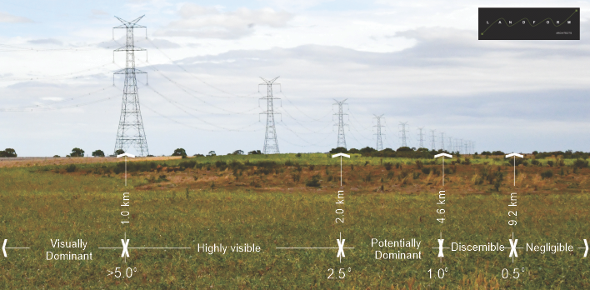
Figure 11.1 Reducing prominence of transmission towers over distance (Source: Landform Architects, 2024)
The same rating method was used for the private realm, with the exclusion of viewer numbers. When considering impacts to the private realm, viewer sensitivity was always considered to be high.
- Identifying relevant existing, approved and future projects that could lead to cumulative impacts when considered together with the Project (refer to Technical Report D: Landscape and Visual Impact Assessment for the full cumulative impact assessment method for landscape and visual).
- Developing EPRs in response to the impact assessment to define the required environmental outcomes that the Project must achieve through the implementation of mitigation measures during construction, operation and decommissioning. Measures to reduce the potential impacts were proposed in accordance with the mitigation hierarchy (avoid, minimise, manage, rehabilitate and offset) and have informed the development of EPRs. Alternative mitigation measures could be implemented to comply with the EPRs based on the specific site conditions, available resources, and the Principal Contractor’s expertise.
- Following application of mitigation measures set out in the EPRs, determining residual impacts of the assessed viewpoints associated with the construction, operation and decommissioning of the Project, and evaluating their significance.

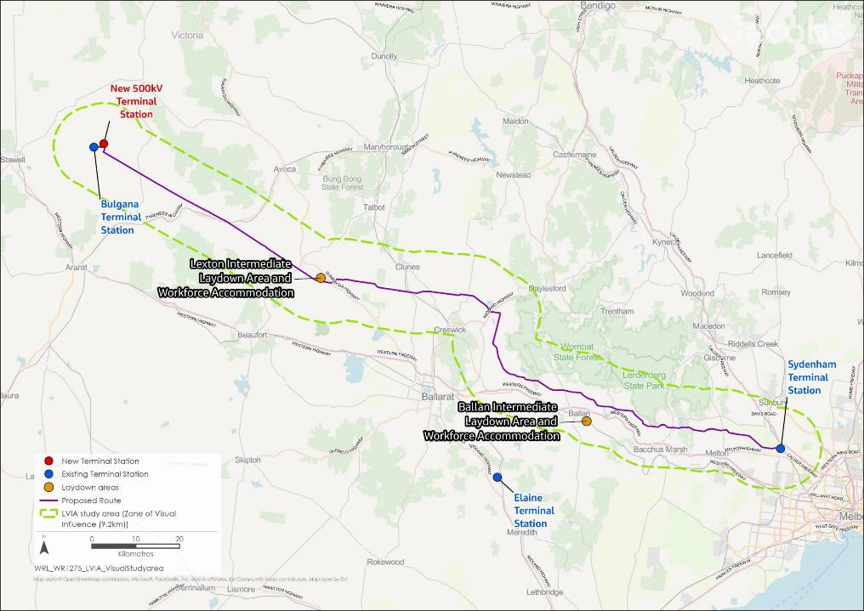
Figure 11.2 Landscape and visual study area

Existing conditions
This section summarises the existing landscape and visual conditions, features and values.
The study area includes a range of landscapes and uses such as national parks, state parks and reserves, townships, landscapes that have been cleared for farming, extractive or industrial uses, and areas of historical heritage. All landscapes are valued, however much of the land in the study area has been highly modified and has a low sensitivity to further change. Landscapes that are valued for their natural features, amenity, biodiversity and recreational uses, and are therefore sensitive to visual change include Ben Major Flora Reserve, Mount Beckworth Scenic Reserve, Lerderderg State Park and Wombat State Forest. These areas have been avoided by the Project.

Landscape character, features and values
Landscape character is defined by the distinct, recognisable features of an area. The review of existing conditions identified different types of landscape character based on policy and planning considerations, and observations of landscape features such as land use, topography, vegetation, waterways, conservation reserves, townships and heritage.
Through the analysis of policy, zoning, land use and existing landscape features throughout the study area, the following four Regional Landscape Character Areas were defined for Technical Report: D Landscape and Visual Impact Assessment (Figure 11.3):
- Vegetated Hills and Farming, from Bulgana Terminal Station to the east of Mount Bolton and Mount Beckworth; defined by elevated views within the Great Dividing Range and native vegetation
- Plains and Volcanic Cones, from Mount Bolton and Mount Beckworth to Rocky Lead Creek, south of Mount Prospect; defined by cleared open grassy plains featuring volcanic cones
- Rolling Farmland and Water Bodies, between Mount Prospect and Darley; defined by cleared rolling hills, intersected by waterways and planted hedgerows
- Peri-Urban and Townships, between Darley and Sydenham; defined by a mix of farming lands, vegetated hills and developed townships, intersected by major roads and infrastructure.

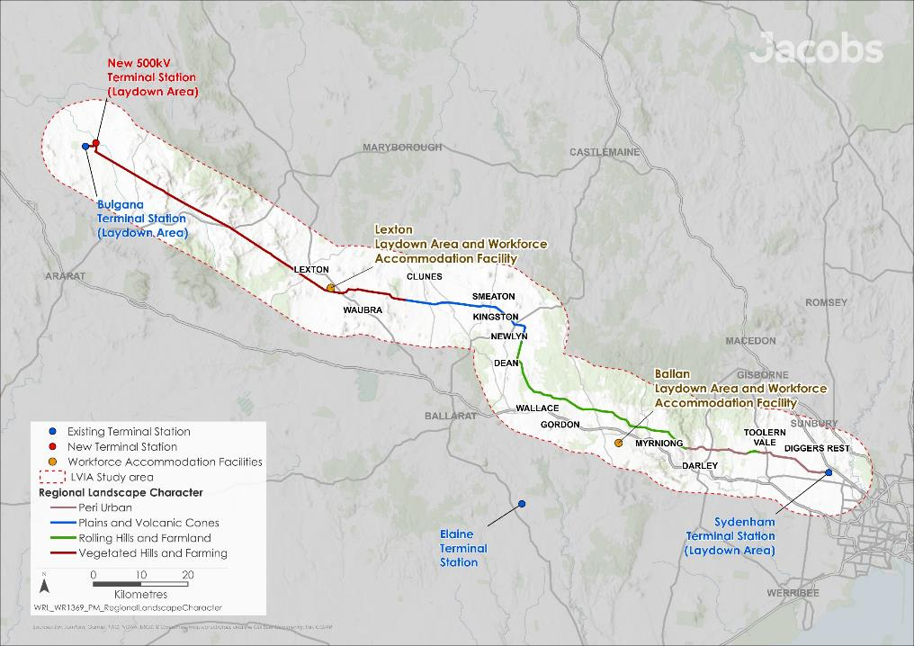
Figure 11.3 Regional landscape character areas within the study area

Within each Regional Landscape Character Area, finer grained Landscape Character Units have been identified based on topography, vegetation, land use, the presence of water and their sensitivities to visual change. Landscape and viewer sensitivity is a measure of the ability of a landscape to absorb visual change based on its particular attributes. The sensitivity of each landscape type will depend on attributes such as location, rarity, and scenic qualities. The sensitivity of the identified landscape types is based on these attributes, feedback gathered through stakeholder and community engagement activities and the statutory provisions and protections that apply to these areas.
Nine Landscape Character Units have been defined within the study area:
- Landscape Character Unit 1a – Townships
- Landscape Character Unit 1b – Rural Residential
- Landscape Character Unit 2a – Cleared Flat Farmland
- Landscape Character Unit 2b – Cleared Hilly Farmland
- Landscape Character Unit 3 – Extractive and Industrial
- Landscape Character Unit 4 – Plantation forests
- Landscape Character Unit 5 – Water bodies and waterways
- Landscape Character Unit 6 – Parks and Forests
- Landscape Character Unit 7 – Volcanic Cones
- Landscape Character Unit 8 – Valleys and Gorges
- Landscape Character Unit 9 – Heritage Landscapes.
These Landscape Character Units describe the diverse range of landscape features within the study area, encompassing townships, cleared farmland, extractive and industrial landscapes (such as quarries), natural areas, and areas of historical heritage.
Different types of landscape character have distinct sensitivities to visual change. Landscape and viewer sensitivity is a measure of the ability of a landscape to absorb visual change based on its particular attributes, such as location, rarity, and scenic qualities. The sensitivity of the Landscape Character Units was determined based on these attributes, having regard to feedback gathered through stakeholder and community engagement activities and the planning and policy protections that apply to these areas.
The sensitivity of some landscapes is high, typically in areas valued for their natural features, amenity, biodiversity and recreational uses. This includes the:
- Water Bodies and Waterways Unit (Figure 11.4)
- Parks and Forests Unit (Figure 11.5)
- Volcanic Cones Unit (Figure 11.6)
- Valleys and Gorges Unit (Figure 11.7).
Landscapes within the Parks and Forests Landscape Unit are pristine, with little development or modifications other than access roads, trails and telecommunications infrastructure. Most views to surrounding areas from within these landscapes are screened or filtered by vegetation. However, there are locations where breaks in vegetation permit views across the landscape and the Project may be visible. Volcanic cones are typically not publicly accessible within the study area; however, they are equally valued for their scientific merit and their contribution to views and landscape character.
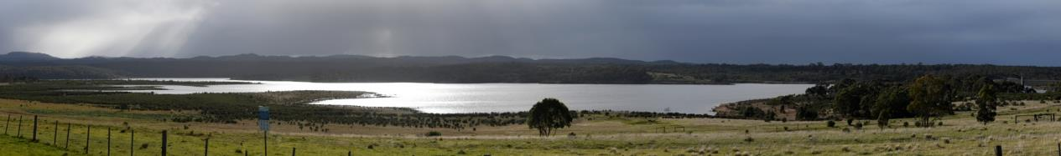
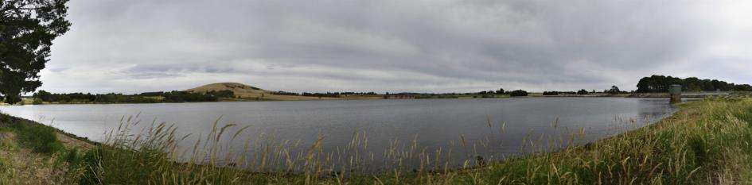
Figure 11.4 Water bodies and Waterways Landscape Unit (Top to bottom: Newlyn Reservoir, Merrimu Reservoir)
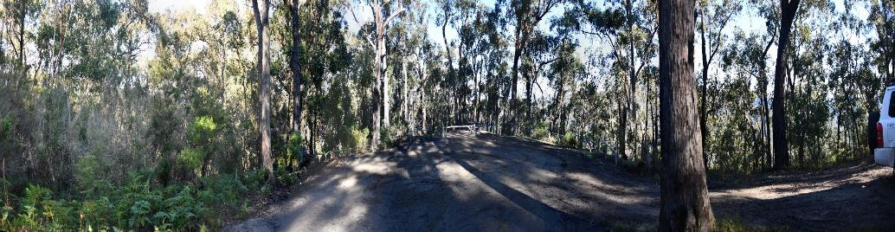
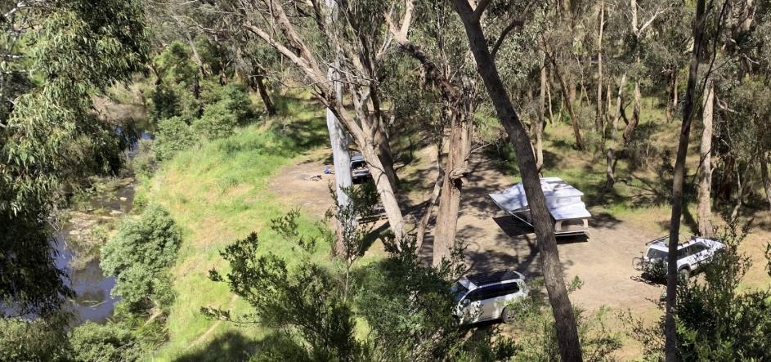
Figure 11.5 Parks and Forest Landscape Unit (Top to bottom: Example of a forest trail; Lerderderg State Forest)
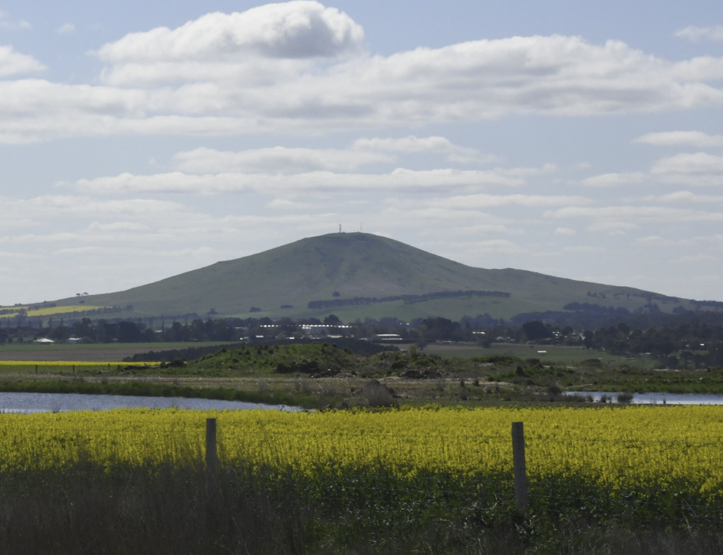
Figure 11.6 Volcanic Cones Landscape Unit (Mount Kooroocheang)
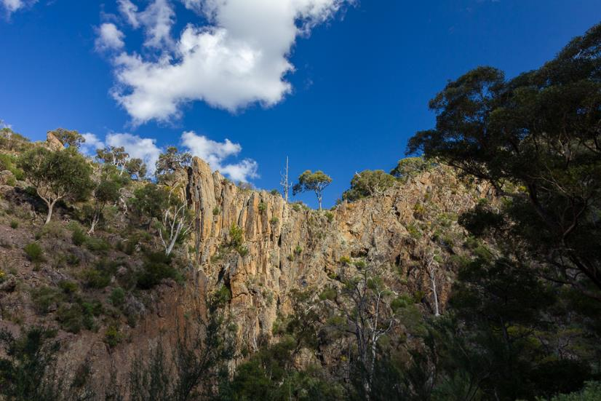
Figure 11.7 Valleys and Gorges Landscape Unit (Werribee Gorge)
Townships Units (Figure 11.8), Rural Residential Units (Figure 11.9), and Heritage Landscape Units (Figure 11.10) were assessed as having a moderate sensitivity, due to the constructed elements and features that are present in existing views. The Heritage Landscape Unit considered post-settlement historical heritage and does not include Aboriginal cultural heritage. The Project’s visual presence on intangible Aboriginal cultural heritage values was assessed separately in Technical Report B: Aboriginal Cultural Heritage (and summarised also in Chapter 9: Aboriginal cultural heritage). In rural areas, these constructed elements include dwellings, structures and sheds, transmission line towers, plantations, power infrastructure, and other developments. It is recognised that many people living in rural residential areas appreciate natural values, rural amenity and outlook. As such, visual sensitivity may be high from individual dwellings. Within townships in the study area, most views across landscapes are screened or filtered by buildings and vegetation.
Heritage landscapes within the study area, include areas of post-settlement historical heritage recognised in planning schemes, such as former gold mining areas, Kingston Avenue of Honour, and the Hepburn Lagoon. Most of these locations are within modified areas, such as townships. They often offer contemplative views, encouraging people to gather and focus on a particular feature or point of interest.
Known areas of historical heritage are detailed in Technical Report C: Historical Heritage Impact Assessment. Refer to Chapter 9: Aboriginal cultural heritage, for information regarding Aboriginal cultural heritage values.
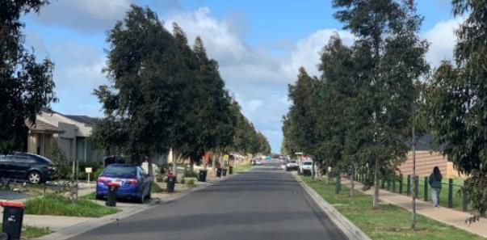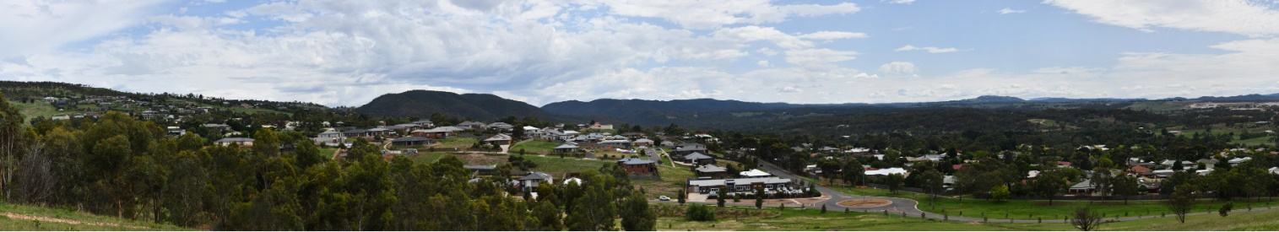
Figure 11.8 Township Landscape Character Unit (Top to bottom: Brookfield, Darley)
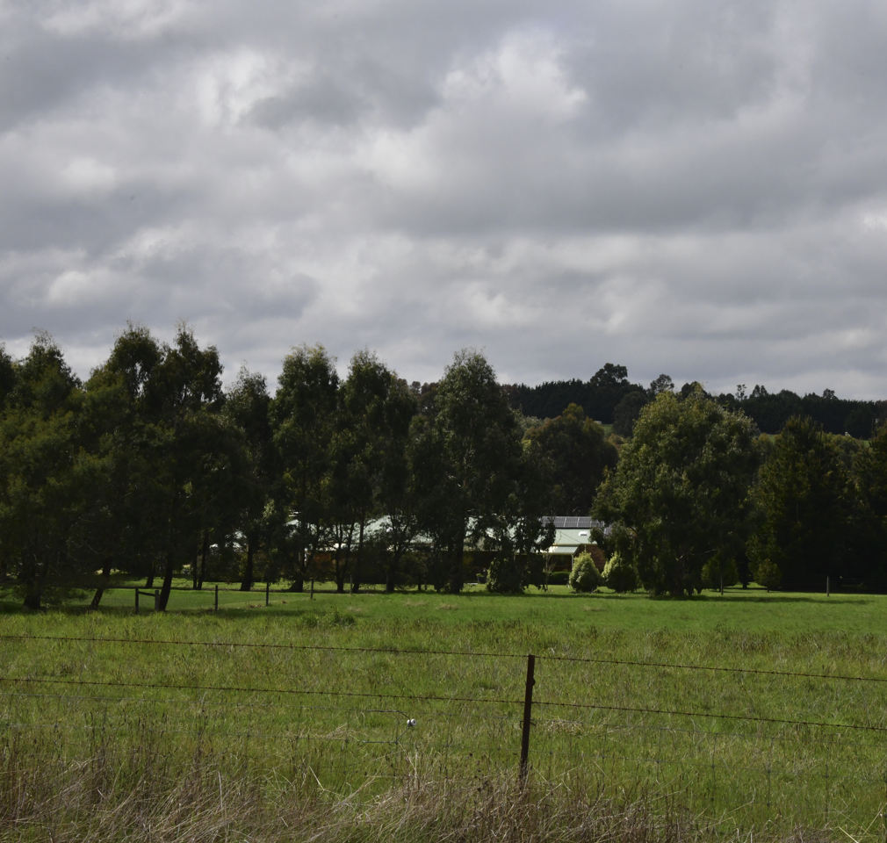
Figure 11.9 Rural Residential Landscape Character Unit (Connor Court, Ballan)
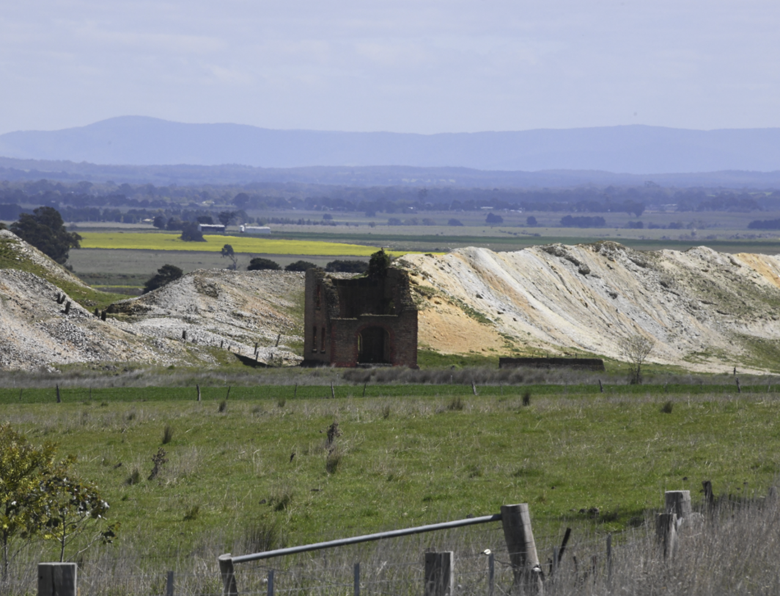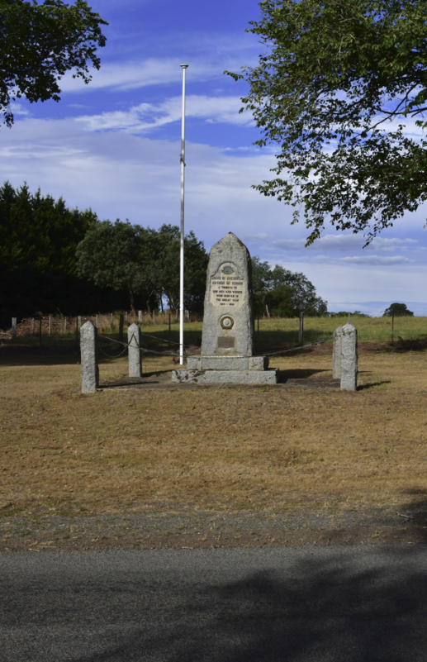
Figure 11.10 Heritage Landscapes Unit (Left to right: Example of heritage mining features, Kingston Avenue of Honour)
Cleared farmland was assessed as having a low sensitivity. Although many residents and visitors find these areas appealing for their apparent natural values, the majority of the landscape has been modified to create this character, and these landscapes are continually changing due to seasonal farming practice and development.
The Cleared Hilly Farmland Landscape Character Unit includes expansive views from elevated locations along the public road network, such as crests and hillsides. Views are varied, but typically include scattered and retained trees.
Other landscapes with low sensitivity to visual change are extractive and industrial landscapes (such as quarries) and timber plantations. These are described further in Technical Report D: Landscape and Visual Impact Assessment.
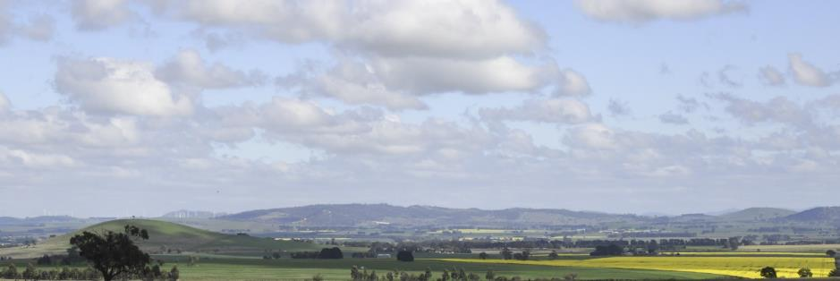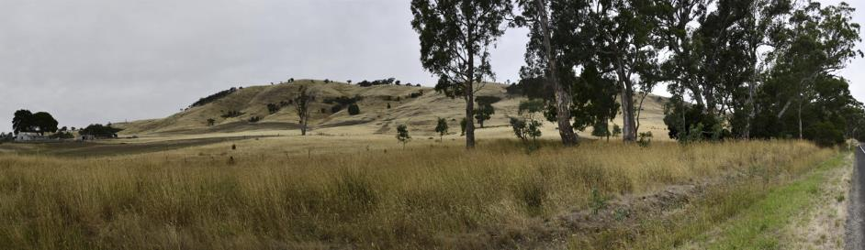
Figure 11.11 Cleared Hilly Farmland Unit (Top to bottom: Views across the centre and western portion of the study area)

Construction impacts
This section outlines the identified key issues and associated impacts during the construction of the Project, noting that these impacts will be temporary and relatively short in duration. The key issues and impacts identified for landscape and visual are discussed according to the following themes:
- Visual impacts from construction activities: the physical presence of construction equipment, materials and activities including laydown areas and the workforce accommodation facilities
- Landscape impacts: the impact of physical activities on the landscape, such as earthworks or vegetation removal
- Potential lighting impacts: the potential for light pollution from construction sites, laydown areas and workforce accommodation facilities, which impact nearby residents.

Visual impacts from construction activities
Construction activities, including those associated with the construction of the transmission line, may be highly visible while underway at any one location. However, these impacts will be temporary and relatively short in duration lasting between nine to 22 weeks over the two-year construction stage as work progressively moves along the Proposed Route. The extent of visual impacts will be minimised through standard site hygiene measures as required in the Construction Environmental Management Plan (EPR EM2). Following construction, temporary construction areas will be rehabilitated and returned to their prior use in consultation with landholders, therefore the residual impact will be nil. There are no other mitigation measures recommended for visual impacts at these sites.
Construction activities with the greatest potential for visual impacts are associated with the laydown areas and workforce accommodation facilities. These facilities will be in place for the entirety of construction works. These facilities have been reviewed for potential visual impacts from nearby sensitive receptors.
Public views from Joel Joel Hall towards the laydown area at the new terminal station near Bulgana will be screened by existing vegetation along the Wimmera River, Six Mile Creek and surrounding the Hall. Within the private domain, this laydown area would be visible from two dwellings located to the south of the site and at these locations, residents may experience a high residual visual impact. However, the impact will be short-term, lasting approximately two years and the extent of visual impacts will be minimised through standard site hygiene measures as required in the Construction Environmental Management Plan (EPR EM2). Landscape screening as a mitigation measure would not be effective due to the time required for plantings to establish. In contrast, the nearby laydown area at the existing Bulgana Terminal Station is expected to experience a low level of residual visual impact, as the site is screened from the nearest dwellings and public viewpoints.
All other laydown areas and workforce accommodation facilities would have low to negligible visual impacts as facilities would be predominantly screened by existing vegetation or topography. Following completion of construction, these temporary construction sites will be rehabilitated. Therefore, the residual impact at these sites will be nil. There are no other mitigation measures recommended for visual impacts at these sites.

Landscape impacts
Although the Project will cause visual impacts during construction, residual landscape impacts associated with the Project are anticipated to be negligible. Earthworks required to construct the Project would produce little or no noticeable change. While vegetation removal will be required to construct the Project, the Project has been designed to minimise vegetation removal along the Project easement. In most circumstances, the existing use of the land under the easement and land use zones would not change.

Potential lighting impacts
The Project’s construction works will be conducted during normal working hours (7am to 6pm Monday to Friday and 7am to 1pm Saturday) where practicable, meaning that lighting at work sites will generally not be required.
However, where construction activities need to occur at night, lighting may result in glow and glare impacts. The Principal Contractor will be required to manage and minimise lighting impacts in accordance with the relevant standards, including Australian Standard 4282 – Control of the obtrusive effects of outdoor lighting (AS 4282 – 1997). Measures to reduce lighting impacts may include using targeted directional lighting and selecting and placing lighting hardware to minimise light spill. Potentially affected residents will be consulted in relation to any works required outside of normal working hours. It is anticipated that any lighting required during construction will be short in duration and temporary.
More details on the working hours nominated for the Project and types of activities that may occur outside of normal working hours are provided in Chapter 6: Project description.

Operation impacts
This section outlines the key issues identified through the risk screening process and associated potential impacts during the operation of the Project. The key issues and impacts identified for landscape and visual are summarised according to the following themes:
- Potential visual impacts on significant landscape values and landforms: the Project may be visible from significant landscapes valued for their environmental values, vegetation, landforms, open spaces and cultural significance, including recreational viewing locations surrounding water bodies and waterways
- Potential visual impacts for landholders, residents and community: visual impacts of the Project from sensitive receptors including open spaces, community buildings and places, and nearby residential dwellings
- Potential lighting impacts: light pollution from terminal station sites.

Impact avoidance through design
The Project has been iteratively designed to reduce operational impacts on landscapes and landforms that hold significant value for communities, residents, and landholders. This has been achieved by:
- Avoiding areas within the Public Conservation and Resource Zone which includes significant landscapes such as national and state parks, scenic reserves, flora and fauna reserves and bushland areas
- Limiting and avoiding direct impacts to areas that are identified by a Significant Landscape Overlay and areas under Environmental Significance Overlays that mention views and amenity as one of the objectives in the statement of significance
- Avoiding direct impacts on historic landscape features and areas within the various Heritage Overlays in the Project Area.
A key measure to mitigate visual impacts is the adoption of a double circuit configuration (single tower). The use of predominantly double circuit towers means that there are fewer visible structures that are visually narrower compared to a single circuit tower design. This will reduce visual clutter from locations along the easement. However, single circuit towers (paired towers), which are shorter than double circuit towers, will be used in some locations where required for technical purposes and to reduce impacts to aviation. This is discussed further in Chapter 6: Project description and Technical Report J: Aviation Impact Assessment.
Figure 11.12 shows an example of a double circuit transmission line on the left and a single circuit transmission line of the same capacity on the right.
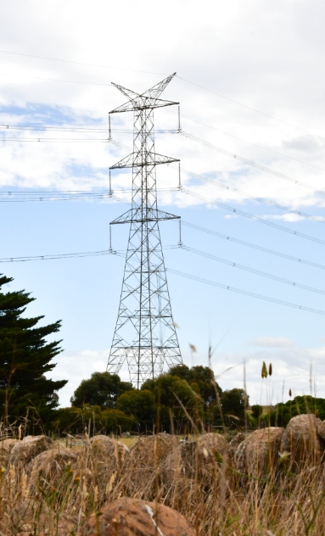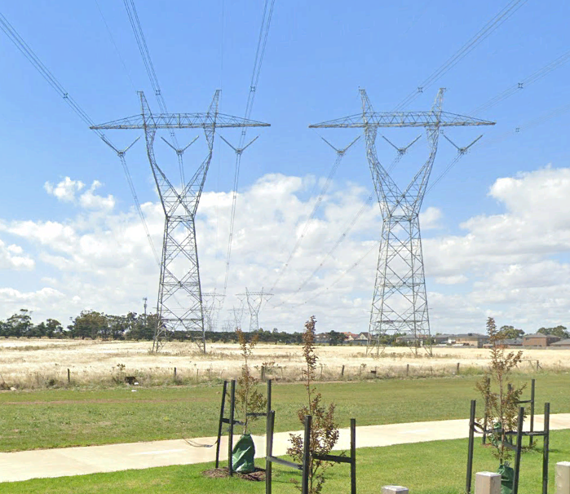
Figure 11.12 500kV double circuit (left); 500kV single circuit (right)
Steel lattice towers are galvanized for protection against corrosion which can have a bright, reflective sheen. This lustre often enhances the obviousness of new structures in views. Whilst galvanised steel will dull naturally over time, reducing the glare and reflectivity of coated surfaces, this can however be accelerated at the coating stage through deglaring. AusNet is including deglaring in its design, to be undertaken during manufacturing of the steel lattice.
Additional design measures were included as potential mitigations in Section 13 of Technical Report D: Landscape and Visual Impact Assessment. AusNet has not adopted these measures into the design of the Project. For example, steel monopoles as opposed to lattice towers are not a feasible option for this Project for reasons detailed by the Project in Chapter 5: Project development. Similarly, while the Project has been proposed as an overhead transmission line, the feasibility of undergrounding as an alternative (including partial undergrounding) was considered to avoid impacts to landscape and visual values. This assessment is provided in Attachment II: Assessment of feasibility for an underground 500kV transmission line for Western Renewables Link.
The visual impacts assessed within this chapter are reflective of the proposed design of the Project, as described in Chapter 6: Project description, and the application of the EPRs described in Section 11.8.

Visual impacts on significant landscape values and landforms
The Project has the potential to impact significant landscape values and landforms. A total of 18 publicly accessible viewpoints of significance were selected from locations identified in the relevant planning schemes as being sensitive or significant areas or vantage points. These viewpoints are shown in Figure 11.13. This included, but was not limited to, areas covered by Significant Landscape Overlays, Heritage Overlays, or Environmental Significance Overlays. Photomontages for a range of the viewing locations assessed are shown in Technical Report D: Landscape and Visual Impact Assessment.
Due to the similarities in views, setting and character, the technical report grouped viewpoints into four regional landscape character areas, as described in Section 11.3.1. The potential impacts to significant landscape values and landforms within each regional landscape character area are described in the following sections, which provide a summary of the technical report findings.

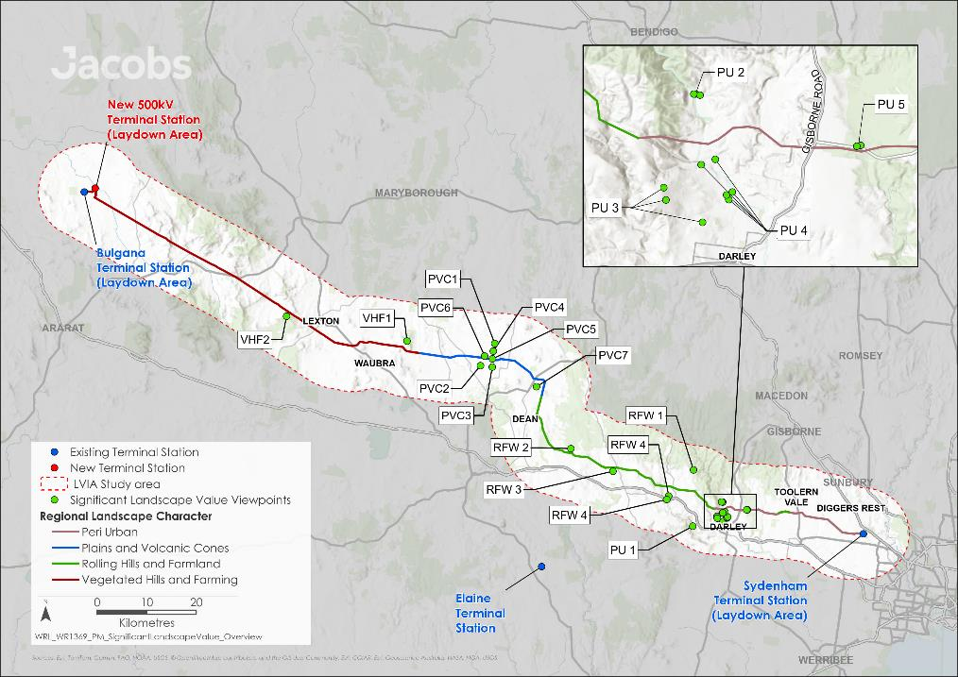
Figure 11.13 Public domain viewpoints - significant landscape values and landforms

Vegetated Hills and Farming
Of the 14 public domain views within the Vegetated Hills and Farming area assessed in the technical report, two viewpoints have potential impacts on significant landscape values and landforms. Prior to any mitigation, visual impacts at these locations are summarised in Table 11.1, and a discussion of the visual impacts from these viewpoints is provided below.
Table 11.1 Summary of significant landscape impacts: Vegetated Hills and Farming
Viewpoint | Distance and direction to Project | Assessed Impact
VHF 1 – Mount Beckworth Scenic Reserve | 1.4km southwest | Moderate - low
VHF 2 – Ben Major Lookout | 950m north | Low – nil
Most of the landscape within this regional landscape character area is cleared farming land, zoned for farming and agricultural purposes, with few overlays that recognise or protect landscape values or features. Sensitive and significant landscapes include the publicly accessible areas of Mount Beckworth Scenic Reserve, and lookouts at Ben Major and Ben Nevis. Although these areas are publicly accessible, they are remote from rural communities and major roads, with challenging terrain limiting access and low viewer numbers. Where visible, the Project would be to the north and parallel to the existing 220kV Horsham to Ballarat transmission line.
Most publicly accessible areas within the Mount Beckworth Scenic Reserve are east facing, where the Project is screened by topography and vegetation. The visual impact from most areas within the reserve would be nil. The view assessed from the western side of the reserve where the Project is visible is considered low-moderate, as the towers will be visible in a modified farming and forestry landscape, but low in view and below a horizon established by rolling hills and by Mount Bolton to the southeast.
Visibility of the Project from most publicly accessible areas within the reserve of the Ben Major Lookout will be low due to screening by nearby topography and vegetation, resulting in a nil visual impact. Towers further to the northwest would be visible, albeit with background elements in views, below a horizon established by rolling hills and modified farming land. In these views the visual impact would be low.
Screening of views from these locations and areas has not been recommended by the technical report for the significant landscape values and landforms within this landscape character area. This is due partly to the level of assessed impact, and partly because screening the Project would also screen views taken in from these locations. In line with the specialist’s recommendations, AusNet is not proposing mitigations at these sites, therefore residual impacts at the assessed viewpoints are anticipated to remain as moderate to nil.
The visual impacts to public viewpoints along major and minor roads and private dwellings located within the Vegetated Hills and Farming regional landscape character area are discussed in Section 11.5.3.1.

Plains and Volcanic Cones
Of the 13 public domain views in the Plains and Volcanic Cones landscape character area assessed in the technical report, seven viewpoints have potential impacts on significant landscape values and landforms. Prior to any mitigation, visual impacts at these locations are summarised in Table 11.2, and a discussion of the visual impacts from these viewpoints is provided below.

Table 11.2 Summary of significant landscape impacts: Plains and Volcanic Cones
Viewpoint | Distance and direction to Project | Assessed Impact
PVC 1 – Buried Rivers of Gold #1 – Daylesford Clunes Road | 3.2km south | Low
PVC 2 – Buried Rivers of Gold #2 – West Berry Road | 1.5km north | Low
PVC 3 – Buried Rivers of Gold #3 - West Berry Road | 1.5km north | Low
PVC 4 – Buried Rivers of Gold #4 – Beaconsfield Road | 1.6km south | Negligible
PVC 5 – Buried Rivers of Gold #5 – Ewen Charlesons Road | 65m south | High
PVC 6 – Buried Rivers of Gold #6– Creswick Lawrence Road | 400m south | High
PVC 7 – Newlyn Reservoir | 1.4km east | Moderate
The Project will be visible from many locations within the regional landscape area due to the long views afforded by open plains, where towers will be added to views that include volcanic cones, and features and landforms associated with the recognised heritage mining landscapes (see Figure 11.10). In most areas, impacts are reduced through the Project’s setback from key roads and tourist routes, townships, parks and reserves, such that the Project will be a background element in views with screening and filtering of views provided by distance, topography and vegetation along roadsides and property boundaries. For these viewpoints, assessed visual impact is low to negligible.
Two viewpoints along the Buried Rivers of Gold tourist drive (Ewen Charlesons Road and Creswick-Lawrence Road) which are understood to be public viewing locations along a tourist route were assessed as being highly visually impacted - whilst Project towers are not expected to reside in front of key features or views, the transmission towers will be highly visible and oblique to primary views. Mitigation measures, such as landscape screening, have not been recommended by the technical specialist. While landscape screening may mitigate visual impacts, any plantings would be located in adjoining private land. Screening would also screen long distance views which would still be visible through the Project’s transmission towers. As such, the visual impact assessment assumed that a high level of residual impact will remain.
Visual impact from Newlyn Reservoir will be moderate, as the towers will be highly visible from an area that permits public access. However, the towers will not obscure views of the water or volcanic cones that visitors and locals enjoy. Landscape screening was considered by the specialist; however, has not been recommended as it would remove views across the Newlyn Reservoir and Mount Bullarook which are enjoyed by locals and their visitors.
The visual impacts to public viewpoints along major and minor roads and private dwellings located within the Plains and Volcanic Cones regional landscape character area are discussed in Section 11.5.3.2.

Rolling Farmland and Water Bodies
Of the 12 public domain views in the Rolling Farmland and Water Bodies landscape character area assessed in the technical report, four viewpoints have potential impacts on significant landscape values and landforms. Prior to any mitigation, visual impacts to these locations are summarised in Table 11.3, and a discussion of the visual impacts from these viewpoints is provided below.
Table 11.3 Summary of significant landscape impacts: Rolling Farmland and Water Bodies
Viewpoint | Distance and direction to Project | Assessed Impact
RFW 1 – Mount Blackwood | 4.2km southwest | Low
RFW 2 – Moorabool Reservoir | 890m south | Low from the car park  Negligible – nil from the reserve
RFW 3 – Bolwarrah Weir | 730m north | High
RFW 4 – Pykes Creek Reservoir | A - 1.9km north  B - 2.6km north | A - Negligible  B - Low
The transmission towers will be visible from public locations such as Bolwarrah Weir, the carpark of the Moorabool Reservoir, the southern end of Pykes Creek Reservoir and the elevated viewing location of Mount Blackwood. The greatest visual impact will be from Bolwarrah Weir, where the siting of Project infrastructure and viewer sensitivity will result in a high level of visual impact prior to any mitigation. Selective landscape screening as detailed in EPR LV1, may assist in screening the Project from the Bolwarrah Weir public entrance and from the existing picnic tables and chairs. However, it is recognised that landscape screening could remove views enjoyed by visitors and therefore may not be desirable. Also, the Project may still be visible from other locations within Bolwarrah Weir. As such, the Project will consult with the relevant landholders or land managers at Bolwarrah Weir to confirm sensitive viewpoints that may be significantly impacted by the Project and determine appropriate measures for mitigating impacts (EPR LV1). At a minimum, the Project will offer of landscape screening to minimise visual impacts from the existing picnic tables and chairs at the Bolwarrah Weir. Any mitigation would be subject to input and agreement with the land manager. As such, the visual impact assessment assumed that a high level of residual impact will remain.
Other than at Bolwarrah Weir, landscape screening has not been considered for the significant landscape values and landforms within this landscape character area as visual impacts at these viewpoints will be low to nil due to the partial screening of the Project (RFW 2, from the reserve, and RFW 4), the Project being a background element in views (RFW 1), or views of the Project being situated in areas of lower sensitivity (RFW2 from the car park).
The visual impacts to public viewpoints along major and minor roads and private dwellings located within the Rolling Farmland and Water Bodies regional landscape character area are discussed in Section 11.5.3.3.

Peri-urban and Townships
Of the 34 public domain views within the Peri-urban and Townships landscape character area assessed in the technical report, five public domain viewpoints have potential impacts on significant landscape values and landforms. Prior to any mitigation, visual impacts to these locations are summarised in Table 11.4, and a discussion of the visual impacts from these viewpoints is provided below.

Table 11.4 Summary of significant landscape impacts: Peri-urban and Townships
Viewpoint | Distance and direction to Project | Assessed Impact
PU 1 – Werribee Gorge | 5.0km northeast | Negligible
PU 2 – Lerderderg Gorge and State Park | A - 1.5km south  B - 1.5km south  C - 1.4km southeast | A - Nil  B - Nil  C - Negligible
PU 3 – Bald Hill | A - 1.5km northeast  B - 2.4km north  C - 1.9km north | A - Negligible (existing setting)  - High (sculpture trail)  - Negligible – nil (other locations)  B - Low – negligible  C - Negligible
PU 4 – Lerderderg Nature Trail | A - 1.8km northwest  B - 1.6km northwest  C - 1.6km northwest  D - 525m northwest  E - 500m north | A - Low  B - Low  C - Negligible – nil  D - Negligible – nil  E - Low
PU 5 – Merrimu Reservoir | A - 185m south (Merrimu Reservoir)  B - 140m south (Merrimu War Memorial) | A - High, reducing to moderate with mitigation  B - High – moderate
Views from Lerderderg State Park to the north of Darley, Mackenzies Flat Picnic Area, Lerderderg Gorge and Werribee Gorge will be screened by existing vegetation and topography, which will reduce the visibility of the Project’s infrastructure. Views from many locations along the proposed Lerderderg Nature Trail will also be partially screened or filtered by existing topography and vegetation. As such, the Project’s visual impact in these areas will be low to negligible.
The Project will be visible from locations associated with Stage 1 of the Bald Hill Activation Area, including the proposed entrance and locations along the northern sculpture trail. In the current setting, visual impacts along the northern edge of Bald Hill are negligible. However, the sculpture trail and other features shown in the Bald Hill Activation Plan are currently under construction. Views from some viewing areas and lookouts within the Bald Hill Activation Plan face to the south and are oriented away, or oblique to the Project resulting in low to negligible visual impacts. In comparison, the visual impact from northern areas and nodes along the sculpture trail will be high. To reduce the visibility of the Project from these locations, the Project will offer landscape screening (as a minimum) from the six sculpture locations and entrance from Swans Road. However, it is recognised that the implementation of landscape screening would alter the northerly panoramic views available from Bald Hill. The Project will consult with the relevant landholders or land managers within the Bald Hill Activation Area to confirm sensitive viewpoints that may be significantly impacted by the Project and determine appropriate measures for mitigating impacts as detailed in EPR LV1. The visual impact assessment assumed that a high level of residual impact will remain.
Visual impacts are also anticipated to be high at the existing picnic facilities and visitor areas associated with Merrimu Reservoir (see Figure 11.14 and Figure 11.15) and high to moderate at the Merrimu War Memorial, due to the viewer sensitivity and orientation toward the Project of these areas. As with the Bald Hill Activation Area, the Project will engage with the relevant landholders and land managers to confirm sensitive viewpoints and determine the appropriate mitigation measures as detailed in EPR LV1. At this location AusNet will offer the following mitigations (at a minimum) to reduce the visual impacts of the Project: development of new public amenities at a suitable location that are oriented away from the Project, reconfiguration or redesign of the Merrimu Reservoir War Memorial, and implementation of landscape screening. It is anticipated that mitigation would reduce visual impacts at the Merrimu Reservoir and Merrimu War Memorial to moderate. Any mitigation would be subject to input and agreement with the land manager.
Within the Peri-urban and Townships regional landscape character area, consideration has been given to mitigation measures which might reduce landscape and visual impacts to significant landscapes. However, as discussed above, mitigations such as screening may not be effective in certain circumstances where the Project is too close to effectively screen or screening would block desirable views. In other locations such as Merrimu Reservoir, mitigation is considered to be effective, and options for reconfiguration of facilities and landscape screening is anticipated to reduce residual impacts from high to moderate. All other viewpoints will have a visual impact ranging from low to nil.
The visual impacts to public viewpoints along major and minor roads and private dwellings located within the Peri-urban and Townships regional landscape character area are discussed in Section 11.5.3.4.

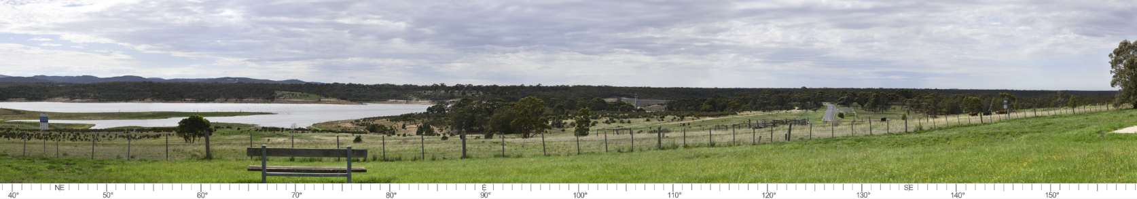
Figure 11.14 Existing conditions at Merrimu Reservoir (Viewpoint PU5)
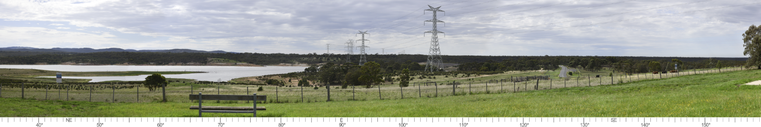
Figure 11.15 Photomontage showing proposed tower locations crossing Merrimu Reservoir (at a distance of approximately 185m) (Viewpoint PU5)

Visual impacts for landholders, residents, and community
The Project will have visual impacts for landholders, residents, and the community, as the transmission towers and transmission line will be visible from public areas including townships, highways, local roads and nearby dwellings. In addition to the public viewpoints discussed in Section 11.5.2 (that relate to significant landscape values and landforms), a further 54 public viewpoints were assessed as being representative of a range of viewing angles, distances and landscape character types within the study area, from locations familiar to the local community. These viewpoints are shown in Figure 11.16 and Figure 11.17 (for townships specifically).
In addition to assessment in the public domain, the technical report considered visual impacts from the private domain. The greatest potential for high visual impacts from the Project is from nearby residential dwellings, as residents may be able to see the Project from their dwelling and will regularly see the Project infrastructure as they move about their local area. The assessment of visual impacts from residences is based upon visibility of the Project features, distance from the Project, the location from which the view is afforded, and the context or sensitivity of the landscape in the view toward the Project.
Representative residential dwellings were identified that had potential unfiltered views to the Project and were within a 2km radius of the Project – the distance at which the towers have the potential to be highly visible and dominate the landscape. This 2km distance to the Project is also consistent with the viewing range within which wind farms and other infrastructure projects in Victoria have been required to provide landscape screening to residential dwellings in rural areas. Representative dwellings were selected where:
- The setting and orientation of views or the influence of vegetation were not obvious through desktop reviews or views from the roadside
- Dwellings were representative of views from a cluster of dwellings
- Dwellings appeared to have a similar landscape setting, elevation, or outlook to other nearby dwellings
- Residents requested a visual assessment to be undertaken.
There are approximately 7,140 dwellings within 2km of the Project and approximately 1,340 dwellings within 1km of the Project. Most dwellings (approximately 74 per cent) are in the urban areas of Darley, Melton and Hillside. The remaining dwellings are in rural areas in the Farming Zone or Green Wedge Zones. The location of all dwellings within 2km of the Proposed Route are shown in Figure 11.17 and Figure 11.18.
In total, 57 landholders granted access to their residences for the purpose of conducting visual impact assessments. The locations of these dwellings are shown in Figure 11.17 and Figure 11.18.
The assessments for each dwelling are presented in Section 12 of Technical Report D: Landscape and Visual Impact Assessment. The following sections provide a summary of the findings.

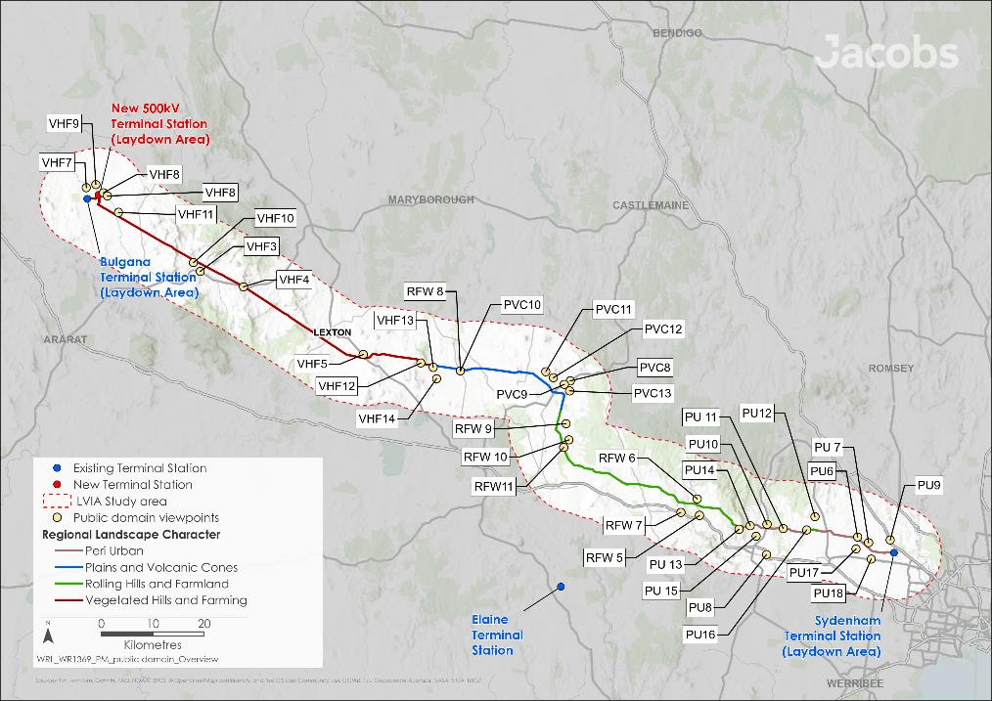
Figure 11.16 Public domain viewpoints - landholders, residents, and community

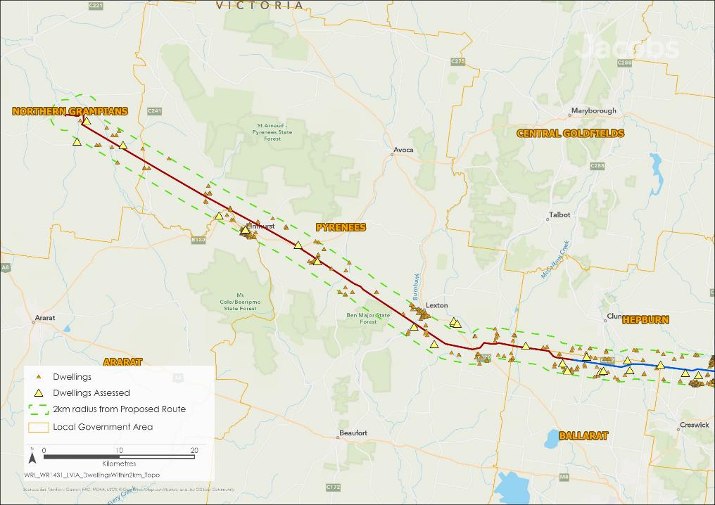
Figure 11.17 Dwellings within 2km of the Proposed Route (Map 1 of 2)
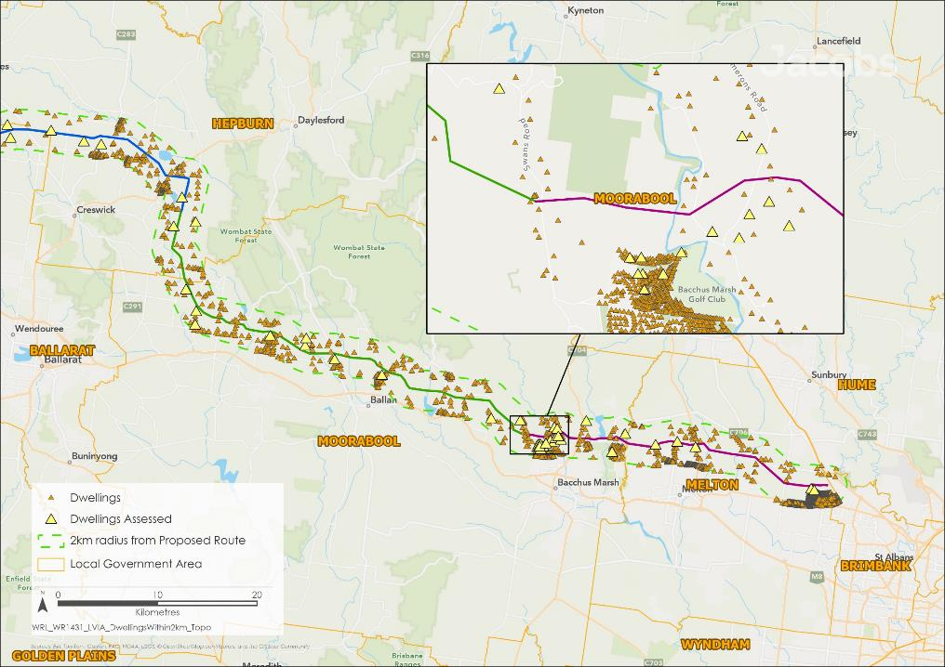
Figure 11.18 Dwellings within 2km of the Proposed Route (Map 2 of 2)

When assessing visual impacts in the private domain, the assessment criteria differ from those used for the public domain. When assessing visual impacts in the private domain, the number of viewers is irrelevant for residential visual impacts, and the viewer sensitivity is always considered ‘high’. Additionally, it is recognised that landholders in farming areas may also be impacted as they work on their properties and in areas that separate from their primary dwellings, in line with accepted methodology and precedent. However, the assessment of visual impacts for residents and landholders considered only the views from the primary dwelling.

Vegetated Hills and Farming

Public domain impacts
Of the 14 public domain views within the Vegetated Hills and Farming area assessed in the technical report, 12 public viewpoints have potential impacts for the local community and key users. Prior to any mitigation, visual impacts to these locations are summarised in Table 11.5, and a discussion of the visual impacts from these viewpoints is provided below.
Table 11.5 Summary of visual impacts from public viewpoints: Vegetated Hills and Farming
Viewpoint | Distance and direction to Project | Assessed Impact
VHF 3 – Pyrenees Highway #1 | 1.3km northeast | Low
VHF 4 – Pyrenees Highway #2 | 40m northeast | Low
VHF 5 – Sunraysia Highway | 1.4km southwest | Low
VHF 6 – Joel Joel Hall | 850m southwest | Negligible
VHF 7 – Landsborough Road | 1.8km south | Low
VHF 8 – Joel Joel Road | 685m south | Low
VHF 9 – Joel Joel War Monument | 1.9km south | Low
VHF 10 – Lexton-Ararat Road | 550m southwest | Low
VHF 11 – Landsborough-Elmhurst Road | 450m northeast | Low
VHF 12 – Coghills Creek Road | 65m southwest | Moderate
VHF 13 – Fentons Road | 375m north | Low
VHF 14 – Corner Coghills Creek Road and Glendonald Road | 2.4km north | Low
From local roads, such as Landsborough-Elmhurst Road (see Figure 11.19 and Figure 11.20) and Fentons Road, the Project’s structures will be highly visible and in relative proximity. Whilst visibility from these local roads will be open and largely unfiltered, views of the Project will occur in transit and be short in duration, and viewer numbers will be low. This is because no roads impacted visually by the Project are designated tourist routes and none include roadside stops, pullout bays or formal viewing locations. Views of the Project will be located in landscapes of a low sensitivity, having been highly modified through farming activities, and the number of viewers will be limited due to the low number of road users in this area and existing vegetation screening along roadsides and neighbouring properties. As a result, the overall visual impact from these roads was assessed as low.
When viewed over a distance, the Project features will either be a background element in views or will be partially filtered by vegetation or screened by intervening topography and vegetation. From these areas, intervening topography and vegetation results in a negligible impact where views of the Project are filtered or partially screened, and nil where completely screened.

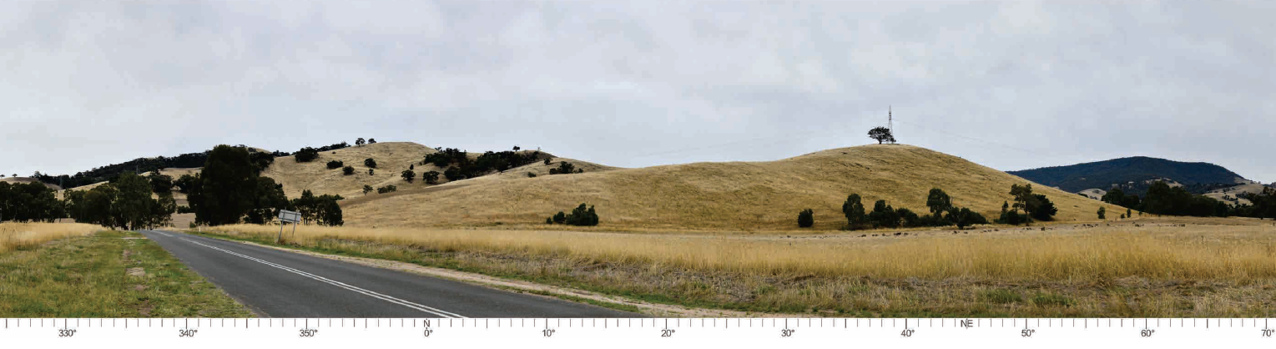Figure 11.19 Existing view on Landsborough-Elmhurst Road, looking northeast towards the Project (at a distance of approximately 450m) (Viewpoint VHF11)
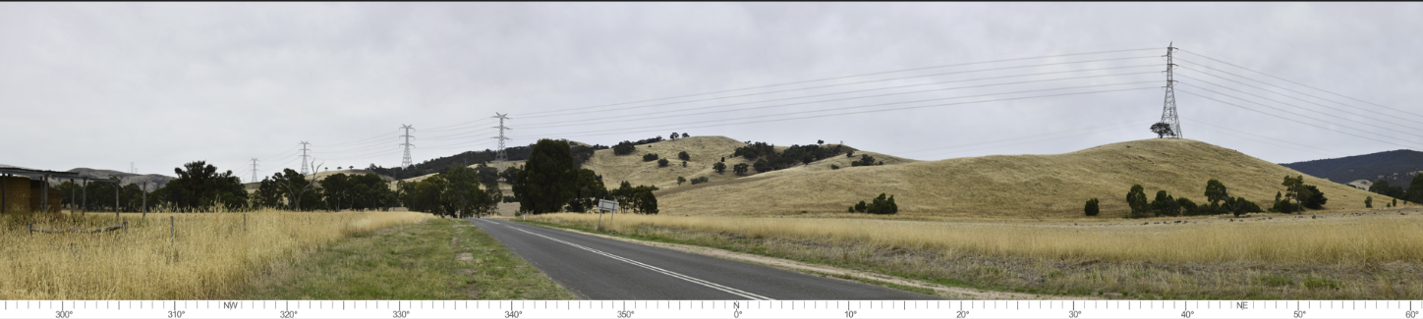
Figure 11.20 Photomontage from Landsborough-Elmhurst Road, looking northeast towards the Project (at a distance of approximately 450m) (Viewpoint VHF11)

Viewpoints to significant landscape values and landforms, such as areas covered by Significant Landscape Overlays, within the Vegetated Hills and Farming regional landscape character area are discussed in 11.5.2.1. For the remaining public viewpoints within this regional character area (as listed in Table 11.5) the technical report has not recommended landscape screening as a mitigation measure. This is due to the moderate to negligible level of assessed impact, determined as a result of generally low viewer numbers, low duration of views, views of the Project situated within modified landscapes, or screening of Project views. In line with the specialist’s recommendations, the Project is not proposing mitigations at these sites, therefore residual impacts are anticipated to remain as moderate to negligible.

Private domain impacts
Within the Vegetated Hills and Farming character area, approximately 240 dwellings are within 2km of the Project. Approximately 70 of these dwellings are within 1.0km of the Project (the distance at which the Project’s 80m high transmission towers will always be visually dominant in the landscape). Access was granted to 13 properties to assess the visual impact from dwellings, varying in distance from 160m to 2km from the Project. Of the 13 dwellings assessed within this character area, most dwellings have existing vegetation that would partially screen or filter views in the direction of the Project or allow for landscape screening to be implemented as detailed in EPR LV2 to mitigate the visual impact of the Project by filtering some views. This is supported by desktop review and observations from roadsides and those dwellings where access was granted. The levels of assessed impacts from dwellings where access was permitted ranged from high to nil. The higher impacts were from locations where dwellings are close to the Project and elevated. At these locations landscape screening may be effective but may also screen views that are desirable to the landowner. Landscape screening may not be possible at some dwellings where there may be limited space to accommodate plantings.
The visual impacts of the new 500kV terminal station near Bulgana have been avoided so far as reasonably practicable by locating the facility in cleared farming land, away from regional centres, communities, and significant public vantage points. The closest dwelling is located approximately 1.4km to the south. At this distance, visual impacts will be high; however, the implementation of landscape screening has been recommended as proposed by EPR LV2 to screen features of the proposed terminal station. If desired by the land title holder, this would reduce the visual impacts for this dwelling to low.
Through the implementation of landscape screening to filter or screen views of the Project, visual impacts at the assessed private viewpoints are anticipated to reduce to low or nil for most dwellings.

Plains and Volcanic Cones

Public domain impacts
Of the 13 public domain views in the Plains and Volcanic Cones landscape character area assessed in the technical report, six public viewpoints have potential impacts for the local community and key users. Prior to any mitigation, visual impacts to these locations are summarised in Table 11.6, and a discussion of the visual impacts from these viewpoints is provided below.
Table 11.6 Summary of visual impacts from public viewpoints: Plains and Volcanic Cones
Viewpoint | Distance and direction to Project | Assessed Impact
PVC 8 – Midland Highway #1 | 2.7km southwest | Low
PVC 9 – Midland Highway #2 | 1.7km south | Low
PVC 10 – Ballarat-Maryborough Road | 260m northeast | Low
PVC 11 – Werona-Kingston Road | 1.8km southwest | Low
PVC 12 – Daylesford Clunes Road | 1.7km southwest | Low
PVC 13 – Blampied-Mollongghip Road #1 | 1.1km southwest | Low
A low level of visual impact is anticipated for all of the locations assessed within this area, due to the Project being set back from key roads and tourist routes, townships, parks and reserves. As such, the Project will be a background element in views with screening and filtering of views provided by distance, topography and vegetation along roadsides and property boundaries. For these reasons, landscape screening has not been recommended by the technical report for the public viewpoints identified in Table 11.6, within this landscape character area. In line with the specialist’s recommendations, the Project is not proposing mitigations at these sites, therefore, residual impacts are anticipated to remain as low.
Viewpoints to significant landscape values and landforms, such as areas covered by Significant Landscape Overlays, within the Plains and Volcanic Cones regional landscape character area are discussed in 11.5.2.2.

Private domain impacts
Within the Plains and Volcanic Cones character area, approximately 350 dwellings have been identified within 2km of the Project. Approximately 80 dwellings are within 1.0km of the Project (the distance at which the 80m high transmission towers will always be visually dominant in the landscape). For the visual assessment, access was granted to seven dwellings varying in distance from 250m to 970m from the Project.
The levels of assessed impacts from the seven dwellings where access was permitted ranged from high to low. Of these seven dwellings, the impact prior to mitigation was high or moderate for five dwellings, and low for two dwellings where existing vegetation would partially screen or filter views in the direction of the Project. One example of an unmitigated high visual impact is a dwelling on Andersons Road (Ballarat LGA) (see Figure 11.21 and Figure 11.22).
Where the Project is visible from inside of the dwelling, or external areas of private open space, landowners would be offered funding for landscape screening to reduce the visual impact of the Project by filtering or screening some views of the Project as detailed in EPR LV2. For six of the seven dwellings assessed, the option to plant landscape screening would reduce the visual impacts to low or nil. The view from the dwelling on Andersons Road (Ballarat LGA) (Figure 11.22) is one such example where the potential for landscape screening would reduce the visual impact from high to low, however it is acknowledged that at this location landscape screening may screen existing landscape views which are favoured.
One dwelling located on R Charlesons Road is the exception, as landscape screening is unlikely to achieve heights to adequately filter views of the Project towers.

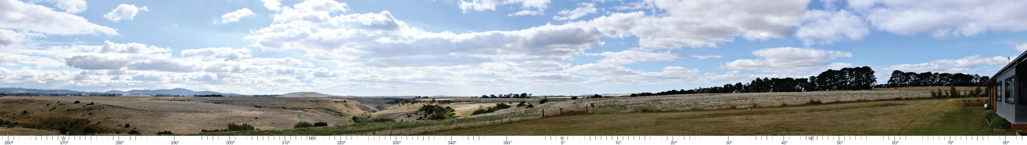
Figure 11.21 Existing view from assessed dwelling along Andersons Road (view looking northwest)
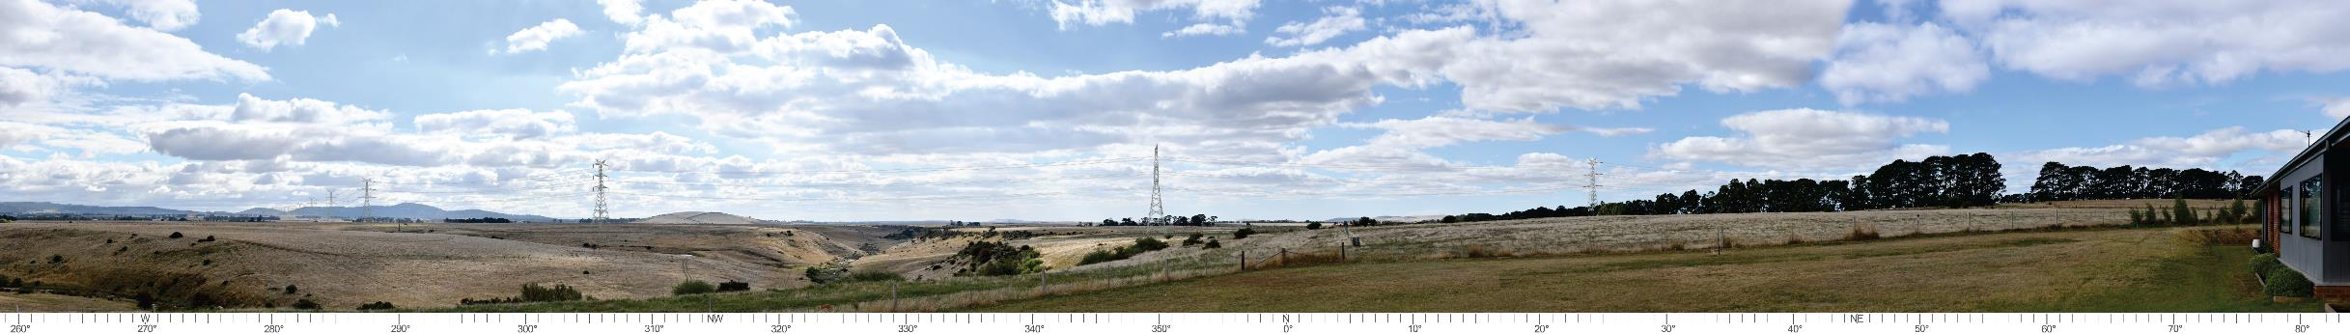
Figure 11.22 Photomontage from assessed dwelling along Andersons Road with a visual impact of high (view looking northwest)

Rolling Farmland and Water Bodies

Public domain impacts
Of the 12 public domain views in the Rolling Farmland and Water Bodies landscape character area assessed in the technical report, seven public domain views have potential impacts on the local community and key users. Prior to any mitigation, visual impacts to these locations are summarised in Table 11.7, and a discussion of the visual impacts from these viewpoints is provided below.
Table 11.7 Summary of visual impacts from public viewpoints: Rolling Farmland and Water Bodies
Viewpoint | Distance and direction to Project | Assessed Impact
RFW 5 – Greendale – Myrniong Road #1 | 1.7km north | Negligible
RFW 6 – Greendale – Myrniong Road #2 | 1.0km south | Low
RFW 7 – Western Freeway #1 | 1.9km north | Low
RFW 8 – Corner Railway Road and Dean-Newlyn Road | 1.4km east | Low
RFW 9 – Blampied-Mollongghip Road #2 | 1.6km west | Low
RFW 10 – Dean-Mollongghip Road | 1.5km west | Negligible – nil
RFW 11 – Springbank Road | 1.6km northeast | Low
From most locations assessed within the Rolling Farmland and Water Bodies character area, the Project will be a background element to views from local roads with few viewers or with low landscape sensitivity. Views from the Western Freeway will either be screened by topography, filtered by existing vegetation or at such a distance that the effect of seeing the transmission towers would not be greater than low.
Views from Railway Road and Blampied-Mollongghip Road include areas that are recognised by schedules to the Significant Landscape Overlay or Environmental Significance Overlay, where the protections are for view or landscape character. However, most public areas in proximity to such features are limited to local roads with few road users, where there are no roadside stops, pullout bays or lookouts identified where people would stop to take in views. As such, views would be short in duration and the level of visual impact is anticipated to be low.
For these reasons, landscape screening has not been recommended by the technical report for the public viewpoints within this landscape character area identified in Table 11.7. In line with the specialist’s recommendations, the Project is not proposing mitigations at these sites, therefore, residual impacts are anticipated to remain as low.
Viewpoints to significant landscape values and landforms, such as areas covered by Significant Landscape Overlays, within the Rolling Hills and Water Bodies regional landscape character area are discussed in 11.5.2.3.

Private domain impacts
Within the Rolling Farmland and Water Bodies regional landscape character area, approximately 410 dwellings have been identified within 2km of the Project. Approximately 160 dwellings are within 1.0km of the Project (the distance at which the Project’s 80m high transmission towers will always be visually dominant in the landscape). For the visual assessment, access was granted to 14 dwellings varying in distance from 275m to 880m to the Project.
Visual impacts at five dwellings in this regional landscape character area were assessed as high, due to the Project being situated in elevated and open views from the dwellings, or the close proximity of the Project to the dwellings. Mitigation through landscape screening (as outlined in EPR LV2) would reduce impacts at three dwellings to low or negligible. For one dwelling assessed (Swans Road within Moorabool Shire Council) with an initial rating of high, factors such as the elevation of the dwelling above ground level and topography which slopes away from the dwelling in the direction of the Project would mean that landscape mitigation would not be effective (the existing view and photomontage showing the Proposed Route is provided in Figure 11.23 and Figure 11.24 respectively), therefore the residual impact would remain high. A second dwelling (Black Swamp Road within Moorabool Shire Council) also with an initial rating of high would not benefit by landscape screening and the residual impact would remain high.
The levels of assessed impacts from the remaining nine dwellings ranged from moderate to negligible, with mitigation through landscape screening (as detailed in EPR LV2) ‒ to filter or screen some views of the Project ‒ reducing impacts at three dwellings to negligible or nil.

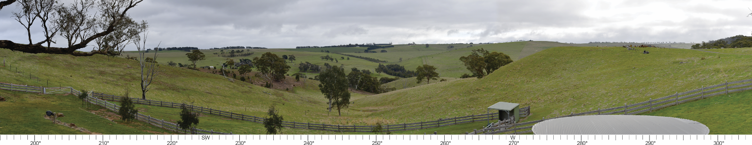
Figure 11.23 Existing view from assessed dwelling along Swans Road (looking southwest through northwest)
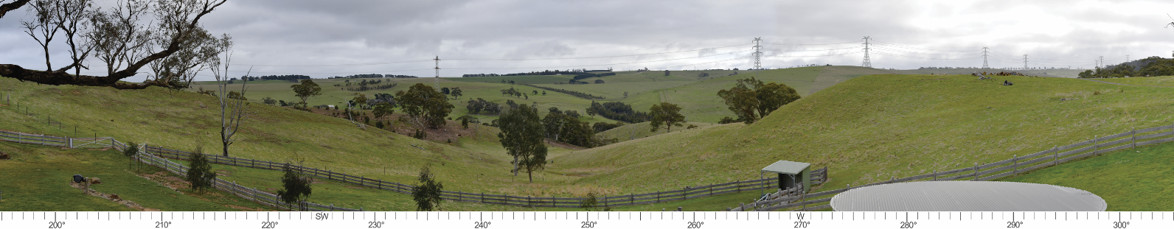
Figure 11.24 Photomontage from assessed dwelling along Swans Road, with a visual impact rating of high

Peri-Urban and Townships

Public domain impacts
Of the 34 public domain views within the Peri-urban and Townships landscape character area assessed in the technical report, 29 public viewpoints have potential impacts for the local community and key users. Prior to any mitigation, visual impacts to these locations are summarised in Table 11.8 (for peri-urban viewpoints) and Table 11.9 (for townships), and a discussion of the visual impacts from these viewpoints is provided below.
Table 11.8 Summary of visual impacts from public viewpoints: Peri-urban
Viewpoint | Distance and direction to the Project | Assessed Impact
PU 6 – Holden / Leakes Road | 200m south | High
PU 7 – Holden Road | 785m southwest | Moderate
PU 8 – Western Freeway #2 | 5.0km north | Negligible
PU 9 – Calder Freeway | 2.4km south | Negligible – nil
PU 10 – Gisborne Road | 770m south | Low
PU 11 – Diggers Rest – Coimadai Road #1 | 75m north | Low
PU 12 – Diggers Rest – Coimadai Road #2 | 2.5km southwest | Negligible
PU 13 – Swans Road | 520m northeast | Moderate – low
PU 14 – Lerderderg Gorge Road #1 | 260m southeast | Moderate – low
PU 15 – Lerderderg Gorge Road #2 | 1.8km northeast | Low
PU 16 – Bulmans Road | 215m southeast | Low
PU 17 – Leakes Road | 2.9km northeast | Low
PU 18 – Plumpton Road | 1.5km north | Low
There are many locations along the local road network where Project features will be viewed in front of Mount Kororoit Volcanic Cone, which is recognised by a Significant Landscape Overlay in the Melton Planning Scheme. In views from the south of Mount Kororoit, the Project will be situated in the background of views or behind the volcanic cone. This includes views from Holden Road, where visual impacts were assessed as high to moderate (Figure 11.26). At Holden / Leakes Road where the visual impact will be high, the design has sought to minimise impacts as much as possible - partly through structure placement and partly through the inclusion of double circuit towers. The latter reduces the number of towers that will be visible and elevates transmission lines to a height where they would not directly impede views of Mount Kororoit. The technical report makes no further recommendation for mitigation at this location and therefore the residual impact will remain high.
In longer views, the proposed 80m high towers will be a small element in views such that they will not alter the perception or prominence of recognised landscape features. Many views from distant locations are through existing transmission lines located along road reserves and properties. At such locations, these features are more apparent than the Project’s towers.

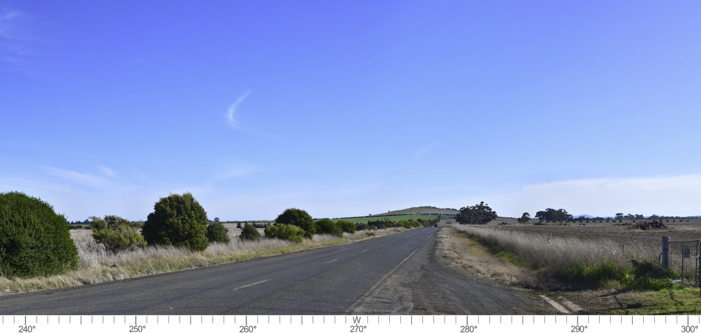
Figure 11.25 Existing view on Holden Road, looking west towards the Project (at a distance of approximately 785m) (Viewpoint PU7)
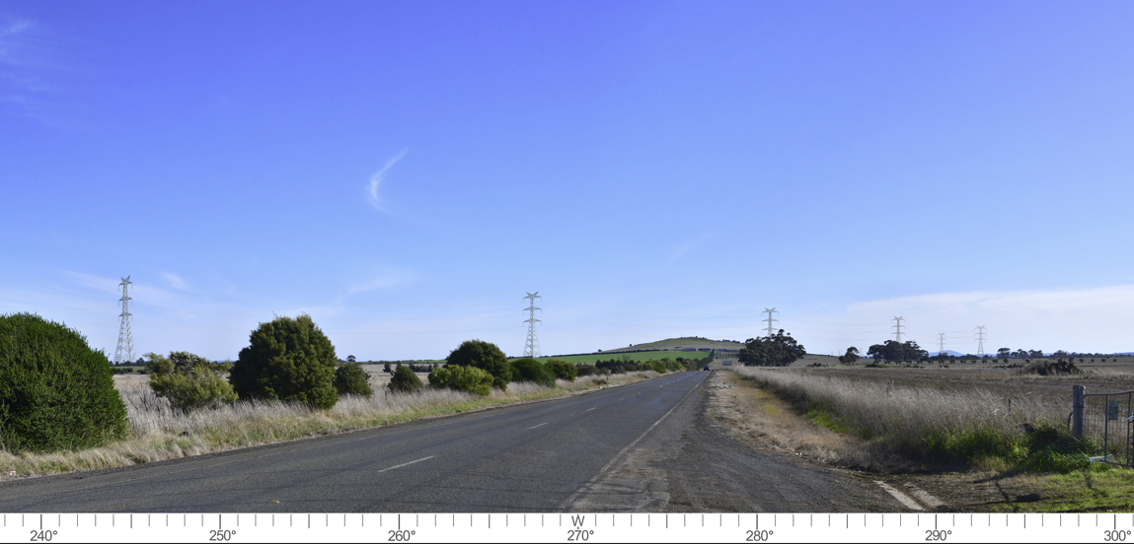
Figure 11.26 Photomontage of Holden Road, looking west towards the Project (at a distance of approximately 785m) (Viewpoint PU7)
Within the study area 16 townships were identified and viewing locations selected to consider the potential visual impact for nearby residents and communities. Multiple viewpoints were selected in larger townships such as Darley, Melton and Hillside to consider the range of views and impacts on these communities. This gave a total of 32 viewpoints across the townships, as shown in Figure 11.27
For each township, viewpoints were selected from locations that demonstrated the character and setting of the town – such as vegetation, buildings and topography – or from key areas within the town such as the town centre, sports fields, key roads or elevated locations where there may be views in the direction of the Project. However, it is recognised that there may be other locations within the townships where the Project may be visible. From most areas, it was observed that the Project will be in the background of views or not visible. The visual impacts from all township viewpoints are presented in Table 11.9.
Table 11.9 Summary of visual impacts from public viewpoints: Townships
Township | Viewpoint | Distance and direction to the Project | Assessed Impact
T1 – Elmhurst | Township center | 1.4km northeast | Negligible – nil
T2 – Amphitheatre | Amphitheatre Recreation Reserve | 5.0km southwest | Nil
T3 – Lexton | Toll Bar Park (A) | 2.2km southwest | Nil
 | Lexton Recreation Reserve (B) | 1.2km southwest | Negligible
T4 – Waubra | Township entrance (A) | 4.2km north | Negligible
 | Waubra Wind Farm Information Centre (B) | 3.6km north | Negligible
 | Waubra Recreation Reserve (C) | 4.0km north | Negligible
T5 – Creswick | Township center | 7.9km north | Nil
T6 – Allendale | Intersection of Creswick-Newstead Road and West Barry Road | 1.6km northwest | Negligible – nil
T7 – Smeaton | Intersection of Creswick-Newstead Road and Daylesford-Clunes Road (A) | 2.6km south | Negligible – nil
 | Intersection of Creswick-Newstead Road and Elizabeth Street (B) | 1.3km south | Negligible – nil
T8 – Kingston | Church Parade | 1.4km northeast | Nil from within the township  Moderate – low along the northern edges of the township
T9 – Newlyn | Midland Highway | 720m north | Negligible – nil from within the township  Moderate along the northern edges of the township
T10 – Ballan | Township center (A) | 4.0km northeast | Negligible – nil
 | West Ballan residences (B) | 4.2km northeast | Negligible – nil
 | Connor Court (C) | 870m northeast | High – negligible
T11 – Myrniong | Myrniong Recreation Reserve (A) | 2.6km northeast | Low
 | Muddy Lane (B) | 2.9km northeast | Low – nil
T12 – Darley | Benson Valley Road (A) | 2.2km northwest | Low
 | Links Road (B) | 1.5km north | Low
 | Bacchus Marsh Golf Club (C) | 1.0km north | Moderate
 | Bacchus Marsh Golf Course (D) | 700m north | Moderate
T13 – Melton | Big Park Sports Field (A) | 2.4km northeast | Negligible
 | Intersection of Minns Road and Black Knight Way (B) | 1.8km north | Low
 | Intersection of Minns Road and Bulmans Road (C) | 1.3km northwest | Low
 | Harkness Road (D) | 2.6km north | Low
 | MacPherson Park (E) | 235m northeast | Moderate – low
T14 – Toolern Vale | Intersection of Diggers Rest – Coimadai Road and Gisborne Melton Road | 3.0km southwest | Low
T15 – Diggers Rest | Old Calder Highway (A) | 4.9km southwest | Nil
 | Intersection of Diggers Rest – Coimadai Road and Plumpton Road (B) | 4.0km southwest | Low
T16 – Hillside | Hillside Linear Reserve (A) | 600m north | Low – nil
 | Reserve north of Viridian Drive (B) | 650m north | Low – nil

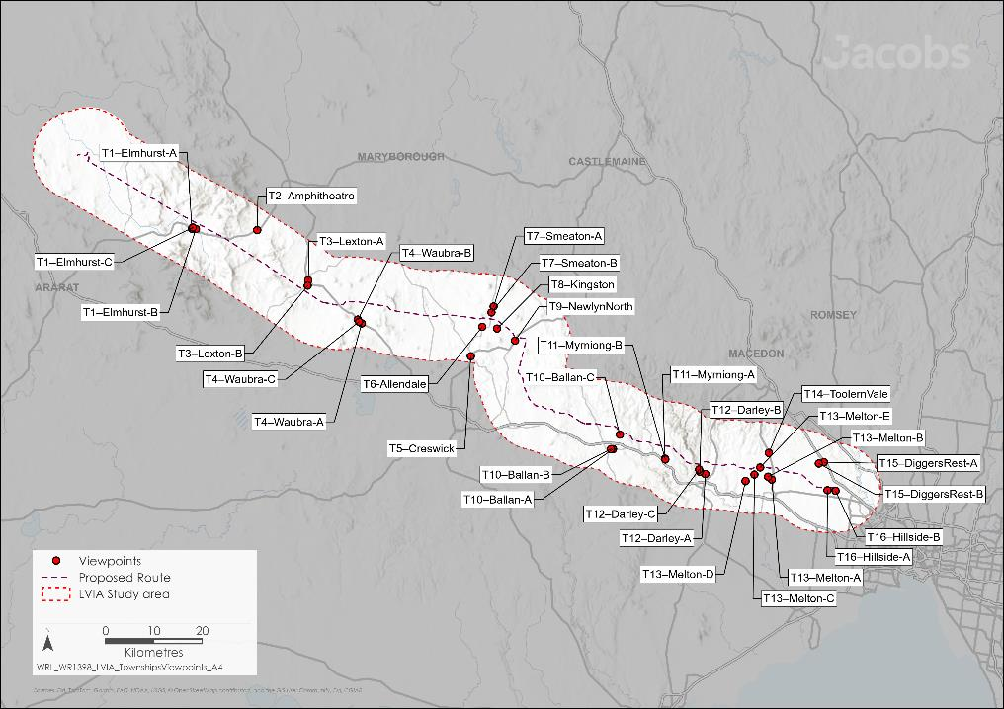
Figure 11.27 Township viewpoints

As shown in Table 11.9, the overall visual impact from most areas within townships was assessed as low to nil. Views of the surrounding landscape from most township areas are either partially screened or filtered by neighbouring dwellings, vegetation and other urban elements. The Project would be a background element in views through these features, if visible. This is evident in views from residential areas in topographically flatter areas such as Melton, Toolern Vale, Diggers Rest and Hillside where features such as neighbouring dwellings, fencing and landscaping screen views to the surrounding area and in the direction of the Project.
One viewpoint to the north of Ballan (Viewpoint T10C – Connor Court Ballan) has been assessed as having high – negligible visual impacts from the Project as shown in Table 11.9. This viewpoint is located alongside a cluster of dwellings in the Rural Living Zone, approximately 870m south of the Project. In some locations distance and existing vegetation will assist in screening or filtering views of the transmission towers. However, to the northern end of Connor Court one or more towers would be visible and dominant elements in views.
Visual impacts on the northern edges of Newlyn will be moderate, recognising that the towers will be dominant elements in the views. However, due to the distance and spacing of transmission towers, their presence in views would not reduce the prominence of the volcanic cones in the rural landscape.
From the township of Darley, there are some viewpoints where the Project is visible, and the visual impact was assessed as moderate or low. The assessment of moderate at some viewpoints is partly due to the visibility of views in the direction of the Project, the distance to the Project and sensitivity of viewers.
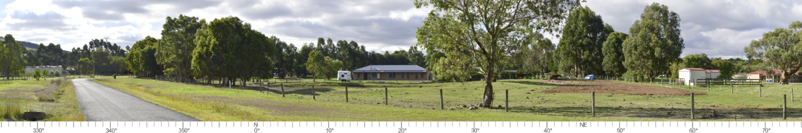Figure 11.28 Photomontage of the view looking north from the northern end of Connor Court towards the Project (Viewpoint T10: C).
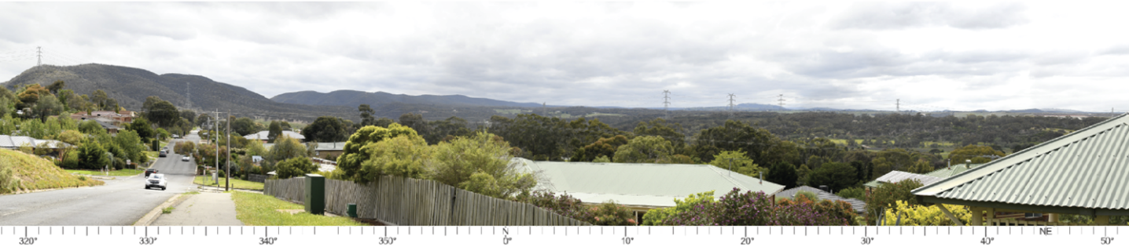Figure 11.29 Photomontage of view from Links Road, Darley, looking northeast towards the Project (at a distance of approximately 1.5km) (Viewpoint T12: B)
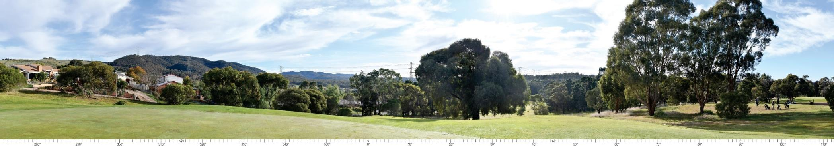Figure 11.30 Photomontage of view from Bacchus Marsh Golf Club 10th Green towards the Project (at a distance of approximately 650m) (Viewpoint T12: D)
Similarly, moderate to low visual impacts will also occur at MacPherson Park, a regional-scale sporting facility north of Melton and south of the Melton Aerodrome. In this location, single circuit towers are required to enable aviation activities to continue at Melton Aerodrome, as discussed in Chapter 16: Aviation, which will range in height between approximately 34 and 37m. Although Project’s transmission towers will be visible, they will be partially filtered by existing vegetation within the reserve or be a background element to views that are focused on sports fields. Upgrades proposed to MacPhersons Park through the 2017 Future Directions Master Paper, including relocating the park entrance and additional landscaping, will further assist in screening views in the direction of the Project and create separation between visitors and the Project.
The Merrimu Precinct Structure Plan (PSP) is a future housing development located to the east of Darley and Gisborne Road. As such, there will be views of the Project from future residential areas. However, these will be limited to the northernmost areas of the Merrimu PSP. In these areas, there is the potential for towers to be highly visible and dominant in views. Public views will be screened by neighbouring dwellings, built form, and vegetation established along roadsides, open space areas and in private allotments. Based on the level of visual impact within the township, the technical report has not considered landscape screening as a mitigation measure, and as such, the level of impact will remain as assessed. It is recognised that although the towers may be visible from certain viewpoints along the outskirts of townships, they will not reduce the prominence of desirable views (such as volcanic cones) when viewed across the cleared farmland and rural landscaped.
Viewpoints to significant landscape values and landforms, such as areas covered by Significant Landscape Overlays, within the Peri-urban and Townships regional landscape character area are discussed in 11.5.2.4.

Private domain impacts
Within the Peri-urban and Townships regional landscape character area, approximately 6,140 dwellings are within 2km of the Project. Most dwellings along this section are in townships and developed areas of Darley, Melton, Diggers Rest, Hillside and Toolern Vale. Approximately 1,340 of these dwellings are within 1.0km of the Project (the distance at which the Project’s 80m high transmission towers will always be visually dominant in the landscape). For the technical report, access was granted to 23 dwellings varying in distance from 170m to 1.8km from the Project.
Of the 23 dwellings visited, 12 were assessed to have a high visual impact prior to mitigation. This was due to higher viewer sensitivity, the close proximity of the dwelling to the Project or the elevation of the dwellings providing expansive views across the landscape in the direction of the Project.
The majority of impacted dwellings are located in the developed areas of Darley, Melton and Hillside. However, most dwellings in Melton, Hillside and east of Links Road in Darley are in low-lying areas where views in the direction of the Project will be filtered by neighbouring dwellings, fencing and vegetation.
The greatest visual impact will be from dwellings on north facing slopes in Darley, generally to the west of Links Road. These areas are elevated, permitting views towards the Project and many dwellings have been established to take in views of the vegetated hills within the Lerderderg State Park to the north. The greatest number of dwellings likely to experience a high level of visual impact are the 27 dwellings located along the northern side of Pamela Court and Augusta Place and three at the northern end of St Andrews Way. Of these dwellings, three were assessed along this location. The likelihood of a high level of visual impact from all dwellings along this edge is conservative as not all dwellings have been assessed. The visual impact from dwellings along this edge may vary depending on the orientation, outlook, fencing and other structures and intervening vegetation in the outlooks and views from individual dwellings. There are limited to no measures that will assist to mitigate the visual impact on an above-ground transmission line through this section of the study area. This is due to the elevation of dwellings and relatively small lot sizes. From these dwellings, residual impacts will remain as assessed (high to moderate). Many dwellings in this area have been designed and oriented to take in views of the Lerderderg State Park and nearby farming areas to the north (see Figure 11.32).
However, where private domain viewpoints are located in developed areas, generally the visual impact was low or negligible. This is due to screening provided by existing built form, fencing and vegetation on neighbouring allotments.

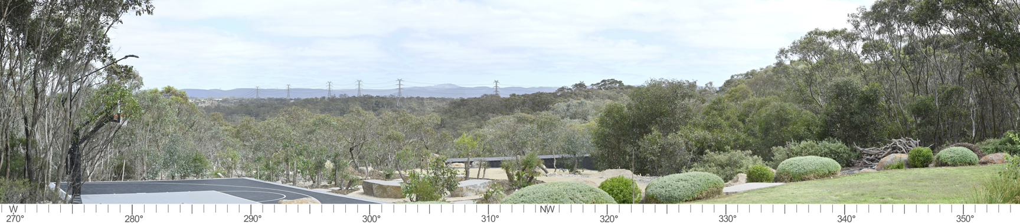
Figure 11.31 Photomontage from an elevated assessed dwelling with views across Pyrites Creek and Long Forest Flora and Fauna Reserve, with a visual impact of high
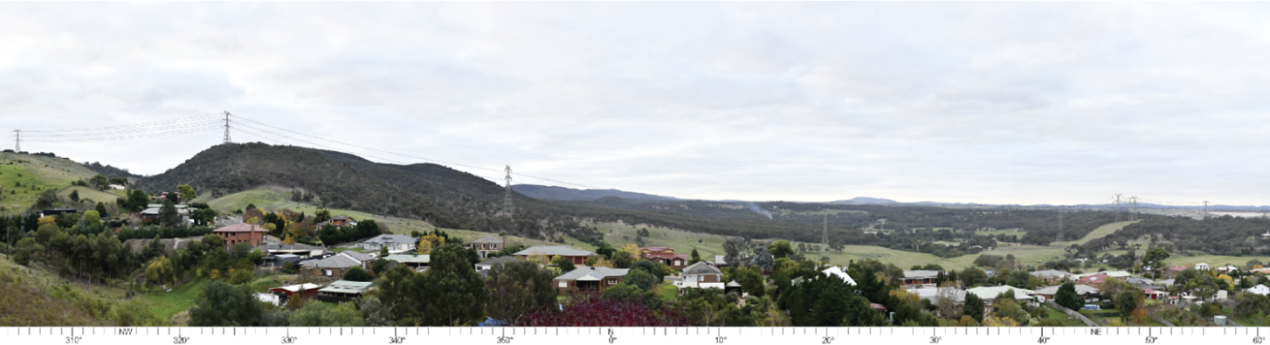Figure 11.32 Photomontage from an elevated assessed dwelling with views toward Lerderderg State Park, with a visual impact of moderate

Potential lighting impacts
During operation, no lighting will be required at any location along the transmission line. Lighting at the terminal stations will be limited to operational and safety lighting, which is activated during an emergency or routine maintenance. Lighting arrangements will be upgraded at the existing terminal stations. These upgrades will be in addition to the existing lighting and, when viewed against the background of existing lighting, will not be a noticeable addition to night-time views. Impacts from permanent Project lighting will be minimised and managed in accordance with AS 4282 – 1997: Control of the obtrusive effects of outdoor lighting.
For these reasons, lighting impacts will be negligible across the Project.

Landscape screening
Landscape screening is an established measure for mitigating the visual impact of large-scale projects from neighbouring dwellings. The relatively fixed locations of views from dwellings (for example, patios or gardens) allow planting to be designed carefully to screen or filter views to reduce the visibility of Project infrastructure, such as the transmission towers. In some instances, this means that views to valued existing landscape features can be maintained, whilst making the presence of Project infrastructure less noticeable or disruptive. The Project has committed to develop a program that provides funding for landscape screening. The funding will be offered to dwellings within 2km of the Project, where the Project is visible from key indoor or outdoor living areas and where landscape screening would assist in mitigating visual impacts. This program will be developed and implemented in accordance with EPR LV2. Through EPR LV2, the Project will provide funds to cover the costs to design, install, monitor and maintain the landscape screening for a two year period. This requirement allows for plantings to establish across at least two growing seasons, after which it can be considered to be successful.
Figure 11.33 shows a hypothetical example of existing vegetation and the placement of a new section of landscaping to assist with screening views to the Project. This example is based on the landholder's desire that the views to the Project should be screened or filtered. Alternatives may include careful placement of large single trees or clusters of trees to screen views to the nearest and most visually noticeable structure.
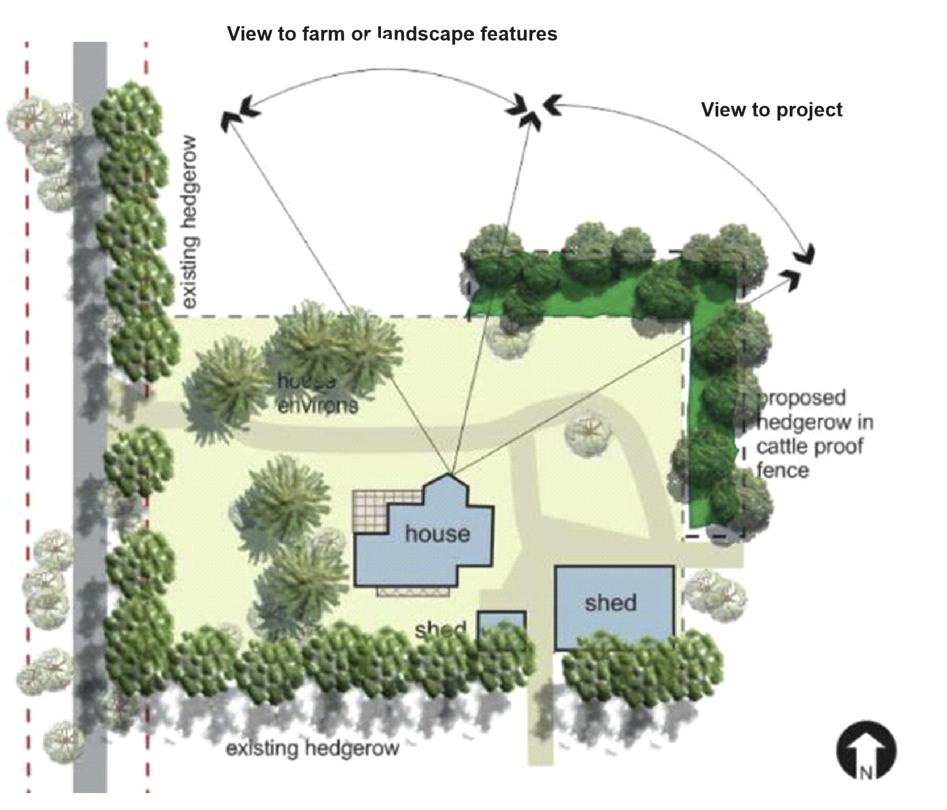
Figure 11.33 Example of landscape screening as a mitigation measure (Source: Landform Architects, 2024)
Many established dwellings within proximity of the Project already have vegetation, including ornamental plantings and dense screening vegetation for wind protection. Nearby vegetation in the landscape was also found to be effective at screening or filtering views to towers at dwellings that were assessed for the technical report. These examples indicate that vegetation will assist to screen or filter views to the Project in many locations.
For the above reasons, landscape screening has also been recommended for Bolwarrah Weir, Merrimu Reservoir and War Memorial, and the Bald Hill Activation Area and this has been committed to by EPR LV1. The Project will consult with the relevant landholders and/or land managers at these locations to confirm sensitive viewpoints and determine and apply appropriate measures for mitigating visual impacts, such as landscape screening. Landscape screening is effective in managing visual impacts but is largely reliant on having a fixed vantage point. At these locations views are longer in duration and therefore more susceptible to visual impacts. As such, it is not typically a recommended mitigation for other public viewpoints (for example viewpoints along major roads) that do not have a fixed vantage point.
AusNet will also adopt a Residential Mitigation and Support Strategy (EPR EM10) which will seek to avoid and minimise impact to landholders directly affected by the Project as a result of the easement being placed on their property. This strategy includes the requirement for AusNet to offer landscape screening, including the costs to monitor and maintain any landscape screening treatment for a period of 2 years, to lessen the visual impact of the Project on landholders’ dwellings and lifestyles.

Decommissioning impacts
As decommissioning activities will be similar to those that occur during construction, the impacts relating to landscape and visual values are expected to be the same as for the construction stage.
Accordingly, the EPRs developed to manage impacts during construction would also be applicable for decommissioning in accordance with the conditions of the time. This would also be managed by a Decommissioning Management Plan (EPR EM11) which would include mitigation measures for impacts to amenity, including visual amenity.

Cumulative impacts
Cumulative impacts have been assessed by identifying nearby relevant existing and future projects that could contribute to cumulative impacts on landscape and visual amenity, considering their spatial and temporal relationships to the Western Renewables Link Project. Several wind farms currently operate or are in development in the region. Existing and approved transmission lines, facilities and wind farms are shown in Figure 11.34.
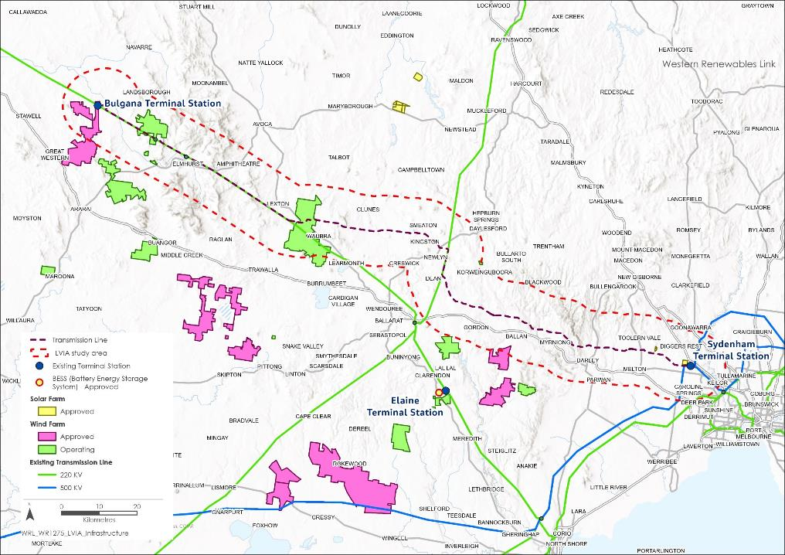
Figure 11.34 Existing and approved transmission lines, facilities and wind farms

The projects considered as potentially relevant to landscape and visual values include:
- 220kV Horsham Terminal Station to Waubra Terminal Station and Bendigo Terminal Station to Ballarat Terminal Station
- 500kV Moorabool Terminal Station to Sydenham Terminal Station, Sydenham Terminal Station to Keilor Terminal Station, and Sydenham Terminal Station to South Morang Terminal Station
- Bulgana Terminal Station
- Crowlands Wind Farm Terminal Station
- Ararat Terminal Station
- Waubra Wind Farm Terminal Station
- Sydenham Terminal Station Rebuild Project
- Wind energy facilities:

  - Bulgana Green Power Hub
  - Crowlands Wind Farm
  - Ararat Wind Farm
  - Nyaninyuk Wind Farm
  - Navarre Green Power Hub
  - Waubra Wind Farm
  - Hepburn Community Wind Farm
  - Yaloak South Wind Farm
  - Moorabool Wind Farm
  - Lal Lal Wind Farm
  - Brewster Wind Farm

- Melbourne Renewable Energy Hub
- Elaine Solar Farm
- Elaine Battery Energy Storage System (BESS)
- Sydenham Terminal Station
- Toolern Vale Solar Farm
- Victoria to NSW Interconnector West (VNI West).
The Melbourne Renewable Energy Hub, located at the eastern end of the Western Renewables Link Project near the existing 500kV Sydenham Terminal Station, is visible from Holden Road. This project will be screened by existing vegetation and new plantings proposed along the southern boundary, and its visibility will be limited. As such, the cumulative visual impacts along Holden Road will be low.
Toolern Vale Solar Farm is also located approximately 600m north at the eastern end of the Western Renewables Link Project. In accordance with permit approvals landscape screening will be put in place to conceal views of the solar farm from neighbouring dwellings and roadsides. For this reason, there would be limited to no significant or sensitive views that would include features in the approved Toolern Vale Solar Farm and the Western Renewables Link Project.
A number of proposed wind farms located in western Victoria will also be visible from the same viewpoints as the Western Renewables Link Project. This includes Brewster Wind Farm, Nyaninyuk Wind Farm and the Navarre Green Power Hub. The proposed wind farms at Navarre and Brewster would be at a distance where they would not contribute significant cumulative impacts. The proposed Nyaninyuk Wind Farm crosses over the Western Renewables Link Project, and as such is likely to contribute significant cumulative impacts. However, public information is limited as this project is in the early stages of development, and cumulative impacts were not able to be assessed in any detail.
VNI West will connect to the Western Renewables Link Project at Bulgana Terminal Station. There are insufficient details available to be considered regarding the potential for cumulative visual impacts of VNI West and the Western Renewables Link Project.
Cumulative visual impacts have been reduced or managed during design by:
- Co-locating transmission lines adjacent to existing easements where practicable
- Reducing visual clutter through structure placement and structure design where co-location of easements and infrastructure is to occur
- Limiting or avoiding the effect of fragmentation or islanding of areas through views to transmission lines in multiple directions
- Locating the new terminal station at Bulgana away from dwellings and settled areas.
Landscape screening offered by the Project to mitigate and manage visual impacts from reserves in the public domain (EPR LV1), and dwellings within 2km of the Western Renewables Link Project (EPR LV2) will further reduce cumulative impacts. Although the potential for cumulative landscape and visual impacts is dependent on the viewpoint, it is considered unlikely that their impacts would be significant enough to increase the level of impact anticipated due to the Western Renewables Link Project alone. As such, residual impacts are expected to be low.

Environmental Performance Requirements
Potential impacts identified through Technical Report D: Landscape and Visual Impact Assessment have informed the development of EPRs for the Project. EPRs set out the environmental outcomes to be achieved through the implementation of mitigation measures during construction, operation and decommissioning. While some EPRs are performance based to allow flexibility in how they will be achieved, others include more prescriptive measures that must be implemented. Compliance with the EPRs will be required as a condition of the Project’s approval. Table 11.10 details the proposed EPRs developed for landscape and visual impacts.
Table 11.10 Environmental Performance Requirements
EPR code | Requirement
EPR LV1 | Minimise visual impacts ‒ Public domain  - During detailed design, develop a process for consulting with the relevant landholders and/or land managers for Merrimu Reservoir and War Memorial, Bald Hill Activation Area and Bolwarrah Weir to:  - Confirm sensitive viewpoints, based on the detailed design that are significantly impacted by the Project from a landscape and visual perspective at Merrimu Reservoir and War Memorial, Bald Hill Activation Area and Bolwarrah Weir; and  - Determine appropriate measures (if any) for mitigating visual impacts with a particular focus on the matters outlined in items 2, 3 and 4 of this EPR (LV1).  - Merrimu Reservoir and War Memorial engagement must include offer of the following, at a minimum, for the relevant landholder and/or land manager’s consideration:  - Landscape screening to filter views towards the Project when facing east from the existing barbecue and picnic facilities at Merrimu Reservoir.  - The development of new public amenities to replace or replicate existing assets in a suitable location within Merrimu Reservoir, which are oriented away from the Project.  - Reconfiguration and/or redesign of the Merrimu Reservoir War Memorial so that views are oriented away from the Project when the parade ground and ceremonial areas are in use.  - Bald Hill Activation Area engagement must include offer of the following, at a minimum, for the relevant landholder and/or land manager’s consideration:  - Landscape screening be installed to filter views towards the Project from the six sculpture locations along the proposed sculpture trail and at the entrance from Swans Road.  - Landscape screening will include selective screen planting to be designed and installed to partially screen individual towers.  - Bolwarrah Weir engagement must include offer of the following, at a minimum, for the relevant landholder and/or land manager’s consideration:  - Landscape screening to minimise visual impacts from the existing picnic tables and chairs at the Bolwarrah Weir.  - Provided the required access and authorisations are granted by the relevant landholders and/or land managers, the measures referred to in 1b) of this EPR, must be implemented, at the proponent’s cost, within 24 months of the completion of construction of the Project.  - To the extent that the measures referred to in 1b) of this EPR require planting to be undertaken, ongoing maintenance will be the responsibility of the relevant landholders and/or land managers.
EPR LV2 | Minimise visual impacts – Private domain landscape screening program  - Prior to the commencement of operation, develop a program that provides offers for landscape screening to eligible land title holders (refer Item 2 (b) of this EPR LV2) to minimise visual impacts.  - The program must:  - Set out the process for informing and making offers for landscape screening, including the timeframe within which offers must be made by the proponent and accepted by the eligible land title holder; and  - Set out the methodology for determining eligibility to participate in the program. Eligible land title holders will include those that meet the following criteria:  - They have elected to participate in the program; and  - The dwelling must be located within 2km of the approved route, and on a property not directly affected by the Project; and  - Project towers must be visible from habitable rooms within the dwelling or attached areas of private open space within the curtilage of the dwelling  - Provide for an offer to be made to eligible land title holders, including the costs to monitor and maintain any landscape screening treatment for a period of 2 years  - Provide for the offer to be made by the proponent to the eligible land title holder within 12 months of the completion of construction of the closest tower to that eligible land title holder’s dwelling which is visible from habitable rooms within the dwelling or attached areas of private open space within the curtilage of the dwelling.  - A suitably qualified bushfire risk consultant must inform the development of the landscape screening program.
Other EPRs contribute to a reduction in the magnitude, extent and duration of impacts for visual amenity. Additional EPRs related to landscape and visual values include:
- EPR EM2 – Develop and implement a Construction Environmental Management Plan
- EPR EM10 – Develop and implement a Residential Mitigation and Support Strategy
- EPR EM11 – Develop and implement a Decommissioning Management Plan.
Refer to Chapter 29: Environmental Management Framework for full details of these EPRs.

Summary of residual impacts
Development of the Project sought to avoid and minimise landscape and visual impacts as discussed in Section 11.5.1. Mitigation measures to further reduce impacts are mainly through implementation of landscape screening which requires consultation with landholders. With application of the mitigation measures to comply with EPRs, it is expected that impacts will be further reduced. Residual impacts at assessed viewpoints are summarised below:
- Residual impacts to significant landscape values and landforms at the assessed viewpoints during operation range from high to low. Where recommended by the technical specialist, the Project will consult with the relevant landholders and/or land managers to determine, design and site appropriate landscape screening to reduce these visual impacts (EPR LV1). However, a high residual visual impact has been assessed for the following significant landscapes and landforms:
  - One viewpoint from Bolwarrah Weir and one viewpoint within the Bald Hill Activation Area. At these locations, the Project will engage with the relevant landholders and land managers to confirm sensitive viewpoints that are significantly impacted by the Project and determine the appropriate measures for mitigating visual impact as detailed in EPR LV1. At a minimum, the Project will offer landscape screening to minimise visual impacts from the existing picnic tables and chairs at the Bolwarrah Weir; and at the Bald Hill Activation Area, the offer of landscape screening along the proposed sculpture trail, at the Swans Road entrance, and selective locations to partially screen individual towers. However, it is noted that landscape screening as a mitigation may have limited benefit or be undesirable due to the screening of favoured viewpoints, so the residual impact may remain high.
  - Two assessed viewpoints along the Buried Rivers of Gold tourist drive, which are understood to be public roadside viewing locations. In these locations Project infrastructure is not located within the key view lines, but directly behind or surrounding the viewing location. Mitigation measures such as landscape screening has not been recommended by the technical specialist. While landscape screening may have benefit, any plantings would be located in adjoining private land and would also screen long distance views which would still be visible through the Project’s transmission towers. As such, no further mitigations will be undertaken and a high level of residual impact will remain.
  - One assessed viewpoint at Merrimu Reservoir. At this location, the Project will engage with the relevant landholder / land manager to confirm sensitive viewpoints and determine the appropriate measures for mitigating visual impact as detailed in EPR LV1. At a minimum, the Project will offer landscape screening, development of new public amenities that are orientated away from the Project, and/or redesign of the Merrimu War Memorial so that views are orientated away from the Project. Over time, the residual impacts at this location are expected to reduce from high-moderate to moderate as the recommended landscape screening (EPR LV1) matures.
- Residual impacts for landholders, residents, and community during operation, with respect to the public domain range from high to negligible. The public domain includes viewpoints to the Project from major and local roads, where the Project will predominately be a glimpse or a brief experience as they drive around the local road network, or a longer view from a recreational area such as an elevated lookout or picnic areas. The Project design has sought to minimise these impacts as much as possible through increased setbacks and right-angled road crossings, however a high level of residual visual impact remains at the Holden / Leakes Road intersection, which has a viewpoint towards Mount Kororoit. In this location impacts have been minimised through structure placement and partly through the inclusion of double circuit towers, however the transmission towers will still be highly visible and dominant in the view. No further mitigation has been recommended at this location.
- Residual impacts for landholders, residents, and community during operation, with respect to the private domain (dwellings) range from high to negligible. For most dwellings, residual impacts are expected to be minimised by the application of voluntary landscape screening (EPR LV2) that will screen or filter views to Project infrastructure. Where landscape screening is effective, the residual impacts in most cases will reduce to low or negligible. Where landscape screening does not mitigate visual impacts, residual impacts will not change – with some dwellings experiencing a high visual impact. This is expected to be limited to dwellings in proximity to the Project, dwellings that are elevated, dwellings with key views oriented in the direction of the Project, and dwellings with topography that falls away from the dwelling, reducing the suitability of landscape screening as an effective mitigation measure. The greatest number of dwellings likely to experience a high level of visual impact are 27 dwellings located along the northern side of Pamela Court and Augusta Place and three at the northern end of St Andrews Way in Darley. Three dwellings along this edge have been directly assessed, each having a high level of visual impact with elevated dwellings, oriented to views across the Lerderderg River, cleared farming land with a backdrop of the Lerderderg State Park. With limited mitigation options to assist in reducing visual impacts, the residual impact is likely to remain high.
- Residual visual impacts during the construction stage will be nil. Construction activities, including those associated with the construction of the transmission line, may be highly visible while underway at any one location, however these impacts will be temporary and relatively short in duration. Following construction, temporary construction areas will be rehabilitated, where practicable, and returned to their prior use. The laydown area at the new terminal station near Bulgana has the potential to cause a high level of visual impact from two dwellings located to the south of the site. Visual impacts will be minimised through standard site hygiene measures as required in the Construction Environmental Management Plan (EPR EM2), however landscape screening as a mitigation measure would not be effective. The residual impact is expected to remain high from the two dwellings. All other laydown areas and workforce accommodation facilities are anticipated to result in low or negligible impacts.
- Residual impacts to landscape and visual values during decommissioning are expected to be the same as for the construction stage. Decommissioning impacts would be managed by a Decommissioning Management Plan (EPR EM11) which would include mitigation measures for impacts to amenity, including visual amenity.
Through the development of the design and placement of Project’s infrastructure and implementation of measures to comply with EPRs, it is considered that the Project meets the evaluation objectives with respect to landscape and visual to “Avoid, or minimise where avoidance is not possible, and manage potential adverse effects on landscape and visual amenity” and “Avoid, or minimise where avoidance is not possible, adverse effects for community amenity, health and safety, with regard to construction noise, vibration, dust, lighting, waste, greenhouse gas emissions, transport network, operational noise, fire risk management and electromagnetic radiation.”

