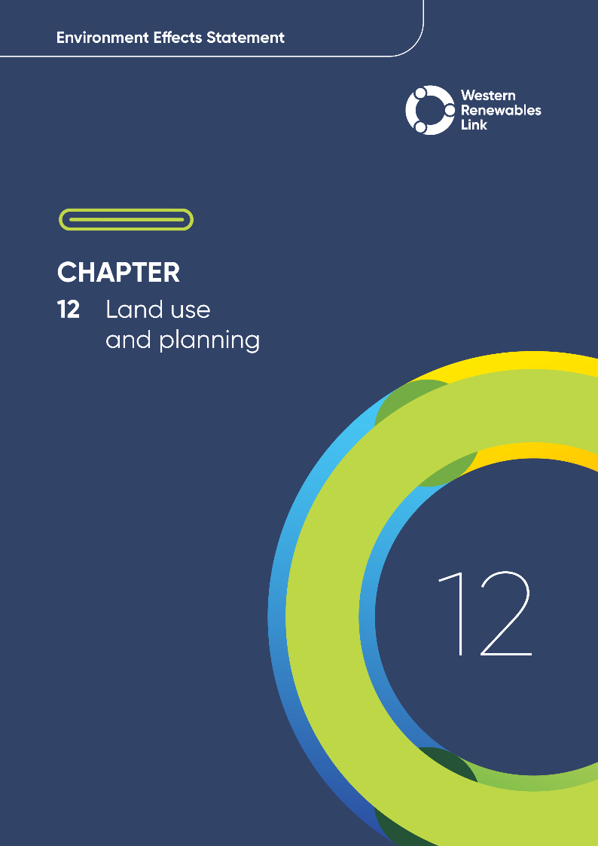

Land use and planning
This chapter provides an overview of the potential land use and planning impacts associated with the construction, operation and decommissioning of the Project. This chapter is based on Technical Report E: Land Use and Planning Impact Assessment.
Land use impacts may occur when a project changes how land is used. These changes can be physical (e.g., vegetation clearance), environmental (e.g., visual, noise, dust) or social (e.g., limiting how land is accessed). These changes can affect local economies, especially in areas that are dependent on agriculture and tourism. They can also influence social dynamics including community cohesion and access to resources. Changes in land use may be temporary, occurring during the construction stage only, or permanent, existing for the life of a project.
Agriculture is the dominant land use in the Project Area, with approximately 90 per cent of the Project located in rural areas. The Project is situated typically 2 to 25km from rural townships, but as it approaches Melbourne, the proximity reduces to 1 to 2km. Nearest settlements include Darley (Moorabool Local Government Area (LGA)), the proposed Merrimu Precinct (Moorabool LGA), and Hillside (Melton LGA). No land within the Project Area is used for industrial, commercial, or retail purposes; however, the Project intersects with MacPherson Park, waterways, sand quarries, three operating windfarms (Crowlands, Waubra, Bulgana) and traverses water reservoirs (Lake Merrimu, Pykes Creek, Dean Reservoir, Wilson Reservoir). The Project is close to existing and planned infrastructure, including water, gas, power, telecommunications, major freeways, arterial roads, rail, Melbourne Airport and the Melton Aerodrome.
Existing and planned land uses and development were considered in the design of the Project to avoid or minimise impacts to public land, land use, land access and amenity.
Evaluation objective
Avoid, or minimise where avoidance is not possible, adverse effects on land use, social fabric of the community, businesses including farming and tourism, local and state infrastructure, aviation safety and to affected and neighbouring landholders during construction and operation of the project.

Evaluation objective
The scoping requirements identify the following evaluation objective relevant to land use and planning:
In response to this evaluation objective, the impacts of the Project on land use were assessed, and measures to avoid, minimise or manage potential impacts have been identified. These measures are discussed throughout this chapter and have informed the development of Environmental Performance Requirements (EPRs). EPRs set out the environmental outcomes to be achieved through the implementation of mitigation measures during construction, operation and decommissioning to avoid, minimise and manage identified impacts. Cumulative impacts associated with relevant future projects were also assessed.
Further information on how the Project has been designed to avoid and minimise impacts is provided in Chapter 5: Project development and Chapter 6: Project description.
Other aspects covered in the Environment Effects Statement (EES) evaluation objective and relevant to land use and planning are addressed in the following EES chapters:

- Chapter 14: Economic
- Chapter 15: Agriculture and forestry
- Chapter 16: Aviation
- Chapter 21: Social.

Method
This section summarises the method adopted in Technical Report E: Land Use and Planning Impact Assessment, which was informed by Chapter 4: EES assessment framework and approach. The key steps in assessing the impacts associated with land use and planning included:
- Defining a study area appropriate for land use and planning as presented in Figure 12.1. This study area encompasses the Project Land and has regard to land uses outside this area where it was considered appropriate for planning context. The study area interfaces with the Shire of Ararat and the City of Brimbank; however, there will be no infrastructure or works within these LGAs, therefore they do not form part of the review of existing conditions undertaken for the impact assessment.
- Reviewing applicable Commonwealth and Victorian legislation, and relevant local, state and national standards, guidelines and policies, including the policy framework, zones, overlays and other provisions contained in the planning schemes.
- Conducting a desktop review of existing and planned land uses in the study area to identify land use and land use features, including:
  - State, regional and local planning policy framework and local government strategic land use plans
  - Planning permits, submitted and approved by council and the Minister for Planning on, and prior to November 2024, dating back to the commencement of the EES
  - Proposed planning scheme amendments, available on, and prior to 6 March 2025
  - Land titles
  - Aerial imagery and Geographic Information System (GIS).
- Conducting site visits to publicly accessible parts of the study area in August 2021, December 2021 and October 2023 to inform characteristics, land uses and development.
- Conducting a risk screening process to identify the key issues during construction, operation and decommissioning for investigation within the technical report.
- Identifying and assessing potential land use and planning related impacts associated with changes to land use, changes to access due to land use disruption, and amenity impacts during construction, operation and decommissioning. These impacts were evaluated according to the following ratings, in relation to the extent, magnitude and duration of the impact:
  - Negligible: Typically, an effect that is localised, limited to the study area, readily reversible or no detectable impact on asset/value/use, impacts on values of low significance
  - Minor: Typically, an effect that will be limited to receptors within or adjacent to the study area. Short term and reversible, impacts on values of local significance or within normal range of change for other values
  - Moderate: May affect a local government area, short-medium term, may impact values of regional significance or impacts are within normal range of change for other values
  - Major: May have regional effects, likely to be long term, impacts on values of regional or state significance, limited impacts on values of national significance
  - Severe: May have state-wide effects, typically will involve permanent significant impacts on values of state or national significance.
- Impact ratings considered changes to land use, access and amenity. The full definition of each rating is provided in Section 5.5 of Technical Report E: Land Use and Planning Impact Assessment.
- Identifying relevant future projects that could lead to cumulative impacts when considered together with the Project (refer to Chapter 4: EES assessment framework and approach for the full cumulative impact assessment method).
- Developing EPRs in response to the impact assessment to define the required environmental outcomes that the Project must achieve through the implementation of mitigation measures during construction, operation and decommissioning. Measures to reduce the potential impacts were proposed in accordance with the mitigation hierarchy (avoid, minimise, manage, rehabilitate and offset) and have informed the development of EPRs. Alternative mitigation measures could be implemented to comply with the EPRs based on the specific site conditions, available resources, and the Principal Contractor’s expertise.
- Following application of mitigation measures that would comply with the EPRs, determining residual impacts associated with the construction, operation and decommissioning of the Project, and evaluating their significance.

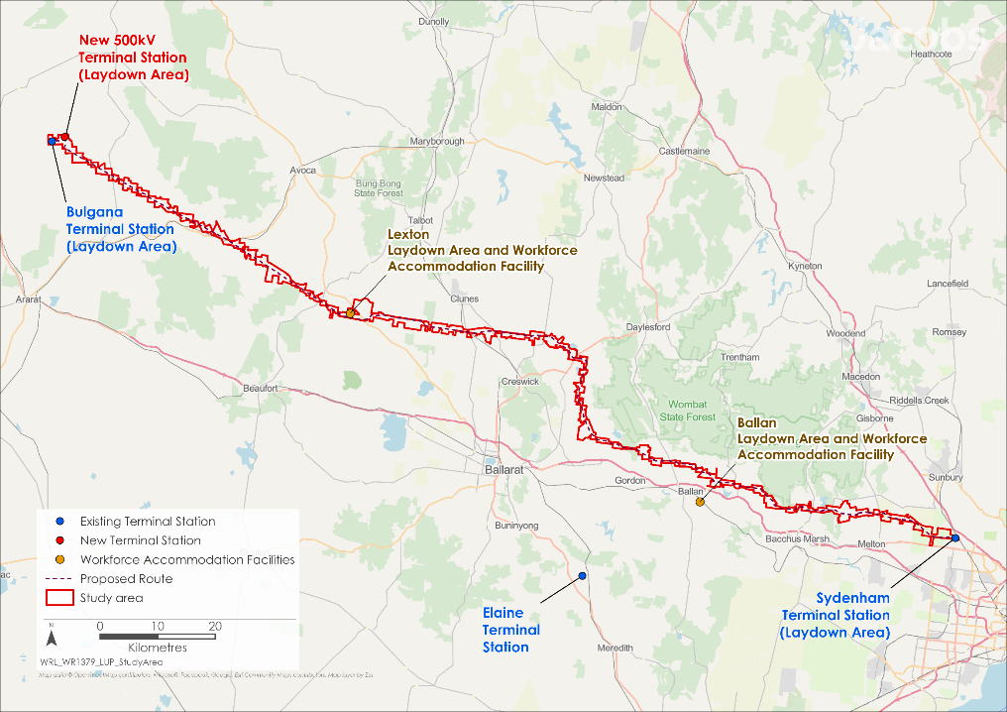
Figure 12.1 Land use and planning study area

Existing conditions
This section summarises the existing conditions for land use and planning according to the following key themes:
- Land uses
- Land tenure.
The Project is located on land covered by the Northern Grampians, Pyrenees, Ballarat, Hepburn, Moorabool and Melton planning schemes. In Victoria, land use and development are guided by the policies in the Planning Policy Framework (PPF) and Municipal Planning Strategy. These policies provide guidance on the use and development of land in Victoria to protect the environment, heritage and built environment and guide decisions on proposed use and development of land.
The planning schemes divide the land into zones to regulate its use. The vast majority of the Project is situated in Rural Zones, including the Farming Zone, Green Wedge Zone, Rural Conservation Zone and Rural Living Zone. Planning schemes also define overlays to regulate land and manage specific features and issues, such as the protection of vegetation and heritage, and defining areas requiring preparation for flooding and bushfire.
Refer to Technical Report E: Land Use and Planning Impact Assessment for further detail on the clauses of the PPF and planning approval requirements relevant to the Project.

Land uses
Four types of land use are present in the study area:
- Agricultural land, as shown in Figure 12.2 to Figure 12.5
- Residential and community facilities, as shown in Figure 12.6 to Figure 12.9
- Industry, mining, aviation and infrastructure, as shown in Figure 12.10 to Figure 12.13
- Natural environment areas, as shown in Figure 12.14 to Figure 12.17.
- Project terms relevant to the land use and planning impact assessment
Project Land: encompasses all land parcels that could be used for the purpose of temporary Project construction and permanent operational components. The Project Land corresponds with the extent of the Specific Controls Overlay proposed in the draft Planning Scheme Amendment for the Project. This generally includes the entire land parcel intersected by a Project component.
Project Area: contained within the Project Land and encompasses all areas that would be used to support the construction and operation of the Project.

Agriculture
Agriculture is the dominant land use in the study area and includes land-dependent production-based agricultural land use activities such as grazing, horticulture, food and crop production, intensive animal husbandry, hobby farms and plantations (forestry). There is approximately 540,000 hectares (ha) of land used for agriculture in the region. Out of the 540,000ha of land in the region used for agricultural production, comprising of cropping, potato growing, grazing and forestry, approximately 2,228ha will be intersected by the Project Area.

Residential and community facilities
Dwellings are present throughout the study area, located on land used for farming, hobby farms and outer edges of settlements. The nearest types of regional centres, townships or residential areas and their approximate distance from the Project are listed in Table 12.1.
Table 12.1 Types of residential areas near the Project
Larger regional centres | Smaller townships or residential areas in regional Victoria | In peri-urban areas | Melbourne’s Urban Growth Boundary
- Ararat (24km)  - Avoca (17km)  - Ballarat (22km)  - Beaufort (18km)  - Creswick (5km) | - Allendale (adjoining the Project Area)  - Amphitheatre (3km)  - Ballan(2km)  - Broomfield(2km)  - Bungaree (5km)  - Clunes (4km)  - Elmhurst (adjoining the Project Area)  - Evansford (5km)  - Gordon (4km)  - Kingston (adjoining the Project Area)  - Lexton (adjoining the Project Area)  - Myrniong (2km)  - Newlyn North (adjoining the Project Area)  - Newlyn(2km)  - Rocklyn (3km)  - Smeaton (adjoining the Project Area)  - Wallace (3km)  - Waubra (2km) | - Bacchus Marsh (2km)  - Darley (1km)  - Diggers Rest (3km)  - The proposed Merrimu (residential) Precinct (adjoining the Project Area as shown in Figure 12.9 | - Hillside (adjoining the Project Area)  - Melton (1km)  - The approved Plumpton Precinct Structure Plan (adjoining the Project Area)  - The unprogrammed Warrensbrook Precinct Structure Plan (500m)  - Toolern Vale (2km)
Community facilities within the study area include MacPherson Park (sport and recreational facility in the Melton LGA, and the Goldfields Track (walking and cycling trail), Great Dividing Trail Network (shared use for mountain bikers and walkers), and the proposed Lerderderg River Nature Trail in the Moorabool LGA. Community facilities in close proximity to the Project include the Creswick and District Motorcycle Club in the Hepburn LGA, Mt Mitchell Homestead and Stables (accommodation and private events venue) in the Pyrenees LGA and Glendaruel Mt Beckworth Fire Station in the Ballarat LGA.

Industry, mining, aviation and infrastructure
Sand quarries, an extractive industry, are currently operated in Darley, within the Moorabool LGA (see Figure 12.13). These quarries are of significance due to their high potential to supply basalt material. Basalt resources are in Extractive Industry Interest Areas (EIIAs) where future extraction may occur.
Major infrastructure in the study area includes freeways and major arterial roads, railways, water reservoirs and pipelines, gas pipelines, high-voltage transmission lines, two terminal stations (Crowlands Terminal Station and Ararat Terminal Station), wind farms, and flight paths for the Melbourne Airport and the Melton Aerodrome. Proposed infrastructure includes the Bacchus Marsh Eastern Link Road, Outer Metropolitan Ring Road, and Western Irrigation Network Sunbury Recycled Water Plant (RWP) to Melton RWP Interconnector Pipeline.
No land in the study area is used for industrial, commercial or retail purposes.

Natural environment
There are no national parks, state parks or state forests within the study area; however, the Lerderderg State Park, Ben Major Flora Reserve and proposed Wombat-Lerderderg National Park are adjacent to the study area. Notable areas within the study area include the Lexton H5 Bushland Reserve in the Shire of Pyrenees, Bullarook Creek Streamside Reserve in the Shire of Hepburn, Mt Kororoit in the City of Melton, as well as major waterways such as the Wimmera River, Lerderderg River and Werribee River. Areas of volcanic peaks, ridges, escarpments and sites of geological significance recognised for their landscape features are also located within the study area. These landscapes are typically located on private land and used for farming.

Land tenure
The Project traverses land tenure that is:
- Crown land – land held by the State of Victoria or Commonwealth Government. Crown land can be reserved for a particular public use, or unreserved (not set aside for a particular public use).
- Freehold – land which has been granted by or alienated from the Crown and transferred to a person, persons or another legal entity. Freehold land is typically owned by a private individual/s or a company. Government departments and public authorities can own freehold land, including water corporations, and VicTrack (railway). The majority of the Project is located within freehold land.
- Government Road – land that has been set aside for public access now or in the future, which is maintained by the Victorian government or an institute of local government or another local authority. It includes an unused road, which is defined as a government road that was officially set aside for public traffic but never constructed or used.

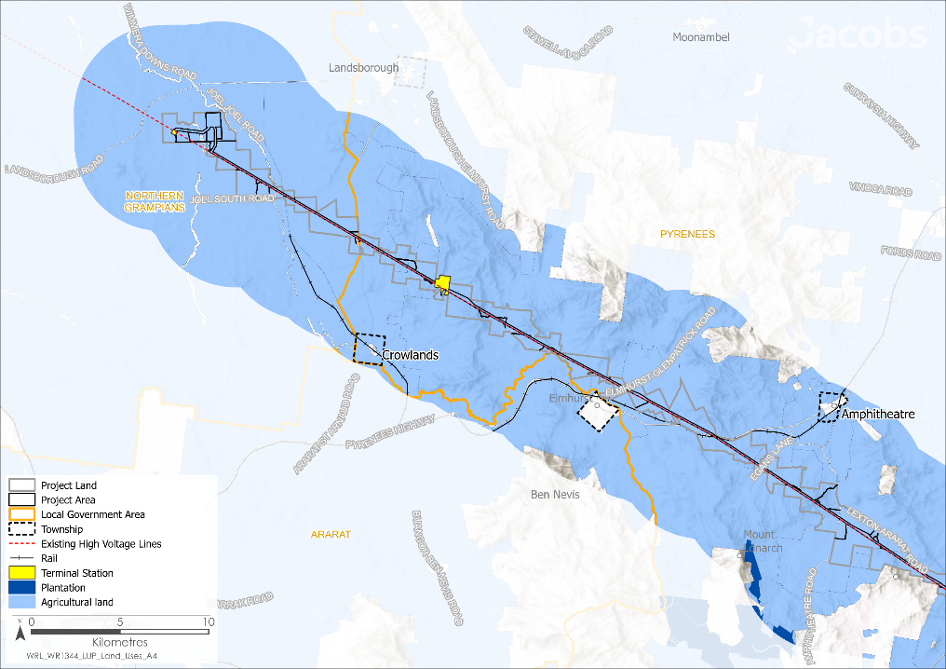
Figure 12.2 Land uses – Agriculture and Plantations

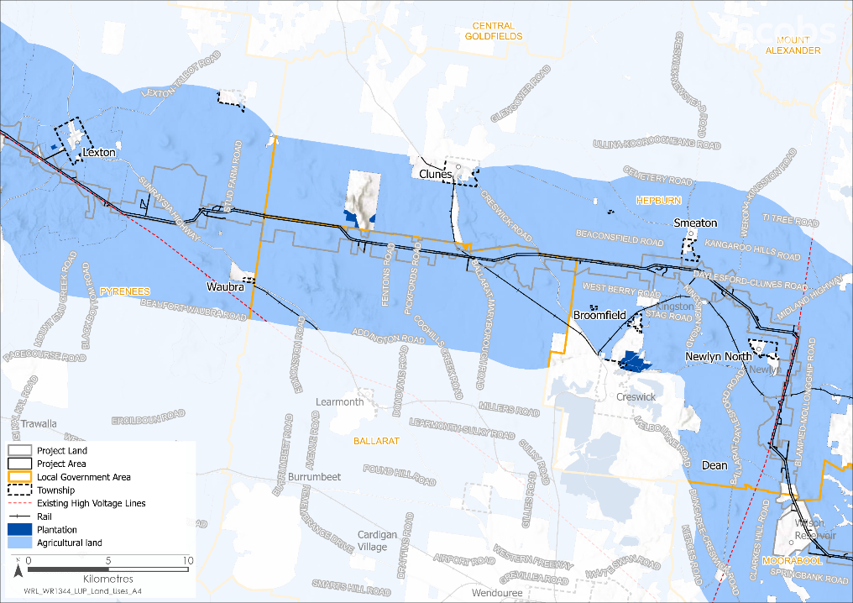
Figure 12.3 Land uses – Agriculture and Plantations
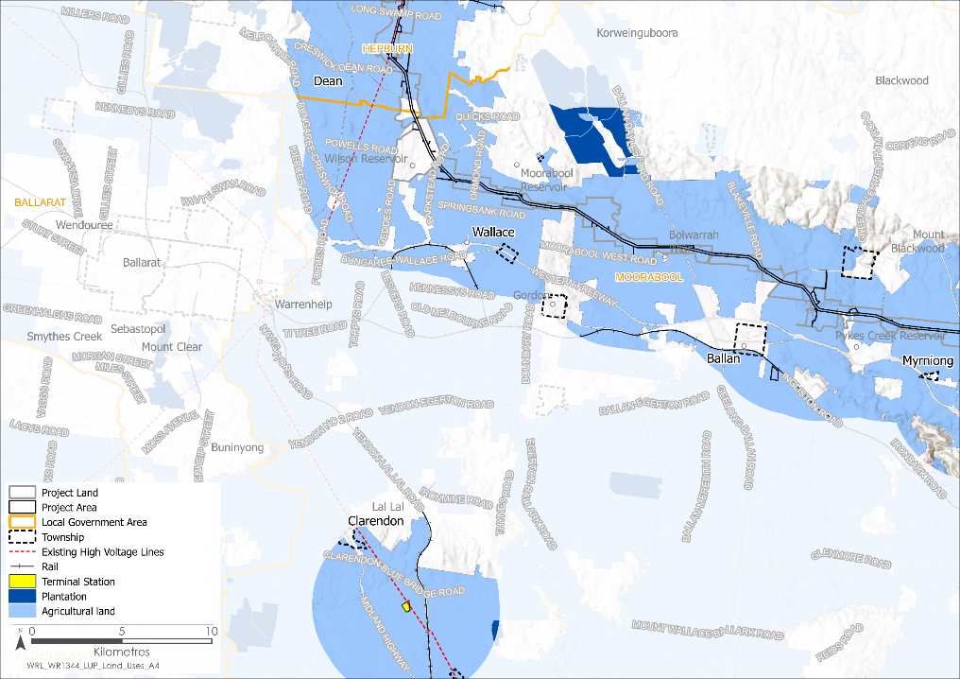
Figure 12.4 Land uses – Agriculture and Plantations

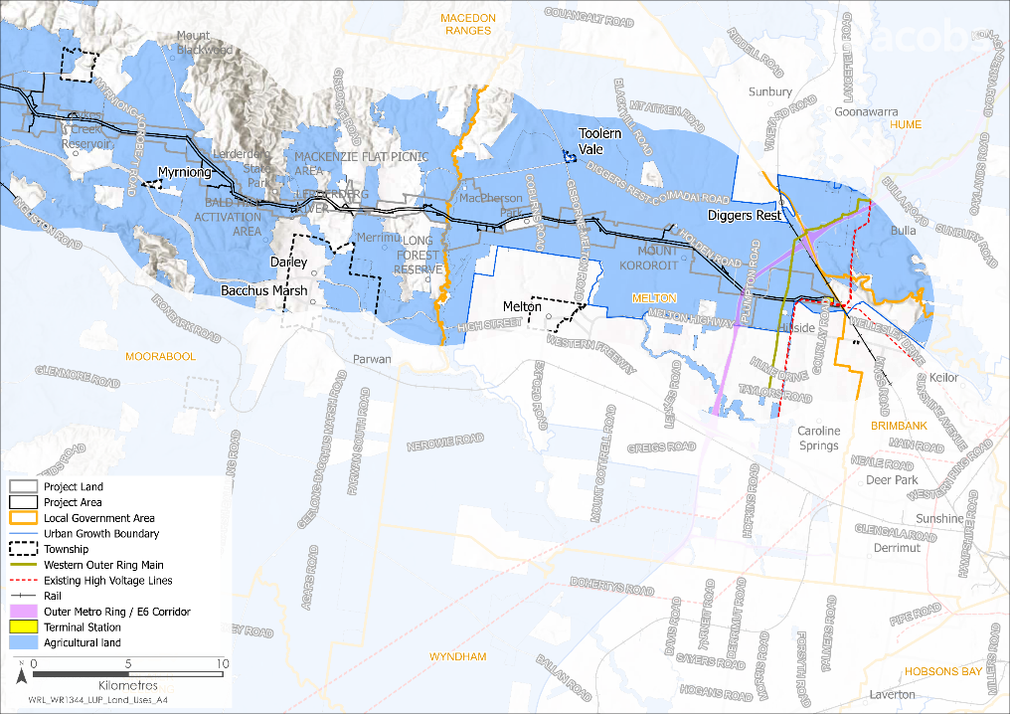
Figure 12.5 Land uses – Agriculture and Plantations
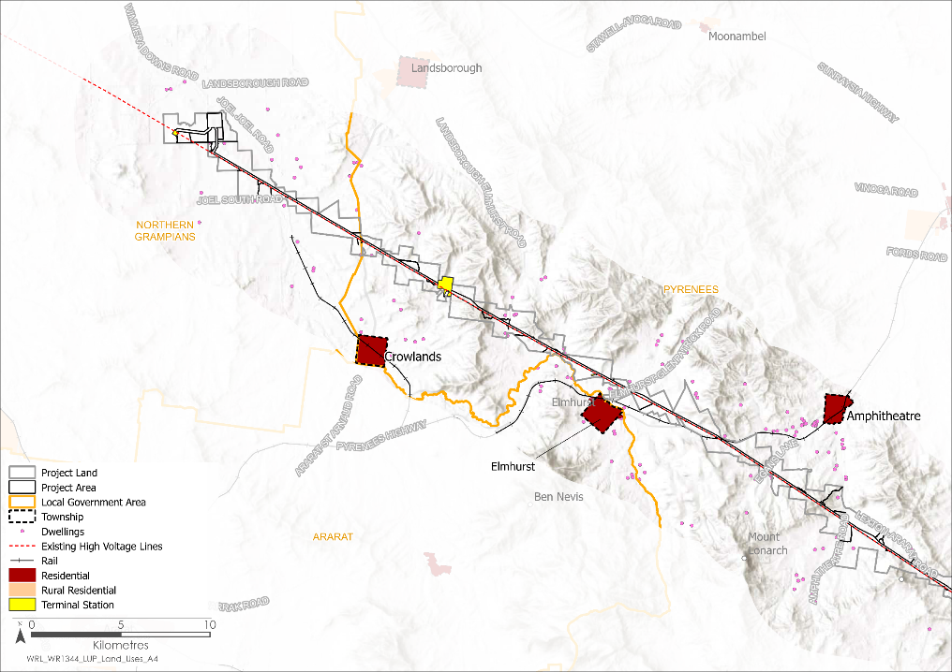
Figure 12.6 Land uses – Residential and community facilities

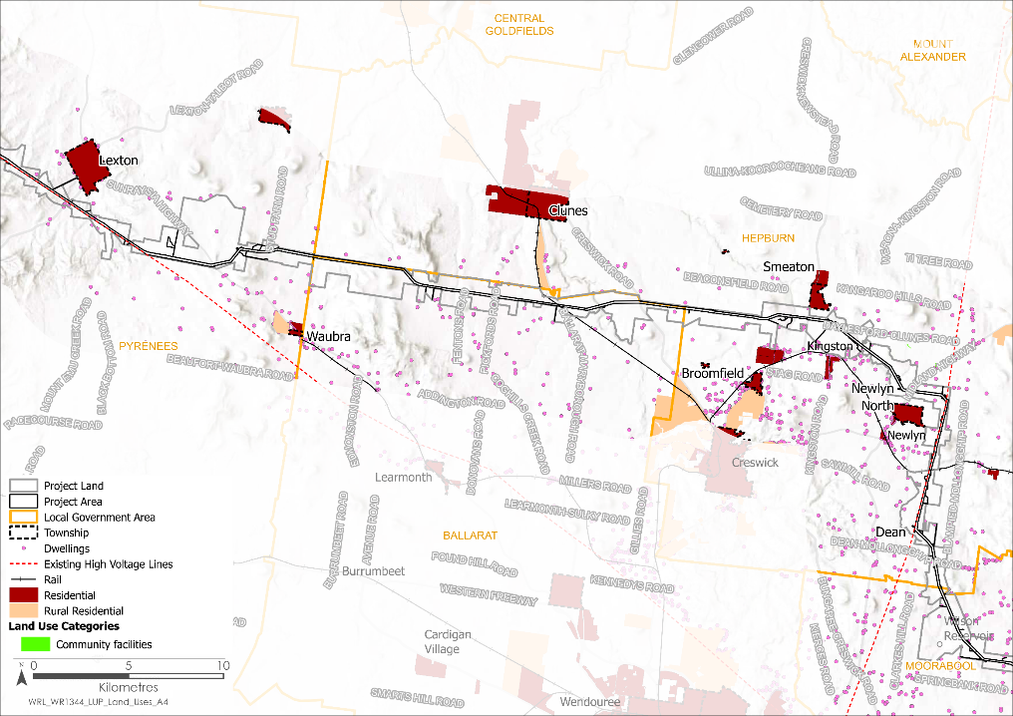
Figure 12.7 Land uses – Residential and community facilities
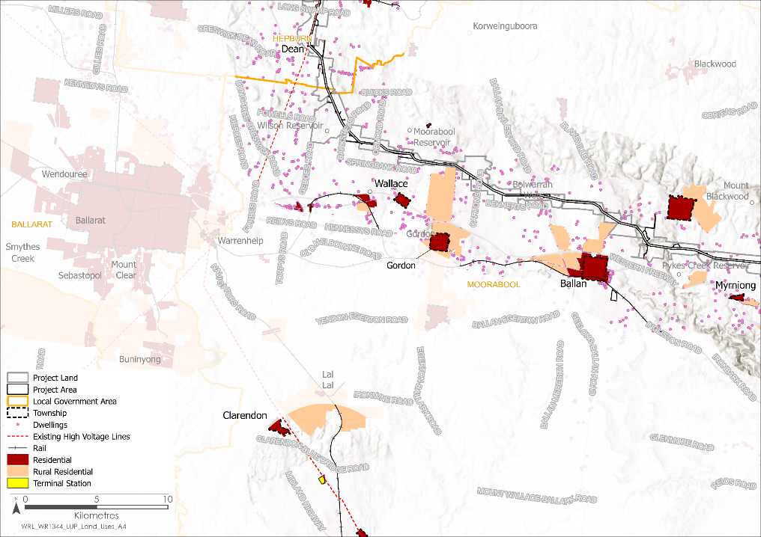
Figure 12.8 Land uses – Residential and community facilities
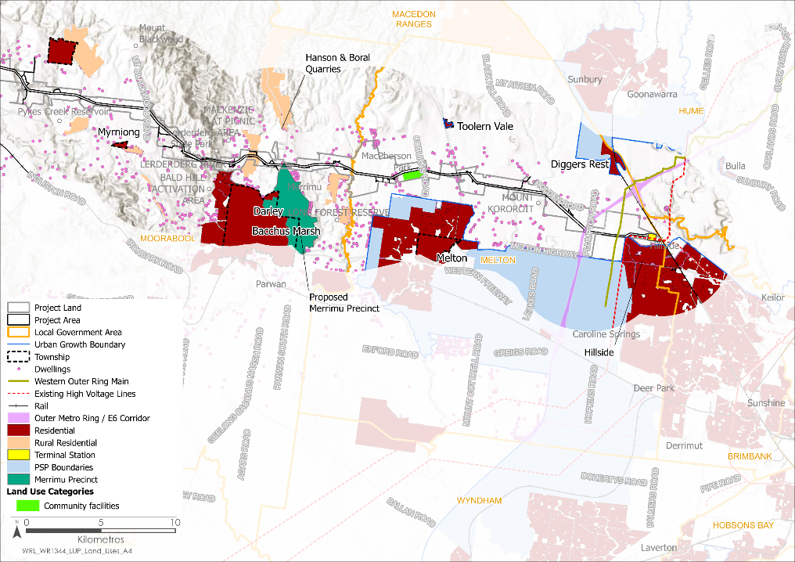
Figure 12.9 Land uses – Residential and community facilities

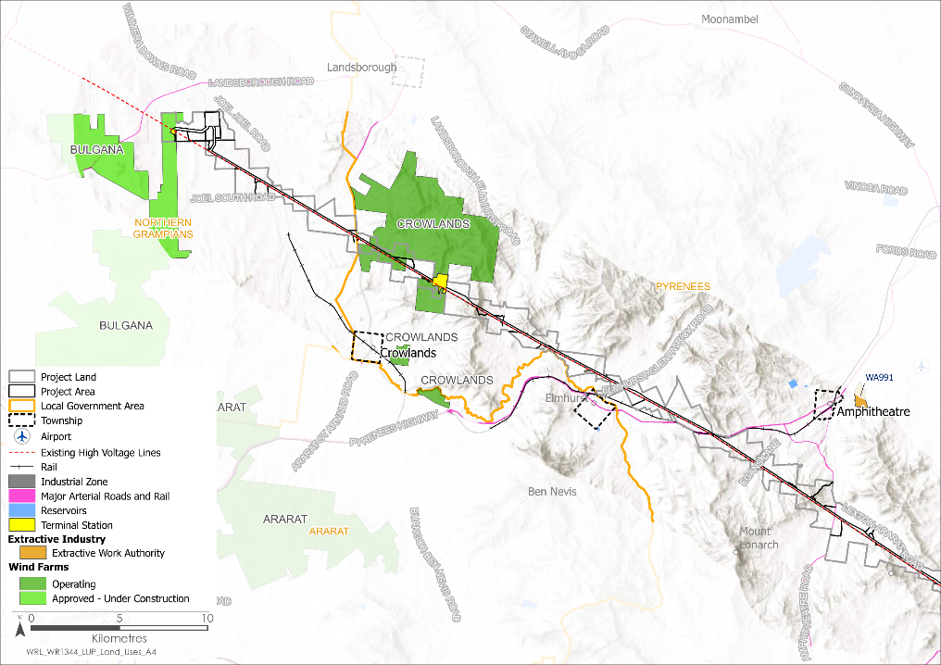
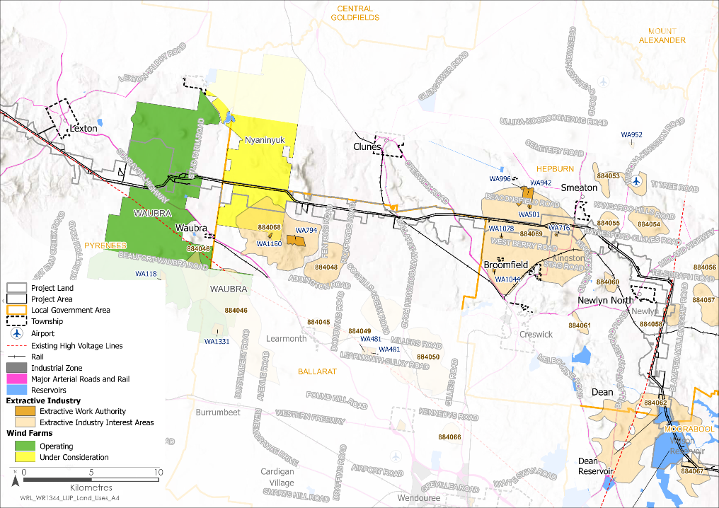
Figure 12.10 Land uses – Industry, mining, aviation and infrastructure
Figure 12.11 Land uses – Industry, mining, aviation and infrastructure
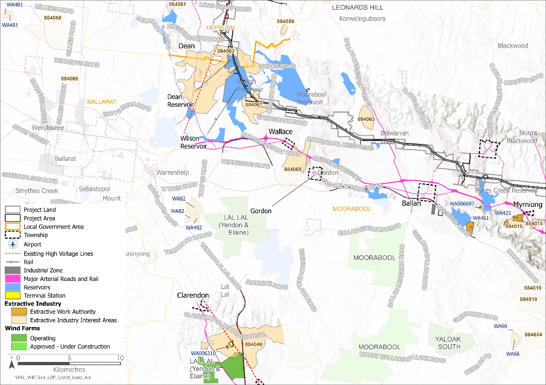
Figure 12.12 Land uses – Industry, mining, aviation and infrastructure
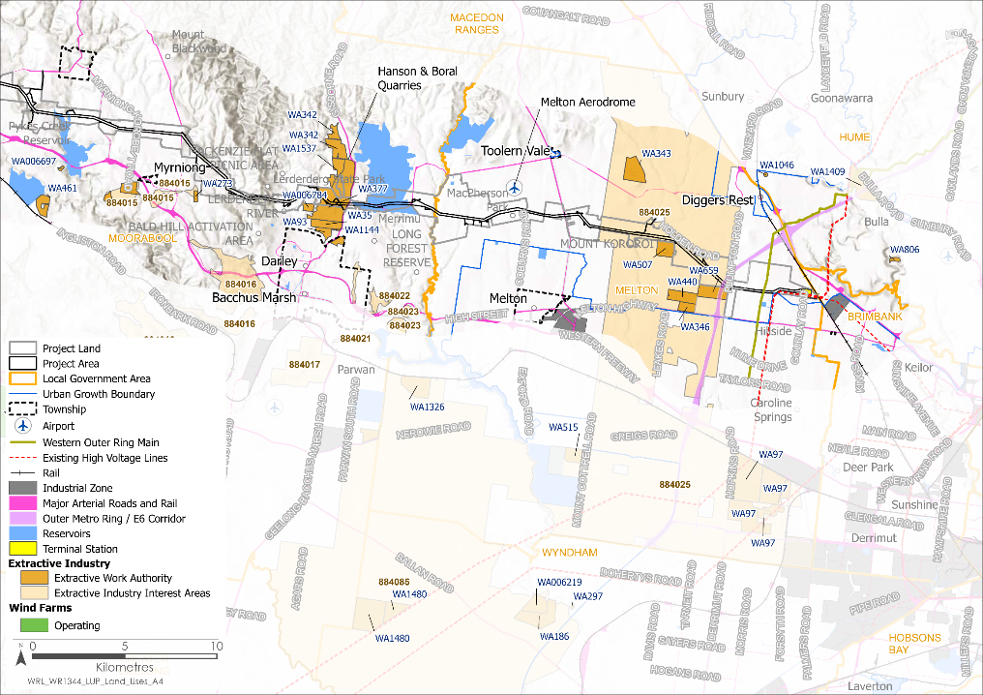
Figure 12.13 Land uses – Industry, mining, aviation and infrastructure
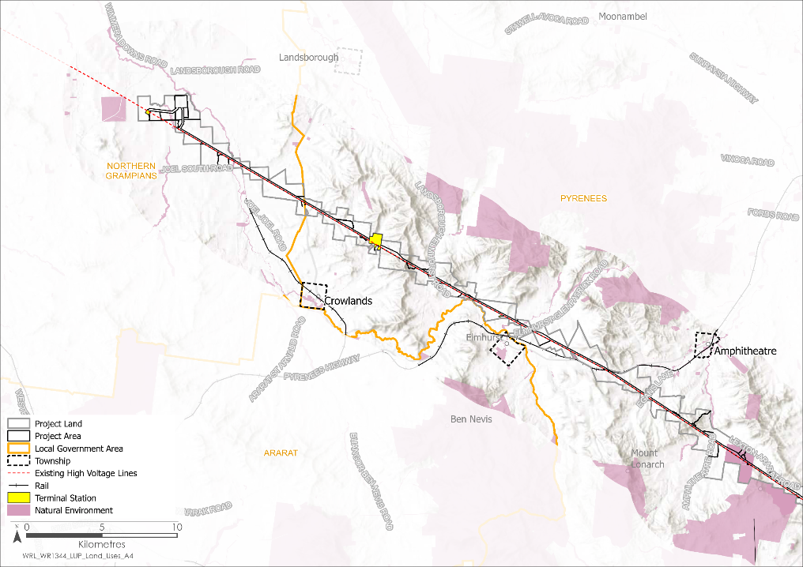
Figure 12.14 Land uses – Natural environment
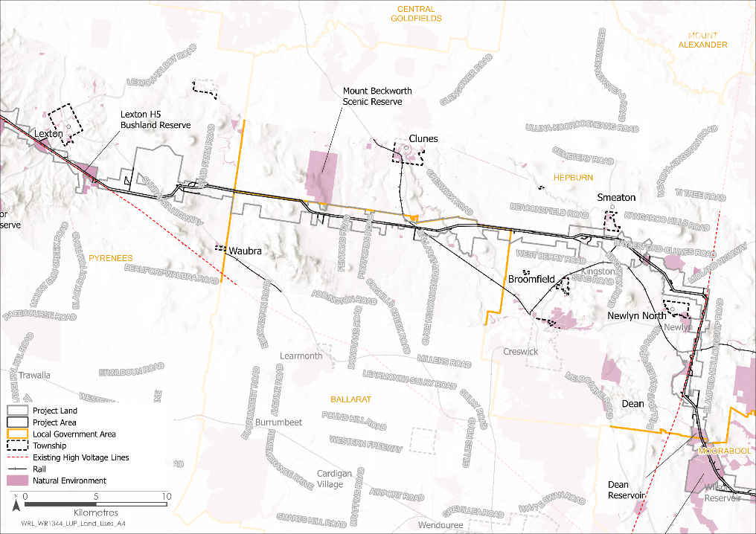
Figure 12.15 Land uses – Natural environment

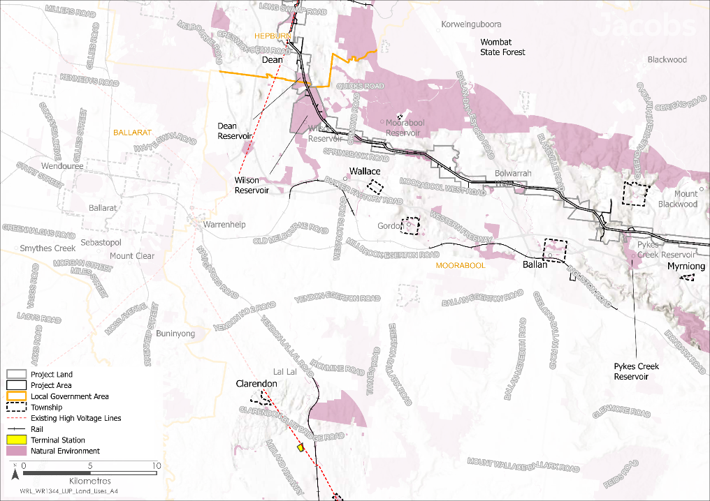
Figure 12.16 Land uses – Natural environment
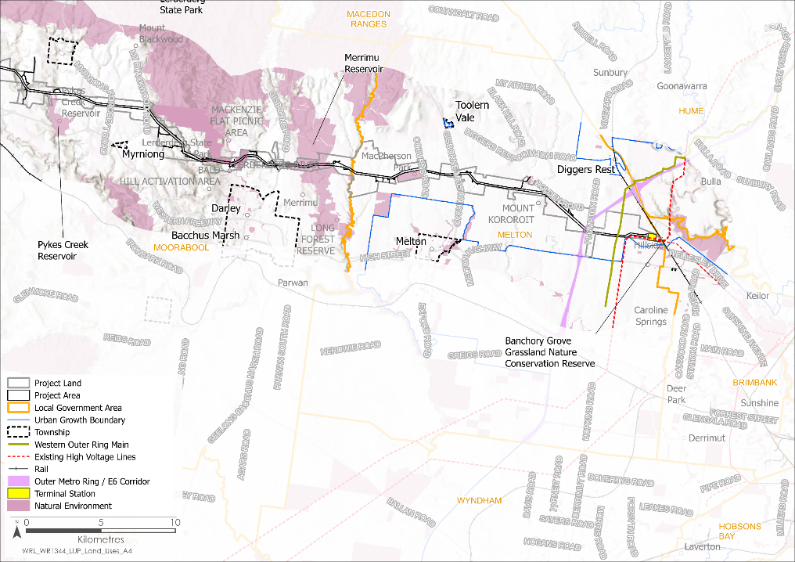
Figure 12.17 Land uses – Natural environment
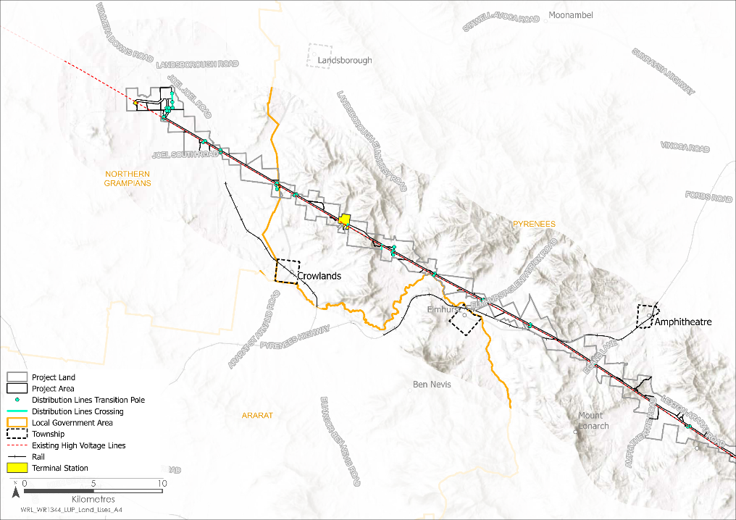
Figure 12.18 Land uses – Distribution lines

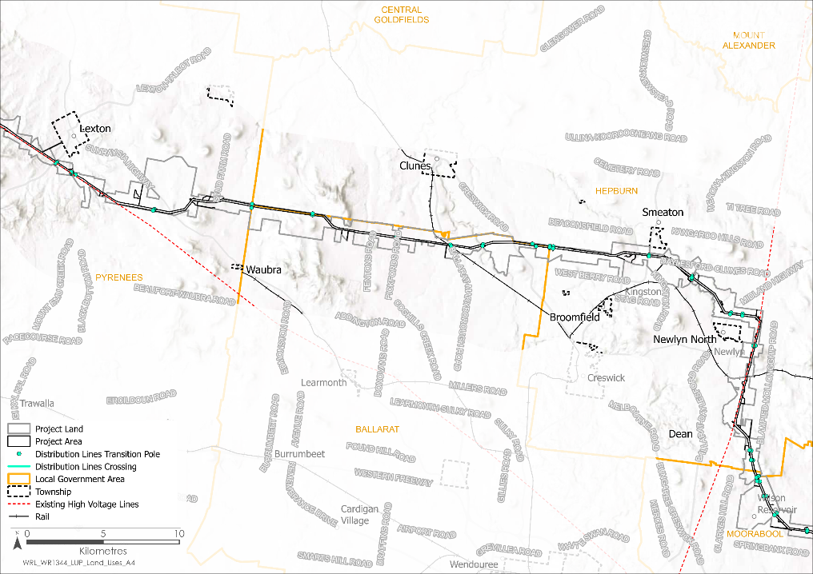
Figure 12.19 Land uses – Distribution lines
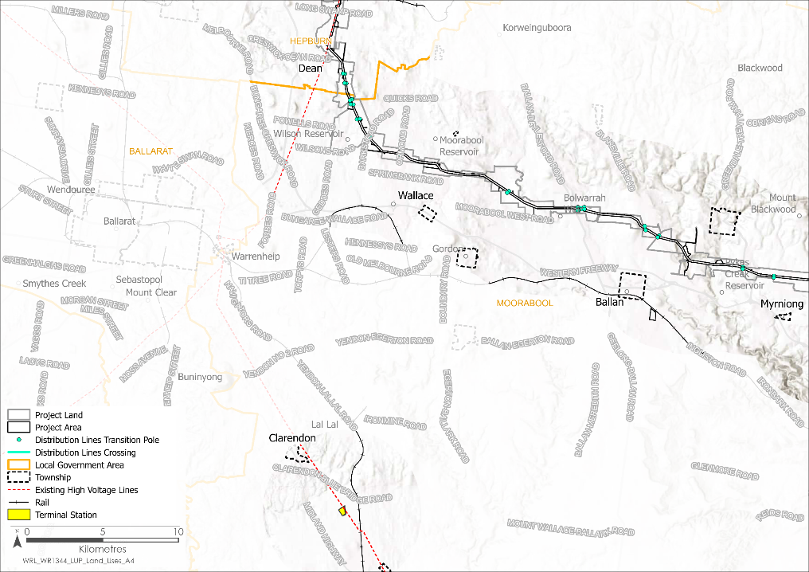
Figure 12.20 Land uses – Distribution lines
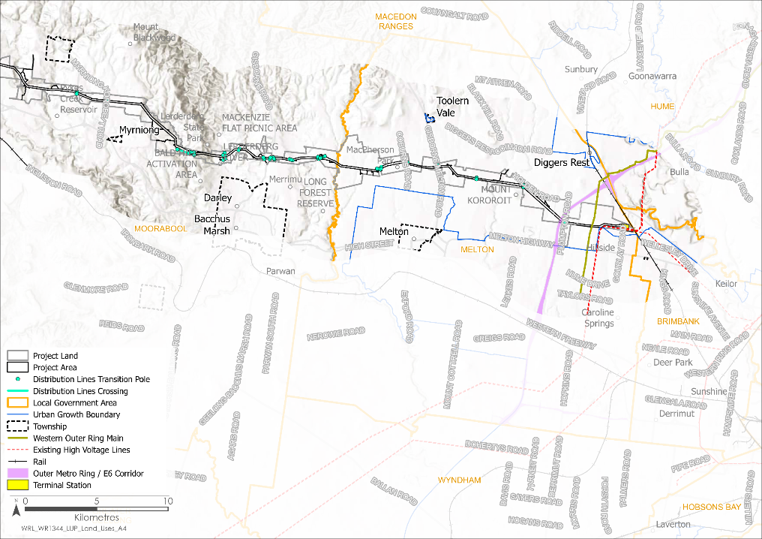
Figure 12.21 Land uses – Distribution lines

Construction impacts
This section outlines the key issues identified through the risk screening process and associated potential impacts during the construction of the Project. The key issues and impacts identified for land use and planning are discussed according to the following themes:
- Change of land use due to the acquisition of land or severance of properties for the establishment of an easement and its conditions that limit use.
- Change of access and disruptions to land use for the purposes of undertaking construction activities that restrict land use or limit access to land temporarily.
- Change of amenity due to construction activities that potentially result in windblown dust, noise and visual impacts.

Change of land use
During the construction of the Project, temporary land use impacts will generally be confined to the proposed easement. Although, some impacts will occur outside the proposed easement, associated with distribution crossovers, hurdles, stringing pads, access tracks, laydown areas and workforce accommodation facilities.
The proposed easement will place restrictions on buildings and activities for safety purposes. Examples include limits on the construction of buildings and activities that impede on clearance under the transmission line (i.e. vehicles over 5m and tall vegetation). Potential impacts on key land uses are described in the following subsections.

Agricultural land
Agricultural land is expected to be temporarily occupied for the construction of the Project, including:
- 2,247ha of farming land used for agricultural production, the majority of which comprises grazing (542ha), cropping (1,028ha) and land used for horticulture (632ha)
- 26ha of land used for forestry (plantations), which is less than one per cent of forestry production in the region.
The new 500kV terminal station near Bulgana will be located on land owned by AusNet, which will be rezoned for this purpose. Approximately 63ha of land (less than 0.5% of the agricultural land in Joel Joel Parish) will be removed from agricultural production.
Two temporary laydown areas and workforce accommodation facilities will be located near Lexton and Ballan (each location will include a laydown area and a workforce accommodation facility). Both areas are currently used for agriculture and will be temporarily occupied for the duration of the construction stage. Potential land use impacts could occur at these sites due to construction activities, such as contamination due to spills or leaks.
Adherence to the Construction Environmental Management Plan will reduce the likelihood of ground contamination at the laydown areas (EPR EM2). A separate Construction Environmental Management Plan will be required for the development of the workforce accommodation facilities (as per conditions of the draft Incorporated Document). The application of measures in compliance with the EPRs and the conditions of the draft Incorporated Document will reduce impacts to a negligible residual impact, therefore allowing the land to be reinstated for farming. Refer to Chapter 23: Contaminated land for further detail on the potential impacts and proposed mitigation measures associated with contamination.
The Project will require the relocation/modification of Powercor distribution lines. A distribution line is a lower voltage line from the transmission network to individual dwellings and businesses (Section 6.6.2 in Chapter 6: Project description provides details of the Powercor distribution lines and their relationship to the Project). The Project will require works to relocate / modify approximately 78 distribution lines, as shown in Figure 12.18 to Figure 12.21.
The Principal Contractor will implement a plan in consultation with landholders to minimise the construction footprint of all works across the Project (EPR LU1). This plan will be informed by a Property Access and Management Plan (EPR EM3) and Specific Property Access Requirements (EPR EM4) which will include a process to maintain landholder access and use of the affected land while works are undertaken, so far as reasonably practicable. After construction, land use can return to its former use, however land within the easement will be subject to restrictions for aerial crop dusting, large irrigation equipment and farming vehicles outlined in a safety assessment to be conducted by AusNet. Chapter 6: Project description, and the Landholder Guide: Easement Safety and Permitted Activities (AusNet, 2024) lists the permitted activities within the easement.
- Landholder Guide: Easement Safety and Permitted Activities
This Landholder Guide (AusNet, 2024) provides landholders, the community and stakeholders (including councils, agencies, businesses and Traditional Owners) with information about permitted activities within the proposed easement for the Project. Available on the Project website at: https://www.westernrenewableslink.com.au/assets/resources/Landholder-guide-Easement-safety-and-permitted-activities.pdf.
Residual impacts on agriculture from construction activities at the new terminal station near Bulgana, within the easement, laydown areas and accommodation facilities will be minor. Many areas isolated by construction will be reinstated as construction progresses along the transmission line. Some individual farms may be limited in the use of irrigators and large machinery, and some agricultural land may be temporarily removed from production. However, the implementation of the mitigation measures will avoid or reduce the extent and magnitude of impacts.

Residential and community facilities
There are 32 existing dwellings located within 150m of the Proposed Route. Of the 32 dwellings, 17 are located within 150m of the centreline of the Proposed Route. Of these 17 dwellings:
- One is located on the boundary of the Proposed Route (SPI: 216L\PP2989).
- Two are located within the Proposed Route (SPI: 23~22\PP3095 and SPI: 209\PP2676).
The Proposed Route traverses the land at SPI 23~22\PP3095 and SPI 20~22\PP3095 (Figure 74). Both parcels are owned by the same land title holder. Three transmission towers are proposed to be constructed on SPI 23~22\PP3095 and one Project tower is proposed to be constructed on SPI 20~22\PP3095. The proposed tower locations avoid the dwelling on lot SPI 23~22\PP3095 and vegetation to the south. The Proposed Route has been widened in this area to allow for ongoing consultation with the land title holder on a preferred alignment within the Proposed Route.
The dwelling at SPI: 216L\PP2989 is outside of the easement and the landholder would not be temporarily or permanently displaced. While the property parcel is intersected by an existing 220kV transmission line, there are no transmission towers for the Project proposed at this property and the proposed easement would not intersect the dwelling.
The dwelling at SPI: 209\PP2676 is located within the Project’s proposed easement. The Proposed Route is constrained by the existing 220kV transmission line and is proposed to be located as far to the south as possible, due to required separation from the existing transmission infrastructure. The construction of the Project will require the existing dwelling to be relocated in consultation with the land title holder.
To minimise the impact on residents, the Project has been located to maximise its distance from habitable dwellings and will not intersect with existing towns or settlements (EPR LU2). The construction of the Project may cause temporary disturbances but would not temporarily or permanently displace the residents of the 30 dwellings.
The following proposed or potential dwellings within the Proposed Route will potentially be impacted by the Project:
- Two permitted but yet to be developed dwellings inside the Proposed Route (SPI: 1\LP96559 and SPI: 1\TP953472, both located in the Moorabool LGA)
- One potential dwelling inside the Proposed Route where a two-lot subdivision has been approved (SPI: 2\PS907847, located in the Moorabool LGA). A potential dwelling on the second lot (SPI: 1\PS907847) would not be directly affected.
To mitigate the impacts on the proposed dwelling at SPI: 1\LP96559, the Project will need to design the Proposed Route to avoid the dwelling or compensate the landholder to relocate the permitted dwelling outside of the Proposed Route (EPR LU2)). The proposed dwelling at SPI: 1\TP953472 is located outside the future easement but within the Proposed Route. Similarly, to mitigate impacts, the Proposed Route should avoid the proposed dwelling, or the dwelling should be relocated outside the Proposed Route.
If an application was lodged and approved as per the plan of subdivision for SPI: 2\PS907847 then the dwelling would be located within the future easement and transmission tower structure. To mitigate impacts, either the location of at least three towers would need to be modified or the building envelope relocated outside the easement.
In relation to community facilities, the Project passes over Pykes Creek Reservoir at its northern edge and would be located approximately 185m from the Merrimu Picnic area, 730m from Bolwarrah Weir, 450m from Hepburn Lagoon, and 50-100m of playing fields at MacPherson Park. One transmission tower and a tower assembly area are proposed in the equestrian centre of MacPhersons Park - in an area proposed for overflow car and float parking on large event days at the Park. The amenity at these community facilities during construction may be affected by construction activity and noise, albeit for a limited period. Following application of the relevant mitigation measures, including the Construction Environmental Management Plan (EPR EM2), the residual impact to community facilities is minor.

Industry, mining, aviation and infrastructure
Industrial land and infrastructure expected to be temporarily occupied during construction of the Project includes, approximately:
- 20ha of land used for sand extraction
- 13ha of trafficable major arterial roads, freeways and rail.
The Project avoids existing extractive industries where possible; however, it intersects two sand quarries located at Darley in an area where the sand resource is undergoing rehabilitation but is still used for processing materials. However, quarry operations are moving to the north, away from the Project, and plant and equipment associated with the quarries are located outside of the Project Area. As such, the residual impact on the extraction of resources and processing of minerals is minor.
The Project will cross utility, road and rail infrastructure, causing minor disruptions to services, and to road and rail users during the construction stage. Most of the works in the road and rail reserves will be for the construction of hurdles, which are required to protect passing traffic while cables are strung between the towers. These disruptions will not change the primary use of the land. Overall, the residual impact to land used for infrastructure is expected to be minor. Details of the potential impacts to road and rail infrastructure are discussed in Chapter 20: Transport.
The Project is located at sufficient setback distances from the nearby wind turbines (Waubra and the proposed Nyaninyuk) so as not to affect the operation of the wind farms. The construction of the Project would not affect the operation of any major water and energy infrastructure (water and gas pipelines, reservoirs and transmission lines), as the Project will work with each relevant utility service provider to facilitate adequate separation between assets (EPR LU2). As such, the residual impact from Project construction on existing infrastructure is minor.
While cranes are used for the construction of the Project, aircraft operations from affected runways at Melton Aerodrome will cease for a time period of four to seven weeks per tower. The Construction Environmental Management Plan (EPR EM2) will include measures to co-ordinate and manage the duration and operation of cranes within four kilometres of the Melton Aerodrome. Through early and regular consultation with the Melton Aerodrome operator regarding the timing, scheduling and duration of works, the residual impact will be moderate.
The proposed works at the existing Bulgana, Elaine and Sydenham terminal stations will be contained within the existing terminal station footprints, with no change in land use. As such, the residual impact is negligible.

Natural environment
Natural environment areas expected to be temporarily occupied for the construction of the Project include:
- Approximately 7ha of land at the Lexton Bushland Reserve and Bullarook Creek Streamside Reserve
- 89ha of water reservoir land, of which 9ha is a water body, 55 ha is concurrently used for farming and the balance is used for water management where public access is restricted.
Except for the Lexton Bushland Reserve, Bullarook Creek Streamside Reserve and some waterway crossings, the Project avoids areas of natural environment such as national parks, state parks and other types of Crown land that are reserved for a public purpose.
The Project also avoids existing and planned national parks, state parks and state forests, minimising impacts on land for conservation and public recreation uses. Most impacts will be visual from construction activities, including vegetation removal. Vegetation protection measures to be implemented during construction include the development and implementation of a Vegetation Management Plan (EPR BD1), which sets out the requirements for the protection of native vegetation and other biodiversity values in the areas identified for retention in the Project Area. These measures will help reduce land use impacts in natural environment areas such that residual impacts on land use associated with natural environment areas are anticipated to be minor. Refer to Chapter 8: Biodiversity and habitat for further detail.
As direct impacts to national parks, state parks and state forests will be avoided, and indirect impact to areas of conservation minimised, the overall residual impacts to land use in the natural environment will be minor.

Change of access – disruptions to land use
Access to land may be disrupted during the construction stage due to the use of arterial and local roads by construction traffic. These impacts are expected to be relatively minor due to the geographic spread of the Project and the wide distribution of traffic (see Chapter 20: Transport). As such, construction is not expected to result in additional land use impacts for those who depend on these roads to access homes, jobs, education, retail, community facilities and recreation in areas interfacing construction zones.

Agricultural land
Access to land for daily movement of stock and/or access to markets may be disrupted by construction activities. Existing farming infrastructure such as gates and fences may also be altered or taken away during construction affecting farming of livestock; however, given the limited duration and the limited extent of disturbance, the residual impacts are likely to be minor to negligible.

Residential and community facilities
The Project is located along the northern boundary of MacPherson Park. The proposed easement would be applied to the north-east and north-west edge of the park. Access to the park may be temporarily affected while the transmission line is strung. Following the application of mitigation measures implemented through the Traffic Management Plan (EPR T1) and the Construction Environmental Management Plan (EPR EM2), the residual impact to residential uses and community facilities is likely to be minor to negligible.

Industry, mining, aviation and infrastructure
Melton Aerodrome operates three runways which support recreational and chartered flying, generally in light aircraft, and a flying training school. During Project construction, the Melton Aerodrome will be impacted temporarily due to the use of plant and equipment, as well as helicopters. The construction of towers in the vicinity of Sydenham Terminal Station also has the potential to result in a minor impact on the operation of the Melbourne Airport. Early and regular consultation with Melton Aerodrome and Melbourne Airport, will be required through the Communications and Stakeholder Engagement Management Plan (EPR EM5). Residual impacts will therefore be moderate for Melton Aerodrome and minor for Melbourne Airport. Further discussion on impacts on Melton Aerodrome are detailed in Chapter 16: Aviation.
To accommodate Oversize and Overmass vehicles, local roads, including Vances Crossing Road, may be upgraded to an appropriate standard for use by construction vehicles. The implementation of the Traffic Management Plan (EPR T1) will minimise disruption to affected local land uses, seeking to limit the extent and duration of road closures to the extent practicable, and manage impacts associated with increased traffic during construction. As such, the residual impacts to land used for transport are expected to be negligible. Potential impacts to the transport network are further discussed in Chapter 20: Transport.

Natural environment
Access to reserves and waterways used by the community for recreation may be affected temporarily while works occur across nearby access roads, such as the stringing of transmission wires across roads. Following the application of mitigation measures implemented through the Traffic Management Plan (EPR T1) and the Construction Environmental Management Plan (EPR EM2) the residual impact on access will be maintained at minor to negligible.

Amenity impacts
The Project may impact the amenity of land uses as a result of air quality (dust), noise, visual changes from infrastructure construction, and vegetation removal. Unmitigated dust from construction may generate a medium impact on sensitive receivers around Allendale to Sydenham. For these locations, there is a higher density of, and/or more proximal, nearby sensitive receivers, with many located downwind of the Project for the prevailing local winds. However, with the implementation of measures outlined in the Air Quality Management Plan (EPR AQ1) residual impacts to air quality amenity would be minor. Potential dust impacts, and proposed mitigations and EPRs are further discussed in Chapter 18: Air quality.
Construction noise would be audible at sensitive receivers (this includes dwellings) near the Project; however, this would be limited to relatively short durations occurring over days or weeks rather than continuously over months, with works generally scheduled to occur during normal working hours. Vibration from the works is not expected to be perceptible beyond 50 to 100m from the works. The Principal Contractor will develop and implement a Construction Noise and Vibration Management Plan (EPR NV1) that would include requirements to manage noise and vibration from works. As such, residual impacts to noise amenity would be minor. Potential noise impacts, and proposed mitigations and EPRs are further discussed in Chapter 19: Noise and vibration.
The tower assembly areas and access tracks have been located to avoid works within and crossings directly over waterways. Where construction is proposed in proximity to waterways, works would temporarily affect the environs of the waterways due to noise, dust and limited vegetation removal. The impact on the amenity and enjoyment of waterways is limited to the publicly accessible area of Pykes Creek Reservoir (motor boating and kayaking), Lake Merrimu (picnicking), Lexton H5 Bushland Reserve (restricted public access) and Bullarook Creek Streamside Reserve (areas for recreation and fishing). The impact to the use of these areas for public recreation is minor given their limited public access. Additionally, the changes to the visual amenity of these locations would be minor and would not alter the underlying use of the land.
The Project has been designed to minimise vegetation removal and affected areas will be rehabilitated, where practicable. Biodiversity impacts, including those impacts from vegetation removal and proposed mitigations and EPRs are discussed in Chapter 8: Biodiversity and habitat.
The lack of sensitive users within the immediate surrounds of the new 500kV terminal station near Bulgana means minimal change in amenity for residents, with the nearest dwelling 1800m away. Chapter 11: Landscape and visual, Chapter 18: Air quality, and Chapter 19: Noise and vibration, have also determined that the new 500kV terminal station near Bulgana, and the associated construction activities are unlikely to have a residual impact on amenity and will not be visually conspicuous. Similarly, the Bulgana and Elaine Terminal Stations are not near sensitive land uses, so residual amenity impacts are also negligible. Although the Sydenham Terminal Station is near Hillside, and residents there may experience temporary noise and dust during construction, these impacts will be mitigated by the Construction Environmental Management Plan (EPR EM2), resulting in negligible residual impacts.
The temporary laydown areas and workforce accommodation facilities near Lexton and Ballan are situated away from sensitive land uses, making significant changes to amenity unlikely. As such, the residual impact on amenity from the laydown areas and workforce accommodation facilities is considered to be negligible.
Overall, amenity impacts during the construction stage will be minor to negligible, with mitigation measures, discipline specific EPRs and EPR EM2 managing the extent, magnitude and duration of residual impacts.

Operation impacts
This section outlines the key issues identified through the risk screening process and associated potential impacts during operation of the Project. The key issues and impacts identified for land use and planning are summarised below according to the following themes:
- Change of land use due to the acquisition of land or severance of properties for the establishment of an easement and its conditions that limit use.
- Change of access and disruptions to land use impacting agricultural land, residential and community land, industrial land and infrastructure, and areas of natural environment due to operational management requirements. This will include the movement of people and vehicles to monitor and maintain the Project, as well as restrictions on limited activities within the easement.
- Change of amenity due to visual changes to existing views within the landscape.

Change of land use
As discussed in Section 12.4, the proposed easement will restrict certain activities. These restrictions will remain in effect throughout operation and may include limits on the construction of buildings and activities that impede on clearance under the transmission lines (i.e. vehicles over 5m and tall vegetation). There will also be an ongoing requirement to refer planning permit applications for land use or development within 60m of the transmission line easement. Potential impacts on key land uses are described in the following subsections.

Agricultural land
Land within the Proposed Route, and the land that will be permanently occupied by the transmission towers, includes up to 2,228ha of agricultural and forestry land; however, the area constrained at ground level by the towers will be less than 9ha (approximately 220 sqm per tower located on the affected land, plus any land required for access tracks). The Project can coexist with the current agricultural land use, with only specific activities within the easement being restricted (such as restrictions on the use of aerial spraying and centre pivot/ lateral move irrigators). As such, the residual impacts to agricultural land use are minor.

Residential and community facilities
Residential and community land to be permanently occupied by the Project includes:
- Approximately 8ha of MacPherson Park will become part of the easement for the Project, with the tower footprint within this easement area amounting to less than 220 sqm (one tower)
- Development potential on five private property lots within the Farming Zone and Rural Living Zone where a significant proportion of the property is taken up by the easement.
The operation of the Project would not result in the change of land use as the transmission line and terminal stations do not intersect with any urban land, zoned for residential land uses. Additionally, it would not result in the change of land use for residential uses in rural areas, or for small lots in rural areas. The overall impact on land zoned for residential purposes is minor.

Industry, mining, aviation and infrastructure
Where possible the Project has avoided EIIAs; however, the Project will cross the boundary of four EIIAs (EIIA 884069, 884058, 884062 and 884067). These EIIAs are sources of basalt and require blasting for extraction. The proximity of the Project to these EIIAs may limit activities; however, given the abundance of basalt in the region, the residual impact to the land use at the EIIAs is considered to be minor.
Three transmission towers will be situated within the Hanson sand quarry, affecting approximately 1,100 sqm of land used for the extraction of sand that is now undergoing rehabilitation. Mining operations can continue with some restrictions, namely operation of tall equipment and vehicles in the easement will require AusNet approval. AusNet will collaborate with the quarry operators to protect both AusNet and quarry assets and the residual impact to the land use of the sand quarry is minor.
The Project is located to the south of Melton Aerodrome. The Project infrastructure has been designed with reduced tower heights (single circuit towers) to reduce the risk to aviation operations. Chapter 16: Aviation determined that, with the implementation of recommended management measures, and the marking of transmission line towers (EPR AV2), minor residual impacts on safe aviation operations are expected at Melton Aerodrome.
The change of land use at the site for the new 500kV terminal station near Bulgana would occur during the construction stage. Inspections of the terminal station during operation would be confined to the site and access would be via public roads and terminal station access tracks. As such, land use impacts are not anticipated for the operation stage.

Natural environment
The proposed easement would affect approximately 7ha of land at the Lexton Bushland Reserve and Bullarook Creek Streamside Reserve. The maintenance of the easement, with the limitations on the height of vegetation, will be the main impact on areas of natural environment during the operation stage. Regrowth will be managed in accordance with AusNet policy and the Vegetation Management Plan (AusNet, 2019). The operation of the Project would not alter the underlying use of the land for conservation.

Change of access – disruptions to land use
The proposed easement for the Project will give AusNet rights to access the land, maintain the land for a transmission line and confirm responsibilities in relation to the Project infrastructure. Some inspections may be conducted via Light Detection and Ranging (LiDAR)/aerial survey to reduce on-ground site visits. Transmission tower maintenance inspections will be scheduled at least once every three years and will be undertaken in accordance with the Property Access and Management Plan (EPR EM3). With these nominal inspection and maintenance intervals, residual impacts on land access during operations will be negligible.

Amenity impacts
The towers and transmission line will be visible from farms, dwellings and areas of the public domain. While changes to visual amenity would not have a land use impact, from a land use planning perspective, the change to the visual amenity within private land may influence how people perceive their environs and where they choose to live and recreate within public spaces.
Views of the Project from land uses with local or regional significance (or where there is an existing high level of visual amenity) will be screened so far as reasonably practicable. Opportunities to minimise visual impact through landscape screening from the Bald Hill Activation Area, Merrimu Reservoir and War Memorial and Bolwarrah Weir will be offered to the relevant landholders. Visual impacts are discussed in Chapter 11: Landscape and visual.
From a land use perspective, the residual impact to amenity from the Project’s infrastructure is considered to be negligible given that alterations to the visual amenity would not change the underlying use of the land.

Decommissioning impacts
As decommissioning activities will be similar to those that occur during construction, the impacts relating to land use and planning are expected to be the same as for the construction stage. It is expected that Project infrastructure will be decommissioned and subsequently land will be reinstated to its former land use and condition, or another land use type where agreed, at the end of its service.
Accordingly, the EPRs developed to manage impacts during construction will also be relevant for decommissioning in accordance with the conditions of the time. This will be managed by a Decommissioning Management Plan (EPR EM11) which would include mitigation measures to avoid or minimise impacts to land use.
Based on this, residual impacts are expected to be minor to negligible for land use during decommissioning.

Cumulative impacts
Cumulative impacts have been assessed by identifying relevant future projects that could contribute to cumulative impacts to land use, considering their spatial and temporal relationships to the Western Renewables Link Project. The projects considered as potentially relevant to land use include:

- 2022 Melbourne Airport Masterplan
- Brewster Wind Farm
- Coimadai Sand Quarry
- Melbourne Renewable Energy Hub
- Merrimu Precinct Structure Plan (PSP)/Bacchus Marsh Urban Growth Framework
- Navarre Green Power Hub
- Nyaninyuk Wind Farm
- Outer Metropolitan Ring Road /E6
- Sydenham Terminal Station Rebuild
- Victoria to New South Wales Interconnector West
- Watta Wella Renewable Energy Project
- WIN Western Irrigation Network Scheme.

Land use and planning cumulative impacts occur when a new use or development, or a change to an existing use or development, affects the use, form, function, amenity or appearance of the existing land use, its surrounding environment and the character of the area affected. Cumulative impacts can also occur when a change in an existing use or development impacts other proposed or newly established projects. These impacts may be more substantial when the impacts of multiple projects on the same receptors are considered.
The potential for cumulative land use and planning impacts is dependent on the timings and sequencing of the Western Renewables Link Project and the identified relevant future projects. However, it is unlikely that the identified relevant future project impacts will be significant to increase the minor level of impact resulting from the Western Renewables Link Project alone. The proposed mitigation measures and EPRs for amenity and access impacts from the Western Renewables Link Project would likely reduce the impact, so far as reasonably practicable. Care and co-ordination will be applied to engagement with other relevant future projects in order to avoid circumstances where the same private or public land uses or infrastructure are affected by the Western Renewables Link Project and surrounding projects.

Planning policy and controls
The overarching policy drivers for the Project from the PPF are energy supply (Clauses 19.01-1S), and renewable energy (Clauses 19.01-2S and 19.01-2R Wimmera Southern Mallee). These polices seek to facilitate the delivery of transmission infrastructure to increase electricity transmission capacity and enable further development of renewable energy generation.
Delivery of the Project will not just facilitate the transmission of renewable energy from western Victoria to Greater Melbourne, but also underpin existing and planned investment into renewable energy generation in regional Victoria as detailed in Chapter 2: Project rationale and Chapter 14: Economic.
The Project will achieve a high level of consistency with planning policies that seek to wisely use Victoria’s natural resources (Clauses 14 and 17), maintain the liveability of communities (Clauses 11, 15, 16, 18 and 19), and to conserve places of environmental, cultural and landscape significance (Clauses 12 and 13).
As detailed in Sections 12.4 and 12.5, the Project will have residual impacts on the receiving environment and land uses, these impacts can be mitigated and managed in accordance with the EPRs.

Environmental Performance Requirements
Potential impacts identified through Technical Report E: Land Use and Planning Impact Assessment have informed the development of EPRs for the Project. EPRs set out the environmental outcomes to be achieved through the implementation of mitigation measures during construction, operation and decommissioning. While some EPRs are performance based to allow flexibility in how they will be achieved, others include more prescriptive measures that must be implemented. Compliance with the EPRs will be required as a condition of the Project’s approval. Table 12.2 details the proposed EPRs developed for land use and planning.
Table 12.2 Environmental Performance Requirements
EPR code | Requirement
LU1 | Develop and implement a plan to minimise land use impacts during construction  - Prior to commencement of construction, develop and implement a plan to minimise the construction footprint so far as reasonably practicable. The plan must be informed by consultation with landholders, the Property Access and Management Plan (PAMP) (EPR EM3) and Specific Property Access Requirements (SPAR) (EPR EM4)  - The plan must consider, but not be limited to:  - Use of existing roads and tracks for access  - Avoiding areas of vegetation and cultural heritage sensitivity  - Existing terrain and reducing areas of excavation where practical
LU2 | Minimise land use impacts through design  - Develop the Project design to avoid and minimise impacts to approved dwellings not yet constructed and other infrastructure as follows:  - Avoid and minimise impacts to approved, but yet to be constructed dwellings located within the Proposed Route, or compensate the affected land title holders to modify their approved planning permit (approved prior to AusNet issuing the Proposed Route) for an alternative dwelling location outside of the Proposed Route.  - Avoid and minimise impacts, so far as reasonably practicable, to transport, utility and service infrastructure in consultation with the asset owners and managers.
Other EPRs contribute to a reduction in the magnitude, extent and duration of impacts for the occupants of land (e.g., a reduction in noise impacts on the amenity of nearby residents) and/or how land is used (e.g., farming practices). Additional EPRs related to land use and planning include:
- EPR AQ1 – Develop and implement an Air Quality Management Plan
- EPR BD1 – Complete ecological surveys and finalise design
- EPR EM11 – Develop and implement a Decommissioning Management Plan
- EPR EM3 – Develop and implement a Property Access and Management Plan
- EPR EM4 – Maintain a record of Specific Property Access Requirements (SPAR) and implement during construction and operation
- EPR EM5 – Develop and implement a Communications and Stakeholder Engagement Management Plan
- EPR NV1 – Develop and implement a Construction Noise and Vibration Management Plan
- EPR T1 – Develop and implement Traffic Management Plans.
Refer to the relevant technical chapters and Chapter 29: Environmental Management Framework for the full detail of these EPRs.

Summary of residual impacts
The residual impacts from the Project will not alter the pattern of land use zoning or underlying use of the land for farming, extractive industry, infrastructure, open space and conservation in the Project Area. With the application of the EPRs, residual impacts associated with land use and planning are considered to be minor to negligible (with the exception of a moderate impact at Melton Aerodrome during construction), as:
- Residual impacts from the temporary reduction and isolation of land used, and changes to access, for farming and forestry, and extractive industries due to construction are minor to negligible. The Principal Contractor will implement a plan in consultation with landholders to minimise the construction footprint (EPR LU1). These plans will be informed by a Property Access and Management Plan (EPR EM3) and Specific Property Access Requirements (EPR EM4) which will include a process to maintain landholder access and use of the affected land while works are undertaken.
- Temporary obstacles and obstructions from construction equipment, such as cranes, towers, and helicopters, will have impact on operations at Melton Aerodrome and Melbourne Airport. Early and regular consultation will be required through the Communications and Stakeholder Engagement Management Plan (EPR EM5). Residual impacts at Melton Aerodrome will be moderate, while impacts at Melbourne Airport will be minor.
- Residual impacts from the temporary changes to the amenity of affected land during construction will have minor to negligible impacts, with the Construction Environmental Management Plan (EPR EM2) minimising the magnitude and duration of impacts like dust, noise, and vibration.
- There are ongoing minor residual impacts to the use of the land within the easement restricting or prohibiting a range of activities, including access for plant and machinery exceeding height limitations, the operation of large gun-type irrigators, aerial crop spraying, establishment of buildings including dwellings, and the storage and stockpiling of materials. Further, the requirement to refer planning permit applications for land use or development within 60m of the transmission line easement would represent an additional ongoing minor residual impact to owners and occupiers of the affected land.
- Residual impacts from the permanent reduction of land used for farming and forestry where the use might not be re-instated during operation due to conflicts with infrastructure (with the affected land representing less than 0.4% of land used for production in the region) are minor.
- Residual impacts from the permanent changes to the visual amenity will be minor. Whilst the change to the visual amenity within private land and publicly accessible areas may influence how people perceive their environs and where they choose to live and recreate within public space, there would be no change to the underlying use of the land.
- Following decommissioning, it is anticipated that the land would be reinstated to its former land use and condition, or another land use and condition as agreed. The contractor appointed at the time of decommissioning would be required to prepare a Decommissioning Management Plan (EPR EM11), which would include management and mitigations measures to minimise the risk of environmental impacts associated with decommissioning activities. The residual impact to land uses is expected to be minor to negligible.
With the implementation of measures to comply with EPRs, it is considered that the Project meets the land use and planning aspects of the evaluation objective “Avoid, or minimise where avoidance is not possible, adverse effects on land use, social fabric of the community, businesses including farming and tourism, local and state infrastructure, aviation safety and to affected and neighbouring landholders during construction and operation of the project.”

