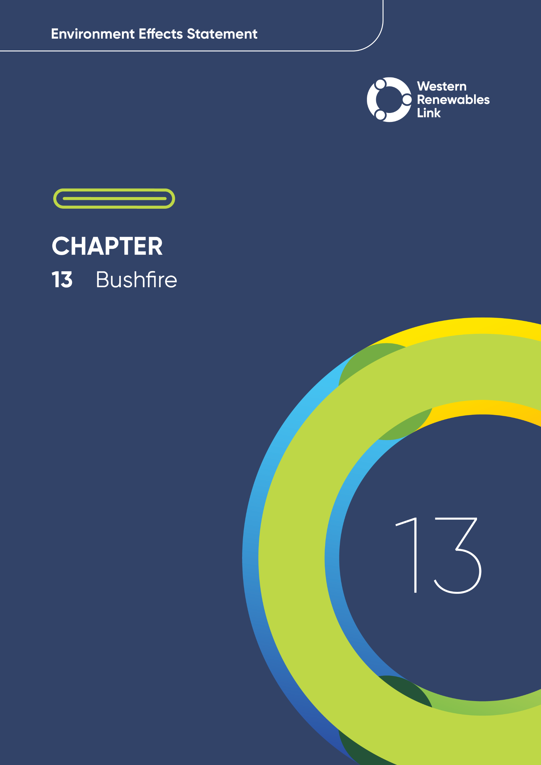

# Bushfire

This chapter provides an overview of the potential bushfire impacts associated with the construction, operation and decommissioning of the Project. This chapter is based on **Technical Report K: Bushfire Impact Assessment**.

* Bushfire

The term ‘bushfire’ is generally used for any type of unplanned landscape fire (or wildfire). ‘Forest fire’ is used for fires in native forests and plantations, while ‘grassfire’ refers to fires in areas with grasses or crops, such as farms or rural residential land.

Bushfires are a natural part of Australia’s ecosystems, and Victoria often experiences weather conditions that can lead to dangerous bushfire events. These fires can occur in almost all types of vegetation, including forests, woodlands, native grasslands, pastoral areas and agricultural croplands. They can also impact nearby settlements and rural living areas.

The Project traverses a landscape that is prone to bushfires, and experiences frequent smaller and infrequent larger fires. There is potential for the Project to affect bushfire conditions during construction and operation. With the planned design, construction and operational measures that will be incorporated, bushfire risk in many parts of the landscape surrounding the Project will remain high but will not be materially increased by the Project.

## Evaluation objective

The scoping requirements identify the following evaluation objectives relevant to bushfire:

**Evaluation objective**

Avoid, or minimise where avoidance is not possible, adverse effects for community amenity, health and safety, with regard to construction noise, vibration, dust, lighting, waste, greenhouse gas emissions, transport network, operational noise, fire risk management and electromagnetic radiation.

Avoid, or minimise where avoidance is not possible, adverse effects on land use, social fabric of the community, businesses including farming and tourism, local and state infrastructure, aviation safety and to affected and neighbouring landowners during construction and operation of the project.

In response to these evaluation objectives, potential bushfire-related impacts from the Project were assessed and measures to avoid, minimise and mitigate potential impacts have been identified. These measures are discussed throughout this chapter and have informed the development of conditions for the draft Incorporated Document that has been prepared to facilitate delivery of the Project. These conditions specify mitigation measures to be undertaken during construction of the Project. During the operation stages of the Project, bushfire-related potential impacts will be managed by AusNet under a regulatory regime that requires risk from bushfire to be reduced as low as practicable.

Environmental Performance Requirements (EPRs) have also been developed in response to other mitigation measures identified by other technical assessments. EPRs set out the environmental outcomes to be achieved through the implementation of mitigation measures during construction, operation and decommissioning to avoid, minimise and manage identified impacts. Cumulative impacts associated with relevant future projects were also assessed.

Further information on how the Project has been designed to avoid and minimise impacts is provided in **Chapter 5: Project development** and **Chapter 6: Project description**.

Other aspects covered in the Environment Effects Statement (EES) evaluation objectives relevant to bushfire are addressed in the following EES chapters:

* **Chapter 11: Landscape and visual**
* **Chapter 12: Land use and planning**
* **Chapter 14: Economic**
* **Chapter 15: Agriculture and forestry**
* **Chapter 16: Aviation**
* **Chapter 17: EMI and EMF**
* **Chapter 18: Air quality**
* **Chapter 19: Noise and vibration**
* **Chapter 20: Transport**
* **Chapter 21: Social**
* **Chapter 26: Greenhouse gas**
* **Chapter 28: Climate change.**

## Method

This section summarises the method adopted in **Technical Report K: Bushfire Impact Assessment**, which was informed by **Chapter 4: EES assessment framework and approach.** The key steps in assessing the impacts associated with bushfire included:

* Defining a study area appropriate for bushfire as presented in Figure 13.1. This included the Project Land and a buffer extending up to 50km into the surrounding landscape. The 50km buffer provided information on the broader landscape and its associated bushfire history (i.e., existing conditions), while a 20km buffer was utilised to assess potential impacts associated with the Project. The scale of the study area was chosen to be consistent with Victorian Government bushfire planning requirements and to consider that bushfires operate and are managed at a landscape scale.
* Reviewing applicable Commonwealth and Victorian legislation, and relevant local, state and national standards, guidelines and policies.
* Conducting a desktop review to determine the existing bushfire conditions, bushfire ignition risks, fire history and bushfire management arrangements. The review included the analysis of data and information from various public sources related to:
  + Bushfire Management Overlays
  + Bushfire Management Zones
  + Bushfire prone areas
  + Farm dams and other potential fire water supplies
  + Fire history for the study area and its landscape context
  + Historical climate records
  + Landforms and topography
  + History of planned and unplanned fires within the study area
  + Values and land uses potentially affected by bushfire
  + Low bushfire rating areas within settlements
  + Neighbourhood safer places-bushfire places of last resort
  + Vegetation mapping
  + Victorian Fire Risk Register – Bushfire
  + Satellite imagery of the Project Land.
* Conducting a risk screening process to identify the types of potential bushfire impact of the Project through its construction, operation and decommissioning and whose mitigation must be addressed within the technical report.
* Undertaking bushfire behaviour modelling at key locations throughout the study area to understand the influence of topography, landform, vegetation and fire weather on the intensity and spread of bushfires at key locations. Bushfire modelling did not specifically inform mitigation measures but provided general context against which the mitigations were assessed and highlighted the need for construction and operational activities to avoid fire ignition and prevent escape from the point of ignition if it occurred.
* Consulting with the relevant regulatory authorities and key stakeholders including Country Fire Authority (CFA), Department of Energy, Environment and Climate Action (DEECA) / Forest Fire Management Victoria (FFMVic), Northern Grampians Shire Council, Pyrenees Shire Council, Hepburn Shire Council, Moorabool Shire Council, Melton City Council and Grampians Regional Emergency Management Planning Committee, and reviewing the pins dropped by community members onto the Project’s Social Pinpoint online mapping tool, which identified locations, features and values of importance.
* Undertaking an assessment of potential impacts of the construction, operation and decommissioning of the Project and describing the existing and planned measures by which these may be mitigated. These were discussed in relation to five “modes” of potential bushfire impact:
  + On-site bushfire ignition: potential impacts of bushfires ignited by the Project or Project-related activities and their mitigation
  + Off-site bushfire ignition: potential impacts on the Project of bushfires ignited and spreading within the landscape it is proposed to traverse and their mitigation
  + Fire suppression: potential impacts of the Project on fire suppression activities in response to on- or off-site bushfire ignitions and their mitigation
  + Bushfire fuel management: potential impacts of the Project on bushfire fuel management in the landscapes surrounding the Project and their mitigation
  + Access and egress: potential impacts of the Project on community egress from areas under bushfire attack and access by fire services to those areas and their mitigation, including analysis of egress towards low bushfire risk areas and Neighbourhood Safer Places – Bushfire Places of Last Resort (NSP-BFPLR).
* Identifying and assessing the potential residual impacts in relation to the five modes of potential bushfire impact, associated with bushfire ignition and bushfire management arrangements. These impacts were evaluated according to the following ratings: in relation to the extent, magnitude and duration of the impacts:
  + Very low: Residual impacts are very well controlled and virtually eliminated by existing and proposed controls across the Project. They would not be expected to occur under reasonably foreseeable conditions.
  + Low: Residual impacts are generally very well controlled across the Project Land. The residual impacts that are described are very uncommon and not expected to recur more frequently than every 50-100 years.
  + Moderate: Residual impacts are generally effectively controlled across the Project Land. The residual impacts that are described may be expected to recur no more frequently than every few decades.
  + High: Residual impacts are not adequately controlled and may be experienced under conditions that can be reasonably expected to recur every few years.
  + Very high: Residual impacts are not adequately controlled under most expected conditions.
* Identifying relevant future projects that could lead to cumulative impacts when considered together with the Project (refer to **Chapter 4: EES assessment framework and approach** for the full cumulative impact assessment method).
* Developing conditions for the Project’s draft Incorporated Document that specify applicable measures for the mitigation of potential bushfire impacts associated with the Project’s construction. These are measures that are not explicitly addressed by existing AusNet bushfire safety procedures under its Electricity Safety Management Scheme (ESMS).

Incorporated Document

Planning approval for the use and development of land required to facilitate the Project will be implemented through a Planning Scheme Amendment and an Incorporated Document. The draft Incorporated Document includes conditions requiring implementation of the Environmental Management Framework, EPRs and other measures to achieve the required environmental outcomes for the Project.

For bushfire-related construction impacts, including those associated with laydown areas and temporary workforce accommodation facilities, the required performance measures are captured as conditions within the draft Incorporated Document, and not as EPRs.

The Incorporated Document has been drafted by AusNet and is being published with the EES.

* Following application of mitigation measures defined in the conditions of the draft Incorporated Document and any relevant EPRs, determining residual impacts associated with the construction, operation and decommissioning of the Project, and evaluating their significance.

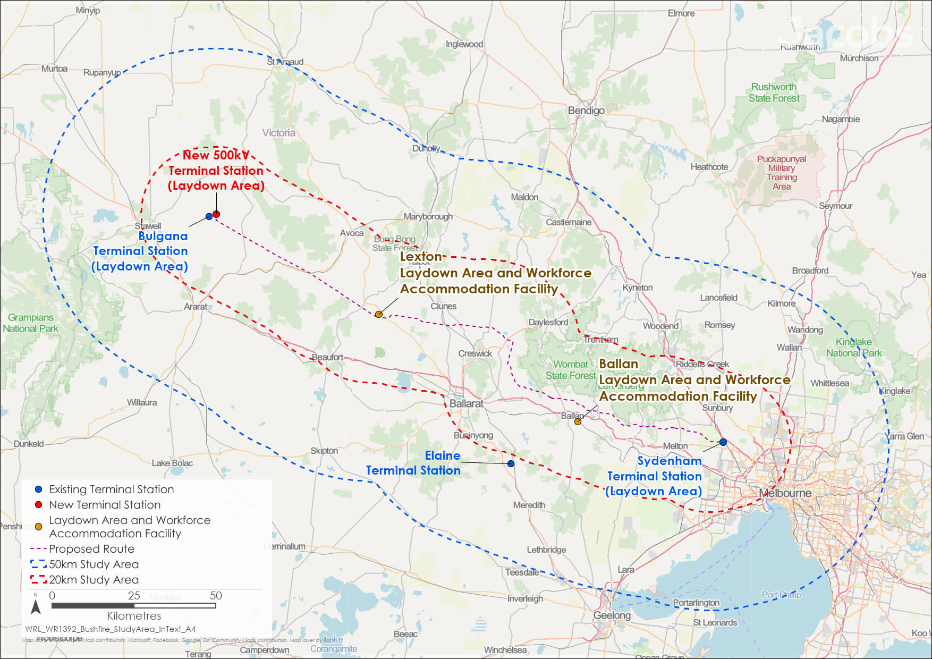

Figure 13.1 Bushfire study area

## Existing conditions

This section summarises the existing conditions for bushfire according to the following key themes:

* Bushfire ignition risks
* Bushfire management arrangements.

The Project is proposed to be constructed in a landscape susceptible to bushfires, where uncontrolled fires have historically caused injuries, fatalities, property damage, and interruptions to land use and business operations. Within the 50km study area, an average of 10,000 hectares (ha) of land has been affected by bushfire each year between 1980 and 2023. Fires are much less common within the Project Land. Only six fires, affecting approximately 3.5 per cent of the Project Land (760ha), have been recorded over that 44-year period.

Several agencies share responsibility for fire prevention, planning, response and recovery, including Emergency Management Victoria (EMV), CFA, DEECA / FFMVic, Fire Rescue Victoria (FRV) and local governments.

### Bushfire ignition risks

* Fire behaviour

Fire behaviour is greatly affected by the shape and features of the land. Fires move faster uphill than on flat land or when burning downhill.

Higher areas face stronger winds, causing fires to spread quicker and throw embers further ahead of the main fire front.

South-facing areas are usually wetter than north-facing ones, making them less prone to fires early in the bushfire season. However, these areas can have more fuel and more intense fires later in summer once they dry out.

On days with highly elevated fire weather conditions (e.g., Black Saturday, 2009), fire behaviour is largely driven more by weather than bushfire fuel availability or landscape features.

Most of the Project Land has been designated by the Victorian Government as bushfire prone and most large patches of woody vegetation within or near it fall within Bushfire Management Overlays, as presented in Figure 13.3 and Figure 13.4. These overlays indicate where bushfire protection measures are required. About 12 per cent of the Project Land is covered by these overlays, compared to 27 per cent of the 20km study area, meaning the Project has been located to reduce exposure to higher bushfire risk areas so far as reasonably practicable, but not completely avoid Bushfire Management Overlay areas.

Much of the public land within the 20km study area is contained in Fire Management Zones designated by DEECA. These are areas designated for bushfire fuel management programs, traditionally implemented via planned burning and increasingly incorporating cultural burning by Traditional Owners. The Project intersects or is adjacent to these areas at five locations.

The highest risk bushfire fuel hazards surrounding the Project includes patches of native eucalypt forest and woodland (located mostly on public land), commercial blue gum and pine forest plantations and roadside vegetation. Pasture grasses and rainfed crops, which cover about 80 per cent of the Project Land, are also significant potential bushfire fuel sources.

DEECA records list over 500 individual bushfire events within 50km of the Project since 1980 (DEECA, 2024). Most of the larger fires originated and / or largely burnt in native forests. Only six of these fires intersected the Project Land (see Figure 13.2).

Bushfire activity is more likely and bushfire behaviour more severe during summer due to bushfire fuels being drier, and the greater frequency of days with elevated temperatures, low relative humidity and intense winds. Highly elevated fire weather conditions typically occur in areas surrounding the Proposed Route on up to two days each year. Climate change is expected to exacerbate these conditions, leading to increase the number of extreme fire weather condition days by about three to six days per year by 2070 (from five to 11 days per year currently).

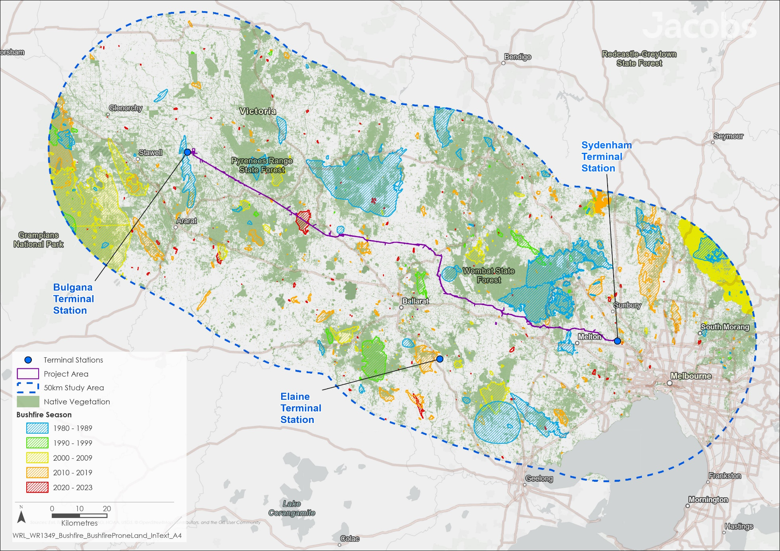

Figure 13.2 Bushfire history in the study area (50km buffer)

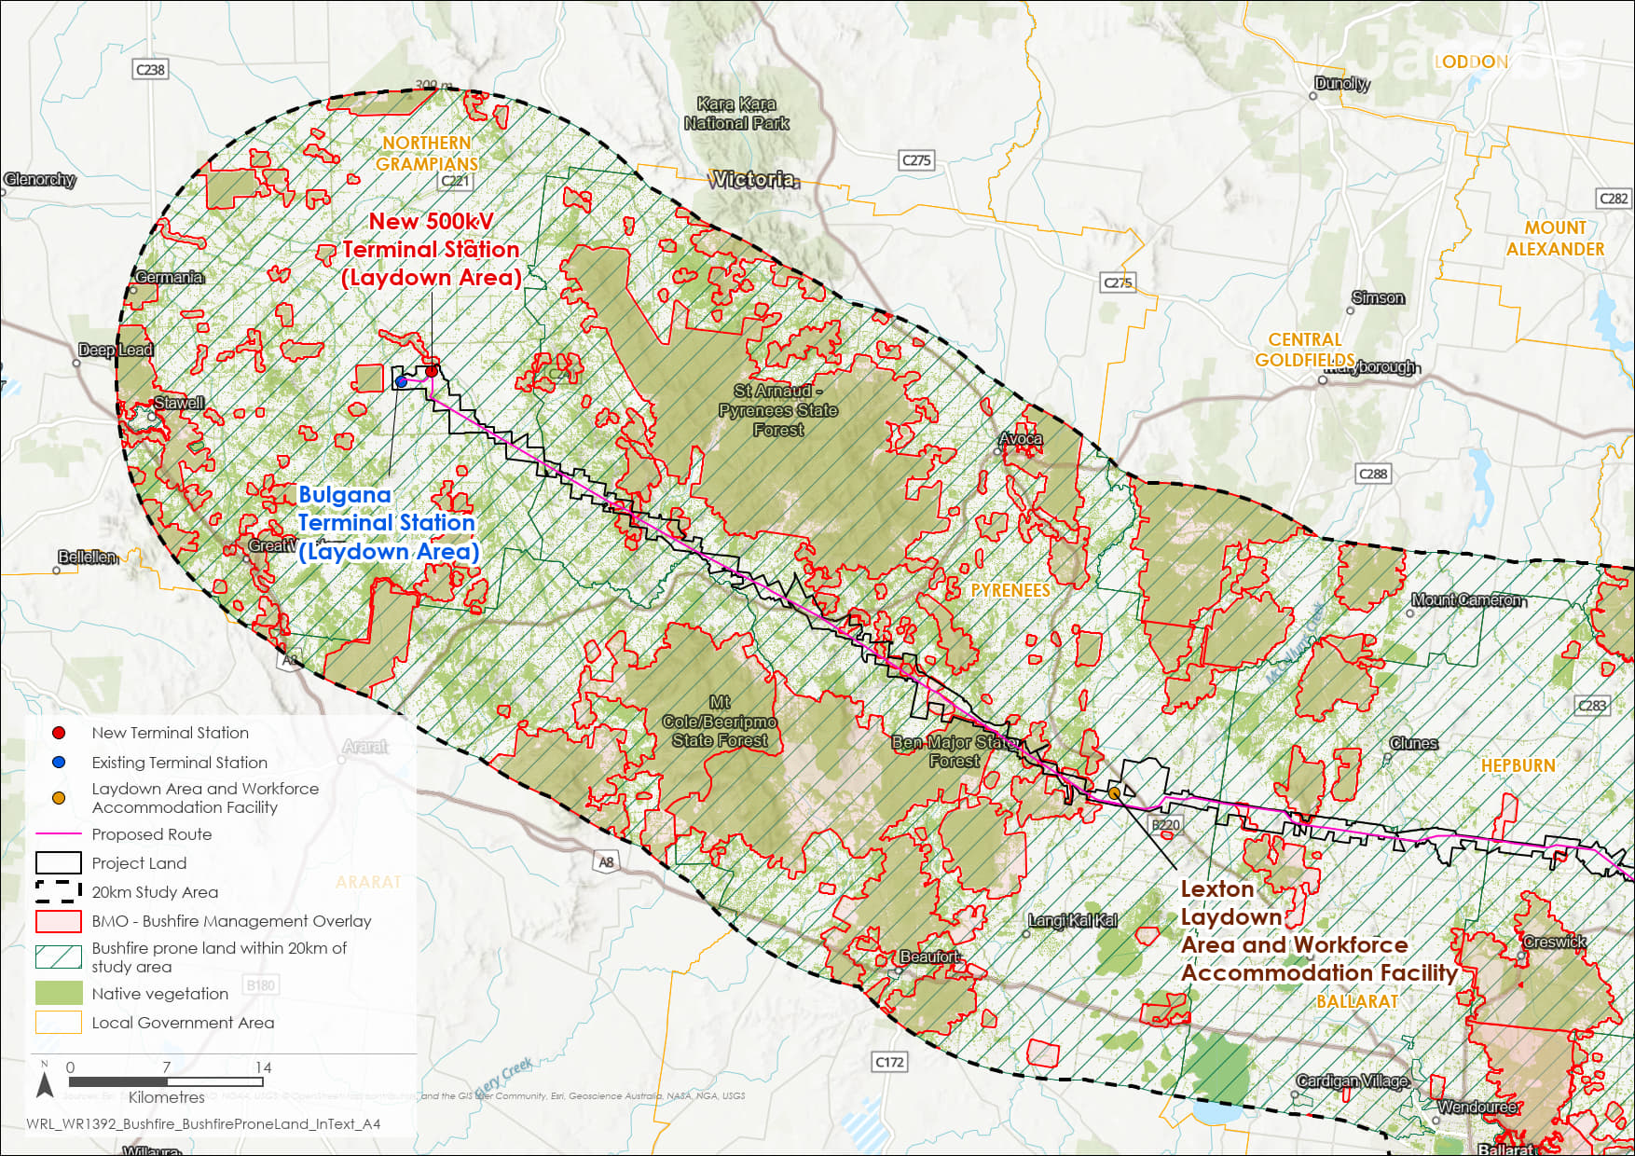

Figure 13.3 Bushfire prone land, land included within the Bushfire Management Overlay and areas supporting native vegetation in the study area: Bulgana to Bolwarrah

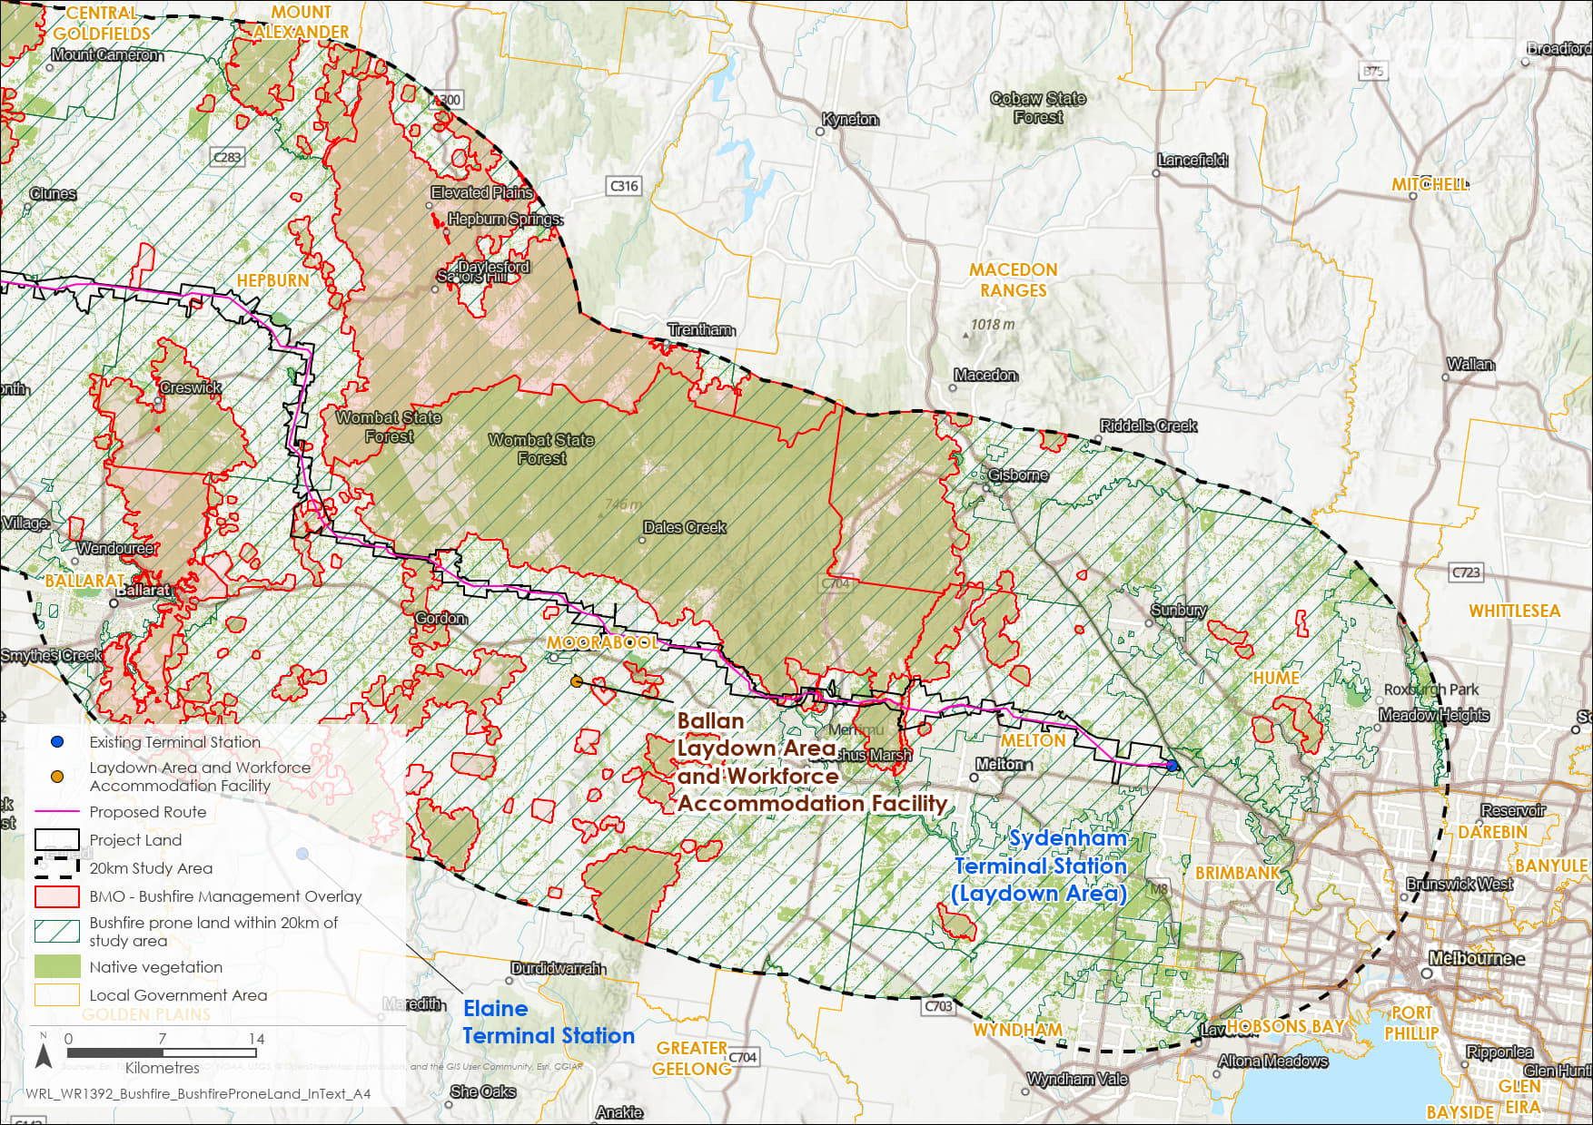

Figure 13.4 Bushfire prone land, land included within the Bushfire Management Overlay and areas supporting native vegetation in the study area: Clunes to Sydenham

The **Technical Report K: Bushfire Impact Assessment** used the Victorian Fire Risk Register – Bushfire and identified assets at risk within 20km of the Project. This includes towns, camping grounds, schools, sports grounds and other facilities mostly located on private land where bushfire could have catastrophic consequences. Economic assets at risk include water, communications and transport infrastructure, forestry plantations and agricultural land uses.

### Bushfire management arrangements

Transmission lines are essential for continuous power supply. Minimising fire ignitions from transmission lines is governed by the *Electricity Safety Act 1998* (Vic), Electricity Safety (Electric Line Clearance) Regulations 2020 and Electricity Safety (Bushfire Mitigation) Regulations 2023. Bushfire prevention, planning and response are coordinated at a state level through the State Emergency Management Plan Bushfire Sub-Plan (EMV, 2021) and regionally through Regional Emergency Management Plans and Regional Bushfire Management Strategies. Key agencies include EMV, CFA, FFMVic, FRV, and local government.

Local government authorities are required to establish Municipal Emergency Management Planning Committees to prepare and review Municipal Emergency Management Plans. These plans cover emergency planning, response and recovery for hazards, identify key emergency events and describe measures to reduce bushfire risk. They also list refuges and Neighbourhood Safer Places-Bushfire Places of Last Resort, where applicable. Each local government authority operating in the Project Area has also prepared a Municipal Fire Management Plan. These plans detail how to prevent, plan, respond and recover from fires, including bushfires and structure fires. They also show where strategic fire breaks and fire control lines are maintained along roads.

AusNet’s electricity safety management framework provides for monitoring and audit of conformance with regulatory requirements. Existing bushfire management measures that apply to the Project fall into four main categories:

* Measures that apply across the Victorian electricity transmission network: AusNet operates within Victoria’s electricity transmission network and has developed its Electricity Safety Management Scheme (ESMS), Bushfire Mitigation Plan and Vegetation Management Plan to comply with regulatory requirements. These measures apply to the design, construction and operation of the Project and fall within the scope of AusNet’s ESMS. The ESMS provides for the safe and reliable operation of the electricity transmission network and includes the avoidance of asset management failures that could lead to bushfire ignitions. AusNet's Bushfire Mitigation and Vegetation Management Plans are included in these measures, which are regulated by the Victorian State Government to minimise bushfire risks as much as possible.
* Measures that apply during planning for and construction of the Project: These measures are specified in the draft Incorporated Document and are intended to prevent bushfire ignitions associated with construction activities and provide for the bushfire-safe development and operation of laydown areas, temporary workforce accommodation facilities and the new 500kV terminal station near Bulgana.

The Victorian Government’s Safer Together policy guides planning to reduce bushfire risk through fuel management on public land. Under this policy and the State Emergency Management Plan Bushfire Sub-Plan, DEECA has prepared bushfire management strategies for its Grampians and Port Phillip regions (DELWP, 2020a; DELWP 2020b). These strategies focus on managing fuel and ecological fire risks.

* Measures that apply during construction and decommissioning of the Project: These measures are incorporated into the Environmental Management Framework as EPRs. EPRs relevant to bushfire vary in their intended outcomes but are mainly focused on avoiding bushfire ignition, managing safety for the construction workforce and minimising disruption to aerial fire response operations.
* Business-as-usual bushfire planning, management and emergency responses by fire authorities and State and local government (via land and air): These measures are undertaken independently to the Project, but may, in some settings, need to be adapted for the Project. Some measures seek to minimise disruption to existing arrangements for bushfire planning, management and emergency response so that landscape bushfire risk is not exacerbated by the Project.

Sometimes, parts of the network may be deactivated when a bushfire is nearby to prevent flashover and the hazard that poses to fire response personnel and others located near the transmission line. Any request by emergency services to deactivate part of the transmission network would have to be approved by the Australian Energy Market Operator (AEMO). Fire authorities have robust safety procedures in place to protect their personnel from flashover during bushfire events.

Aircraft are widely used in fire suppression across Victoria. They typically operate in conjunction with ground crews to reduce the intensity and spread of a bushfire. Fire response aircraft are based at or may use several airfields situated near the Project, including those at Stawell, Ballarat, Bacchus Marsh, Melton, Essendon and Avalon. Fixed-wing aircraft (e.g., airplanes) return to their bases or other suitable nearby airfields to refill with water, while helicopters can refill with water (where available) from local farm dams and water supply reservoirs.

Aerial firefighting is conducted at low levels by trained and experienced pilots who operate in accordance with visual flight rules. Pilots must be able to see the ground and avoid smoke to drop water or fire retardant safely and accurately. Fixed wing aircraft usually do not fight fires at night, but helicopters fitted with night vision imaging systems may do so. Further details are provided in **Technical Report J: Aviation Impact Assessment** and **Technical Report K: Bushfire Impact Assessment**.

* AusNet’s Electricity Safety Management Scheme (ESMS)

AusNet is required by the *Electricity Safety Act 1998* (Vic) to maintain an ESMS that is reviewed and, if appropriate, accepted by Energy Safe Victoria (ESV). The ESMS describes the policies, strategies and procedures within AusNet’s Asset Management System that provide for the safe operation of the transmission network – including safety from a bushfire perspective. These documents provide for:

* Application of design standards that provide for the structural resilience of transmission towers and lines
* Quality assurance processes for design and construction to ensure conformance with relevant Australian Standards
* Protection systems that de-energise transmission lines if there is any form of electrical connection with the ground
* Inspection and maintenance of the infrastructure for the detection and rectification of any issues that would compromise electrical safety
* Training of AusNet’s personnel to ensure competency in their roles. For roles relating to the Bushfire Mitigation Plan, competencies are audited annually.

AusNet’s Bushfire Mitigation and Vegetation Management Plans are included within the ESMS framework. The framework is intended to reduce, as low as practicable, all safety risks associated with AusNet’s electricity transmission network, including its bushfire safety. There are no known examples in Victoria over the last 30 years of the ignition and escape of bushfires from AusNet’s transmission network.

## Construction impacts

This section outlines the key issues identified through the risk screening process and associated potential impacts during the construction of the Project. The key issues and impacts identified for bushfire are discussed according to the following themes:

* Bushfire ignition impacts: potential on-site bushfire ignition impacts and off-site bushfire ignition impacts.
* Bushfire management arrangements: potential impacts to bushfire suppression, bushfire fuel management, and bushfire emergency access and egress.

### Bushfire ignition impacts

* Flashover

A flashover occurs when electricity, especially at higher voltages, jumps across an air gap to create a conductive path. A flashover may occur between powerlines or from powerlines to the ground. It is typically seen as a flash and /or heard as an explosion or loud cracking sound.

Under everyday conditions, the height of powerlines and their separation from each other are designed to be entirely safe from flashover. However, smoke or gases from a fire burning under or close to the powerline can provide a conductive path that increases the potential for flashover.

Flashover poses a safety hazard to fire responders and others located near powerlines when thick smoke is present. For this reason, fire authorities’ safety procedures require personnel to maintain appropriate clearances when working near powerlines during bushfires and planned burns.

As described in Section 13.3, most of the Project Area is prone to bushfire, with most larger patches of bushfire prone woody vegetation (native forests and woodlands, pine and eucalypt plantations) located within Bushfire Management Overlays under local planning schemes.

In the absence of mitigation measures, construction activities associated with the Project could ignite a bushfire that escapes beyond the immediate vicinity, and result in harm to the public and / or workforce personnel, and damage to public and private property, equipment and Project infrastructure. Ignition could occur via ‘hot works’ (activities with potential to create a spark or generate hot particles, such as welding), fires being deliberately lit, off-road vehicle use, a vehicle accident or parking in areas where dry grass or similar bushfire fuels contact the hot parts of vehicles (such as exhausts).

Depending on the severity of the fire and warning time, an off-site bushfire or an on-site fire ignition could, in the worst case, lead to injury, loss of life, psychological trauma to both the public and construction personnel, and / or damage and / or disruption to property, land uses, the environment and / or heritage features in the surrounding landscape.

In consultation with relevant fire authorities, the Principal Contractor will develop and implement a Project-wide Construction Bushfire Management Plan to eliminate, so far as reasonably practicable, the potential of on-site bushfire ignition and escape during construction activities. A Construction Bushfire Management Plan will also be developed for the two workforce accommodation facilities. Requirements for these plans are set out in the draft Incorporated Document, with mitigation measures to include:

* Use of a hot works permit system, which will provide an authorisation framework and set of controls for construction activities that generate sparks, heat or hot material. Hot works would not be permitted outside of the CFA permitting framework, and specifically would not be permitted in Bushfire Prone Areas on a day of Total Fire Ban and / or under Catastrophic fire weather conditions.
* Controls on the storage of flammable liquids to provide appropriate separation is maintained between any hot works or potential bushfire fuels and stored flammable liquids.
* Specific requirements for vehicles travelling on unsealed public roads during the declared fire danger period and on Total Fire Ban days, including requirements to carry a fire extinguisher, park away from potential bushfire fuels, how petrol-powered vehicles with a catalytic converter are used and carrying out vehicle condition checks.
* Having an on-site fire response capability during construction, including requiring construction crews to have adequate fire water supplies and appropriate hand tools available to extinguish/contain any fire ignition, and requiring personnel to have relevant accredited training in ignition prevention and response.
* Vegetation and vegetation stockpile management to prevent on-site accumulation of bushfire fuels.
* Preparation of an emergency management plan that addresses bushfire and other applicable hazards.

Other bushfire protection measures include vegetation removal at the construction sites and laydown areas and the inherent fire resilience of most Project-related construction materials and equipment. Vegetation within the laydown areas, existing Bulgana Terminal Stations, new 500kV terminal station near Bulgana and temporary workforce accommodation facilities will be maintained as low-threat vegetation (e.g., grass kept to less than 100mm in height) for the duration of their use in relation to the Project.

In the event of a bushfire ignited off-site moving onto the Project Land; flames, radiant heat, smoke or embers could affect construction workforce personnel and damage Project infrastructure and equipment at construction sites and laydown areas. However, significant fire damage to Project infrastructure during construction is unlikely due to the materials used and their inherent fire resilience.

The construction stage will also require the implementation of a Project-wide Emergency Management Plan (EPR EM6) that will form part of or complement the Construction Environmental Management Plan (EPR EM2). The plan will be prepared in consultation with fire authorities and will address both on-site and off-site ignition, including:

* Daily readiness and preparation for bushfire requirements, including awareness of forecast fire weather conditions and monitoring fire incidence and bushfire warnings in the landscape surrounding the construction site(s)
* Advice on what to do in case of on-site and off-site fire ignition
* Evacuation routes should construction and / or laydown areas be threatened by fire
* Roles and responsibilities of key personnel and training requirements
* Induction, exercising and other processes to raise awareness and application of the Plan by construction crews.

These measures will be supplemented by fire detection and suppression activities by fire authorities (CFA and FFMVic) and public bushfire safety warnings. Within the Project Area, fire detection and suppression activities by emergency services are expected to continue to control the size and impact of most fires that ignite (both on-site and off-site). Prior to the commencement of construction, relevant fire authorities will be notified by AusNet that the infrastructure is not electrically active and hence safe to approach during a bushfire event. Subsequent notification of when this will change is to be provided prior to the infrastructure becoming electrically active. This notification is included as a condition of the draft Incorporated Document and provides for the safety of fire response personnel working near the Project.

The laydown areas and workforce accommodation facilities are situated on land that is designated as bushfire prone, but outside higher bushfire risk areas within the Bushfire Management Overlay. They will be designed and laid out to achieve required setback distances from classified vegetation. Temporary workforce accommodation facilities and other structures in which people congregate will be exposed to a Bushfire Attack Level (BAL) of no more than BAL-Low, as defined by AS3959:2018 Construction of buildings in Bushfire Prone Areas, required under Clause 13.02-1S Bushfire planning of the Planning Scheme, and in compliance with conditions in the draft Incorporated Document. Vegetation within these properties will be maintained as low-threat vegetation (e.g. ensuring grass growth is less than 100mm in height) for the duration of their use in relation to the Project, which will limit fire spread into and through these sites. Further information regarding assessment of the laydown areas and temporary workforce accommodation facilities is proved in Appendix L of **Technical Report K: Bushfire Impact Assessment.**

A Construction Bushfire Management Plan will also be developed specifically for the temporary workforce accommodation facilities, in line with the Project-wide Construction Bushfire Management Plan. This will be based on a comprehensive assessment of bushfire hazards and will mitigate these to the extent reasonably practicable (in line with Victorian Occupational Health and Safety legislation and in compliance with the conditions of the draft Incorporated Document). An Emergency Management Plan for the temporary workforce accommodation facilities is also required as a condition of the draft Incorporated Document. This will be prepared in consultation with the relevant fire authorities and relevant councils. Similar to the Project-wide Emergency Management Plan (EPR EM6), it will also include procedures for how to deal with fire in buildings, bushfire, and medical emergencies. Details of the condition are provided in Table 13.1.

The Project’s fire safety measures will minimise the opportunities for fire ignition and bushfire escape. By designing and locating temporary workforce accommodation facilities to avoid impacts, and by various other measures specified here, in **Technical Report K: Bushfire Impact Assessment** and in draft conditions of the draft Incorporated Document, the residual impacts of bushfires starting during construction are expected to be low for off-site ignition and very low for on-site ignition.

### Bushfire management arrangements

In the absence of mitigations, the presence of Project infrastructure could diminish the effectiveness of fire suppression activities and bushfire fuel management activities, as well as impede access to or egress from nearby active firegrounds.

##### Fire suppression activities

During construction, Project infrastructure has the potential to hinder fire suppression efforts, potentially causing fires to spread more than usual. This could lead to greater impacts on people, property, the environment, and heritage sites.

As detailed in Section 13.4.1, an Emergency Management Plan (EPR EM6) will be prepared in consultation with emergency service authorities for the construction stage which will detail what to do in case of on-site or off-site fire ignition, roles and responsibilities and training, and awareness for staff.

Once the transmission line is strung (i.e. in place, regardless of their electrical activity), fire response helicopters will not be able to access fire water supplies from the relatively small number of farm dams located near to the Project. However, there are many other nearby farm dams or larger water supply reservoirs that could be accessed by helicopters. Hence aerial access to in-field fire water supplies is unlikely to be materially disrupted by the Project.

While unlikely, fire response aircraft could make contact with transmission towers or non-operational transmission lines, leading to an air crash / safety incident (and injury or death of aircraft operators) or a near miss. This could lead to aerial fire responses being suspended, and increased reliance on ground-based responses. Notably, there are no known records in Australia of such crashes during aerial fire-fighting operations. The main mitigation for these potential impacts is to inform pilots (via the Civil Aviation Safety Authority) of the Project and the location of the infrastructure (EPR AV1).

If emergency services do not adapt their response protocols to the presence of the Project, the efficacy of fire suppression operations may be impaired around the Project. For example, ground-based fire crews may be unable to work in the immediate vicinity of the transmission line during construction if there is uncertainty about electrical hazards. To mitigate this, fire authorities will be informed that the Project infrastructure is not electrically active during construction. They will also be notified when the infrastructure becomes electrically active, allowing them to update their response procedures, minimise emergency service personnel safety risks and the impact on fire suppression efforts.

Backburning, a tactic to contain bushfires by igniting fires along pre-established control lines (e.g., firebreaks, roads) will not be impacted by construction activities, noting that this activity is not likely to be conducted adjacent to the Project.

Through the implementation of measures in compliance with the draft Incorporated Document and EPRs for environmental and emergency management during construction, residual impacts relating to fire suppression activities during construction are expected to be low to very low.

##### Bushfire fuel management activities

The presence of Project infrastructure during the construction stage has the potential to constrain bushfire fuel management activities. Planned fuel reduction burning near construction sites and transmission lines might be constrained by the presence of the infrastructure. This could lead to the build-up of bushfire fuel loads and a greater risk of larger, harder-to-control fires.

However, given the limited construction period (approximately two years), it is unlikely that excessive bushfire fuel accumulation would result during the construction period. Furthermore, the Project does not generally pass through the large blocks of public land that are subject to planned burning activities to manage landscape fuel loads. In some isolated instances, the clearance and maintenance of the transmission line corridor may provide a control line which would further assist planned burning and bushfire fuel management. The presence of the transmission line is not expected to affect mechanical bushfire fuel controls along roadsides and the preparation of strategic fire breaks and fire control lines which intersect the Project. Therefore, the residual impact on bushfire fuel management is expected to be very low.

##### Access to and egress from active firegrounds

The Project crosses priority bushfire access and egress routes at four locations, as seen in Figure 13.5 andFigure 13.6. There are no known incidents in Victoria where collapse of electricity transmission infrastructure has blocked fire access or egress during bushfire events. These routes are designated in Municipal Fire Management Plans as priority evacuation routes from bushland areas in the Pyrenees Ranges, Wombat Forest, Lerderderg/Darley/Coimadai area and at Long Forest. They also serve as access routes for emergency services entering fire grounds in these same areas.

In these areas, potential structural failures of infrastructure (due to wind, sabotage or contact with a vehicle or farm machinery), could result in a tower or transmission line falling across an access or egress route. If a structural failure was to occur, this could impede or prevent access to fire grounds by emergency services, and / or egress ahead of an approaching fire. Evacuees’ escape ahead of an approaching fire could be delayed if they awaited confirmation that the infrastructure was safe to cross, or they sought alternative escape routes. The hazard in this scenario is partly reduced given that Project infrastructure is not electrically active during the construction stage. In accordance with one of the conditions in the draft Incorporated Document, AusNet will formally advise fire authorities that the Project infrastructure is not electrically active during construction, and of the date at which Project infrastructure will be electrically active and hence cannot be assumed to be safe to cross.

Transmission line design is in accordance with AS/NZS 7000:2016 *Overhead line design* and AS/NZS 1170.2-2021 *Structural design actions. Part 2: Wind actions*, which provides for resilience under extreme wind conditions. Design standards of towers also provide sufficient strength for the structures to resist accidental damage from contact with vehicles or farm machinery. Transmission towers are placed outside of public road reserves, greatly reducing the chance of accidental contact by vehicles. Towers are located at sufficient distances from most (but not all) fire access routes and fire control lines, to avoid the chance of structural failure of towers leading to these routes being obstructed. For further information refer to Appendix G of **Technical Report K: Bushfire Impact Assessment.**

Construction traffic is unlikely to affect fire access for emergency services. The Construction Emergency Management Plan will stop construction access on key routes during active bushfires or on days with catastrophic fire weather (EPR EM6). It would specify that construction traffic would be halted along key emergency access / egress routes during a bushfire event in proximity to the Project or under catastrophic fire weather conditions. This should prevent construction traffic from disrupting fire-related access and egress.

Access and egress constraints posed during the construction stage would be confined to a relatively brief period (approximately two years). Design mitigations, together with other mitigation measures reduce these constraints to access and egress to achieve compliance with the EPRs and draft Incorporated Document conditions, and result in a very low residual impact.

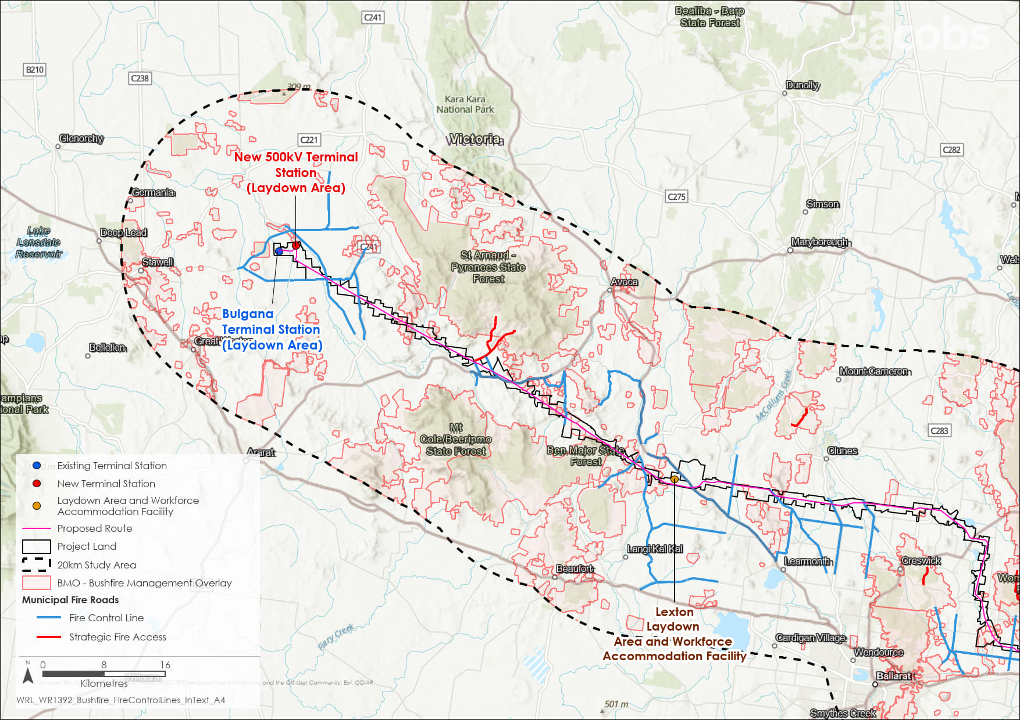

Figure 13.5 Location of strategic fire control lines and fire access roads in proximity to the Project. Redrawn from Northern Grampians, Pyrenees, Ballarat, Hepburn and Moorabool Municipal Fire Management Plans (Bulgana to Bolwarrah)

Figure 13.6 Location of strategic fire control lines and fire access roads in proximity to the Project. Redrawn from Northern Grampians, Pyrenees, Ballarat, Hepburn and Moorabool Municipal Fire Management Plans (Clunes to Sydenham)

## Operation impacts

This section outlines the key issues identified through the risk screening process and associated impacts during the operation of the Project. The key issues and impacts identified for bushfire during operation of the Project are summarised according to the following themes:

* Bushfire ignition impacts: potential on-site bushfire ignition impacts and off-site bushfire ignition impacts.
* Bushfire management arrangements: potential impacts to bushfire suppression, bushfire fuel management, and bushfire access and egress.

### Bushfire ignition impacts

In the absence of mitigation measures, the ways in which the operation of the Project could ignite a fire include:

* Lightning striking a transmission tower
* An extreme wind event or structural fault causing a transmission tower to collapse or a live transmission powerline to contact the ground, vegetation and / or another live powerline
* Vegetation or wildlife contacting transmission lines or switchgear at a terminal station
* Explosive failure of a transformer at a terminal station
* Maintenance activities such as hot works and off-road vehicle use and parking (as for construction activities – see Section 13.4.1)
* Flashover whereby electricity is conducted from a transmission line via smoke, flame or water vapour to the ground. Unlike the other potential sources of ignition, any ignition resulting from flashover would only occur if fire was already in close proximity to the Project.

While on-site bushfire ignition is unlikely, a fire ignited in any of these ways that spreads beyond the Project easement or footprint of the terminal stations could cause harm to people, damage property and disrupt agricultural and other land uses. As the population grows in the study area, more people and property could be exposed. This increased exposure will mainly affect Bushfire Prone Areas. Urban growth within or near the Project will see an increase in population and property development but may reduce the area of bushfire prone land.

Strict safety laws govern electrical infrastructure in Victoria. As the Project’s operator, AusNet is required to comply with the *Electrical Safety Act 1998* (Vic) and its regulations. AusNet must maintain and implement an Electricity Safety Management Scheme (see ‘Electricity Safety Management Scheme’ information box) that is accepted by ESV. The Scheme includes AusNet’s existing Bushfire Mitigation Plan, which outlines how bushfire risks are managed across the entire transmission network. The Bushfire Mitigation Plan must comply with regulatory requirements under the Electricity Safety (Bushfire Mitigation) Regulations 2023 and include the following elements:

* Policies and programs to mitigate fire ignition risk from network assets, and processes to monitor their implementation and effectiveness
* Procedures for monitoring, reviewing, auditing and reporting on the implementation and effectiveness of the bushfire mitigation strategies and programs
* Procedures for operating and maintaining the network in hazardous bushfire risk areas during the fire season period and on Total Fire Ban days
* Roles and responsibilities for preparation and implementation of the Bushfire Mitigation Plan
* Contact details in the event of an emergency.

Managing vegetation is crucial for reducing bushfire risks around electricity networks. AusNet’s Vegetation Management Plan complies with the Code of Practice for Electric Line Clearance under the Electricity Safety (Electric Line Clearance) Regulations 2020 to provide safe operation of the electricity network by keeping clear spaces and managing fuel hazards near transmission lines. For the Project, AusNet will monitor and, as necessary, trim, vegetation to maintain regulated minimum clearances with powerlines in line with the Electricity Safety (Electric Line Clearance) Regulations 2020.

A fire due to either on-site or offsite ignition could damage transmission line infrastructure, temporarily disrupt power supply and / or threaten the safety of maintenance crews. The impact will depend on how intense the fire is, how much warning there is, and how well it can be managed. If a fire occurs near the Project infrastructure, the materials used in the towers and transmission line are designed to withstand the heat. Conformance with transmission line safety controls and vegetation management within the transmission line easement will limit fire intensity and the level of damage to Project infrastructure and power supply disruption. A fire event may cause minor delays in maintenance works. If the transmission line is damaged, it will need to be repaired before electricity transmission can resume. Sometimes, the transmission line might be deactivated to help with fire suppression efforts.

Fires burning in the agricultural areas through which the Project is proposed to be constructed are unlikely to develop such extreme winds that towers may collapse. Adherence to design standards for the infrastructure (AS/NZS 7000:2016 *Overhead line design.* Standards Australia, 2016; AS/NZS 1170.2-2021 *Structural design actions. Part 2: Wind actions.* Standards Australia, 2021) mean that the infrastructure would be resilient under reasonably foreseeable wind conditions that may be experienced in the landscape around the Project Area, both during a fire and at other times.

Vegetation management, around and within the terminal stations will also reduce the potential of radiant heat and embers causing damage to the infrastructure.

Implementation of AusNet’s standard procedures for its transmission network (e.g., Electricity Safety Management Scheme, Bushfire Mitigation Plan and Vegetation Management Plan) will assist to mitigate and manage the potential for bushfire ignition. The potential residual impact of both on-site and off-site fire ignitions is expected to be very low.

### Bushfire management arrangements

Without appropriate mitigations, the presence of electrically active transmission infrastructure for the Project could hinder efforts to suppress fires, affecting both ground-based or aerial fire responses, and potentially causing a fire to spread to a greater extent than it would have otherwise. If management of bushfire fuels (through hazard reduction burning or slashing) in forests, farmland and roadsides adjacent to the transmission line was constrained by the presence of Project infrastructure, bushfire fuel loads might accumulate to excessive levels, resulting in larger and harder-to-control fires if ignited. If the Project infrastructure were to fail during a bushfire, people’s evacuation ahead of an approaching fire or fire services’ access to active firegrounds might be restricted, increasing the potential for physical harm to evacuees and worsening the impacts due to restricted access for suppression efforts.

##### Fire suppression activities

With no controls in place, the operation of the Project could impair efforts to suppress landscape-scale fires in the following ways:

* Disrupting access by fire response helicopters to fire water supplies located near the Project – namely parts of Hepburn Lagoon, Pykes Creek Reservoir and Merrimu Reservoir, and various farm dams. Flight paths to and from water sources may need to be altered, which could slow down the response time and make it harder to support ground-based crews fighting the fire. As discussed in Section 13.4.2, helicopters would not be able to draw water for firefighting from farm dams located below or adjacent to Project infrastructure.
* Fire response aircraft might collide with the transmission line or towers, causing a crash or safety incident. A near miss could disrupt aerial fire operations, requiring ground-based crews to work without aerial support, thereby reducing the overall effectiveness of fire suppression.
* Fire response aircraft are unable to operate in the immediate vicinity of the proposed transmission line, potentially making them less effective in supporting ground-based fire crews.
* Ground-based fire crews cannot work in the immediate vicinity of the transmission line due to electrical safety concerns. If they cannot fight fires in the immediate vicinity of the transmission line, the fire response may not be as effective.

If fire suppression efforts are hindered, the fire could spread farther than might otherwise be the case, causing greater or more severe damage to people, property, the environment, and heritage sites.

The measures to control the potential impacts on fire during the operation of the Project are largely as described for its construction stage (see Section 13.4.2). The key difference is the potential disruption to ground-based fire suppression efforts near electrically active Project infrastructure. During operation, road congestion would not be an issue as AusNet maintenance traffic will not noticeably affect traffic flows.

As outlined in Section 13.4.2, pilots of fire response aircraft will be informed (via the Civil Aviation Safety Authority) of the presence of Project infrastructure (EPR AV1). As long as the pilots have visibility of the infrastructure and potential fire water supply, they should be able to access fire water supplies located near the Project. Few farm dams are located directly below or adjacent to Project infrastructure and nearby alternatives are available throughout the study area.

Through the application of EPR AV1, AusNet’s operational bushfire controls (as per its Electricity Safety Management Scheme) and standard fire response measures, potential residual impacts to fire suppression activities during operation of the Project are expected to be similar to the construction stage – low to very low for most locations.

A moderate residual impact is expected in locations where the Project intersects strategic fire control lines and fuel breaks designated in Municipal Fire Management Plans. This impact relates to the operation of fire control lines and fuel breaks where the Project crosses public roads that are used for these functions. Although fire response crews may safely drive below transmission lines, electrical safety procedures do not permit fire response crews to work within the transmission line easement. This could reduce their effectiveness and impair aspects of the fire response depending on the relative orientation of the approaching fire front and the control line / fuel break. Potential disruptions to the use of fire control lines may be minimised through the implementation of specific fire response tactics by the fire authorities.

##### Bushfire fuel management activities

With no controls in place, the presence of the transmission line infrastructure might limit planned or hazard reduction burning in forests, farmland and / or roadsides. This could lead to the build-up of bushfire fuel loads and a greater risk of larger, harder -to-control fires. Most planned burns are undertaken in native forests on public land, so the impact would be confined to four locations: the far north-east of Ben Major State Forest, southern section of Mount Beckworth Scenic Reserve, Bolwarrah, the southern extent of Lerderderg State Park, and north of Long Forest. However, with appropriate controls and safety clearances, planned burning is permitted near electricity transmission lines.

While machinery will need to maintain appropriate separation to avoid contact with and damage to the towers, transmission line infrastructure will not prevent bushfire fuel management undertaken by mechanical methods. Accordingly, the residual impact for bushfire fuel management activities during the operation of the Project is expected to be very low.

##### Access to and egress from active firegrounds

As discussed in Section 13.4.2, the Project crosses priority bushfire access and egress routes in the Pyrenees Ranges, Wombat Forest, Lerderderg/Darley/Coimadai and Long Forest areas. In these areas, emergency access and egress routes could be impeded if a structural failure of infrastructure were to occur (due to wind, sabotage or contact with a vehicle or farm machinery). While the transmission line would most likely be deactivated automatically (by network protection systems) once it made earth contact, people and fire crews are advised not to cross fallen transmission lines unless advised / demonstrated by AusNet that it is safe to do so.

If ground-based emergency service personnel cannot access fire grounds, there is a potential that the fire’s impact could worsen. Evacuees trying to escape from fire grounds could be delayed as they await confirmation that the infrastructure is safe to cross or seek alternative escape routes (where they exist). This could expose them to harm from the approaching fire. However, this impact is highly unlikely and would only happen if the Project infrastructure failed at the time and place needed for escape during a severe fire. There is no known record of such an incident in Victoria.

Bushfire modelling case studies reinforce the importance of following emergency service advice to leave early from areas with limited fire egress. While people located in areas where potential access / egress issues have been flagged are threatened by fires burning towards them through forested areas to the north, they are also threatened by fires that are driven by strong south-westerly winds following the passage of the cool change. Such fires, particularly if burning across farming land, will advance at much greater speed and over a wider front and may prevent safe egress. This is a more foreseeable threat to these communities than blocked access / egress due to transmission infrastructure failure.

The primary controls for access and egress impacts during the operation stage are the same as during the construction stage, as described in Section 13.4.2. They include adherence to AS/NZS design standards, the placement of all towers outside of public road reserves and the placement of most towers typically at sufficient distances from fire access routes and fire control lines. The residual impact is low in the Lerderderg Gorge Road area, north of Darley where there are no alternative access / egress routes, and very low in other areas.

## Decommissioning impacts

As decommissioning activities will be similar to those that occur during construction, the impacts relating to bushfire are assessed to be the same as for the construction stage. No new potential impacts, mitigations or potential residual impacts have been identified. There may be unforeseen changes in technology and / or practice that could further mitigate potential impacts by the time Project infrastructure is decommissioned.

Climate change during the operating life of the Project is projected to exacerbate fire weather conditions and may lead to more severe fire behaviour. Given the potential for advancements in fire detection and response technology over the Project’s operating life, it is not possible to determine whether climate change will amplify decommissioning-stage potential impacts.

Accordingly, the EPRs and draft Incorporated Document conditions developed to manage impacts during construction would also be applicable for decommissioning in accordance with the conditions of the time. This would also be managed by a Decommissioning Management Plan (EPR EM11) which would include mitigation measures for bushfire risks.

Based on this, residual impacts are expected to be low for fire suppression impacts and very low for other bushfire impacts.

## Cumulative impacts

Cumulative bushfire impacts were assessed by identifying relevant future projects that could contribute to cumulative impacts, considering their spatial and temporal relationship with the Western Renewables Link Project.

The projects considered as potentially relevant to bushfire include:

* Coimadai Sand Quarry
* Lerderderg River Nature Trail
* Lerderderg-Wombat National Park
* Merrimu Precinct Structure Plan (PSP)/Bacchus Marsh Urban Growth Framework
* Nyaninyuk Wind Farm
* Victoria to New South Wales Interconnector West
* Watta Wella Renewable Energy Project.

Key issues associated with these projects include:

* Fire ignition
* Increasing the number of people and properties potentially exposed to a bushfire and / or being located on bushfire prone land
* Increasing the likelihood of landscape fire within the Project Area, with greater potential impacts to people and property.

Where relevant, the proposed projects will be subject to applicable CFA and Planning Scheme (e.g., Bushfire Management Overlays) requirements, in addition to various bushfire planning, fuel management and fire prevention and response activities. Therefore, the expected cumulative bushfire impacts from each of these projects with the Western Renewables Link Project is anticipated to be low to very low.

## Conditions of the draft Incorporated Document and Environmental Performance Requirements

Potential bushfire impacts identified for construction, operation and decommissioning of the Project have informed the development of bushfire management conditions in the draft Incorporated Document for the Project. In accordance with the *Planning and Environment Act 1987,* conditions of the draft Incorporated Document must be met to the satisfaction of the Minister for Planning or other specified approval authority. Table 13.1 details the proposed conditions related to bushfire.

Table 13.1 Bushfire specific conditions of the draft Incorporated Document

| Draft Incorporated Document condition | Requirement |
| --- | --- |
| Condition 4.11.1 | Before development starts, a Construction Bushfire Management Plan must be prepared in consultation with the relevant fire authority and must address the following:   * + Controls on hot works, flammable liquid storage, vehicle use and other activities that could result in fire ignition, including additional controls during the declared fire danger period, Total Fire Ban days and any days of Catastrophic fire weather conditions.   + Securing Country Fire Authority permits for any essential hot works on Total Fire Ban days.   + Management of stores of fuel or other flammable materials.   + Separation of any offices, lunch rooms and other buildings in which people will congregate in laydown areas from bushfire fuels, resulting in no more than BAL-12.5 exposure.   + Provision of mains and / or static water supply and hoses at laydown areas.   + Provision of vehicle-based fire water supply, pumps and hoses at all transmission line construction sites during declared fire danger periods.   + Coordination with Councils and relevant fire authority to develop conditions under which municipal fire control lines and strategic fire access routes are used by construction traffic during the declared fire danger period and periods of elevated fire weather.   + Communication of forecast fire weather conditions to the construction workforce.   + Removal of vegetation residue from clearing of vegetation for the Project.   + Applicable bushfire-related training and competency requirements for construction personnel. |
| Condition 4.11.2 | Prior to commencement of construction, all relevant fire authorities must be notified (for dissemination to incident control personnel) that the infrastructure is not electrically active during the construction phase. These agencies must also be notified prior to the activation of the Project, of the date that the infrastructure should be assumed to be electrically active. The second notification must be accompanied by the provision of spatial data on the locations of transmission towers, conductors, new components of the Bulgana and Sydenham terminal stations and the new terminal station near Bulgana. |
| Condition 4.13.2 | Before development of any temporary workforce accommodation starts, a Temporary Workforce Accommodation Plan (TWAP) must be approved and endorsed by the Minister for Planning. The TWAP must include the following:   * + Fully dimensioned site plans and elevations for each accommodation site including:     - Allowance for a perimeter road that has a minimum width of 4 metres and is constructed to an all-weather use standard.     - Demonstration that the siting of the temporary workforce accommodation is within BAL-LOW areas     - Any emergency management design features and facilities required as result of condition 4.13.3.     - Annotation on the site plan for the Lexton facility stating that the temporary workforce accommodation buildings will have a minimum of BAL 29 construction.     - Annotation on the site plan for the Ballan facility stating that the temporary workforce accommodation buildings will have a minimum of BAL12.5 construction.   + Demonstration that the building locations for accommodation on the site are appropriate having regard to:     - Whether the land is flood prone, at risk of bushfire, or has any particular environmental sensitivity, and that the works will be suitably managed to address any risk.     - Building-to-building fire spread. |
| Condition 4.13.3 | Before development of any temporary workforce accommodation starts, a Construction Bushfire Management Plan must be prepared in consultation with the relevant fire authority that addresses the requirements at Clause 4.11.1 where relevant to the temporary workforce accommodation. |
| Condition 4.13.4 | Before use of the temporary workforce accommodation sites starts, an Emergency Management Plan must be prepared in consultation with the relevant Fire Authority and the relevant councils and approved by the Minister for Planning. The Emergency Management Plan must include the following information:   * + Procedures for on-going management of vegetation with the sites to maintain it as low threat vegetation as per AS3959:2018 Construction of buildings in bushfire prone areas   + Procedures for how to deal with fire in buildings, bushfire, and medical emergencies   + A Bushfire Preparedness and Response Plan addressing the following matters:     - Actions for days with elevated fire danger     - Monitoring of and response to fire emergency warnings     - Water and power supply     - Evacuation and / or shelter in place instructions     - Location of assembly areas     - Fire response roles, responsibilities and competency requirements     - Access to and use of fire water supplies, hoses and other fire response equipment     - Implementation of the preparedness and response plan.   + Provide for the procedures outlined in the Bushfire Preparedness and Response Plan as well as Site Plan to be on prominent display in the temporary workforce accommodation buildings. |
| Condition 4.13.6 | Before use of the temporary Workforce Accommodation sites starts an Operational Management Plan (OMP) must be prepared in consultation with the relevant Council and must be approved and endorsed by the Minister for Planning. The OMP must include:   * + Procedures for on-going management of vegetation with the sites to maintain it as low threat vegetation as per AS3959:2018 Construction of buildings in bushfire prone areas. |

Other EPRs contribute to a reduction in the magnitude, extent and duration of bushfire impacts. Additional EPRs related to bushfire include:

* EPR AV1 – Provide notification to Airservices Australia
* EPR EM2 – Develop and implement a Construction Environmental Management Plan
* EPR EM6 – Develop and implement a Construction Emergency Management Plan
* EPR EM11 – Develop and implement a Decommissioning Management Plan.

Refer to the relevant technical chapters and **Chapter 29: Environmental Management Framework** for full detail of these EPRs.

Further to the above requirements, AusNet are required by legislation and the electrical safety regulator to maintain a Bushfire Mitigation Plan and Vegetation Management Plan as part of their ESMS. The Bushfire Mitigation Plan and Vegetation Management Plan and other proposed monitoring programs required by the EPRs are outlined in **Chapter 29: Environmental Management Framework**.

## Summary of residual impacts

With the application of bushfire management conditions of the draft Incorporated Document and relevant EPRs, almost all bushfire-related residual impacts from the Project are expected to be low to very low:

* Residual impacts associated with on-site and off-site bushfire ignition during construction are considered to be very low and low, respectively. Controls implemented via conditions of the draft Incorporated Document provide for:
  + Avoidance of ignition and fire spread from construction activities
  + Separation of any offices, lunch rooms and other buildings in which people will congregate in laydown areas from bushfire fuels, resulting in no more than BAL-12.5 exposure
  + Construction of temporary workforce accommodation facilities with fire resistant materials to BAL-12.5 and BAL-29 standard for Ballan and Lexton, respectively and construction and maintenance of a perimeter track
  + Suppression of off-site fire spread into the temporary workforce accommodation facilities through maintenance of vegetation to a low threat state as per AS3959:2018 Construction of buildings in Bushfire Prone Areas
  + Provision of fire water, hoses and other relevant equipment and appropriately trained staff to provide at least first response to any fires igniting at laydown areas and field construction sites
  + Development of emergency management plans that articulate planned responses in case of fire.
* Residual impacts associated with both on-site and off-site bushfire ignition during operation are considered to be very low. AusNet’s standard bushfire management procedures, including the ESMS, Bushfire Mitigation Plan and Vegetation Management Plan will apply through the Project’s operation. These procedures seek to prevent fire ignition and spread from the infrastructure and maintenance activities, as well as provide for the safety of maintenance crews. The design of the Project moderates fire intensity and provides for resilience to off-site fires burning through the Project Land.
* Residual impacts associated with fire suppression activities during all stages of the Project are expected to be low to very low for most locations:
  + Access to in-field fire water supplies directly below or adjacent to the Project will be constrained once the transmission powerlines are strung. However, there are many alternative and unconstrained potential sources of fire water throughout the Project Land. The Project will have no material impact on aerial or ground access to fire water.
  + Aerial fire responses will be impeded in the immediate vicinity of the Project, for the safety of the aircraft and its crew and to avoid damage to the infrastructure. Collisions between aircraft and the infrastructure should be (and have historically been) avoided by pilot’s operation under visual flight rules, their familiarity with this type of hazard and notification of the presence of the Project. Aerial fire suppression activity may proceed before a fire passes below the transmission line and following its exit, with only minimal, short-term disruption.
  + Ground-based fire responses will also be impeded directly below the transmission line once it is electrically active. Fire services have robust safety procedures to protect personnel working near transmission line and other electricity infrastructure. As with aerial fire responses, ground crews will be unable to directly attack a fire below a transmission line. Under most conditions, the impact on fire suppression efforts will be low.
* A moderate residual impact is likely to remain to fire suppression activities during operation where the Project intersects strategic fire control lines and fuel breaks designated in Municipal Management Plans. While relevant fire authorities will be notified when Project infrastructure becomes electrically active, and though fire response crews may safely drive below transmission lines, electrical safety procedures do not permit fire response crews to work within the transmission line easement. At locations where the Project crosses public roads that serve as strategic fire control lines and fuel breaks and depending on the relative orientation of the approaching fire front, this inability to work within the easement may reduce effectiveness and impair aspects of fire response by fire authorities. Potential disruptions to the use of fire control lines may be further minimised through the implementation of specific fire response tactics by fire authorities.
* Residual impacts associated with bushfire fuel management activities during all stages of the Project are expected to be very low. The Project generally does not intersect large blocks of public land in which planned burning is used to manage bushfire fuels and so it is unlikely to affect bushfire fuel accumulation and its influence on landscape fire. Mechanical control of bushfire fuels along roadsides and strategic fire breaks or fire control lines will be unaffected by the presence of the Project.
* Residual impacts associated with access to, and egress from, active firegrounds during all stages of the Project are expected to be low to very low. Potential impacts are minimised by constructing the transmission infrastructure in accordance with Australian design standards and conducting regularly maintenance as outlined in AusNet’s ESMS. These construction standards and maintenance practices aim to maintain the infrastructure's resilience to extreme wind conditions, thereby preventing potential collapses of transmission towers. In the highly unlikely event of a transmission tower collapse during a bushfire, alternative access and egress routes are available for all residents, except those in the Lerderderg Gorge Road area at North Darley. These residents would need to shelter in place in this highly unlikely scenario.
* Residual impacts during decommissioning are expected to be low for fire suppression and very low for bushfire ignition, bushfire fuel management and access and egress. Conditions developed to manage impacts during construction will also be applicable for decommissioning and will be incorporated into the Decommissioning Management Plan (EPR EM11).

Bushfire risk in many parts of the landscape surrounding the Project is high independently of the Project. With the suite of network-wide, Project-specific and business-as-usual bushfire protection measures that are either in place or would be implemented with the Project, the level of landscape bushfire risk will remain high, but not be materially increased by the Project. With the implementation of the standard controls and specific measures, bushfire risk in many parts of the landscape surrounding the Project will not be materially increased by the Project. This means that the Project conforms with policy objectives related to bushfire in local government Planning Schemes, including Clause 13.02-1S Bushfire Planning.

In addition, the implementation of the full suite of bushfire mitigations, including those specified in the conditions of the draft Incorporated Document and relevant EPRs, it is considered that the Project meets the bushfire aspects of the following evaluation objectives:

* *“Avoid, or minimise where avoidance is not possible, adverse effects for community amenity, health and safety, with regard to construction noise, vibration, dust, lighting, waste, greenhouse gas emissions, transport network, operational noise, fire risk management and electromagnetic radiation.”*
* *“Avoid, or minimise where avoidance is not possible, adverse effects on land use, social fabric of the community, businesses including farming and tourism, local and state infrastructure, aviation safety and to affected and neighbouring landowners during construction and operation of the project.”*

