|  |
| --- |
|  |

[Document title]  
[five or six words]

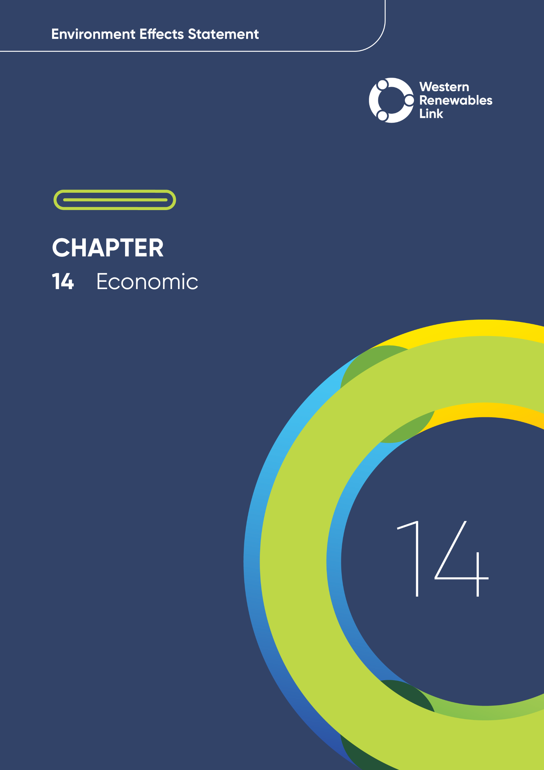

# Economic

This chapter provides an overview of the potential economic impacts associated with the construction, operation and decommissioning of the Project. This chapter is based on **Technical Report G: Economic Impact Assessment.**

Economic impacts are assessed through both quantitative economy-wide analysis and qualitative assessment of impacts on businesses at the industry level. These two scales of assessment provide complementary reviews of the change in key economy-wide variables such as Gross Domestic Product (GDP), employment and welfare, as well as further detail of impacts the Project may have on businesses operating in the study area, at an industry level.

The Project has the potential to have economic impacts during construction, operation and decommissioning.

## Evaluation objective

The scoping requirements identify the following evaluation objective relevant to the economic impact assessment:

Evaluation objective

Avoid, or minimise where avoidance is not possible, adverse effects on land use, social fabric of the community, businesses including farming and tourism, local and state infrastructure, aviation safety and to affected and neighbouring landowners during construction and operation of the project.

In response to this evaluation objective, the economic impacts of the Project have been assessed, and measures to avoid, minimise or manage potential impacts have been identified. These measures are discussed throughout this chapter and have informed the development of Environmental Performance Requirements (EPRs). EPRs set out the environmental outcomes to be achieved through the implementation of measures during construction, operation and decommissioning to avoid, minimise and manage identified impacts. Cumulative impacts associated with relevant future projects were also assessed.

Further information on how the Project has been designed to avoid and minimise impacts is provided in **Chapter 5: Project development** and **Chapter 6: Project description**.

Other aspects covered in the Environment Effects Statement (EES) evaluation objective and relevant to the economic impact assessment are addressed in the following EES chapters:

* **Chapter 11: Landscape and visual**
* **Chapter 12: Land use and planning**
* **Chapter 15: Agriculture and forestry**
* **Chapter 16: Aviation**
* **Chapter 17: EMI and EMF**
* **Chapter 18: Air quality**
* **Chapter 19: Noise and vibration**
* **Chapter 20: Transport**
* **Chapter 21: Social**
* **Chapter 26: Greenhouse gas**.

## Method

This section summarises the method adopted in **Technical Report G: Economic Impact Assessment**, which was informed by **Chapter 4: EES assessment framework and approach**. The key steps in assessing the economic impacts included:

* Statistical Areas

The Australian Bureau of Statistics (ABS) collates economic, social and other demographic data at various levels of granularity called Statistical Areas. Statistical Area Level 3 (SA3) provides a standardised regional breakup of Australia.

* Defining a study area appropriate for the economic impact assessment as presented in Figure 14.1. This encompasses the five Statistical Area 3 (SA3) regions traversed by the Project: Grampians, Maryborough-Pyrenees, Ballarat, Creswick-Daylesford-Ballan and Melton-Bacchus Marsh.
* Reviewing applicable Commonwealth and Victorian legislation, and relevant electricity market and renewable energy-related plans and reports.
* Conducting a desktop review to determine the existing economic conditions including:
  + The economic profile of the study area including working age population, employment and unemployment, income and expenses, industries (using the Australia and New Zealand Standard Industrial Classification (ANZSIC) categories), and gross value added (which represents the economic value generated in an area).
  + Existing and expected renewable energy projects in the study area.
* Consideration of key issues identified during stakeholder consultation conducted by AusNet.
* Using a risk-based approach to identify potential economic impacts for investigation within the technical report.
* Computable general equilibrium (CGE) modelling

Provides information about macroeconomic and distributional impacts of large projects (Infrastructure Australia, 2021), and whether there is a net improvement in welfare. It is the preferred framework for determining macroeconomic impacts (both positive and negative) of large, multi year projects throughout the economy, and is widely recognised across all levels of government in Australia.

* Conducting an economy-wide analysis (see Section 14.4) by identifying and assessing the potential direct and flow-on macroeconomic impacts using computable general equilibrium (CGE) modelling, to assess impacts associated with employment and industry at local, regional and national scales. The CGE model applied is the Victoria University Regional Model; a multi-regional model of Australia’s eight regional economies — the six states and two territories. Key inputs to the CGE modelling were:
  + Development and construction expenditure estimated by AusNet and assumed to occur from 2024 (including early works and procurement of long-lead items) to 2028.
  + Forecasted gross market benefits of the Project, as modelled by Ernst & Young (EY, 2024) on behalf of AEMO for the period 2024 to 2050.
* Conducting a business impact analysis (see Section 14.5) by identifying and assessing potential economic impacts of the Project on non-agricultural businesses operating in the study area. The analysis assessed potential impacts on non-agricultural businesses within 2km of the Project and all businesses within the broader study area, at an industry level. Businesses within the ‘Agriculture, Forestry and Fishing’ ANZSIC category were excluded. **Technical Report H: Agriculture and Forestry** has assessed potential impacts on this industry in detail. The business impact analysis considered impacts identified in other technical reports prepared for the Project after mitigation recommended in those reports was implemented. Impacts were evaluated according to the following qualitative ratings, in relation to the extent, magnitude and duration of the impacts:
  + **Negative:** the combination of individual impacts assessed could result in conditions which have an adverse impact on the industry, and to individual businesses within that sector.
  + **Neutral:** the combination of individual impacts assessed is unlikely to disrupt ‘business as usual’ operating conditions for that sector.
  + **Positive:** the combination of individual impacts assessed could result in conditions which have a positive impact on the industry.
* Identifying other relevant future projects that could lead to cumulative impacts (see Section 14.6) when considered together with the Project (refer to **Chapter 4: EES assessment framework and approach** for the full cumulative impact assessment method).
* Developing EPRs (see Section 14.7) in response to the impact assessment to define the required environmental outcomes that the Project must achieve through the implementation of mitigation measures during construction, operation and decommissioning. Measures to reduce the potential impacts were proposed in accordance with the mitigation hierarchy (avoid, minimise, manage, rehabilitate and offset) and have informed the development of EPRs. Alternative mitigation measures could be implemented to comply with the EPRs based on the specific site conditions, available resources, and the Principal Contractor’s expertise.
* Following application of mitigation measures that would comply with the EPRs, determining residual impacts (see Section 14.8) associated with the construction, operation and decommissioning of the Project, and evaluating their significance.

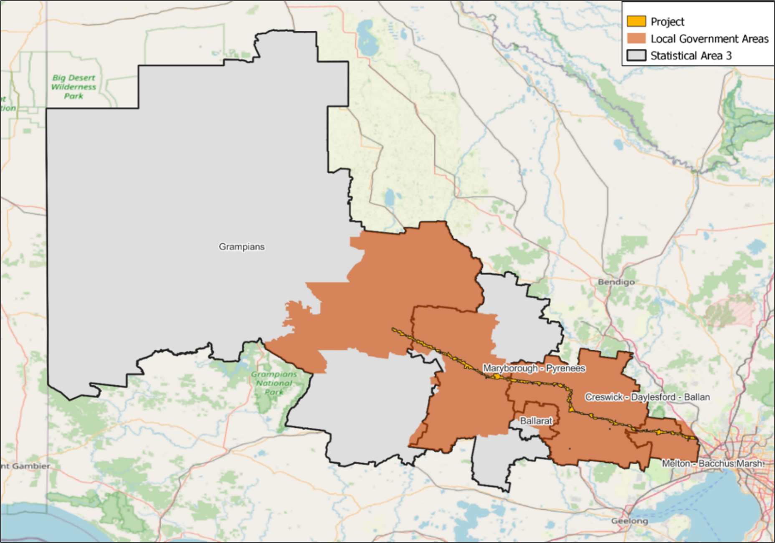

Figure 14. Economic study area

## Existing conditions

This section summarises the existing economic conditions in the study area according to the following key themes:

* Economic profile of the study area including working age population, employment and unemployment, income and expenses, business profile, and gross value added.
* Existing and expected renewable energy generation projects.

### Economic profile of the study area

The existing economic conditions have been identified as a point-in-time snapshot of the population, jobs, income levels, industries, gross value added and tourism parameters across the SA3 regions.

##### Working age population

The 2021 working age population in the study area ranges from approximately 15,000 in the Maryborough-Pyrenees to 133,000 in Melton-Bacchus Marsh. All SA3s in the study area are expected to experience an increase in working age population from 2021 to 2036, from an increase of 0.2 per cent in Grampians to 21.5 and 68.7 per cent in Ballarat and Melton-Bacchus Marsh respectively. The increases in Ballarat and Melton-Bacchus Marsh are higher than the increase of 17.9 per cent expected for the whole of Victoria as shown in Figure 14.2.

Figure . Working age population (population aged 15 to 64) by SA3 and Victoria (source: **Technical Report G: Economic Impact Assessment)**

##### Employment, income and expenses

As of June 2023, Melton-Bacchus Marsh had the highest unemployment rate in the study area, at 5.8 per cent, above the Victorian unemployment rate of 3.6 per cent. Maryborough-Pyrenees, at 4.1 per cent, also sits above the Victorian average. Grampians, Ballarat and Creswick-Daylesford-Ballan unemployment rates were below the Victorian average, at 3.5, 2.3 and 1.7 per cent respectively as shown in Figure 14.3.

Median weekly household income and expenses across the study area largely correlate with distance from Melbourne, with Melton-Bacchus Marsh being the most expensive and Grampians being the least expensive. From east to west, household incomes and expenses trend downwards, and are all generally lower than the Victorian average as shown in Figure 14.4.

‘Health Care and Social Assistance’ is the top employing industry in the majority of SA3s in the study area, accounting for between 10 and 21 per cent of total jobs. Other top employing industries across the study area including ‘Agriculture, Forestry and Fishing’ (1 to 16 per cent of total jobs), ‘Construction’ (7 to 16 per cent of total jobs), ‘Education and Training’ (7 to 13 per cent of total jobs), and ‘Retail Trade’ (8 to 12 per cent of total jobs). Tourism, which occurs across multiple industries, contributes 1.8 to 37.4 per cent of total jobs across the study area, as follows:

* Grampians (Central Highlands Tourism Region): 14.7 per cent of total jobs (approximately 2,300 jobs).
* Maryborough-Pyrenees and Ballarat (Ballarat Tourism Region): 4.3 per cent of total jobs (approximately 3,800 jobs).
* Creswick-Daylesford-Ballan (Spa Country Tourism Region): 37.4 per cent of total jobs (approximately 2,900 jobs).
* A graph of colored lines

  AI-generated content may be incorrect.Melton-Bacchus Marsh (Macedon Tourism Region and Melbourne Tourism Region): 4.6 per cent of total jobs (approximately 1,700 jobs) in the Macedon Tourism Region and 1.8 per cent of total jobs (approximately 68,100 jobs) in the Melbourne Tourism Region.

Figure . Historical unemployment rate (%) by SA3 and Victoria, December 2010 to June 2023 (source: **Technical Report G: Economic Impact Assessment**)

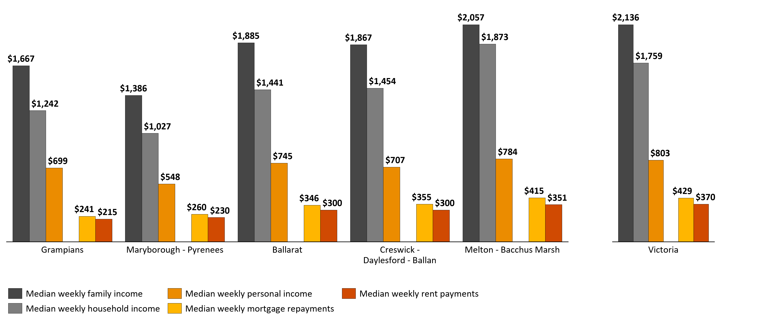Figure . Weekly income and housing expenses by SA3 and Victoria, 2021 (source: **Technical Report G: Economic Impact Assessment**)

##### Business in the study area

The top three industries in the study area for number of actively trading businesses are ‘Construction’, ‘Transport, Postal and Warehousing’ and ‘Agriculture, Forestry and Fishing’. Almost two thirds (63 per cent) of these are non-employing businesses, such as sole proprietorships and partnerships without employees, 35 per cent are small businesses (one to 19 employees), 2 per cent are medium businesses (20 to 199 employees), and less than 1 per cent are large businesses (200+ employees).

Within each of the SA3s that form the study area:

* Grampians: The top three industries for number of actively trading businesses are ‘Agriculture, Forestry and Fishing’, ‘Construction’ and ‘Rental Hiring and Real Estate Services.’ Over half (59 per cent) are non-employing businesses, 39 per cent are small businesses, 2 per cent are medium businesses, and less than 1 per cent are large businesses. Non-agricultural businesses within 2km of the Project represent 0.01 per cent of total businesses in the region, and all are in the ‘Electricity, Gas, Water and Waste Services’ industry, comprising 4 per cent of all ‘Electricity, Gas, Water and Waste Services’ businesses in the region.
* Maryborough - Pyrenees: The top three industries for number of actively trading businesses are ‘Agriculture, Forestry and Fishing’, ‘Construction’ and ‘Rental Hiring and Real Estate Services.’ Over half (60 per cent) are non-employing businesses, 39 per cent are small businesses, 1 per cent are medium businesses, and less than 1 per cent are large businesses. Non-agricultural businesses within 2km of the Project represent 1 per cent of total businesses in the region. The ‘Accommodation and Food Services’ industry has the greatest number of businesses, with four businesses within 2km of the Project, representing 4 per cent of all ‘Accommodation and Food Services’ businesses in the region.
* Ballarat: The top three industries for number of actively trading businesses are ‘Construction’, ‘Rental Hiring and Real Estate Services’ and ‘Professional Scientific and Technical Services.’ Over half (59 per cent) are non-employing businesses, 38 per cent are small businesses, 3 per cent are medium businesses, and less than 1 per cent are large businesses. The Project does not directly traverse the Ballarat region, and there are no known businesses in this region within 2km of the Project.
* Creswick - Daylesford - Ballan: The top three industries for number of actively trading businesses are ‘Agriculture, Forestry and Fishing’, ‘Construction’ and ‘Professional, Scientific and Technical Services.’ Over half (62 per cent) are non-employing businesses, 37 per cent are small businesses, 1 per cent are medium businesses, and none are large businesses. Non-agricultural businesses within 2km of the Project represent 2 per cent of total businesses in the region. The ‘Other Services’ industry has the greatest number of businesses, with 18 businesses within 2km of the Project, representing 13 per cent of all ‘Other Services’ businesses in the region.
* Melton - Bacchus Marsh: The top three industries for number of actively trading businesses are ‘Transport, Postal and Warehousing’, ‘Construction’ and ‘Professional, Scientific and Technical Services.’ Over two-thirds (68 per cent) are non-employing businesses, 30 per cent are small businesses, 1 per cent are medium businesses, and less than 1 per cent are large businesses. Non-agricultural businesses within 2km of the Project represent 1 per cent of total businesses in the region. The ‘Other Services’ industry has the greatest number of businesses, with 41 businesses within 2km of the Project, representing 4 per cent of all ‘Other Services’ businesses in the region.

##### Gross value added

Gross value added is a measure of the industry production value and the contribution to overall gross product and is considered a reliable estimate of economic contribution as it removes distortions caused by taxes and subsidies across different industries. The industries providing the greatest contribution to the gross value added for each SA3 region are:

* Grampians: ‘Agriculture, Forestry and Fishing’ is the largest industry, contributing 26 per cent of the gross value added. ‘Health Care and Social Assistance’ and ‘Mining’ are the second and third largest industries in the region. Tourism contributes 3.8 per cent to gross value added in the region (Central Highlands Tourism Region).
* Maryborough - Pyrenees: ‘Agriculture, Forestry and Fishing’ is the largest industry, contributing 22 per cent of the gross value added. ‘Mining’ and ‘Construction’ are the second and third largest industries in the region. Tourism contributes 2.0 per cent to gross value added in the region (Ballarat Tourism Region).
* Ballarat: ‘Health Care and Social Assistance’ is the largest industry, contributing 28 per cent of the gross value added. ‘Construction’ and ‘Manufacturing’ are the second and third largest industries in the region. Tourism contributes 2.0 per cent to gross value added in the region (Ballarat Tourism Region).
* Creswick - Daylesford - Ballan: ‘Agriculture, Forestry and Fishing’ is the largest industry, contributing 28 per cent of the gross value added. ‘Construction’ and ‘Health Care and Social Assistance’ are the second and third largest industries in the region. Tourism contributes 9.9 per cent to gross value added in the region (Spa Country Tourism Region).
* Melton - Bacchus Marsh: ‘Construction’ is the largest industry, contributing 27 per cent of the gross value added. ‘Education and Training’ and ‘Public Administration and Safety’ are the second and third largest industries. Tourism contributes 2.2 and 1.0 per cent to gross value added in the region (Macedon Tourism Region and Melbourne Tourism Region respectively).

### Renewable energy generation

The profile of existing and expected renewable energy projects, that are likely to be commissioned prior to the opening of the Project, provides context as to the current economic role of renewable energy generation within the study area. The following projects have been identified by the Department of Transport and Planning as occurring in the study area, also presented in Figure 14.5:

* Wind energy projects: There are 14 operational projects in the study area, largely within the Grampians and Maryborough-Pyrenees regions, three projects that are approved but not yet operational, and one project for which a planning permit application has been submitted. Collectively, these projects provide approximately 2,744MW of power.
* Solar energy projects: There are no operational solar farms in the study area, 12 projects that are approved but not yet operational, and one project for which a planning permit application has been submitted. Collectively, these projects provide a maximum of approximately 673MW of power.
* Battery energy storage projects: There are two operating battery energy storage projects in the study area, and three projects that are approved but not yet operational. Collectively, these projects provide a maximum of approximately 1,700MW of power.

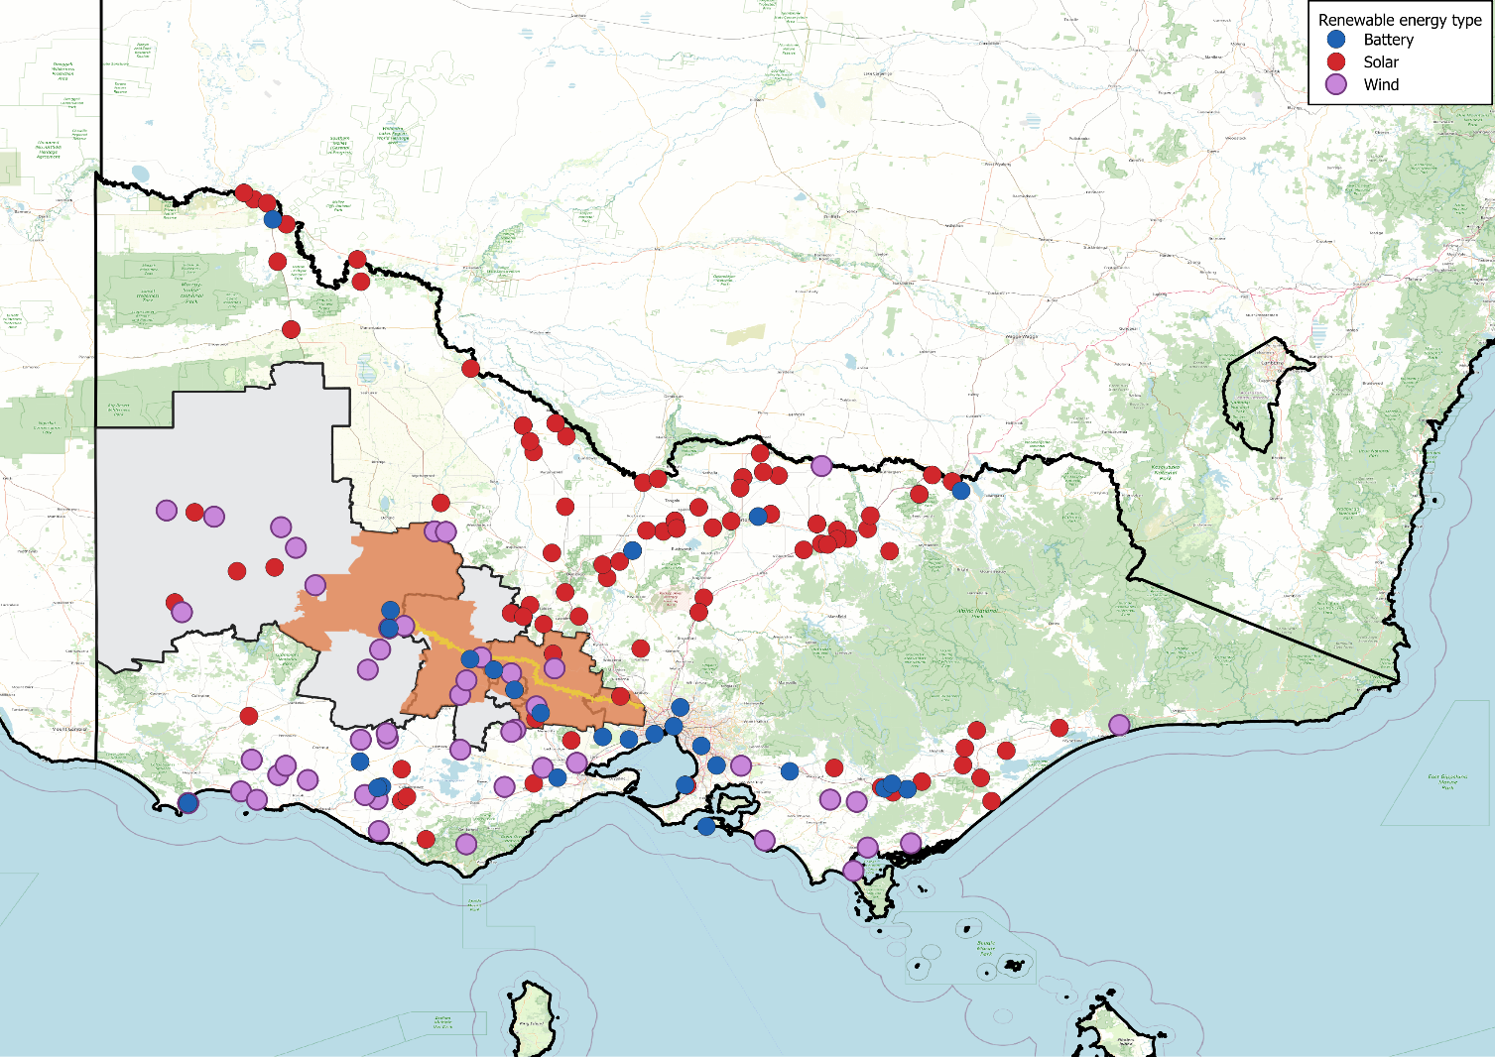

Figure . Renewable energy projects in the study area (source: **Technical Report G: Economic Impact Assessment)**

## Economy-wide analysis

The economy-wide modelling estimates the direct and flow-on (i.e. indirect and induced) economic effects of the Project, from 2024 to 2050. The modelling reported the following for the study area, the rest of western Victoria, the rest of Victoria, and the rest of Australia:

* Changes in GDP, investment, household and government consumption, and a net welfare assessment to Australia (welfare analysed only for Australia as a whole) (see Section 14.4.1).
* Employment impacts across Victoria during and following construction (see Section 14.4.2).

The economy-wide modelling does not estimate potential economic effects of decommissioning the Project, as this is beyond the period of analysis within the CGE model. The CGE modelling reports economy-wide impacts to Financial Year (FY) 2050.

### Changes in GDP, investment and consumption

The modelled effect of the Project on GDP, investment, consumption and welfare from 2024 to 2050 outlined in Table 14.1.

Key findings include, by FY2050:

* The Project increases Australia’s GDP by $4.5 billion and the Gross Regional Product of the study area by $0.9 billion. These impacts are largely driven by increases in investment and consumption in Victoria.
* Investment in the study area (due to the Project and induced investment in renewable generation and storage) drives Victorian investment up $2.0 billion. This impact is partially offset across the rest of Australia, as cheaper Victorian electricity generation replaces more expensive generation investment that would otherwise have been built in other states.
* Private and government consumption increase in Australia by $3.7 billion and $1.4 billion respectively, due to cost savings in the energy sector being passed on to consumers.
* Overall, the net welfare benefit for Australia is positive – indicating that the Project provides a net benefit to Australians. A positive impact on net welfare means that the Project is projected to improve overall living standards. As a result of producing electricity more efficiently with the Project, there is a $4.7 billion net increase in living standards.

Table . Cumulative projected macroeconomic impacts from 2024 to 2050 (real 2024 $millions, discounted at 7 per cent)

|  |  |  |  |  |  |
| --- | --- | --- | --- | --- | --- |
| Macroeconomic indicator | Study area | Rest of western Victoria | Rest of Victoria | Victoria total | Australia total |
| GDP | $921 | $655 | $2,667 | $4,244 | $4,504 |
| Private investment | $1,407 | $176 | $459 | $2,041 | $978 |
| Private consumption (1) | $762 | $366 | $1,758 | $2,886 | $3,749 |
| Government consumption (2) | $44 | $78 | $645 | $767 | $1,359 |
| Change in net foreign liabilities in FY2050 (3) | N/A | N/A | N/A | N/A | $467 |
| Residual capital stock in FY2050 (4) | N/A | N/A | N/A | N/A | $48 |
| Welfare (1 + 2 – 3 + 4) | N/A | N/A | N/A | N/A | $4,689 |

Source: **Technical Report G: Economic Impact Assessment**

### Employment impacts

The economy-wide analysis reported employment impacts, including consideration of:

* Jobs required to construct the Project.
* Additional employment in the upstream and downstream industries providing goods or services during construction.
* Negative impacts to employment in the study area.

The modelled Project employment impacts during the development stage, construction stage and five years following construction are outlined in Table 14.2.

The Project will contribute to economic opportunities in the study area, including increased employment. New employment in the study area induced by the Project was modelled to peak in 2028 at 346 workers. Total employment in Victoria due to the Project was modelled to peak in the same year at 2,089 workers. Beyond the construction stage, a large amount of renewable energy investment is anticipated to be attracted to Victoria due to the increased transmission capacity provided by the Project. This contributes to additional employment catalysed by the Project, but not directly related to the Project construction. Following this, there is expected to be a relatively slow fall back to base case employment by 2032. This effect is typical in CGE modelling, as employment in the long-term is determined by demographic fundamentals, rather than individual projects.

Table . Project employment impacts (in number of full-time equivalent personnel) *

| Financial year | Study area | Rest of western Victoria | Rest of Victoria | Victoria total* |
| --- | --- | --- | --- | --- |
| 2024 | 14 | 28 | 116 | 158 |
| 2025 | 20 | 40 | 164 | 224 |
| 2026 | 22 | 45 | 185 | 253 |
| 2027 | 264 | 196 | 623 | 1,083 |
| 2028 | 346 | 377 | 1,366 | 2,089 |
| 2029 | 120 | 130 | 472 | 722 |
| 2030 | 36 | 39 | 143 | 218 |
| 2031 | 48 | 52 | 189 | 290 |
| 2032 | 34 | -29 | -78 | -73 |
| 2033 | -34 | 29 | 79 | 74 |

Source: **Technical Report G: Economic Impact Assessment**

* Figures may not sum due to rounding

## Business impact analysis

This section outlines the key issues identified through the risk screening process and associated potential business impacts during the construction, operation and decommissioning of the Project.

### Construction impacts

Within 2km of the Project, the ‘Accommodation and Food Services’ and ‘Arts and Recreation Services’ industries were identified as being subject to potential negative impacts from Project construction. There are 27 businesses in the ‘Accommodation and Food Services’ industry and 21 businesses in the ‘Arts and Recreation Services’ industry within 2km of the Project (see **Technical Report G: Economic Impact Assessment**). Businesses in these industries may experience negative impacts from construction noise, traffic and visual amenity impacts, leading to reduced visitation. These businesses may include, for example, golf clubs, equestrian academies, cellar doors and bed and breakfast accommodation. The actual impacts experienced by each individual business will depend on its specific characteristics, including viewpoints impacted, proximity to the Project and operating hours. Impacts on businesses in these industries within 2km of the Project are expected to be highly localised and short-term. Due to the proposed staggered approach to construction, areas should on average be affected for nine to 22 weeks over a two-year period. Overall, a net negative economic impact may be experienced for businesses in these industries operating within 2km of the Project. EPRs were developed to manage and reduce the potential negative impacts of the Project’s construction stage on businesses in the ‘Accommodation and Food Services’ and ‘Arts and Recreation Services’ industries. These include the development and implementation of a Business Mitigation and Support Strategy for directly affected businesses (EPR EC1) and a Business Mitigation and Support Strategy for businesses within 2km of the Project (EPR EC3). These strategies will identify, offer and implement any practicable mitigation measures that could be applied to lessen the impacts of the Project on the business (both infrastructure and day to day operations), or that may otherwise support the business.

The ‘Manufacturing’ industry was identified as potentially experiencing a positive impact during construction, associated with the procurement of key Project materials from businesses within the study area, such as concrete and steel. There are 1,197 ‘Manufacturing’ businesses in the study area (see **Technical Report G: Economic Impact Assessment**). The positive impact experienced will depend on the extent to which local businesses can be utilised in the delivery of the Project. Business which may experience positive impacts include manufacturers, building and construction material providers, quarries, electricians, and other construction-related businesses. Overall, a net positive impact may be experienced for businesses in this industry operating in the study area. EPR EC2 was developed to maximise the potential positive impact of the Project’s construction stage on businesses in the ‘Manufacturing’ industry. This EPR includes the development and implementation of initiatives to increase positive social and economic impacts through the procurement of goods and services from local communities and social enterprises, including initiatives and commitments to prioritise to the extent practicable the procurement of goods and services from local businesses, sustainable social enterprises and Aboriginal-owned businesses.

The ‘Other Services’, ‘Mining’, ‘Transport and Warehousing’, ‘Retail Trade’, ‘Wholesale Trade’, ‘Administrative and Support Services’ and ‘Construction’ industries, along with the ‘Accommodation and Food Services’ and ‘Arts and Recreation Services’ industries beyond 2km from the Project, were assessed as likely to continue usual business operations and be unaffected by Project construction. Therefore, the impact to these industries is considered to be neutral.

### Operation impacts

Significant industry-wide impacts to businesses during Project operation were considered unlikely. Individual businesses in the ‘Accommodation and Food Services’ and ‘Arts and Recreation Services’ industries that are located within 2km of the Project and that rely on the amenity of the natural landscape to attract visitation to the area may experience negative impacts during operation from reduced visual amenity. There are 16 businesses in the ‘Accommodation and Food Services’ and ‘Arts and Recreation Services’ located within 2km of the Project that have been identified as potentially susceptible to potential effects on amenity, as they are dependent to some extent on the existing aesthetic quality of their surrounds to attract visitors (see **Technical Report F: Social Impact Assessment**). Impacts would be long-term, given the 80-year service life of the transmission line. However, impacts are likely to be highly localised and business-specific. The industry level effect for the ‘Accommodation and Food Services’ and ‘Arts and Recreation Services’ industries has been assessed as neutral, as many businesses in these industries that do not rely on visual amenity are likely to be unaffected. The Business Mitigation and Support Strategy for directly affected businesses (EPR EC1) and Business Mitigation and Support Strategy for businesses within 2km of the Project (EPR EC3) have been developed to manage and reduce the potential negative impacts of the Project’s operation stage on businesses in the ‘Accommodation and Food Services’ and ‘Arts and Recreation Services’ industries. These strategies will identify, offer and implement any practicable mitigation measures that could be applied to lessen the impacts of the Project on the business (both infrastructure and day to day operations), or that may otherwise support the business.

Other industries operating within the study area are likely to experience a neutral impact during the operation of the Project. Increased renewable generation in the study area as a result of the Project may boost spending and create potential competition for employees in respect of existing wind energy projects and battery energy storage projects, which may impact the ‘Construction’ industry. However, these effects are unlikely to generate a significant net negative or positive impact within the study area, and the net impact to these industries is considered to be neutral.

### Decommissioning impacts

During decommissioning, similar impacts to those reported during construction are likely to occur, and economic effects during decommissioning are likely to be similar to those experienced during construction. However, the number and profile of businesses in the study area at the end of the Project life are likely to change significantly. While the nature of impacts identified is likely to remain similar to those for construction, the number of businesses impacted could materially change and could affect the assessment of effects. The economy-wide modelling does not estimate potential economic effects of decommissioning the Project, as this is beyond the period of analysis within the CGE model. The CGE modelling reports economy-wide impacts to FY2050.

Business impacts during decommissioning of the Project are likely to comprise:

* A largely neutral effect for most industries in the study area.
* Potential highly localised negative impacts to businesses within 2km of the Project in the ‘Accommodation and Food Services’ and ‘Arts and Recreation Services’ industries.
* Potential positive impacts for businesses in the study area, where they experience increased investment in services and materials to facilitate the decommissioning of the Project.

Prior to commencement of decommissioning, a Decommissioning Management Plan will be developed and implemented to manage impacts associated with decommissioning of the Project, including economic impacts. Management and mitigation measures included in the Decommissioning Management Plan will be consistent with management strategies, practices, and technologies current at the time (EPR EM11; see **Chapter 29: Environmental Management Framework**).

## Cumulative impacts

Cumulative impacts have been assessed by identifying relevant future projects that could contribute to cumulative economic impacts, considering their spatial and temporal relationships to the Western Renewables Link Project. The projects considered as potentially relevant are listed in the following sections. Although the potential for cumulative economic impacts depends on the precise timings and sequencing of the Western Renewables Link Project and the listed projects, it is considered unlikely that their impacts would be significant enough to influence the outcomes of this assessment. Specific commentary is included in the following sub-sections.

### Energy infrastructure projects

Relevant projects include:

* Brewster Wind Farm
* Elaine Solar Farm
* Melbourne Renewable Energy Hub, Plumpton, Victoria
* Navarre Green Power Hub
* Nyaninyuk Wind Farm
* Powercor Mt Cottrell Zone Substation
* Sydenham Terminal Station Rebuild
* Toolern Vale Solar Farm
* Victoria to New South Wales Interconnector West
* Watta Wella Renewable Energy Project.

These projects are most likely to compete for resources with the Western Renewables Link Project. To the extent that these projects compete for investment or local labour, this may increase economic activity in Victoria.

Except for the Sydenham Terminal Station rebuild, these projects will likely have overlapping construction stages with the Western Renewables Link Project, which is likely to contribute to cumulative disruption costs, such as traffic congestion, noise and visual amenity impacts.

The interconnected nature of these projects, including the Sydenham Terminal Station Rebuild, will contribute to cumulative cost savings in energy generation and storage infrastructure. The Western Renewables Link Project will provide transmission capacity to integrate renewable generation projects and therefore as the number of renewable generation projects feeding into the Western Renewables Link increase, this will result in a lower average cost of provision.

### Transport infrastructure projects

Relevant projects include:

* 2022 Melbourne Airport Masterplan
* Melbourne Airport Business Park – Sky Road West Warehouse Developments
* Outer Metropolitan Ring Road/E6 (OMR)
* Beaufort Bypass (Western Highway)
* Sunbury Line Level Crossing Removals
* West Gate Tunnel (formerly the Western Distributor Project).

To the extent that these projects compete for investment or local labour, this may increase economic activity in Victoria. The OMR is the only project known to fall within the Western Renewables Link Project Land, while other projects (except the West Gate Tunnel) are within 15km of Project Land. These could lead to cumulative disruption costs, including traffic congestion on shared construction transport and haulage routes.

### Urban development projects

Relevant projects include:

* Delahey Urban Development
* Bacchus Marsh Urban Growth Framework (as part of the Merrimu Precinct Structure Plan).

While these projects will attract investment, material cumulative impacts are not anticipated in the construction stage due to their relatively small scale.

### Other infrastructure projects

Relevant projects include:

* Western Irrigation Network (WIN) Scheme – Recycled Water Supply Infrastructure Project
* Coimadai Sand Quarry.

While the Western Renewables Link Project may have to consider the sequencing of construction where there is geographical overlap with the WIN Scheme, no material cumulative economic impacts are expected. Due to the nature of the sand quarry project, no material cumulative economic impacts are expected.

### Nature and parks

Relevant projects include:

* Lerderderg River Nature Trail
* Lerderderg-Wombat National Park.

Construction timeframes for these projects are unknown. The Western Renewables Link Project may impact visual amenity of Trail and Park users. However, any cumulative economic impacts are unlikely to be significant.

## Environmental Performance Requirements

Potential impacts identified through **Technical Report G: Economic Impact Assessment** have informed the development of EPRs for the Project. EPRs set out the environmental outcomes to be achieved through the implementation of mitigation measures during construction, operation and decommissioning. While some EPRs are performance based to allow flexibility in how they will be achieved, others include more prescriptive measures that must be implemented. Compliance with the EPRs will be required as a condition of the Project’s approval. Table 14.3 details the proposed EPRs developed for economic impacts.

Table . Environmental Performance Requirements

| EPR code | Requirement |
| --- | --- |
| EC1 | **Develop and implement a Business Mitigation and Support Strategy for directly affected businesses**   1. Prior to the commencement of construction, develop and implement an overarching ‘Business Mitigation and Support Strategy’ to avoid and minimise impacts on businesses that could be directly affected by the Project, as a result of the transmission line easement being placed on land associated with the business, to the extent reasonably practicable. 2. The strategy must be informed by the Communications and Stakeholder Engagement Management Plan (EPR EM5). 3. The strategy must define the process and requirements for: 4. Consulting with business owners that agree to engage with the Project, to discuss their business and the specific impacts that their business may experience. As a minimum, this will consider business operations and services that may be affected or require alteration as a result of dust, noise and traffic generated by construction of the Project, or by the physical presence of Project infrastructure during operation of the Project. 5. Provided the business owner agrees to engage with the Project, identifying, offering and implementing any practicable mitigation measures that could be applied to lessen the impacts of the Project on the business (both infrastructure and day to day operations). This includes but is not limited to measures that seek to, where practicable: 6. Establish landscape screening to avoid and minimise the visual impact of the Project. 7. Reconfigure, relocate or re-orientate any existing business assets that have views to the Project to avoid and minimise the visual impact. 8. Increase marketing and promotional activities to encourage patronage. 9. Avoid and minimise air quality impacts on business operations in accordance with the Air Quality Management Plan (EPR AQ1). 10. Avoid and minimise noise and vibration impacts on business operations in accordance with the Construction Noise and Vibration Management Plan (EPR NV1) and in accordance with EPR NV3. 11. Avoid and minimise traffic impacts on business operations in accordance with the Traffic Management Plans (EPR T1). 12. Maintain access for business operations, including if necessary establishing alternative temporary access and signage. 13. Avoid impacts on business assets or relocate and re-establish assets in an agreed location. 14. Provide for reinstatement and rehabilitation of construction areas and temporary access tracks. 15. Provide early and ongoing information and notification about details and timing of proposed works in proximity to the business (as per EM5). 16. If requested by the business and it would assist in the identification of practicable mitigation measures, provide a consultant(s) with skills and qualifications relevant to the affected business to advise on mitigation of specific impacts. 17. Documenting the outcomes for individual businesses and provide the business with the information and implementation steps. 18. The information which must be provided to the land title holder as to whether disturbance would be rectified, rehabilitated or compensated, either under the Options for Easement agreement, or in accordance with the requirements of the *Land Acquisition and Compensation Act 1986* 19. Notification of construction timetable and changes to traffic conditions and duration of impact to assist landholder business planning 20. Inclusion of information on a reporting and complaints handling system for affected businesses to use consistent with the Australian Standard AS/NZS 100002: 2014 Guidelines for Complaints Management in Organisations. 21. Prepare, provide to business owners and implement plans for affected businesses in accordance with the strategy. 22. The Project will provide for engagement with business owners for 12 months following completion of construction activities that directly affect the business and will implement agreed mitigation measures within that time unless otherwise agreed with the relevant business owner. |
| EC2 | **Develop and implement initiatives for procurement of goods and services from local communities and social enterprises**   1. Prior to the commencement of construction, develop and implement a plan to increase positive social and economic impacts through the procurement of goods and services from local communities and social enterprises. 2. The plan must include initiatives and commitments to prioritise to the extent practicable the procurement of goods and services from: 3. Local businesses, particularly within the local government areas intersected by the Project and small to medium enterprises. 4. Sustainable social enterprises and Aboriginal-owned businesses. |
| EC3 | **Develop and implement a Business Mitigation and Support Strategy for eligible businesses within 2km**   1. Prior to the commencement of construction, develop and implement a 'Business Mitigation and Support Strategy’ to avoid and minimise, to the extent reasonably practicable, impacts from the Project to existing businesses that would not be supported under EPR EC1 but which: 2. are within 2km of the Project; and 3. rely on the existing character of the natural landscape to attract customers. 4. The strategy must include actions that will be undertaken to avoid and minimise amenity impacts to the businesses referred to in 1 above. The strategy should define the process and requirements for: 5. Consulting with business owners that agree to engage with the Project, to discuss their business and the specific impacts that their business may experience. As a minimum, this will consider business operations and services that may be affected or require alteration as a result of dust, noise and traffic generated by construction of the Project, or by the physical presence of Project infrastructure during operation of the Project. 6. Provided the business owner agrees to engage with the Project, identifying, offering and implementing any practicable mitigation measures that could be applied to lessen the impacts of the Project on the business (both infrastructure and day to day operations), or that may otherwise support the business. This includes but is not limited to measures that seek to, where practicable: 7. Establish landscape screening to avoid and minimise the visual impact of the Project. 8. Reconfigure, relocate or re-orientate any existing business assets that have views to the Project to avoid and minimise the visual impact. 9. Increase marketing and promotional activities to encourage patronage. 10. Provide early and ongoing information and notification about details and timing of proposed works in proximity to the business (as per EPR EM5). 11. Documenting the outcomes for individual businesses and provide the business with the information and implementation steps. 12. Offering and implementing any agreed mitigation measures. 13. A reporting and complaints handling system for landholders and community to use consistent with the Australian Standard AS/NZS 100002: 2014 Guidelines for Complaints Management in Organisations. 14. Prepare, provide to business owners and implement plans for affected businesses, in accordance with the strategy. 15. The Project will provide for engagement with business owners for 12 months following completion of construction of the towers which are visible from the business and will implement agreed mitigation measures within that time unless otherwise agreed with the relevant business owner. |

Other EPRs contribute to a reduction in the magnitude, extent and duration of potential economic impacts. Additional EPRs related to potential economic impacts include:

* EPR AF1 – Develop and implement an Agriculture and Forestry Business Mitigation and Support Strategy
* EPR EM5 – Develop and implement a Communications and Stakeholder Engagement Management Plan
* EPR EM11 – Develop and implement a Decommissioning Management Plan.
* EPR SC3 – Develop and implement initiatives to maximise employment opportunities for local communities, First Nations people and vulnerable and disadvantaged groups
* EPR T1 – Develop and implement Traffic Management Plans.

Refer to the relevant technical chapters and **Chapter 29: Environmental Management Framework** for full detail of these EPRs.

Frequent and ongoing consultation and communication with businesses and the community throughout the planning, construction and decommissioning stages will be important to avoid, minimise and manage potential economic impacts of the Project. The Communications and Stakeholder Engagement Management Plan (EPR EM5) will include monitoring and review of the effectiveness of proposed mitigation and management measures through direct engagement with affected stakeholders. Where required, additional measures may be warranted to respond to individual issues or unexpected impacts.

The objectives of the proposed monitoring programs for the Project required by the EPRs are outlined in **Chapter 29: Environmental Management Framework**.

## Summary of residual impacts

The economy-wide analysis concludes that the Project would lead to:

* An increase in Australia's GDP of $4.5 billion by 2050
* An increase in the Gross Regional Product of the study area of $0.9 billion by 2050
* An increase in Victorian investment of $2.0 billion by 2050, partially offset across the rest of Australia
* An increase in private and government consumption in Australia of $3.7 billion and $1.4 billion respectively, by 2050
* A $4.7 billion net increase in living standards in Australia by 2050.

With application of the EPRs, residual business impacts of the Project are considered to include:

* A largely neutral effect for most industries in the study area throughout the Project’s construction, operation and decommissioning stages.
* Potential negative impacts during construction on businesses in the ‘Accommodation and Food Services’ and ‘Arts and Recreation Services’ industries within 2km of the Project. There are 27 businesses in the ‘Accommodation and Food Services’ industry and 21 businesses in the ‘Arts and Recreation Services’ industry within 2km of the Project (see **Technical Report G: Economic Impact Assessment**). Residual impacts on businesses in these industries would occur for a relatively short period, with construction activity (from mobilisation to de-mobilisation) at each tower expected to take about nine to 22 weeks over a two-year period, depending on weather and if tasks are able to immediately follow one another. The Business Mitigation and Support Strategy for directly affected businesses (EPR EC1) and Business Mitigation and Support Strategy for businesses within 2km (EPR EC3) will be implemented to avoid, minimise and mitigate potential negative economic impacts of the Project on potentially affected businesses (both infrastructure and day to day operations).
* Potential positive impacts during construction on businesses in the ‘Manufacturing’ industry within the study area. There are 1,197 ‘Manufacturing’ businesses in the study area (see **Technical Report G: Economic Impact Assessment**), with the industry as a whole expected to potentially experience a positive impact from the Project, associated with the procurement of key Project materials such as concrete or steel. This impact will be largely dependent on the procurement strategy adopted for the Project. Prior to commencement of construction, AusNet will develop and implement initiatives to increase positive social and economic impacts through the procurement of goods and services from local communities and social enterprises, including initiatives and commitments to prioritise to the extent practicable the procurement of goods and services from local businesses, sustainable social enterprises and Aboriginal-owned businesses (EPR EC2).
* Potential negative and long-term (given the 80-year service life of the transmission line) impacts during Project operation on individual businesses in the ‘Accommodation and Food Services’ and ‘Arts and Recreation Services’ industries, without an industry-level effect. Businesses that rely on the amenity of the natural landscape to attract visitation may experience modest negative economic effects during Project operation due to reduced visual amenity. There are 16 businesses in the ‘Accommodation and Food Services’ and ‘Arts and Recreation Services’ located within 2km of the Project that have been identified as potentially susceptible to potential effects on amenity, as they are dependent to some extent on the existing aesthetic quality of their surrounds to attract visitors (see **Technical Report F: Social Impact Assessment**). At an industry level, the potential impact of the Project is considered to be neutral for businesses in these industries. The Business Mitigation and Support Strategy for directly affected businesses and Business Mitigation and Support Strategy for eligible businesses within 2km will be implemented to avoid, minimise and mitigate potential negative economic impacts of the Project on potentially affected businesses (both infrastructure and day to day operations) (EPR EC1 and EPR EC3).

With the implementation of measures to comply with EPRs, it is considered that the Project meets the economic aspects of the evaluation objective *“Avoid, or minimise where avoidance is not possible, adverse effects on land use, social fabric of the community, businesses including farming and tourism, local and state infrastructure, aviation safety and to affected and neighbouring landowners during construction and operation of the project.”*

