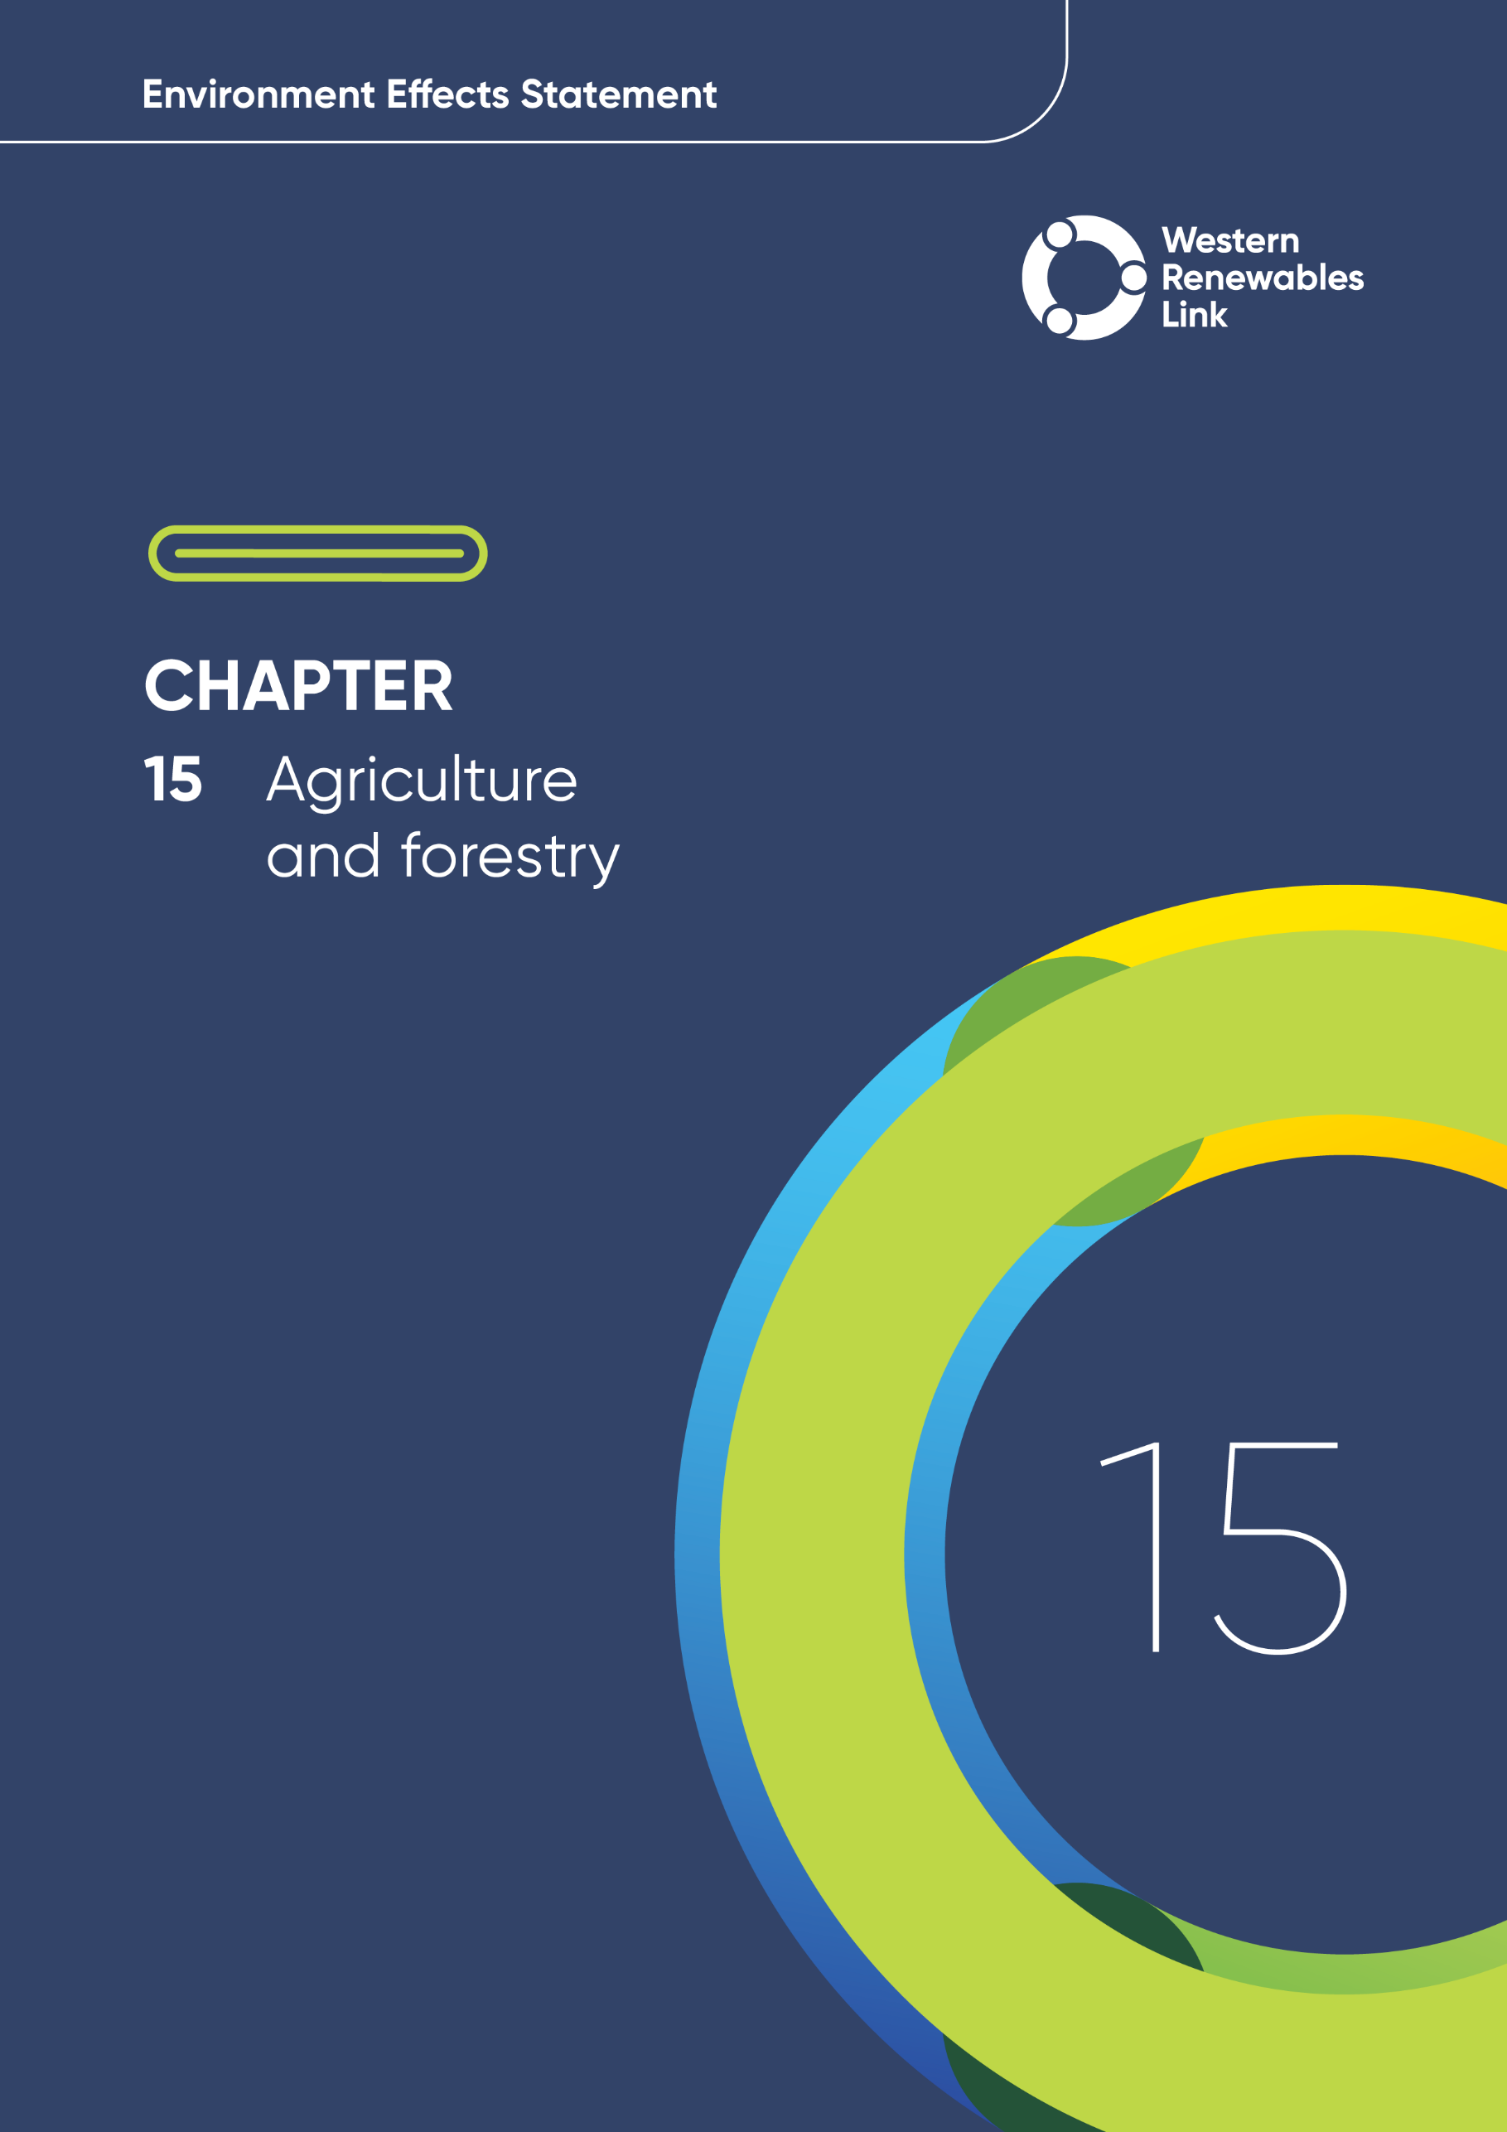

# Agriculture and forestry

This chapter provides an overview of the potential agriculture and plantation forestry impacts associated with the construction, operation and decommissioning of the Project. This chapter is based on **Technical Report H: Agriculture and Forestry Impact Assessment**.

Agriculture is the dominant land use traversed by the Project, with properties used for grazing, broadacre cropping, horticulture, and plantation forestry. The range and value of agricultural products produced by properties varies widely, with local industries contributing significantly to production in Victoria. Productive agricultural land can contain significant assets and infrastructure, such as dams, sheds, and yards. Agriculture is an important source of employment and a driver of economic activity in rural areas traversed by the Project.

## Evaluation objective

The scoping requirements identify the following evaluation objective relevant to agriculture and forestry:

**Evaluation objective**

Avoid, or minimise where avoidance is not possible, adverse effects on land use, social fabric of the community, businesses including farming and tourism, local and state infrastructure, aviation safety and to affected and neighbouring landowners during construction and operation of the project.

In response to this evaluation objective, impacts of the Project on agriculture and plantation forestry were assessed and measures to avoid, minimise or manage potential impacts that have been identified. These measures are discussed throughout this chapter and have informed the development of Environmental Performance Requirements (EPRs). EPRs set out the environmental outcomes to be achieved through the implementation of mitigation measures during construction, operation and decommissioning to avoid, minimise and manage identified impacts. Cumulative impacts associated with relevant future projects were also assessed.

Further information on how the Project has been designed to avoid and minimise impacts is provided in **Chapter 5: Project development** and **Chapter 6: Project description**.

Other aspects covered in the Environment Effects Statement (EES) evaluation objective and relevant to agriculture and forestry are addressed in the following EES chapters:

* **Chapter 12: Land use and planning**
* **Chapter 14: Economic**
* **Chapter 16: Aviation**
* **Chapter 21: Social.**

## Method

This section summarises the method in **Technical Report H: Agriculture and Forestry Impact Assessment**, which was informed by **Chapter 4: EES assessment framework and approach**. The key steps in assessing the impacts associated with agriculture and forestry included:

* Defining a study area appropriate for agriculture and plantation forestry impacts as presented in Figure 15.1. This included the agricultural and forestry properties located within the Project Land.
* Reviewing applicable Commonwealth and Victorian legislation, and relevant local, state and national standards, guidelines and policies.
* Conducting a desktop review to determine the existing agriculture and plantation forestry conditions including land production potential and regional production value, including:
  + Analysing each individual property within the study area using aerial imagery to develop an understanding of their visual condition, assets and activities, as well as the productive land that could potentially be affected by the Project, particularly during construction activity.
  + Reviewing a range of spatial data (including satellite and aerial imagery, parcel and property information, and a digital terrain model) and statistical data (sourced from the Australian Bureau of Statistics (ABS), state government and industry bodies) to develop a thorough understanding of the region.
* Consulting with the relevant regulatory authorities and key stakeholders including the local community, industry and farming groups, Agriculture Victoria, and local governments.
* Interviewing a representative sample of landholders along the Project to test findings and identify issues. This sample was representative of the different geographies, enterprises, and farm sizes along the Project, with additional interviews undertaken to include equine-related industries.
* Preparing a set of agriculture case studies with direct input from landholders and farmers around Australia, exploring the range of issues associated with overhead transmission lines in a variety of agricultural landscapes. The case studies can be found in **Technical Report H: Agriculture and Forestry Impact Assessment.**
* Conducting field investigations and ground-truthing from public areas along the study area, including roadside inspections.
* Conducting a risk screening process to identify the key issues during construction, operation and decommissioning for investigation within the technical report.
* Identifying and assessing the potential impacts associated with the reduction of usable agricultural land, disturbance of livestock, restrictions on the use and development of agricultural assets and infrastructure, and potential biosecurity breaches during construction, operation and decommissioning. These impacts were evaluated according to the following ratings, in relation to the extent, magnitude and duration of these impacts:
  + Negligible**:** minor impacts to agriculture and forestry values of importance and/or where agricultural or forestry activity is materially unaffected; temporary impacts to commercial enterprises or markets.
  + Minor**:** Local impacts to agriculture and forestry values of importance; temporary or transient impacts; no long-term impacts to commercial enterprises or regional markets; standard mitigations required.
  + Moderate**:** Medium or localised impacts to agriculture and forestry values of importance; short-term, and potentially some long-term impacts to commercial enterprises or regional markets; local/regional concern; standard mitigations required.
  + Major**:** Long-term/widespread impacts to agriculture and forestry values of importance; significant economic effects; state government assistance may be required for recovery; the agricultural or forestry value(s) would be difficult or very costly to repair or reinstate and recovery may only be partially successful; comprehensive and monitored mitigation measures are necessary.
  + Severe**:** Irreversible or widespread harm to an agricultural or forestry values of importance; government intervention likely; very difficult to repair; significant mitigations required.
* Identifying relevant future projects that could lead to cumulative impacts when considered together with the Project (refer to **Chapter 4: EES assessment framework** **and approach** for the full cumulative impact assessment method).
* Developing EPRs in response to the impact assessment to define the required environmental outcomes that the Project must achieve through the implementation of mitigation measures during construction, operation and decommissioning. Measures to reduce the potential impacts were proposed in accordance with the mitigation hierarchy (avoid, minimise, manage, rehabilitate and offset) and have informed the development of EPRs. Alternative mitigation measures could be implemented to comply with the EPRs based on the specific site conditions, available resources, and the Principal Contractor’s expertise.
* Following application of mitigation measures that would comply with the EPRs, determining residual impacts associated with the construction, operation and decommissioning of the Project, and evaluating their significance.

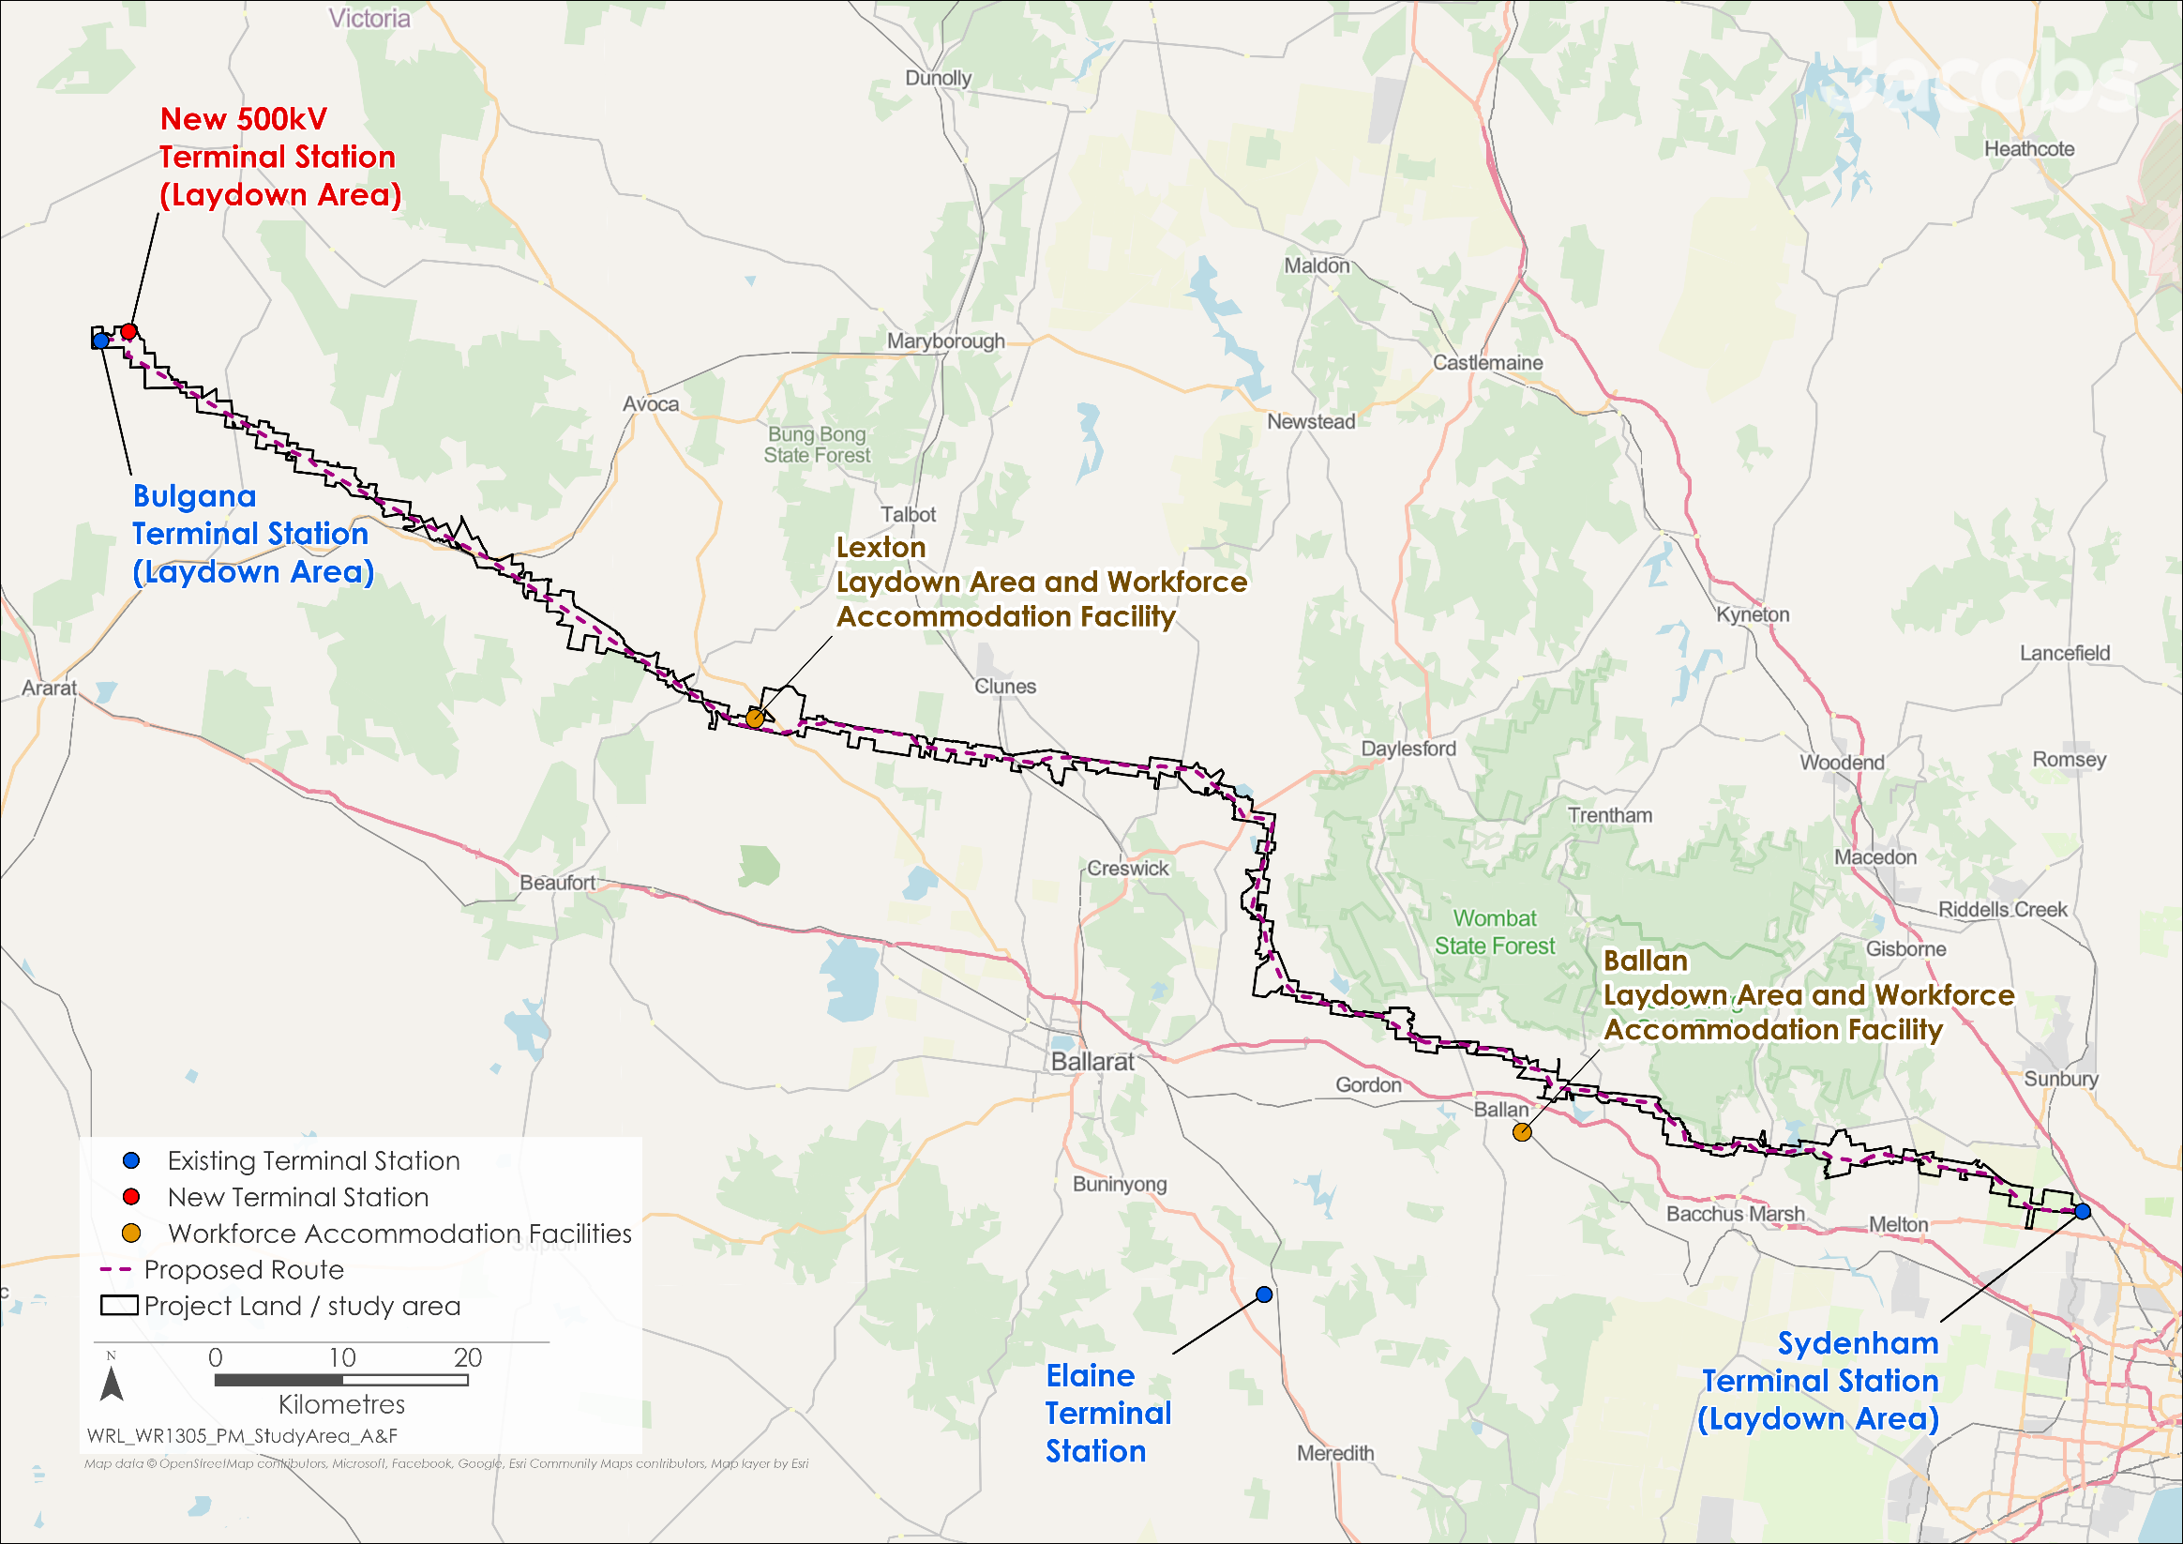

Figure 15.1 Agriculture and forestry study area

## Existing conditions

This section summarises the existing conditions for agriculture and forestry according to the following key themes:

* Regional agricultural production
* Regional plantation forestry production
* Properties traversed by the Project.

Existing agriculture and forestry conditions along the Project are highly variable, with a range of products being cultivated, produced and managed. The value of production is also variable, dependent on factors such as such as soil, climate, availability of irrigation water, product markets, management decisions, skills, and expertise. Many farmers operate multiple agricultural enterprises concurrently on their land, producing a range of commodities and rotating the enterprises between paddocks and over time, to match market requirements, supply quotas, and for weed, disease, and pest management.

For the purpose of the agriculture and forestry impact assessment, primary production land uses were categorised as four enterprise types on the basis that normal on-property activities and the potential impacts of the Project are likely to be similar within each type: grazing, cropping, horticulture, and forestry. These categories were allocated based on desktop spatial analysis, with consideration given to historic and current activity, and to how the land could potentially be used for agriculture or forestry in the future. Production data at a regional scale was obtained from 11 statistical regions, defined by the ABS, that cover the length of the Project.

* Enterprise types

**Grazing** - refers to agricultural enterprises that are solely based on grazing livestock, such as sheep, cattle, horses and goats. These properties are only used for grazing and do not use irrigation. Livestock are produced for meat or fibre (e.g., wool), breeding (e.g., stud stock) and racing or eventing (e.g., horses).

**Cropping** - refers to agricultural enterprises that practice some dryland broadacre cropping. These properties usually include a mix of grazing and cropping. Dryland cropping does not involve irrigation. Crops may include legumes and cereals.

**Horticulture** - refers to an enterprise that grows high-value horticultural crops, such as potatoes or other vegetables. Horticulture crops are generally grown using irrigation. Most properties growing horticultural crops also grow broadacre crops and graze livestock. They are differentiated from grazing and cropping enterprises by the presence of horticultural crops and irrigation.

**Forestry** - refers to enterprises that grow trees for timber production. Many forestry properties in the region also grow broadacre crops, graze livestock and may also be involved in irrigated horticulture production. These enterprises are differentiated from grazing, cropping and horticulture types by the presence of plantation forestry.

Most properties are involved in multiple enterprises. For the agriculture and forestry impact assessment, each property affected by the Project was assigned to one of these enterprise types, based on the highest-value enterprise on that property (e.g., if a property had grazing and horticulture, it was considered to be a horticulture enterprise).

### Regional agricultural production

Agriculture and plantation forestry are dominant land uses in the region, accounting for 540,517 hectares (ha) of land. This represents approximately 5 per cent of the total area of land used for agriculture and plantation forestry in Victoria. However, some specific industries – namely grazing, potatoes and forestry – are more significant for the state than this figure suggests. This is because the land used for these industries within the region, amounts to more than 5 per cent of the statewide total area for each.

The majority of agricultural land in the study area is used for cropping (including broadacre mixed farming) and grazing. Although horticulture enterprises occupy significantly less land in the region, they typically generate the highest gross value of production per hectare. Potatoes are the most significant crop grown in the region, when measured as a percentage of Victoria’s total production and total area of production. While relatively small as a percentage of total regional land use, potatoes grown in the region represent 42 per cent of the total production for Victoria. Sheep and lambs are the dominant livestock in the region, contributing 11 per cent to Victoria’s total production.

The soils in the central part of the study area, between Waubra and Gordon, are some of the most productive in Victoria, with higher value and higher production farming systems present in this area. More specifically, the soils east and northeast of Ballarat sustain potatoes and intensive crops with very high value production per hectare. Less intensive and less productive agricultural uses occur along the remainder of the study area. However, the agricultural areas traversed by the Project (particularly those close to metropolitan Melbourne) are identified in state and local policies as being of significant economic and social value.

Farm machinery and equipment used on agricultural properties across the region varies depending upon the specific enterprise. Intensive cropping, like potato production, requires the use of centre pivot and lateral move irrigators, as well as specialist sowing and harvesting machinery. Broadacre cropping operations will also use specialised machinery for sowing, fertilising and harvesting of crops. Infrastructure for grazing operations includes stock yards and loading ramps, hay sheds and shearing sheds.

* Gross value of agricultural production

The gross value of agricultural production (GVAP) is a measure used by the Australian Bureau of Statistics (ABS) to calculate the value of agricultural commodities produced within a year, measured at the point of sale.

In 2020/21, the total gross value of agricultural production (GVAP) in the region was $648 million. This was a significant contribution to the local economy and to Victoria, accounting for four per cent of the state’s total GVAP. Grazing and cropping were the dominant contributors, representing 86 per cent of the total regional value with key products including sheep and lambs, beef and other livestock, and cereal crops.

The GVAP per hectare for 2020/21 was $7,239 for horticulture properties (based on a conservative crop rotation in which potatoes are grown in one year and the land is cropped for the following three years), $1,183 for cropping properties, and $989 for grazing properties.

### Regional forestry production

There are approximately 4,505ha of plantation forestry in the region, primarily comprising of radiata pine (*Pinus radiata*) and Tasmanian blue gum (*Eucalyptus globulus*). In total, forestry enterprises in the region account for approximately 8 per cent of the total area of plantation forestry in Victoria, making it significant at the state level.

There are two types of plantation ownership within the region: corporate forestry and farm forestry. Corporate growers are typically large-scale operations, with HVP Plantations and Midway Plantations being the main corporate growers in the region. HVP Plantations have several large areas of contiguous pine plantations in the region, whilst Midway Plantations have smaller scale blue gum plantations scattered across the region. These corporate growers are in the forestry business for the long term and manage their plantations with the aim of harvesting similar volumes each year.

Farm foresters typically own smaller areas of plantation, often less than 50ha in size. They tend to harvest about once every 10 to 20 years (depending on species, growth rates and available markets) because of their small scale and limited area.

There are several large areas of radiata pine plantation surrounding Creswick, Wilsons Reservoir (near Bullarook), Spargo Creek and Bostock Reservoir. There are also scattered radiata pine plantations between Lexton and Creswick. The largest grouping of blue gum plantations is located around Lexton, with smaller plantations also located between Waubra and Mount Beckworth, and near Gordon and Moorabool Reservoir. There are very few plantations beyond Mount Lonarch in the western extent of the Project. Figure 15.2 shows the locations of plantation forestry in proximity to the Project.

The value of timber plantations varies with age, with the most valuable being those that have reached maturity and are ready to be harvested. Radiata pine is managed over longer rotations with thinning, whereas blue gum is typically managed over shorter rotations without thinning. As such, mature radiata pine plantations can be worth more than $30,000 per hectare, whilst mature blue gum plantations can be worth more than $15,000 per hectare. Young plantations typically vary in value from $1,500 to $3,000 per hectare.

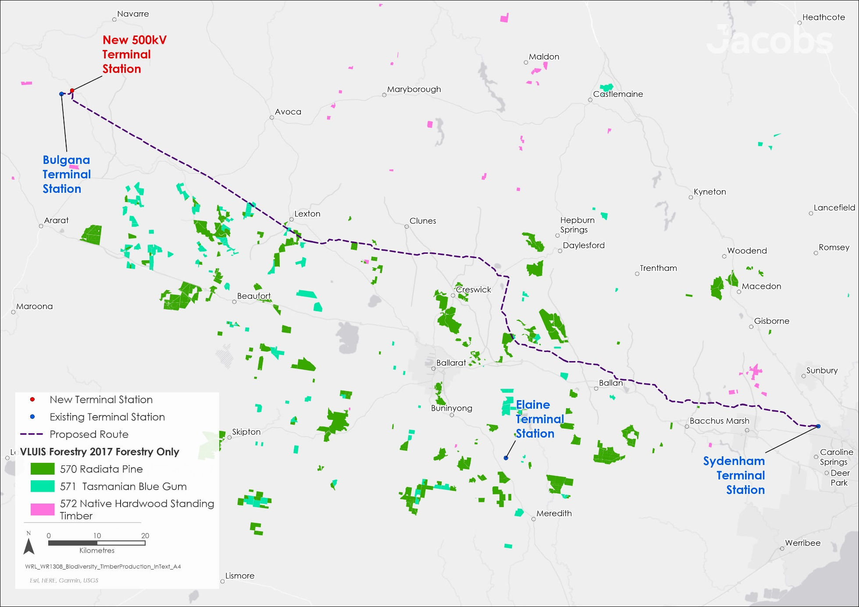

Figure 15.2: Commercial timber production in the region

### Properties traversed by the Project

There are 229 agricultural and forestry properties proposed to be traversed by the Project. A summary of these properties is presented in Table 15.1 and Figure 15.3 by enterprise type. Most properties (85 out of 229 properties) undertake broadacre mixed farming or ‘cropping’. Grazing (76 properties) is the next most dominant enterprise, followed by horticulture (65 properties) and forestry (3 properties). In total, the affected properties have an area of 33,612ha, representing 6 per cent of the agricultural land in the region and approximately 0.3 per cent of the agricultural land in Victoria.

Within these properties, a total of 2,228ha of agricultural land are directly affected by the Project, equivalent to 0.4 per cent (or less than one half of one per cent) of the area used for agriculture within the region. Agricultural land will also be used for laydown areas and workforce accommodation facilities during construction (approximately 12ha of land categorised as cropping, and approximately 24ha of land categorised for grazing), and for the new 500kV terminal station near Bulgana (approximately 64ha of land categorised for grazing).

It is important to note that the size of the properties traversed by the Project may not represent the total area of the farm businesses. Many small farm businesses have only one land parcel in the study area, but there are also a significant number of farm businesses that operate across multiple land parcels in the region (and beyond). As such, the size of their business may be significantly larger than the areas reported in the data presented here.

Table 15.1 Type, number and area of properties in the study area

| Enterprise type | No. of properties | Area affected by Project(ha) | Affected properties total area (ha) | Area of land use in the region (ha) | Area of properties as a % of region |
| --- | --- | --- | --- | --- | --- |
| Grazing | 76 | 542 | 10,488 | 363,106 | 3% |
| Cropping | 85 | 1,028 | 13,982 | 196,307 | 7% |
| Horticulture | 65 | 632 | 8,880 | 6,848 | n/a* |
| Forestry | 3 | 26 | 262 | 4,505 | 6% |
| TOTAL | 229 | 2,228 | 33,612 | 570,766 | 6% |
| * Note: The total area of the properties with a horticulture enterprise is greater than the total area of horticulture crops in the region because these properties use multi-year rotations, and so also conduct cropping, grazing and in a small number of situations, forestry. | | | | | |

Consultation with industry suggests that approximately 70 per cent of farmers in the region who undertake irrigation now use overhead irrigators, and some farms in the study area use overhead centre pivot/ lateral move irrigators and gun irrigators (also called rain guns or big guns) to grow potatoes and other horticultural crops. Overhead irrigators can be up to 7.5m tall and can pulse water up to 15m high. Rotational cropping could mean that irrigation equipment is moved from paddock to paddock. Aerial application of fertiliser and chemicals for pest and disease management is used on some cropping and horticultural farms that are in the study area. High value crops including potatoes may require multiple aerial treatments each season. This can be carried out by fixed wing aircraft or helicopters fitted with specialised spraying equipment. Drones are becoming more widely used in this application.

Other large equipment used on farms within the study area include harvesters and boom sprays for chemical application. Business size, production levels and profitability determine a farmer’s ability to invest in these ‘tools of the trade’, often worth hundreds of thousands of dollars each.

* Potato production in the study area

Potatoes are the most significant crop in the region, accounting for a large percentage of Victoria’s total agricultural production. As such, a thorough investigation of potato production on properties that will be traversed by the Project was undertaken (see **Technical Report H: Agriculture and Forestry Impact Assessment**) and determined that the annual area of potato production is variable. Farmers in the region typically grow potatoes for one season and then rotate the land for different uses for the next three to four years. It is estimated that 390ha of potatoes were planted in paddocks potentially traversed by the Project in the three growing seasons from 2019 to 2022, averaging 130ha per year.

The total area of horticultural land identified as being traversed by the Project is higher than this (632ha, Table 15.1), as it includes land that may be rotationally used for horticulture.

No operating dairies, piggeries, poultry operations or vineyards were identified in the study area. Further, the technical investigation did not identify agricultural processing and manufacturing facilities, saleyards, or large packing / distribution sheds that would be directly affected by the Project.

Detailed descriptions of other types of properties, including typical production activities and their timing, infrastructure and equipment used, irrigation requirements and key sensitivities, can be found in **Technical Report H: Agriculture and Forestry Impact Assessment**.

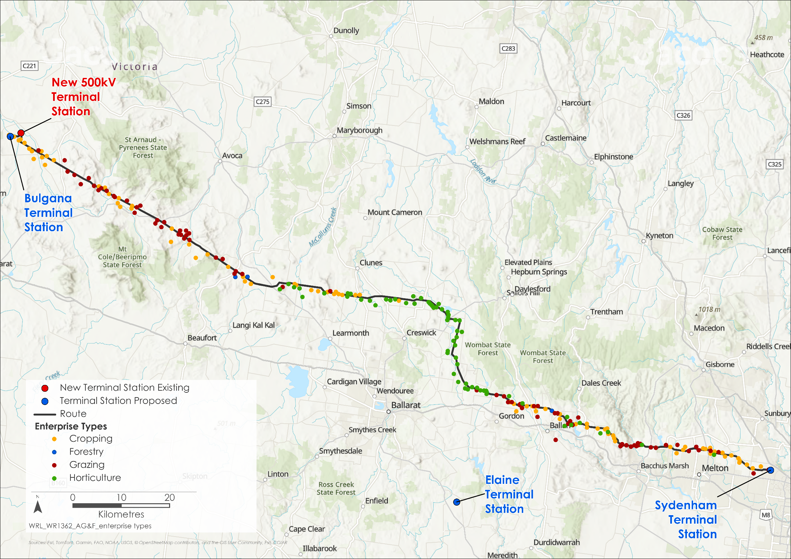

Figure 15.3 Geographic distribution of (highest value) enterprise types

## Construction impacts

This section describes the key issues identified through the risk screening process and the associated potential impacts during the construction of the Project. The key issues and impacts identified for agriculture and forestry are discussed according to the following themes:

* Occupation of productive land: the temporary removal of land from production during construction, resulting in economic impacts to the property or enterprise. These impacts could persist over multiple growing seasons
* Restrictions and disruptions to routine activities: interruptions to farming activities during optimal times, and restrictions to movement across properties. The use of machinery and equipment, such as irrigation equipment and aerial spraying, may also be impacted
* Isolation and redundancy of productive land: economic losses associated with land being split by construction activity or transmission structures
* Soil fertility and quality: potential contamination, erosion or compaction of quality, productive soils
* Biosecurity risks: the potential introduction or spread of pest species due to construction activities and property access
* Livestock health: distress to livestock caused by unusual activity and noise associated with construction of the Project. Further, livestock could be impacted by localised contamination (for example, due to machinery hydrocarbon or agricultural chemical spills) or restrictions to movement.

### Occupation of productive land

As described in Section 15.3, agricultural products and the value of production for properties located along the Project is highly variable. This means that specific impacts vary between properties and between years, depending on management systems, rotations, the season, timing of weather events (particularly extreme events), enterprise mix and market conditions. The Project has been designed to maximise the distance between transmission towers, known as the transmission line span, so that significant agricultural assets can be avoided. Along the proposed transmission line, the span is generally between 450 and 550m. As a result, some properties traversed by the Project have no physical footprint (transmission towers or access tracks) of the Project on their property, reducing the barriers to farming activity to during construction. However, land used for laydown areas and workforce accommodation facilities will be temporarily occupied for the two year construction stage then restored to its original use, as follows:

* Lexton laydown area and workforce accommodation facility - approximately 12ha of land categorised as cropping will be removed from agricultural production during construction. This represents just under one per cent of the total area of cropping land impacted by the Project.
* Ballan laydown area and workforce accommodation facility - approximately 24ha of land categorised as grazing will be removed from agricultural production during construction. This represents just under two per cent of the total area of grazing land impacted by the Project.

Approximately 63ha of land that is categorised as cropping will also be removed from agricultural production for the life of the Project to support the new 500kV terminal station near Bulgana. This site represents just over six per cent of the total area of cropping land impacted by the Project.

The occupation of land during construction will result in economic and production losses for grazing, cropping, horticulture and forestry enterprises. The removal of land from production during construction cannot be avoided, and some construction areas may be fenced so the safety of the public, farm workers and stock is maintained. For any one property, construction may occur intermittently over a period of two years, with a total duration of approximately nine to 22 weeks for each transmission tower. Depending on climate and operations, returning production to normal levels will require different lengths of time depending on the property. For example, at the end of construction, the rehabilitation and re-establishment of pasture and crops may take two growing seasons (one full year), or longer in low rainfall dryland conditions. Economic losses will be experienced with any loss of land, reduction in production or farming inefficiencies that are created by the Project.

Construction may also lead to loss of land access along and adjacent to Project infrastructure, untimely scheduling that interferes with optimal timing for stock breeding, crop sowing or harvest, or land clearance that reduces pasture for stock grazing or reduces crop area and yield. Dealing with construction and access issues can also take up a landholder’s productive time, and agricultural costs may accumulate when normal schedules and activities are interrupted. For instance, contract workers may be required for longer periods if the area cannot be accessed at the optimal time due to the construction works schedule. In plantations, construction works could also impact tree roots or canopies, reducing growth outside of the construction area.

* Landholder compensation

Comprehensive information on the process for easement acquisition through a voluntary Option for Easement proposal, the payments landholders will be entitled to, and how compensation is assessed is provided in AusNet’s *Landholder Guide: Option for Easement process, compensation and benefits* (AusNet, 2025b). This Guide is available at: <https://www.westernrenewableslink.com.au/assets/resources/Landholder-Guide-Option-for-Easement-process-and-compensation.pdf>

The total annual value of lost production for agriculture (grazing, cropping and horticulture) during the Project’s construction is conservatively estimated at around $6.3 million per year. Whilst the significance on individual properties will vary, following the application of mitigations that will reduce the extent and duration of impacts, the residual regional impact on agricultural production is minor, equating to approximately one per cent of the regional annual production value, and just over five per cent of the gross value of potato production in the region. Mitigations include developing an Agriculture and Forestry Business Mitigation and Support Strategy (EPR AF1) with landholders to identify specific actions to minimise production and financial impacts. Consultation with landholders will be undertaken in accordance with the Project’s Communications and Stakeholder Engagement Management Plan (EPR EM5).

Approximately 26ha of forestry will also be removed to facilitate the construction and operation of the Project, resulting in a further economic loss of just under $462,000. Plantation forestry operators shall receive compensation commensurate with production losses experienced during construction. Appropriate communications will also be put in place (EPR EM5) so landholders will be given adequate notice of approaching construction activity so that they can harvest at the optimal time for their operations. This communication will also be supported by discussions and requirements established by EPR AF1, the Project’s Property Access and Management Plan (PAMP) (EPR EM3), and the Specific Property Access Requirements (EPR EM4). With compensation and appropriate communication, residual impacts to plantation forestry operations and infrastructure will also be minor.

At the individual property level, residual impacts to some individual agricultural properties or enterprises may be more significant. Agricultural land title holders will also be financially compensated for loss of land for production and foregone income, disruption that results in expense or time impositions, and redundancy of land during construction. This will continue until agreed standards of rehabilitation have been achieved. Any removal of, or detrimental alteration to, farm infrastructure will also be compensated.

The level of compensation will be negotiated between AusNet and the individual farm or land title holder, with an independent valuer ensuring the fair assessment of compensation. If agreement cannot be reached, AusNet may compulsorily acquire an easement and the land title holder will be compensated under the *Land Acquisition and Compensation Act 1986.* As part of both a voluntary Option for Easement Agreement or acquisition under the *Land Acquisition and Compensation Act 1986*, land title holders will also be able to obtain and be compensated for appropriate advice (agronomic, legal and financial).

### Restrictions and disruptions to routine activities

Construction activities may disrupt or restrict normal farming and forestry activities, including interrupting the optimal timing for stock breeding, crop sewing, or harvest. This includes restrictions on the movement of livestock to access water, yards, and sheds, as well as access for personnel and machinery to conduct soil preparation, sowing, spraying, and harvesting, and the removal of trees from forestry areas. Further, the use of irrigation infrastructure, farm machinery and aerial services (spraying and surveillance) may be restricted. Managing these disruptions may result in some landholders incurring additional costs, for example, where limitations on the use of aerial spraying increase the cost of ground-based applications.

As previously discussed, the Agriculture and Forestry Business Mitigation and Support Strategy (EPR AF1) will identify practical mitigations that will minimise the magnitude, duration, and extent of production and financial impacts. To prepare this Strategy, Land Liaison Officers will work with host landholders to understand the land uses and activities that occur across the Project Area and discuss easement requirements. This will allow for activities, assets and values to be understood at the farm level, and unnecessary impacts due to restrictions and disruptions to be avoided, and if that is not possible, minimised as far as practicable. These discussions and mitigations will be documented and implemented by the Project. For example, discussions with landholders to inform the Agriculture and Forestry Business Mitigation and Support Strategy (EPR AF1) will identify situations where construction timelines could be adjusted to avoid or minimise disturbance at critical times of the year (e.g. breeding, lambing/calving, sowing and harvesting) thereby allowing farmers to optimise production. These adjustments will be applied so far as reasonably practicable, with consideration given to the construction schedule, weather and availability of specialist crews and equipment.

In addition, at a Project level, the PAMP will apply to all affected properties (EPR EM3). This will detail the actions that are to be taken so that impacts to property and farm access, and livestock are minimised during construction. At the individual property level, Specific Property Access Requirements (EPR EM4) will be consulted with landholders, recorded, and implemented during construction. The Agriculture and Forestry Business Mitigation and Support Strategy (EPR AF1), the PAMP (EPR EM3), and the Specific Property Access Requirements (EPR EM4) will be developed prior to the commencement of construction activities.

Farmers will be given notice of approaching construction activity in accordance with the periods outlined in the PAMP (EPR EM3) or other timeframes as identified either through consultation for the Agriculture and Forestry Business Mitigation and Support Strategy (EPR AF1), or in accordance with agreed Specific Property Access Requirements (EPR EM4). This advanced notification is important for some landholders so that they do not invest in crops or activities that will not reach the point of financial return before construction starts.

Following application of these mitigation strategies, residual impacts on plantation forestry operations will be minor, however residual impacts to agricultural enterprises at the property level will vary. Typically, disruptions and restrictions will have a residual minor impact due to construction generally being localised and of a short duration. However, impacts on some individual properties or enterprises may be more significant.

### Isolation and redundancy of productive land

Disruptions and restrictions to routine activities could also impact productive land beyond the immediate construction area. Land may become isolated or redundant due to paddocks being split by construction activity or transmission infrastructure. This may prevent the continued operation of, for example, irrigation equipment (Figure 15.4) and could result in significant parts of affected farms being unable to be put to their best economic use.

Irrigation is critical to the profitable production of horticulture enterprises in the region, as high yields are required to cover the costs of production and the price of land. These isolated areas may be removed temporarily from production during construction or may have to be permanently removed for the operating life of the Project unless a redesign of paddock layout or change to irrigation infrastructure can occur.

* Property Access and Management Plan (PAMP) (EPR EM3)

The PAMP aims to avoid unnecessary disruptions or restrictions to farming activities as far as possible during construction. At a minimum these will include:

* Notification procedures for access to the property
* Biosecurity requirements
* An obligation to undertake an assessment of existing farm conditions
* An overview of fire management measures
* Processes to minimise impacts to property and farm access, and livestock movement
* Processes to manage animal health and safety, soil, dust, and drainage
* Processes to rehabilitate and reinstate land following works.

The Agriculture and Forestry Business Mitigation and Support Strategy (EPR AF1) will identify practical mitigation measures that will reduce the impact on agriculture and forestry business, including isolated or redundant land. In high value agricultural areas, where farm irrigation infrastructure, systems and practices are impacted by construction, and where there is the expectation that this impact will continue during the Project’s operation, an irrigation evaluation may be undertaken. This evaluation will be undertaken by an independent irrigation specialist and determine whether adjustments to paddock layout or purchase of alternative irrigation equipment could significantly reduce production losses. Where feasible, support will be provided to farmers to adjust or replace irrigation systems and paddock layout in response to the recommendations of the irrigation evaluation. Where there is an ongoing economic loss or increase to the costs of production due to restrictions to irrigation, compensation will be provided as appropriate as discussed in Section 15.4.1. Requirements identified in the Agriculture and Forestry Business Mitigation and Support Strategy are required to be recorded for each participating property (EPR EM4).

Figure 15.4 Centre pivot irrigation (left) and rain gun (right)

The scale of the economic impact of these isolated areas is not easily calculated without specific consideration at the individual farm level. It is likely that only a minority of horticultural and cropping enterprises are in situations where it is not possible to make sufficient adjustments to irrigation layouts and infrastructure. For grazing, isolation of parts of a property may prevent stock access to pasture, shelter, stock yards or water; or may affect access for farm workers to manage their animals. Being unable to move stock or stock being unable to access fresh pasture, shelter and water can affect their health and lead to poorer production or loss of animals.

With the application of mitigations in accordance with EPRs AF1 and EM4, residual impacts associated with the isolation and redundancy of productive land will be managed and are minor at a regional scale. As construction progresses along the transmission line, many isolated areas will be reinstated, however some impacts will persist throughout the construction period. Where there is a significant impact on irrigation operations, the residual impact from the isolation and redundancy of productive land could be more significant. However, it is anticipated that implementation of the irrigation evaluation recommendations will avoid or reduce the extent and magnitude of impacts in most cases.

### Soil fertility and quality

Construction activities could impact the quality of productive soil through contamination, erosion, or compaction. Where productive soils are improperly protected this could result in decreased yields for several years following construction, and reduced growth and productivity in plantations. During construction, the Project will avoid importing external soil onto productive farmland, as this could potentially contain pollutants, weeds, pests or pathogens. If required, imported soil must be certified as being free of pests, disease and weed.

Rehabilitation (as per EPR GSL2) of agricultural land will include the removal of foreign gravel and base materials, and reinstatement of the soil profile so far as reasonably practicable, particularly the topsoil which is the most organically rich upper layer of soil and is important for soil fertility and production. Soil disturbance and compaction could also lead to reduced rain infiltration, resulting in reduced growth and productivity in plantations. As such, rehabilitation will include appropriate aeration, compaction, profiling, and erosion control, prior to re-planting. Existing land conditions (including soil, landform, vegetation, and infrastructure conditions) within areas used to support construction will be assessed as required by the PAMP to inform rehabilitation following the completion of construction (EPR EM3).

Dust may be generated by the movement of construction vehicles and machinery moving over dry tracks and surfaces, indicating a loss of soil. Further, this could smother vegetation and crops and reduce amenity. The Construction Environmental Management Plan (CEMP) (EPR EM2) will require the Principal Contractor to implement standard techniques to retain and conserve the soils on each property. The management and mitigation of construction dust is further discussed in **Chapter 18: Air quality.** Following application of these mitigation strategies, residual impacts associated with soil health and fertility are minor during construction.

Mitigation measures for leaks and spills of oils, chemicals and solid and liquid wastes that may cause contamination on farming properties are described in **Chapter 23: Contaminated land.** Further, an ongoing inspection and maintenance schedule will be developed as part of the CEMP (EPR EM2) to identify and remediate contaminated land issues. Following application of these mitigation and management strategies, the extent and magnitude of impacts associated with contamination will be reduced, resulting in minor residual impacts.

* Biosecurity breaches

A biosecurity breach in agriculture and forestry refers to the introduction or spread of harmful organisms such as pests, diseases, or invasive species, which can negatively impact plant and animal health, soil quality, and overall ecosystem stability.

### Biosecurity risks

There is the potential for biosecurity breaches resulting from the movement of people, vehicles, equipment and machinery across agricultural land to prepare sites, build access tracks, construct the transmission towers, and undertake rehabilitation activities. Biosecurity risk is a major concern to the Australian agricultural industry. This is reflected in Victorian legislation and policy, national animal traceability systems, and in standard farm management practices (such as requirements for individual properties to keep biosecurity records, including records of people and stock moving on and off the farm).

The movement of people, vehicles and equipment during construction has the potential to introduce or spread weeds, pests, fungi and diseases. These threats may be carried in water or soil that is attached to vehicles, shoes and equipment, or may be hidden inside packaging, equipment and vehicles. In some areas, where aerial spraying is vital for control of weeds (including steep landscapes with infestations of serrated tussock), the construction of the transmission line may temporarily prevent the use of aircraft.

In a worst-case scenario with no mitigations applied, a biosecurity breach could spread beyond property boundaries and across a region. The impact of weeds, pests, pathogens or diseases can last for long periods and introductions are often difficult or impossible to reverse, as control and treatment options can be time-consuming and costly. As such, biosecurity breaches can lead to losses in agricultural productivity, ill-health or death of livestock and breeding restrictions. Disease status can also affect the marketability and price of agricultural product.

The Principal Contractor will implement a Project-wide Biosecurity Management Plan (EPR EM8) in accordance with AusNet’s existing biosecurity management procedure(s), to reduce the likelihood of work crews or equipment introducing or exacerbating biosecurity risks. Through this, the Principal Contractor will also be required to maintain a record and implement landholder’s individual biosecurity management plans and requirements. In areas where weed control relies on aerial services and these services are restricted by the Project, the Agriculture and Forestry Business Mitigation and Support Strategy (EPR AF1) will identify practical mitigation measures, including cost-effective alternative options for continued weed management.

The Biosecurity Management Plan will define the processes for biosecurity breach detection, compliance, reporting and response. In the event of a biosecurity incident, AusNet will implement incident and emergency response procedures, in accordance with AusNet’s integrated HSEQ Management System and the Incident Management Procedure to facilitate an efficient and effective response and investigation process. This is further described in **Chapter 29: Environmental Management Framework**.

With the application these mitigation strategies, the potential magnitude, extent, and duration of biosecurity incidences will reduce. Residual impacts associated with biosecurity will be minor.

### Livestock health

Construction may cause livestock to become distressed as it will involve unusual activity, noise and disrupted routines. Distress in animals can translate into altered feeding patterns, erratic behaviour, accidental harm, slower growth rates and reduction in animal health. Subsequently, anxious livestock can make handling tasks more dangerous for farm workers. These effects are only likely to be experienced by livestock in paddocks immediately adjacent to the tower assembly areas, laydown areas or access tracks. Disturbance is likely to be of short duration (days to weeks) and intermittent while construction works are actively occurring at each site. It is anticipated that on most properties, sensitive stock can be moved sufficiently far away to be unaffected during the window of construction.

Livestock health could also be impacted if localised contamination occurred on farming properties, or if access to shelter was restricted during critical periods (such as severe weather events). The Agriculture and Forestry Business Mitigation and Support Strategy (EPR AF1) will address the issue of livestock disturbance, including how sensitive locations (such as stock yards) or timings (such as lambing) can be managed. With the application of these mitigation strategies, residual impacts associated with animal disturbance will be minor, temporary and localised.

## Operation impacts

This section outlines the key issues identified through the risk screening process and associated potential impacts during the operation of the Project. The key issues and impacts identified for agriculture and forestry are summarised according to the following themes:

* Permanent infrastructure and restrictions: restrictions on land uses under the transmission line and the use of aerial spraying, the isolation and redundancy of productive land where paddocks are split by transmission infrastructure, and electromagnetic interference
* Operation inspections and maintenance activities: biosecurity risks due to the movement of vehicles, machinery and personnel between properties, disruption to farm operations and livestock, and forestry activity.

### Permanent infrastructure and restrictions

Once construction is complete, approximately 2,202ha of farmland and 26ha of plantation forestry land will be subject to the operation conditions of the Project (i.e., easement, permanent access tracks, terminal stations). The changes in agricultural and forestry activity to accommodate the Project will have already been implemented during the construction stage, and potential impacts for many landholders will diminish or no longer exist during operation. During construction, plantation trees in the easement will be removed or harvested, regardless of maturity. These areas will be unable to be used for plantation forestry during operation. As with the construction stage, clearing of the easement may affect adjacent tree health, with reduced growth and productivity if roots and canopies are damaged, or where soil disturbance and compaction leads to reduced infiltration of rain. However, with compensation (as discussed in Section 15.4.1), residual economic impacts to ongoing plantation forestry operations are expected to be minor.

A range of permitted agricultural activities can continue beneath the transmission line, including grazing and many forms of cropping and horticulture. Certain equipment, activities or land uses in an easement will require a safety assessment or a permit to work. In each case, a written notice of permission to proceed will be issued following an assessment. Safety assessments will be conducted by qualified safety professionals and will be provided by AusNet free of charge. Permits to work will be issued and managed by AusNet in accordance with their internal safety management system policies and procedures.

Once construction is complete, normal grazing activity can resume along the remainder of the easement. This means that the economic impact to graziers will be minor during operation. However, restrictions on the placement and use of infrastructure and machinery within the easement will impact horticulture, cropping, and plantation operations for the life of the Project. Ongoing impacts to horticultural and cropping properties are due to the restrictions on the easement that affect the ability to manoeuvre large machinery to prepare the soil, sow, harvest, spray and irrigate. Firefighting aircraft, crewed aircraft including light planes and helicopters, will generally not be allowed within the transmission easement. The Agriculture and Forestry Business Mitigation and Support Strategy (EPR AF1) and Specific Property Access Requirements (EPR EM4) developed during construction will consider how alternative technologies can be used to reduce these impacts throughout construction and operation, including ground-based or (where allowed) drone application of fertiliser and chemicals. The lost value of agricultural production due to areas of productive land being excluded from grazing, cropping, and horticulture production (due to the presence of transmission towers or access tracks) is approximately $561,000 per annum across the 229 affected properties. Where business losses during operation cannot be fully mitigated, there will be financial compensation, as described in Section 15.4.1. Land used for the laydown areas and workforce accommodation facilities during construction will be restored to its current use after the construction of the Project. As such, no residual impacts to agriculture at these sites are expected.

For the majority of properties, the area impacted by the Project, relative to the whole property, is small. However, for some properties land will be removed from agricultural production for the life of the Project including approximately 63ha associated with the new 500kV terminal station near Bulgana. Considering compensation, and the application of mitigation measures to meet the EPRs, residual economic impact of lost productive land due to towers and access tracks will be minor to negligible and will not adversely affect regional agricultural production or the regional economy.

* Permitted activities within easement

Within the proposed easement (up to 50m either side of the transmission line) permitted activities will include:

* Cropping
* Grazing
* Market gardens
* Orchard and horticultures nurseries (excluding buildings)
* Water storage dams (subject to sufficient clearances)
* Operation of irrigation equipment (rain guns not permitted).

More information on activities permitted and not permitted within the proposed easement is available in AusNet’s *Landholder Guide: Easement safety and permitted activities* (Ausnet, 2024). This Guide is available at: <https://www.westernrenewableslink.com.au/faqs/what-activities-are-permitted-within-easements/>

Economic losses are not limited to land directly within the proposed easement. Indirectly affected land includes areas on the same properties that are isolated and made redundant due to access issues, small residual size, increased costs of production or physical constraints or safety restrictions on the movement and use of machinery and irrigators. On some properties, this will require changes to farm operation. Access under the transmission line will be reinstated once construction and rehabilitation are completed, lowering the impact of isolation and redundancy for grazing enterprises. However, irrigated properties will be affected by restrictions within the easement, unless the easement runs adjacent to the property boundary so that there are no redundant areas created within the property. Irrigation modifications and/or changes to paddock layouts during the construction stage will resolve many of the impacts on high-value horticultural and cropping enterprises. In some situations, landholders may need to change their enterprise mix to maximise profitability of their land during the construction stage. Where these changes are necessary, and because they continue for the life of the Project, they could have long-term financial implications for individual farm businesses. If required, landholders will be provided support for modifications to their existing irrigation systems, through the Agriculture and Forestry Business Mitigation and Support Strategy (EPR AF1) which will identify, offer and implement practicable measures to minimise impacts to irrigation, which may include re-design of existing irrigation systems on impacted properties.

With the Project being designed to minimise the extent and magnitude of isolation and redundancy of productive land, where practicable, and the tailored mitigations prepared for each affected property through the Agriculture and Forestry Business Mitigation and Support Strategy (EPR AF1) and Specific Property Access Requirements (EPR EM4), the residual impacts of isolated land are anticipated to be minor. However, there may be some properties where the residual impacts could be more significant. Where required, an irrigation evaluation will be undertaken to support farmers adjusting to this change.

During operation, the transmission line will produce electromagnetic interference (EMI) and electric and magnetic fields (EMF), as described in **Chapter 17: EMI and EMF**. EMI is likely to only occur directly under the transmission line in heavy rainfall conditions. The presence of the transmission towers (being large, metal objects) could also interrupt GPS and telecommunications systems used to control irrigators and cropping machinery. A similar effect can also be caused by the presence of windmills, sheds or other metal structures. Such interference could lead to inconsistent sowing, harvesting and application of irrigation water, as well as disruption to the use of variable rate irrigation technology which may impose additional costs on cropping and horticultural operations. However, impacts would be minor as the effect only occurs directly under the transmission line and the area affected would subsequently be very small. GPS guided machinery would use the previous correction to reach the other side of the impacted area, then receive a new correction. EMF will not have measurable impact on livestock or workers at ground level.

* EMI and EMF

Electric and magnetic fields (EMF) are invisible, physical fields that surround electrical charges and exert forces on nearby charged objects. Extremely low frequency electric and magnetic fields produced by transmission lines can affect both people and the proper functioning of sensitive electrical and electronic equipment. High frequency electromagnetic fields can interfere with the reception of radio, television and mobile communication signals, which is referred to as electromagnetic interference (EMI).

### Operation inspections and maintenance

The operation stage of the Project will involve minimal access through agricultural land. However, the movement of people, vehicles and equipment for the purpose of monitoring and maintenance has the potential to introduce or spread weeds, pests, fungi and diseases. Although these activities pose a biosecurity risk, the much lower levels of activity during the operation stage (two maintenance visits per year) mean the potential for impact is significantly reduced compared to the construction stage.

In some areas, the presence of the transmission line structures may disrupt weed management, particularly where aerial spraying to is used. The control of weeds without aerial spraying may be more difficult and more costly.

As described in Section 15.4.2, a Project-wide Biosecurity Management Plan in accordance with AusNet’s existing biosecurity operational procedure(s) will be implemented (EPR EM8). Further, the Specific Property Access Requirements (EPR EM4) will also contain protocols and requirements for biosecurity management, where required. Following application of these mitigation strategies, the potential magnitude, extent, and duration of biosecurity incidences will reduce. Residual impacts associated with biosecurity will be minor.

Monitoring and maintenance activities and access may also have the potential to distress livestock, due to the presence of unusual activity and noise, and disruption to routines. In particular, the use of helicopters could be disruptive, especially during sensitive periods such as calving, lambing, and handling. However, they are often used to minimize the environmental impacts of repeated vehicle movements on environmentally or culturally sensitive areas. Using the outcomes of the Agriculture and Forestry Business Mitigation and Support Strategy (EPR AF1), the Specific Property Access Requirements (EM4) would record and continue to maintain requirements around specific property actions that will address the issue of livestock disturbance during operation of the Project. Further, disruption will be minimised or avoided through early communication with landholders, enabling livestock to be moved to avoid impacts. All vehicles entering the property must travel at slow speed, drivers remain aware of their surroundings, give way to livestock, and leave gates how they found them (open if found open, closed if found closed). Helicopter use will also be minimised over paddocks holding livestock to reduce the extent and duration of impacts. Residual impacts on normal farm practices are minor and no discernible economic impact is anticipated.

Monitoring and maintenance activities during operation may interfere with plantation forestry activity adjacent to the easement, including planting, spraying, pruning and harvesting. Plantations located near transmission lines also typically have higher management costs due to restrictions on aerial spraying requiring more expensive land-based application methods.

For plantation forestry operations, the implementation of the Agriculture and Forestry Business Mitigation and Support Strategy (EPR AF1) and Specific Property Access Requirements (EPR EM4), will identify arrangements for operational activities that minimise disruption. With the application of these mitigation strategies, residual impacts to plantations are minor.

## Decommissioning impacts

As decommissioning activities will be similar to those that occur during construction, but with less ground disturbance, the impacts relating to agriculture and forestry are assessed to be the same as for the construction stage. However, due to the 80-year timeframe and uncertainties around technology, production values, social values and relevant regulation at that time, potential decommissioning impacts are difficult to accurately assess. If appropriate mitigation measures, as incorporated into the Project’s EPRs listed in Section 15.8, are implemented successfully, then legacy and disruption impact during decommissioning will be minor.

Accordingly, the EPRs developed to manage impacts during construction would also be applicable for decommissioning in accordance with the conditions of the time. This would also be managed by a Decommissioning Management Plan (EPR EM11) which would include mitigation measures for agriculture and forestry.

Based on this, residual decommissioning impacts are expected to be minor at a state and regional production level for agriculture and forestry. However, impacts at an individual property or enterprise level could be more significant.

## Cumulative impacts

Cumulative impacts have been assessed by identifying relevant future projects that could contribute to cumulative impacts on agriculture and forestry, considering their spatial and temporal relationships to the Western Renewables Link Project. The projects considered as potentially relevant to agriculture and forestry include:

* Beaufort Bypass (Western Highway)
* Brewster Wind Farm
* Elaine Solar Farm
* Navarre Green Power Hub
* Nyaninyuk Wind Farm
* Outer Metropolitan Ring Road / E6 (OMR)
* Toolern Vale Solar Farm
* Victoria to New South Wales Interconnector West (VNI West)
* Watta Wella Renewable Energy Project
* Western Irrigation Network (WIN) Scheme – Recycled Water Supply Infrastructure Project.

Cumulative impacts associated with the construction, operation and decommissioning of the Western Renewables Link Project will be at an individual property level, where other projects occur on the same farms or plantation forests that are affected by Western Renewables Link. Additionally, impacts may arise when other projects affect large areas of agricultural or plantation forest land in the region, thereby impacting regional farm and forestry business or production. For example, if a project led to large areas of farmland being converted to non-agricultural uses, this could add further pressure on those remaining farms, which could affect their viability.

Potentially relevant projects were considered based on timing (e.g., where construction occurs in a similar timeframe), location (where projects are in proximity), and impact on agriculture and plantation forestry. The potential for cumulative impacts was considered at the individual property level and at the regional level.

The construction of infrastructure for the Brewster Wind Farm, Elaine Solar Farm, Navarre Green Power Hub, Nyaninyuk Wind Farm, Toolern Vale Solar Farm, and the Watta Wella Renewable Energy Project may impact agricultural production at the property level. There is the potential for directly affected properties to experience moderate to high cumulative impacts if, for example, the construction period coincided with the Western Renewables Link where they intersect the same properties. However, at the regional level the cumulative impacts of these projects are expected to be minor primarily because the impacts on agricultural production will be small and temporary.

Although the detailed design for Outer Metropolitan Ring Road (OMR)/E6 is not yet finalised, it will likely traverse and displace agriculture on some of the same properties affected by the Western Renewables Link. If a property is affected by both projects the impacts could be moderate to high as OMR/E6 will result in the permanent loss of agricultural land. Regionally however, the improved connectivity could have a positive impact for regional agricultural and forestry industries.

The Western Irrigation Network (WIN) Scheme intersects with the Western Renewables Link between Bacchus Marsh and Melton. The property and regional level cumulative impacts are expected to be negligible to positive for agriculture. There may be some negative impacts during construction, however the overall impacts are likely be positive for agriculture since the WIN will result in improved water access and increased agricultural productivity.

The study area for the Beaufort Bypass project is approximately 11km from the Western Renewables Link Project Land, and as such, it is unlikely that any single property will be affected by both projects. Cumulative regional impacts are anticipated to be minor because of the small areas of land affected.

There is currently insufficient public information to assess the cumulative impacts with respect to individual properties from Victoria to New South Wales Interconnector West (VNI West). However, it is possible that the VNI West transmission lines could traverse some of the same properties affected by Western Renewables Link. If this occurs, there could be cumulative impacts on agricultural production from those specific properties and these impacts could be significant (at the property scale). At the regional scale, cumulative impact is expected to be minor because the impact would be confined to be small areas on only one or two properties.

Overall, no regionally significant cumulative impacts on agriculture and forestry are anticipated.

## Environmental Performance Requirements

Potential impacts identified through **Technical Report H: Agriculture and Forestry Impact Assessment** have informed the development of EPRs for the Project. EPRs set out the environmental outcomes to be achieved through the implementation of mitigation measures during construction, operation and decommissioning. While some EPRs are performance based to allow flexibility in how they will be achieved, others include more prescriptive measures that must be implemented. Compliance with the EPRs will be required as a condition of the Project’s approval. Table 15.2 details the proposed EPR developed for agriculture and forestry.

Table 15.2 Environmental Performance Requirements

| EPR code | Requirement |
| --- | --- |
| EPR AF1 | **Develop and implement an Agriculture and Forestry Business Mitigation and Support Strategy**   1. Prior to the commencement of construction, develop and implement an Agriculture and Forestry Business Mitigation and Support Strategy to avoid, minimise and mitigate impacts to agriculture and forestry (such as direct disruptions and disruption to farm and forestry businesses) from the Project, to the extent reasonably practicable. The strategy must be informed by the Communications and Stakeholder Engagement Management Plan (EPR EM5). 2. The strategy must define the process and requirements for: 3. Consulting with landholders to discuss their individual business and specific impacts that their business may experience due to the Project. 4. Provided the landholder agrees to engage with the Project, identifying, offering and implementing any practicable mitigation measures that could be applied to minimise the impacts of the Project on the business (both infrastructure and day to day operations). This includes but is not limited to measures that seek to, where practicable: 5. Maintain access for farm operations 6. Maintain water supply for livestock troughs or relocate and re-establish at an agreed location 7. Avoid the disturbance of farm assets such as sheds or relocate and re-establish assets in an agreed location 8. Avoid irrigation systems or if not practicable re-design the system and replace it to enable irrigation of the affected paddock 9. Maintain fences and gates or relocate and re-establish to maintain workable paddocks 10. Provide for reinstatement and rehabilitation of construction areas and access tracks 11. Documenting the above discussions (a and b) and agreed mitigation measures for individual properties. This document will be provided to the landholder. 12. If relevant and requested by the business, the appointment of agricultural or forestry consultant(s) with skills and qualifications relevant to the affected business, to advise the business on mitigation of specific property impacts (e.g., redesign of irrigation systems). 13. Providing information to the land title holder as to whether disruptions (e.g., impacts on farm or forestry business infrastructure) will be rectified, rehabilitated or compensated, either under the Options for Easement agreement, or in accordance with the requirements of the *Land Acquisition and Compensation Act 1986*. 14. Documenting areas on a property that should be avoided where reasonably possible and to record and implement any specific property biosecurity requirements as required. 15. Notifying landholders of construction timetable to assist landholder planning. 16. A reporting and complaints handling system for landholders and community to use consistent with the Australian Standard AS/NZS 100002: 2014 Guidelines for Complaints Management in Organisations. 17. Consulting with neighbouring landholders who have been identified as being indirectly affected and identifying reasonable mitigation measures which could be offered. 18. The Project will provide for engagement with businesses for 24 months following completion of construction of the towers on their property and will implement agreed mitigation measures within that time unless otherwise agreed with the relevant business. |

Other EPRs contribute to a reduction in the magnitude, extent and duration of impacts for the occupation of productive land (e.g., access and notification requirements), and agriculture and forestry operations (e.g., biosecurity and contamination management). Additional EPRs related to agriculture and forestry include:

* EPR EM2 – Develop and implement a Construction Environmental Management Plan
* EPR EM3 – Develop and implement a Property Access and Management Plan
* EPR EM4 – Maintain a record of Specific Property Access Requirements (SPAR) and implement during construction and operation
* EPR EM5 – Develop and implement a Communications and Stakeholder Engagement Management Plan
* EPR EM8 – Develop and implement a Biosecurity Management Plan
* EPR EM11 – Develop and implement a Decommissioning Management Plan
* EPR GSL2 – Develop and implement a Sediment and Erosion Control Management Plan
* EPR GSL3 – Identify and remediate erosion and land stability issues.

Refer to the relevant technical chapters and **Chapter 29: Environmental Management Framework** for full detail of these EPRs.

Monitoring will be undertaken during the construction and operation of the Project. Post-construction soil and rehabilitation monitoring will be undertaken for early identification and management of regrowth problems, erosion, compaction and contamination, in accordance with EPR GSL3. Monitoring may also be undertaken by landholders and reported to AusNet, and AusNet will establish a complaints process for landholders (EPR AF1), with a commitment that a responsible person will respond within a reasonable timeframe and repair damage or bring the rehabilitated land up to standard. The complaints process will be consistent with the Australian Standard AS/NSZ 10002:2014: Guidelines for Complaint Management,and monitor that rehabilitation is performed to agreed standards with fair outcomes for landholders.

As part of the Project-wide Biosecurity Management Plan (EPR EM8), regular biosecurity monitoring will be undertaken through construction, to enable the quick detection and eradication of emerging weeds (spraying, etc.) and other pests and diseases. Records of vehicles, people, plant and equipment movement on and off affected properties during construction will be kept.

The objectives of proposed monitoring programs for the Project required by the EPRs are outlined in **Chapter 29: Environmental Management Framework.**

## Summary of residual impacts

With the application of the EPRs, residual impacts associated with agriculture and forestry are considered to be minor:

* Although the overall residual impact due to the occupation of productive farming and forestry land during construction is minor, localised and short-term the degree of localised disturbance can vary considerably between individual locations. As such, the residual impacts experienced by certain individual farming properties or enterprises may be more significant. This includes land used to support the new 500kV terminal station near Bulgana, and a small area of land that will be occupied temporarily for the two year construction stage to support the proposed laydown areas and workforce accommodation facilities, that will be restored to its original use following the completion of construction. All eligible impacted agricultural land title holders will be financially compensated according to the compensation framework for loss of land for production and foregone income (EPR AF1) (refer to Section 15.4.1).
* Residual impacts due to restrictions and disruptions to routine agricultural activities during construction are minor on a regional level, as they are localised, only lasting for the length of construction, with some impacts able to be mitigated or avoided. However, impacts to some individual farming properties or enterprises may be more significant. Specific actions to minimise disruptions and the impacts of restrictions will be developed with each participating landholder through the Agriculture and Forestry Business Mitigation and Support Strategy, including timely notifications (EPR AF1, EPR EM3, and EPR EM4). Residual economic and disruption impacts to plantation forestry operations will be minor.
* Residual impacts due to the isolation and redundancy of productive land during construction are minor, however residual impacts may be greater where there is a significant impact on irrigation operations. Impacted land title holders will be financially compensated for losses due to land isolation, inaccessibility, and redundancy during construction, and the Agriculture and Forestry Business Mitigation and Support Strategy will identify practical mitigation measures (EPR AF1), with agreed Specific Property Access Requirements (EPR EM4).
* Residual impacts to soil fertility and quality during construction are minor. Soil quality will be maintained through aeration, compaction and profiling during rehabilitation, prior to re-planting (EPR GSL2). The process to rehabilitate and reinstate land after construction works will be informed by baseline assessments of existing land conditions (EPR EM3).
* Residual impacts due to biosecurity risks during construction are considered to be minor. A Project-wide Biosecurity Management Plan will be implemented (EPR EM8) that captures specific property requirements to manage biosecurity risks.
* Residual impacts to livestock health during construction are anticipated to be minor, temporary and localised, with sensitive stock able to be moved sufficiently far away from active construction works at most properties (EPR AF1).
* Residual impacts due to permanent Project infrastructure and land use restrictions during operation are minor to negligible at a regional scale. Restrictions during the construction stage will diminish for many landholders during operation. However, some land will be removed from agricultural production for the life of the Project including approximately 63ha associated with the new 500kV terminal station near Bulgana. Land title holders will be compensated for agricultural economic losses, and tailored mitigations will be provided so far as reasonably practicable through Agriculture and Forestry Business Mitigation and Support Strategy (EPR AF1), and Specific Property Access requirements (EPR EM4) will provide for tailored mitigations for these and other impacts as far as practicable. Land used for to support the laydown areas and workforce accommodation facilities will be rehabilitated and reinstated following the construction period and residual impacts to agriculture at these sites are not expected.
* Residual impacts due to inspections and maintenance activities during operation are minor. During the operation stage, biosecurity risks will be managed using AusNet’s existing procedures (EPR EM8, EPR EM4), and disruption from inspections and maintenance activities will be managed using the outcomes of the Agriculture and Forestry Business Mitigation and Support Strategy (EPR AF1) and implementation of the Specific Property Access Requirements (EPR EM4).
* Residual impacts to agriculture and forestry during decommissioning are likely to be similar to the construction stage, however they will require less ground disturbance. As such, EPRs developed to manage impacts during construction will also be applicable for decommissioning and will be incorporated into the Decommissioning Management Plan (EPR EM11).

With the implementation of measures to comply with EPRs, it is considered that the Project meets the agriculture and forestry aspects of the evaluation objective *“avoid, or minimise where avoidance is not possible, adverse effects on land use, social fabric of the community, businesses including farming and tourism, local and state infrastructure, aviation safety and to affected and neighbouring landowners during construction and operation of the project.”*

