|  |
| --- |
|  |

AusNet Transmission Group Pty Ltd is an independent

subsidiary of AusNet Pty Ltd ABN 45 603 317 559

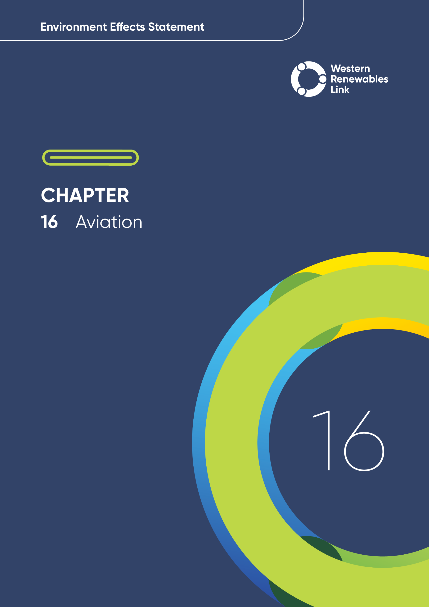

# Aviation

This chapter provides an overview of the potential aviation impacts associated with the construction, operation and decommissioning of the Project. This chapter is based on **Technical Report J: Aviation Impact Assessment**.

The aviation-related values assessed in this chapter include Certified Aerodromes, Uncertified Aerodromes, air navigation and air traffic management services, transiting air routes, and authorised low flying activities within the spatial extents of the airspace potentially impacted by the Project.

## Evaluation objective

The scoping requirements identify the following evaluation objective relevant to aviation:

**Evaluation objective**

Avoid, or minimise where avoidance is not possible, adverse effects on land use, social fabric of the community, businesses including farming and tourism, local and state infrastructure, aviation safety and to affected and neighbouring landholders during construction and operation of the project.

In response to this evaluation objective, the impacts of the Project on aviation were assessed and measures to avoid, minimise or manage potential impacts have been identified. These measures are discussed throughout this chapter and have informed the development of Environmental Performance Requirements (EPRs). EPRs set out the environmental outcomes to be achieved through the implementation of mitigation measures during construction, operation and decommissioning to avoid, minimise and manage identified impacts. Cumulative impacts associated with relevant future projects were also assessed.

Further information on how the Project has been designed to avoid and minimise impacts is provided in **Chapter 5: Project development** and **Chapter 6: Project description**.

Other aspects covered in the Environment Effects Statement (EES) evaluation objective and relevant to aviation are addressed in the following EES chapters:

* **Chapter 7: Community and stakeholder engagement**
* **Chapter 12: Land use and planning**
* **Chapter 13: Bushfire**
* **Chapter 14: Economic**
* **Chapter 15: Agriculture and forestry**
* **Chapter 21: Social.**

## 

## Method

This section summarises the method adopted in **Technical Report J: Aviation Impact Assessment**, which was informed by **Chapter 4: EES assessment framework and approach**. The key steps in assessing the impacts associated with aviation included:

* Defining a study area appropriate for aviation as presented in Figure 16.1. This considered Certified Aerodromes and Uncertified Aerodromes (including helicopter landing sites and aircraft landing areas), air navigation and air traffic management services facilities, transiting air routes and authorised low flying. The spatial extent of the study area is described in Table 16.1.
* Reviewing applicable Commonwealth and Victorian legislation, and relevant local, state and national standards, guidelines and policies.
* Aircraft Landing Area (ALA)

The ‘Manual of Standards Part 139 —Aerodromes’ defines an ALA as an “aircraft landing area, being an area for the landing, movement and take-off of aircraft that is not a certified or registered aerodrome”. This includes airstrips on farms.

In this definition, the term ‘aircraft’ is taken to include rotary wing aircraft (i.e., helicopters).

* Conducting a desktop review to determine the existing aviation conditions within the study area, including:
  + Certified Aerodromes
  + Uncertified Aerodromes including helicopter landing areas and aircraft landing areas (ALAs)
  + Air navigation and air traffic management services
  + Transiting air routes
  + Authorised low flying activities, including aerial agricultural applications, aerial firefighting, medical and emergency flights, flight training, sports aviation, private flights and tourism, military activities, and other aviation activities.
* Consulting with the relevant regulatory authorities and key stakeholders including local councils, community groups, industry bodies and associations, agriculture groups, Airservices Australia and aerodrome operators, and reviewing the pins dropped by community members onto the Project’s Social Pinpoint online mapping tool, which identified locations, features and values of importance.
* Conducting a risk screening process to identify the key issues during construction, operation and decommissioning for investigation within the technical report.
* Identifying and assessing the potential impacts associated with aviation, namely identifying Project hazards such as the presence of transmission towers and lines and construction activities that may impact existing aviation values including Certified Aerodromes and Uncertified Aerodromes, air navigation and air traffic management services, transiting air routes, and authorised low flying activities during construction, operation and decommissioning. These impacts were evaluated according to the following ratings, in relation to the extent, magnitude and duration of the impacts:
  + No impact: No change to current baseline operations. Operations continue as normal.
  + Minor: Minor change to current baseline operations. Operations continue as normal, with the mitigator that pilots are aware of the Project activity/infrastructure and the need to fly accordingly (i.e., the Pilot in Command has to make minor (i.e. immaterial) adjustments e.g., to the descent and departure angles/profiles, to ensure clearance is maintained over the Project activity/infrastructure). Minor (i.e., immaterial) impacts to air navigation and air traffic management services.
  + Moderate change to current baseline operations. Operations continue as normal, with the mitigator that pilots are aware of the Project activity/infrastructure and the need to make moderate (i.e., material but not unachievable) adjustments (e.g., to the descent and departure angles/profiles, to ensure clearance is maintained over the Project activity/infrastructure) to maintain safe flying. Moderate (i.e., material but not unmanageable) impacts to air navigation and air traffic management services.
  + Major change to current baseline operations. i.e. The Pilot in Command has to make significant (i.e., material and challenging) adjustments (e.g., to descent and departure angles/profiles) to ensure clearance is maintained over the Project activity/infrastructure, e.g., for aerodromes, operations are required to be curtailed or severely limited on particular runways and/or for specific aircraft types. Major (i.e., material and disruptive) impacts to air navigation and air traffic management services.
  + Unacceptable: Operations are unable to continue owing to conditions that preclude the ability of an aircraft to safely operate at a location, as well as land or take off from an aerodrome. Air navigation and air traffic management services become ineffective.
* Identifying relevant future projects that could lead to cumulative impacts when considered together with the Project (refer to **Chapter 4: EES assessment framework and approach** for the full cumulative impact assessment method).
* Standard units

Standard units for aviation usually include nautical miles (nm), knots (kn), and feet (ft). While metric units are referenced in this chapter, these imperial units are also referenced as they are aviation specific.

* Developing EPRs in response to the impact assessment to define the required environmental outcomes that the Project must achieve through the implementation of mitigation measures during construction, operation and decommissioning. Measures to reduce the potential impacts were proposed in accordance with the mitigation hierarchy (avoid, minimise, manage, rehabilitate and offset) and have informed the development of EPRs. Alternative mitigation measures could be implemented to comply with the EPRs based on the specific site conditions, available resources, and the Principal Contractor’s expertise.
* Following application of mitigation measures that would comply with the EPRs, determining residual impacts associated with the construction, operation and decommissioning of the Project, and evaluating their significance.

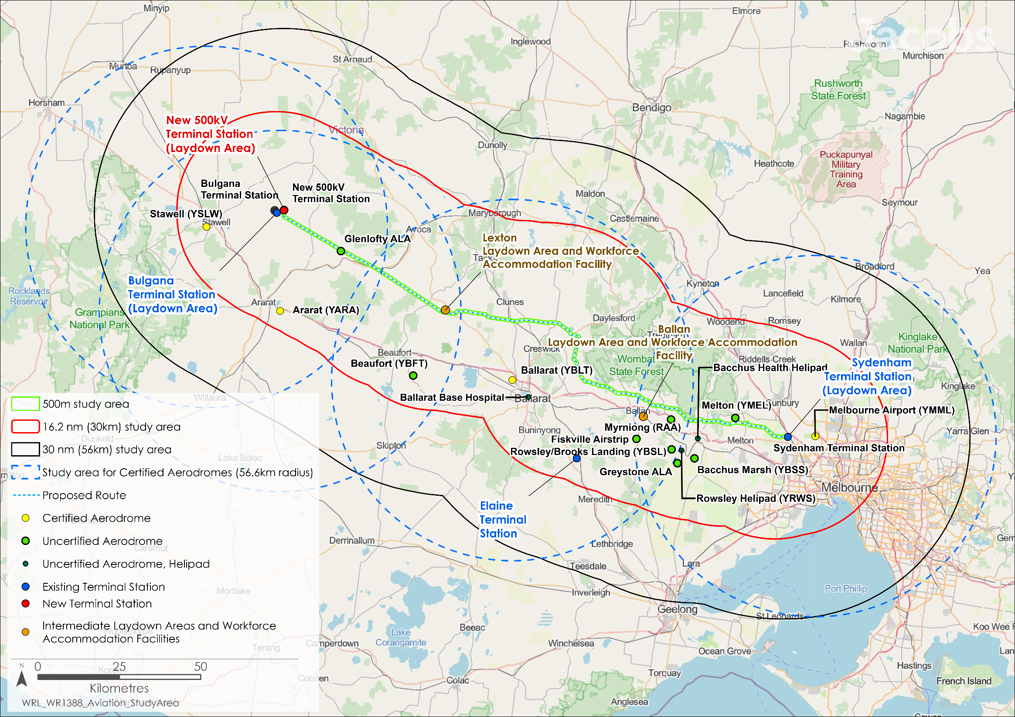

Figure . Aviation study area

Note: Mount William and Mount Macedon radar sites are not displayed

Table . Spatial extents of study area as relevant to different aviation values

|  |  |  |
| --- | --- | --- |
| Aviation aspect | Study area | Reason for consideration |
| Operations at surrounding Certified Aerodromes. | Any Certified Aerodrome within 30nm (56km) of the Proposed Route must be assessed. | This encompasses the protected airspace surrounding each identified Certified Aerodrome. The protected airspace surrounding Certified Aerodromes extends to 25nm (46.3km) with an associated safety buffer of 5nm (9.26km) taking the area to be assessed to 30nm (55.6km) radius of the Certified Aerodrome’s Aerodrome Reference Point. This area encompasses the Obstacle Limitation Surfaces (OLSs) that can extend to 15km from the runway end and the Procedures for Aircraft Navigation Services – Aircraft Operations (PANS-OPS) surfaces protecting published Instrument Approach Procedures. |
| Operations at nearby Uncertified Aerodromes, including helicopter landing areas and ALAs. | Within 16.2nm (30km) of the Proposed Route. | The 16.2nm (30km) distance adopted for Uncertified Aerodromes and helipads is in line with the Victoria Planning Provisions for aerodromes which uses the ‘National Airports Safeguarding Framework Guideline D Managing the risk to aviation safety of wind turbine installations (wind farms)/wind monitoring towers’ of 30km. |
| Air navigation and air traffic management services. | * + Communications: Within 30nm (56km) of Proposed Route   + Navigation: Within 30nm (56km) of Proposed Route   + Surveillance: 250nm (463km) from the Radar Site at Mount Macedon. | * + Communications: Study area developed with reference to guidance from ‘Manual of Standards Part 139: Chapter 19’, (Civil Aviation Safety Authority (CASA))   + Navigation: Study area developed with reference to guidance from ‘Manual of Standards Part 139: Chapter 19’, (CASA)   + Surveillance: In accordance with ‘EUROCONTROL Guidelines on assessing the potential impact of wind turbines on surveillance sensors Edition 1.2’, (EUROCONTROL, 2014). |
| Transiting air routes. | Within 16.2nm (30km) of the Proposed Route. | Transiting air routes are published in the Aeronautical Information Publication (AIP). Noting the granularity of information presented in the AIP, a conservative approach was taken to consider all routes within 30km of the Proposed Route. |
| Authorised low flying including:   * + Aerial agricultural spraying   + Aerial firefighting   + Flight training   + Sports aviation   + Private flights and tourism   + Military activities. | Below 50ft and within 500m of the Proposed Route. | Authorised low flying occurs at or below 500ft and is permitted for suitably trained and endorsed pilots. Impacts are only possible if these activities interact with the Project. |

* Civil Aviation Safety Authority (CASA) and Airservices Australia

CASA is the Australiangovernmentauthorityresponsible under the *Civil Aviation Act 1988* for developing and promulgating appropriate, clear and concise aviation safety standards.As Australia is a signatory to the International Civil Aviation Organisation (ICAO) *Chicago Convention,* CASA adopts the standards and recommended practices established by ICAO, except where a difference has been notified*.*

Airservices Australia is the national air navigation service provider, responsible for ensuring the safety and efficiency of air traffic control, aviation rescue, and aerial firefighting services across Australia.

## Existing conditions

This section summarises the existing conditions for aviation, according to the following key values:

* Certified Aerodromes
* Uncertified Aerodromes including helicopter landing areas and ALAs
* Air navigation and air traffic management services
* Transiting air routes
* Authorised low flying activities.

Existing aviation values within the study area relate to current aviation infrastructure and services that support commercial enterprises, farming operations, education and training, emergency services and recreation. Aviation operations in the study area include aerial agricultural applications for crop disease and weed control, aerial firefighting, emergency services operations, gliding clubs, and flight training schools.

### Certified Aerodromes

* Obstacle Limitation Surface (OLS)

A series of planes associated with each runway at a Certified Aerodrome that defines the desirable limits to which objects may project into the airspace around the aerodrome so that aircraft operations may be conducted safely.

Procedures for Air Navigation Services – Aircraft Operations(PANS-OPS)

[Air Traffic C](http://en.wikipedia.org/wiki/Air_Traffic_Control)ontrol term denominating rules for designing [instrument approach](http://en.wikipedia.org/wiki/Instrument_approach) and departure [procedures](http://en.wikipedia.org/wiki/Procedural_control#Procedural_approaches). Such procedures are used to allow aircraft to land and take off under [Instrument Meteorological Conditions](http://en.wikipedia.org/wiki/Instrument_meteorological_conditions) (IMC) or Instrument Flight Rules ([IFR](http://en.wikipedia.org/wiki/IFR)). [ICAO](http://en.wikipedia.org/wiki/International_Civil_Aviation_Organization) [document 8168-OPS/611 (volumes 1 and 2)](http://dcaa.slv.dk:8000/icaodocs/Doc%208168%20-%20Aircraft%20Operations/) outlines the principles for airspace protection and procedure design which all ICAO signatory states must adhere to. The regulatory material surrounding PANS-OPS may vary from country to country.

Within 56km of the Proposed Route, there are four Certified Aerodromes: Stawell (YSWL), Ararat (YARA), Ballarat (YBLT) and Melbourne (YMML).

These Aerodromes are protected by an OLS which limits the height of tall structures within the OLS. Certified Aerodromes also have Instrument Approach Procedures protected by PANS-OPS prescribed airspace, which is higher than the OLS and is designed to provide protection for safe instrument flying. This airspace should never be breached. Stawell, Ballarat and Melbourne have PANS-OPS; Ararat does not. Melbourne, being a controlled airport, also has a controlled airspace, where aircraft movements must comply with Air Traffic Control instructions.

### Uncertified Aerodromes including helicopter landing areas and ALAs

Within 30km of the Proposed Route, there are ten privately owned and operated Uncertified Aerodromes: Glenlofty ALA, Beaufort (YBFT), Ballarat Hospital (YXBT), Myrniong ALA, Rowsley/Brooks Landing (YBSL), Rowsley Helipad (YRWS), Greystones ALA, Bacchus Marsh (YBSS), Bacchus Health Helipad, and Melton (YMEL). Of these, Glenlofty ALA, Myrniong ALA and Greystones ALA are ‘unverified’, with the remaining being ‘verified’. ‘Verified’ aerodromes are recorded in Airservices Australia’s Aeronautical Database and are published on associated charts. For ‘unverified’ aerodromes, the status and serviceability have not yet been provided to or confirmed by Airservices Australia.

The key aviation activities at Beaufort, Rowsley/Brooks Landing and Rowsley Helipad are private use flights. Glenlofty ALA and Greystones ALA are both understood as primarily being used for aerial agricultural purposes. Melton Aerodrome, home to Melton Airservices, is a flight training school, charter, and aircraft maintenance organisation. Bacchus Marsh is a general aviation facility that hosts commercial flying training, aircraft maintenance, private flying and hangar space for light aircraft. Bacchus Marsh also has an active Flying Training School and three active Gliding Clubs (Melbourne Gliding Club, Geelong Gliding Club and Beaufort Gliding Club). Sport aviation is also the expected primary use at Myrniong ALA. Finally, the key authorised low flying activities at Bacchus Health Helipad and Ballarat Hospital Helipad are Helicopter Emergency Medical Services.

* Australian Height Datum (AHD)

The datum to which all vertical control for mapping is to be referred. The datum surface is that which passes through mean sea level at the 30 tide gauges and through points at zero AHD height vertically below the other basic junction points.

### Air navigation and air traffic management services

The study area encompasses several air navigation and air traffic management facilities for communications, navigation, and surveillance services. Air traffic control facilities are located at Mount William (44km southwest of the Proposed Route at an elevation of 1141m Australian Height Datum (AHD), Mount Macedon (28.5km north of the Proposed Route at an elevation of 883m AHD), and Melbourne Airport (7.6km east of the Proposed Route at an elevation of 130m AHD). These communication facilities have Building Restricted Areas (BRAs), which can extend up to 15km to prevent development or other activities interfering with these facilities’ operations. BRAs are designed to prevent obstructions that can interfere with line-of-sight, reflections, or electromagnetic interference, which could impact the operability of the communications facility.

Melbourne Airport hosts aviation ground-based navigation equipment (navaids), including Instrument Landing Systems, very high frequency Omni Range, Distance Measuring Equipment and Ground Based Augmentation Systems. There are no other navaids in the study area.

Surveillance includes both primary and secondary radar systems, as well as ground-based Automatic Dependent Surveillance – Broadcast (ADS-B) receivers. Radars are located at Mount Macedon and Gellibrand Hill, with ADS-B at Melbourne Airport and Mount William.

### Transiting air routes

There are three transiting air routes that cross the study area's spatial extents, as presented in Table 16.2.

Table . Air routes that cross the study area

| Air Route | Lowest Safe Altitude |
| --- | --- |
| V223 | 4,800ft (1,500m) AHD |
| H345 | 4,800ft (1,500m) AHD |
| W657 | 4,000ft (1,200m) AHD |

### Authorised low flying activities

Authorised low flying activities within the study area include aerial agricultural applications, aerial firefighting, medical and emergency flights, flight training, sports aviation, private flights and tourism, military activities, and other aviation activity. Pilots engaged in these low flying activities use aeronautical charts that identify potential obstacles such as tall structures like transmission towers and transmission lines and must manage operations to avoid these obstacles.

Authorised low flying is conducted by suitably trained and endorsed pilots who are aware of the hazards of such activity and plan their flights accordingly. In general, authorised low flying occurs below 500ft (152m) above ground level, often down to 10ft (3m) or less for aerial application (e.g. agricultural spraying) operations. Authorised low flying is permitted in the study area, except within 14km of Melbourne Airport.

The study area is in ‘Class G uncontrolled’ airspace, except for the section within 14km of Melbourne Airport’s Aerodrome Reference Point which is in ‘Class C controlled’ airspace. In Class G airspace, aircraft can operate anywhere, at any time as permitted by the Civil Aviation Safety Regulations 1998, as such these flights are neither monitored nor recorded. The Pilot In Command is responsible for ensuring the safety of the flight. This includes avoiding obstacles.

##### Aerial agricultural applications

Aerial agricultural applications (e.g., using aerial spraying for disease and weed control) using fixed-wing and rotary-wing aircraft are an authorised low flying activity. These operations are known to occur from Stawell and Ballarat aerodromes, but they can take place from any suitable aerodrome. Within the study area, potato growing, and other high intensity crops are the only agricultural enterprises known to use aircraft as part of their farming systems.

##### Aerial firefighting

Aerial firefighting is authorised within the study area, conducted at low altitudes using specialist aircraft under Visual Flight Rules. These rules dictate that the pilot must maintain ground visibility and remain clear of smoke to drop the fire retardant accurately and safely. Fixed-wing and rotary-wing fire response aircraft are based at several nearby aerodromes. Fixed-wing aircraft can use any suitable aerodrome to refill with retardant, while rotary-wing aircraft can also refill from field sources, including farm dams, swimming pools, and water reservoirs. Fixed-wing aircraft typically do not fight fires at night, but rotary-wing aircraft and some helicopters with night vision imaging systems may do so in certain circumstances.

* Aeronautical Information Publication (AIP)

A publication promulgated to provide operators with [aeronautical](http://en.wikipedia.org/wiki/Aeronautics) information of a lasting character essential to [air navigation](http://en.wikipedia.org/wiki/Air_navigation).

##### Medical and emergency flights

Medical and emergency flights, including Helicopter Emergency Medical Services originating from Essendon, Warrnambool or Bendigo, and Police Airwing based at Essendon are authorised low-flying activities. Other emergency flights (such as search and rescue) will originate wherever suitable aircraft are available.

##### Flight training

Flight training, including single engine light aircraft, light twin engine aircraft and larger twin turboprop aircraft, is also an authorised low-flying activity. Flight training schools are located at Ballarat, Bacchus Marsh and Melton aerodromes.

##### Sport aviation

Sport aviation, including gliding, parachuting and aerobatics, usually occurs within Class G uncontrolled airspace. This requires certain Visual Meteorological Conditions, such as the activity area being clear of clouds. Gliding clubs are located at Ararat and Bacchus Marsh aerodromes, and the gliders are towed into by single-engine light aircraft. A hang-gliding area is present on the hills east of Ararat. With respect to parachuting and other sporting aviation, no specific locations are shown in the AIP although they could take place at suitable locations within the study area.

##### Private flights and tourism

Private flights and tourism involve light aircraft for private, aerial work and charter operations. These are mostly single-engine aircraft flown under Visual Flight Rules, though some charter flights may use Instrument Flight Rules (navigating based on electronic signals). Tourism flights are generally not endorsed for low flying and are considered Charter Flying, which has additional requirements. In Class G airspace (which the Project is predominantly within), aircraft may operate freely, making the exact locations and numbers of such activities unpredictable.

##### Military applications

The Royal Australian Air Force (RAAF) Base Point Cook which is located approximately 27km south of the eastern end of the Proposed Route, and RAAF Base East Sale which is located approximately 190km east of Melbourne, have military aircraft, and both may fly aircraft at low levels through the study area.

##### Other aviation activities

Other aviation activities include model aircraft and drones, both governed by the Civil Aviation Safety Regulations 1998 and typically occurring within Class G airspace during the day. The exact locations and numbers of these activities are unpredictable. A model aircraft site is located approximately 3.5km east of Sydenham Terminal Station.

## Construction impacts

This section outlines the key issues identified through the risk screening process and associated potential impacts during the construction of the Project.

The key aviation construction related issues (potential hazards) relevant to aviation include:

* Pre-construction aerial survey of the Proposed Route by helicopter and other aircraft.
* Use of cranes and/or helicopters to facilitate tower construction over a period of approximately four to seven weeks at each location.
* Use of helicopters and other tall ground-based equipment for conductor and earth wire stringing between towers.

The key issues and impacts identified for aviation are discussed according to the following themes: Certified and Uncertified Aerodromes, air navigation and traffic management, transiting air routes and authorised low flying activities.

### Certified Aerodromes and Uncertified Aerodromes

Maintaining safe distances from Certified and Uncertified Aerodromes and complying with the requirements of Obstacle Limitation Surface (OLS) and PANS-OPS airspace penetration around Certified Aerodromes, notably at Melbourne Airport, was a key factor in planning the Proposed Route.

At Melbourne Airport, the towers are designed to sit below the minimum vertical extents. However, during their construction, plant and equipment, as well as helicopters may need to be used at vertical levels above the OLS, resulting in a minor impact to the operation of Melbourne Airport. Authorisation is required from Melbourne Airport if works are within the protected airspace.

No impacts are anticipated at other Certified Aerodromes (Stawell, Ararat and Ballarat) as the Project design has avoided their associated protected airspaces. For Ballarat Certified Aerodrome, it is noted that Project construction activities will be required within the spatial extents of the published instrument approach path for RWY18, but are expected to remain below the associated minimum vertical level. As such, no impacts at Ballarat Aerodrome are expected, provided that all construction activities remain below this documented level.

It is not expected that the Project would introduce additional operational restrictions at the Glenlofty ALA, Beaufort, Ballarat Hospital, Myrniong ALA, Rowsley/Brooks Landing, Rowsley Helipad, Greystones ALA, Bacchus Marsh and Bacchus Health Helipad Uncertified Aerodromes.

Melton Uncertified Aerodrome facilitates ultra-light and light aircraft operations, training, and aircraft maintenance. The construction of the transmission towers for the Project may interfere with these operations. Pilots must ensure the area for take-off or landing is suitable for the particular aircraft, in the particular situation of that operation; however, construction activities will add additional obstacles and constraints for pilots utilising the Melton Uncertified Aerodrome, resulting in moderate to major impacts to the operation of Melton Uncertified Aerodrome should restrictions to operations occur. The application of mitigation measures and compliance with EPRs is required to manage the potential impacts to Melton Aerodrome during construction.

The aviation industry, managed by Airservices Australia, is responsible for managing air traffic and ensuring safe, efficient air travel through aviation regulations, training, pilot assessments and accurate dissemination of flight information. Throughout the construction stage, the Project will provide Airservices Australia with the relevant details of Project plant and equipment and infrastructure to inform pilots of the existence and location of aspects of the Project that may pose a hazard to aircraft operations (EPR AV1).

Prior to the commencement of construction activities that could present a hazard to aircraft operations, the Principal Contractor will also consult and liaise with key aviation stakeholders, in particular the Melbourne Airport and the Melton Uncertified Aerodrome to minimise the extent and duration of impacts to aircraft operations. These requirements will be set out in the Communications and Stakeholder Engagement Management Plan (EPR EM5).

The implementation of EPR AV1 and EPR EM5 will manage potential impacts by disseminating knowledge about the location and duration of the Project’s construction activities to the aviation industry. As such, residual impacts associated with the Project are assessed to be moderate at Melton Uncertified Aerodrome and there will be no residual impacts at Melbourne Airport.

### Air navigation and air traffic management

During construction, there will be no impacts to the air navigation and air traffic management services described in Section 16.3.3. Use of tall equipment and helicopters during construction would not affect these facilities as construction activities will occur outside the BRAs (15km radius) of all of the identified communication facilities, except at Melbourne Airport. At Melbourne Airport, the Project will co-ordinate with the airport during construction and the operators of all communication facilities will also be made aware of Project construction activities via the notifications made to the AIP (EPR AV1). As such, there will be no impacts to air navigation and air traffic management during construction.

### Transiting air routes

Section 16.3.4 sets out the transiting air routes identified within the study area. The lowest safe altitude for transiting air routes in the study area is 4,000ft (1,200m) AHD. This is safely above the highest level that could be expected to be reached by the Project activities during construction. As such, there will be no residual impacts to transiting air routes during construction.

### Authorised low flying activities

As soon as a tall structure is constructed, it becomes an aviation obstacle. This includes the Project’s transmission towers and transmission lines as they are erected progressively throughout the construction stage, and the use of tall equipment and helicopters required to build tower infrastructure. Pilots engaged in low flying activities - such as aerial agricultural applications, aerial firefighting, emergency services, flight training, sport aviation and military operations – plan, using aeronautical charts that will identify the Project, operations to manage this and avoid these obstacles. All other flights, including tourism flights, must maintain an altitude of at least 500ft above the transmission towers.

Project construction activities including the use of aerial survey technology during the pre-construction stage, the use of cranes and/or helicopters for tower construction, and the use of helicopters and other equipment for conductor and earth wire stringing have the potential to impact these low-flying aviation activities to a minor extent.

There are no reasonable and feasible alternative construction methods for the Project which would not require the use of cranes and helicopters. The most effective measure for limiting the potential for Project construction to impact authorised low flying activities is notification of Project activities via the AIP (EPR AV1). Airservices Australia then issue an AIP Supplementary notice to notify the aviation community of the Project construction locations, heights, and durations. This notification, combined with notification to the relevant aerodrome operators, will provide the aviation industry with the necessary information, such that pilots will plan their flights to avoid these potential hazards. With this notification, residual impacts of Project construction activities on authorised low flying activities due to the use of tall equipment and helicopters during construction will remain minor, as pilots may need to make minor adjustments to planned routes in order to maintain clearances from obstacles.

## Operation impacts

This section outlines the key issues identified through the risk screening process and associated potential impacts during the operation of the Project. The key aviation related values (potential hazards) from the Project during operation include:

* Presence of new transmission towers, terminal stations and overhead transmission lines: The Project infrastructure includes various tall tower structures that can present an obstacle to aviation. For the assessment, the towers were considered at a height of 85m, except for the single circuit towers that pass by Melton (YMEL) Uncertified Aerodrome (where towers are no more than 44.5m tall); and height limited towers from 44m to 74m under the Melbourne Airport (YMML) Protected Airspace west from Sydenham Terminal Station. It is noted that there are other locations where shorter towers would be used, however, the conservative 85m was applied in assessing the operational impacts of the Project (excepting the two instances described above).
* Use of aircraft for transmission line inspection and maintenance: Helicopters and tall equipment may occasionally be used to inspect and maintain the Project infrastructure, including towers and transmission lines during operations.

The key issues and impacts identified for aviation are discussed according to the following values: Certified and Uncertified Aerodromes, air navigation and traffic management, transiting air routes and authorised low flying activities.

### Operations at Certified and Uncertified Aerodromes

The Project is designed to avoid impacting protected airspace at Certified Aerodromes and minimise changes to operations at Uncertified Aerodromes. Apart from the Uncertified Melton Aerodrome, the operation of the Project will have no impacts on aviation operations at the Certified and Uncertified Aerodromes within the study area. Regarding operational maintenance activities, potential impacts are expected to be comparable to or less than those determined to exist during construction. Although the hazards (e.g., use of tall equipment and helicopters) during operational maintenance activities would occur much less frequently than during construction, the activities are comparable and so present similar risks as a potential hazard to aviation operations.

Melton Aerodrome hosts ultra-light and light aircraft operations and maintenance. The proximity of the new 500kV transmission line in relation to the Melton Aerodrome is shown in Figure 16.2. Pilots are required to make themselves familiar with the aerodrome limitations prior to deciding that the aerodrome is suitable for the aircraft operation intended. The proximity of the Project infrastructure to Melton Aerodrome is such that aircraft arriving and departing on runways RWY04/22, RWY14/32 and RWY34 will need to be briefed by the aerodrome operator on the location and height of the Project infrastructure to inform their flight plan, resulting in moderate impacts to the operation of Melton Aerodrome. The Pilot in Command is required to seek prior permission to use Melton Aerodrome and obtain information regarding the status of the aerodrome, including local hazards such as powerlines, prior to landing or taking off from the aerodrome. Shorter Project towers (single circuit towers side by side) ranging in height from approximately 33.7m to 39.6m will be constructed near Melton Aerodrome to provide safe clearance and reduce the extent of potential impacts to aircraft operations as much as reasonably practicable.

In addition, the transmission towers and transmission line in the vicinity of the Melton Aerodrome will be marked with standard obstacle markings as per Australian Standard AS 3891.1:2021 and AS 3891.2 to make them more visible to pilots flying at Melton Aerodrome (EPR AV2). The inclusion of additional notes in the AIP (EPR AV1) for pilots using Melton Aerodrome will indicate the presence of the Project such that they can plan their flights accordingly.

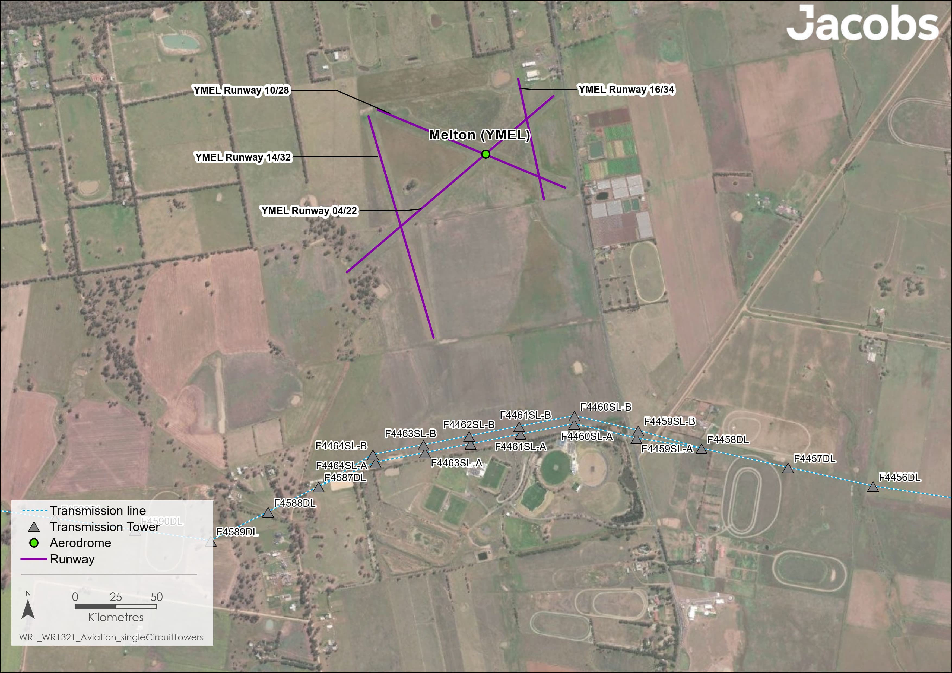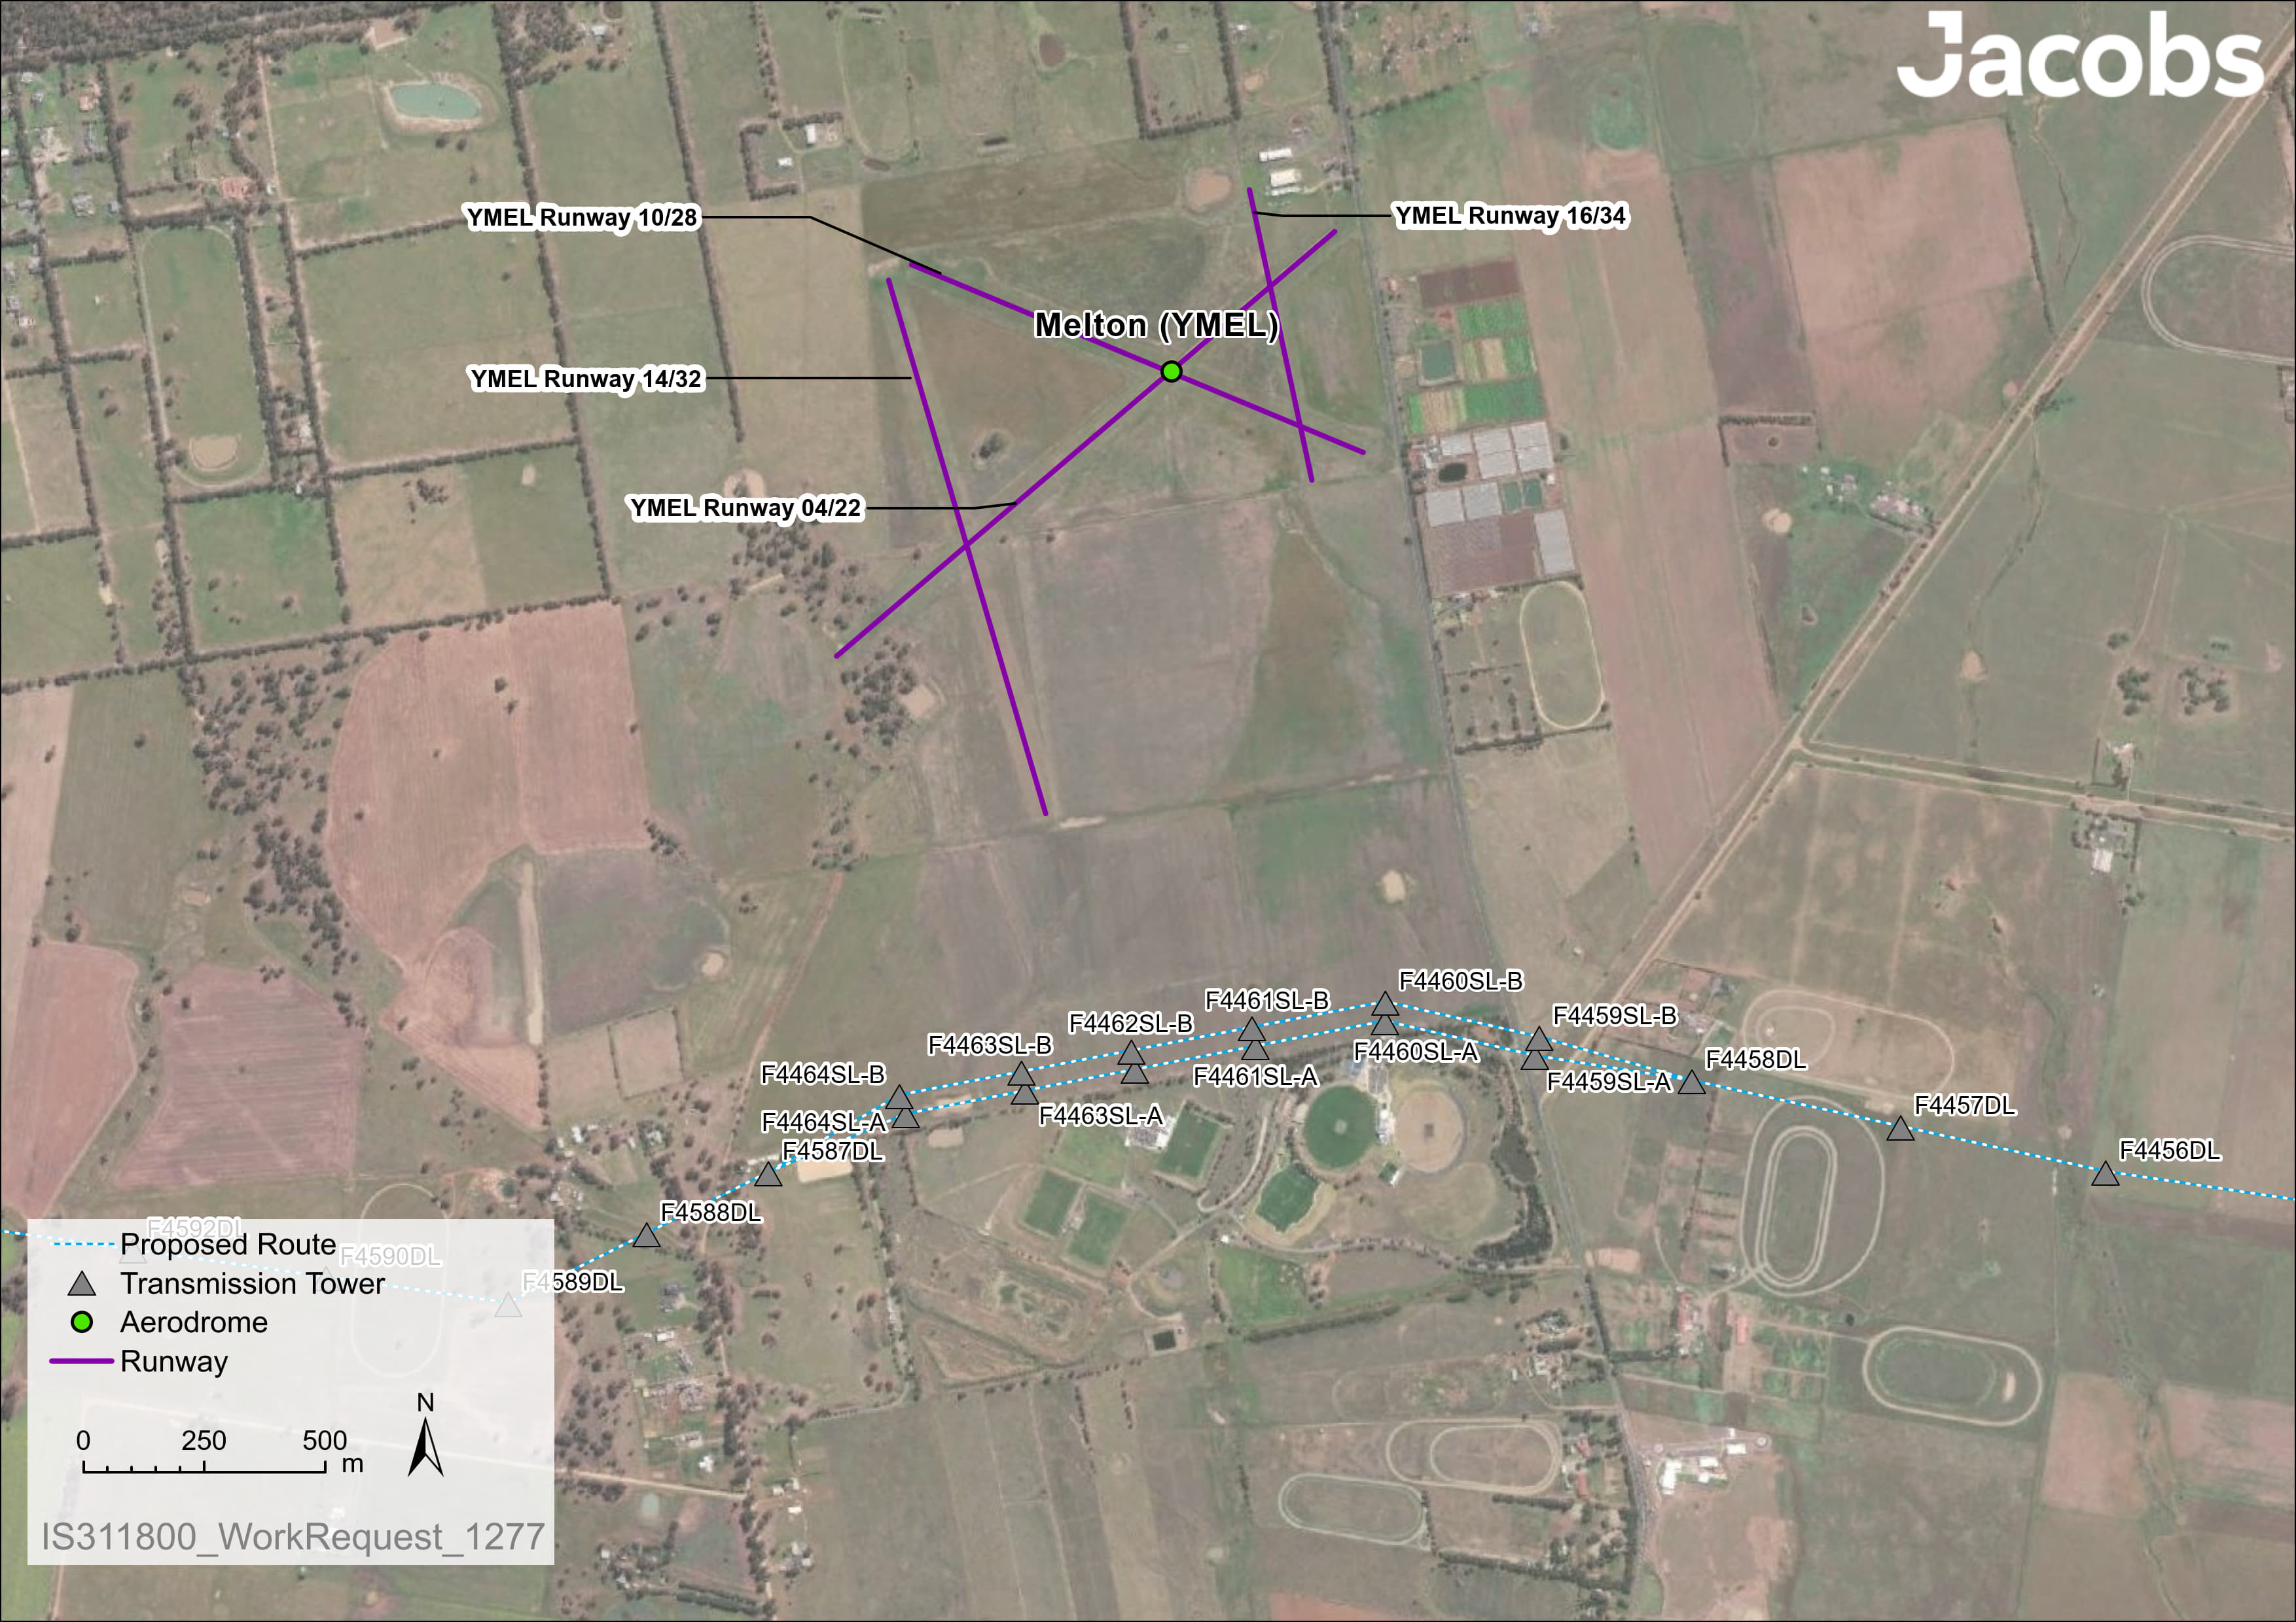

Figure . Proximity of Melton Aerodrome to the proposed transmission line and existing aerodrome configuration

With implementation of management measures in EPR AV1, EPR AV2 and EPR EM5, the residual impacts associated with the Project are assessed to be minor at Melton Aerodrome. There will be no residual impacts to aviation values during Project operations on Stawell (USWL), Ararat (YARA), Ballarat (YBLT) and Melbourne Airport (YMML) Certified Aerodromes as the Project avoids existing OLS and PAN-OPS protected airspaces. At some Certified Aerodromes, such as Stawell (USWL) and Ararat (YARA), the Project will be shielded by other existing infrastructure (such as windfarms or transmission lines), which already limits aircraft operating in the vicinity to avoid the infrastructure as existing obstacles.

### Air navigation and air traffic management

There will be no impacts to air navigation and air traffic management services, as described in Section 16.3.3, during the operational stage of the Project. These communication facilities are not affected by the presence of existing high voltage transmission lines and terminal stations (e.g., 500kV transmission line in Bulla and the existing Sydenham Terminal Station) and therefore the Project is also not expected to impact these services.

Operators of these facilities will be made aware of the presence of the Project infrastructure through notification made to the AIP (EPR AV1). As such, there will be no residual impacts to air navigation and air traffic management during operation of the Project.

### Transiting air routes

Section 16.3.4 sets out the transiting air routes identified within the study area. The lowest safe altitude for transiting air routes in the spatial extents of the study area is 4,000ft (1,200m) AHD. This is safely above the highest level that could be expected to be reached by Project activities during operation. As such, there will be no residual impacts to transiting air routes during operation of the Project.

### Authorised low flying activities

Operation of the Project will not impact most low-flying activities within the study area. However, Project operations are assessed to have a minor impact on aerial agricultural flying, medical and emergency flights, and aerial firefighting due to the need for the Pilot in Command of these operations to make minor (immaterial) adjustments to the descent and departure angles/profiles to take into account the Project infrastructure.

The requirement to provide notification of Project details to the AIP and relevant aerodrome operators will help pilots avoid any hazards (EPR AV1). The residual impacts of Project operations on aerial agricultural, aerial firefighting and medical and emergency flights remain minor as flight adjustments would still be required with the presence of Project infrastructure. There will be no residual impacts for other low-flying activities.

## Decommissioning impacts

As decommissioning activities will be similar to those that occur during construction, the impacts relating to aviation are assessed to be the same as for the construction stage. As such, no residual impacts were identified at surrounding aerodromes, except at Melton Uncertified Aerodrome, where moderate residual impacts were determined. Minor residual impacts were also determined for authorised low flying activities within the vicinity of the Project infrastructure.

Accordingly, the EPRs developed to manage impacts during construction would also be applicable for decommissioning in accordance with the conditions of the time. This would also be managed by a Decommissioning Management Plan (EPR EM11) which would include mitigation measures for aviation management requirements.

Based on this, residual impacts are expected to be moderate to none for aviation.

## Cumulative impacts

Cumulative impacts have been assessed by identifying relevant future projects that could contribute to cumulative impacts on aviation values, considering their spatial and temporal relationships to the Western Renewables Link Project. The projects considered as potentially relevant to aviation include:

* Brewster Wind Farm
* Melbourne Renewable Energy Hub
* Nyaninyuk Wind Farm
* Sydenham Terminal Station Rebuild
* Victoria to New South Wales Interconnector (VNI) West
* Watta Wella Renewable Energy Project.

The Melbourne Renewable Energy Hub is a battery and solar farm project proposed adjacent to the Sydenham Terminal Station. In terms of aviation aspects, the Melbourne Renewable Energy Hub could result in glint and glare impacts from the photovoltaic cell arrays, however the Project would not result in glint and glare impacts, such that associated cumulative effects of both projects are not expected. Additionally, although both the Melbourne Renewable Energy Hub and the Project will include tall structures, cumulative impacts are not anticipated, noting that the Project is not expected to result in any residual impacts to Melbourne Airport (during construction, operations or decommissioning), and with structures being lower for the Melbourne Renewable Energy Hub, its impacts are expected to be negligible.

The Brewster Wind Farm and the Western Renewables Link Project will not have cumulative aviation, given the wind farm’s distance from the Project of 16km.

The VNI West Project will have similar impacts to aviation as the Western Renewables Link Project, and cumulative localised impacts to low flying aircraft near Bulgana due to the additional infrastructure associated with both projects.

The Watta Wella Renewable Energy Project, comprising of a wind farm, solar farm and battery, will be associated with considerably higher operational structures associated with than the Western Renewables Link Project. Similarly**,** the infrastructure associated with the Nyaninyuk Wind Farm will taller than that of the Western Renewables Link Project. The wind turbines associated with both projects would become the main aviation obstacles in the area, shielding any effects associated with the Western Renewables Link Project. As such, the potential for cumulative impacts is limited.

Finally, for the Sydenham Terminal Station Rebuild, connecting Project infrastructure and infrastructure associated with the upgrade have been designed so that they remain below the minimum vertical extents of Melbourne Airport’s Protected Airspace. As such, the potential for the Project and Sydenham Terminal Station Rebuild to have cumulative aviation impacts would be limited.

The Western Renewables Link Project’s location will be communicated to the aviation industry through the AIP and aeronautical charts, ensuring pilots are aware of aviation hazards along their routes. As such, cumulative impacts of the relevant future projects will be managed effectively through avoidance, engineering and administrative controls and the potential for significantly adverse cumulative impacts are not expected.

## Environmental Performance Requirements

Potential impacts identified through **Technical Report J: Aviation Impact Assessment** have informed the development of EPRs for the Project. EPRs set out the environmental outcomes to be achieved through the implementation of mitigation measures during construction, operation and decommissioning. While some EPRs are performance based to allow flexibility in how they will be achieved, others include more prescriptive measures that must be implemented. Compliance with the EPRs will be required as a condition of the Project’s approval. Table 16.3 details the proposed EPRs developed for aviation.

Table . Environmental Performance Requirements

| EPR code | Requirement |
| --- | --- |
| EPR AV1 | **Provide notification to Airservices Australia**   1. The Project must provide relevant Project details to Airservices Australia so that pilots, including operators of any fire response aircraft, are aware of its existence, location and features of the Project that may pose a hazard to aircraft operations. 2. The information must include relevant details of the Project plant, equipment and infrastructure, and meet the requirements (detail and frequency) of Airservices Australia for the promulgation of an Aeronautical Information Circular (AIC) and where required a Notice to Airmen (NOTAM) or Aeronautical Information Publication Supplement (AIP SUP) to keep the aviation industry informed of progress throughout construction. 3. This information is to be reported in accordance with CASA Advisory Circular AC139.E-05 Obstacles (including wind farms) outside the vicinity of a CASA certified aerodrome and AC139.E-01 Reporting of tall structures. |
| EPR AV2 | **Mark transmission line towers and associated catenary around Melton Uncertified Aerodrome (YMEL)**   1. Towers and associated catenary are to be marked with standard obstacle markings as per Australian Standard AS 3891.1:2021 and AS 3891.2 to make them more visible to pilots flying. Towers near the Melton Uncertified Aerodrome (YMEL) are to be marked, including:    * + F4458DL      + F4459SL-A      + F4460SL-A      + F4461SL-A      + F4462SL-A      + F4463SL-A      + F4464SL-A      + F4459SL-B      + F4460SL-B      + F4461SL-B      + F4462SL-B      + F4463SL-B      + F4464SL-B      + F4587DL      + F4588DL      + F4589DL      + F4590DL      + F4592DL      + F4593DL      + F4594DL      + F4595DL. |

Other EPRs contribute to a reduction in the magnitude, extent and duration of impacts for aviation values. Additional EPRs related to aviation include:

* EPR EM5 – Develop and implement a Communications and Stakeholder Engagement Management Plan
* EPR EM11 – Develop and implement a Decommissioning Management Plan.

Refer to the relevant technical chapters and **Chapter 29: Environmental Management Framework** for full detail of these EPRs.

No specific ongoing environmental management and monitoring requirements are required for aviation.

## Summary of residual impacts

With application of the EPRs, residual impacts from the Project associated with aviation are moderate to none:

* There will be no residual impacts to Certified Aerodromes during construction. Construction activities are within the Controlled Airspace at Melbourne Airport where plant and equipment used during construction (including the use of helicopters) may be above the OLS. However, the Project will consult and liaise with Melbourne Airport to minimise the extent and duration of works and impacts to operation, and co-ordinate construction activities with air traffic so that both activities can be conducted safely (EPR EM5). Similarly, the Project will engage with aerodrome operators at Ballarat Aerodrome if any construction activities are planned within the instrument approach path for RWY18 (EPR EM5). At both locations, works in protected airspaces will not be undertaken without authorisation from respective aerodrome operators. No other Certified Aerodromeswill be impacted by the Project.
* Residual impacts to Uncertified Aerodromes including helicopter landing areas and ALAs during construction are moderate to none. Moderate impacts are only anticipated to occur at the Melton Aerodrome, where the Project’s proximity will require updates to procedures to notify pilots of the requirements before landing or taking off (EPR AV1). Consultation with the Melton Aerodrome and co-ordination of construction activities in this location will minimise interruptions to operations as far as practicable (EPR EM5). There will be no residual impacts to other Uncertified Aerodromes during construction, as the Project will not introduce additional restrictions at these sites.
* There will be no residual impacts to Certified Aerodromes during operation. This is primarily due to the Project design having avoided protected airspaces as much as possible as well as notification to the aviation industry of the permanent change along the route via the AIP (EPR AV1).
* Residual impacts to Uncertified Aerodromes including helicopter landing areas and ALAs during operation are minor to none. Minor impacts are only anticipated to occur at the Melton Aerodrome where the Project will construct shorter (single circuit) towers, providing safe clearance and reducing impacts to aircraft operations so far as reasonably practicable. These towers will be marked with standard obstacle markings (EPR AV2) and pilots will be provided with information to plan their flights accordingly (EPR AV1). There will be no residual impacts to other Uncertified Aerodromes during operation, as the Project will not introduce additional restrictions at these sites.
* There will be no residual impacts to air navigation and air traffic management services during construction and operation. These communication facilities are not affected by the presence of existing high voltage transmission lines and terminal stations, therefore the Project, once in operation is also not expected to impact these services. During construction of the Project, these communication facilities will not be impacted by the use of tall equipment and helicopters, as construction activities will occur outside the BRAs (15km radius) of these sites, with the exception of Melbourne Airport, where the Project will co-ordinate with the airport during construction. There are also no know impacts from existing transmission lines and terminal station on traffic management services at Melbourne Airport. Operators of all aerodrome communication facilities will also be informed of the status and location of Project infrastructure (EPR AV1 and EPR EM5).
* There will be no residual impacts on transiting air routes during construction and operation. The lowest safe altitude for transiting air routes is above the highest level that any Project activities could reach, as such impacts are avoided.
* Residual impacts to authorised low flying activities during construction are minor. Relevant Project details will be provided to Air Services Australia so that pilots, including those undertaking authorised low flying activities, are aware of planned activities and potential hazards via the AIP and NOTAM (EPR AV1). This will enable pilots to make required minor adjustments when flying to maintain clearance from Project construction obstacles.
* Residual impacts to low flying activities during operation are minor to none. A minor impact may be experienced by aerial agricultural applications, aerial firefighting, and medical and emergency flights, noting that such operations may still be required in close proximity to Project infrastructure and that its presence could result in minor adjustments when flying. Pilots will be made aware of any hazards posed by the Project during operation through notification to the AIP and relevant Aerodrome Operators to enable aircraft adjustments to be made around infrastructure (EPR AV1).
* Residual impacts to aviation during decommissioning are considered to be the same as for the construction stage. As such, EPRs developed to manage impacts during construction will also be applicable for decommissioning and will be incorporated into the Decommissioning Management Plan (EPR EM11).

With the implementation of measures to comply with EPRs, it is considered that the Project meets the evaluation objective *“to avoid, or minimise where avoidance is not possible, adverse effects on land use, social fabric of the community, businesses including farming and tourism, local and state infrastructure, aviation safety and to affected and neighbouring landholders during construction and operation of the project”.*

