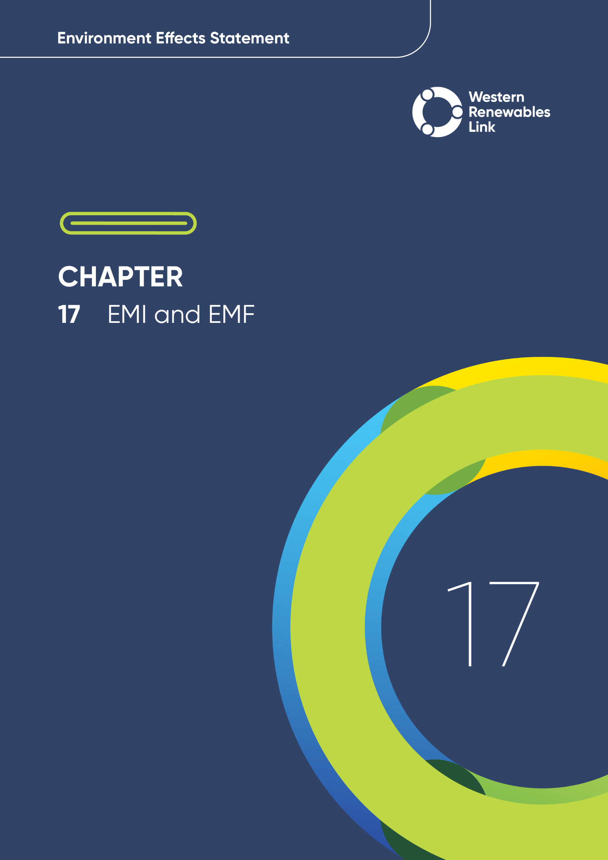

EMI and EMF
This chapter provides an overview of the potential electromagnetic interference and electric and magnetic field impacts associated with the construction, operation and decommissioning of the Project. This chapter is based on Technical Report L: EMI and EMF Impact Assessment.
Electric and magnetic fields (EMF) are invisible, physical fields that surround electrical charges and exert forces on nearby charged objects. Extremely low frequency (i.e. 50 hertz (Hz)) EMF produced by transmission lines can affect both people and the proper functioning of sensitive electrical and electronic equipment. High frequency electromagnetic fields can interfere with the reception of radio, television and mobile communication signals, which is referred to as electromagnetic interference (EMI). The Project has the potential to impact receptors that are located in close proximity to the proposed transmission line that may be sensitive to EMI and EMF, including hospitals and medical centre equipment, point-to-point radio communications equipment, electrical/electronic equipment in residential/commercial/industrial areas, and human and animal health receptors (e.g., public areas, workers, livestock etc.).

Evaluation objective
The scoping requirements identify the following evaluation objective relevant to EMI and EMF:
Evaluation objective
Avoid, or minimise where avoidance is not possible, adverse effects for community amenity, health and safety, with regard to construction noise, vibration, dust, lighting, waste, greenhouse gas emissions, transport network, operational noise, fire risk management and electromagnetic radiation.
In response to this evaluation objective, impacts of the Project on EMI and EMF levels were assessed and measures to avoid, minimise or manage potential impacts have been identified. These measures are discussed throughout this chapter and have informed the development of Environmental Performance Requirements (EPRs). EPRs set out the environmental outcomes to be achieved through the implementation of mitigation measures during construction, operation and decommissioning to avoid, minimise and manage identified impacts. Cumulative impacts associated with relevant future projects were also assessed.
Further information on how the Project has been designed to avoid and minimise impacts is provided in Chapter 5 Project development and Chapter 6: Project description.
Other aspects covered in the Environment Effects Statement (EES) evaluation objective and relevant to EMI and EMF are addressed in the following EES chapters:

- EES Chapter 11: Landscape and visual
- EES Chapter 13: Bushfire
- EES Chapter 18: Air quality
- EES Chapter 19: Noise and vibration
- EES Chapter 20: Transport
- EES Chapter 23: Contaminated land
- EES Chapter 26: Greenhouse gas.

Method
This section summarises the method adopted in Technical Report L: EMI and EMF Impact Assessment, which was informed by Chapter 4: EES assessment framework and approach. The key steps in assessing the impacts associated with EMI and EMF included:
- Defining a study area appropriate for EMI and EMF as presented in Figure 17.1. This included the Project Area plus an additional 5km buffer.
- Reviewing applicable Commonwealth and Victorian legislation, and relevant local, state and national standards, guidelines and policies.
- Conducting a desktop review to determine the following existing EMI and EMF conditions, including identifying existing and future committed sensitive receptors, and existing sources of EMI and EMF. The following data sources and reference standards were reviewed:
  - AusNet circuit data sheets to determine the existing transmission line assets
  - AusNet Standard Design Manual 08-0100 Version 3.0 - Overhead Transmission Lines Design Standard, for the design minimum ground clearances
  - Geospatial data for identification of any sensitive receptors within the study area that may be sensitive to EMI and EMF levels below the accepted reference levels and limits
  - Australian Communications and Media Authority (ACMA) website, to determine fixed radio communication site locations and installed equipment within the study area.
- Defining Project limits for EMI and EMF, based on international guidelines and reference levels (see Section 17.2.1).
- Consulting with the relevant regulatory authorities and key stakeholders, including Moorabool Shire Council and Southern Rural Water, and reviewing the pins dropped by community members via the Project’s Social Pinpoint online mapping tool, which identified locations, features and values of importance.
- Conducting field investigations and targeted site inspections/walkovers to measure existing EMI and EMF levels in the study area. For the assessment of existing EMI and EMF levels, the study area was divided into western and eastern sections, with the middle point near Creswick.
- Conducting a risk screening process to identify the key issues during construction, operation and decommissioning for investigation within the technical report.
- Identifying and assessing the potential impacts associated with EMI and EMF during construction, operation/maintenance, and decommissioning of the Project with regards to human health, interference with communication or infrastructure systems, Active Implantable Medical Devices, livestock and apiaries, and Global Positioning Systems (GPS). These impacts were evaluated according to the following ratings, in relation to the extent, magnitude and duration of the impacts:
  - Negligible: Electromagnetic fields do not interfere with proper functioning of sensitive receptors.
  - Minor: Electromagnetic fields may exceed equipment sensitivity ratings but will not impact on proper function.
  - Moderate: Electromagnetic fields exceed sensitive receptor immunity ratings resulting in minor to moderate impact on proper system functioning; these impacts can be overcome through operational controls such as recalibration or restart processes or the accuracy of the device is downgraded.
  - Major: Electromagnetic fields exceed sensitive receptor immunity ratings to the extent that degrades the performance of the receiver, negatively impacting on operational processes that rely on that receiver; sensitive receptors may require complex restart or recalibration process or cannot be used during certain times of day.
  - Severe: Electromagnetic fields exceed sensitive receptor immunity ratings to the extent that the receiver is rendered inoperable until repair, recalibration or adjustment of the receiver; severe impact on operational processes that rely upon the receiver.
It is noted that these impact ratings are limited to electrical and electronic equipment, as assessment of EMI and EMF levels associated with the new Project infrastructure will be below reference levels and limits for people and animals (with the exception of non-native honeybee species kept in apiaries, although these are not present in the EMF impact zones – see Section 17.5.2). As such, human and animal health were not included as part of the impact ratings. When they are assessed, it is in terms of non-significance - EMF will still be experienced by humans and animals, but at levels below all defined safety limits).
- Identifying relevant future projects that could lead to cumulative impacts when considered together with the Project (refer to Chapter 4: EES assessment framework and approach for the full cumulative impact assessment method).
- Developing EPRs in response to the impact assessment to define the required environmental outcomes that the Project must achieve through the implementation of mitigation measures during construction, operation and decommissioning. Measures to reduce the potential impacts were proposed in accordance with the mitigation hierarchy (avoid, minimise, manage, rehabilitate and offset) and have informed the development of EPRs. Alternative mitigation measures could be implemented to comply with the EPRs based on the specific site conditions, available resources, and the Principal Contractor’s expertise.
- Following application of mitigation measures that would comply with the EPRs, determining residual impacts associated with the construction, operation and decommissioning of the Project, and evaluating their significance.

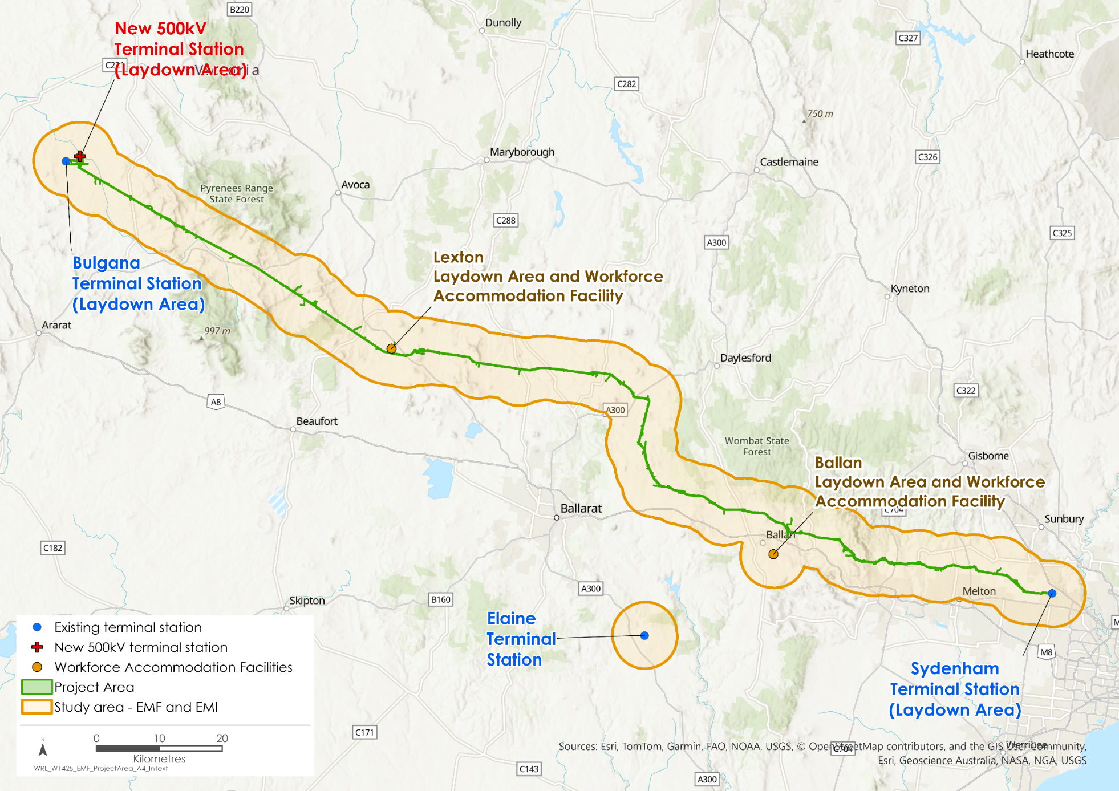
Figure 17.1 EMI and EMF study area

Defining EMI and EMF Project limits

EMF
Electric fields are quantified in terms of electric field strength, which is measured in units of volts per metre (V/m) and typically stated in units of kilovolts per metre (kV/m) for electrical power infrastructure. Magnetic fields are quantified in terms of the magnetic flux density, which is measured in tesla (T) and typically stated in microtesla (µT) for electrical power infrastructure, which is one millionth of a tesla.
The range of EMF levels experienced in the home, office, public streets and neighbourhoods is shown in Table 17.1.
Table 17.1 Typical EMF field strength levels for different types of sources
Environment |  | Typical Range of Magnetic Fields (µT)  (ARPANSA, 2025a) | Typical Range of Electric Fields (kV/m)  (Transpower, 2022)
Around the home and office | General areas in the home or office | 0.05 to 0.15 | 0.003 to 0.02
 | Electric stove | 0.2 to 3 | 0.07 to 0.1
 | Refrigerator | 0.2 to 0.5 | Not reported
 | Electric kettle | 0.2 to 1 | Not reported
 | Television | 0.02 to 0.2 | Not reported
 | Electric heater blanket | 0.5 to 3 | 0.058 to 0.6
 | Hair dryer | 1 to 7 | 0.3 to 0.8
Public streets and neighbourhoods | Street-side power lines (directly under the line) | 0.2 to 3 | 0.01 to 0.06
 | Street-side power lines (10m from the line) | 0.05 to 1 | Not reported
 | High voltage transmission line (directly under the line) | 1 to 20 | 0.003 to 9*
 | High voltage transmission line (10m from the line) | 0.2 to 5 | 4.5
*This range is for a wide range of transmission line voltages, from 110kV through to 500kV.

The International Commission on Non-Ionizing Radiation Protection (ICNIRP) Guidelines for Limiting Exposure to Time-varying Electric and Magnetic Fields (1Hz to 100Hz) (ICNIRP, 2010) reflect international best practice and adopt a conservative approach to setting EMF exposure thresholds. These guidelines include basic restrictions and reference levels. Basic restrictions are exposure limits, whilst reference levels are practical parameters for determining compliance with the limits, however, are not limits themselves.
Based on referenced ICNIRP basic restriction calculations, the Project has adopted a 7kV/m electric field limit as the design limit that shall not be exceeded for the Project’s new 500kV transmission line. The ICNIRP reference level of 5kV/m has been adopted for assessing the impacts of the Project’s other infrastructure, given that the 7kV/m design limit was only derived for the 500kV transmission line. A magnetic flux density of 200µT has been adopted as the general public exposure limit for the Project, based on the ICNIRP reference level.
Medical and research equipment may be sensitive to extremely low frequency (50Hz) magnetic fields at levels between 0.003 and 3.8µT. Electrical and electronic equipment found more generally in residential, commercial and light industrial environments within the study area are less sensitive to extremely low frequency magnetic fields. For general equipment in this environment, the Project has adopted a required 3.8µT magnetic flux density limit for 50Hz magnetic fields, as defined in Australian/New Zealand Standard (AS/NZS) 61000.6.1 – 2006: Electromagnetic Compatibility – Immunity for residential, commercial and light-industrial environments. For equipment in an industrial environment, the Project has adopted a 38µT magnetic flux density limit, as defined in AS/NZS 61000.6.2 – 2006: Electromagnetic Compatibility – Immunity for industrial environments.

EMI
Transmission line conductors (i.e., the ‘lines’ or ‘wires’) carry high-voltage electricity over long distances and connect into terminal stations (see Figure 17.2). The electric field levels between transmission line conductors and the ground are much larger near the surface of the conductors, compared to the electric field levels people are exposed to at ground level. Water droplets that form on the surface of the conductors during rain increase the electric field strength near the surface of the conductors due to their shape. As a result, EMI levels from the transmission line increase under wet conductor conditions. These very large fields (during both wet and dry conditions) near the surface of the conductors are able to ionise the air immediately surrounding the conductors, creating an electrical discharge from the conductors, referred to as corona discharges, that can interfere with the reception of radio, television and mobile signals nearby.
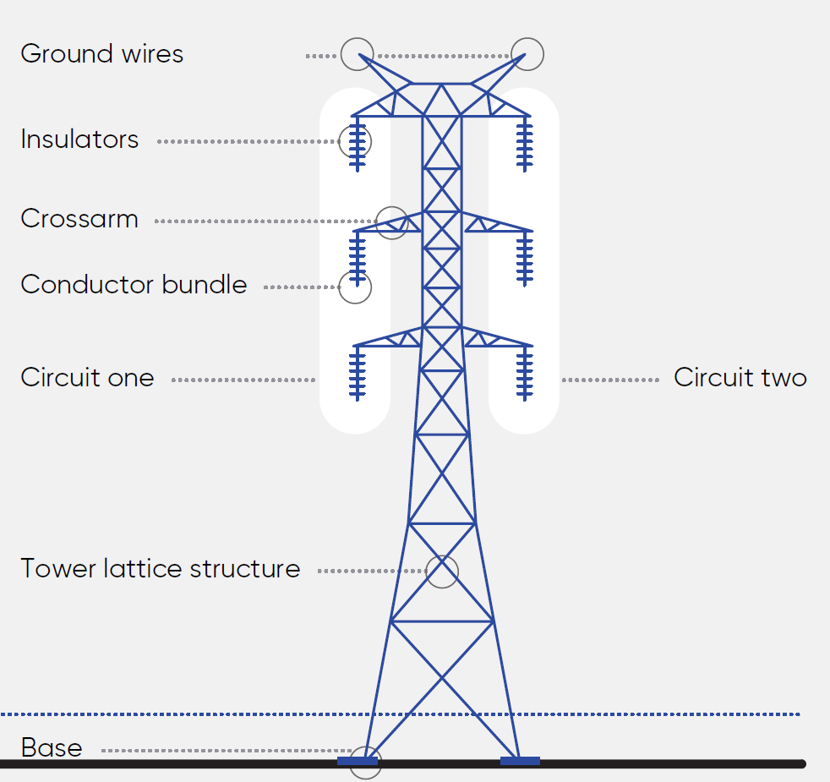
Figure 17.2 Example transmission conductors hung on a 500kV transmission tower
Gap (also known as spark) discharges are another source of EMI. This is where very large localised electric fields appear across polluted or damaged insulators (see Figure 17.2 for indication of insulator positions) and loose or damaged line fittings associated with the conductor bundles (see also Figure 17.2). These localised electric fields cause complete, momentary ionisation of the surrounding air, resulting in sparking across small gaps. This does not interrupt the electrical supply as the insulation of the air is quickly restored and the spark extinguished, but the momentary current that flows in the spark does cause radio interference near the transmission line.
The Australian Standard (AS) 2344 - 2016: Limits of electromagnetic interference from overhead a.c. powerlines and high voltage equipment installations in the frequency range of 0.15MHz to 3000MHz, sets the EMI limits for transmission lines, maintaining satisfactory radio and television reception for various communication services. A satisfactory level of radio reception can be expected when radio frequency emissions for the transmission line are below these limits. These limits are generally applied at the boundary of a transmission line easement.
Magnetic field strength and electric field strengths associated with emission limits are commonly measured on a decibel scale referenced to one microampere per metre (dBµA/m) for frequencies below 30MHz and to one microvolt per metre (dBµV/m) for frequencies above 30MHz.
The International Council on Large Electric Systems Technical Brochure 20 (CIGRE, 1974) offers a qualitative scale to evaluate the impact of radio interference from EMI levels. A Code 2 protection margin, rated at 12dB, suggests that EMI will likely degrade music listening quality, though speech will remain intelligible. Code 2 is also considered when assessing impacts to emergency services broadcasts.

Existing conditions
This section summarises the existing conditions for EMI and EMF according to the following key themes:
- Existing sources and levels of EMF
- Existing sources and levels of EMI.
The Project has been designed, where possible, to run parallel to existing transmission lines and connect to existing terminal stations (see Figure 17.3). Existing electrical plant and equipment contribute to EMF levels in the Project Area. In the western section of the study area, from Bulgana Terminal Station through to Mount Prospect, terminal stations link parts of the 220kV transmission grid at Horsham, Bulgana, Crowlands, Ararat, Waubra, and Ballarat. The Elaine Terminal Station plays a crucial role by connecting the Mt Mercer Wind Farm to the 220kV grid. Moving eastward from Mount Prospect to the Sydenham Terminal Station, terminal stations at Moorabool, Sydenham, South Morang, and Keilor connect segments of the 500kV transmission grid.

Existing sources and levels of EMF
The electric field strength and magnetic flux density levels associated with the existing transmission lines were calculated at 1m above ground level and at the edge of an assumed 40m wide easement for 220kV transmission lines and 60m wide easement for 500kV transmission lines. Using maximum rated voltages and currents, the worst-case EMF were calculated. The levels were also measured under the existing lines and represent the everyday field levels under the transmission lines during normal operating voltages and currents. For both calculated and measured data, the highest levels were found directly below the transmission line, but the levels decreased quickly with increased distance from the transmission line.
Both the worst-case and everyday electric field strength and magnetic flux density levels for existing transmission lines are below the AusNet design limit of 7kV/m and 200µT (see Section 17.2.1) in both western and eastern sections of the study area (see Table 17.2 and Table 17.3).
Table 17.2 Calculated and measured electric field strength levels associated with the existing the 220kV and 500kV transmission lines in the study area
Assessment | Exposure scenario | Design limit (kV/m)* | Maximum electric field strength (kV/m)
Western section of the study area (220kV transmission lines)
Calculated (worst case) | Directly under the line | 5 | 4.40
 | 20m from centreline (edge of easement) | 5 | 0.90
Measured (everyday) | Directly under the line | 5 | 0.77
 | 20m from centreline (edge of easement) | 5 | 0.45
Eastern section of the study area (500kV transmission lines)
Calculated (worst case) | Directly under the line | 7 | 6.7
 | 20m from centreline (edge of easement) | 7 | 2.5
Measured (everyday) | Directly under the line | 7 | 3.7
 | 20m from centreline (edge of easement) | 7 | 1.9
*The design limit for the existing 220kV transmission lines is 5kV/m as this relates to infrastructure other than the 500kV transmission lines.
Table 17.3 Calculated and measured magnetic flux density levels associated with the existing the 500kV and 220kV transmission lines in the study area
Assessment | Exposure scenario | General public exposure reference level (µT) | Maximum magnetic flux density (µT)
Western section of the study area (220kV transmission lines)
Calculated (worst case) | Directly under the line | 200 | 32.2
 | 20m from centreline (edge of easement) | 200 | 4.40
Measured (everyday) | Directly under the line | 200 | 2.56
 | 20m from centreline (edge of easement) | 200 | 1.83
Eastern section of the study area (500kV transmission lines)
Calculated (worst case) | Directly under the line | 200 | 6.7
 | 30m from centreline (edge of easement) | 200 | 2.5
Measured (everyday) | Directly under the line | 200 | 3.7
 | 30m from centreline (edge of easement) | 200 | 1.9
The worst-case (calculated) magnetic flux density (i.e., magnetic strength) from the existing transmission line is below the required immunity limits set for both residential, commercial, and light -industrial environments (3.8µT, from AS/NZS 61000.6.1) and industrial environments (38µT, from AS/NZS 61000.6.2) at distances greater than 28m from the centre of the transmission line in the western section of the study area, and at distances greater than 103m in the eastern section. Sensitive medical and research receptors are present in the study area, but none are located near the existing transmission lines, or the proposed location of the Project. Distances range from 2km (Capital Radiology in Sydenham) to 23km (Ballan District Health and Care) from the existing transmission lines. Magnetic field levels at these distances are below the conservative reference level of 0.003µT, as discussed in Section 17.2.1.
Lower voltage lines (66kV and below) in the eastern section of the Project contribute minimal EMF that is within safe limits.
The EMF measurements at Bulgana, Waubra, and Sydenham Terminal Stations show everyday EMF levels are well below the ICNIRP public exposure levels. These measurements were lower than EMF measurements from the transmission lines and details can be found in Technical Report L: EMI and EMF Impact Assessment.

Existing sources and levels of EMI
Radio interference associated with the existing transmission lines were calculated at 2m above ground level and at the edge of an assumed 40m wide easement for 220kV transmission lines and 60m wide easement for 500kV transmission lines. Radio interference from existing 220kV and 500kV transmission lines was also measured under average fair weather (dry conductor) conditions.
A radio interference level that is greater (more positive) than the limits represent a risk of perceivable interference to music and intelligible speech. Calculated worst case radio interference from the existing transmission lines will occur during heavy rain conditions. Comparing worst case interference levels and reference levels (Table 17.4), interference is only likely to AM radio reception, and only during heavy rain conditions and when close to or under the line. Average fair weather conditions (i.e., the measured levels) represent the typical EMI emissions. The radio interference levels under these conditions were observed to be below the limits defined in the Australian standard for both AM and FM radio reception (see Table 17.4).
Table 17.4 Summary of the calculated radio and television interference levels at typical frequencies for existing transmission lines
Electromagnetic Interference | Calculated Radio Interference (dBµV/m) |  | Measured Radio Interference (dBµV/m) | Reference Levels (dBµV/m)
 | Wet | Dry | Dry | AS 2344 | CIGRE Code 2
Western area (220kV)
AM radio interference @ 500kHz | 3.5 | -14 | -25.8 | -15.5 | 2.5
FM radio interference @ 90MHz | 16.2 | -1.3 | 17 | 30 | 48
Terrestrial TV interference @ 600MHz | -0.3 | -17.8 | 18 | 37 | 55
Eastern area (500kV)
AM radio interference @ 500kHz | 19 | 3 | 3.33 | -15.5 | 2.5
FM radio interference @ 90MHz | 27.1 | 9.6 | 17 | 30 | 48
Terrestrial TV interference @ 600MHz | 10.6 | -6.9 | 18 | 37 | 55
Existing point-to-point communication links are assumed to operate satisfactorily across the existing environment of the Project.
Measurements of the EMI levels at Bulgana, Waubra and Sydenham Terminal Stations are below AS 2344 and CIGRE Code 2 levels. These measurements are lower than EMI measurements from the transmission lines and details can be found in Technical Report L: EMI and EMF Impact Assessment.

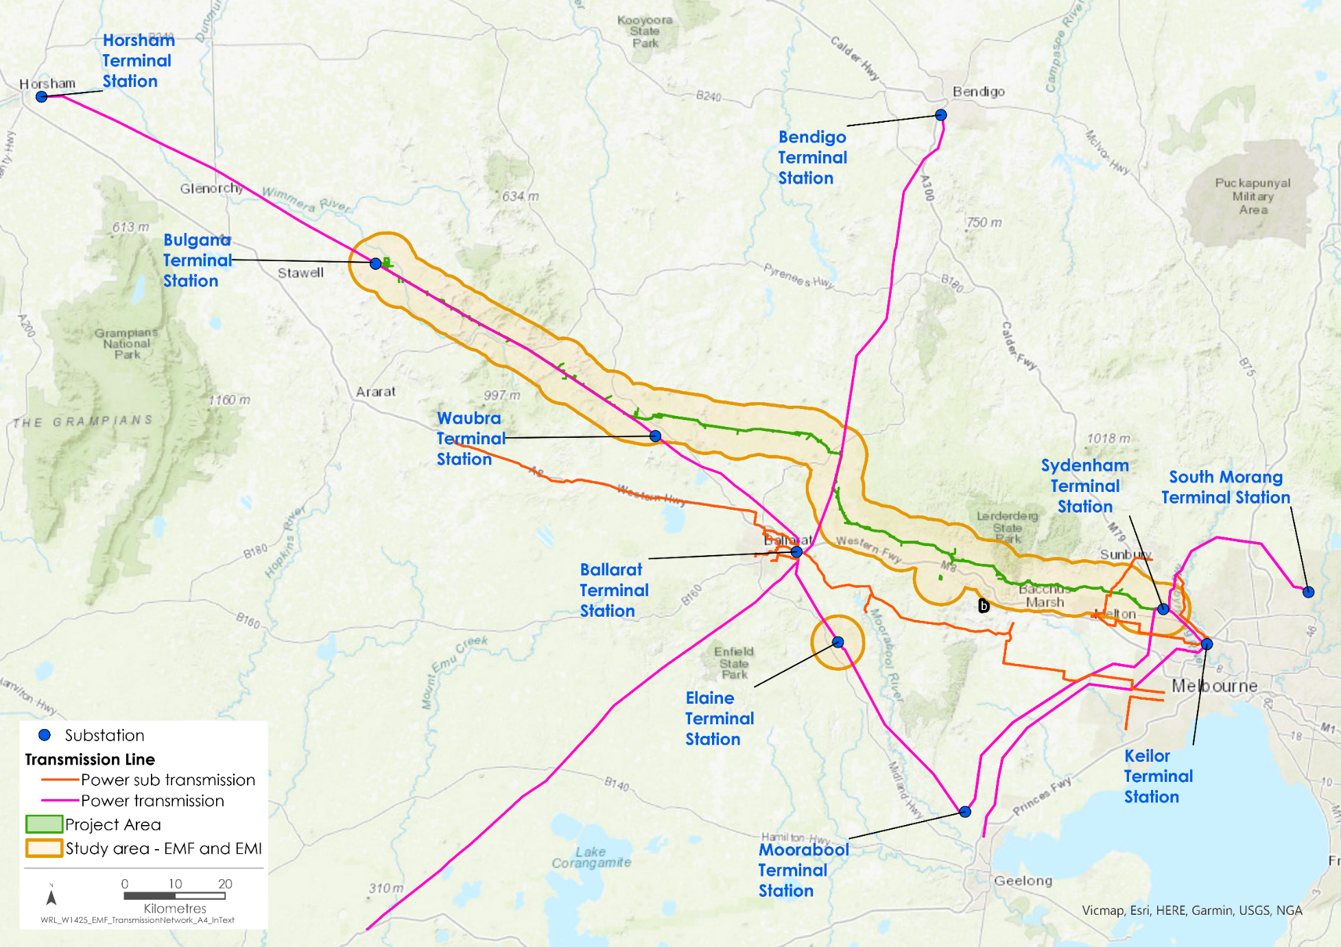
Figure 17.3 Existing transmission lines and terminal stations

Construction impacts
This section outlines the key issues identified through the risk screening process and associated potential impacts during the construction of the Project. The key issues and impacts identified for EMI and EMF are discussed according to the following theme:
- Potential EMI and EMF impacts: impacts to human health and sensitive receptors (including radiocommunication and sensitive medical and research equipment).
As the new transmission line will not produce EMI and EMF emissions or impacts prior to being electrified, the EMI and EMF impacts during the Project's construction are mainly due to the use of construction and radiocommunication equipment. As this equipment will be subject to regulatory compliance, construction impacts are negligible, prior to the application of any mitigations.

Potential EMI and EMF impacts
Construction equipment, including heavy machinery and vehicles, can generate EMI and EMF. The EMI has the potential to cause interference to radiocommunications, and EMF the potential to impact nearby sensitive receptors (e.g., sensitive medical and research equipment) and human health. In addition, elevated levels of EMF near existing power infrastructure may cause EMI to radiocommunication equipment used for construction activities.
The electrical plant and equipment used for the Project’s construction will have the appropriate electromagnetic compatibility certification, complying with Australian Standards for EMI and EMF in residential, commercial, and industrial settings. This compliance is incorporated into the design of the Project.
EMF levels generated during the Project’s construction may impact workforce personnel and the public. EMF levels will be similar to those generated at typical construction sites, with prolonged exposure controlled by adopting safe construction practices (Energy Safe Victoria, 2022) for work on or near high voltage electrical apparatus (e.g., near existing operational 220kV transmission lines). These practices follow a policy of ‘prudent avoidance’ that specifies time limits for exposure to EMF (see ‘EMF and human health box’ in Section 17.5.2). Occupational exposure to EMF will be managed as part of safe work method planning in accordance with occupational health and safety requirements, including implementation of access controls and/or appropriate warning signs. Public access to work sites will also be restricted with appropriate fencing. These standard industry controls effectively avoid this impact, as such no significant EMF impacts to human health will occur during construction.
The closest sensitive medical and research receptors are more than 1.9km from the Project. At this distance, EMF generated by the Project’s construction activities will have a negligible impact.
Construction work sites may be located near electronic equipment installed to support farming activities, such as differential GPS (DGPS) base stations and telemetry communications links that use unlicensed bands (public radio frequencies). EMI generated by the construction equipment has the potential to impact on these receptors. As part of the standard industry controls for the Project, the radio communication equipment used during construction will be required to have appropriate Regulatory Compliance Mark labelling. This trademark indicates compliance with electrical safety and communications standards and shows that a product is safe to use in Australia. This control effectively avoids this impact and results in negligible EMI impacts during construction.
The adoption of standard industry controls, namely, the certification of electrical and electronic equipment and safe work method planning, will keep EMI and EMF levels to acceptable standards. As such, impacts associated with EMI and EMF during construction will be avoided, with negligible EMI and EMF impacts to any nearby sensitive receptors, and no EMF impacts that will adversely affect workforce personnel or the public. As such, further mitigation is not considered necessary. However, EMI and EMF emission levels will be verified as part of the EMI and EMF verification assessment at the detailed design stage (EPR EL1), and the Principal Contractor will develop and implement a process for recording, managing and resolving complaints consistent with the Australian/New Zealand Standards (EPR EM7).

Operation impacts
This section outlines the key issues identified through the risk screening process and associated potential impacts during the operation of the Project. The key issues and impacts identified for EMI and EMF are discussed according to the following themes:
- EMI: potential impacts on the reception of radio, television, emergency services broadcasts, agricultural equipment, point-to-point radio, and mobile communications due to elevated levels of EMI associated with the electrification of the transmission line.
- EMF: potential impacts to human and animal health, and the operation of sensitive receptors including medical and research facilities due to elevated levels of EMF associated with the electrification of the transmission line.
Standard controls have been incorporated into the design of the Project to reduce EMI and EMF impacts. These design controls are considered to largely eliminate (i.e., avoid) EMI and EMF impacts, and the operation impacts discussed are therefore post implementation of these standard design controls. Where these impacts have been identified as minor or negligible (following implementation of the standard design controls), additional mitigations are often not practicable to further reduce the impact and are therefore not considered or discussed in the relevant impact sections. Additional mitigation is not considered practicable because the only at-source mitigation that will reduce minor impacts to negligible is the use of a much larger, heavier phase conductor bundle along the proposed 500kV transmission line. This would require much larger, taller towers and would also increase the EMF levels in the vicinity of the proposed 500kV transmission line. There are other types of conductors that claim improved EMI performance (e.g., trapezoidal wire conductors and polyurethane coated conductors), however there is no consensus or verifiable operational evidence that these conductors deliver improved performance. Further, the only at-receiver mitigation that will reduce identified minor impacts to negligible is the replacement of existing radio communication channels that are impacted by the EMI with channels at higher frequencies. This would require a new license and extensive changes throughout the broadcast area and as such is not considered practicable.
Therefore, in cases where the identified impact is minor or negligible (post-implementation of design controls), this is also considered to be the residual impact, and mitigation measures (as required to comply with EPR EL1) are not deemed necessary. As part of the Project’s detailed design stage, a Project wide EMI and EMF verification assessment will be conducted and will apply to identified impacts (EPR EL1). Additional mitigations will be applied where the verification assessment determines they are required. In the case of the minor and negligible impacts (post-implementation of design controls), the verification assessment (EPR EL1) will only verify the already minor and negligible impacts and will not reduce them further.
Where additional mitigation to further reduce post design control impacts has been identified, it has been considered, and if required, informed EPR EL1 in Section 17.8.

EMI
Operation of the transmission line and terminal stations will generate EMI that can interfere with the reception of radio, television, emergency services broadcasts, agricultural equipment, point-to-point radio, and mobile communication.
Table 17.5 compares the calculated EMI levels with the AS 2344 and CIGRE Code 2 limits. During planned and unplanned outages on one of the circuits, the double circuit transmission line will operate in single circuit mode. Therefore, both double circuit and single circuit operations were considered for the length of the transmission line. Within Table 17.5, a radio interference level that is greater (i.e., more positive) than the limits represents a risk of perceptible interference to music listening and intelligible speech.

Radio, TV, and emergency services broadcasts
The study area has several AM radio transmitters for public use. The EMI levels at the edge of the Project’s transmission line easement were calculated to be higher than the AS 2344 general limits for AM radio reception under dry and wet conditions. However, the overall AM radio signal strength within the study area is strong, so the EMI is unlikely to affect radio reception quality at places that have good radio reception. Where the existing quality of radio reception is poor within the study area, the interference from the new transmission line may be more noticeable, especially in rainy conditions.
For FM radio TV, and emergency services broadcasts, the calculated EMI levels are below the AS 2344 standard levels during wet and dry conditions. The reception of FM radio stations with weak signals might experience some impact during rain, but there are alternative stations with strong signals that will not be affected. Similarly, there are some emergency services radio channels that may be impacted under rainy conditions; however, these broadcasts have generally strong signal strength within the study area. Calculated EMI levels for TV broadcasts are below the AS 2344 standard levels during wet and dry conditions, and as a result effects to TV broadcast reception within the study area will not be significant under any weather and operating conditions.
With the adoption of standard controls in the Project design, EMI impacts to radio, to TV, and emergency services broadcasts during operation are mostly avoided, and the residual impacts will be minor to negligible. Residual EMI impacts to AM and FM radio reception and emergency services during rainy conditions will be minor, and residual EMI impacts on TV reception are negligible.
Table 17.5 Summary of calculated radio interference levels for the Project transmission line
Transmission line section | Transmission line operating state* | Calculated radio interference  @ 500kHz (dBµA/m) |  |  | Limit (dBµA/m)
 |  | Dry | Wet | Heavy rain | AS 2344 | CIGRE Code 2
New 500kV transmission line (sections with double circuit towers) | Double circuit | -2.96 | 14.5 | 23.3 | -15.5 | 2.5
 | Single circuit | -5.20 | 12.3 | 21.6 | -15.5 | 2.5
Existing 220kV transmission line co-located with new 500kV transmission line between Bulgana Terminal Station and Waubra Terminal Station | Double circuit | -1.57 | 15.93 | 24.6 | -15.5 | 2.5
 | Single circuit | -1.48 | 16.06 | 24.7 | -15.5 | 2.5
New 500kV transmission line (sections with two adjacent single-circuit towers) | Double circuit | -4.14 | 13.36 | 22.77 | -15.5 | 2.5
 | Single circuit | -5.42 | 12.08 | 21.57 | -15.5 | 2.5
New 220kV connections between the existing Bulgana Terminal Station and the new terminal station at Bulgana | Double circuit | n/a** | n/a** | n/a** | -15.5 | 2.5
 | Single circuit | n/a** | n/a** | n/a** | -15.5 | 2.5
*All double circuit transmission lines will be operated in single circuit mode during planned and unplanned outages on one of the circuits. EMI is therefore calculated for both double circuit and single circuit operation for all line sections
**The calculated value is negligible due to the low surface voltage gradient

Agricultural equipment
Generally, GPS communication equipment used in agricultural equipment is not affected by EMI from transmission lines. A study on GPS receivers under transmission lines found that no degradation in receiver performance was attributed to electromagnetic emissions from transmission lines under normal or foul weather (Silva and Olsen, 2002). However, if the transmission line insulators or fittings are damaged, there may be some interference to GPS systems. This potential impact will be managed by standard maintenance practices to be implemented by AusNet during operation.
The DGPS system in Australia broadcasts correction signals in the same frequency, or ‘band’, as commercial FM radio. Correction signals are land-based signals used to correct the error in positioning introduced by satellite signals. Calculated radio interference levels for FM radio are below the AS 2344 standard levels under all operating and weather conditions, noting that these calculations were not carried out for directly under the transmission line.
There is a residual minor EMI impact on DGPS signals for land navigation directly under the proposed 500kV transmission line during heavy rain conditions. However, the brief interruption of DGPS signals will not impact autonomous operations as the equipment will use the existing correction signals and then update it once the equipment moves past the area under the transmission line.

Point-to-point radio
Point-to-point radio links, like those used by the Australian Federal Police, the Department of Defence and emergency services, can be affected by EMI from the transmission line. The extent and impact of signal blocking and scattering effects depends on the type of service interfered with, and the frequency, especially if the transmitter or receptor is near the transmission line. It is possible (though considered unlikely) that the Project may cause moderate impacts on some point-to-point radio links within the study area, and mitigation measures will potentially be required to comply with EPR EL1. A detailed investigation of potential point-to-point communication link performance issues and verification of impacts prior to the operation of the transmission line (EPR EL1) will determine whether any of the following mitigation measures will be required (in order of application): an increase in transmit power level, increase in antenna height, or relocation of the antenna.
With the adoption of mitigation measures to comply with EPR EL1, EMI impacts to point-to-point radio will be reduced to acceptable levels. Following the required detailed investigation and subsequent determination of any significant impacts to point-to-point radio (per EPR EL1), the residual impact on point-to-point radio will reduce to negligible.

Mobile phone communications
Mobile phones (3G, 4G and 5G) and WiFi reception will not be affected by the scattering effects of the steel lattice transmission line towers. EMI near the edge of the transmission line easement will be below the AS 2344 limits for mobile phone and WiFi reception. As such, residual EMI impacts to mobile phone and WiFi are negligible.

EMF

Human and animal health
EMF from the transmission line not only affects electronic equipment but can also contribute to human and animal health impacts (see information boxes on ‘EMF and human health’ and 'EMF and animal health’). The EMF from the Project’s transmission line was calculated at 1m above the ground using the highest possible voltage and current to identify if the emissions from the transmission line and terminal stations exceed the electric field strength design limit and magnetic field strength reference levels adopted for the Project (see Table 17.6).
In the worst-case scenario, electric field strength levels are below the conservative 7kV/m electric field strength limit defined for the Project. The electric field strength will not exceed the safety restrictions for humans standing directly under the transmission line during the worst-case scenario. Similarly, the magnetic field levels, even in the worst case, are well below the safety limits for public exposure (200µT).

Table 17.6 Summary of calculated EMF strength levels for the Project transmission line
Transmission line section | Operating state* | Exposure scenario | Electric Field Project Exposure Limit (kV/m) | Maximum calculated Electric Field Strength (kV/m) | Magnetic Field General Public Exposure Reference Level (µT) | Maximum calculated Magnetic Flux Density (µT)
New 500kV transmission line (sections with double circuit towers) | Double Circuit | Directly under the line | 7 | 5.51 | 200 | 28.3
 |  | 30m from centreline | 7 | 0.94 | 200 | 7.68
 | Single Circuit | Directly under the line | 7 | 6.43 | 200 | 23.9
 |  | 30m from centreline | 7 | 0.90 | 200 | 10.9
Existing 220kV transmission line co-located with new 500kV transmission line within a common easement between Bulgana and Waubra | Double Circuit | Directly under the line | 7 | 5.70 | 200 | 31.0
 |  | 30m from centreline | 7 | 0.95 | 200 | 7.6
 | Single Circuit | Directly under the line | 7 | 6.58 | 200 | 32.6
 |  | 30m from centreline | 7 | 0.97 | 200 | 11
New 500kV transmission line (sections with two adjacent single circuit towers) | Double Circuit | Directly under the line | 7 | 6.61 | 200 | 39.6
 |  | 30m from centreline | 7 | 2.91 | 200 | 16.56
 | Single Circuit | Directly under the line | 7 | 6.52 | 200 | 43.5
 |  | 30m from centreline | 7 | 2.86 | 200 | 14.2
New 220kV connections between switchyards at Bulgana Terminal Station | Double Circuit | Directly under the line | 7 | 2.90 | 200 | 33.4
 |  | 30m from centreline | 7 | 0.35 | 200 | 6
 | Single Circuit | Directly under the line | 7 | 2.90 | 200 | 36.6
 |  | 30m from centreline | 7 | 0.35 | 200 | 4.6
*All double circuit transmission lines will be operated in single circuit mode during planned and unplanned outages on one of the circuits. EMI is therefore calculated for both double circuit and single circuit operation for all line sections.

The actual, everyday operating EMF levels will be lower than the worst-case values presented in Table 17.6. People working near or under the transmission line might experience higher EMF than at home, but these levels are still within safe limits. In some areas, the electric field might exceed 5kV/m during worst-case scenarios, potentially causing people to experience micro-shocks to metal objects like fences. As required by relevant industry standards, these objects will be grounded, moved, or replaced with non-conductive materials during Project construction to eliminate this hazard. The actual EMF levels are also safe for people with Active Implantable Medical Devices (e.g. pacemakers). As such, residual EMF impacts from the Project are avoided, and will not have a significant impact on human health.
Research studies show that Project EMF levels do not pose a risk to livestock health or production (see ‘EMF and animal health’ information box). However, non-native honeybee species kept in apiaries may be impacted if the electric field is greater than 4.1kV/m or the magnetic field exceeds 100µT. This could alter their flight and feeding habits, raise hive temperatures, cause queen loss and affect winter survival. The worst case calculated electric field under the transmission line can exceed 4.1kV/m at 1m above ground level; however, no existing apiaries are known to be present in the Project Area where the electric field may exceed the reference level. An EMI and EMF verification assessment will be conducted prior to construction as part of the Project’s detailed design stage (as required by EPR EL1). This assessment will identify any (additional) sensitive receptors, including apiaries, that are identified in areas subjected to the elevated electric fields. Identified apiaries will be relocated outside the transmission line easement to eliminate all known health effects. With the avoidance of this impact, residual EMF impacts will not have a significant impact on animal health.

Sensitive receptors
Sensitive medical and research receptors in the study area are located 1.9km or further away. The calculated magnetic field strength at this distance is below the conservative limit of 0.03µT (see Section 17.2.1). As such, EMF will have a negligible residual impact on medical and research sensitive receptors.
Southern Rural Water’s Merrimu Reservoir wall is located approximately 230m south of the Project. There are no radio links at the wall, and any equipment at this reservoir should meet industrial standards, maintaining reliable operation when exposed to a magnetic field level up to 37.6µT (see Section 17.2.1). The magnetic field from the transmission line is below this limit, even during worst case operating conditions, both beneath the conductors and away from the transmission line. As such, EMF will have a negligible residual impact on any equipment installed at the reservoir.
Electrical and electronic equipment found in residential, commercial and light industrial environments within the vicinity of the Project may be less immune to magnetic fields than industrial equipment. The limit for general equipment in these environments is 3.8µT of magnetic field strength. The calculated magnetic field strengths for the Project are below this level at distances greater than 48m from the centre of the transmission line during worst-case, contingency operating conditions. No sensitive receptors were identified along the Project within the identified impact zone, avoiding any impacts. Under normal operating conditions, the magnetic field strength will not exceed this level outside the easement. Dwellings and farm buildings will not be permitted within the transmission line easement, avoiding EMF impact to these sensitive receptors.
The application of post design and standard industry controls means that operation of the Project is not expected to exceed the Project’s reference levels, and therefore, avoid causing EMF impacts to nearby sensitive receptors. As a result, EMF from the Project infrastructure will have a negligible residual impact on sensitive receptors.
- EMF and human health
High levels of extremely low frequency EMF can cause nerve and muscle stimulation and changes in the central nervous system (World Health Organization, 2007). Established biological effects caused by acute exposure to high EMF levels include magneto-phosphene effects (the sensation of flashes of light caused by induced electric currents stimulating the retina) and micro-shocks (a sensation caused by a small electric spark discharge or arc when a person touches an earthed metallic object).
The Project will generate extremely low frequency EMF. Extensive scientific research examining health risks associated with exposure to extremely low frequency EMF has been undertaken since the 1970s. The Australian Radiation Protection and Nuclear Safety Agency (ARPANSA) advises that ‘most of the research indicates that the extremely low frequency EMF exposure normally encountered in the environment, including in the vicinity of powerlines, does not pose a risk to human health’ (ARPANSA, 2025b). In this context, ‘in the vicinity of powerlines’ relates to the vicinity of publicly accessible areas surrounding the Project’s 500kV transmission line and terminal stations.
ARPANSA has concluded that, on the balance of the published research, the possible association reported in some research between increased rates of childhood leukaemia and prolonged exposure to extremely low frequency EMF (at levels below the exposure limits but higher than what is typically encountered) is not supported by laboratory or animal studies and no credible theoretical mechanism has been proposed to support the possible association.
Based on these research findings, the International Agency for Research on Cancer has prudently classified extremely low frequency magnetic fields as ‘possibly carcinogenic to humans’ and extremely low frequency electric fields as a ‘not classifiable as to carcinogenicity’ (IARC, 2025).
Extensive studies have also been carried out into other possible health effects of EMF exposure, including cancers in adults, depression and suicide. The World Health Organization has concluded that there is little scientific evidence supporting an association between extremely low frequency EMF exposure and other adverse health effects (World Health Organization, 2007).
In 2015, ARPANSA recognised the ICNIRP Guidelines for limiting exposure to time-varying EMF (1Hz – 100kHz) (ICNIRP, 2010) as setting public exposure levels for EMF based on the best available science. The INCIRP Guidelines provide a high level of protection to people, with a conservative safety margin built-in to protect exceptionally sensitive individuals.
A policy of ‘prudent avoidance’ is also adopted in the design and operation of transmission lines in Australia to reduce public exposure to EMF. This means doing what can be done without undue inconvenience and at modest cost, while noting that electric power brings obvious health, social and economic benefits and there should be a credible scientific foundation for reducing exposure levels any further (World Health Organization, 2007).

- EMF and animal health
The Scientific research into the possible health effects of extremely low frequency EMF for large and small ruminants (large hoofed herbivorous grazing or browsing mammals like cattle and sheep) has been undertaken since the 1970s.
An investigation into the possible impact of the extremely low frequency EMF from a 765kV transmission line found no differences on the dairy production and behaviour of grazing herds (Busby et al., 1974). Comparable studies on the impact of a 765kV transmission line with electric field strengths up to 12.5kV/m on the health, behaviour, or productivity of beef cattle, dairy cows, sheep, pigs, and horses found similar results, with no reported impacts.
A study of the effects of extremely low frequency EMF exposure on the health of sheep was conducted by studying interleukin proteins in ewe lambs (Hefneider et al., 2001). Interleukin proteins are involved in cell-to-cell communication related to both growth and immunity in the animals and are considered an indicator of general health in sheep. The ewes were exposed to magnetic fields of 3.5 to 3.8µT and electric fields of 5.2 to 5.8kV/m over a course of 27 months. The study showed that there was a significant reduction in interleukin protein (IL-1) in ewe lambs that were 8 to 10 weeks of age in the first study. However, there were no significant differences found between the treated group and the control group in the follow-up study (i.e., the observed effects were not statistically significant). Collectively, these studies, along with other similar studies conducted over the past 50 years, indicate that EMF from transmission lines do not pose a significant risk of adverse health effects or negative impacts on production in livestock.
Additionally, studies have been conducted to determine the effects of EMF on apiaries. In particular, the Gibbs report (Gibbs, 1991) concluded that bees in hives under or near to transmission lines are adversely affected by shocks created by currents induced by the lines, but that the effect can be mitigated by shielding. The findings of the Gibbs Report was supported by published research conducted in 1981, which focused on the different biological effects on honeybee colonies under a 765kV transmission line (Greenberg et al.,1981). The observed effects included increased motor activity with transient increase in hive temperature, impaired hive weight gain, queen loss and abnormal production of queen cells, decreased sealed brood and poor winter survival. The study found that at incremental distances from the line, different electric field strengths resulted in different biological effects: “Hive net weights showed significant dose-related lags at the following exposures: 7kV/m, one week; 5.5kV/m, 2 weeks; and 4.1kV/m, 11 weeks. The two lowest exposure groups had normal weight after 25 weeks. Queen loss occurred in 6 of 7 colonies at 7kV/m and 1 of 7 at 5.5kV/m, but not below. Foraging rates were significantly lower only at 7 and 5.5kV/m.”
Research into the effect of EMF on non-native honeybees, other than the effects of induced shocks, has been subsequently reported on in 2018 (Shepherd et al., 2018). The study findings noted that reduced learning, altered flight dynamics and altered feeding habits were observed when the bees were subjected to a simulated magnetic field between 100µT and 1000µT, which is typically only encountered in close proximity to the transmission conductors. Hence, the effects of EMF within the Project Area may therefore impact apiaries if the levels exceed 4.1kV/m and 100µT respectively. Given that native Australian bees are solitary and do not live in colonies, it is concluded that there is no significant impact on native Australian bees. The EMF impact assessment therefore only considers the impact on apiaries.

Decommissioning impacts
As decommissioning activities will be similar to those that occur during construction, the impacts relating to EMI and EMF are assessed to be the same as for the construction stage. Construction equipment used for decommissioning, including heavy machinery and vehicles, can generate EMI and EMF, potentially impacting nearby sensitive receptors, human health, and causing interference to radio communications. During decommissioning, the transmission line will not be electrified and therefore will not produce any EMI or EMF emissions or impacts.
Accordingly, the EPRs developed to manage impacts during construction would also be applicable for decommissioning in accordance with the conditions of the time. This would also be managed by a Decommissioning Management Plan (EPR EM11) which would include mitigation measures for EMI emissions resulting from construction and radio communication equipment.
Based on this, residual impacts are expected to be negligible for EMI and EMF.

Cumulative impacts
Cumulative impacts have been assessed by identifying relevant future projects that could contribute to cumulative EMI and EMF impact, considering their spatial and temporal relationships to the Western Renewables Link Project. The projects considered as potentially relevant to EMI and EMF include:
- Melbourne Renewable Energy Hub
- Sydenham Terminal Station Rebuild
- Victoria to New South Wales Interconnector West (VNI) West.
Smaller sub-transmission lines and cables, such as those associated with windfarms, solar farms and renewable energy park collector networks will have much lower EMF levels and are anticipated to have minimal cumulative impact.
Cumulative impacts of the relevant future projects will be managed effectively through avoidance, engineering and administrative controls (e.g., timings and sequencing of the Western Renewables Link Project and the identified relevant future projects). EPR EL1 accounts for cumulative impact assessment requirements for all existing and future committed developments. However, cumulative EMI and EMF emission contributions are negligible based on the physical separation between infrastructure.

Environmental Performance Requirements
Potential impacts identified through Technical Report L: EMI and EMF Impact Assessment have informed the development of EPRs for the Project. EPRs set out the environmental outcomes to be achieved through the implementation of mitigation measures during construction, operation and decommissioning. While some EPRs are performance based to allow flexibility in how they will be achieved, others include more prescriptive measures that must be implemented. Compliance with the EPRs will be required as a condition of the Project’s approval. Table 17.7 details the proposed EPR developed for EMI and EMF.
Table 17.7 Environmental Performance Requirements
EPR code | Requirement
EPR EL1 | Undertake an Electric and Magnetic Field and Electromagnetic Interference Assessment  - Design and construct the Project to reduce electric and magnetic fields (EMF) and electromagnetic interference (EMI) from the Project infrastructure to below the reference levels and limits for the Project, or as low as reasonably practicable to avoid and minimise impacts.  - The applicable reference levels and limits are defined in EES Technical Report L: EMI and EMF Impact Assessment. The design must be informed by a Project wide EMI and EMF verification assessment for all the proposed infrastructure at the detailed design stage, identifying existing sensitive receptors and committed future developments within the study area.  - Prior to the commencement of the relevant construction works, the assessment must be documented in a management plan for implementation and includes, but is not limited to:  - Outcomes of the Project wide EMI and EMF verification assessment at the detailed design stage and details of the areas assessed.  - The location of all sensitive receptors that may be impacted by the infrastructure.  - Where at-receiver mitigation measures to sensitive receptors are required to avoid or minimise adverse impacts.  - If mitigation measures are identified as per Item 3(c) (e.g. point-to-point communication links), identify what the mitigation works are, and timeline for implementation.  - A pre- and post-construction testing strategy to verify design calculations, impacts on sensitive equipment and the efficacy of any specified mitigation measures.  - Remedial action to be investigated if EMI and EMF limits are not met during the construction, testing, and commissioning.
An additional EPR which contributes to a reduction in the magnitude, extent and duration of EMI and EMF impacts is EPR EM7 – Develop and implement a Complaints Management System.
Refer to Chapter 29: Environmental Management Framework for full detail of this EPR.
No specific ongoing monitoring requirements are required for EMI and EMF.

Summary of residual impacts
Considering the post-design and standard industry controls, and with the application of the EPRs where required, residual impacts associated with EMI and EMF are considered to be minor to negligible:
- Residual impacts due to elevated levels of EMI and EMF during construction are not significant when considering EMF impacts on human health and negligible when considering EMI and EMF impacts on sensitive receptors, including radiocommunication and sensitive medical and research equipment. The transmission line will not produce EMI and EMF emissions or impacts prior to being electrified, and commercial plant and electrical equipment will have appropriate EMC certification. Occupational exposure to higher EMF levels at operational transmission infrastructure sites will be managed as part of safe work method planning.
- Residual impacts due to EMI emissions during operation are minor to negligible. EMI from the Project infrastructure may have a minor impact on AM radio, FM radio and emergency services radio reception during extreme weather events, and a negligible impact on TV, point-to-point communication links, and mobile phone reception. During operation, there is also a minor EMI impact on DGPS correction signals for land navigation directly under the proposed 500kV transmission line in heavy rain conditions. However, the impact will be short-lived and the DGPS will correct itself once the equipment clears the area under the transmission line. Mitigation measures that will reduce minor impacts to negligible are not considered practicable and are not deemed necessary or recommended by the technical specialist. This is because the only proven at-source mitigation measure is to increase the size and weight of the phase conductor bundle along the proposed 500kV transmission line, which will require much larger, heavier towers and increase EMF levels in the vicinity of the line. Additionally, the only at-receiver mitigation measure that will reduce minor impacts to negligible is to replace the existing impacted radio communication channel with channels at higher frequencies, which would require a new license and extensive hardware changes throughout the broadcast area.
- Residual impacts due to EMF emissions during operation are negligible. Residual impacts on human and animal health are not anticipated to be significant, and sensitive medical and research receptors are located at suitable distances to meet conservative EMF limits, with a negligible impact.
- Residual impacts due to EMI and EMF emissions during decommissioning are considered to be the same as for the construction stage. As such, EPRs developed to manage impacts during construction will also be applicable for decommissioning and will be incorporated into the Decommissioning Management Plan (EPR EM11).
With the implementation of measures to comply with EPRs, it is considered that the Project meets the EMI and EMF aspects of the evaluation objective “Avoid, or minimise where avoidance is not possible, adverse effects for community amenity, health and safety, with regard to construction noise, vibration, dust, lighting, waste, greenhouse gas emissions, transport network, operational noise, fire risk management and electromagnetic radiation.”

