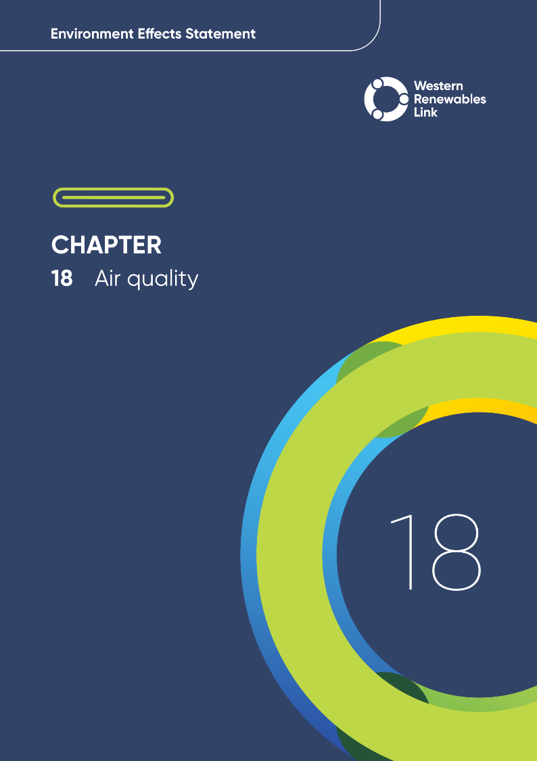n

# Air quality

This chapter provides an overview of the potential air quality impacts associated with the construction, operation and decommissioning of the Project. This chapter is based on **Technical Report I: Air Quality Impact Assessment**.

Air quality can be affected by dust, exhaust emissions, odours, and airborne hazards associated with the construction, operation and decommissioning of the Project. The Project passes through areas of western Victoria that range from remotely populated pastoral farmland through to urban areas. Without effective management, emissions to air from the Project during construction, operation and decommissioning may disrupt amenity at surrounding sensitive receptors.

## Evaluation objective

The scoping requirements identify the following evaluation objective relevant to air quality:

**Evaluation objective**

Avoid, or minimise where avoidance is not possible, adverse effects for community amenity, health and safety, with regard to construction noise, vibration, dust, lighting, waste, greenhouse gas emissions, transport network, operational noise, fire risk management and electromagnetic radiation.

In response to this evaluation objective, impacts of the Project on air quality were assessed and measures to avoid, minimise or manage potential impacts have been identified. These measures are discussed throughout this chapter and have informed the development of Environmental Performance Requirements (EPRs). EPRs set out the environmental outcomes to be achieved through the implementation of mitigation measures during construction, operation and decommissioning to avoid, minimise and manage identified impacts. Cumulative impacts associated with relevant future projects were also assessed.

Further information on how the Project has been designed to avoid and minimise impacts is provided in **Chapter 5: Project development** and **Chapter 6: Project description**.

Other aspects covered in the Environment Effects Statement (EES) evaluation objective and relevant to air quality are addressed in the following EES chapters:

* **EES Chapter 11: Landscape and visual**
* **EES Chapter 13: Bushfire**
* **EES Chapter 17: EMI and EMF**
* **EES Chapter 19: Noise and vibration**
* **EES Chapter 20: Transport**
* **EES Chapter 26: Greenhouse gas.**

## Method

This section summarises the method adopted in **Technical Report I: Air Quality Impact Assessment**, which was informed by **Chapter 4: EES assessment framework** **and approach**. The key steps in assessing the impacts associated with air quality included:

* Defining a study area appropriate for air quality as presented in Figure 18.1. This included the Project Area, with a 500m buffer applied consistent with relevant guidance as discussed in Section 5.2 of **Technical Report I: Air Quality Impact Assessment**.
* Sensitive receptors

Land uses that may be sensitive to air quality impacts from a construction or operational source were identified as sensitive receptors. These include educational, health, community, and residential land uses.

* Reviewing applicable Commonwealth and Victorian legislation, and relevant local, state and national standards, guidelines and policies.
* Conducting a desktop review of publicly available information to characterise the existing background air quality within the study area, existing local sources of emissions to air, land uses and sensitive receptors, topography and meteorology (weather), including:
  + Background air quality data from Environment Protection Authority Victoria (EPA) annual datasets for Geelong and Melton (Data.Vic, 2023)
  + Local existing sources of emissions to air identified using information sourced from the Victorian Government (Data.Vic, 2023) including EPA License Dataset; EPA Victorian Landfill Register; EPA Environmental Audit Reports Dataset; EPA Priority Sites Register Dataset; and from the National Pollutant Inventory Facilities Dataset for 2022 to 2023 reporting year (DCCEEW, 2024)
  + Land uses and sensitive receptors identified using Google Earth aerial imagery Planning and Land Use Maps from VicPlan and Dwelling locations from Ferguson Perry on behalf of AusNet
  + Local topography data from Ferguson Perry on behalf of AusNet via Aerometrex (Dated August 2021)
  + Prevailing local weather conditions determined using data collected 2011 to 2022 from the Commonwealth Bureau of Meteorology’s (BoM) stations operated at Stawell, Pyrenees, Ballarat, and Melbourne Airport.
* Conducting a risk screening process to identify the key issues during construction, operation and decommissioning for investigation within the technical report.
* Consulting with the relevant regulatory authorities and key stakeholders including the EPA, and reviewing the pins dropped by community members via the Project’s Social Pinpoint online mapping tool, which identified locations, features and values of importance.
* Receiving environment sensitivity ratings (EPA, 2022)

A key component of the EPA’s nuisance dust assessment framework considers the context (historical and land use) within which an activity or project is to be completed. Section 6.5 of **Technical Report I: Air Quality Impact Assessment** provides the guidance for characterising these aspects for an assessment.

* Identifying and assessing the potential impacts associated with dust generation, exhaust emissions from plant and equipment, and odours and airborne hazards from the handling of potentially contaminated materials and groundwater. For assessing potential dust impacts, a semi-quantitative method developed by the EPA in Publication 1943: Guidance for assessing nuisance dust (EPA Publication 1943) was applied which provides a framework for assessing nuisance dust impacts considering dust sources, exposure pathways and the sensitivity of the receiving environment. Other impacts to air quality were assessed in accordance with the guidance and structure established by *EPA Victoria in Publication 1961: Guideline for assessing and minimising air pollution in Victoria*. These impacts were qualitatively assessed based on the magnitude of expected emissions, the likelihood that they would affect surrounding receptors, and the extent and duration. The likelihood of these impacts occurring were evaluated according to the following ratings, based on those set out in EPA Publication 1943:
  + Negligible: Dust impacts, exhaust emissions and/or odours/airborne hazard impacts are extremely unlikely to occur.
  + Low: Dust impacts, exhaust emissions and/or odours/airborne hazard impacts are not likely and are expected to be minimal.
  + Moderate: Dust impacts, exhaust emissions and/or odours/airborne hazard impacts only likely to occur on rare occasions. Although there may be some residual impacts, it is possible it can be practically and effectively managed.
  + Medium: Dust impacts, exhaust emissions and/or odours/airborne hazard impacts likely. Some impacts to occur and without careful and considered application of mitigation measures it is likely to cause impacts. The focus should be what can be done to break the source-pathway-receiving environment chain.
  + High: Dust impacts, exhaust emissions and/or odours/airborne hazard impacts highly likely to occur. Significant impacts to occur, and impacts are highly likely. There may be some interventions that can be applied to reduce the impacts, but it is likely that significant re-engineering or redesign will be required.
  + Very high: Dust impacts, exhaust emissions and/or odours/airborne hazard impacts almost certain. Interventions to reduce impacts in either the source, pathway or receiving environment are unlikely to be practical so effective mitigation is doubtful.

The same ratings were also applied for exhaust emissions from plant and equipment used during construction operation and decommissioning, and odours and airborne hazards from the handling of potentially contaminated materials and groundwater as above for dust.

* Identifying relevant future projects that could lead to cumulative impacts when considered together with the Project (refer to **Chapter 4: EES assessment framework and approach** for the full cumulative impact assessment method).
* Developing EPRs in response to the impact assessment to define the required environmental outcomes that the Project must achieve through the implementation of mitigation measures during construction, operation and decommissioning. Measures to reduce the potential impacts were proposed in accordance with the mitigation hierarchy (avoid, minimise, manage, rehabilitate and offset) and have informed the development of EPRs. Alternative mitigation measures could be implemented to comply with the EPRs based on the specific site conditions, available resources, and the Principal Contractor’s expertise. The EPRs have been developed to meet the requirements of the General Environmental Duty (GED) under the *Environment Protection Act 2017* (Vic).
* Following application of mitigation measures that would comply with the EPRs, determining residual impacts associated with the construction, operation and decommissioning of the Project, and evaluating their significance.

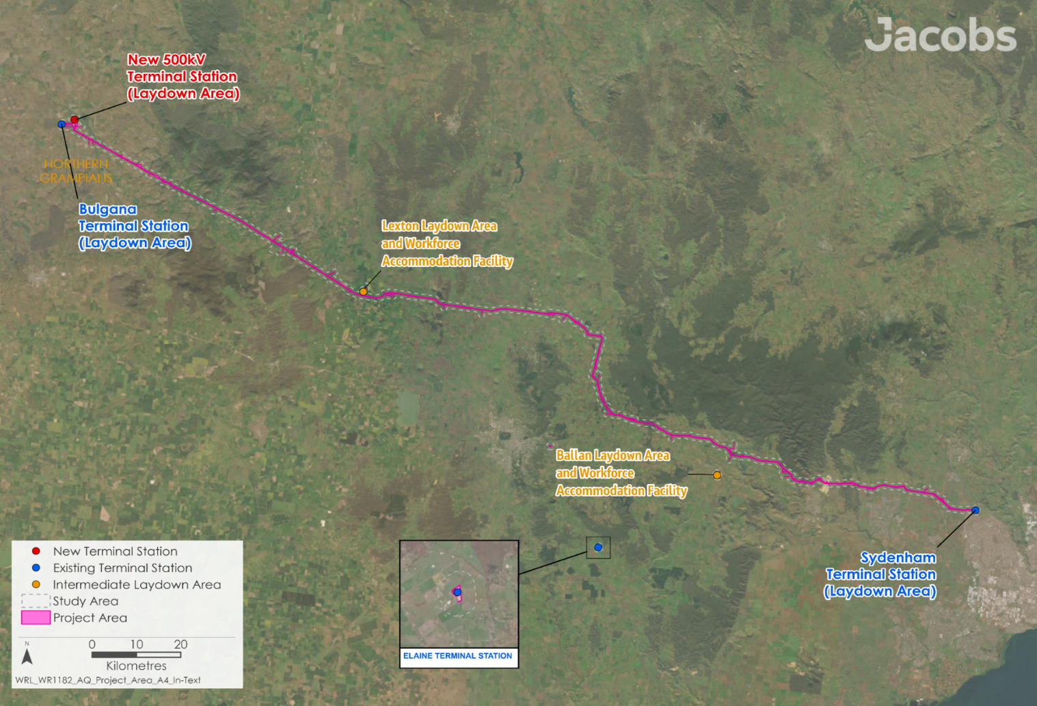

Figure 18.1 Air quality study area

## Existing conditions

This section summarises the existing conditions for air quality according to the following key themes:

* Background air quality
* Existing local sources of pollutants
* Existing weather conditions
* Sensitive receptors.

The majority of the study area and surrounding land is rural. However, pollutants potentially discharged into the air from the Project, such as exhaust emissions and dust, can also originate from other industrial activities present in the region including manufacturing sites, energy generation, and extractive industries like quarries and mining. Existing agricultural operations and unsealed roads are also sources of dust in the study area.

Air quality can be impacted by local weather conditions and terrain features, which can cause dust, odour, or other pollutants to accumulate in certain areas. However, the land in the study area is generally flat, and Project activities and infrastructure will typically be at the same altitude as surrounding sensitive receptors.

* Particulate matter

PM10 is particulate matter with equivalent aerodynamic diameter of 10 microns or less.

PM2.5 is finer particulate matter with equivalent aerodynamic diameter of 2.5 microns or less.

### Background air quality

As there are no ambient air quality monitoring stations within the vicinity of the Project, existing air quality conditions were characterised using data from EPA monitoring stations located in suitably representative locations. These stations monitor the levels of a range of pollutants including carbon monoxide (CO), nitrogen dioxide (NO₂), sulfur dioxide (SO₂) and dust. The level of dust in the air is monitored by the total number of suspended particles in the air. Dust particles can be categorised as particulate matter (PM10 or PM2.5) based on their size, which determines how they interact with the human body and the environment.

* Environment Reference Standard

The Environment Reference Standard, established by EPA Victoria, outlines the environmental values and objectives for air quality in Victoria.

These objectives are commonly compared to when describing air quality, as they reflect the latest health evidence and national standards.

This review showed that:

* The air quality from Ballarat to Sydenham was estimated using observations from the EPA air quality monitoring station in Geelong, with PM2.5 data also considered from the station at Melton. The data from Geelong for particulate matter may overestimate concentrations in Ballarat, as Geelong is a larger more populous city. The air quality in Bacchus Marsh is likely to be similar to Ballarat or Melton. Review of the air quality data from these areas indicates that air quality consistently meets the objectives set in the Environment Reference Standard.
* The air quality within the study area is generally better than in Ballarat and Sydenham given it is situated in rural areas with fewer people and less traffic. However, dust storms and bushfires can sometimes worsen the air quality across this area.

### Existing local sources of pollutants

A review of information from Data Vic and from the National Pollutant Inventory Facilities datasets indicated that:

* Existing industrial sources of air emissions within the vicinity of the Project could result in a cumulative impact on air quality. Sensitive receptors may be affected by the Boral, Hanson, Excel, and Barro Group quarries near Bacchus Marsh (see Figure 18.2), and the Rockbank Quarry near Sydenham Terminal Station. These quarries create dust from operational activities including crushing and blasting, which can combine with other dust sources and worsen air quality within the study area.
* The study area is predominantly rural with land used for intensive farming and grazing. Dust can be generated from this land use, particularly in drier months when it is windy. The amount of dust will change throughout the year depending on how much vegetation there is, how moist the soil is, and the type of farming being done, such as tilling or harvesting.
* Unsealed roads in the study area are a source of dust (whether vehicles are driving on them or not). The amount of dust depends on how wet and compact the road surface is, the wind speed and direction, and the weight of the vehicles.

### Existing weather conditions

**Technical Report I: Air Quality Impact Assessment** assessed weather patterns to understand how air quality affects sensitive receptors. Several weather stations near the Project provided data showing that prevailing winds mostly come from the north or south. This means that sensitive receptors downwind from the Project for these prevailing conditions are most likely to be affected.

### Sensitive receptors

Sensitive human receptors are locations where people spend time and where property may be impacted by dust. By looking at aerial images, land use information, and dwelling data from AusNet, nearby sensitive areas were identified. The closest sensitive areas to each part of the Project are listed in Table 18.1 and are all residential properties.

Table 18.1 Nearest sensitive receptors

|  |  |
| --- | --- |
| Project element | Approximate distance to nearest residential sensitive receptor |
| Transmission lines, temporary construction infrastructure, and ancillary works (including access tracks) | Generally, 50 to 100m consistent with minimum easement requirements |
| Powercor distribution line crossovers | Generally, 50 to 100m consistent with minimum easement requirements |
| Existing Bulgana Terminal Station | Approximately 2,000m |
| New 500kV terminal station at Bulgana | Approximately 1,100m |
| Elaine Terminal Station | Approximately 1,300m |
| Ballan intermediate laydown area | Approximately 700m |
| Lexton intermediate laydown area | Approximately 1,450m |

There are fewer sensitive receptors near the Project to the west of Allendale compared to the east. Between Allendale and Sydenham, 20 residential sensitive receptors were found within 100m of the Project, while only two were found between Bulgana and Allendale. The closest sensitive receptors are shown in shown on Figures 6.3 to 6.7 provided in **Technical Report I: Air Quality Impact Assessment**.

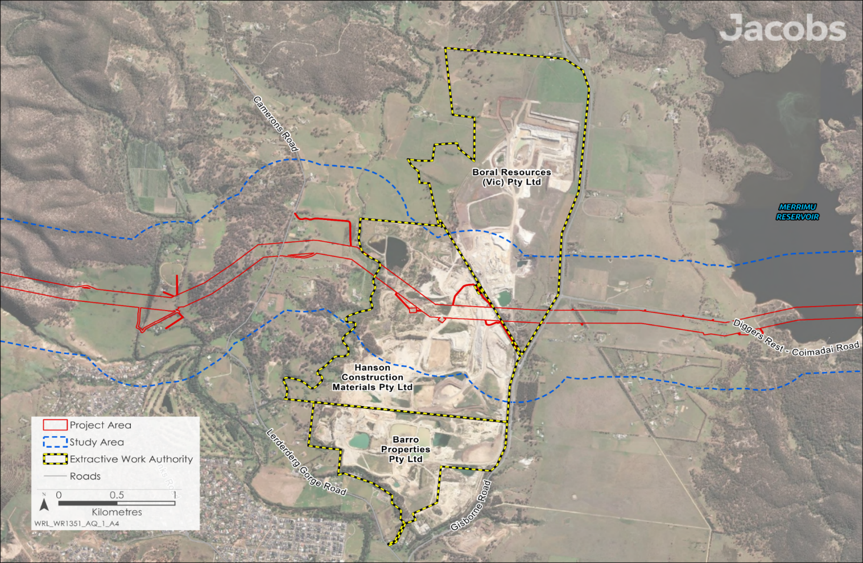

Figure 18.2 Quarries in Bacchus Marsh

### Significance for the assessment

The data presented in the Section 18.3, has informed the application of receiving environment sensitivity ratings for each section of the Project, as well as an assessment of the effectiveness of the dust transmission pathway from the source to the receiving environment, in accordance with EPA Publication 1943. The Project weightings breakdowns, rating definitions and summary of the significance assessment, are provided in Section 6.5 of **Technical Report I: Air Quality Impact Assessment**. As rural farmland is identified as the predominant land use between Allendale to Sydenham, with more proximal and / or higher densities of rural residential receptors, this section of the Project is considered to have the highest receiving environment sensitivity weighting.

## Construction impacts

This section outlines the key issues identified through the risk screening process and the associated potential impacts during the construction of the Project. The key issues and impacts identified for air quality are discussed according to the following themes:

* Dust generation: including the excavation, handling, transport, storage and placement of soil and materials, which may generate dust. Further, dust may be generated by the movement of vehicles and machinery, and the erosion of exposed surfaces, including unsealed access tracks by wind.
* Air pollutants from vehicles and machinery: including exhaust emissions from trucks, heavy machinery, plant and equipment used during construction of the Project.
* Air pollutants from contaminated material: including the potential to encounter contaminated soil, rock, or groundwater during construction activities. This could result in odour, fumes, and airborne hazards which may affect amenity.

### Dust generation

Works associated with the construction of the transmission line, Powercor distribution line crossovers, new and upgraded terminal stations, the workforce accommodation facilities and temporary supporting infrastructure (such as concrete batching plants, access tracks and hardstands) including laydown areas may generate dust. When not managed, this dust can present a nuisance and potentially result in human health impact, including to psychological health. Dust can be generated during digging, handling, transporting, and placing materials, as well as from wind blowing over stored materials and exposed surfaces.

**Technical Report I: Air Quality Impact Assessment** identified 30 residential receptors within 100m of the Project Area, including 20 located near the transmission line east of Allendale to Sydenham Terminal Station. At these locations many residences and/or homes are located downwind of the Project given the prevailing local winds.

There are no residential sensitive receptors within 1,000m of the new 500kV terminal station at Bulgana, Bulgana Terminal Station, or Elaine Terminal Station. The nearest residential sensitive receptors to the Sydenham Terminal Station connection works are within 500m, in the suburb of Hillside. For the laydown areas and workforce accommodation facilities, the closest sensitive receptors are situated approximately 700m from the Ballan intermediate laydown area. Additionally, there are no residential sensitive receptors within 1,000m of the Lexton intermediate laydown area and workforce accommodation facility.

Using a method developed by the EPA, as detailed in **Technical Report I: Air Quality Impact Assessment**, dust impacts during the construction stage could be moderate or medium if not effectively managed. Moderate means dust problems are rare without management, while medium means dust problems are likely without proper management. The medium impact is for areas along the transmission line and construction sites between Allendale and Sydenham. Table 18.2 provides a summary of the unmitigated dust impact ratings for Project activities and elements.

Dry conditions with light to moderate winds blowing in the direction(s) from dust-generating activities towards sensitive receptors are most likely to lead to potential impacts without controls being implemented. As discussed in Section 18.3.3, local background air quality and weather conditions were a key consideration when determining the construction dust impact.

Table 18.2 Unmitigated construction dust impacts

| Project stage | Activity/element | Highest determined impact |
| --- | --- | --- |
| Construction | Transmission line (Bulgana to Allendale) | Moderate impact |
| Transmission line (Allendale to Sydenham) | Medium impact |
| Powercor distribution line crossovers | Moderate impact |
| Existing Bulgana Terminal Station upgrade | Moderate impact |
| New 500kV terminal station near Bulgana | Moderate impact |
| Existing Elaine Terminal Station upgrade | Moderate impact |
| Intermediate laydown areas | Moderate impact |

The Project has been iteratively developed to avoid nearby sensitive receptors so far as reasonably practicable, whilst considering other social, cultural, environmental and engineering factors.

EPRs were developed to manage and reduce the moderate and medium potential impacts associated with dust generation, as detailed in Table 18.2. These include the development of a Construction Environmental Management Plan (CEMP) (EPR EM2) for the Project, which will include an Air Quality Management Plan (EPR AQ1). The purpose of the Air Quality Management Plan will be to identify measures to minimise the risk of air quality impacts during construction, and it is required to detail how the Project will control and where necessary monitor dust emissions. The effectiveness of these controls will be reviewed and amended if required by the Principal Contractor when reviewing monitoring results. Industry standard measures to minimise and manage dust generation that may be included in the Air Quality Management Plan include:

* Watering access tracks and exposed and disturbed areas to reduce the level of dust generated from Project traffic along unsealed roads and from wind erosion from exposed and disturbed areas, such that associated residual impacts would be minimised
* Modifying the intensity of activities based on observed dust levels and weather conditions so that activities can be scaled back or suspended to reduce the potential for residual impacts when poor ambient air quality and weather conditions are identified
* Avoiding the burning of trimmed and cleared vegetation to prevent associated emissions to air, which include particulate matter associated with these types of activities
* Covering loads and removing loose materials/debris before vehicles exit the site to minimise dust associated with the transport of construction materials
* Minimising the extent of disturbed and exposed areas and stockpiles to limit dust arising from wind erosion
* Covering or stabilising long-term stockpiles to limit the extent of dust resulting from wind erosion effects at these areas
* Positioning dusty activities such as concrete batching and materials stockpiles as far as practicable away from surrounding receptors
* Identifying appropriate site speed limits to minimise dust generation
* Revegetating or sealing finished areas to reduce susceptibility to wind erosion
* Maintaining minimum setback distances of at least 100m to sensitive receptors from temporary concrete batch plants
* Consulting with surrounding sensitive receptors to discuss and review the suitability of controls
* Implementation of monitoring, with the application of short-term trigger response criteria, so that any changes to the efficacy of activities and /or controls can be made readily.

The establishment of laydown areas, as per the draft Incorporated Document conditions, can be done as preparatory works and are not subject to EPRs. The construction of the workforce accommodation facilities are subject to conditions in the draft Incorporated Document which includes the requirement to develop and implement a CEMP that includes management of air quality impacts. EPRs however do apply to the use of the workforce accommodation facilities during Project construction.

Following application of these types of mitigation measures, residual impacts associated with dust generation are low. The residual dust impacts are anticipated to be short-term, and only occur on rare occasions during exceptional circumstances. For example, existing elevated background conditions could lead to minor nuisance dust soiling, and/or inclement weather such as winds blowing in the direction from the Project towards sensitive receptors. The resulting dust levels at surrounding receptors would be at nuisance level and non-harmful to human health and be within the natural variations found in the existing environment.

### Air pollutants from vehicles and machinery

Trucks, heavy machinery and mobile generators used during construction may release pollutants from their exhausts including nitrogen oxides, carbon monoxide, sulfur dioxide, and particulate matter, affecting air quality.

Generators with self-bunded fuel tanks will be required to power laydown areas and smaller generators will be used in various construction activities. These generators will be fuelled by diesel or unleaded fuel, which will release exhaust emissions. It is anticipated that most vehicles used in construction will also be diesel fuelled. As the machinery, vehicles, and generators used during construction will operate in open areas, exhaust emissions will quickly disperse into the air and are anticipated to be minimal when compared to everyday vehicle emissions generated in Victoria.

Construction vehicles can also produce odours if not well maintained; however, these odours are not expected to impact surrounding sensitive receptors due to their distance from the Project Area. Prior to any mitigation, construction of the Project may cause low air quality impacts due to the use of vehicles and machinery. The Air Quality Management Plan (EPR AQ1) is required to include detail on how the Project will control the release of exhaust emissions, fumes and odour during construction to the extent reasonably practicable. To achieve this, the Principal Contractor will implement measures to maintain construction plant and equipment in a proper and efficient manner. Other mitigation measures that may be implemented to achieve this EPR could include switching off all vehicles, plant and equipment when not in-use for extended periods to avoids unnecessary exhaust-related emissions by removing the emissions source.

With the application of these mitigation measures to comply with EPRs, the extent, duration and magnitude of the Project’s impacts associated with emissions from vehicles and machinery will be reduced, and the residual impacts are low.

### Air pollutants from contaminated material

Earthworks and excavations may uncover contaminated soil, rock, and groundwater, causing odour, fumes and airborne hazards that can be unpleasant. The potential to uncover both known and unknown sources of contamination is discussed further in **Chapter 23: Contaminated Land**. Soils with naturally occurring chemicals such as sulphides can release an unpleasant gas (hydrogen sulphide) when exposed to air.

No significant sources of contaminated soil, rock or groundwater were identified that would be affected by the Project, and therefore the potential impacts were low. If contaminated materials or groundwater is discovered during construction, associated odours, fumes or airborne hazards will be managed to minimise, so far as reasonably practicable, impacts on amenity and human health. Measures will be detailed in the Air Quality Management Plan (EPR AQ1), which requires odours and fumes to be controlled so far as reasonably practicable, as discussed in Section 18.4.2. The CEMP will also include an Unexpected Finds Plan (EPR CL2) that will be implemented should unexpected, contaminated soil or groundwater be identified during earthworks. This will include requirements for the removal and disposal of contaminated and hazardous materials, and industry standard measures to control impacts, such as the application of odour suppressing agents.

Following application of these mitigation measures to comply with EPRs, the extent, duration and magnitude of the Project’s air quality impacts associated with contaminated material will be reduced, and the residual impacts remain low.

## Operation impacts

This section outlines the issues identified through the risk screening process and associated potential impacts during the operation of the Project. The key issues and impacts identified for air quality are summarised according to the following themes:

* Dust generation: including operational maintenance and inspection activities that may generate dust, particularly through the use of vehicles, plant and equipment use along access routes. Exposed surfaces resulting from vegetation removal may also generate dust.
* Other air quality impacts: including exhaust emissions from plant and equipment used during operational inspection and maintenance activities.

### Dust generation

Dust may be generated during inspection and maintenance activities during operation. These activities will include vegetation removal in the easement, resulting in exposed surfaces that could generate dust, and the movement of vehicles, plant and equipment. As noted in Section 18.4.1, dust emissions can cause health and amenity issues when not managed.

Prior to any mitigation, operation of the Project may cause moderate to low dust impacts, with moderate impacts only anticipated along the transmission line between Allendale and Sydenham – where the receiving environment has a higher sensitivity rating. In this area, dust impacts could occur under certain conditions without management measures in place, such as when background concentrations are already elevated, and winds are blowing in the direction from the Project towards sensitive receptors. Other operational activities, for example those undertaken at terminal station sites, are anticipated to only rarely result in dust impacts without proper management.

Although the potential for air quality impacts during the Project’s operational stage is lower than during the construction stage, AusNet will implement mitigation strategies to minimise dust emissions from operational activities, including managing dust from vehicles, plant and equipment used during schedule maintenance activities or routine vegetation management required within the easement (EPR AQ2). Following application of these mitigation strategies to comply with EPRs, dust impacts would be unlikely and may only occur on rare occasions during exceptional circumstances such as when there is existing elevated background conditions and/or inclement weather. There may be occasional short-term (i.e., hours) occurrences where there may be elevated dust levels that could lead to minor nuisance dust soiling but remain non-harmful to human health, and residual impacts associated with dust generation during operation would be low.

Mitigation strategies will be determined by the AusNet prior to the Project being operated. Industry standard mitigation strategies that may be required include:

* Switching off plant and equipment when not in-use
* Operating and maintaining plant in a proper and efficient manner
* To the extent practicable, limiting the extent of cleared areas of vegetation to reduce the potential for dust arising from wind erosion effects
* Inspecting and maintaining unsealed access routes
* Reviewing meteorological and ambient air quality conditions, and plan activities accordingly.

With the implementation the mitigation and management strategies required by the EPRs, the extent, duration and magnitude of the Project’s impacts from dust generation during operations will be reduced, and the residual impacts are minor.

### Other air quality impacts during operation

As described in Section 18.4.2, plant and equipment used during operational inspection and maintenance activities will produce exhaust emissions and may generate odour if not well maintained. The release of pollutants associated with exhaust emissions, including nitrogen oxides, carbon monoxide, sulfur dioxide, and particulate matter can affect air quality. However, these emissions are not expected to impact surrounding sensitive receptors due to their distance from the Project Area and impacts are considered to be negligible. No additional management measures are required, beyond maintaining and operating plant and equipment in a proper and efficient manner. As such, the residual impact associated with the use of plant and equipment remains negligible.

## Decommissioning impacts

As decommissioning activities will be similar to those that occur during construction, the impacts relating to air quality are assessed to be the same as for the construction stage. It is noted that this is with the exception of the potential degradation of water quality by groundwater disposal or slurry generation, as neither groundwater nor slurry is expected to be required during decommissioning. Small amounts of contamination may be generated from equipment leaks or from maintenance activities over the service life of the Project assets. Whilst it is possible that odours and other airborne hazards may arise, should this contamination be present at the time of decommissioning, it is not expected that specific management measures would be required other than those required to clean up contamination.

Accordingly, the EPRs developed to manage impacts during construction would also be applicable for decommissioning in accordance with the conditions of the time. This would also be managed by a Decommissioning Management Plan (EPR EM11) which would include mitigation measures for air quality.

Based on this, residual impacts are negligible for air quality.

## Cumulative impacts

Cumulative impacts have been assessed by identifying relevant future projects that could contribute to cumulative impacts on air quality values, considering their spatial and temporal relationships to the Western Renewables Link Project. The projects considered as potentially relevant to air quality include:

* Coimadai Sand Quarry
* Elaine (Akaysha) Battery Energy Storage System (BESS)
* Elaine Solar Farm
* Lerderderg River Nature Trail
* Lerderderg-Wombat National Park
* Melbourne Renewable Energy Hub
* Merrimu Precinct Structure Plan/Bacchus Marsh Urban Growth Framework
* Nyaninyuk Wind Farm
* Outer Metropolitan Ring Road/E6
* Sydenham Terminal Station Rebuild
* Victoria to New South Wales Interconnector West
* Western Irrigation Network Scheme – Recycled Water Supply Infrastructure Project.

Air emissions from multiple projects can have prolonged or greater impacts to receptors effected by multiple projects. These emissions, which include dust, exhaust from construction equipment, and odours from handling potentially contaminated materials can impact human health and amenity.

The relevant future projects may produce similar emissions to those expected from the Western Renewables Link Project, such as dust, and may impact common receptors. The impact of cumulative air quality effects on nearby sensitive areas is dependent on the timing and sequencing of construction, operation, and decommissioning activities undertaken for the Project, as well as other relevant future projects. However, it is unlikely that the combined emissions will significantly increase the anticipated impact from the Project alone. Through application of the Air Quality Management Plan (EPR AQ1) and the management and mitigation measures (EPR AQ2), including identifying the Western Renewables Link Project contributions, alongside contributions from other surrounding projects that could be leading to cumulative effects, residual cumulative air quality impacts will be low.

## Environmental Performance Requirements

Potential impacts identified in **Technical Report I: Air Quality Impact Assessment** have informed the development of EPRs for the Project. EPRs set out the environmental outcomes to be achieved through the implementation of mitigation measures during construction, operation and decommissioning. While some EPRs are performance based to allow flexibility in how they will be achieved, others include more prescriptive measures that must be implemented. Compliance with the EPRs will be required as a condition of the Project’s approval. Table 18.3 details the proposed EPRs developed for air quality.

The cornerstone of the Environment Protection Act is the GED. The GED requires anyone conducting an activity that poses risks of harm to human health and the environment from pollution or waste to minimise those risks, so far as reasonably practicable. To meet the requirements of the GED, the Project is required to minimise the risk of harm from air emissions, so far as reasonably practicable. The recommended EPRs require the contractors to identify risks prior to undertaking activities and implement measures to mitigate and manage potential impacts.

Table 18.3 Environmental Performance Requirements

| EPR code | Requirement |
| --- | --- |
| EPR AQ1 | **Develop and implement an Air Quality Management Plan**   1. Prior to construction commencing, develop, implement and maintain an Air Quality Management Plan as part of the Construction Environment Management Plan (CEMP) (EPR EM2) to minimise air quality impacts during construction at surrounding sensitive receptors. 2. The Air Quality Management Plan must: 3. Identify the main sources of dust and airborne pollutants, and the location of sensitive land uses. 4. Include a procedure for how the Project will control and where necessary monitor the emission of dust, exhaust emissions, fumes, odour and other pollution into the atmosphere during construction in accordance with relevant statutes, policies and guidelines to the extent reasonably practicable, including EPA Publication 1834.1: the Civil Construction, Building and Demolition Guide. 5. Outline a process for regular review and update of The Air Quality Management Plan and assess the effectiveness of controls implemented. Reviews of the plan would be undertaken when there are changes in design, conditions, monitoring results or as a result of investigating complaints: 6. Provide a process to address complaints related to air quality and identify mitigation measures. The process must include: 7. Follow-up with the potentially affected stakeholder(s) and capture all details. 8. Review the results of air quality and meteorological monitoring and details of Project activities for any non-compliance or complaints received. A targeted trigger monitoring criterion with 1-hour averaged PM10 above 80 ug/m3 provides an indication when air quality conditions are poor, and that the 24-hr averaged 50 ug/m3 PM10 concentration objective would be exceeded to inform onsite management and controls as required. 9. Identify Project contributions, including key activities, as well as contributions from other surrounding projects that could be leading to cumulative effects. 10. Review associated controls for Project activities, and where necessary modifying these controls or the intensity of activities to address the measured/reported issue. 11. Provide feedback on action taken to the affected stakeholder(s) and confirm the complaint is closed out. 12. Monitors are required to be installed at or near works associated with the existing Bulgana Terminal Station, the new 500kV terminal station near Bulgana, Sydenham Terminal Station connection works and all laydown areas to reflect long term prevailing wind conditions and specific areas where sensitive receptors are located for the duration of construction works. The data collected would be used for compliance and management purposes. |
| EPR AQ2 | **Implement air quality management and mitigation measures for operation**  Implement mitigation measures to avoid the generation of off-site visible dust during specific operational activities (i.e., dust from vehicles, plant and equipment used during scheduled maintenance activities or routine vegetation management required within the easement). |

Other EPRs contribute to a reduction in the magnitude, extent and duration of air quality impacts. Additional EPRs related to air quality include:

* EPR CL2 – Unexpected Finds Plan
* EPR EM2 – Develop and implement a Construction Environmental Management Plan
* EPR EM9 – Audit and report on environmental compliance
* EPR EM11 – Develop and implement a Decommissioning Management Plan.

Refer to the relevant technical chapters and **Chapter 29: Environmental Management Framework** for full detail of these EPRs.

Air quality inspections and monitoring will be undertaken to review and verify the effectiveness or need for additional controls, primarily during construction. The Air Quality Management Plan (EPR AQ1) will outline the requirements for dust, exhaust emissions, fumes, odour, and emissions of other pollution into the atmosphere to be monitored. For example, monitoring may be required where relevant future projects are occurring simultaneously, or in response to community complaints or enquiries. The CEMP, which includes the Air Quality Management Plan, will be reviewed and updated annually, as well as in response to Project changes, changes to conditions, monitoring results or enquiries/complaints.

Air quality monitoring stations will also be installed at or near the existing Bulgana Terminal Station, the new terminal station near Bulgana, connection works at Sydenham Terminal Station and all laydown areas. These monitoring stations will collect data in real-time, which will be used for active management by the Principal Contractor. This data will inform the adequacy of existing controls and whether there is a need for review and update of onsite management and controls if certain concentrations of PM10 are exceeded (EPR AQ1). Such data will be made available to the Independent Environmental Auditor for review (EPR EM9). Auditing requirements are further detailed in **Chapter 29: Environmental Management Framework.**

The objectives of proposed monitoring programs for the Project required by the EPRs are outlined in **Chapter 29: Environmental Management Framework**.

The conditions associated with the construction of the workforce accommodation facilities are included in the draft Incorporated Document. These conditions have been informed by Project EPRs and include requirements to avoid, minimise and manage air quality impacts associated with these activities.

## Summary of residual impacts

With the application of the EPRs, residual impacts associated with air quality are considered to be low to negligible:

* Residual impacts to air quality due to dust generation during construction are low. It is expected that all impacts could be avoided with the proactive implementation of management measures, and residual impacts are anticipated to only occur during exceptional circumstances and have a short-term duration. Minor nuisance dust experienced at sensitive receptors would be non-harmful to human health.
* Residual impacts to air quality due to vehicles and machinery used during construction are low. The Air Quality Management Plan will require exhaust emissions, fumes and odour associated with vehicles and machinery to be controlled the extent reasonably practicable and all equipment to be well maintained as detailed in EPR AQ1.
* Residual impacts to air quality due to contaminated material discovered during construction are low. An Unexpected Finds Plan will be implemented should unexpected, contaminated soil or groundwater be identified during earthworks as required by EPR CL2, that will include measures to minimise air quality impacts.
* Residual impacts to air quality due to dust generation during operation are low. Similar to construction, dust impacts during the operation stage would be non-harmful to human health and within normal air quality fluctuations experienced in the existing environment.
* Residual impacts to air quality during operation due to plant and equipment emissions are negligible. The low level of emissions are not expected to impact surrounding sensitive receptors due to their distance from the Project Area.
* Residual impacts to air quality during decommissioning are the same as for the construction stage. As such, EPRs developed to manage impacts during construction will also be applicable for decommissioning and will be incorporated into the Decommissioning Management Plan (as required by EPR EM11).

With the implementation of measures to comply with EPRs, it is considered that the Project meets the air quality aspects of the evaluation objective “*avoid, or minimise where avoidance is not possible, adverse effects for community amenity, health and safety, with regard to construction noise, vibration, dust, lighting, waste, greenhouse gas emissions, transport network, operational noise, fire risk management and electromagnetic radiation.”*

