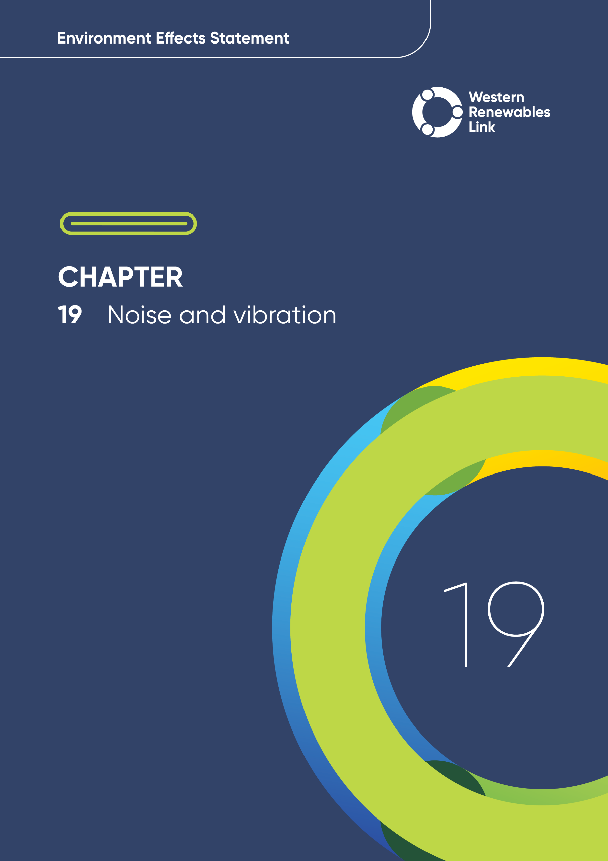

# Noise and vibration

This chapter provides an overview of the potential noise and vibration impacts associated with the construction, operation and decommissioning of the Project. This chapter is based on **Technical Report O: Noise and Vibration Impact Assessment**.

The noise and vibration generated through the construction, operation and decommissioning of the Project may disturb sensitive receivers including residences (dwellings), schools and aged care facilities. These receivers may experience noise and/or vibration during site preparation (e.g., vegetation clearance and earthworks), construction of hardstands, footings and foundations, concrete pouring, assembly of the tower structures, construction traffic, helicopter movements, operation of terminal stations and high voltage power transmission infrastructure (e.g., overhead transmission lines - aeolian and corona noise), and dismantling and demolition of the Project.

The Project passes through diverse environments, including agricultural lands, residential zones, and recreational areas. Each of these areas has a unique existing ambient sound environment, experiencing different levels of noise that contribute to the amenity of the area. The ambient sound environment refers to the overall sound levels present in each area, encompassing both natural and human-made sounds. Environmental values, indicators, and objectives are associated with each ambient sound environment.

The ambient sound environment is crucial for maintaining the environmental values that support human health and well-being. This includes maintaining sound levels that allow for restful sleep, peaceful recreation, and the overall enjoyment of natural and urban settings.

## Evaluation objective

The scoping requirements identify the following evaluation objective relevant to noise and vibration:

**Evaluation objective**

Avoid, or minimise where avoidance is not possible, adverse effects for community amenity, health and safety, with regard to construction noise, vibration, dust, lighting, waste, greenhouse gas emissions, transport network, operational noise, fire risk management and electromagnetic radiation.

In response to this evaluation objective, the impacts of the Project on the ambient noise and vibration environment were assessed, and measures to avoid, minimise or manage potential impacts have been identified. These measures are discussed throughout this chapter and have informed the development of Environmental Performance Requirements (EPRs). EPRs set out the environmental outcomes to be achieved through the implementation of mitigation measures during construction, operation and decommissioning to avoid, minimise and manage identified impacts. Cumulative impacts associated with relevant future projects were also assessed.

Further information on how the Project has been designed to avoid and minimise impacts is provided in **Chapter 5: Project development** and **Chapter 6: Project description**.

Other aspects covered in the Environment Effects Statement (EES) evaluation objective and relevant to noise and vibration are addressed in the following EES chapters:

* **Chapter 11: Landscape and visual**
* **Chapter 13: Bushfire**
* **Chapter 17: EMI and EMF**
* **Chapter 18: Air quality**
* **Chapter 20: Transport**
* **Chapter 26: Greenhouse gas.**

## Method

This section summarises the method adopted in **Technical Report O: Noise and Vibration Impact Assessment,** which was informed by **Chapter 4: EES assessment framework and approach**. The key steps in assessing the impacts associated with noise and vibration included:

* Defining a study area appropriate for noise and vibration impacts as presented in Figure 19.1. This included a 10km buffer either side of the Proposed Route, laydown areas and workforce accommodation facilities.
* Dividing the study area into five Noise Catchment Areas (presented in Figure 19.1) that represent areas with similar existing ambient sound environments based on current land use and noise monitoring results.
* Reviewing applicable Commonwealth and Victorian legislation, and relevant local, state and national standards, guidelines and policies.
* Consulting with the relevant regulatory authorities and key stakeholders including Environment Protection Authority (EPA) Victoria, and reviewing the pins dropped by community members via the Project’s Social Pinpoint online mapping tool, which identified locations, features and values of importance.
* Conducting a desktop review of land zoning and noise sensitive receivers to identify areas that were representative of different, or potentially different, ambient sound environments.
* Conducting both unattended and short-term attended noise monitoring at select locations that represent the typical sound environment around the nearest noise sensitive land uses to the Project. Vibration is not normally a significant feature of rural areas; as such, background vibration level monitoring was deemed unnecessary and was not conducted. Construction noise provisions and operational noise limits for the Project were established using the measured background noise levels and relevant EPA guidance, and construction vibration targets were established in accordance with standard industry practices.
* Conducting a risk screening process to identify the key issues during construction, operation and decommissioning for investigation within the technical report.
* Developing a digital noise model to predict noise levels at sensitive receivers arising from typical construction scenarios and activities at laydown areas and workforce accommodation facilities.
* Sensitive receivers

Land uses that may be sensitive to noise or vibration from a construction or operational source have been identified in accordance with the Environment Protection Regulations 2021 as sensitive receivers. These include residential land uses (including aged care), and educational land uses.

* Predicting vibration levels at sensitive receiver locations based on measurements undertaken at previous projects within Victoria, that included similar construction activities.
* Developing a digital noise model to predict operational noise levels and assist in identifying and assessing the potential impacts associated with noise generated at the transmission lines and towers, and terminal stations.
* Identifying and assessing the potential impacts associated with the noise and vibration generated by the Project during construction, operation and decommissioning. These impacts were evaluated according to the following ratings, in relation to the extent, magnitude and duration of the impacts:
  + Negligible: During construction, noise levels may be just audible at times but would be limited to Normal Working Hours. Construction vibration is expected to be imperceptible. During operation, noise is expected to be inaudible. Vibration is expected to be imperceptible.
  + Minor**:** During construction, noise levels are expected to be intermittently higher than the existing environment but would occur predominantly during Normal Working Hours. Vibration levels may exceed human comfort targets on occasion, but this would be limited to Normal Working Hours. During operation, noise levels may be audible at times but are expected to remain comfortably below applicable noise limits. Vibration may be slightly perceptible at times but is expected to remain comfortably below human comfort criteria.
  + Moderate: During construction, noise levels are expected to be considerably higher than the existing environment for extended periods of time, including outside of Normal Working Hours. Vibration levels are expected to exceed human comfort targets for extended periods of time but remain below the level that would pose a risk to building damage. During operation, noise levels are expected to be noticeably higher than the existing environment but would not exceed applicable noise limits at times at sensitive receivers. Vibration would be perceptible but is not expected to exceed human comfort criteria.
  + Major: During construction, noise levels are expected to be significantly higher than the existing environment for extended periods of time and may pose a risk of harm to human health at times. Vibration levels exceed human comfort targets at numerous sensitive receivers and occasionally exceed limits set for preventing building damage. During operation, noise levels are expected to be significantly higher than the existing environment and exceed applicable noise limits at sensitive receivers. Vibration would be readily perceptible and exceed human comfort criteria.
  + Severe: During construction, noise levels pose a risk of harm to human health over extended periods of time. Vibration levels consistently exceed damage limits to numerous buildings along the Proposed Route. During operation, noise levels are expected to be significantly above applicable noise limits for extended periods of time at sensitive receivers. Vibration would be readily perceptible, significantly exceed human comfort criteria and may pose a risk to building structures.
* Human comfort criteria

As there are no Victorian-specific standards or guidelines for the control of vibration, the British Standard BS 6472-1:2008 *Guide to evaluation of human exposure to vibration in buildings* is used as a reference for the Project.

This standard sets forth criteria for the assessment of potential impacts on human comfort from vibration.

* Identifying relevant future projects that could lead to cumulative impacts when considered together with the Project (refer to **Chapter 4: EES assessment framework and approach** for the full cumulative impact assessment method).
* Developing EPRs in response to the impact assessment to define the required environmental outcomes that the Project must achieve through the implementation of mitigation measures during construction, operation and decommissioning. Measures to reduce the potential impacts were proposed in accordance with the mitigation hierarchy (avoid, minimise, manage, rehabilitate and offset) and have informed the development of EPRs. Alternative mitigation measures could be implemented to comply with the EPRs based on the specific site conditions, available resources, and the Principal Contractor’s expertise. The EPRs were developed to meet the requirements of the General Environmental Duty (GED) under the *Environment Protection Act 2017* (Vic)*.*
* Following application of mitigation measures that would comply with the EPRs, determining residual impacts associated with the construction, operation and decommissioning of the Project, and evaluating their significance.

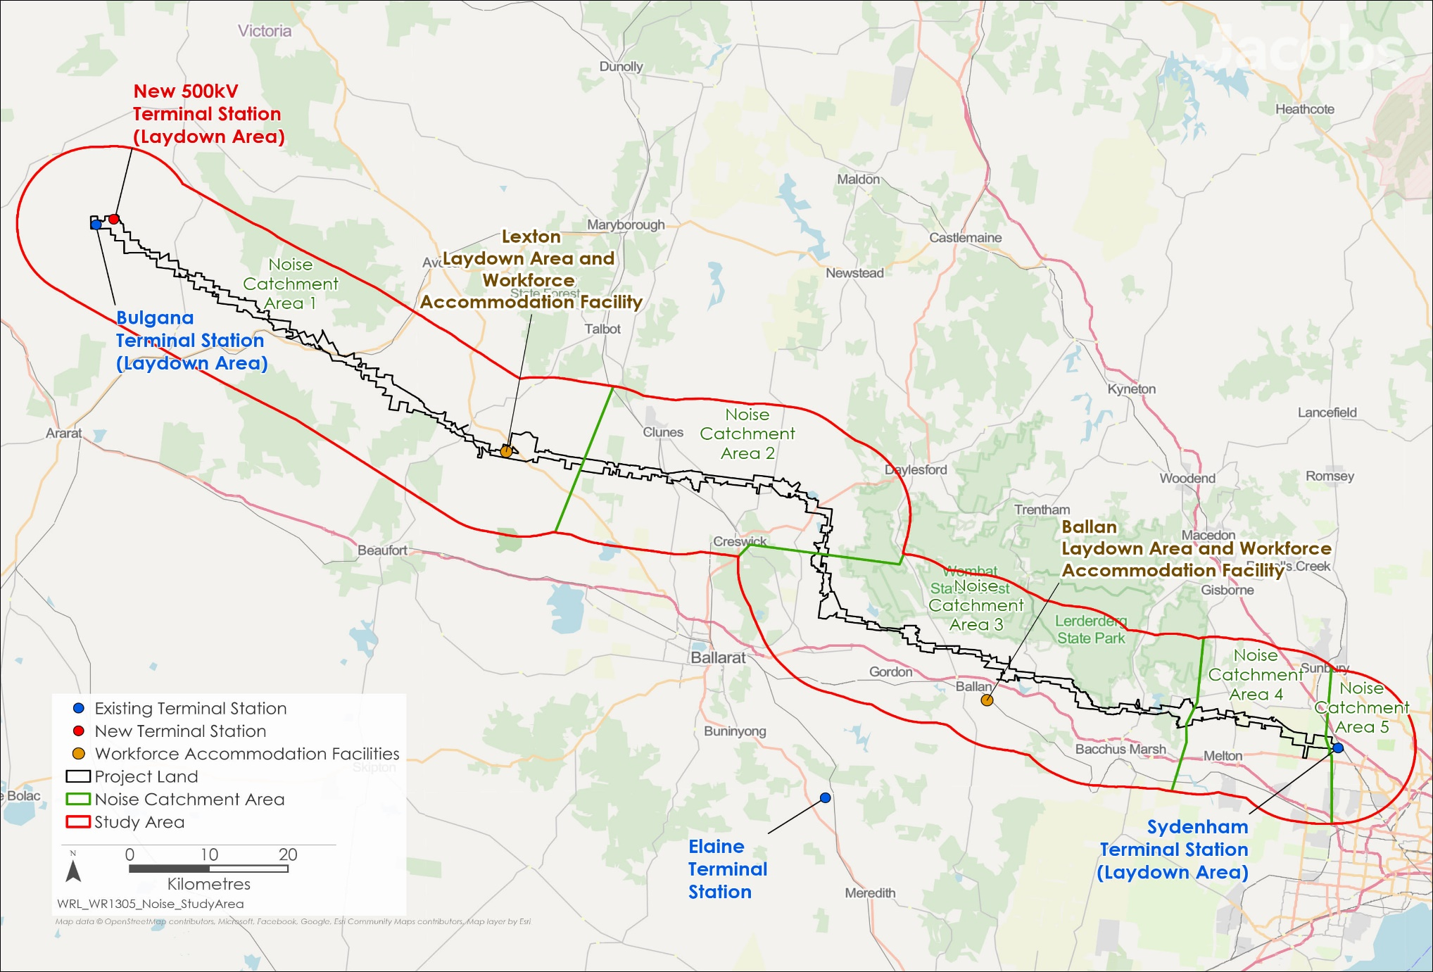

Figure 19.1 Noise and vibration study area

## Existing conditions

This section summarises the existing conditions for noise and vibration according to the following key themes:

* Sensitive receivers
* Noise environment
* Vibration environment.

The existing environment is characterised by rural and residential areas, with limited significant existing sources of noise and vibration. Industrial noise was observed in certain areas, such as near the Coimadai quarries. However, this noise remained within the typical range for the area’s land use. Perceptible vibration is not generally experienced by sensitive receivers within the study area.

### Sensitive receivers

* Noise Catchment Areas

Noise Catchment Areas are defined as areas within the overall study area that are considered to have similar existing ambient sound environments based on existing conditions and noise monitoring results.

Sensitive receivers to noise and vibration were identified based on known residence locations and a review of publicly available data, including the locations of non-residential sensitive receivers such as schools and hospitals. The nearest sensitive receivers to Project activities in each Noise Catchment Area, including those associated with the laydown areas and the workforce accommodation facilities, are described in Table 19.1.

Locations identified by the community and stakeholders as potentially sensitive to noise, such as the sporting facilities at MacPherson Park, were also considered. Although these locations are not classified as sensitive receivers under Victorian legislation, they will require noise reduction measures during construction and operation, so far as reasonably practicable. The sensitive receivers identified by the Project are illustrated in Figure 19.2 and detailed further by Noise Catchment Area in Section 6 of **Technical Report O: Noise and Vibration Impact Assessment.**

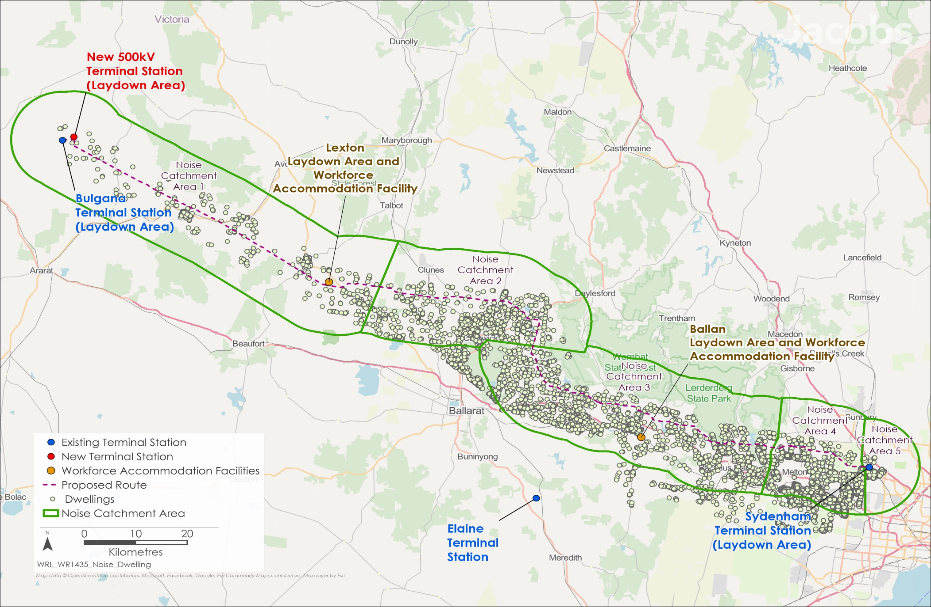

Figure 19.2 Sensitive receivers to noise and vibration

Table 19.1 Nearest noise and vibration sensitive receivers

| Project location | Nearest sensitive receivers to the Project |
| --- | --- |
| Noise Catchment Area 1:  Bulgana Terminal Station to Waubra | * + Isolated rural and farming residences.   + Residences set back at least 140m from the proposed transmission line, with one residence south of Lexton located approximately 80m from the proposed transmission line.   + The proposed transmission line is located approximately 1km from Elmhurst, approximately 1.4km from Lexton, and approximately 3km from Waubra.   + Both the existing Bulgana Terminal Station and the new 500kV terminal station near Bulgana are significantly removed (over 800m) from sensitive receivers. |
| Noise Catchment Area 2:  Waubra to Mount Prospect | * + The nearest sensitive receivers are isolated farming residences, and these are set back at least 200m from the proposed transmission line.   + The proposed transmission line is located approximately 1.5km north of Allendale, approximately 900m south of Smeaton, approximately 1.3km north of Kingston, and approximately 750m north of Newlyn North. |
| Noise Catchment Area 3:  Mount Prospect to Harkness | * + The nearest sensitive receivers are isolated residences, and residences located on the outskirts of towns.   + The nearest noise sensitive receivers are set back at least 80m from the proposed transmission line.   + The proposed transmission line runs adjacent to Gordon, is located approximately 100m north of Ballan, passes through Darley and is approximately 400m north of Long Forest. |
| Noise Catchment Area 4:  Harkness to Sydenham Terminal Station | * + The nearest sensitive receivers are isolated residences in the City of Melton, and these are set back at least 80m from the proposed transmission line.   + The transmission line runs adjacent to Hillside.   + The Melton Christian College Toolern Vale Campus, is a nearby non-residential noise sensitive receiver located approximately 700m from the proposed transmission line. |
| Noise Catchment Area 5:  Sydenham Terminal Station | * + The nearest sensitive receivers are residences located approximately 470m to the south of the Sydenham Terminal Station, in the suburb of Hillside.   + Unlike the other Noise Catchment Areas for the Project, the majority of sensitive receivers are in a defined urban area under the Noise Protocol, which typically have higher background noise levels than rural areas. These are predominantly single- and double-storey detached residences. |

* Noise Protocol

The ‘Noise Protocol’ refers to EPA Victoria Publication 1826.4, which sets out the standards for acceptable noise levels in various environments in conjunction with the Environment Protection Regulations 2021.

The specific noise limits set in the relevant planning scheme zones and by the Noise Protocol are provided in **Technical Report O: Noise and Vibration Impact Assessment.**

### Noise environment

The existing noise environments in each Noise Catchment Area contribute to the noise limits that apply within the relevant local planning schemes as set by the EPA Victoria ‘Noise Protocol’ for rural and urban areas as shown in Table 19.2.

Table 19.2 Noise Catchment Area operational noise limits

|  |  |  |  |
| --- | --- | --- | --- |
| Noise Catchment Area | Day limit (dB L*Aeq, 30min*) | Evening limit (dB L*Aeq, 30min*) | Night limit (dB L*Aeq, 30min*) |
| Noise Catchment Area 1 | 45 | 38-39 | 33-34 |
| Noise Catchment Area 2 | 45 | 39 | 34 |
| Noise Catchment Area 3 | 45-53 | 38-48 | 33-43 |
| Noise Catchment Area 4 | 45-50 | 39-44 | 34-39 |
| Noise Catchment Area 5 | 46-51 | 44-46 | 38-41 |
| Note: Where a range of sound levels are provided this indicates that the noise limit is dependent on the land use zoning of the noise source and relative noise sensitive receiver, and the distance between them. The noise limits for each land use zone and scenario are provided in Section 6 of Technical Report O: Noise and Vibration Impact Assessment. | | | |

Noise Catchment Area 1: Bulgana Terminal Station to Waubra

Noise Catchment Area 1 is characterised by agricultural land uses and undeveloped rural land. The noise environment is typically quiet, with observed background noise levels of 23 to 31dB LA90 typically comprising of natural sounds, such as wind through vegetation.

Ambient noise levels were measured between 27 to 59dB LAeq, with higher noise levels associated with daytime periods and locations where there was occasional traffic. Overall, the existing noise environment in Noise Catchment Area 1 is considered consistent with a typical rural area.

Noise Catchment Area 2: Waubra to Mount Prospect

LAeq

LAeq indicates the average noise volume of the existing environment over a set period.

LA90

LA90 indicates the volume exceeded for 90% of the measurement period. As such, it represents background noise levels, excluding short-term or temporary loud noises.

Both descriptors measure A-weighted sound levels, which reflect the sensitivity of the human ear to different frequencies. The higher the sound level, the more discomfort to humans.

Noise Catchment Area 2 is characterised by agricultural land uses. Generally, the environment is unaffected by significant temporal background noise sources such as traffic, with noise levels generally observed to be controlled by natural sources such as wind through vegetation and at times, livestock noises. Background noise levels of 28 to 38dB LA90 were recorded during long-term unattended monitoring.

Ambient noise levels were measured between 36 and 50dB LAeq. Overall, the existing noise environment for Noise Catchment Area 2 is considered consistent with a typical rural area.

Noise Catchment Area 3: Mount Prospect to Harkness

Noise Catchment Area 3 is characterised by agricultural land use, quarry operation at Coimadai and aircraft operations at the Melton Aerodrome.

The existing noise environment is consistent with typical rural industry areas, passing through three quarries at Coimadai. The background LA90 noise levels stay relatively consistent during the day and night, although the ambient LAeq levels increase during the day. Background noise levels at night are between 35 and 40dB LA90, higher than those measured in other Noise Catchment Areas. Ambient noise levels varied between 40 and 66dB LAeq depending on the time and local noise sources

The noise from the quarries is audible at night in some areas but does not impact the overall noise environment nearby. Blasting activities can generate audible noise beyond the boundary of the quarry sites; however, this is limited to the duration of the blasting activities. Similarly, occasional aircraft noise from Melton Aerodrome is audible when aircraft are in operation.

Noise Catchment Area 4: Harkness to Sydenham Terminal Station

Noise Catchment Area 4 is characterised by agricultural land prior to connecting with the Sydenham Terminal Station.

The noise environment is typically quiet at night, with background noise levels between 26 to 31dB LA90. The background noise levels increase during the day to 35 to 45dB LA90, due to a higher volume of traffic. The ambient noise environment varies depending on the distance to busier roads, with ambient noise levels of up to 71dB LAeq at night near Coburns Road and ambient noise levels as low as 35dB LAeq in the Hillside residential area, at night away from busy roads. The majority of Noise Catchment Area 4 is defined as a rural area by the Noise Protocol; the exception to this is the Hillside area, which is defined as an urban area and where higher operational noise limits apply.

Noise Catchment Area 5: Sydenham Terminal Station

Noise Catchment Area 5 is characterised by cleared, undeveloped land around the terminal station. Traffic along the Calder Freeway, approximately 900m north of the Sydenham Terminal Station, is a dominant existing source of noise in this area. Other existing sources include the Calder Park Raceway and the Calder Park Stabling Yard.

Noise Catchment Area 5 has daytime background noise levels of 34 to 41dB LA90 and night-time background noise levels of 26 to 39dB LA90, with higher noise levels attributed to traffic noise from the Calder Freeway, as well as occasional aircraft and local traffic noise. Ambient noise levels range from 35 to 53dB LAeq, depending on the contribution of transport noise at the particular location.

The noise levels at the boundary of the existing Sydenham Terminal Station were measured at 45dB LAeq, which includes contribution of traffic generated noise from the Calder Freeway. Noise from the existing terminal station was not audible at the nearby sensitive receivers.

### Vibration environment

As perceptible ground-borne vibration is not generally a characteristic of the environment in rural areas, the EES scoping requirements do not require the ambient vibration environment to be assessed. Accordingly, no vibration monitoring was conducted to establish existing conditions.

Existing potential sources of vibration include road traffic on major roads, and occasional activities undertaken at quarries, such as the Boral Quarry on Bacchus Marsh-Gisborne Road north of Bacchus Marsh. While these sources may occasionally generate perceptible vibration in proximity to the source, vibration is not expected to be perceptible at sensitive receivers most of the time. During engagement, community members reported that blasting at the quarries can produce perceptible vibration. However, this is limited to the duration of the intermittent blasting activities and is not indicative of an underlying continuous source of vibration.

In general, it is not expected that sensitive receivers within and around the Project Area are regularly exposed to existing perceptible vibration, and ground-borne vibration is not a significant existing condition in the areas traversed by the Project.

## Construction impacts

This section outlines the issues identified through the risk screening process and associated potential impacts during the construction of the Project. The key issues and impacts identified for noise and vibration are discussed according to the following themes:

* Noise and vibration generated by construction activities: the potential for excessive noise and vibration (in terms of duration and timing) to be generated by construction activities for the Project, both within and outside of normal working hours.
* Noise and vibration generated by construction traffic: excessive noise and vibration generated by Project-related traffic at construction sites, laydown areas and workforce accommodation facilities, and along transport routes.

### Noise and vibration generated by construction activities

* Normal working hours

Under EPA guidelines, normal working hours for construction noise are from 7am to 6pm on weekdays and 7am to 1pm on Saturdays. Construction outside these hours is typically subject to additional noise restrictions.

Noise impacts

Where possible, construction activities for the Project will be undertaken during normal working hours (7am to 6pm Monday to Friday, and 7am to 1pm Saturdays); however, the construction of the transmission line and terminal station have the potential to generate excessive noise and vibration that may be disruptive to nearby sensitive receivers.

Individual residences may be exposed to audible construction noise for a period of a few weeks over the course of site establishment works and the construction of the transmission towers. For the worst-case scenarios considered as part of the assessment, the number of residences predicted to experience LAeq 30min noise levels greater than 45 dB(A) in each Noise Catchment Area are detailed in Section 7.3 of **Technical Report O: Noise and Vibration Impact Assessment**.

Elevated noise levels generated by the construction of the Project are not anticipated to cause disturbance to schools surrounding the Project.

Most sensitive receivers are expected to experience construction noise levels no higher than 65dB LAeq, comparable to those adjacent to a busy road. However, a small number of residences may experience noise levels up to 78dB LAeq, comparable to residential renovation works being undertaken at a neighbouring property (within 15m). These residences are identified in Figure 19.3. While this noise will be audible to residents, it will be temporary and will occur only intermittently and during normal working hours. Individual residences will experience the noise during works on the nearest transmission towers, with the noise decreasing as the works move away from the residence.

The loudest construction activity is predicted to be the intermittent stringing of the transmission line and tower construction using a helicopter, lasting only a few hours at a time across several days during normal working hours. This level of noise is comparable to that of a truck passing by 20m away, or a neighbour carrying out external renovation works within 15m. Most of the transmission line will not be strung using helicopters and helicopters will not be required for tower construction in all instances. Typically, specialised on-ground plant and equipment will be used, with aerial methods reserved for environmentally or culturally sensitive areas. Ground-based stringing methods, such as the use of winches and tensioners, are expected to be significantly quieter.

Six sensitive receivers in Noise Catchment Area 3 may be exposed to noise from the laydown areas and workforce accommodation facility, with noise levels of up to 50dB LAeq predicted for one residence near the proposed laydown area southeast of Lexton. This estimate is based on the most intensive activities occurring at the laydown area and workforce accommodation facility during normal working hours and would only persist for relatively short periods of time during establishment of the sites. Construction activities may be audible at nearby sensitive receivers, but would not be significantly louder than the existing daytime ambient noise level. Establishment of the laydown areas will be managed using standard mitigation measures consistent with EPA Publication 1834.1: Civil construction, building and demolition guide. The implementation of these standard mitigation measures is expected to mitigate the potential of construction noise exceeding levels that cause disturbance on the six sensitive receivers, after which residual impacts will be negligible. The development of workforce accommodation facilities will be managed in accordance with a Construction Environmental Management Plan and relevant EPA publications for noise and vibration (as required by the conditions outlined in the draft Incorporated Document, after which residual impacts are negligible.

The majority of sensitive receivers will not be exposed to noise generated due to construction works at the terminal stations that would be higher than the existing ambient noise environment. Works at the existing Bulgana Terminal Station and Elaine Terminal Station are not predicted to exceed 45dB LAeq at any time. At the new terminal station near Bulgana and connection to Sydenham Terminal Station, noise may be intermittently audible for up to 34 weeks but should not exceed existing daytime ambient noise level in each Noise Catchment Area. At these sites, site preparation will be the loudest activity and is anticipated to impact 91 sensitive receivers, primarily surrounding Sydenham Terminal Station. One sensitive receiver near the new terminal station at Bulgana may temporarily experience elevated construction noise of up to 70dB LAeq, but this will only occur during work on the access track connection to Vances Crossing Road and is expected to be limited to a short duration. Other sensitive receivers near the new terminal station near Bulgana and connection to Sydenham Terminal Station are not anticipated to be exposed to noise levels above 55dB LAeq.

The Project’s Principal Contractor will develop a Construction Noise and Vibration Management Plan (CNVMP), in consultation with EPA Victoria, to minimise noise and vibration impacts to the extent reasonably practicable (EPR NV1). The CNVMP will identify and assess expected noise and vibration levels at sensitive receivers, detail construction activities and schedules, establish procedures for community notifications in accordance with the Communications and Stakeholder Engagement Management Plan (EPR EM5), and set out the mitigation and management measures that will be implemented on site.

The CNVMP will adopt standard construction and equipment measures to reduce noise and vibration, which include:

* Controlling the sources of noise and vibration, such as selecting the quietest available equipment or process for the job and using best practice construction technologies
* Shielding noisy activities using existing structures or enclosures for stationary plant
* Scheduling works during less sensitive periods.

The CNVMP will also include additional applicable mitigation and management measures specific to the Principal Contractor’s construction method.

The CNVMP will also set out complaint response procedures with respect to construction noise and vibration, in accordance with the Project’s Complaints Management System (EPR EM7). Noise monitoring will be undertaken to validate predictions of the digital noise model where a risk of harm to human health or the environment has been identified, to assess the effectiveness of management measures, and to confirm that noise emissions are being minimised so far as reasonably practicable (EPR NV1).

In certain circumstances, there may be people who sleep during the day, such as shift workers, for whom noise levels could be a concern, even when occurring during normal working hours. The CNVMP will include methods to address these specific circumstances. For example, alternative accommodation could be offered for the duration of the construction noise exposure.

While most construction works will occur during normal working hours, some unavoidable tasks may need to occur out of hours. This includes delivering oversized plant and equipment, and concreting works that cannot be reasonably stopped once started. These unavoidable tasks are expected to be brief. Other out of hours construction activities will only occur outside of normal working hours if they comply with weekend, evening and night-time noise and vibration targets set in EPA Victoria Publication 1834.1 and British Standard BS-6472-1:2008 (EPR NV3). Unavoidable works undertaken outside of normal working hours will be detailed within the CNVMP (EPR NV1).

Whilst construction noise will be minimised so far as reasonably practicable through the implementation of measures to comply with the CNVMP (EPR NV1) construction noise will be audible at times. For some construction activities, such as the stringing of transmission lines or tower construction using a helicopter, no practicable measures can be applied to reduce the noise further due to the nature of the works. However, noise impacts will be limited to relatively short durations (days or weeks) near the transmission line, and while they will extend over months at the terminal stations, they generally will not exceed the existing ambient environment noise and vibration levels. Based on this, the residual impacts from construction noise on sensitive receivers are minor.

Vibration impacts

Ground vibration from construction works could arise from activities such as heavy vehicle movements, excavation or compaction. Depending on their magnitude, these vibrations can disturb building occupants which inconveniences or interferes with the occupants’ activities and potentially damage building structures and underground assets (such as pipework).

Vibration levels are not expected to be perceptible beyond 50m from the construction works and will stay within the most stringent human comfort targets. The exception to this is if larger vibratory rollers are used for compaction activities; in this case there is the potential for human comfort impacts to occur at nine nearby residences. As with the noise target levels, the Principal Contractor will be required to implement management actions to reduce vibration to the extent reasonably practicable, including instances where the guideline target levels for vibration are not achieved (EPR NV3).

Vibration associated with construction activities is expected to be below relevant vibration limits that prevents building damage at heritage or residential structures. The implementation of management actions will be necessary if guideline targets are not achieved. Thereby, reducing the extent, magnitude and duration of vibration impacts to sensitive receivers. As such, construction vibration disturbance will result in minor residual impacts.

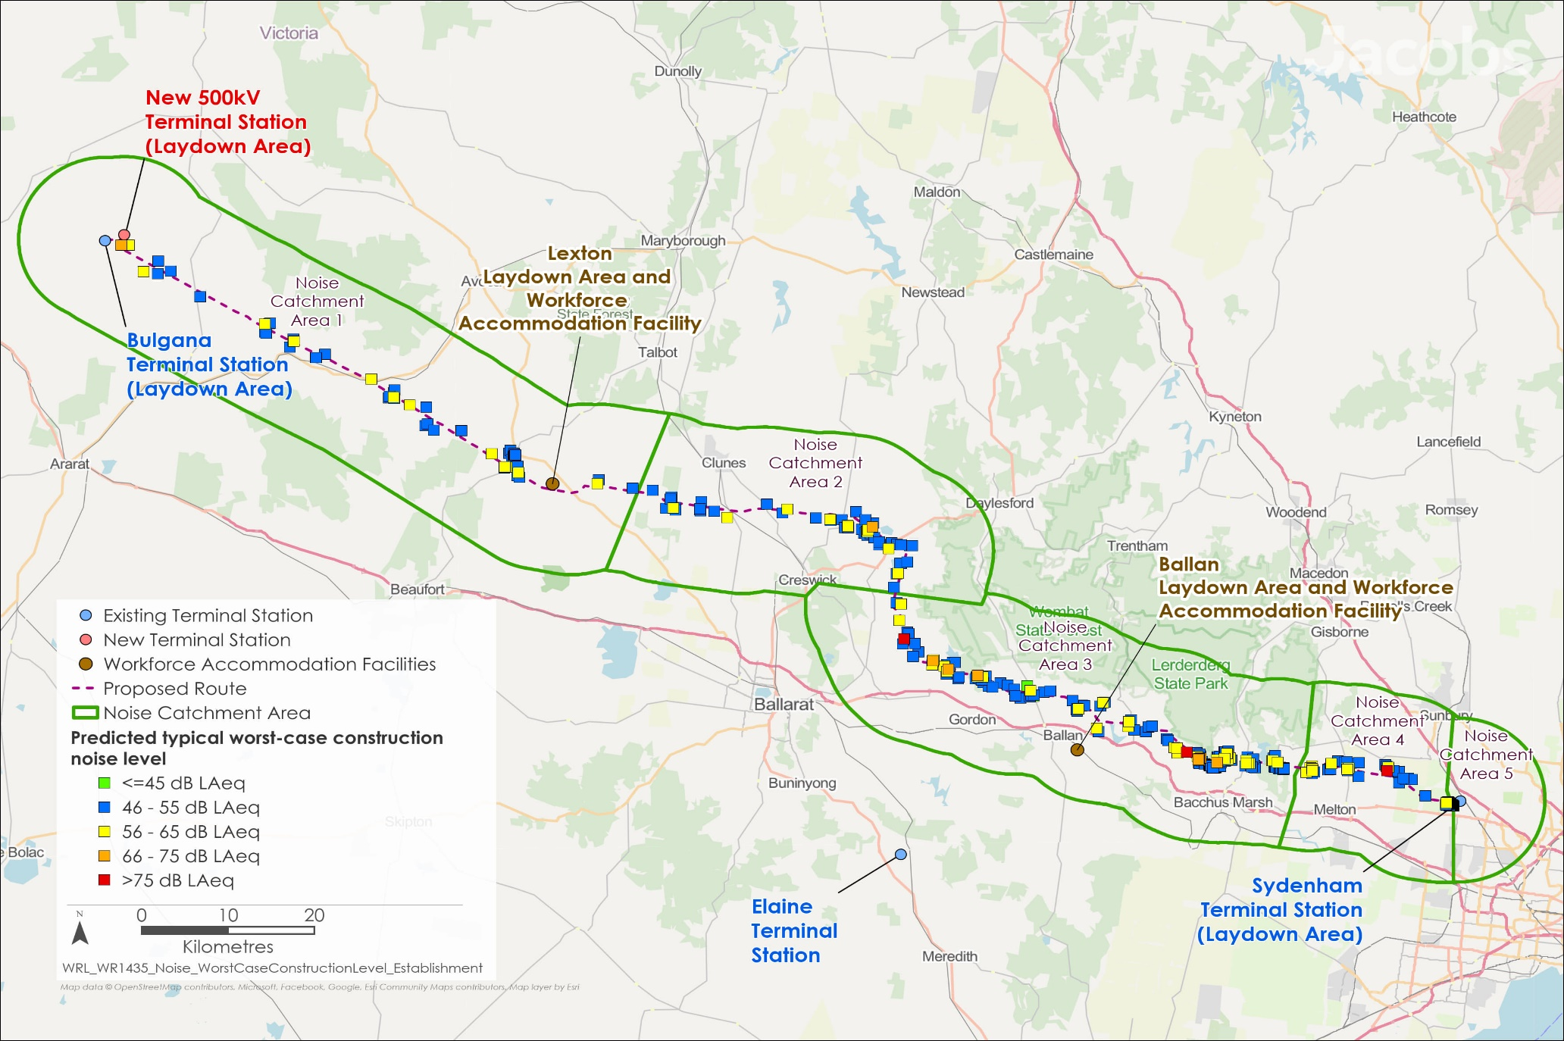

Figure 19.3 Predicated impacts to sensitive receivers

### Noise and vibration generated by construction traffic

The Project is expected to increase traffic volumes on access routes used to transport materials from the Port of Melbourne to construction sites and laydown areas. This may generate noise and vibration that’s disruptive to nearby sensitive receivers. The potential for increased traffic volumes to cause congestion, delays, and safety conflicts is further discussed in **Chapter 20: Transport**.

The CNVMP will include measures to manage the noise and vibration from construction traffic (EPR NV1), including:

* Planning traffic flow, parking, and loading zones to avoid the need for reversing near residential areas
* Locating loading zones, site access points, roads and construction traffic routes as far as possible from residential areas
* Restricting construction traffic to designated roads and traffic speeds across the construction site
* Implementing procedures so truck drivers do not unnecessarily use engine breaks.

Traffic along major roads is already a potential source of vibration. However, construction-related vibration from heavy vehicles used during construction is not anticipated to result in perceptible vibration.

Following the implementation of mitigation measures to comply with the EPRs, noise and vibration from construction traffic, will be managed in accordance with the requirements of EPA Victoria guidelines. The CNVMP (EPR NV1) will consider and implement measures to minimise the noise and vibration generated by construction traffic, for example through restricting construction traffic to designated roads. As such, residual impacts from construction traffic will be minor.

## Operation impacts

This section outlines the key issues identified through the risk screening process and associated impacts during the operation of the Project. The key issues and impacts identified for noise and vibration are summarised according to the following themes:

* Noise and vibration generated by Project infrastructure: aeolian noise and corona discharge generated by the transmission line, noise and vibration generated at the terminal station sites that may exceed operational noise limits.
* Noise and vibration generated through maintenance activities: noise generated through infrequent helicopter movements required for transmission line inspections, which could potentially exceed relevant guideline levels.

### Noise and vibration generated by Project infrastructure

During the operational stage of the Project, noise will be generated by operating equipment at the new and upgraded terminal stations and transmission line infrastructure. However, no operational vibrations from electrical and mechanical equipment at terminal stations are expected to be perceptible beyond the boundaries of the terminal station sites or the transmission line easement.

Transformers and reactors are anticipated to be the primary sources of noise at terminal stations. The highest predicted noise levels at the new terminal station near Bulgana and at the connection to the new Sydenham Terminal Station are below the most stringent nighttime noise limits in the Noise Protocol.

* Aeolian and corona noise

Aeolian and corona noise are associated with the operation of high voltage transmission lines.

Aeolian noise can be heard as a low humming, caused by transmission lines vibrating in the wind.

Corona noise can be heard as a faint hissing or crackling sound, caused by the air surrounding the transmission line becoming energised.

During the operational stage of the Project, noise levels above the ambient environment may occur due to occasional aeolian and corona noise.

Aeolian noise is most prominent during conditions where high, steady winds are occurring at right angles to the transmission line infrastructure. Typically, aeolian noise at wind speeds higher than 36km/h is masked by the prevailing windy conditions, such as the noise of wind through local vegetation. The specific conditions required to generate aeolian noise are uncommon and no aeolian noise was detected during representative monitoring on the existing Moorabool-Heywood transmission line.

Corona discharge noise can be heard near to transmission lines during periods of light rain or humid periods as a hissing or crackling sound, caused by the implosion of ionised water droplets in the air. This noise is generally masked by heavier rainfall.

During September and October 2021, noise monitoring was undertaken for the Project at a location on the existing Moorabool-Heywood transmission line where the design factors are similar to the Project’s 500kV transmission line in Victoria. The results were conservatively applied to predict corona noise levels at noise-sensitive land uses within the study area. The predicted maximum corona noise levels at residences are between 24 and 34dB LAeq, a level similar to, or lower than, that of a quiet library. This prediction is conservative, based on older design principles for transmission lines, and the detailed technical design will further minimise the risk of corona discharge noises (EPR NV4).

The EPRs require the Project’s design to minimise noise emissions so far as reasonably practicable and to comply with the noise limits defined in the Environment Protection Regulations 2021 (EPR NV4). This includes designing the transmission line infrastructure to reduce aeolian and corona noise. The equipment at the new and upgraded terminal stations will include firewalls to reduce noise generation, with noise attenuation barriers or other noise reduction measures considered if necessary. A suitably qualified acoustic consultant will assess noise levels at the terminal stations during commissioning and implement contingency measures if the noise limits defined in the Environment Protection Regulations 2021 are not met (EPR NV5).

Following the implementation of the mitigation measures to comply with the EPRs, noise and vibration generated by Project infrastructure is expected to comply with the relevant noise limits and vibration targets. Noise from the terminal stations is predicted to comply with the Noise Protocol noise limits. Intermittent noise from transmission lines arising from specific weather conditions, such as aeolian or corona noise, will be managed through the application of appropriate design measures. No operational vibration impact is predicted from the Project. As such, the residual impacts on the noise and vibration ambient environment due to operational Project infrastructure will be minor.

### Noise and vibration generated through maintenance activities

During operations, routine maintenance inspections of the transmission line, easement, and vegetation will be conducted through vehicle patrols or aerial surveys. In some instances, these maintenance inspections may be carried out by helicopter. Consequently, there may be occasions when residential areas are affected by noise from these helicopter movements. However, maintenance inspections are expected to occur infrequently, and due to the considerable distance between the transmission line and residential receivers in most areas, noise impacts from maintenance activities are anticipated to be minor.

Helicopter noise associated with maintaining transmission line infrastructure is excluded from the Environment Protection Regulations 2021 and, therefore, from the requirements of the Noise Protocol. EPA Victoria Publication 1254.2 Noise Control Guidelines provides guidance on the assessment and management of noise from sources that are not subject to the Noise Protocol requirements. As the Project’s operator, AusNet will be expected to not exceed the maximum noise level at residential residences for helicopter operations specified in these guidelines and to maintain the recommended separation distances from residential premises. Inspections and maintenance will be restricted to the hours of 7am to 6pm Monday to Saturday, and 9am to 6pm on Sundays and public holidays, except in an emergency (EPR NV6).

Following the implementation of mitigations to comply with the EPR NV6, noise and vibration from the Project’s maintenance are expected to comply with applicable noise limits and vibration targets. Noise associated with maintenance activities will be infrequent and will be minimised, so far as reasonably practicable, for example by using quieter equipment such as drones where possible. As such, residual impacts to the noise and vibration ambient environment due to operational maintenance of the Project are expected to be minor.

## Decommissioning impacts

As decommissioning activities will be similar to those that occur during construction, the impacts related to noise and vibration are assessed to be the same as for the construction stage. During both construction and decommissioning of the Project, noise and vibration issues are largely related to the use of plant and equipment and traffic for vehicles to access the Project.

Accordingly, the EPRs developed to manage impacts during construction will also be applicable for decommissioning in accordance with the conditions of the time. This will also be managed by a Decommissioning Management Plan (EPR EM11), which will include mitigation measures for noise and vibration.

Based on this, residual impacts are expected to be minor for noise and vibration.

## Cumulative impacts

Cumulative impacts were assessed by identifying relevant future projects that could contribute to cumulative impacts on the ambient sound and vibration environment, considering their spatial and temporal relationships to the Western Renewables Link Project. The projects considered as potentially relevant to noise and vibration include:

* Coimadai Sand Quarry
* Elaine Solar Farm
* Elaine (Akaysha) Battery Energy Storage System
* Melbourne Renewable Energy Hub
* Nyaninyuk Wind Farm
* Outer Metropolitan Ring Road/E6
* Sunbury Line Level Crossing Removals
* Sydenham Terminal Station Rebuild
* Toolern Vale Solar Farm
* Victoria to New South Wales Interconnector (VNI) West.

Noise and vibration impacts associated with the construction, operation and decommissioning of the Western Renewables Link Project are generally localised. As such, it is unlikely that cumulative construction noise presents a concern unless works for two projects occur within approximately 500m of an individual noise sensitive receiver - and even where this occurs, the increase in noise level is not anticipated to be noticeable. However, cumulative construction could extend the duration for which that receiver is exposed to construction noise at a particular level. This situation could arise around the Project Land if, for example, the Melbourne Renewable Energy Hub or Sunbury Line Level Crossing Removals were still being constructed during the construction of the Western Renewables Link Project. These impacts could also occur with smaller-scale construction projects that do not require Ministerial approval. At distances greater than 500m, noise from construction of a project during normal working hours is likely to be below the ambient noise level, making cumulative impacts unlikely. At distances greater than 500m, noise from construction of a project during normal working hours is likely to be below the ambient noise level, making cumulative impacts unlikely.

Cumulative operational noise impacts surrounding the terminal stations were considered in the design of the Western Renewables Link Project. This includes the potential cumulative noise effects of existing equipment installed at the Bulgana Terminal Station and Sydenham Terminal Station, as well as new equipment installed as part of the new 500kV terminal station near Bulgana, the Sydenham Terminal Station Rebuild Project, and the VNI West. The predicted noise levels from these sites are significantly lower than the applicable noise limits, meaning cumulative contribution from other projects is not likely to result in an exceedance of these limits. At Elaine Terminal Station, the Western Renewables Link Project will not install new operational noise sources and as such will not contribute to cumulative increases in noise. Cumulative noise effects related to the operation of the transmission lines are expected to be limited to areas within proximity to the transmission line, where no residences have been identified.

The Western Renewables Link Project’s CNVMP will consider the potential for cumulative impacts during construction and implement additional management measures to limit the contribution of the Western Renewables Link Project, so as far as reasonably practicable (EPR NV1). As such, significant cumulative impacts related to construction or vibration are anticipated to be minor.

## Environmental Performance Requirements

* Unreasonable and aggravated noise

'Unreasonable noise' refers to noise that is disruptive or harmful to individuals or the environment, exceeding acceptable levels.

'Aggravated noise' is a more severe form of unreasonable noise, often involving repeated or intentional breaches.

Potential impacts identified through **Technical Report O: Noise and Vibration Impact Assessment** have informed the development of EPRs for the Project. EPRs set out the environmental outcomes to be achieved through the implementation of mitigation measures during construction, operation and decommissioning. While some EPRs are performance based to allow flexibility in how they will be achieved, others include more prescriptive measures that must be implemented. Compliance with the EPRs will be required as a condition of the Project’s approval. Table 19.3 details the proposed EPRs developed for noise and vibration.

The cornerstone of the *Environment Protection Act 2017* (Vic)is the GED. The GED requires anyone conducting an activity that poses risks of harm to human health and the environment from pollution or waste to minimise those risks, so far as reasonably practicable. To meet the requirements of the GED, the Project is required to minimise the risk of harm from noise and vibration as far as reasonably practicable and not generate any unreasonable or aggravated noise.

Recommended EPRs were developed to meet the GED using reasonably practicable avoidance or mitigation measures for noise and vibration impacts.

Table 19.3 Environmental Performance Requirements

| EPR code | Requirement |
| --- | --- |
| EPR NV1 | **Develop and implement a Construction Noise and Vibration Management Plan**   1. As part of the Construction Environmental Management Plan (CEMP) (EPR EM2), develop a Construction Noise and Vibration Management Plan (CNVMP) to avoid and minimise, so far as reasonably practicable, noise and vibration impacts at sensitive receivers. 2. The CNVMP must be developed in consultation with EPA Victoria and comply with the *Environment Protection Act 2017* and subordinate legislation, including the general environmental duty, and with reference to the Civil construction, building and demolition guide (EPA Publication 1834.1, as amended from time to time) and Construction – guide to preventing harm to people and the environment (EPA Publication 1820.1, as amended from time to time). 3. The CNVMP must be informed by noise and vibration modelling of Project works. 4. The CNVMP must include: 5. Identification of noise and vibration sensitive receivers, including consideration of sensitive receivers that may be more sensitive during Normal Working Hours such as shift workers or agricultural operations or community events that are more sensitive at specific times of year. 6. Construction noise and vibration reference levels and criteria as per EPRs NV2 and NV3. 7. Details of relevant construction activities and an indicative schedule for construction works, including identification of the activities that have the potential to generate noise and/or vibration impacts at sensitive receivers. 8. A noise and vibration risk assessment for operation of laydown areas. 9. How the risks of construction noise and vibration will be minimised, including but not limited to: 10. Where noise and vibration modelling of the demonstrates a potential exceedance of reference levels 11. Where cumulative noise and vibration from Project works and from other developments occurring during construction could exceed reference levels 12. Where the environmental values for ambient sound defined in the Environment Reference Standard are at risk. 13. Management actions and mitigation measures to reduce noise and vibration impacts so far as reasonably practicable. 14. Roles and responsibilities. 15. Community notification procedures in accordance with EPR EM5 (Communications and Stakeholder Engagement Management Plan). 16. Complaint response procedures in accordance with EPR EM7 (Complaints Management System). 17. A program for monitoring and inspections to: 18. Validate construction noise and vibration predictions. 19. Assess the effectiveness of management measures 20. Assess whether noise and vibration emissions are being minimised so far as reasonably practicable 21. Verify noise predictions for Unavoidable Works and Managed-Impact Works. 22. Processes for reviewing and updating the modelling, plan and implemented controls in response to Project changes, changes to conditions, monitoring results or enquiries/complaints. 23. The CNVMP must identify Unavoidable Works (refer to EPR NV2) that would be undertaken, including their location, timing and duration. The CNVMP must either include a clear rationale for defining works or a list of the type of planned works that constitute Unavoidable Works and response strategies to mitigate the impacts of these Unavoidable Works, consistent with EPA Publication 1834.1 (as amended from time to time). 24. Note that, in the context of this EPR, noise and vibration reference levels are not compliance levels that if met will discharge the requirements of the general environmental duty. Reference levels represent levels above which harm to human health and the environment is more likely to occur. At all times, the contractor must first eliminate risks of harm so far as reasonably practicable, then reduce risks of harm so far as reasonably practicable. If exceedance of reference levels occurs after all reasonably practicable measures have been implemented, then management actions must be implemented in accordance with the CNVMP. |
| EPR NV2 | **Minimise construction outside of Normal Working Hours**   1. Schedule works during Normal Working Hours between the hours of 7am – 6pm Monday to Friday, and 7am – 1pm Saturdays to minimise noise impacts. 2. Works must be scheduled during Normal Working Hours unless the works meet the following requirements: 3. Construction noise levels are predicted not to exceed the noise requirements specified in Table 4.3 of the Civil construction, building and demolition guide (EPA Publication 1834.1 as amended from time to time), construction vibration levels are predicted to comply with the relevant vibration reference level specified in BS6472-1:2008 (NV3), and works are undertaken in accordance with management measures set out in the CNVMP developed under EPR NV1; or 4. The proposed scope of Unavoidable Works or Managed-Impact Works, as defined in the CNVMP, are reviewed and verified by the Independent Environmental Auditor to meet the definition of Unavoidable Works or Managed-Impact Works as outlined in EPA Publication 1834.1 (as amended from time to time), and noise and vibration emissions (and their impacts) are proposed to be managed so far as reasonably practicable. 5. Notification of any Unavoidable Works must be provided to potentially affected landholders and made available on the Project website where the Weekend/Evening or Night reference levels specified in EPA Publication 1834.1 (as amended from time to time) are predicted to be exceeded. 6. Noise and vibration monitoring must be carried out at the commencement of Unavoidable Works and Managed-Impact Works to confirm predicted levels and that appropriate management measures are implemented in accordance with the Construction Noise and Vibration Management Plan (CNVMP) developed under EPR NV1 as verified by the Independent Environmental Auditor (IEA). 7. The above requirements do not apply to emergency works to avoid the loss of life, damage to property, or to prevent environmental harm. The CNVMP must set out a process for responding to emergency works and informing EPA Victoria and relevant regulators about these works. |
| EPR NV3 | **Minimise construction vibration impacts on amenity**   1. Develop and implement measures to minimise impact to human comfort in occupied buildings from continuous vibration if target levels are exceeded. 2. Implement management actions if the following guideline target levels for continuous vibration from construction activities are not achieved (levels are calculated as lower range of ‘adverse comment possible’ from the British Standard BS6472-1:2008).  |  |  | | --- | --- | | Location | Guideline target (VDV m/s1.75) | | Residential (Night – 10pm to 7 am) | 0.2 | | Residential (Day – 7am to 10 pm) | 0.4 | | Commercial offices, 7am to 10 pm | 0.8 | | Workshops, 7am to 10 pm | 1.6 |  1. Notes: 2. The reference levels are non-mandatory; they are goals that should be sought to be achieved through the application of practicable mitigation measures. If exceeded, then management actions will be required. 3. The Vibration Dose Values (VDV) may be converted to Peak Particle Velocity (PPV) levels within the Construction Noise and Vibration Management Plan (CNVMP). The methodology to convert VDV to PPV must be verified by the Independent Environmental Auditor (IEA). |
| EPR NV4 | **Design operational noise sources to minimise noise so far as reasonably practicable**   1. Design and operate the Project to avoid and minimise impacts due to noise emissions as follows: 2. Design and operate the new 500kV terminal station near Bulgana, connection to Sydenham terminal station and new transmission infrastructure elements that are subject to Part 5.3, Division 3 (Unreasonable and aggravated noise from commercial, industrial and trade premises) of the Environment Protection Regulations 2021 to: 3. Minimise the risk of harm from noise associated with the Project so far as reasonably practicable, 4. Prevent unreasonable noise by ensuring the risk of sporadic noise and low frequency noise is eliminated or managed to the extent reasonably practicable, and 5. Not exceed the noise limits set by the Environment Protection Regulations 2021, to the extent reasonably practicable. 6. Noise predictions and analysis for the purposes of this EPR must be conducted in accordance with the Noise Protocol (EPA Publication 1826.4 as amended from time to time), Measuring and analysing industry noise and music noise (Technical Guide: EPA Publication 1997 as amended from time to time) and, where relevant, the Noise guideline – assessing low frequency noise (EPA Publication 1996 as amended from time to time). |
| EPR NV5 | **Undertaken commissioning noise monitoring of terminal stations**   1. Within six months of completing construction, appoint a suitably qualified acoustic consultant to undertake commissioning noise measurements of the new 500kV terminal station near Bulgana and connection to Sydenham terminal station, following completion of the Project works, to assess levels with respect to the EPRs and to identify and implement contingency measures if the requirements in the EPRs are not met. |
| EPR NV6 | **Minimise the impact of noise from maintenance activities**   1. Develop and implement measures to avoid and minimise noise emissions during operation as follows: 2. Prior to commencing maintenance activities, prepare and implement measures to undertake the activities to avoid or, where not possible to avoid, minimise noise so far as reasonably practicable. 3. Restrict inspections and maintenance to the hours of 7am to 6pm Monday to Saturday and 9am to 6pm on Sunday and public holidays where reasonably practicable. |

Other EPRs contribute to a reduction in the magnitude, extent and duration of impacts for noise and vibration values. Additional EPRs related to noise and vibration include:

* EPR EM5 – Develop and implement a Communications and Stakeholder Engagement Management Plan
* EPR EM11 – Develop and implement a Decommissioning Management Plan.

Refer to **Chapter 29: Environmental Management Framework** for full detail of these EPRs.

The draft Incorporated Document was informed by the EPRs and includes conditions to avoid, minimise and manage impacts associated with the development of workforce accommodation facilities. For noise and vibration, this includes a requirement to manage the risk of noise and vibration from the workforce accommodation facilities in accordance with a Construction Environmental Management Plan and relevant EPA publications for noise and vibration.

Noise and vibration monitoring will be undertaken as required by the CNVMP and Decommissioning Management Plan. Monitoring will aim to validate the predictions of the digital noise model in areas where there is a risk of harm to human health or the environment, assess the effectiveness of management measures, and confirm that noise and vibration generation has been minimised to the extent practicable. Additionally, if work is required outside of normal working hours, extra noise monitoring will be undertaken to verify noise predictions and confirm that appropriate management measures have been implemented.

The objectives of proposed monitoring programs for the Project required by the EPRs are outlined in **Chapter 29: Environmental Management Framework.**

## Summary of residual impacts

With the application of the EPR’s, residual impacts associated with noise and vibration are considered to be minor:

* Residual impacts to the noise and vibration ambient environment due to construction activities are minor. At times, construction noise will be audible at sensitive receivers, as there are no reasonably practicable measures that can be applied to reduce the noise due to the nature of the works. For example, this is the case for the use of a helicopter to string transmission lines or for tower construction in areas where it is not possible to shield the noise source. However, noise impacts will be limited to relatively short durations (days or weeks) near the transmission line during construction, while they will extend over a period of months at the terminal stations, they are generally not expected to be significantly higher than the existing ambient environment. The CNVMP will consider and implement measures to minimise the noise and vibration generated by construction activities (EPRs NV1 and NV3).
* Residual impacts to the noise and vibration ambient environment due to construction traffic are minor. The CNVMP will consider and implement measures to minimise the noise and vibration generated by construction traffic, for example through restricting construction traffic to designated roads (EPRs NV1 and NV3).
* Residual impacts to the noise and vibration ambient environment due to operational Project infrastructure are minor. Noise from the terminal stations is predicted to comply with the Noise Protocol noise limits at all times of day and intermittent noise from transmission lines arising from specific weather conditions, namely aeolian noise or corona noise, will be managed through the application of appropriate design measures (EPR NV4). No operational vibration impact was predicted as a result of the Project.
* Residual impacts to the noise and vibration ambient environment due to operational maintenance of the Project are minor. Noise associated with maintenance activities is anticipated to be very infrequent and will be minimised so far as reasonably practicable, for example through the use of quieter equipment such as drones where possible (EPR NV6).
* Residual impacts to the noise and vibration ambient environment during decommissioning are considered to be the same as for the construction stage. As such, EPRs developed to manage impacts during construction will also be applicable for decommissioning and will be incorporated into the Decommissioning Management Plan (EPR EM11).

With the implementation of measures to comply with EPRs and the draft Incorporated Document, it is considered that the Project meets the noise and vibration aspects of the evaluation objective “*Avoid, or minimise where avoidance is not possible, adverse effects for community amenity, health and safety, with regard to construction noise, vibration, dust, lighting, waste, greenhouse gas emissions, transport network, operational noise, fire risk management and electromagnetic radiation.”* Furthermore, through the implementation of the EPRs, the Project is expected to meet the requirements of relevant legislation and guidelines designed to protect the health and amenity of residents and communities, including the GED.

