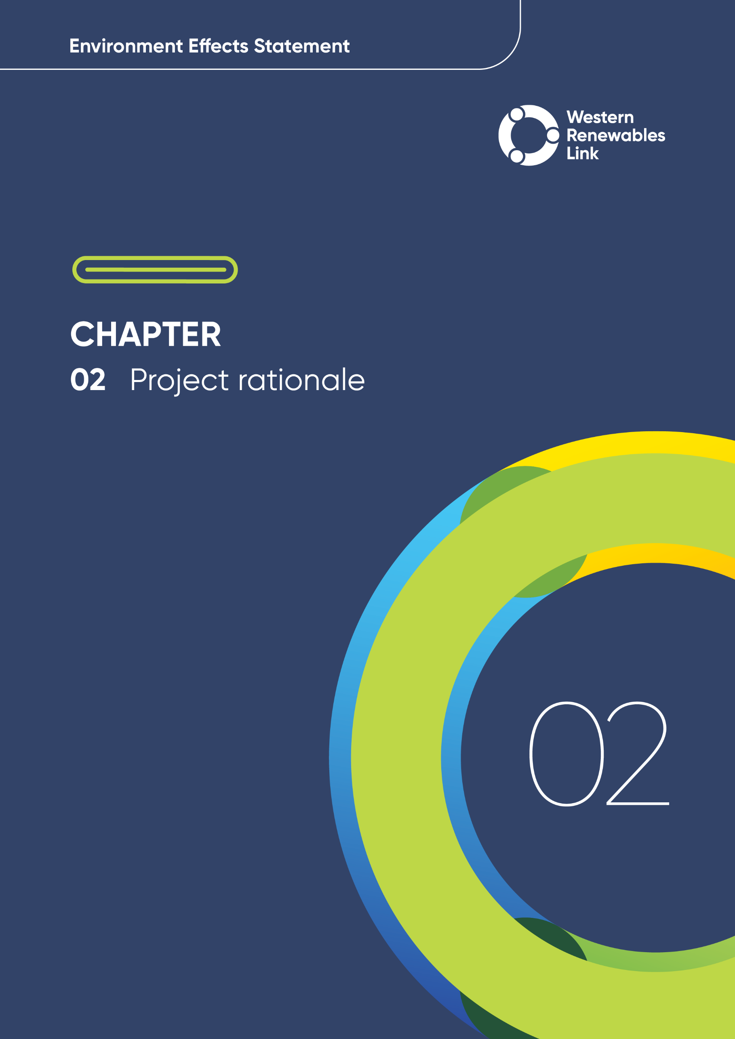

# Project rationale

This chapter outlines the rationale for the Project, the context within which it is being planned and delivered, and the potential benefits that would be derived from the Project.

Renewable energy is produced using natural resources that are constantly replaced and never run out.

Just as there are many natural sources of energy, there are many renewable energy technologies. Common technologies include solar, wind power and hydropower.

As discussed in **Chapter 1: Introduction**, the Project aims to maintain the security and reliability of the transmission network, create opportunities for strategic development of the National Electricity Market (NEM) and deliver infrastructure which realises a net benefit for Victorians by helping to unlock clean electricity in western Victoria. Targeted and timely delivery of transmission infrastructure in western Victoria is required to harness renewable energy generation and maintain the reliability and security of the state’s electricity supply.

This chapter describes the global and national context of the Project in relation to renewable energy policy. It outlines the challenges the Australian Energy Market Operator (AEMO), and Commonwealth and State Governments are facing in reconfiguring Australia’s energy supply and the NEM to maintain network reliability as Australia transitions towards renewable energy generation. It also outlines constraints within the western Victorian transmission network and explains how, by achieving the Project’s objectives, the Project will address those constraints and deliver anticipated benefits.

The Project’s development, from its initial identification through to the proposed design and route assessed in the EES is set out in detail in **Chapter 5: Project development**. A summary of the Project’s development is provided in this chapter.

## The need for renewable energy

This section discusses the broader global context of trends in renewable energy policy and investment which drive key commitments to energy generation and transmission frameworks in Australia and Victoria.

### Global trends

The 2015 Paris Agreement on climate change commits signatories, including Australia, to limiting global warming to below 2 degrees Celsius, and preferably 1.5 degrees Celsius. In November 2021, nearly 200 signatory countries, including Australia, reaffirmed this commitment at the COP26 (Conference of the Parties) Glasgow summit and adopted a new climate pact that includes making efforts to phase-down coal power and end fossil fuel subsidies (United Nations, 2021). At the COP28 Dubai summit in December 2023, there was a further call to action to triple renewable energy capacity globally by 2030 and transition away from fossil fuels in energy systems. The COP29 summit in Baku, Azerbaijan in November 2024 resulted in further commitments, including tripled climate finance for developing countries by 2035.

Reducing global carbon dioxide emissions to net-zero by 2050 is recognised as a critical goal to avert the worst effects of climate change. The United Nations report on the COP26 summit noted that over 90% of world Gross Domestic Product was covered by net-zero emissions commitments, up from 30% in 2019 (United Nations, 2021).

The International Energy Agency’s *Net Zero Roadmap: A Global Pathway to Keep the 1.5 °C Goal in Reach* (International Energy Agency, 2023) outlines the pathway for the energy sector to reach net-zero by 2050. The roadmap states that the challenge is formidable and will require an unprecedented transformation in how energy is produced, transported and used – but the benefits of this transformation are substantial, including a cleaner environment, new jobs and dynamic and resilient economies dominated by renewable energy generation like solar and wind. The International Energy Agency projected in 2020 that renewable energy will account for 95% of the net increase in global power capacity from 2020 to 2025 (International Energy Agency, 2020) and estimated in 2024 that global renewable capacity will grow by 2.7 times by 2030 (International Energy Agency, 2024).

The global trend away from fossil fuels has picked up pace in recent years, with several large investors indicating they are transitioning away from these fuels and looking to fund renewables. In May 2021, the Asian Development Bank announced that it will end all financing for fossil fuel production, following similar announcements from the European Investment Bank and the Norwegian Government Pension Global Fund, the world’s largest sovereign wealth fund (Asian Development Bank, 2021; Ekblom, 2019; Davies, 2019). Key national and state policy instruments have been developed to align with global trends and to meet Australia’s commitments to reduce greenhouse gas emissions and meet climate change targets. These include the Australian Renewable Energy Target (RET) and the Victorian Renewable Energy Target (VRET), established in 2001 and 2017 respectively, and discussed in the following sections.

### National commitments

The Commonwealth Government has made a commitment to drive Australia’s transition to net zero as part of its effort to meet its global commitments to address climate change. In 2022, the Commonwealth Government legislated ambitious climate change and emissions reduction targets including a 43% reduction in greenhouse gas emissions by 2030 from a 2005 baseline, and a target of net zero emissions by 2050. To meet its emissions reduction targets, the Commonwealth Government has introduced several policy and finance measures focused on transforming the electricity sector, such as the Powering Australia plan (to create jobs, reduce pressure on energy bills, and lower emissions by boosting renewable energy), National Energy Transformation Partnership (a framework for government cooperation on reforms to achieve net zero by 2050), Capacity Investment Scheme (a framework to encourage new investment in renewable capacity), the Rewiring the Nation program (to modernise the electricity grid and deliver new and upgraded transmission infrastructure), as well as setting a Renewable Energy Target (RET), through the Renewable Energy (Electricity) Act 2000. The RET is a key policy instrument for Australia to align with global trends and meet its commitments to reduce greenhouse gas emissions and meet climate change targets.

The RET was established in 2001 as the Mandatory Renewable Energy Target to encourage investment in renewable energy power projects, including hydro power stations, wind farms and large-scale solar. The RET was split in 2011 into the Large-scale Renewable Energy Target and Small-scale Renewable Energy Scheme. The current annual target for development of new power generation under the Large-scale Renewable Energy Target has been set at 33,000 gigawatt-hours (GWh) until the scheme ends in 2030. The RET plays an important part in unlocking investment in large-scale solar and wind generation across Australia.

### Victorian commitments

Through policy announcements made in 2021, the Victorian Government indicated its commitment to achieve net-zero emissions by 2050 and announced interim targets of a 28 to 33% emissions reduction (on 2005 levels) by the end of 2025, and a 45 to 50% reduction by the end of 2030 (Victorian Government, 2021). In 2023, the Victorian Government set a new emissions reduction target of 75 to 80% by 2035, and revised its net-zero target from 2050 to 2045 (Victorian Government, 2023). Several strategies are outlined to achieve these targets, including reducing fossil fuel use, increasing renewable energy generation and accelerating development of key transmission infrastructure (Victorian Government, 2023).

The Victorian Government has signalled its intention to transform Victoria into ‘a renewable energy powerhouse’ and is making a substantial investment in renewable energy generation. From 2019/2020 to 2023, the Victorian Government invested $4.5 billion to accelerate the energy transition, including by increasing renewable energy generation capacity and supporting more solar power for household use.

In 2017, the Victorian Government released its Renewable Energy Action Plan. The Plan included the VRET, legislated through the Renewable Energy (Jobs and Investment) Act 2017, which is Victoria’s target to source 65% of its electricity generation from renewable energy sources by 2030. Recent Victorian Government announcements set more ambitious targets for renewable energy and emissions reductions, seeking to achieve a target of 95% renewable energy generation by 2035 (Victorian Government, 2023).

The VRET will contribute to Victoria’s long-term target of achieving net-zero emissions by 2045. The Victorian Government held a reverse auction in 2017 (referred to as VRET1) to support the VRET, which involved calls for large-scale renewable energy projects. Five projects were delivered under VRET1, creating 800 megawatts (MW) of new renewable capacity. A second reverse auction was announced in November 2020 (referred to as VRET2), which sought to bring a further 600 MW of renewable energy online. Six VRET2 projects were selected to create 623 MW of new renewable generation capacity and up to 365 MW and 600 megawatt-hours (MWh) of new battery energy storage.

### Western Victoria Renewable Energy Zone

Much of the grid-scale renewable energy generation required to meet Australia’s commitments will be built in Renewable Energy Zones (REZ, or REZs), which are efficient clusters of renewable energy developments[1]. The 2017 Independent Review into the Future Security of the NEM – established by the Council of Australian Governments Energy Council and led by Australia’s Chief Scientist – recommended the creation of these zones as geographic areas where governments could target investment to efficiently and effectively consolidate and coordinate renewable energy generation (Australian Government, 2017). The Independent Review recommended that these zones be developed before significant amounts of coal-fired generation begin to exit the market, and that upgrades to the transmission network are required to ‘unlock’ these zones. It also recommended that AEMO, as the transmission network planner for Victoria at the time, identify a list of potential priority projects to enable the efficient development of REZs in each region of the market.

Following the 2017 Independent Review, AEMO’s 2018 Integrated System Plan (ISP) noted that REZs emerging in western Victoria and north-western Victoria would require transmission investment to improve access to renewable generators in these areas. The 2018 ISP nominated ‘access to renewable energy in western and north-western Victoria’ as a development where immediate investment should be undertaken, with completion as soon as practicable.

The Victorian Government released a Directions Paper in February 2021 setting out actions it will take to develop REZs in Victoria (DELWP, 2021a). The Directions Paper presented a map of six planned REZs that had been identified in AEMO’s ISP, including the Western Victoria REZ, as shown in Figure 2.1.

The Directions Paper observed that many renewable energy projects in Victoria are experiencing long and costly connection processes and/or restrictions due to existing transmission infrastructure approaching its maximum capability to carry electricity and/or low network system strength (DELWP, 2021a). The Directions Paper identified several potential immediate priority transmission network upgrade projects to support existing and future renewable energy generation, including the Project as assessed in this EES.

By improving the transmission network servicing the Western Victoria REZ, the Project aims to support the transition towards increased renewable energy generation in the state. That is, the Project provides additional transmission capacity to increase access to existing renewable energy generation and for the development of additional new renewable energy generation projects in the Western Victoria REZ.

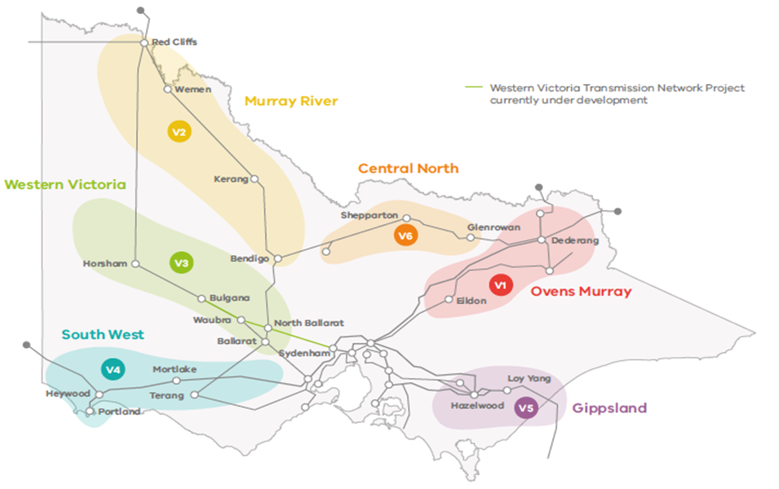

Western Renewables Link

Figure 2.1 Victoria’s Renewable Energy Zones (Source DELWP, 2021a)

## The need for transmission network augmentations to the NEM

This section discusses augmentation required for the NEM to meet the needs for connection and transmission of renewable energy and to give context to how the Project will support the connection of renewable energy. The NEM is the existing wholesale electricity market and transmission network of the east coast of Australia. There are key constraints and challenges facing the NEM transmission network given the commitments discussed in Section 2.1, and as the network continues to grow and experience increasing demand for electrification of transport, households, and industry (AEMO, 2024a).

Electricity generation and consumption regions in New South Wales, Victoria, South Australia, Tasmania, Queensland, and the Australian Capital Territory, are serviced by the NEM, as shown in Figure 2.2. The NEM involves wholesale electricity that is transported via high voltage transmission lines from generators to large industrial energy users, and to local electricity distributors in each region, which deliver it to homes and businesses. The Australian Energy Market Commission (AEMC) has made the National Electricity Rules under the National Electricity Law which govern the operation of the NEM. The National Electricity Rules, together with the Project objectives developed by AEMO and AusNet (see Section 2.4), and the Project’s functional requirements defined by AEMO, are the overarching key criteria that have guided the assessment of feasible potential alternative network solutions, corridors, routes and Project components. The key criteria are discussed in detail in **Chapter 5: Project development**.

The NEM operates as both a wholesale electricity market and the physical transmission network. Across the five regional markets in the east coast of Australia, the NEM supplies about 200 terawatt hours (TWh) of electricity each year to industry, businesses and households, accounting for around 80% of Australia’s electricity consumption (AEMC, 2025a).

There are over 600 registered participants in the NEM, including generators, retailers, transmission network service providers and distribution network service providers. The NEM works as a ‘pool’ or ‘spot’ market, where power supply and demand are matched instantaneously through a centrally coordinated dispatch process managed by AEMO.

The NEM’s transmission network, shown in Figure 2.2, is the backbone of Australia’s energy system. It extends over approximately 5,000km, from Port Douglas in far north Queensland to Port Lincoln in South Australia and across the Bass Strait to Tasmania, carrying power between electricity generators, large industrial energy users and local electricity distributors. The network covers around 40,000km and as of December 2024 had a total electricity generating capacity of around 88,000 MW (AEMO, 2025).

AEMO manages the operation of the NEM and seeks to maintain the reliability of the power system (having enough generation and network capacity to meet customer demand, plus a safety margin) and keep the system secure and technically stable.

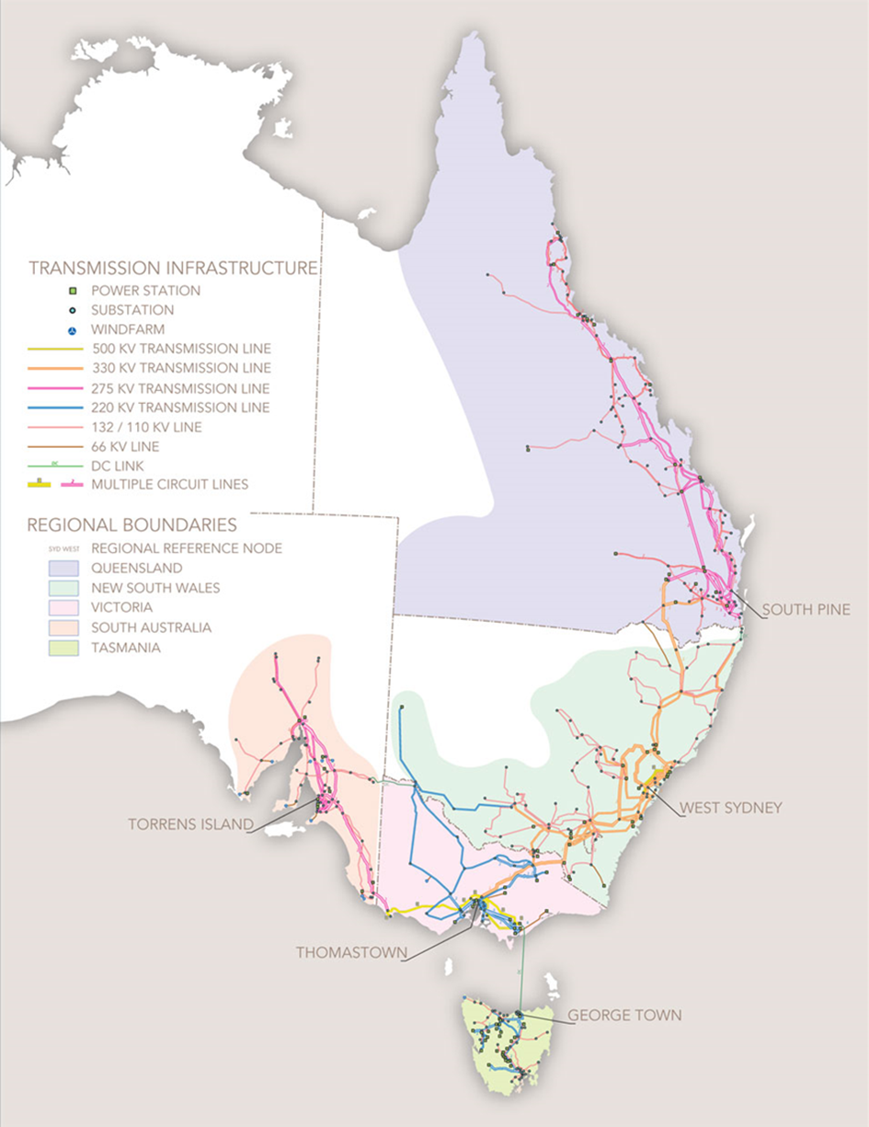

Figure . NEM transmission grid (Source: AEMO, 2021b)

### Challenges facing the NEM

The electrification of transport, households and industry will more than double demand for electricity in the NEM by 2050, reaching over 410 TWh per year (AEMO, 2024a). This presents a key challenge for the NEM, as Australia-wide, coal-fired generators are reaching the end of their service life, with owners of almost all coal-fired generators servicing the NEM having announced retirements between now and 2051 (AEMO, 2024a). Coal-fired generators are retiring faster than these announcements, and replacement capacity is needed in advance to ensure the reliability of the power system is not compromised (AEMO, 2024a).

Reflecting the speed and scale of the energy transformation underway in Australia, the total capacity of utility-scale wind and solar is forecast to increase six-fold from 21 GW to 127 GW by 2050 and distributed solar is forecast to increase four-fold from 21 GW to 86 GW by 2050 (AEMO, 2024a). A combination of distributed solar capacity, distributed storage, enhanced grid-scale or utility-scale renewable generation and increased firming capacity is required to meet the future needs of the NEM (AEMO, 2024a).

In response to retiring coal-fired generation capacity and increased demand for electricity, Australia needs to increase the capacity of grid-scale renewable energy generation each year from the current rate of 3 to 4 GW per year to approximately 6 GW per year, increasing total capacity of grid-scale renewable energy generation from 21 GW currently to 127 GW by 2050 (AEMO, 2024a).

As discussed previously, much of the grid-scale renewable energy resources required for the NEM will be built in REZs. As more renewable generation comes online and distributed energy resources continue to grow, the configuration and capacity of the transmission network is increasingly unsuited to the emerging mix of power generation and storage (see Sections 2.2.2 and 2.2.3). Targeted augmentations to the NEM transmission network are required to secure the success of REZs (see Section 2.2.4).

### Challenges facing the Western Victoria Renewable Energy Zone

Significant renewable energy development is proposed and committed to in western Victoria, with large amounts of additional renewable generation expected to be operational in the near term as Victoria seeks to achieve its renewable energy targets. As outlined in Section 2.1, there is significant growth in renewable generation in the region. As of 2024, existing and committed renewable energy generation projects in the Western Victoria REZ have a combined generation of 1,883 MW, and projects at the pre-application, application or enquiry stage account for an additional 4,580 MW in the REZ (AEMO, 2024a).

To support this growth and future investments for increased renewable generation in the Western Victoria REZ, upgrades to transmission infrastructure in the region are critical. For example, at times of maximum wind generation in 2022, the existing transmission lines servicing the REZ were approaching their maximum capability to carry electricity, i.e. the lines were reaching their thermal limitations (AEMO, 2022a). When a transmission line is at or approaching its maximum capability to carry electricity, existing generators must operate at a reduced rate because the existing transmission network cannot accept additional electricity, and the generators are subject to curtailment (reduced electricity generation) by the network operator.

In the NEM, the curtailment of renewable wind generation has been steadily increasing as the level of renewable generation in Victoria grows. This curtailment is driven by constraints in the transmission network on the dispatch of electricity. These circumstances pose a significant obstacle to the development and commissioning of new renewable generation within the Western Victoria REZ. The weakness of the western and north-western Victorian transmission network is identified in AEMO’s Victorian Annual Planning Report (VAPR) as a key constraint on the NEM that is experiencing increasing limitations as more generators in the region connect (AEMO, 2022a; 2023a).

### Challenges to security and reliability of electricity supply

As coal-fired generators near the end of their service life and retire, replacement capacity is needed in advance to ensure the reliability of the power system is not compromised. Unplanned coal generator outages are also becoming more common as the coal-fired generators age (AEMO, 2024a).

Victoria has traditionally relied on brown coal from the Latrobe Valley and oil and gas from Bass Strait for power. Between 2007 and 2017, Victoria’s reliance on coal decreased by 20% as large thermal power stations such as Anglesea and Hazelwood reached the end of their life and closed. This trend is set to continue, with the Yallourn Power Station expected to close in 2028 and AGL, while initially announcing it was preparing to close the Loy Yang Power Station between 2047 and 2048 (AEMO, 2021b), has recently committed to closing the power station (Victoria’s largest power station) by 2035 (AGL, 2022).

Coal-fired generation is forecast in AEMO’s 2024 ISP to retire faster than announced, and may retire even faster than those forecasts, with contributing factors such as higher operating costs, reduced fuel security, high maintenance costs and greater competition from renewable energy (AEMO, 2024a). As a result, replacement generation must be brought online in a timely manner to maintain the reliability of the power system (AEMO, 2024a).

AEMO forecasted that Victoria will face risks to the reliability of electricity supply in 2028 to 2029 when Yallourn Power Station closes (AEMO, 2023c; 2024b). Risks to reliability (the ability of the system to meet energy demand levels), as coal-fired plants become increasingly unreliable, require urgent investment to meet Victoria’s electricity needs.

As renewable energy resources become the NEM’s primary energy resource, it is increasingly important to preserve the resilience of the electricity system against the increasing frequency of extreme weather events and climate impacts (AEMO, 2022a). Developing the transmission system to support a variable renewable energy mix across diverse locations improves the operability of the grid under all conditions (AEMO, 2022a).

By providing targeted and timely delivery of transmission infrastructure in western Victoria, the Project aims to harness the generation capacity of the Western Victoria REZ and help maintain the reliability and security of Victoria’s electricity supply.

### Identifying the network augmentation required for western Victoria

AEMO has a role as national transmission planner for the NEM and separately has a Victorian planning role in which it is responsible for the planning of the Victorian transmission network. Across these two roles, AEMO has several forecasting and planning reports that describe and assess the NEM and identify key projects required to address issues and constraints in Victoria. The two key documents in relation to the Project are:

* AEMO’s Integrated System Plan (ISP). This plan is published every two years by AEMO in its role as national transmission planner for the NEM under the National Electricity Law and provides an integrated roadmap for the development of the NEM over the next 20 years and beyond[2].
* AEMO’s Victorian Annual Planning Report (VAPR). This plan is published yearly by AEMO in its Victorian planning role and reviews the ability of the Victorian transmission network to meet its reliability and security requirements.

Beginning in 2016, the need for augmentations to the transmission network in western Victoria, and eventually, the need for the Project, were identified and described in these reports. These reports are discussed further in this section and summarised in Figure 2.3.

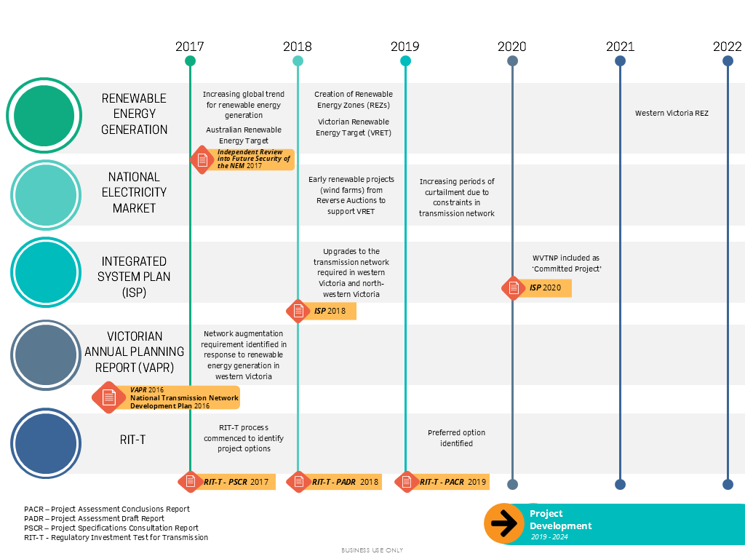

Figure . Relationship between the ISP, VAPR and RIT-T in the national planning framework

The need for the Project was first described in AEMO’s 2016 NTNDP, in AEMO’s role as national transmission planner under the National Electricity Law, and the 2016 VAPR, in AEMO’s Victorian planning role. These reports discussed the high level of interest in renewable generation in western Victoria, further accentuated by the VRET, and noted transmission network constraints may be likely if the projected volume of energy generated was connected into the grid.

In response to the need for transmission network augmentations outlined in the 2016 VAPR and NTNDP, AEMO commenced a Regulatory Investment Test for Transmission (RIT-T) in 2017 to assess the technical and economic viability of addressing current limitations in the western Victorian transmission network, in accordance with the National Electricity Rules. The RIT-T process considered only the net economic benefit to electricity consumers. The RIT-T guidelines in place at the time excluded matters related to social and environmental impacts on local communities unless it conflicts with the law. The guidelines, for example, explicitly excluded consideration of an option’s impact on the environment or for matters such as the loss of visual amenity, that are not regulated. As such, the RIT-T process assessed the technical and economic viability of options to increase capacity and address constraints in the western Victorian transmission network.

As required by the RIT-T assessment process, AEMO produced three reports between 2017 and 2019 to summarise the outcomes: the Project Specification Consultation Report in April 2017 (AEMO, 2017), Project Assessment Draft Report in December 2018 (AEMO, 2018), and Project Assessment Conclusions Report in July 2019 (AEMO, 2019). These reports included consultation and feedback provided by government, industry, and the local community. The final report, the July 2019 Project Assessment Conclusions Report, outlined the preferred investment option to address constraints on the western Victorian transmission network.

The RIT-T process involved refining the five broad investment options initially identified in the Project Specification Consultation Report into the two most credible options in the Project Assessment Draft Report, and eventually into the preferred option that delivers the highest economic net benefit, as described in the Project Assessment Conclusions Report. The options were assessed against the terms of the RIT-T process and the National Electricity Rules.

During the RIT-T process, AEMO gave due consideration to other potential options to address the identified network need, including building a new fully underground transmission line. The fully underground option, along with other potential options, were considered to not address the identified need, or to not be technically or commercially feasible, and were therefore not included in market modelling as ‘credible options.’

In addition, as part of this EES, AusNet assessed the feasibility of an underground 500kV transmission line, which is documented in **Attachment II: Assessment of feasibility for an underground 500kV transmission line for Western Renewables Link.** This addresses the EES scoping requirements and acknowledges the community interest in undergrounding of the proposed transmission line. The assessment considered a conceptual High Voltage Direct Current (HVDC) underground cable, which would be a point-to-point connection from Bulgana to Sydenham, and considered whether this conceptual underground project would meet the Project objectives.

The assessment found:

* An HVDC underground cable would not easily facilitate connections from renewable energy generators in the Western Victoria REZ. HVDC cables require terminal stations with alternating current to direct current converter stations for electricity generators to be able connect to the cable.
* The estimated cost of the conceptual underground project is substantially more expensive than the cost of an overhead Project.
* A fully underground project would not meet the State’s urgent need to increase electricity transmission capacity and maintain reliability while the coal fired plants are phased out and become increasingly unreliable, based on a fully underground project requiring an estimated seven to eight year lead time to supply convertor stations and the additional time taken to design and gain approval (see **Attachment II: Assessment of feasibility for an underground 500kV transmission line for Western Renewables Link).**

Overall, the technical considerations associated with an HVDC underground project highlighted that, while an underground cable may be a possible technical solution, there are additional requirements, and cost and schedule implications that result in it not being able to meet the Project objectives. An underground project also would not meet the Victorian Government energy policy goal to increase the affordability and accessibility of energy services.

Following the RIT-T process, the Project, then known as the Western Victoria Transmission Network Project, was announced and included in AEMO’s 2020 ISP as a ‘Committed’ project. In the ISP, projects are categorised as Committed if AEMO considers that they will proceed with known timing, or are highly likely to proceed, and have satisfied most or all of AEMO’s criteria around land, contracts, planning, finance and construction.

In May 2023, a Victorian Government Order was issued under the National Electricity (Victoria) Act 2005 (herein referred to as the May 2023 NEVA Order), which related to the neighbouring VNI West project. VNI West is a proposed high capacity 500kV overhead transmission line that will run between Victoria and New South Wales. Though VNI West is not an AusNet project, as identified by the VNI West RIT-T process, it will connect into the new terminal station near Bulgana that will be built as part of the Western Renewables Link Project. As a result of the development of VNI West, the May 2023 NEVA Order also included proposed changes to the Western Renewables Link Project including to:

* Increase (or ‘uprate’) the capacity of the 220kV section of the transmission line between Ballarat and Bulgana to 500kV, such that the Project would comprise 500kV end-to-end.
* Remove the proposed new terminal station north of Ballarat, which would no longer be required given the uprate.
* Provide for a new 500kV switchyard and associated equipment near the existing Bulgana Terminal Station, including provisions for the connection of VNI West.[3]

Facilitating connection of VNI West to the Project has subsequently resulted in changes to the Project’s components and locations, as summarised in Table 2.1 and discussed in detail in **Chapter 5: Project development.** An overview map of the Project, VNI West, and the surrounding REZs is provided in Figure 2.4.

Table . Summary of key changes to the Project through its development

|  |  |  |  |
| --- | --- | --- | --- |
| As described in | Project summary | Project components | Summary of changes |
| 2017 Project Specification Consultation Report | Overhead 220kV (Ballarat to Bulgana) and 500kV (Sydenham to Ballarat) double circuit transmission line | New North Ballarat (Mount Prospect) Terminal Station  New Sydenham Terminal Station | N/A |
| 2018 ISP | 500kV double circuit transmission line (Bulgana to Sydenham) | New 500kV terminal station at Bulgana  Connection to New Sydenham Terminal Station | Uprate of Project to 500kV  North Ballarat/Mount Prospect Terminal Station changed to new 500kV terminal station at Bulgana  Sydenham Terminal Station works limited to building connection only. A separate project is underway for the construction of the new terminal station. |

AEMO’s 2022 ISP (AEMO, 2022b) confirmed the Project as one of seven ‘committed and anticipated network investments’ in the NEM’s optimal development path and essential to providing additional capacity to the Western Victoria REZ. The uprated version of the Project was included in AEMO’s 2024 ISP (AEMO, 2024a). The Project is described as a ‘500 kV double-circuit network upgrade to provide additional capacity to the Western Victoria REZ, including updated project scope to relocate a terminal station and increase the line capacity.’ The Project and VNI West, are listed as key projects to realising an anticipated 23 GW of new utility-scale wind and solar by 2049-50, including 9GW of offshore wind (AEMO, 2024a).

In summary, the NEM requires enhanced grid-scale renewable energy generation to meet forecasted demand for energy. Targeted and timely delivery of transmission infrastructure in western Victoria is required to harness this energy generation and maintain the reliability and security of the state’s electricity supply.

Figure 2.4 shows new major transmission links under development in western Victoria, including the Project. The indicative REZs and transmission links shown in the figure are based on information available at the time of writing and will be superseded by the Victorian Transmission Plan, once released, which is a long-term strategic plan being prepared by VicGrid. The first Victorian Transmission Plan is due to be released by VicGrid in 2025 and is proposed to include draft proposed REZs and transmission infrastructure projects to meet Victoria’s energy needs over the next 15 years.

The Project is identified in AEMO’s forecast and planning reports as a key project required to unlock renewable energy resources, reduce network congestion and maintain utilisation of existing assets in the western parts of Victoria. Across the NEM, network transmission augmentation projects such as this, are integral to addressing issues associated with curtailment, which affect the security and reliability of electricity supply to consumers.

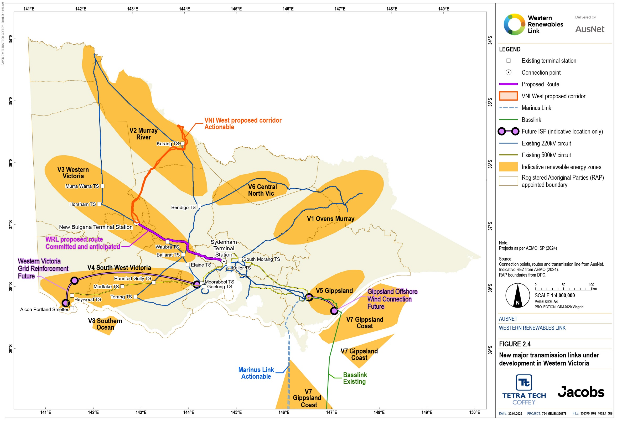Figure . New major transmission links under development in Western Victoria

## Project benefits

The Project addresses the constraints of the western Victorian transmission network by providing additional transmission capacity needed to service existing renewable generation and drive the development of further renewable energy resources in western Victoria. This section outlines the benefits of the Project and how these benefits respond to the current electricity market context facing Victorians.

### Energy supply benefits

There are significant benefits associated with Victoria moving to a more diverse energy supply mix and meeting its target of net-zero emissions by 2045. The Project will make an important contribution to these broader benefits by upgrading the transmission network servicing increased renewable energy generation. In particular, the Project will:

* Prevent or reduce generator curtailment and address constraints facing the operation of generators in the Western Victoria REZ
* Support energy supply diversification
* Support achievement of the VRET
* Contribute to the orderly shift to renewable energy as coal-fired power stations near the end of their service life and retire in the years ahead.

The Project aims to overcome the capacity constraints in the existing western Victorian transmission network, enabling the more efficient dispatch of existing and proposed renewable energy generation from western Victoria into the NEM.

The Project aims to create a direct connection from western Victoria to the Sydenham Terminal Station to overcome the constraint that existing transmission infrastructure in western Victoria is approaching its maximum capability to carry electricity (see Section 2.2.2). Overcoming the existing and potential future congestion will enable more efficient dispatch of existing and proposed renewable energy generation from western Victoria into the NEM and help secure Victoria’s electricity supply.

The connection at Sydenham will also create a third 500kV connection from western Victoria into the Melbourne load centre, which helps to maintain network reliability and security through greater geographic diversity and increased capacity.

The delivery of the Project in western Victoria will harness the generation capacity of the REZ and maintain the reliability and security of the state’s electricity supply as Victoria transitions away from coal-fired power generation.

The Project will also reduce Victoria’s reliance on energy supply from interstate as Victoria will be able to harness the energy generation of the Western Victoria REZ before relying on interstate energy supply to meet demand.

### Create opportunities for strategic development of the NEM

The Project assets have the capability to deliver over 3,000MW of network capacity to the NEM. In addition, as the Project would help alleviate current network constraints associated with the existing transmission network, AEMO has modelled that the Project will facilitate the delivery of an additional 1,460MW of output from the western Victorian region.

The Project is part of a larger, long-term power system plan underway to strategically coordinate future development in transmission and generation across Victoria and the NEM. There is a market benefit when a project facilitates more cost-efficient investment patterns across the NEM for generators and large-scale storage. In the market modelling work commissioned by AEMO (EY, 2024), generation and storage cost savings due to the more efficient development of the NEM resulting from the Project are forecast to be approximately $1.71 billion, comprising $1.29 billion of deferred or avoided capital costs of new generation capacity and $418 million of deferred or avoided operation and maintenance costs. This saving is primarily due to the more efficient use of existing wind generation in the Western Victoria REZ and a reduction in the need for new energy projects in other parts of the NEM to meet demand.

The Project provides access to a region rich in renewable energy resources and future interstate connections.

As summarised previously and discussed in detail in **Chapter 5: Project development**, the Project will also provide a connection point for VNI West into Victoria’s electricity grid. Interconnection between NSW and Victoria will significantly strengthen the reliability and security of the Victorian transmission system by providing access to replacement dispatchable capacity i.e. sources of energy that can be adjusted quickly to respond to supply across the NEM as coal retires and providing Victoria with additional export opportunities.

### Deliver infrastructure which realises a net benefit for Victorians

Given the risks to electricity supply outlined in Section 2.2.2, the Project is considered critical. Construction of the Project is targeted for completion by late 2028.

The significant economic value created by planned transmission network improvements that will connect new renewable generation and storage developments is identified by AEMO in the ISP and VAPR. The Project provides transmission access to a region rich in renewable energy resources and future interstate connections for the benefit of Victoria. The gross market benefits of the Project have been calculated as approximately $2.2 billion (EY, 2024).

The Project will deliver a range of indirect economic benefits to the region and wider Victoria. These are illustrated in Figure 2.5 and described in the following sub-sections.

|  |  |  |
| --- | --- | --- |
| A picture containing text, night sky  Description automatically generated  Increased local economic activity | Construction worker male outline  700 direct jobs in construction | Users outline  Local business, education and employment opportunities |
| Modern architecture with solid fill  More jobs and activity in industries supporting the renewable energy sector |   Facilitate a decarbonised economy | **Neighbourhood outline**  A positive legacy and contribution through a Community Benefit Fund and Social Procurement |

Figure . Benefits to Victoria

##### Increased local economic activity

The Project will make a major economic investment in western Victoria, creating additional jobs and driving higher levels of economic activity during and after construction. Local goods and services are expected to be used throughout the Project’s construction, including supply of materials and fuel. AusNet will work with businesses in western Victoria to maximise local participation in the Project.

The Project will also support the development of future energy resources in western Victoria, creating additional economic investment and opportunities in the region. New benefits may result from renewable energy developments in other ways. For example, landholders may experience increased income when they have wind turbines installed on their land, which could serve to stabilise farm revenues.

Modelling undertaken for **Technical Report G: Economic Impact Assessment** for the EES found that the Project will increase the Gross Regional Product of the broader area surrounding the Project by $0.9 billion (to Financial Year (FY) 2050 in net present values). The area is also projected to benefit from an additional $1.4 billion in government consumption and $3.7 billion in private consumption of goods and services.

##### Employment benefits

**Technical Report G: Economic Impact Assessment** for the EES found new employment due to the Project peaks in FY2028 at 346 workers, during the Project’s construction stage, in the regions in western Victoria across which the Project extends (Grampians, Maryborough-Pyrenees, Ballarat, Creswick-Daylesford-Ballan, and Melton-Bacchus Marsh). Additional jobs are expected in other areas of Victoria, with total employment in Victoria due to the Project peaking at 2,089 in FY2028.

The employment impacts represent not only jobs required directly for the construction of the Project, but also indirect employment effects. This accounts for any additional employment in the upstream and downstream industries providing goods or services in the construction of the Project.

Potential employment benefits for local communities will depend on the availability of specialist skills in the local labour force (such as construction workers with experience in the construction of towers and terminal stations and stringing of transmission lines) and the level of unemployed labour available for positions such as traffic management and labouring. AusNet will implement measures to enable employment opportunities created by the Project to be accessed by local residents, including through training and upskilling programs such as apprenticeships, traineeships, and cadetships, and it is AusNet’s intention to recruit as many Project employees from within the local community as possible.

Additional local employment opportunities may be generated by renewable energy investment in western Victoria facilitated by the Project. The Reserve Bank of Australia has observed that renewable energy investment in Australia has supported activity and employment, particularly in regional areas where large-scale renewable generators tend to be located. While many components associated with renewable energy generation are imported (for example, solar panels and wind turbines), the Reserve Bank’s liaison with energy industry stakeholders suggests that there are spillovers to domestic firms, with local content accounting for 25 to 40% of total costs (mainly engineering, construction and installation services) (de Atholia et al., 2020).

##### Social value and the Community Benefit Fund

AusNet is developing social value initiatives such as benefit sharing, social procurement, education opportunities and a Community Benefit Fund. AusNet’s social values initiatives are informed by social research, and broad community and stakeholder engagement. The initiatives will be co-designed in partnership with the community and key Project stakeholders with a focus on identifying opportunities to leverage additional funding to maximise value and meet community needs. The initiatives will focus on partnering with community to identify opportunities to use the Project construction stage to deliver economic and community value. The emphasis is on meeting specific community needs by addressing issues that might include energy reliability, telecommunications reliability and housing availability.

Significant opportunities exist to partner with State and Commonwealth Government funding programs, and with identified local government expenditure, to maximise what can be achieved through the Community Benefit Fund. Exploring the potential to leverage these partnerships will form part of the co-design process which will also specifically seek input from Traditional Owners, Indigenous people and young people (17-25 years age group) who are often under-represented in more traditional engagement processes.

It is likely that grants will be provided to initiatives that make a positive contribution to the local community, with preference given to those that create ongoing benefits.

AusNet will implement a specific Community Benefit Fund to provide opportunities for community input into the Project’s legacy and to make a positive contribution to the region.

AusNet will work with stakeholders and the community to determine the most appropriate allocation of this funding, recognising each community’s unique needs and circumstances.

##### Decarbonisation benefits

The benefits of decarbonisation for Victorians include new jobs, energy bill savings, improved health and environmental benefits (Victorian Government, 2023). Victoria’s renewable energy target of 95% by 2035 and energy storage target of 6.3 GW by 2035 are estimated to bring forward around $9.5 billion in economic activity and create 59,000 jobs over the period to 2035.

By addressing the constraints in the western Victorian transmission network, the Project has the potential to unlock further solar and wind projects in western Victoria and provide the region with efficient connections to dispatch power, helping to attract new energy investments. This potential for additional investment helps Victoria achieve its renewable energy and climate action targets (see Section 2.1.3).

New renewable energy generation will contribute to Victoria’s net-zero emissions target. Enabling more generation in Victoria will reduce reliance on other mechanisms to achieve net-zero, such as purchasing carbon offsets.

## Project objectives

The Project objectives were developed by AEMO and AusNet as a guide for the development of the Project to achieve the Project benefits and have been informed by the Western Victoria RIT-T and reinforced by the May 2023 NEVA Order (see **Chapter 5: Project development**). The Project will help maintain the security and reliability of the transmission network in western Victoria and help unlock clean electricity for Victorians. Having regard to current and expected future demands on Victoria’s electricity transmission network, a ‘do nothing’ approach involving no investment in or development of the transmission network is not feasible. AusNet has considered feasible project alternatives as set out in **Chapter 5: Project development** and has determined that the Project best meet's the Project objectives as outlined in Table 2.2.

By addressing the transmission constraints identified in Sections ‎2.1 and ‎2.2 of this report and delivering the benefits described in Section ‎2.3, the Project meets the objectives outlined in Table 2.2.

Table . Project objectives

| Project objective | How the Project objective is addressed | Reference to where the Project objective is addressed |
| --- | --- | --- |
| Maintain the security and reliability of the transmission network for customers by:   * + increasing electricity transmission capacity in western Victoria to minimise the congestion constraining current and future electricity generation in the region; and   + ensuring the Project complies with the power system security requirements of the National Electricity Rules. | **The Project will address constraints facing generation of renewable energy in the Western Victoria REZ.**  Curtailment of existing generators would persist in the absence of enhanced transmission infrastructure, as insufficient transmission infrastructure would continue to constrain the amount of renewable energy that can be delivered from generators to end users.  The construction of additional transmission lines as proposed by the Project has the potential to address constraints currently facing the transmission network, reduce the rate of curtailment and maintain network reliability and security.  **The Project will help secure the success of the Western Victoria REZ.**  The significant renewable energy investment in the Western Victoria REZ cannot be realised without augmenting transmission infrastructure servicing the REZ, as proposed by the Project.  Without the additional transmission network capacity provided by the Project, the ability to continue to grow the Western Victoria REZ would diminish. As result, investments in renewable energy generation could preferentially be made in other areas with lower quality resources as renewable energy companies look to locations where they can more easily connect to a reliable, higher capacity network. | See Section ‎2.3.1 |
| Create opportunities for strategic development of the National Electricity Market (NEM) by:   * + increasing electricity transmission capacity, thereby facilitating more efficient connection and dispatch of electricity generation in and from the region; and   + enabling future transmission network expansion from Victoria to New South Wales. | **The Project is part of AEMO’s optimal development path to support Australia’s energy transition towards net zero emissions and provide consumers in the NEM with reliable, secure and affordable electricity.**  Without the Project, and as coal fired power stations are phased out, Victoria may need to import clean energy or build renewable generation in more costly or less efficient locations (or some combination of these) to achieve its 2045 net-zero emissions target and replace retiring coal-fired generation.  The Project also provides for connection of VNI West. Interconnection between NSW and Victoria will maintain the reliability and security of the Victorian transmission system by providing access to replacement dispatchable capacity i.e. sources of energy that can be adjusted quickly to respond to supply across the NEM as coal retires and providing Victoria with additional export opportunities. | See Section ‎2.3.2 |
| Deliver infrastructure which realises a net benefit for Victorians by:   * + delivering the Project in a timely and cost-efficient manner; and   + delivering transmission infrastructure which, by increasing capacity, facilitates the further development of renewables in western Victoria, encouraging further investment in the industry and associated economic growth. | **The Project will enable more renewable energy generation in Victoria, and this will reduce reliance on other mechanisms to achieve net-zero, such as purchasing offsets.**  If unable to source clean power in the absence of the Project, Victorians are likely to use more fossil fuels to meet the demand for electricity.  **The Project will contribute to maximising investment in renewable energy in Victoria.**  There is increasing demand for renewable energy generation in western Victoria. Without the Project, investment could shift to places with lower quality resources as renewable energy companies look to locations where they can more easily connect to a reliable, higher capacity network.  The Project assets have the capability to deliver over 3,000MW of network capacity to the NEM. The connection of the Project will deliver savings across the NEM from the efficient connection of renewable energy resources, including: capital expenditure and fixed operation and maintenance cost savings of $1,293 million and $418 million respectively; electricity transmission construction cost savings of $418 million; fuel costs savings of $114 million, and unserved energy and demand side participation cost savings of $60 million (EY, 2024).  **The Project will deliver local and regional benefits to the Victorian and western Victorian renewable energy industry.**  The Project will deliver a range of indirect economic benefits to the region and wider Victoria, including increased local economic activity and employment opportunities, as well as increasing benefits from social value initiatives and the Community Benefit Fund.  The proposed technical solution for the Project will deliver a net benefit for Victoria.  If the Project did not proceed, increased economic activity and employment benefits (both direct and indirect) provided by the Project would not be realised. | See Section ‎2.3.3 |

1. The Renewable Energy Zones (REZs) discussed in this chapter are indicative zones as identified by AEMO as part of its nationwide planning. These are different to the REZs that will be identified by VicGrid and ultimately declared in Victoria by the Victorian Minister for Energy following the final 2025 Victorian Transmission Plan.
2. Prior to AEMO’s first ISP in 2018, the National Transmission Network Development Plan (NTNDP) was published by AEMO each year from 2010 to 2016, as part of AEMO’s role as national transmission planner under the National Electricity Law. The 2017 NTNDP was never published and was eventually incorporated into the 2018 ISP. From 2018 onwards, the ISP has effectively replaced the NTNDP as “the ISP’s purpose and scope encompass those which would normally be covered in AEMO’s National Transmission Network Development Plan (NTNDP).”
3. A more detailed explanation of Committed projects and the land, contracts, planning, finance and construction criteria is provided in the ‘background information’ tab in the NEM generation information spreadsheet available at: <https://www.aemo.com.au/energy-systems/electricity/national-electricity-market-nem/nem-forecasting-and-planning/forecasting-and-planning-data/generation-information>.