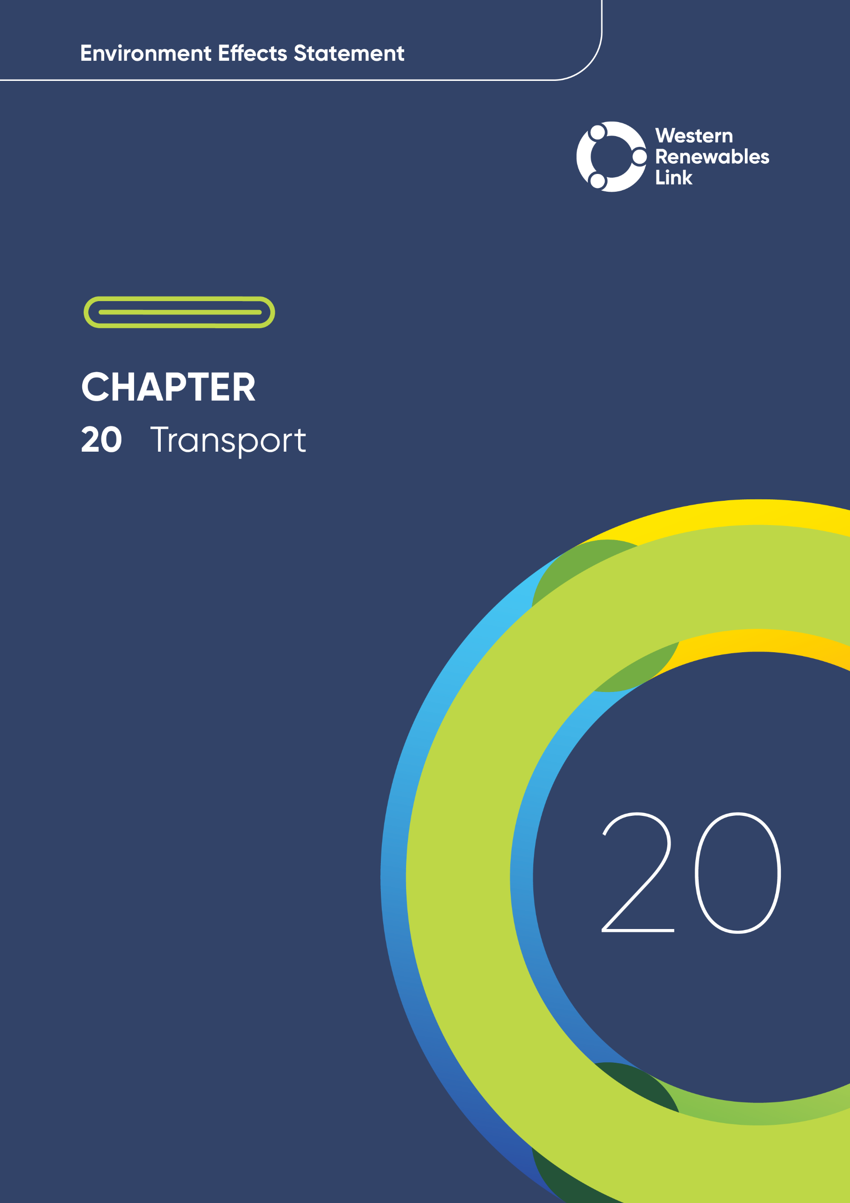

Transport
This chapter provides an overview of the potential impacts to the transport network associated with the construction, operation and decommissioning of the Project. This chapter is based on Technical Report P: Transport Impact Assessment.
Assessment of potential transport impacts includes the assessment of all Project trips on the local road network, including local, regional and state managed roads. Project traffic primarily involves the transportation of materials, equipment, and labour. Most of the Project traffic will originate at the Port of Melbourne and travel westward on major roads such as the Western Freeway and Calder Freeway to the laydown areas, workforce accommodation facilities, and construction sites.
Project traffic also includes trips for construction workforce personnel travelling from the workforce accommodation facilities to the construction sites. Two workforce accommodation facilities are proposed, co-located with each of the intermediate laydown areas at Lexton and Ballan, each with a capacity for up to 350 personnel. Trip generation modelling has assumed 175 trips per day (assuming two people per vehicle), in addition to trips generated by the delivery of labour and materials, distributed across the Construction Sites to account for workforce trips. A conservative peak hour trip value was used for the assessment.
The terminal station upgrades and connection works at Bulgana and Sydenham Terminal Stations will require Oversize Overmass (OSOM) components and equipment, requiring OSOM vehicles. OSOM vehicles would not be required for other Project components and would not be delivered to any other locations.

Evaluation objective
The scoping requirements identify the following evaluation objective relevant to transport:
Evaluation objective
Avoid, or minimise where avoidance is not possible, adverse effects for community amenity, health and safety, with regard to construction noise, vibration, dust, lighting, waste, greenhouse gas emissions, transport network, operational noise, fire risk management and electromagnetic radiation.

In response to this evaluation objective, impacts of the Project on the transport network were assessed and measures to avoid, minimise or manage potential impacts have been identified. These measures are discussed throughout this chapter and have informed the development of Environmental Performance Requirements (EPRs). EPRs set out the environmental outcomes to be achieved through the implementation of mitigation measures during construction, operation and decommissioning to avoid, minimise and manage identified impacts. Cumulative impacts associated with relevant future projects were also assessed.
Further information on how the Project has been designed to avoid and minimise impacts on the transport network is provided in Chapter 5: Project development and Chapter 6: Project description.

Other aspects covered in the Environment Effects Statement (EES) evaluation objective and relevant to transport are addressed in the following EES chapters:

- EES Chapter 11: Landscape and visual
- EES Chapter 13: Bushfire
- EES Chapter 17: EMI and EMF
- EES Chapter 18: Air Quality
- EES Chapter 19: Noise and vibration
- EES Chapter 26: Greenhouse gas.

Method
This section summarises the method adopted in Technical Report P: Transport Impact Assessment, which was informed by Chapter 4: EES assessment framework and approach. The key steps in assessing the impacts associated with transport included:
- Defining a study area appropriate for transport as presented in Figure 20.1. This included the road network that can be used to access the Project, including laydown areas and workforce accommodation facilities. The study area was divided into the six local government areas that cover these roads.
- Reviewing applicable Commonwealth and Victorian legislation, and relevant local, state and national standards, guidelines and policies.
- Conducting a desktop review to determine the existing transport conditions including existing road uses, pavement conditions and other relevant features (e.g., major culverts, bridges / overpasses, low-clearance locations, infrastructure with load limits and other restrictions), public transport infrastructure (i.e. trains, public bus and school bus routes) and active transport infrastructure within the study area, including:
  - Desktop assessment using Google Maps and VicPlan
  - Department of Transport and Planning Open Data Hub Traffic Volumes
  - GIS layers from Victorian Government Data Portal
  - National Heavy Vehicle Regulator (NHVR) B-Double and OSOM network
  - Information from consultation with relevant councils
  - Victorian Road Crash Data.
- Consulting with the relevant regulatory authorities and key stakeholders including Shires of Northern Grampians; Pyrenees; Hepburn; Moorabool; Ballarat City Council; Melton City Council; Department of Transport and Planning (DTP); and Metropolitan Road Program Alliance, and reviewing the pins dropped by community members onto the Project’s Social Pinpoint online mapping tool which identified locations, features and values of importance.
- Conducting field investigations and targeted site inspections / walkovers to inform site characteristics such as peak period traffic performance, road pavement condition (sealed / unsealed / partially sealed), road geometry, sight lines, access configurations to laydown areas and construction sites, vegetation encroachments, bus stop infrastructure, school bus routes, load limits, safety issues, culturally significant features, major bridges / culverts, and OSOM routes.
- Iteratively refining the proposed construction transport route to follow major roads and connectors for as long as possible before using local roads connecting to access tracks to mitigate conflicts with transport modes, surrounding land use, and road conditions.
- Proposed construction transport route
The existing conditions review of roads in the study area culminated in the identification of the proposed construction transport route, shown in Figure 20.2, which includes all the roads that are proposed to be used to deliver materials, equipment, and the workforce needed to construct the Project.
The proposed construction transport route has been strategically chosen after assessment of all roads that could provide access from origin points or were the links that could provide direct access from origin points (Port of Melbourne, laydown areas and workforce accommodation facilities) to destination points (laydown areas and construction sites). These were generally major arterial roads, connectors and local roads that connected to access tracks that lead to the transmission line.
The proposed construction transport route was refined iteratively as conflicts and issues with transport modes, the surrounding land use, road geometry, and road conditions were identified throughout the review of existing conditions. Roads in the study area that were deemed unsuitable based on these elements were excluded from the final proposed construction transport route. As such, the determined route may not represent the shortest possible route but avoids conflicts and inadequate road infrastructure, so far as reasonably possible. This progressive iteration is further discussion in Technical Report P: Transport Impact Assessment.
The proposed construction transport route travels westward from the Port of Melbourne and connects to the Project Area, including at laydown areas and workforce accommodation facilities. The laydown areas are located at the Bulgana Terminal Station, the new terminal station near Bulgana, Sydenham Terminal Station, and near Lexton and Ballan.
Local trips for locally sourced material or the workforce are assumed to begin at the laydown areas or workforce accommodation facilities and only use the proposed construction transport route to get to site. The potential maximum number of Project vehicles along the route were considered in the traffic modelling.
Through engagement with relevant road authorities, refinements to the proposed construction transport route may be necessary to address local road conditions, safety needs and / or requirements of the relevant road authority. Any refinements to the proposed construction transport route would be considered and managed in accordance with the EPRs.
Detailed maps of the proposed construction transport route are available in Appendix A of Technical Report P: Transport Impact Assessment.

- Level of Service (LOS)
LOS is a qualitative measure used to evaluate the quality of traffic flow on roadways and intersections. It ranges from LOS A (the best) to LOS F (the worst) based on factors including speed and congestion.
At LOS E, roads are approaching capacity and traffic is significantly slowed. At LOS F, there is a total breakdown in traffic flow.
- Developing a traffic model to assess the performance of roads along the proposed construction transport route with and without Project traffic, that describes its Level of Service (LOS).
- Conducting a risk screening process to identify the key issues during construction, operation and decommissioning for investigation within the technical report.
- Modelling, identifying and assessing the potential transport impacts associated with traffic performance, degradation of road infrastructure and reduced safety during construction, operation and decommissioning. These impacts were evaluated according to the following ratings, in relation to the extent, magnitude and duration of the impacts:
  - Negligible: No detectable change in a local transport operational setting.
  - Minor: Short term, reversible changes in a local transport operational setting.
  - Moderate: Long term but limited changes to transport operational setting that can be managed.
  - Major: Long term, significant changes resulting in risks to safety and / or the functioning of the transport network beyond the Project.
  - Severe: Irreversible, significant changes resulting in widespread risks to safety and / or the functioning of the transport network at a regional scale.
Impact ratings considered changes to the transport network in terms of capacity/performance, condition, safety, accessibility and amenity. The full definition of each rating is provided in Section 5.5 of Technical Report P: Transport Impact Assessment.
- Identifying relevant future projects that could lead to cumulative impacts when considered together with the Project (refer to Chapter 4: EES assessment framework and approach for the full cumulative impact assessment method).
- Developing EPRs in response to the impact assessment to define the required environmental outcomes that the Project must achieve through the implementation of mitigation measures during construction, operation and decommissioning. Measures to reduce the potential impacts were recommended in accordance with the mitigation hierarchy (avoid, mitigate, manage, rehabilitate and offset) and have informed the development of EPRs. Alternative mitigation measures could be implemented to comply with the EPRs based on the specific site conditions, available resources, and the Principal Contractor’s expertise.
- Following application of mitigation measures that would comply with the EPRs, determining residual impacts associated with the construction, operation and decommissioning of the Project, and evaluating their significance.

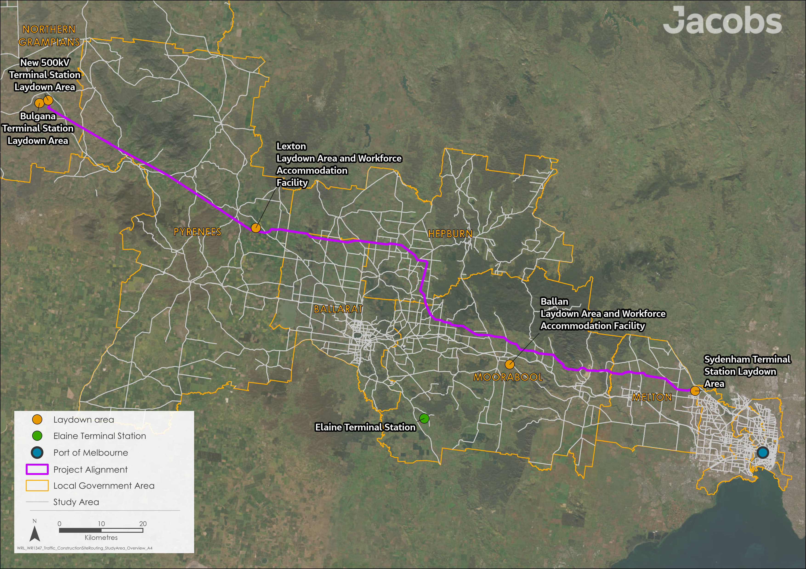
Figure 20.1 Transport study area
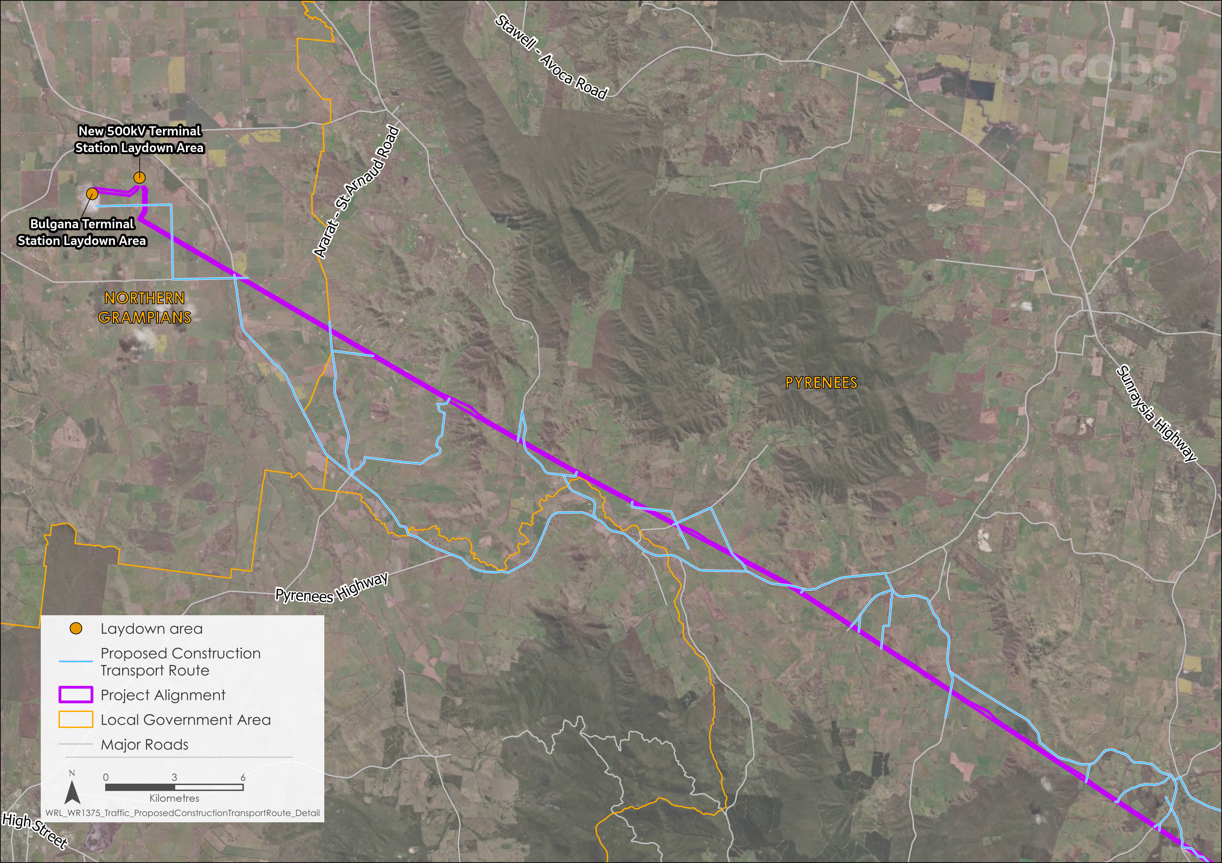
Figure 20.2 Proposed construction transport route (Sheet 1 of 4)

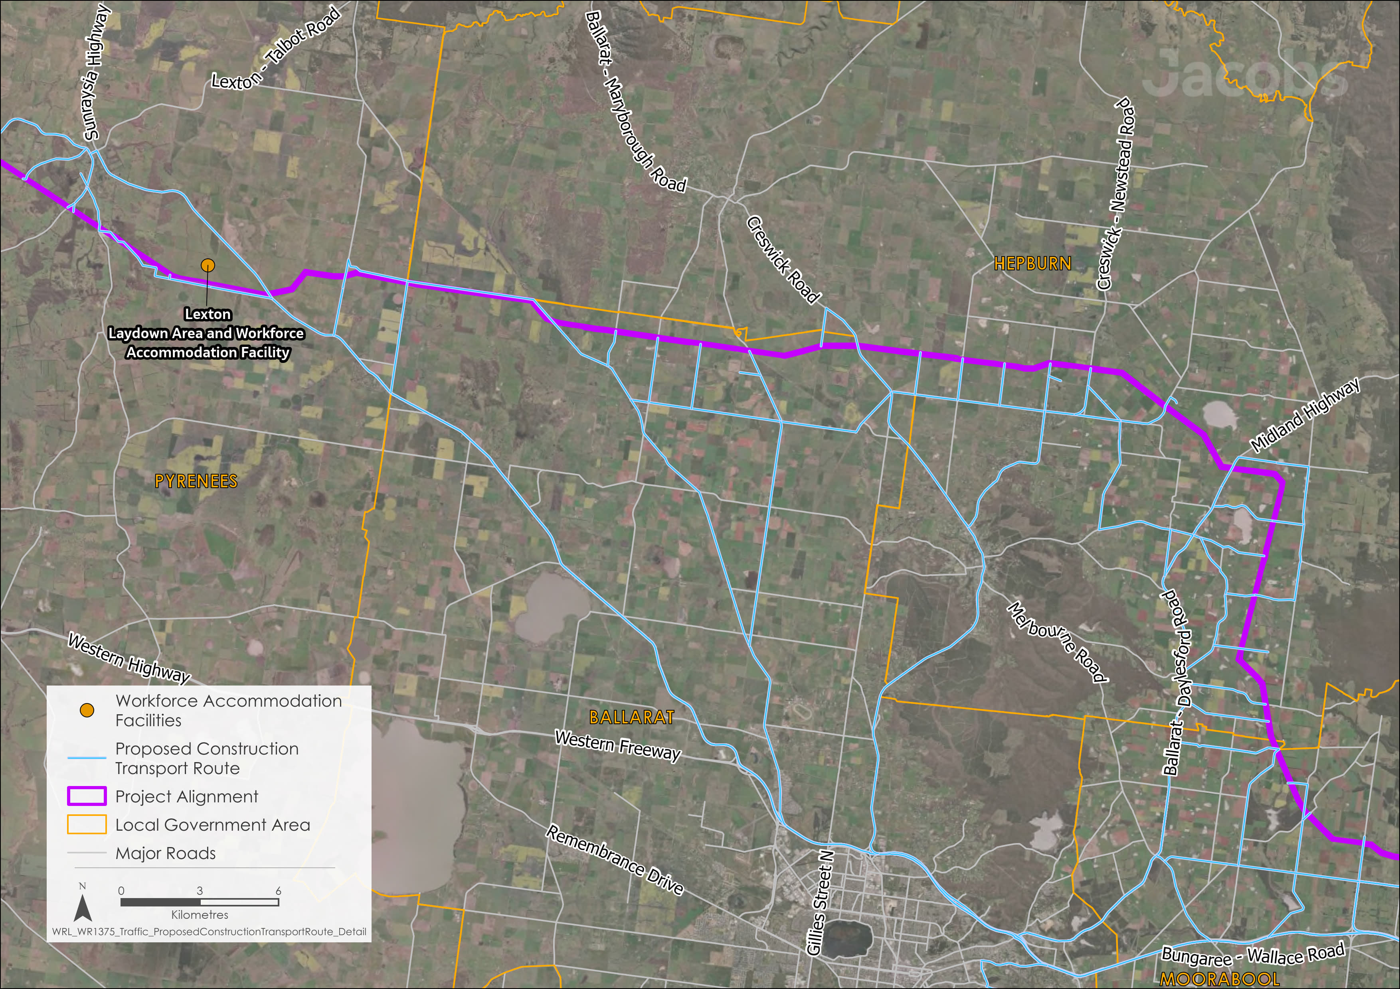
Figure 20.2 Proposed construction transport route (Sheet 2 of 4)
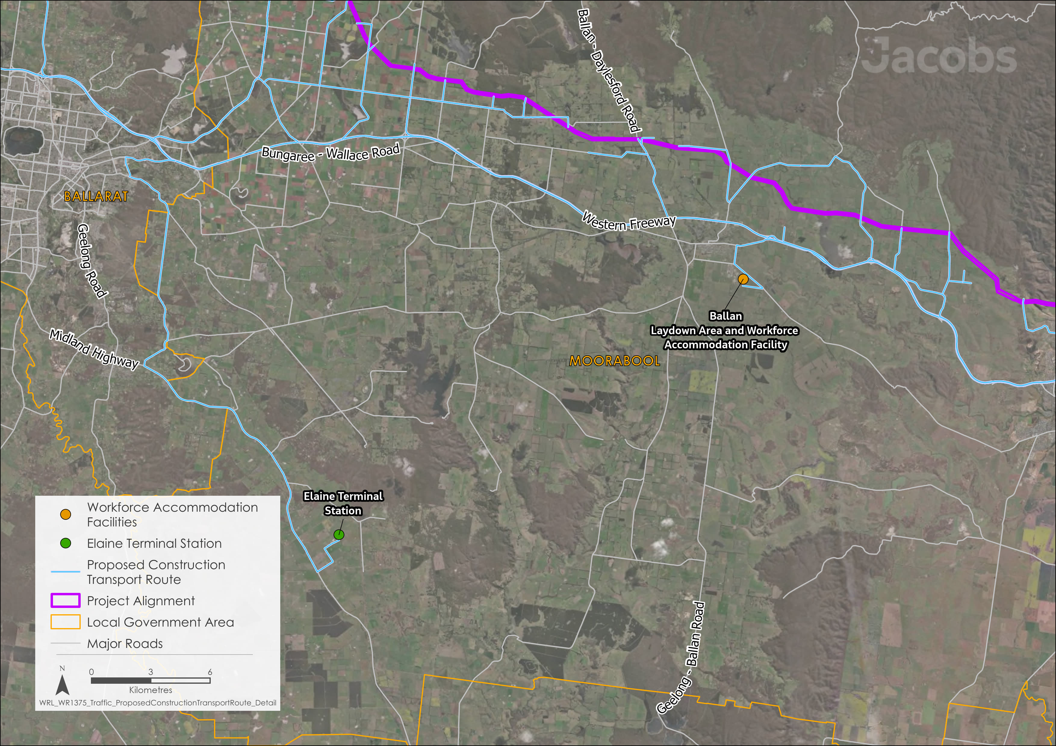
Figure 20.2 Proposed construction transport route (Sheet 3 of 4)
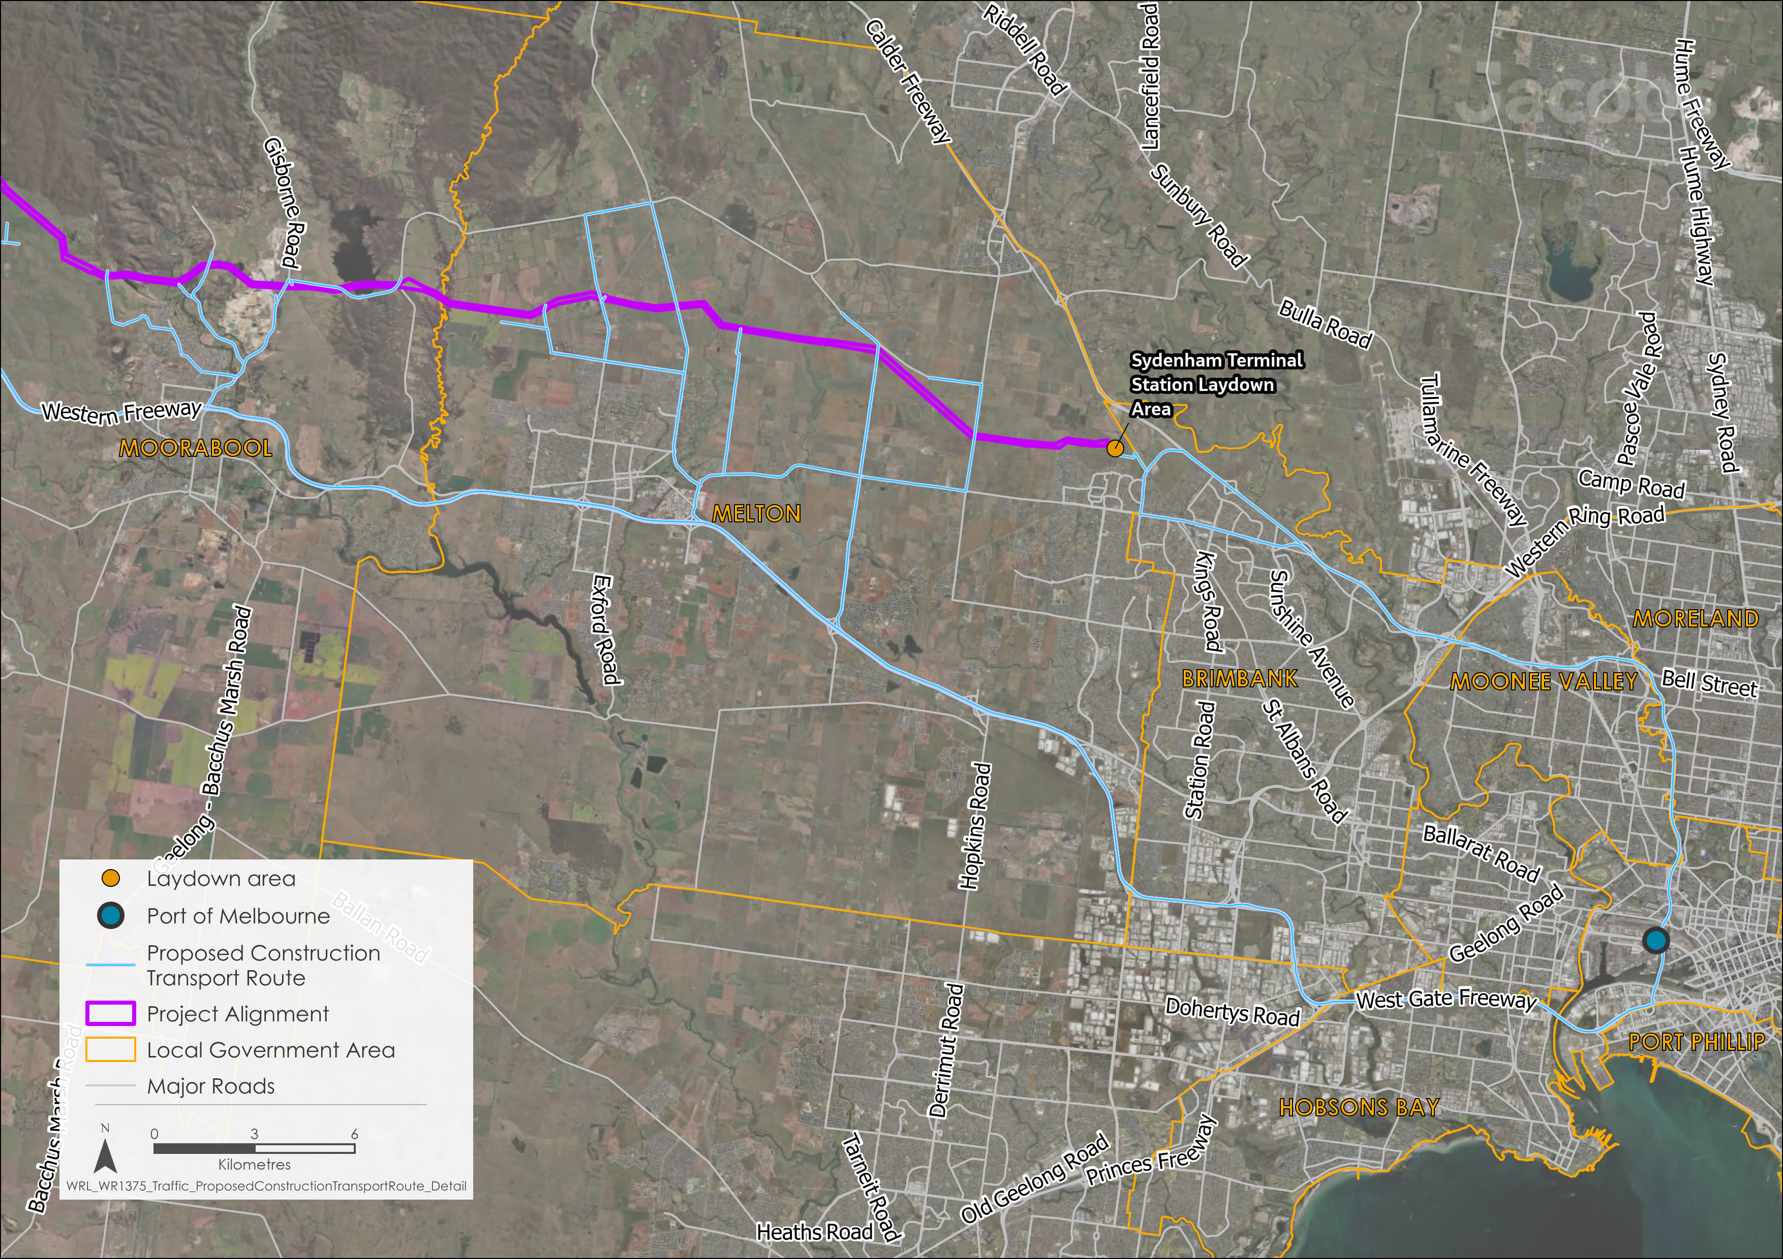
Figure 20.2 Proposed construction transport route (Sheet 4 of 4)

Existing conditions
This section summarises the existing conditions for the transport network according to the following key themes:
- Key roads
- Accessibility
- Potentially sensitive users.
This includes information on traffic volumes, heavy vehicle routes, road condition, road safety, public transport services, school bus routes, and walking and cycling facilities. The information is grouped into the Local Government Areas (LGAs). As noted in Section 20.2, the existing conditions assessment culminated in the definition of the proposed construction transport route. As this route is the basis for the transport impact assessment, the existing conditions focus only on the roads and locations that are relevant to the proposed construction transport route.

Shire of Northern Grampians
- Approvals for heavy vehicle use
The Department of Transport and Planning and National Heavy Vehicle Regulator are required to approve roads for the use of heavy vehicles, such as the B-double trucks required to transport cables, plant, equipment, and other materials for the Project.
There is an existing network of approved roads. Some road upgrades may be required if additional roads are proposed to be used (and therefore approved).

The western-most section of the proposed construction transport route is in the Northern Grampians Shire. Approximately 13km of the 500kV transmission line is proposed to be situated in this area, starting from the existing Bulgana Terminal Station and running parallel to the existing 220kV transmission line between Bulgana and Waubra.
The proposed construction transport route includes five local council roads within the Northern Grampians Shire: Curries Lane, Joel Joel Road, Joel South Road, Shays Flat Road and Vances Crossing Road. These have no known congestion issues and are all classified as LOS A (the highest level of service).
These roads have not been approved for use by heavy vehicles including B-doubles and larger trucks. As such, approval would be required to facilitate the use of these roads by the Project which may require upgrade works. In addition, all roads along the proposed construction transport route within the Northern Grampians Shire have been identified as potentially requiring additional treatment to prevent degradation due to Project traffic, due to being fully or partially unsealed, narrow, or requiring the removal of vegetation. This is described further in Section 20.4.2.
This section of the proposed construction transport route includes six bridges or major culverts, with load limits typically between 22.5 and 42.5 tonnes. One bridge has an unspecified load limit. There are no overpasses imposing height restrictions that may impact Project traffic.
The Northern Grampians Shire does not have an extensive public transport network. The closest passenger rail service operates at Ararat, approximately 40km south of the Bulgana Terminal Station. While the Nhill railway line operates through the town of Stawell, which is closer at approximately 20km west of the Bulgana Terminal Station, it only operates in a tourist service capacity. The public transport network is also concentrated around the township of Stawell. As such, no bus routes are located on, or intersect with, the proposed construction transport route that provides access to construction sites and laydown areas for the Project. However, Joel Joel Road and Joel South Road are used as school bus routes.
There are no formal cycling paths or footpaths within the Northern Grampians Shire on, or intersecting with, the proposed construction transport route. Hiking trails do occur within the two national parks within the Northern Grampians Shire: Grampians National Park, located west of the townships of Stawell and Glenorchy; and Kara Kara National Park, located south of the township of St Arnaud along the Sunraysia Highway. However, these park trails are not located within a reasonable walking distance to the Project.
Analysis of the crash data from 2014 to 2019 for the Northern Grampians Shire shows few severe crashes (i.e., fatal or serious injury crashes) and these occurred near the Bulgana Terminal Station along Stawell-Avoca Road, a road not included in the proposed construction transport route for the Project.

Shire of Pyrenees
To the south-east of the Northern Grampians Shire lies the Pyrenees Shire. Approximately 55km of the 500kV transmission line is proposed to pass through this area, between the Bulgana Terminal Station and Waubra.
- DTP State Declared Roads
DTP State Declared Roads are key routes managed by the Department of Transport and Planning (DTP) to support efficient and safe travel across the state. These roads are crucial for connecting major cities, towns, and regions.
The proposed construction transport route includes five DTP State Declared Roads: Ararat-St Arnaud Road (C241), Beaufort-Lexton Road (C172), Pyrenees Highway (B180), Sunraysia Highway (B220), and Williamson Street (C172). These have all been approved for use by heavy vehicles, with Ararat-St Arnaud Road (C241) highlighted by the community as being used by heavy vehicles and oversized agricultural machinery and providing suitable overtaking opportunities to pass slower-moving machinery / vehicles.
The proposed construction transport route also includes 22 local council roads, which have not been approved for use by heavy vehicles. As such, approval would be required to facilitate the use of these roads by the Project which may require some upgrade works. In addition, 15 of the local council roads along the proposed construction transport route within the Pyrenees Shire have been identified as potentially requiring additional treatment to prevent degradation due to Project traffic, due to being fully or partially unsealed, narrow, or requiring the removal of vegetation. This is described further in Section 20.4.2.
All roads along the proposed construction transport route within the Pyrenees Shire have no known congestion issues and are all classified as LOS A.
This section of the proposed construction transport route includes 15 bridges or major culverts, typically with unspecified load limits. Of these, three have been approved for use by heavy vehicles. There are no overpasses imposing height restrictions that may impact Project traffic.
The Pyrenees Shire is partially served by the Ararat spur of the Ballarat railway line, via the Beaufort railway station. The public transport network with routes within the Pyrenees Shire includes:
- Ararat – Maryborough via Elmhurst and Avoca (via Pyrenees Highway)
- Ballarat – Maryborough (via Sunraysia Highway)
- St Arnaud – Stawell via Ararat (via Ararat-St Arnaud Road).
Sunraysia Highway, Pyrenees Highway, Beaufort-Lexton Road, Ararat-St Arnaud Road, Waubra-Talbot Road, Lexton-Ararat Road, Amphitheatre Road, Black Bottom Road and Forest Road (included in the proposed construction transport route) are used as school bus routes. Waubra Primary School, located on Sunraysia Highway in Waubra, is situated on the proposed construction transport route.
There are no formal cycling infrastructure or footpaths along the proposed construction transport route. However, the Pyrenees Highway between Lexton-Ararat Road and Keiths Road is an informal on-road cycle route. Nearby, Mount Buangor State Park has 15km of walking tracks, and Pyrenees State Forest, west of Avoca, features two main walking tracks: the 18km Pyrenees Endurance Walk and the 1km Valley Walk.
From 2014 to 2019, the Pyrenees Highway recorded five severe crashes, and Lexton-Ararat Road recorded eight severe crashes along areas to be used for the proposed construction transport route.

City of Ballarat
To the east of the Pyrenees Shire lies the City of Ballarat, approximately 80km from Melbourne’s Central Business District (CBD). Approximately 20km of the 500kV transmission line is proposed to be located along the northern boundary of the City of Ballarat. The proposed construction transport route includes six DTP State Declared Roads: Ballarat-Daylesford Road (C292), Ballarat-Maryborough Road (C287), Clunes-Creswick Road (C291), Midland Highway (A300), Sunraysia Highway (B220), and Western Freeway (M8). These have all been approved for use by heavy vehicles.
The proposed construction transport route also includes 12 local council roads, which have not been approved for use by heavy vehicles. As such, approval would be required to facilitate the use of these roads by the Project which may require some upgrade works. In addition, seven of the local council roads along the proposed construction transport route within the City of Ballarat have been identified as potentially requiring additional treatment to prevent degradation due to Project traffic, due to being fully or partially unsealed, or narrow. This is described further in Section 20.4.2.
All roads along the proposed construction transport route within the City of Ballarat have no known congestion issues and are classified as LOS A.
This section of the proposed construction transport route includes five bridges or major culverts, all with unspecified load limits. Overpasses along the Western Freeway impose height restrictions, with vertical clearances ranging between 4.9 and 5.6m and may impact the use of some vehicles for the Project along these sections of the Freeway.
The City of Ballarat contains the regional city of Ballarat, which is a regional hub for rail services in the western Victorian region. Both the Ararat and Maryborough railway spurs meet at Ballarat station and join the Ballarat railway line. Railway stations include Ballarat, Wendouree (Ararat railway line), and Tourello (Maryborough railway line).
The public transport network centres around the city of Ballarat approximately 20km south of the Project. Most bus routes originate in the city centre and mainly serve areas south of the Western Freeway. Bus routes on Sunraysia Highway (Route 31), Midland Highway (Route 30), Ballarat-Maryborough Road (Route 31), Ballarat-Daylesford Road (Route 15) and Clunes-Creswick Road (Route 30), use the proposed construction transport route.
The Western Freeway, Sunraysia Highway, Ballarat-Daylesford Road, Ballarat-Maryborough Road, Coghills Creek Road, and Glendonald Road (included in the proposed construction transport route) are used as school bus routes including Woodmans Hill School, which is situated on the south-eastern corner of Fussell Street and Ballarat-Burrumbeet Road. Woodmans Hill School is located along the proposed construction transport route for the Project.
There are no formal cycling infrastructure or footpaths within the City of Ballarat along the proposed construction transport route.
From 2014 to 2019, the Western Freeway recorded six severe crashes, including one fatality; Midland Highway recorded four severe crashes; Sunraysia Highway recorded five severe crashes; and Creswick-Clunes Road recorded six severe crashes.

Shire of Hepburn
The Hepburn Shire is located to the north-east of the City of Ballarat and is approximately 100km north-west of Melbourne CBD. It spans across central Victoria between the parklands of Creswick, Wombat and Fryers Ridge. Approximately 45km of the 500kV transmission line is proposed to be situated in this area.
The proposed construction transport route includes two DTP State Declared Roads: Creswick-Newstead Road (C283), and Midland Highway (A300). These have both been approved for use by heavy vehicles.
The proposed construction transport route also includes 18 local council roads, the majority of which have not been approved for use by heavy vehicles. As such, approval would be required to facilitate the use of these roads by the Project which may require some upgrade works. Sections of Church Parade and Kingston Road, both located in Kingston, are the only local roads approved for use by heavy vehicles. Twelve of the local council roads along the proposed construction transport route within the Hepburn Shire have been identified as potentially requiring additional treatment to prevent degradation due to Project traffic, due to being fully or partially unsealed, or narrow. This is described further in Section 20.4.2.
All roads along the proposed construction transport route within the Hepburn Shire have no known congestion issues and are all classified as LOS A.
This section of the proposed construction transport route includes eight bridges or major culverts, all with unspecified load limits. There are no overpasses imposing height restrictions that may impact the Project.
Hepburn Shire is partially served by the Maryborough spur of the Ballarat railway line, via the Bald Hills, Creswick, and Clunes railway stations. The public transport network with routes within the Hepburn Shire include:
- Route 30: Ballarat Station – Creswick (via Midland Highway and Creswick-Newstead Road)
- Hepburn – Creswick via Daylesford (via Midland Highway).
The Midland Highway, Creswick-Newstead Road, Dean-Mollongghip Road, Dean-Newlyn Road, Kingston Road and Church Parade (included in the proposed construction transport route) are used as school bus routes. Newlyn Primary School is situated on the north-western corner of Ballarat-Daylesford Road, Dean-Newlyn Road and Midland Highway, along the proposed construction transport route.
There are no formal cycling paths or footpaths within the Hepburn Shire along the proposed construction transport route.
To the south-east of the Creswick township lies the Creswick Regional Park which contains part of the Goldfields Trail. The Goldfields Trail is a 210km shared use path along the Great Dividing Range between Bendigo, Ballarat and Buninyong. There is a walk / cycle crossing point on the Midland Highway within the Creswick town centre as part of the Goldfields Trail to connect users to the Maryborough railway corridor.
From 2014 to 2019, 22 severe crashes were recorded on or near the Midland Highway along the proposed construction transport route, five of which resulted in fatalities. Crashes tend to be spread uniformly across the road, though some clustering is found around the town of Creswick. Severe crashes have also occurred on Creswick-Newstead Road (three) near Allendale; and Creswick-Clunes Road (one).

Shire of Moorabool
The Moorabool Shire is located to the south-east of Hepburn Shire and is bounded by the Greater Melbourne metropolitan area to the east and the City of Ballarat to the west. Moorabool Shire stretches from the Lerderderg State Park in the north to Beremboke in the south. Approximately 50km of the 500kV transmission line is proposed to pass through this area.
The proposed construction transport route includes eight DTP State Declared Roads: Ballan-Daylesford Road (C141), Ballan-Greendale Road, Ballarat-Daylesford Road (C292), Bungaree-Creswick Road (C291), Diggers Rest-Coimadai Road (C706), Gisborne Road (C704), Greendale-Myrniong Road (C318), and Western Freeway (M8). These have all been approved for use by heavy vehicles.
The proposed construction transport route includes 32 local council roads, which have not been approved for use by heavy vehicles. As such, approval would be required to facilitate the use of these roads by the Project which may require some upgrade works. In addition, 20 of the local council roads along the proposed construction transport route within the Moorabool Shire have been identified as potentially requiring additional treatment to prevent degradation due to Project traffic, due to being fully or partially unsealed, narrow, or requiring vegetation removal. This is described further in Section 20.4.2.
Most roads along the proposed construction transport route within the Moorabool Shire have no known congestion issues and are classified as LOS A. Roads that have a LOS rating of B or below are described in Table 20.1.
Table 20.1 Roads within the Moorabool Shire with a service level less than LOS A
Road | Section / Bounding roads | Locality | LOS
DTP State Declared Roads
Western Freeway (M8) | Ormond Road to Bungaree-Creswick Road | Bungaree | B
Western Freeway (M8) | Ballan-Daylesford Road to Ormond Road | Springbank | B
Western Freeway (M8) | Ballan-Greendale Road to Ballan-Daylesford Road | Ballan | B
Western Freeway (M8) | Greendale-Myrniong Road to Tregothnan Road | Ballan | C
Western Freeway (M8) | Tregothnan Road to Ingliston Road (E and W) | Ballan | B
Western Freeway (M8) | Gisborne Road to Old Western Highway | Myrniong | B
Western Freeway (M8) | Old Western Highway to Greendale-Myrniong Road | Myrniong | B
Gisborne Road (C704) | Western Freeway to Tower Sites | Darley | B
Local council roads
Navigators Road | Eureka Street to Yankee Flat Road | Warrenheip | B
Links Road | Albert Street to Swans Road | Darley | B
Albert Street | Gisborne Road to Links Road | Darley | C
This section of the proposed construction transport route includes six bridges, four of which are approved for use by heavy vehicles. Two bridges have an unspecified load limit. There are no overpasses imposing height restrictions that may impact the Project.
In terms of rail transport, the Moorabool Shire is solely served by the Ballarat railway line, via Bacchus Marsh and Ballan railway stations. There is a railway crossing 40m north of the intersection of Ingliston Road and Gillespies Lane. The public transport network with routes along the proposed construction transport route include:
- Route 435: Bacchus Marsh to Darley (via Gisborne Road and Albert Street)
- Public Transport Victoria (PTV) Regional Bus - Ballan to Hepburn via Daylesford (via Ballan-Daylesford Road).
A network of roads is currently used as school bus routes including Darley Primary School and Myrniong Primary School, located on the proposed construction transport route. Darley Primary School is situated close to the proposed construction transport route on the south-western corner of Albert Street and Nelson Street. Myrniong Primary School is situated on Muddy Lane on the proposed construction transport route.
The active transport network within the Moorabool LGA lacks formal cycling infrastructure (e.g., dedicated cycling paths) included on the proposed construction transport route. However, two roads included on the proposed construction transport route have footpaths that could be used for walking and cycling: Gisborne Road (C704) and Albert Street in Darley. Pedestrian signage is also present on Long Forest Road and Ballan-Greendale Road, while bicycle signage is found on Lerderderg Gorge Road. Notably, many cyclists, motorcyclists, and pedestrians use the roads within the Bacchus Marsh and Darley area.
The Lerderderg State Park is located to the north of the Bacchus Marsh / Darley township, in close proximity to the Project. Among other recreational outdoor activities, the Park is a popular hiking location with several tracks.
From 2014 to 2019, there were 47 serious crashes, including nine deaths along the Western Freeway. Many crashes happened near Bacchus Marsh and Darley, especially at the intersections with Long Forest Road and Gisborne Road. In addition, Ballan-Daylesford Road recorded four serious crashes and Ballarat-Daylesford Road recorded three.

City of Melton
The City of Melton is part of the Greater Melbourne metropolitan area and will contain the new Sydenham Terminal Station and approximately 20km of the 500kV transmission line. It is bounded by City of Hume and City of Wyndham at the Calder Freeway and Boundary Road, toward the north-east and south respectively. To the west, the City of Melton is largely defined by the Djerriwarrh Creek.
The proposed construction transport route includes six DTP State Declared Roads: Calder Freeway (M79), CityLink (M2), Federation Drive (C705), Gisborne-Melton Road (C705), Melton Highway (C754), and Western Freeway (M8). These have all been approved for use by heavy vehicles.
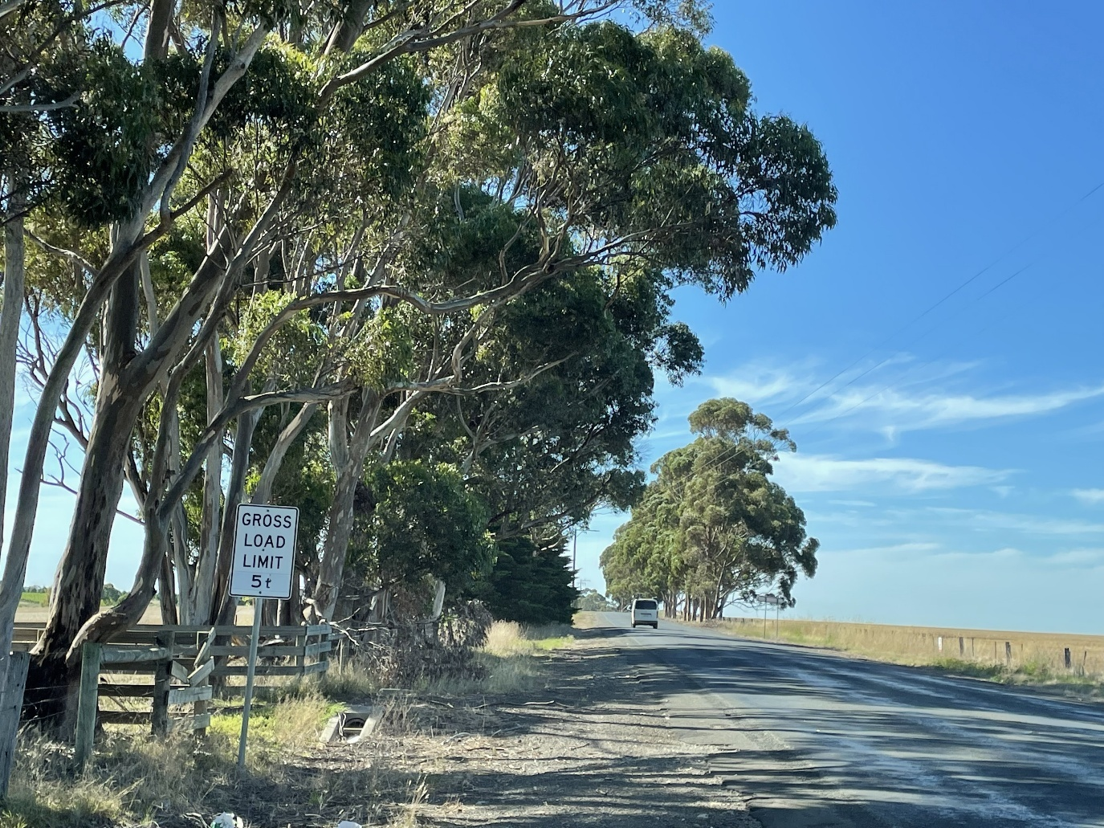
The proposed construction transport route includes nine local council roads, the majority of which have not been approved for use by heavy vehicles. As such, approval would be required to facilitate the use of these roads by the Project which may require some upgrade works. Sections of Holden Road and Leakes Road, located in Plumpton, as well as Coburns Road, located in Toolern Vale, are the only roads approved for use by heavy vehicles. However, the section of Holden Road between Leakes Road and Plumpton Road has been excluded from the proposed construction transport route (see Figure 20.3) as it has a gross load limit (5 tonnes) which prevents heavy vehicle usage. Four of the local council roads along the proposed construction transport route within the City of Melton have been identified as potentially requiring additional treatment to prevent degradation due to Project traffic, due to being fully or partially unsealed, or narrow. This is described further in Section 20.4.2.
Figure 20.3 Gross load limit on Holden Road between Leakes Road and Plumpton Road
Almost half of the roads along the proposed construction transport route within the City of Melton have no known congestion issues and are classified as LOS A. Comparative to the other LGA’s traversed by the Project, roads are typically more congested, with some nearing capacity. In particular, the section of Melton Highway between Plumpton Road and Leakes Road has poor traffic performance (LOS E) with only one lane in each direction. Roads that have a LOS rating of B or below are described in Table 20.2.
Table 20.2 Roads within the City of Melton with a service level less than LOS A
Road | Section / Bounding roads | Locality | LOS
DTP State Declared Roads
Federation Drive (C705) | Melton Highway to Gisborne-Melton Road | Melton | D
Melton Highway (C754) | Ryans Lane to Federation Drive | Melton | D
Melton Highway (C754) | Federation Drive to Western Freeway | Melton | D
Western Freeway (M8) | Western Ring Road to Leakes Road | Derrimut | D
Western Freeway (M8) | Leakes Road to Melton Highway | Melton | D
Melton Highway (C754) | Leakes Road to Ryans Lane | Melton | D
Melton Highway (C754) | Leakes Road to Ryans Lane | Melton | D
Melton Highway (C754) | Plumpton Road to Leakes Road | Melton Highway (C754) | E
Western Freeway (M8) | Port of Melbourne to Western Ring Road | Western Freeway (M8) | D
Calder Freeway (M79) | CityLink to Calder Park Drive | Keilor Park | D
CityLink (M2) | Port of Melbourne to Calder Freeway | Melbourne | D
Local council roads
Bulmans Road | Minns Road to Tower Sites | Harkness | C
Calder Park Drive | Calder Freeway to Victoria Road | Calder Park | D
This section of the proposed construction transport route includes three bridges, two of which are approved for use by heavy vehicles. Overpasses along the Western Freeway impose height restrictions, with vertical clearances ranging between 5.4 and 6.8m and may impact the use of some vehicles for the Project.
The City of Melton is primarily served by the Ballarat railway line. Regional V / line services operate between Southern Cross station in Melbourne and Melton, Ballarat, Ararat, and Maryborough railway stations. Metropolitan services also operate between Southern Cross station in Melbourne and Melton, stopping at Caroline Spring, Rockbank, Cobblebank and Melton railway stations within the City of Melton.
The public transport network within the City of Melton is concentrated around Melton and extends out to Kurunjang, Brookfield, and Melton South. Routes also serve the Caroline Springs and Sydenham areas near the City of Melton’s eastern edge, as well as other growth areas such as Plumpton and Rockbank.
The Western Freeway, Melton Highway, Coburns Road, Gisborne-Melton Road, and Plumpton Road (included in the proposed construction transport route) are used as school bus routes including Melton Christian College, approximately 950m north of Minns Road. Melton Christian College is located along the proposed construction transport route for the Project. Bicycle paths on the Melton Highway, Coburns Road and Calder Park Drive may interact with Project traffic.
From 2014 to 2019, the City of Melton experienced 60 severe crashes along the Western Freeway from the Deer Park Bypass which resulted in three fatalities. Key intersections with high crash rates include Coburns Road / High Street (12 crashes), Melton Highway / High Street (6 crashes), Leakes Road / Holden Road (3 crashes), and Gisborne-Melton Road near the transmission line (1 crash). Additionally, Coburns Road, Melton Highway and High Street have a consistent distribution of severe crashes along their lengths.

Construction impacts
This section outlines the key issues identified through the risk screening process and associated potential impacts during the construction of the Project. The key issues and impacts identified for the transport network are discussed according to the following themes:
- Road performance: potential increases to road congestion along key access routes, leading to reduced LOS.
- Degradation of road infrastructure: potential excess or premature degradation of road infrastructure due to increased heavy vehicle construction traffic.
- Safety: an increase in heavy vehicles on the road network, particularly where proposed heavy vehicle routes interact with public transport, school bus routes and walking and cycling facilities may reduce safety.

Road performance
Road traffic is expected to increase along the proposed construction transport route (shown in Figure 20.2) to facilitate the delivery of materials, equipment, and the workforce to the transmission tower sites, terminal station sites, laydown areas, and workforce accommodation facilities. AusNet proposes to utilise temporary construction workforce accommodation facilities to accommodate construction workforce personnel. Two facilities are proposed; one in each of the western and eastern portions of the Project ‒ co-located with each of the intermediate laydown areas (Lexton and Ballan). Each facility will have capacity for approximately up to 350 personnel. As part of the trip generation assumptions, the Ballan and Lexton laydown areas, which include workforce accommodation facilities, have been assumed 175 trips per day (assuming two people per vehicle), in addition to trips generated by the delivery of labour and materials, distributed across the Construction Sites to account for workforce trips.
Construction of the 500kV transmission towers is anticipated to require approximately 92 heavy vehicle trips (excluding OSOM) and 464 light vehicle trips across the Project daily during the construction stage. In addition to this, approximately 112 heavy vehicle trips and 735 light vehicle trips are anticipated to be generated daily between the Port of Melbourne and the laydown areas and terminal station sites. However, across the majority of the proposed construction transport network this increase in road traffic is not anticipated to lead to increased congestion or longer travel times for local commuters.
The construction impacts on roads along the proposed construction transport route were assessed and compared to existing conditions to determine if the construction traffic reduced the road’s LOS, potentially causing delays. The traffic model developed for the Project, discussed in the Method section (Section 20.2), was used to evaluate the LOS of each road under existing and peak construction conditions. Across the proposed construction transport route only three sections of road, one located within the City of Ballarat and two in the Shire of Moorabool, are anticipated to experience a reduction in LOS rating due to this additional traffic, as detailed in Table 20.3. While a reduction in LOS from A to B, or B to C, is anticipated on the Western Freeway at these sections, these roads still maintain an acceptable LOS rating of B or C.
Table 20.3 Project roads anticipated to experience a reduction in LOS during construction
Road | Section / bounding roads | Locality | Existing LOS | Construction LOS
Western Freeway (M8) | Barkstead Road to Bungaree-Creswick Road (W) | Moorabool | A | B
Western Freeway (M8) | Bungaree-Creswick Road to Ballarat-Daylesford Road (W) | Ballarat | A | B
Western Freeway (M8) | Gisborne Road to Old Western Highway (W) | Moorabool | B | C
As detailed in Sections 20.3.5 and 20.3.6, some road sections along the proposed construction transport route have an existing LOS rating below A. This includes roads in the City of Melton and Melbourne with service ratings of LOS E (Citylink, Western Highway and Melton Highway between Plumpton Road and Leakes Road). Traffic performance is already considered poor on these sections of road, with the addition of Project traffic found to potentially increase peak hour traffic volumes by approximately 1 per cent. As such, the Project is not expected to cause significant road performance impacts to these already poor performing roads.
Construction traffic is expected to cause minor to negligible residual impacts to overall road performance; as the LOS for the majority of the roads along the proposed construction transport route will not change, the Project is not expected to impact traffic performance or cause major congestion.
With the use of heavy vehicles, the freight network may also be impacted by congestion as a result of construction traffic associated with the Project. However, the Project’s residual impact on the freight network is minor in the City of Melton and the City of Ballarat, and negligible in all other areas along the proposed construction transport route.
To further manage impacts to road performance, Traffic Management Plans consistent with the Road Management Act 2004 (EPR T1) will be implemented. The Traffic Management Plans will manage risks and minimise disruption to all transport modes due to construction traffic, detailing how expected changes to the operation of the transport network will be managed to optimise road performance, including temporary changes to traffic conditions, road or footpath closures, and traffic detours. Traffic Management Plan mitigations could include, but are not limited to:
- Specifying changes to intersections and signal timings
- Providing alternative routes for affected road users including pedestrians and cyclists, where practicable
- Maintaining property access during construction, where practicable, or providing alternative access arrangements
- Notifying affected residents and landholders of changes to traffic conditions and property access for the duration of the works
- Limiting the extent and duration of road closures to the extent practicable.
Following application of these mitigations, the extent, magnitude and duration of impacts associated with road performance throughout the proposed construction transport route will be reduced, with minor residual impacts associated with road performance due to some increase in traffic delays from light and heavy vehicles use.

Degradation of road infrastructure
The Project may cause premature degradation of road infrastructure along the proposed construction transport route due to additional heavy vehicle traffic, including OSOM vehicles. Road works will be required for relevant local roads experiencing degradation, including bridges and major culverts, before, during and after construction, especially for unsealed, partially sealed, and narrow roads. This will include road upgrades where required to make roads safe for Project traffic.
The impacts of heavy vehicle traffic on the degradation of road infrastructure was assessed by considering the existing pavement condition of roads along the proposed construction transport route. It is anticipated that Project traffic will impact on local council roads, mainly affecting unsealed roads. The roads detailed in Table 20.4 have been assessed to have a higher risk of degradation.

Table 20.4 Project roads that have been assessed to potentially require treatment due to construction traffic
Road | LGA | Road condition
Vances Crossing Road | Northern Grampians | Unsealed / potential vegetation removal required
Shays Flat Road | Northern Grampians | Unsealed
Curries Lane | Northern Grampians | Unsealed
Joel South Road | Northern Grampians | Sealed – one lane width only
Joel Joel Road | Northern Grampians | Sealed – one lane width only
Spring Flat Road | Pyrenees | Unsealed
Landsborough-Elmhurst Road | Pyrenees | Potential vegetation removal required
Wiltshires Lane | Pyrenees | Unsealed
Sandy Lane | Pyrenees | Sealed – one lane width only
Egans Lane | Pyrenees | Sealed – one lane width only / potential vegetation removal required
Townsing Road | Pyrenees | Unsealed / potential vegetation removal required
Forest Road | Pyrenees | Unsealed / potential vegetation removal required
Gallaghers Road | Pyrenees | Unsealed
Glendhu Road | Pyrenees | Unsealed
Black Bottom Road | Pyrenees | Sealed – one lane width only
Stud Farm Road | Pyrenees | Sealed – one lane width only
Iles Lane | Pyrenees | Unsealed
Keiths Road | Pyrenees | Unsealed
Rifle Range Road | Pyrenees | Unsealed / potential vegetation removal required
Easter Brooks Lane | Pyrenees | Unsealed
Coutts Road | Ballarat | Sealed – one lane width only
Anderson Road | Ballarat | Unsealed
Tourello Road | Ballarat | Unsealed
Pickfords Road | Ballarat | Sealed – one lane width only
Fentons Road | Ballarat | Sealed – one lane width only
Trewins Road | Ballarat | Sealed – one lane width only
Glendonald Road | Ballarat | Sealed – one lane width only
Kingston Road | Hepburn | Unsealed
Sutton Park Road | Hepburn | Unsealed
R Charlesons Road | Hepburn | Unsealed
Ewen Charlesons Road | Hepburn | Unsealed
Myers Road | Hepburn | Unsealed
Railway Road | Hepburn | Unsealed
Telegraph Road | Hepburn | Unsealed
Creswick-Lawrence Road | Hepburn | Unsealed
Long Swamp Road | Hepburn | Sealed – one lane width only
Dean-Mollongghip Road | Hepburn | Poorly sealed – one lane width only
Dean-Reservoir Road | Hepburn | Sealed – one lane width only
Lone Hand Road | Hepburn | Sealed – one lane width only
Boundary Church Lane | Moorabool | Unsealed
Callaghans Lane | Moorabool | Unsealed / potential vegetation removal required
Moorabool W Road | Moorabool | Unsealed
Long Point Road | Moorabool | Unsealed
Haydens Hill Road | Moorabool | Unsealed / potential vegetation removal required
Stone Hut Lane (Aldreds Lane to Blakeville Road) | Moorabool | Unsealed
Tregothnan Road | Moorabool | Unsealed
Myrniong-Korobeit Road | Moorabool | Unsealed
Kerrins Lane | Moorabool | Unsealed
Calway Lane | Moorabool | Unsealed
Murphys Road | Moorabool | Unsealed
Barkstead Road | Moorabool | Sealed – one lane width only
Mollongghip Road | Moorabool | Sealed – one lane width only
Burkes Road | Moorabool | Poorly sealed – one lane width only
Dehnerts Road | Moorabool | Sealed – one lane width only
Stone Hut Lane | Moorabool | Sealed – one lane width only
Blakeville Road | Moorabool | Sealed – one lane width only
Ingliston Road (Ingliston Road to Jaicomellis Lane) | Moorabool | Sealed – one lane width only
Albert Street | Moorabool | Albert St – Fitzroy St roundabout upgrade  Albert St – Nelson Rd roundabout upgrade  Albert St – Links Rd roundabout upgrade
Swans Road | Moorabool | Sealed – one lane width only
Porteous Road | Melton | Unsealed
Ryans Lane | Melton | Unsealed
McCorkells Road | Melton | Unsealed

- Oversize Overmass (OSOM)
OSOM vehicles are heavy vehicles that exceed general access mass or dimension limits.
The movement of these vehicles requires approval from the Department of Transport and Planning, and the National Heavy Vehicle Regulator.
OSOM vehicles will deliver large components to the Bulgana and Sydenham Terminal Stations as part of upgrade and connection works. These movements are in addition to the standard Project construction traffic. OSOM vehicle movements will require approval from DTP and NHVR, which may require swept path assessments for intersections and road upgrades in consultation with relevant authorities. As part of the OSOM permit application, Traffic Management Plans (EPR T1) will determine and document the most suitable route based on the final OSOM vehicle dimensions and weight. The Traffic Management Plan will also include a final detailed route, escort procedures, transport scheduling to minimise impacts such as travelling outside of peak traffic periods, and an emergency service communication strategy.
Dilapidation surveys (EPR T2) will be conducted for local roads used by Project traffic both prior to and after construction. These surveys will inspect and identify upgrades as needed to allow safe use for construction (and local) vehicles. It also allows existing local road conditions to be recorded so that any road damage caused by the Project can be restored to previous conditions at the end of construction. The content of the dilapidation surveys will be agreed with the relevant local Council. In addition, road condition monitoring will be undertaken by the Principal Contractor during construction on local roads. This will identify when road degradation occurs due to Project construction traffic, and any maintenance/rectification that is required (EPR T2). Restoration works (EPR T2), to restore roads to their previous condition prior to construction, will commence after construction is complete. With the implementation of mitigation measures in compliance with EPR T2, the residual impact on the condition of local council roads is minor. Prior to commencing any rectification or restoration works, approvals or permits will be sought, and Traffic Management Plans for the specific locations will be prepared (EPR T1).
Load limit and height clearance data have been used to assess the potential impacts of using construction vehicles on bridges and major culverts. Structures with unspecified load limits and height restrictions are at risk of potential damage. Those with height restrictions and without specified load limit data will require further evaluation or approval for use (as listed in Table 20.5 and Table 20.6) and will be investigated as part of the dilapidation surveys conducted by the Principal Contractor (EPR T2). These assessments will contribute to Traffic Management Plans (EPR T1), which will also include details on avoiding culverts via traffic diversions where necessary. With the implementation of mitigation measures in compliance with EPRs T1 and T2, residual degradation impacts to bridges and major culverts are minor. These structures will be included in the dilapidation surveys (EPR T2), monitored during construction, and restored to their original condition upon completion of construction.
Table 20.5 Remaining bridge and major culverts without specified load limit data and not on the DTP gazetted B-Double Network
Road | Section / bounding roads | Description | LGA
Joel Joel Road | Ararat - St Arnaud Road to Joel South Road | Bridge over Sheas Creek | Northern Grampians
Joel Joel Road | Ararat - St Arnaud Road to Joel South Road | Bridge over Glendhu Creek | Northern Grampians
Joel South Road | Joel Joel Road to Curries Lane | Bridge over Wimmera River | Northern Grampians
Vances Crossing Road | Joel Joel Road to Curries Lane | Bridge over Wimmera River | Northern Grampians
Landsborough-Elmhurst Road | Pyrenees Highway to Illes Lane | Bridge over Wimmera River | Pyrenees
Coghills Creek Road | Ballarat - Maryborough Road to Trewins Road | Bridge over Beckworth Creek | Ballarat
Glendonald Road | Ballarat - Maryborough Road to Andersons Road | Culvert Box over Creswick Creek | Ballarat
Pickfords Road | Coghills Creek Road to Cooks Road | Bridge over Glendaruel Creek | Ballarat
Lerderderg Gorge Road | Gisborne Road to Camerons Road | Bridge over Goodman Creek | Moorabool
Ballan-Greendale Road | Greendale-Myrniong Road to Western Freeway | Bridge over Blue Gully | Moorabool
Table 20.6 Bridges / overpasses with height restrictions
Road | Section / bounding roads | Description | Vertical clearance | LGA
Western Freeway | Daylesford Road to Ballarat - Burrumbeet Road | Ballarat - Burrumbeet Road Overpass | 5.6m | Ballarat
Western Freeway | Lofven Street to Hillcrest Road | Hillcrest Road Overpass | 5.6m | Ballarat
Western Freeway | Lofven Street to Daylesford Road | Daylesford Road Overpass | 4.9m | Ballarat
Western Freeway | Doodts Road to Lofven Street | Lofven Street Overpass | 5.4m | Ballarat
Western Freeway | Swinglers Road to Doodts Road | Doodts Road Overpass | 5.1m | Ballarat
Western Freeway | Gillies Street North to Midland Highway | Gillies Street North Overpass | 5.5m | Ballarat
Western Freeway | Howe Street to Gillies Street North | Gillies Street North Overpass | 5.3m | Ballarat
Western Freeway | Sunraysia Highway to Howe Street | Howe Street Overpass | 5.6m | Ballarat
Western Freeway | Christies Road - Western Freeway (M8) | Overpass | 5.9m | Melton
Western Freeway | Deer Park Bypass - Western Freeway (M8) | Overpass | 6.8m | Melton
Western Freeway | Hopkins Road - Western Freeway (M8) | Overpass | 5.4m | Melton
Western Freeway | Leakes Road - Western Freeway (M8) | Overpass | 5.9m | Melton
Western Freeway | Melton Highway - Western Freeway (M8) | Overpass | 5.5m | Melton
Western Freeway | Station Road - Western Freeway (M8) | Overpass | 5.7m | Melton
Western Freeway | Station Road - Western Freeway (M8) | Pedestrian Overpass | 5.8m | Melton
Western Freeway | Coburns Road - Western Freeway (M8) | Overpass | 5.6m | Melton
Western Freeway | Bulmans Road - Western Freeway (M8) | Overpass | 6.54m | Melton
With the application of the mitigations outlined in the Traffic Management Plans, and the implementation of dilapidation surveys, road condition monitoring and road rectification / restoration, the extent, magnitude and duration of impacts associated with degradation of road infrastructure will be reduced. Project traffic causing degradation of road infrastructure during construction is expected to be short-term and reversible, with an overall minor residual impact.

Safety
Road safety along the proposed construction transport route may be impacted due to an increase in heavy vehicles on the road network, especially where heavy vehicles may interact with public transport, schools and school bus routes, and walking and cycling facilities.
The potential for interaction between construction traffic associated with the Project and other road users such as public transport, school buses, and active transport was assessed for roads along the proposed construction transport route. Table 20.7 lists the roads with an increased risk of impact from the Project due to the proximity of other road user infrastructure and services.
Table 20.7 Public and active transport infrastructure that may conflict with construction traffic
Road | LGA | Conflict
Andersons Road | Ballarat | Level crossing approximately 1km north of Glendonald Road intersection
Ballarat-Maryborough Road | Ballarat | Level crossing approximately 1km east of Tourello station
Ballarat-Daylesford Road | Ballarat | High volume along the Ballarat Station – Brown Hill bus route
Midland Highway | Hepburn | Level crossing approximately 1km north of Sulky Road
Midland Highway | Hepburn | Intersects with Goldfields Hiking Trail
Midland Highway | Hepburn | High volume along the Hepburn – Creswick via Daylesford bus route
Calder Park Drive | Melton | On-road cycle lanes (shoulder)
Coburns Road | Melton | On-road cycle lanes
Given the overall additional Project traffic volume is minor (i.e., approximately 1 per cent), the Project is not anticipated to impact the performance, or LOS, of the roads listed in Table 20.7. To minimise interactions between Project traffic and other roads users, the proposed construction transport route avoids potential conflicts with public transport, school buses, and active transport users as much as practicable. As such, interactions between Project traffic and other road users are expected to be infrequent. Project construction activities will comply with all relevant road and transport authority requirements with respect to transport network user safety via the implementation of Traffic Management Plans and Road Safety Audits (EPR T1). Considering these mitigations, Project traffic causing impacts to public transport and other road users during construction is expected to be short-term, with a minor residual impact. To further minimise safety impacts around schools, potential alternate routes are proposed for Project traffic, during peak school times (8am to 9:30am and 2:30pm to 4pm). This will avoid potential conflicts with Waubra Primary School, Newlyn Primary School, and Melton Christian College. Alternate routes for the Project will be consulted on and approved via Traffic Management Plans (EPR T1).
Where alternative routes were not possible, heavy vehicle restrictions are proposed at two high-risk locations near schools during peak times. This will reduce disruption and avoid the potential impact of increased interaction between heavy vehicles, school traffic and other vulnerable users. Heavy vehicle restrictions will be consulted on and applied through the implementation of traffic management plans (EPR T1). These restrictions are proposed for Woodmans Hill School, Ballarat (along Fussell Street between Ballarat-Burrumbeet Road and Eureka Street, shown in Figure 20.4, and Darley Primary School, Darley (along Albert Street between Gisborne Road and Links Road, shown in Figure 20.5)). At both of these locations, the residual impact to road safety is anticipated to be minor, keeping in mind that vulnerable users may be present on the road network at times outside of the proposed time restrictions for Project traffic.
The Project's construction traffic is not expected to impact road traffic volume or composition, therefore, an increase in crash frequency in high-risk areas is unlikely. High-risk areas and locations with crash histories will be managed through traffic management plans (EPR T1), which will address requirements around speed limits, sight lines, and signage to minimise safety risks. These Traffic Management Plans will also be required to consider any additional appropriate road safety considerations as informed by a Road Safety Audit, for example reduced speeds for Project traffic in Creswick and Allendale, where fatal crashes have previously occurred. Any new hazards identified during the Project will be incorporated into updated traffic management plans with revised mitigations. With these mitigations in place to minimise and manage impacts, residual safety impacts at high-risk locations are minor.
Due to the low existing traffic on most roads, minimal additional Project traffic, and expected infrequent interactions between Project traffic and other road users, combined with the implementation of mitigations required through traffic management plans and accompanying Road Safety Audits (EPR T1), the extent, magnitude, and duration of safety impacts across the proposed construction transport route will be minimised. As such, the residual impact on the overall safety of road users from construction traffic generated by the Project is minor. The residual impacts include minor impacts to schools as vulnerable users may be present on the road network at times outside the proposed time restrictions for Project traffic.

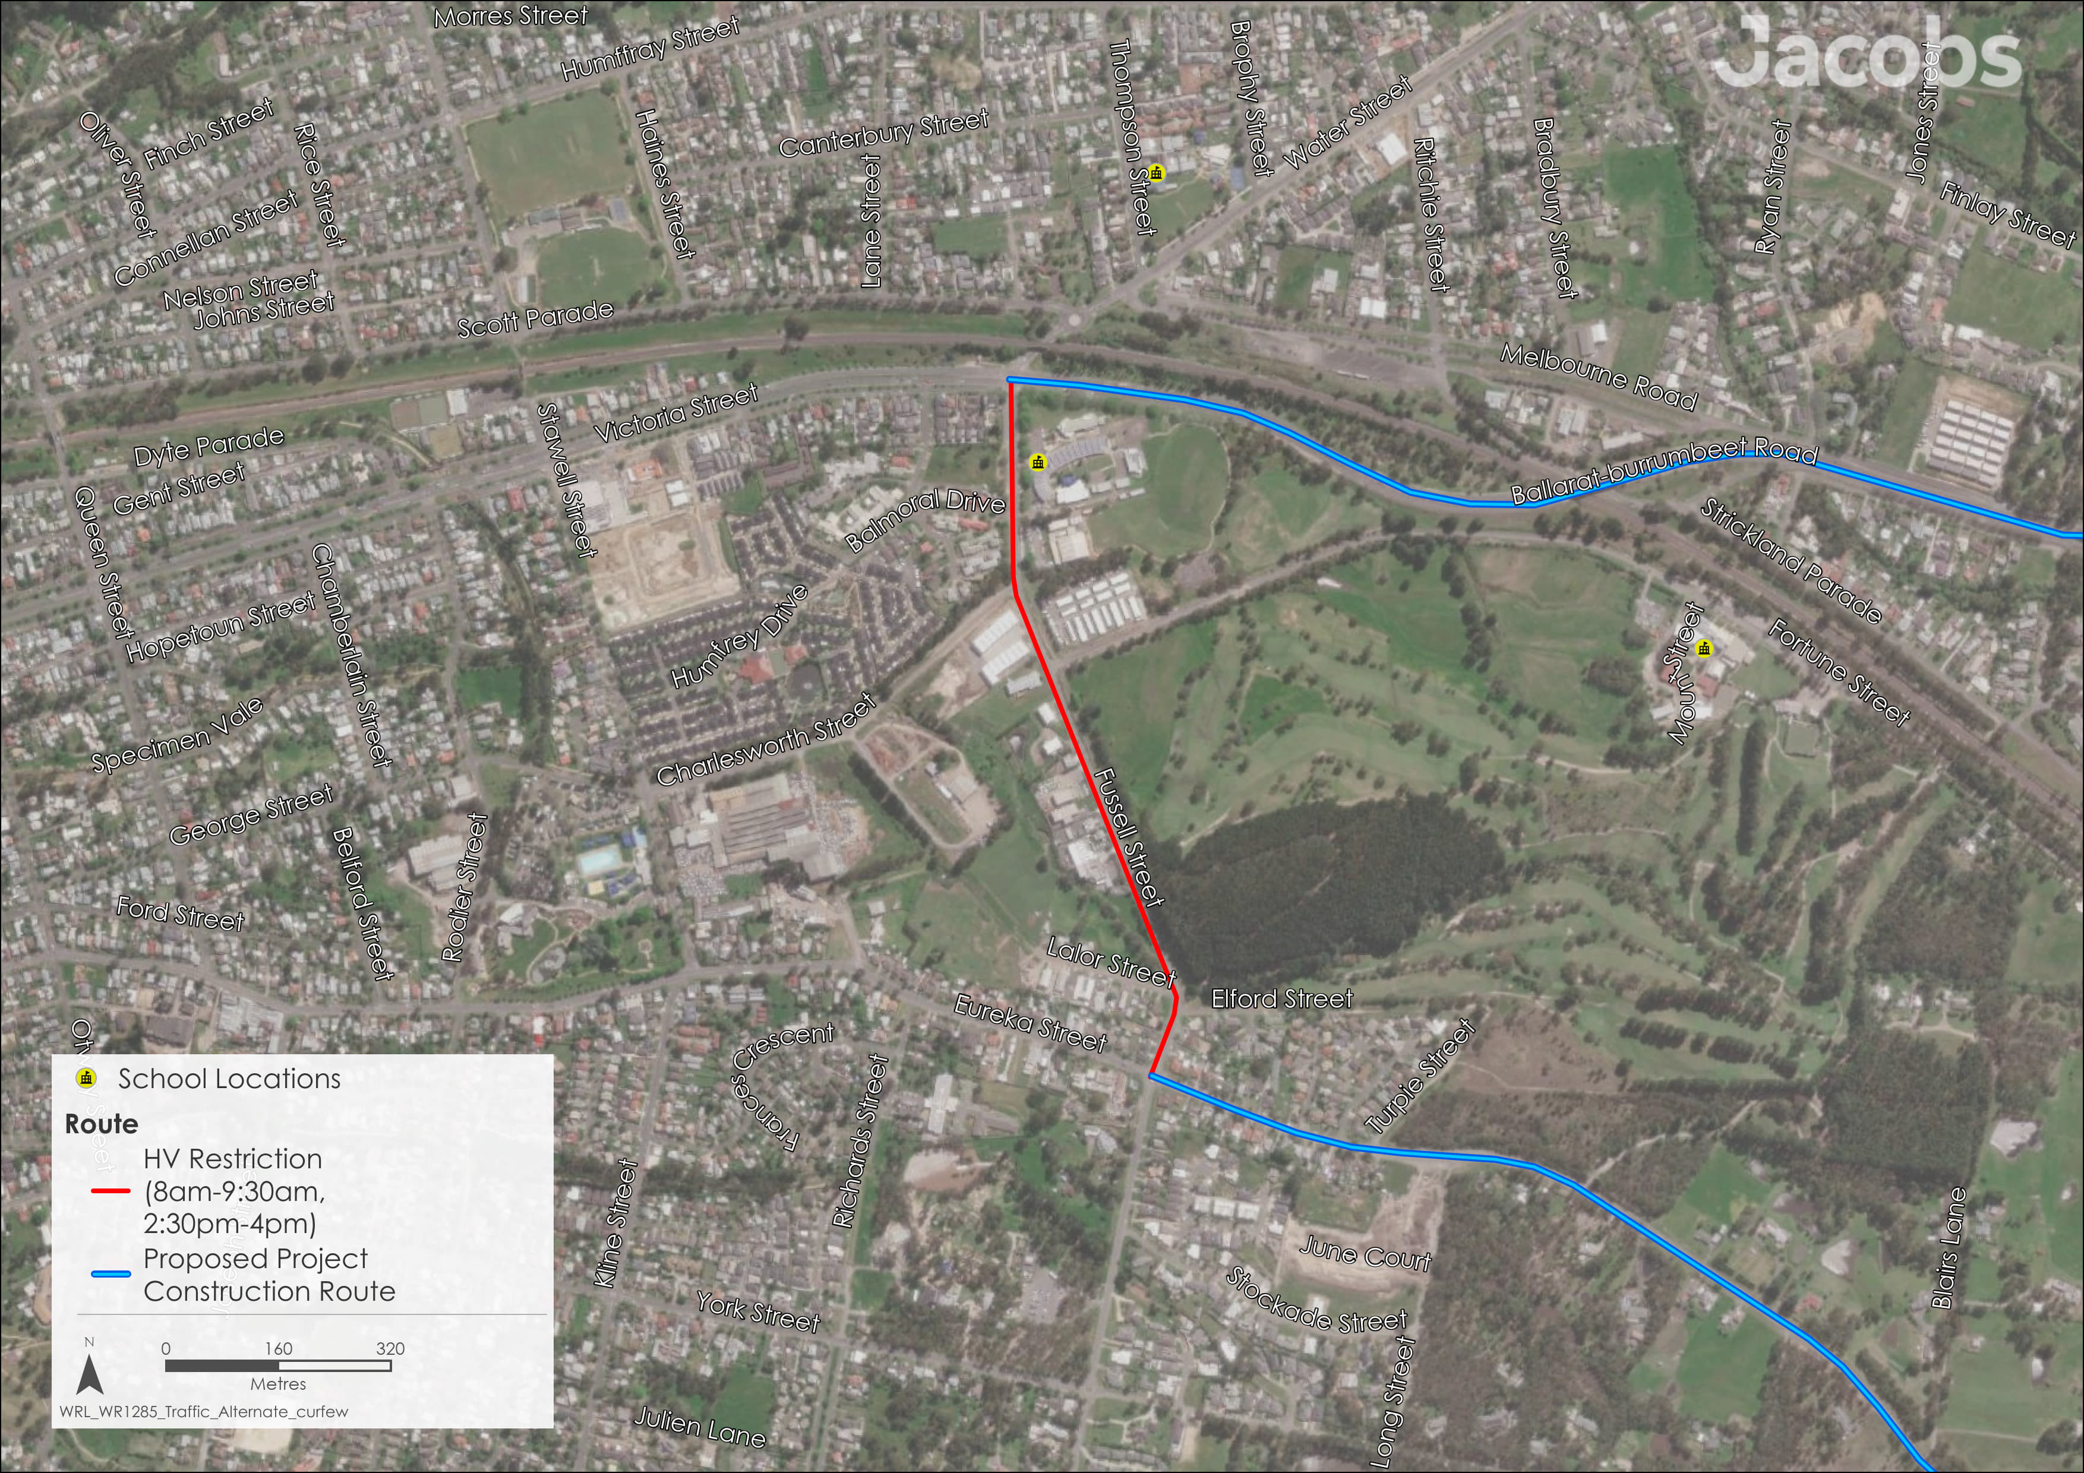
Figure 20.4 Heavy vehicle restriction location, Woodmans Hill School, Ballarat
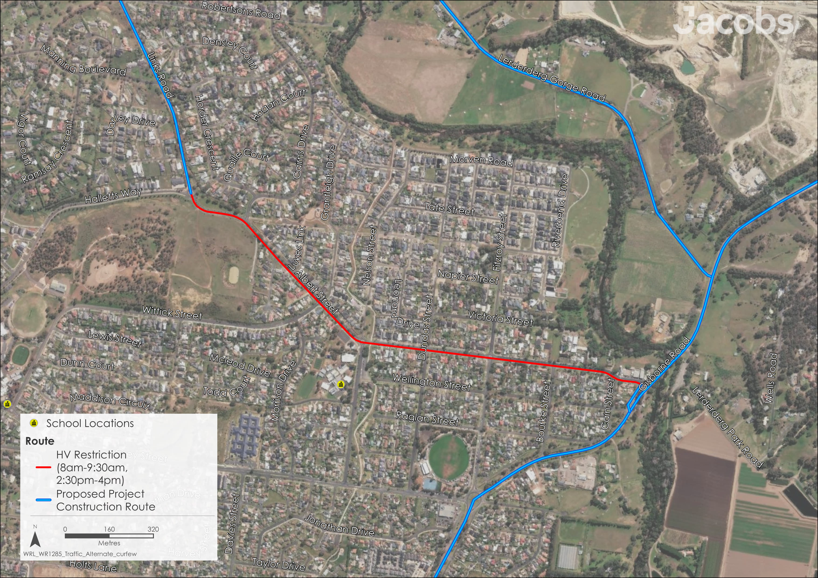
Figure 20.5 Heavy vehicle restriction location, Darley Primary School, Darley

Operation impacts
Trips undertaken during the operational stage would consist of maintenance staff travelling to the terminal stations and transmission tower sites every other month, resulting in only one to two vehicle trips to a site at any given time. The number of trips will depend on the timing of scheduled inspections, the nature of the maintenance tasks to be completed, and the number of people required to safely complete these tasks. Other inspection findings may also influence the number of trips. As such, negligible impacts to the transport network are expected from the Project’s operational activities. The number of trips to the Project terminal stations and transmission towers during the operational stage will be much lower than during construction and will primarily use the access tracks built during construction to reach the Project’s built infrastructure.
While irregular events, such as emergency restoration or maintenance work, may generate more traffic, these volumes will be small compared to the construction stage. Therefore, the traffic expected during the operational stage is expected to have a negligible impact on the transport network, and no specific mitigation measures are proposed.

Decommissioning impacts
As decommissioning activities will be similar to those that occur during construction, the impacts relating to transport are assessed to be the same as for the construction stage. The decommissioning stage of the Project is expected to generate a similar number of trips as the construction stage, using similar vehicles and routes over a similar timeframe. The main difference between these stages is the level of background traffic on the road network. Over the expected 80-years between the construction and decommissioning stages, background traffic is expected to increase. As such, the impact of Project traffic on road network performance, safety, and road condition is expected to be no greater than the impacts during construction.
Accordingly, the mitigations and EPRs developed to manage impacts during construction would also be applicable for decommissioning in accordance with the conditions of the time. This would be managed by a Decommissioning Management Plan (EPR EM11) which would include mitigation measures for transport impacts.
Given the minor traffic performance impacts caused by the construction traffic as outlined in Section 20.4, the decommissioning stage is expected to have a similar level of residual impact. The potential impact to unsealed / partially sealed road conditions and other road users would, however, likely require additional review and assessment at the time of decommissioning.

Cumulative impacts
Cumulative impacts have been assessed by identifying relevant future projects that could contribute to cumulative impacts on the transport network, considering their spatial and temporal relationships to the Western Renewables Link Project.
Of the 23 projects identified in Chapter 4: EES assessment framework and approach, nine projects were deemed to have potential cumulative transport impacts with the Western Renewables Link Project. These projects were identified based on their proximity and projected timings that may overlap with to the Western Renewables Link Project and the proposed construction transport route, their potential for transport network overlap and include:

- Elaine Solar Farm
- Navarre Green Energy Hub
- Nyaninyuk Wind Farm
- Outer Metropolitan Ring Road / Outer Metropolitan Ring Road Rail
- Sunbury Line Level Crossing Removals (Calder Park Drive and Holden Road Level Crossing Removal Project)
- Sydenham Terminal Station Rebuild
- Toolern Vale Solar Farm
- Victoria to New South Wales Interconnector West
- Westgate Tunnel Project.
The potential transport impacts from interfacing projects are increased vehicular traffic and access issues, including road closures from overlapping project areas. Specific construction movements for these projects will be considered as part of construction traffic management planning for the Western Renewables Link Project. Traffic Management Plans (EPR T1), which require consultation with and approval by the relevant council and transportation authorities, would consider overlapping traffic requirements, and include mitigation for significant cumulative effects. Therefore, it is expected that once mitigation measures are put in place the cumulative impacts to the transport network will be minor.

Environmental Performance Requirements
Potential impacts and their mitigations identified through Technical Report P: Transport Impact Assessment have informed the development of EPRs for the Project. EPRs set out the environmental outcomes to be achieved through the implementation of mitigation measures during construction, operation and decommissioning. While some EPRs are performance based to allow flexibility in how they will be achieved, others include more prescriptive measures that must be implemented. Compliance with the EPRs will be required as a condition of the Project’s approval. Table 20.8 details the proposed EPRs developed for transport.
Table 20.8 Environmental Performance Requirements
EPR code | Requirement
EPR T1 | Develop and implement Traffic Management Plans  - Prior to commencement of construction, develop and implement Traffic Management Plans (TMPs) to manage risks, so that works are delivered in a manner which promotes safety on the road network, and minimises and manages disruption to all transport modes due to construction traffic required for Project construction. TMPs can be prepared in stages according to locations of Project works and the roads used by construction traffic. TMPs must, as a minimum:  - Be consistent with Clause 3 of Schedule 7 to the Road Management Act 2004 and be developed in accordance with the Code of Practice for Worksite Safety – Traffic Management and Australian Standard AS1742.3: Manual of uniform traffic control devices, Part 3: Traffic control for works on roads.  - Confirm routes for construction haulage and construction vehicles (including Oversize Overmass (OSOM) vehicles) travelling to and from the Project laydowns and Construction Sites, including the confirmation of access point locations, recognising sensitive receptors and minimising the use of local roads where practicable.  - Include mitigation measures to avoid and minimise road safety impacts as a result of the Project.  - Include mitigation measures as required to avoid and minimise disruption to transport network users including traffic, public transport, school buses, freight, pedestrian and bicycle movements as a result of the Project.  - In developing Project TMPs, the Principal Contractor must:  - Consider and coordinate with other TMPs developed for the Project and TMPs developed for other works potentially impacting transport routes in the same area.  - Consult with all relevant road authorities including the Department of Transport and Planning, Public Transport Victoria, VicTrack, National Heavy Vehicle Regulator, emergency services, and local Councils. This will include the exchange of information and discussion of issues and feedback for haulage routes (including OSOM vehicles), road modifications/upgrades (as identified in pre-construction dilapidation surveys required by EPR T2), alternate/detour routes, access points and local access routes, and optimisation of works method and staging. This may also include engagement regarding sensitive, high-risk locations with stakeholders about the need for any additional measures.  - Use Austroads Guide to Temporary Traffic Management Part 10 - Supporting Guidance, undertake independent Road Safety Audits (RSA) of all TMPs prior to their implementation to confirm that Project construction activities comply with all relevant road and transport authority requirements with respect to transport network user safety. Mitigation measures recommended by the RSA will be considered in the TMPs.  - Obtain approval from the relevant road authorities for each TMP including the Department of Transport and Planning, National Heavy Vehicle Regulator, and relevant local Councils, and advise on likely implementation timing.
EPR T2 | Undertake dilapidation surveys, road condition monitoring and rectification/restoration  - Based on the location of construction works and the roads to be used by construction traffic, the Principal Contractor must undertake dilapidation surveys, road condition monitoring and rectification/restoration of any council managed roads which heavy vehicles will use during Project construction. These activities must be undertaken for construction traffic routes at the following frequency:  - Dilapidation survey and upgrade/rectification: Prior to commencement of construction works at each location. Dilapidation surveys will document the existing road condition and be used to determine any upgrades and rectifications required prior to use by Project traffic. Roads identified for upgrade works must be upgraded ahead of construction stage works commencing.  - Road condition monitoring and rectification: Monitoring, reporting and rectification by the Principal Contractor throughout the construction period, to identify when damage occurs due to Project construction traffic, and any maintenance/rectification required.  - Dilapidation survey and restoration: Once construction works at each location are complete, dilapidation surveys will determine restoration required as per Item 3.  - Content of dilapidation surveys to be agreed with relevant local Council.  - In accordance with Clause 12 of Schedule 7 to the Road Management Act 2004, any council managed road, including bridges and culverts, that experiences damage or degradation due to Project construction traffic must be restored to the previous condition as recorded in the pre-construction dilapidation surveys. Any such works will be done by the Principal Contractor in accordance with necessary approvals and in consultation with the relevant local Council and Department of Transport and Planning. A plan will be developed for restoration works in consultation with relevant local Councils, to be implemented at the end of the construction period for relevant locations. Road restoration works are to be informed by dilapidation surveys as described in Item 1a).  - Road condition monitoring and outcomes during Project construction must be shared with local Council and relevant transportation authorities.  - Traffic Management Plans (EPR T1) must be prepared and implemented to undertake any works to rectify/restore any Project damage or degradation at specific locations found through Item 1a), 1b) and 1c).
Another EPR that contributes to a reduction in the magnitude, extent and duration of impacts for transport values is EPR EM11 – Develop and implement a Decommissioning Management Plan. Refer to Chapter 29: Environmental Management Framework for full detail of this EPR.
EPR T2 include measures for inspections and monitoring to review and verify the effectiveness or need for additional controls during construction. Dilapidation surveys, road condition monitoring and rectification/restoration are required for council managed roads which use heavy vehicles during Project construction. Road condition monitoring and outcomes will be shared with local council and relevant transportation authorities.
The objectives of proposed monitoring programs for the Project required by the EPR are outlined in Chapter 29: Environmental management framework.

Summary of residual impacts
With the application of the EPRs, residual impacts associated with transport are considered to be minor:
- Residual impacts to road performance during construction are minor. Across the proposed construction transport route only three sections of the Western Freeway (M8) are anticipated to have a reduced level of service, however they will still result in a LOS which remains within an acceptable level. The sections are from Barkstead Road to Bungaree-Creswick Road (W) (LOS B); Bungaree-Creswick Road to Ballarat-Daylesford Road (W) (LOS B); and from Gisborne Road to Old Western Highway (W) (LOS C). Traffic performance will be optimised through the implementation of Traffic Management Plans (EPR T1).
- Residual impacts to road condition, such as damage and degradation to local roads, and bridges and major culverts due to increased heavy vehicle construction traffic and OSOM vehicle movements during construction are minor. Dilapidation surveys will be undertaken prior to and post construction, and relevant roads, bridges or culverts damaged by construction traffic will be reinstated to their original condition following the completion of construction (EPR T2).
- Residual impacts to road safety due to interactions (conflicts or severe crashes) between Project traffic and other road users such as public transport, school buses, and active transport during construction are minor. Where practicable, alternative routes and heavy vehicle restrictions will be used to avoid vulnerable users (e.g. schools). Further, the Traffic Management Plans will require a Road Safety Audit to confirm construction activities comply with all relevant road and transport authority requirements with respect to transport network user safety conditions, and any additional safety considerations or mitigations as a result of these audits will be included (EPR T1).
- Operation of the Project is expected to result in a negligible impact to the transport network.
- As decommissioning activities will be similar to those that occur during construction, the decommissioning impacts are assessed to be the same as for the construction stage. The decommissioning stage of the Project is expected to generate a similar number of trips as the construction stage, using similar vehicles and routes over a similar timeframe. As such, EPRs developed to manage impacts during construction will also be applicable for decommissioning and will be incorporated into the Decommissioning Management Plan (EPR EM11). The residual traffic performance impacts are minor.
With the implementation of measures to comply with EPRs, it is considered that the Project meets the transport aspects of the evaluation objective “avoiding, or minimising where avoidance is not possible, adverse effects for community amenity, health and safety, with regard to construction noise, vibration, dust, lighting, waste, greenhouse gas emissions, transport network, operational noise, fire risk management and electromagnetic radiation.”

