AusNet Transmission Group Pty Ltd is an independent

subsidiary of AusNet Pty Ltd ABN 45 603 317 559

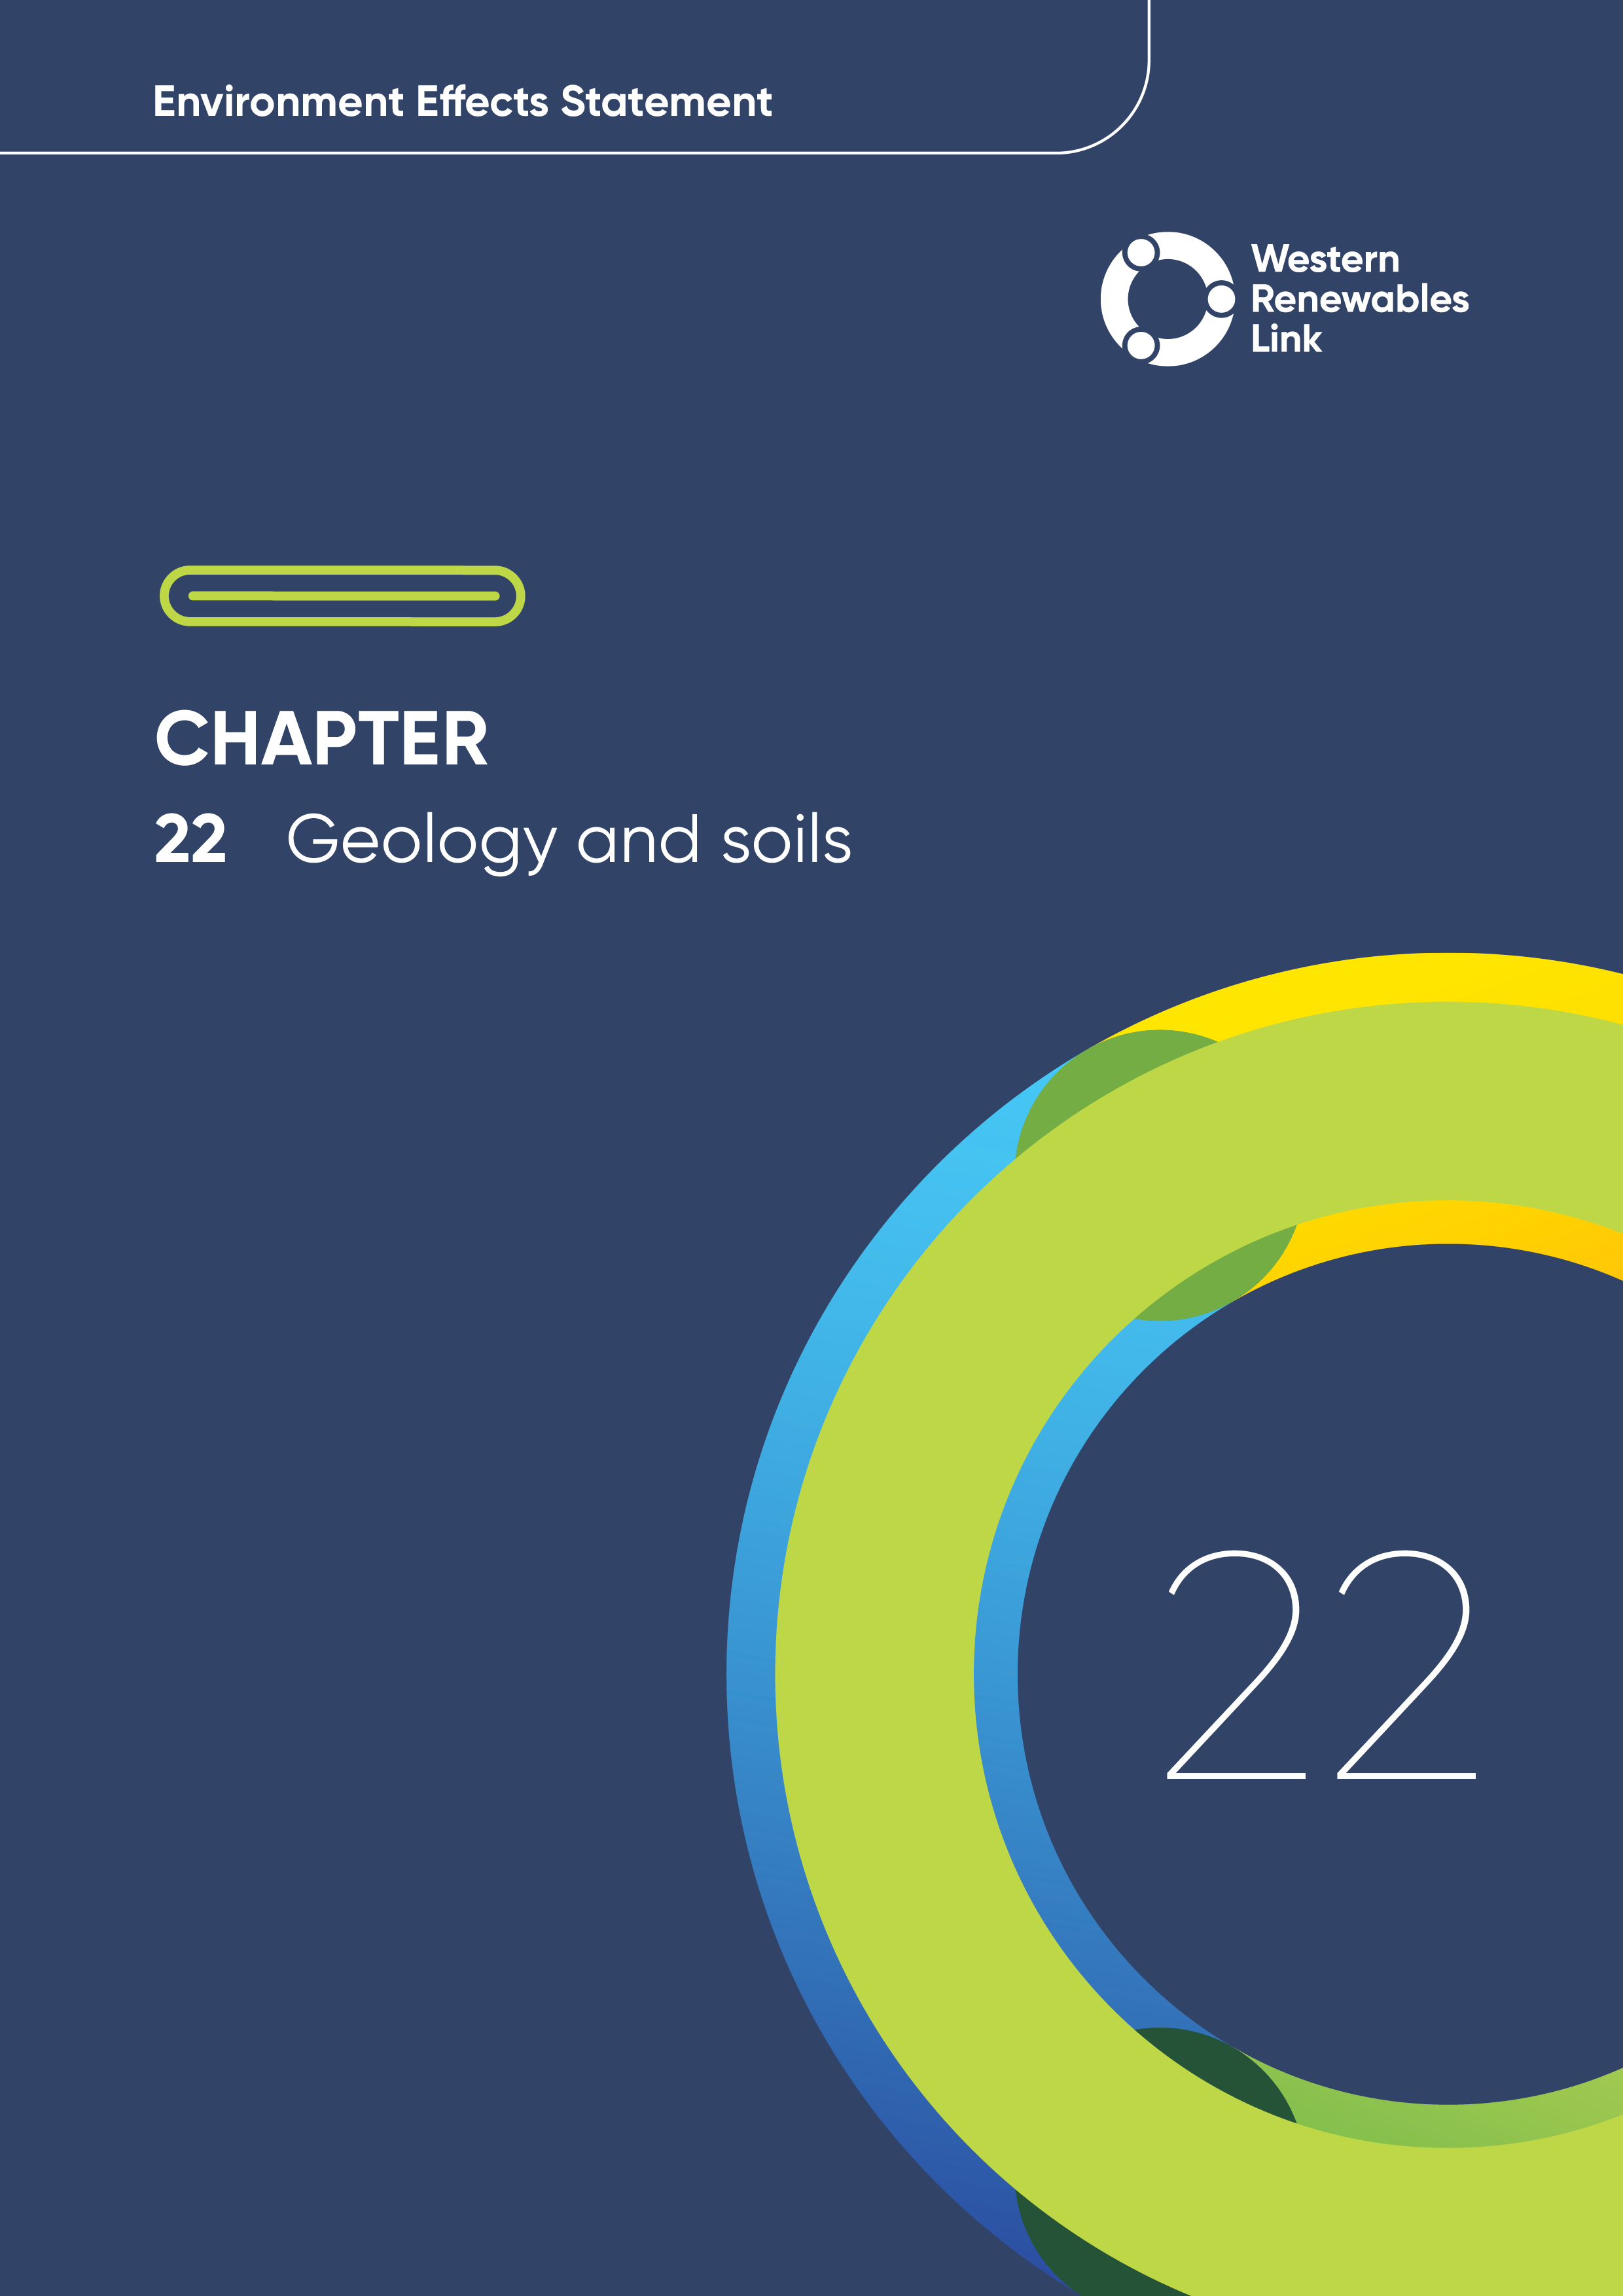

# Geology and soils

This chapter provides an overview of the potential impacts to geology and soils associated with the construction, operation and decommissioning of the Project. This chapter is based on **Technical Report Q: Geology and Soils Impact Assessment**.

This chapter describes the geology and soils on and below the ground, as well as natural earth processes such as erosion, transportation and deposition of sediment that shape the landscape and associated landforms in the Project Area.

Construction of the Project has the potential to alter the natural earth processes that shape the land and disturb soil and/or rock through activities such as construction of access tracks, construction of foundations for transmission towers and terminal stations, and earthwork activities associated with the Project.

Considerable effort has been applied to design of the Project to avoid, as far as practicable, steep slopes, and the siting of access tracks has sought to minimise disturbance to soil and avoid potentially unstable ground conditions. This detailed planning will continue as the Project design progresses, to reduce the extent and significance of the Project’s potential impacts on geology and soils.

## Evaluation objective

The scoping requirements identify the following evaluation objective relevant to geology and soils:

**Evaluation objective**

Maintain the functions and values of aquatic environments, surface water and groundwater quality and stream flows and prevent adverse effects on protected beneficial uses.

In response to this evaluation objective, impacts of the Project on geology and soils were assessed and measures to avoid, minimise or manage potential impacts have been developed. These measures are discussed throughout this chapter and have informed the development of Environmental Performance Requirements (EPRs). EPRs set out the environmental outcomes to be achieved through the implementation of mitigation measures during construction, operation and decommissioning to avoid, minimise and manage identified impacts. Cumulative impacts associated with relevant future projects were also assessed.

Further information on how the Project has been designed to avoid and minimise impacts is provided in **Chapter 5 Project development** and **Chapter 6: Project description**.

Other aspects covered in the Environment Effects Statement (EES) evaluation objective and relevant to geology and soils are addressed in the following EES chapters:

* **Chapter 23: Contaminated land**
* **Chapter 24: Groundwater**
* **Chapter 25: Surface water.**

## Method

This section summarises the method adopted in **Technical Report Q: Geology and Soils Impact Assessment**, which was informed by **Chapter 4: EES assessment framework and approach**. The key steps in assessing the impacts associated with geology and soils included:

* Defining a study area appropriate for geology and soils as presented in Figure 22.1. This included the Project Land, subdivided into four sections based on distinctive geological and geomorphological conditions (being Bulgana to Lexton, Lexton to Ballan, Ballan to Melton West and Melton West to Sydenham). The width of the study area varies from approximately 0.3 to 4km along the Proposed Route.
* Reviewing applicable Commonwealth and Victorian legislation, and relevant local, state and national standards, guidelines and policies.
* Conducting a desktop review of publicly available information to characterise the geology and soils within the study area, including:
  + Published geological and geomorphological maps
  + Previous geotechnical reports
  + Victorian planning schemes relating to geology and soils including Erosion Management Overlays (EMO) and Significant Landscape Overlays (SLO)
  + Published soil overlays and hazard susceptibility mapping, including:
    - Susceptibility of land (not subject to an EMO) to land degradation processes (e.g., gully erosion, landslip and wind erosion)
    - Hazard levels for land degradation processes based on a three-tier geomorphological mapping system from the Geomorphology of Victoria dataset.
  + The Victorian Soil Types dataset, which provides the mapped soil types in Victoria in accordance with the Australian Soil Classification
  + Victoria’s Salinity Provinces – a framework used to describe land and water (surface and groundwater) salinity in Victoria
  + Sites of Geological and Geomorphological significance as determined by the Geological Society of Australia.
* Reviewing the Digital Elevation Model generated from Project specific Light Detection and Ranging (LiDAR) surveys of the study area to map important geological features such as potential landslides, areas of erosion, existing drainage pathways and waterways.
* Consulting with the relevant regulatory authorities and key stakeholders including the Environment Protection Authority Victoria (EPA Victoria) and Department of Energy, Environment and Climate Action (DEECA, formerly DELWP), and reviewing the data provided by community members via the Project’s Social Pinpoint online mapping tool, which identified locations, features and values of importance.
* Conducting field investigations and targeted site inspections/walkovers at 38 checkpoint locations identified in the desktop review. These locations are mapped in Appendix A of **Technical Report Q: Geology and Soils Impact Assessment**. Soil samples were collected for geological laboratory testing at areas of potential concern, adjacent to checkpoint locations.
* Conducting a risk screening process to identify the key issues during construction, operation and decommissioning for investigation within the technical report.
* Identifying and assessing the potential impacts associated with soil erosion and dispersive soils, slope instability, compressible soil, reactive clay soil, saline soil and geologically significant sites during construction, operation and decommissioning. These impacts were evaluated according to the following ratings, in relation to the extent, magnitude and duration of impacts:
  + Negligible: No impact on landscape, environment, land-use, or assets due to negligible erosion, soil disturbance, or disruption to geological sites.
  + Minor: Minor, localized, and short-term disruptions due to some erosion, soil disturbance, or minor damage to geological sites.
  + Moderate: Moderate, medium-scale, and ongoing disruptions within the study area due to moderate erosion, soil disturbance, or moderate damage to geological sites.
  + Major: Significant, widespread, and long-term impacts beyond the study area due to major erosion, soil disturbance, or significant damage to geological sites.
  + Severe: Severe, regional, and irreversible damage to landscape, environment, land-use, assets, or geological sites due to erosion or soil disturbance.
* Identifying relevant future projects that could lead to cumulative impacts when considered together with the Project (refer to **Chapter 4: EES assessment framework and approach** for the full cumulative impact assessment method).
* Developing EPRs in response to the impact assessment to define the required environmental outcomes that the Project must achieve through the implementation of mitigation measures during construction, operation and decommissioning. Measures to reduce the potential impacts were proposed in accordance with the mitigation hierarchy (avoid, minimise, manage, rehabilitate and offset) and have informed the development of EPRs. Alternative mitigation measures could be implemented to comply with the EPRs based on the specific site conditions, available resources, and the Principal Contractor’s expertise.
* Following application of mitigation measures that would comply with the EPRs, determining residual impacts associated with the construction, operation and decommissioning of the Project, and evaluating their significance.

Figure .: Geology and soils study area

## Existing conditions

This section summarises the existing conditions for geology and soils according to the following key themes:

* Geological setting
* Geomorphology (e.g., landforms)
* Erosion and land stability
* Soil types (dispersive soils, saline soils, reactive soils, compressible soils)
* Sites of geological importance.

The study area was split into four sections based on distinctive geological and geomorphological conditions (being Bulgana to Lexton, Lexton to Ballan, Ballan to Melton West and Melton West to Sydenham).

The identified geological sites of significance, areas of potentially saline or erosive soils, areas of observed existing erosion, existing landslips and land susceptible to instability, and soils of other special characteristics in the study area can be found in **Technical Report Q: Geology and Soils Impact Assessment.**

* **Alluvial deposits**

Sediments composed of gravel, sand, silt or clay deposited in river channels or on floodplains.

Colluvial deposits

Loose, unconsolidated sediments that have been deposited at the base of hillslopes - transported by gravity (not by rivers or streams).

### Geological setting

##### Bulgana to Lexton

The geology from Bulgana to Lexton consists primarily of Cambrian age sedimentary rock units which comprise sandstone and siltstone which create many of the hills and elevated areas. Around rivers and streams, there are alluvial deposits that have been carried by water and settled into the ground.

##### Lexton to Ballan

The geology from Lexton to Ballan consists primarily of volcanic rocks which comprise basalt and scoria formed by lava flows during the Quaternary and Tertiary periods. Around Mount Bolton and Mount Beckworth and in the southern part of this section, there are large coarse-grained granite rocks from the Cambrian and Devonian periods. Near rivers and streams, there are alluvial deposits and at the base of the sedimentary hills are colluvial deposits.

##### Ballan to Melton West

The geology from Ballan to Melton has various layers of rocks and sediments. Around surface water features such as Goodman Creek and Merrimu Reservoir, there are alluvial deposits. These deposits often cut into volcanic rocks. There are also gravel and sediment layers, as well as volcanic rocks from the Pentland Hills and ancient sedimentary rocks from the Permian period. Beneath all these layers, and sometimes visible at the surface, are even older bedrock layers comprised of marine sandstone, siltstone, and shale.

##### Melton West to Sydenham

The geology from Melton West to Sydenham mainly features volcanic olivine basalt rocks from the Quaternary and Tertiary periods. Around rivers and streams, there are alluvial deposits cutting into these basalt rocks. In low-lying areas near Toolern Creek and other small drainage lines, there are colluvial deposits from soil and rock movement.

### Geomorphology, erosion and land stability

##### Bulgana to Lexton

Situated within the Western Uplands, this section has rolling hills and ridges formed by sedimentary rock units, with valleys filled with narrow creeks and broad low-lying areas. An example of the typical landscape observed within this section is shown in Figure 22.2, looking towards the hills surrounding Mount Lonarch, with Avoca River and floodplain at base of slope. This is a view towards the north-west, along the existing 220 kV transmission line connecting Ballarat to Horsham.

There are several instances of gully erosion has occurred, especially on steep slopes and near creeks, due to fine soil and loose material. Some minor instability, such as uneven ground and slow soil movement, was also observed on steep hills and valleys. The field observations are consistent with DEECA erosion and landslide susceptibility mapping, which show that hilly areas and ridgelines are prone to erosion, but landslides are unlikely.

##### Lexton to Ballan

Situated within the Western Uplands, this section has gently rolling hills formed by lava flows with isolated steep hills created from volcanic eruptions. An example of the typical landscape observed within this section is shown in Figure 22.3, showing a volcanic eruption point in the distance surrounded by flat plains, located near Allendale.

Several areas in this section are subject to EMO mapping, which are mainly associated with surface watercourses and volcanic eruptions. EMO overlays protect land prone to erosion and landslip by minimising land disturbance and inappropriate development.

There are a few areas with soil gully erosion, generally these areas are near steep slopes and around existing creeks, but overall, the area has low erosion risk.

Localised minor land instability was observed in this section, mainly occurring where creek banks have cut into the underlying basalt rock resulting in some soil movement. This aligns with DEECA mapping which shows a low landslide risk in this section.

Figure . Example landscape - Bulgana to Lexton

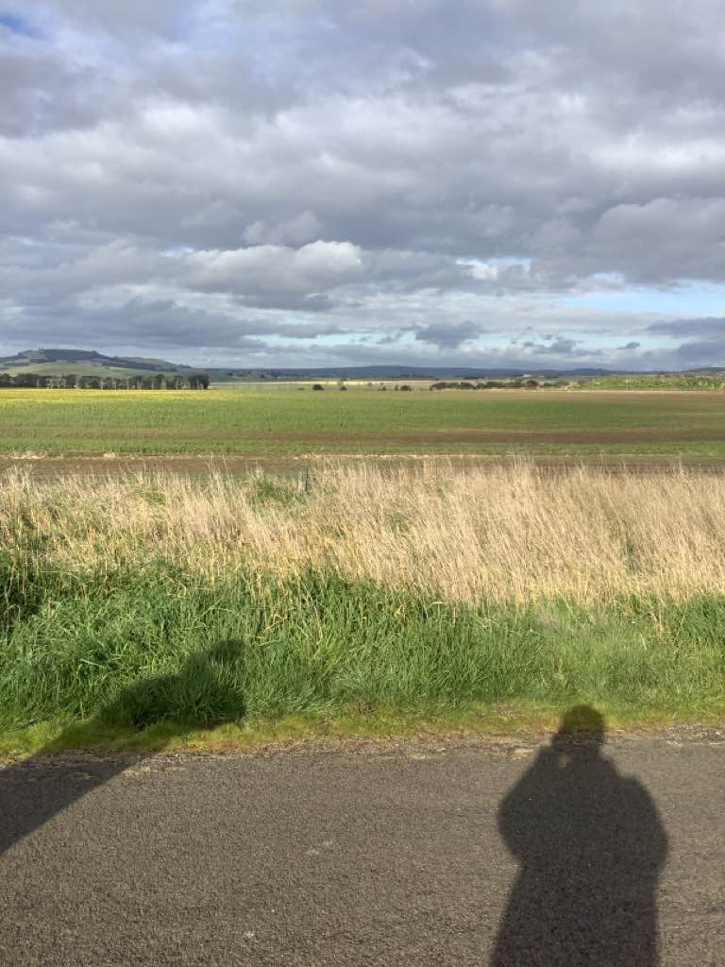

Figure . Example landscape - Lexton to Ballan

##### Ballan to Melton West

Situated within the Western Uplands and Western Plains geomorphic provinces, this section has rolling hills with steep ranges formed by sedimentary rock, with broad low-lying areas filled with alluvial deposits. An example of the typical landscape observed within this section is shown in Figure 22.4, looking over flat plains associated with the Lerderderg River towards an elevated ridgeline, located near Darley.

Several areas of active and inactive gully erosion were observed, mainly on steep slopes. This aligns with DEECA mapping which indicates this section has a high susceptibility to gully erosion on hills and ridgelines. This section is generally considered to have a low risk of landslides, but recent observations show that landslides have occurred on slopes that are close to the Proposed Route.

##### Melton West to Sydenham

Situated within the Western Plains, this section is characterised with flat volcanic plains and low-lying areas near watercourses and drainage lines. An example of the typical landscape observed within this section is shown in Figure 22.5, showing how the land drops around Kororoit Creek in the foreground, and rises at Mount Kororoit, a volcanic eruption point near Melton.

A few areas of gully erosion were observed in this section; however, the soils in this area can easily break apart which may lead to tunnel and gully erosion if exposed. DEECA mapping indicates this section generally has a low susceptibility to gully erosion, with only a small section of the low-lying area mapped as moderate.

Localised land instability and rock outcropping were observed on steep valley slopes of Kororoit Creek.

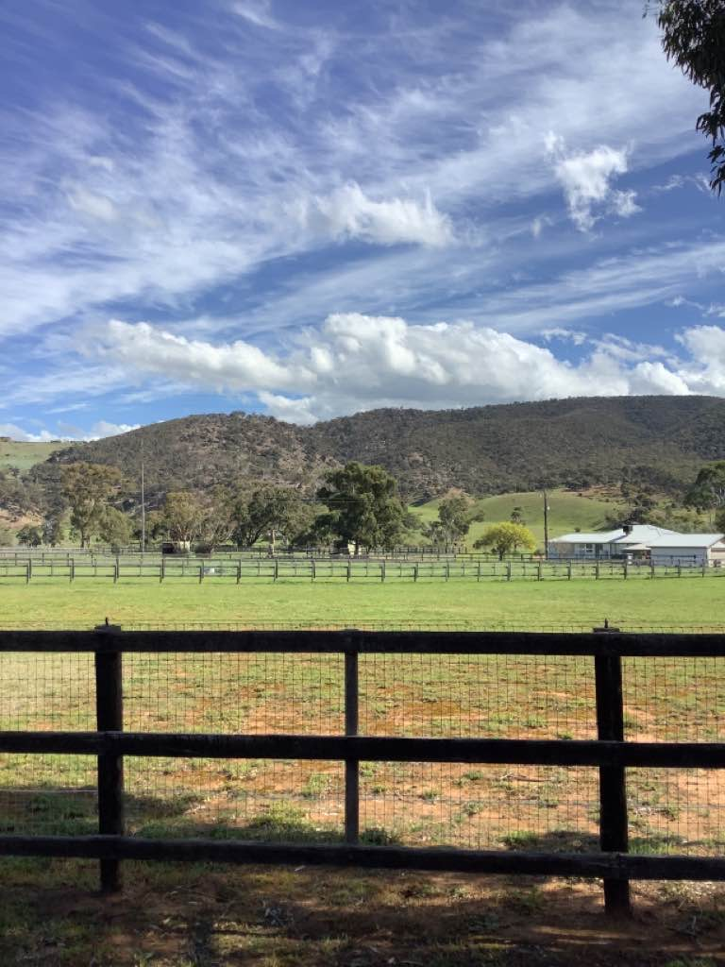

Figure . Example landscape - Ballan to Melton West

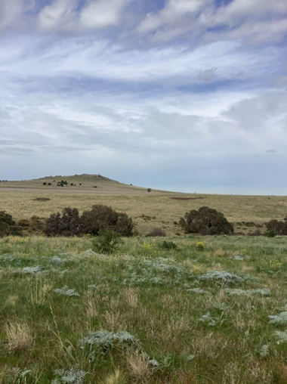

Figure . Example landscape - Melton West to Sydenham

* Salinity provinces

Salinity provinces are specific geographic areas where the landscape and physical process contributing to salinity are similar.

Each province contains areas where salinity has been identified in the soil, groundwater, or surface water.

### Soil types and presence of dispersive soils

##### Bulgana to Lexton

Soil types in this section are predominantly Chromosols and Rudosols from Bulgana to Amphitheatre Creek and Sodosols from Amphitheatre Creek to Lexton. Possible soil salinity was indicated by the presence of bare patches of soil in some areas, with the section intersecting the Elmhurst, Amphitheatre and Lexton salinity provinces (shown in Figure 22.6). Limited soil salinity testing indicated that soils are slightly/moderately saline to non-saline. The likelihood of encountering reactive soils is very low. Compressible soils are likely to be encountered around creeks and rivers within this section.

##### Lexton to Ballan

* Soil types

**Chromosols** are typically characterised by alluvial deposits and are non-sodic (low levels of sodium and well-draining).

**Dermosols** are generally stable soils; however, they can exhibit high silt content in areas which can lead to erosion.

**Ferrosols** are typically acidic and well-draining.

**Kurosols** are known to display high acidity at surface (low pH level) that could potentially corrode construction materials.

**Sodosols** are susceptible to dispersion and are extremely prone to gully and tunnel erosion if subsoils are exposed or if surface runoff is poorly managed.

**Vertosols** are known to be susceptible to cracking, slickensides and shrink-swell behaviour.

**Saline soils** contain high levels of soluble salts, which can hinder plant growth by making it difficult for plants to absorb water.

**Reactive soils** are clay-type soils that swell on wetting and shrink on drying, which can cause ground movement that affects the footings or foundations of buildings and structures.

Soil types in this section are predominantly Dermosols, Ferrosols and Kurosols from Lexton to Kingston, Ferrosols from Kingston to Bolwarrah and Sodosols and Chromosols from Bolwarrah to Ballan. This section intersects the upper Loddon Volcanic Plains and Upper Moorabool salinity provinces (shown in Figure 22.6). However, no obvious signs of salt scalding or salinity indicator species were observed. The likelihood of encountering reactive soils this section is high, and compressible soils are also likely to be encountered around creeks and rivers.

##### Ballan to Melton West

Soil types in this section are mainly Sodosols with a small section of Vertosols between Ballan and Myrniong, Dermosols from Myrniong to the Lerderderg River and Sodosols and Chromosols from Lerderderg River to Melton West (shown in Figure 22.6). No salinity provinces are located within this section and no obvious signs of salt scalding or salinity indicator species were observed in this section. The likelihood of encountering reactive soils this section is high, and compressible soils are also likely to be encountered around creeks and rivers.

##### Melton West to Sydenham

Soil types in this section are mainly Sodosols. The risk of dispersion increases for sodic soils where the overlying topsoil is removed or if surface runoff is poorly managed. This section intersects the Lancefield - Sunbury salinity province (shown in Figure 22.6). However, no obvious signs of salt scalding or salinity indicator species were observed in this section. The likelihood of encountering reactive soils this section is high, and compressible soils are also likely to be encountered around creeks and rivers.

### 



Figure . Salinity provinces intersected by the Proposed Route

### Sites of geological significance

Sites of geological significance represent a specific characteristic of the region or include an outstanding, rare, or possibly unique geological or geomorphological feature. Several sites of geological significance exist along or near the study area at:

* **Bulgana to Lexton:** Landsborough Fault Road cutting and Mount Direction Roof Pendant Remnant
* **Lexton to Ballan:** Mount Beckworth and Hepburn Lagoon
* **Ballan to Melton West:** Lerderderg River Morven Terrace, Lerderderg River Permian sequence, Lerderderg Valley Alluvial Fan, Pykes Hill and Lake Merrimu road cutting
* **Melton West to Sydenham**: Mount Kororoit

Several areas subject to an SLO are also present within the study area. The purpose of these SLO areas is to “*to implement the Municipal Planning Strategy and the Planning Policy Framework, to identify significant landscapes and to conserve and enhance the character of significant landscapes*” (DTP, 2018). These areas are not listed as geologically significant features; however, there is a permit application requirement to develop or carry out works in these areas. The following relevant locations were identified:

* **Lexton to Ballan**: Potential eruption point near Mount Gap, eruption point near Mount Prospect, eruption point near Newlyn Reservoir, Eruption point near Mount Bolton adjacent to the study area and eruption point near Birch Hill
* **Ballan to Melton West**: Steep hills west of Bacchus Marsh
* **Melton West to Sydenham**: Eruption point near Mount Kororoit.

## Construction impacts

This section outlines the key issues identified through the risk screening process and associated potential impacts during the construction of the Project. The key issues and impacts identified for geology and soils are discussed according to the following themes:

* Soil disturbance: encountering, disturbing or constructing on top of dispersive or erosive soils, reactive soils, and saline soils. The removal of vegetation will expose soils, and if unmitigated could contribute to erosion.
* Land instability: slope instability caused by earthworks undertaken for the Project, and possible excavation, vehicle movement or construction in areas where compressible soils are located.
* Sites of geological significance: potentially damaging or restricting access to geologically significant sites that are on or close to the Proposed Route.

### Soil disturbance

As described in Section 22.3.4, dispersive and erosive soils are likely to be present along much of the Proposed Route. This means that, without appropriate measures in place, activities such as topsoil stripping and removal of some vegetation have the potential to result in a loss of soil material that can lead to sedimentation of waterways and adjacent land. Excessive erosion and scouring at the bottom of slopes on hillsides and ridgelines could undermine these slopes and cause or exacerbate instability.

Re-use of erosive or dispersive soil for earthworks (such as access tracks, embankments) will need to be managed as the soil may be susceptible to erosion and gullying, which could affect the integrity of earthworks and potentially lead to sedimentation of waterways and adjacent land.

In the absence of mitigation, construction of the Project may cause major soil erosion or dispersive soil impacts. The Project will implement a suite of mitigation strategies that comply with the EPRs and avoid and minimise these impacts. The Principal Contractor will avoid, where practicable, areas susceptible to soil erosion and areas with dispersive soils and implement design options and measures to limit erosion and minimise earthworks through the implementation of a pre-construction Site Investigation Plan (EPR GSL1, EPR GSL3). In addition, an Erosion and Sediment Control Plan (EPR GSL2) as part of the Construction Environment Management Plan (CEMP) (EPR EM2), including inspection requirements for erosion prone areas will be developed and implemented. Application of these avoidance and management measures to comply with the EPRs will reduce the likelihood, extent and magnitude of impacts associated with soil erosion and dispersive soils, and residual impacts are low.

Reactive soils are found extensively throughout western Victoria and are likely to be present along the Proposed Route. Without adequate design, pre-construction investigations, foundations, and drainage, these soils may cause moderate ground surface movement that could affect the integrity of temporary access tracks and hardstands, as well as permanent access tracks and structures. Reactive clay soils may also be unsuitable for re-use as fill without treatment.

In the absence of mitigation, construction of the Project may cause moderate impacts to reactive soils. However, the Principal Contractor will avoid, where possible, areas of reactive soils identified during geotechnical site investigations (EPR GSL1). In addition, temporary and permanent earthworks will consider drainage diversion, and provide subgrade treatment or treatment of reactive soil for re-use, if required, to preserve integrity of the infrastructure throughout the Project’s design life (EPR GSL3). Application of avoidance and mitigation measures to comply with the EPRs will reduce the likelihood, extent and magnitude of impacts associated with reactive soils, and residual impacts are negligible.

Disturbance and / or stockpiling of saline soils during construction or the use of saline soils as fill material for earthworks may result in runoff having increased salinity during wet weather. Increased salinity could moderately impact the water quality of watercourses, or existing drainage systems and groundwater. Saline soil may also cause corrosion of buried concrete structures such as the piled foundations for the towers. The Principal Contractor will avoid, where possible, areas of saline soils (EPR GSL1). Permanent works in areas where saline soil is identified during geotechnical site investigations will be designed to manage these types of soils to protect the integrity of the Project infrastructure throughout the design life (EPR GSL1). In addition, an Erosion and Sediment Control Plan (EPR GSL2) as part of the CEMP (EPR EM2) will include measures to control and manage saline runoff in locations where saline soil is disturbed and/or stockpiled during construction works (EPR GSL2). Application of these avoidance and management measures to comply with the EPRs will reduce the likelihood, extent and magnitude of impacts associated with saline soils, and residual impacts are low.

* Batter design

Batter slopes are a control measure that help to maintain slope stability and prevent erosion during excavation and earthworks. To batter an excavation means to angle the slope of the wall or excavation at an angle greater than 90 degrees, enhancing the stability of the unsupported slope.

To be an effective control measure, the gradient of the batter slope needs to be designed in consideration of the geological conditions present.

### Land instability

Construction of access tracks, laydown areas and workforce accommodation facilities, distribution line crossovers, temporary hardstands and tower foundations will be undertaken on or near slopes of volcanic hills, hills and ridgelines. Observations of existing hill slopes indicated that most slopes along the Proposed Route are stable; however, earthworks that cut into the slope or otherwise alter the slope in some way may cause instability. Slope instability may also result from inadequate slope and batter design.

Areas that could be affected are:

* Hills and ridgelines formed from rocks of the Pyrenees Formation between Bulgana and Lexton
* Hills and ridgelines formed from rocks of the Castlemaine Group between Lexton and Ballan
* Haydens Hill (Located between Lexton and Ballan)
* Most hills, ridgelines, valley side slopes between Ballan and Melton West, in particular the valley side slopes around Pykes Creek
* Valley side slopes at Kororoit Creek (Located between Melton West and Sydenham).

Uncontrolled earthworks on slopes could potentially result in slope instability to the landscape, environment, existing land-use and assets within and beyond the Project Land, and result in major impacts. The Principal Contractor will avoid, where possible, areas susceptible to slope instability and minimise cut earthworks on slopes identified during geotechnical site investigations (EPR GSL1). If works are required on slopes, they will be conducted in accordance with the industry standards (EPR GSL1). Application of these avoidance and mitigation measures to comply with the EPRs will reduce the likelihood, extent and magnitude of impacts associated with slope instability, and residual impacts are minor.

Soft, compressible and potentially saturated soils may be encountered around watercourses. In the absence of mitigation, excavation, vehicle movements and the construction of structures in these locations have the potential to result in moderate impact to settlement and/or land instability due to the inadequate bearing capacity of the soils. The Principal Contractor will avoid, where possible, areas of compressible soils (EPR GSL1). Temporary and permanent earthworks and subgrade treatment will be implemented, as required, to prevent excessive settlement or failure of access roads, temporary hardstands, piling and crane platforms (EPR GSL1). Application of these avoidance and mitigation measures to comply with the EPRs will reduce the likelihood, extent and magnitude of impacts associated with compressible soils, and residual impacts are negligible.

### Sites of geological significance

Geologically significant sites and areas subject to SLO overlay are described in Section 22.1.1.

In the absence of mitigation, construction works may moderately impact geologically significant sites. However, the Principal Contractor will avoid, as far as reasonably practicable, sites of geologically significant sites identified during geotechnical site investigations by situating works outside of these areas (EPR GSL1). In addition, access controls and measures to maintain access by the general public to geologically significant sites will be developed and implemented as part of the CEMP (EPR GSL4, EPR EM2). Application of these avoidance and management measures to comply with the EPRs will reduce the potential to impact geologically significant sites, and residual impacts are negligible.

## Operation impacts

No geological impacts are expected from the Project’s operational activities. Impacts to soils include the potential for spoil with low levels of contamination generated during construction to be reused within the Project Area. During operation, AusNet will develop and implement controls and measures in accordance with AusNet’s existing operational procedures to maintain access to publicly accessible geologically significant sites during operation (EPR GSL4).

In addition, AusNet will develop an inspection and maintenance schedule as part of AusNet’s operational requirements to inform adaptive management and/or measures to maintain integrity of infrastructure (EPR GSL3). This will detail the minimum ongoing inspection requirements needed to inform adaptive management and preserve the integrity of the Project during operation.

Based on this, residual impacts to geology and soils are expected to be negligible during the Project’s operation.

## Decommissioning impacts

As decommissioning activities will be similar to those that occur during construction, the impacts relating to geology and soils are assessed to be the same as for the construction stage.

Accordingly, the EPRs developed to manage impacts during construction would also be applicable for decommissioning in accordance with the conditions of the time. This would also be managed by a Decommissioning Management Plan (EPR EM11) which would include mitigation measures for sediment and erosion control.

Based on this, residual impacts are expected to be negligible for geology and soils.

## Cumulative impacts

Cumulative impacts have been assessed by identifying relevant future projects that could contribute to cumulative impacts on geology and soils, considering their spatial and temporal relationships to the Western Renewables Link Project. The projects considered as potentially relevant to geology and soils include:

* Elaine Solar Farm
* Lerderderg River Nature Trail
* Melbourne Renewable Energy Hub
* Merrimu Precinct Structure Plan/Bacchus Marsh Urban Growth Framework
* Nyaninyuk Wind Farm
* Outer Metropolitan Ring Road/E6
* Sydenham Terminal Station Rebuild
* Toolern Vale Solar Farm
* Victoria to New South Wales Interconnector West
* Western Irrigation Network Scheme.

Potential cumulative impacts to geology and soils can arise from earthworks occurring across multiple projects that may collectively impact slope stability, disturb erosive, compressible reactive or saline soils or restrict access to geological sites of significance. The assessment found that the cumulative impacts of the relevant future projects can be managed effectively through avoidance, engineering and administrative controls and the potential for significantly adverse cumulative impact is negligible. Further, construction related risks from these projects can be primarily controlled with the proposed EPRs for the Western Renewables Link Project – that is, the EPRs will control WRL impacts to avoid cumulative impacts with other projects.

## Environmental Performance Requirements

Potential impacts identified through **Technical Report Q: Geology and Soils Impact Assessment** have informed the development of EPRs for the Project. EPRs set out the environmental outcomes to be achieved through the implementation of mitigation measures during construction, operation and decommissioning. While some EPRs are performance based to allow flexibility in how they will be achieved, others include more prescriptive measures that must be implemented. Compliance with the EPRs will be required as a condition of the Project’s approval. Table 22.1 details the proposed EPRs developed for geology and soils.

Table . Environmental Performance Requirements

| EPR code | Requirement |
| --- | --- |
| EPR GSL1 | **Develop and implement a pre-construction Site Investigation Plan to inform detailed design**   1. Prior to the commencement of construction works, develop and implement a pre-construction Site Investigation Plan for geotechnical site investigations to inform detailed design. The plan must be developed in accordance with AS 1726-2017 and include the locations, number, and type of geotechnical site investigations to determine the sub-surface conditions and soil/rock characteristics, and to characterise and assess the nature of the soils, including compressible, reactive, erosive/dispersive and saline soils. 2. Detailed design of the Project must consider the findings of the geotechnical site investigations, with design measures to be incorporated as far as reasonably practicable to reduce the potential for erosion and sedimentation (including considering appropriate surface drainage and existing topography of land), and impact to geologically significant sites. Detailed design must consider: 3. Earthworks design must be undertaken in accordance with AS 3798-2007. 4. Landslide risk and slope stability must be assessed in accordance with AGS Practice Note Guidelines (AGS, 2007c). Mitigation measures and practices must be developed with reference to AGS GeoGuide LR8 (AGS, 2007e). 5. Foundation design must be undertaken in accordance with AS/NZS 7000-2016 with reference to the handbook HB331:2020, AS2159-2009 and AS5100.3:2017 as applicable. |
| EPR GSL2 | **Develop and implement a Sediment and Erosion Control Management Plan**   1. Develop and implement a Sediment and Erosion Control Management Plan as part of the Construction Environmental Management Plan (CEMP) (EPR EM2). 2. The Sediment and Erosion Control Management Plan must incorporate drainage, erosion and sediment control measures and stockpile management from industry guidelines, including IECAA Best Practice Erosion and Sediment Control, 2008 and EPA Victoria Publication No. 1834.1: Civil construction, building and demolition guide. It must include measures to: 3. Minimise clearance of vegetation and retain existing vegetation wherever possible, particularly along drainage lines and waterways, steep slopes and areas with unstable soils. 4. Stabilise exposed soil where applicable with the appropriate structural materials and media for the construction activities (e.g., stabilisation matting, rock armour or vegetation). 5. Manage vehicle movement to designated roads and access areas, and use dust-suppression measures where practicable. 6. Where, required, reinstate vegetation as soon as works in an area have finished (staged reinstatement). Maintain erosion controls until vegetation is established (as per EPR GSL3). 7. Install sediment control measures around stockpiles to contain sediment 8. If required, treat in situ and site won dispersive or reactive soils prior to construction to improve the performance. 9. Any imported material should be tested for dispersive/reactive soil behaviour prior to use in construction in accordance with AS 3798-2007 and the Project earthwork specification. 10. Maintain existing erosion management controls within existing biodiversity corridors and reinstate if damaged. |
| EPR GSL3 | **Identify and remediate erosion and land stability issues**   1. Develop and implement an inspection and maintenance schedule as part of the Construction Environmental Management Plan (CEMP) (EPR EM2) and AusNet’s operational procedures to inform adaptive management and/or measures to maintain integrity of infrastructure during and post construction. The schedule will include: 2. Minimum ongoing inspection and monitoring requirements, including frequency, timing and locations. 3. Requirements for ongoing maintenance of permanent erosion control measures (e.g., vegetation). 4. Remediation requirements for areas that have experienced unexpected disturbance that have not been controlled appropriately with other measures. |
| EPR GSL4 | **Maintain current public access to geologically significant sites**   1. Develop and implement access controls and measures as part of the Construction Environmental Management Plan (CEMP) (EPR EM2) and AusNet’s operational procedures to maintain safe access (where sites are currently accessible by the general public) to geologically significant sites during construction and operation. 2. Geologically significant sites include the following locations: 3. Bulgana to Lexton: 4. Landsborough Fault road cutting (BL120) 5. Mount Direction Roof Pendant Remnant, (BL123). 6. Lexton to Ballan: 7. Mount Beckworth (BL39) 8. Hepburn Lagoon (BL45) 9. Potential eruption point near Mount Gap (SLO), eruption point near Mount Prospect (SLO), eruption point near Newlyn Reservoir (SLO)1 10. Eruption point near Mount Bolton (SLO)1 adjacent to the study area and eruption point near Birch Hill (SLO)1 within the study area. 11. Ballan to Melton West: 12. Lerderderg River Morven Terrace (ML294), Lerderderg River Permian sequence (ML201), Lerderderg Valley Alluvial Fan (ML291) 13. Pykes Hill (ML278) 14. Lake Merrimu road cutting (ML113) 15. Steep hills west of Bacchus Marsh (SLO)1. 16. Melton West to Sydenham: 17. Mount Kororoit (ML66) 18. Eruption point near Mount Kororoit (SLO)1. 19. Distribution line crossovers: 20. Landsborough Fault road cutting (BL120) 21. Lerderderg River Permian sequence (ML201) and Lerderderg River Morven Terrace (ML294) 22. Mount Kororoit (ML66) 23. Eruption point, near Newlyn Reservoir (SLO)1 24. Steep hills west of Bacchus Marsh (SLO)1 25. Eruption point near Mount Kororoit (SLO)1.   Note: 1 indicates that Sites are not identified as geologically significant sites however they are covered by a SLO. |

Other EPRs contribute to a reduction in the magnitude, extent and duration of impacts for geology and soil values. Additional EPRs related to geology and soils include:

* EPR EM2 – Develop and implement a Construction Environmental Management Plan
* EPR EM11 – Develop and implement a Decommissioning Management Plan.

Refer to **Chapter 29: Environmental Management Framework** for full detail of these EPRs.

An ongoing inspection and maintenance schedule will be developed as part of the CEMP (EPR EM2) and AusNet’s operational procedures to identify and remediate erosion and land stability issues should they arise. This schedule will set the minimum ongoing monitoring requirements, including timing, frequency and locations.

The objectives of proposed monitoring programs for the Project required by the EPRs are outlined in **Chapter 29: Environmental Management Framework**.

## Summary of residual impacts

With the application of the EPRs, residual impacts associated with geology and soils are minor to negligible:

* Residual impacts due to the potential disturbance of dispersive or erosive soils, reactive soils, and saline soils during construction are minor to negligible. Where practicable, the Project will avoid or minimise disturbance in these areas, and soil disturbance will be addressed in the Erosion and Sediment Control Management Plan (EPR GSL2). If required, dispersive or reactive soils will be treated on site to further reduce the potential for impact.
* Residual impacts to land stability during construction are minor to negligible. These impacts can be managed effectively through avoidance, engineering and administrative controls, and ongoing inspection and maintenance schedule will be implemented as part of the CEMP (EPR EM2).
* Residual impacts to sites of geological significance are negligible. Where sites are currently accessible by the general public, measures will be implemented to maintain safe access to geologically significant sites along the Proposed Route (EPR GSL4).
* Operation of the Project will not result in impacts to geology or soils. An inspection and maintenance schedule will be developed in accordance with AusNet’s existing operational procedures, to inform adaptive management and maintain the integrity of the Project post-construction.
* Residual impacts to geology or soils during decommissioning are considered to be the same as for the construction stage. As such, EPRs developed to manage impacts during construction will also be applicable for decommissioning and will be incorporated into the Decommissioning Management Plan (EPR EM11).

With the implementation of measures to comply with EPRs, it is considered that the Project meets the geology and soils aspects of the evaluation objective “*Maintain the functions and values of aquatic environments, surface water and groundwater quality and stream flows and prevent adverse effects on protected beneficial uses.”*

