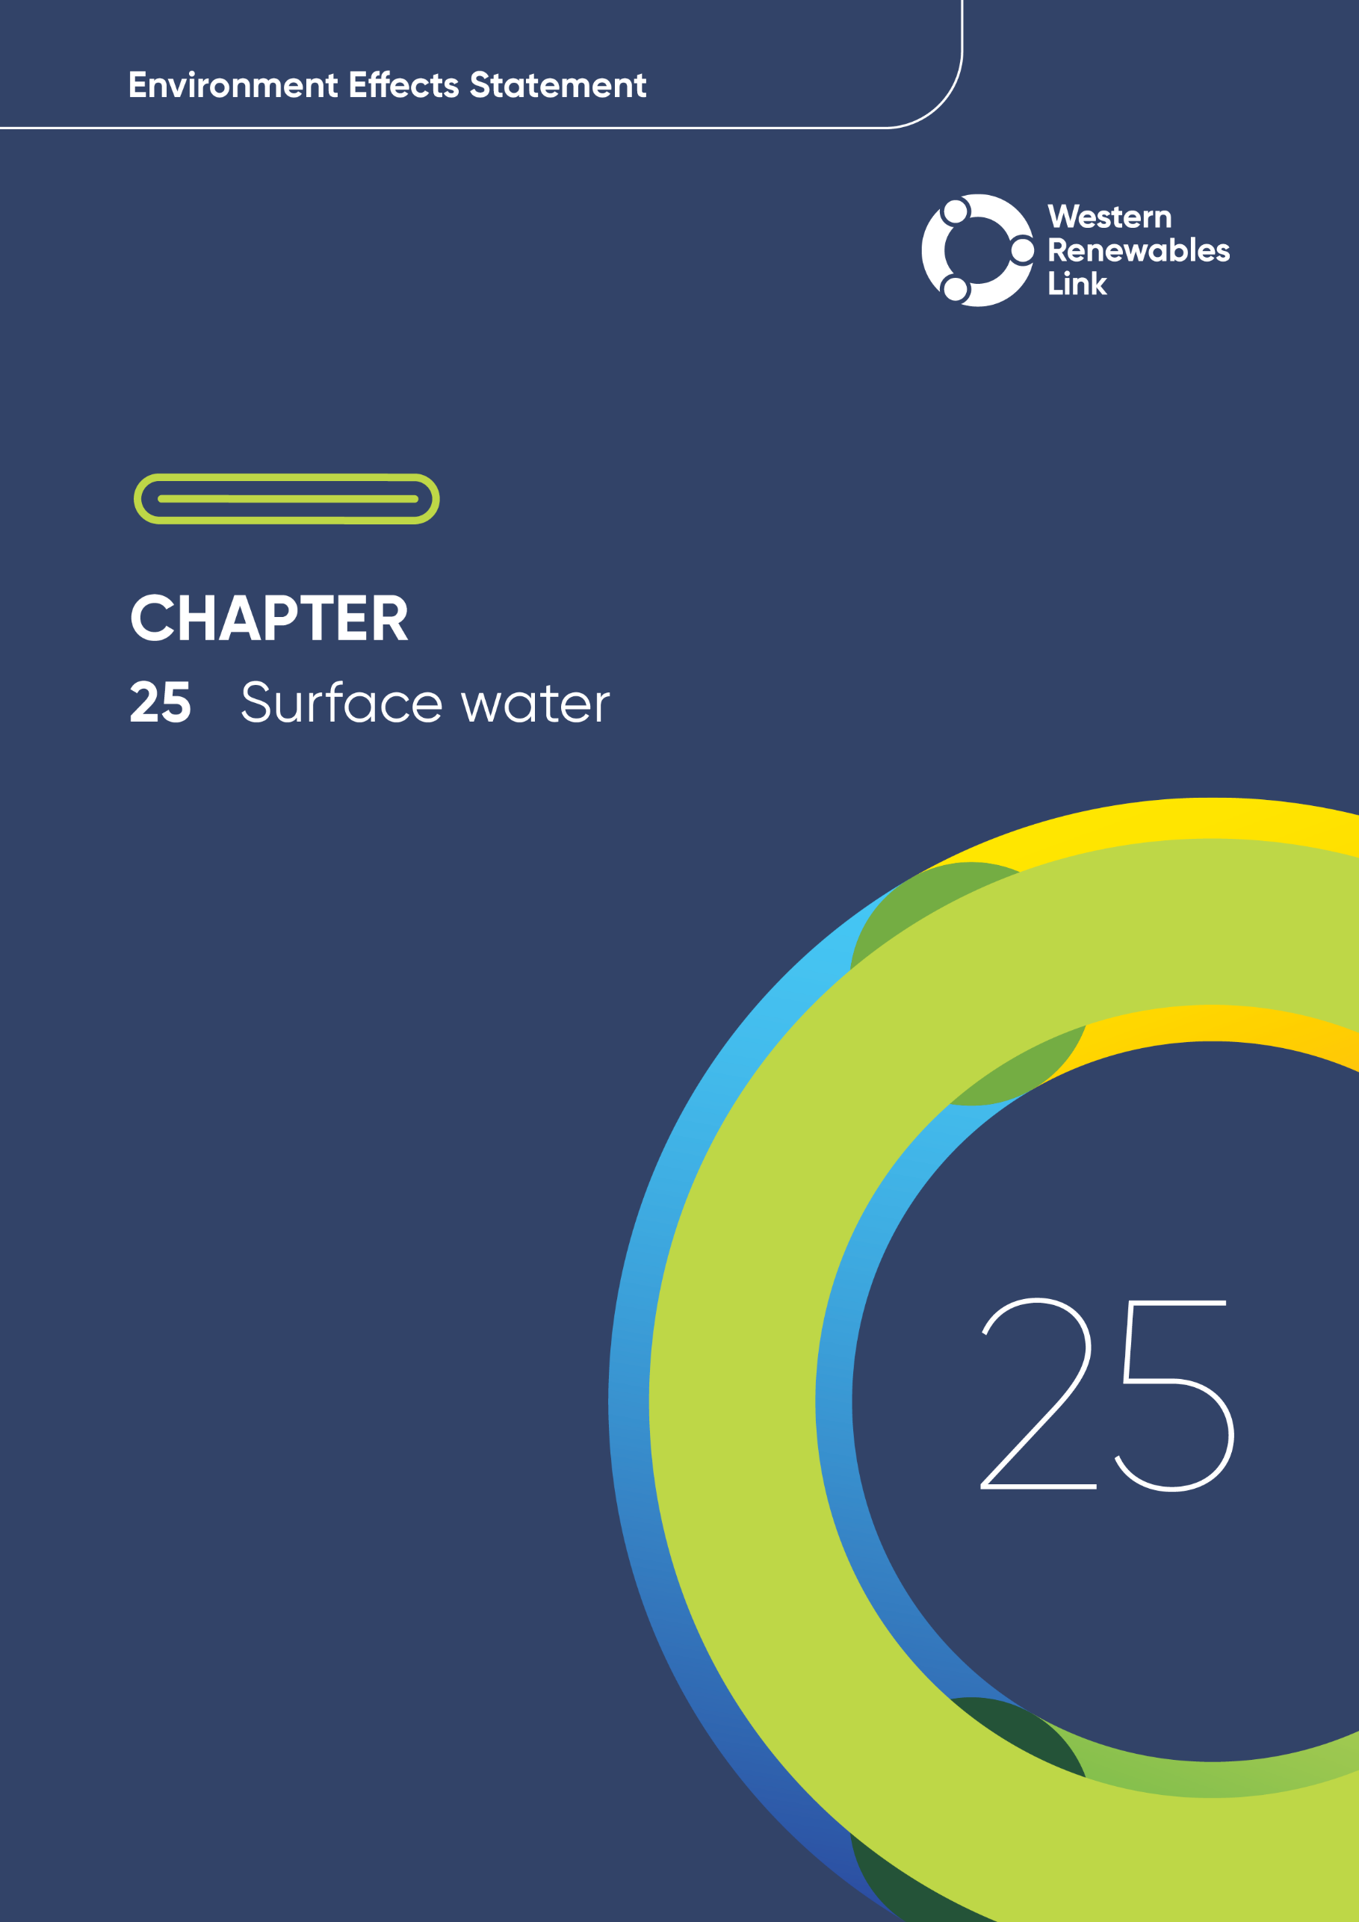

# Surface water

This chapter provides an overview of the potential surface water impacts associated with the construction, operation and decommissioning of the Project. This chapter is based on **Technical Report T: Surface Water Impact Assessment**.

Surface water includes natural water on the land’s surface including streams, lakes and wetlands. It provides aquatic and riparian habitat, supports recreational, domestic, agricultural and industrial uses and has Aboriginal cultural heritage values. The Project traverses several waterways and water bodies with varying characteristics including small, ephemeral creeks and major waterways with permanent flows.

## Evaluation objective

The scoping requirements identify the following evaluation objective relevant to surface water:

**Evaluation objective**

Maintain the functions and values of aquatic environments, surface water and groundwater quality and stream flows and prevent adverse effects on protected beneficial uses.

In response to this evaluation objective, potential impacts of the Project on surface water were assessed and measures to avoid, minimise or manage potential impacts have been identified. These measures are discussed throughout this chapter and have informed the development of the Environmental Performance Requirements (EPRs). EPRs set out the environmental outcomes to be achieved through the implementation of mitigation measures during construction, operation and decommissioning to avoid and mitigate identified impacts. Cumulative impacts associated with relevant future projects were also assessed.

Further information on how the Project has been designed to avoid and minimise impacts is provided in **Chapter 5: Project development** and **Chapter 6: Project description**.

Other aspects covered in the Environment Effects Statement (EES) evaluation objective relevant to surface water are addressed in the following EES chapters:

* **Chapter 8: Biodiversity and habitat**
* **Chapter 22: Geology and soils**
* **Chapter 23: Contaminated land**
* **Chapter 24: Groundwater.**

## Method

This section summarises the method adopted in **Technical Report T: Surface Water Impact Assessment**, which was informed by **Chapter 4: EES assessment framework and approach**. The key steps in assessing the potential impacts associated with surface water included:

* Defining a study area appropriate for surface water as presented in Figure 25.1. This included the Project Land, with additional consideration given to broader regional catchment and environmental values that may be impacted by the Project.
* Reviewing applicable Commonwealth and Victorian legislation, and relevant local, state and national standards, guidelines and policies.
* Conducting a desktop review and analysis to assess the existing surface water conditions including key waterway characteristics, values and protected areas, flood behaviour and water quality, including:
  + Identifying environmental values using publicly available mapping and databases, and additional relevant reports where available, including from CMAs databases.
  + Analysing water quality, flow and flooding data for waterways in the study area using published reports from water authorities and Catchment Management Authority (CMA) flood data.
* The following data sources and reference standards were reviewed:
  + Aerial photography, topographic maps and LiDAR to categorise defined and undefined waterways.
  + Published reports from water authorities and CMA flow and flood data.
* Catchment Management Authorities (CMAs)

CMAs are responsible for the sustainable management of land, water, and biodiversity resources within a specific catchment area.

The catchment areas traversed by the Project are managed by the Wimmera CMA, North Central CMA, Corangamite CMA, and Melbourne Water (which now undertake the responsibilities of the former Port Phillip and Westernport CMA).

* Surface water related fieldwork was not conducted as desktop assessment of the Project design and known surface water values was sufficient to identify potential impacts and develop mitigation measures. The surface water assessment also relied on the biodiversity field surveys undertaken to inform **Technical Report A: Biodiversity Impact Assessment**.
* Conducting a risk screening process to identify the key issues during construction, operation and decommissioning for investigation within the technical studies.
* Consulting with the relevant regulatory authorities and key stakeholders including the CMAs and water management authorities responsible for resources intersected by the Project, and reviewing the pins dropped by community members via the Project’s Social Pinpoint online mapping tool which identified locations, features and values of importance.
* Review of other relevant technical chapters for disciplines that interact with surface water, including groundwater and biodiversity.
* Identifying and assessing the potential impacts to waterway health, water quality, flow and flood conditions as a result of Project works damaging stream beds and banks, degrading surface water quality or altering streamflow and flood conditions. These potential impacts were evaluated according to the following ratings, in relation to the extent, magnitude and duration of the impacts:
  + Negligible: No measurable change or impact, for example where it is anticipated that water quality guidelines will always be met and there will be no detectable change to existing surface water quality.
  + Minor: Small changes with minor implications that are quickly reversible, for example where it is anticipated that water quality would return to pre-impact conditions quickly (within days to weeks) and water quality guidelines would still frequently be met.
  + Moderate: Noticeable changes with moderate implications, for example where it is anticipated that water quality would be impacted for an extended period (weeks to months) and impacts may extend downstream of the immediate impact area. Water quality guidelines would still occasionally be met.
  + Major: Significant changes with major implications, for example where it is anticipated that water quality impacts would persist for months or longer, and water quality guidelines would rarely be met, including downstream of the immediate impact area.
  + Severe: Extensive and often irreversible changes that may require difficult or expensive rehabilitation, for example where it is anticipated that water quality guidelines would never be met.

Impact ratings considered the conditions and sensitivity of the existing environment, relevant legislative and policy benchmarks or standards, and the magnitude, duration and extent of Project impacts on identified values. The full definition of each rating is provided in Section 5.5 of **Technical Report T: Surface Water Impact Assessment**.

* Identifying relevant future projects that could lead to cumulative impacts when considered together with the Project (refer to **Chapter 4: EES assessment framework and approach** for the full cumulative impact assessment method).
* Developing EPRs in response to the impact assessment to define the required environmental outcomes that the Project must achieve through the implementation of mitigation measures during construction, operation and decommissioning. Measures to reduce the potential impacts were proposed in accordance with the mitigation hierarchy (avoid, minimise, manage, rehabilitate and offset) and have informed the development of EPRs. Alternative mitigation measures could be implemented to comply with the EPRs based on the specific site conditions, available resources, and the Principal Contractor’s expertise.
* Following application of mitigation measures that would comply with the EPRs, determining residual impacts associated with the construction, operation and decommissioning of the Project, and evaluating their significance.

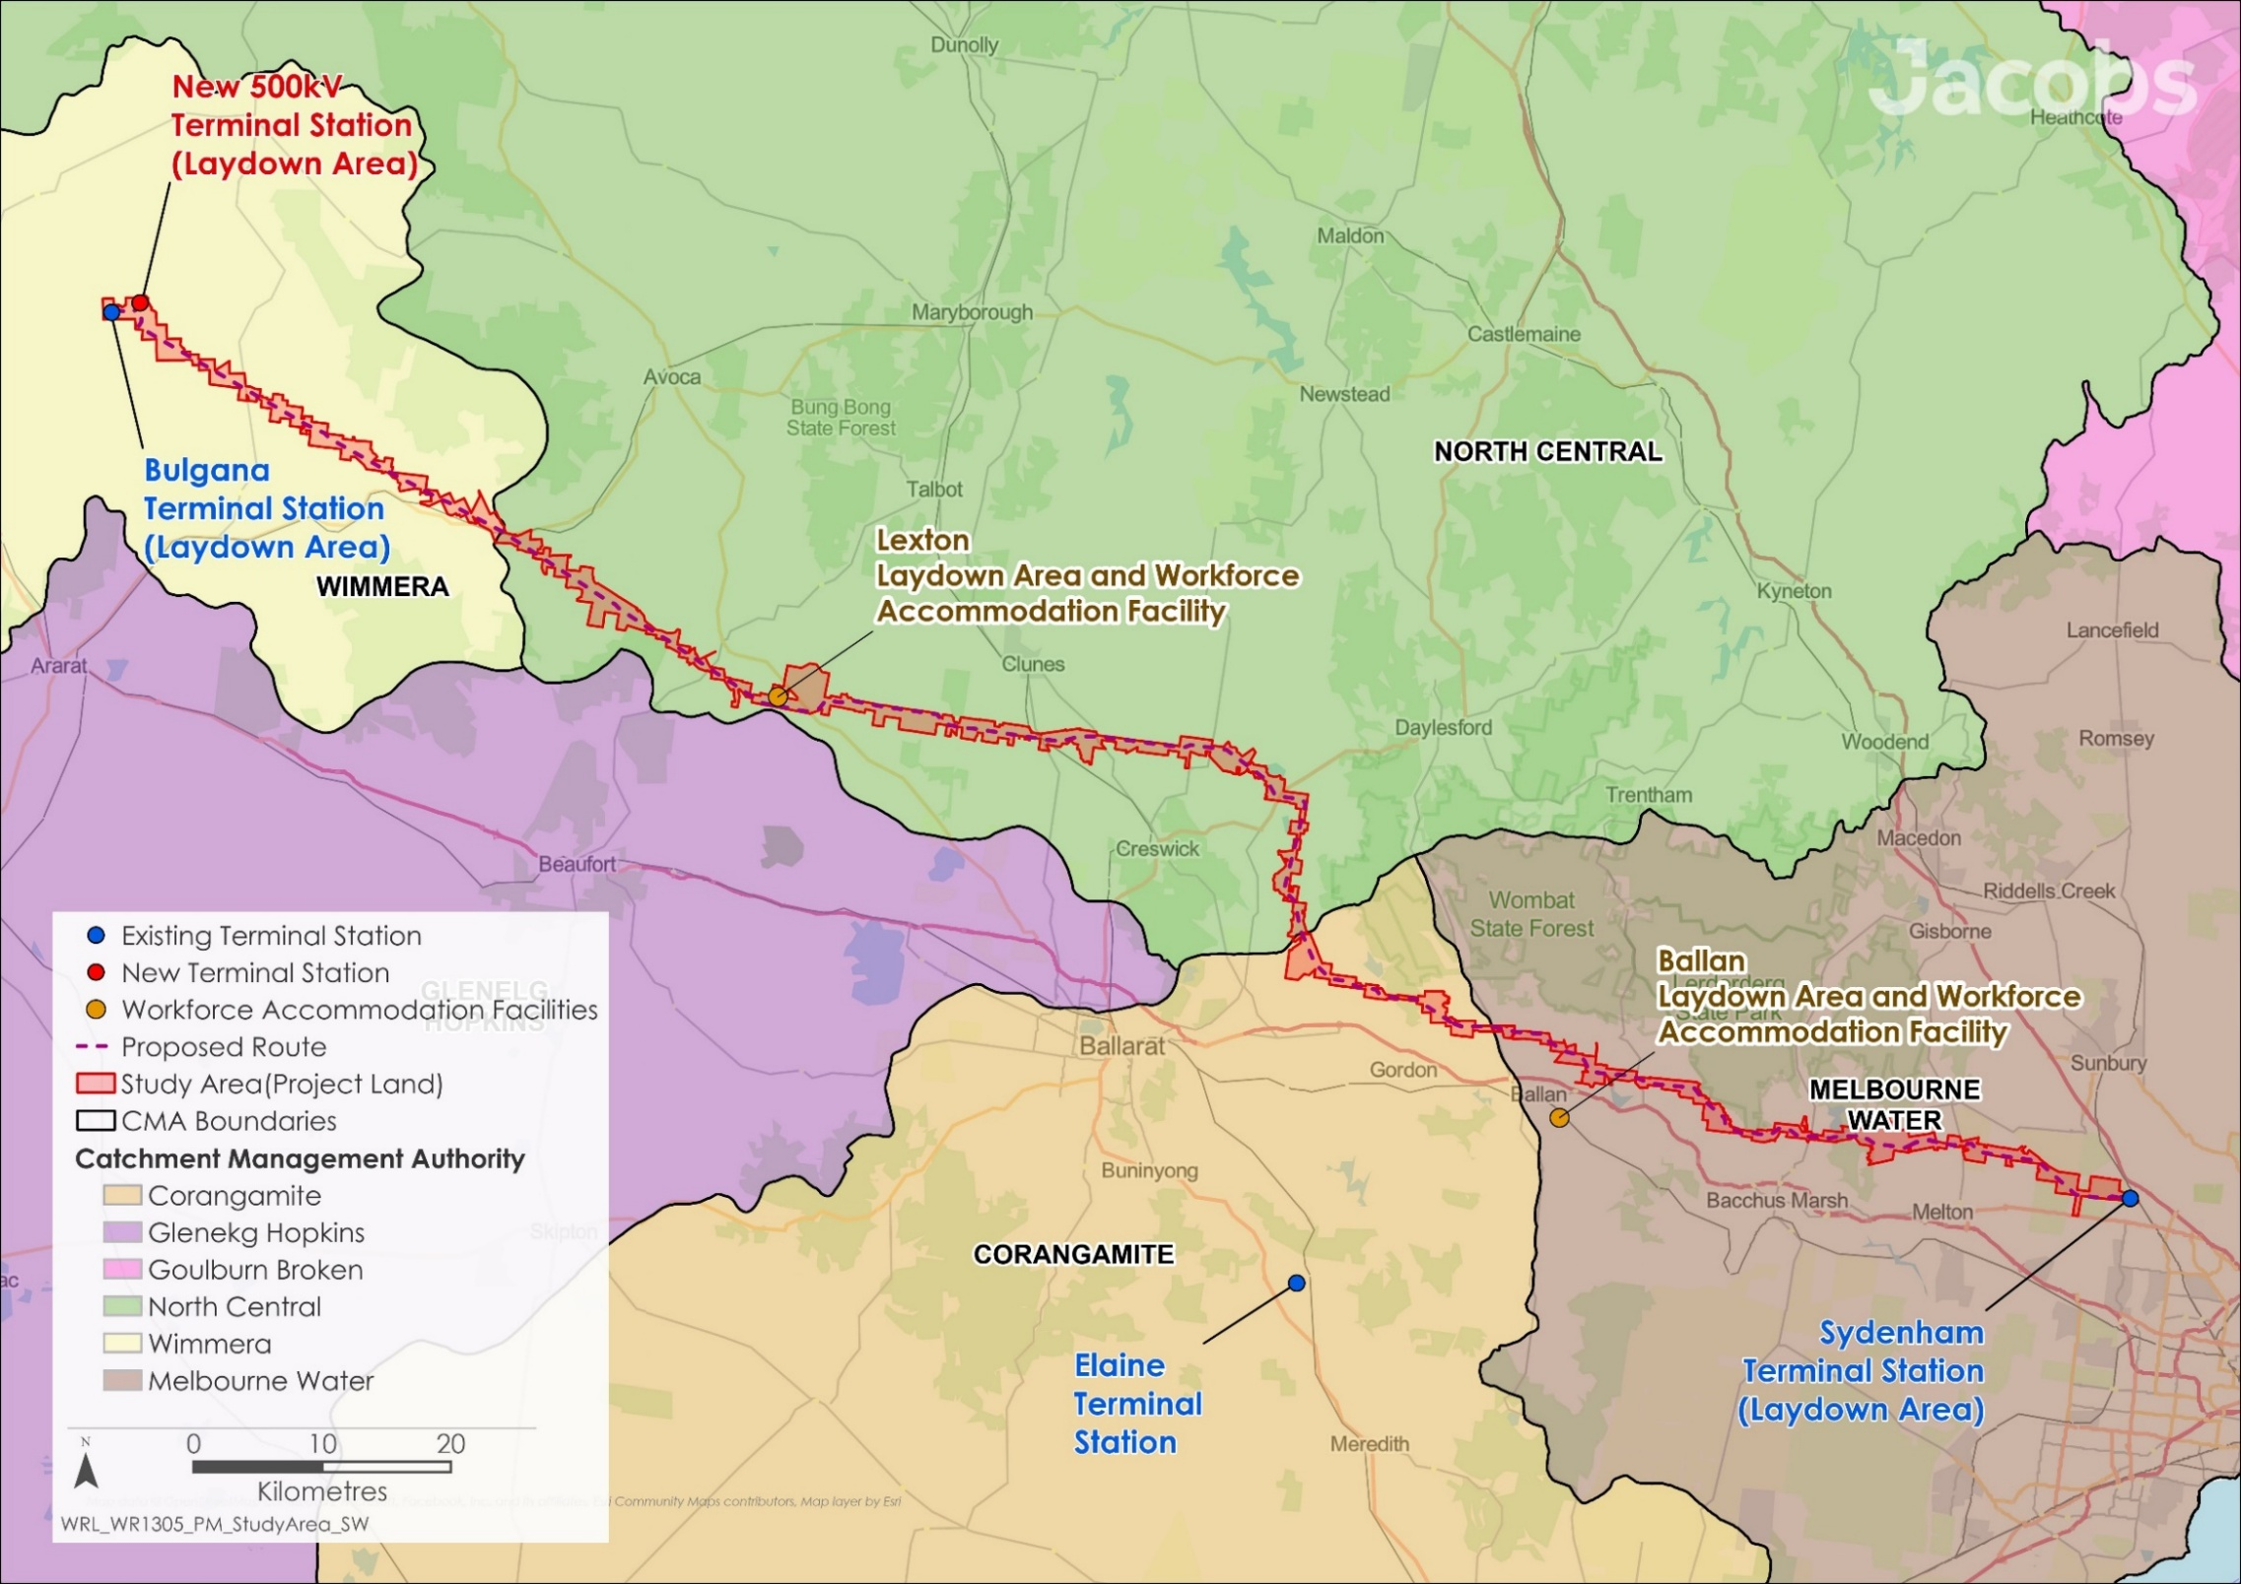

Figure 25.1 Surface water study area

## Existing conditions

This section summarises the existing conditions for surface water according to the following key themes:

* Key waterways
* Environmental values

The *Environmental Reference Standard* *2017* identifies the environmental values of surface water that the Victorian community wants to achieve and maintain. These refer to the ecological, cultural, and recreational benefits of surface water, and are used to assess and protect the health of surface water environments.

* Flow and flooding
* Water quality.

Existing surface water conditions are highly variable along the Project: many waterways are small, ephemeral creeks that only flow following rainfall, while other waterways such as the Lerderderg, Werribee and Wimmera rivers are major waterways with permanent flow in most reaches.

The study area encompasses several protected environmental values, including slightly to moderately modified water-dependent ecosystems and species, water for human consumption (after appropriate treatment), human consumption of aquatic foods, agriculture and irrigation (including farm dams), aquaculture, industrial and commercial uses, water-based recreation, and Traditional Owner cultural values. Additionally, surface waters along the Project are valued for activities such as recreational fishing, swimming, boating, water skiing, and for the enjoyment they bring during picnics, bushwalking, or camping.

* Declared Water Supply Catchments

Water Supply Catchments can be declared and protected under the *Catchment and Land Protection Act 1994* (Vic)*.*

This highlights the importance of the catchment for domestic and irrigation water supply to land users, managers and planners.

### Key waterways

The Project traverses the Wimmera-Avon, Avoca, Loddon, Moorabool, Werribee, and Maribyrnong River basins, and crosses 11 Declared Water Supply Catchment Areas which are protected as they provide water for human consumption following appropriate treatment. These Declared Water Supply Catchments include Wimmera Systems, Loddon River (Laanecoorie), McCallum Creek, Tullaroop Reservoir, Creswick, Ballarat, Lal Lal Reservoir, Moorabool River (Sheoaks), Pykes Creek Reservoir and Werribee River, and Lake Merrimu (Merrimu Reservoir), shown in Appendix A.4 of **Technical Report T: Surface Water Impact Assessment**. Of these, Pykes Creek Reservoir and Merrimu Reservoir are also Safe Water Drinking Storages under the *Safe Drinking Water Act 2003* (Vic)*.*

Surface waters can be considered high value if they are known to support listed, threatened or protected ecosystems, communities or species. Groundwater dependent ecosystems (GDEs) are described in **Technical Report S:** **Groundwater Impact Assessment**. Instances where GDEs interact with surface waters are included in the description of key waterway characteristics, values and protected areas.

All river basins, major and minor waterways crossed by the Project are listed in Sections 6.2.3, 6.3.3, 6.4.3 and 6.5.3 of **Technical Report T: Surface Water Impact Assessment**. Priority sections of streams or rivers identified within, or in the vicinity of, the Project are shown in Figure 25.2 and includes:

* Glenlofty Creek due thigh value bird and macroinvertebrate communities and pond system that provides and its ‘chain of ponds’ geomorphology which provides habitat for fish, platypus of and other freshwater species, particularly during dry conditions
* Birch’s Creek due the need to maintain or improve the habitat for highly threatened or rare water dependent species known to be present
* Avoca River due its important community values (e.g., human consumption after treatment, agriculture and irrigation, aquaculture, industrial and commercial use, water-based recreation, and Traditional Owner cultural values) and status as a ‘representative river’ for the west Victorian dissected uplands
* Moorabool River due to the presence of native fish, platypus, rare or threatened species or communities, significant landscape features, social values and economic importance (urban or rural water supply). It also holds great cultural significance for the Wadawarrung Traditional Owners and is valued for recreational uses
* Wilson Reservoir due to economic importance, as it is connected to Ballarat’s drinking water supply
* Werribee River due to its considerable retained environmental and ecological values, including native fish, frogs, platypus, and diverse macroinvertebrate communities and vegetation in the upper reaches, despite being heavily impacted by land clearance and urban development
* Lerderderg River due to its areas of very high vegetation value and significant ecological value. A section of the Lerderderg River immediately adjacent to the northern edge of the Project Land is listed in the Directory of Important Wetlands in Australia (DIWA), applying to the section of the river located in the Lerderderg State Park
* Wimmera River due to its high hierarchy and listing under the Wimmera Regional Water Strategy. It also intersects with the Project at multiple points.
* The Wimmera River, Sandy Creek, Six Mile Creek, Glenlofty Creek, Spring Creek and Glenpatrick Creek are also recognised in the Wimmera Waterway Strategy due to the presence of ‘rare or threatened species or communities’ and ‘naturalness’ values.

Pykes Creek Reservoir and Merrimu Reservoir are major water supply storages, and Hepburn Lagoon, a volcanic crater lake, is also located approximately 300m north of the proposed transmission line. A large number of smaller water storages are located within the study area, including weirs, farm dams and rainwater tanks.

There are no Wetlands of International Importance (listed under the Ramsar Convention) within or in the vicinity of the Project. However, there is a section of the Lerderderg River immediately north of the Project which is listed on the DIWA. There are also wetland areas present which are not listed on the DIWA, including temporary and permanent freshwater lakes, swamps, and marshes. Mapping produced by the Department of Energy, Environment and Climate Action (DEECA) indicated the presence of 52 wetlands that intersect the study area, consisting of:

* Eight permanent and seven temporary freshwater lakes
* Two permanent and two temporary freshwater swamps
* Two temporary freshwater marshes and meadows
* 31 unknown wetland types (e.g., farm dams and water impoundments).

Of these, 17 are located within the Project Area. Impacts to wetlands, and the habitat and biodiversity they support, are also discussed in **Chapter 8: Biodiversity and habitat**.

### Flow and flooding

The study area crosses numerous small waterways which are likely to flow for only part of the year (seasonally) or following rainfall, particularly in the upper Wimmera River catchment. Surface water flows in key waterways, such as the Wimmera River and Avoca Creek, are unregulated and can be highly variable. Due to this, periods of no flow can occur in waterways throughout the study area, particularly in drought conditions. Other key waterways, such as the Moorabool River and Werribee River are highly regulated, with flow being diverted for irrigation and domestic purposes or controlled by releases from upstream reservoirs.

There are many farm dams throughout the study area, used for irrigation, livestock watering, and domestic supply. This has impacted the hydrology of the catchments by reducing flow to waterways, particularly during low flow periods. Future flows of waterways within the study area are also expected to be affected by a future changed climate, with average rainfall across much of Victoria expected to decrease, while the intensity of extreme rainfall events (storms) is expected to increase. This may result in changes including lower overall flows, and larger, more rapid flow increases after rain events.

* Annual Exceedance Probability

Annual Exceedance Probability (AEP) is the chance of a flood of a given size (or larger) occurring within a period of one year, expressed as a percentage. For example, a 1% AEP Flood means there is a 1-in-100 chance that a flood of that size (or larger) could occur in any one year.

The 1% AEP flood event is the design flood event used for land use planning and building purposes in Victoria. It is defined as an event with a 1% probability of being equalled or exceeded in any given year.

Given the significance of the rivers located in the vicinity of the Project, the study area has the potential to experience floods during construction and operation. Flood maps with 1% Annual Exceedance Probability (AEP) flood event were assessed for most major rivers in the study area noting many smaller streams either lack available data on inundation extents or do not have planning scheme overlays. These maps are provided in Section 6 of **Technical Report T: Surface Water Impact Assessment**.

Areas within and in the vicinity of the Project known to have AEP flood extents or flooding-related planning overlays where construction activities could occur include Six Mile Creek, Wimmera River, Glenlofty Creek, Glenpatrick Creek, Sandy Creek, Glenlogie Creek, Avoca River, Bet Bet Creek, Burnbank Creek, McCallum Creek, Beckworth Creek, Creswick Creek, Birch Creek, Dean Reservoir, Moorabool River, Werribee River, Korjamnunnip Creek, Stony Hut Creek, Myrniong Creek, Lerderderg River, Goodman Creek, Cockatoo Creek, Little Blind Creek, Toolern Creek, and Kororoit Creek. These locations are presented in **Attachment VI: Map book**.

### Water quality

Limited recent water quality data was available for several waterways within the study area. All available data was analysed and compared to the water quality objectives specified in the *Environmental Reference Standard 2017* to provide a high-level assessment of overall water quality characteristics within or near the study area. Available data for each water quality site is provided in Appendix C of **Technical Report T: Surface Water Impact Assessment** and indicated variations in water quality between waterways and regions. However, for waterways intersecting the study area, the water quality is within the specified objectives for nutrients, salinity, turbidity and metals.

Waterway conditions in the study area are influenced by various land uses, including vegetation clearing, water extraction and flow regulation. The condition of river reaches ranges from very poor to good, with most sites rated as being in a moderate condition in the Index of Stream Condition. Generally, condition ratings tend to be low for hydrology (representing impacts to natural flow conditions) and physical form (the condition of riverbanks and instream habitat).

Water quality in all catchments is affected by salinity, turbidity, nutrients and pathogens due to historic mining, land clearing, agricultural land use and urban development. Changes in land use and stream diversions have altered the magnitude and timing of flows in several places. Gully erosion has also exacerbated the decline in surface water quality and reduced stream flows in a number of locations.

Despite these diminished values, significant natural values exist within some waterways near the Project. In particular, the upper forested areas of the Werribee River and Lerderderg River within Lerderderg State Park at the eastern end of the study area, are identified as priority reaches and contain areas of significant biodiversity values. These values are further discussed **Technical Report T: Surface Water Impact Assessment**.

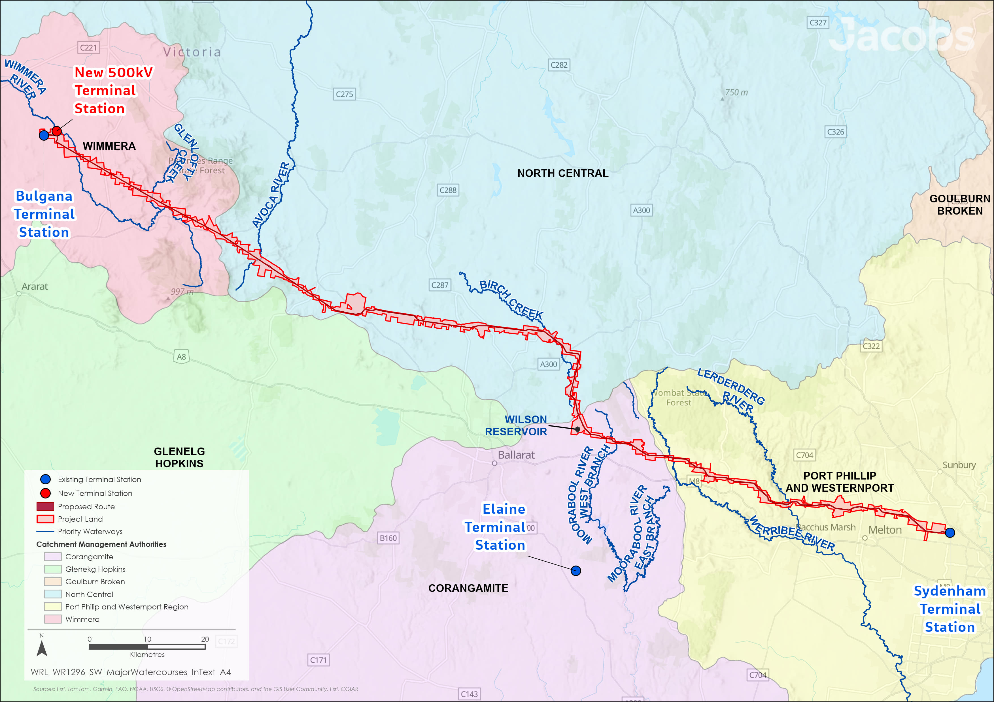

Figure 25.2 Priority reaches intersecting the study area

## Construction impacts

This section outlines the key issues identified through the risk screening process and associated potential impacts during the construction of the Project. The key issues and impacts identified for surface water are discussed according to the following themes:

* Waterway beds and banks: changes or blockages in water flow, soil erosion, and sedimentation impacts to the stability of waterway beds and banks, especially where vegetation is removed from the riparian zone.
* Surface water flows and flood impacts: changes or blockages of drainage lines, surface water flow paths or surface water flow patterns impact the availability of water for natural stream flow, extraction volumes and floodplain function.
* Surface water quality: degradation of waterways and water quality through direct damage to waterways from improper disposal of liquid wastes, leaks and spills, removal of riparian vegetation, erosion, and sediment discharge.

### Waterway beds and banks

The construction of transmission towers adjacent to waterways and removal of vegetation during construction has the potential to destabilise stream beds, banks and channels, as well as affect the volume, flow path and quality of surface water runoff into waterways. To avoid and minimise this potential impact, tower footings will be located at a minimum recommended distance from waterways, wherever possible (EPR SW1). Where the recommended setback distances are not able to be achieved, the Principal Contractor will undertake a site-specific assessment to determine the potential impacts and adopt site-specific monitoring and mitigation strategies, that will be embedded into the Surface Water Management Plan (EPR SW2).

Waterway crossings and access tracks will be required during Project construction. These are likely to physically disturb the waterway bed and banks of waterways and water bodies, and block or alter flows, which could create a barrier for fish movement and impact instream or riparian habitat. As such, access tracks will use existing waterway crossings where possible. Where this is not possible individual waterway crossings will be designed and constructed in accordance with best practices, informed by site walkovers undertaken to inform the Surface Water Management Plan (SWMP) (EPR SW2). This may include timing the constructing access tracks to occur outside of flow periods in ephemeral waterways, to avoid sediment input to waterway or flow disruption. The Project has also been designed to avoid and minimise impacts to native vegetation wherever possible, as described in **Chapter 8: Biodiversity and habitat.**

An important part of mitigating the Project’s impacts on waterway beds and banks will be to maintain appropriate distances between waterways and construction activities. As outlined in Table 25.1, the towers, terminal stations and access tracks will be sited at minimum prescribed distances from waterways, water bodies and the floodplain where possible (EPR SW1). If these set back distances are not able to be achieved, site-specific monitoring and mitigation strategies will be adopted. See **Technical Report A: Biodiversity Impact Assessment** for further information on assessment of potential impacts to riparian vegetation.

A limited number of towers are proposed to be located within or close to the recommended set-back distances from waterways. These include two tower footings immediately adjacent to Merrimu Reservoir, which is in a Declared Water Supply Catchment area that provides irrigation water and drinking water to the Werribee Irrigation District. The surrounding area is also valued for recreation, with amenities including a picnic area and playground on the edge of the reservoir which provide scenic views of the reservoir. These amenities will be impacted by construction of the Project. In this location, soils may be highly erodible and interactions between surface water and groundwater are highly likely. As such, without the application of the EPRs construction could result in the input of sediment and other contaminants into the reservoir, leading to moderate impacts on water quality. Through the implementation of monitoring and mitigation strategies as required by an additional site-specific surface water assessment to be undertaken by the Principal Contractor (EPR SW1), the magnitude, extent and duration of water quality impacts will be managed resulting in a minor residual impact to the reservoir, with no detectable impacts to drinking water quality in the reservoir.

Table 25.1 Siting of works to reduce potential for surface water impacts

| Category | Siting of works |
| --- | --- |
| Floodplain | Outside of the floodplain (as defined by the 1% AEP flood extent), where possible. |
| Designated waterways and water bodies in areas managed by the Wimmera, North Central, Glenelg Hopkins or Corangamite CMAs | 30m from waterways where possible. |
| Designated waterways in the Melbourne Water management area | To be determined in consultation with Melbourne Water, with consideration of guidance provided in the *Waterway Corridors, Guidelines for greenfield development areas within the Port Phillip and Westernport Region* (Melbourne Water, 2013):  20m from first or second order waterways  30m from third order waterways  50m from fourth order or higher waterways.  Waterway order is based on how many streams join to create the waterway. A first order waterway has no tributaries; a second order waterway is formed when two first order streams converge; a third order waterway is created when two second order streams join – and so on. |

The Project design and tower placement has mitigated the overall disturbance of waterway bed and banks, as towers across the Project are generally not located within close proximity to waterways. The implementation of standard controls and measures required by the EPRs includes set back distances from waterways during construction and the requirement for site-specific assessments where these cannot be maintained, to determine potential impacts and identify appropriate monitoring and mitigation measures (EPR SW1). These requirements will be incorporated into the SWMP (EPR SW2). Following application of these avoidance, mitigation and management measures, the extent and magnitude of impacts to waterway beds and banks will be reduced and the residual impacts across the whole of the Project Area will be minor.

### Surface water flows and flood impacts

The blockage, diversion or alteration of surface water flow paths due to construction works or access tracks could impact the timing, volume or velocity of surface water flows, and has the potential to impact flows into farm dams as well as the availability of water for extractive uses on private properties. This is particularly relevant if blockages result in diversion of flows in ephemeral waterways, where flows may only occur for a brief period. Waterway crossing construction could also result in impacts to surface water flow if the construction works create instream flow barriers or blockages. This could impact the movement and health of fish and other aquatic life.

Surface water flows could also be impacted if water is extracted or diverted from natural flow paths or waterways to facilitate construction of the Project. However, this is not expected to occur. Local water sources such as farm dams and reservoirs may be used for Project construction, in consultation with local landholders and stakeholders. Additional water may be sourced from town supplies to support the needs of the workforce and temporary workforce accommodation facilities.

Although unlikely, there is the potential for impacts on flooding conditions during construction activities in the floodplain (areas of land that are inundated during a flood event) with various towers, access tracks and construction sites located within the 1% AEP floodplain. When designing where to place the transmission towers, the Project considered cultural heritage values, geological conditions and existing vegetation. To avoid these values, it is probable that some construction works may need to occur in the floodplain. The locations of the new terminal station near Bulgana, connection works at Sydenham Terminal Station, and the laydown area near Lexton are also likely to be subject to flooding impacts.

The estimated time to construct each transmission tower is nine to 22 weeks over a two year period, and 20 months for construction at terminal stations. As such, there is a chance that a 1% AEP flood event could occur at any location in the floodplain during the construction stage. The areas within and in the vicinity of the Project known to have AEP flood extents or flooding-related planning overlays where construction activities could occur are listed in Section 25.3.2. Although improbable, if flooding did occur at the Project construction sites it could pose impacts to public health or cause pollutants to be released into waterways.

The Principal Contractor will be required to develop and implement a SWMP that will include controls to avoid or minimise potential impacts to the protected environmental values of surface water and set out the methods that will be used to maintain existing flow paths and drainage lines and avoid diverting or blocking flows to farm dams and other extractive users (EPR SW2). Where possible, the functionality and reliability of existing flow paths, drainage lines and floodplain storage will be retained, and Project infrastructure will be sited to avoid the diversion or blockage of flows.

The SWMP will also set out specific controls that must be applied to avoid or minimise potential impacts to human health and the environment from pollution or waste associated with the Project (EPR SW2). This will include compliance with Environment Protection Authority Victoria (EPA) guidelines to manage erosion and sedimentation, leaks and spills, stormwater and contaminated surface water runoff, and working within or adjacent to waterways.

If works are located within the floodplain, these will undergo a flood assessment during the Project’s detailed design stage to avoid flood impacts on adjacent landholders, waterways or floodplain function (EPR SW4). Flooding response and measures to manage flood impacts will also be included in the Project’s Construction Emergency Management Plan (EPR EM6).

With the implementation of standard controls and the specific measures required by the EPRs, the extent, duration and magnitude of impacts to surface water flows from the Project’s construction activities will be reduced, and residual impacts are minor.

### Surface water quality

During rainfall events, surface water or stormwater runoff may be generated within areas disturbed by construction activities, including hardstand areas, access tracks, and workforce accommodation facilities. This could transport sediment or contaminants to receiving waterways and impact water quality. Leaks or spills of fuels or other pollutants from machinery and equipment used during construction works, temporary workforce accommodation facilities, or drilling of piles could also enter local waterways or drainage paths. Additionally, the disposal or runoff from wastewater or slurry generated during the construction of the transmission tower footings could affect surface water.

Given the relative scale of potential contaminated stormwater runoff, leaks, or spills compared to passing flows and the surrounding surface water catchments, even unmitigated impacts are unlikely to result in measurable change to water quality. However, the General Environmental Duty (GED) under the *Environment Protection Act 2017* requiresthat risks of harmto human health and the environment must be minimised so far as reasonably practicable. Degradation of water quality can adversely affect water dependent ecosystems and species, require an increased level of treatment before water is suitable for human consumption, irrigation or livestock drinking water supply, clog irrigation equipment and decrease the visual amenity and recreational enjoyment of a waterway. The removal of riparian and floodplain vegetation may increase erosion, scour and sediment runoff, degrading surface water quality. Further, removal of vegetation for the laydown areas and workforce accommodation facilities will also result in exposed soil and potential for erosion. If not managed properly, these activities could impact ecological processes and affect the quality of surface water flowing to farm dams and available for extractive uses. In some locations, impacts may be greater where waterways crossed by access tracks drain directly to nearby farm dams or reservoirs.

The proposed access tracks cross a large number of unnamed drainage lines and tributaries as well as more significant water bodies such as the Lerderderg River. The proposed Lerderderg River waterway crossing spans approximately 50m. The Lerderderg River is a waterway of environmental significance and construction of a crossing could result in impacts to environmental values through a direct loss of habitat, disturbance to aquatic life, alteration of flows, increased sedimentation and other potential water quality impacts. The proposed waterway crossing location has been selected to maximise the use of existing access tracks either side of the River.

The SWMP will contain requirements to maintain surface water quality including, minimising the potential for erosion and sedimentation, stormwater runoff, and contamination entering the surface water system.This will include detailed management measures for the laydown areas, including site drainage, stormwater runoff, liquid storage and spill control, the supply of potable and non-potable water and water, and greywater and sewage management.Water quality will be monitored in waterways potentially affected by the Project’s activities prior to and during construction in accordance with a monitoring program developed and implemented in consultation with EPA Victoria, Melbourne Water and the relevant CMAs (EPR SW3). Surface water quality impacts associated with workforce accommodation facilities will be managed through compliance with the conditions of the draft Incorporated Document.

In addition, the Construction Environment Management Plan (CEMP) (EPR EM2) will include requirements for the management, storage and use of chemicals, fuels and hazardous materials during construction. This will be informed by EPA Victoria guidelines and include industry standard controls such as using self-bunded fuel tanks at the tower assembly area, which allow for the safe storage of fuel or diesel through their double walled design that contains leakages. The CEMP will also include incident management requirements in the case of a spill or other incident.

With the implementation of standard controls, mitigation and management measures required by the EPRs and conditions of the draft Incorporated Document, the Project will reduce the extent, magnitude and duration of surface water quality impacts during construction, and meet the requirements of the GED. In addition, the SWMP will include requirements for managing residual impacts (i.e., through monitoring and corrective action) (EPR SW3). With the exception of Merrimu all Declared Water Supply Catchments are located outside of the recommended set-back distances for the Project (EPR SW1) where impacts are waterways are expected to be negligible. Residual impacts at specific locations where towers cannot be located outside the minimum recommended set back area (including Merrimu Reservoir) are expected to be minor, as discussed in Section 25.4.1. Considering all waterways within the Project Area, residual impacts to surface water quality and associated environmental values from the Project’s construction activities are minor.

## Operation impacts

This section outlines the key issues identified through the risk screening process and associated potential impacts during the operation of the Project. The key issues and impacts for surface water are summarised according to the following themes:

* Surface water flows and flood impacts: potential impacts on flood conditions and waterways in the floodplain from Project infrastructure and increased proportions of impervious surfaces, such as concrete, at the terminal stations.
* Surface water quality and values: potential impacts to surface water quality stormwater runoff from the application of herbicides for weed management, and chemicals and liquids.

### Surface water flows and flood impact

During the operational lifespan of the Project, there is a 39.5% chance that a 1% AEP flood event will occur on any given waterway that would impact the Project terminal stations. This considers the impacts of climate change, with modelling conducted for **Technical Report N: Climate Change Assessment** indicating that heavy rainfall, which may cause flooding and erosion of exposed and susceptible soils, is projected to become more extreme. The location of the connection works at Sydenham Terminal Station, various towers and access tracks are likely to be subject to flooding. As such, operational infrastructure may experience flood damage during periods of high rainfall or stream flow. Some transmission towers could also be flooded due to dam failure near Moorabool Reservoir and Korweinguboora Reservoir. As such, inspection and maintenance personnel could be impacted while working on structures or sites within the floodplain.

While there are no works planned that would have a significant impact on flood depth, velocity or hazard, reductions in floodplain storage or the diversion of flows could potentially have flood level impacts. These potential impacts are primarily associated with waterway crossings or cut-and-fill associated with tower or terminal station hardstand areas, most notably the connection into the Sydenham Terminal Station. As the footings for terminal stations will be constructed to ground level, they are not expected to lead to significant adverse flood impacts.

Flood impacts will be managed by further assessment during the Project’s detailed design stage of structures located within the floodplain (EPR SW4). This assessment will identify mitigations to prevent impacts to adjacent landholders, surface water users, waterways or floodplain function. These flood impact assessments will meet the requirements of the relevant CMA, be supported by flood modelling, where possible, and consider climate change impacts. Future climate change conditions will be revisited at 5-yearly intervals (EPR CC2) throughout the Project life. Where a material change to climate change projections is determined, additional flood assessments will be undertaken to facilitate the appropriate management of flood impacts on an ongoing basis.

A flood response management plan will be developed for the Project and included within AusNet’s operational plans. This plan will include relevant flood response actions, clear roles and responsibilities and consideration of available Municipal Flood Emergency Plans and Local Flood Guides (EPR SW6).

During operation, rainfall runoff from impervious surfaces, particularly at the terminal stations, could also alter the flow regime of receiving waters. The cumulative impact of greater stormwater runoff due to more impervious surfaces being created within catchments is a recognised threat to waterway health, particularly in urban areas. However, it is highly unlikely that unmitigated stormwater runoff generated from the slight increase in impervious surfaces within the Project Area will cause a catchment-scale measurable change in flow regime. Local impacts will be managed through the design and implementation of management measures for stormwater runoff from impervious surfaces, to be applied where appropriate (EPR SW5). For example, applying integrated water management and / or use of water sensitive urban design principles in terminal stations to promote infiltration to reduce the volume of stormwater entering local waterways.

With the implementation of standard controls and the mitigation and management measures required by the EPRs, the extent, magnitude and duration of the Project’s impacts to surface water flow from the Project’s operations will be reduced, and the residual impacts are negligible.

### Surface water quality

Surface water quality could also be degraded by herbicides used for weed management, entering waterways through spray drift, runoff from sprayed areas after rainfall or following a spill. An unmitigated leaks or spills from wastewater storages at terminal stations or the workforce accommodation facilities. These leaks or spills could result in nutrients and pathogens entering surface waters. Further, the increased proportion of impervious surfaces, particularly at terminal stations, could impact water quality by increasing loads of suspended solids, nutrients and other toxicants. These impacts are not expected to result in a measurable change in surface water quality even if unmitigated due to the relative expected volumes. However, more localised impacts are possible, especially where farm dams and other extractive uses could be affected, with consideration given to the cumulative impacts of herbicide application across the Project Area.

Natural flow regimes and localised soil erosion can also be altered by the location of structures, access tracks, cleared easements, and the increased proportion of impervious surfaces within a catchment. Permanent unsealed waterway crossings or access tracks may result in ongoing impacts to water quality where flow occurs over the track, increasing sedimentation in runoff.

Potential impacts to surface water quality from stormwater runoff will be managed through the design of the Project which will include measures to manage stormwater runoff from impervious surfaces (EPR SW4). This could include the capture and reuse of stormwater runoff for non-potable activities such as toilet flushing or landscape irrigation at the terminal stations. Within urban areas, stormwater runoff from the Project Area will be monitored and treated in accordance with EPA Publication 1739.1 Urban stormwater management guidance. A suitably qualified engineer will develop a drainage and water management plan for the workforce accommodation facilities in accordance with the conditions of the draft Incorporated Document.

Periodic inspections of permanent access tracks located within waterway set back distances or those with waterway crossings will be undertaken (EPR SW5). These inspections will monitor their condition and determine maintenance needs in order to minimise impacts of stormwater runoff on waterways. In addition, the Project will be required to develop and implement operational emergency flood management strategies (EPR SW6). With the implementation the mitigation and management measures required by the EPRs and the conditions of the draft Incorporated Document, the extent, duration and magnitude of the Project’s impacts to surface water quality from the Project’s operations will be reduced, and the residual impacts are minor.

## Decommissioning impacts

As decommissioning activities will be similar to those that occur during construction, the impacts relating to surface water are the same as for the construction stage. It is noted that this is with the exception of the potential degradation of surface water quality by groundwater disposal or slurry generation, as neither groundwater nor slurry is expected to be encountered during decommissioning.

Accordingly, the EPRs developed to manage impacts during construction would also be applicable for decommissioning in accordance with the conditions of the time. This would also be managed by a Decommissioning Management Plan (EPR EM11) which would include mitigation measures for surface water, sediment and erosion controls and spoil management requirements, and be approved by the Minister for Planning.

Based on this, residual impacts are expected to be minor for surface water.

## Cumulative impacts

Cumulative impacts have been assessed by identifying relevant future projects that could contribute to cumulative impacts on surface water values, considering their spatial and temporal relationships to the Western Renewables Link Project. The projects considered as potentially relevant to surface water include:

* Coimadai Sand Quarry
* Melbourne Renewable Energy Hub
* Outer Metropolitan Ring Road/E6
* Western Irrigation Network Scheme.

Cumulative impacts from other projects are expected to be minor and are not anticipated to substantially alter the potential impact levels of the Western Renewables Link Project. For example, it is expected that road construction projects occurring in the study area will be managed to avoid sediment runoff into waterways as far as possible; however, some minor sedimentation may occur. Although this impact is minor, it may be more significant when considered at a catchment or regional scale due to multiple projects occurring. As such, even minor impacts from the Project will be avoided wherever possible, as reflected in the EPRs proposed for the protection of surface water.

Relevant future projects are primarily road and infrastructure projects, which are likely to have similar impacts to this Project in terms of surface water flow and quality. These potential impacts primarily relate to the potential for erosion, sediment input to waterways, changes to surface water flows and quality because of increased impervious surface area and runoff from project activities, interactions with groundwater, removal of vegetation, and the use of waterway crossings. Construction related potential impacts from these projects can be primarily controlled with the proposed EPRs for the Western Renewables Link Project – that is, the EPRs will control impacts associated with the Western Renewables Link sufficiently to prevent any cumulative impact with other projects occurring.

## Environmental Performance Requirements

Potential impacts identified through **Technical Report T: Surface Water Impact Assessment** have informed the development of EPRs for the Project. EPRs set out the environmental outcomes to be achieved through the implementation of mitigation measures during construction, operation and decommissioning. While some EPRs are performance based to allow flexibility in how they will be achieved, others include more prescriptive measures that must be implemented. Compliance with the EPRs will be required as a condition of the Project’s approval. Table 25.2 details the proposed EPRs developed for surface water.

Table 25.2 Environmental Performance Requirements

| EPR code | Requirement |
| --- | --- |
| EPR SW1 | **Site works to reduce potential for surface water impact**   * Develop and implement works to avoid and minimise the potential impact to surface water. Plans must be developed and implemented for the siting of access tracks, transmission towers and/or terminal stations which show that works will be:  1. Located outside of the floodplain (as defined by the 1% Annual Exceedance Probability (AEP) flood extent) where possible. If siting of towers within the floodplain cannot be avoided, further flood protection measures may need to be considered in design. 2. Located at a setback distance of 30m from all designated waterways and water bodies in areas managed by the Wimmera CMA, North Central CMA, Glenelg Hopkins CMA or Corangamite CMA 3. Located to achieve minimum set back distance determined in consultation with Melbourne Water and based on distances specified in “Waterway Corridors, Guidelines for greenfield development areas within the Port Phillip and Westernport Region” (Melbourne Water, 2013) as follows: 4. 20m for first or second order waterways 5. 30m for third order waterways 6. 50m for fourth order or higher waterways.   Note: stream orders are as defined by the Strahler stream ordering system (Strahler, AN 1953).  If proposed access tracks, transmission towers and/or terminal stations are located within the setback distance nominated in items 1a), 1b) or 1c), the Principal Contractor is to undertake a site-specific assessment to determine potential impacts and adopt site-specific monitoring and mitigation strategies. Such requirements are to be embedded into the Surface Water Management Plan (SWMP) (EPR SW2). |
| EPR SW2 | **Develop and implement a Surface Water Management Plan**   * Prior to construction commencing, develop and implement a Surface Water Management Plan (SWMP) as part of the CEMP (EPR EM2) to minimise the risk of harm to environmental values of surface water from pollution or waste associated with the construction of the Project; protect waterways and surface water users and maintain floodplain function so far as reasonably practicable.  1. To inform the development of the SWMP, the Principal Contractor is to conduct site walkovers as part of construction site preparation for transmission towers and terminal stations. Site walkovers shall inspect adjacent waterways; confirm the location of all potential surface waters or surface water users within and adjacent to the construction footprint; and determine the potential for direct impacts. This shall include local and ephemeral drainage paths and potential flow or water quality impacts to farm dams or other extractive uses. 2. The SWMP will include management and mitigation measures for: 3. Operation of temporary laydown areas, including: 4. Minimising impacts of vegetation clearance and construction of access tracks, and associated stormwater runoff from exposed or disturbed soil 5. Management of site drainage, stormwater runoff, liquid storage and spill control, supply of potable water and non-potable water, and details on greywater and sewage generated onsite. 6. Minimising the potential for erosion and sedimentation, in general accordance with relevant EPA Publications including publications 1820.1 (Construction – Guide to preventing harm to people and the environment); 1894 (Managing soil disturbance); and 1893 (Erosion, sediment and dust: treatment train) 7. Prevention of leaks and spills from entering local waterways, drainage lines or the stormwater network, in general accordance with relevant EPA Publications including publications 1700 (Preventing liquid leaks and spills from entering the environment) and 1698 (Liquid storage and handling guidelines). 8. Minimising stormwater runoff, in general accordance with EPA Publication 1834.1 (Civil construction, building and demolition guide) and Urban Stormwater Best Practice Environmental Management Guidelines. 9. Minimising disturbance of waterway bed or banks or alteration of flow regime, in general accordance with EPA Publication 1896 (Working within or adjacent to waterways). 10. The SWMP must also set out the requirements and methods for: 11. Maintaining the key hydrologic and hydraulic functionality and reliability of existing flow paths, drainage lines and floodplain storage wherever possible. 12. Siting and construction of Project infrastructure to avoid diversion or blockage of flows to farm dams and extractive users both during and after construction. This includes highly localised flows and ephemeral drainage lines. |
| EPR SW3 | **Monitor water quality**   * As part of the Surface Water Management Plan (EPR SW2), develop and implement a surface water quality monitoring program prior to and during construction for designated waterways likely to be directly impacted by Project activities. The monitoring program is to be developed in consultation with EPA Victoria, relevant CMAs and Melbourne Water to:  1. Establish the baseline condition of designated waterways within or immediately adjacent to the construction footprint that could be directly impacted by construction activities. This includes waterways crossed by access tracks and waterways that have tower footings located within the minimum set back distance (as defined EPR SW1) 2. Monitor water quality prior to construction commencing (subject to flow conditions in seasonal waterways) to establish baseline ambient water quality conditions both upstream and downstream of potential point of impact (i.e., track crossing or tower footing). 3. Monitor water quality during construction to detect impacts to water quality and take actions to address impacts 4. Monitor water quality following completion of construction to establish return to pre-construction water quality conditions both upstream and downstream (allowing for natural and seasonal variability).  * The monitoring program must:  1. Be consistent with recommendations for surface water monitoring provided in EPA Publication IWRG701 (Sampling and analysis of waters, wastewaters, soils and wastes and the Australian and New Zealand Guidelines for Fresh and Marine Water Quality). 2. Specify locations, parameters, and frequency of monitoring. 3. Take into account the timing of construction works so that monitoring programs are reflective of site activities.  * Measures for addressing any water quality impacts attributed to the Project must be outlined in the Surface Water Management Plan (EPR SW2). |
| EPR SW4 | **Minimise risks from changes to flood levels, surface flows and velocities**   * Undertake a flood assessment for the Project during its detailed design phase to inform development of design and construction methods to avoid and minimise impact to flood levels, surface flows and velocities. The flood assessment is to be undertaken in accordance with the Guidelines for Development in Flood Affected Areas (DELWP, 2019) and the requirements of the relevant CMAs.  1. The assessment must identify potential flood risks and mitigate these through appropriate design considerations by addressing the following criteria supported by flood modelling where possible: 2. Flood safety: Refer to EPR SW6 for including flooding into the emergency response plan. 3. Flood damages: As terminal stations are considered critical infrastructure, all electrical plant equipment at the proposed new 500kV terminal station near Bulgana must be set at a threshold level based on an appropriate freeboard allowance above the 1% AEP flood level including consideration of climate change and in consultation with the relevant referral authority. 4. Flood impacts: Flood impact assessment, including impacts on adjacent landholders and users, and on waterway and floodplain function within the floodplain (as defined by the 1% AEP flood extent), including in ephemeral waterways. 5. The adopted flood and climate change conditions must be revisited at 5-yearly intervals in line with EPR CC2. If material changes have occurred in climate conditions and associated flood risks, relative to those forecast and/or assumed at design stage, then additional flood risk assessments are to be carried out.  * Design for, and implement measures for the management of stormwater runoff from impervious surfaces to minimise the risk of harm to surface water environments, so far as reasonably practicable. |
| EPR SW5 | **Manage stormwater runoff to reduce potential for surface water impact**   * Conduct periodic inspections of terminal stations, cleared easement areas and permanent AusNet access tracks located within minimum waterway set back distances or at waterway crossings, to maintain conditions to minimise impacts of stormwater runoff on waterways. |
| EPR SW6 | **Operational emergency flood response management**  Prior to the commencement of construction, develop and implement a flood response management plan for the Project. The plan will be consistent with AusNet’s existing procedures and include relevant flood response actions, clear roles and responsibilities, and consideration of available Municipal Flood Emergency Plans and Local Flood Guides. |

Other EPRs contribute to a reduction in the magnitude, extent and duration of impacts for surface water values. Additional EPRs related to surface water include:

* EPR CC2 – Review climate change risk.
* EPR EM2 – Develop and implement a Construction Environmental Management Plan
* EPR EM6 – Develop and implement a Construction Emergency Management Plan
* EPR EM11 – Develop and implement a Decommissioning Management Plan.

Refer to the relevant technical chapters and **Chapter 29: Environmental Management Framework** for full detail of these EPRs.

Surface water monitoring will be undertaken prior to and during construction of the Project, as required by the SWMP. This monitoring will be undertaken at waterways where the Project has potential to have an impact on water quality, for example due to the construction of a waterway crossing. It aims to establish baseline conditions both upstream and downstream of the Project, detect changes to water quality during construction, and facilitate a return to the pre-construction water quality conditions following the completion of construction. Additionally, if Project components are unable to be sited outside of the nominated set back distances the Principal Contractor will be required to undertake site-specific monitoring to understand the potential impacts and validate the effectiveness of mitigation strategies.

The objectives of proposed monitoring programs for the Project required by the EPRs are further outlined in **Chapter 29: Environmental Management Framework**.

## Summary of residual impacts

With the application of the EPRs, residual impacts associated with surface water are minor to negligible:

* Residual impacts to waterway beds and banks across the whole Project Area during construction are minor. Where possible, access tracks, transmission towers and terminal stations will be strategically placed to reduce the potential for surface water impact. However, where towers are located close to waterbodies, such as those on the banks of Merrimu reservoir, temporary water quality impacts during construction may occur despite management efforts. Site-specific assessment, monitoring, and mitigation strategies will be applied in these circumstances (EPR SW1). As a result, these temporary construction impacts will be minor in the context of the reservoir catchment and storage, and will not result in detectable impacts to drinking water quality in the reservoir. Longer term post-construction impacts relating to minor erosion around tower footings and associated sediment input to the reservoir will be mitigated through suitable design and construction measures (EPR SW1). Where waterway crossings are required, direct interaction with waterway channels and riparian zones will be unavoidable and additional site-specific assessments, design and engineering will be required (EPRs SW2 and SW3).
* Residual impacts to surface water flows and flood impacts during construction are minor. Where possible, access tracks, transmission towers and terminal stations will be strategically placed outside of the floodplain, with local-scale flood modelling informing design and flood management measures (EPRs SW1 and SW4). The SWMP will set requirements to maintain the functionality and reliability of existing flow paths, drainage lines, and floodplain storage wherever possible, while protecting the environmental values of surface water (EPR SW2). Further assessment of laydown areas will be required during design stage to assist in managing potential surface water impacts appropriately. Surface water impacts associated with the workforce accommodation facilities will be managed in accordance with the conditions of the draft Incorporated Document.
* Residual impacts to surface water quality during construction are minor. Waterways that are likely to be directly impacted by Project activities will have their water quality monitored, enabling impacts to be detected and management measures to be actioned (EPR SW3). Potential impacts associated with liquid spills into waterways will be adequately mitigated through measures set out in the SWMP (EPR SW2).
* Residual impacts to surface water flows and flood impacts during operation are minor. Terminal stations will present a negligible impact to surface water flow as flood modelling will inform the final design and construction methods (EPR SW4).
* Residual impacts to surface water quality during operation are minor. Ongoing management will avoid impacts from sediment runoff and weed spraying, and access tracks within set back distances to waterways will be monitored (EPR SW3). Periodic inspections, integrated water management and water sensitive urban design principles will be implemented in terminal stations and urban areas where appropriate to protect water quality (EPRs SW4 and SW5).
* Residual impacts to surface water during decommissioning will be the same as for the construction stage or lessened. As such, EPRs developed to manage impacts during construction will also be applicable for decommissioning and will be incorporated into the Decommissioning Management Plan.

With the implementation of measures to comply with EPRs, it is considered that the Project meets the evaluation objective to “*maintain the functions and values of aquatic environments, surface water quality and stream flows, and preventing adverse effects on protected beneficial uses.”*

