AusNet Transmission Group Pty Ltd is an independent

subsidiary of AusNet Pty Ltd ABN 45 603 317 559

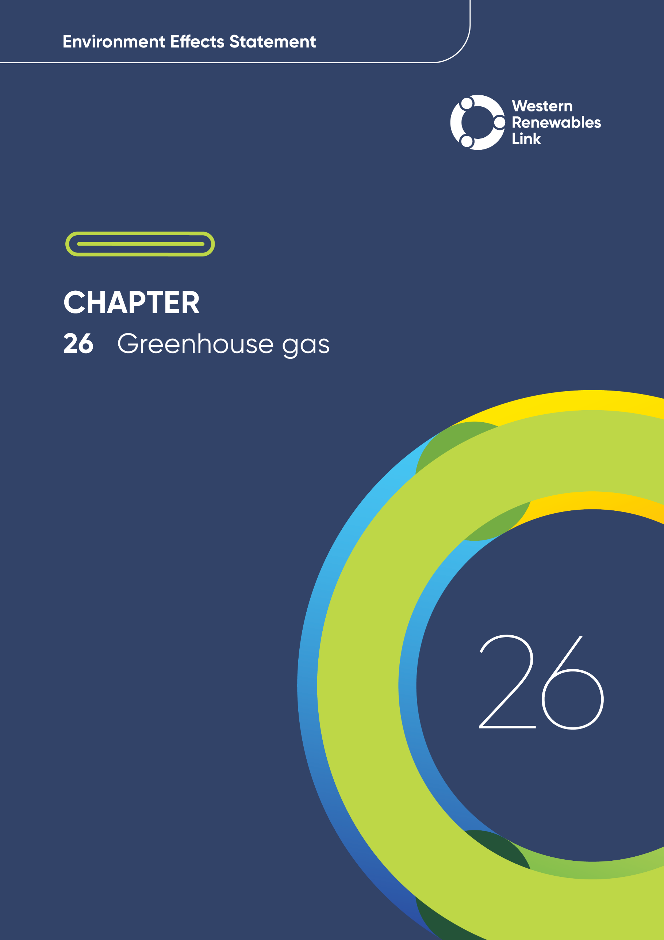

# Greenhouse gas

This chapter provides an overview of the potential greenhouse gas impacts associated with the construction, operation and decommissioning of the Project. This chapter is based on **Technical Report M: Greenhouse Gas Impact Assessment**.

Human induced climate change and its impacts have prompted the Commonwealth and State Governments to set targets to reduce and mitigate greenhouse gas emissions. The Project will generate greenhouse gas emissions during construction, operation, and decommissioning. These emissions will contribute to the overall emissions for Victoria and Australia and will be accounted for in state-wide and national greenhouse gas accounting, goals, and targets.

## Evaluation objective

The scoping requirements identify the following evaluation objective relevant to greenhouse gas:

Evaluation objective

Avoid, or minimise where avoidance is not possible, adverse effects for community amenity, health and safety, with regard to construction noise, vibration, dust, lighting, waste, greenhouse gas emissions, transport network, operational noise, fire risk management and electromagnetic radiation.

In response to this evaluation objective, the impacts of greenhouse gas emissions from the Project were quantified, and measures to avoid, minimise or manage potential impacts have been identified. These measures are discussed throughout this chapter and have informed the development of Environmental Performance Requirements (EPRs). EPRs set out the environmental outcomes to be achieved through the implementation of mitigation measures during construction, operation and decommissioning to avoid, minimise and manage identified impacts. Cumulative impacts associated with relevant future projects were also assessed.

Further information on how the Project has been designed to avoid and minimise impacts is provided in **Chapter 5: Project development** and **Chapter 6: Project description**.

Other aspects covered in the Environment Effects Statement (EES) evaluation objective and relevant to greenhouse gas emissions are addressed in the following EES chapters:

* **Chapter 11: Landscape and visual**
* **Chapter 13: Bushfire**
* **Chapter 17: EMI and EMF**
* **Chapter 18: Air quality**
* **Chapter 19: Noise and vibration**
* **Chapter 20: Transport**
* **Chapter 23: Contaminated lan****d.**

## Method

This section summarises the method adopted in **Technical Report M: Greenhouse Gas Impact Assessment**, which was informed by **Chapter 4: EES assessment framework and approach**.The key steps in assessing the impacts of greenhouse gas emissions included:

* Defining a study area appropriate for greenhouse gas emissions: recognising that greenhouse gas emissions impacts are a global issue, and emissions associated with the Project will fall into the total emissions for Victoria and Australia as a whole. The study area was not spatially limited to the physical construction and operational boundary for the Project. It included all areas in which greenhouse gas emissions from the Project may be produced and/or where emissions from the Project will have an impact on climate change.
* Reviewing applicable international, Commonwealth and Victorian legislation, and relevant local, state and national standards, guidelines and policies.
* Conducting a desktop review in accordance with the Greenhouse Gas Protocol issued by the World Business Council for Sustainable Development, World Resources Institute and ISO 14064-1:2006 Greenhouse gases – Part 1: Specification with guidance at the organisation level for quantification and reporting of greenhouse gas emissions and removals to assess the existing greenhouse gas conditions including Victorian and National emissions levels from the most recently available data sources, including:
  + Australian National Greenhouse Accounts (published by the Commonwealth Department of Industry, Science, Energy and Resources (DISER))
  + Australia’s emissions projections 2023(DCCEEW, 2023a).

Greenhouse gas related fieldwork was not conducted for this impact assessment, as the desktop assessment of the Project design and sources of emissions was considered to be sufficient.

* Consulting with relevant regulatory authorities and key stakeholders including Department of Jobs, Precincts and Regions, Agriculture Victoria, Australian Energy Market Operator (AEMO), former Department of Environment, Land, Water and Planning (DELWP) - Regional Planning Services (now Department of Transport and Planning (DTP), Moorabool Shire Council, former DELWP Impact Assessment Unit (now DTP).
* Conducting a risk screening process to identify the key issues during construction, operation and decommissioning for investigation.
* Carbon dioxide equivalent

CO2e – or carbon dioxide equivalent – is a term for describing different greenhouse gases in a common unit. For any quantity and type of greenhouse gas, CO2e signifies the amount of carbon dioxide that would have the equivalent global warming impact.

* Identifying and assessing the potential impacts associated with the Project’s Scope 1 and 2 emissions during construction and operation stages. The definitions and examples for emission scope types are described in the ‘carbon dioxide equivalent’ information box. These impacts were evaluated against the existing conditions for greenhouse gas emissions produced in Victoria and Australia, and according to the following ratings, in relation to the extent, magnitude and duration of the impacts:
  + Negligible: Construction Scope 1 and Scope 2 greenhouse gas emissions are insignificant, that is annual emissions are less than 5,000 tonnes CO2e. Operational Scope 1 and Scope 2 greenhouse gas emissions are insignificant, i.e., the Project is near to or on par with the ‘no project’ scenario.
  + Minor: Construction or operational Scope 1 and Scope 2 greenhouse gas emissions are below the *National Greenhouse and Energy Reporting* (NGER) Scheme reporting threshold (25,000 tonnes CO2e per year).
  + Moderate: Construction or operational Scope 1 and Scope 2 greenhouse gas emissions trigger the NGER Scheme reporting threshold (25,000 tonnes CO2e per year).
  + Major: Construction or operational Scope 1 and Scope 2 greenhouse gas emissions trigger referral for individual potential environmental effects under the *Environment Effects Act 1978* (200,000 tonnes CO2e per year).
  + Severe: Construction or operational Scope 1 and Scope 2 greenhouse gas emissions represent a non-negligible proportion of Victoria’s greenhouse gas emissions (> 1per cent).
* Scope 1, 2 and 3 emissions

**Scope 1** **(direct emissions):** Emissions from sources owned or operated by the organisation reporting the emissions (for example, combustion of fuel used in on-site vehicles or in power generation, carbon sink loss due to vegetation clearance, or the leakage of sulphur hexafluoride (SF6) and fluorinated gasses)**.**  
  
**Scope 2** **(indirect emissions):** Emissions associated with the import of energy from another source (for example, the purchase of electricity at terminal stations during operations)**.**  
  
**Scope 3 (other indirect emissions):** Emissions that are a direct result of the operations of the organisation but from sources not owned or operated by it (examples include embedded emissions in raw materials such as bricks and concrete, and haulage and disposal of materials and waste).

A number of the emissions associated with the Project are Scope 3 emissions, such as embedded emissions in construction materials and fuel produced externally to the Project. The Greenhouse Gas Protocol, and many other reporting schemes, require the reporting of Scope 1 and 2 sources, whilst reporting of Scope 3 sources is optional. Similarly, Scope 3 greenhouse gas emissions are not reported under the NGER Scheme. As such, while Scope 3 emissions were quantified in the technical investigation and considered in the overall greenhouse gas estimates, they did not inform the impact ratings for the Project.

* Identifying relevant future projects that could lead to cumulative impacts when considered together with the Project (refer to **Chapter 4: EES assessment framework and approach** for the full cumulative impact assessment method).
* Developing EPRs in response to the impact assessment to define the required environmental outcomes that the Project must achieve through the implementation of mitigation measures during construction, operation and decommissioning. Measures to reduce the potential impacts were proposed in accordance with the mitigation hierarchy (avoid, minimise, manage, rehabilitate and offset) and have informed the development of EPRs. Alternative mitigation measures could be implemented to comply with the EPRs based on the specific site conditions, available resources, and the Principal Contractor’s expertise.
* Following application of mitigation measures that would comply with the EPRs, determining residual impacts associated with the construction, operation and decommissioning of the Project, and evaluating their significance.

## Existing conditions

This section summarises the existing conditions for greenhouse gas emissions produced in Victoria and Australia, to understand baseline greenhouse gas emissions for comparison with Project emissions.

Greenhouse gas emissions produced in Victoria and Australia are tracked through the Australian National Greenhouse Accounts, a series of reports published by the DISER. The Australian Greenhouse Emissions Information System provides detailed emissions data drawn from the National Greenhouse Accounts. Victorian and Australian greenhouse gas emissions over the last ten years of available data (2012 to 2022) are shown in Table 26.1.

Table . Victorian and Australian greenhouse gas emissions, 2012 to 2022

|  |  |  |  |  |  |  |  |  |  |  |  |
| --- | --- | --- | --- | --- | --- | --- | --- | --- | --- | --- | --- |
| Source of emissions | Reported greenhouse gas emissions (Mt CO2e) | | | | | | | | | |  |
| **2012** | **2013** | **2014** | **2015** | **2016** | **2017** | **2018** | **2019** | **2020** | **2021** | **2022** |
| Victoria | 133 | 120 | 113 | 113 | 104 | 100 | 91 | 87 | 83 | 80 | 85 |
| Australia | 579 | 561 | 556 | 541 | 512 | 510 | 514 | 506 | 494 | 465 | 433 |

As shown in Figure 26.1, greenhouse gas emissions in Australia and Victoria have been steadily trending downwards.

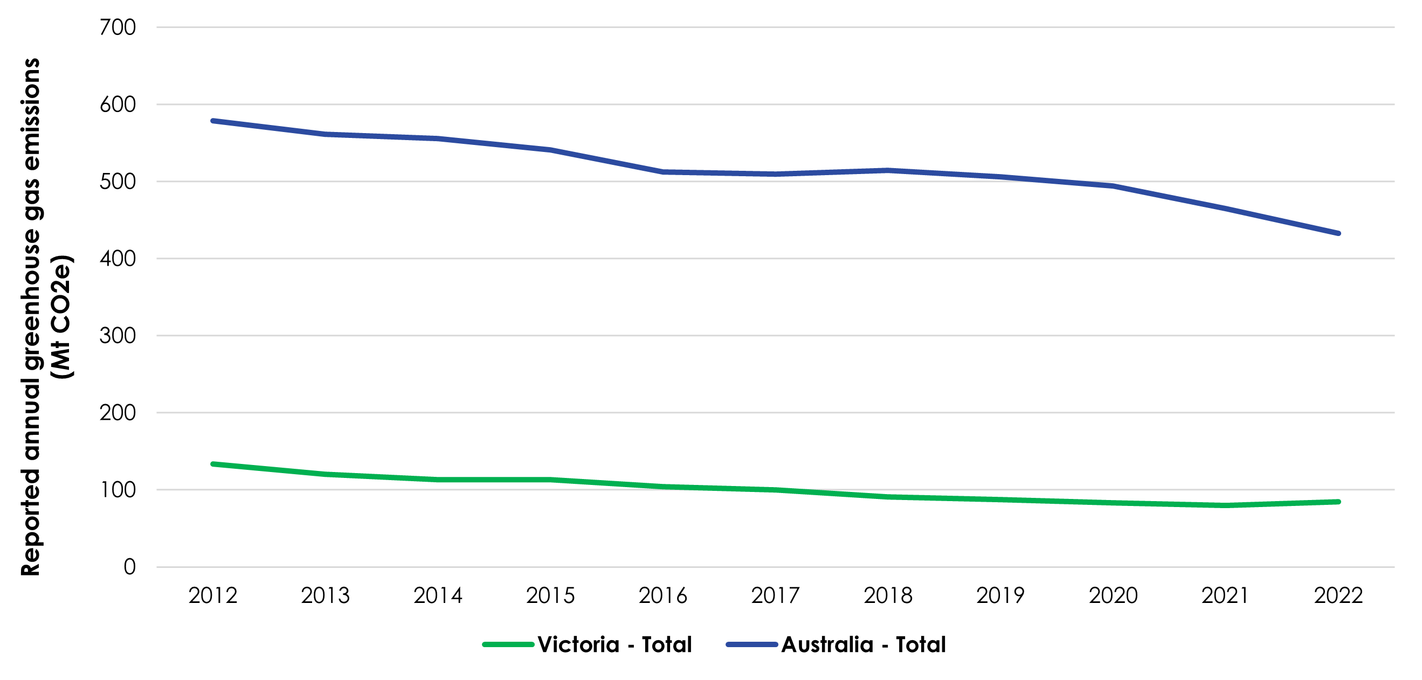

Figure 26. Trends in Victorian and Australian greenhouse gas emissions, 2012 - 2022

At the time of assessment, the data for 2023 and 2024 were not available, greenhouse gas emissions data for the most recent available year (2022) were adopted as the existing conditions benchmark for assessing the implications of the greenhouse emissions produced by the Project.

## Construction impacts

This section outlines the key issues identified through the risk screening process and associated impacts during the construction of the Project. The key issues and impacts identified for greenhouse gas are discussed according to the following themes:

* Energy related greenhouse gas emissions: fuel consumption, and emissions associated with transport and the haulage of construction materials, waste and earth.
* Non-energy related greenhouse gas emissions: embedded emissions associated with the materials used in construction, vegetation removal, and waste generation.

### Energy related greenhouse gas emissions

Energy related emissions associated with the construction of the Project include those from the consumption of fuel used on site.

Fuel will be needed during the Project’s construction for construction plant and equipment, on-site light vehicles, and generators at construction sites, laydown areas, and workforce accommodation facilities. Combustion of fuel in vehicles, plant and equipment will result in greenhouse gas emissions.

In addition to on-site vehicle usage, vehicles will be required to transport workforce personnel from the accommodation facilities to the construction sites, generating additional emissions from fuel usage.

Section 26.4.3 describes the overall greenhouse gas emissions for Project construction. As shown in Figure 26.2 fuel consumption from construction plant and equipment will account for approximately 15 per cent of total Project construction emissions. Together workforce personnel movements and haulage of materials are predicted to generate approximately 2 per cent of total emissions.

AusNet will continue to integrate sustainable design practices into the Project’s design process to minimise, to the extent practicable, greenhouse gas emissions arising from the construction of the Project (EPR SG2). For energy related greenhouse gas emissions, this could include adopting construction procedures to minimise fuel combustion where possible, through shutting off equipment when not in use and adopting more fuel-efficient equipment and methods.

### Non-energy related greenhouse gas emissions

Non-energy related emissions associated with the construction of the Project include embedded emissions in construction materials, clearing of vegetation and the transport of waste and materials.

Embedded emissions refer to the CO2e emissions associated with the production of the materials such as cement and steel (used for constructing the transmission towers and terminal station) used in the construction of the Project. As shown in Figure 26.2, embedded emissions account for the majority of the Project’s overall construction emissions, approximately 72 per cent.

Vegetation clearing will also result in the loss of carbon sink that if left present, would capture emissions. Vegetation clearing carbon sink losses account for approximately 11 per cent of overall construction emissions.

Project construction will generate waste which will degrade at landfill and generate greenhouse gas emissions in the form of methane gas, contributing to the Project emissions during construction. When considering the Project’s total construction emissions, the amount generated from landfilled waste is relatively low, accounting for 0.09 per cent of the total emissions (which rounds to 0 per cent in Figure 26.2).

AusNet will continue to integrate sustainable design practices into the Project’s design process to minimise, to the extent practicable, greenhouse gas emissions arising from construction (EPR SG2). The Principal Contractor will select construction materials with low associated emissions, where possible, and to monitor energy and carbon consumption during construction. Detailed modelling will provide that cut and fill balances are managed to minimise unnecessary haulage of material, waste and earth. The implementation of the EPRs will reduce greenhouse gas emissions, indicatively by 30 per cent, based on leading practice reductions in construction greenhouse emissions, as defined by the Infrastructure Sustainability Council.

Figure 26. Project construction emissions by source

### Overall greenhouse gas emissions during construction

Overall, construction of the Project is predicted to generate 464 kilotonnes[1] of CO2e, translating to 232 kilotonnes of CO2e per year of construction. The annual Scope 1 and Scope 2 emissions from the Project construction are expected to be 55 kilotonnes of CO2e, which is greater than the NGER Scheme reporting threshold of 25 kilotonnes CO2e.

The integration of sustainable design practices (EPR SG2) is expected to mitigate this impact by saving energy and promoting renewable technology. As such, the overall residual construction impact on greenhouse gas emissions is moderate.

## Operation impacts

This section outlines the key issues identified through the risk screening process and associated potential impacts during the operation of the Project. The key issues and impacts identified for greenhouse gas are discussed according to the following themes:

* Energy related greenhouse gas emissions: electricity consumption at terminal station sites, and emissions related to fuel use for inspection and maintenance activities.
* Non-energy related greenhouse gas emissions: potential leakage of SF6 from circuit breakers in terminal stations, and embodied emissions in replacement equipment over the life of the Project.

### Energy related greenhouse gas emissions

During operation, energy related greenhouse gas emissions associated with the Project include those from the consumption of fuel during maintenance and inspection activities and the electricity required to perform standard operations at the terminal stations.

As maintenance activities will be undertaken on an ‘as-needed’ basis, emissions cannot be easily quantified for these activities. Most items that will require more frequent maintenance and replacement are usually small parts and the associated maintenance and replacement works are expected to contribute a negligible amount of greenhouse gas emissions.

Since the transmission line will connect renewable energy to the grid, the usage they of electricity by the Bulgana and Elaine Terminal Stations, as well as the new 500kV terminal station near Bulgana, will be predominately associated with renewable sources of generated electricity and will generate net-zero emissions. The Sydenham Terminal Station, however, will be powered by a separate grid connection which is assumed to comprise electricity representing the average National Electricity Market mix of generators. As the electricity grid continues to undergo decarbonisation, the emissions associated with the usage of grid electricity may reduce until the target deadline to decarbonise in 2050. As such, over the 45-year life of the terminal stations, the emissions associated with their operation will progressively reduce to net-zero over time.

As discussed in Section 26.4, the development and implementation of sustainability targets, a Sustainability Management Plan (EPR SG1), and measures incorporated into the Project’s detailed design stage will minimise greenhouse gas emissions during operation of the Project (EPR SG2). Specific management measures during the operational stage of the Project to reduce energy related greenhouse gas emissions include:

* Adopting inspection and maintenance procedures to minimise fuel combustion where possible, including shutting off equipment when not in use and using more fuel-efficient equipment
* Exploring opportunities to use renewable energy sources for inspection vehicles, where practical. This could include the adoption of electric or hybrid vehicles into the inspection vehicle fleet or mandating the use of biodiesel in inspection vehicles.

Following the application of these measures, Scope 1 and Scope 2 greenhouse gas impacts in the initial year would likely remain greater than 25 kilotonnes CO2e, and would have a moderate residual impact. As the grid continues to undergo decarbonisation, the residual impact rating will reduce to minor.

### Non-energy related greenhouse gas emissions

During operation, non-energy related emissions associated with the Project include embedded emissions in replacement materials and the leakage of SF6 from terminal stations.

Over the life of the Project, certain equipment on the transmission line and at the terminal stations may need to be replaced. These replacement parts and equipment will have embedded emissions. Due to the vastly differing types of parts and equipment and the fact that the equipment will be replaced on an ‘as needed’ basis, the associated emissions cannot be easily quantified.

As discussed in Section 26.8, the development and implementation of sustainability targets, a Sustainability Management Plan (EPR SG1), and measures incorporated into the Project’s detailed design stage will minimise greenhouse gas emissions during the operational stage of the Project (EPR SG2). Further, the Sustainability Management Plan will include measures to track and manage SF6, which is a key emission from circuit breakers in terminal stations. AusNet will utilise a leak detection and repair strategy to effectively detect and manage SF6 (EPR SG1). Measures implemented during design will include ensuring vendors adopt technology to minimise handling during SF6 delivery and maximise SF6 utilisation (EPR SG2). Given the items predicted to be replaced annually are typically small parts, it is expected that the embedded emissions in the replacement equipment would contribute a negligible amount of greenhouse gas emissions.

### Overall greenhouse gas emissions during operation

The operation of the Project is predicted to produce 27.04 kilotonnes of CO2e during the first year of operation with a gradual decrease from 2029 onwards as the grid decarbonises over the Project’s 80-year life to 0.27 kilotonnes of CO2e by the final year of operation. The implementation of sustainability targets and a Sustainability Management Plan (EPR SG1) will mitigate greenhouse gas emissions during operation. As such, residual impacts associated with the Scope 1 and Scope 2 emissions during operation would initially be moderate, and would decrease to minor as the grid continues to decarbonise.

With no mitigation measures applied, the operation of the Project will contribute approximately 0.03 per cent to less than 0.01 per cent of Victoria’s, and 0.006 per cent to less than 0.001 per cent of Australia’s overall greenhouse gas emissions. As the Project also intends to increase the uptake of zero emissions renewable energy, it meets the requirements of the *Climate Change Act 2017* and fits in with the goals of the Australian Government’s 2030 Emissions Reduction Target.

Table . Emission contributions of the Project in the context of overall state and Commonwealth emissions

|  |  |  |  |  |  |
| --- | --- | --- | --- | --- | --- |
| Project stage | Annual Project emissions (Mt CO2e/year) | 2022 Victorian emissions (Mt CO2e/ year) | 2022 Australian emissions (Mt CO2e/ year) | Contribution to Victorian annual emissions | Contribution to Australian annual emissions |
| Operation | 0.0270 – 0.0003 | 84.7 | 432.6 | 0.03% - <0.01% | 0.006% - <0.001% |

The measures described will facilitate a reduction in greenhouse gas emissions; however, some residual emissions will remain. Improving fuel efficiency during inspection and maintenance activities and choosing lower emission fuels provide the best opportunity for minimising residual impacts.

As the Project will facilitate the connection of renewable energy sources to energy consumers, it is expected to contribute to its own emissions reduction, in addition to an overall reduction in greenhouse gas emissions from the national electricity grid.

## Decommissioning impacts

It is difficult to predict the greenhouse gas emissions associated with decommissioning, given the expected changes in technologies and policy that are likely to have occurred by the time of the Project’s decommissioning. The activities to be undertaken for decommissioning however are similar to the construction activities, which means that mitigation measures would be similar to those required for the construction stage (see Section 26.4). A large portion of Project materials – including steel, concrete and aluminium – would be recycled and reused. This would have a positive greenhouse gas impact by supplanting some of the demand for these materials that otherwise could have been filled by newly produced (and more emissions intensive) materials.

Accordingly, the EPRs developed to manage impacts during construction would also be applicable for decommissioning in accordance with the conditions of the time. This would also be managed by a Decommissioning Management Plan (EPR EM11) which would include mitigation measures to minimise the impact of harm to human health or the environment of all activities associated with decommissioning.

Based on this, residual impacts are expected to be moderate to negligible for greenhouse gas emissions.

## Cumulative impacts

Unlike other cumulative impact considerations which typically have a localised impact around a project in question, greenhouse gas emissions contribute towards a global greenhouse gas impact. Hence, when considering cumulative greenhouse gas impacts of the Western Renewables Link Project, local projects are not any more relevant than other greenhouse gas emitting projects across Victoria, Australia, or the world.

A more relevant assessment of cumulative greenhouse gas impacts would be in the form of a comparison of the Western Renewables Link Project emissions against Victorian and Commonwealth greenhouse gas emissions. The greenhouse gas impacts from the Western Renewables Link Project were assessed against recent data on Victorian and Commonwealth greenhouse gas emissions. At a state level, emissions from the Project were anticipated to constitute 0.3 per cent of Victoria’s overall greenhouse gas emissions during construction, and less than 0.05 per cent in operation. At the federal level, the Western Renewables Link Project will contribute 0.05 per cent of Australia’s emissions in construction, and less than 0.009 per cent in operation.

As it is the purpose of the Western Renewables Link Project to increase the supply of renewable energy by improving connectivity of renewable energy sources in western Victoria to the national grid, it will actively contribute to a reduction in emissions across the grid, including emissions associated with its own electricity consumption.

Given the generally low emissions from the Western Renewables Link Project in comparison to the Victorian total emissions, and its contribution toward reducing emissions across the grid, the Western Renewables Link Project is in line with the requirements of the *Climate Change Act 2017* (Vic) and aligns with the goals of the Commonwealth 2030 Emissions Reduction Target.

## Environmental Performance Requirements

Potential impacts identified through **Technical Report M: Greenhouse Gas Impact Assessment** have informed the development of EPRs for the Project. EPRs set out the environmental outcomes to be achieved through the implementation of mitigation measures during construction, operation and decommissioning. While some EPRs are performance based to allow flexibility in how they will be achieved, others include more prescriptive measures that must be implemented. Compliance with the EPRs will be required as a condition of the Project’s approval. Table 26.3 details the proposed EPRs developed for greenhouse gas.

Table . Environmental Performance Requirements

|  |  |
| --- | --- |
| EPR code | Requirement |
| EPR SG1 | **Develop and implement sustainability targets and a Sustainability Management Plan**   1. Develop and implement sustainability targets and specify ratings to reduce construction and operational greenhouse gas emissions. 2. To aid in achieving the targets, the Principal Contractor must develop and implement a Construction Sustainability Management Plan prior to the commencement of construction and an Operational Sustainability Management Plan prior to the commencement of operation that contain measures to meet the sustainability targets and specified ratings and include the requirement to monitor and report on the progress of achieving the sustainability targets and implementation of the Sustainability Management Plans. At a minimum, this will include: 3. Measures to minimise fuel combustion where possible. 4. Adopting the waste management hierarchy in accordance with the *Environment Protection Act 2017.* 5. Vendors must adopt technology to minimise handling of sulfur hexafluoride (SF6) during delivery and maximise the efficiency of SF6 utilisation as far as reasonably practicable when its use cannot be avoided. 6. Measures to track and manage sulfur hexafluoride (SF6) utilisation, including a leak detection and repair (LDAR) strategy to effectively detect and rapidly manage any SF6 leaks. |
| EPR SG2 | **Consider environmentally sustainable design**   1. Select and source materials in detailed design, and monitor energy and carbon use during construction, to reduce greenhouse gas emissions associated with materials and energy consumption as far as practicable. 2. Investigate, document and implement opportunities to use green power sourced from renewable energy and bio diesel where practicable. 3. Integrate sustainable design practices into the design process to minimise, to the extent practicable, greenhouse gas emissions arising from construction, operations and maintenance of the Project in line with the ratings and targets selected as part of SG1. |

Another EPR contributes to a reduction in the magnitude, extent and duration of impacts for greenhouse gas: EPR EM11 – Develop and implement a Decommissioning Management Plan. Refer to **Chapter 29: Environmental Management Framework** for full detail of this EPR.

As a corporation registered under the *National Greenhouse and Energy Reporting Act 2007* (NGER Act), AusNet will follow the NGER guidelines for monitoring and reporting of emissions produced by the Project. Additionally, in accordance with guidance from the Environment Protection Authority (EPA) Victoria, reporting of Scope 1 and Scope 2 emissions will be carried out on a quarterly basis instead of an annual basis during construction, and the reporting will be made publicly available on the Project website. This reporting and the associated requirements would form part of the Project Construction Environmental Management Plan.

The objectives of proposed monitoring programs for the Project required by the EPRs are outlined in **Chapter 29: Environmental Management Framework.**

## Summary of residual impacts

With the application of the EPRs, residual impacts associated with greenhouse gas are moderate to negligible:

* Residual greenhouse gas emissions during construction will primarily be due to embedded emissions from construction materials. A leading practice reduction in construction greenhouse gas emissions, as defined by the Infrastructure Sustainability Council, reduces emissions by 30 per cent. Residual Scope 1 and Scope 2 greenhouse gas emissions will be greater than 25 kilotonnes CO2e, and hence the residual impacts will remain moderate.
* Residual greenhouse gas emissions during operation will primarily be from electricity consumption from the grid, SF6 leakage from circuit breakers in terminal stations, and fuel usage for maintenance and inspection vehicles. As the Project will increase the connectivity of renewable energy sources to the national electricity grid, it is actively contributing to the reduction of emissions across the grid and of its own emissions. Other actions, such as maintaining a proactive approach to SF6 management, and using low emission and/or electric vehicles during inspection and maintenance activities will provide the best opportunity to minimise residual impacts. Residual Scope 1 and Scope 2 greenhouse gas impacts in the initial year will likely remain greater than 25 kilotonnes CO2e and have a moderate residual impact. As the grid continues to undergo decarbonisation, the impact will reduce to minor.
* Residual impacts to greenhouse gas emissions during decommissioning will be dependent on the changes in technologies and policy likely to occur prior to the Project’s decommissioning. However, EPRs developed to manage impacts during construction will also be applicable for decommissioning and will be incorporated into the Decommissioning Management Plan.

With the implementation of measures to comply with EPRs, it is considered that the Project meets the greenhouse gas aspects of the evaluation objective “*Avoid, or minimise where avoidance is not possible, adverse effects for community amenity, health and safety, with regard to construction noise, vibration, dust, lighting, waste, greenhouse gas emissions, transport network, operational noise, fire risk management and electromagnetic radiation.”*

1. 1 kilotonne equals 1,000 tonnes