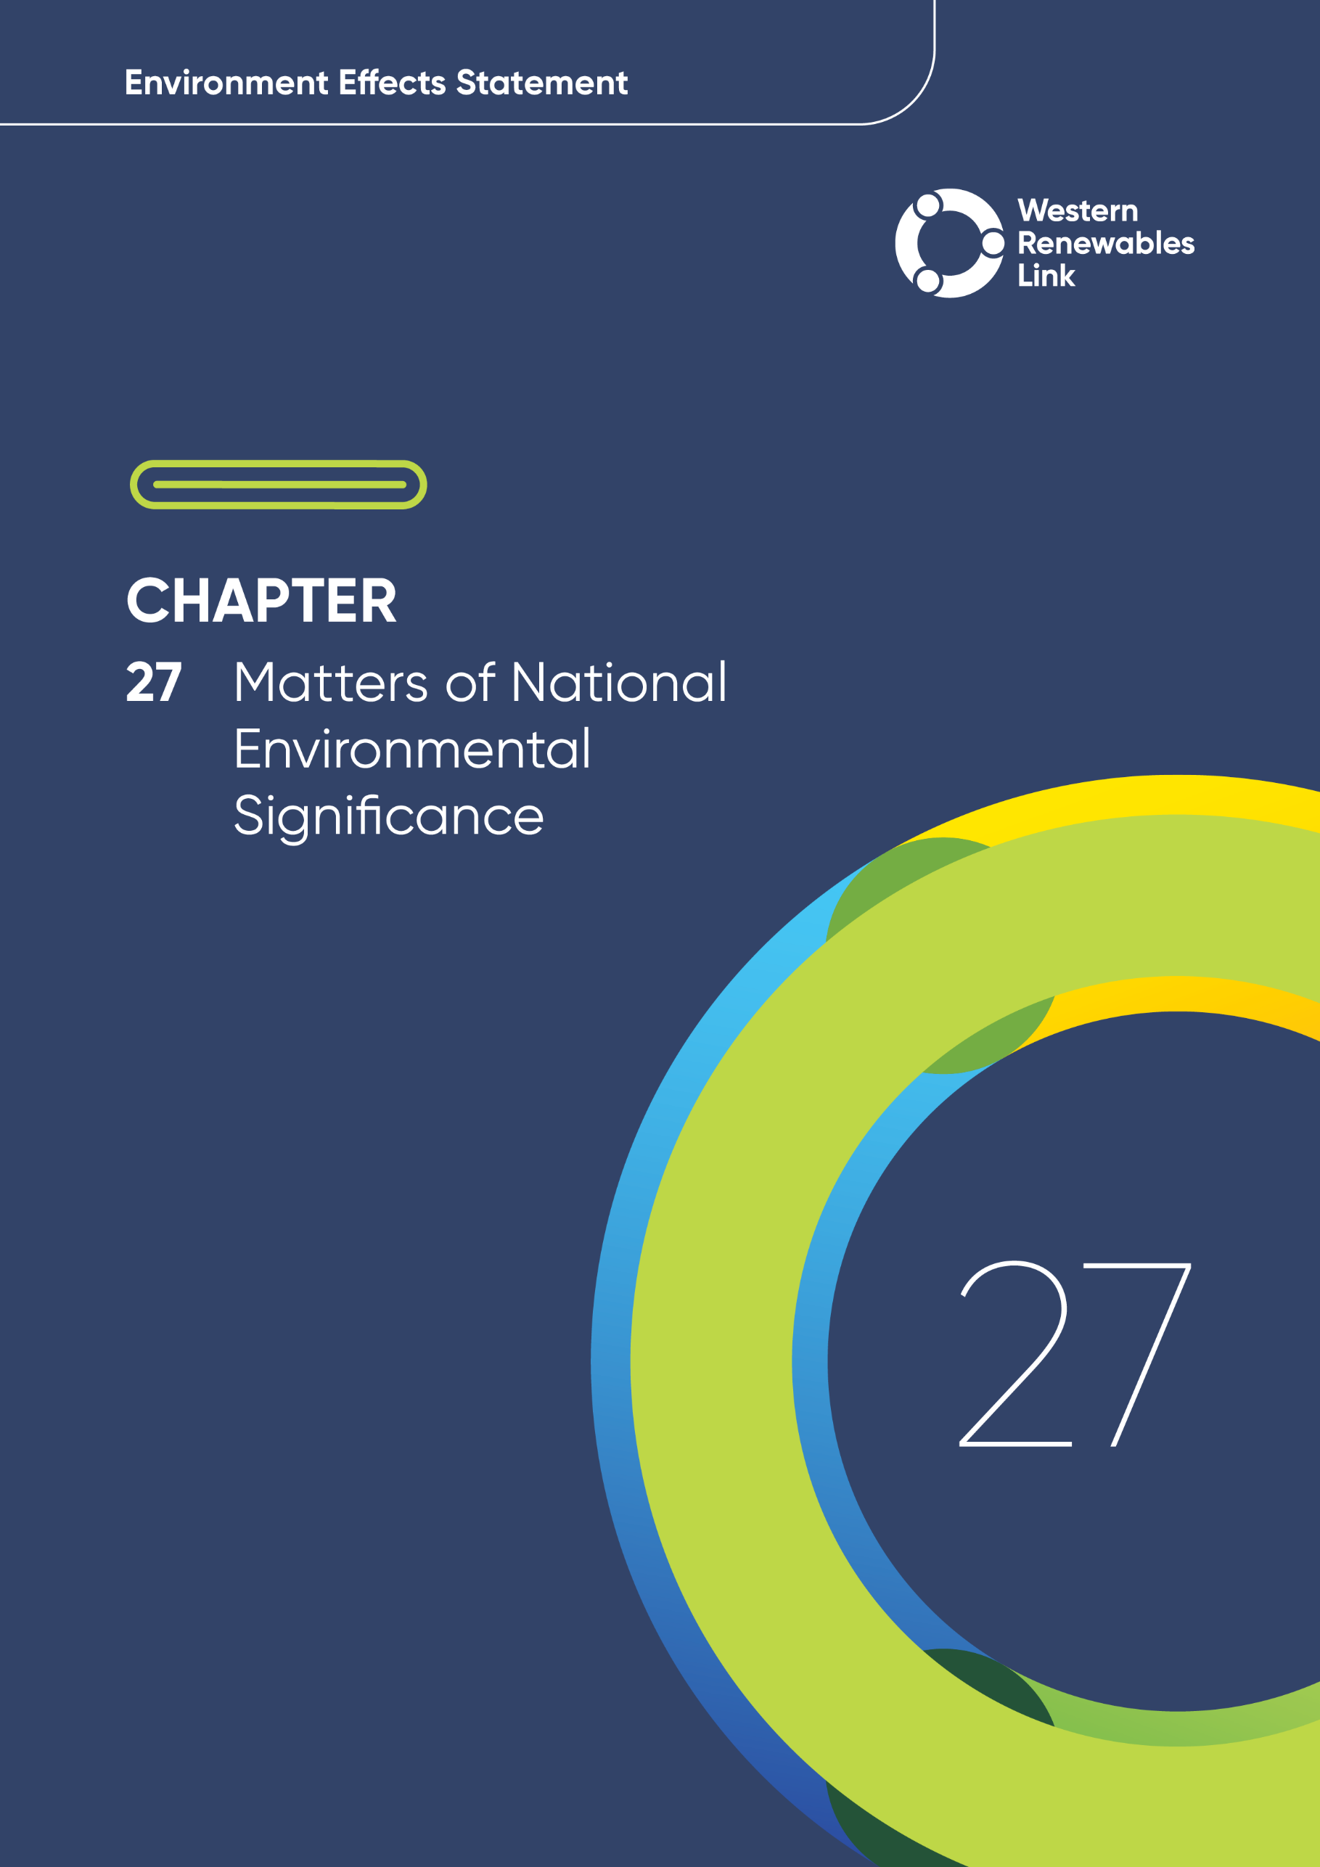

Matters of National Environmental Significance
This chapter provides an overview of the potential impacts on Matters of National Environmental Significance (MNES) associated with the construction, operation and decommissioning of the Project. This chapter is based on Technical Report A: Biodiversity Impact Assessment.
- Defining ‘significant impact’
The Matters of National Environmental Significance – Significant impact guidelines 1.1 (DoE, 2013) define a ‘significant impact’ as an impact which is important, notable, or of consequence, having regard to its context or intensity.
Whether or not an action is likely to have a significant impact depends upon the sensitivity, value, and quality of the environment, which is impacted, and upon the intensity, duration, magnitude and geographic extent of the impacts.
MNES are crucial components of Australia’s environmental protection framework identified under the Environment Protection and Biodiversity Conservation Act 1999 (EPBC Act). The EPBC Act provides for the listing of nationally threatened species, threatened ecological communities (TECs) and key threatening processes; and provides the legal framework to protect and manage nine MNES:
- World heritage properties
- National heritage places
- Wetlands of international importance (Ramsar wetlands)
- Listed threatened species and communities
- Listed migratory species
- Commonwealth marine areas
- The Great Barrier Reef Marine Park
- Nuclear actions
- Water resources, in relation to coal seam gas and large coal mining development.
The Project was determined to be a ‘controlled action’ requiring assessment and approval under the EPBC Act due to the likelihood of having a significant impact on MNES. The relevant MNES for the Project is listed threatened species and communities. More information on this decision is provided in Chapter 3: Legislative framework and approval requirements.
Under section 45 of the EPBC Act, the Environment Effects Statement (EES) process is accredited under the bilateral (assessment) agreement and will be the primary assessment process for the Project. This chapter informs the assessment of the Project under this agreement and focuses only on MNES. Other impacts to biodiversity and habitat, including threatened species listed under the Flora and Fauna Guarantee Act 1988 and native vegetation, are presented in Chapter 8: Biodiversity and habitat.
Offsets have been identified, consistent with the requirements of the EPBC Act Environmental Offsets Policy (DSEWPaC, 2012).
It is acknowledged that Aboriginal peoples have strong links to the land and the flora and fauna values contained within. Accordingly, the consideration of culturally significant flora and fauna is discussed in Chapter 9: Aboriginal cultural heritage.

Evaluation objective
The scoping requirements identify the following evaluation objectives relevant to MNES:
Evaluation objectives
Avoid, and where avoidance is not possible, minimise potential adverse effects on protected native vegetation and animals (particularly listed threatened species and their habitat and listed ecological communities), as well as address offset requirements consistent with state and Commonwealth policies.
In response to this evaluation objective, impacts of the Project on MNES were assessed and measures to avoid, minimise or manage potential impacts have been identified. These measures are discussed throughout this chapter and have informed the development of Environmental Performance Requirements (EPRs). EPRs set out the environmental outcomes to be achieved through the implementation of mitigation measures during construction, operation and decommissioning to avoid, minimise and manage identified impacts. Cumulative impacts associated with relevant future projects were also assessed.
Further information on how the Project has been designed to avoid and minimise impacts is provided in Chapter 5: Project development and Chapter 6: Project description.
Other aspects covered in the EES evaluation objectives and relevant to MNES are addressed in the following EES chapters:

- Chapter 8: Biodiversity and habitat
- Chapter 17: EMI and EMF
- Chapter 24: Groundwater
- Chapter 25: Surface water.

Method
This section summarises the method adopted in Technical Report A: Biodiversity Impact Assessment, which was informed by Chapter 4: EES assessment framework and approach. The key steps in assessing the impacts associated with MNES included:
- Defining a study area appropriate for MNES as presented in Figure 27.1. This included the Project Land, with a ten-kilometre buffer applied. This area comprises approximately 500,000 hectares (ha) which is considered sufficient to contextualise the biodiversity values present in the wider landscape.
- Reviewing applicable Commonwealth and Victorian legislation, and relevant local, state and national standards, guidelines and policies.
- Conducting a desktop review to characterise the landscape, and to assess the existing biodiversity and habitat conditions including native vegetation, TECs, and threatened flora and fauna previously recorded or modelled to occur within the study area, including:
  - Public web-based databases developed by the state and commonwealth government departments, government agencies, and scientific institutions, that model, map, and record the presence of biodiversity values.
  - Publications released by local councils and Catchment Management Authorities located within the study area, related to the presence and management of biodiversity values.
  - Published targeted surveys, habitat assessments, and environmental reports relevant to the study area.
  - Conservation advice, recovery plans and action statements for threatened species and communities.
  - Aerial photography, topographic maps and LiDAR.
A full list of the data sources and literature accessed are listed in Section 5.4 of Technical Report A: Biodiversity Impact Assessment.
- Consulting with the relevant regulatory authorities and key stakeholders including local councils and Catchment Management Authorities, the Department of Energy, Environment and Climate Action (DEECA), the Department of Climate Change, Energy, the Environment and Water (DCCEEW), Pentland Hills Landcare Group (Myrniong Biolink Project), Friends of Werribee Gorge and Long Forest Mallee Inc., Parks Victoria, Southern Rural Water, and Victorian National Parks Association, and reviewing the pins dropped by community members onto the Project’s Social Pinpoint online mapping tool, which identified locations, features and values or importance.
- Conducting field investigations and targeted surveys for the relevant biodiversity values. This chapter uses the results of these investigations from 2019 through August 2024 where there was a determined need from the desktop assessment and where land access was available. This included:
  - A preliminary field assessment to guide further surveys and assess the likelihood of threatened species' presence. This involved a rapid evaluation of native vegetation and habitat quality without entering private property.
  - A general field survey focused on areas identified as potentially containing biodiversity values. It included four components: Vegetation Quality Assessment (VQA), TEC assessment, threatened species habitat assessment and general fauna survey. These assessments determined the need for further targeted surveys.
  - Targeted flora and fauna surveys conducted for species with a likelihood of occurrence above "low". These surveys were undertaken during appropriate (seasonal) times and in accordance with relevant survey guidelines. For some faunal species (particularly non-cryptic birds), targeted surveys were not undertaken due to the presence of extensive existing records.
  - Where property access for field surveys was limited, desktop data was used to identify potential habitat for TECs and threatened flora and fauna. Review of aerial imagery and visual inspection from adjacent properties was used to exclude areas of modelled habitat where possible, however, this only occurred in a few limited locations. When threatened species habitat is established through suitable survey on an accessible parcel, habitat has been extrapolated into adjoining inaccessible parcels where visual inspection or aerial imagery indicates it is contiguous habitat of similar condition. This approach does not alleviate the need for completing subsequent detailed surveys as required by EPR BD1.
- Mapping the type and extent of patches of native vegetation throughout the Project Area using an Integrated Native Vegetation assessment approach, which incorporated both DEECA modelled data and Jacobs field investigation data. The Integrated Native Vegetation assessment approach is described in full in Section 5.12.2 of Technical Report A: Biodiversity Impact Assessment.
- Assessing the likelihood of occurrence for threatened flora and fauna in the Project Area, as defined by the criteria set out in Section 5.5 of Technical Report A: Biodiversity Impact Assessment. This included the EPBC listed threatened species and communities listed in the EES scoping requirements, as well as those identified in the desktop review as having records or potentially occurring within the study area. This considered the results of all field investigations and species with a low or higher likelihood of occurrence in the Project Area were considered in the impact assessment.
- Calculating the area of native vegetation (including EPBC listed species and communities) required to be partially or completely removed within the Construction Footprint, based on modelled and mapped native vegetation. This calculation included the removal of vegetation greater than 3 metres (m) in height within the transmission line easement, trees that are at risk of falling into the operational safety clearance zone for the transmission line, vegetation required to be removed for fuel load reduction to manage bushfire risks and areas of vegetation removal required to build Project infrastructure.
- Conducting a risk screening process to identify the key issues during construction, operation and decommissioning for investigation within the technical report.
- Identifying and assessing the potential impacts to MNES potentially present within the Project Area in line with the Matters of National Environmental Significance – Significant impact guidelines 1.1 (DoE, 2013) (MNES Significant Impact Guidelines 1.1) and relevant MNES specific guidelines, including listed threatened ecological communities, listed threatened flora and fauna, and associated habitat (including, but not limited to, those species outlined in the scoping requirements). The first step was to determine the likely presence of a species / community, then an assessment was made on the potential impact to a MNES based on the following scale:
  - Low: Generally the impact is so small it is considered negligible or not noticeable / measurable.
  - Low – moderate: Some impact may occur and may affect some individuals or an area of TEC but would probably not result in meaningful or demographic change with regard to a population, or a significant portion of a TEC, and is unlikely to be a significant impact for EPBC Act species.
  - Moderate: Impact potentially meaningful at the population level (e.g., may result in loss of genetic diversity, or a significant proportion of a population / TEC) and may be a significant impact for EPBC Act species or TECs.
  - High: Likely to influence the demographics of a population and / or likely a significant impact for EPBC Act species or TECs.
- Undertaking a more detailed significant impact assessment if potential impacts were greater than low, against the relevant MNES Significant Impact Guidelines 1.1, discussed further in the significance of residual impacts point below. This included consideration of relevant threat abatement plans, Recovery Plans and conservation advice.
- Identifying opportunities for the avoidance, minimisation and mitigation of impacts through Project design that could, so far as reasonably practicable, reduce the likelihood, extent and / or duration of potential impacts on MNES. Avoidance associated with determining the alignment of the corridor was the most critical factor in reducing impacts. This included the aim to avoid large contiguous areas of native vegetation and habitat and prevent the creation of easements fragmenting national parks, state and regional parks, and state forests during the initial design stage.
- Identifying other relevant future projects that could lead to cumulative impacts when considered together with the Project (refer to Chapter 4: EES assessment framework and approach for the full cumulative impact assessment method).
- Developing Environmental Performance Requirements (EPRs) in response to the impact assessment to define the required environmental outcomes that the Project must achieve through the implementation of mitigation measures during construction, operation and decommissioning. Measures to reduce the potential impacts were proposed in accordance with the mitigation hierarchy (avoid, minimise, manage, rehabilitate and offset) and have informed the development of EPRs. Alternative mitigation measures could be implemented to comply with the EPRs based on the specific site conditions, available resources, and the Principal Contractor’s expertise.
- Significant impact assessment
In relation to MNES, the EPBC Act lists significant impact criteria for listed species and communities related to their conservation status. A level of impact exceeding these criteria is referred to as a ‘significant impact’.
- Following application of mitigation measures that would comply with the EPRs, assessing the significance of residual impacts to MNES in accordance with the MNES Significant Impact Guidelines 1.1 (and associated MNES specific guidelines) for EPBC Act listed species and communities with a potential impact rating greater than low, as defined in the dot point above. Residual impacts discussed within this chapter relate specifically to these guidelines and are reported for each criterion as ‘unlikely’, ‘possible’ and ‘likely’ to result in a significant impact. Impacts associated with broader biodiversity values are described in Chapter 8: Biodiversity and habitat.
- Determining offset requirements triggered under the EPBC Act to compensate for residual significant impacts to MNES as a result of construction and operation of the Project.
- Developing an Offset Management Strategy (Attachment V: Offset Management Strategy) which describes the approach on how to offset residual significant impacts to MNES which are unavoidable, in accordance with the EPBC Act Environmental Offsets Policy (DSEWPaC, 2012).

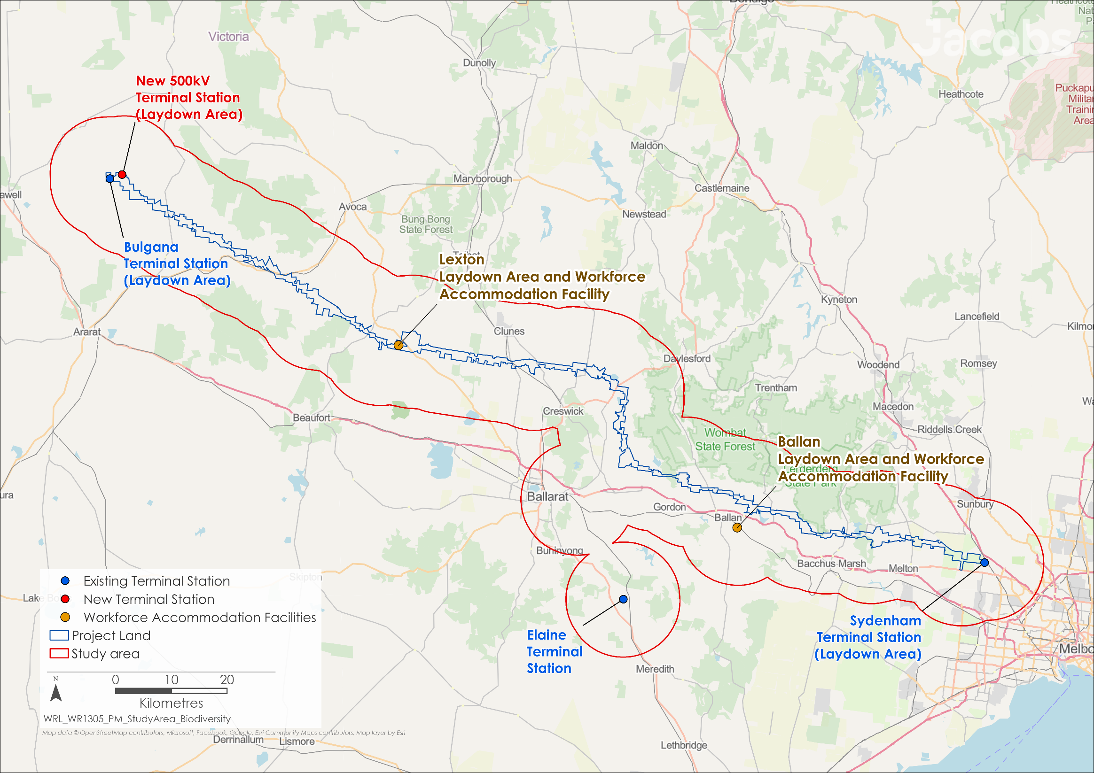
Figure 27.1 MNES study area

Existing conditions
This section summarises the existing conditions for MNES according to the following key ecological values:
- Threatened Ecological Communities
- Threatened flora
- Threatened fauna.
These values cover the aspects of MNES determined to be relevant to the Project (listed threatened species and communities), as confirmed by the EPBC Act referral decision. No world heritage properties, national heritage places or Ramsar wetlands occur within the study area or were assessed as being relevant to the Project. The Great Barrier Reef marine park is also not relevant. Further, the Project does not involve any nuclear actions or relate to coal seam gas or coal mine development.
Existing conditions for the biodiversity and habitat values within the region are described in Chapter 8: Biodiversity and habitat.
- Threatened ecological communities
A threatened ecological community (TEC) is a naturally occurring group of native plants, animals and other organisms that interact in a unique habitat and are listed as vulnerable, endangered, or critically endangered under the EPBC Act.

Threatened ecological communities
The scoping requirements for the Project outlined five EPBC Act listed TECs requiring assessment in the EES, including:
- Grassy Eucalypt Woodland of the Victorian Volcanic Plain (Critically Endangered)
- Grey Box (Eucalyptus microcarpa) Grassy Woodlands and Derived Native Grasslands of South-eastern Australia (Endangered)
- Natural Temperate Grassland of the Victorian Volcanic Plain (Critically Endangered)
- Seasonal Herbaceous Wetlands (Freshwater) of the Temperate Lowland Plains (Critically Endangered) and
- White Box-Yellow Box-Blakely’s Red Gum Grassy Woodland and Derived Native Grassland (Critically Endangered).
The PMST search identified two additional TECs with a modelled occurrence within the study area:
- Natural Grasslands of the Murray Valley Plains (Critically Endangered)
- Mallee Bird Community of the Murray Darling Depression Bioregion (Endangered).
Of these seven TECs, two were recorded within the Project Area during field assessment: Grey Box (Eucalyptus microcarpa) Grassy Woodlands and Derived Native Grasslands of South-eastern Australia and Natural Temperate Grassland of the Victorian Volcanic Plain. The field-mapping confirmed the extent of these two TECs, as shown in Figure 27.2. Details of the EPBC listed TECs are provided in Chapter 8: Biodiversity and habitat, in Table 8.2, and a summary of the likelihood of occurrence is provided in Table 27.1
White Box-Yellow Box-Blakely’s Red Gum Grassy Woodland and Derived Native Grassland is considered to have a ‘high’ likelihood of occurrence within areas of the Project Area not yet surveyed. At least one patch of vegetation located at the western end of the Project Area has the potential to support a Yellow Box canopy over a moderately intact understorey. If present, the overall area of land occupied by this TEC is likely to be small given the generally poor condition of understorey vegetation present within similar field-mapped vegetation.
Targeted field assessments, undertaken during seasonally appropriate conditions, did not identify Seasonal Herbaceous Wetlands (Freshwater) of the Temperate Lowland Plains within the Project Area and similarly, Natural Grasslands of the Murray Valley Plains and the Mallee Bird Community of the Murray Darling Depression Bioregion were not considered likely to occur within the Project Area.
Table 27.1 Likelihood of occurrence for Threatened Ecological Communities relevant to the Project
Community | Likelihood of occurrence within the Project Area
Grassy Eucalypt Woodland of the Victorian Volcanic Plain (Critically endangered) | Low. This TEC was recorded in the south-eastern part of the study area in the vicinity of Exford, south of the Werribee River, and well outside the Project Area. Low likelihood of occurrence within unsurveyed areas of the Project Area. 10.20ha of EVC equivalents for this TEC are modelled to occur in the Project Area in areas not yet surveyed, however evidence from aerial imagery and adjacent field survey indicates these areas are unlikely to support the TEC.
Grey Box Grassy Woodlands and Derived Native Grasslands of South-eastern Australia (Endangered) | Present. 12.48ha has been recorded within the Project Area. This TEC makes up a large proportion of the remaining native vegetation within the Project Area between the Lerderderg River in the west and Djerriwarrh Creek in the east. A total of 15.96ha of EVC equivalents for this TEC are modelled to occur in areas of the Project Area where field survey has not been completed. However, desktop review indicates these areas are unlikely to support the TEC.
Mallee Bird Community of the Murray Darling Depression Bioregion (Endangered) | N/A. The Project Area is outside the natural range for this TEC.
Natural Grassland of the Murray Valley Plains (Critically endangered) | N/A. The Project Area is outside the natural range for this TEC.
Natural Temperate Grassland of the Victorian Volcanic Plain (Critically endangered) | Present. 38.05ha recorded in Project Area comprising 16 patches, 14 located between Merrimu and Melton and two along Kingston Road in Allendale. A total of 2.33ha of EVC equivalents for this TEC are modelled to occur in areas of the Project Area where field survey has not been completed. However, desktop review indicates these areas are unlikely to support the TEC.
Seasonal Herbaceous Wetlands (Freshwater) of the Temperate Lowland Plains (Critically endangered) | Low. There is a low likelihood of occurrence within unsurveyed areas. No EVC equivalents for this TEC occur in the Project Area in areas not yet surveyed, nor has any ‘over the fence’ observation indicated the potential presence of this TEC.
White Box-Yellow Box-Blakely’s Red Gum Grassy Woodland and Derived Native Grassland (Critically endangered) | High. Likely occurrence within western extent of the Project Area, however, none recorded to date. There is 28.28ha of EVC equivalents for this TEC modelled to occur in the Project Area. Desktop information and preliminary survey indicate some of these are likely to support the TEC and the occurrence of the TEC within the Project Area is expected to be much less than the modelled EVC equivalents given the generally poor condition of understorey vegetation present within similar field-mapped vegetation.

Ecological surveys are still to be completed in some areas (due to access limitations) and will be undertaken as access issues are resolved. Surveys will include mapping of native vegetation (including TECs), identification of habitat, and targeted survey for threatened flora and fauna (as required). The outcomes of these surveys will inform design (e.g., to determine if micro-siting of infrastructure can be considered to avoid and further minimise impacts to biodiversity) and identify (construction) no go zones to protect areas of native vegetation. This information will also be used to finalise offset requirements. For the purpose of the biodiversity assessment, a conservative approach has been taken, with the use of desktop information, including modelled data to map the extent of native vegetation and assumes the potential presence of TEC’s and threatened species habitat where surveys have not yet been undertaken due to access limitations.
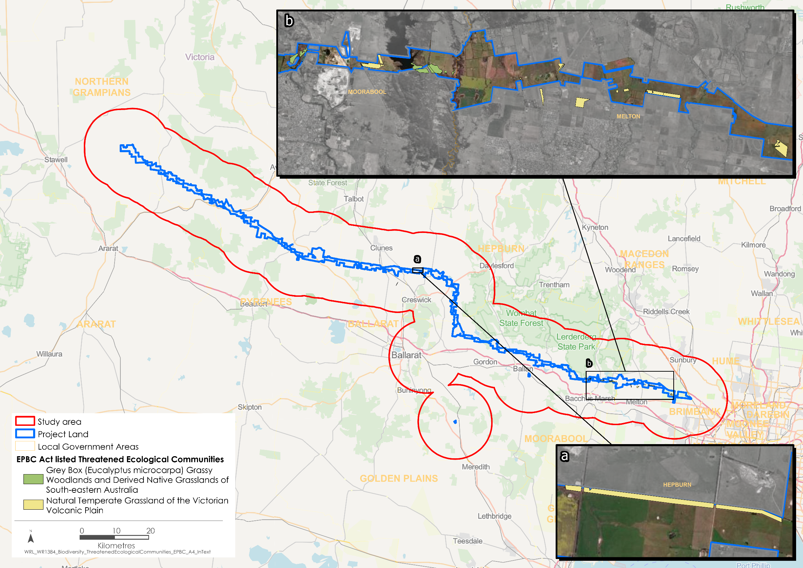
Figure 27.2 Field recorded extent of EPBC Act listed threatened ecological communities

Threatened flora
A likelihood of occurrence assessment was undertaken for all threatened floral species previously recorded or modelled to occur in the study area. Species considered in the assessment were derived from searches of the PMST, VBA, and other species listed in the scoping requirements. Species were initially assessed for their likelihood of occurrence in the Project Land and subsequently assessed for their likelihood of occurrence within the Project Area.
Six EPBC Act listed threatened floral species were considered to have a likelihood of occurrence that is greater than ‘low’ in the Project Area. These are described in Chapter 8: Biodiversity and habitat, in Table 8.4, and their likelihood of occurrence summarised in Table 27.2.
Table 27.2 Likelihood of occurrence for threatened floral species relevant to the Project
Species | Likelihood of occurrence within the Project Area
Matted Flax-lily (Dianella amoena)  (Endangered) | Moderate. There are no records for Matted Flax-lily associated with the Project Area and only a small number associated with the much broader study area, occurring east from Melton. Fieldwork has not recorded the species. Of the remaining areas not yet surveyed due to access constraints, a total of 67ha of potential grassland and drier grassy woodland / forest habitat occurs within the Project Area.
Small Golden Moth Orchid (Diuris basaltica)  (Endangered) | Low-Moderate. Species not recorded in Project Area to date and is considered unlikely to occur given the highly degraded nature of native grassland present. Of the remaining areas not yet surveyed due to access constraints, 2.34ha of potential plains grassland habitat in the Melton Plain occurs within the Project Area.
Basalt Peppercress (Lepidium hyssopifolium s.s.)  (Endangered) | Low-Moderate. Known from a managed conservation population within Moorabool Reservoir, adjacent to the Project Area but no other records nearby. Most of the potential habitat near Moorabool Reservoir in areas not subject to cultivation, were assessed and species not recorded. There is a lack of records to indicate it occurs elsewhere nearby the Project.
Spiny Rice-flower (Pimelea spinescens subsp. spinescens)  (Endangered) | Low-Moderate. Limited habitat in Project Area. The species was originally assumed to have a moderate likelihood of remaining in moderate to high quality grassland in the Project Area, however, there is a limited extent of such grassland within the Project Area. These areas have been surveyed and the species was not located. The potential unsurveyed habitat is less than 5ha and tends to be low quality, heavily grazed or subject to biomass build-up, which results in the unlikely occurrence of the species.
Button Wrinklewort (Rutidosis leptorhynchoides)  (Endangered) | Low-Moderate. Areas of potential habitat limited within the Project Area. Known records are mostly to the south of the study area on the lower plain. Most potential habitat has been surveyed and the species has not been recorded. The potential unsurveyed habitat is less than 5ha and tends to be low in quality, heavily grazed or subject to biomass build-up.
Swamp Fireweed (Senecio psilocarpus)  (Vulnerable) | Moderate. Targeted surveys did not detect the species. However, it has the potential to occur given one individual was recorded in Masons Swamp (DEECA Wetland 55625) within a grassy wetland area, immediately adjacent to the Project Area. In addition to Mason’s Swamp, there is 1.22ha of potential habitat that has not been surveyed within the Project Area.

Figure 27.3 provides the location of the VBA records for these six EPBC Act listed species with an above ‘low’ likelihood of occurrence in the Project Area.
No EPBC Act listed threatened floral species have been recorded within the Project Area during field investigations, including targeted surveys.

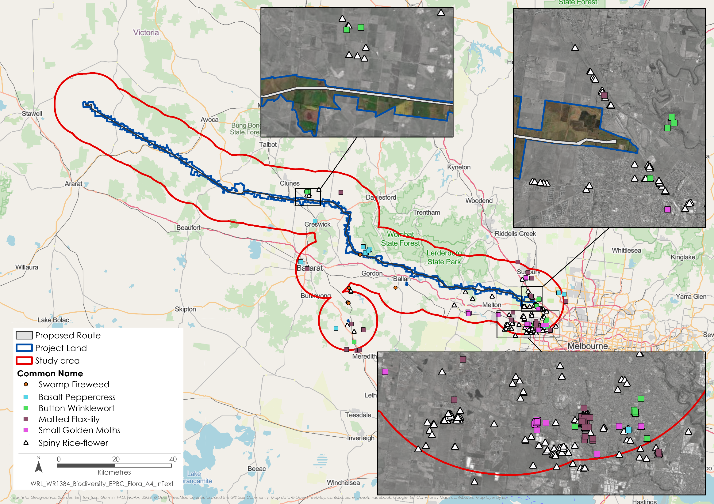
Figure 27.3 Location of existing VBA records of EPBC Act listed floral species with an above 'low’ likelihood of occurrence within the Project Area

Threatened fauna
A likelihood of occurrence assessment was undertaken of all threatened fauna species previously recorded or modelled to occur in the study area. Species considered in the assessment were derived from searches of the PMST, VBA, BirdLife Australia Birdata Atlas and other species listed in the scoping requirements for the Project. Species were initially assessed for their likelihood of occurrence in the Project Land and subsequently assessed for their likelihood of occurrence within the Project Area.
Fifteen EPBC Act listed threatened fauna species were considered to have an above ‘low’ likelihood of occurrence in the Project Area, which are described in in Table 8.5 of Chapter 8: Biodiversity and habitat, and a summary of the likelihood of occurrence is discussed in Table 27.3.
Table 27.3 Threatened fauna with an above ‘low’ likelihood within the Project Area
Species | Likelihood of occurrence within the Project Area
Growling Grass Frog (Litoria raniformis) (Vulnerable) | High. Potential aquatic and riparian habitat was identified within and nearby the Project Area, scattered between west of Lexton to east of Melton.
Blue-winged Parrot (Neophema chrysostoma) (Vulnerable) | High. The has been observed by a third party in 2019 along R Charleston Road, Clunes, which transverses the Project Area.
Brown Treecreeper (Climacteris picumnus) (Vulnerable) | Present. Observed opportunistically across several forested areas, including at Long Forest, Lerderderg and north of Lexton.
Diamond Firetail (Stagonopleura guttata) (Vulnerable) | Present. Four individuals were recorded in the Long Forest area, south of the Project Area, and may also be present in the Lerderderg environs.
Gang-gang Cockatoo (Callocephalon fimbriatum) (Endangered) | Present. 11 individuals were observed opportunistically in the vicinity of Lerderderg State Park, Long Forest Nature Conservation Reserve and on the Melton Plain. Also recorded on a SongMeter south of Wombat State Forest. Multiple database records (>50) within the study area, including recent records. Suitable forest and woodland habitat scattered throughout the Project Area.
Hooded Robin (south-eastern) (Melanodryas cucullata) (Endangered) | Moderate. The species is occasionally observed near Long Forest area and tends to occur far more frequently across the northern slopes of the Great Divide.
Latham's Snipe (Gallinago hardwickii) (Vulnerable) | High. The species was recorded during field assessment west of Bolwarrah, outside of the Project Area. The species is likely to utilise wetlands with high emergent aquatic vegetation across the eastern extent of the study area.
Painted Honeyeater (Grantiella picta) (Vulnerable) | Moderate. Some individuals of the species are likely to seasonally forage through relevant habitat within the Project Area, but are not thought to breed in, or make significant use of the habitat.
Swift Parrot (Lathamus discolor) (Critically endangered) | High. The local migration route generally follows regularly visited stopping points up through the Brisbane Ranges and Long Forest, which may change to the east or west depending on rainfall in any given year and the flowering response of the various flowering eucalypt species relied on during their travels. Areas of important feed trees (Melbourne Yellow-gum and Grey Box) occur in high concentrations in some areas of the Project Area.
White-throated Needletail (Hirundapus caudacutus) (Vulnerable) | High. The species may regularly overfly the Project Area along with much of the state.
Golden Sun Moth (Synemon plana) (Vulnerable) | Present. Incidentally recorded at seven sites during general field survey, west of Lexton in areas of unimproved pasture. All potential habitat has been identified throughout the Project Area including unsurveyed areas.
Southern Greater Glider (Petauroides volans) (Endangered) | Moderate. Targeted survey has not recorded the species within the Project Area, although areas of connected potential habitat are present. Potential habitat recorded in the Hayden Hill bushland area where habitat is connected and in proximity to a known population.
Grey-headed Flying-fox (Pteropus poliocephalus) (Vulnerable) | Known. Known to regularly fly over portions of the eastern extent of the Project Area; however, no significant camps have been recorded during targeted survey, noting a seasonal camp was observed 2km south of the Project Area at Darley.
Victorian Grassland Earless Dragon (Tympanocryptis pinguicolla) (Critically endangered) | Low-Moderate. The only known extant population was discovered south of Bacchus Marsh in 2022 outside of the Project Area. Given the very limited known extent of this species it seems unlikely the areas of potential habitat in the Project Area support the species, however its potential presence cannot be excluded.
Striped Legless Lizard (Delma impar) (Vulnerable) | Moderate. The species was not recorded during targeted surveys in the small extent of accessible habitat identified, however its presence cannot be ruled out in areas not subject to survey yet.

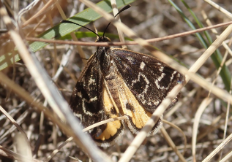
Three of these species – the Golden Sun Moth (refer to Figure 27.4), Gang-gang Cockatoo and Brown Treecreeper – have been recorded in the Project Area during field surveys to date.
An additional species, the Diamond Firetail, has been recorded south of the Project Area around the Long Forest area. A seasonal Grey-headed Flying-fox camp was also recorded south of the Project Area at Darley.
Figure 27.5 provides the location of the VBA records for these fifteen EPBC Act listed species with an above ‘low’ likelihood of occurrence in the Project Area.
Figure 27.4. Golden Sun Moth located in areas of unimproved pasture and derived grasslands in the western extent of the Project.

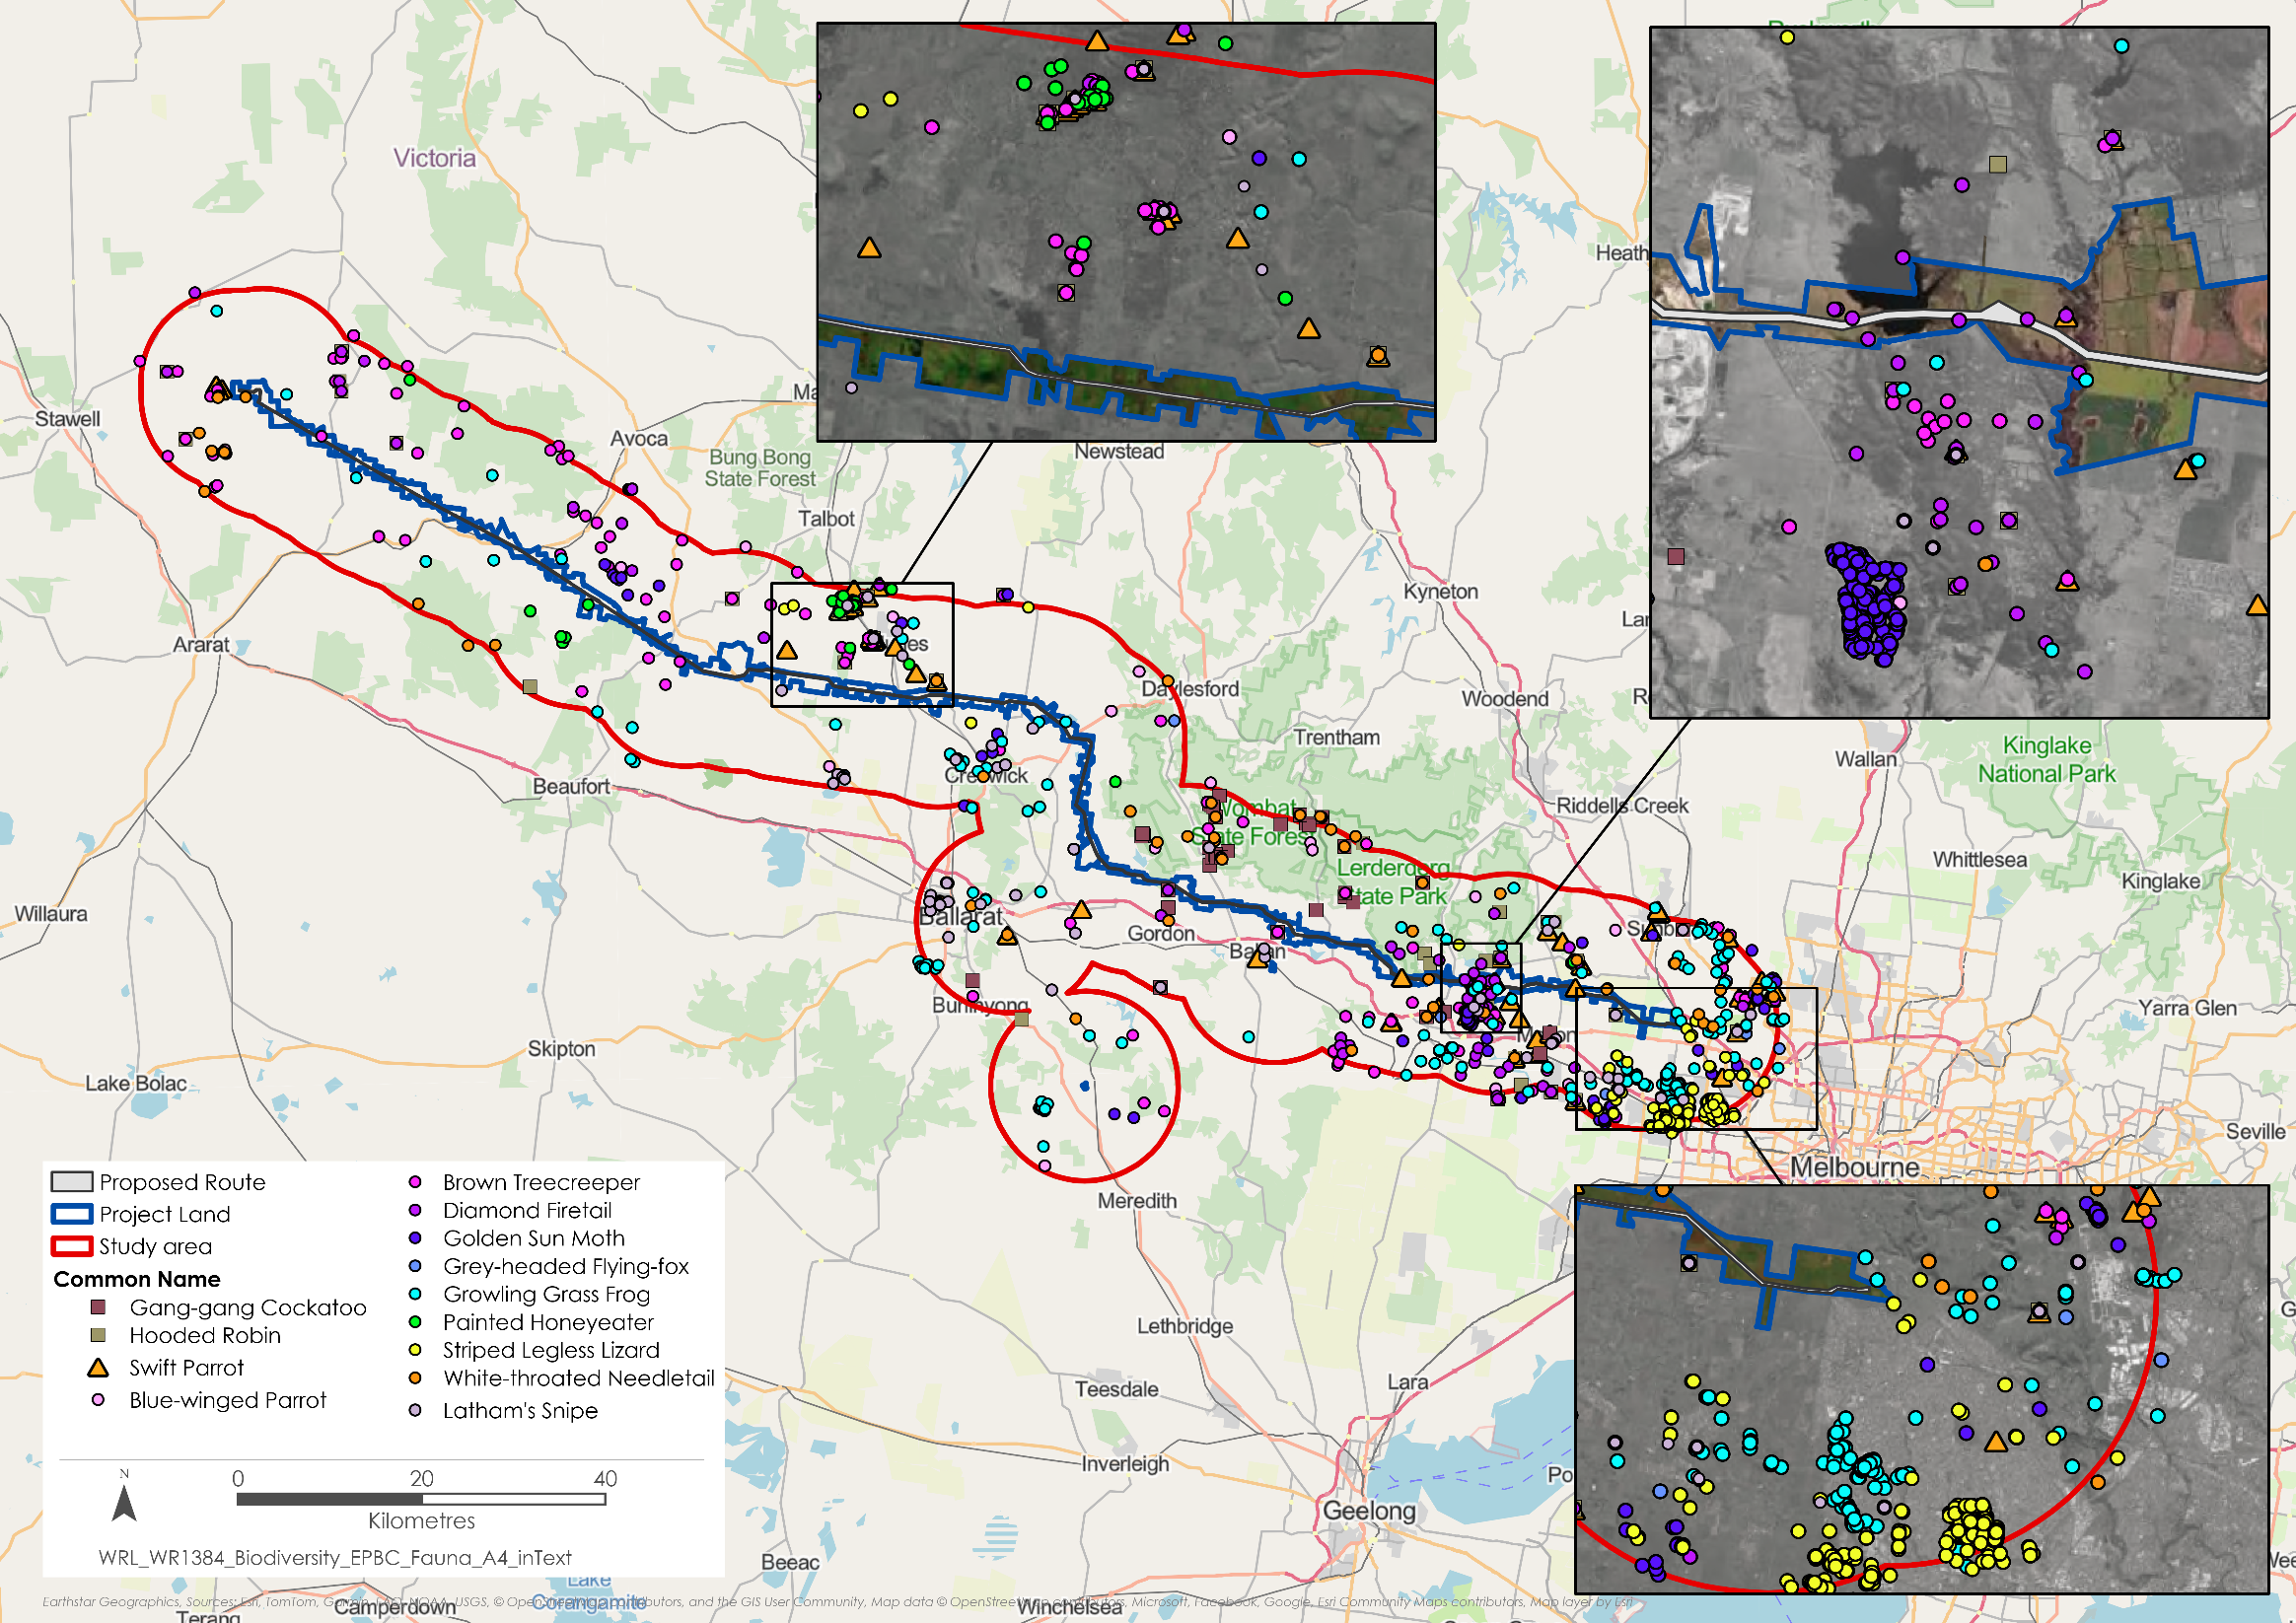
Figure 27.5 Location of existing VBA records of EPBC Act listed fauna species with an above 'low’ likelihood of occurrence within the Project Area
- Migratory species
Migratory species move from one habitat to another during different times of the year, as they cannot live in the same environment all year round due to seasonal limitations such as food, sunlight, and temperature.

Listed migratory species
Two migratory species that are listed as threatened under the EPBC Act were identified as potentially occurring within the study area: Latham’s Snipe and White-throated Needletail.
Latham’s Snipe may occasionally utilise the limited wetland habitats within the Project Area but are more likely to fly over as they move between better quality wetland habitats in the broader area.
The White-throated Needletail is a mostly aerial species that is likely to fly over the Project Area but is unlikely to reside or utilise the Project Area for breeding. The species only breeds outside of Australia.
A summary of the likelihood of occurrence of the migratory species listed as threatened is discussed in Table 27.4.
It is unlikely that the Project Area supports habitat considered important for foraging or breeding activity for any listed migratory species or for an ecologically significant proportion of a population.
Figure 27.6 provides the location of the VBA and BirdLife Australia records for these two migratory species with an above ‘low’ likelihood of occurrence in the Project Area.
Table 27.4 Migratory species listed as threatened under EPBC Act summary table
Species | Likelihood of occurrence within the Project Area
^White-throated Needletail (Hirundapus caudacutus) (Vulnerable) | High. The species may regularly overfly the Project Area along with much of the state.
Latham's Snipe (Gallinago hardwickii) (Vulnerable) | High. Species recorded during field assessment west of Bolwarrah, outside of the Project Area. The species is likely to utilise wetlands with high emergent aquatic vegetation across the eastern extent of the study area.

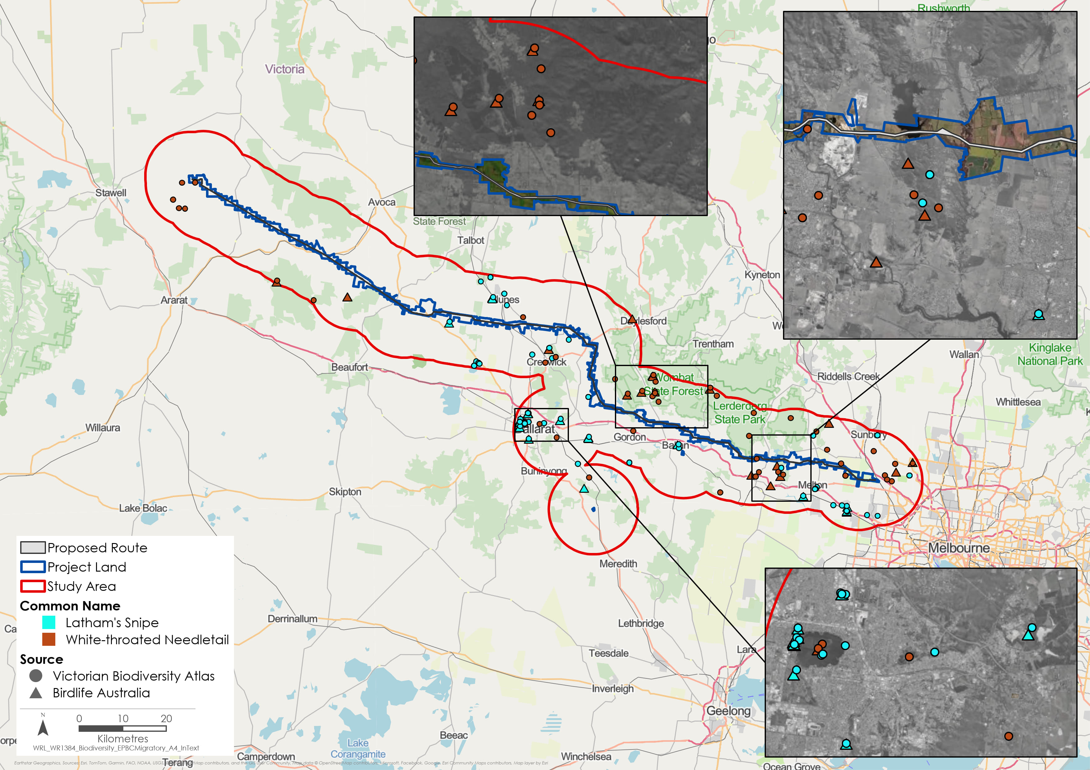
Figure 27.6 Location of existing records of migratory species listed as threatened in EPBC Act – species with an above 'low’ likelihood of occurrence within the Project Area

Construction and operation impacts
This section outlines the key issues identified through the risk screening process and the associated potential impacts during the construction and operation of the Project. This chapter considers operational impacts together with construction impacts, as the significant impact assessments against the MNES Significant Impact Guidelines include consideration of both construction and operational activities and associated impacts.
The key issues and impacts identified for MNES are discussed according to the following ecological values:
- Threatened ecological communities: complete or partial removal of areas of TEC, and potential damage to retained areas of TEC due to adjacent construction activities.
- Threatened flora: removal, loss or degradation of habitat for EPBC Act listed threatened flora through clearing areas of habitat and habitat modification such as canopy removal.
- Threatened fauna: removal, loss or degradation of habitat for EPBC Act listed threatened fauna through vegetation clearing, the introduction of obstacles (including Project infrastructure and fragmentation of habitat) and/or increased noise, dust and light.
As outlined in Chapter 8: Biodiversity and habitat, it is expected that most impacts to MNES from the Project will arise during the construction stage from:
- Direct impacts to native vegetation and habitat through clearance activities, including the development of the transmission line infrastructure and associated easement where vegetation occurs and where clearing is required to facilitate construction and comply with the Australian standard AS / NZS 7000:2016 Overhead Line Design and AusNet's Electricity Safety Management Scheme. Direct construction impacts include Project components where native vegetation occurs and impacts are considered unavoidable, including tower footprints, access track creation, construction laydown/accommodation areas and stringing pads.
- Indirect impacts including changes to the abiotic environment through removal of canopy species, habitat fragmentation, potential for weed invasion and general disturbance from works activities.
During the operation stage, activities will be undertaken in accordance with a Vegetation Management Plan (EPR BD2) and will include (but not limited to) the following:
- Managing trees to maintain minimum clearance space around transmission tower infrastructure and the transmission line, which includes cutting and pruning vegetation according to location and anticipated regrowth rates
- Mitigating fire risks associated with fuel loads below the transmission line
- Attaining ‘self-managing’ easements by removing inappropriate species, limiting existing vegetation height to an acceptable level, limiting the quantum and density of retained vegetation, and encouraging low growing appropriate species.
The avoidance of MNES has been an important design consideration for the Project from its inception. In the first instance, the Project sought to avoid large contiguous areas of native vegetation and habitat, with a focus on avoidance of areas of EPBC Act listed TECs and habitat for EPBC Act listed floral and faunal species. Sections of the Project have been iteratively designed to further reduce impacts following field investigations.
The magnitude of impacts from the Project has been assessed to reduce by applying measures to comply with EPRs. These measures include completion of outstanding surveys (where current land access constraints occur) to inform further design refinements to minimise impacts, the establishment of no go zones, salvage of hollows, and biosecurity measures to prevent spreading weeds and pathogens.

Threatened ecological communities
As discussed in Section 27.3.1, two TECs were recorded within the Project Area, Grey Box (Eucalyptus macrocarpa) Grassy Woodlands and Derived Native Grasslands of South-eastern Australia and Natural Temperate Grassland of the Victorian Volcanic Plain. The residual impact ratings have considered the implementation of the following EPRs:
- EPR BD1: Complete ecological surveys and finalise design (in areas where access limitations occur)
- EPR BD2: Develop and implement a Vegetation Management Plan (particularly related to establishment and enforcement of no go zones)
- EPR BD6: Develop and implement measures to manage riparian and aquatic habitat (particularly related to retention of understorey and ground cover vegetation)
- EPR BD7: Develop and implement an Operational Vegetation and Habitat Management Plan
- EPR BD8: Complete ecological surveys and finalise design for TEC White Box-Yellow Box-Blakely’s Red gum Grassy Woodland (WBYB)
- EPR EM8: Develop and implement a Biosecurity Management Plan.
A summary of the significant impact assessment undertaken following application of these EPRs is provided in Table 27.5 and Table 27.6. This assessment demonstrates that, following application of the EPRs and the related mitigation measures, impacts to the TECs will be reduced, but will not change the significant impact rating for Grey Box (Eucalyptus macrocarpa) Grassy Woodlands and Derived Native Grasslands of South-eastern Australia. This is because there will be a direct reduction in habitat extent, fragmentation of habitat, and change in species composition associated with the construction activities of the Project.
Mitigation measures such as design refinements and incorporation of no go zones (BD1) and contractor inductions (EPR BD2) will reduce the residual impact and will also protect the TECs from accidental clearance during the construction stage of the Project. Furthermore, the development of an Operational Vegetation and Habitat Management Plan (EPR BD7) and Biosecurity Management Plan (EPR EM8) will identify where appropriate measures are required to manage potential degradation impacts to TECs.
- Construction Footprint
The Construction Footprint is indicative, contained within the Project Area and encompasses the land required to facilitate construction of the Project, including the vegetation removal needed to achieve the operational safety clearance zone for the transmission line. Components in the Construction Footprint, such as access tracks, indicative stringing pads, and tower assembly areas, are included in Attachment VI: Map book.
White Box-Yellow Box-Blakely’s Red Gum Grassy Woodland and Derived Native Grassland has not been recorded during field assessments. However, 17ha of potential habitat that has not been subject to field survey occurs in the Construction Footprint. Future field investigation may therefore identify occurrences of this TEC within the Construction Footprint, and it is possible that a significant impact may occur, given avoidance of this community could be difficult if a significantly sized patch is identified. However, given that 145ha of modelled habitat for the TEC has been surveyed and the TEC has been found to not be present in these areas, it is reasonable to assume that much of the remaining 17ha is unlikely to support the TEC. Desktop review of the remaining 17ha indicates that no more than 5ha is likely to contain the TEC, and this is provided as a worst-case estimate of impact for the TEC.
Refer to Section 9.1.1 of Technical Report A: Biodiversity Impact Assessment for further details regarding the significant impact assessments against the MNES Significant Impact Guidelines 1.1 and Section 27.9 for an overview of TEC offset obligations.
Table 27.5. Summarised Significant impact assessments for Grey Box (Eucalyptus microcarpa) Grassy Woodlands and Derived Native Grasslands of South-eastern Australia
Significant impact criteria  (Endangered TEC) | Grey Box (Eucalyptus microcarpa) Grassy Woodlands and Derived Native Grasslands of South-eastern Australia
Reduce the extent of an ecological community. | Likely  - Potential impact of 6.79ha on confirmed extent.  - Largely associated with fuel load reduction, line clearance activities and the Easement Corridor Construction Footprint.  - A further 9.82ha of potential extent may be impacted in areas yet to be surveyed (low likelihood that these areas support the TEC).
Fragment or increase fragmentation of an ecological community, for example by clearing vegetation for roads or transmission lines. | Likely  - Dissection of a relatively continuous extent that extends down the eastern side of the Lerderderg River valley, extending from the Lerderderg State Park in the north, south around the escarpment into the Goodmans Creek catchment.  - Dissection on the eastern side of the Merrimu Reservoir, that occurs on both sides of the Diggers Rest-Coimadai Road.  - Dissection of a continuous extent of which occurs on the upper areas of the western flank of Djerriwarrh Creek gorge.
Adversely affect habitat critical to the survival of an ecological community | Unlikely  - When considering the extent of the community in the broader landscape  - The two largest areas of impacts comprise partial clearance areas where vegetation cover is low such that canopy and shrub removal will incur minimal impact to other strata.  - Other six areas impacts are largely limited to edges of these patches on the marginal boundary of this reserve.
Modify or destroy abiotic (non-living) factors (such as water, nutrients, or soil) necessary for an ecological community’s survival | Unlikely  - There is not expected to be change to abiotic factors outside areas of vegetation clearance; surface water drainage is not expected to be substantially altered.
Cause a substantial change in the species composition of an occurrence of an ecological community, including causing a decline or loss of functionally important species | Likely  - Fuel reduction and line clearance activities will involve the removal of the canopy (Grey Box), and the tall shrub elements, where components of the community are greater than 3m in height.  - It is likely lower elements will be affected by changes to solar exposure.
Assisting invasive species, that are harmful to the listed ecological community, to become established, or | Possible  - The partial clearance of the community is likely to favour the establishment of invasive weeds known to the area.  - A Biosecurity Management Plan (EPR EM8) will be developed to manage invasive species.
Causing regular mobilisation of fertilisers, herbicides or other chemicals or pollutants into the ecological community which kill or inhibit the growth of species in the ecological community, or | Unlikely  - The Project is not expected to significantly mobilise detrimental chemicals into fully or partially retained areas of this community.  - However, there is likely an increased need for herbicide application to manage weeds in areas disturbed by the Project.
Interfere with the recovery of an ecological community. | Unlikely  - The partial clearance and complete removal, where impacts are limited to edges of these patches, is not expected to interfere with the recovery of the community.

Table 27.6. Summarised Significant impact assessments for Natural Temperate Grassland of the Victorian Volcanic Plain, and for White Box-Yellow Box-Blakely’s Red Gum Grassy Woodland and Derived Native Grassland
Significant impact criteria  (Critically Endangered TEC) | Natural Temperate Grassland of the Victorian Volcanic Plain | White Box-Yellow Box-Blakely’s Red Gum Grassy Woodland and Derived Native Grassland
Reduce the extent of an ecological community. | Likely  - 4.47ha impact is unavoidable and will require removal for the Project.  - 0.90ha of potential extent may be impacted in areas yet to be surveyed. | Possible  - Up to 5ha of the TEC may require removal due to the Project.
Fragment or increase fragmentation of an ecological community, for example by clearing vegetation for roads or transmission lines. | Unlikely  - Natural Temperate Grasslands mapped in the Project Area occur in a highly fragmented mosaic, resulting from structural decline from lack of suitable management.  - No further fragmentation will occur as a direct result of the Project.  - In instances where access tracks are proposed, it is along the boundary of the community and the 5m wide access tracks are unlikely to create new barriers to movement and / or isolate or disconnect the TEC from the rest of the patch. | Possible  - It is possible that clearing for road access or the transmission line may increase fragmentation of patches within the Project Area.
Adversely affect habitat critical to the survival of an ecological community | Unlikely  - Other than the direct loss of the 4.47ha confirmed extent, the remaining 33.64ha of confirmed extent within the Project Area will not be impacted (removed or modified). | Possible  - The conservation advice for this community states that given the currently highly fragmented and degraded state of this ecological community, all areas of the ecological community that meet the minimum condition criteria should be considered critical to the survival of this ecological community.  - It is possible the Project will adversely affect such an area.
Modify or destroy abiotic (non-living) factors (such as water, nutrients, or soil) necessary for an ecological community’s survival | Unlikely  - There is not expected to be change to abiotic factors outside areas of vegetation clearance; surface water drainage is not expected to be substantially altered. | Unlikely  - There is not expected to be change to abiotic factors outside areas of vegetation clearance.
Cause a substantial change in the species composition of an occurrence of an ecological community, including causing a decline or loss of functionally important species | Unlikely  - Lack of management has already reduced the biodiversity in the Natural Temperate Grasslands recorded. The lack of burning, weed invasion and grazing has seen the loss of most non-graminoid species, issues that will not be exacerbated by the Project. | Likely  - Fuel reduction and line clearance activities will involve the removal of the canopy (Yellow Box), and the tall shrub elements, where components of the community are greater than 3m in height.  - It is likely lower elements will be affected by changes to solar exposure.
Assisting invasive species, that are harmful to the listed ecological community, to become established, or | Unlikely  - Patches recorded already contain a high weed density, it is not expected that the Project will exacerbate this. | Possible  - The partial clearance of the community is likely to favour the establishment of invasive weeds.  - A Biosecurity Management Plan (EPR EM8) will be developed to manage invasive species.
Causing regular mobilisation of fertilisers, herbicides or other chemicals or pollutants into the ecological community which kill or inhibit the growth of species in the ecological community, or | Unlikely  - The Project is not expected to significantly mobilise detrimental chemicals.  - Many of the patches recorded already retain a high level of organic material, and the nutrients it contains in the slash material are apparent on site. | Unlikely  - The Project is not expected to significantly mobilise detrimental chemicals into fully or partially retained areas of this community.  - However, there is likely an increased need for herbicide application to manage weeds in areas disturbed by the Project.
Interfere with the recovery of an ecological community. | Unlikely  - Given the land use, quality, and management apparent in the areas recorded, these patches are unlikely to significantly contribute to the recovery of the community, regardless of the disturbance associated with the Project. | Unlikely  - Given the condition of understory vegetation observed and the land use apparent it is unlikely, that if present, any patches will provide a significant contribution to the recovery of this TEC.

Threatened flora
A significant impact assessment has been undertaken for the threatened flora identified in Section 27.3.2. Several mitigation measures and corresponding EPRs have been developed to mitigate the severity of impacts, including:
- EPR BD1: Completion of ecological surveys and design refinement to avoid/minimise impacts where surveys have not yet been undertaken
- EPR BD2: Development and implementation of a Vegetation Management Plan, including construction and post-construction monitoring of threatened flora populations
- EPR BD2: Utilisation of no go zones in areas where no impacts are to take place; particular care is required to protect threatened species habitat in the easement corridor where access is not required to undertake fuel reduction works. This activity is captured in the development and implementation of a Vegetation Management Plan and the development of Threatened Flora Management Plans.
- EPR BD2: Development of measures to protect and minimise impact to threatened flora during construction and operation, including processes to follow should new occurrences of the threatened flora be identified during construction.
- EPR EM8: Inclusion of measures to prevent potential impacts to EPBC Act listed floral species in the Construction Environmental Management Plan (CEMP) (EPR EM2), including hygiene and management of weeds, pest animals and harmful pathogens.
Of the six EPBC Act listed threatened flora species (listed in Table 27.2) with a greater than ‘low’ likelihood of occurrence in the Project Area, three had an above ‘low’ potential impact and are considered further to assess if residual impacts would result in a significant impact:
- Matted Flax-lily (Dianella amoena) (Endangered) (refer to Figure 27.7)
- Small Golden Moth Orchid (Diuris basaltica) (Endangered)
- Swamp Fireweed (Senecio psilocarpus) (Vulnerable).
The significant impact assessments undertaken for these three species of threatened flora concluded that, following application of the EPRs, a significant impact is considered unlikely. Table 27.7 and Table 27.8 summarise the significant impact assessments which can be found in Section 9.1.2 of the Technical Report A: Biodiversity Impact Assessment.
Impacts to the remaining three species listed below were assessed as having a low potential impact and therefore were not assessed further:
- Basalt Peppercress (Lepidium hyssopifolium s.s.) (Endangered)
- Spiny Rice-flower (Pimelea spinescens subsp. spinescens) (Critically Endangered) (refer to Figure 27.8)
- Button Wrinklewort (Rutidosis leptorhynchoides) (Endangered).
No EPBC Act listed threatened floral species have been recorded within the Construction Footprint during field surveys.
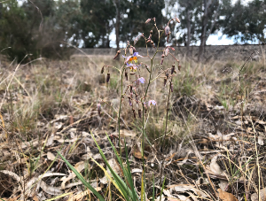 |  | 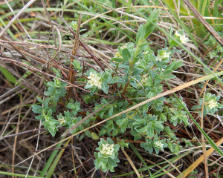
Figure 27.7 Dianella amoena (Matted Flax-lily) is usually found in areas of grassland and grassy woodland subject to periodical burning and with low weed densities. This individual was located in the Ballarat rail corridor |  | Figure 27.8 Pimelea spinescens subsp. spinescens (Spiny Rice-flower) are known in the wider vicinity of the study area, mainly where grassland habitat is subject to periodical burning and domestic livestock is excluded. This individual was located in the Ballarat rail corridor.
Table 27.7. Summarised significant impact assessment for Matted Flax-lily and Small Golden Moth Orchid
Significant impact criteria (Critically Endangered / Endangered) | Matted Flax-lily (Dianella amoena) | Small Golden Moth Orchid (Diuris basaltica)
Lead to a long-term decrease in the size of a population | Unlikely  - No important or known population sites are known from the Project Area. According to National Recovery Plan for the species, most known populations are small and fragmented.  - No individuals recorded within the Project Area to date and the species has only a moderate likelihood of occurrence in the Project Area. Should a population be recorded avoidance may be achieved through micro-siting, or impacts minimised through management conditions approved by DCCEEW. | Unlikely  - Only three wild populations (Rockbank, Derrimut and Laverton) known and listed in the National Recovery Plan (Backhouse and Lester, 2010).  - No important or known population sites are known from the Project Area.  - No individuals were recorded within the Project Area to date.
Reduce the area of occupancy of the species | Unlikely  - More than half (20.68ha) of 40.25ha of potential habitat occurs within the Easement Corridor Construction Footprint, where there may be no or minimal impacts within this area.  - Patches of potential habitat are scattered within a significantly modified landscape (Agricultural and soil disturbance).  - No important populations are known from the Project Area and Construction Footprint, and any populations recorded during future surveys will likely be small and therefore relatively easy to avoid through micro-siting of impacts.  - The Project does not propose to significantly reduce the area of occupancy for the species or of an important population. | Unlikely  - The Project has the potential to reduce 1.0ha of potential habitat in areas not surveyed.  - Patches of potential habitat are scattered within a significantly modified landscape (Agricultural and soil disturbance).  - Indications that modelled patches are not high quality as the modelled condition score suggests.  - No important populations are known from the Project Area and Construction Footprint.  - The Project does not propose to significantly reduce the area of occupancy for the species or of an important population.
Fragment an existing population into two or more populations | Unlikely  - Fragmentation of an important population (not recorded or likely to be present) is unlikely. | Unlikely  - Fragmentation of an important population (not recorded or likely to be present) is unlikely.
Adversely affect habitat critical to the survival of a species | Unlikely  - No individuals or habitat critical to the survival of the species recorded or known to occur from the Project Area. | Unlikely  - No individuals or habitat critical to the survival of the species recorded or known to occur from the Project Area.
Disrupt the breeding cycle of a population | Unlikely  - No individuals or habitat critical to the survival of the species recorded or known to occur from the Project Area. | Unlikely  - No individuals or habitat critical to the survival of the species recorded or known to occur from the Project Area.
Modify, destroy, remove or isolate or decrease the availability or quality of habitat to the extent that the species is likely to decline | Unlikely  - Potential habitat for the species occurs in previously modified environments.  - The impacts proposed to potential habitat is not expected to affect the availability or quality of the potential habitat that would cause the species to decline. | Unlikely  - Potential habitat for the species occurs in previously modified environments.  - The impacts proposed to potential habitat is not expected to affect the availability or quality of the potential habitat that would cause the species to decline.
Result in invasive species that are harmful to a critically endangered or endangered species becoming established in the critically endangered or endangered species’ habitat | Unlikely  - Potential habitat for the species occurs in previously modified environments.  - The Project is unlikely to further alter the current dominant nature of exotic plants in the area. | Unlikely  - Potential habitat for the species occurs in previously modified environments.  - The Project is unlikely to further alter the current dominant nature of exotic plants in the area.
Introduce disease that may cause the species to decline | Unlikely  - No specific diseases listed for the species.  - General pathogens managed through CEMP. | Unlikely  - No specific diseases listed for the species.  - General pathogens managed through CEMP.
Interfere substantially with the recovery of the species | Unlikely  - Impacts proposed to potential habitat will not interfere substantially with the recovery of the species. | Unlikely  - No individuals were recorded in the Project Area and a population is unlikely to be present within potential habitat in the Construction Footprint.  - Proposed impacts to potential habitat will not interfere substantially with the recovery of the species.

Table 27.8 Summarised significant impact assessment for Swamp Fireweed
Significant impact criteria (Vulnerable) | Swamp Fireweed (Senecio psilocarpus)
Lead to a long-term decrease in the size of an important population of a species | Unlikely  - A single individual was located outside of the Project Area and Construction Footprint.  - No population sites are known from the Project Area.  - No other individuals located in the vicinity of this area and other areas surveyed within the Project Area.
Reduce the area of occupancy of an important population | Unlikely  - No other individuals located in the vicinity of the individual recorded.  - The Project does not propose to significantly reduce the area of occupancy for the species or of an important population.
Fragment an existing important population into two or more populations | Unlikely  - The Project is unlikely to result in a barrier that will fragment populations.
Adversely affect habitat critical to the survival of a species | Unlikely  - Project infrastructure targeted to occur in higher and drier areas than core habitat.  - If critical habitat does occur within the Project Area, it is unlikely to be affected.
Disrupt the breeding cycle of an important population | Unlikely  - If individuals exist within the Project Area, they are unlikely to be impacted and breeding unaffected.
Modify, destroy, remove or isolate or decrease the availability or quality of habitat to the extent that the species is likely to decline | Unlikely  - The species is unlikely to occur within the potential habitat areas  - Habitats of higher value to the species will be unaffected.  - As such, Project impacts are unlikely to affect the availability or quality of the potential habitat that would cause the species to decline.
Result in invasive species that are harmful to a vulnerable species becoming established in the vulnerable species’ habitat | Unlikely  - Potential habitat for the species occurs in previously modified environments.  - The Project is unlikely to further alter the current dominant nature of exotic plants in the area.
Introduce disease that may cause the species to decline | Unlikely  - No specific diseases listed for the species.  - General pathogens managed through CEMP.
Interfere substantially with the recovery of the species | Unlikely  - No individuals were recorded in the Project Area and a population is unlikely to be present within potential habitat in the Construction Footprint.  - Proposed impacts to potential habitat will not interfere substantially with the recovery of the species.

Threatened fauna
Although the Project’s design has reduced impacts to biodiversity, some habitat loss is unavoidable. Habitat removal has been restricted to the minimum extent necessary to efficiently develop and operate the Project in line with Project objectives. The impact of habitat loss on specific species varies, largely depending on their mobility. Highly mobile species, such as birds and the Grey-headed Flying-fox (Pteropus poliocephalus), are less likely to be significantly impacted by habitat loss associated with the Project. However, more sedentary species such as the Southern Greater Glider (Petauroides volans) (refer to Figure 27.10) or species with very specific habitat requirements such as the Striped Legless Lizard (Delma impar) (refer to Figure 27.9), are more susceptible to associated impacts.
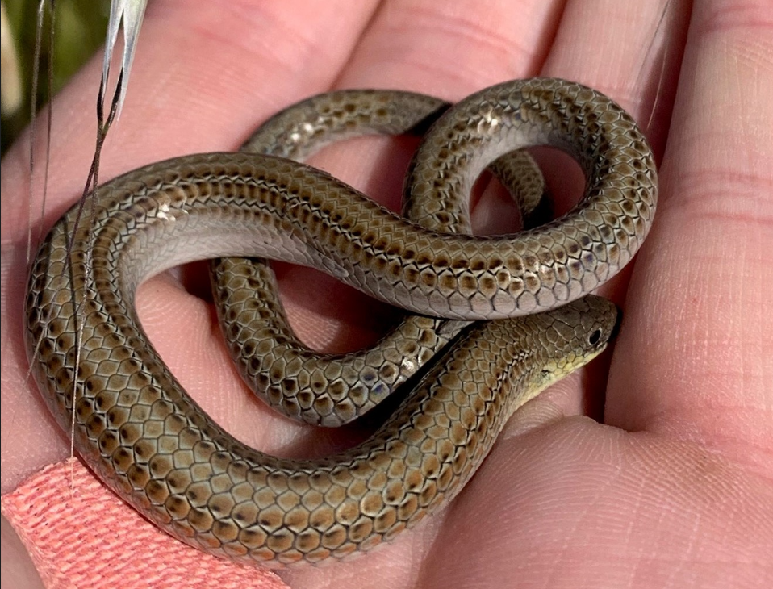 |  | 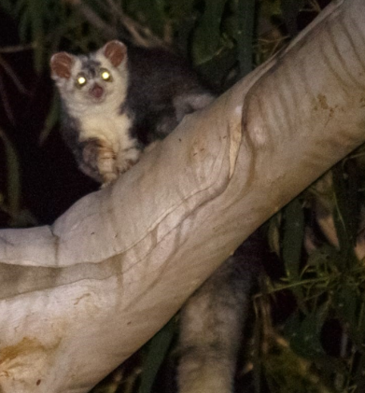
Figure 27.9 Striped Legless Lizard associated with native and exotic tussock grassland areas over cracking clay soils (Species located outside study area and not recorded during surveys). |  | Figure 27.10 Southern Greater Glider with characteristic eye shine aiding detection during the survey (Species located outside study area and not recorded during surveys).

A significant impact assessment has been undertaken for the threatened faunal species identified in Section 27.3.3. Various mitigation measures will be implemented to achieve the EPRs to minimise the severity of impacts to threatened fauna. The significant residual impact ratings have considered the implementation of these relevant EPRs, including:
- EPR BD2: Vegetation protection measures during construction will be implemented to protect retained habitat
- EPR BD3: A Fauna Management Plan will be developed and will include measures to manage threatened species habitat within the Project Area
- EPR BD4: Specific Threatened Fauna Management Plans will also be developed for EPBC Act listed faunal species; Golden Sun Moth (Diuris basaltica), Growling Grass Frog (Litoria raniformis), Swift Parrot (Lathamus discolor), Southern Greater Glider (Petauroides volans), Striped Legless Lizard (Delma impar), and Victorian Grassland Earless Dragon (Tympanocryptis pinguicolla)
- EPR BD4: The fragmentation of habitat is considered in the significant impact assessment of the Southern Greater Glider (Petauroides volans). While the Project has been designed to minimise impacts to moderate quality habitat and is situated at the interface of potential habitat and adjoining settled lifestyle properties, in a catastrophic event such as bushfire, the species ability to escape may be hindered by habitat fragmentation. As such, glider poles and fauna rope bridges are proposed in some sections of the Project identified as important habitat for arboreal (tree dwelling) species to minimise the severity of potential impacts. These have proved effective in facilitating arboreal fauna movement across otherwise fragmented habitat. This measure will be included in required Threatened Fauna Management Plans
- EPR BD5: Whilst none of the EPBC Act listed bird species of relevance to the Project (or Grey-headed Flying-fox (Pteropus poliocephalus)) are considered of particular or elevated risk due to collision with Project infrastructure, the installation of internationally recognised collision risk measures has been proposed for species identified as high risk in proximity to the Project as part of a Collision Risk Management Plan that will be developed and implemented
- EPR EM8: Implementation of a Construction Environmental Management Plan will include controls to prevent impacts from spread of noxious and environmental weeds, biosecurity and risks associated with pest species during construction
Of the 15 EPBC Act listed threatened fauna listed in Table 27.3, 13 have been assessed as having an above ‘low’ potential impact and were considered as part of the significant impact assessment against the MNES Significant Impact Guidelines 1.1. Significant impact assessments included consideration of the EPRs. Table 27.9 and Table 27.10 summarise the residual impacts identified through the significant impact assessments for these species.
The significant impact assessments undertaken in accordance with the MNES Significant Impact Guidelines 1.1 and relevant species guidelines concluded that significant impacts are possible for:
- Golden Sun Moth (Synemon plana) (Vulnerable)
- Southern Greater Glider (Petauroides volans) (Endangered)
- Striped Legless Lizard (Delma impar) (Vulnerable)
- Victorian Grassland Earless Dragon (Tympanocryptis pinguicolla) (Critically Endangered).
See Section 27.9 for an overview of offset requirements.
For the remainder of species assessed, a significant impact was assessed as unlikely. See Section 8 of Technical Report A: Biodiversity Impact Assessment for full details.
Table 27.9 Summarised significant impact assessments for EPBC listed Vulnerable fauna
Significant impact criteria | Golden Sun Moth (Synemon plana) | Brown Treecreeper (Climacteris picumnus) | Painted Honeyeater (Grantiella picta) | Blue-winged Parrot (Neophema chrysostoma) | Diamond Firetail (Stagonopleura guttata) | Grey-headed Flying-fox (Pteropus poliocephalus) | Striped Legless Lizard (Delma impar)
Lead to a long-term decrease in the size of an important population of a species. | Possible  - Much of the mapped potential habitat (275.18ha mapped in Project Lands) can have impacts avoided.  - 21.00ha of potential habitat is expected to be disturbed.  - Possible that impacts could lead to the long-term decrease in the size of an important population. | Unlikely  - Patches of suitable habitat are unlikely to reduce or fragment.  - Construction mortality is unlikely as all tree hollows to be checked and cleared by experienced ecologists.  - Species not at risk of collision. | Unlikely  - DAWE indicates one of the key biodiversity areas for the species is the Warby-Chiltern Box-Ironbark Region in northeastern Victoria, which 200km north east of the Project Area (DAWE, 2021b). | Unlikely  - The Project is unlikely to notably limit foraging habitat or breeding habitat, create a movement barrier or create significant collision risk for the species to the extent that a population decrease would occur.  - Construction mortality is unlikely as all tree hollows to be checked and cleared by experienced ecologists. | Unlikely  - Species populations appear less likely to regularly utilise areas lacking remnants of native vegetation larger than 200ha (DCCEEW, 2023d).  - Occurrences are likely to be occasional and opportunistic foraging.  - The species is unlikely to be reliant on the impacted habitat patches in the Project Area, rather preferring the expansive contiguous habitat nearby at Long Forest or Lerderderg (>200ha). | Unlikely  - No species camps were recorded within the Project Area.  - Patches of potentially suitable foraging habitat are unlikely to be reduced in size or fragmented such that loss of resources will result in the decrease of a population.  - Direct mortality due to construction is unlikely due to mobile nature of the species. | Unlikely  - Potentially suitable habitats identified in the Project Area are generally avoided remaining impacts being discrete (tower footprints and access tracks).  - Small area of impact (compared to large potential habitat), would not result in the long-term decrease in any potential populations at the impact locations.
Reduce the area of occupancy of an important population. | Possible  - The species is known to be particularly susceptible to ground disturbance.  - These areas will be a loss of habitat as they will be the permanent hardstand areas for the infrastructure.  - Possible that impacts at some of these locations could reduce the area of occupancy of an important population. | Unlikely  - Unlikely to reduce the area of occupancy for the species, given the Project impacts the edge of the suitable habitat.  - The modified Easement Corridor will decrease habitat quality but not isolate populations or prevent use of the modified habitat.  - The Project will only potentially impact 69.26ha of the 307,317ha modelled habitat in the wider study area. | Unlikely  - Species mainly associated with the Goldfields bioregion to the north of the Project Area. | Unlikely  - Unlikely given the highly mobile nature of the species.  - Unlikely to reduce the area of occupancy given the relatively localised nature of impacts compared to the much larger bushland areas in the wider vicinity.  - Density of Suitable breeding hollows considered low across the Project Area.  - The species primarily breed in heathy woodland and wet forest that are limited in the Project Area. | Unlikely  - Diamond Firetail populations appear unable to persist in areas which lack remnants of native vegetation larger than 200ha (DCCEEW, 2023d).  - Potential habitat within the Project Area is considered a small amount of occasional and opportunistic foraging habitat particularly near Long Forest.  - It is unlikely that the proposed extent of vegetation clearance will reduce the area of occupancy of these species. | Unlikely  - While areas of potentially suitable foraging bushland will be lost due to the Project, it is unlikely to noticeably reduce the area of occupancy for the species, given the Project impacts the edge of the large patches of suitable habitat. | Possible  - The small area of impact (in comparison to the relatively large area) towards the potential habitat would not notably decrease the area of occupancy at the impact locations. However, given any population (particularly within a larger patch of suitable habitat) is likely to be important, there remains the chance the impacts associated with the Project may reduce the area of occupancy of an important population to a small degree.
Fragment an existing important population into two or more populations. | Unlikely  - Ground disturbance will likely be discrete, limited to tower footprints and access tracks, and is unlikely to fragment existing populations. | Unlikely  - While this species is vulnerable to fragmentation (e.g., patches <300ha (DCCEEW, 2023b)) it is thought that the Project will not create a significant barrier to its movement to fragment populations. Furthermore, impacts to the larger patches of potential habitat generally occur to their edges. | Unlikely  - The species is not thought to make significant use of the Project Area and is likely only a seasonal visitor to the area. | Unlikely  - Impacts are considered towards marginal habitats that are not considered high quality, given younger age class of canopy tree species and the limited tree hollows.  - This species is highly mobile, and it is unlikely the Project will create a barrier to its movement. | Unlikely  - The impacts to disturbed edges of discrete habitat patches would not be considered critical habitat.  - While the clearance of vegetation required for the Project may serve as a barrier to dispersal for the occasional individuals making opportunistic use of the area, mitigations such as revegetation will minimise this. | Unlikely  - This species is highly mobile, and it is thought that the Project will not create a barrier to its movement. The species is considered to have a ‘mild’ risk of collision. | Unlikely  - Disturbance to some potential grassland habitat will be discreet and limited to tower footprint locations. The location of a small number of access tracks and some distribution line crossings does occur in areas where the species can’t be ruled out. However, if present, such actions are unlikely to fragment an important population.
Adversely affect habitat critical to the survival of a species. | Unlikely  - Several patches of habitat were confirmed to be occupied by the species and 21.00ha (or 8.05% of the habitat identified in Project Land) will be impacted under the current design.  - It is noted that many of the patches identified are large contiguous areas of habitat extending beyond those mapped. | Unlikely  - While there will be large trees lost and areas of fallen timber cleared due to the Project, it is expected that this will only be a minor impact to the overall habitat available.  - Suitable woodland habitat is likely used opportunistically given the highly disturbed nature of the ground layer.  - The Project will potentially impact 89.41ha of the 307,317ha of habitat modelled to occur in the wider study area. | Unlikely  - This species is highly mobile, and it is unlikely the Project will create a barrier to its movement, nor will it be at significant risk of collision. | Unlikely  - 39.32ha of potentially suitable foraging habitat will be impacted, though this is not thought to be notable given the amount present in the wider area (216.30ha in the Project Area alone).  - Hollow density is very low in forested areas surveyed.  - Indigenous revegetation and placement of nest boxes and / or chainsaw hollows to be conducted. | Unlikely  - Potential habitat within the Project Area is considered a small amount of occasional and opportunistic foraging habitat particularly near Long Forest.  - It is unlikely that the proposed extent of vegetation clearance will noticeably influence the availability of critical resources used by these species and therefore negatively influence the survival of the species. | Unlikely  - Only limited recorded occurrences of critical flowering species appear in the Project Area.  - No known nationally important camp exists within 20km of the Project Area.  - A potential temporary camp was briefly observed 2km south of the Project Area but was absent in follow up surveys (as well as during previous targeted survey of the area). | Unlikely  - Most of the potential habitat identified exhibits poor connectivity.  - It is thought that the identified sites are likely marginal habitat for the species and unlikely to provide critical habitat.  - Small areas of impact at these sites in comparison to the relatively large area of potential habitat would not likely influence the habitat critical to the survival of the species.
Disrupt the breeding cycle of a population. | Unlikely  - Breeding disturbance will be minimised by avoiding construction within suitable habitat in the breeding season (mid-October to early January). | Unlikely  - Breeding generally takes place in large trees with suitable hollows most of which are avoided by Project infrastructure. Some individuals may be disturbed during removal of unavoidable trees but all tree hollows will be checked and cleared by experienced ecologists meaning mortality is unlikely. It is not expected that hollow loss associated with the Project will notably limit future breeding opportunities for a population. Furthermore, Project mitigation measures include the salvage and reinstatement of hollows when removed. | Unlikely  - The Project is outside the range of likely breeding areas in Boree / Weeping Myall or Brigalow woodlands. | Unlikely  - Suitable hollow density is generally quite low in the Project Area.  - Higher quality breeding habitat (thought to be heathy woodland and wet forest) are limited in the Project Area.  - Construction mortality is unlikely as all tree hollows to be checked and cleared by experienced ecologists.  - It is not expected that hollow loss will notably limit future breeding opportunities for a population. | Unlikely  - The species is known to prefer larger patches greater than 10ha within agricultural landscapes (Watson et al., 2000).  - It is not expected to extensively utilise the lower-quality disturbed edges of woodland habitats proposed for impacts, particularly for breeding.  - It is unlikely that the proposed removal of vegetation will disrupt the breeding cycle of an important population. | Unlikely  - Breeding generally takes place in large established camps.  - No permanent camps were recorded during targeted survey and limited suitable camp habitat was noted in the Project Area. | Unlikely  - The presence of a population is considered unlikely.  - The small areas of impact are not likely to affect future breeding.  - Identified potential habitat can be subject to further assessment prior to construction and work methods can be applied to avoid potential or confirmed habitat during construction to reduce impact in during peak breeding activity (Oct - Dec).
Modify, destroy, remove, isolate, or decrease the availability or quality of habitat to the extent that the species is likely to decline. | Unlikely  - Given the small amount of each patch of impact to be impacted, it is not expected to notably reduce the habitat quality in each area for the species such that the species would decline | Unlikely  - The Project will result in 69.261ha lost but this is not thought to be a notable reduction given the 307,317ha in the wider study area. | Unlikely  - As above. | Unlikely  - The Project will result in 109.97ha of potential habitat lost but this is not thought to be a notable reduction given the potential habitat (314,029ha) within Victoria ( DELWP, 2021b). | Unlikely  - The proposed removal of low-quality grassy woodland habitat patches is unlikely to impact significantly on these species’ populations in the wider landscape.  - The limited extent of impact and disturbed condition of the vegetation makes it unlikely that these species would be reliant on these areas. The proposed impacts are unlikely to modify, destroy, remove or isolate or decrease the availability or quality of habitat to the extent that these species are likely to decline. | Unlikely  - The Project will result in 10.17ha of potentially suitable foraging habitat lost but this is not thought to be a notable reduction given the vast amount available in the wider study area. | Unlikely  - While many areas mapped as suitable habitat for Striped Legless Lizard are avoided by the Construction Footprint, 1.44ha may be impacted under the current Project design.  - This is not expected to result in a decline in the species.
Result in invasive species that are harmful to a vulnerable species becoming established in the vulnerable species’ habitat. | Unlikely  - Unlikely as the Project will follow strict decontamination and hygiene protocols outlined in the CEMP.  - Invasive herbivores such as rabbits are already well established throughout the Project Area  - Increased predation risk that occurs with introducing shrubs and trees, that predators use for perching, to grassland habitat is unlikely.  - It is also unlikely that the tower infrastructure will significantly alter and / or increase the number of available perching structures for predators | Unlikely  - Unlikely as the Project will follow strict decontamination and hygiene protocols outlined in the CEMP.  - Feral predators such as foxes and cats are already well established throughout the Project area, as are feral herbivores such as rabbits. | Unlikely  As above. | Unlikely  - Unlikely as the Project will follow strict decontamination and hygiene protocols outlined in the CEMP.  - Feral predators such as foxes and cats are already well established throughout the Project Area, as are feral herbivores such as rabbits. | Unlikely  - Feral predators (such as foxes and cats) are already widely established in the Project Area.  - Competition pressure from Noisy Miners will be minimised by revegetating the shrub layer of cleared areas to reduce habitat suitability for Noisy Miners. | Unlikely  - Predation is not a priority threat to the species  - Feral predators such as foxes and cats are already well established throughout the Project Area. | Unlikely  - Unlikely as the Project will follow strict decontamination and hygiene protocols outlined in the CEMP.  - Feral predators such as foxes and cats are already well established throughout the Project Area.
Introduce disease that may cause the species to decline. | Unlikely  - There are no recognised pathogens to Golden Sun Moth. | Unlikely  - Spread of diseases such as Psittacine cirovirus will be improbable as the Project will follow strict decontamination and hygiene protocols outlined in the CEMP. | Unlikely  - Unlikely as the Project will follow strict decontamination and hygiene protocols outlined in the CEMP.  - Feral predators such as foxes and cats are already well established throughout the Project area.  - Fragmentation is likely to lead to predator presence in some areas. | Unlikely  - Spread of diseases such as Psittacine cirovirus will be improbable as the Project will follow strict decontamination and hygiene protocols outlined in the CEMP. | Unlikely  - Following the implementation of mitigation measures, including strict hygiene measures outlined in the CEMP, it is considered unlikely that the proposed removal of habitat will cause the introduction of a disease that may cause a decline of these species. | Unlikely  - Limited information exists on the impact of disease on Flying fox populations but it is unlikely that the Project will result in the introduction or spread of any diseases with the potential to infect the species. | Unlikely  - There are no known pathogens relating to Delma that could be exacerbated by the Project.
Interfere with the recovery of the species. | Unlikely  - While the Project will impact some suitable habitat, the losses are expected to be small. The Project is not expected to change the stock grazing regimes of habitat, spread invasive weeds, affect fire regularity, or increase predation risk. | Unlikely  - Given the limited habitat removal proportional to the range of the species, it is thought unlikely that the Project will interfere with the recovery actions listed in the Conservation advice for the species (DCCEEW 2023b). | Unlikely  - There are no known pathogens relating to Grantiella picta that could be exacerbated by the Project. Spread of diseases such as Psittacine cirovirus will be improbable as the Project will follow strict decontamination and hygiene protocols outlined in the CEMP. | Unlikely  - Limited habitat removal proportional to the range of the species.  - Furthermore, the Project is not expected to result in Inappropriate fire regimes, changes in domestic stock grazing levels (already high in much of the Project Area) or and increased likelihood of extreme events (listed priority impacts on recovery (DCCEEW, 2023c)). | Unlikely  - The inconsequential amount of already degraded potential habitat that is proposed for impact is unlikely to noticeably influence the availability of critical resources used by the species or negatively influence the size of the population.  - Individuals that do occur in the region are likely to access the immediately available higher quality habitat in adjacent conservation reserves.  - The Project is not expected to affect any of the conservation actions listed in the species Conservation Advice (DCCEEW 2023d) | Unlikely  - The Project is not expected to impact any of the recovery objectives discussed in the recovery plan (DAWE, 2021a).  - Electrocution on powerlines is listed as one of the recovery objectives but this mainly refers to urban distribution lines rather than transmission lines.  - Transmissions lines, being much higher (but certainly not beyond the flight path of the species) and with much greater distances between conductors, mean the species is less likely to make contact and therefore, far less prone to electrocution. | Unlikely  - The Project is not expected to impact on any of the Conservation Actions outlined in the Conservation Advice (TSSC, 2016b).

Table 27.10 Summarised significant impact assessments for EPBC listed Critically Endangered and Endangered fauna
Significant impact criteria | Gang-gang Cockatoo (Callocephalon fimbriatum) | Swift Parrot (Lathamus discolor) | Southern Greater Glider (Petauroides volans) | Victorian Grassland Earless Dragon (Tympanocryptis pinguicolla) | Hooded Robin (south-eastern) (Melanodryas cucullata)
Lead to a long-term decrease in the size of a population. | Unlikely  - Unlikely to limit foraging habitat, create a movement barrier or create significant collision risk for the species.  - Construction mortality is unlikely as all tree hollows to be checked and cleared by experienced ecologists. | Unlikely  - Unlikely to limit foraging habitat, create a movement barrier or create significant collision risk for the species.  - A threatened fauna management plan is to be developed and implemented during construction over the breeding season for the species (EPR BD3). | Unlikely  - Species not known to occur within the Project Area and not identified during surveys of potential habitat.  - Potential habitat within the Project Area is near the edge of a larger area of the contiguous habitat area and is close to human settlements, in more open habitat of lower quality.  - The Project is not expected to result in mortality or decrease the size of a population. | Unlikely  - Much of the Project Area is unlikely to support the species due current land use activities (agriculture).  - Potentially suitable habitats identified in the Project Area are generally avoided remaining impacts being discrete (tower footprints and access tracks).  - Small area of impact (compared to large potential habitat), would not result in the long-term decrease in any potential populations at the impact locations. | Unlikely  - Impacts to the potential habitat (<3ha) are not considered to noticeably influence the availability of critical resources used by these species. Patches of suitable habitat are unlikely to reduce or fragment.  - Construction mortality is unlikely due to mobile nature of the species  - Species not at risk of collision.
Reduce the area of occupancy of the species. | Unlikely  - Unlikely given the highly mobile nature of the species.  - Unlikely to reduce the area of occupancy given the relatively localised nature of impacts compared to the much larger bushland areas in the wider vicinity.  - Removed hollows are unlikely to have served as suitable breeding areas. The species primarily breed in wet montane forest that do not occur in the Project Area. | Unlikely  - Unlikely given the highly mobile nature of the species.  - Unlikely to reduce the area of occupancy given the relatively localised nature of impacts compared to the much larger bushland areas in the wider vicinity. | Unlikely  - While a known population occurs 4.3km to the northeast of the Project Area, the potential habitat associated with the Project Area is not known to be occupied. | Possible  - Given the species is so restricted any loss of utilised habitat may lead to a decrease in area of occupancy. However, it is thought the small area of impact at these sites in comparison to the relatively large area of potential habitat would not notably decrease the area of occupancy at the impact locations. | Unlikely  - Potential habitat within the Project Area is considered a small amount of occasional and opportunistic foraging habitat for Hooded Robin.  - The small proportion of impacted potentially suitable grassy woodland habitat will not noticeably reduce the area of occupancy of these species considering the expansive habitat available in contiguous habitat nearby.
Fragment an existing important population into two or more populations. | Unlikely  - This species is highly mobile, and it is unlikely the Project will create a barrier to its movement. | Unlikely  - This species is highly mobile, and it is unlikely the Project will create a barrier to its movement.  - Collision is a known threat. However, the key area of concern is low visibility structures (windows, wire-mesh fencing) and moving structures (windmills and cars) (TSSC, 2016a; SWIFFT, 2020).  - Unlikely the Project’s static infrastructure will pose a significant barrier. | Possible  - Potential the species occupies habitat to the north and south of the proposed alignment and that the transmission line will prevent movement between these areas. | Unlikely  - Disturbance to some potential grassland habitat will be discreet and limited to tower footprint locations. The location of a small number of access tracks and some distribution line crossings does occur in areas where the species can’t be ruled out, however, if present, such actions are unlikely to fragment populations. | Unlikely  - Unlikely the Project will create a significant barrier to the species movement. Revegetation (where possible) as well as retaining vegetation lower than 3m will provide some cover for the spices while it traverses habitat patches impacted by the Project. Furthermore, impacts to the larger patches of potential habitat generally occur to their edges.
Adversely affect habitat critical to the survival of a species. | Unlikely  - While critical habitat is listed as any habitat used by the species, breeding habitat (generally mountain old growth wet forest) is exceptionally limited in the Project Area.  - The Project will result in 40.97ha of suitable foraging habitat potentially impacted but this is not thought to be a notable reduction given the 1,350,000ha of habitat modelled to occur in the wider study area by DEECA. | Unlikely  - A small proportion of the potential bushland habitat is recognised as important migratory habitat.  - It is considered unlikely that even the large numbers of these trees considered unavoidable by the Project, would result in a notable impact given the very localised nature of the loss and the much larger proportion of habitat available in the landscape. | Possible  - Proposed clearance of the 12.28ha of potential habitat within the easement could prevent future use of the habitat within the Project Area that may be critical to the survival of the species.  - It is possible that the Project could create a barrier to the species accessing potential habitat to the south. | Possible  - Critical habitat for the species is not well defined but any habitat inhabited by the species is thought to be critical.  - The species was not recorded in the Project Area and important habitat indicators were not noted in potential habitat.  - Small areas of impact at these sites in comparison to the relatively large area of potential habitat results in a low risk. | Unlikely  - The species appears to generally inhabit larger remnants, based on existing records, as such the impacts to disturbed edges of discrete habitat patches would not be considered critical habitat and would not result in further fragmentation of the species’ population.
Disrupt the breeding cycle of a population. | Unlikely  - Breeding generally takes place in spring-summer when the species is in tall mountain forests and unlikely to be in the Project Area. Only one patch was noted as potentially suitable breeding habitat and it is still thought unlikely to be utilised by the species given its small size and isolation. | Unlikely  - Swift Parrots breed in Tasmania only and migrate to mainland Australia during autumn to winter. With the Project Area occurring in Victoria, works will not result in disruption of breeding cycles, nor significantly impact resources critical to the breeding cycle of the species. | Unlikely  - The Project Area is located approximately 4.3km from a known population  - Due to the limited nesting sites (large hollows) available, it is thought unlikely that the Project Area is an important breeding area. | Unlikely  - The presence of a population is considered unlikely.  - The small areas of impact are not likely to affect future breeding.  - Identified potential habitat can be subject to further assessment prior to construction and work methods can be applied to avoid potential habitat during construction to reduce impact in the likely breeding season of late spring - summer (Oct - Feb). | Unlikely  - The species is known to prefer larger patches greater than 10ha within agricultural landscapes (Watson et al., 2000), therefore it is not expected to extensively utilise the disturbed edges of woodland habitats proposed for impacts. The impacts are not considered to noticeably influence the availability of critical resources used by these species and therefore negatively influence breeding cycles. Clearing activities in vegetated areas is to be supervised by experienced ecologists and suspected nests dealt with appropriately.
Modify, destroy, remove, isolate, or decrease the availability or quality of habitat to the extent that the species is likely to decline. | Unlikely  - The Project will result in potential loss to 40.97ha foraging habitat but this is not thought to be a notable reduction given the 1,350,000ha of habitat modelled to occur in the wider study area by DEECA. | Unlikely  - The vegetation present provides early winter (north) and early spring (south) foraging resources for migration. It is unlikely that relatively localised losses associated with the Project would lead to a species decline given the amount of similar habitat available in the wider region.  - The loss of scattered areas across 190km, is unlikely to adversely impact the species. | Unlikely  - The removal of 12.28ha near the edge of a much larger area of potential habitat, on the interface with settled areas is not expected to contribute to the decline of the species or the local population. | Unlikely  - While many areas mapped as potentially suitable habitat for the species are avoided by the Construction Footprint, 1.62ha may be disturbed under the current Project design. | Unlikely  - The proposed removal of low-quality grassy woodland habitat patches is unlikely to impact significantly on these species’ populations in the wider landscape.  - It is unlikely that these species would be reliant on these areas.
Result in invasive species that are harmful to a critically endangered or endangered species becoming established in the endangered or critically endangered species’ habitat. | Unlikely  - Unlikely as the Project will follow strict decontamination and hygiene protocols outlined in the CEMP.  - Feral predators such as foxes and cats are already well established throughout the Project area. | Unlikely  - Feral predators such as foxes and cats are already well established throughout the Project area.  - Competition pressure from Noisy Miners will be minimised by revegetating the shrub layer of cleared areas (where possible) to reduce habitat suitability for Noisy Miners. | Unlikely  - Invasive species that utilise tree hollows at the expense of local wildlife are considered a threat to the species (e.g., European Honeybee).  - The establishment of an easement in the proposed area is not expected to increase the risk of hollow loss to invasive species, noting there are few hollows in the area. | Unlikely  - Unlikely as the Project will follow strict decontamination and hygiene protocols outlined in the CEMP.  - Feral predators such as foxes and cats are already well established throughout the Project area. | Unlikely  - Feral predators such as foxes and cats are already well established throughout the Project area.  - Competition pressure from Noisy Miners will be minimised by revegetating the shrub layer of cleared areas (where possible) to reduce habitat suitability for Noisy Miners.
Introduce disease that may cause the species to decline. | Unlikely  - Spread of diseases such as Psittacine cirovirus will be improbable as the Project will follow strict decontamination and hygiene protocols outlined in the CEMP. | Unlikely  - While Psittacine Beak and Feather Disease (PBFD) is a common and potentially deadly disease of parrots, the Project is unlikely to create any additional exposure pathways for the disease. | Unlikely  - Spread of diseases such as Phythophthora cinnamomi (known to impact glider habitat) will be unlikely as the Project will follow strict decontamination and hygiene protocols outlined in the CEMP. | Unlikely  - There are no known pathogens relating to the species that could be exacerbated by the Project. | Unlikely  - Unlikely as the Project will follow strict decontamination and hygiene protocols outlined in the CEMP.
Interfere with the recovery of the species. | Unlikely  - Given the limited habitat removal proportional to the range of the species, it is thought unlikely that the Project will interfere with the recovery actions listed in the Conservation advice for the species (DAWE, 2022). | Unlikely  - The Project Area will dissect areas important to the movement corridor but is in neither the breeding grounds nor winter feeding grounds for the species. It is considered unlikely that the Project will impact any of the recovery actions outline in the recovery plan for the species (DAWE, 2019) | Possible  - One of the primary conservation actions outlined in the conservation advice (TSSC, 2022) is retention of hollow-bearing trees and habitat connectivity.  - The Project is likely to remove some hollow-bearing trees and potentially reduce the connectivity in the area.  - As such it is considered possible the Project could interfere with the recovery of the species. | Unlikely  - The Project is not expected to impact on any of the Conservation Actions outlined in the Conservation Advice (DCCEEW, 2023e). | Unlikely  - It is unlikely this species is heavily reliant on the habitat within the Project Area.  - The species is known to prefer larger patches greater than 10ha within agricultural landscapes (Watson et al., 2000). It is unlikely that the proposed removal of vegetation will disrupt the breeding cycle of a population.

Table 27.11 Summarised significant impact assessment for Growling Grass Frog (Litoria raniformis)
Significant Impact Criterion | Impact Threshold | Significant Impact Assessment
Habitat degradation in an area supporting an *important population | Permanent removal or degradation of terrestrial habitat (for example between ponds, drainage lines or other temporary / permanent habitat) within 200m of a water body in temperate regions, or 350m of a water body in semi-arid regions, that results in the loss of dispersal or overwintering opportunities for an important population. | Unlikely  - The Project will be impacting 0.74ha of field and desktop-mapped potential habitat for Growling Grass Frog. Generally small discrete areas within much larger areas of potential habitat. Impact to these proportionally small areas is not likely to result in the loss of dispersal or overwintering opportunities for a population.  - Much of the terrestrial habitat mapped within the Project contained limited shelter around waterways due agricultural activities.  - The species was not recorded during targeted surveys.  - Habitat is generally isolated and of low quality.
 | Alteration of aquatic vegetation diversity or structure that leads to a decrease in habitat quality. | Unlikely  - Impacts to potential aquatic habitat for Growling Grass Frog will be limited to 0.013ha of impacts to the edge of one dam in Bunding where the species is unlikely to occur.  - Although the construction of a tower along the edge of this dam will influence the aquatic vegetation and potentially impact the entire dam, it is unlikely to result in the degradation of aquatic habitat.
 | Alteration to wetland hydrology, diversity and structure (e.g., any changes to timing, duration or frequency of flood events) that leads to a decrease in habitat quality. | Unlikely  - The Project will largely avoid works near and within waterways and wetlands, specifically those considered potential habitat for Growling Grass Frog.  - Earth works generally occur in small and finite areas and are not likely to result in hydrological changes to wetlands.  - The Project’s CEMP will also allow water flows and quality (e.g., sedimentation, chemicals) are not affected, as well as exacerbation of invasive species establishment.
 | Introduction of predatory fish and / or disease agents. | Unlikely  - The Project will largely avoid works in and around waterways and the Project’s CEMP will also allow strict hygiene protocols to prevent exacerbation of invasive species establishment.
Isolation and fragmentation of populations | Net reduction in the number and / or diversity of water bodies available to an important population. | Unlikely  - The Project will largely be avoiding disturbance to the habitat. Impacts limited to 0.013ha to the edge of one dam in Bunding  - Although this may affect the overall quality of this dam, impacts will not cause a net reduction in water bodies available that would impact an important population and / or affect the diversity of water bodies for an important population.
 | Removal or alteration of available terrestrial or aquatic habitat corridors (including alteration of connectivity during flood events). | Unlikely  - The small discrete areas of habitat potentially impacted occur within much larger areas of potential habitat.  - The protection of habitat is included in the EMF and CEMP requirements and the opportunity for further refinement of infrastructure location to avoid all relevant areas is possible.  - The impacts proposed are unlikely to impact habitat connectivity and movement of frogs across the landscape.
 | Construction of physical barriers to movement between water bodies, such as roads or buildings | Unlikely  - The infrastructure proposed is unlikely to result in a barrier to movement. Tower pads can be navigated around and the proposed access tracks are small (e.g. <5m wide) and are unlikely to act as an impassible barrier.

Threatened migratory species
The Project traverses several important areas of habitat through easement clearing, potentially impacting fauna movement required for dispersal, migration and to respond to catastrophic events such as bushfire. Two migratory species listed as threatened in the EPBC Act, are considered likely to move through the Project Area as part of their annual migration.
The impact assessment concluded that there was a low potential impact to these species, therefore, further assessment regarding significant residual impacts was not considered to be required. Refer to Section 7.3.4 of Technical Report A: Biodiversity Impact Assessment for further details regarding this rating.

Decommissioning impacts
As decommissioning activities will be similar to those that occur during construction, the impacts related to MNES are assessed to be the same as for the construction stage. Potential impacts relate mainly to the removal of Project infrastructure and the rehabilitation of the easement. However, it is assumed that vegetation management within the easement would no longer be required following decommissioning of the Project. As such, periodic tree removal and understorey thinning would cease, and natural regeneration would take place.
Accordingly, the EPRs developed to manage impacts during construction would also be applicable for decommissioning in accordance with the conditions of the time. This would also be managed by a Decommissioning Management Plan (EPR EM11) which would include mitigation measures for biodiversity and habitat. The plan would provide for easement restoration and rehabilitation, which could include passive rehabilitation (such as encouraging natural regrowth and regeneration over the easement) or active rehabilitation (planting of local native species). Further details on easement restoration and rehabilitation are provided in Chapter 6: Project description.
Given the expected lifespan of the Project, it is likely that the current standards, guidelines, and controls for managing biodiversity impacts may no longer apply at the time of decommissioning. As such, the Decommissioning Management Plan will determine how best to avoid, manage or mitigate impacts given the circumstances and conditions at the time.
Based on this, residual impacts are expected to be moderate for MNES and are unlikely to significantly alter ecological values across the landscape in which the Project occurs.

Cumulative impacts
Cumulative impacts have been assessed by identifying relevant future projects that could contribute to cumulative impacts on biodiversity and MNES values, considering their spatial and temporal relationships to the Western Renewables Link Project. The considered as potentially relevant to MNES include:

- 2022 Melbourne Airport Masterplan
- Beaufort Bypass (Western Highway)
- Brewster Wind Farm
- Coimadai Sand Quarry
- Elaine Solar Farm
- Lerderderg River Nature Trail
- Lerderderg-Wombat National Park
- Melbourne Airport Business Park (MABP) – Sky Road West Warehouse Developments
- Melbourne Renewable Energy Hub
- Merrimu Precinct Structure Plan (PSP) / Bacchus Marsh Urban Growth Framework
- Outer Metropolitan Ring Road / E6 (OMR)
- Powercor Mt Cottrell Zone terminal station
- Sunbury Line Level Crossing Removals
- Sydenham Terminal Station Rebuild
- Watta Wella Renewable Energy Project
- West Gate Tunnel (formerly the Western Distributor Project)
- Western Irrigation Network Scheme.
Cumulative impacts to MNES may arise from the interaction of construction, operation and decommissioning activities for the Western Renewables Link Project, and other developments, activities, land uses and projects in the area, both current and future. When considered in isolation, specific project impacts may be minor but may become more substantial when the impact of multiple projects on the same receptors are considered. A cumulative impact assessment considers the impacts of a project together with the impacts of other relevant projects that may interact spatially and temporally to change the level of impact on environmental, social or cultural values.
Twenty-two shortlisted relevant projects currently understood to be in planning have been considered as potentially relevant to biodiversity based on:
- Their proximity to the Western Renewables Link Project and thus their potential to cause cumulative biodiversity impacts within the same broad areas
- Their projected timings such that they may overlap with the Western Renewables Link Project
- Similarity of their key impacts to the Western Renewables Link Project which could lead to cumulative effects.
Many of the future relevant projects do not have publicly available or quantifiable data on the complete nature of their impact. As such, the cumulative impact assessment for biodiversity has been undertaken on a subset of these projects comprising those with available, quantifiable information relevant to the biodiversity impacted due to the Western Renewables Link Project.
Each biodiversity value impacted by the Project has been assigned a scale for both the Project’s contribution to cumulative impact (Table 27.12) and the significant cumulative impact across the landscape (Table 27.13).
Table 27.12 Guide to determining contribution to cumulative impact
Contribution to significant impact | Criteria
Minor | <10%
Moderate | >10-<50%
Major | >50%

Table 27.13 Guide to determining significant cumulative impact across landscape
Scale | Guide to determining significant impact
Low | Generally, impacts are localised and small, considered negligible or not noticeable when considered at the landscape level.
Low-Moderate | Cumulative impacts would probably not result in meaningful or demographic change with regard to a population or significant proportion of a TEC or EPBC Act listed species at the landscape level.
Moderate | Impact potentially meaningful at the population / landscape level (e.g., may result in loss of genetic diversity or a significant proportion of a population / TEC).
High | Impact likely to influence the demographics of a population and / or likely a significant impact for TECs or EPBC Act listed species.

The Project impact presented in Table 27.14 provides the ‘worst case’ scenario which includes impact to both confirmed and potential habitat.

Table 27.14 Summary of cumulative impacts to MNES
Biodiversity value | Project impact |  |  | Contribution to cumulative impact | Significant cumulative impact
 | Combined impact of relevant projects | Western Renewables Link Project impact | Cumulative impact
TECs
Grey Box (Eucalyptus microcarpa) Grassy Woodlands and Derived Native Grasslands of South-eastern Australia | 104ha | 16.61ha | 120.61ha | Moderate | Moderate
Natural Temperate Grassland of the Victorian Volcanic Plain | 113.29ha | 5.37ha | 118.663ha | Minor | Moderate
White Box-Yellow Box-Blakely’s Red Gum Grassy Woodland | 5.64ha | 5.00ha | 10.64ha | Major | Low-Moderate
EPBC Act listed flora
Matted Flax-lily (Dianella amoena) | 4 individuals | 40.25ha | 40.25ha | None | Low
EPBC Act listed fauna
Growling Grass Frog (Litoria raniformis) | 149.84ha | 0.74ha | 150.58ha | Minor | Moderate
Swift Parrot (Lathamus discolor) | 68.02ha | 18.22ha | 86.24ha | Moderate | Low-Moderate
Golden Sun Moth (Synemon plana) | 107.19ha | 21.00ha | 128.19ha | Moderate | Moderate
Striped Legless Lizard (Delma impar) | 11.69ha | 1.44ha | 13.13ha | Minor | Moderate

Environmental Performance Requirements
Potential impacts identified through Technical Report A: Biodiversity Impact Assessment have informed the development of EPRs for the Project. EPRs set out the environmental outcomes to be achieved through the implementation of mitigation measures during construction, operation and decommissioning. While some EPRs are performance based to allow flexibility in how they will be achieved, others include more prescriptive measures that must be implemented. Compliance with the EPRs will be required as a condition of the Project’s approval. Table 27.15 details the proposed EPRs developed for MNES.
Table 27.15 Environmental Performance Requirements
EPR code | Requirement
EPR BD1 | Complete ecological surveys and finalise design  - Prior to the finalisation of the detailed design for an area, complete ecological survey of the area if yet to be surveyed (additional surveys) and identify native vegetation and threatened species habitat that may be impacted by the Project.  - Surveys must be completed in areas not previously surveyed due to access limitations, as shown on the plans in Appendix A of EES Technical Report A: Biodiversity Impact Assessment as “Survey Not Completed”. These surveys must be completed for areas that have not been surveyed at all as well as areas that have been partially surveyed.  - The additional surveys must include, to the extent necessary, where impacts cannot be avoided or not already completed:  - mapping of native vegetation (including TECs);  - identification of threatened flora and fauna habitat; and  - targeted survey for threatened flora and fauna (or assume presence in suitable habitat for mobile species and species with a limited seasonal survey period).  - Identify all native tree protection zones associated with access tracks outside the Easement Corridor and abutting the easement and if practicable modify the location of the access track to avoid the tree protection zones.  - Reduce the extent of vegetation identified to be removed in the Easement Corridor (the Easement Corridor Construction Footprint) by:  - identifying any areas of disturbance to enable removal of vegetation identified in the Vegetation Clearance Risk Footprint in the Easement Corridor; and  - undertaking further design to identify no go zones within the Easement Corridor – being the native vegetation and habitat that can be avoided and that does not need to be removed within the Easement Corridor and is to be retained.  - Prior to the finalisation of the detailed design for an area, mapping is to be updated in Appendix O of EES Technical Report A: Biodiversity Impact Assessment to include the outcomes of the additional survey, the no go zones, updated Easement Corridor Construction Footprint and areas associated with tree protection zones.  5. When finalising the detailed design for an area the updated mapping must be considered and infrastructure moved on the basis of the new information to avoid native vegetation, TECs and threatened taxa to the extent practicable.
EPR BD2 | Develop and implement a Vegetation Management Plan  - Prior to commencement of construction, develop and implement a Vegetation Management Plan in consultation with DEECA and DCCEEW to protect and monitor native vegetation (including TECs) and other biodiversity values in the areas where native vegetation is to be retained. The Vegetation Management Plan must be a sub plan to the CEMP.  - The Vegetation Management Plan must include but not be limited to:  - Designating and implementing controls to prevent unauthorised access or disturbance to the no go zones identified in the Easement Corridor and shown on the updated Appendix O maps  - Implementing controls to minimise disturbance to tree protection zones associated with access tracks construction  - Within the areas identified for Partial Clearance, understorey vegetation is to be maintained and clearing limited to canopy trees only with minimal disturbance to the understorey  - A hollow replacement strategy that includes identification of tree hollows and requirements for removal and areas of re-establishment in adjoining habitat (e.g., strapped onto suitable trees where available) where practicable and subject to landholder agreement. In particular, consideration of tree hollows must be given in the following areas:  - impacted forest habitat located at Lexton, Lerderderg and Haydens Hill, hollows with an opening greater than 20cm diameter (to support owl species, Gang-gang Cockatoo (EN, en) and potentially Southern Greater Glider (EN, en) at Haydens Hill)  - impacted woodland habitat located at Lexton and Lerderderg, hollows with an opening greater than 5cm diameter (to support the smaller arboreal fauna group, potentially Brush-tailed Phascogale (vu), that inhabits these areas).  - Measures to maximise reuse of cleared native vegetation such as logs, salvaged hollows and other coarse woody debris for habitat in suitable areas (i.e. vegetated areas where practicable), subject to landholder consent  - Develop tailored construction methods and measures to minimise removal of native vegetation in patches of native vegetation where full removal is not required, and to minimise ground disturbance in patches of native vegetation where works are required where practicable  - Requirements for reestablishment of areas of native vegetation removed during construction works in areas that are not required to be maintained clear of native vegetation during operation of the transmission line (e.g. temporary access tracks)  - Procedures and methods for briefing all contractors and sub-contractors on requirements for the protection of flora and fauna habitat, and response procedures if unexpected threatened species are identified.  - The Vegetation Management Plan must include measures to minimise impacts to threatened flora, in areas identified as being habitat or potential habitat for the following threatened flora:  - Matted Flax-lily (Dianella amoena) (EN, cr)  - Small Golden Moth Orchid (Diuris basaltica) (EN, cr)  - Swamp Fireweed (Senecio psilocarpus) (VU)  - Bacchus Marsh Wattle (Acacia rostriformis) (vu)  - Cane Spear-grass (Austrostipa breviglumis) (en)  - Melbourne Yellow-gum (Eucalyptus leucoxylon subsp. connata) (en)  - Yarra Gum (Eucalyptus yarraensis) (cr)  - Brittle Greenhood (Pterostylis truncata) (cr)  - Fragrant Saltbush (Rhagodia parabolica) (vu)  - Floodplain Fireweed (Senecio campylocarpus) (en)  - Glaucous Flax-lily (Dianella longifolia var. grandis s.l.) (cr).  - The threatened flora measures must address or satisfy as a minimum the following requirements:  - A seasonal survey of identified potential threatened flora habitat where survey has not been completed under EPR BD1 for seasonal species  - Identification on the relevant maps prepared under EPR BD1 for confirmed habitat or potential habitat for the threatened flora listed above  - A process to be followed to avoid as far as practicable any new occurrences of threatened flora which are identified during surveys required under EPR BD1 and EPR BD2 (4a)  - Details of species awareness materials to be presented to construction personnel at Project induction and toolbox meetings  - For Brittle Greenhood (cr) (between towers F4515DL and F4374DL S), use of heavy machinery is to be avoided where practicable, and ground disturbance is to be minimised for all construction works including tree removal.  - The Vegetation Management Plan must define post construction monitoring requirements and time frame required to confirm compliance with management plans, including:  - The condition and extent of native vegetation, including TECs, and threatened flora  - Works associated with revegetation and remediation  - weed management.
EPR BD3 | Develop and implement a Fauna Management Plan  - Prior to the commencement of construction, develop and implement a Fauna Management Plan in consultation with DEECA to avoid and minimise impacts to native fauna during construction. The Fauna Management Plan must be a sub plan to the CEMP and include as a minimum the following requirements:  - To undertake pre-clearing inspections and supervise habitat removal by a qualified and experience ecologist or wildlife handler. Any fauna protected under the Wildlife Act 1975 that is disturbed in the process must be safely relocated to the nearest suitable habitat outside the Construction Footprint  - Measures to avoid entrapment of fauna in excavations (e.g., by ensuring excavations are not left open overnight or installing temporary fencing to prevent fauna access and undertaking daily inspections of excavations before starting works for the day) where practicable  - Fauna that may be displaced due to habitat removal or encountered on site during construction works must be managed in compliance with the Wildlife Act 1975  - Measures to map active eagle (such as Wedge-tailed Eagle, White bellied Sea Eagle) nest locations in suitable breeding habitat- forested areas with large trees and measures to minimise impacts such as applying spatial or temporal buffers to works in proximity to active nests during breeding season  - Identify opportunities where nest box and artificial hollows could be installed where hollow salvage is not practicable, or in areas that could benefit from the addition of them, subject to landholders providing consent for placement on their land, and requirements to deploy nest boxes and artificial hollows in specified circumstances.
EPR BD4 | Develop and implement Threatened Fauna Management Plans  - Prior to the commencement of construction, develop and implement Fauna Management Plans, in consultation with DEECA and DCCEEW where relevant, to minimise potential impacts to identified or potential habitat for threatened fauna species. The plans must be prepared for the following species:  - Brown Toadlet (Pseudophryne bibronii) (en)  - Western Burrowing Crayfish (Engaeus merosetosus) (en)  - Growling Grass Frog (Litoria raniformis) (VU, vu)  - Swift Parrot (Lathamus discolor) (CR, cr)  - Barking Owl (Ninox connivens) (cr)  - Powerful Owl (Ninox strenua) (vu)  - Masked Owl (Tyto novaehollandiae) (cr)  - Golden Sun Moth (Synemon plana) (VU, vu)  - Fat-tailed Dunnart (Sminthopsis crassicaudata) (vu)  - Brush-tailed Phascogale (Phascogale tapoatafa) (vu)  - Southern Greater Glider (Petauroides volans) (EN, en)  - Platypus (Ornithorhynchus anatinus) (vu)  - Tussock Skink (Pseudemoia pagenstecheri) (en)  - Striped Legless Lizard (Delma impar) (VU, en)  - Victorian Grassland Earless Dragon (Tympanocryptis pinguicolla) (CR, cr).  - The threatened fauna management plans must include requirements for:  - Identification on the relevant maps prepared under EPR BD1 the confirmed habitat or potential habitat for the threatened fauna listed above  - Avoiding construction activities in identified habitat for threatened fauna if occupied during breeding season to the extent practicable, (in particular for: Brush-tailed Phascogale; Growling Grass Frog (VU, vu); Powerful Owl (vu); Barking Owl (cr))  - Retention of groundstorey and shrub layer in the easement where possible and identification of opportunities to increase cover particularly in areas of habitat for woodland birds, Brown Toadlet (en) and Brush-tailed Phascogale (vu)  - Apply recommendations from the Growling Grass Frog Crossing Design Standards (DELWP, 2017b) where required for access tracks cross or impact on mapped aquatic habitat for the species.  - Identification and installation of measures to support movement for Brush-tailed Phascogale (vu) and Southern Greater Glider (EN, en) in identified habitat that is fragmented by the Project Area. This is likely to require rope bridges (near Lexton between F6120DL and F6123DL, Darley between F4649DL and F4387DL, Djerriwarrh Creek between F4608DL and F4609DL) and glider poles (at Haydens Hill between F4399DL and F4404DL) across the transmission line easement at approximately 50m intervals where retained canopy vegetation is available on both sides of the clearing. The height of glider poles shall be established in accordance with the Electricity Safety Regulations and subject to landholder discussion and agreement of placement.  - Define reporting and post construction monitoring requirements and time frames to:  - confirm compliance with management plans to demonstrate impacts have been managed; and  - determine effectiveness of installed habitat (e.g. salvaged hollows, artificial hollows, nest boxes) and connectivity measures (e.g. glider poles and rope-bridges).  - Preparation of species awareness materials on threatened fauna to be presented to construction personnel at Project induction and toolbox meetings.  - Installation of signage along access routes through habitat for threatened fauna to raise awareness of wildlife crossings and implementation of measures such as reduced vehicle speeds to minimise the risk of collisions with wildlife.
EPR BD5 | Develop and implement a Collision Risk Management Plan  - Prior to the commencement of construction, develop and implement a Collision Risk Management Plan, in consultation with DEECA, to minimise the potential for bird and bat collisions with transmission line infrastructure. The plan should:  - Identify key collision risk areas for the Project, focussing on areas of high bird utilisation, habitat for species identified as high risk or in proximity to key habitat features (wetlands, riparian corridors, movement corridors).  - Describe mitigation measures to be implemented for key collision risk areas during construction and operation of the Project (e.g. larger wire diameters or vertical line marking such as bird flappers or diverters).  - Describe a carcass monitoring plan (post construction) to assess success of mitigation measures applied and to identify any further areas of collision concern, that require mitigation measures to be applied.
EPR BD6 | Develop and implement measures to manage riparian and aquatic habitat  - Prior to commencement of construction, develop and implement measures to avoid and minimise, to the extent reasonably practicable, short and long-term adverse impacts on riparian, riverbed and aquatic habitat, and aquatic fauna connectivity during construction activities. The measures must be developed in consultation with the relevant catchment management authorities, and be documented in the CEMP. Measures should include as a minimum but not limited to:  - Retaining understorey and ground cover vegetation in the riparian area, and tree stumps to maintain bank stability and retaining in-stream habitat features such as woody snags where practicable;  - Identifying areas of revegetation and locations where fencing will enhance the success of the revegetation (in consultation with landholders);  - Standard erosion and sediment control measures as outlined in EPA Victoria construction guidelines (Publications 275, 1820.1 and 1834.1) along waterways during the construction period.  - Establishment of native vegetation in any riparian areas disturbed during construction that are not otherwise required for the operation of the Project.
EPR BD7 | Develop and implement an Operational Vegetation and Habitat Management Plan  - Prior to the commencement of operation of the Project, develop and implement an Operational Vegetation and Habitat Management Plan in consultation with DEECA that sets out the requirements and methods for protection of native vegetation and flora and fauna habitat during operations and in accordance with the Electricity Act Regulations.  - The plan should include, as a minimum:  - Within areas identified as containing high densities of threatened flora (between Swans Road and Camerons Road, Darley), where native understorey vegetation is to be maintained within the easement area (outside permanent hardstand sites and access tracks), clearing of native vegetation must be limited to canopy trees >3m only, ensuring minimal disturbance to the understorey (refer to Appendix O.3 of EES Technical Report A: Biodiversity Impact Assessment)).  - Within identified habitat for Brittle Greenhood (cr) (between towers F4515DL and F4374DL S) (refer to Appendix O.3 of EES Technical Report A: Biodiversity Impact Assessment), use of heavy machinery is to be avoided where practicable, and ground disturbance is to be minimised.  - Implementation of appropriate measures to manage the risk of spread, and treat the introduction of pest animals, weeds and pathogens  - Processes to manage any spread of weeds and pathogens resulting from ongoing maintenance works within the easement.
EPR BD8 | Complete ecological surveys and finalise design for TEC – White Box-Yellow Box-Blakely’s Red Gum Grassy Woodland and Derived Native Grassland (WBYB)  Complete ecological surveys and finalise design for TEC – White Box-Yellow Box-Blakely’s Red Gum Grassy Woodland and Derived Native Grassland (WBYB).  Prior to the finalisation of the detailed design for an area, complete survey for areas yet to be surveyed and where impacts to WBYB TEC cannot be avoided.  Undertake design refinements and establish no go zones to avoid or minimise impacts to WBYB TEC so that impacts do not exceed the area of removal as assessed within EES Technical Report A: Biodiversity Impact Assessment. When finalising the detailed design update mapping in accordance with BD 1. Impacts that cannot be avoided will require offsets under the EPBC Act.

Other EPRs contribute to a reduction in the magnitude, extent and duration of impacts to MNES. Additional EPRs related to MNES include:
- EPR EM2 – Develop and implement a Construction Environmental Management Plan
- EPR EM8 – Develop and implement a Biosecurity Management Plan
- EPR EM11 – Develop and implement a Decommissioning Management Plan.
These will work in conjunction with related EPRs for surface water, groundwater, noise and vibration, to manage identified potential impacts to biodiversity. Refer to the relevant technical chapters and Chapter 29: Environmental Management Framework for full detail of these EPRs.
Monitoring will be undertaken during the construction and operation of the Project, as required by the relevant Management Plans. This will include monitoring of the ongoing presence, extent and quality of threatened flora species and TECs within the transmission line easement, weed densities in areas of native vegetation, the performance and integrity of specific mitigation actions (such rope bridges and glider poles), revegetation efforts, and collision mortality rates in birds and bats.
The objectives of the proposed monitoring programs for the Project required by the EPRs are outlined in Chapter 29: Environmental Management Framework.

Summary of residual impacts
With the application of the EPRs, significant impacts associated with MNES are considered to be those that are ‘likely’ or ‘possible’ with regard to the MNES Significant Impact Guidelines 1.1, as summarised below. Those considered ‘unlikely’ to experience significant impacts are also summarised below.
- Three EPBC Act listed TECs present in the Project Area may be significantly impacted by the Project:
  - Grey Box (Eucalyptus microcarpa) Grassy Woodland and Derived Native Grasslands of South-eastern Australia – 12.48ha has been recorded within the Project Area of which 6.79ha will be impacted. This includes impacts associated with line clearance and fuel reduction activities (4.62ha) and to a lesser extent (1.08ha) associated with ground disturbance activities for tower structure and access tracks as part of the Vegetation Clearance Construction Footprint. It is noted that 1.90ha of impacts are associated with the Easement Corridor Construction Footprint, where the Project has conservatively assumed vegetation impact. However, there may be no or minimal impact to areas of the Easement Corridor that already meet risk clearance standards. A further 9.82ha of EVC equivalents for this TEC may potentially occur in areas of the Project Area where field survey has not been completed. However, desktop review indicates these areas are unlikely to support the TEC. A significant impact under the EPBC Act is likely given there will be a reduction in extent, fragmentation and change in species composition associated with the construction activities of the Project.
  - Natural Temperate Grassland of the Victorian Volcanic Plain – 38.05ha has been recorded within the Project Area of which 4.47ha may be impacted. A further 0.90ha of EVC equivalents for this TEC may potentially occur in areas of the Construction Footprint where field survey has not been completed. Impacts to this community are associated with unavoidable impacts associated with construction of tower structures and access tracks. A significant impact under the EPBC Act is likely given there will be a reduction in extent of this ecological community.
  - White Box-Yellow Box-Blakely’s Red Gum Grassy Woodland and Derived Native Grassland – This community has not been recorded within the Project Area. However, 17ha of potential (areas not yet surveyed) habitat is modelled to occur within the Construction Footprint and may be impacted. Desktop review indicates that some of these areas are likely to support the TEC, and for the purposes of this assessment it has been assumed up to 5ha of this TEC will be impacted. Should future field investigation confirm this, a significant impact is possible given avoidance of this community could be difficult if a significantly sized patch is identified.
- Three EPBC Act listed threatened floral species were included in the residual impact assessment, all of which are unlikely to have a significant impact:
  - Matted Flax-lily – No individuals have been recorded within the Project Area. However, 40.25ha of potential habitat (areas not surveyed) may be impacted. Given that remaining potential habitat is largely fragmented and of small scale in comparison to that of the broader landscape, significant impact is unlikely.
  - Small Golden Moth Orchid – No individuals have been recorded within the Project Area. However, one hectare of potential habitat (areas not yet surveyed) may be impacted. A significant impact is unlikely.
  - Swamp Fireweed – One individual was recorded 30m south of the Project Area. However, no Swamp Fireweed individuals were recorded within the Project Area. However, 4.11ha of potential habitat (areas not yet surveyed) may be impacted. Preconstruction survey of relevant habitat in the Construction Footprint, and opportunities to protect habitat (application of no go areas) and micro-siting infrastructure to avoid impacts can be applied. Given the availability of this process and the limited presence of suitable high-quality herb-rich wetlands, the Project is not likely to significantly affect populations. A significant impact is unlikely.
- Four EPBC Act listed threatened faunal species potentially occurring in the Project Area may be significantly impacted by the Project:
  - Golden Sun Moth – Forty individuals recorded in the Project Area and 9.71ha of confirmed habitat and 11.29ha of potential habitat (not yet surveyed) may be impacted by the Project. Given that the species is particularly susceptible to ground disturbance and grassy woodland habitats will be impacted within the Project Area, impacts could lead to the long-term decrease in size of an important population at some locations. A significant impact is possible due to the potential long-term decrease in the size of an important population and reduction in the area of occupancy of an important population.
  - Southern Greater Glider – 12.06ha of potential field mapped habitat may be impacted by the Project. There is a risk that the Easement Corridor will increase fragmentation of habitat. However, the habitat patch is already somewhat fragmented (connected by a strip approximately 100m wide and 100m long) from the larger area of habitat to the north and fragmentation can be partially mitigated. A significant impact is possible due to potential fragment an existing population, adverse impacts to critical habitat and possible interference with the recovery of the species.
  - Striped Legless Lizard – 1.44ha of field mapped potential habitat may be impacted by the Project. These are in discrete areas associated with tower structures and access tracks and confined to grassland edges. While much of this habitat is considered of lower quality, the species may still occur. A significant impact is possible due to the potential reduction in the area of occupancy of an important population.
  - Victorian Grassland Earless Dragon – 3.48ha of field mapped potential habitat may be impacted by the Project. It is unlikely that the species persists in the Project Area but given its cryptic nature and the presence of potentially suitable habitat, it cannot be ruled out. Any loss of utilised habitat may lead to a decrease in area of occupancy as the species is heavily restricted. A significant impact is possible due to the potential reduction in the area of occupancy of an important population and possible effects to habitat critical to the survival of the species.
- For the remaining EPBC listed threatened faunal species considered in the MNES significant impact assessment, a significant impact of unlikely for:

  - Growling Grass Frog
  - Gang-gang Cockatoo
  - Brown Treecreeper (south-eastern)
  - Painted Honeyeater
  - Swift Parrot
  - Hooded Robin (south-eastern)
  - Blue-winged Parrot
  - Diamond Firetail
  - Grey-headed Flying-fox.

For threatened species, private properties suitable for offsets have been identified for purchase where the habitat will be placed into conservation management in perpetuity.
With the implementation of measures to comply with EPRs, it is considered that the Project meets the MNES aspects of the evaluation objective “Avoid, and where avoidance is not possible, minimise potential adverse effects on protected native vegetation and animals (particularly listed threatened species and their habitat and listed ecological communities), as well as address offset requirements consistent with state and Commonwealth policies.”

Offset requirements
An Offset Management Strategy is currently under development, which will describe approaches to offset residual impacts to MNES which are unavoidable, in accordance with the EPBC Act Environmental Offsets Policy (DSEWPaC, 2012) and Guidelines for the removal, destruction or lopping of native vegetation (DELWP, 2017a). A summary of estimated EPBC Act offsets required is outlined in Table 27.16, with all Project offsets identified in Attachment V: Offset Management Strategy. However, as surveys are still being completed, the figures are to be used as a guide only. Offset requirements have been calculated for impacts that have been confirmed. In addition, a worst-case scenario calculation has also been completed. For this scenario, the precautionary principle has been applied, assuming presence of habitat and species for those areas yet to be confirmed through surveys. As more surveys are completed, the impacts are expected to reduce, thus reducing the offset requirements.
Table 27.16 EPBC Act offset requirement (indicative only and subject to change with further surveys)
MNES | Significant impact | Field mapped and modelled data and estimated worst-case scenario | Area impacted (ha) | Quality score | Quantum of impact (ha) | Area to be offset (ha)
TEC
Grey Box (Eucalyptus microcarpa) Grassy Woodlands and Derived Native Grasslands of South-eastern Australia | Likely | Field mapped | 6.79 | 5 | 3.4 | 54.65
 |  | Modelled data | 9.82 | 5 | 4.91 | 79.03
 |  | Worst-case TEC impact | 16.61 | 5 | 8.31 | 133.68
Natural Temperate Grassland of the Victorian Volcanic Plain | Likely | Field mapped | 4.47 | 3 | 1.34 | 36.99
 |  | Modelled Data | 0.9 | 3 | 0.27 | 7.45
 |  | Worst-case TEC impact | 5.37 | 3 | 1.61 | 44.44
White Box-Yellow Box-Blakely’s Red Gum Grassy Woodland | Possible | Field mapped | 0.00 | - | - | -
 |  | Modelled Data | 17.00* | - | -
 |  | Worst-case# TEC impact | 5.00* | 3 | 1.50 | 41.38
Threatened species
Golden Sun Moth habitat | Possible | Field mapped | 9.71 | 4 | 3.88 | 56.61
 |  | Modelled Data | 11.29 | 4 | 4.52 | 65.81
 |  | Worst-case habitat impact | 21.00 | 4 | 8.4 | 122.42
Southern Greater Glider habitat | Possible | Field mapped | 12.06 | 4 | 4.82 | 77.68
Victorian Grassland Earless Dragon habitat | Possible | Field mapped | 3.48 | 3 | 1.04 | 28.80
Striped Legless Lizard | Possible | Field mapped | 1.44 | 3 | 0.39 | 6.30
# Desktop review, preliminary survey and general survey of nearby areas indicate that most of these areas are unlikely to support the TEC (White Box-Yellow Box-Blakely’s Red Gum Grassy Woodland) due to incorrect floristics (e.g. lack of Yellow Box) or relatively small size and poor quality of patches that do not meet the condition thresholds to qualify.
* While 17ha of modelled potential extent occurs, it is estimated that no more than 5ha is likely to qualify as the TEC. This will be further refined with on-ground surveys.

Quantum of impact is an automatic calculation in the Commonwealth offset calculator. It is based on threatened status, area impacted and the quality score of the impacted habitat.
Areas to be offset, for these indicative offset calculations, were determined by using the Commonwealth offset calculator in the offset calculation section. It uses the:
- Quantum of impact score
- 20 for the risk related time horizon
- 10 for time until ecological benefit
- Quality score of impacted habitat
- Future score without offset as the same input as the quality score
- Future quality with offset using a 1-point increase
- 70 percent confidence.
Using those inputs, offset required was estimated upon which a score close to 100 per cent of required offset was expressed. When potential offsets sites are found, then the inputs will be updated in the calculations. Offsets are discussed in further detail in Attachment V: Offset Management Strategy.

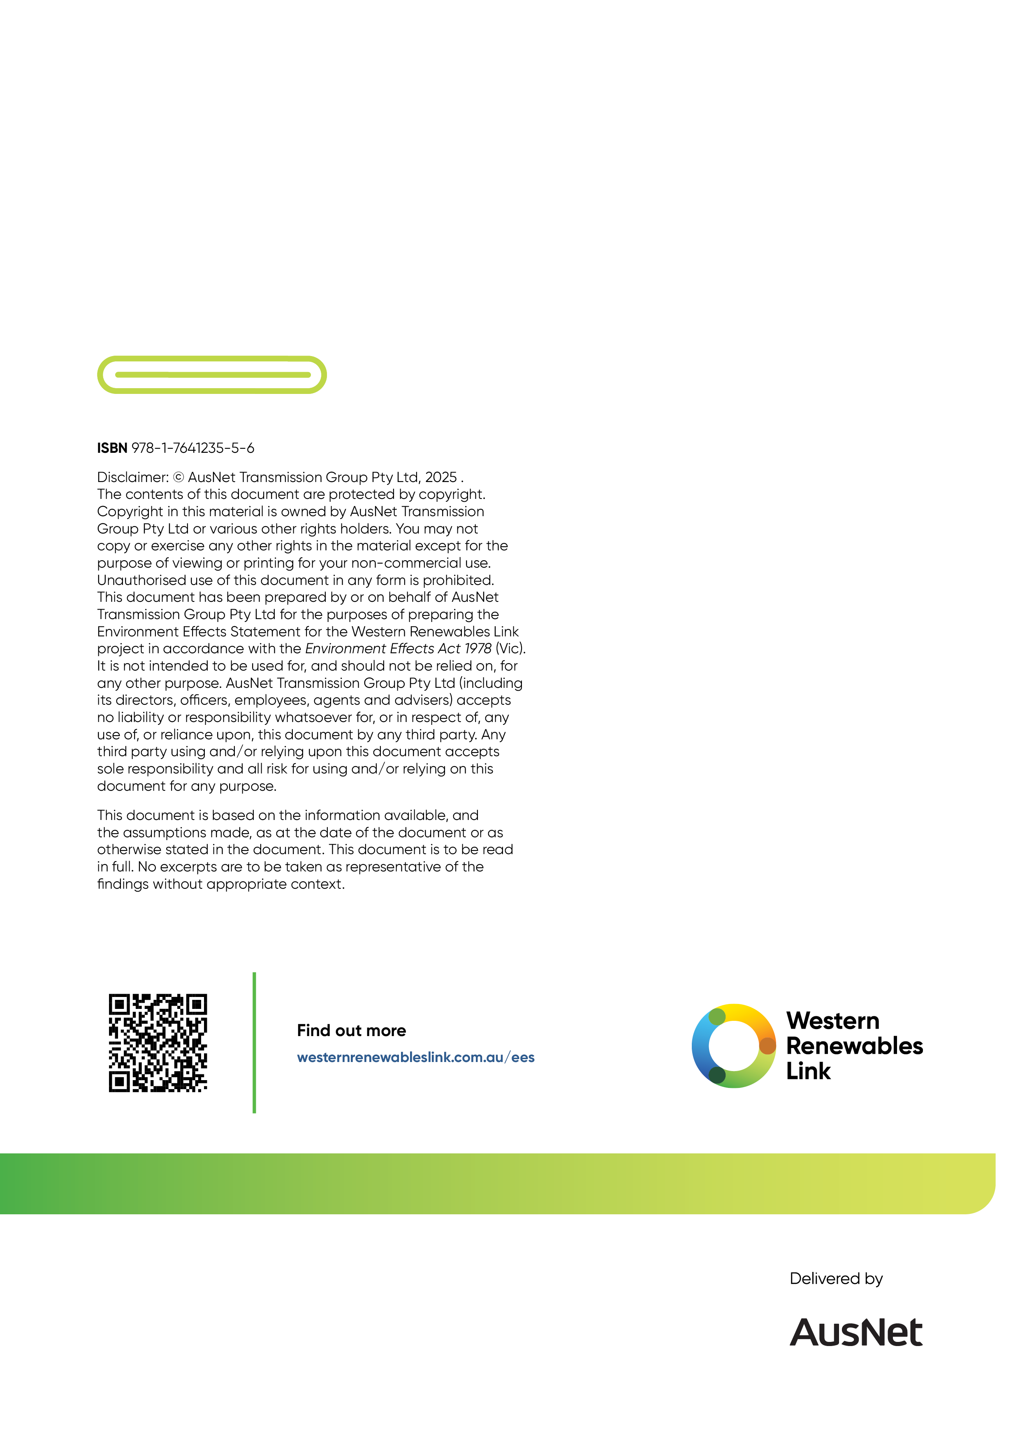

VBA records for Victorian Grassland Earless Dragon are not included within this figure due to the sensitive nature of these records
No individuals have been recorded but 40.25ha of potential habitat remains to be surveyed. If any individuals are recorded in the future the determination would change.

