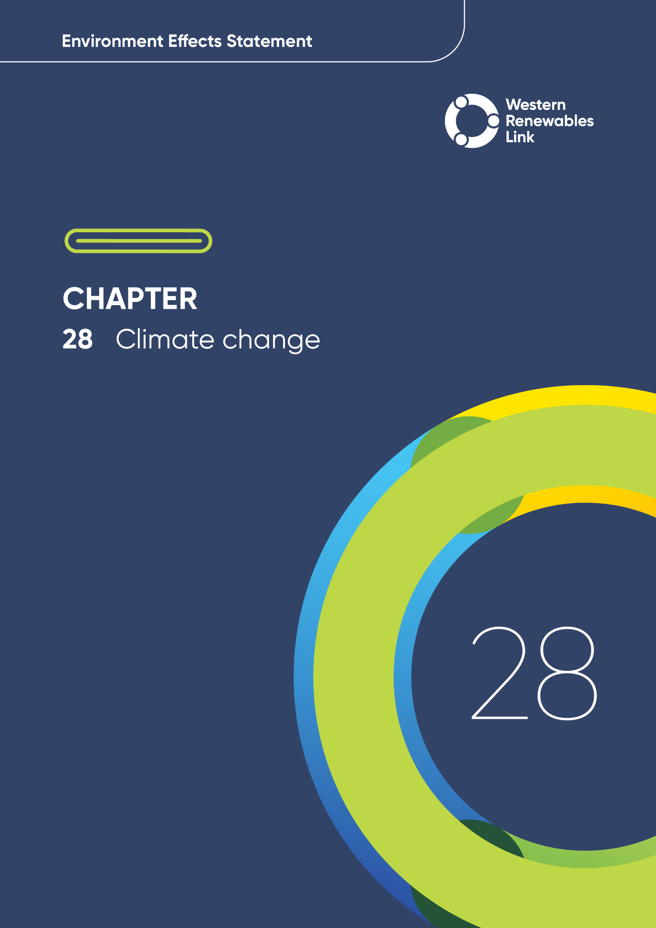

# Climate change

This chapter provides an overview of the current and future climate conditions for the Project and how potential climate-related impacts may affect the Project. This chapter is based on **Technical Report N: Climate Change Assessment.**

The Project provides critical infrastructure required to unlock Victoria's renewable energy potential as the state transitions to cleaner, more sustainable energy. It aims to deliver renewable energy from wind and solar farms in western Victoria, a key renewable energy zone, to homes across the state and into the national electricity grid. By increasing the accessibility of renewable energy, the Project will help Victoria achieve its climate action targets. The climate change assessment provides projections about the likely future climate in which the Project will operate to inform relevant technical investigations and to assist them in identifying and assessing potential impacts associated with changing climate conditions.

## Evaluation objective

The scoping requirements identify the following evaluation objective relevant to climate change:

**Evaluation objective**

Avoid, or minimise where avoidance is not possible, adverse effects for community amenity, health and safety, with regard to construction noise, vibration, dust, lighting, waste, greenhouse gas emissions, transport network, operational noise, fire risk management and electromagnetic radiation.

* Climate change

The Intergovernmental Panel on Climate Change defines climate change as a change in the climate's state - detected by changes in the average and/or variability of its properties, often identified through statistical tests, which lasts for an extended period, usually spanning decades or more.

This definition encompasses both natural and human-induced changes.

In response to this evaluation objective, the impacts of climate change on the Project were assessed and measures to avoid, minimise or manage potential impacts have been identified. These measures are discussed throughout this chapter and have informed the development of Environmental Performance Requirements (EPRs). EPRs set out the environmental outcomes to be achieved through the implementation of mitigation measures to avoid, minimise and manage identified impacts.

Further information on how the Project has been designed to avoid and minimise impacts is provided in **Chapter 5: Project development** and **Chapter 6: Project description**.

**Technical Report N: Climate Change Assessment** describes the current climate of the landscape which the Project is proposed to traverse, and how climate models expect this will change from now until 2090 under contrasting future greenhouse gas emissions scenarios. It satisfies the EES scoping requirements by assessing potential physical impacts of climate-related impacts on the Project and provides climate change projections that have been used in other technical assessments to consider how climate change may amplify or mitigate any potential impacts of the Project. It did not assess the Project’s impacts on climate change.

The climate change assessment does not consider the decommissioning, cumulative and residual impacts associated with climate change on the Project. The primary climate-related impact of the Project is the release of greenhouse gas emissions; these impacts are detailed in **Chapter 26: Greenhouse gas**.

Other aspects covered in the Environment Effects Statement (EES) evaluation objective and relevant to climate change are addressed in the following EES chapters:

* **Chapter 13: Bushfire**
* **Chapter 18: Air quality**
* **Chapter 25: Surface water**
* **Chapter 26: Greenhouse gas.**

## Method

This section summarises the method adopted in **Technical Report N: Climate Change** **Assessment**, which was informed by **Chapter 4: EES assessment framework and approach**. The key steps in assessing the impacts associated with climate change included:

* Defining a study area appropriate for climate change as presented in Figure 28.1. This area was developed from the location of three weather stations (Ararat, Ballarat and Melbourne Airport) situated within 20km of the Project, which have comprehensive long-term meteorological observations that are suitable for characterising the climate to which the Project may be exposed.
* Reviewing applicable Commonwealth and Victorian legislation, and relevant local, state and national standards, guidelines and policies.
* Scaling factors

Climate change scaling factors are the amount or percentage change in a climate variable that is projected to occur by a given timeframe under a specific greenhouse gas emissions scenario.

* Conducting a desktop review of data sources and reference standards to determine the existing climate conditions and projected changes to the climate, including collating historical meteorological observations relevant to the study area including:
  + Historical climate records for Ararat, Ballarat and Melbourne Airport weather stations from the Australian Bureau of Meteorology
  + Baseline climate data and climate change scaling factors applicable to the study area, using data from ‘Climate Change in Australia’ and CLIMsystems’ ‘Climate Insights’ tool
  + Australian Rainfall and Runoff data hub from Geoscience Australia.
* Consulting with key stakeholders and the community to inform the potential impacts associated with climate change.
* Identifying and assessing the potential implications of weather extremes and projected climate change on the Project, based on the outcome of the desktop review. No impact ratings were adopted as part of this assessment. The weather extremes identified include extreme heat and rainfall, prolonged wet weather, storms, extreme wind and bushfires.
* Developing EPRs in response to the impact assessment to define the required environmental outcomes that the Project must achieve through the implementation of mitigation measures. Measures to reduce the potential impacts were proposed in accordance with the mitigation hierarchy (avoid, minimise, manage, rehabilitate and offset) and have informed the development of EPRs. Alternative mitigation measures could be implemented to comply with the EPRs based on the specific site conditions, available resources, and the Principal Contractor’s expertise.

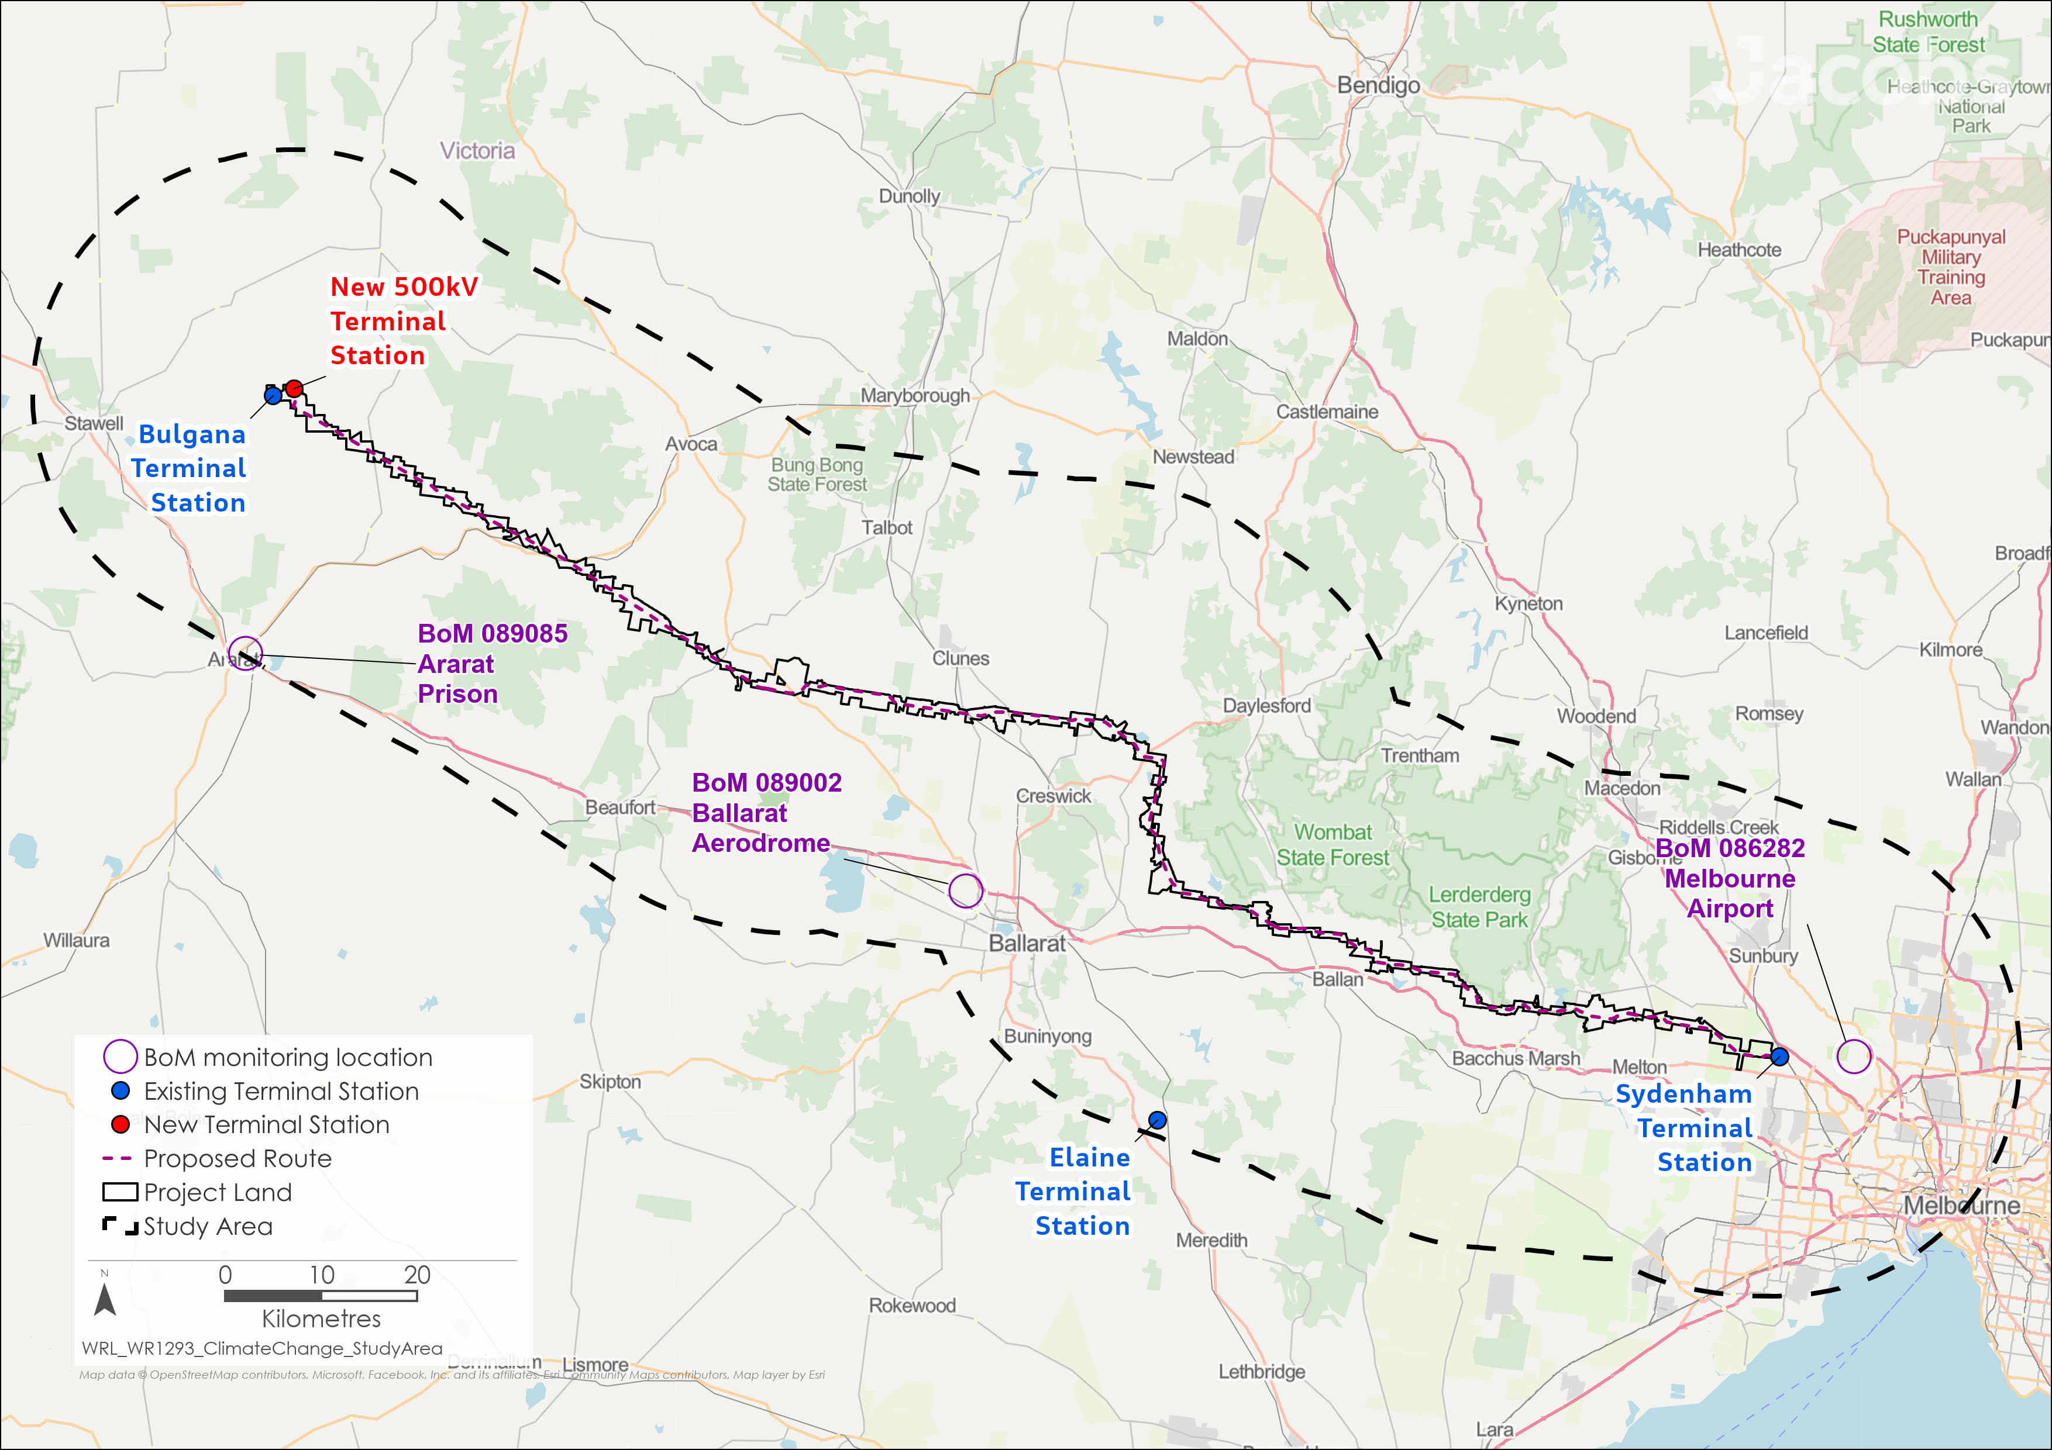

Figure . Climate change study area

## Existing conditions

This section summarises the existing conditions for the regional climate and current climate change projections according to the following key themes:

* Rainfall
* Temperature
* Wind
* Climate change projections.

Climate and weather conditions vary across the study area, with average temperatures and rainfall influenced by topography. Historical climate information was gathered from meteorological stations operated by the Bureau of Meteorology at Ararat, Ballarat and Melbourne Airport. These locations were chosen because they broadly represent the region and have consistent, long-term records of rainfall, temperature, wind speed and humidity.

Dangerous fire weather conditions typically occur several times each year, characterised by very high temperature, low humidity and strong winds.

### Rainfall

Figure 28.2 maps the average annual rainfall across the study area for Ararat, Ballarat and Melbourne Airport weather stations, ranging from 541 to 689mm. Ararat averages 587mm annually, with totals ranging from 302 to 909mm. Ballarat averages 689mm, with totals from 302 to 996mm, and Melbourne Airport averages 541mm, with totals from 310 to 821mm. Unlike Ararat and Ballarat, where rainfall peaks in winter, Melbourne Airport experiences a bimodal pattern with peaks in autumn and spring. Ballarat receives the most rainfall, followed by Ararat and Melbourne Airport.

Extreme daily rainfall totals are typically greater in late summer-early autumn than at other times of year. The highest daily rainfall total was recorded in February at each of the three locations, and ranges from 99 to 139mm.

### Temperature

Temperature conditions vary across the study area. As shown in Figure 28.3, average maximum temperatures are higher at lower elevations in the west and east (~19°C) and are lower (~16°C) in more elevated locations around the Wombat State Forest. Average daily minimum temperatures follow similar patterns.

Average temperatures in western Victoria are typically warmer in summer and early autumn, and cooler in winter. At Ararat, the highest recorded temperature is 44.7°C (February 2009), with average maximum temperatures ranging from 11.8°C in July to 27.1°C in February, and minimum temperatures from 3.4°C in July to 11.3°C in February. The lowest temperature recorded is -7.3°C (July 1976).

Ballarat's temperature patterns are similar, with a high of 44.1°C (February 2009), average maximum temperatures from 10.1°C in July to 25.3°C in January, and minimum temperatures from 3.2°C in July to 11.5°C in February. The lowest recorded temperature is -6°C (July 1982).

Melbourne Airport also follows these patterns, with temperatures above 46°C recorded in January and February (2019 and 2009). Average maximum temperatures range from 13.2°C in July to 26.6°C in January and February, and minimum temperatures from 5.4°C in July to 14.1°C in February. The lowest recorded temperature is -2.5°C (August 1986).

All three stations have recorded temperatures over 40°C during summer, and Melbourne Airport also in November and March. Freezing temperatures (0°C or below) have been recorded throughout autumn, winter, and spring at Ararat and Ballarat, and between June and September at Melbourne Airport, though less frequently.

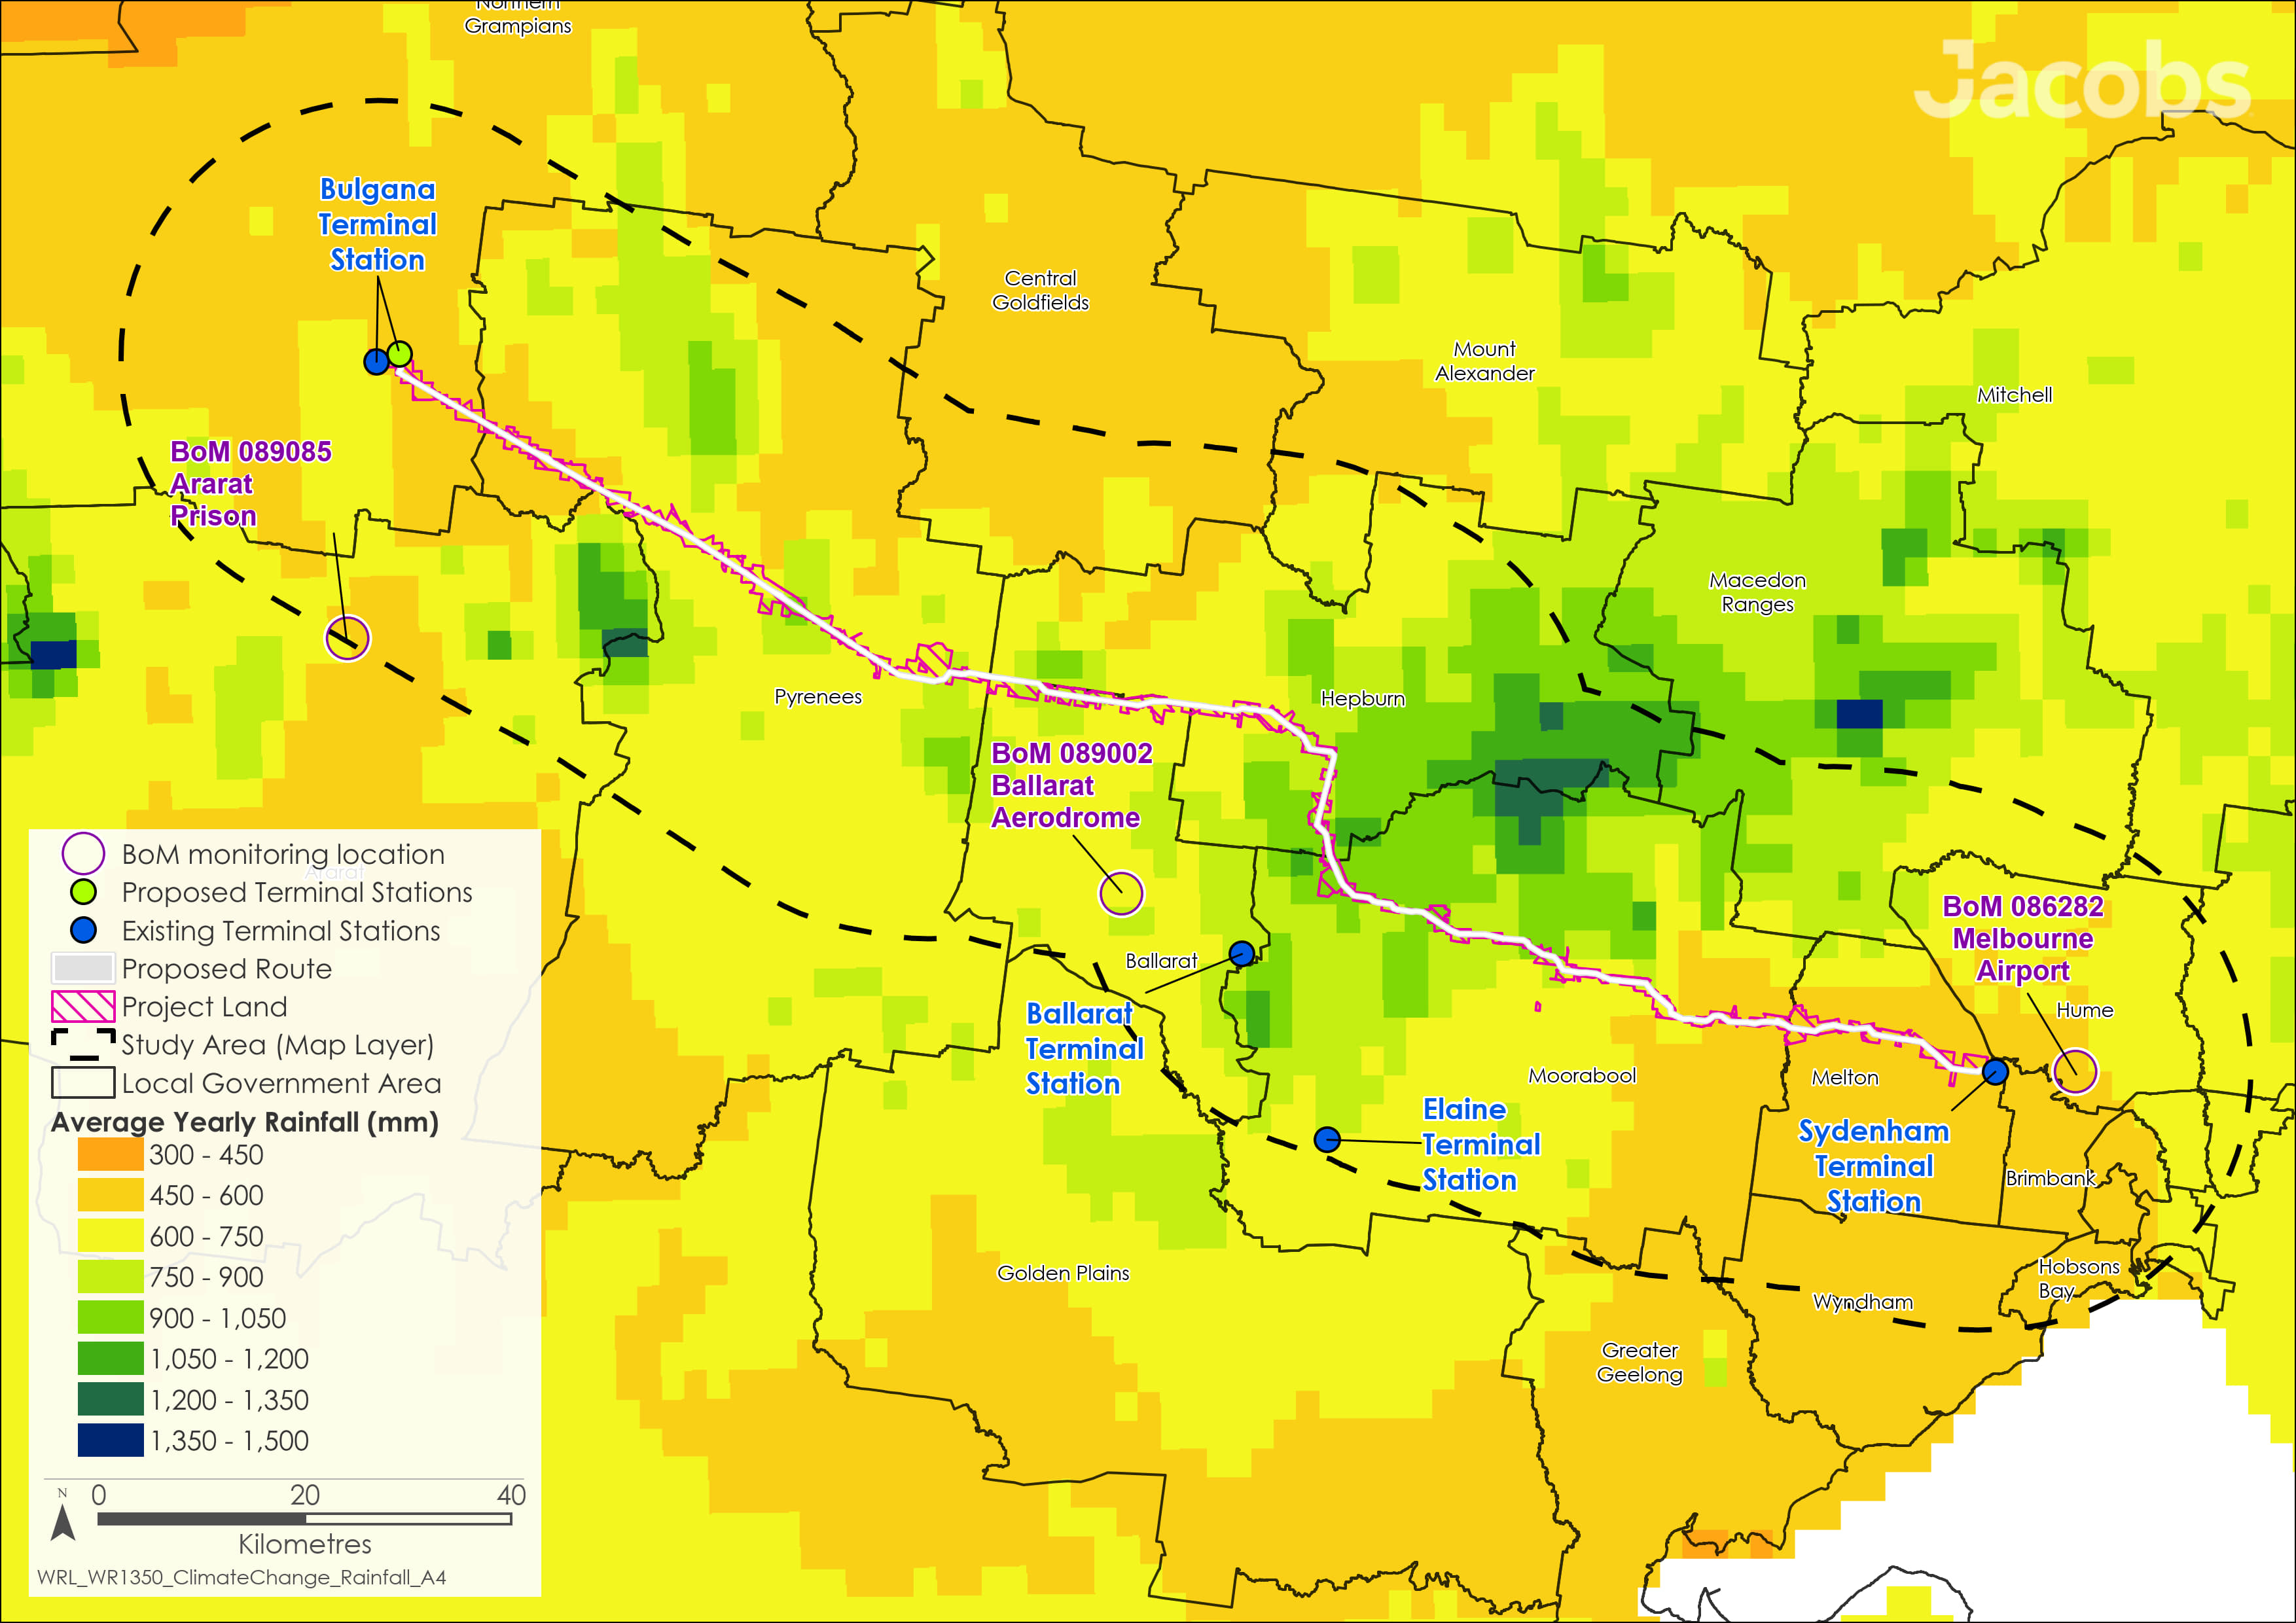

Figure .: Baseline annual rainfall conditions for climate change assessment study area

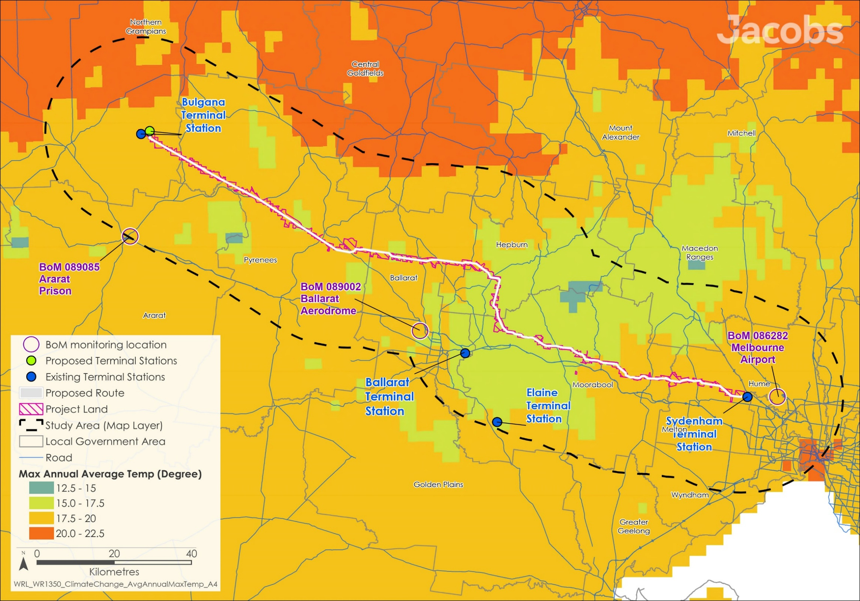

Figure .: Baseline annual average maximum temperature for the study area

### Wind

Across the region, wind speed is typically lower in the morning than during the mid to late afternoon, with windspeed at Melbourne Airport consistently greater than at Ararat or Ballarat.

The maximum wind gust recorded at Ballarat is 117km/h, with gusts of 100km/h or more recorded in January, April, July, September, November and December. The strongest wind gust recorded at Melbourne Airport is 139km/h. Wind speeds over 100km/h have been recorded during each month of the year. Wind gust records are not available for Ararat.

### Climate change projections

A summary of the climate change projections for the study area is provided below, based on global climate model outputs from ‘CLIMsystems’ ‘Climate Insights’ tool. Further information on climate change projections for the study area is provided in Section 7.0 of **Technical Report N: Climate Change Assessment**.

* Warmer: daily maximum, minimum and average temperatures, as well as temperatures on extreme hot and cold days are all projected to increase. Maximum or extreme high temperatures are projected to increase at a greater rate than averages, minimums or extreme low temperatures
* Drier: annual precipitation is projected to decline, but with only small differences between emissions scenarios. While annual average rainfall is projected to decline by a relatively small amount, increased temperature and evaporation and reduced relative humidity are projected to reduce the availability of surface water and groundwater resources
* More solar radiation: solar radiation is projected to increase slightly, consistent with reduced rainfall and cloudiness
* Heavier extreme precipitation: extreme rainfall events are projected to become heavier as the atmosphere warms
* Fire days: increased frequency of days with highly elevated fire weather conditions. The frequency and severity of bushfires and grassfires may therefore be expected to increase, unless bushfire or grassfire fuel and ignition sources are managed to effectively prevent or control fire
* Average wind speed declines: average wind speeds are projected to decline slightly, with greater change under the higher emissions scenario.

## Construction impacts

This section outlines the key issues identified through the risk screening process and associated potential impacts during the construction of the Project. The key issues and impacts identified for climate change are discussed according to the following extreme weather or climate-related conditions:

* Extreme heat: impacts to workforce personnel’s health and safety, requiring adjustments to work schedules and practices on very hot days
* Extreme rainfall and flooding: temporary disruption of construction activities or damage to construction sites and access tracks, requiring rehabilitation works to repair damage
* Prolonged wet weather: disruptions to construction activities or schedules as well as restricting access to certain areas, impacting schedules
* Storms and extreme wind: safety hazards and damage to partly constructed electricity transmission infrastructure, requiring work practices to be adjusted or repairs to damaged Project infrastructure
* Bushfires: threats to workforce personnel, disruption of activities, and damage to equipment and infrastructure. Some construction activities could ignite fires that escape and affect surrounding property and communities. Severe fire weather conditions could limit construction activities on some days and disrupt works schedules.

While the Intergovernmental Panel on Climate Change’s Sixth Assessment Report indicates that some extreme weather conditions may be influenced by climate change and human-induced greenhouse gas emissions, they mainly reflect natural climate variability during the construction stage. These climate-related natural hazards will be considered when scheduling construction and developing work practices, including:

* Work health and safety protocols for heat, storms, landscape fire and other severe weather events
* Siting laydown areas, workforce accommodation facilities and hazardous goods storage with appropriate flood protection and setbacks from fire-prone vegetation
* Installing erosion protection measures at temporary construction sites, laydown areas and access tracks.

While climate and weather extremes, such as extreme heat, dangerous fire weather and extreme rainfall may temporarily disrupt construction, the proposed management measures are well-established best practices for workplace health and safety and environmental management.

Mitigation of potential effects associated with bushfire and flooding are detailed in **Chapter 13: Bushfire** and **Chapter 25: Surface water.**

The Project’s EPRs require AusNet to undertake a climate change risk assessment during the detailed design, considering climate change risks to Project infrastructure and to surrounding communities, land uses, properties and the environment (EPR CC1 and EPR SW4).

## Operation impacts

This section outlines the key issues identified through the risk screening process and associated potential impacts during the operation of the Project. The key issues and impacts identified for climate change are discussed according to the following extreme weather or climate-related conditions:

* Extreme heat: reductions in the transmission line’s capacity to transfer electricity on very hot days
* Bushfire: potential damage to Project infrastructure. However, this is unlikely, even with climate change
* Extreme winds: potential damage to Project infrastructure. Although extreme winds have the potential to damage Project infrastructure, the transmission towers will be designed in accordance with AS/NZS 1170.2-2021 ‘Structural design actions’ to withstand expected wind loads. Given the lack of clear scientific evidence suggesting that the severity of extreme winds in southern Australia will be significantly exacerbated by climate change, the standard does not require adjustments to the design to account for climate change
* Heavy rain: flooding and erosion of exposed and susceptible soils due to heavy rain could increase exposure to flood and erosion-related impacts for parts of the Project, for example at the terminal stations and along any retained access tracks.

The Project Area will likely experience a range of extreme weather events and climate-related natural hazards during operation of the Project. The severity of some of these events and hazards (particularly extreme heat, heavy rainfall, floods, severe fire weather) is anticipated to be amplified by climate change, while others (i.e., extreme wind) may not. Based on current knowledge, most potential impacts during operation of the Project are addressed through design standards (e.g., for extreme wind) or construction techniques (e.g., construction and maintenance of regulated vegetation clearances in the transmission line easement) and are expected to be effectively mitigated.

The primary climate change impact during the Project's operation is the more frequent and severe extreme heat, which could lower electricity transmission capacity. Extreme heat conditions often coincide with very high demand for cooling and conditions that reduce electricity generation from solar panels and transmission capacity. The impact of extreme heat on the capacity of transmission lines is partly mitigated by the size of the transmission lines and the materials used. In addition, extremely hot weather in Victoria is typically accompanied by sufficient wind to partly dissipate the heat that would otherwise accumulate within the lines and reduce electricity transmission.

During operation, five-yearly reviews of the best available climate change science will be used to update the climate change risk assessment to identify any additional adaptive measures required to control priority risks arising from climate change (EPR CC2).

## Environmental Performance Requirements

Potential impacts identified through **Technical Report N: Climate Change Assessment** have informed the development of EPRs for the Project. EPRs set out the environmental outcomes to be achieved through the implementation of mitigation measures during construction and operation. While some EPRs are performance based to allow flexibility in how they will be achieved, others include more prescriptive measures that must be implemented. Compliance with the EPRs will be required as a condition of the Project’s approval. Table 28.1 details the proposed EPRs developed for climate change.

Table . Environmental Performance Requirements

|  |  |
| --- | --- |
| EPR code | Requirement |
| EPR CC1 | **Undertake a climate change risk assessment**   1. Undertake a climate change risk assessment for the Project during its detailed design stage to consider risks climate change related hazards may pose to Project infrastructure. This assessment must:    * 1. Consider risks to Project infrastructure that arise from climate change      2. Consider how existing risks to surrounding communities, land uses, properties and environments that arise from climate change may change as a result of the Project      3. Develop practicable adaptation measures, if necessary, to address priority risks and provide assurance that the Project will satisfy performance expectations as critical electricity supply infrastructure over its planned operating life under projected climate change. |
| EPR CC2 | **Review climate change risk**   1. Five-yearly reviews of the best available climate change science relating to key climate-related hazards for Project infrastructure will be used to update the climate change risk assessment for the Project (EPR CC1). Where new information suggests the climate-related hazard context for the Project has materially changed or is projected to change materially from that considered in the initial climate change risk assessment, additional measures (or climate adaptations) may be identified to provide assurance that Project infrastructure will satisfy performance expectations as critical electricity supply infrastructure under climate change. Those measures would be implemented through on-going asset management. |

The EPRs for climate change reflect the need to consider climate change risks and responses in the Project’s detailed design, as well as the need to provide on-going assurance that the Project’s infrastructure, and on-going management, provide the necessary climate resilience to satisfy service objectives over its operating life.

## Conclusion

Design and construction of the Project are anticipated to mitigate potential impacts of climate change on the Project. The implementation of the EPRs for climate change considers an on-going risk management approach of the impacts associated with climate change on the Project.

On-going consideration of climate risk, in the context of evolving best available information on climate change, is needed to avoid damages resulting from climate change and to meet the evaluation objective “*Avoid, or minimise where avoidance is not possible, adverse effects for community amenity, health and safety, with regard to construction noise, vibration, dust, lighting, waste, greenhouse gas emissions, transport network, operational noise, fire risk management and electromagnetic radiation.”*

