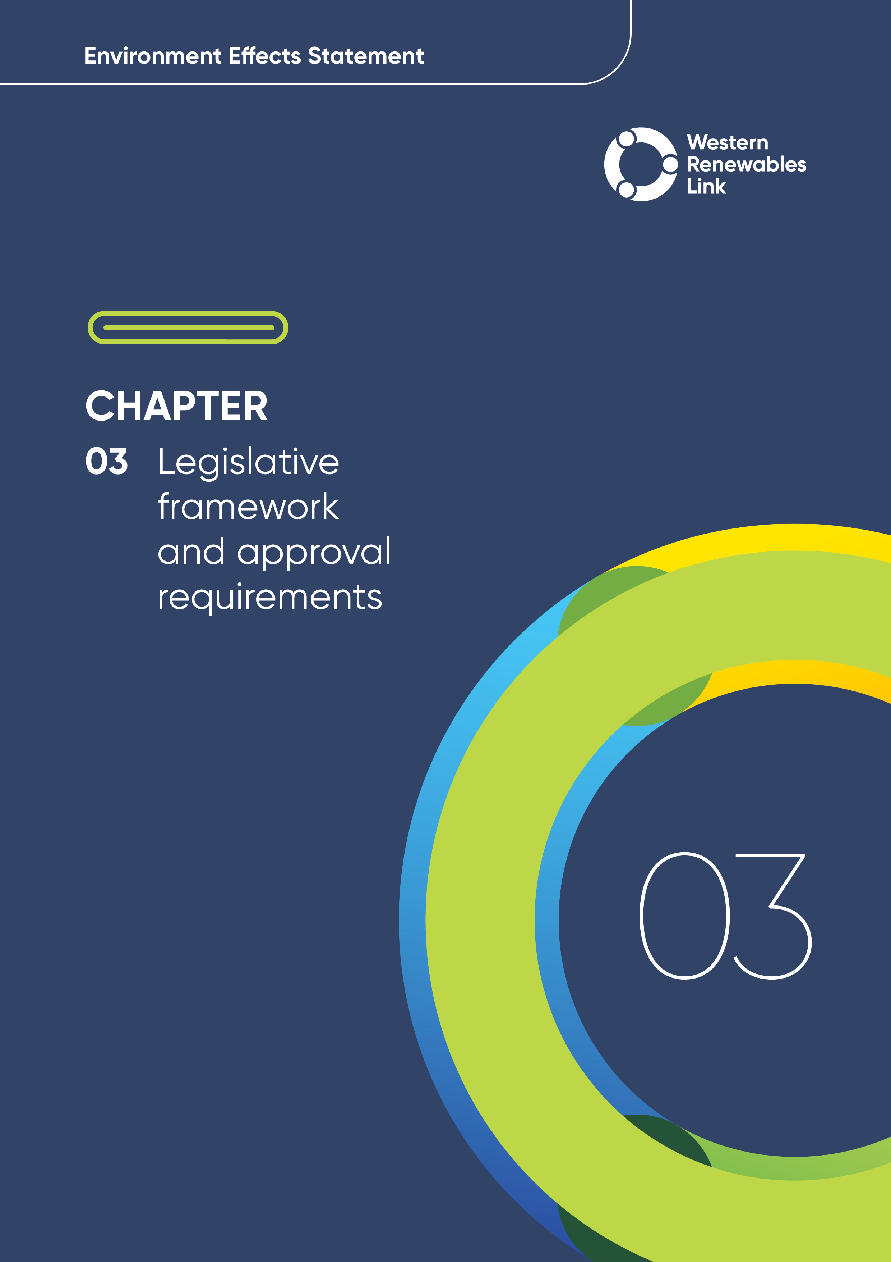

# Legislative framework and approval requirements

## Introduction

Section 3.5 of the scoping requirements for the Project provides that:

“In addition to the EE Act [Environment Effects Act] and the EPBC Act [Environment Protection and Biodiversity Conservation Act], the EES will need to identify all relevant legislation, policies, guidelines and standards, and assess their specific requirements or implications for the project, particularly in relation to required approvals. The EES should identify and characterise expected or progressing changes to relevant legislation.”

This chapter outlines the environmental approvals process along with the principal planning, environmental and heritage legislation and approvals applicable to the Project. An overview of the secondary approvals required for the Project is also provided.

The technical reports of this Environment Effects Statement (EES) provide further information on legislation, policies, guidelines and standards relevant to each technical specialist area. Commonwealth (Cth) and Victorian (Vic) energy policy and strategic planning, and other energy-related matters of relevance to the Project are discussed in Section 3.5.7 and in **Chapter 2: Project rationale**.

## EES assessment process

The Project will require principal approvals under Commonwealth and Victorian legislation, which are described in Section 3.3. In addition to these principal approvals, a number of secondary approvals will be required for the purposes of the Project — these are discussed in Section 3.4.

Assessment of the Project is being undertaken through this EES, in accordance with the *Environment Effects Act 1978* (Vic) (Environment Effects Act). Broadly, an EES describes a project, documents an integrated assessment of the potential for impacts to the bio-physical, social and economic environment based on detailed technical reports undertaken by subject matter experts, and seeks to identify avoidance, mitigation or other measures to avoid or minimise any adverse impacts. The EES is not an approval process in and of itself; rather, it provides an assessment of the environmental effects of a project by the proponentand its technical specialists to inform the Minister for Planning to make an assessment of the acceptability of a project’s environmental effects. It also assists statutory decision-makers to make informed decisions regarding approvals and consents.

The matters to be investigated and documented in this EES are set out in the 'final scoping requirements' issued by the Minister for Planning in November 2023. These scoping requirements generally mirror those issued by the former Minister for Planning in December 2020; however also specify a longer public exhibition period for the EES of 40 business days.

This EES has been prepared in accordance with the scoping requirements (see Section 1.5.3 in **Chapter 1: Introduction**) and informed by engagement with the Technical Reference Group (TRG) and Community Consultative Group (CCG) (see **Chapter 7: Community and stakeholder engagement**). Table 3.1 provides details of where the scoping requirements have been addressed in the EES. The related evaluation objectives are discussed in Table 4.1 in **Chapter 4: EES assessment framework and approach**.

Table . EES scoping requirements

|  |  |
| --- | --- |
| Scoping requirements | Relevant EES Chapter |
| 3.1 General approach | Throughout |
| 3.2 Content and style | Throughout |
| 3.3 Project description | **Chapter 6: Project description** |
| 3.4 Project alternatives | **Chapter 6: Project description**  **Attachment I: Project development and assessment of alternatives**;and **Attachment II: Assessment of feasibility for an underground 500kV transmission line for the Western Renewables Link** |
| 3.5 Applicable legislation, policies and strategies | **Chapter 3: Legislative framework and approval requirements**  **Chapter 4: EES assessment framework and approach**  **EES technical reports (A to T)** |
| 3.6 Evaluation objectives | **Chapter 4: EES assessment framework and approach**  **Chapters 8 to 30**  **EES technical reports (A to T)** |
| 3.7 Environmental management framework | **Chapter 29: Environmental Management Framework** |

The EES process includes the following:

* The Minister for Planning determines the adequacy of the EES and technical reports for public exhibition. The EES will be displayed alongside the draft Group of Councils (GC) Planning Scheme Amendment (PSA) for the Project.
* Concurrent to the public exhibition period, the Minister for Planning will appoint an independent Inquiry and Advisory Committee (IAC). The IAC will hold an inquiry into the environmental effects of the Project where it will review the EES and public submissions and report its findings and recommendations to the Minister for Planning. The IAC will also be an advisory committee appointed to review the draft GC PSA and any public comments received. The IAC will include its recommendations on the draft GC PSA in its report to the Minister for Planning.
* The Minister for Planning will consider all relevant information including this EES, public submissions, and the IAC findings and recommendations on the EES and draft GC PSA and will document and publish an assessment of the Project (Minister’s assessment).
* The Minister’s assessment may conclude that the Project will or will not have an acceptable level of environmental effects or that the Project needs modifications and / or further investigations or that the Project should be subject to other requirements to achieve acceptable outcomes. The Minister’s assessment will inform decisions about whether approvals for the Project should be granted and what conditions should apply.
* The Minister’s assessment will inform whether to approve the Project under the *Planning and Environment Act 1987* (Vic) (Planning and Environment Act) and, in accordance with bilateral assessment arrangements, will inform the Commonwealth Minister for the Environment and Water’s decision as to whether to approve the Project under the *Environment Protection and Biodiversity Conservation* *Act 1999* (Cth) (EPBC Act).
* The Minister’s assessment will also inform the decision-making by First Peoples – State Relations and the relevant Registered Aboriginal Parties (RAPs) with respect to the Cultural Heritage Management Plans (CHMPs) required for the Project under the *Aboriginal Heritage Act 2006* (Vic) (Aboriginal Heritage Act).

## Principal approvals

The Project will require the following principal approvals under Commonwealth and Victorian legislation:

* Approval of the Project as a ‘controlled action’ under theEPBC Act (see Section ‎3.3.1)
* Planning approval under the Planning and Environment Act for the use and development of land for a utility installation (transmission lines at or above 500kV and terminal stations) and associated matters including native vegetation removal under the Northern Grampians, Pyrenees, Ballarat, Hepburn, Moorabool, and Melton Planning Schemes, following amendment of the planning schemes (see Section ‎3.3.2)
* Preparation, approval of and adherence to CHMPs prepared under the Aboriginal Heritage Act (see Section ‎3.3.3).

The EES assessment process, as relevant to the Project, and the relationship between the principal Project approvals under the EPBC Act, Planning and Environment Act and Aboriginal Heritage Act are depicted in Figure 3.1.

A brief summary of each of the principal approvals is set out in the following sections.

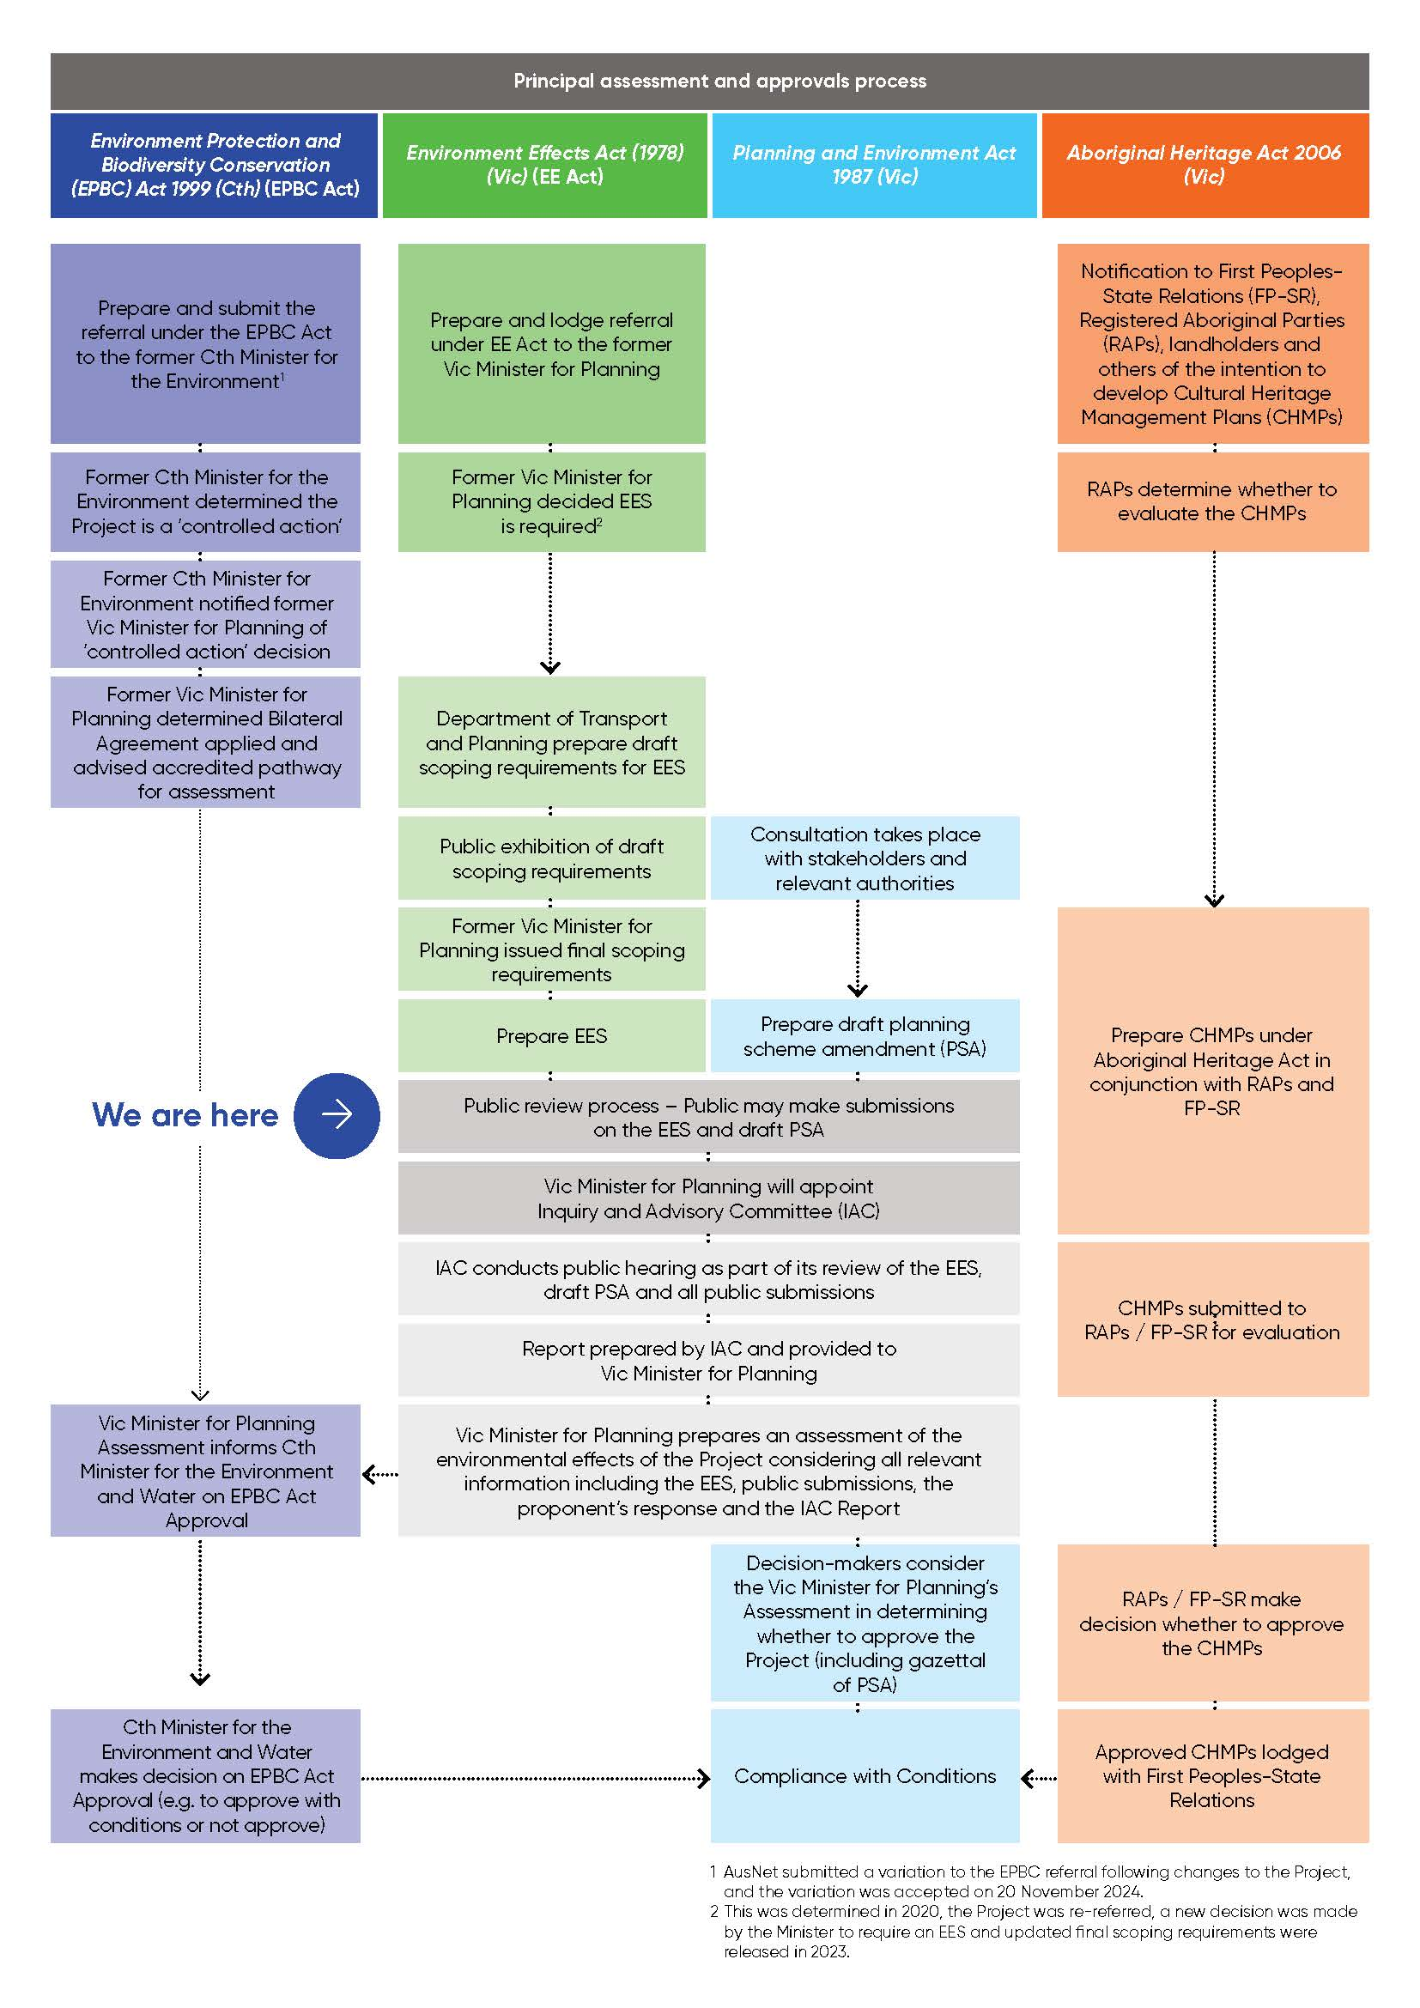

Figure 3.1 Principal assessment and approvals process

### Environment Protection and Biodiversity Conservation Act

The EPBC Act is the Australian Government’s central piece of environmental legislation. The EPBC Act creates a legal framework designed to protect and manage matters of national environmental significance (MNES), which include world heritage areas, national heritage places, wetlands of international importance, listed threatened species and ecological communities, listed migratory species, Commonwealth marine areas, the Great Barrier Reef Marine Park, nuclear actions and water resources (in relation to coal seam gas and large coal mining development).

Any project that is likely to have a significant impact on MNES must be referred to the Commonwealth Minister for the Environment and Water via the Department of Climate Change, Energy, the Environment and Water (DCCEEW) for a decision on whether it is a ‘controlled action’ requiring assessment and approval under the EPBC Act.

The Project was originally referred to the former Commonwealth Minister for the Environment by AusNet in July 2020 (EPBC referral 2020/8741). A delegate for the former Minister determined on 2 September 2020 that the Project is a ‘controlled action’ requiring assessment and approval under the EPBC Act because of its potential to impact on listed threatened species and communities. This decision was re-confirmed in a variation approval on 20 November 2024.

Sections 18 and 18A, as the controlling provisions for listed threatened species and communities in the EPBC Act, provide that taking an action that has, will have, or is likely to have a significant impact is prohibited without approval and make it an offence to undertake such an action without approval. The Minister’s decision stated that the Project will be ‘assessed under the assessment bilateral agreement with the Victorian Government’. Accordingly, the Minister will be informed by the EES process, including the Victorian Minister for Planning’s Assessment, in determining whether to approve the Project under the EPBC Act. The Minister may approve the Project, approve it subject to conditions or refuse it. The final decision will be provided to AusNet and also published on the Australian Government Notices Gazette and public notices website.

If the Project is approved subject to conditions – for example, independent environmental auditing and compliance monitoring – DCCEEW will closely monitor the Project to ensure compliance with these conditions.

The EPBC Act also regulates actions that may have a significant impact on World and National Heritage sites. Section 12 states no one can take actions that may impact the World Heritage values of these declared sites. A section of the Project Area is understood to be located within the curtilage of a World Heritage bid currently under consideration for the Victorian Goldfields (i.e., the Berry Deep Leads). Inclusion in the World Heritage List would require prior inclusion in the National Heritage List. If this area is included in the National Heritage List, regardless of it being a potential World Heritage listing, further consultation with DCCEEW may be required to determine appropriate consultation processes that may be required to be undertaken. **Technical Report A: Biodiversity Impact Assessment** has assessed all matters listed under the EPBC Act relevant to the Project as of 14 August 2024. This approach ensures that any additional or change in status of MNES listed under the EPBC Act between the original referral in 2020 and the submission for variation in 2024, were also considered. Further detail is included in **Chapter 8: Biodiversity** and **Chapter 27: Matters of National Environmental Significance**.

### Planning and Environment Act

The Planning and Environment Act regulates the use and development of land in Victoria. The Planning and Environment Act sets out the framework and procedures for preparing and amending planning schemes, obtaining planning permits, settling disputes, enforcing compliance with planning schemes and other administrative procedures.

The construction and operation of the Project will occur across six municipalities — Northern Grampians, Pyrenees, Hepburn, Ballarat, Moorabool and Melton — and is subject to the provisions of their respective planning schemes. The use and development of land for the Project triggers the need to obtain planning approval under all six planning schemes. These approval triggers are described in detail in **Chapter 12: Land use and planning** and **Technical Report E: Land Use and Planning Impact Assessment**.

Due to the number of planning schemes being affected, permit triggers under each planning scheme, and stakeholders involved in the Project, approval under the Planning and Environment Act will be sought via a draft GC PSA rather than separate planning permits. A GC PSA allows for the simultaneous amendment of more than one planning scheme by the Minister for Planning. The GC PSA would introduce a Specific Controls Overlay and Incorporated Document for the Project into each of the six planning schemes.

The Specific Controls Overlay would be applied to the Project Land and will not impact the underlying planning scheme zones and overlays for purposes unrelated to the Project delivery. The Specific Controls Overlay with the Incorporated Document would authorise the use and development of the Project Land for the purposes of the Project and exclude other planning scheme controls from applying to the Project. The Incorporated Document would also include conditions requiring the preparation and approval of an Environmental Management Framework for the Project. The purpose of the Environmental Management Framework is to provide a transparent framework with clear accountabilities for managing and monitoring the environmental effects and risks associated with the construction and operation of the Project through the implementation of the Environmental Performance Requirements (EPRs).

This approvals structure is commonly used for the delivery of major linear infrastructure projects in Victoria. Recent examples include the Melbourne Metro, North East Link and Suburban Rail Loop projects.

The proposed draft GC PSA has been informed by and is being exhibited concurrently with this EES. The draft GC PSA allows for the application of the PSA to be applied to all six planning schemes at the same time. AusNet also propose to rezone the land associated with the existing Bulgana Terminal Station and the new 500kV terminal station near Bulgana from ‘Farming Zone’ to a ‘utility installation (Special Use Zone)’ under the Northern Grampians Planning Scheme. This will result in amendments to mapping and application of the new schedules for the Specific Controls Overlay and Special Use Zone, and insertion of the ‘Western Renewables Link Incorporated Document’ into the relevant planning schemes.

The IAC (see Section 3.2) will consider and provide recommendations in respect of both the EES and the draft GC PSA to the Minister for Planning. The proposed draft GC PSA is provided as **Attachment III: Draft Planning Scheme Amendment**.

### Aboriginal Heritage Act

The Aboriginal Heritage Act is the primary legislation governing Aboriginal cultural heritage in Victoria. The Aboriginal Heritage Act and associated Aboriginal Heritage Regulations 2018 (Vic) (Aboriginal Heritage Regulations) establish a legal framework designed to protect and conserve Aboriginal cultural heritage in Victoria and recognise Aboriginal people as the primary guardians, keepers and knowledge holders of Aboriginal cultural heritage. This framework includes the establishment of an Aboriginal Cultural Heritage Register and processes for managing and protecting Aboriginal heritage.

For the Project, the risk of harm to Aboriginal cultural heritage will be managed through the CHMP process. A CHMP is underpinned by a detailed assessment of the potential impact of a proposed activity on Aboriginal cultural heritage. The plan itself outlines measures to be taken before, during and after an activity to manage and protect Aboriginal cultural heritage.

The Aboriginal Heritage Regulations stipulate that a CHMP is required if all or part of the ‘activity area’ for an activity is within an area of ‘cultural heritage sensitivity’ and all or part of the activity is a ‘high impact activity’. A search of the Aboriginal Cultural Heritage Register and Information System has confirmed that the Project’s Activity Area (as defined in a CHMP) is subject to areas of ‘cultural heritage sensitivity’ and is host to numerous registered Aboriginal places, including artefact scatters, low density artefact distributions, scar trees, earth features, and object collections. The Project is also considered to be a ‘high impact activity’.

Furthermore, section 49 of the Aboriginal Heritage Act specifies that if an EES is required in respect of any works, then a CHMP for the area in which the works are to be carried out must be prepared before those works are commenced. Accordingly, AusNet is consulting with the following entities to develop nine CHMPs for the Project, which will cover the Project’s Activity Area, as shown on Figure 3.2.

* Area 1 - CHMP 17313: Barengi Gadjin Land Council Aboriginal Corporation
* Area 2 - CHMP 17321: Eastern Maar Aboriginal Corporation (EMAC) (EMAC has deferred evaluation of the CHMP to First Peoples - State Relations)
* Area 3 - CHMP 17312: First Peoples - State Relations
* Area 4 - CHMP 17311: Dja Dja Wurrung Clans Aboriginal Corporation
* Area 4 - CHMP 18101: Dja Dja Wurrung Clans Aboriginal Corporation
* Area 5 – CHMP 18108: Wadawurrung Traditional Owners Aboriginal Corporation
* Area 5 – CHMP 20436: Wadawurrung Traditional Owners Aboriginal Corporation
* Area 6 - CHMP 18111: Wurundjeri Woi Wurrung Cultural Heritage Aboriginal Corporation
* Area 6 - CHMP 20459: Wurundjeri Woi Wurrung Cultural Heritage Aboriginal Corporation

The CHMPs will be developed in accordance with the Aboriginal Heritage Act and the Aboriginal Heritage Regulations. The presence, nature and extent of Aboriginal heritage values within the Project Area will be confirmed as part of the CHMP process, which will also be informed by the findings of this EES. Aboriginal cultural heritage matters are discussed further in **Chapter 9: Aboriginal cultural heritage** and **Technical Report B: Aboriginal Cultural Heritage Impact Assessment**.

Figure 3.2 Cultural Heritage Management Plan Areas

## Secondary approvals

A range of secondary approvals will need to be obtained for the Project. Secondary approvals are the authorisations required under legislation and various instruments to facilitate the construction and ongoing operation of the ‘approved’ Project.

As the requirements and triggers for secondary approvals are often confirmed only after detailed design has been developed for a project, these approvals are typically sought after principal approvals have been obtained.

The subsequent sections outline the secondary approvals that are likely to be required based on the findings of the impact assessments.

### Flora and Fauna Guarantee Act

The *Flora and Fauna Guarantee Act 1988* (Vic) (FFG Act) provides a legal framework for biodiversity conservation in Victoria. The FFG Act provides for a consistent state approach to assessing and listing threatened species and communities of flora and fauna, and other prescribed flora species, as well as listing threatening processes. Where required, EES technical reports have considered the requirements of the FFG Act to ensure the Project fulfils its obligations in identifying and mitigating impacts on threatened flora and fauna species and communities and takes the appropriate actions to protect these species. Further information on the threatened flora and fauna species and communities impacted by the Project is provided in **Chapter 8: Biodiversity and habitat** and **Technical Report A: Biodiversity Impact Assessment**.

Division 2 of the FFG Act provides that a permit to take is required to remove threatened flora, threatened flora communities and other protected flora (e.g., Orchidaceae) from public land (defined as Crown land or land owned by, or vested in, a public authority). A range of FFG Act-listed flora species are present within the Project Area. The Project will need to obtain a permit to take under the FFG Act if works require the removal of protected flora in road reserves, conservation reserves and other public land (e.g., land managed for water supply and production such as reservoirs).

### Heavy Vehicle National Law Application Act

The *Heavy Vehicle National Law Application Act* *2013* (Vic) (HVNL Act) adopts the Heavy Vehicle National Law (HVNL). The HVNL establishes a national scheme for facilitating and regulating the road use of heavy vehicles with a mass exceeding 4.5 tonnes or aggregate trailer mass (the total weight a trailer can handle, including its own mass and the load it is carrying).

The HVNL Act ensures consistency and alignment with the national framework. It covers various aspects related to heavy vehicles, including safety, licensing, registration, and road transport operations. In Victoria, the National Heavy Vehicle Regulator will provide escort services to Oversize Overmass transport vehicles that carry, or are specially designed to carry, large items to construct the Project.

An Oversize Overmass Permit will be required from the National Heavy Vehicle Regulator Portal for transport of materials on Victorian roads.

### Heritage Act

The *Heritage Act 2017* (Vic) (Heritage Act) is administered by Heritage Victoria and its purpose is to, among other things, ‘provide for the protection and conservation of the cultural heritage of the State’. The Heritage Act protects all categories of cultural heritage relating to the non-Aboriginal settlement of Victoria including buildings, structures, objects and archaeological sites. There are two categories of listing under the Heritage Act:

* Victorian Heritage Register (VHR) or state-significant places and objects; and
* Victorian Heritage Inventory (VHI) for archaeological sites.

Under the Heritage Act, a permit is required from Heritage Victoria to interfere with a heritage place or object listed on the VHR. Similarly, a consent is required to interfere with a site listed on the VHI or an ‘archaeological site’ not listed on the VHI.

As detailed in **Chapter 10: Historical heritage** and **Technical Report C: Historical Heritage Impact Assessment**, no VHR places will be directly impacted by works in the Project Area. A small number of VHI places and unlisted archaeological sites may be directly impacted by the Project and will require consent from Heritage Victoria should there be unavoidable impact to any of these places.

### Rail Management Act

The *Rail Management Act 1996* (Vic) (Rail Management Act) governs various aspects related to rail management and operations. Victorian Rail Track (VicTrack) is a statutory corporation established in 1997 under the Rail Management Act and is owned by the Victorian Government. VicTrack is the legal owner of Victoria’s railway land and infrastructure, and its main functions include the delivery of government services and providing third party access to those parts of its rail infrastructure it has control.

As such, VicTrack manages applications to build new, or change existing, utility services on its land or adjacent to their infrastructure. The Head, Transport for Victoria and the rail operators will review applications and grant approval. Upon approval, VicTrack will send a Letter of Offer or Licence Agreement for execution.

Project works to install and / or maintain electricity lines are required within five metres of VicTrack assets. A permit to work will be required. Applications are reviewed by VicTrack for approval.

### Road Management Act

The *Road Management Act 2004* (Vic) (Road Management Act) establishes the statutory framework for management of the Victorian road network by the Head, Transport for Victoria, the Department of Transport, councils and other road authorities. The Road Management Act facilitates coordination of the various uses of road reserves for roadways, pathways, infrastructure and the like for the purpose of delivering safe and efficient state and local public road networks.

Under the Road Management Act, the Head, Transport for Victoria is the coordinating road authority for declared arterial roads and freeways, while municipal councils are the responsible road authorities for municipal roads within their municipal districts. The coordinating road authority for non-arterial State roads varies and can be prescribed by legislation but, in certain circumstances, may be a Crown land manager such as the Department of Energy, Environment and Climate Action (DEECA) or Parks Victoria.

Under the Road Management Act, a person wishing to undertake works in a road may apply to the coordinating road authority for permission to undertake proposed ‘works’ in, on, under or over a road. ‘Works’ is broadly defined and includes works to construct, maintain or repair the road, as well as works to install, maintain or repair infrastructure (such as water or gas mains, drainage infrastructure or power and telecommunications infrastructure). It is also possible to enter into an agreement with the coordinating road authority in respect of proposed works on roads, in which case consent does not need to be sought for each instance of works.

The Project will require consents or agreements under the Road Management Act for any Project construction or operation activities that involve works being undertaken in, on, under or over a road, subject to any limited exemptions that may apply under the Road Management Act and associated regulations. In addition, permits may be required for heavy vehicle or large loads transport or escorted transport. It is understood that there are a number of amendments to the Road Management Act which are in the process of being made law. Descriptions of these amendments and their impacts to the Project are discussed in **Technical Report P: Transport Impact Assessment**.

### Water Act

The *Water Act 1989* (Vic) (Water Act) provides the legal framework for managing Victoria’s water resources with the purpose of promoting the orderly, equitable and efficient use of water resources to make sure that they are conserved and properly managed for sustainable use for the benefit of present and future Victorians. The Water Act regulates impacts to surface water and groundwater resources.

Under section 67 of the Water Act, a licence is required to construct, alter, operate, remove or decommission any works on a designated waterway. Authority for issuing these licences is delegated by the Minister for Water to the Catchment Management Authorities, who then implement these requirements through their works on waterways permitting processes. The Project will likely require a Works on Waterways Permit where the Project crosses a designated waterway or will disturb the banks adjacent to a designated waterway.

Under section 8 of the Water Act, the Project must not prevent access to surface water for domestic and stock purposes, or other licenced or allowed activity.

### Wildlife Act

The *Wildlife Act 1975* (Vic) (Wildlife Act) establishes procedures for the protection and conservation of wildlife (e.g., indigenous vertebrates, deer, nonindigenous quail, pheasants, and partridges and animals declared wildlife by the Governor in Council), the prevention of wildlife becoming extinct and the sustainable use of and access to wildlife. The Act also includes procedures to prohibit and regulate the conduct of persons engaged in activities concerning or related to wildlife.

All fauna species indigenous to Victoria are listed as protected under the Wildlife Act. Potential impacts to these species, including needing to relocate species temporarily or permanently, would require authorisation from DEECA.

The Project will require any persons involved in handling, relocating, disposing of deceased wildlife or caring for wildlife will be required to hold an appropriate licence or authorisation under the Wildlife Act. This may include professionals involved in pre-clearance surveys, or supervision of vegetation removal, vegetation maintenance and management. The Act is currently being reviewed, and the Project will comply with applicable changes to the legislation, as required.

## Other legislation of relevance

### Legislation relevant to Crown land tenure

Crown land legislation has provisions for agreements to be made between the Minister for Environment and electricity companies to authorise access to and use of a range of classes of Crown land. The proposals to use and occupy Crown land will be provided in the EES, however final authorisation may not occur until after Ministerial approval.

A land legislation agreement with an electricity company is an authorisation option for access and use of Crown land associated with large projects. Individual parcel agreements or licences can also be put in place.

##### Crown Land (Reserves) Act

The *Crown Land (Reserves) Act 1978* (Vic) (CLRA) is the principal legislation for the reservation and management of Crown land in Victoria. The CLRA provides the reservation for a variety of public purposes and governs the management of this land. The Minister for Environment administers the CLRA, and in most cases DEECA and/or Parks Victoria are the government bodies responsible for the control and management of reserved Crown land. However, a Committee of Management or private entity under lease or licence may be responsible for the management of reserved Crown land.

The Project will be governed by the CLRA where it traverses Crown land. Leases, licences or agreements under the CLRA will need to be secured for the construction and ongoing operation and maintenance of the Project. Under section 18A of the CLRA, the Minister for Environment may enter into an agreement with an electricity company to manage and control, or to carry out duties, functions and powers related to the company’s purpose, on any reserved Crown land. AusNet is working with the relevant government bodies to obtain the appropriate approvals required under the CLRA.

##### Land Act

The *Land Act 1958* (Vic) (Land Act) governs unreserved Crown land. The Land Act is administered by a range of Ministers, including the Minister for Planning, the Minister for Environment and the Minister for Local Government. The land manager, depending on the land in question, will be Parks Victoria or the Secretary of DEECA.

It is anticipated that the Project will traverse Crown land governed by the Land Act. If this occurs, tenure will need to be secured under the Land Act for the construction and ongoing operation and maintenance of the Project. A range of tenure options are available under the Land Act and AusNet is working with the relevant Crown land managers to determine the appropriate tenure for the Project.

##### Forests Act

The *Forests Act 1958* (Vic) (Forests Act) provides for the protection and management of state forests. The Minister for Environment administers the Act in most cases and the land manager, depending on the land in question, will be Parks Victoria or the Secretary of DEECA.

Tenure will need to be secured under the Forests Act for the construction and ongoing operation and maintenance of the Project. A range of tenure options are available under the Forests Act and AusNet would work with the relevant Crown land managers to determine the appropriate tenure for the Project.

### Legislation relevant to private and public land tenure

##### Land Acquisition and Compensation Act

AusNet intends to negotiate transmission line easements with landholders for all land required for the Project. However, it is anticipated that some easements may need to be compulsorily acquired.

The *Land Acquisition and Compensation Act 1986* (Vic) (LACA) sets out the circumstances in which an ‘Authority’ may acquire land where it is empowered to do so under a ‘special Act’. In this case, AusNet may be empowered by the *Electricity Industry Act 2000* (Vic) (Electricity Industry Act) to compulsorily acquire easements for the purposes of erecting and / or laying and maintaining power lines provided those certain procedures are followed, and approval is obtained from the Governor in Council on the recommendation of the Minister for Energy and Resources. Any compulsory acquisition of interests in land by AusNet must be undertaken in accordance with the requirements of the LACA.

### Native Title legislation

Native title is the recognition by Australian law of Aboriginal and Torres Strait Islander people's traditional rights and interests in land and waters held under traditional law and custom. The native title rights and interests held will differ depending on the traditional owners’ laws and customs and the historical use of the land in question, but can range from non-exclusive rights, such as hunting, gathering or fishing rights and interests, to possession, occupation, use and enjoyment of land or waters to the exclusion of all others.

##### Native Title Act

The *Native Title Act 1993* (Cth) (Native Title Act) is the key piece of legislation governing native title in Australia. The Native Title Act provides a national system for the recognition and protection of native title and for its coexistence with the national land management system. While not an approval in its own right, the Native Title Act requirements, including any procedural rights, will need to be fulfilled before certain actions, including authorisations, can be taken.

Relevant to the Project, the Native Title Act provides that native title cannot be extinguished contrary to the Act. The Project has the potential to give rise to ‘future acts’ — being something that is done, or authorised to be done, on land or waters that would extinguish native title or is otherwise inconsistent with the existence, enjoyment or exercise of native title rights — ‘Future acts’ cannot be undertaken validly unless certain procedures under the Native Title Act are followed.

AusNet will comply with all relevant statutory procedures under the Native Title Act including registering Indigenous Land Use Agreements, where required. AusNet will also manage risks to native title posed by the Project through engagement with native title holders, traditional owner groups, Registered Aboriginal Parties and other relevant stakeholders (including government).

##### Traditional Owner Settlement Act

The *Traditional Owner Settlement Act 2010* (Vic) (TOSA) was developed as an alternative framework to that offered by the Native Title Act for the settlement of native title claims in Victoria. The TOSA enables the State to enter into settlement agreements with traditional owners to achieve comprehensive out-of-court settlement of claims in exchange for the provision of benefits, such as the grant of freehold land, joint management of public lands and opportunities and funding to facilitate the sustainable economic development of the traditional owner group.

The Project is expected to traverse an area of land subject to a registered Recognition and Settlement Agreement under the TOSA between the Dja Dja Wurrung Clans Aboriginal Corporation and the State, and two proposed Recognition and Settlement Agreements with the Wotjobaluk Peoples and Eastern Maar Peoples.

A settlement package under the TOSA will include a range of documents but the most relevant to the Project is the Land Use Activity Agreement (LUAA), which allows traditional owners to comment on or consent to certain activities on public land — this replaces the future acts regime under the Native Title Act. The LUAA will underpin consultation with traditional owners about activities occurring on land subject to a settlement. The LUAA will specify exactly which activities will trigger its application and different activities will require different procedures to be followed. AusNet will comply with the requirements of the TOSA in delivering the Project.

The native title strategy being developed for the Project will include land covered by the TOSA.

### Aboriginal and Torres Strait Islander Heritage Protection Act 1984

*The Aboriginal and Torres Strait Islander Heritage Protection Act 1984* protects Aboriginal cultural property that is significant to Aboriginal people. Cultural property includes any places, objects and folklore that ‘are of particular significance to Aboriginals in accordance with Aboriginal tradition’. This includes intangible cultural heritage values.

*The Aboriginal and Torres Strait Islander Heritage Protection Act* may apply to contemporary Aboriginal cultural property as well as ancient sites. This Act takes precedence over State cultural heritage legislation where there is conflict. Under section(s) 9 and 10 of *The Aboriginal and Torres Strait Islander Heritage Protection Act*, the responsible Minister may make a declaration in situations where state or territory laws do not provide adequate protection of heritage places.

The Commonwealth Minister for the Environment is responsible for administering this Act and can make declarations to protect these areas and objects from specific threats of injury or desecration. The Minister cannot make a declaration unless an Aboriginal person (or a person representing an Aboriginal person) has asked the Minister to protect an area or object.

Consultation with Aboriginal stakeholders during the CHMP process will minimise the risk of an application for a declaration being made to the Minister for the Project.

### Environment Protection Act

The *Environment Protection Act 2017* (Vic) (EP Act) establishes the legislative framework for protecting Victoria’s environment and human health from pollution and waste. The Environment Protection Authority (EPA) Victoria administers the EP Act and associated orders and regulations, including the Environment Reference Standard (ERS) which set out the environmental values of the ambient air, ambient sound, land and water environments that are sought to be achieved or maintained in Victoria and standards to support those values.

The EP Act introduces a risk-based approach to preventing harm to human health and the environment and its cornerstone is a general environmental duty (GED). The GED requires persons engaging in an activity that may give rise to risks of harm to human health or the environment from pollution or waste to understand those risks and minimise them so far as is reasonably practicable. The concept of minimising risks so far as reasonably practicable is described further in section 6 of the EP Act and includes eliminating the risk or reducing the risk where elimination is not reasonably practicable.

Several matters must be considered in deciding what is reasonably practicable:

* The likelihood of those risks eventuating
* The degree of harm that would result if those risks eventuated
* What the person concerned knows, or ought to reasonably know, about the harm or risks of harm and any ways of eliminating or reducing those risks
* The availability and suitability of ways to eliminate or reduce those risks
* The cost of eliminating or reducing those risks.

When dealing with a common risk or harm, demonstrating that the person or business undertaking the activity has done what is reasonably practicable can be achieved if:

* Well-established effective practices or controls have been adopted to eliminate or manage risk
* Well-established practices or controls do not exist, it can be shown that effective controls have been assessed and adopted.

The EP Act includes a number of other important duties relevant to the Project, including a duty to respond to pollution incidents, report pollution and contaminated land, manage contaminated land, and dispose of classified industrial waste at a lawful place via a permitted waste hauler.

The Project’s impacts to air, water, land and human health have been assessed in accordance with the requirements of the EP Act, subordinate legislation, including the Environment Protection Regulations 2021 and ERS, and published guidance material to provide a state of knowledge and develop mitigation measures to manage them.

During operations, through the implementation of the EPRs, AusNet will comply with the requirements of the GED under the EP Act. EPRs define the environmental outcomes that the Project must achieve and are incorporated into an Environmental Management Framework. The duties under the EP Act, including the GED, are embedded into the Environmental Management Framework. The proposed Environmental Management Framework and EPRs are presented in **Chapter 29: Environmental Management Framework**.

### Catchment and Land Protection Act

The *Catchment and Land Protection Act 1994* (Vic) (CaLP Act) provides a framework for the integrated management and protection of catchments, the management of invasive plants and animals and also deals with land degradation, conservation of soil and protection of water resources. The CaLP Act aims to ensure the quality of Victoria’s land and water resources (and their associated plant and animal life) are maintained and enhanced and establishes processes that can be used to assess the condition of land and water resources, including the effectiveness of land protection measures.

The CaLP Act is administered by Agriculture Victoria, with a range of duties under the CaLP Act being attributed to the Secretary of DEECA and to Catchment Management Authorities.

The CaLP Act establishes a framework which defines the roles and responsibilities of regulatory bodies within the various catchments within the Project Area. It sets up a system of controls to manage noxious weeds and pest animals, facilitates an integrated management process for catchment planning and land management and creates a regulatory regime. This regulatory regime, the Special Water Supply Catchments, have referral and approval requirements for planning applications that can impose obligations on persons with respect to matters subject to the CaLP Act, as well as offence provisions and enforcement mechanisms.

Relevant to the Project, under the CaLP Act, persons responsible for land have legal obligations regarding the management of declared noxious weeds and pest animals on that land. This includes the requirement to take all reasonable steps to eradicate, control and / or prevent the spread of certain weeds and pests. A failure to comply with the requirements of the CaLP Act carries penalties.

To comply with the principles of the CaLP Act, the management of noxious and environmental weeds, pest animals and pathogens will be addressed through EPRs and management controls detailed in the Principal Contractor’s Construction Environmental Management Plan (EPR EM2).

Additionally, the Project Area crosses 11 water supply catchment areas, which from west to east are: Wimmera Systems, Loddon River (Laanecoorie), McCallum Creek, Tullaroop Reservoir, Creswick, Ballarat, Lal Lal Reservoir, Moorabool River (Sheoaks), Pykes Creek and Werribee River, and Lake Merrimu. These are declared and protected under the CaLP Act, and as such require approval from the relevant land manager for activities conducted under other statutes and statutory planning schemes. Continued engagement with the Catchment Management Authorities during design and construction of the Project will be required.

### Legislation relevant to electricity supply and management

##### Electricity Industry Act

The Electricity Industry Act regulates the Victorian electricity supply industry. In accordance with this Act, AusNet has an existing licence to transmit and supply electricity though the Project’s transmission system from the Essential Services Commission (ESC) of Victoria.

Further, the Act provides AusNet with powers to access land for certain purposes (e.g., for environmental investigations associated with the Project) and to acquire the transmission line easements required for the Project, where such access or interests cannot be secured by negotiation.

ESC’s Land Access Code of Practice governs procedures for electricity transmission companies to follow when seeking access to private land under the Electricity Industry Act. The purpose of the Code of Practice is to mandate specific requirements to be followed before, during and after land access under section 93 of the Act to improve communication with landholders, occupiers and other key stakeholders and minimise impacts.

##### Electricity Safety Act

The *Electricity Safety Act 1988 (Vic)* (Electricity Safety Act), administered by Energy Safe Victoria, regulates the safety, reliability and security of the electricity supply and uses in Victoria. A range of duties under the Electricity Safety Act are attributed to the Secretary of DEECA that includes, but is not limited to, vegetation clearance for bushfire mitigation and safe operation of energy installations.

The relevant Technical Reports have considered the requirements of the Electricity Safety Act and associated regulations including the Electricity Safety (Bushfire Mitigation) Regulations 2023 and the Electricity Safety (Electric Line Clearance) Regulations 2020, where relevant to each discipline.

### Airports Act

The *Airports Act 1996* (Cth) (Airports Act) provides a regulatory system for airports, requiring all leased federal airports (excluding Tennant Creek and Mount Isa) to hold a Master Plan approved by the Commonwealth Minister for Infrastructure, Transport and Regional Development and Local Government. These plans are renewed every five years and provide the future strategic vision for the airport. Significant developments occurring under the Master Plan also require Major Development Plans to be produced and approved by the Minister.

The Melbourne Airport Master Plan was approved by the Minister in November 2022. The approved Master Plan confirms Melbourne Airport's plan for a third runway built in a north-south orientation and proposes a future fourth runway in an east-west direction.

In accordance with the requirements of Part 3C of the Planning and Environment Act, Clause 51.04 (Melbourne Airport Environs Strategy Plan) of all planning schemes in Victoria requires there to be consistency between the planning schemes and the Melbourne Airport Environs Strategy Plan (i.e., the Melbourne Airport Master Plan). This is in part achieved through Clause 18.02-7S (Airports and airfields) and Clause 18.02-7R (Melbourne Airport), which specify strategies to ensure land use or development does not pose risks to the safe and efficient operation of Melbourne Airport (and other Victorian airports), including risks associated with intrusion into protected airspace. As such, in the design of the Project, AusNet has considered the protected airspace (e.g., Obstacle Limitation Surfaces) of current and future runways of Victorian airports, including those planned for in the 2022 Melbourne Airport Master Plan.

### Civil Aviation Act

The *Civil Aviation Act 1988* (Cth) (Civil Aviation Act) provides a regulatory framework for maintaining, enhancing and promoting the safety of civil aviation, with particular emphasis on preventing aviation accidents and incidents.

The Project will require approval under the Civil Aviation Act for construction within the protected airspace of the Melbourne Airport.

### Climate Change Act

The *Climate Change Act 2017* (Vic) (Climate Change Act) provides a legislative framework to manage climate change risks; set targets for greenhouse gas emission reductions for Victoria; and drive strategic responses to climate change and the consideration of climate change in government decision making. The Act includes a set of policy objectives for climate change and guiding principles: Key objectives relevant to the consideration of climate change in the Project are to:

* Build the resilience of the State’s infrastructure, built environment and communities through effective adaption and disaster preparedness action
* Manage the State’s natural resources, ecosystems and biodiversity to promote their resilience.

One of the Climate Change Act’sguiding principles is that of risk management. It specifies that decisions, policies, programs or processes should be based on a careful evaluation of the best practically available information about the potential impacts of climate change, to avoid where practicable scenarios or irreversible damage resulting from climate change. As such, AusNet has taken into consideration the risk of climate change when designing the Project.

### National Greenhouse and Energy Reporting Act

The Commonwealth Government uses the *National Greenhouse and Energy Reporting Act* *2007* (Cth) (NGER Act) for the measurement, reporting and verification of Australian greenhouse gas emissions. This legislation is used for a range of purposes, including being used for international greenhouse gas reporting purposes. Corporations which meet the thresholds for reporting under the NGER Act must register and report their greenhouse gas emissions.

Under the NGER Act, corporations in Australia which exceed thresholds for greenhouse gas emissions, energy production or consumption are required to measure and report data to the Clean Energy Regulator on an annual basis. The National Greenhouse and Energy Reporting (Measurement) Determination 2008 identifies a number of methods to account for greenhouse gas from specific sources relevant to the Project. This includes emissions of greenhouse gases from direct fuel combustion (fuels for transport energy purposes), emissions associated with consumption of power from direct combustion of fuel (e.g., diesel generators used during construction), and from consumption of electricity from the grid. AusNet will be required to report the greenhouse gas emissions generated from the Project for annual submission to the Clean Energy Regulator.

