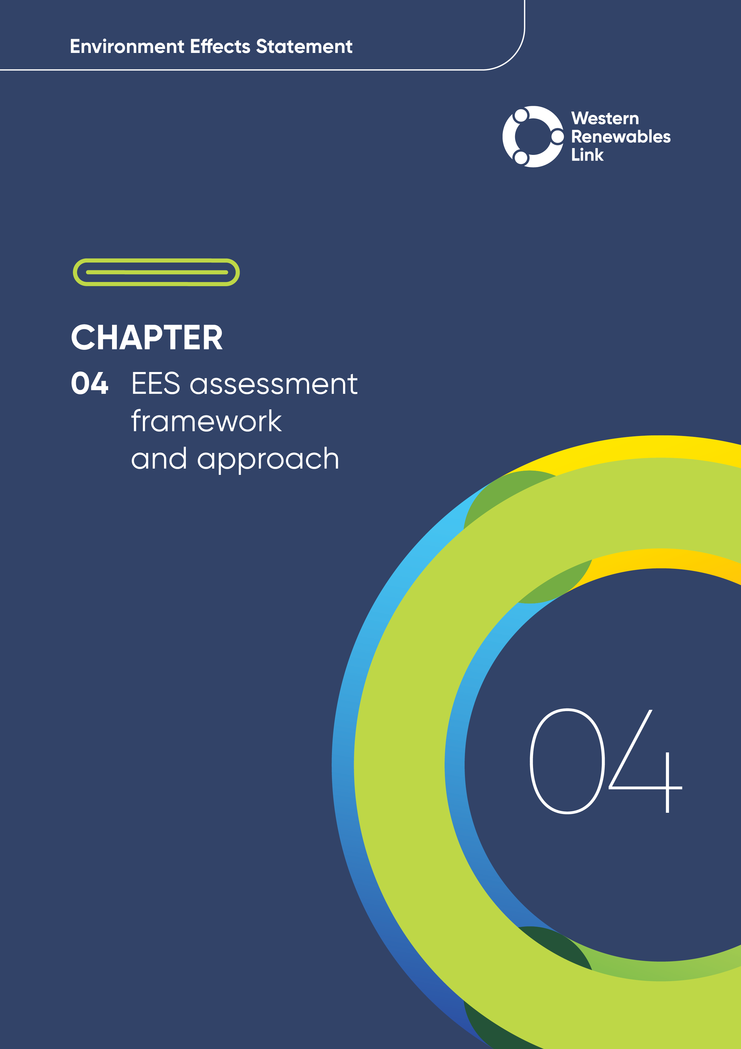

# EES assessment framework and approach

An assessment framework was developed for the Environment Effects Statement (EES) to provide a consistent and transparent approach across the technical reports to assess the potential impacts of the Project on the environment. This chapter describes the components of the assessment framework and the processes that were applied in preparing the EES.

The development of the EES assessment framework is consistent with the following:

* ‘Scoping Requirements Western Renewables Link Project Environment Effects Statement’
* Legislation, including the General Environmental Duty imposed by the *Environment Protection Act 2017 (Vic)* (Environment Protection Act).

## Overview of the EES assessment framework

The EES assessment framework consists of the following key components:

* **Legislation, policy, guidelines and EES evaluation objectives:** These requirements form the foundation of the EES assessment framework and inform the technical reports prepared and identification of matters to be investigated in the EES.
* **Project development and Project description:** The Project’s objectives (see **Chapter 1: Introduction**) guided the development of the design for the Project. The Project description outlines the project design and (see **Chapter 6: Project description**) forms the basis for the EES assessment. The Project’s development and refinement was iterative and informed by the impact assessment process in response to the identification of potential Project impacts, and landholder and stakeholder feedback (see **Chapter 5: Project development**).
* **Impact assessment:** Identifying and assessing impacts to the environment due to the Project forms the basis of the EES. The process involved desktop review, field surveys, stakeholder engagement, characterisation of the existing environmental values, identification of key issues and impacts, and assessment of the potential effects on the existing environment. Mitigation measures to avoid, minimise, manage, rehabilitate and offset those effects were identified to inform the development of Environmental Performance Requirements (EPRs), and assessment of residual impacts. The impact assessment also involved consideration of other relevant projects that could lead to cumulative impacts.
* **Environmental Performance Requirements (EPRs):** EPRs were developed through the preparation of the impact assessments. EPRs define the environmental outcomes to be achieved during construction, operation and decommissioning. While some EPRs are performance based to allow flexibility on how they will be achieved, others include more prescriptive measures that must be implemented. Compliance with the EPRs will be required as a condition of the Project’s approval. Mitigation measures described in the impact assessments have informed the development of the EPRs. The EPRs are incorporated into the Environmental Management Framework, provided in **Chapter 29: Environmental Management Framework**.
* **Management:** An Environmental Management Framework provide a transparent framework for the management of environmental effects of the Project during construction, operation and decommissioning. It is one component of the overall governance framework developed for the delivery of the Project to meet statutory requirements, protect environmental values and provide stakeholder confidence. The Environmental Management Framework outlines the roles, responsibilities, and requirements for environmental management, monitoring, reporting, and auditing. It also includes accountabilities for the implementation of, and compliance with, the Environmental Management Framework and EPRs.
* **Consultation and engagement:** The Project’s consultation and engagement program seeks input from Traditional Owners, landholders, the community, and other stakeholders on design and development, aims to keep the community informed of the Project’s progress and provides a platform to identify and respond to stakeholder and community concerns. The outcomes of consultation with the community and engagement with the Technical Reference Group and other stakeholders are key inputs into the assessment and management components of the EES assessment framework, particularly with respect to the identification of existing conditions and values, assessment of impacts, identification of avoidance and mitigation measures and development of the Environmental Management Framework and EPRs.

The Minister for Planning’s assessment of this EES will inform statutory decision makers on the key approvals for the Project, including the Group of Councils (GC) Planning Scheme Amendment to the relevant planning schemes prepared and approved under the *Planning and Environment Act 1987 (Vic)*; approval of and adherence to Cultural Heritage Management Plans (CHMPs) under the *Aboriginal Heritage Act 2006 (Vic)*; and approval of the Project which is a ‘controlled action’ under the Environment Protection and *Biodiversity Conservation Act 1999 (Cth)* (EPBC Act).

A range of secondary approvals and consents are also potentially required for the Project to proceed (see **Chapter 3: Legislative framework and approval requirements**).

The relationship between the key components of the EES assessment framework are shown in Figure 4.1 and these are discussed in more detail in the sections that follow.

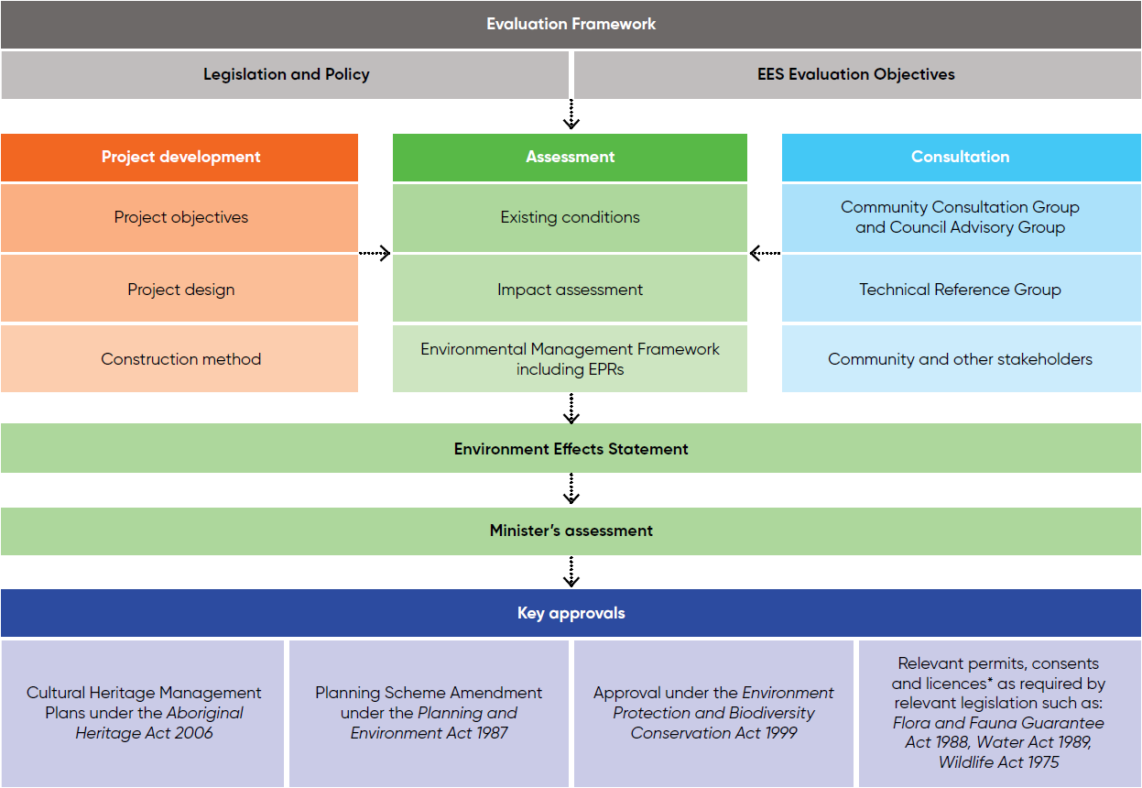

*Additional approvals / permits are required beyond those listed. Further detail is available in Chapter 3: Legislative framework and approval requirements.

Figure 4.1 EES assessment framework

A number of technical reports were independently reviewed to provide further confidence in the EES findings and conclusions. The reviews considered the assumptions, method, findings, suitability of EPRs, and if the report adequately addresses the relevant evaluation objective(s) in the EES scoping requirements. Independent reviews were conducted for the following technical reports:

* **Technical Report C: Historical Heritage Impact Assessment – Lovell Chen**
* **Technical Report D: Landscape and Visual Impact Assessment – Hansen Partnership**
* **Technical Report J: Aviation Impact Assessment – Aviation Projects**
* **Technical Report K: Bushfire Impact Assessment – Fire Risk Consultants**
* **Technical Report L: EMI and EMF Impact Assessment – EMF Scientific.**

## Legislation, policy, guidelines and EES evaluation objectives

The EES assessment framework responds to applicable legislation and the scoping requirements, incorporating the EES evaluation objectives issued by the Minister for Planning in November 2023. The evaluation objectives identify the desired environmental outcomes to manage the potential adverse effects of the Project and have guided the matters to be investigated and documented in the preparation of this EES.

The Project was determined to be a ‘controlled action’ by the Commonwealth Minister for the Environment and Water on 20 November 2024, requiring assessment and approval under the EPBC Act. The Minister’s decision stated that the Project will be ‘assessed under the assessment bilateral agreement with the Victorian Government’. Accordingly, the Minister will be informed by the EES process, including the Victorian Minister for Planning’s Assessment, in determining whether to approve the Project under the EPBC Act.

Table 4.1 presents the Project’s EES evaluation objectives, associated legislation and a reference to where each evaluation objective is addressed within the EES main report and EES technical reports. This table includes an overview of key legislation specific to each discipline considered in their respective EES technical reports.

Table 4.1 EES evaluation objectives and corresponding legislation

| EES evaluation objective | Relevant legislation | Relevant EES chapter and technical report |
| --- | --- | --- |
| Biodiversity and habitat: Avoid, and where avoidance is not possible, minimise potential adverse effects on protected native vegetation and animals (particularly listed threatened species and their habitat and listed ecological communities), as well as address offset requirements consistent with state and Commonwealth policies. | * + *Catchment and Land Protection Act 1994 (Vic)*   + *Environment Protection Act 2017 (Vic)*   + *Environment Protection and Biodiversity Conservation Act 1999 (Cth)*   + *Flora and Fauna Guarantee Act 1988 (Vic)*   + *Planning and Environment Act 1987 (Vic)*   + *Water Act 1989 (Vic)*   + *Wildlife Act 1975 (Vic)* | * + **Chapter 8: Biodiversity and habitat**   + **Chapter 27: Matters of National Environmental Significance**   + **Technical Report A: Biodiversity Impact Assessment**   + **Technical Report S: Groundwater Impact Assessment**   + **Technical Report T: Surface Water Impact Assessment** |
| Cultural heritage: Avoid, or minimise where avoidance is not possible, adverse effects on Aboriginal cultural heritage and historic heritage values. | * + *Aboriginal Heritage Act 2006 (Vic)*   + *Heritage Act 2017 (Vic)*   + *Planning and Environment Act 1987 (Vic)*   + *Native Title Act 1993 (Cth)*   + *Traditional Owner Settlement Act 2010 (Vic)* | * + **Chapter 9: Aboriginal cultural heritage**   + **Chapter 10: Historical heritage**   + **Technical Report B: Aboriginal Cultural Heritage Impact Assessment**   + **Technical Report C: Historical Heritage Impact Assessment** |
| Landscape and visual: Avoid, or minimise where avoidance is not possible, and manage potential adverse effects on landscape and visual amenity. | * + *Planning and Environment Act 1987 (Vic)*   + *Aboriginal Heritage Act 2006 (Vic)*   + *Heritage Act 2017 (Vic)* | * + **Chapter 11: Landscape and visual**   + **Technical Report D: Landscape and Visual Impact Assessment** |
| Land use and socioeconomic: Avoid, or minimise where avoidance is not possible, adverse effects on land use, social fabric of the community, businesses including farming and tourism, local and state infrastructure, aviation safety and to affected and neighbouring landowners during construction and operation of the project. | * + *Air Navigation Act 1920 (Cth)*   + *Civil Aviation Act 1988 (Cth)*   + *Electrical Safety Act 1998 (Vic)*   + *Environment Protection Act 2017(Vic)*   + *Planning and Environment Act 1987 (Vic)*   + *Transport Integration Act 2010 (Vic)*   + *Native Title Act 1993 (Cth)*   + *Land Act 1958 (Vic)*   + *Crown Land (Reserves) Act 1978 (Vic)*   + *Forests Act 1958 (Vic)*   + *Land Acquisition and Compensation Act 1986 (Vic)* | * + **Chapter 12: Land use and planning**   + **Chapter 14: Economic**   + **Chapter 15: Agriculture and forestry**   + **Chapter 16: Aviation**   + **Chapter 21: Social**   + **Technical Report E: Land Use and Planning Impact Assessment**   + **Technical Report F: Social Impact Assessment**   + **Technical Report G: Economic Impact Assessment**   + **Technical Report H: Agriculture and Forestry Impact Assessment**   + **Technical Report J: Aviation Impact Assessment**   + **Technical Report Q: Geology and Soils Impact Assessment**   + **Technical Report R: Contaminated Land Impact Assessment** |
| Community amenity, safety roads and transport: Avoid, or minimise where avoidance is not possible, adverse effects for community amenity, health and safety, with regard to construction noise, vibration, dust, lighting, waste, greenhouse gas emissions, transport network, operational noise, fire risk management and electromagnetic radiation. | * + *Climate Change Act 2017 (Vic)*   + *Country Fire Authority Act 1958 (Vic)*   + *Environment Protection Act 2017 (Vic)*   + *Occupational Health and Safety Act 2004 (Vic)*   + *Planning and Environment Act 1987 (Vic)*   + *Public Health and Wellbeing Act 2008 (Vic)*   + *Rail Management Act 1996 (Vic)*   + *Road Management Act 2004 (Vic)*   + *Road Safety Act 1986 (Vic)*   + *Transport Integration Act 2010 (Vic)*   + *Work Health and Safety Act 2011 (Cth)* | * + **Chapter 13: Bushfire**   + **Chapter 17: EMI and EMF**   + **Chapter 18: Air quality**   + **Chapter 19: Noise and vibration**   + **Chapter 20: Transport**   + **Technical Report D: Landscape and Visual Impact Assessment**   + **Technical Report F: Social Impact Assessment**   + **Technical Report I: Air Quality Impact Assessment**   + **Technical Report K: Bushfire Impact Assessment**   + **Technical Report L: EMI and EMF Impact Assessment**   + **Technical Report M: Greenhouse Gas Impact Assessment**   + **Technical Report N: Climate Change Assessment**   + **Technical Report O: Noise and Vibration Impact Assessment**   + **Technical Report P: Transport Impact Assessment** |
| Catchment values and hydrology: Maintain the functions and values of aquatic environments, surface water and groundwater quality and stream flows and prevent adverse effects on protected beneficial uses. | * + *Catchment and Land Protection Act 1994 (Vic)*   + *Environment Protection Act 2017 (Vic)*   + *Environment Protection and Biodiversity Conservation Act 1999 (Cth)*   + *Flora and Fauna Guarantee Act 1988 (Vic)*   + *Planning and Environment Act 1987 (Vic)*   + *Water Act 1989 (Vic)*   + *Safe Drinking Water Act 2003 (Vic)* | * + **Chapter 22: Geology and soils**   + **Chapter 23 Contaminated land**   + **Chapter 24: Groundwater**   + **Chapter 25: Surface water**   + **Chapter 14: Catchment Values and Water**   + **Technical Report Q: Geology and Soils Impact Assessment**   + **Technical Report R: Contaminated Land Impact Assessment**   + **Technical Report S: Groundwater Impact Assessment**   + **Technical Report T: Surface Water Impact Assessment** |

## Assessment approach

The key elements of the EES assessment framework include establishing existing conditions and environmental values, identifying key issues and risks through risk screening, engaging with communities and stakeholders, carrying out an impact assessment, assessing potential cumulative impacts, and preparing an Environmental Management Framework. This process is depicted in Figure 4.2.

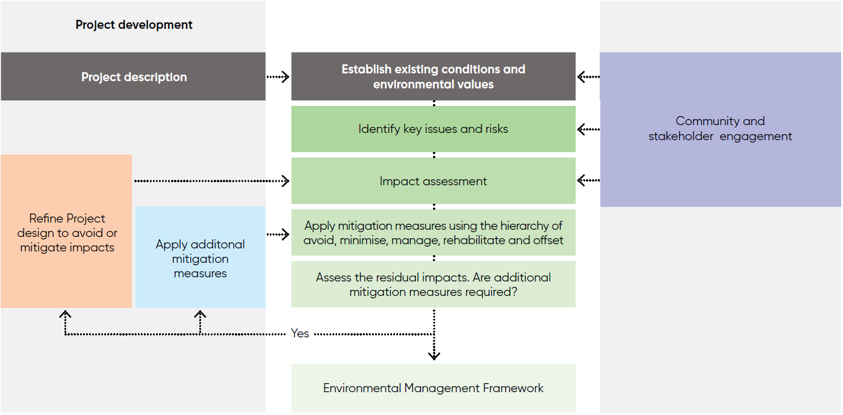

Figure 4.2 Impact assessment process

### Performance based approach

The Project has sought to avoid potential impacts through the selection of the preferred corridor, Proposed Route, and design development whilst meeting the objectives of the Project (**Chapter 5: Project development** and **Chapter 6: Project description**). The technical reports have assessed the Project’s potential impacts and identified where further mitigation is required to reduce impacts. In order to encourage innovation and allow for the best outcomes for the Project, a performance-based approach to finalising the project design, delivery approach and environmental mitigation measures has been adopted through the development of EPRs.

The EPRs set out the environmental outcomes to be achieved through the implementation of mitigation measures during construction, operation and decommissioning. While some EPRs are performance based to allow flexibility in how they will be achieved, other EPRs include more prescriptive measures that must be implemented.

This approach encourages innovation as it allows for flexibility in how outcomes are achieved, regardless of the final design of the Project. The Principal Contractor and AusNet can determine the best way to achieve EPRs and manage impacts, which allows design solutions and construction methods to be optimised. In developing EPRs, technical specialists have considered industry standards and guidelines, good practice and the latest approaches to mitigating impacts.

### Project description

The Project description, comprising the Proposed Route, key elements (e.g., transmission towers and terminal stations) and construction methodology, was developed to allow specialists to identify and assess the potential human health and environmental effects of the Project for the EES (see **Chapter 6: Project description**).

To develop the Project, AusNet sought early input from Traditional Owners, the community, Councils, non-government organisations and government agencies on key issues such as community values, energy transmission issues and renewable energy projects planned in western Victoria. This engagement informed the investigation of corridor options, alternative routes (see **Attachment I: Project development** **and assessment of alternatives** and **Attachment II: Assessment of feasibility for an underground 500kV transmission line for Western Renewables Link**) and guided the overall development of the Proposed Route. The Project development process is described in **Chapter 5: Project development**.

The Project’s design evolved and was refined throughout the impact assessment process, enabling it to adapt and respond to identified issues, including changes to the design, construction method or implementation of feasible Project alternatives. This iterative process occurred in parallel with the EES assessment process to produce the design assessed by the EES.

* Existing conditions

The existing conditions characterise the current condition and values of the physical, biological and social environment. The existing conditions form the baseline against which the impacts are measured.

### Existing conditions

The EES scoping requirements state that the EES must describe the ‘existing environment’ in the area potentially affected by the Project. This involves characterising the existing condition of the environment, namely the assets, values and uses of the environment and sensitive receptors within that environment. This is a crucial step as these existing conditions form the baseline and identify the values which the Project could potentially impact.

Each EES technical report identifies the existing conditions relevant to that discipline.

The study area for the existing conditions was different for each EES technical report. The study area provides the extent that is needed by each technical discipline from which to assess if an impact could occur and its significance. It also reflects the differences in the extent of risks for each discipline. In some cases, this area extended beyond the Project Area. For example, the existing conditions for aviation considered the flight paths to airports outside of the Project Area.

The existing conditions are summarised within each technical chapter (**Chapter 8 to 28**) and the detail can be found in **Technical Report A to T.**

### Environmental values

The Ministerial guidelines for assessment of environmental effects under the *Environment Effects Act 1978 (Vic),* Eighth edition, 2023 (DTP, 2023b) (Ministerial Guidelines) define the ‘environment’ to be the physical, biological, heritage, cultural, social, health, safety and economic aspects of human surroundings, including the wider ecological and physical systems within which humans live.

For the Project, environmental values are defined as:

* A quality or physical characteristic of the environment important to ecological health, cultural value, public benefit, amenity, safety or human health
* A quality, feature or use identified and declared to be of biological, physical, socioeconomic or cultural value under a statutory policy or regulation.

The technical specialists adopted environmental values set out in statutory policies or regulations. Where not provided, values are identified using professional experience, accepted practice and / or input from key stakeholders. The environmental values are identified within each technical report.

### Risk screening

Based on the findings of the existing conditions, a risk screening process was conducted by each technical specialist to identify the key issues during construction, operation and decommissioning. This process informed development of the scope and method and defining the extent of the impact assessment for each technical report as outlined in Section 4 of the scoping requirements.

The Project’s environmental risk screening process followed AS ISO 31000: 2018 Risk Management – Guidelines, an Australian standard that provides guidance on managing risk faced by organisations. The risk screening process:

* Identifies environmental, social and economic risks associated with the design, construction, operation and decommissioning of the Project
* Facilitates a consistent approach to identifying and considering risks across all technical reports
* Facilitates a proportionate level of investigation to the relative environmental risk.
* Risk and impact

Preparation of the EES and the necessary investigation of effects should be proportional to the environmental risk, as outlined in the Ministerial Guidelines (p. 9): “A risk-based approach should be adopted in the assessment of environmental effects. Suitably intensive methods should be applied to accurately assess matters that pose relatively high risk of significant adverse effects and to guide the design of strategies to manage those risks.”

‘Risk’ is a function of the likelihood of an adverse ‘event’ occurring, and the consequence of the event.

‘Impact’ relates to the outcome of an event in relation to sensitive values and uses.

The risk screening involved describing each risk, identifying standard controls and assigning likelihood and consequence ratings, resulting in an initial risk rating. The likelihood and consequence criteria for the risk assessment were informed by the AusNet Health, Safety and Environment (HSE) Risk Assessment Framework. Discipline-specific consequence criteria were also considered by each technical specialist.

### Impact assessment

An impact is defined as a change to the environment resulting from the construction, operation and/or decommissioning of the Project. Impacts can be direct or indirect, and positive or negative. Cumulative impact can also occur due to other major projects occurring in the same location or timeframe as the project being assessed.

The nature and extent of the impact is measured against the existing conditions by evaluating the significance, considering mitigation measures both before and after application.

The approach for the cumulative impact assessment is described in Section 4.3.7.

The definition of ‘significance’ of an impact for each technical report is provided in each of the EES technical reports. However, for consistency across all technical reports, the following factors have been considered when determining the significance of potential environmental impacts:

* Sensitivity of the environmental values potentially affected (e.g., character, occurrence, values, importance)
* Magnitude, extent, and duration of impact on identified environmental values
* Existing activities (e.g., existing projects or relevant future projects) that when considered together with the Project could give rise to a cumulative impact on the same environmental values (see Section 4.3.7)
* Benchmarks and standards set by statutory planning and environmental requirements and approvals and consents
* The policies and guidelines that apply to the Project
* The likely effectiveness of measures to avoid, minimise and/or manage the magnitude, extent or duration of the impact.

The EES technical reports identify possible measures in accordance with the mitigation hierarchy, and these measures informed the development of EPRs. This enabled an assessment of the expected residual impacts of the Project on the existing environment. The mitigation hierarchy has been adopted (as defined below) where the preference is to avoid impacts wherever possible through Project refinement (in particular, design changes) and implementing mitigations to minimise, manage, rehabilitate or offset where avoidance is not possible.

The EES technical reports recommend EPRs which set out the environmental outcomes to be achieved through the implementation of mitigation measures during construction, operation and decommissioning. While some EPRs are performance based to allow flexibility in how they will be achieved, others include more prescriptive measures that must be implemented. Compliance with the EPRs will be required as a condition of the Project’s approval.

* Mitigation hierarchy

The mitigation hierarchy of avoid, minimise, manage, rehabilitate and offset is paramount to the impact assessment process, where the preference is to avoid impacts wherever possible through Project refinement, thereby making and implementing minimisation, management (including rehabilitation) or offset measures where avoidance is not possible. These terms are defined as follows:

**Avoid** – means undertaking measures to avoid creating adverse environmental impacts from the outset, such as careful planning in the placement of infrastructure to avoid disturbance of environmentally sensitive areas or a change in the construction approach.

**Minimise** – means undertaking mitigation measures for those impacts that cannot be avoided in order to minimise the magnitude, extent and duration of impact. Examples include sedimentation controls, or establishment of no-go zones to protect native vegetation during construction.

**Manage** – means implementing management controls where impacts cannot be avoided or minimised. Examples include implementation of environmental management plans and training of staff.

**Rehabilitate or restoration** – means providing measures to improve a degraded environment following exposure to impacts that cannot be completely avoided or minimised. Opportunities may also be taken to restore and enhance natural and built environments.

**Offset** – means implementing measures to compensate for residual, adverse impacts after full implementation of the previous steps.

### Cumulative impact assessment

In accordance with Section 4 of the scoping requirements, the EES assesses *”the cumulative effect of the project in combination with other activities in the broader area/region … for all significant adverse effects.”*

A cumulative impact assessment (CIA) was conducted by each technical specialist to evaluate the combined impacts of the Project (referred to in this section as ‘the Western Renewables Link Project’ for clarity) and other relevant future projects that may interact spatially and temporally to change the level of impact on environmental, social or cultural values. Cumulative impacts may be positive or negative and arise from the interaction of construction, operational and decommissioning activities of the Western Renewables Link Project, and other developments, activities, land uses and projects in the area, both current and future. When considered in isolation, specific Western Renewables Link Project impacts may be considered manageable. These manageable impacts may, however, be more substantial, when the impact of multiple projects on the same receptors are considered.

Each CIA undertaken is presented within the associated technical report, with an overview provided in the relevant EES technical chapter. The scope of each assessment was relative to the discipline and nominated study area. However, the overarching approach was consistent for all disciplines, with two exceptions:

* The CIA conducted to assess potential cumulative impacts on landscape and visual values also considered existing built infrastructure and followed an alternative method. This method is summarised in **Chapter 11: Landscape and visual** and detailed in **Technical Report D: Landscape and Visual Impact Assessment.**
* The CIA conducted to assess potential cumulative greenhouse gas emissions used an alternative method, as all emissions contribute towards a global greenhouse gas impact. As such, a comparison against Victorian and Commonwealth greenhouse gas emissions was undertaken. This method is summarised in **Chapter 25: Greenhouse gas** and detailed in **Technical Report M: Greenhouse Gas Impact Assessment.**

##### Cumulative impact assessment approach

In the absence of guidelines for CIA under the Environment Effects Act or other Victorian legislation or guidelines, a method for CIA has been adopted from the International Finance Corporation Good Practice Handbook: Cumulative Impact Assessment and Management: Guidance for the Private Sector in Emerging Markets (IFC, 2013); and NSW Government Cumulative Impact Assessment Guidelines for State Significant Projects (NSW Government, 2021). This approach includes:

* Establishing baseline conditions and identifying the valued environmental, social and cultural characteristics of the Project Land. These aspects formed the basis for identifying and evaluating cumulative impacts as they may arise from the Western Renewables Link Project and other projects.
* Identifying projects that overlap or intersect spatially with the Western Renewables Link Project activities, including those that are:
  + Geographically connected, for example via a river or road, or near to each other, or where there may be shared sensitive receivers for noise or air quality impacts.
  + Located in the same region, such as western Victoria. Projects involving vegetation removal in the same region as the Western Renewables Link Project could contribute to cumulative impacts on threatened vegetation communities, habitats, or species. Other projects in western Victoria could also contribute to cumulative social impacts due to the demand for construction workers, the resulting effects on the local workforce, the demand for accommodation, and the impacts on rental costs.
  + Connected to the same receiving environments, for example the same downstream water environments. Downstream impacts on waterways may be exacerbated by incremental contributions of sediment to rivers that collectively may result in changed hydrology and impacts on land use and aquatic ecosystems.
  + Planning to use similar transportation routes or to obtain resources from the same locations, such as the Port of Melbourne.
* Identifying projects that overlap in time with the Western Renewables Link Project’s activities, including for construction, operation and decommissioning stages, thereby establishing a temporal relationship. These relationships were identified based on the expectation that, pending approval, construction of the Western Renewables Link Project is expected to commence in late 2026, taking approximately two years to complete, and the estimated service life of the Project is 80 years. Speculative projects in early planning phases, likely to be designed and developed after the Western Renewables Link Project, were not considered relevant from a temporal relationship perspective. It is assumed that the impacts of the Western Renewables Link Project will be considered in the CIAs of those future projects.

Projects that may be temporally connected with the Western Renewables Link Project include those that are:

* + Currently in operation but have plans to change the scope of their operations during the life of the Western Renewables Link Project, for example where an existing quarry is seeking to expand during the life of the Western Renewables Link Project
  + Approved and ready to commence construction, where construction, operation or decommissioning of the project is planned to occur during the life of the Western Renewables Link Project
  + Under construction or being commissioned, where remaining construction, operation or decommissioning of the project is planned to occur during the life of the Western Renewables Link Project
  + Currently undergoing the approvals process and likely to proceed during the life of the Western Renewables Link Project if approval is obtained.
* Determining if other projects qualify as ‘relevant future projects’. For a project to be considered a relevant future project and eligible for consideration in the CIA, it must meet the following criteria:
  + Proportionate to the scale and potential significance of the impacts of the Western Renewables Link Project. While not all selected projects are proportional to the Western Renewables Link, if a project’s location and likely interaction with the Western Renewables Link was considered sufficient to require assessment, then it was included
  + Have sufficient publicly available information in an EES or an environmental approvals application that describes the potential impacts on environmental, social and cultural values in enough detail to assess the project’s contribution to cumulative impacts
  + Be in a spatial and temporal relationship to the Western Renewables Link Project.
* Assessing the cumulative impacts and their significance
* Proposing mitigation strategies where the Western Renewables Link Project could contribute to a possible and significant cumulative impact.

Using this approach, 23 projects were identified as relevant future projects for the purposes of the CIA. These are shown in Figure 4.3 and summarised in Table 4.2.



Figure 4.3 Relevant future projects

Table 4.2 Relevant future projects

| Project | Description | Spatial relationship | Temporal relationship | Eligibility | Identified aspect(s) with potential cumulative impacts |
| --- | --- | --- | --- | --- | --- |
| 1. 2022 Melbourne Airport Masterplan | The 2022 Melbourne Airport Masterplan, approved by the Commonwealth Minister for Infrastructure, Transport, Regional Development and Local Government to guide future growth and development of the Melbourne Airport. Major Projects include the development of the third runway, the T4 Express Link, and connecting an elevated road and forecourt. | This project is located within the Melbourne Airport environs, approximately 6km from the eastern end of Project Land. As such, potential impacts are expected to have a spatial relationship with the Western Renewables Link Project. | This project has been approved and is currently under construction. Works are planned until 2027. As such, potential impacts are expected to have a temporal relationship with the Western Renewables Link Project. | Sufficient information is publicly available as environmental impact assessments have been undertaken by the project proponent as part of the Major Development Plan process. | * + Aviation. |
| 1. Beaufort Bypass (Western Highway) | A new 11km duplication of the Western Highway to bypass Beaufort, linking completed sections of the Western Highway duplication to the east and west of Beaufort. | The study area is within 16km of Project Land and is expected to have a spatial relationship with the Western Renewables Link Project. | The Minister for Planning’s assessment of the EES for this project was released in November 2023, and the Planning Scheme Amendment request has been submitted. While all funds are currently for planning purposes only, it is possible funding for construction may be approved in the next few years. If so, any potential impacts are expected to have a temporal relationship with the Western Renewables Link Project. | Sufficient information is publicly available as environmental impact assessments were undertaken by the project proponent as part of the EES process. | * + Agriculture and forestry   + Biodiversity. |
| 1. Brewster Wind Farm | Consists of up to six wind turbine generators with an anticipated capacity of 40MW between Trawalla and Brewster. Tower heights will be up to 247m. | This project is located between the Western Highway and Trawalla Road, Brewster, and is approximately 14km south of Project Land. As such, potential social impacts are expected to have a spatial relationship with the Western Renewables Link Project relating to the construction workforce. | The planning permit application for this project was lodged with Minister for Planning in 2021 and was approved in February 2025. It is therefore likely that potential impacts will have a temporal relationship with the Western Renewables Link Project. | Sufficient information is publicly available as environmental impact assessments were undertaken by the project proponent as part of the planning process. | * + Agriculture and forestry   + Biodiversity   + Landscape and visual amenity   + Social. |
| 1. Delahey Urban Development | Development and subdivision of 46.1 hectares of land in Delahey for housing and complementary mixed-uses. | This project is located at 250a Taylors Road, Delahey, and has a spatial relationship with the Western Renewables Link Project as it is approximately 6km from the eastern end of Project Land. | In August 2023 it was determined that an EES was not required for this project, subject to certain conditions. The timeline for this development is not yet published; however, the construction timeline is assumed to be at least 10 years. As such, potential impacts are expected to have a temporal relationship with the Western Renewables Link Project. | Sufficient information is publicly available as environmental impact assessments were undertaken by the project proponent as part of the EES referral process. | * + Biodiversity. |
| 1. Elaine (Akaysha) BESS | A 311MW Battery Energy Storage System (BESS) proposed to be developed adjacent the existing Elaine Terminal Station. The development will include battery units, associated infrastructure, grid connection, access roads, vegetation screening and security fencing. | This project connects to the Elaine Terminal Station, which is part of the Western Renewables Link Project. | The planning permit application for this project was approved by the Minister for Planning in September 2024. No information has been released publicly on the estimated construction timeline. However, as the project aims to assist in the achievement of Victoria’s 2.6GW energy storage capacity by 2030 target, it is anticipated that there will be a temporal relationship with the Western Renewables Link Project. | Sufficient information is publicly available as a number of environmental impact assessments were undertaken by the project proponent as part of the planning permit application. | * + Bushfire   + Landscape and visual amenity   + Noise and vibration   + Transport. |
| 1. Elaine Solar Farm | A 150 megawatt (MW) solar project and a 250 MW battery approved by the State government to be developed neighbouring the Elaine Terminal Station. | This project connects to the Elaine Terminal Station, which is part of the Western Renewables Link Project. | Construction has not yet commenced, however once begun the project will have a 12-month construction timeline. | A 150 megawatt (MW) solar project and a 250 MW battery approved by the State government to be developed neighbouring the Elaine Terminal Station. | * + Contaminated land   + Groundwater   + Landscape and visual amenity   + Noise and vibration   + Surface water. |
| 1. Lerderderg River Nature Trail | A new 5km trail that would extend the Aqualink hike and bike network through to MacKenzies Flat picnic area. This would highlight the geological values of this area, including exposed Permian glacial rocks along the Lerderderg Riverbeds in Darley. | Lerderderg River Nature Reserve and a section of this River Nature trail has a spatial relationship with the Western Renewables Link Project as they are located within Project Land, to the east of Darley. | Following the announcement of this project no information regarding the approvals process or construction timeline has been publicly released. However, it is assumed the opening of the nature trail will occur within the life of the Western Renewables Link Project, therefore, it is considered that the project has a temporal relationship with the Western Renewables Link Project. | Sufficient information is publicly available. | * + Aboriginal cultural heritage   + Bushfire   + Geology and soils   + Landscape and visual amenity. |
| 1. Lerderderg-Wombat National Park | Lerderderg-Wombat National Park, proposed to be created by linking existing Lerderderg State Park and much of the existing Wombat State Forest to create a new national park covering more than 44,000 hectares between Daylesford and Bacchus Marsh. This will include upgrading campgrounds and new and upgraded walking trails and facilities. | This project is located directly south of Project Land, between Lerderderg State Park and Wombat National Park. As such, it has a spatial relationship with the Western Renewables Link Project. | Following the announcement of this project no information regarding the approvals process or construction timeline has been publicly released. However, it is assumed the opening of the existing parkland as ‘Lerderderg-Wombat National Park’ will occur within the life of the Western Renewables Link Project, bringing an increase of human activity to the area, therefore, it is considered the project has a temporal relationship with the Western Renewables Link Project. | Sufficient information is publicly available. | * + Aboriginal cultural heritage   + Bushfire. |
| 1. Melbourne Airport Business Park (MABP) – Sky Road West Warehouse Developments | 25 hectares of land to construct manufacturing, logistics, and industrial warehouse units within the Melbourne Airport Business Park - Sky Road area. | This project is located approximately 9km east of the Project Land; as such, potential impacts are expected to have a spatial relationship with the Western Renewables Link Project. | This project is undertaking assessment under the Commonwealth EPBC Act and requires approval. Construction is anticipated to be completed in June 2034. As such, potential impacts are expected to have minimal or no temporal relationship with the Western Renewables Link Project. | Sufficient information is publicly available and environmental impact assessments were undertaken by the project proponent as part of the EPBC Act referral. | None identified. |
| 1. Melbourne Renewable Energy Hub | A battery project that will store wind, hydro and solar energy from regional Victoria and will connect into the adjacent Sydenham Terminal Station. It includes a 12.5MW solar farm to recover battery efficiency losses and ensure low cost and ‘net-zero emission’ operations of the Battery Energy Storage System. | This project is located at 77-347 Holden Rd, Plumpton, and is within and directly adjacent to Project Land. As such, potential impacts are expected to have a spatial relationship with the Western Renewables Link Project. | This project is anticipated to become operational in 2025. As such, there may be overlap in construction activities with the Western Renewables Link Project and it is considered that a temporal relationship exists. | Sufficient information is publicly available and environmental impact assessments were undertaken by the project proponent as part of the EPBC referral. | * + Aboriginal cultural heritage   + Biodiversity   + Bushfire   + Geology and soils   + Landscape and visual amenity   + Noise and vibration   + Social   + Surface water. |
| 1. Merrimu Precinct Structure Plan (PSP)/Bacchus Marsh Urban Growth Framework | A proposed 7,200 lot residential precinct near Bacchus Marsh, north-west of Melbourne under the Bacchus Marsh Urban Growth Framework. This framework identifies new areas for jobs, housing and infrastructure, while protecting valuable cultural and environmental assets. | The northern-most section of this project intersects with the Western Renewables Link Project in Merrimu; therefore, has a spatial relationship with the Western Renewables Link Project. | Merrimu PSP is being prepared and will guide future development. No information on the timeline for the Merrimu PSP has been released publicly. However, there is potential that there will be a temporal relationship with the Western Renewables Link Project. | Sufficient information is publicly available and supporting background studies were developed by the Victorian Planning Authority. | * + Bushfire   + Geology and soils   + Landscape and visual amenity   + Transport. |
| 1. Navarre Green Power Hub | A wind farm and battery project with a proposed capacity of approximately 600MW. The wind farm is proposed to be located within the Barkly and Kanya Ranges to the north of Navarre, with tower heights of 200-250m. | This project is located to the north of Navarre, approximately 15 km north of Project Land. As such, potential impacts are expected to have a spatial relationship with the Western Renewables Link Project. | This project has been referred under the Environment Effects Act and expects to begin construction in 2025. As such, potential impacts are expected to have a temporal relationship with the Western Renewables Link Project. | Sufficient information is publicly available and environmental impact assessments were undertaken by the project proponent as part of the EES and EPBC referrals. | * + Agriculture and forestry   + Landscape and visual amenity   + Transport. |
| 1. Nyaninyuk Wind Farm | 58 wind turbine generators between Evansford, Clunes, and Waubra with a total combined capacity of up to 330MW. | This project has a spatial relationship with the Western Renewables Link Project as it is located between Evansford, Clunes and Waubra and intersects with the Western Renewables Link Project. | This project is currently in the feasibility stage; however, have a temporal relationship with the Western Renewables Link Project as construction is anticipated to commence in late 2026. | Sufficient information is available on the Nyaninyuk Community Hub Website. | * + Aboriginal cultural heritage   + Agriculture and forestry   + Bushfire   + Contaminated land   + Geology and soils.   + Groundwater   + Landscape and visual amenity   + Noise and vibration   + Surface water   + Transport. |
| 14. Outer Metropolitan Ring Road/E6 | A new four-lane (bi-directional) freeway, linking Werribee with Thomastown, via Melton, Tullamarine, Craigieburn, and Epping. The proposal includes a freight and high-speed passenger rail line in the median strip. | This project is located within the eastern end of Project Land. As such, it has a spatial relationship with the Western Renewables Link Project. | Construction of the road and railway is unlikely to start before 2030. However, due to the project’s direct interface with the Western Renewables Link Project and potential design constraints, it is considered the project has a temporal relationship with the Western Renewables Link Project. | Sufficient information is publicly available as environmental impact assessments were undertaken by the project proponent as part of the Planning Assessment Report. | * + Agriculture and forestry   + Geology and soils   + Noise and vibration   + Surface water   + Transport. |
| 15. Powercor Mt Cottrell Zone Substation | Substation in Truganina to support future development and industry. | This project is located at 535-601 Troups Road, Truganina, approximately 10km south of the Project Land. As such, potential impacts are expected to have a spatial relationship with the Western Renewables Link Project. | This project has been referred under the EPBC Act, and construction is anticipated to be completed in October 2025. As such, potential impacts are expected to have a temporal relationship with the Western Renewables Link Project. | Sufficient information is publicly available and environmental impact assessments were undertaken by the project proponent as part of the EPBC referral. | None identified. |
| 16. Coimadai Sand Quarry | Re-establishment by Hanson for the purposes of extracting mineral resources (sand and gravel) over a 20-year period. | This project has a spatial relationship with the Western Renewables Link Project as it is located to the north of Seereys Road, Coimadai, approximately 1km north of Project Land. | This project is undertaking assessment under the EPBC Act and requires approval. It is anticipated to be active for approximately 20 years following approval. As such, potential impacts are expected to have a temporal relationship with the Western Renewables Link Project. | Sufficient information is publicly available as environmental impact assessments were undertaken by the project proponent as part of the EPBC referral process. | * + Bushfire   + Contaminated land   + Groundwater   + Landscape and visual amenity   + Noise and vibration   + Surface water. |
| 17. Sunbury Line Level Crossing Removals | Sunbury Line Level Crossing Removal project proposes the removal of level crossings at Calder Park Drive and Holden Road by building a new road bridge over the rail line. This project sits within a larger suite of works aimed at removing all level rail crossings along the Sunbury Line in 2025. | This project is located along the Sunbury Train Line at Calder Park, within 1km of the eastern end of Project Land. As such, potential impacts are expected to have a spatial relationship with the Western Renewables Link Project. | This project is undertaking assessment under the EPBC Act and requires approval. Construction is anticipated be completed in December 2025. As such, potential impacts are expected to have a temporal relationship with the Western Renewables Link Project. | Sufficient information is publicly available as environmental impact assessments were undertaken by the project proponent as part of the EPBC referral process. | * + Aboriginal cultural heritage   + Noise and vibration. |
| 18. Sydenham Terminal Station Rebuild | The Sydenham Terminal Station Rebuild is a critical infrastructure project that will replace the existing terminal station. This was removed from the Western Renewables Link Project EES referral in August 2023 and is being completed as a standalone project due to its urgency to ensure network reliability. | This project is located within the eastern end of Project Land in Plumpton. As such, it has a spatial relationship with the Western Renewables Link Project. | Following the removal of this Project from the Western Renewables Link Project EES referral, a planning permit was approved by the Minister for Planning. Construction started in April 2025 and is expected to be complete by early 2028. As the Western Renewables Link Project will connect to the rebuilt terminal station it is considered the project has a temporal relationship with the Western Renewables Link Project. | Sufficient information is publicly available. | * + Aboriginal cultural heritage   + Bushfire   + Geology and soils   + Landscape and visual amenity   + Noise and vibration   + Transport. |
| 19. Toolern Vale Solar Farm | Toolern Vale Solar Farm, a 12.5MW solar and storage project approved by the Minister for Planning. | This project is located at 1375-1415 Holden Rd, Toolern Vale, and is directly adjacent to Project Land. As such, potential impacts are expected to have a spatial relationship with the Western Renewables Link Project. | This project has been delayed due to council and community opposition; however, the decision to grant a permit was affirmed by the Victorian Civil and Administrative Tribunal (VCAT) in 2022. The permit will expire if development has not begun by March 2026, or if it is not completed by March 2028. As such, it is expected that there will be a temporal relationship with the Western Renewables Link Project. | Sufficient information is publicly available as environmental impact assessments were discussed in the Victorian Civil and Administrative Tribunal appeal. | * + Aboriginal cultural heritage   + Bushfire   + Contaminated land   + Geology and soils   + Landscape and visual amenity   + Noise and vibration   + Surface water. |
| 20. Victoria to New South Wales Interconnector (VNI) West | A proposed new high-capacity overhead transmission line connecting renewable energy zones in New South Wales and Victoria. | This preferred option for this project connects with the Western Renewables Link Project at Bulgana. As such, it has a spatial relationship with the Western Renewables Link Project. | The project is in the initial planning phase and therefore, there is limited information available publicly regarding project timeline or impacts. However, as the Western Renewables Link Project will connect to VNI West infrastructure it is considered the project has a temporal relationship with the Western Renewables Link Project. | Sufficient information is publicly available. | * + Aboriginal cultural heritage   + Agriculture and forestry   + Bushfire   + Contaminated land   + Geology and soils   + Groundwater   + Landscape and visual amenity   + Noise and vibration   + Surface water. |
| 21. Watta Wella Renewable Energy Project | Watta Wella Renewable Energy Project, consisting of three co-located renewable energy projects - a wind farm, solar farm and battery energy storage facility. | This project is located at 465 Vineyard Road, Concongella, approximately 6km from the western end of Project Land. As such, potential impacts are expected to have a spatial relationship with the Western Renewables Link Project. | Construction is anticipated to begin in late 2027 following the approval of planning applications. As such, potential impacts are expected to have a temporal relationship with the Western Renewables Link Project. | Sufficient information is publicly available as environmental impact assessments were undertaken by the project proponent. | * + Aboriginal cultural heritage   + Agriculture and forestry   + Bushfire. |
| 1. West Gate Tunnel (formerly the Western Distributor Project) | A proposed new tunnel and elevated motorway and widening of the existing West Gate Freeway. | The project is located far east of the eastern end of the Western Renewables Link Project; however, a spatial relationship is considered to exist due to the shared use of construction transport and haulage routes. | Major construction of this project began in 2018 and is anticipated to continue into late 2025. As such, potential impacts are expected to have a temporal relationship with the Western Renewables Link Project. | Sufficient information is publicly available as environmental impact assessments were undertaken by the project proponent as part of the EES process. | * + Social   + Transport. |
| 1. Western Irrigation Network Scheme – Recycled Water Supply Infrastructure Project | A large-scale irrigation project that will deliver a new, secure source of Class C recycled water for irrigation of farmland in the Parwan-Balliang agricultural district in Melbourne’s outer west. The recycled water is produced in Melton and Bacchus Marsh. | This is a large-scale project, that intersects with the Western Renewables Link Project between Bacchus Marsh, Melton, and Sunbury. As such, it has a spatial relationship with the Western Renewables Link Project. | In August 2021 it was determined that an EES was not required for this project, subject to certain conditions. Construction of the interconnector pipeline between Sunbury and Melton Recycled Water Plants is planned to be undertaken from 2023 to 2025. As such, potential impacts are expected to have a temporal relationship with the Western Renewables Link Project. | Sufficient information is publicly available as environmental impact assessments were undertaken by the project proponent as part of the EES referral process. | * + Aboriginal cultural heritage   + Agriculture and forestry   + Geology and soils   + Surface water. |

##### Assessment of cumulative impacts

To identify potentially significant adverse cumulative impacts, technical specialists undertook a review of:

* Relevant future projects that may be developed within the same geographic area and over the same time as the Western Renewables Link Project (Table 4.2)
* Relevant existing or potential legislation, plans, policies or guidelines, including strategic plans developed by local and state government
* Key aspects that could be significantly affected by the impacts of these projects
* The likely scale and nature of the cumulative impacts of these projects when considered in conjunction with the Western Renewables Link Project.

The following principles were adopted in the assessment of cumulative impacts:

* Consideration of the potentially significant adverse impacts of the Western Renewables Link Project (such as threatened species and communities, ambient noise levels in certain locations, regional housing availability and affordability), together with the impacts of other relevant future projects.
* The CIA undertaken for each technical report was proportionate to the scale and potential significance of the impacts of the Western Renewables Link Project. For example, if the Western Renewables Link Project does not make a material contribution to the cumulative impacts, then the recommended EPRs for the Western Renewables Link Project will be sufficient to reduce impacts and additional EPRs are not required.
* The CIA focusses on the key issues that are reasonably proximate to the Western Renewables Link Project and within the proponent’s control – recognising that it is not practical or reasonable to require the proponent to identify, assess and manage the impacts of other projects.
* Managing cumulative impacts is a shared responsibility. This means that in undertaking the CIA and identifying relevant EPRs, the proponent of the Western Renewables Link Project may need to work with the proponents of other projects, the owners/operators of other infrastructure and activities, government, industry and the community to identify and assess cumulative impacts and determine what actions can be taken to mitigate and manage these impacts.

If the CIA identified Western Renewables Link Project could make a material contribution to cumulative impacts, that is, where potentially significant adverse cumulative impacts were identified due to the Western Renewables Link Project, technical specialists identified further measures to minimise the Western Renewables Link Project contribution to these impacts.

## Environmental Management Framework

The Environmental Management Framework sets out a framework for how the proponent will manage the Project’s identified environmental impacts and sets clear accountabilities for the delivery and monitoring of compliance with Project approvals.

The Environmental Management Framework includes:

* The context of required approvals and consents
* The proposed environmental management system to be adopted
* Organisational responsibilities and accountabilities for environmental management
* A description of the environmental risk assessment process to be maintained during Project construction and operation
* An overview of events for which contingency measures will be developed to respond to unexpected but foreseeable environmental risks, should they eventuate
* The EPRs proposed to avoid, minimise, manage, rehabilitate and offset impacts. These are informed by the mitigation measures considered by the technical assessments, and define environmental outcomes as well as other environmental management requirements
* Requirements for monitoring, auditing a reporting of compliance with the Environmental Management Framework
* Requirements for community consultation, stakeholder engagement and communications.

The EPRs will be implemented through the Environmental Management Framework, as a condition of the Incorporated Document. The Incorporated Document will be included in the six council Planning Schemes through a GC Planning Scheme Amendment. AusNet and its Principal Contractor will be responsible for complying with the Environmental Management Framework and EPRs and, as such, contractual requirements will reflect the Environmental Management Framework and EPRs where appropriate.

The proposed Environmental Management Framework and EPRs are presented in **Chapter 29: Environmental Management Framework.**

## Consultation and engagement

To understand the key issues of particular concern to Traditional Owners, local communities and stakeholders, a program of consultation and engagement was implemented for the Project and will continue beyond the EES phase. The program began with consultation and engagement activities in mid-2020, before the Project’s Area of Interest was announced. A Consultation Plan (AusNet, 2025a) was specifically prepared for the EES phase, as required by the EES scoping requirements for the Project. The main forms of consultation and engagement have included:

* Meetings with Councils, community groups and other stakeholders
* Meetings with landholders and occupiers within the Project Area
* Meetings and fieldwork with Registered Aboriginal Parties and Traditional Owners
* Community information forums, drop-in sessions, online Q&A and ‘meet the team’ sessions
* Meetings with the EES Technical Reference Group, made up of representatives from Councils, Registered Aboriginal Parties and relevant government agencies
* Meetings with the Community Consultation Group, set up with the aim of enhancing communication both within the community and between the community and the Project
* Project awareness raising, comprising distribution of Project information to residents and businesses in the Project Area
* The establishment of a Project website and other communication channels to share Project information, progress updates and seek input from interested parties.

The findings of the consultation and engagement with Traditional Owners, community and stakeholders were considered during the Project’s design development, EES risk screening and EES preparation. Community consultation outcomes provided an understanding of the concerns and preferred outcomes of landholders and occupiers, businesses and other interested parties, for consideration in the design and assessment process.

Ongoing engagement with Councils and relevant government agencies has enabled two-way communication on the key issues and policy priorities of State and local government, and this has been incorporated into both the Project design and the EES technical reports. The Technical Reference Group provided advice to the Project team on key issues and concerns from their respective areas of interest.

Further information on the approach taken to consultation and engagement is provided in **Chapter 7: Community and stakeholder engagement** and **Attachment IV: Stakeholder and community engagement consultation report.**

