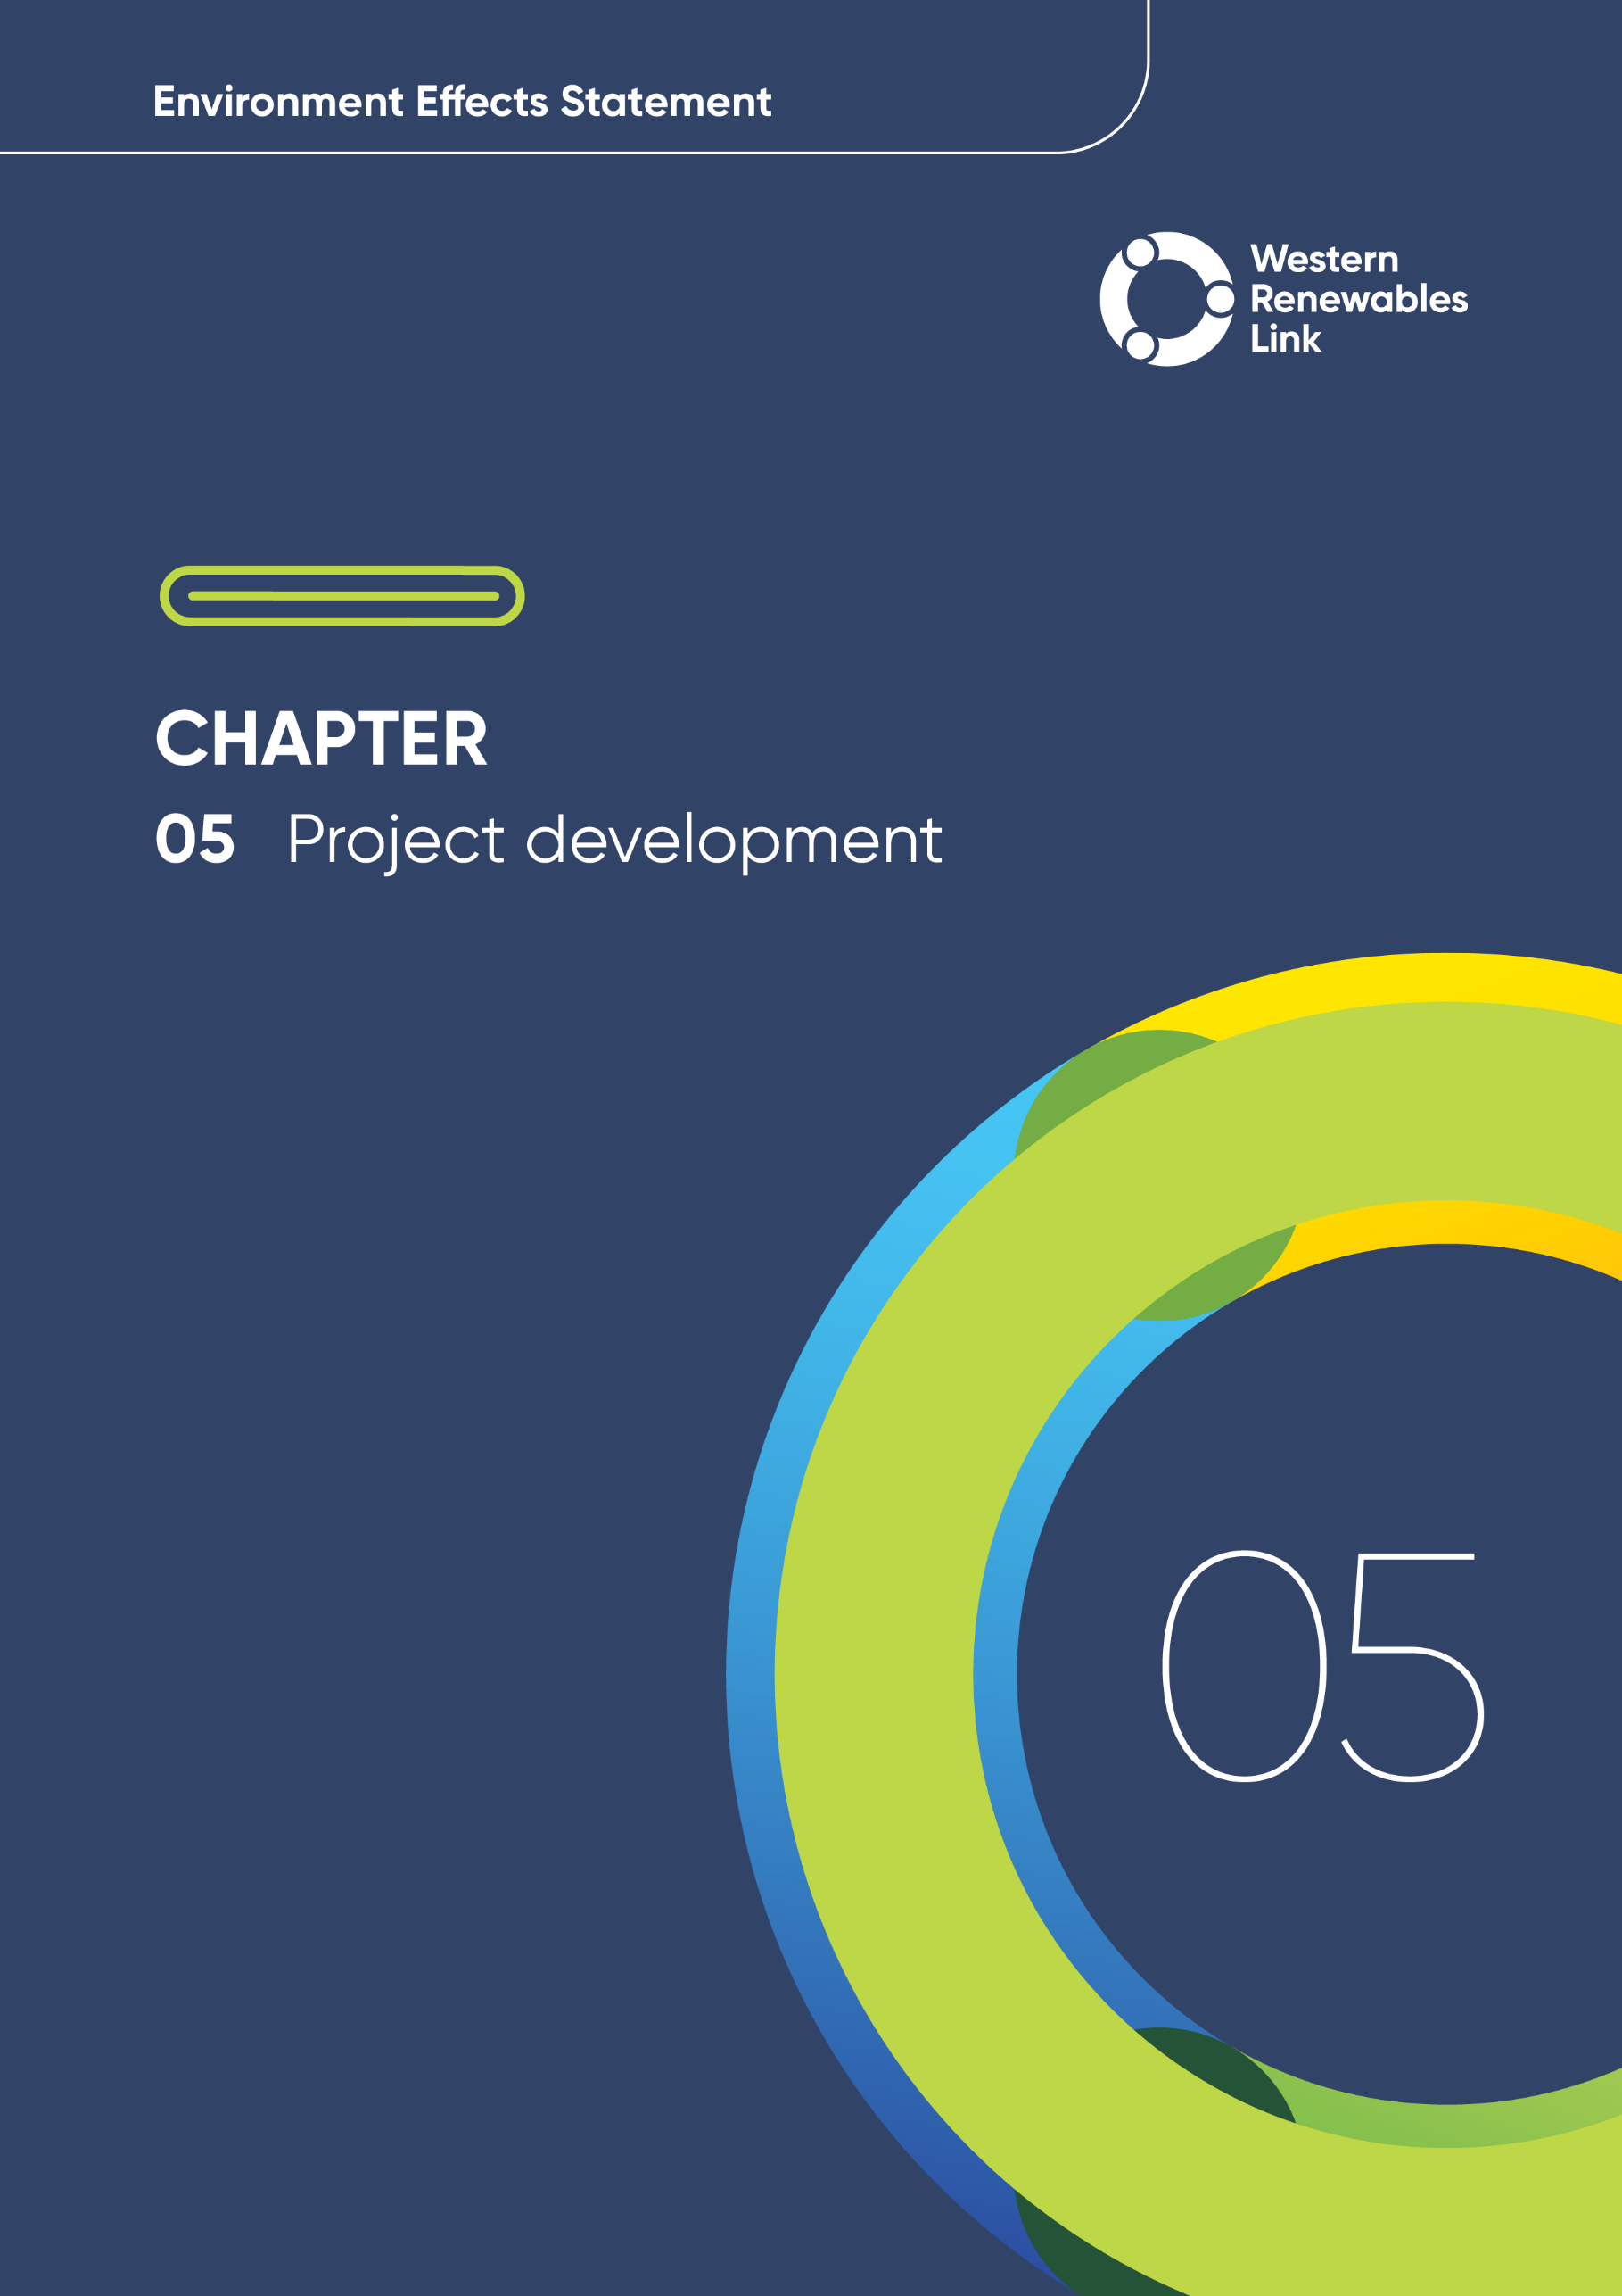

REVISION AND APPROVAL

NOTE: The above tables are mandatory during the development, review, and approval of the EES chapters.
These tables are to be removed prior to print & replaced with the completed approval table below.

Project development
This chapter describes the Project’s development process, from its initial identification to the Proposed Route and design being assessed in the Environment Effects Statement (EES).
It outlines the:
- Regulatory Investment Test for transmission (RIT-T) process which has defined the preferred network solution which informed the area of interest
- Preferred network solution, including required transmission line voltage capacity
- Route selection process, including evaluation of feasible alternative corridors and routes, route refinements and partial underground routes at Darley
- Siting of the new terminal station
- Siting of workforce accommodation facilities and laydown areas.
A summary of how feasible alternative transmission line alignments have been considered and assessed against the Project objectives, with an aim to avoid or minimise environmental effects, has also been provided in Section 5.3.
… document the proponent's design development process leading to the proponent’s preferred form of the project as presented in the EES. The EES should explain the proponent’s criteria for evaluating the feasibility of potential alternatives and explain how specific alternatives were shortlisted or rejected for evaluation within the EES. The EES should document the likely environmental effects of feasible alternatives, particularly where these offer a potential to avoid or minimise adverse environmental effects whilst meeting the objectives of the project.
The chapter responds to Section 3.4 of the scoping requirements issued by the Minister for Planning, which require the EES to:

The Project will increase the transmission capacity of Victoria’s western and north-western zones, unlock renewable energy resources and relieve congestion. AusNet Transmission Group Pty Ltd (AusNet) was selected by Australian Energy Market Operator Ltd (AEMO) in December 2019 to develop, obtain approvals, construct, own and operate the transmission upgrade recommended in the RIT-T process (see Section 5.2). The recommendation from the RIT-T Project Assessment Conclusions Report was an overhead transmission line to provide additional capacity to AEMO’s Western Victoria Renewable Energy Zone (REZ) (see Section 5.2.1) and will function independently of other projects, such as Victoria to New South Wales (NSW) Interconnector West (VNI West). The transmission solution for the Project has changed to addresses the NEVA orders issued in 2023.
Through development of the Project, AEMO and AusNet have sought early and ongoing input from the community, landholders, local councils, non-government organisations, government entities and industry. Key matters raised by stakeholders such as Australia’s energy future, energy market and transmission issues, planned new renewable energy investment in western Victoria and community values have been taken into consideration for the Project. This input contributed to setting the Project’s objectives, which have guided the investigation of corridor and route options and the overall design and scope of the Project.
- Renewable Energy Zones (REZs)
REZs discussed in this chapter are those identified by AEMO as part of its nationwide planning. These are different to the REZs that will be identified by VicGrid and ultimately declared in Victoria by the Victorian Minister for Energy following the final 2025 Victorian Transmission Plan. The Victorian Transmission Plan allows for integration with existing planning documents produce by AEMO including the Integrated System Plan and Victorian Annual Planning Report.
The Project was formerly known as the Western Victoria Transmission Network Project. The Project name changed to the Western Renewables Link Project (the Project) in 2022 to more accurately reflect the role the Project will play in bringing renewable wind and solar energy from the AEMO's Western Victoria REZ to the Victorian grid and the National Electricity Market (NEM).
Further detail on the rationale for the Project and the policy context within which it is being planned and delivered, as well as the potential benefits that would be derived from the Project, are outlined in Chapter 2: Project rationale.
Attachment I: Project development and assessment of alternatives describes the assessment process for development of the Project in further detail and should be read in conjunction with this Chapter.

Key criteria in Project development
The Project is required to provide the capacity and connection to facilitate development of the AEMO's Western Victoria REZ. The Project’s functional requirement as defined by AEMO, the Project objectives and the National Electricity Rules are the overarching key criteria that have guided the assessment of feasible potential alternative network solutions, corridors, routes and Project components. Alternative corridors, routes, and siting of infrastructure were not shortlisted or progressed if they did not meet these criteria.
Development of the Project commenced in early 2020 with an area of interest provided in the June 2020 EES referral. The area of interest was progressively refined to a preferred route in late 2021. In 2023 the Victorian Minister for Energy and Resources used powers under the National Electricity (Victoria) Act 2005 (NEVA) to issue orders that required investigation of changes to the Project development and what could be considered as feasible Project alternatives. Following the NEVA orders the proposed route was revised for a 500kV transmission line from Bulgana Terminal Station to Sydenham Terminal Station. The NEVA orders are further described in Section 5.2.2 and are key criteria that have to be met in the Project development.

Project functional requirements
The Project’s functional requirements define the technical requirements for the Project and transmission network augmentations that AusNet will be engaged to deliver. These requirements are listed in Table 5.1 and shown in Figure 5.1 and reflect changes following the publication of the NEVA orders in 2023.
Table 5.1 Project functional requirements
Project component | Requirement
Connection at Bulgana Terminal Station | - Redevelopment of the existing 220kV Bulgana Terminal Station
New 220kV transmission line connection | - Construction of a new 220kV double circuit transmission line from the new terminal station to the existing Bulgana Terminal Station
New terminal station near Bulgana | - Establishment of a new 500/220kV terminal station located approximately two kilometres east of the existing Bulgana 220kV Terminal Station
New 500kV transmission line | - Construction of a new 500kV double circuit transmission line from the new terminal station near Bulgana to Sydenham Terminal Station
Connection at Sydenham Terminal Station | - Modification of the 500kV bay and a new 500kV bay extension with associated infrastructure at the Sydenham Terminal Station
Other activities | - Alterations to the existing 220kV Elaine Terminal Station and associated transmission line connections  - Secondary (protection, control, monitoring and communications) system modifications at the existing Sydenham, Bulgana, Bulgana Wind Farm, Moorabool, Elaine, Ballarat, Waubra, Ararat, Crowlands, South Morang, Hazelwood and Horsham terminal stations  - Validation of the capabilities of the existing earthing systems at Ararat, Ballarat, Crowlands, Elaine, Horsham and Waubra terminal stations and the connected 220kV transmission lines tower earthing systems and upgrade as required to provide for the increased fault levels at each location  - The addition of two physically independent route communication links between Bulgana Terminal Station and the new terminal station, and between the new terminal station and Sydenham Terminal Station

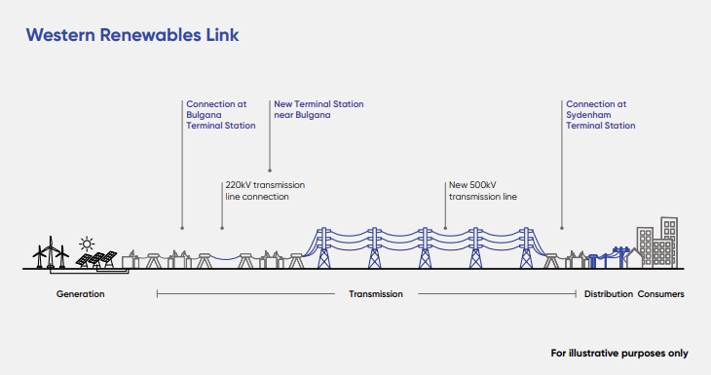
Figure 5.1 Western Renewables Link

Project objectives
The Project seeks to achieve the Project objectives outlined in Table 5.2. The Project objectives were developed by AEMO and AusNet having regard to the Western Victoria Renewable Integration RIT-T and reinforced by the NEVA orders issued in 2023. The Project objectives aim to address the capacity, security and reliability constraints facing Victoria and the NEM.
Table 5.2 Project objectives
Project objectives
Maintain the security and reliability of the transmission network for customers by:
  - Increasing electricity transmission capacity in western Victoria to minimise the congestion constraining current and future electricity generation in the region
  - Ensuring the Project complies with the power system security requirements of the National Electricity Rules.
Create opportunities for strategic development of the NEM by:
  - Increasing electricity transmission capacity, thereby facilitating more efficient connection and dispatch of electricity generation in and from the region
  - Enabling future transmission network expansion from Victoria to New South Wales.
Deliver infrastructure which realises a net benefit for Victorians by:
  - Delivering the Project in a timely and cost-efficient manner
  - Delivering transmission infrastructure which, by increasing capacity, facilitates the further development of renewables in western Victoria, encouraging further investment in the industry and associated economic growth.

National Electricity Rules
The Australian Energy Market Commission (AEMC) has made the National Electricity Rules under the National Electricity Law. The National Electricity Law is a Schedule to the National Electricity (South Australia) Act 1996 which is applied as law in each participating jurisdiction of the NEM. Refer to Chapter 2: Project rationale for further description of the NEM.
The AEMC defines the rules for operation and expansion of the Australian electricity and gas markets. AEMC is required by law to apply the National Electricity Objective as stated in the National Electricity Law, when establishing the National Electricity Rules. The purpose of the National Electricity Rules is to provide appropriate regulation of the NEM and set out rights and responsibilities of market participants so that consumers do not pay more than necessary for their electricity. The National Electricity Rules define a national framework for transmission and distribution network planning and expansion. The national framework consists of an annual planning, decision-making and reporting process as well as a detailed cost-benefit analysis (the RIT-T process) of particular projects. The RIT-T process considers the net economic benefit to electricity consumers and technical viability of a network solution (see Section 5.2.1).
The National Electricity Rules (AEMC, 2025b):
- Govern the operation of the wholesale electricity market - the market arrangements for the commercial exchange of electricity from the electricity producers (generators) through to the electricity retailers
- Govern the economic regulation of the services provided by monopoly transmission and distribution networks
- Govern the way in which the AEMO manages power system security
- Apply to those states and territories that are electrically connected – Queensland, NSW, Australian Capital Territory (ACT), Victoria, South Australia and Tasmania, collectively referred to as the NEM.

RIT-T
As described in Chapter 2: Project rationale, the NEM requires enhanced grid-scale renewable energy generation to meet forecasted demand for energy. Targeted and timely delivery of transmission infrastructure in western Victoria is required to harness this energy generation and maintain the reliability and security of the state’s electricity supply. The need for the Project has been identified as an immediate priority since 2018 by AEMO.
Once the need for a project is identified by AEMO, the RIT-T assesses the technical and economic viability of addressing network limitations in accordance with the National Electricity Rules. The RIT-T is a process regulated by the Australian Energy Regulator (AER) and is an economic cost-benefit test applied to new transmission infrastructure proposed for the NEM. It is designed to identify the option that will deliver the highest net economic benefit to all those who produce, transport and consume electricity in the market. The RIT-T process is undertaken in accordance with guidelines developed by the AER (currently RIT-T for transmission application guidelines, Version 4.0 (AER, 2024)). The RIT-T guidelines in operation at the time of the assessment did not consider social, heritage and environmental factors or community impacts in the assessment.
Chapter 2: Project rationale provides an overview of the assessments completed by AEMO that identified the Project need.
This section explains how the Project developed as part of the RIT-T process, including through the following reports required at the conclusion of the process:
- The Project Specification Consultation Report (AEMO, 2017), which seeks feedback and advice on the identified need for network solutions
- The Project Assessment Draft Report (AEMO, 2018), which identifies and seeks feedback on the preferred infrastructure investment option
- The Project Assessment Conclusions Report (AEMO, 2019), which presents the recommended solution to deliver the highest net economic benefit and intended course of action.
This section also discusses the Project’s development following the 2023 announcement of the neighbouring VNI West project and the resulting Victorian Government Order under the National Electricity (Victoria) Act 2005 (herein referred to as the May 2023 NEVA Order). VNI West is a proposed high capacity 500kV overhead transmission line that will run between Victoria and New South Wales. Though VNI West is not an AusNet project, as identified by the VNI West RIT-T process, it will connect into the Project. Facilitating this connection has subsequently resulted in changes to the Project’s components and locations, as discussed further in this section.
Figure 5.2 summarises the RIT-T process timeline leading to the proposed Project design and Proposed Route and corridor selection process which led to the route that is assessed in this EES.

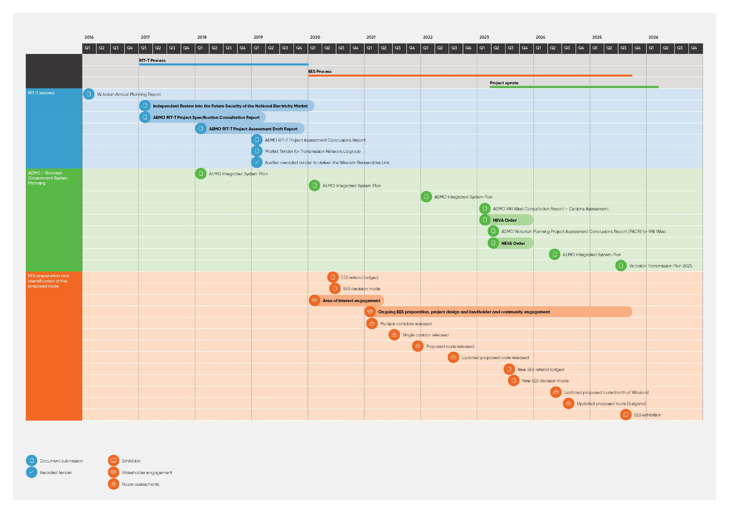
Figure 5.2 Western Renewables Link Project RIT-T, route and corridor selection process and timeline

Conducting the RIT-T
In 2017, AEMO – in its role as the transmission network planner for Victoria – commenced a RIT-T for Western Victoria Renewable Integration (herein referred to as the ‘2017 RIT-T’) to assess the technical and economic viability of addressing current limitations in the western Victoria transmission network, in accordance with the National Electricity Rules.
The 2017 RIT-T process assessed the technical and economic viability of options to increase capacity and address constraints in the western Victoria transmission network. This RIT-T process was undertaken in accordance with the National Electricity Rules and the RIT-T guidelines in operation at that time (RIT-T for transmission application guidelines – Version 1.0 (AER, 2010) for the Project Specification Consultation Report, Version 2.0 (AER, 2017) for the Project Assessment Draft Report, and Version 3.0 (AER, 2018) for the Project Assessment Conclusions Report).
As part of the 2017 RIT-T process, government, industry and the community were invited by AEMO to provide feedback on the need for new network investment and credible options to address the need. This consultation included an opportunity for the public and key stakeholders to make submissions and the hosting of industry forums to provide updates throughout the process.
As required by the RIT-T process, AEMO produced three reports summarising the outcomes of the process:
- Project Specification Consultation Report (AEMO, 2017) – This report described the need for investment in the transmission network in western Victoria and considered five broad investment options to address this need, including minor network augmentations, new transmission capacity and non-network options (such as battery storage and energy demand management).
- The key need identified by AEMO was ‘to increase the thermal capability of the Western Victoria power system to reduce constraints on anticipated new connected generation’. This highlighted that greater system strength is required to ensure the stable operation of new and existing generators as the connection of wind and solar generation increases.
- The report identified the following five broad options to be further investigated in the Project Assessment Draft Report:
  - Minor network augmentations
  - New 220kV transmission capacity
  - New 275kV or 330kV transmission capacity
  - New 500kV transmission capacity
  - Non-network options.
- Project Assessment Draft Report (AEMO, 2018) – This report assessed the credible network options presented in the Project Specification Consultation Report and further refined them into eight options summarised in the Project Assessment Draft Report, including responding to stakeholder submissions received during that stage. These options were assessed against the terms of the RIT-T process and the National Electricity Rules, and the two most credible options were identified:
  - Option B3: Construction of a new 220kV circuit line from Moorabool to Elaine to Ballarat to Bulgana, and retire Ballarat to Moorabool circuit No. 1 and connection to Ballarat to Moorabool circuit No. 2 at Elaine
  - Option C2: Construction of a new 500kV double circuit line from Sydenham to Ballarat, construction of a new 220kV double circuit line from Ballarat to Bulgana, and connection to Ballarat to Moorabool 220kV circuit No. 2 at Elaine.
- The Project Assessment Draft Report identified the above options as the potentially preferred transmission upgrade option based on the delivery of the greatest net market benefits. Both options provide a combination of minor augmentations to existing transmission lines. The key categories of market benefit for this analysis were changes in generation investment costs and changes in fuel consumption, with a net market benefit representing an increase in consumer and producer surplus through significant, long-term reductions in the capital and dispatch cost of generation.
- The Project Assessment Draft Report also outlined how the preferred options could be delivered in stages, with a focus on addressing the expected congestion affecting existing and committed generators and on those network areas where intervention is most likely to deliver the highest net market benefit. The Project Assessment Draft Report further refined the identified need as listed in the Project Specification Consultation Report, prioritising the alleviation of future constraints on the western Victoria, Moyne and Murray River corridors. The report was published in 2018 and submissions from key stakeholders and communities were considered until February 2019.
- Other potential options were also considered, including building a new transmission cable entirely underground, but were discounted as they were not expected to address the identified need and/or to not be technically or commercially feasible and therefore not considered credible options. The fully underground option was discounted as a credible option in the Project Assessment Draft Report as it was expected to cost up to 10 times more per kilometre than overhead lines and not expected to deliver net market benefits. An assessment of the feasibility of building a full underground transmission line is also provided in Attachment II: Assessment of feasibility for an underground 500kV transmission line for Western Renewables Link. This is further discussed in Chapter 2: Project rationale.
- Project Assessment Conclusions Report (AEMO, 2019) – This report presented AEMO’s recommended solution and confirmed that this solution addresses the identified need to increase the thermal capability of the western Victoria power system and would deliver the highest net market benefits. Based on the outcomes of the stakeholder submissions and the Project Assessment Draft Report, the Project Assessment Conclusions Report further concluded that a refined version of Option C2 as defined in the Project Assessment Conclusions Report was the preferred solution due to its net market benefits. The Project Assessment Conclusions Report-refined version of Option C2 also included:
  - Connecting one of the proposed Bulgana to North Ballarat circuits to Waubra Terminal Station and disconnect Waubra Terminal Station from the existing Ballarat to Waubra to Ararat to Crowlands to Bulgana 220kV transmission line to manage transmission line flows between Ballarat to Bulgana
  - Install additional circuit breakers at Ballarat Terminal Station to establish a bus splitting control scheme following a critical contingency
  - Connect the existing Ballarat to Bendigo 220kV transmission line to North Ballarat Terminal Station, forming a new Ballarat to North Ballarat to Bendigo 220kV transmission line
  - Install 4 x 50 megavolt amperes – reactive (MVAr) reactors on each end of the 500kV transmission lines from Sydenham to North Ballarat Terminal Station.
Following completion of the RIT-T, AEMO issued a tender for provision of the services required to construct the overhead new transmission line. The requirements of the invitation to tender issued by AEMO, also included the construction of a new terminal station at Sydenham to avoid potential interface issues and outages associated with construction within the existing operational Sydenham Terminal Station site.
The Project Assessment Conclusions Report concluded that a combination of an overhead 220kV and 500kV double circuit transmission line (in additional to minor augmentations) would address the identified need to increase the capability of the Western Victoria power system, to reduce constraints on projected new generation in that region.
At the conclusion of the RIT-T process, these options were not considered to address the identified need, and to not be technically or commercially feasible, and were therefore not included as ‘credible options’. An assessment of the feasibility of building a full underground transmission line is also provided in Attachment II: Assessment of feasibility for an underground 500kV transmission line for Western Renewables Link. This is further discussed in Chapter 2: Project rationale.
Further information on the assessment of Project alternatives is provided in Attachment I: Project development and assessment of alternatives.

Changes to the Project solution identified by the RIT-T
As discussed in Section 5.2, changes to the Project as identified in the 2017 RIT-T process were required as a result of the 2023 announcement of the neighbouring VNI West project and the May 2023 NEVA Order. This section discusses the resulting changes to the Project’s components and locations.
In July 2022, the VNI West Project Assessment Draft Report was published by AEMO which identified VNI West (via Kerang) as the proposed preferred option for that project (AEMO, 2022c). This included VNI West connecting to the Project (at the proposed terminal station north of Ballarat) with the proposed Dinawan substation to be constructed as part of Project EnergyConnect (comprising of new transmission lines between the electrical grids of New South Wales, South Australia and Victoria), via new stations near Bendigo and Kerang. During consultation of the VNI West Project Assessment Draft Report, it was identified that the southern connection point into the Project and its compatibility with high value agricultural land use between Ballarat and Bendigo was constrained. In response, AEMO undertook an investigation of alternate VNI West options, still running via a terminal station near Kerang, but with connection to the Project west of the previously proposed terminal station north of Ballarat.
On 20 February 2023, the Victorian Minister for Energy and Resources used powers under the NEVA to issue an order pursuant to segment 16Y of the NEVA (No. S60)(the February NEVA Order). The February NEVA Order conferred on AEMO the function to evaluate alternative options to connect VNI West into the Project.
Following the February NEVA Order, AEMO published an Additional Consultation Report (AEMO, 2023f) on the outcomes of the alternate options assessment and accompanying material. The Additional Consultation Report assessed seven options for VNI West. These options included consideration of various connection points with the Project further west than the preferred connection point identified in the VNI West Project Assessment Draft Report (north of Ballarat). One of the reasons for selecting the location further west was to avoid high value agricultural (horticulture) land use concerns between Bendigo and Ballarat that had been identified by stakeholders.
The Additional Consultation Report (2023) identified Option 5, connecting to the Project (at Bulgana) with EnergyConnect (at Dinawan) via a new terminal station near Kerang, as the new proposed preferred option for VNI West. Following a six-week engagement period on the proposed preferred option for VNI West, AEMO consulted with VicGrid (a division of the Victorian Department of Energy, Environment and Climate Action) on the draft outcomes of the alternate options analysis and the 2023 VNI West Project Assessment and Conclusions Report, as required under the February NEVA Order. A draft of this Project Assessment and Conclusions Report was then provided to the Victorian Minister for Energy and Resources on the 3 May 2023.
On the 27 May 2023, a second NEVA Order was published by the Victorian Minister for Energy and Resources (No. S267) (the May 2023 NEVA Order) describing the preferred option for VNI West as Option 5A, “a route option from the WRL at Bulgana directly to a terminal station near (directly east of) Kerang”. The order also explained “Option 5A requires some changes to the WRL, including relocation of the Mount Prospect terminal station site to Bulgana and uprating the WRL from 220 kilovolts to 500 kilovolts from Mount Prospect to Bulgana”.
As a result of the May 2023 NEVA Order, the preferred form of the Project changed from what was originally proposed in the Project’s 2017 RIT-T, to proposing a 500kV double circuit transmission line from Bulgana to Sydenham. A key function of the terminal station previously proposed north of Ballarat at Mount Prospect was to switch the voltage from 220kV to 500kV however the specification for an uprate made the requirement for a terminal station at this location redundant. Instead, the works proposed at the existing Bulgana Terminal Station increased, with both an upgrade to the existing terminal station and a new 500kV terminal station in proximity becoming a requirement. The key benefits of the uprate for the Project were that it provided additional capacity, allowed for future growth of generation and resulted in a less constrained location for the terminal station than the original site at Mount Prospect.
Due to delays to the Project, critical asset replacement works at Sydenham Terminal Station were separated from the Project as they must be delivered prior to the Project’s works to maintain reliable transmission services in Victoria. These works to replace and rebuild the terminal station are referred to as the Sydenham Terminal Station Rebuild project. The technical reports undertaken for the purposes of the Project, namely the biodiversity, cultural heritage, surface water and contaminated land studies, show that the Sydenham Terminal Station Rebuild project does not have the potential to cause significant environmental impacts that would warrant assessment under the Environment Effects Act 1978. Therefore, the rebuild was subject to a separate planning approval pathway. A planning permit was granted for the Sydenham Terminal Station Rebuild project in November 2024.
The removal of the new terminal station at Sydenham from the Project scope required a second EES referral to be made in August 2023. The new EES referral also reflected the uprated Project from 220kV to 500kV from Mount Prospect to Bulgana and a new terminal station near or at the existing Bulgana Terminal Station. The Minister for Planning determined that an EES was required for the new referral.
Following the announcement of the uprate in 2023, AusNet subsequently reviewed the Project development approach and route options assessment process. Applying the method outlined in this chapter, the outcome of this assessment was that the previously identified route remained the preferred route for the revised Project scope, with some route refinements around Bulgana, Waubra and north of Ballarat due to the change in terminal station connections.
The location of the key components of the Project is shown in Figure 5.3.
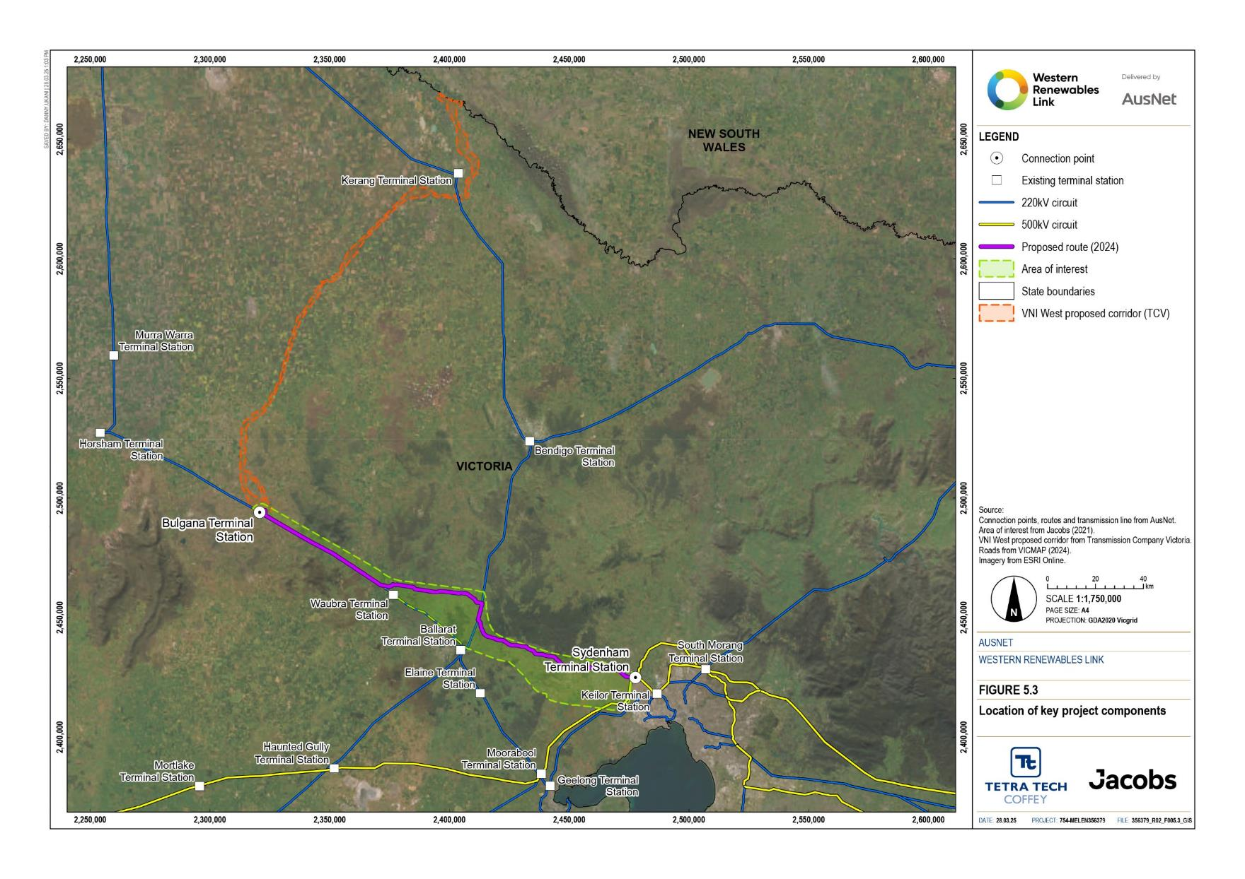
Figure 5.3 Location of key Project components

Assessment of alternative corridors and routes
Corridor and route selection involves the progressive refinement of feasible alternatives within the area of interest considering the environmental, social, cultural, land use and planning constraints. Feasible alternatives are corridors and routes that meet the Project objectives and are economically and technically feasible.
AusNet’s consideration of feasible alternative corridor options that could meet the Project objectives began in early 2020. Attachment I: Project development and assessment of alternatives describes the assessment process in further detail and should be read in conjunction with this Chapter.
This process culminated in the proposed design, scope and route being assessed in this EES and described in detail in Chapter 6: Project description.

Assessment approach
Assessment of corridors and selecting a Proposed Route has considered:
- Environmental, social, cultural, land use and planning constraints
- Opportunities for the Proposed Route along existing linear infrastructure corridors
- Community values and concerns informed through consultation with community, First Peoples, government agencies and departments.
Corridor and route selection involved the progressive refinement and consideration of alternatives within the area of interest. Feasible alternatives within the area of interest are those that meet the Project objectives, Project timeline, have the overall lowest level of constraints, and are economically and technically feasible.
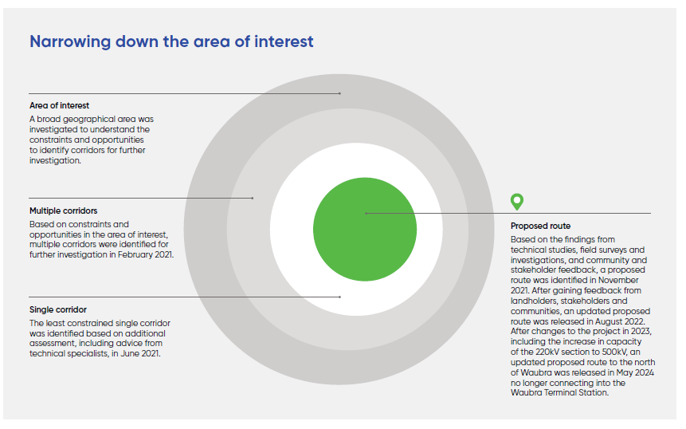
A broad geographic area of interest was defined, which was further refined into potential corridors and routes through progressive identification and assessment. The process is outlined in Figure 5.4.
Figure 5.4 Process to narrow down the area of interest
As illustrated in Figure 5.5, the process involved the progressive refinement of feasible alternative corridor options within an area of interest that aligned with the Project objectives. The refinement of the area of interest considered the environmental, social, cultural, land use and planning constraints, opportunities provided by existing linear infrastructure corridors, and feedback and information gathered through consultation with community groups, government departments and agencies, and other stakeholders. The considerations listed in Figure 5.5 also incorporate community/social values. For example, landscape and visual impact is a key concern of affected communities and agricultural land uses including potato farming land are highly valued.
The process was led by AusNet with support from its technical specialists who completed investigations and provided advice to inform AusNet’s decision making as summarised in Table 5.3.
Table 5.3 Summary of technical specialist input throughout Project development and assessment of alternatives
Description | Technical specialist input | Relevant technical discipline
Constraints mapping (Section •) | Classification and ranking of constraints | Biodiversity, Aboriginal cultural heritage, historic heritage, land use planning, landscape and visual
Corridor development and assessment (Section 5.3.5) | - Desktop assessment and field work for each corridor option  - Development of corridors through workshops with designers and specialists  Consultation with specialists assisted in determining the least constrained corridor by assessing key differences between conceptual routes within the shortlisted corridors | Biodiversity, Aboriginal cultural heritage, historic heritage, Land use planning, landscape and visual  Biodiversity, land use planning, historic cultural heritage, Aboriginal cultural heritage, agricultural and landscape and visual
Route selection and assessment (Section 5.3.6) | Specialists gather desktop and field information in development of the EES technical reports | All disciplines assessed in the EES (environmental, social and cultural heritage)
Hepburn Lagoon & Melton aerodrome / MacPherson Park (Section 5.3.6) | Evaluation of route options | Biodiversity, Aboriginal cultural heritage, historic heritage, agriculture, landscape and visual amenity, social, aviation (for Melton area only)
Alternative routes and alternative projects proposed by stakeholders (Section 5.3.6) | Provision of advice on key issues | Biodiversity, Aboriginal cultural heritage, historical heritage, agriculture, landscape and visual and bushfire
Route refinements (Section 5.3.6) | Consultation, including via workshops, to assess potential impacts of proposed changes | Varied disciplines depending on the key issues in the affected locations
Darley route options (overhead) (Section 5.3.6) | Review of site-specific information against Project design and AusNet’s vegetation management practices | Biodiversity, design
Partial undergrounding at Darley (Section 5.3.7) | Evaluation of potential partial underground routes at Darley against the proposed overhead route | Biodiversity, Aboriginal cultural heritage, historic heritage, landscape and visual, contaminated land, land use and planning, social, business impacts, electromagnetic interference (EMI) and electric and magnetic fields (EMF), transport, groundwater, surface water, bushfire
New 500kV terminal station near Bulgana (Section 5.4.1) | Specialists developed the site selection criteria  Preliminary assessment of site options | Land use planning, transport, biodiversity, Aboriginal cultural heritage, historic heritage, bushfire.  Aboriginal cultural heritage, biodiversity
Laydown area and workforce accommodation facilities (Section 5.4.2) | Specialists completed desktop assessment of the four shortlisted sites to determine their suitability initially for a laydown area and subsequently for a co-located laydown area and workforce accommodation facility | Land use planning and amenity, transport, biodiversity and Aboriginal cultural heritage (including targeted field investigation), surface water, bushfire, noise and vibration

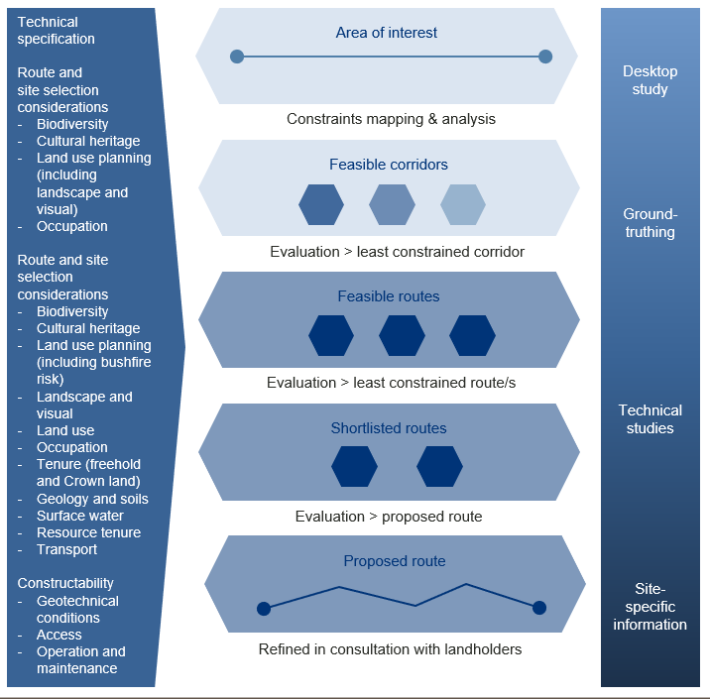
Figure 5.5 Corridor and route selection process (Source: Tetra Tech Coffey)

Considering community values and constraints
From the outset, preserving important community values and identifying environmental, heritage and other constraints were critical considerations in the investigation of the Project’s Proposed Route, with community engagement commencing in early 2020. A summary of the Project’s stakeholder engagement process as it relates to the Project’s development is provided here and discussed in detail in Attachment IV: Stakeholder and community engagement consultation report and summarised in Chapter 7: Community and stakeholder engagement.
As the route was defined, community and stakeholder engagement continued to build awareness of the Project and identify places of environmental, social, and community importance. Feedback was sought through several engagement tools including face-to-face engagement sessions (community group discussions and dinner events), online engagement methods (live webinars, Social Pinpoint data mapping and virtual engagement rooms), direct engagement with landholders, local advertising and targeted letterbox drops.
Key stakeholders included host landholders, surrounding landholders, community members, the six Councils along the Proposed Route, community groups, government Ministers, government departments and agencies, and the five Traditional Owner groups and Registered Aboriginal Parties.
Data collected using the online interactive mapping tool, Social Pinpoint, was used to obtain feedback about what is important to people in their local communities. The tool allowed community members to drop a virtual pin on a specific location and provide commentary. Over 5,450 virtual pins were dropped on the map across two rounds of data collection. The tool was used to enhance the Project team’s understanding of the local area and was not intended as a full representation of important community information. The data collected helped to identify important destinations, sites and features to the community relating to environmental features, historic sites, land and economic uses, and recreational or social sites.
Engagement at an early stage in the design and development of the Project was used to collect information regarding community values and to identify specific constraints and opportunities for consideration in technical reports, field surveys and other investigations. These considerations informed the identification, assessment and selection of multiple potential corridors, the preferred single corridor and the Proposed Route for the Project. For example, at MacPherson Park, the Proposed Route was aligned with the park’s northern boundary, to minimise impacts to community groups and businesses in surrounding areas, sporting fields, urban areas and a local school. This change is discussed in Section 5.3.6.
As development of the Project progressed, further detail on constraints was identified and considered, such as land uses, the location of waterways and previously unrecorded heritage sites. For example, in response to stakeholder suggestions the Proposed Route was realigned further north along the southern boundary of Merrimu Reservoir to avoid native vegetation and ecological values at Long Forest Flora and Fauna Reserve, as well as maximising distance to residential properties along Symington Road and Moonah Drive. This change is discussed in Section 5.3.6.
The outcomes of engagement have also informed tower relocations and changes to the Proposed Route. Based on landholder feedback towers have been relocated in several locations to align with internal and boundary fences and avoid the most productive land. The opportunities and constraints raised ultimately formed the route selection criteria listed in Section 5.3.6.
Some communities and stakeholders asked that an underground transmission line for all - or parts - of the transmission line be considered. Partial underground alternative routes were investigated at Darley as part of the Project development process and is discussed in Section 5.3.7. Refer to Chapter 2: Project rationale and Attachment II: Assessment of feasibility for an underground 500kV transmission line for Western Renewables Link for an assessment of the feasibility of a fully underground transmission line.
- Area of interest
A broad area of interest for the Project was identified in early 2020 based on the points identified as requiring connection through the RIT-T process - Bulgana in western Victoria and Sydenham on the western outskirts of Melbourne.

Defining an area of interest
For linear projects, an area of interest is defined by the start and end points to be connected. A straight line between these points is the starting point for route selection.
An initial broad area of interest for the Project was identified in early 2020 based on the points identified as requiring connection through the RIT-T process (Bulgana in western Victoria and Sydenham on the western outskirts of Melbourne as shown in Figure 5.6). Technical investigations of the land between these points (including the physical landscape, biological environment and social and economic features) were undertaken and the need to avoid highly constrained areas of regional and national importance was considered in the process of refining the area of interest.
Consideration was also given to the opportunities provided by existing linear infrastructure corridors, with the area of interest also encompassing the Horsham–Ballarat 220kV transmission line and the Ballarat–Bendigo 220kV transmission line. The area of interest was sufficiently large enough to encompass feasible alternatives for connecting the transmission line at Bulgana and Sydenham.
Following the May 2023 NEVA Order confirming the uprated capacity of the Project, the area of interest was expanded to include a larger area around the existing Bulgana Terminal Station to facilitate the expansion of the terminal station, and some small areas of land to the south of the existing Bulgana to Waubra 220kV transmission line, potentially required for access tracks and construction purposes. The expanded area of interest was still based on the same initial connection points but sought to include additional land that could be required for the delivery of the ultimate Project.
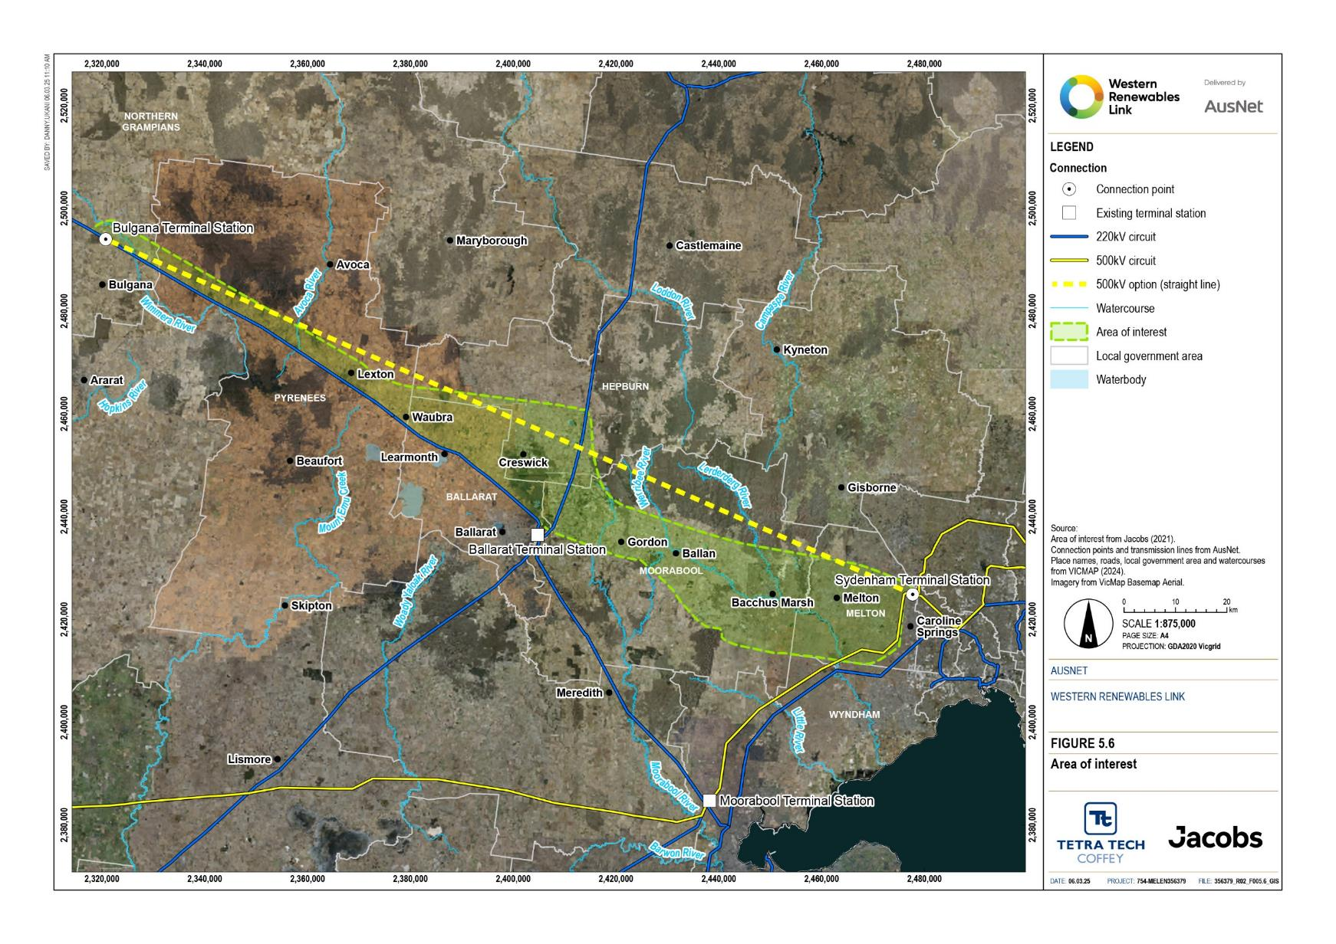
Figure 5.6 Area of interest
- Land use for strategic energy infrastructure
Unlike transport corridors that have been protected through public acquisition overlays, land use planning in Victoria does not reserve land for strategic energy infrastructure. This means that existing linear corridors (such as roads, highways, pipelines and transmission lines) are the only opportunities available for the co-location of new strategic energy infrastructure. However, competing interests, space constraints and encroaching development severely limit the capacity of many of these corridors to accommodate additional infrastructure.

Constraints mapping
Constraints mapping was used to identify environmental and social values within the area of interest that could be potentially impacted or constrain potential corridors, routes and sites for the Project’s new infrastructure. The mapped values are those protected under local, state and Commonwealth legislation such as heritage overlays, native vegetation and threatened ecological communities.
Specific constraints were investigated in relation to biodiversity, Aboriginal cultural heritage, historic heritage, landscape and visual, and land use planning (including agriculture and urban settlement). Preliminary investigations were undertaken during this stage of the assessment to gain an understanding of the area of interest. Community and stakeholder consultation, including engagement with potentially affected landholders, was also undertaken.
Constraints were ranked as low, medium, high or very high based on a rationale provided by technical specialists. The criteria adopted for the constraints mapping is detailed in Table 5.4.

Table 5.4 Constraints mapping criteria
Criteria | Low | Medium | High
Biodiversity | Disturbed and modified areas cleared of native vegetation and threatened species habitat as part of settlement.  No specific permits or approvals required as they relate to biodiversity. | Areas of moderate biodiversity significance where native vegetation removal requires planning permit approvals, non-statutory threatened species exist, suitable habitat occurs and/or approval is required under the Flora and Fauna Guarantee Act 1988 (Vic) (FFG Act).  Wetlands of state significance and designated waterways. | Areas of significant biodiversity, where disturbance requires approval under the Environment Protection and Biodiversity Act 1999 (EPBC Act) and FFG Act, including listed threatened species, threatened ecological communities, Ramsar wetlands and wetlands of national significance.
Aboriginal cultural heritage | Areas away from registered Aboriginal cultural heritage places and objects, and areas of Aboriginal cultural heritage sensitivity. | Areas of Aboriginal cultural heritage sensitivity, as defined under the Aboriginal Heritage Regulations 2018. | Registered Aboriginal cultural heritage places and objects.
Historic cultural heritage | Historic cultural heritage places included in the Register of the National Estate (RNE), National Trust of Australia (Victoria) and not included on any other register. | Historic cultural heritage places subject to a Heritage Overlay (HO) or listed on the Victorian Heritage Register (VHR), National Heritage List (NHL) or Commonwealth Heritage List (CHL). | Historic cultural heritage places subject to a HO, listed on the VHR, NHL, CHL or World Heritage List.
Land use planning | Areas of land use not identified as strategic assets in any regional strategy or policy. | Areas of land use formally identified as strategic assets in any regional strategy or policy, rural residential areas, areas of regional environmental significance, regional conservation reserves, areas of public use such as council parks and reserves, areas potentially containing contaminated land, areas subject to public acquisition notices, areas subject to erosion management measures. | Areas of land use formally identified as strategic assets in any state and national strategy or policy state reserves, State Parks and National Parks, high density areas including existing and proposed residential areas, township areas, commercial activity areas, land used for schools, education and health services, areas subject to significant landscape overlays, areas within a required statutory buffer for industry and sensitive uses.
Publicly available geospatial data was used for the constraints mapping, sourced primarily through the Victorian Government’s spatial data service. The constraints mapping presented in Figure 5.7 shows:
- The area adjacent to the Horsham–Ballarat 220kV transmission line is moderately constrained with Lexton H5 Bushland Reserve, Mount Beckworth Scenic Reserve and Mount Bolton highly constrained
- Ballarat and Creswick and adjacent rural residential areas, Creswick Regional Park, and the Berry Deep Lead historic goldfields between Allendale, Smeaton and Clunes (north of Creswick) are highly constrained areas
- Expanding residential and rural residential development around Gordon and Ballan is highly constrained
- Werribee Gorge State Park south of the Western Freeway and Lerderderg State Park north of the freeway are highly constrained areas
- Bacchus Marsh and its satellite suburbs (including Darley) are highly constrained areas, as is the adjacent horticultural area
- Long Forest Flora and Fauna Reserve between Bacchus Marsh and Melton is highly constrained
- The area between the Melton and Western highways between Caroline Springs and Melton is highly constrained by existing and planned residential development.
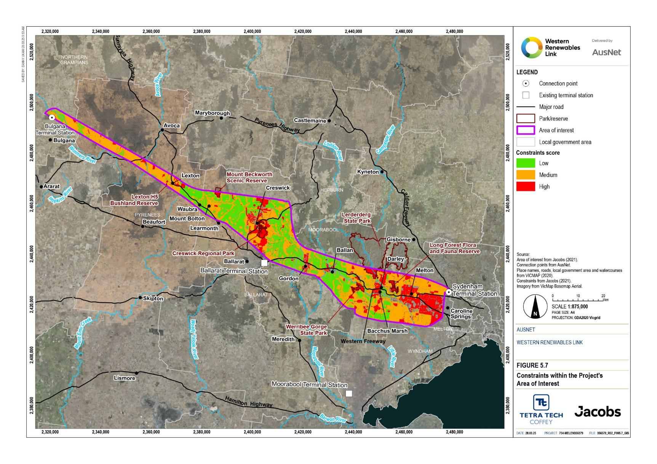

Figure 5.7 Constraints within the Project’s area of interest

Identifying a feasible corridor
AusNet’s approach to identifying potential feasible corridors for the Project focused on minimising and mitigating the potential adverse impacts of new infrastructure on the environment and communities, while delivering a project that meets its technical and economic objectives.
To identify corridors for more detailed investigation, constraints mapping (discussed in Section •) was prepared in conjunction with aerial imagery and the relevant planning scheme provisions covering the area of interest. This approach considered corridors that would:
- Avoid, manage or minimise potential environmental and social impacts
- Minimise the length of the transmission line route and consequent cost to electricity consumers
- Follow the path of least constraint, while still achieving the objectives of the Project.

Identifying multiple corridors
Potential corridors were informed by the identified constraints and the Project components that form part of the preferred option identified in the RIT-T Project Assessment and Conclusions Report. Potential terminal station sites north of Ballarat, along the existing 220kV line to Mount Prospect were originally. This was further refined with the May 2023 NEVA order uprating the entire length of the Project to 500kV and therefore removing the requirement for a new terminal station north of Ballarat. Removing the need for a terminal station on the Ballarat–Bendigo 220kV transmission line does not change the potential corridors due to the constraints associated with Ballarat and Creswick and adjacent towns and rural residential areas.
Potential corridors were identified by linking the least constrained areas and using opportunities provided by existing linear infrastructure. These corridors are described below and shown at a high level in Figure 5.8. Attachment I: Project development and assessment of alternatives provides the full evaluation of the potential corridors.
The area of interest was considered in three segments, including:
Western segment (Bulgana to Waubra)
- Bulgana to Waubra along the existing Horsham to Ballarat 220kV transmission line.
Central segment (Waubra to Ballarat to Bendigo 220kV transmission line)
- Northern corridor: Waubra to Mount Prospect north of Creswick and Creswick Regional Park and two alternative corridors including Coghills Creek valley (Coghills Creek alternative) and the existing stock route from near Learmonth to near Allendale (stock route alternative). The two alternatives link the northern corridor to the southern corridor.
- Southern corridor: Waubra to Bullarook south of Creswick and north of Ballarat.
Eastern segment (Ballarat to Bendigo 220kV transmission line to Sydenham)
- Northern corridor: Mount Prospect to Sydenham west and south of Wombat State Forest, south of Lerderderg State Park, and north of Bacchus Marsh and Melton.
- Southern corridor: Bullarook to Sydenham via Gordon, Fiskville, the Parwan valley and Bacchus Marsh–Melton area with an alternative corridor identified from Ballan to Fiskville and three alternative corridors for connection to Sydenham including:
  - Corridor along the Djerriwarrh Creek valley between Bacchus Marsh and Melton (Bacchus Marsh-Melton alternative).
  - Corridor along the proposed Outer Metropolitan Ring Road (Outer Metropolitan Ring Road alternative).
  - Corridor along the existing Sydenham–Moorabool 500kV transmission line ((SYTS-MLTS 500kV OHTL alternative).

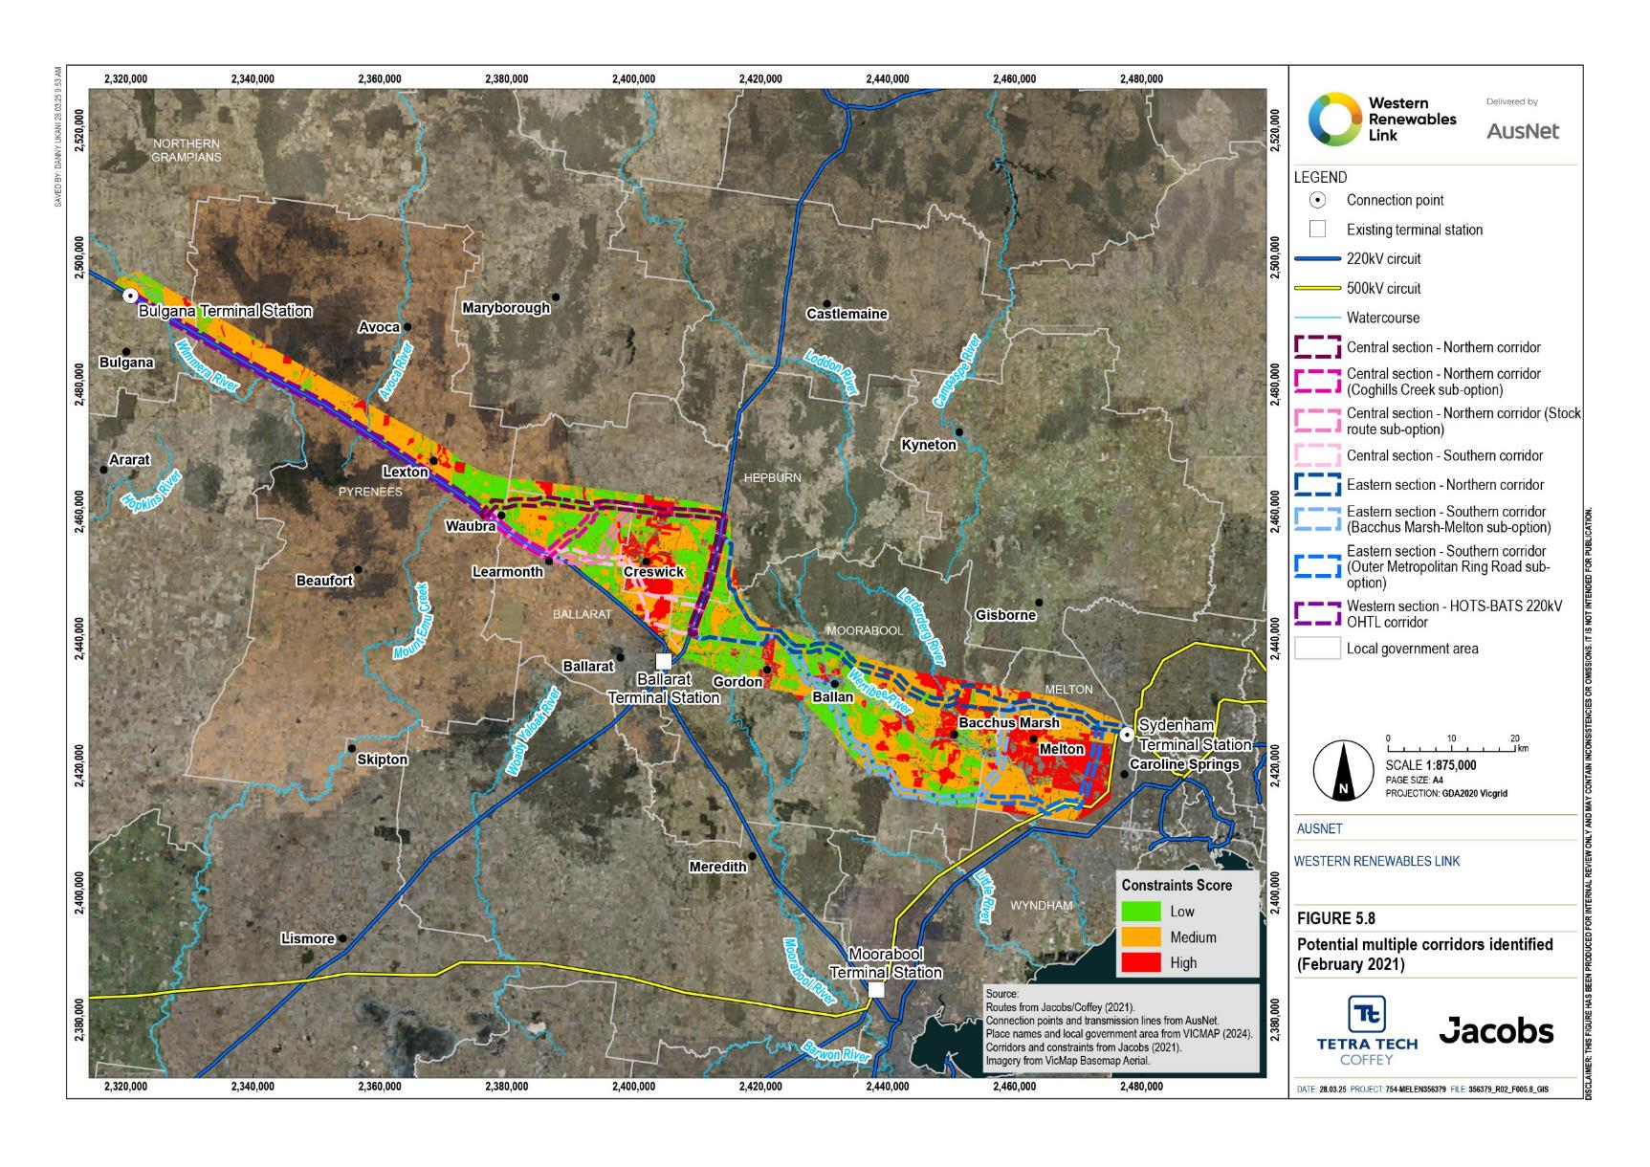
Figure 5.8 Potential multiple corridors identified (February 2021)

Shortlisting corridors
The potential multiple corridors were evaluated and shortlisted considering the constraints and comparing against the criteria used to inform the constraints mapping. This analysis was informed by desktop studies and ground-truthing by technical specialists. These least constrained corridors were inspected by biodiversity, land use planning, historic heritage, Aboriginal cultural heritage and landscape and visual specialists in October 2020, prior to their confirmation as the Project’s shortlisted corridors. The locations of the shortlisted corridors are shown in Figure 5.9.
The least constrained corridors in each segment that were considered for further investigation included:
Western segment (Bulgana to Waubra)
- Bulgana to Waubra along the existing Horsham–Ballarat 220kV transmission line
While having an incremental impact on affected properties, this corridor is the most direct route to Waubra. Following the existing transmission line reduces cost, avoids creating an ‘island effect’ between two roughly parallel transmission lines (i.e., landholders are impacted from more than one direction due to having transmission lines present on more than one side of their property) and prevents severance between paddocks within a property.
Central segment (Waubra to Ballarat–Bendigo 220kV transmission line)
- Northern corridor: Waubra to Mount Prospect north of Creswick and Creswick Regional Park
This corridor is less constrained than the southern corridor due to the intact forest and associated habitat values of the Glen Park State Forest and the potential difficulties in gaining tenure over land leased from the Victorian Plantations Corporation. The alternative along the stock route was discounted as being highly constrained by the EPBC Act listed critically endangered Natural Temperate Grassland of the Victorian Volcanic Plain.
Eastern segment (Ballarat–Bendigo 220kV transmission line to Sydenham)
- Northern corridor: Mount Prospect to Sydenham west and south of Wombat State Forest, south of Lerderderg State Park, and north of Bacchus Marsh and Melton
- Southern corridor - Bacchus Marsh-Melton alternative: Bullarook to Sydenham via Gordon, Fiskville, the Parwan valley and Bacchus Marsh–Melton area, with connection to Sydenham via the Bacchus Marsh to Melton alternative
All corridors through this area traverse highly constrained sections. The southern corridor – Ballan to Fiskville alternative was discounted as being longer and more constrained by residential development than the corridor between Ballan and Gordon.
The southern corridor - SYTS-MLTS 500kV OHTL alternative was discounted as insufficient space exists in the Sydenham–Moorabool 500kV transmission line easement to accommodate the new transmission line and the easement cannot be widened due to existing and proposed residential development alongside the easement. The southern corridor – Outer Metropolitan Ring Road alternative was also discounted as co-location within the Outer Metropolitan Ring Road and associated rail corridor is also not possible due to space and safety requirements for the proposed transport infrastructure.
The alternative Bacchus Marsh to Melton corridor west of the Djerriwarrh Creek valley was discounted as it traverses the Bacchus Marsh agricultural valley, Bacchus Marsh Avenue of Honour and significant landscapes and highly sensitive areas for Aboriginal cultural heritage.
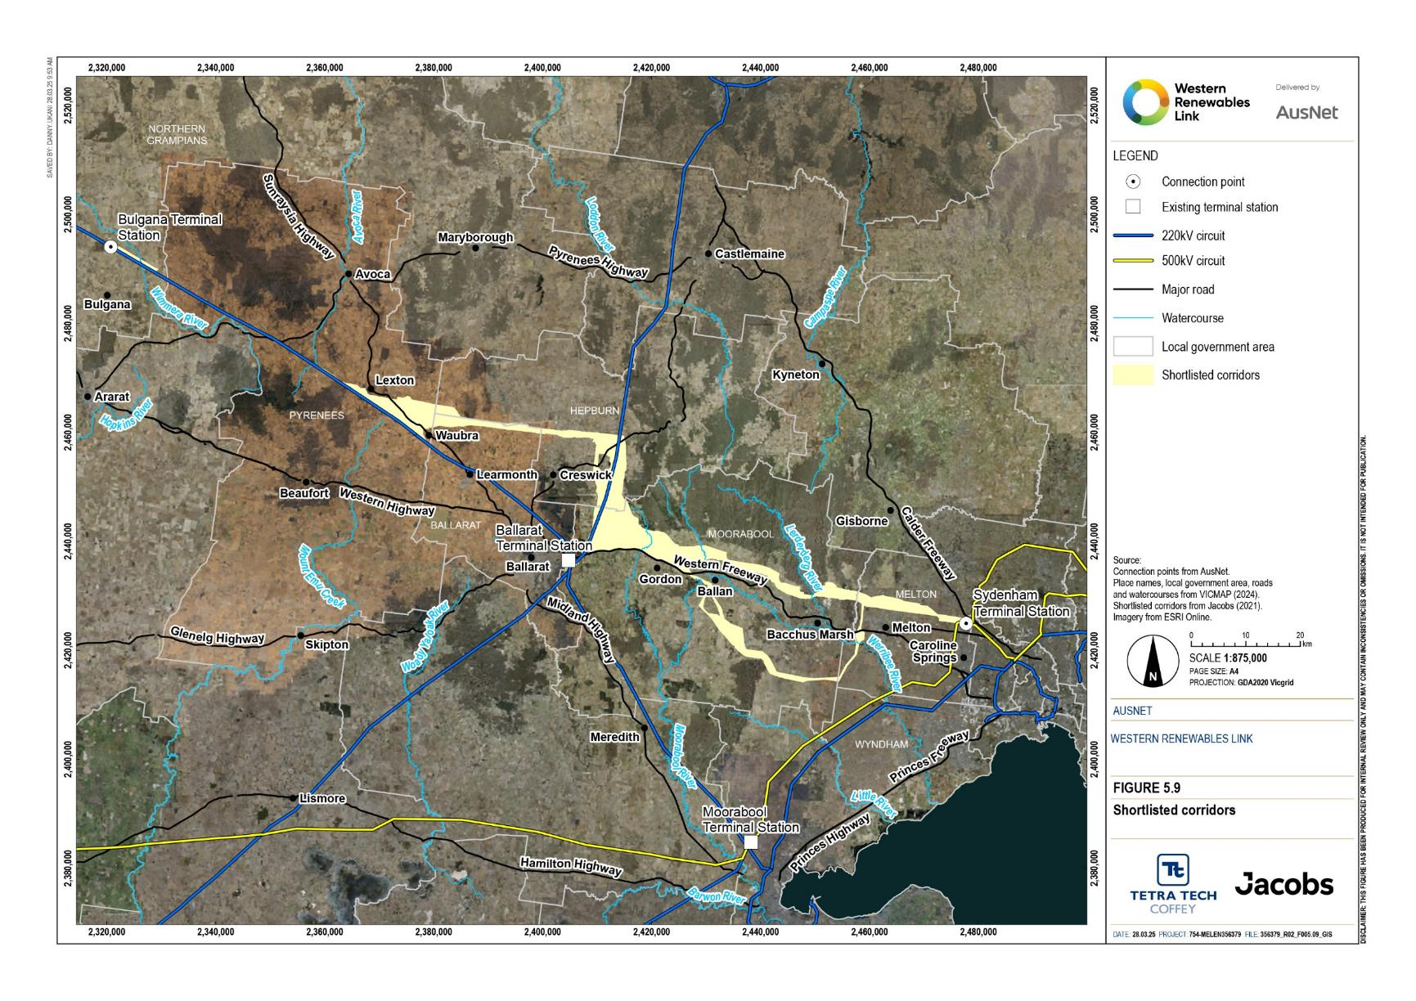
Figure 5.9 Shortlisted corridors

Identify the least constrained corridor
To assess the shortlisted corridors and to identify a least constrained corridor, conceptual routes were designed within the corridors in each segment. Twenty-four potential conceptual routes were assessed to select a single corridor: one in the western segment, 11 in the central segment and 12 in the eastern segment. Assessment of the conceptual routes in each corridor confirmed that the shortlisted corridors are the least constrained. It also found that routes using the Ballaratto Bendigo 220kV transmission line for as long as practicable are less constrained than routes in other corridors, confirming the benefits of co-locating transmission infrastructure where possible. Conceptual routes in each segment are shown in Figure 5.10 to Figure 5.12.
Conceptual routes were designed within each shortlisted corridor, overlaid with a comprehensive suite of geospatial datasets to understand the level of constraint for each route. This included consultation with biodiversity, land use planning, historic cultural heritage, Aboriginal cultural heritage, agricultural and landscape and visual specialists. The least constrained corridor was identified by this analysis. The geospatial datasets used to inform analysis covered the following themes:
- Land tenure (freehold and Crown land)
- Conservation parks and reserves
- Resource tenure (mining and extractive)
- Land use planning (zones and overlays)
- Land use
- Occupation (dwellings)
- Infrastructure (road transport, aviation, pipelines and transmission lines)
- Aboriginal and historic cultural heritage
- Ecological vegetation communities
- Listed threatened species and their habitat
- Geology and soils.
The conceptual routes were compared against a broader set of route selection criteria to understand the level of constraint. The shortlisted routes that were further investigated:
- Exclude urban and built-up areas, such as Creswick, Newlyn, Ballan, Bacchus Marsh and Melton
- Exclude large areas of forested public land with high environmental and cultural heritage values, such as the Brisbane Ranges National Park
- Include areas where a new transmission line could be located alongside existing electricity infrastructure, such as the Bulgana to Waubra line and the Ballarat to Horsham line
- Align with AEMO’s preferred approach to options selection by:
  - Maximising the net economic benefit; and
  - Ensuring effective connection of the western Victoria renewable sector to the NEM.

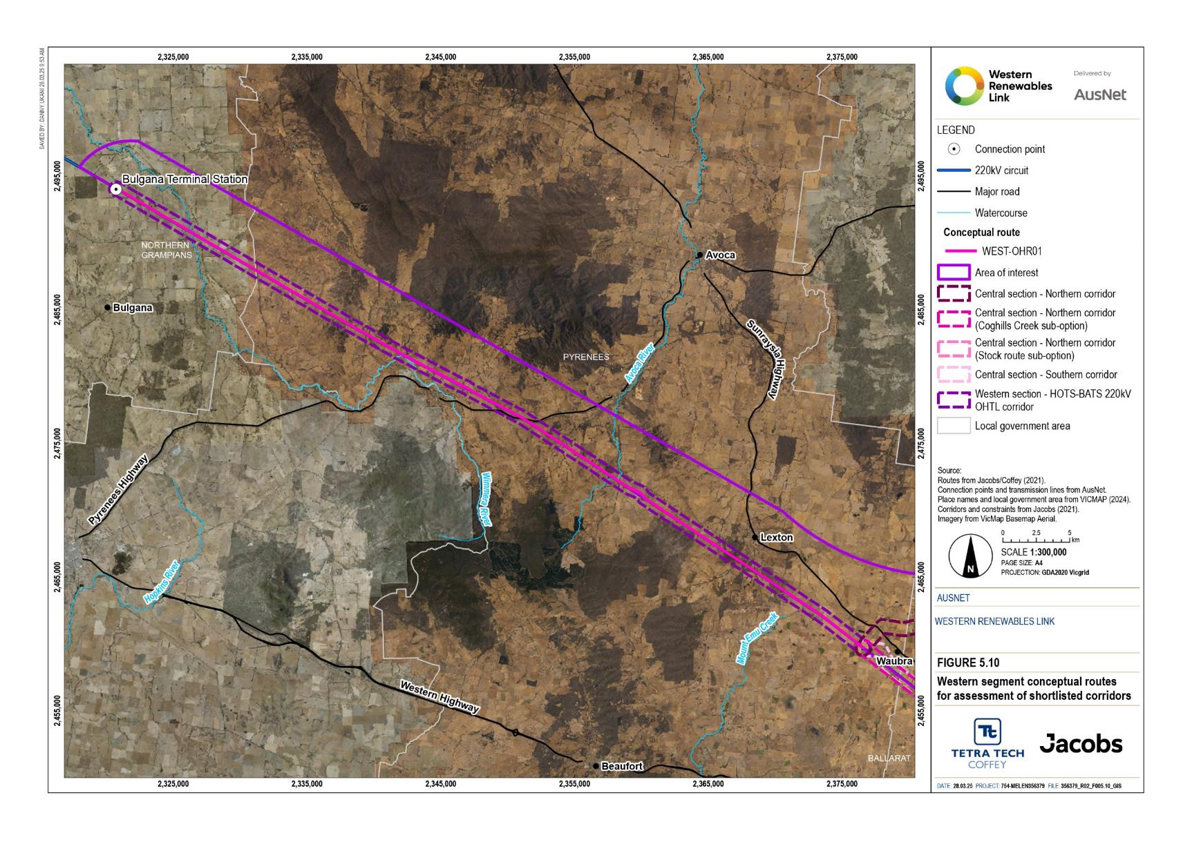
Figure 5.10 Western segment conceptual routes for assessment of shortlisted corridors

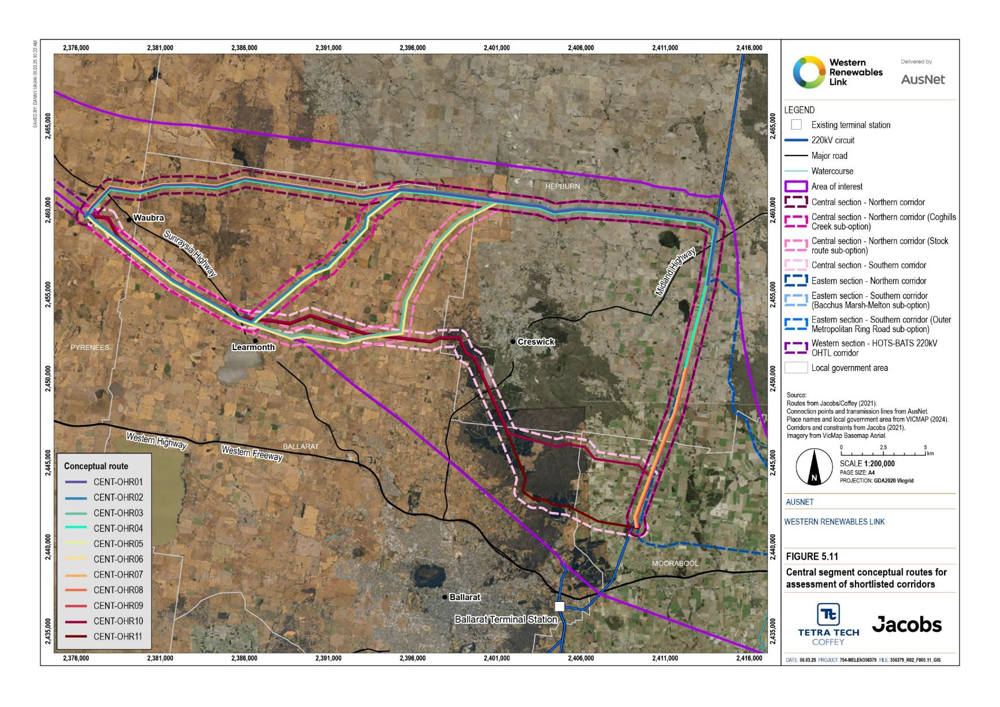
Figure 5.11 Central segment conceptual routes for assessment of shortlisted corridors

Figure 5.12 Eastern segment conceptual routes for assessment of shortlisted corridors
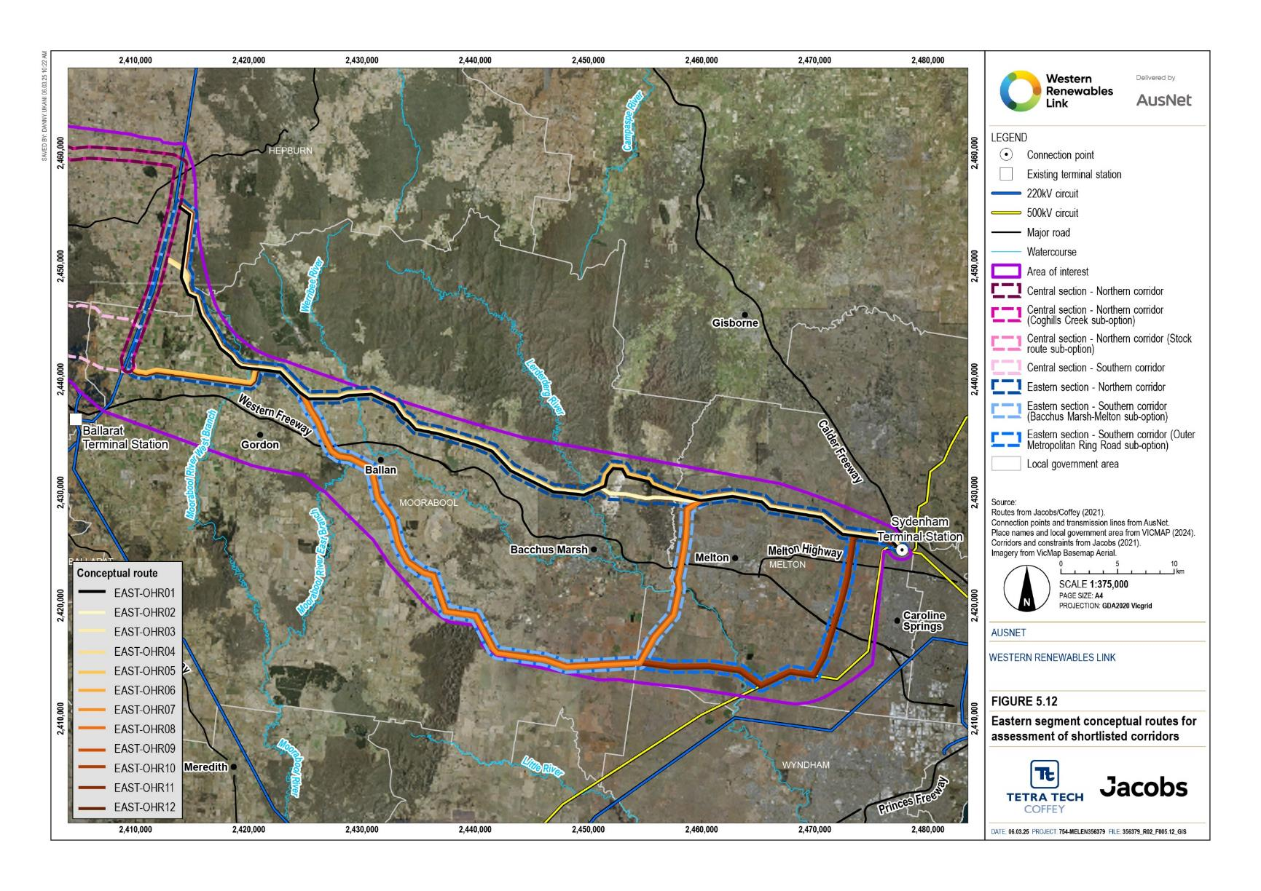

The results of the analysis were reviewed by relevant technical specialists to better understand and define the level of constraint along each route and the opportunities for managing and mitigating impacts. This work indicated that the least constrained corridor overall comprises:
Western segment (Bulgana to Waubra)
- Corridor adjacent to the Horsham to Ballarat 220kV transmission line
Central segment (Waubra to Ballarat–Bendigo 220kV transmission line)
- Northern corridor from Waubra to Mount Prospect north of Creswick and Creswick Regional Park
Eastern segment (Ballarat–Bendigo 220kV transmission line to Sydenham)
- Northern corridor from Mount Prospect to Sydenham west and south of Wombat State Forest, south of Lerderderg State Park, and north of Bacchus Marsh and Melton.
This least constrained corridor is shown in Figure 5.13. On 30 June 2021, AusNet announced this corridor as the preferred single overhead corridor for the Project.

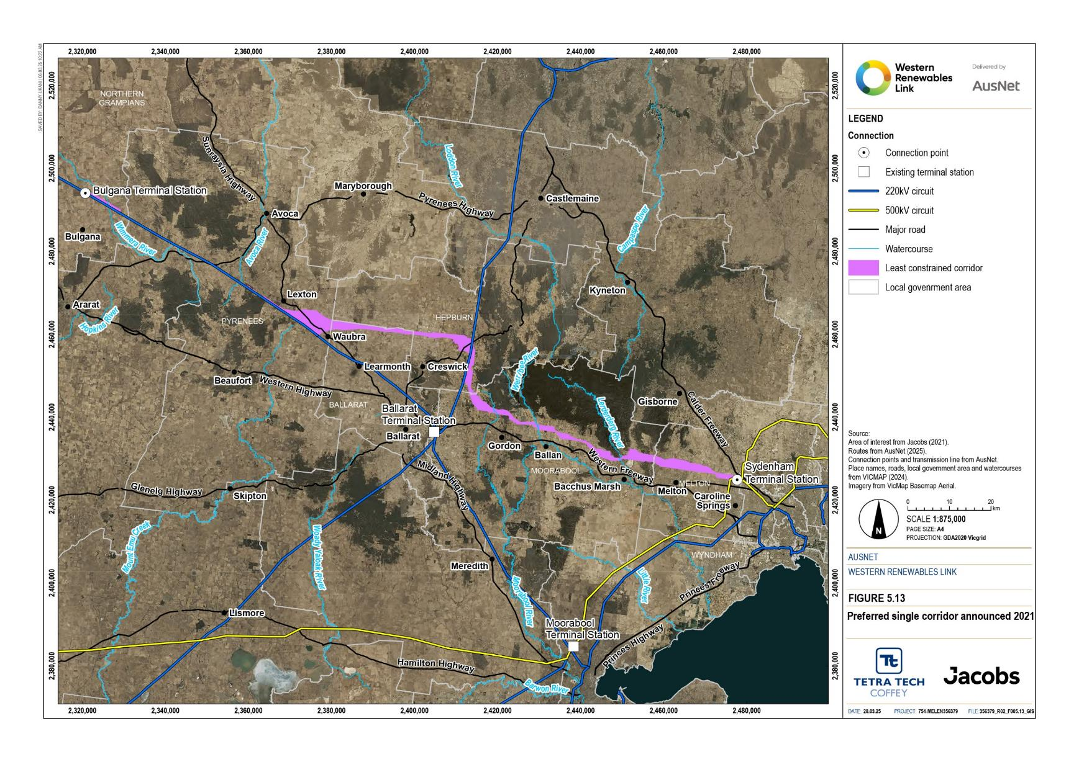
Figure 5.13 Preferred single corridor announced 2021

Identifying a Proposed Route
Following the identification of the preferred single corridor, AusNet and its technical specialists continued to gather information from landholders, local councils, community groups, industry and government and completed further technical reports, field surveys and investigations to understand the constraints, impacts and opportunities within this corridor to inform the selection and progressive refinement of the Proposed Route. As outlined in the assessment approach (Section 5.3.1), the Proposed Route was initially designed within the single corridor considering local and property constraints, and design and constructability requirements.
At this stage of the design process, the Proposed Route adopted an assumed 100m-wide easement, 50m either side of a conceptual centreline and a nominal span length (distance between adjacent transmission line support structures) of 450m, noting that span length can vary with terrain. Terrain with more height difference allows longer spans, whereas flat terrain or rolling terrain with less height difference may require shorter spans. Access to tower structure locations was a key consideration, as was clearance over roads and rail lines. Tower structures close to road and rail lines maximise the ground clearance to those features.
The route selection criteria designed to avoid (or minimise where avoidance is not possible) environmental, cultural and social impacts of the Project and used to guide the design of the Proposed Route were:
- Maximise distance to houses and other sensitive facilities
- Follow existing transmission line easements where practicable and where houses or other infrastructure have not been built up to the edge of the easement
- Avoid registered Aboriginal cultural heritage sites and culturally significant places, where known
- Avoid registered historic heritage sites (Victorian Heritage Register and Victorian Heritage Inventory)
- Use natural terrain and existing vegetation to screen the transmission line from views from houses and public viewing areas
- Avoid areas protected by significant landscape overlays, where practicable
- Align the route at the back/rear of properties to reduce impacts on land use, including agriculture and land access
- Adopt property boundaries where practicable to reduce diagonal cuts of paddocks and reduce land use impacts
- Avoid severing or separating large areas of properties that could impact on the existing land use, including agriculture
- Minimise impacts on irrigated paddocks and irrigator operation
- Minimise impacts on existing aerodrome operations
- Avoid windbreak plantings and shelter belts or use design to reduce impacts where unavoidable
- Avoid large tracts of native vegetation where practicable
- Preferentially avoid highly erosive soils and areas subject to landslip
- Avoid reservoirs and large waterbodies where overhead lines may limit recreation and management activities
- Maintain straight lines and avoid acute angles of more than 45 degrees
- Consider transmission network diversity (geographic distribution of grid infrastructure).
A summary of the Proposed Route development is provided in Table 5.5 and discussed in this section.
Table 5.5 Summary of Proposed Route development
Timeline | Summary of Proposed Route development
2021 | Proposed route (2021)  In November 2021, AusNet announced a Proposed Route to be reviewed as part of community and stakeholder consultations during the EES process
2021-2022 | Assessment of alternative route options and route refinements (EES)  Ongoing community consultation and technical reports identified two highly constrained locations that warranted consideration of alternative route options:  - Hepburn Lagoon  - Melton Aerodrome / MacPherson Park.  The alternative route options at these two locations were assessed by AusNet as part of the EES process.  In addition, the Proposed Route was refined in several areas including:  - Waubra to Glendonald  - Mount Prospect to Darley (Bolwarrah, Mount Steiglitz to Korjamnunnip Creek, Myrniong, Darley Military Camp area, and Merrimu Reservoir).
2022 | Proposed route (2022)  AusNet announced an updated Proposed Route that incorporated the outcomes of the alternative route options assessment and route refinements in 2021 – 2022.
2023 | Assessment of key route refinements following the 2023 NEVA Orders (EES)  Changes to the Project’s scope associated with the announcement of the neighbouring VNI West transmission project, including the uprate of the Project to 500kV and changes to the required terminal stations, resulted in refinements to the Proposed Route at Waubra and north of Ballarat (Mount Prospect).  Ongoing community consultation and technical reports as part of the EES process also identified potential refinements to the Proposed Route at Darley given the visual amenity impacts in this area and the discovery of significant native vegetation. An investigation of partial underground routes was also undertaken for Darley.
2024 | Proposed route (2024)  AusNet announced an updated Proposed Route that incorporates the Project scope changes, and key route refinements assessed in 2023. The Proposed Route (2024) is the focus of the EES.

Key alternative routes
Alternative routes have been proposed by AusNet during Project development and by individuals, communities, and other stakeholders in submissions on the draft scoping requirements for the Project and as part of ongoing community engagement while preparing the EES. Where practicable, alternative routes have been considered in designing the Proposed Route, for example in two highly constrained areas of Hepburn Lagoon and Melton Aerodrome. Potential route options were assessed in these areas to determine which option best managed the constraints and minimised impacts on environmental and social values. The least constrained option for each of these areas was incorporated in the updated Proposed Route.
The following four alternative routes were also assessed to determine if they met the Project objectives and reduced impacts of the Proposed Route:
- Lerderderg State Park alternative route
- Wombat State Forest alternative route
- Southern corridor alternative route
- Creswick Plantation alternative route.
Technical specialist input informed the evaluation of the alternative routes against the Project objectives (Section 5.1.2) and key environmental, cultural and social route selection criteria (see section above). The assessment determined these four alternative routes were more constrained than the Proposed Route, would not reduce impacts associated with the Proposed Route and in the case of the Southern corridor and Creswick Plantation alternative routes, do not meet the Project objectives as efficiently as the Proposed Route. Refer to Attachment I: Project development and assessment of alternatives for further detail on these alternative routes and their evaluation against the Proposed Route.
Two alternative projects with their associated routes (RIT–T Option B3 alternative route and Mortlake-Moorabool alternative route) were also assessed to respond to community interest. However, neither of these projects is considered a feasible alternative, as they are not supported by the National Electricity Law and would require a RIT-T or NEVA order to demonstrate they are better alternatives to the Project. To respond to community requests for further information, the routes were assessed against the Project objectives and the route selection criteria to determine if they reduced impacts compared to the Proposed Route. Both the RIT-T Option B3 and Mortlake-Moorabool alternative routes fail to meet Project objectives and while they reduce some impacts, they introduce other impacts or transfer impacts to other areas. Refer to Attachment I: Project development and assessment of alternatives for further detail on these alternative routes and their evaluation against the Proposed Route.
Hepburn Lagoon
Hepburn Lagoon is a flooded volcanic caldera (crater lake). The volcanic crater and surrounds have high potential for Aboriginal cultural heritage values and artefact discoveries. The lagoon is a popular fishing spot and a scenic area with associated tourism and social values. North of the area, the Daylesford-Clunes Road is a tourist route with views towards the lagoon. Numerous species of water bird have been identified at Hepburn Lagoon and nearby wetlands. Threatened species records at Hepburn Lagoon include Growling Grass Frog, Musk Duck, Platypus and White-bellied Sea-Eagle. Refer to Technical Report A: Biodiversity Impact Assessment for further information on species recorded at Hepburn Lagoon.
Two alternative routes were considered at Hepburn Lagoon, as shown in Figure 5.14. The northern route is further away from Birch Creek, a designated waterway that has been revegetated in sections to improve waterway health. The topography of the southern route alternative (tuff ring along the southern side of the lagoon) may assist with screening the transmission line from views to Hepburn Lagoon from the Daylesford-Clunes Road. This route departs the single corridor in a small segment to maximise the distance to existing dwellings, but is disadvantaged as it follows Birch Creek.
Technical specialists in the relevant disciplines of biodiversity, Aboriginal cultural heritage, historic heritage, agriculture, landscape and visual amenity and social evaluated the route options to assist identifying the least constrained option. The evaluation by technical specialists concluded that the southern route is less constrained overall, with:
- Greater separation to dwellings, historic sites, some tourism businesses, and the Daylesford–Clunes Road scenic tourist drive
- Less diagonal cuts of agricultural properties achieved in part by following property boundaries in sections
- Potential for the eroded Hepburn Lagoon caldera rim to partially screen the transmission infrastructure.
Based on the assessment, the southern route option was selected as the preferred route.
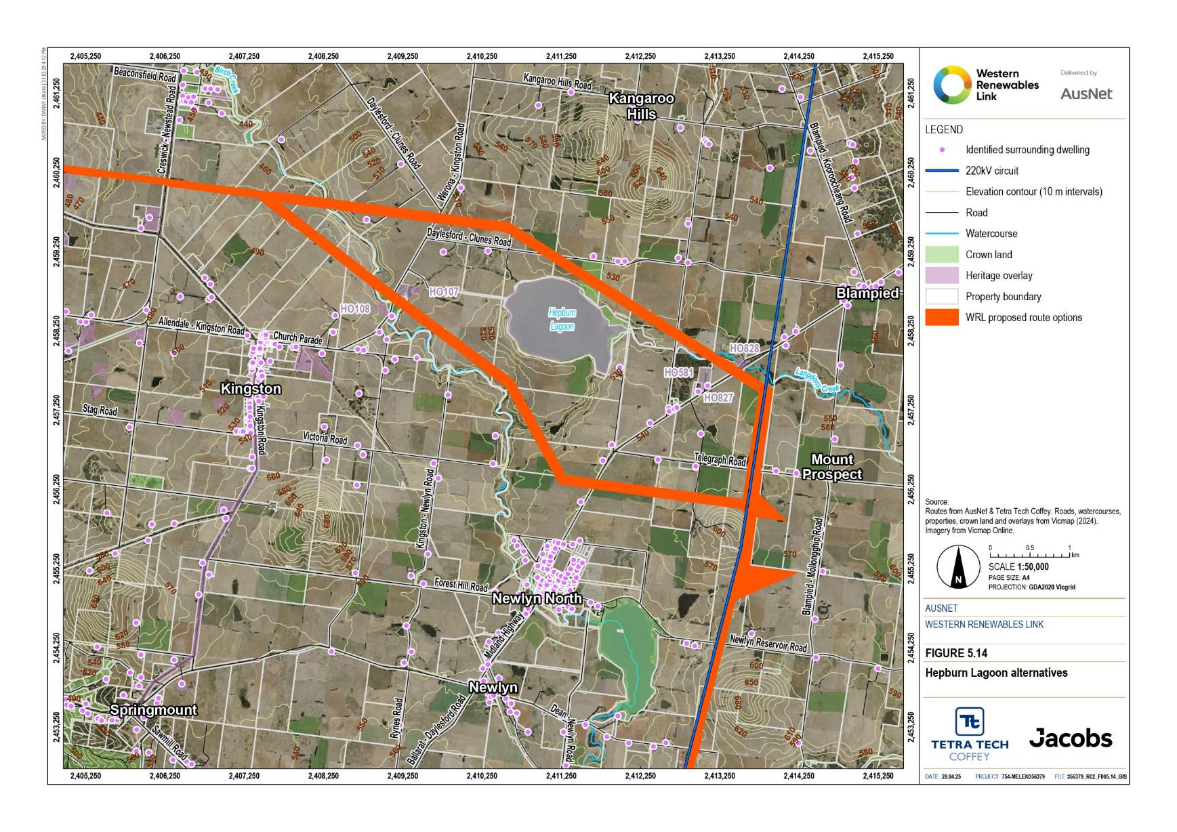
Figure 5.14 Hepburn Lagoon alternatives
Melton Aerodrome and MacPherson Park
The area north of Melton is highly constrained by existing and proposed development, including:
- Melton Aerodrome, an uncertified aerodrome
- MacPherson Park multi-use recreation facility which includes football, netball, soccer, equestrian and pony club facilities
- Proposed Melton Christian College
- “Melton Park” historic property
- Melton Gilgai Woodlands Nature Conservation Reserve
- Melton West Memorial Park
- Melbourne Assembly Hall of Jehovah's Witnesses
- Urban Growth Boundary and associated residential subdivision
- Rural residential subdivision, many with horse training facilities.
Two route options were identified to address the constraints and were evaluated by technical specialists to assist in identifying the least constrained route.
The northern route alternative runs closer to the existing runways at Melton Aerodrome and would require shorter towers. This route is further away from existing houses, the Urban Growth Boundary and the proposed new Christian College, but it may constrain future expansion of the aerodrome. The southern route alternative provides more distance between the transmission line and the aerodrome but is closer to existing houses, the Urban Growth Boundary and the proposed new college.
To address potential impacts on existing aerodrome operations, variations on the northern and southern routes were investigated. The northern route was moved adjacent to the northern boundary of MacPherson Park and the southern route was moved to the southern boundary of MacPherson Park. The technical specialists were asked to evaluate the revised route options. The evaluation of the revised route options found:
- No difference in potential biodiversity or Aboriginal cultural heritage impacts between the revised northern and southern routes
- The revised southern route was preferable from a landscape and visual aspect as it reduced fragmentation of land and increased separation to “Melton Park”
- Avoiding the “Melton Park” setting was a priority for historic heritage, which made the revised southern route preferable
- Land use planning and social technical specialists preferred the revised northern route as it increased separation to the proposed Melton Christian College, Melbourne Assembly Hall of Jehovah's Witnesses and maximised separation to residential and rural residential development.
The revised southern route would substantially encroach on three properties with dwellings. For this reason, and this route option’s proximity to residential and rural residential developments, the southern route and revised southern route are more constrained than the revised northern route.
Following consultation with the owner of Melton Aerodrome, the Department of Education, the City of Melton, and the completion of Technical Report J: Aviation Impact Assessment, the revised northern route was selected as shown in Figure 5.15. This alternative requires towers to be as short as practicable to maintain safe operations at the aerodrome and minimise any impacts to aerodrome users. The Proposed Route aligns with the northern boundary of MacPherson Park balancing the distance between the transmission line and Melton Aerodrome to the north and the proposed new Melton Christian College campus to the south.
The Proposed Route has been designed to minimise impacts to existing operations at the Melton Aerodrome and reduce the risk to aviation safety. A segment of single circuit towers (two towers side-by-side), which are shorter than double circuit towers, will be constructed near the aerodrome to improve safety and avoid impacts on existing ﬂight paths. The revised route is the least constrained route in this area, as it:
- Avoids substantial encroachment on three properties with dwellings
- Increases separation to the proposed Melton Christian College, Melton West Memorial Park and Melbourne Assembly Hall of Jehovah's Witnesses
- Increases separation to the wetland north of “Melton Park”
- Increases separation to residential and rural residential developments along Minns Road
- Increases distance to Melton Aerodrome runways and with single circuit transmission lines marked in accordance with the Civil Aviation Advisory Publication No. 92-1(1) Guidelines for Aeroplane Landing Areas, July 1992 (Civil Aviation Safety Authority (CASA) regulations), reduces the risk to aircraft operations, consistent with CASA regulations for uncertified aerodromes
- Reduces land use impacts by following property boundaries in sections.

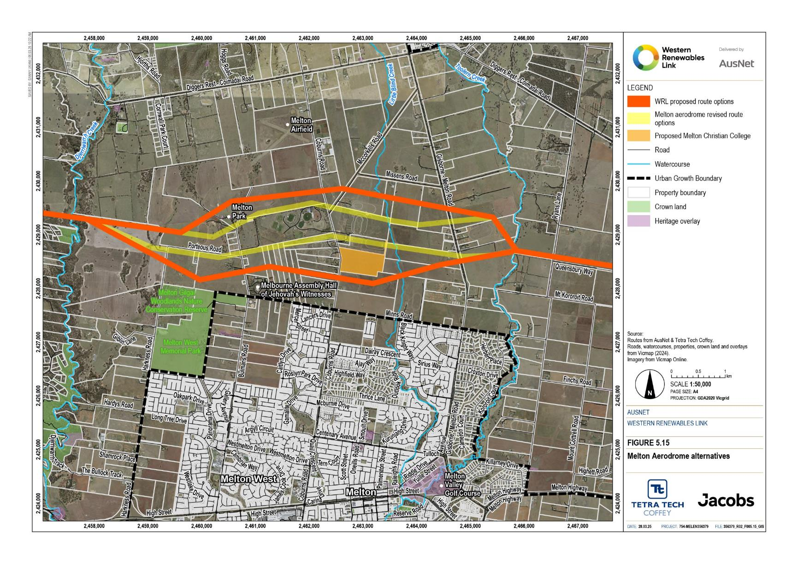
Figure 5.15 Melton Aerodrome alternatives

Key route refinements
Refinements of the Proposed Route were investigated based on new technical and landholder information to minimise the overall impact of the proposed transmission line on landholders, the community, and the environment. A range of technical reports have informed the refinement of the Proposed Route including land use, agriculture, flora and fauna, Aboriginal cultural heritage, historic heritage, and landscape and visual amenity. Route refinement has resulted in changes on individual properties and in some instances changes across several properties. While all landholder requests have been considered, before a change is made to the Proposed Route, the request must be assessed against the aim to avoid and minimise overall Project impacts, meaning not all requests have resulted in updates to the Proposed Route.
Following the May 2023 NEVA Order (described in Section 5.2.2) the Proposed Route was further refined using the same key route selection criteria to determine the least impact solution in light of changes to the Project scope and terminal station connections.
Waubra to Glendonald
The Proposed Route between Waubra and Glendonald traverses properties generally used for broadacre cropping, with irrigated cropping and forestry plantations in some areas. Mount Bolton and Mount Beckworth are recognised visual features of the landscape that are avoided by the Proposed Route. Volcanic cones, which are recognised places of Aboriginal cultural heritage significance, and sites protected by significant landscape overlays are avoided by the Proposed Route.
The Proposed Route was realigned between Waubra to Glendonald to minimise land use impacts in this area. Updates to the Proposed Route have been made to more closely follow property and parcel boundaries where possible between Waubra and Glendaruel, and to the northeast of Tourello near Creswick Creek. The realignment is shown in Figure 5.16.
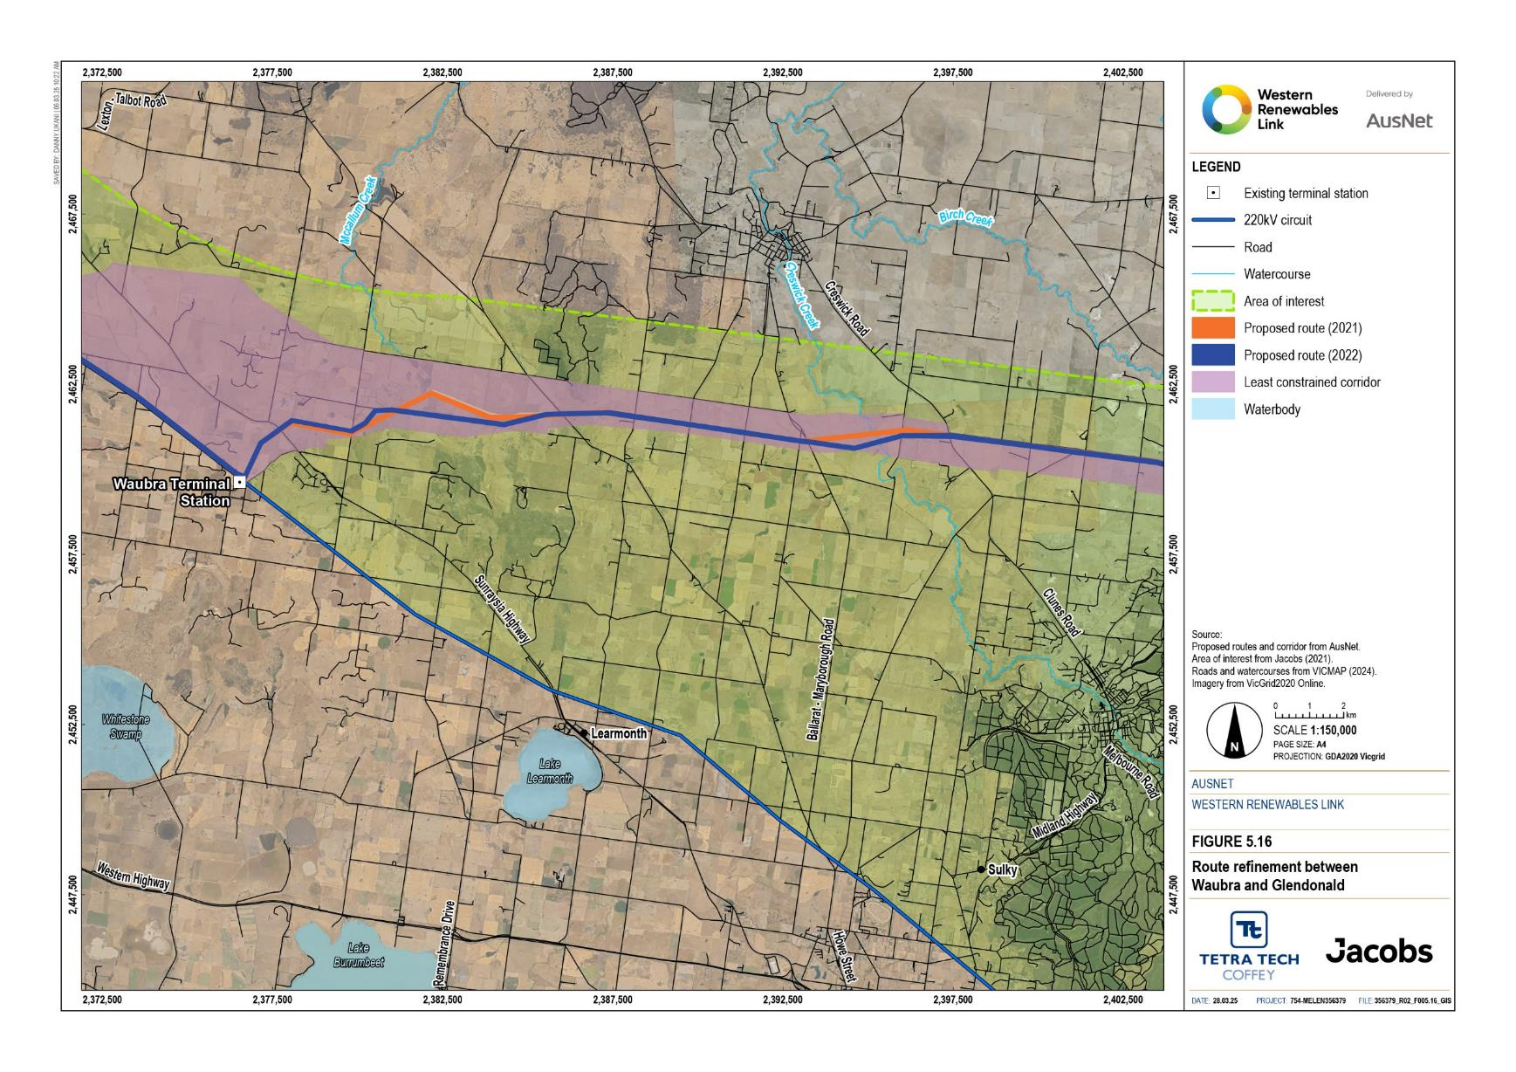
Figure 5.16 Route refinement between Waubra and Glendonald
Mount Prospect to Darley
Route refinements were considered for Bolwarrah, Mount Steiglitz to Korjamnunnip Creek, Myrniong, Darley military camp area and Merrimu Reservoir to respond to landholder requests while minimising environmental, cultural and social impacts.
This section of the Proposed Route, as shown in Figure 5.17, contains bushland with potential habitat for Greater Glider, listed as endangered under the EPBC Act, Powerful Owl and other native fauna including koala. There is also challenging terrain, the historic Darley military camp area and potential for Aboriginal cultural heritage. The Proposed Route avoids and minimises impacts to these values through the narrow area between Darley and the Lerderderg State Park.
The Proposed Route in this section:
- Minimises impacts on heavily vegetated areas east of Moorabool River West Branch with potential for Aboriginal cultural heritage
- Maximises use of cleared land east of Moorabool River West Branch and avoids a large cluster of endangered Brooker’s gums however other clusters of Brooker’s gums in this area are still impacted
- Minimises impacts on native vegetation and potential habitat for Greater Glider, listed as endangered under the EPBC Act, as well as Powerful Owl and other threatened and native species
- Avoids the wetland adjacent to the Moorabool River West Branch, which is potential habitat for Growling Grass Frog
- Reduces visual impact through screening in the Tooheys Close area
- Reduces the visual scale of towers from Myrniong township through increased distance between the transmission line and the town
- Locates the transmission line in an area where it will be screened or ﬁltered in views from a greater distance along Mt Blackwood Road
- Is more effectively set against the backdrop of forested hills and ridges of the Lerderderg State Park reducing visual impacts on adjacent houses
- Minimises impacts on the area of cultural sensitivity associated with Myrniong Creek with potential for Aboriginal cultural heritage
- Avoids impacts on the signiﬁcant biodiversity values of Long Forest
- Avoids impacts on Aboriginal cultural heritage, including artefact scatters
- Maximises distance to residential properties south of the Diggers Rest–Coimadai Road including those along Symington Road and Moonah Drive
- Crosses Diggers Rest–Coimadai Road east of the Coimadai Avenue of Honour to avoid impacts on this community asset and potential associated social impacts
- Avoids potential impacts on any future Merrimu Reservoir dam wall upgrade works
- Minimises impacts on Southern Rural Water’s existing quarry operations.
While aiming to minimise impacts on bushland, including Lerderderg State Park, Wombat State Forest and Long Forest Flora and Fauna Reserve, the Proposed Route, does not avoid all areas of biodiversity value completely. The Proposed Route has been moved approximately 1km north-east toward Lerderderg State Park, further away from Myrniong. The Proposed Route aims to minimise impacts to areas of Aboriginal cultural heritage sensitivity along and adjacent to Myrniong Creek. The Proposed Route is close to the Korkuperrimul Creek but maintains a separation from the creek to reduce potential impacts on areas of Aboriginal cultural heritage sensitivity.
The Proposed Route was realigned to the south near Moorabool River West Branch to reduce impacts on native vegetation including large old habitat trees and habitat for threatened species, areas of Aboriginal cultural heritage sensitivity along and adjacent to the Moorabool River, and impacts to local wetlands.
Following engagement with impacted and surrounding landholders, the Proposed Route was realigned to the north between Haydens Hill Road and Calway Lane. The change will reduce the visual impact from houses near Tooheys Close by increasing the distance and screening from trees between the houses and the Proposed Route. Modiﬁcations between Calway Lane and McHughs Road were made to reduce impacts on several freehold bushland properties. Near Paddock Creek, updates were made to reduce impacts on houses, visual amenity and land use.
Due to the proximity of the township of Darley to the Lerderderg State Park, the hilly terrain and the constraints in the area, there is the potential an overhead transmission line in this segment would result in a high landscape and visual impact for the town’s residents when looking toward the Lerderderg State Park. For these reasons, a southern route, options for impact mitigation and localised underground construction, have been considered at Darley. This is discussed further in this section (Darley southern route) and also in Section 5.3.7.
A southern route has also been investigated at Darley to minimise impact on Melbourne Yellow Gums identified along the route. This is discussed below in the section titled ‘Darley southern route’.
The Proposed Route has been realigned to the north of Diggers Rest–Coimadai Road and the Merrimu Reservoir dam wall, avoiding the reservoir pumphouse and associated infrastructure. The revised Proposed Route crosses the Diggers Rest–Coimadai Road closer to, but avoiding, the Merrimu Reservoir picnic area and memorial, and Coimadai Avenue of Honour. Views from the picnic area across the reservoir will be impacted by this change. There is an opportunity to improve the views through landscaping which will be explored with the owner, Southern Rural Water, and memorial and picnic user groups. The Proposed Route will avoid newly identiﬁed Aboriginal cultural heritage south of the Diggers Rest–Coimadai Road.
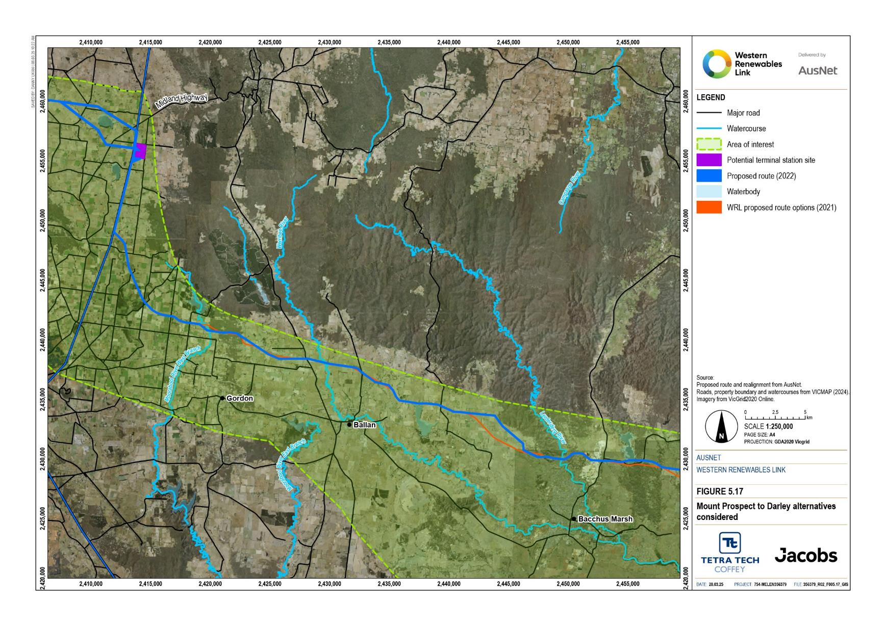
Figure 5.17 Mount Prospect to Darley route refinements considered
Waubra and Mount Prospect terminal station connections
The May 2023 NEVA Order required an uprate of the entire Project to 500kV. Prior to this, the segment from Waubra to Bulgana was 220kV, which therefore required connection to the Waubra Terminal Station that is located on the existing 220kV line and adjacent to the Waubra wind farm. With the uprate to 500kV, the connection to the Waubra Terminal Station was no longer required so route refinements were investigated in the Waubra area. The terminal station north of Ballarat at Mount Prospect was also no longer required with the uprate of the Project. As a result, the Proposed Route was adjusted around the former terminal station location and where the Proposed Route joins the existing Ballarat to Bendigo transmission line easement. Tower location and access track changes were also made in response to landholder feedback and technical specialist advice.
AusNet worked directly with landholders to the north of the Waubra Terminal Station within the corridor area to identify possible routes. Key considerations for selecting a revised route includes avoiding impacts to houses, agricultural land use, the Waubra wind farm, the natural landscape including Mount Beckworth, Mount Bolton and Mount Ercildoun, volcanic cones which are recognised places of Aboriginal cultural heritage significance, and native vegetation and habitat.
Rather than following the existing 220kV transmission line and connecting into the existing Waubra Terminal Station as previously proposed, the Proposed Route was realigned to the north of the existing Waubra Terminal Station. The new Proposed Route departs from the existing 220kV transmission line heading east along Forest Road, across the Sunraysia Highway and through the Waubra wind farm. It re-joins the existing Proposed Route north of Glendaruel, as shown in Figure 5.18. The Waubra route refinement was publicly released in May 2024.
Compared to the other route options investigated north of the Waubra Terminal Station, the chosen realignment:
- Affects less properties
- Reduces land use impacts by following property boundaries where practicable thereby reducing diagonal cuts of paddocks, maintaining adequate separation from Waubra wind farm turbines and avoiding an Extractive Industry Interest Area (for granite, sand and clay)
- Avoids historic cultural heritage (McPhee’s Hut ruins) located south of Coutts Road
- Potentially affects Aboriginal cultural heritage associated with the volcanic cones. The presence of multiple volcanic cone landforms is indicative of the potential for Aboriginal cultural heritage to be present within the area
- Reduces biodiversity impacts by avoiding areas with potential threatened species and threatened species habitat, and increasing separation to Mount Bolton and running on the west side of Coghills Creek Road to increase separation to Mount Beckworth, thereby reducing collision risk associated with local and predatory bird populations
- Reduces bushfire risk in vicinity of Lexton and Mount Beckworth (Coghills Creek Road) as it helps to address egress issues and enables continued use of Coghills Creek Road in fire responses.

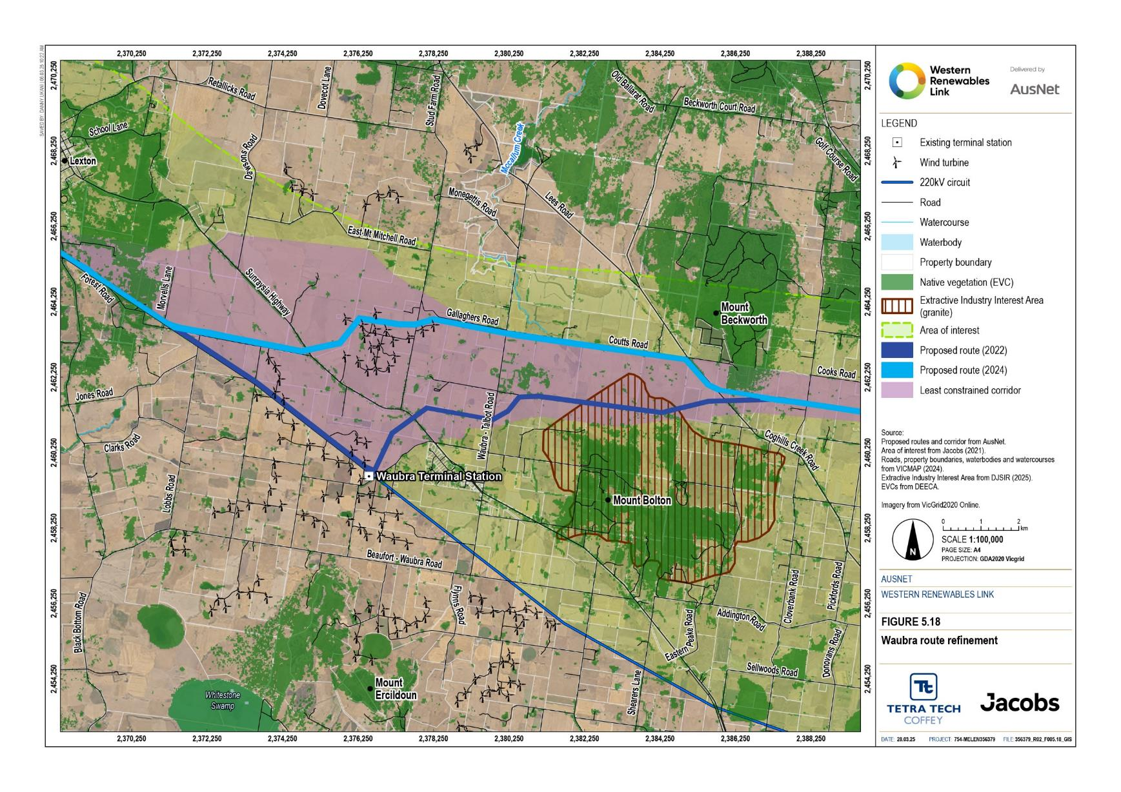
Figure 5.18 Waubra route refinement
Darley southern route
The Proposed Route runs immediately south of the Lerderderg State Park north of Darley (Darley northern route). In this location there are a number of species listed under the FFG Act which includes a large population of Melbourne Yellow Gum with other species such as Bacchus Marsh Wattle and Austral Tabacco, and other habitat for threatened ecological communities.
The biodiversity values were identified through surveys and estimates on private property that was not able to be accessed south of the Lerderderg State Park. Melbourne Yellow Gums have been recorded in various locations from Korkuperrimul Creek in the west, through to Djerriwarrh Creek in the east, with some planted individuals around MacPherson Park, Melbourne. There is potential for further individuals to be present in the broader area and within the Lerderderg State Park.
Prior to the survey undertaken as part of the Project, the previously known population of Melbourne Yellow Gums was approximately 600 recorded across the state as registered in the Victorian Biodiversity Atlas. Approximately 3,000 individuals have now been located as part of the Project surveys.
AusNet’s existing Vegetation Management Plan (Electricity Transmission Network) details maintenance of and requirements for clearance spaces for the Project. The Plan considers minimum clearances and fuel load requirements around transmission infrastructure required to comply with the Electricity Safety Act 1998 and Electricity Safety (Electric Line Clearance) Regulations 2020 to provide for safe and reliable operation and manage fire risks associated with fuel density.
AusNet has existing processes in place for management of vegetation of significance that will apply along the Proposed Route, including along the northern route through Darley. A site-specific vegetation management plan within AusNet’s overarching Vegetation Management Plan for all transmission assets is required for this area to manage ongoing operational requirements to protect the identified biodiversity values, including the population of Melbourne Yellow Gum. This management plan will also meet the AusNet’s requirements under the Electricity Safety Act 1998 and associated Regulations on safe and reliable operation of the asset. This requirement is documented in the Project’s Environmental Performance Requirements (see Chapter 29: Environmental Management Framework).
A review was undertaken by AusNet and its technical specialists considering existing topography (LiDAR), transmission line design, specific site information against AusNet’s Vegetation Management Plan to define safe clearances and fuel load requirements around infrastructure with maintenance requirements. This review resulted in an increased understanding of existing topography in immediate area and clearance heights to define what areas of native vegetation could be retained and what was required to be removed to support safe and reliable operation of the Project. Limited vegetation removal is required in areas to facilitate construction of towers, which includes establishment of an access track for specific towers, and defined areas where minimum clearances are required under the transmission lines for safe operation. Trimming of trees would be undertaken in accordance with AusNet’s existing vegetation and easement management practices, and a site-specific vegetation management plan would be developed for this area to clearly outline the approval requirements and ongoing management of vegetation. Following implementation of these avoidance, mitigation and management measures through the Project’s design process, the biodiversity impacts of the Proposed Route in this area being investigated for partial undergrounding (Section 5.3.7) have been substantially reduced, including reduced impacts on threatened flora species (Melbourne Yellow-gum, Bacchus Marsh Wattle and Fragrant Saltbush) and the threatened ecological community Grey Box (Eucalyptus microcarpa) Grassy Woodlands and Derived Native Grasslands of South-eastern Australia. The estimated native vegetation loss has been reduced from the preliminary estimate of approximately 25ha to 12ha. There is potential to further reduce this vegetation loss estimate and associated impacts through implementation of Environmental Performance Requirements, particularly BD1 (Chapter 29: Environmental Management Framework). AusNet will explore opportunities to undertake similar reviews for other specific areas along the Proposed Route with significant biodiversity values noting the site-specific conditions at Darley, particularly topography and existing vegetation cover, are the key factors in the ability to maintain safe clearances and fuel densities.
The alternative route developed to avoid the threatened vegetation communities of Lerderderg State Park is shown in Figure 5.19. The landscape and visual impacts of this alternative southern route were investigated by assessing photomontages of multiple viewpoints within Darley of both the alternative and proposed routes. Both routes are north of Darley and on land in the Farming Zone, starting from a similar location west of Swans Road and join at a similar location, west of Lerderderg Gorge Road. The southern route included two alternatives: a route using double circuit steel lattice towers, and a route using pairs of single circuit steel lattice towers.
A southern route at Darley was considered to avoid and further minimise impacts to biodiversity values present in the area.
The key issues with the alternative southern route at Darley included that:
- The alternative southern route was closer to a number of existing residential dwellings and the residential area of Darley, increasing potential visual impacts
- The alternative southern route still has native vegetation impacts and also impacted areas of agricultural land
- The alternative southern route was not as steep and more favourable for construction
- Potential for Aboriginal cultural heritage values to be encountered in area.
Based on the assessment and the findings of the more detailed review of the Project design against AusNet’s vegetation management practices, the alternative southern route at Darley was not progressed and the Proposed Route in this section remained unchanged.
Partial undergrounding was also investigated at Darley as underground cables have potential to reduce visual and biodiversity impacts. The options considered for an underground route in this section are discussed below.

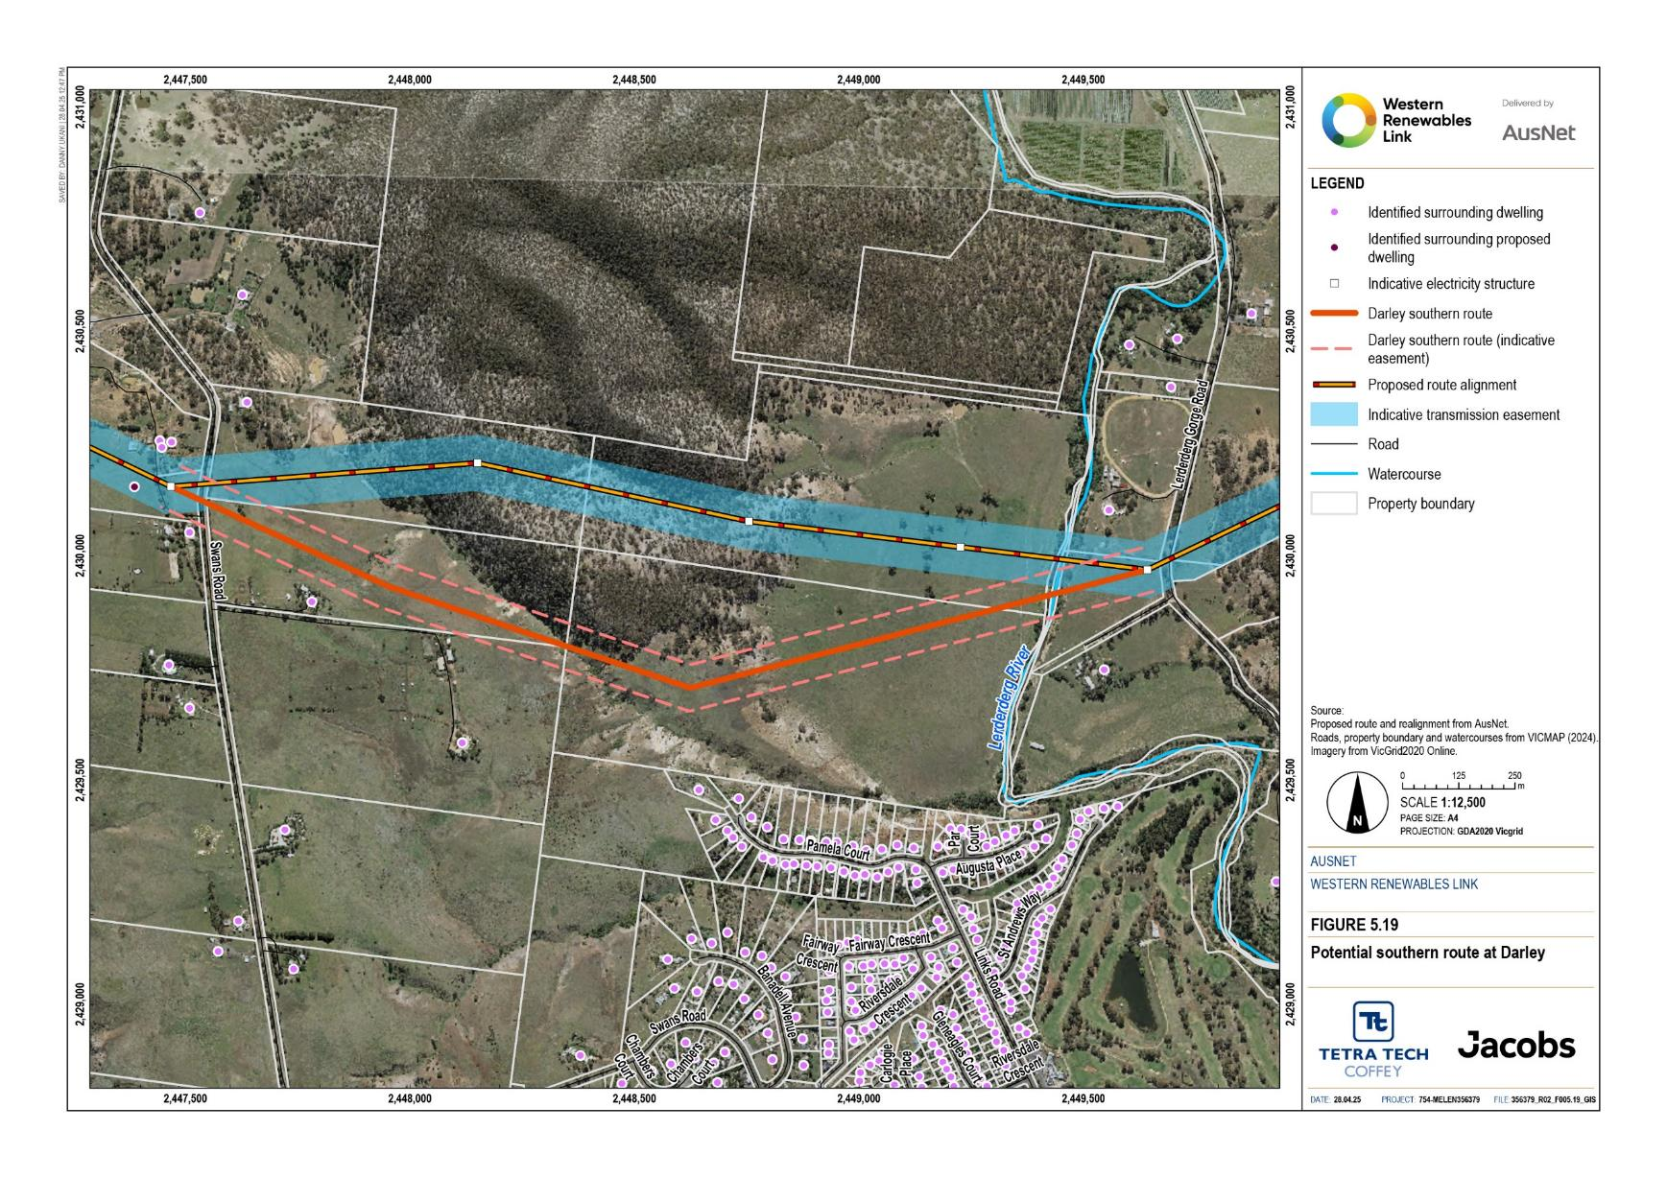
Figure 5.19 Potential southern overhead transmission line route at Darley

Partial undergrounding at Darley
Partial undergrounding as a Project alternative has been assessed in the Darley area. Following this assessment, it was determined that the Proposed (overhead) Route and other mitigation options are preferred given that while the partial underground routes minimise biodiversity and visual amenity impact they result in other impacts due to their increased ground disturbance, and partial undergrounding does not align with the Project objectives (Section 5.1.2) given the materially higher cost and associated Project delays.
The Project development approach adopted to avoid and minimise adverse impacts during design is as follows:
1. Progressive refinement of the area of interest to least constrained corridor and adoption of route selection criteria which are designed to avoid (or minimise where avoidance is not possible) environmental, cultural and social impacts of the Project and guide the design of the Proposed Route
2. Identify measures to avoid and minimise impacts along the Proposed Route, for example siting infrastructure such as towers and access tracks to avoid site-specific environmental, cultural and social values and establishment of no-go zones
3. If residual impacts remain high following (1) and (2) then investigate alternative overhead routes (see section Darley southern route)
4. If there are no feasible alternative overhead routes that avoid or minimise impacts then investigate alternative designs such as partial undergrounding if partial undergrounding may allow for further avoidance and minimisation of impacts.
The Darley area warranted an investigation of partial undergrounding options due to:
- The type of impacts expected in this location and the expected level of impact:
  - The residential areas located on the north-facing slopes of Darley were expected to experience the greatest visual impact when compared to other dwellings along the alignment. Many dwellings in this area have been established to take in views of the vegetated hills within the Lerderderg State Park to the north. Partial undergrounding has potential to reduce visual impacts.
  - The Proposed Route runs immediately south of the Lerderderg State Park north of Darley. In this location there are a number of species listed under the FFG Act which includes a large population of Melbourne Yellow Gum with other species such as Bachus Marsh Wattle and Austral Tabacco, and other habitat for threatened ecological communities. Partial undergrounding along a different route may allow for avoidance or minimisation of impacts to biodiversity values in this area.
- Overhead transmission line route refinement was explored for this area (see section Darley southern route) however is constrained by existing built infrastructure and space is limited to achieve separation from residential dwelling from new overhead transmission infrastructure.
- Community members at Darley raised concerns with the potential visual impacts of the Project and requested investigation into underground construction in this section. This concern was supported by the findings of the initial technical specialist assessments involved with the route options assessment which identified it to be a highly constrained section with high level of impacts.

Partial underground routes
High voltage alternating current (HVAC) partial undergrounding was investigated at Darley as it is much lower in cost over a short distance compared to high voltage direct current (HVDC) cable, which requires converter stations. Transition stations would be required at each end of the underground segment to enable the overhead transmission line conductors to be connected to the underground cables.

The partial underground option also requires construction of concrete conduits and joint pits at typically one to two metres below ground, and the joint pits will need to be accessed for maintenance. Trenchless construction methods would be used if geotechnically feasible and required to avoid major assets and sensitive areas. Easement restrictions would apply to protect the underground cables restricting some land uses. The easement could be in the order of 25m wide.
To understand the possible impacts and costs associated with partial undergrounding, five potential partial underground routes were identified at Darley. As a partial underground option has different construction requirements to an overhead transmission line it generally requires a different route. There are challenges with underground routes at this location due to the terrain and land use constraints associated with steep topography and settlement.
Key considerations for developing the patrial underground routes included:
- Topography and geology
- Avoiding and minimising impacts to environmental, cultural and social values
- Available space for up to a 40m wide construction corridor and space to accommodate the use of horizontal directional drilling where required to avoid impacts
- Location of third-party infrastructure
- Technical considerations such as avoiding sharp bends, avoiding steep slopes, crossing roads and other linear infrastructure or features at right angles, accessible locations for joint pits in operation.
As the technical considerations for the proposed partial underground cable are different to those for an overhead transmission line, the routes would be in different locations.
The identified potential partial underground routes at Darley are described in Table 5.6 and shown in Figure 5.20.
Table 5.6 Description of potential partial underground routes assessed at Darley
Option | Description
Route 1 (4km) | Route 1 commences west of Swans Road above Korkuperrimul Creek where a transition station would be located. Korkuperrimul Creek is deeply incised and narrow. The creek and valley are most effectively crossed using overhead construction. This route passes around and between houses on Swans Road and the prominent ridge extending east from that road to the steep slope that extends to the Lerderderg River floodplain. The potential route runs perpendicular to the slope to the valley floor which it crosses to the Lerderderg River. Crossing the river and Lerderderg Gorge Road, the route runs to and along the toe of the escarpment forming the eastern edge of the valley. The route crosses the escarpment to the transition station adjacent to Camerons Road.
Route 2 (4.2km) | Similar to potential partial underground route 1, except at the steep slope west of the Lerderderg River valley, this route option continues along the prominent ridge passing a house to the potentially less severe spur adjacent to Darley. The route follows this spur to the Lerderderg River floodplain where it joins and follows potential partial underground route 2 to the Camerons Road transition station site.
Route 3 (7.3km) | This route is the same as potential partial underground route 1 to near Camerons Road where it continues northeast, then east to the sand quarries. The route follows the existing road and adjacent hardstands through the infrastructure area of the quarries, after which it turns east to cross Gisborne Road to the transition station between that road and Bences Road.
Route 4 (4.2km) | Route 4 follows the existing access track and then proposed access road to the unmade extension of Swans Road. Swans Road and Robertson Road are less steep than the slopes northwest of Darley. The route follows these roads to and across the Lerderderg River. After crossing the river, the route passes between houses and crosses Lerderderg Gorge Road to enter the sand quarry site. The route runs along the western boundary of the quarry to the transition station site at the toe of the escarpment being mined.
Route 5 (5.9km) | This route is the same as potential partial underground route 4, except route 5 commences at the Swans Road transition station. From the transition station the route runs along the Swans Road ridge, west of houses fronting that road to the Bald Hill Activation Project site. The route follows potential partial underground route 4 to the Goodman Creek transition station adjacent to the sand quarry.

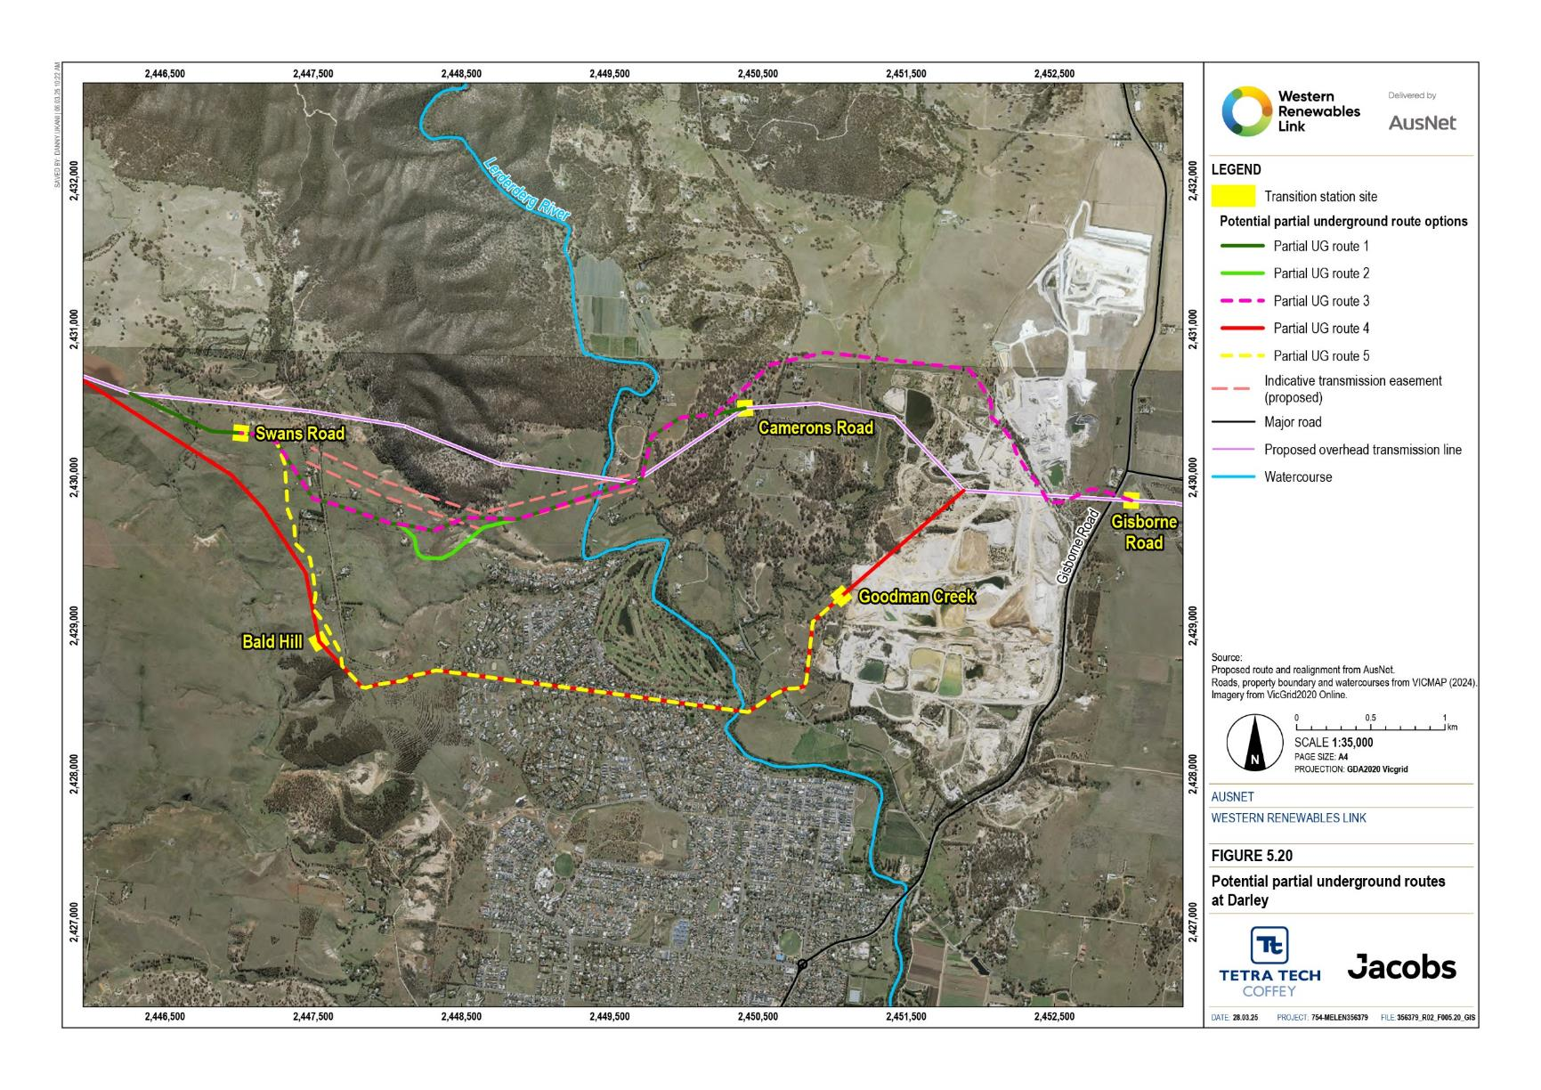
Figure 5.20 Potential partial underground routes at Darley

Evaluation of partial underground routes
As potential underground route 1 is a variation on potential underground route 2, and potential underground route 3 had substantial construction, operation and maintenance constraints, these two routes were not considered further. Potential underground routes 2, 4, and 5 were evaluated.
The evaluation considered possible environmental, social and cultural impacts from these partial underground options compared to the overhead transmission line route and a summary of findings is provided in Attachment I: Project development and assessment of alternatives.
Key findings from the evaluation of the potential partial underground routes compared to the overhead route include:
- The partial underground routes involve more ground disturbance than the proposed overhead route given the substantially smaller area required to construct tower footings compared to trenching. As a result, partial underground routes have higher potential impacts as follows:
  - The significantly reduced area of ground disturbance required for the overhead route minimises the impact on potential Aboriginal cultural heritage values by a very significant degree when compared to the underground routes.
  - The overhead route is expected to result in minimal direct impacts to waterways and water quality as the overhead transmission line overflies watercourses and riparian vegetation to avoid disturbance. The excavation of underground cable trenches on unvegetated steep slopes and/or the Lerderderg River for the partial underground routes has potential for direct and indirect impacts to local waterways, including erosion and sedimentation, water quality impacts and impacts to aquatic values.
  - Groundwater impacts are lower for the overhead route due to the nature of construction, that is, piling for tower foundations versus trenching of the underground cables. Groundwater impacts of the overhead route are expected to be negligible with implementation of standard controls. For the partial underground routes, the assessment identified sections that may encounter groundwater. Groundwater inflow to trenches would require groundwater extraction to create dry conditions for construction which has the potential to reduce availability of groundwater to groundwater dependent ecosystems and groundwater users. Groundwater impacts of the partial underground routes are expected to be unlikely to minor noting site-specific assessments are required to confirm potential impacts.
  - From a contaminated land perspective, construction of the tower footings for the overhead route would result in significantly less spoil volume compared to trenching for the partial undergrounding routes, noting that all routes traverse areas where potentially contaminated soils and/or groundwater may be present from historical gold mining activity or suburban development. The potential for exposure to contaminated materials having an adverse impact on human health or the environment is higher for the partial underground routes.
- The potential partial underground routes either traverse the Darley township or are in close proximity to its residential areas due to the avoidance of Lerderderg State Park and terrain and land use constraints in the area. As a result, partial underground routes have higher potential impacts as follows:
  - Partial underground routes are expected to have higher impacts to residential amenity during construction due to their location within or in proximity to the Darley township and residential areas, and construction method of open trenching and trenchless drilling.
  - Partial underground routes would result in increased heavy vehicle traffic through the Darley town centre during construction, with some of the route options requiring lane closures and diversions which would likely reduce amenity and accessibility for local residents and businesses for a period of between six to nine months. Construction of the overhead route would be outside of the Darley township, with minimal impact on roads or contribution to traffic.
- Some partial underground routes reduce the following impacts more effectively than the proposed overhead route:
  - While the greater ground disturbance associated with underground cables typically results in greater biodiversity impacts, the potential partial underground routes at Darley were specifically designed to avoid native vegetation and therefore result in less biodiversity impacts than the overhead route. The overhead route is estimated to require greater native vegetation removal (preliminary estimate of approximately 25ha refined to approximately 12ha) than the partial underground routes (1.3 to 3ha) of generally higher quality than the more degraded areas traversed by the partial underground routes, and includes Melbourne Yellow Gums. The overhead route will also result in the fragmentation of the southern extent of forested habitat contiguous with Lerderderg State Park. As discussed in Section 5.3.6, further detail (Project design, site specific conditions, AusNet’s existing vegetation management practices) were considered to refine the preliminary estimate for the overhead route and identify opportunities to avoid and minimise impacts of the overhead route to native vegetation, trees and threatened species in this area.
  - Partial underground routes are expected to have less visual amenity impact than the overhead route during operation due to the removal of prominent structures from public and private views of Lerderderg State Park from locations in the northern areas of Darley, noting many dwellings were established to take in these views to the north. The transition station would be visible and prominent from dwellings along Camerons Road and elevated locations.
  - From a bushfire perspective, the partial underground routes have fewer impacts during operation. Overhead routes pose constraints on bushfire responses in the immediate vicinity of the transmission lines and access and egress issues associated with failure of a tower or fallen conductors during a bushfire event. The probability of tower collapse or conductor fall occurring at the same time as a significant bushfire event affecting the area in vicinity of the Project is exceedingly low, and further assessment of the Proposed Route (including the overhead route in Darley) determined that the residual impact is low in the Lerderderg Gorge Road area, north of Darley, and very low in other areas with application of controls (Technical Report K: Bushfire Impact Assessment). The primary controls for access and egress impacts are intended to prevent failure of a tower or fallen conductor under reasonably foreseeable extreme wind conditions or due to other forms of structural failure. The primary controls include adherence to AS/NZS design standards, the placement of all towers outside of public road reserves and the placement of towers typically at sufficient distances from fire access routes and fire control lines. In addition, the operation of the transmission line requires the implementation of AusNet’s Electricity Safety Management Scheme and Asset Management Scheme, including the Bushfire Mitigation Plan.
  - Partial underground routes 4 and 5 have lower historic impacts than the overhead route and partial underground route 2 as they do not intersect with any known historical heritage place, including Darley military camp.

Potential cost and timing of partial undergrounding
Generally, installing high voltage underground cables costs more than placing them overhead. The main cost difference relates to the higher cost of materials and construction, including the cost of the two transition stations which are required for the partial underground routes. The Project Assessment Draft Report (AEMO, 2018) concluded that an underground project was expected to cost ‘up to 10 times more per kilometre’ than an overhead transmission line. The Amplitude report commissioned by Moorabool Shire Council (Amplitude, 2021) states that the conceptual HVDC underground project they assessed would cost approximately 5 times more than the equivalent overhead HVAC transmission line option.
AusNet engaged quantity surveyors to prepare an independent cost estimate of a conceptual partial underground section of the Project at Darley. The cost of a HVAC overhead transmission line from Sydenham to Bulgana with a 5km section of HVAC partial undergrounding cable in Darley would cost approximately 1.4 times the total cost of the equivalent end-to-end HVAC overhead transmission line (2023 dollars). The cost estimate represents a point in time only and represent 2023 dollars. The costs have not been updated to reflect current costs.
Currently, there are a limited number of companies in the world able to manufacture underground cables at 500kV. Unlike low voltage underground cables used in rural residential and residential subdivisions, high voltage cables at the voltage required for the Project are bespoke (project specific) designs that need to be ordered and allocated a manufacturing slot. In contrast, overhead transmission line conductors are manufactured to standard specifications for the voltage and power transfer requirements. The bespoke (project specific) design of underground cables, the limited number of manufacturers, and number of projects currently in planning, design and construction are limiting the supply and resulting in increased cost.
Based on supplier information, partial undergrounding could take two to three years to design and install (excluding civil works). Partial undergrounding would also have assessment and approval requirements including environmental and heritage surveys further to what has been completed for the Project to date which would extend the timeframe for construction commencement for the Project.

Conclusion
Partial undergrounding was investigated at Darley given the high visual amenity and biodiversity impacts expected in this area and given the proximity of the Lerderderg State Park and other dwellings in the area an alternative overhead route with less constraints and potential impacts was not identified. Underground construction provides opportunities to potentially reduce these impacts. Underground construction requires vegetation clearance within the construction footprint therefore following the same route as the overhead option would not reduce the high biodiversity impacts. Alternative routes that avoid native vegetation were investigated.
While the partial underground routes were determined to reduce some impacts (biodiversity, visual amenity, bushfire and historic heritage) they introduce other impacts or transfer impacts to other areas which are affected by the increased ground disturbance required for trenching (Aboriginal cultural heritage, surface water, groundwater and contaminated land) and location of the routes within or in close proximity to the Darley township and its residential areas (traffic and transport, amenity). For example, while all overhead and underground routes pass through areas of Aboriginal Cultural Heritage Sensitivity, the significantly reduced ground disturbance area for the overhead route lessens the impact on potential heritage values by a very significant degree when compared to underground routes. Other more targeted mitigation options are available to avoid and minimise impacts of the overhead route such as siting of towers and access tracks to avoid biodiversity values, establishment of no-go zones to protect vegetation of significance and landscape screening to filter views and minimise visual amenity impacts. Other mitigation options include application of site-specific vegetation management plans which require maintenance of understorey vegetation and limit clearing to canopy trees only with minimal disturbance to the understorey where safe clearances and fuel load and density can be maintained, re-establishment of tree hollows in adjoining habitat, and re-establishment of native vegetation in areas that are not required to be maintained clear of native vegetation during operation of the Project (e.g. temporary access tracks).
A key differentiator in the evaluation was the preliminary estimate for native vegetation clearance required for the routes, with the estimate for the overhead route being highly conservative and assuming a generally 100m width impact area. As discussed in Section Darley southern route, further investigations were undertaken and measures explored to avoid and minimise the biodiversity impacts of the overhead route in this area. This included a review of existing topography (LiDAR), transmission line design (tower locations and height, span length etc.), site specific information (surveys, inspections and photos) and AusNet’s Vegetation Management Plan to define safe clearances and fuel load requirements around infrastructure with maintenance requirements. This review identified what vegetation within this area could be retained and therefore substantially reduced the estimated vegetation loss in this section of the Proposed Route from the preliminary 25ha to approximately 12ha. This includes reduced loss of threatened flora species such as Melbourne Yellow-gum and a threatened ecological community. There is potential to further reduce this vegetation loss estimate and associated impacts through implementation of Environmental Performance Requirements, particularly BD1 which requires additional surveys, design modifications and establishment of no-go zones to further avoid and minimise biodiversity impacts (Chapter 29: Environmental Management Framework).
Partial undergrounding at Darley would cost more and take longer to deliver. Installing high voltage underground cables costs more than placing them overhead due to the cost of the transition stations required and the cost of underground cables. Quantity surveyors engaged by AusNet estimated the cost of a HVAC overhead transmission line from Sydenham to Bulgana with a 5km section of HVAC partial underground cable in Darley would cost approximately 1.4 times the total cost of the equivalent end-to-end HVAC overhead transmission line (2023 dollars). Under the current regulatory framework, project costs are passed through to consumers. There are also challenges in sourcing bespoke (project specific) high voltage underground cables as there are a limited number of companies in the world able to manufacture them. Based on supplier information, partial undergrounding could take two to three years to design and install (excluding civil works) and require further time for assessment and approvals. Partial undergrounding does not align with Project objectives (Section 1.3) as it would not be cost-effective and compared to the proposed Project would not be able to be delivered in a timely fashion to meet the urgent need for additional transmission capacity.
The overhead route is preferred given that: while the partial underground routes minimise biodiversity and visual amenity impact they result in other impacts due to their increased ground disturbance; other more targeted mitigation options are available to avoid and minimise impacts; the cost of undergrounding is materially higher than overhead transmission lines and; there is limited availability of bespoke (project-specific) high voltage underground cables which would result in Project delays.
Partial undergrounding was not investigated in other locations considering the Project development approach adopted to avoid and minimise adverse impacts outlined above in this section and given that no other locations are expected to experience as high visual amenity and biodiversity impacts as the Darley area or be as constrained by existing built infrastructure and dwellings that limit alternative overhead route options. Impacts have been avoided and where avoidance is not possible, minimised, through route selection including assessment of alternative routes and route refinements (see sections • through to 5.3.6).
Locations supporting higher biodiversity values that were not able to be avoided include bushland areas at Lexton, Haydens Hill, and Lerderderg – Long Forest. Impacts in the Haydens Hill (near Bolwarrah) and Long Forest (near Merrimu Reservoir) bushland areas could not be avoided by use partial undergrounding as the native vegetation largely runs north-south while the Proposed Route runs east-west, the location of existing infrastructure and dwellings means there are limited opportunities to avoid intersecting and underground construction through vegetated areas results in biodiversity impacts. Underground construction would require clearance of all the native vegetation in the construction corridor for trenching, and deep-rooted trees would not be able to be grown in the underground cable easement during operation. Installing underground cables may impact tree roots, extending the impact beyond the trench and the construction corridor. Transition stations either end of the partial underground cables would also increase the disturbance footprint and create other impacts. Route refinements to avoid and minimise impacts have occurred in these locations (Section 5.3.6 Mount Prospect to Darley). In Lexton there is an area of native vegetation intersected by a small length of the Proposed Route (approximately 1km) of an over 50km section of the Proposed Route that is co-located with an existing 220kV transmission line. Co-locating with the existing transmission line reduces the overall disturbance footprint and impacts to adjacent landholders. The proximity of Lexton township constrains alternative partial underground routes to the north, and routes to the south that avoid the bushland areas would require a longer line length, development of two transition stations and would result in other impacts including increased ground disturbance, bringing the Project closer to dwellings to the south and require several more crossings of watercourses/drainage lines. Other biodiversity values along the Proposed Route, such as smaller patches of native vegetation, scattered trees, waterways and other habitat features, are more dispersed and therefore not suitable for partial undergrounding which requires one defined section of underground cable with transition stations at either end.
Other types of mitigation have also been identified during the EES process, such as siting infrastructure (e.g. towers and access tracks) to avoid site-specific values, retention of understorey vegetation (partial clearance) and establishment of landscape screen from public and private views. Impact reduction will continue through later stages of Project design planning including reducing required vegetation removal through additional surveys and subsequent modifications to design and establishment of no-go zones.

The Proposed Route assessed in the EES
The Proposed Route was developed through progressive refinement as set out in Section 5.3.6 to avoid and minimise impacts identified by technical assessment and stakeholder and landholder requests for design refinement. In some instances, the results and requests have resulted in route realignment outside the corridor. The key objective in refining the route is impacts overall will not be greater than impacts associated with the Proposed Route.
AusNet will continue to consider requests from directly affected landholders and communities in relation to further refinement of the Project elements and design.
Figure 5.21 shows the Proposed Route that has been assessed in the EES. A detailed description of the Project design along this route is provided in Chapter 6: Project description.
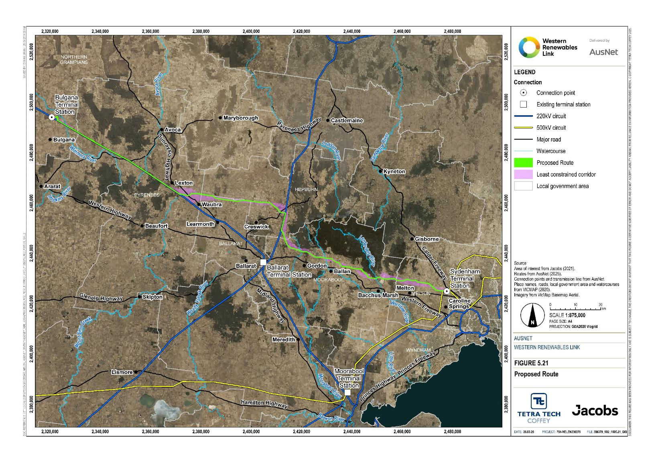
Figure 5.21 Proposed Route

Siting other Project components

New terminal station
The Project requires a new terminal station at Bulgana to enable connection into the existing network and to enable connection of other transmission lines to the Project.
The requirement for a new 500kV terminal station at Bulgana, rather than upgrading the existing Bulgana Terminal Station, was determined following the May 2023 NEVA order. A summary of the site selection and evaluation process is provided below with further detail documented in Attachment I: Project development and assessment of alternatives.
The key objectives for selecting a new site for the terminal station include:
- Proximity to the existing Bulgana Terminal Station with suitable main road access
- Providing future opportunities for connections into the grid including VNI West
- Minimising social, environmental and heritage impacts.
As part of the EES, technical specialists developed a range of criteria to inform site selection. An area of investigation was defined by proximity to the existing Bulgana Terminal Station and being to the north of the existing Ballarat to Horsham 220kV transmission line. The site selection was also informed by consultation with directly affected landholders.
A number of constraints were identified in the area of investigation around the existing Bulgana Terminal Station. These included the proposed Watta Wella renewable energy project, residential dwellings, the Joel Joel Nature Conservation Reserve and its associated Bushfire Management Overlay, and waterways with associated floodplains that form the headwaters of the Wimmera River.
Site selection criteria and evaluation
The criteria for selection the new 500kV terminal station site at Bulgana included:
- Site size to accommodate the ultimate layout and provide for future expansion
- Connection to the existing Bulgana Terminal Station without constraining future connections
- Proximity to the existing Ballarat to Horsham 220kV transmission line to enable consolidation of infrastructure
- Connection opportunities for future transmission lines
- Land access
- Resources tenure and avoiding extractive industries
- Existing land use and capability, planning zones and overlay
- Site access
- Constructability (geology, required earthworks)
- Exposure to natural hazards such as floods, inundation with water, and bushfire
- Proximity to residential dwellings
- Biodiversity
- Bushfire risk
- Aboriginal and historical heritage
- Amenity impacts to sensitive receptors
- Third party infrastructure
- Contaminated land and other environmental considerations.
Six sites were identified within four km of the existing Bulgana Terminal Station and assessed against each of these criteria, as shown in Figure 5.22 and summarised below.
- Option 1: The overall site suitability is low. The site cannot accommodate the ‘ultimate layout’ for the terminal station and there is limited opportunity to expand the site. There is a higher likelihood of Aboriginal cultural heritage being present on-site relative to the other site options.
- Option 2: The overall site suitability is moderate. Construction of a terminal station at this site would require watercourse diversion, as part of the site is within the Six Mile Creek floodplain. The site has good access off Vances Crossing Road but is less desirable as it intersects multiple properties rather than a single property, and is within the proposed Watta Wella wind farm boundary.
- Option 3: The overall site suitability is low. The site is located within the Six Mile Creek floodplain and would require imported fill to create a benched area. Construction at this site would have an impact on flood water behaviour caused by a reduction in the storage capacity of the floodplain.
- Option 4: The overall site suitability is moderate. The site has limited capacity for expansion and is constrained by the proposed Watta Wella wind farm.
- Option 5: The overall site suitability is moderate. The site is less desirable than other sites due to its remoteness from the existing Bulgana Terminal Station and Ballarat to Horsham 220 kV transmission line. However, the site provides maximum opportunities for expansion and is located on a separate land parcel.
- Option 6: The overall site suitability is high. The site is remote from the existing Bulgana Terminal Station, but close to the existing Ballarat to Horsham 220 kV transmission line. It provides maximum opportunities for expansion and is on a separate land parcel. The site does not however enable connection of VNI-West.
Preferred site
Options 5 and 6 rated higher than the other options. Options 5 and 6 were assessed as both being equally suitable for a new 500kV terminal station against the site selection criteria, and both are located in separable land parcels providing maximum opportunities for expansion. Option 6 rated slightly better than Option 5 because it was closer to the existing Ballarat to Horsham 220 kV transmission line. However, further investigation confirmed that Option 6 could not accommodate the connection with VNI West. Option 6 was therefore ruled out on this basis, and Option 5 was carried forward as the preferred option.
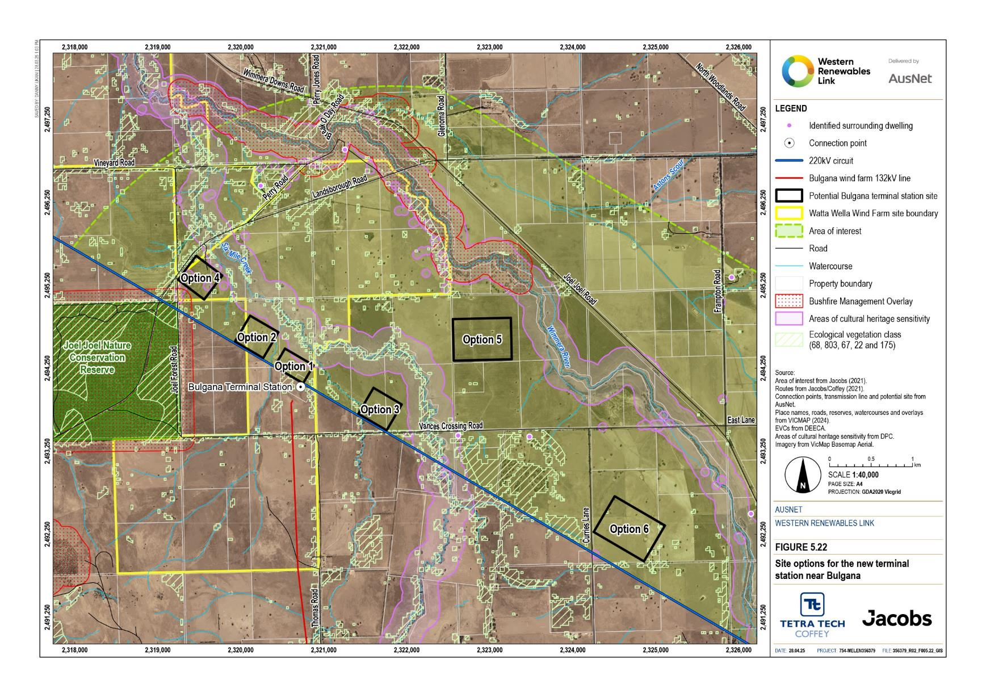
Figure 5.22 Site options for the new terminal station near Bulgana

Laydown areas and workforce accommodation facilities
Multiple temporary laydown areas are required to support construction of the Project, as the Project spans 190km between Bulgana in western Victoria and Sydenham at the western outskirts of Melbourne.

Laydown areas
Laydown areas are required at the three terminal stations (Bulgana, the new terminal station and Sydenham), and at additional intermediate locations along the Proposed Route. The intermediate laydown areas are required to store construction materials such as steel members for the towers and transmission line materials, and are located at approximately equal intervals along the Proposed Route to minimise travel times for fatigue management and achieve cost and logistics efficiencies for the Project. This includes minimising travel times and distances, while evenly spreading transport requirements and keeping traffic volumes (and particularly heavy vehicles) on local roads to a minimum. This is balanced with the need to minimise the overall number of laydown areas to minimise potential impacts on surrounding communities.
The key objectives for selecting the sites for the intermediate laydown areas were:
- To minimise the total number of laydown areas, which minimises duplication of facilities required at each laydown area.
- To locate each laydown area within reasonable proximity of regional towns and centres, within reasonable proximity of the Proposed Route, and with suitable main road access.
- To locate the laydown areas so they are spaced at approximately equal intervals along the Proposed Route, providing a balance between minimising the number of laydown areas required and the need to provide adequate coverage along the Proposed Route
- To locate the laydown areas in low bushfire risk locations
- To avoid material social, environmental and heritage impacts to the greatest extent practicable, including via the lease of private land with minimal to no environmental values, or industrial or commercial land or Council or Agency-owned land which is already highly modified, together with avoidance of impacts on known social, environmental and heritage values identified through technical reports and community and stakeholder engagement
- To locate the laydown areas on properties available for lease or purchase from willing landholders.
Taking into consideration these objectives, it was determined that two intermediate laydown areas would provide an optimal solution for the Project. This was the minimum number of intermediate laydown areas required along the Proposed Route to achieve logistical efficiencies for the Project. With two intermediate laydown areas, the preferred location for each would be approximately one-quarter to one-third of the way along the Proposed Route from each end, for example, around the Lexton and Bacchus Marsh areas.
The assessment has considered that each intermediate laydown area site would need to be at least two to four hectares in size. Together with the key objectives listed above, this size requirement was used to identify potential candidate laydown area sites. The following were also taken into consideration in identifying candidate sites:
- Flat land was preferred over undulating land as this would reduce or avoid the need for cut and fill
- The planning zones and overlays should be those where a site facility or laydown area is permissible without the need for planning approval to avoid impacts to matters protected in relevant zones and overlays
- The site should be located to avoid impacts on sensitive receptors (in particular, dwellings) and community facilities (in particular, schools) to avoid issues with traffic and truck movements
- The site should avoid land that is designated as being of cultural heritage sensitivity
- The site should ideally be highly modified and require minimal rehabilitation after its use
- The site should be close to a regional township or close to the Project. The former provides a greater likelihood of finding appropriately zoned land (for example, industrial land), while the latter reduces potential traffic impacts by reducing travel distances
- Adjoining land uses should be considered to ensure they generate minimal dust which can impact on conductors and equipment that would be stored at the laydown areas
- The site should ideally contain an already constructed hardstand area.
AusNet also consulted with relevant local Councils to identify potential candidate sites. This included consideration of potential opportunities to select a site which could be transformed into a community or Council asset following completion of construction noting that the lack of opportunities identified meant this was not further progressed and is not considered by the Project as described in Chapter 6: Project description. Given the key objectives, site size requirements and additional considerations listed above, 19 potential candidate sites were identified, and in some cases discounted from further assessment. Detail on the assessment of each site is provided in Attachment I: Project development and assessment of alternatives.
Of the 19 identified sites, Site 8 (private farmland, Ballan) and Site 15 (Farming Zone land, Lexton) were shortlisted for further investigation. These two sites together would provide one site in the western half and one site in the eastern half of the Project.
Following the shortlisting of these sites, a new landholder in Lexton expressed interest in leasing their property to AusNet for a laydown area (Site 20 – Farming Zone, Lexton). A review of this site confirmed it met the key objectives and may be preferable to Site 15 in Lexton as it did not require clearing of tree roots and debris, nor did it require construction vehicles to pass through the township of Lexton to travel between the laydown area and the Project work sites. Both Site 15 and Site 20 were carried forward for more detailed investigation. A further site was later identified as meeting the key objectives and potentially suitable (Site 21 – private farmland, Mount Lonarch). The four shortlisted sites (Sites 8, 15, 20, and 21) were carried forward for further investigation.
This further investigation comprised of technical specialists completing a largely desktop review supplemented by targeted biodiversity and Aboriginal cultural heritage field investigations for each of the four potential sites, considering:
- Land use planning and amenity
- Transport and access
- Biodiversity
- Aboriginal cultural heritage
- Surface water quality and hydrology
- Bushfire risk
- Noise and vibration.
Following assessment of the four potential sites against these aspects, each was determined to be suitable to establish a laydown area. Each site had sufficient available land with suitable terrain and topography to accommodate the required infrastructure. Each site was suitably located in proximity to the main road network and had good accessibility to the Proposed Route for construction. Further detail on the evaluation of site options, which included consideration of co-located workforce accommodation facilities and laydown areas as discussed in the section below, is provided in Attachment I: Project development and assessment of alternatives. Site 8 (Ingliston Road, Ballan) and Site 20 (Sunraysia Highway, Lexton) were carried forward as the preferred options for assessment in the EES and are shown on Figure 5.23. Refer to the section below for a summary of reasons for selecting these two sites as the preferred options.
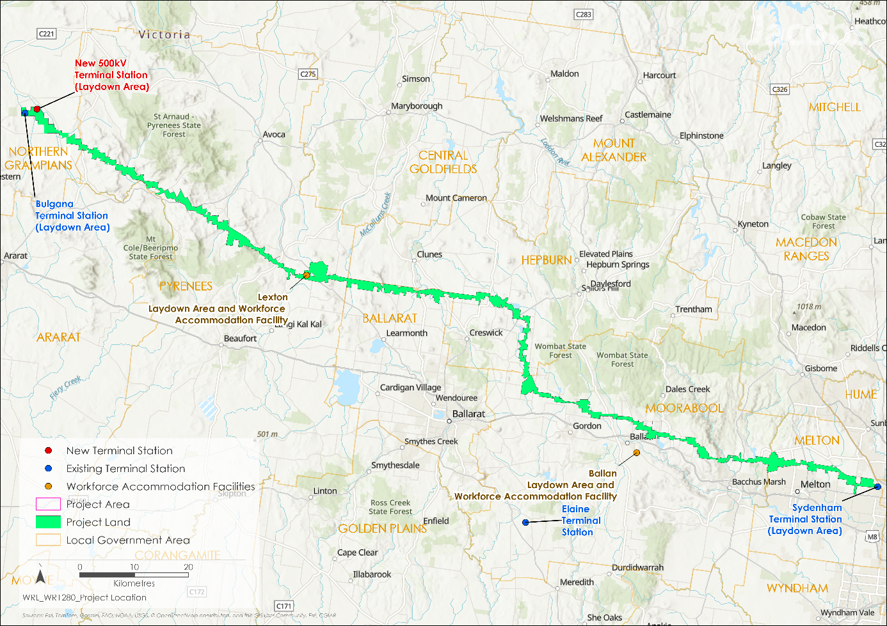
Figure 5.23 Project location including co-located laydown area and workforce accommodation facilities

Workforce accommodation facilities
AusNet has sought to minimise effects on visitor accommodation and affordable rental accommodation due to increased demand from the Project construction workforce. As such, the Project proposes to establish dedicated workforce accommodation facilities (to be co-located with laydown areas at Site 8 (Ingliston Road, Ballan) and Site 20 (Sunraysia Highway, Lexton) to service the east and west sections of the Project.
The need for dedicated workforce accommodation facilities was confirmed following an investigation into existing accommodation capacity available at specific locations along the Proposed Route. The preferred locations were Lexton in the western half, and Ballan in the eastern half of the Proposed Route, as these locations were each approximately halfway between either end and the middle of the Proposed Route. As discussed for laydown areas, these locations help achieve cost and logistics efficiencies for the Project, and minimise travel times and distances, while evenly spreading transport requirements and keeping traffic volumes on local roads to a minimum.
As an alternative to dedicated workforce accommodation facilities, available accommodation capacity at Lexton and Ballan was investigated using Australian Bureau of Statistics 2016 and 2021 Census data, active bond data, and search results from Airbnb.com, realestate.com and bookings.com. The investigation confirmed that neither Lexton nor Ballan has sufficient available accommodation to cater for the peak construction workforce requirements of approximately 350 personnel in each location. The two locations together had an estimated four properties (11 total bedrooms) available.
Although Lexton and Ballan were ideal locations to accommodate the construction workforce, other potential locations were investigated, including Ararat and Stawell, as these could avoid the need to construct a dedicated accommodation facility in the western half of the Project (while not being close enough to reliably service the eastern half of the Project). Together, Ararat and Stawell were estimated to have 66 properties (335 total bedrooms) available and could potentially meet all or most of the peak workforce demand in the western part of the Project. However, utilising this amount of accommodation for all or most of the two-year duration of Project construction, would remove large amounts of stock from the market for a significant period of time, meaning other uses, such as business travel and tourism, would be significantly impacted. Further, the locations of Ararat and Stawell are sub-optimal for servicing the western end of the Project, being located an additional 25-to-35-minute drive beyond the western end of the Project and Bulgana, and resulting in progressively increasing driving times with increasing distance along the Project to the east. Increasing driving times are of high importance to the siting of workforce accommodation facilities given the health and safety risk of fatigue, and the requirement for the Project to manage workforce fatigue. These locations also provide an acceptable solution for the eastern section of the Project.
Ballarat was another alternative location that was considered. It was identified as a location that could potentially have sufficient available accommodation for all or a substantial proportion of the peak Project construction workforce. However, Ballarat was ruled out as, despite its central location, it would have resulted in unacceptable driving times when Project personnel would be required to work toward the eastern or western ends of the Proposed Route.
The potential effect of the Project’s construction workforce on demand for housing and community services surrounding the Proposed Route was identified in the development of Technical Report F: Social Impact Assessment. Given the peak construction workforce would be large (approximately 700 workers) and working in areas that are relatively sparsely populated, the construction workforce was identified as having the potential to result in severe social impacts relating to the potential demand for housing and community services. Together with the insufficient supply of available accommodation in preferred locations, the Project was amended to avoid these impacts through the incorporation of two purpose-built workforce accommodation facilities. Due to the very low availability of properties and beds and the potential for adverse social impacts on housing and community services, a hybrid arrangement whereby a significant proportion of the workforce was accommodated in existing available accommodation (and the remainder in the workforce accommodation facilities) was discounted. Alternative arrangements may be agreed with local authorities where there is potential for positive socioeconomic outcomes while avoiding and minimising potential negative social impacts, in accordance with the Project’s Environmental Performance Requirements (EPR SC1 – Chapter 29: Environmental Management Framework).
Siting of the workforce accommodation facilities considered the same key objectives as the laydown areas (see section above), with the additional consideration of workforce safety with regard to fatigue management. The objectives relating to siting in proximity to the Proposed Route and spacing at equal intervals along the Proposed Route act to minimise travel distances and hence safety risks related to driver fatigue. With the need for dedicated workforce accommodation facilities confirmed, and with the accommodation facilities and laydown areas sharing the same fundamental requirements with respect to their location, the sites already identified as potentially suitable for the laydown areas (Sites 8, 15, 20 and 21 – see section above) were re-assessed to confirm their suitability for co-location of laydown areas and workforce accommodation facilities. Co-location of workforce accommodation facilities and laydown areas was considered in the first instance rather than investigation of alternative sites for the accommodation facilities. Co-location was considered as it provides Project efficiencies additional to those sought through the site selection objectives for these Project components separately. That is, co-location avoids duplication of facilities and infrastructure that would be common to both the laydown areas and workforce accommodation facilities, such as meeting rooms, lunch rooms, toilet blocks, water tanks, generators, parking areas, walkways, fencing, gates, security and lighting. Co-location also avoids the need for construction personnel to travel between the accommodation facilities and the laydown areas prior to commencing work at Project work sites, further reducing potential traffic impacts and potential safety risks from driver fatigue.
Further detail on the evaluation of site options, which included consideration of co-located workforce accommodation facilities and laydown areas as discussed in the section above, is provided in Attachment I: Project development and assessment of alternatives. Site 8 (Ingliston Road, Ballan) and Site 20 (Sunraysia Highway, Lexton) were carried forward as the preferred options for assessment in the EES. Site 8 was the only shortlisted site in the eastern half of the Project and was confirmed to be suitable to meet the Project’s requirements. Sites 15, 20 and 21 were considered as options for the western half of the Project. Site 20 was preferred over Sites 15 and 21. When comparing Site 15 and Site 20, the comparative analysis demonstrates that Site 20 is further from the closest dwelling, Site 15 supports more significant biodiversity and surface water values, Site 20 has higher potential to support Aboriginal cultural heritage values, and Site 15 was subject to a higher bushfire risk. When comparing Site 20 and Site 21, both sites were rated similarly in many respects. Site 20 was ultimately preferred as it was further from the closest dwelling, was subject to a lower bushfire risk and posed a lower risk to surface water values.

Alternative transmission structures
AusNet has reviewed available tower types and the current technology to select the proposed Project design assessed in this EES. A summary of the key considerations and options assessed is provided below.
As described in Chapter 6: Project description, the main tower configuration for the Project is double circuit steel lattice towers, referring to the electrical circuits on either side of the tower. Of the three broad types of transmission tower structure types (lattice, pole, or guyed structures).
The Project considered the following when selecting the tower configuration for the Project:
- Lattice structures have a proven service life and have low maintenance requirements. The lattice structure is the most prevalent structure utilised for transmission lines globally, with most high voltage (220kV and above) transmission lines utilising lattice structures. Their prevalence means replacement or repair parts are readily available, compared to custom-based solutions such as monopole structures. They are versatile and high strength and can be constructed in difficult conditions such as poor ground conditions, limited access, and varying terrains.
- Monopole structures are rarely used at high voltages such as 500kV, are not currently used in Australia for 500kV and would require custom design. The service life of monopoles at high voltages can be uncertain and tend to be shorter than lattice structures. Monopoles are smaller in footprint and can be assembled quickly. At high voltages the smaller footprint of structures such as monopoles contributes towards a higher risk of corrosion.
- Guyed structures are also used less frequently. They are generally used as a lower cost solution over long distances of substantially flat terrain. Guy wires generally require a wider easement and have a larger restriction of movement around them due to a larger footprint.
Prior to the May 2023 NEVA Order, other tower types such as monopoles and single circuit steel lattice towers were also considered in areas of lower voltage (220kV) and areas with height restrictions, such as the Melton Aerodrome and Melbourne Airport. However, with the uprate of the whole Project to 500kV following the May 2023 NEVA Order, the Project no longer has long sections of lower voltage transmission lines and alternative structures for the 500kV lines are not preferred. Lattice structures, including the double circuit steel lattice towers proposed, remain the most suitable transmission tower type for the Project. Single circuit steel lattice towers are proposed in select locations including near the Melton Aerodrome and Melbourne Airport to improve safety and avoid impacts on existing ﬂight paths (see Section 5.3.6 for discussion of the route near Melton Aerodrome).

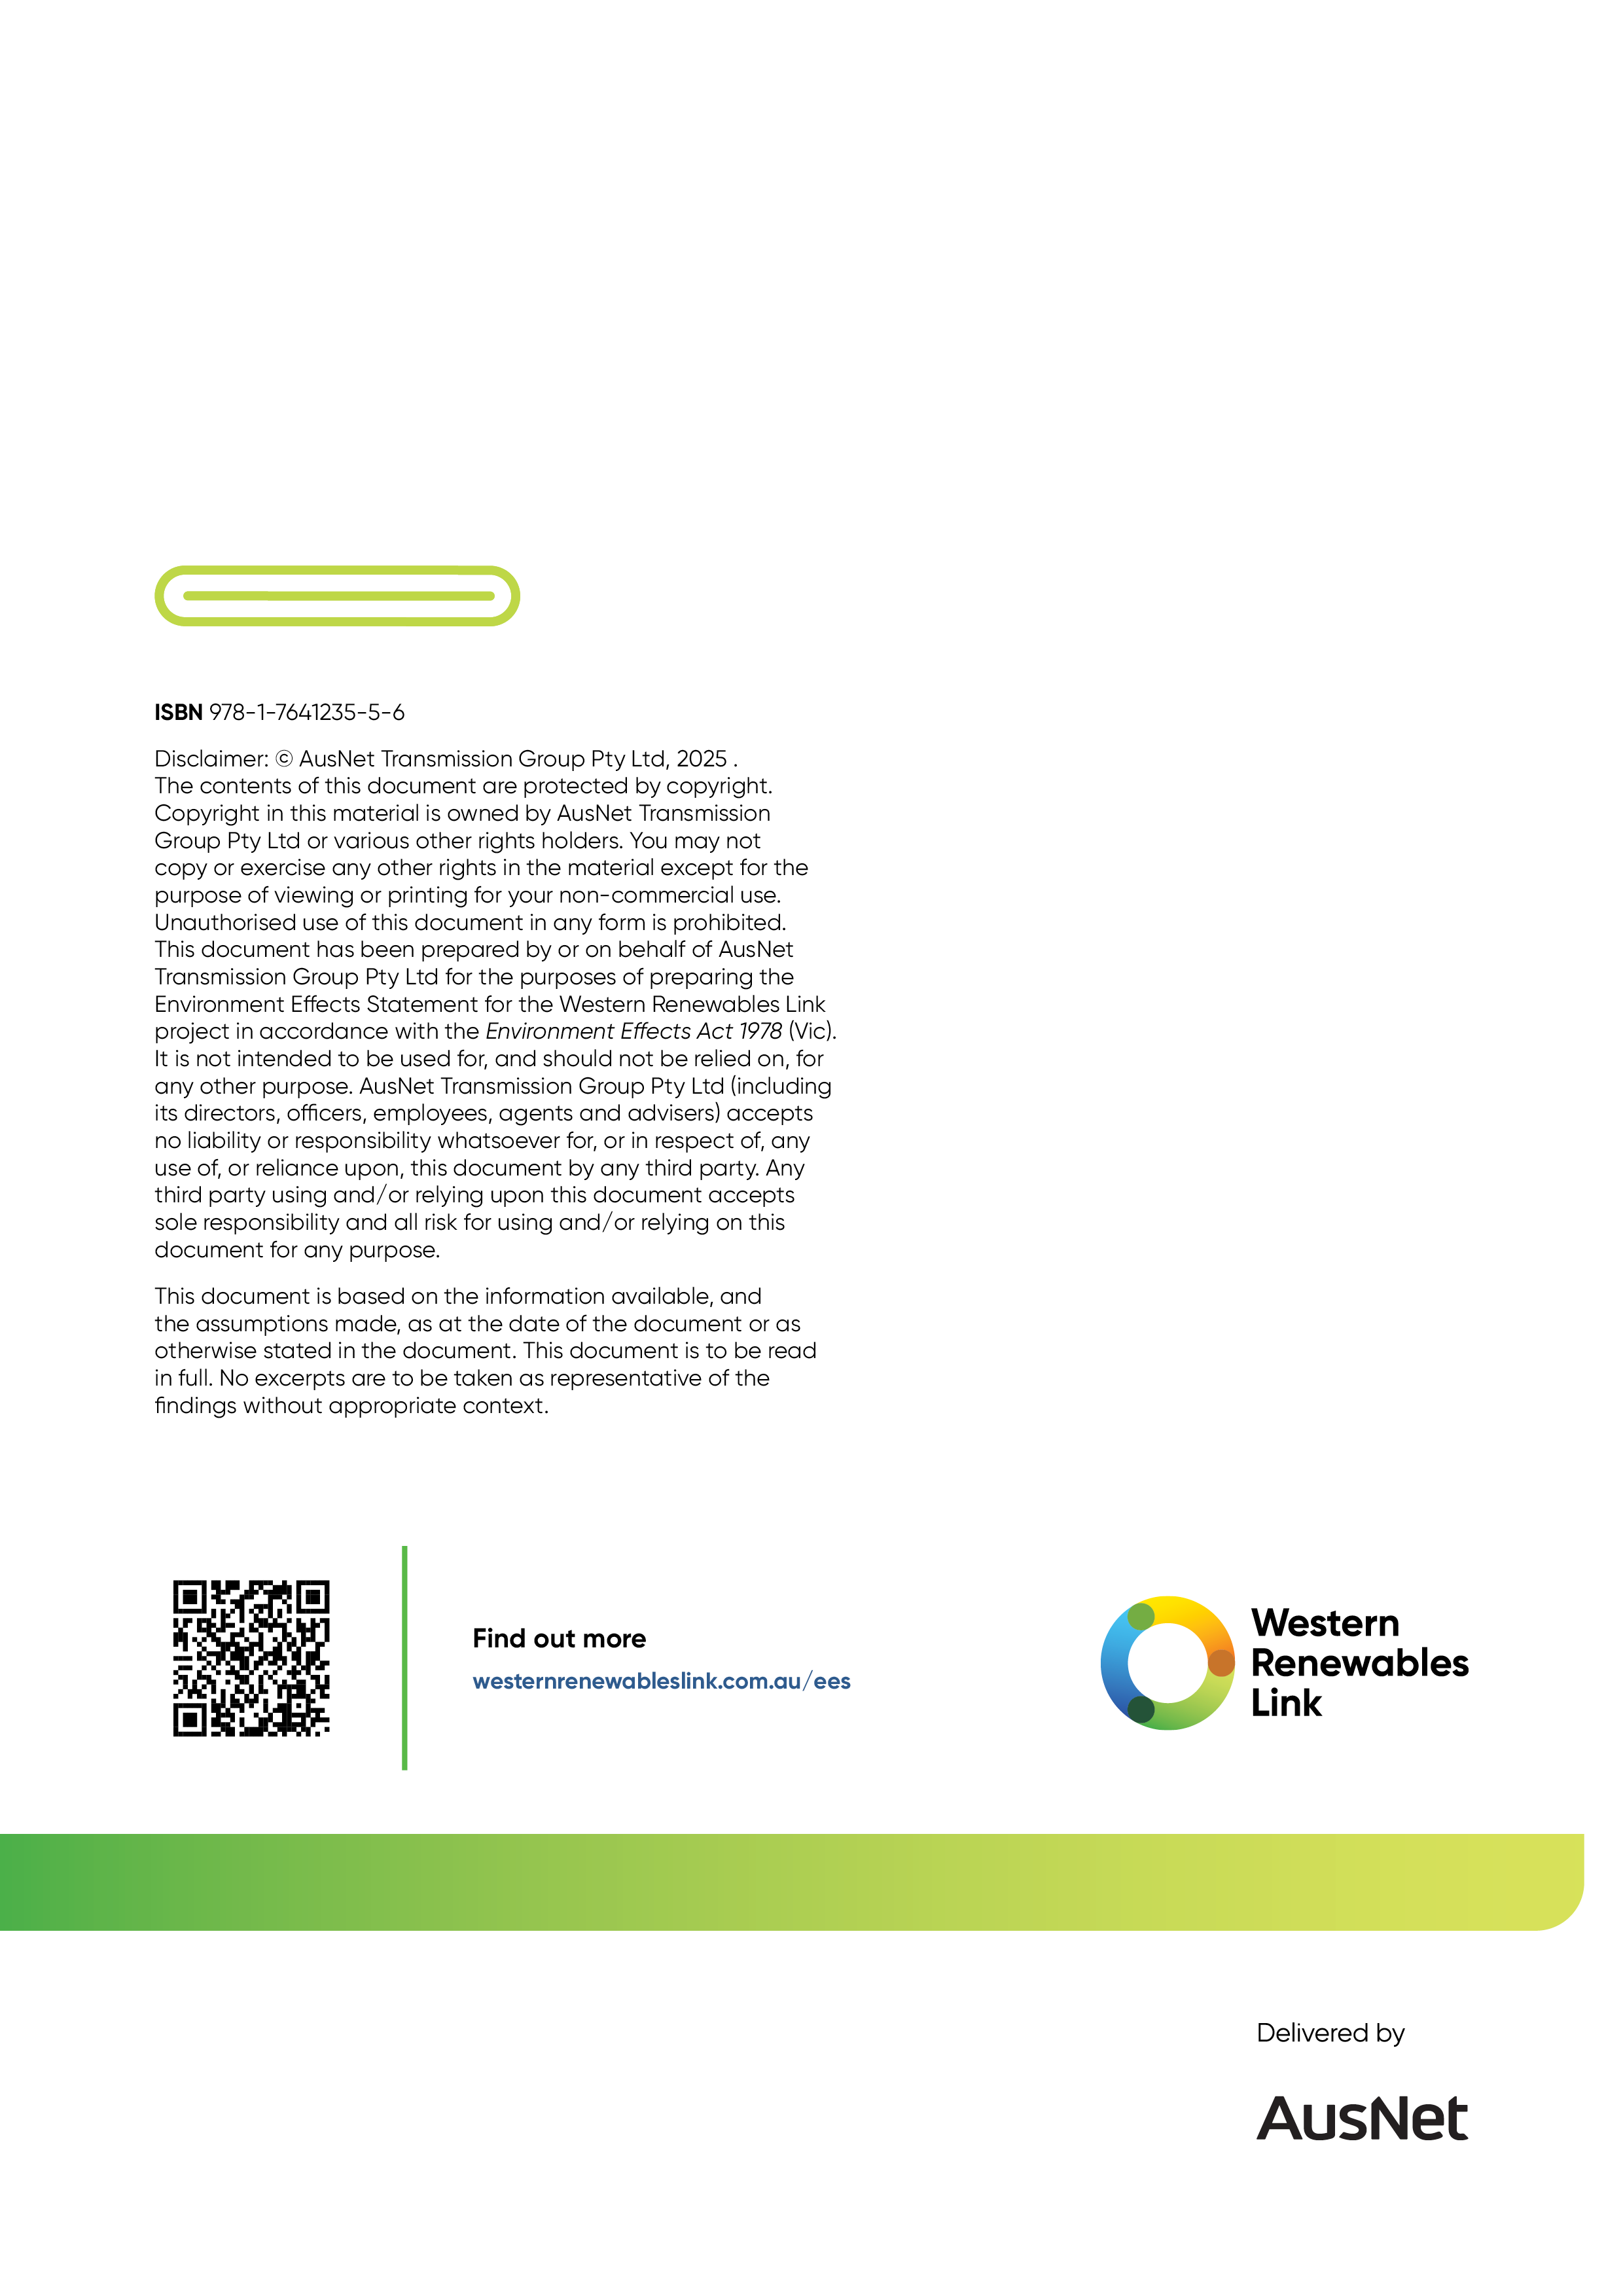

These three RIT-T reports and associated updates are published on the AEMO website: https://aemo.com.au/en/initiatives/major-programs/western-victorian-regulatory-investment-test-for-transmission.
Invitation to Tender is published on the AEMO website: https://aemo.com.au/-/media/files/electricity/nem/planning_and_forecasting/victorian_transmission/2019/call-for-expressions-of-interest-western-victoria-transmission-network-project.pdf?la=en&hash=D9764049FEE5039F13F4E56E68426DE8

