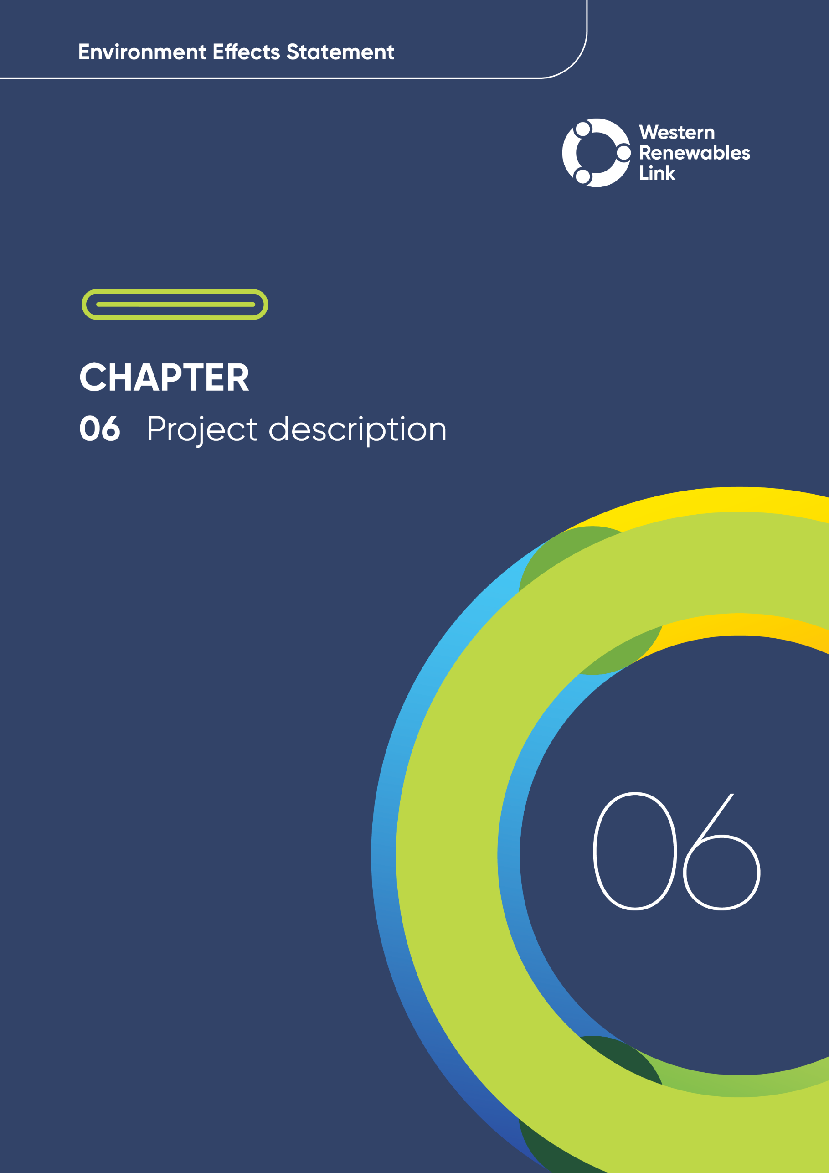

Document No. | Issue NO. | STATUS | APPROVER | DATE OF APPROVAL
[AAA 000] | V[00] | [Select One] | [Name Surname] | [Select Date]

NOTE: The above tables are mandatory during the development, review, and approval of the EES chapters.
These tables are to be removed prior to print & replaced with the completed approval table below.

Project description
This chapter outlines the Project’s design, infrastructure components, construction activities, operational activities and decommissioning requirements to enable the assessment of potential environmental effects. This chapter should be read in conjunction with Chapter 5: Project development and Attachment VI: Map book.
This chapter responds to Section 3.3 of the scoping requirements for the Project, issued by the Minister for Planning, which requires this Environment Effects Statement (EES) to detail:
- applicable standards and adopted specifications for transmission and terminal station infrastructure
- location, footprint, layout and access arrangements during construction and operation
- clearing or lopping of native vegetation for construction or operations
- design and expected construction staging and scheduling
- proposed construction methods and materials, and extent of areas to be disturbed during construction
- solid waste, wastewater and hazardous material generation and management during construction and operation
- rehabilitation of site works areas
- proposed tenure arrangements to provide for access for maintenance or other operational purposes
- lighting, safety, security, and noise requirements during construction and operation
- hours of construction work and a description of the expected duration of project components, including which components are temporary and which are permanent
- operational requirements including maintenance activities and decommissioning.
It is common practice for projects to change whilst undertaking the EES process in response to the recommendations of technical specialists to avoid and minimise impacts, and address issues raised by stakeholders. As such the Project’s design has evolved in response to technical investigations and matters raised by the EES Technical Reference Group, landholders, members of the public, community groups and other stakeholders in a range of forums where these refinements align with the Project objectives and assist in developing a Project that avoids environmental impacts or where avoidance is not possible, minimises impacts.
The Project as described in this chapter is the design assessed through the EES process. The Project’s transmission line components are described in more detail in Sections 6.2.1 to 6.2.3, while the terminal station works are described in more detail in Section 6.2.4 of this chapter. The potential construction activities and methods proposed for the Project are described in Section 6.6.
The Project description in this chapter is based on the design that has been developed for the Project. The Project description forms the basis of the impact assessments in this EES and has been used to develop the Environmental Performance Requirements (EPRs) for the Project. The EPRs set the environmental outcomes that must be achieved by the Project, regardless of the final design. Contractors tendering to construct the Project may offer alternatives to the Project’s design or proposed construction methods as described in the EES where these deliver better environmental outcomes, value for money or incorporate innovative approaches. However, any further refinements to the Project, must comply with the approved EPRs and any relevant approvals. Refer to Chapter 29: Environmental management framework for further information on EPRs and the process for management of design change.
AusNet is committed to employing environmental management strategies during all stages of the Project that meet legislative, regulatory and best practice requirements current at the time. The Project has been designed to meet the general environment duty under Victoria’s Environment Protection Act 2017 (EP Act) and achieve (at a minimum) the benchmarks set out in the EP Act’s Environment Reference Standards (see Chapter 3: Legislative framework and approval requirements for information about these requirements).
AusNet has guidance materials, procedures, manuals and other documentation that personnel and contractors are required to follow in the construction, operation and decommissioning of transmission lines, terminal stations and associated infrastructure. A number of these documents are required by regulatory authorities (such as Energy Safe Victoria (ESV) and are subject to approval by these authorities. A list of relevant AusNet documents is provided in Chapter 29: Environmental Management Framework.
Energy-related technical terms used in this chapter are defined in the Glossary and abbreviations.

Project overview
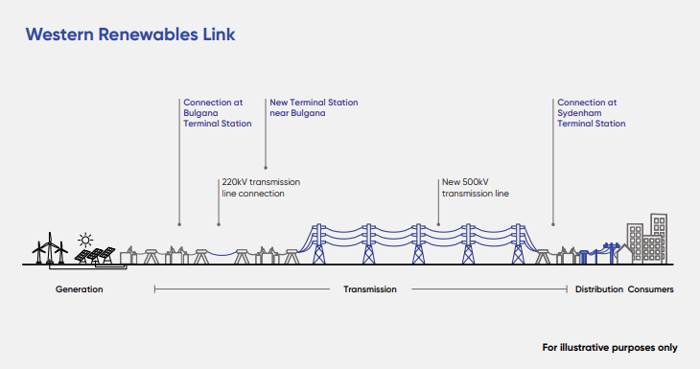
Figure 6.1 Western Renewables Link
The Project consists of a new overhead double circuit 500kV transmission line, approximately 190km long, from near Bulgana in Victoria’s west to Sydenham in Melbourne’s north-west. The Project includes the following works:
- The construction and operation of a new overhead double circuit 500kV transmission line from a new 500kV terminal station near Bulgana to the Sydenham Terminal Station
- The construction and operation of a new 500kV terminal station near Bulgana
- Expansion of the existing Bulgana Terminal Station and connection to the proposed new 500kV terminal station near Bulgana via a single circuit 220kV transmission line, comprising paired single circuit 500kV towers (i.e., 500kV towers strung with 220kV conductors)
- Connection works at the Sydenham Terminal Station including the modification of a bay and a bay extension with associated infrastructure
- Upgrade of Elaine Terminal Station, through the diversion of an existing line
- Protection system upgrades at connected terminal station sites.
The Project’s broad components are summarised in Figure 6.1 and the location is shown in Figure 6.2.
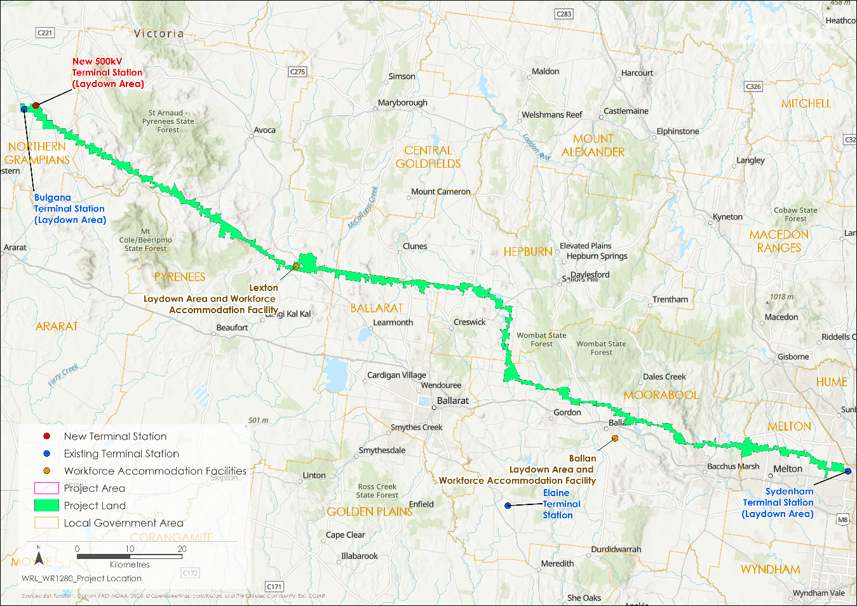
Figure 6.2 Project location and Proposed Route
The Project can be described by the following key area terms:
- Proposed Route: The Proposed Route is approximately 100 to 170m wide and encompasses the nominal future easement (including a buffer either side), and the terminal station areas. The Proposed Route was progressively refined from an initial area of interest as described in Chapter 5: Project development and is located within the Project Area.
- Project Area: The Project Area is contained within the Project Land and encompasses all areas that would be used to support the construction and operation of the Project. The Project Area is shown in Figure 6.2.
- Project Land: The Project Land encompasses all land parcels that could be used for the purpose of temporary Project construction and permanent operational components. The Project Land corresponds with the extent of the Specific Controls Overlay proposed in the draft Planning Scheme Amendment for the Project. This generally includes the entire land parcel intersected by a Project component. The Project Land is shown in Figure 6.2.
The Proposed Route commences at the existing Bulgana Terminal Station with a 220kV transmission line connection to the new 500kV terminal station approximately 2km to the northeast. The Proposed Route then runs from the new 500kV terminal station to the north of the existing Ballarat to Horsham transmission line, where it then runs parallel to the existing transmission line for approximately 60km. East of Lexton, the Proposed Route deviates from the Ballarat to Horsham transmission line, passing through the northern section of the Waubra Wind Farm between Mount Bolton and Mount Beckworth. Continuing east, the Proposed Route passes south of the Berry Deep Lead gold mining precinct and north of Allendale and Kingston. North of Kingston the Proposed Route turns southeast to Mount Prospect. From Mount Prospect to near Dean, the Proposed Route is adjacent to the existing Ballarat to Bendigo transmission line. Near Dean, the Proposed Route deviates from the existing transmission line to run south, then east through Bolwarrah, Bunding and Myrniong to Darley. The Proposed Route then continues eastward crossing Merrimu Reservoir north of Long Forest and along the northern boundary of MacPherson Park at Melton, connecting to the existing electricity network at the Sydenham Terminal Station.

Project infrastructure
The Project will install the infrastructure shown in Table 6.1 and detailed in Attachment VI: Map book.
Table 6.1 Project infrastructure – key components*
Double circuit 500kV lattice towers | 418 double circuit towers
Single circuit 500kV lattice towers** | 36 single circuit towers, 18 sets of two side-by-side
Approximate length of 500kV transmission line route | Approximately 190km, between near Bulgana in Victoria’s west to Sydenham in Melbourne’s north-west
Approximate length of 220kV transmission line route** | Approximately 2.5km, between the existing Bulgana Terminal Station to the new 500kV terminal station near Bulgana
Terminal stations | A new 500kV terminal station and associated infrastructure near to the existing Bulgana Terminal Station
 | An expansion of the existing Bulgana Terminal Station
 | A connection to the Sydenham Terminal Station, including the modification of a 500kV bay and a new 500kV bay extension with associated infrastructure
 | Relocation and diversion of existing 220kV transmission lines at Elaine Terminal Station
Approximate total length of all access tracks | 155km
* These figures are approximate and subject to final detailed design, which will consider further landholder consultation and geotechnical, site and other investigations.
** The 220kV transmission line route is assumed to be 8 sets of paired single circuit 500kV lattice towers (16 towers in total), strung with 220kV conductors.

Transmission towers
This section describes the overarching tower design and dimensions proposed to be used on the Project. Typical tower design is presented in this Project description to provide an overview of the form of these structures and to inform technical assessments. It is noted that the detailed tower design and associated steel member configuration is subject to refinement through the detailed design stage.
To develop the transmission line between Bulgana and Sydenham, transmission towers will be constructed, and the conductors (wires or lines) strung onto the towers along the Proposed Route. The transmission towers will support the overhead conductors at the required height above the ground to meet regulations and safety requirements. The towers are designed to carry the weight of the overhead conductors.
The siting of the Project’s tower locations has taken into consideration design and safety requirements, the need to avoid obstacles and the need to avoid or minimise effects on environmental, social and heritage values.
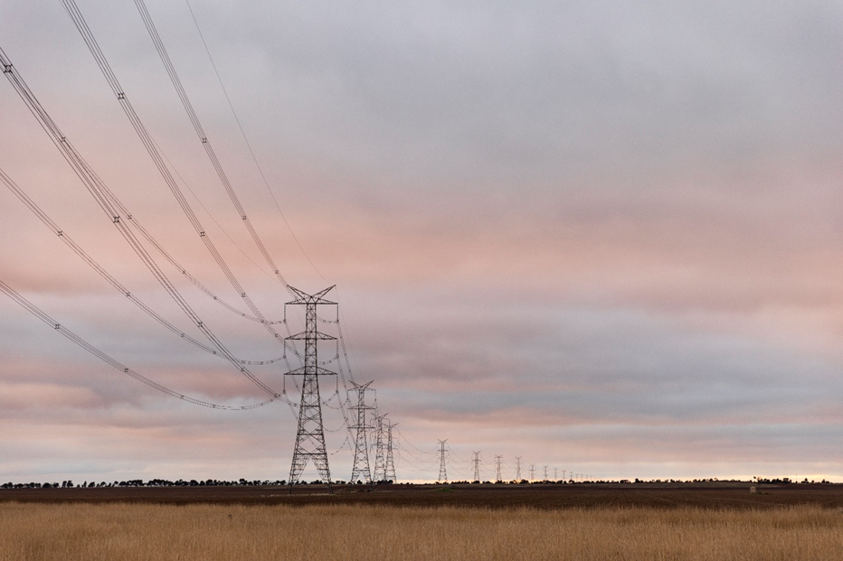
Figure 6.3 Example of a 500kV transmission line

Tower types and numbers
Table 6.2 provides a breakdown of the different tower types proposed to be used for the Project and the approximate numbers of each tower type for the Project.
Table 6.2 Transmission line tower types and approximate numbers*
Tower type | Quantity
500kV double circuit suspension tower | 328
500kV double circuit strain tower | 90
500kV single circuit suspension or strain tower (pair of towers)** | 36 (18 sets)
* These figures are approximate and subject to final detailed design, which will consider further landholder consultation and geotechnical, site and other investigations.
** The 220kV transmission line route is assumed to be eight sets of paired single circuit 500kV lattice towers (16 towers in total), strung with 220kV conductors.

Tower configuration

Double circuit towers
At the time of preparing this EES, the preferred tower configuration for the Project is double circuit steel lattice towers, similar to those found elsewhere across Victoria and within the national energy network and shown in Figure 6.3. They are called ‘double circuit’ towers as each tower supports two independent electrical circuits, one on each side of the tower.
An overview of the features of the double circuit steel lattice towers is shown in Figure 6.4. The towers are designed to meet the requirements of AS/NZS 7000:2016 Overhead Line Design, which sets the construction engineering requirements for the structural integrity of the towers and their associated footings and conductors.
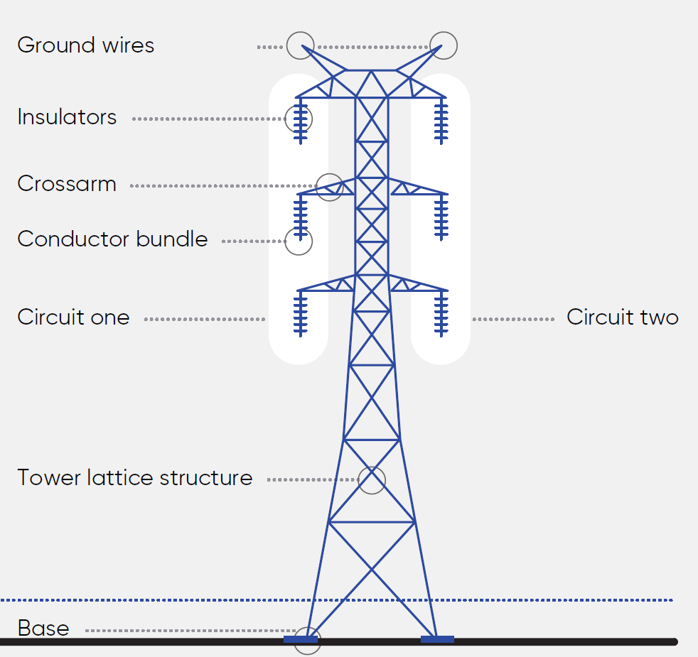  / OPGW | The conductor bundles (two or more conductors grouped together) are hung on each side of the tower crossarms. Insulators are used to attach the conductors to the towers. The insulators provide insulation between the high voltage electricity flowing through the conductors and the (earthed) steel lattice tower structure.  The ground (or earthing) wires are a safety control that directs electricity to the earth by creating the shortest and easiest path in the event of a fault.  Ground wires may incorporate a fibre optic core to provide communication between terminal stations. These modified ground wires are commonly known as optical ground wires (OPGW).
Figure 6.4 Example double circuit lattice tower features
To protect against corrosion, new towers are made of galvanised steel. Newly galvanised steel is bright and reflective, though it dulls over time. To minimise glare and reflectivity and reduce the landscape and visual impacts of the new Project towers, deglaring will be undertaken by the Principal Contractor during manufacturing of the steel. The method of deglaring will be determined by the Principal Contractor.
Suspension and strain tower types will be used to meet the Project’s design requirements at specific locations. Figure 6.5 shows examples of these tower structure types.
Suspension towers will be erected where the transmission line is in a straight line or has a very small deviation angle (up to 15 degrees). The insulators and conductors are strung vertically from the tower crossarms. Although designed to withstand high wind speeds, suspension towers hold up the wires but don’t pull them to change the transmission line direction. These towers have a smaller base and are lighter in weight and appearance relative to strain towers.
Strain towers will generally be erected at locations where the transmission line changes direction beyond 15 degrees. These towers need to pull on the wires and are designed to take the tension load (or strain) of the wires. Generally, strain towers are larger at the base and heavier compared to suspension towers. The insulators and conductors are strung horizontally on the tower crossarms with some hanging insulators to help hold the conductors in place.
For suspension and strain tower types, typical vertical separation distances between crossarms range from 10.5m -11.6m (500kV) and 5.6m - 6m (220kV). Insulator length ranges between 2.1m (220kV) to 4.3m (500kV).
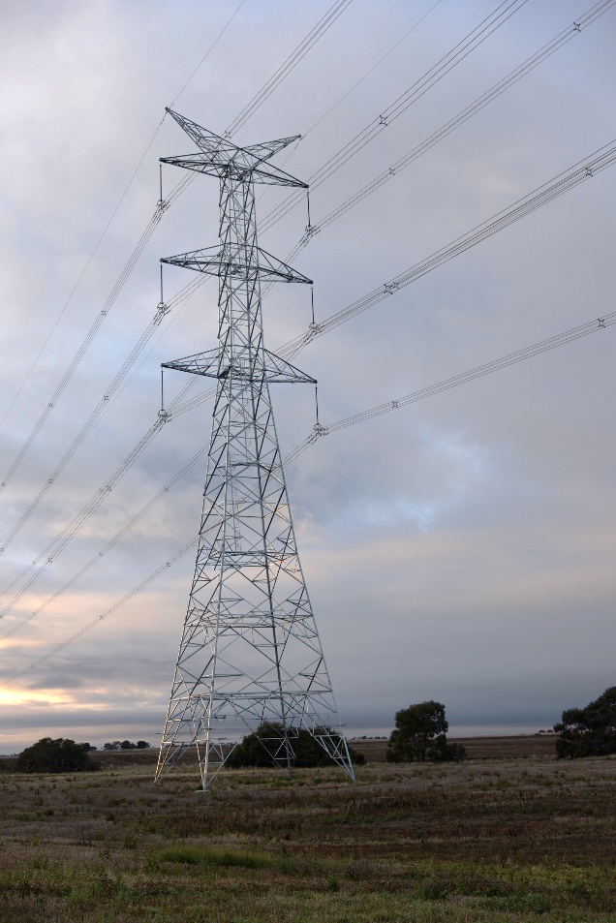 | 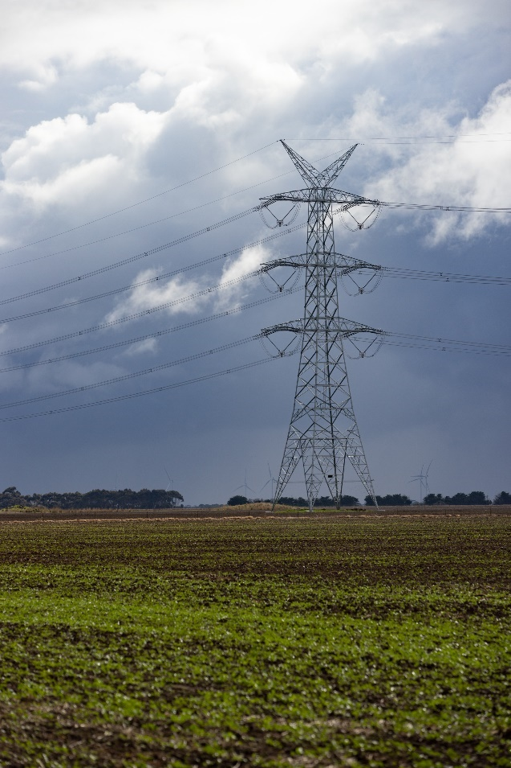
Figure 6.5 Example suspension tower (left) and strain tower (right)
The height of the towers and minimum permissible distances between the conductors (wires) and the ground or water is guided by the AS/NZS 7000:2016 Overhead Line Design, design and AusNet’s Electricity Safety Management Scheme (ESMS). The height of individual towers is determined by factors such as topography, the distance between two towers, minimum permissible ground clearance, the vertical spacing between conductors and the vertical clearance between the ground wire and top conductor. As long as the minimum permissible ground clearance is maintained, the towers can vary in height. Varying the height of a tower allows for a variation in the span (the distance between two towers). Typically, a higher tower can span greater distances.
The 500kV double circuit steel lattice towers proposed for the Project are typically between 60 and 80m high, as shown in Figure 6.6. Shorter, single circuit, towers may also be used at locations where height restrictions apply (such as adjacent to the Melton Aerodrome, see below).
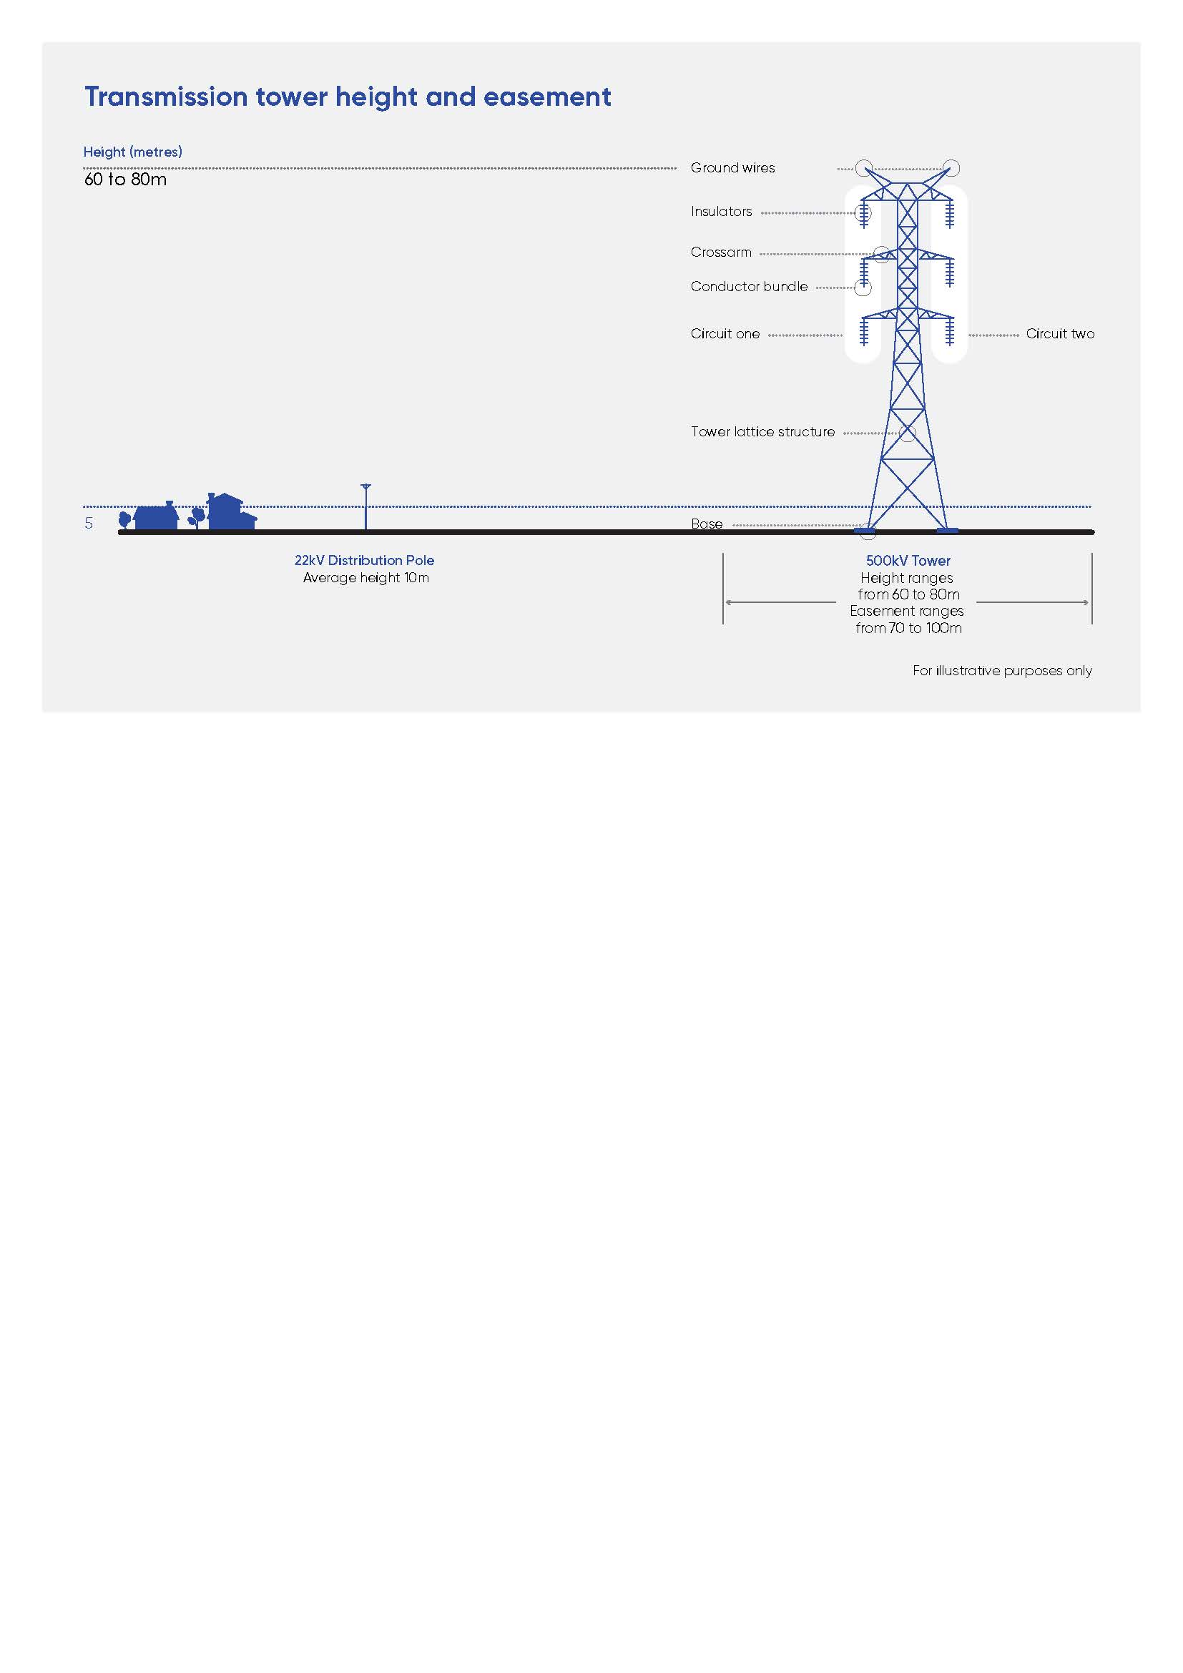
Figure 6.6 Typical 500kV double circuit tower height
The spacing – or span length – between each tower is determined by the height from the ground that the conductors need to be to achieve the required ground clearance in the middle of the span. As shown in Figure 6.7, the typical span between towers on the transmission line is between 450 and 550m.
Where the terrain permits, larger spans – up to a maximum of 1km – are possible. However, longer spans require taller towers to provide safe ground clearances, and wider easements to allow for greater sway of the conductors. Similarly, where it is difficult to achieve the required ground clearance in the middle of the span, due to topography or obstacles, the tower span may be reduced below 450m.
Figure 6.7 Typical tower span
The tower base widths and the widths of the outer edges of the tower footings are shown in Figure 6.8. This width of the outer edge of the footings is the extent of the permanent footprint of each tower. Between the tower footings, it is not proposed that any base material or concrete pad will be laid.
Figure 6.8 Typical 500kV tower base and footings
Four separate concrete pile footings (or foundations) are required for each tower. These are typically 1.8m in diameter and 9m deep, as shown in Figure 6.8. The diameters and depth of footings will be determined based on the different tower type used (suspension or strain) and the soil conditions at each tower site.
Each tower will have a climbing leg, which provides access to a tower for maintenance purposes as shown in Figure 6.9. An approved anti-climbing device will be fitted at approximately 3m above the ground on the climbing leg of the tower. These typically consist of a steel mesh or barbed wire barrier that can only be passed via a locked gate. Safety signs, acknowledging the risk of electrocution, will also be placed on all towers.
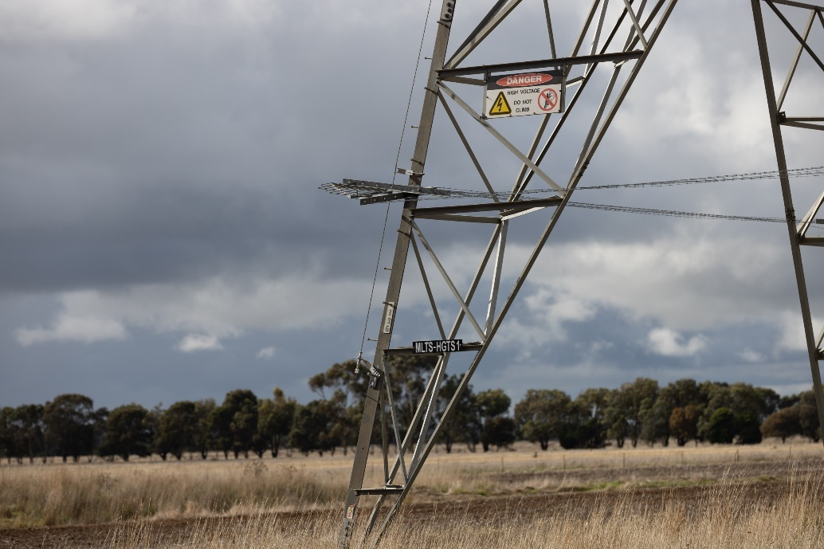
Figure 6.9 Anti-climbing device and safety signs on tower

Single circuit towers
In addition to the proposed 500kV double circuit towers, 500kV single circuit towers are also proposed as part of the Project. Single circuit steel lattice towers support one circuit per tower, therefore two single circuit towers located side-by-side are required to provide the double circuit transmission line capacity required for the Project. Single circuit transmission towers are lower in height in comparison to double circuit towers, with a generally smaller base tower width footprint ranging from approximately 10 to 14m as shown in Figure 6.10. The single circuit towers proposed for the Project are typically between 30 and 50m high, with a maximum height of 55m. The two single circuit towers require a separation distance of approximately 40m (centre to centre) within an easement up to 100m wide. Single circuit towers will also be deglared.
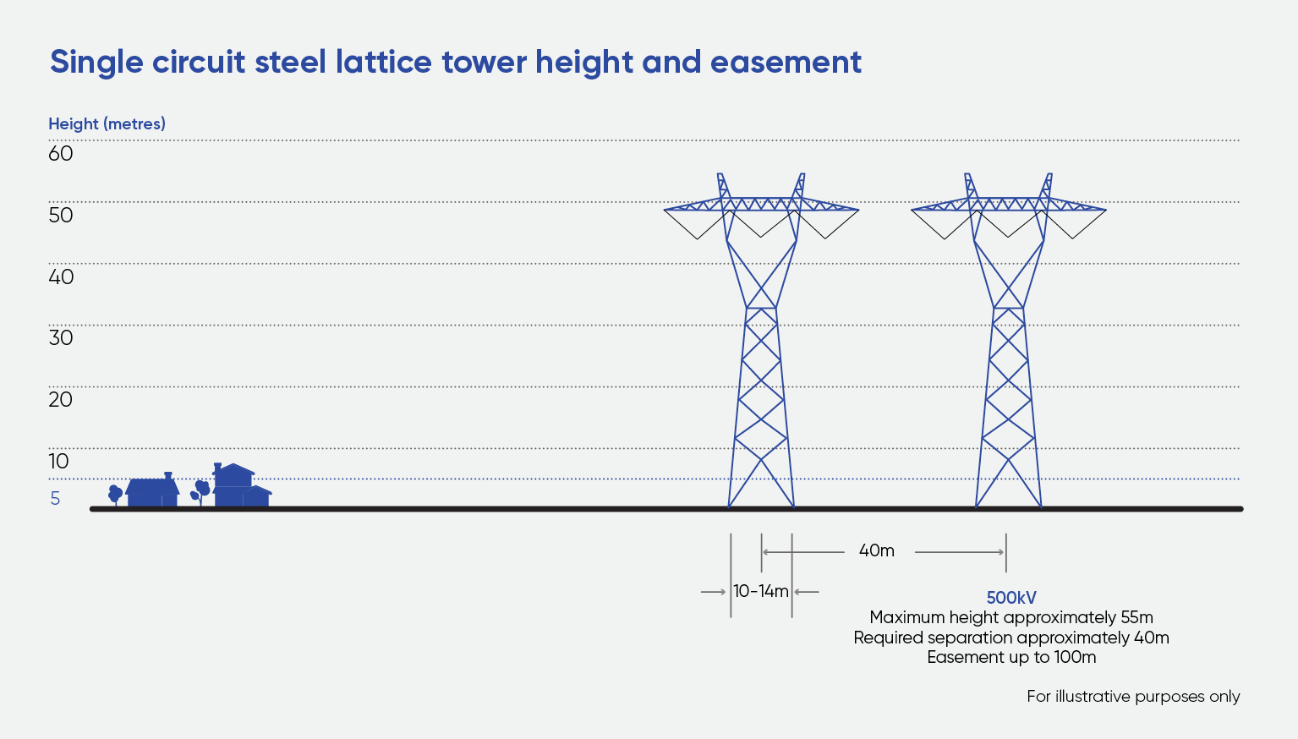
Figure 6.10 Example 500kV single circuit lattice tower
To improve safety and mitigate impacts to aircraft, single circuit towers are proposed for approximately 2km along the section of the transmission line near the Melton aerodrome. Along this section, single circuit towers will be approximately 35m high and marked with standard obstacle markings as per the Civil Aviation Safety Authority’s Manual of Standards Part 139 Aerodromes to make them more visible to pilots flying at the aerodrome. The markings may include coloured objects attached to the ground wire or conductors and/or marking other obstacles (such as the tower steel members) in a pattern of contrasting colours.
The Project connection to the existing Sydenham Terminal Station is within the protected airspace for Melbourne Airport which limits the height of structures in the area. As a result, single circuit towers of approximately 35 to 45m height will be adopted to the west of Sydenham Terminal Station.
To ensure that the voltages within each circuit remain balanced or equal to one another, at approximately one third intervals along the transmission line, it will be necessary to rotate the position of each conductor bundle in a circuit. This rotation of the conductor bundles is referred to as a ‘transposition’ and involves the replacement of one double circuit tower with a pair of single circuit towers.
To connect between the existing Bulgana Terminal Station and the new 500kV terminal station near Bulgana, a 220kV transmission line connection is proposed for approximately 2.5km as shown in Attachment VI: Map book. Although it is a 220kV connection, the tower type for this section of the Project will be eight sets of two side-by-side 500kV single circuit towers strung with 220kV conductors. The Project will transition directly from 500kV double circuit towers to 500kV single circuit towers. The location of single circuit towers for the Project is shown in Attachment VI: Map book.
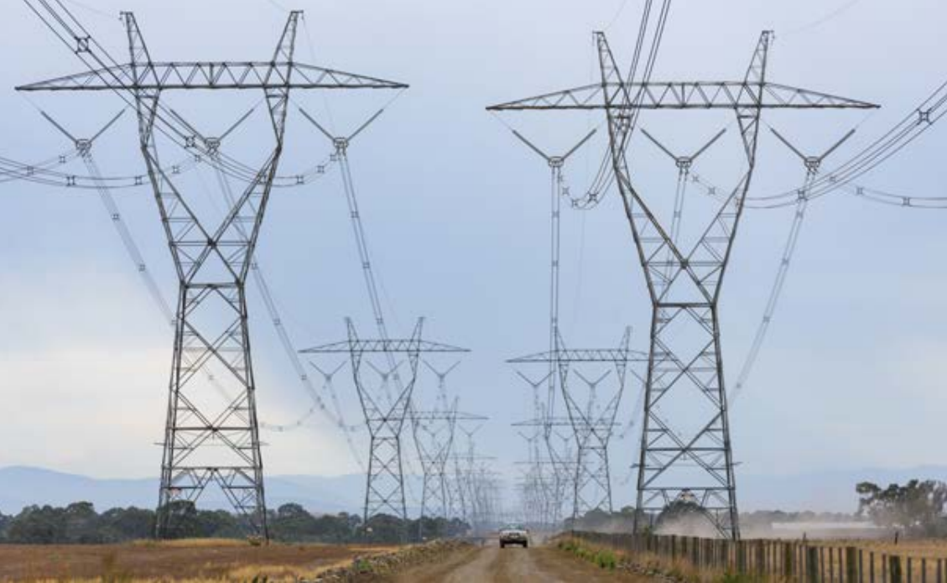
Figure 6.11 Example image of 500kV single circuit transmission towers

Transmission conductors
Transmission conductors, also referred to as ‘lines’ or ‘wires’, are the individual metal cables that carry high-voltage electricity over long distances (see Figure 6.12). Conductors operate at high voltages to reduce the amount of power that is lost in transit. As electricity flows through the conductor, some of it dissipates as heat due to conductor ‘resistance’. The higher the voltage is on a transmission wire, the less power it loses.
The AS/NZS 7000:2016 Overhead Line Design, design and AusNet’s Electricity Safety Management Scheme (ESMS) guide the height above ground that the conductors need to be strung from the towers. These height clearances allow for the required electrical safety separation and sufficient height for vehicles and equipment to work beneath the transmission line. This separation also considers days when there is increased power consumption or generation (e.g., hot days), when the conductors expand due to heat.
For the Project, the typical minimum clearance distance from the height of the wires to the ground is 15m (see Figure 6.13). Closer to the towers, the distance from the conductors to the ground will be higher, ranging between approximately 29 to 37m.
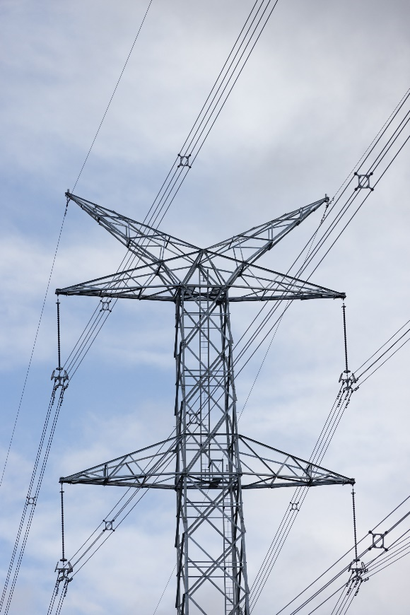 | 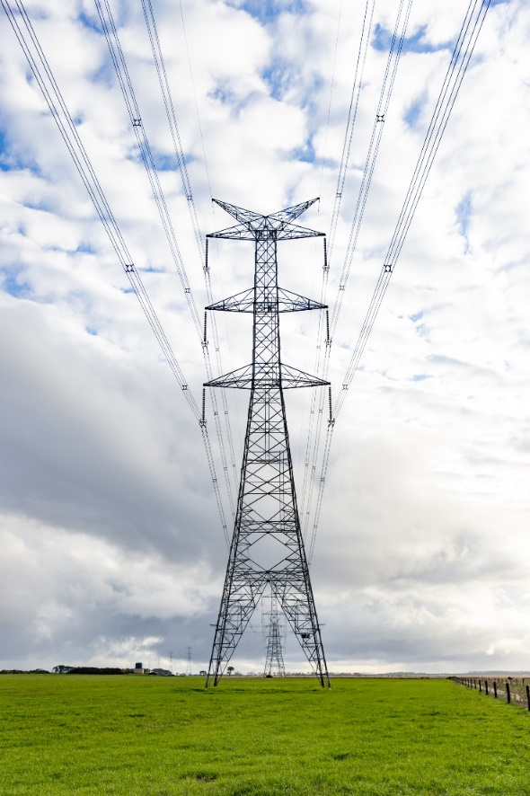
Figure 6.12 Example of transmission conductors hung on 500kV transmission towers
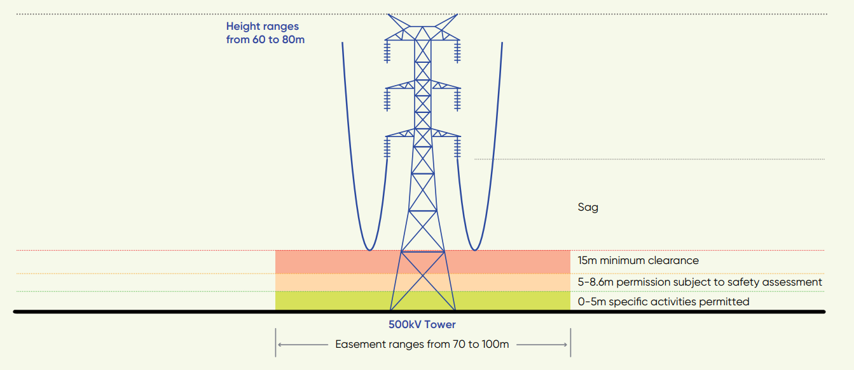
Figure 6.13 Safety clearance dimensions for vehicles and equipment

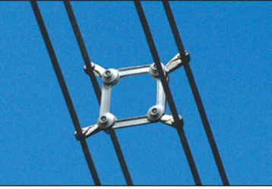
Each conductor is approximately 32mm thick and made of aluminium wire strands with a steel core. The conductors are configured in groups, called a ‘conductor bundle’ (also known as a ‘phase’), as shown in Figure 6.14.
A quad conductor bundle, which has four conductors grouped together to efficiently increase power transmission for high voltage transmission lines will be used on the Project.
For the 500kV double circuit towers, each span will have two circuits of three conductor bundles each, with four conductors per conductor bundle, as shown in Figure 6.12 – plus two ground wires (OPGW) (see Section 6.2.3). Accordingly, each span will comprise 26 wires (24 conductors plus two ground wires) in total, or 13 wires on each side of the tower cross arms.
Figure 6.14 Single phase quad conductor bundle
Unlike (or diagonal) phasing will be adopted for the 500kV transmission line. This phasing arrangement is generally used in the electrical transmission industry as it maximises electric and magnetic field cancellation and thereby minimises public exposure at ground level near transmission lines.
Insulators are used to attach the conductors to the towers (see Figure 6.15). These provide insulation between the high voltage electricity flowing through the conductors and the (earthed) metal towers. The insulators are made of glass, porcelain or polymer. The length of the insulators strung on the conductor is determined by line voltage and clearance requirements.
The towers are earthed via their foundations. Earthing of the towers is required to ensure the safety of people and animals in the proximity of the tower, and to protect the conductors against lightning strikes, which can cause line outages. When lightning strikes, it strikes the ground wire which runs along the top of the towers, the power in the strike is directed safely into the ground through the ground wire and the earthed tower.
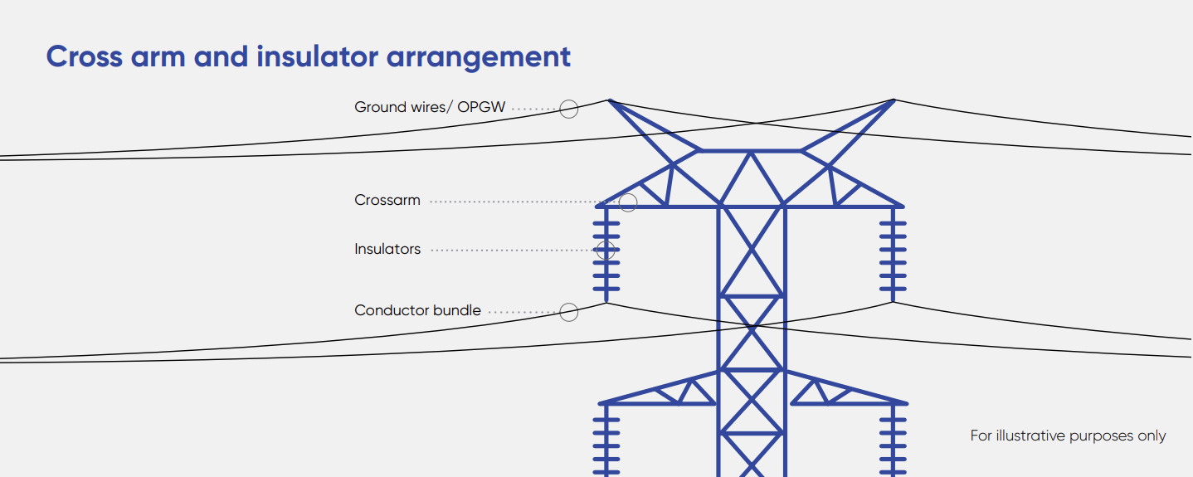
Figure 6.15 Example crossarm and insulator arrangement

Fibre optic ground wire (OPGW) and cable
A telecommunications system will provide communications and real-time monitoring of the transmission network. Ground wires on the transmission towers may incorporate a fibre optic core to provide communication between terminal stations. These modified ground wires are commonly known as optical ground wires (OPGW). At each terminal station, the OPGW will terminate to a fibre optic cable that will run down the tower to a pit and then runs via an underground conduit to connect to the communications equipment in the terminal station control room.
To install the cable conduits, a deep trench approximately 450mm wide by 750mm will be excavated. The OPGW and cable will be installed as part of the transmission line construction and stringing process, including the fibre optic cable connection to the terminal station control room.

Terminal stations

Terminal stations control and maintain the flow of power on transmission lines between the power generators and the major load centres where the voltage is stepped down (transformed) and local distribution companies supply it to homes and businesses.
Terminal stations contain electrical plant equipment (structures and components) used to transfer power between different voltage levels (transformers), stabilise voltage levels along the transmission line, move electrical energy from one point to another and monitor and protect the transmission network.
The transmission line will connect to a terminal station at each end of the line, allowing for the flow of energy from the western Victoria Renewable Energy Zone to the existing 500kV transmission network at Sydenham Terminal Station.
As part of the Project, a new 500kV terminal station is proposed approximately 2km northeast of the existing Bulgana Terminal Station. The new terminal station will connect to the existing Bulgana Terminal Station, via a single circuit 220kV transmission line providing connection between the existing 220kV transmission network and the proposed 500kV Project. As part of the works, the existing Bulgana Terminal Station will also be expanded.
At Sydenham Terminal Station, the Project will connect into the rebuilt Sydenham Terminal Station, creating a connection for the Project into the Victorian 500kV transmission network. Sydenham Terminal Station is proposed to be rebuilt as part of a separate project that is subject to a separate approvals process. The Project connection works include the modification of a 500kV bay (constructed by the separate Sydenham Terminal Station Rebuild project) and a new 500kV bay extension with associated infrastructure.
At Elaine Terminal Station, the Project will relocate the existing 220kV lines connected to Elaine Terminal Station to an adjacent bay and an existing 220kV line will also be diverted into the terminal station.
The location of the new 500kV terminal station near Bulgana, and the existing Bulgana, Sydenham and Elaine terminal stations are shown in Figure 6.2 and detailed in Attachment VI: Map book.
To facilitate successful integration and operation of the Project, minor systems upgrades are required to connected terminal stations to modify the existing protection and control software and hardware. These upgrades are to be completed within existing buildings, do not require ground disturbance or environmental or planning approval and are therefore excluded from the Project Area and Project Land.
The typical configuration of a terminal station is shown in Figure 6.16. Terminal stations typically use air insulated switch gear, some of which will contain sulfuric hexafluoride gas (SF₆), and some oil filled equipment such as power transformers and reactors, along with a diesel generator for backup support to keep the station operating in the event of an internal power failure. The works proposed at Bulgana and Sydenham terminal stations will have built-in control measures to manage and contain any gas or oil leak or spill that may occur in the unlikely event of equipment failure.
Temporary and permanent Project lighting will be designed and installed in accordance with relevant standards, including Australian Standard 4282 – Control of the obtrusive effects of outdoor lighting (AS 4282 – 1997). Figure 6.17 shows a typical view of a terminal station during the day and at night, and an example of nighttime lighting during emergency maintenance scenarios. Light spill at the new 500kV terminal station near Bulgana will be minimised by the strategic placing of the structures and lighting arrangements on the Project. Lighting at night will operate at low levels for security purposes. A terminal station or switchyard operated by AusNet will only be fully illuminated when emergency maintenance is required, or there is a security concern.
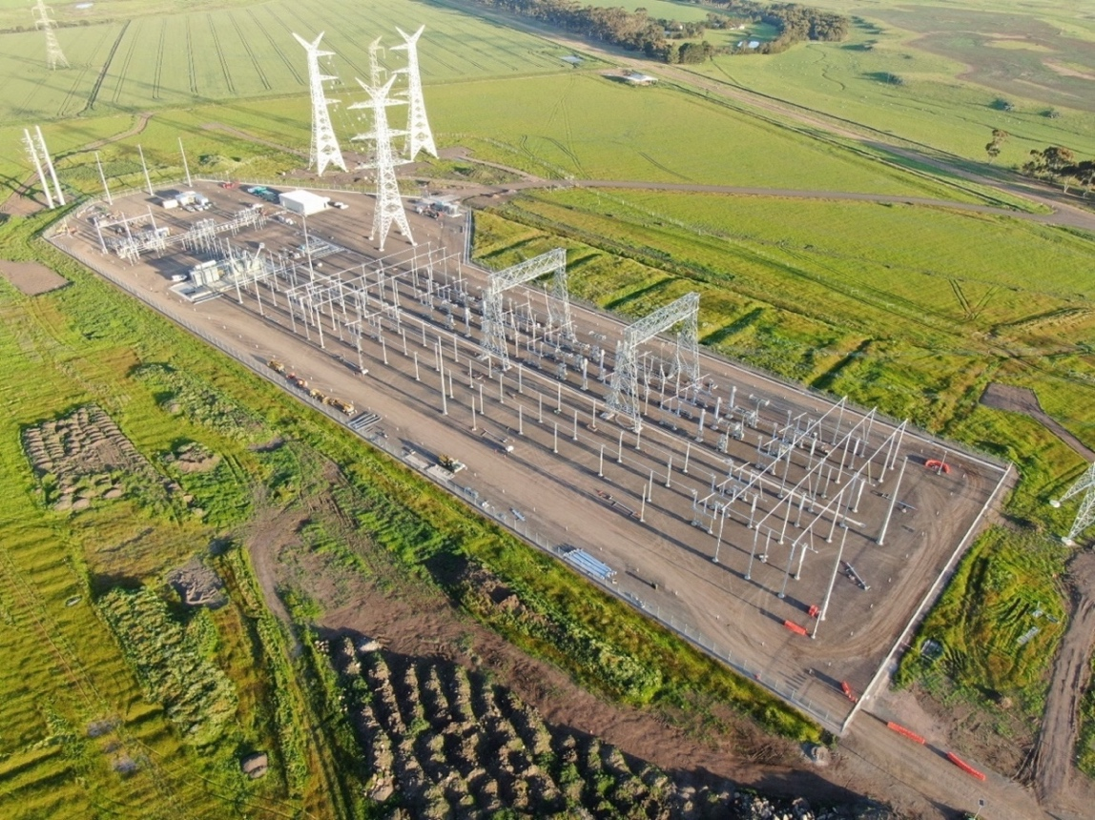
Figure 6.16 Typical terminal station configuration – Haunted Gully Terminal Station near Lismore, Victoria

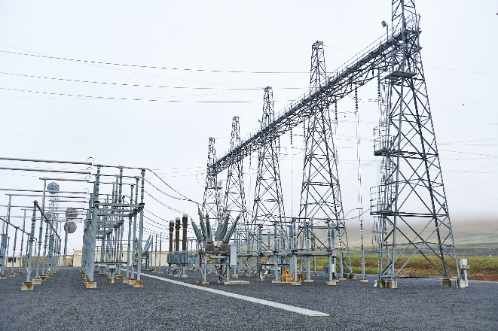 | 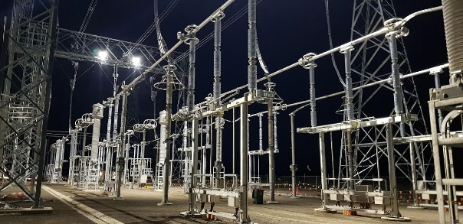
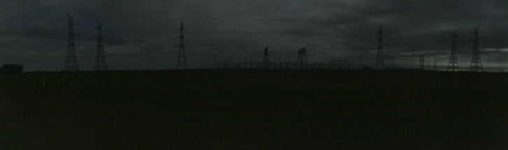
Figure 6.17 Typical view of a terminal station during the day, if fully illuminated for emergency maintenance activities, and at night (Source: AusNet and Technical Report D: Landscape and Visual Impact Assessment)

New 500kV terminal station near Bulgana
The new 500kV terminal station is proposed at Vances Crossing Road, Joel Joel, approximately 2km northeast of Bulgana Terminal Station. The Project proposes the construction of a new terminal station and associated equipment to support the connection of the proposed transmission line and facilitate future connections into the terminal station from other projects. The proposed works include:
- A new 500kV switchyard, including associated switchgear and equipment:
  - Configuration of four (4) breakers and a half bay with two (2) of the circuit breakers installed for each bay complete with other equipment and associated infrastructure
  - Two (2) sets of 500kV line reactors
  - Two (2) sets of 500/220kV 1000 mega volt-amp (MVA) power transformers
- A new control room, battery room, amenities building, and storage and maintenance area
- A new 220kV switchyard, including associated switchgear and equipment
- Site provisioning and line cut in works prior to commissioning.
The new terminal station would be within a site of approximately 800m by 800m (Figure 6.18). The terminal station yard will be fenced with security systems and controls installed to ensure the safety of the yard.
The tallest structures within the new terminal station will be the gantries, which are typically 30m high for 500kV infrastructure. A gantry is a structure used for landing the conductors from the tower near the terminal station to the electrical equipment within the terminal station. The gantries at the existing Bulgana Terminal Station are 26m high. All other infrastructure within the switchyard will be between 8 to 10m high. Figure 6.19 shows an example of the scale of the terminal station infrastructure, including a gantry and circuit breaker (to the right of the gantry).
The new terminal station will be connected to the existing Bulgana Terminal Station via a single circuit overhead 220kV transmission line over approximately 2.5km, comprising eight sets of two side-by-side single circuit lattice towers (16 towers in total).
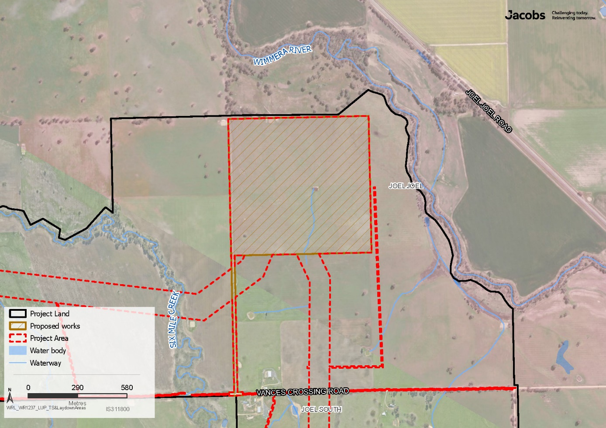
Figure 6.18 New 500kV terminal station near Bulgana

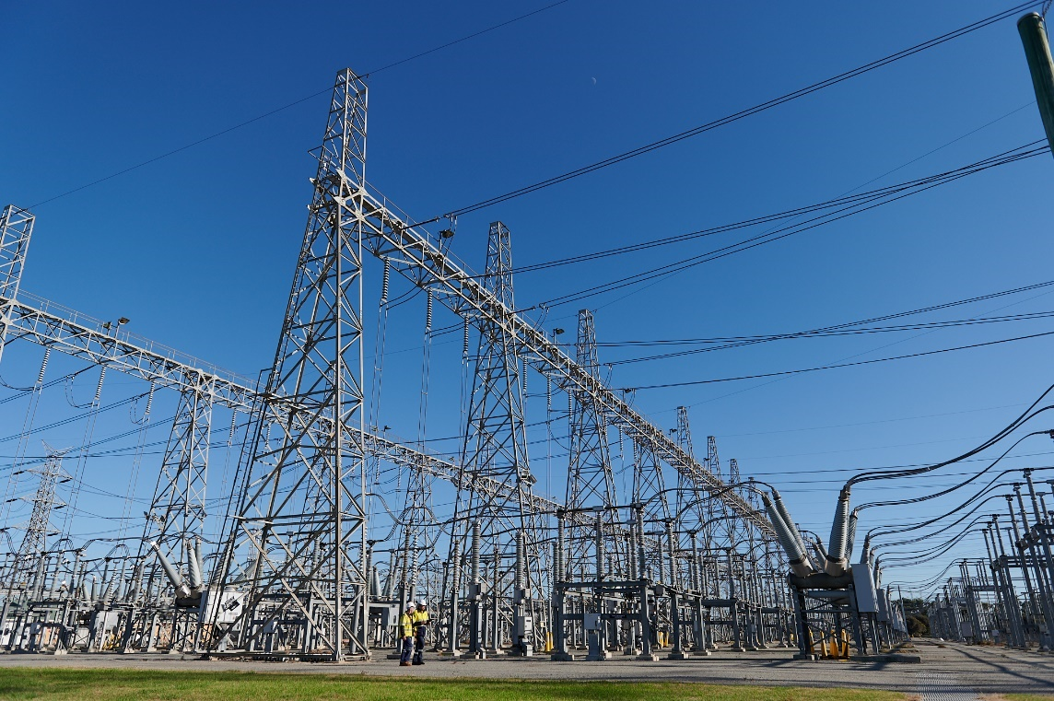
Circuit breaker
Gantry
Figure 6.19 Example of a gantry at Keilor Terminal Station and circuit breaker

Expansion of Bulgana Terminal Station
The existing Bulgana Terminal Station is located at 255 Vances Crossing Road, Joel Joel, on land owned by AusNet. The Project proposes an expansion of the Bulgana Terminal Station to support the connection of the new 500kV terminal station into the existing 220kV switchyard. The proposed expansion works within the existing terminal station site include:
- The installation of eight (8) circuit breakers and associated infrastructure and equipment
- Reconfiguration of the existing transformer connection
- Extension of the existing control room to accommodate additional protection and communications equipment
- Re-alignment of the Crowlands to Bulgana, Horsham to Bulgana 220kV transmission lines in the terminal station yard, to allow for the connection of the lines to the two sets of 500/220kV MVA power transformers
- Site provisioning works prior to commissioning.
To accommodate the new 220kV transmission line connection, works will be required at the existing Bulgana Terminal Station to expand the existing pad (crushed rock hardstand). This includes additional switchgear and the expansion of the existing fence, from 105m by 105m to 130m by 170m. Figure 6.20 shows the location of proposed works at Bulgana Terminal Station.
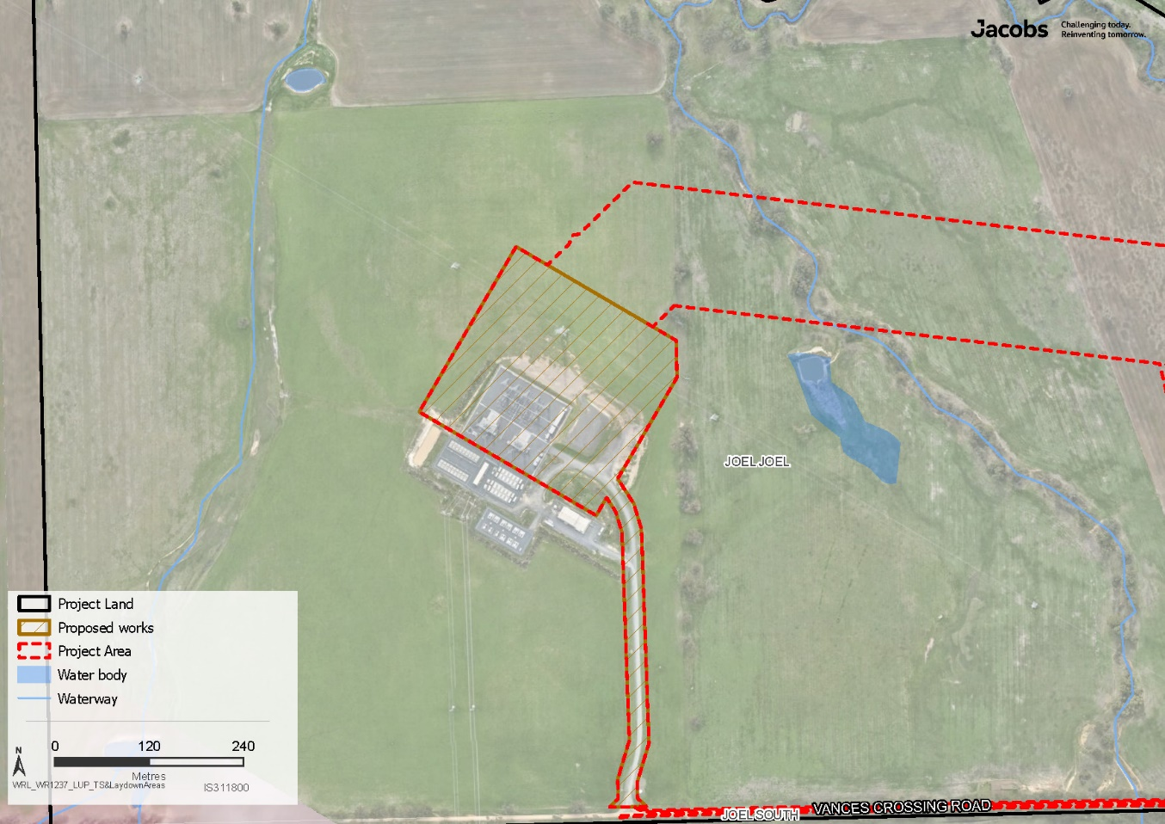
Figure 6.20 Bulgana Terminal Station

Connection to Sydenham Terminal Station
The Sydenham Terminal Station is located at 67 Victoria Road, Plumpton. This land is owned by AusNet and all terminal station works proposed are to be contained within the existing property boundary. The proposed works area at Sydenham Terminal Station is shown in Figure 6.21 and includes:
- Modification of a 500kV Bay (1x 500kV circuit breaker, instrument transformers and associated infrastructure)
- A 500kV Bay extension with:
  - Two (2) 500kV Rack structures and associated infrastructure
  - One (1) 100MVAr (mega volt-amp reactive) bus reactor, one (1) rack structure, foundations, and associated infrastructure
  - Two (2) 500kV bus bar extensions and associated infrastructure
  - Three (3) 500kV circuit breakers complete with other equipment and associated infrastructure
- Two (2) 70MVAr line reactors, four (4) rack structures, a firewall, foundations, and associated infrastructure.
These works will facilitate the connection of the new 500kV transmission line into the 500kV Victorian transmission network.
The existing Sydenham Terminal Station is being re-built through the Sydenham Terminal Station Rebuild Project, which commenced in April 2025. The Sydenham Terminal Station Rebuild is a separate project, independent of the Western Renewables Link, which includes construction of new Air Insulated Switchgear to the north of the current Gas Insulated Switchgear Switchyard on land owned by AusNet within the existing terminal station property boundary. When the Western Renewables Link is constructed, it will build connections into the rebuilt Sydenham Terminal Station.
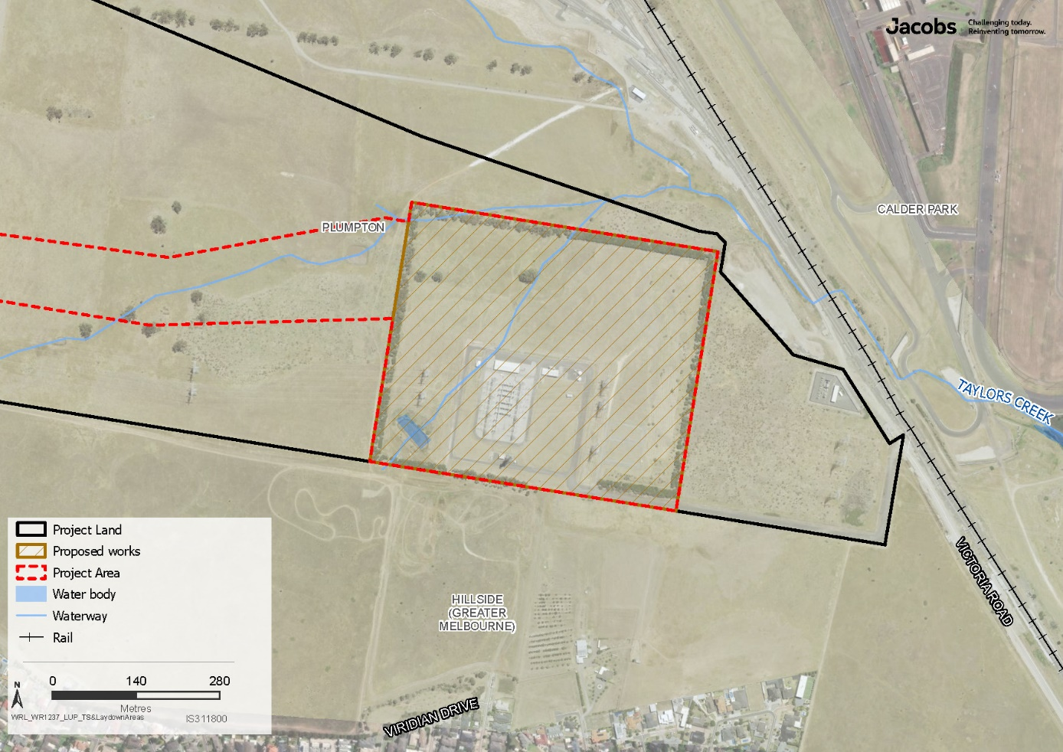
Figure 6.21 Sydenham Terminal Station works area

Transformers and line reactors
As described above, new transformers and line reactors will be required to manage the new 500kV transmission line at the terminal stations, including:
- At the new 500kV terminal station near Bulgana, two sets of 500kV/220kV 1000 mega volt-amp (MVA) power transformers are proposed
- A set of line reactors will also be installed at both the new 500kV terminal station near Bulgana and at Sydenham Terminal Station for each 500kV line
- One bus reactor is also proposed at Sydenham Terminal Station, as part of the Project connection works.
These transformers and the line reactors will be filled with mineral oil, installed in bunds. The oil acts as an insulator, as well as a cooling medium. A bund is a retaining structure designed to contain any leaks or spills of potentially polluting substances (in this instance, the mineral oil). The bunds will be designed in accordance with EPA Publication 1698 Liquid Storage and Handling Guidelines. Implementation of the Project’s operational Surface Water Management Plan (as required by the EPRs) will ensure that industry standard controls and best practice measures are applied to prevent any leaks and spills associated with activities at the terminal stations from reaching waterways (see Chapter 25: Surface water for details). Figure 6.22 shows a transformer that has been installed at AusNet’s Waubra Terminal Station.
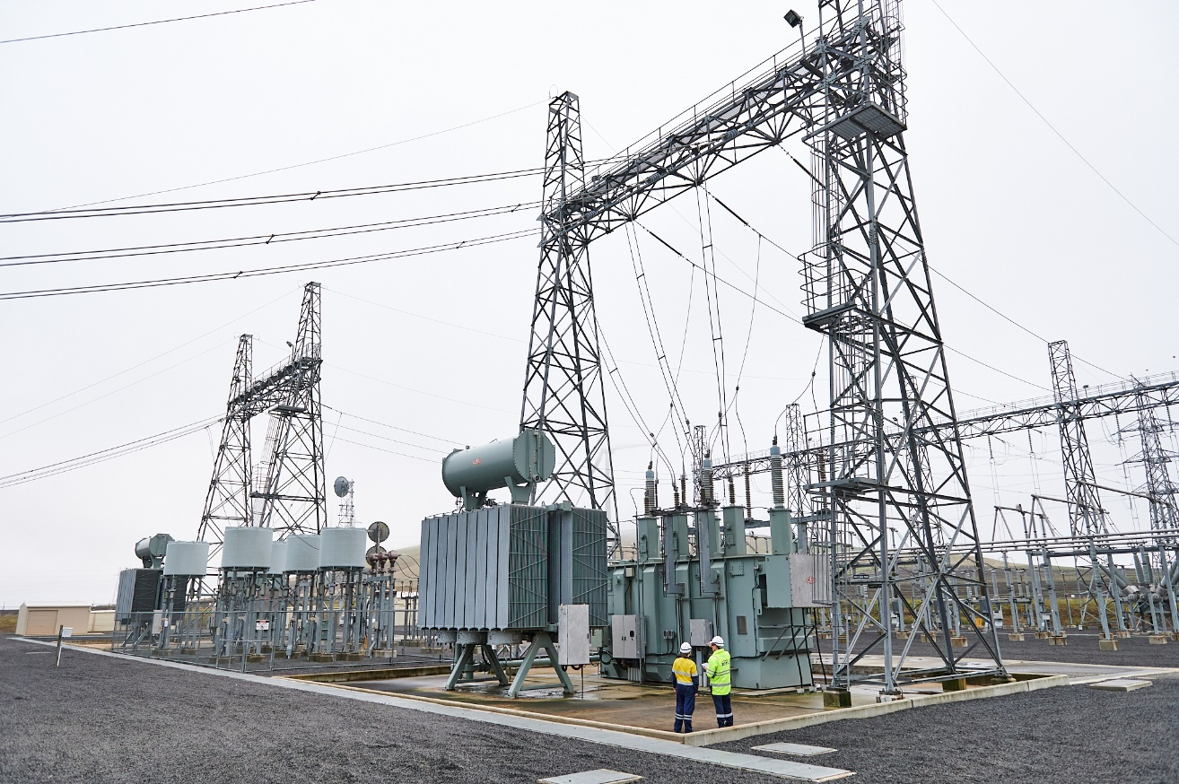
Figure 6.22 Example of a transformer bank at Waubra Terminal Station

Upgraded Elaine Terminal Station
The Elaine Terminal Station is owned by the Australian Energy Operators Pty Ltd (AEO), at Woolshed Road, Elaine. An existing 220kV transmission lines is currently diverted into Elaine Terminal Station, whilst another existing 220kV transmission line bypasses Elaine Terminal Station, running adjacent to the station. As part of the Project, the existing 220kV line connected to Elaine Terminal Station will be relocated to an adjacent bay and renamed, and the existing 220kV line that currently bypasses the station will also be diverted into the terminal station. AusNet will build two transmission line poles to allow for the relocation/diversion of the transmission lines, one inside the terminal station yard and one outside of the terminal station yard but within the property boundary.
An upgrade of the terminal station will facilitate the connection and switching of the lines. The terminal station upgrade works are proposed to be delivered by AEO as part of the Project and include:
- Extension of two existing 220kV bays
- Removal of one existing 220kV bay
- Modifying two existing 220kV bays
- An extension to the existing control room.
Figure 6.23 shows the proposed Elaine Terminal Station works. The footprint of the terminal station will not change, and all new equipment will be approximately the same height and scale as existing structures and equipment at the Elaine Terminal Station.
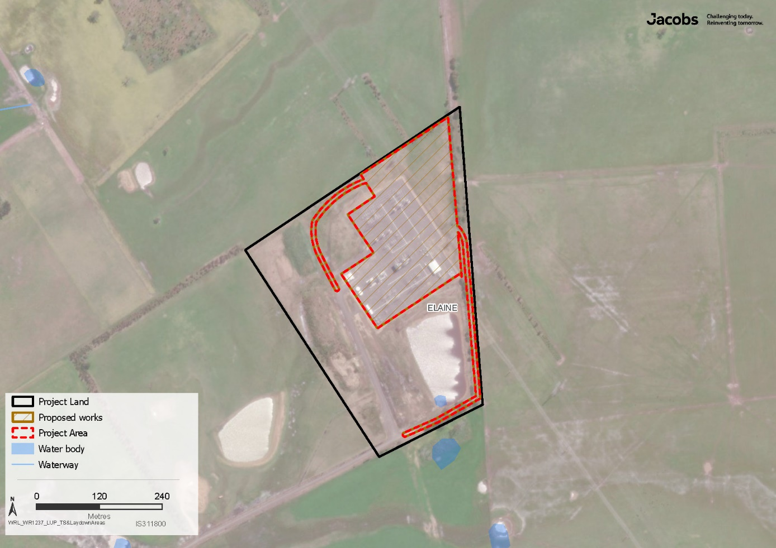
Figure 6.23 Elaine Terminal Station

Protection system upgrades at connected terminal stations
To facilitate successful integration and operation of the Project, minor system upgrades are required to connected terminal stations to modify the existing protection and control software and hardware. The system upgrades will be completed at Ararat Terminal Station, Ballarat Terminal Station, Crowlands Terminal Station, Horsham Terminal Station, Moorabool Terminal Station, and Waubra Terminal Station. The upgrades are to be completed within existing buildings and do not require ground disturbance or environmental or planning approval.

Easements
For the Project, easements will be used for construction, occupation, operation and maintenance of the new transmission line on freehold land. Transmission line easements:
- Protect public safety – ensuring that only activities which are compatible and safe can occur within the easement area
- Provide access to infrastructure to help maintain a reliable transmission network, allowing AusNet to efficiently access its infrastructure to maintain it and ensure it is operating as it should, including in emergencies.
An easement is a legal right held by a person (or party) to access, occupy and/or use part of the land owned by another person (or party) for a particular purpose. Easements are interests in land and are generally registered on the title of the land affected, creating a public record of the existence of the interest in land. Easement rights over land may also be created via statute (for example via the Electricity Industry Act 2000). Ownership of land subject to an easement remains with the registered proprietor on title.
The terms of the easement set out what the landholder and the easement holder can and cannot do within the easement area.
The easement width for the majority of the transmission line ranges from 70 to 100m wide. In some specific sections, for example when adjacent to an existing transmission line, the easement is around 55m wide. The widest section of easement along the route is 115m wide where the Project crosses the Korkuperrimul Creek. A visualisation of an easement is shown on Figure 6.24. The easement width can vary depending on the design of the towers and relevant safety matters such as fire safety, electric and magnetic fields and distance from existing infrastructure and facilities.
The width of an easement must comply with the Australian/New Zealand Standard on Overhead Line Design (AS/NZS 7000:2016). This standard sets detailed design, construction and operation requirements for new overhead transmission lines, including spacing between the wires, clearances to structures, objects and the ground, and other requirements to ensure acceptable levels of safety.
Where the Project runs parallel to existing 220kV transmission lines, the Project will be partially situated within the existing easement. This will reduce the total footprint of the new easement area proposed for the Project in these sections.
On Crown land, authority to access, construct and operate the transmission line will be determined on a parcel-by-parcel basis. Typically, such authority will be established through a lease, licence or consent to occupy and conduct activities on land, secured by entering into agreements with the relevant government agency or Crown land administrator in accordance with the legislation and associated regulations that govern the land.
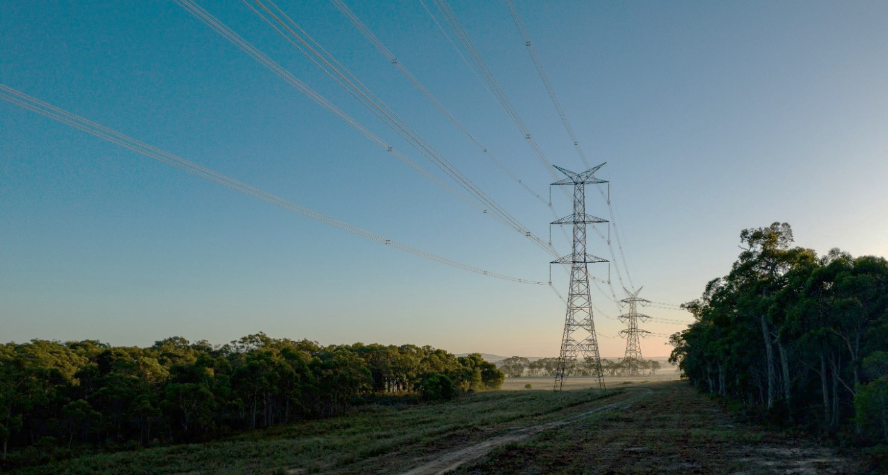
Figure 6.24 Example of a 500kV transmission line and cleared area underneath

The applicable legislation and process for acquiring an easement on freehold land and agreement or consent on Crown land is described in Technical Report E: Land Use and Planning Impact Assessment, along with details of the types of land tenure containing the Project components.
For inspection and maintenance of the Project’s infrastructure, carriageway easements will also be obtained for some permanent access tracks if these are outside the transmission line easement. These access tracks will enable AusNet to travel from a public access point (generally a road) to the transmission line easement area. If access is required over another separate property title (owned by the same or another landholder), a carriageway easement will be used to ensure ongoing access to the transmission line easement for operation, maintenance and repair activities. Additional detail on access tracks is provided in Section 6.6.3. The location of all proposed access tracks is shown in Attachment VI: Map book.
AusNet is required to maintain adequate clearance around the transmission line and manage vegetation and fuel hazards within the easement to mitigate bushfire risk and ensure safe and reliable operation of the transmission line, in accordance with the Code of Practice of Electric Line Clearance under the Electricity Safety (Electric Line Clearance) Regulations 2020.
Any vegetation clearance required for the Project will be undertaken in accordance with planning and regulatory approvals issued for the Project and AusNet’s Vegetation Management Plan, which sets out transmission line and easement vegetation management practices. This Plan is a regulatory requirement, required to comply with the Code of Practice for Electric Line Clearance. The Plan is reviewed every five years and submitted to ESV for approval under the Electricity Safety Act 1998. Additional detail on vegetation clearance required for the Project is provided in Section 6.8.
During operations, AusNet has a policy of developing sustainable transmission line easements. Within the easement, mature trees and shrubs are permitted subject to height limitations (see Table 6.3) and the fuel loads for bushfire mitigation. Generally, no vegetation will be removed outside the easement, however, in some locations, vegetation may need to be lopped where it overhangs the easement or poses a risk from falling in accordance with the Electricity Safety Act 1998 and Electricity Safety (Electric Line Clearance) Regulations 2020. During operation, where vegetation is required to be lopped or removed, the necessary environmental approvals will be obtained.
A wide range of activities – including grazing, cropping and other agricultural and horticultural practices – can continue within the easement beneath the transmission line. However, some uses are prohibited under the easement terms. Some activities require a safety assessment, which are provided to landholders free of charge.
Figure 6.13 shows the safety clearance dimensions for vehicles and equipment in relation to the towers and transmission wires. Table 6.3 lists the main activities that are permitted or not permitted within a 500kV transmission line easement. A full list of the types of land uses that can continue and those that are prohibited in an easement is provided in AusNet’s Landholder Guide: Easement safety and permitted activities (AusNet, 2024).
Table 6.3 Activities permitted or not permitted within 500kV transmission line easements
Activities | Permitted | 500kV transmission line conditions
Vegetation | Yes | Mature tree and shrub growth of 3m in height is allowed up to 30m from the centre of the tower. For vegetation above 3m in height, an AusNet safety assessment is required to ensure that minimum clearances and fuel load densities are maintained.
 |  | Planting trees and shrubs should be scattered or clumped with no more than 10% density of cover over the easement area.
Crops | Yes | Ground-growing crop types are allowed without requiring an AusNet safety assessment or permit if at least 5m away from the tower and earth movement change is less than 300mm in depth. If over 300mm, a Before You Dig Australia enquiry and subsequent safety assessment must be completed.
Grazing of livestock | Yes | No conditions.
Irrigation - centre pivot and lateral moving | Yes | Allowed to operate up to a height of 5m without an AusNet safety assessment. May be allowed to operate up to 8.6m in height, subject to an AusNet safety assessment which must be sought prior to operating. Water streams must be directed away from the transmission line infrastructure.
Irrigation - large gun-type | No | Large water spray irrigators of the gun type are not allowed to operate within the easement due to safety risks and potential damage to electricity infrastructure.
Irrigation – boom type | Yes (subject to a safety assessment) | Allowed up to 5m in height subject to an AusNet safety assessment, which must be sought prior to operating. Water streams must be directed away from the transmission line infrastructure.
Use of headers with augers extended | Yes | Allowed to operate up to a height of 5m without an AusNet safety assessment and may be allowed to operate between 5m and 8.6m in height, subject to an AusNet safety assessment which must be sought prior to operating.
Vehicles and equipment | Yes (subject to a safety assessment) | Are allowed to travel under the lines and operate vehicles up to 5m in height without an AusNet safety assessment.  May be allowed to operate vehicles between 5m and 8.6m in height, subject to an AusNet safety assessment which must be sought prior to operating.
Aerial crop spraying and aircraft using manned aircraft (e.g., light planes and helicopters) | No | Aerial crop spraying (crewed) is prohibited within 45m of the conductors due to the safety risk and potential damage to electricity infrastructure. However, drone spraying may be allowed subject to an AusNet safety assessment and permit.
 |  | With the exception of firefighting aircraft, crewed aircraft will not generally be allowed within the easement.
Fuel reduction and stubble burning | Yes (subject to safety assessment) | Fire activity such as fuel reduction and stubble burning will be allowed within the easement with a permit from AusNet (required year-round).  During the Fire Danger Period, fire activity will also require a permit from the CFA.
Buildings and dwellings | No | Not allowed within the easement.
Cattle yards | Yes (subject to safety assessment) | Allowed up to 30m from the centre of the tower with a safety assessment where the cattle fencing and ramps are earthed.
Market gardens, orchards and horticultural nurseries | Yes | Excluding buildings and subject to relevant height restrictions.
Ploughing | Yes | Allowed up to 5m from the base of the tower.
Seeders | Yes | Allowed to operate up to 5m in height without restriction or an AusNet safety assessment. May be allowed to operate between 5m and 8.6m in height, subject to an AusNet safety assessment which must be sought prior to operating.
Solar pumps | Yes (subject to safety assessment) | Allowed with a safety assessment at least 30m from the centre of the tower. Earthing will be required.
Stockpiling and storage of materials | No | Not allowed within the easement.
Fencing | Yes | Non-metallic fencing up to 3m in height is allowed.  Non-electrified, metallic fences or fences with metallic parts must be earthed and sectionalised and are subject to prior approval from AusNet.
Electric fencing | Yes | Allowed within the easement. Earth filters may be needed.
Electrically conductive materials | Yes (subject to a safety assessment) | May be allowed provided that they are at least 30m from the centre of the tower and subject to a safety assessment.
Explosives, electrical detonation or storage of explosives | No | Not allowed within the easement.
Landscaping and paving | Yes (subject to a safety assessment) | Safety assessment required for earth movement changes of more than 300mm in height, to ensure sufficient clearances to the conductors and towers are maintained.
Lighting poles | Yes (subject to a safety assessment) | Allowed within the easement, subject to sufficient clearance to the conductors and towers. The power supply must be underground, and the lighting poles must lower to the ground for servicing.
Metallic structures | Yes (subject to a safety assessment) | High voltage lines can induce voltage into nearby metallic structures (e.g., fences, water pipes, silos, clotheslines, etc.). Proper earthing is important to avoid electrical discharges (similar to an electric fence ‘shock’).
Parking of cars and caravans | Yes (short term only) | While short-term camping will be allowed, camping and long-term parking will not be allowed.
Playground equipment | Yes (subject to a safety assessment) | Allowed up to one metre in height.
Scaffolding | Yes (subject to a safety assessment) | Contact AusNet for more information.
Sewerage, drainage and water pipes | Yes | Sewerage, drainage and water pipes constructed of earthenware or plastic materials will be allowed up to 30m from the centre of the tower.
Storage or handling of flammable liquids or gases | No | Planning laws restrict the storage or handling of flammable liquids and gases from bulk delivery vehicles within 60m of the centre line of a transmission line easement.
Storage of materials in industrial type waste bins and skips | No | Not allowed within the easement.
Swimming pools | No | Not allowed within the easement.
Tennis courts | Yes (subject to a safety assessment) | Contact AusNet for more information.
Excavation (including digging and earth moving activities) | Yes (subject to safety assessment) | Allowed up to 300mm in depth without an AusNet safety assessment or permit provided that it is at least 30m from the centre of the tower. Depths greater than 300mm may be allowed provided that it is at least 30m from the centre of the tower and a Before You Dig Australia enquiry and subsequent safety assessment are completed before starting work.  Within 30m of the centre of the tower steelwork, excavation of more than 300mm in depth is not allowed without written authorisation from AusNet.
Lifting wet heads from sunken bores | Yes (subject to safety assessment) | AusNet safety assessment required.
Dams | Yes | Entire coverage of easement by dams is not allowed.
 |  | Dams cannot be located within a 30m radius of any tower centre.
 |  | Where a dam is proposed to be located outside the 30m radius of any tower, the high-water level and the top of earthworks/ embankments must continue to maintain the minimum ground clearance of 15m.
 |  | Seek advice from AusNet for appropriate location of dam.
GPS | Yes | The flow of electrical energy through the transmission line does not affect GPS signals.  There can be a small effect on GPS signals if under or right alongside a tower. This is known as multipathing. It is associated with being too close to a steel structure which could be a tower, windmill, shed or any other metal structure.  The effect is only noticeable within about 3m of the metal object.
Grain shifting augers | Yes | Allowed to operate up to 5m in height without restriction or an AusNet safety assessment. May be allowed to operate between 5m and 8.6m in height, subject to an AusNet safety assessment, which must be sought prior to operating.
Harvesters | Yes | Allowed to operate up to 5m in height without restriction or an AusNet safety assessment. May be allowed to operate between 5m and 8.6m in height, subject to an AusNet safety assessment, which must be sought prior to operating.
Indoor growing facilities | Yes (subject to a safety assessment) | Poly tunnels and netting will be allowed up to 5m in height. Hothouses may be allowed subject to safety assessment (excluding buildings).
Ground level sporting activities | Yes (subject to a safety assessment) | May also be allowed subject to specific requirements being met such as the earthing of metal fences and height limitations on goals and light poles.

Acquisition of easements
Ideally, the granting of an easement and its terms will be negotiated and agreed between a landholder and AusNet. Where this is not possible, legislation allows for the acquisition of an easement and may also set out the terms of those easements — these are called ‘statutory easements’.
Under the Electricity Industry Act 2000 (Vic) an electricity corporation, such as AusNet, may, with the approval of the Governor in Council, compulsorily acquire easements over private land to erect, lay and maintain powerlines.
Where possible, the creation of easements for the Project and the easement terms and compensation will be negotiated and agreed between a landholder and AusNet. For this Project, AusNet has sought to negotiate an option for easement with landholders, which is a legally binding agreement that gives AusNet a right to acquire an easement over the landholder’s land on agreed terms and for agreed compensation and payments within a certain period of time (Option for Easement).
AusNet is seeking voluntary Options for Easement with landholders to provide the opportunity to negotiate with AusNet and provide specific property requirements. Through this process AusNet seeks to identify landholder needs and design opportunities to improve Project outcomes.
In circumstances where an Option for Easement cannot be voluntarily negotiated between AusNet and the landholder, AusNet can take steps to compulsorily acquire easements under the Electricity Industry Act 2000. Where a negotiated easement agreement is not reached, and an easement is compulsorily acquired under the Electricity Industry Act 2000, ongoing access will be in accordance with the terms of the easement reached through that process.
If an easement is compulsorily acquired, the registered proprietor is entitled to compensation. Where applicable, any other interest-holder (i.e., a tenant) may also be entitled to compensation, or may submit a claim for compensation. The amount of compensation offered accords with valuation principles set out in the Land Acquisition and Compensation Act 1986 as well as the Valuation of Land Act 1970.
Where compulsory acquisition occurs, landholders or any entitled interest holders may accept, partially accept or reject an offer for compensation. The Land Acquisition and Compensation Act 1986 outlines a comprehensive pathway for dispute resolution if parties cannot agree on the quantum of compensation.
Regardless of whether the easement is acquired by agreement or compulsorily, compensation would be paid to landholders where an easement is acquired over their property. Landholders will continue to have possession and use of the land to which the easement affects, subject to the terms and conditions of the easement.
Landholders are responsible for general maintenance of the land within the easement in the same way they are responsible for maintenance of any property owned. Landholders are not responsible for maintaining any electrical or other infrastructure belonging to AusNet.

Land for terminal stations
The existing Bulgana Terminal Station is located on 255 Vances Crossing Road, Joel Joel, on land owned by AusNet. The new 500kV terminal station near Bulgana and associated infrastructure is to be located on land purchased by AusNet via a negotiated agreement. It is approximately 2km northeast of the existing Bulgana Terminal Station at the street address of Vances Crossing Road, Joel Joel. Pending approval of the Project, the land at both terminal station sites will be rezoned under the local planning scheme for the purpose of a terminal station use.
The connection works proposed at the new Sydenham Terminal Station will be situated on land already owned by AusNet with an existing terminal station use. Sydenham Terminal Station is located at 67 Victoria Road, Plumpton.
At terminal station sites not owned by AusNet, access and works will be arranged by AusNet with the terminal station owner through an agreed construction interface deed.

Construction activities
Construction of the Project will include the establishment of temporary infrastructure (such as laydown areas and workforce accommodation facilities); construction of the towers and the transmission line works; construction works at terminal stations; site rehabilitation works; and testing and commissioning activities. This section details each construction activity and discusses the expected workforce, types of equipment and construction assumptions.
These activities provide the basis for assessing the potential impacts of the Project during construction. The Project’s recommended EPRs set out specific management requirements for a range of construction activities in accordance with the general environmental duty and relevant legislation and guidelines, including EPA Victoria construction guidance. EPRs are also specified for activities such as construction noise, traffic management, vegetation removal, erosion control and surface water and groundwater management. Prior to construction commencing, the Principal Contractor, in collaboration with AusNet, will prepare a Construction Environmental Management Plan (CEMP). The CEMP will reflect the relevant EPRs and include measures to eliminate or reduce the risk of harm to human health and the environment through implementation of EPA Publication 1820.1: Construction – guide to preventing harm to people and the environment.
Further details on the CEMP, the EPRs and the Project’s Environmental Management Framework are provided in Chapter 29: Environmental Management Framework.

Indicative construction program
Construction is expected to take approximately two years. This schedule is dependent on contractor engagement to develop detailed designs and the receipt of Project approvals within certain timeframes. Once construction is complete, commissioning activities include final inspections and other safety and pre-operational checks (see Section 6.6.13).
The estimated timing and potential staging of the main Project activities is set out in Table 6.4. Further details on the construction sequence and timeframes for the towers and terminal stations are provided in Section 6.6.3 and Section 6.6.4 respectively.
Table 6.4 Indicative construction schedule
Construction Activity | 2026 |  |  |  | 2027 |  |  |  | 2028
 | Q1 | Q2 | Q3 | Q4 | Q1 | Q2 | Q3 | Q4 | Q1 | Q2 | Q3 | Q4
Preparatory Works
Site establishment, vegetation removal, utility works
Construction of towers and transmission line stringing
Transmission line
Terminal stations
Sydenham Terminal Station Connection
New 500kV terminal station near Bulgana
Expansion of Bulgana Terminal Station
Site rehabilitation and Project completion
Commissioning
Rehabilitation and demobilisation

Preparatory activities
Before construction starts, land access agreements will be finalised with relevant landholders. A draft Property Access and Management Plan (PAMP) has been prepared and issued to landholders as part of the Option for Easement offers to inform landholders of the proposed protocols and management commitments to which AusNet and its contractors will comply when accessing property within the Proposed Route. A copy of the draft PAMP will be exhibited as part of the EES and any updates required by the Minister for Planning will be made before the PAMP is finalised and issued to landholders pre-construction.
Pending the granting of the required approvals, preparatory buildings and works will need to occur prior to the commencement of construction of the Project. The preparatory buildings and works are defined within the Project’s proposed Incorporated Document.

Site investigations, testing and works
Prior to construction activities commencing on individual properties, a detailed site assessment and a condition survey of the Project’s confirmed route will be completed including the proposed terminal station sites. The existing (baseline) conditions at each property affected by the Project will be recorded through surveys and documented together with photographic records as appropriate.
Specific site investigations required by the EPRs (such as geotechnical investigations and opportunistic soil sampling) will be completed before construction begins to determine the suitability of the land and inform design. The tower locations, along with points on the easement boundaries and access tracks, will be surveyed and pegged.

The establishment of environment and traffic controls
All environmental, cultural and heritage values and sites that have been identified as requiring protection will be flagged or fenced off as appropriate to ensure no accidental damage occurs during construction. All construction workforce employees undertaking site works in the vicinity of these areas will be inducted into the protective measures that apply to each area.
All traffic controls required to ensure safe access and egress to site will be implemented, including but not limited to signage, barriers, portable traffic lights and boards.

The establishment of temporary laydown areas
The establishment of temporary laydown areas, site fencing and hoarding, security lighting and cameras, site offices, amenities and temporary car parking is to be part of preparatory works. See Section 6.6.8 for detail on laydown areas.

Management of existing utility services
To prevent damage and utility disruption, a search of existing utility services (for example, Before You Dig Australia) will be conducted prior to any construction works to identify their location. Where necessary, these services will be relocated. If the relocation of services is not possible, micro-siting of the towers may be necessary to adjust the tower position. AusNet will work with each relevant utility services provider to ensure adequate separation between assets.
Where the Project crosses roads, railways, electricity lines or communication lines, protective works (such as hurdles, scaffolding and nets) will be installed temporarily during construction. In addition, protective scaffolding or hurdles will be installed on low and medium voltage lines to protect people and the existing infrastructure from damage if any construction issues occur during the period of the works.
There are two common ways of installing hurdles. The first method involves drilling and inserting at least two timber poles into the ground using an auger drill and crane and installing a crossbeam between the poles, which acts as a barrier to prevent conductors falling or contacting the ground. Where drilling cannot be undertaken due to environmental or cultural heritage constraints or where it is difficult to implement, purpose-built prefabricated concrete stay blocks will be placed on the ground and timber poles inserted into these blocks and cross-beams installed. These poles have stay wires installed that are tied back to additional concrete blocks to provide further support. Examples of these protective works are shown in Figure 6.25.
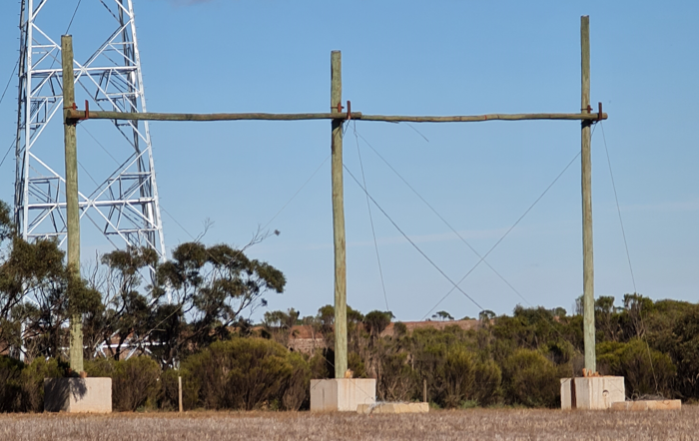
Figure 6.25 Examples of protective hurdle works during construction

Preparing distribution line crossovers
Power distribution lines supply lower voltage electricity to consumers, like individual residencies and commercial businesses. At approximately 70 locations, the proposed transmission line route crosses over the path of the existing power distribution lines. These distribution lines are operated by Powercor. The locations of all distribution line crossovers are shown in Attachment VI: Map book.
Distribution line crossover services are proposed to be placed underground, where they intersect with the Project easement. AusNet has completed a design process to determine the most appropriate location for placement and construction techniques. This work has considered surrounding land uses and the need to avoid areas of significant environmental and cultural heritage values. The detailed design and construction of each distribution line crossover point will be undertaken by Powercor.
AusNet will obtain easements for the distribution line crossovers on Powercor’s behalf as part of the process to obtain easements for the Project.
Typical buried distribution services involve a trench approximately 600mm wide and 1m deep. Trenches are expected to be 100 to 300m long with a construction impact area around 3 to 4m wide (to dig a 600mm wide trench). The trench will normally extend from just outside the edges of the Project easement, meaning that its length will be dependent on the angle at which the crossover lines intersect with the Project transmission line. The temporary impact of this trenching work will vary and is highly dependent on the location and terrain. The impacts associated with trenching and installation of these crossovers have been assessed as part of the EES, including but not limited to Technical Report S: Groundwater Impact Assessment and Technical Report Q: Geology and Soils Impact Assessment. A diagram of a typical distribution line crossover point is shown in Figure 6.26.
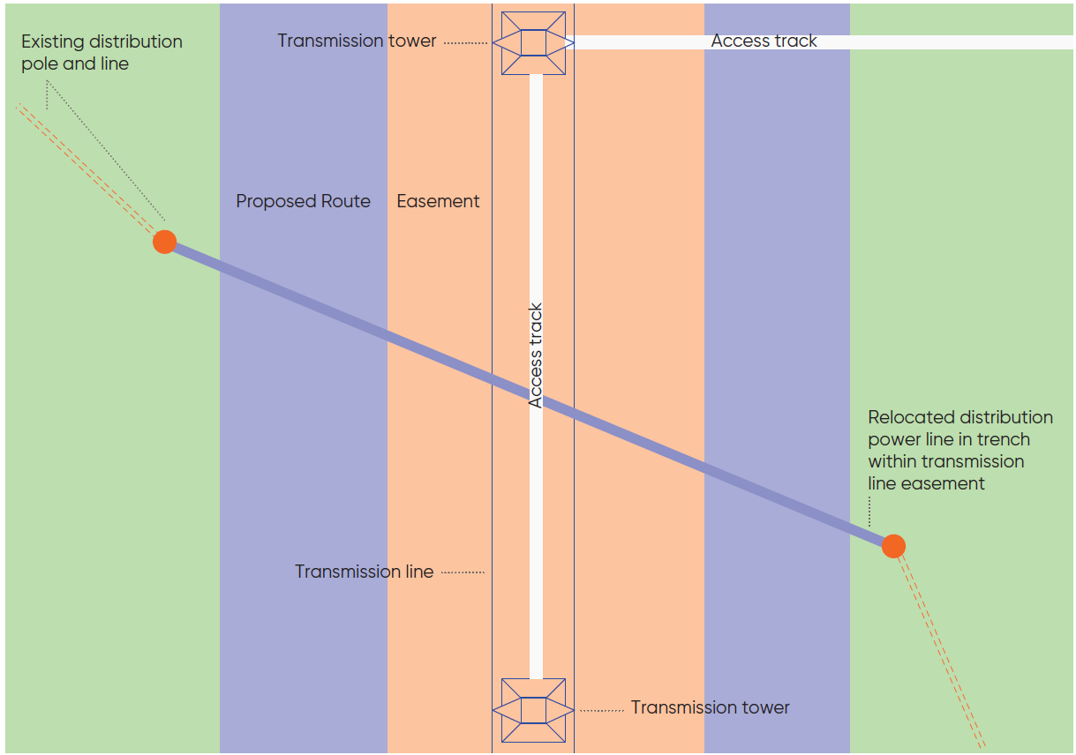
Figure 6.26 Configuration of distribution line crossover points

Central Highlands Water pipeline cathodic protective works
A Central Highlands Water pipeline runs parallel to the existing 220kV single circuit Bendigo to Ballarat transmission line. The Project will run parallel to this pipeline for approximately 7km, where the Project is collocated with the Bendigo to Ballarat transmission line.
Depending on the ultimate proximity of the Project to the Central Highlands Water pipeline, mitigation measures will likely be required by the Project to minimise electrical hazards on the metallic pipeline. Standard mitigation measures typically employed by the Victorian water industry, like safety earth beds, have been proposed as part of preliminary assessment into the pipeline.
Further assessment will be undertaken to verify if additional pipeline treatment is required prior to construction. This will include:
- Engagement with Central Highlands Water to verify the specification of the pipeline types and the electrical hazard treatments already installed along the pipeline
- Confirmation of the Proposed Route and tower placement in relation to the Central Highlands Water pipeline
- Completion of soil resistivity testing along the section of pipeline that parallels the Project
- Completion of a detailed electrical hazard assessment, in accordance with AS/NZS4853 Electrical Hazards on Metallic Pipelines, to confirm the pipeline treatment requirements
- Further engagement with Central Highlands Water to carry out a Safety in Design assessment for the proposed treatments of the pipeline and get their endorsement of the proposed treatments.
A minimum distance of 10m to the pipeline is required to avoid significant damage to the pipeline network.

Vegetation clearance for preparatory works
To the minimum extent necessary, AusNet will undertake clearing of vegetation to enable the above preparatory activities prior to commencing the main construction works.
Typically, vegetation clearance will occur in areas where AusNet are required to re-locate existing services that are likely to be impacted or in the area of construction activities.

Construction of towers and transmission line works

Tower construction sequence
Work crews will move through sections of the Proposed Route to construct the transmission line following the series of construction steps shown in Figure 6.27.
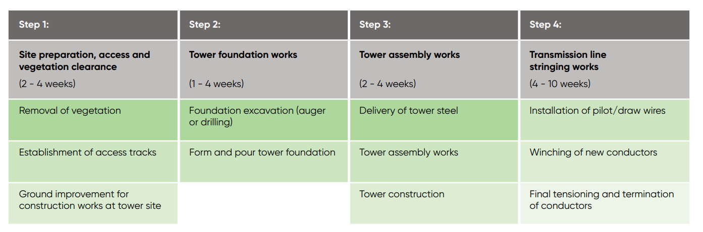
Figure 6.27 Typical tower and transmission line stringing construction sequence
Construction may occur at multiple tower sites at the same time and the construction steps outlined in Figure 6.27 may occur across an extended period of time. Once foundations are complete, work may cease for several months until crews return to assemble and erect the towers. Work may then cease again for several months until crews return for stringing. From mobilisation to de-mobilisation, construction work at each tower may take about nine to 22 weeks depending on weather and if tasks are able to immediately follow one another.
The starting point and direction for construction activities along the Proposed Route will be determined prior to construction commencing on the Project. Throughout the construction stage, work crews will endeavour to work continuously and sequentially.
Transmission line stringing is typically undertaken sequentially along the line. The direction will be determined by the Principal Contractor.
Weather, ground conditions and unexpected issues may affect the construction sequence. The Principal Contractor will be responsible for adjusting the sequencing as appropriate and for communicating any major changes (or delays) in scheduling to the relevant authorities, landholders and other stakeholders.

Upgrading roads and bridges on the construction route
Roads of varying standard will be required for heavy haulage for the Project’s construction. Existing roads to be used during construction will be assessed by the Principal Contractor for their capability to support the required haulage and routes will be selected to avoid having to upgrade roads or bridges to accommodate heavy vehicle movements where possible. This includes no use of over-dimensional or overweight loads, spreading loads among vehicles when using narrow or non-reinforced bridges, and selecting longer transport routes rather than having to upgrade local bridges.
Where small bridges or narrow country roads require upgrade or restorative works, this will be undertaken in consultation with the relevant road authority (local council or the Department of Transport and Planning). Relevant approvals under the Road Management Act 2004 and other legislation will be obtained, as necessary. The number of upgrades required is expected to be minimal.

Site preparation, access and vegetation clearance

Tower assembly area
At the base of all tower sites, a work area, referred to as the tower assembly area, will need to be established for use during construction and assembly of the towers. These areas will be placed around the tower legs and include an area for a crane, an elevated work platform for vehicles to work from, an area for foundation drilling equipment, and areas for the assembly of the tower components and to string the conductors.
The tower assembly area will be established by clearing an area typically no greater than 50 by 70m. Site-specific conditions, such as the slope of the land or soil conditions, may influence the size and shape of the cleared area. Minor ground improvement works (e.g., levelling works, or benching) may be needed at the site to ensure safe access for construction workers and equipment. Figure 6.28 shows an example of a tower assembly site.
The location of the tower assembly area will be selected based on the location of the tower and preparatory site investigations, considering terrain, fences, landholder requests, or any other identified constraints. Depending on the ground conditions, an area of compacted rock may be required to create a work area (hardstand) for the foundation work equipment and crane pads used to assemble the tower.
The extent of the crane pad area within the tower assembly area will typically be in the range of 12 by 12m. The pad will align with the access track to the tower assembly area, as shown in Figure 6.28.
Blasting is not anticipated to be required to construct the towers or any other elements of the Project.
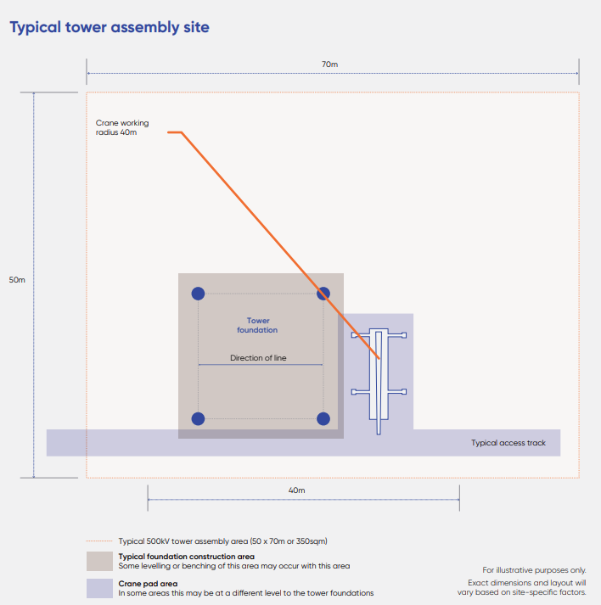
Figure 6.28 Indicative diagram of tower assembly area

Access tracks
Access tracks are required to facilitate the transport of plant and equipment to the tower assembly areas and other temporary construction areas (such as stringing pads). Attachment VI: Map book shows the indicative locations of access tracks. It is likely some of the tracks will change in consultation with landholders and as the detailed design is developed.
Access tracks will typically be a trafficable width of 4 to 6m wide with a one metre allowance on either side for drainage and retaining batters, where required. At a very small number of locations – for example, where the access track is on a steep slope – the full width (trafficable width plus allowances) may need to extend to between 10 to 15m.
The overarching principles for the selection and siting of access tracks are:
- Site assessment with landholders, wherever possible, to identify existing tracks that can be used or upgraded for the purposes of the Project
- Identifying access points that are closest to the nearest public road
- Minimising disturbance to ecological and cultural heritage values
- Avoiding or minimising waterway and drainage line crossings
- Avoiding steep slopes, waterlogged land and potentially unstable ground
- Avoiding interaction with potential acid sulphate soils and contaminated groundwater.
Existing tracks (such as those used for farm vehicles or for other projects) will be used and if required improved, by laying a road base material (crushed rock) and compacting the material using a roller to minimise disturbance to landholders. If ground conditions are good and can support heavy loads, minimal work will be required to prepare an appropriate access track. Landholders will be consulted prior to conducting any upgrades to existing tracks.
Where there is no suitable existing access track that can be used, a new access track may be built for temporary construction use or permanent access. Access tracks may be temporary (used only to support construction activities) or permanent (used to support the Project on an ongoing basis). In some circumstances, access tracks may be permanently retained to allow safer and easier access for ongoing operations and maintenance activities. The permanence of access tracks will be negotiated with the landholder, noting that in some instances there may be a mutual benefit to AusNet and the landholder to leave the track in place. Construction of new access tracks typically involves:
- Removal of vegetation and topsoil (up to 150mm) using graders or tracked bulldozers
- Stockpiling of topsoil for reuse
- Surface levelling using a roller
- Adding crushed rock
- Compaction rolling.
Removal, stockpiling and reuse of topsoil will be in accordance with the Spoil Management Plan developed for the Project, which will be incorporated within the CEMP.
In areas of high sensitivity, construction methods using geofabric and crushed rock/road bases over existing ground surfaces will be used to avoid impacts. Where the terrain is steep or the ground is too wet, cut and fill construction methods may be required; however, this will be avoided wherever possible. In wet weather, bog mats may be used to minimise ground disturbance. Bog mats are high strength temporary ground covers that help to protect a variety of terrain, minimise ground disturbance and improve access for construction traffic. Bog mats are laid on the ground surface using light cranes on the back of four-wheel drive trucks. No topsoil is removed where bog mats are used. When work is complete, bog mats will be removed from the site, washed down at a laydown area to prevent weed spread and re-used for other sites as required.
During construction, there may be some scope for landholders to share use of access tracks with the Principal Contractor, subject to safety and seasonal considerations. As construction works are typically carried out in bursts with reasonable gaps between activities, landholders may be able to use the tracks in between these times. The Principal Contractor will be responsible for managing any requests for use from landholders.
When construction is completed, temporary tracks will be reinstated to previous conditions (or as close as reasonably practicable) subject to the requirements of the landholder who may prefer to use the track for other purposes. Requests from landholders to retain these tracks for their own use as permanent tracks will be considered.

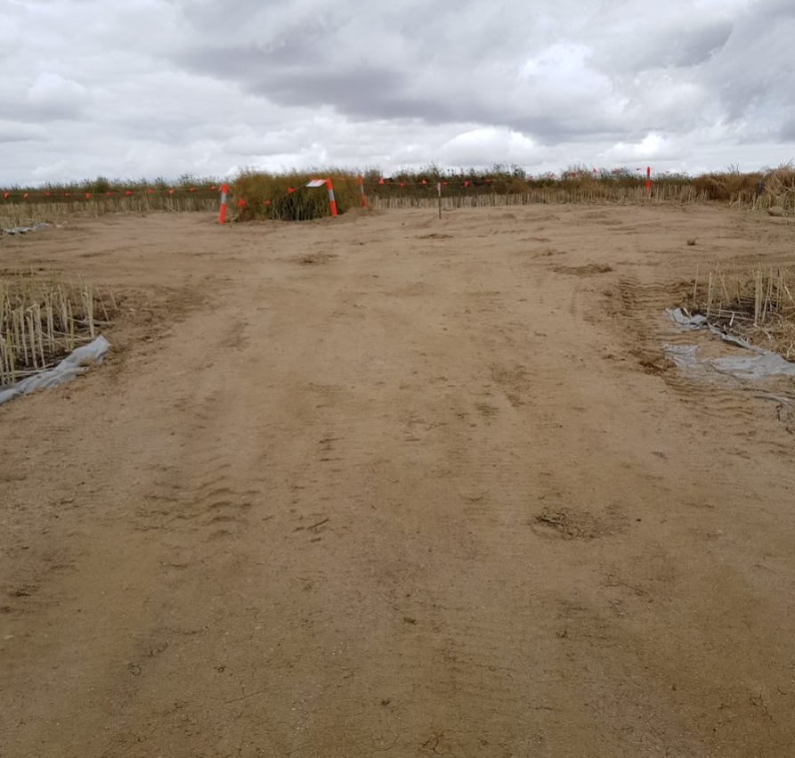 | 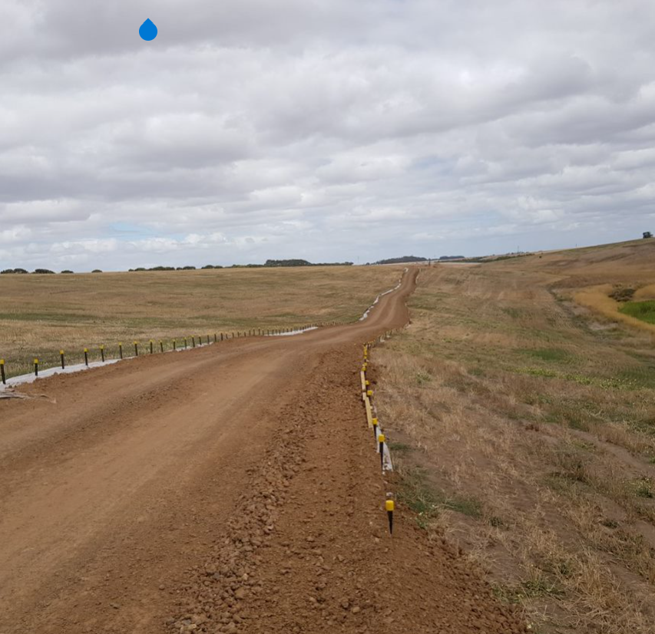
Figure 6.29 Examples of typical access tracks

Vegetation clearance
Vegetation may need to be cleared to provide space for the Project’s construction of the towers and transmission line, including the establishment of the tower assembly areas, access tracks and transmission line stringing works. Section 6.8 describes the proposed vegetation clearance approach for the Project.
Vegetation clearance will be undertaken in accordance with the EPRs, the planning and regulatory approvals issued for the Project and with AusNet’s Vegetation Management Plan.

Tower foundation works
Majority of the tower foundations will be bored pile foundations. Construction activities will commence with temporary pegs being placed within the tower assembly area to mark out locations for drilling the tower footings. Once the pegs are in position, track mounted piling and drill rigs will be used to pile or drill the footings to depths dependent on the condition of the surrounding soil. In unstable ground conditions, steel liners may be inserted to stabilise the excavation. The tower stub legs and steel reinforcement are placed within the footing holes and stabilised with concrete.
In areas where rock is encountered, additional rock drilling equipment could be used to construct the tower foundations. Geotechnical investigation works undertaken during preparatory works will identify the correct style of construction required and foundation to be designed and installed. Other foundation types other than the bored pile foundations described above may be utilised depending on the geotechnical conditions, for example rock anchor, pad and pier, screw piles or driven piles.
As described in Section 6.2.1, excavations for the tower footings would typically be 9m in depth. Where groundwater is shallow, alternative construction methods and designs will be implemented (such as boring) to limit interaction with groundwater. If groundwater is encountered or the excavations are filled by rainwater, the excavation would be dewatered and managed in accordance with the CEMP. Dewatering may also be required during the concrete pour process. Concrete would be poured wet into the pile footings with any water removed from the top of the concrete as required.

Tower assembly and erection
The materials for each tower will be fabricated, galvanised, deglared and bundled offsite prior to the delivery to each designated tower assembly area. Given the size of a tower, these materials are generally delivered via multiple semi-trailers or off-road style vehicles. Section 6.6.5 provides detail on how materials and equipment will be transported for the Project.
Mobile cranes will be used to assemble and erect the towers, with work crews installing and tightening all bolts and ensuring the structure is complete. During the assembly period, the bundled steel that has been delivered will be laid out and partly assembled around the tower footings and the crane pad.
A larger crane will follow this work to erect the preassembled sections into their final positions (see Figure 6.30). This normally occurs shortly after the assembly works have been completed. If heavy machinery cannot gain access to the construction site due to site conditions and accessibility, alternative design, machinery or construction techniques will be developed in conjunction with the Principal Contractor. For example, a smaller crane or derricks (frameworks that support lifting tackle) could be used. Helicopters will also be used in certain areas to lift pre-assembled tower sections, securing the towers into their final position.
Once the foundations and tower are installed, the tower is tested for earthing characteristics. If any additional earthing is required, an engineering solution will then be developed. Standard mitigation measures typically involve short trenches and/or additional electrodes to be installed within in the tower assembly area.
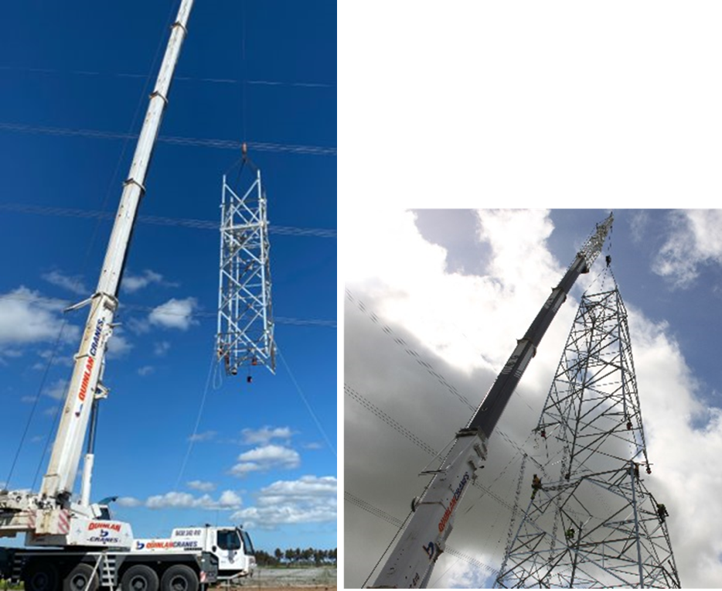
Figure 6.30 Cranes lifting tower sections into place for crews to bolt together

Plant and equipment
At each tower site, the main plant and equipment required to construct the tower and access tracks are likely to include:
- Mobile cranes
- Mobile concrete batching plants
- Piling rigs
- Rock drill (as required)
- Skid steer loader
- Bulldozer (for the access tracks if needed)
- Three to four light vehicles (at any one time)
- Trucks for delivery of plant and materials
- Semi-trailers (as required)
- Concrete trucks (quantity will vary from tower to tower).
Typically, small portable generators will be used to power the tower construction sites.
Plant and equipment that cannot be sourced locally will be imported through the Port of Melbourne and transported to construction sites as required. For plant and equipment transported from Melbourne, the Western Ring Road (M80) will form the starting point through which all traffic will flow, and from there, the Western Freeway (M8) will generally form the major corridor for the Project’s vehicle travel.
The management and maintenance of plant and equipment will be determined by the Principal Contractor during the Project’s detailed design stage and will include measures to eliminate or reduce the risk of harm to human health and the environment through implementation of EPA Publication 1834.1: Civil construction, building and demolition guide. All plant and equipment will be operated and maintained in accordance with EPA Publication 1698 Liquid Storage and Handling Guidelines. Implementation of the Project’s Surface Water Management Plan will ensure that industry standard controls and best practice measures are applied to minimise the risk of fuel or oil leaks and spills associated with the use of plant and equipment and prevent these liquids from reaching waterways (see Chapter 25: Surface water for details).

Transmission line stringing
The stringing of transmission lines is the process of hanging materials and equipment onto the towers and then pulling the conductors between the transmission towers into final position. Insulators are used to attach the conductors to the tower cross arms. The stringing of transmission lines is usually carried out in sections of varying lengths between the towers, depending on constraints, terrain and access requirements.
Temporary hurdles (see Figure 6.25 under Preparatory Activities) may be used to protect existing infrastructure, such as roads and other transmission lines, from being touched and/or damaged while stringing is in progress.
Stringing pads will be required between the towers or behind and in line with the towers in some locations for the placement of equipment associated with the stringing works (such as winches, tensioners, conductor drums and anchor blocks). These work areas are typically located every five to eight kilometres along the transmission line or where there are acute angles in the line. The total number of stringing pads will be informed by the Principal Contractor’s methodology, however, a minimum of 29 stringing pad sites will be required along the length of the transmission line. The current proposed locations of stringing pads are identified in Attachment VI: Map book.
The stringing pads will be unpaved and cover an area typically 40 by 80m, but will vary depending on the terrain, type of equipment required, and the length of the span associated with the site. Where there are large angles or changes in direction, two pads may be needed around a single tower. These temporary works areas will be reinstated after the stringing activities are completed.
Pulleys (also known as stringing sheaves) are fixed to the transmission tower cross-arms via insulators, at each location where a conductor will be attached. A helicopter, tractor or drone is then used to run out a winch rope known as a pilot wire. This pilot wire is placed into the pulleys along the stringing section. The pilot wire is connected to the conductor and pulled out under tension through the pulleys from the stringing pads. Finally, the conductor is then attached to the tower in the final fitting arrangement and adjusted to the right tension.
Stringing of transmission lines can be undertaken using specialised on-ground plant and equipment; however, at times it may be undertaken using aerial methods. Figure 6.31 shows an example of aerial stringing by helicopter. Typically, aerial methods are used to avoid or reduce the environmental impacts of stringing wires on environmentally or culturally sensitive areas. The stringing methodology will be determined in consultation with the Principal Contractor.
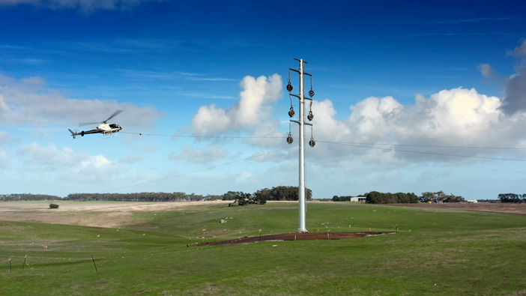
Figure 6.31 Line stringing by helicopter, Stockyard Hill Wind Farm construction

Construction of terminal station works

Construction sequence/timeframes
The works proposed at the new 500kV terminal station near Bulgana, the Bulgana Terminal Station, and connection to Sydenham Terminal Station will take approximately 20 months to complete, with several tasks overlapping. The typical construction sequencing, for both sites, is shown in Figure 6.32.
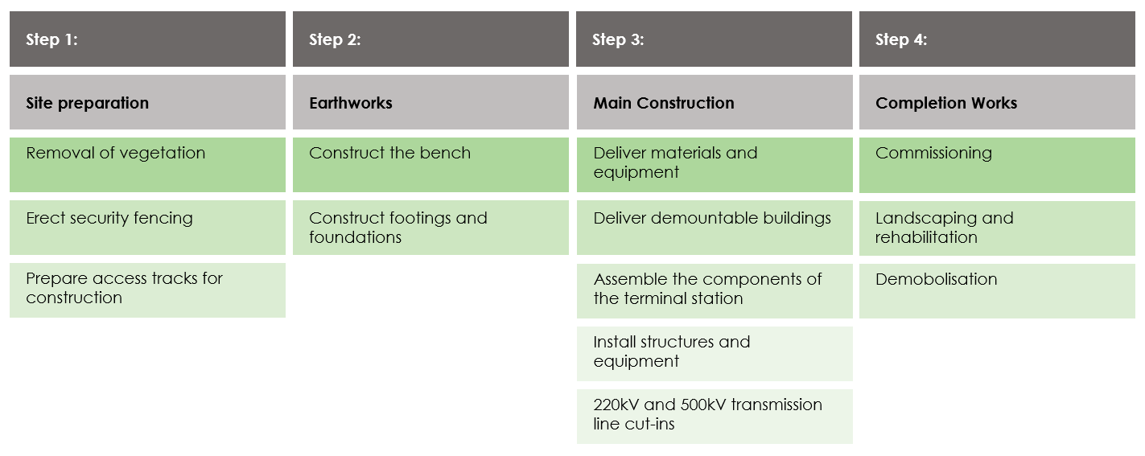
Figure 6.32 Typical terminal station construction sequence

Site preparation
Prior to commencing any construction activities at the terminal station sites, a detailed site assessment and survey will be completed as part of preparatory activities (see Section 6.6.2). No-go zones will be verified and demarcated on the ground at the site, and their importance reinforced as part of the induction process for all workers on the site. The terminal station site will then be cleared of vegetation to facilitate construction.
At Sydenham and Bulgana, the existing terminal station construction sites will be contained within the existing terminal station yard protected and secured by existing security fencing, gates and a security system. Access will only be permitted to authorised personnel only.
The new 500kV terminal station construction site will be surrounded by a security fence with a minimum height of 3m. Fences, gates and a security system will be installed throughout the construction stage to maintain site security and allow entry by authorised vehicles and personnel only.
As heavy vehicle access will be required throughout the duration of construction, any access roads to the terminal stations will be designed and constructed to accommodate these vehicles. If the terminal stations can be accessed via public roads, the Principal Contractor will upgrade and maintain these roads in accordance with the Project’s EPRs.

Earthworks
Footing/foundations for the terminal station structures and equipment will be constructed and surfaces at each terminal station site will be prepared using a cut and fill process to provide a level base. The extent of the foundation works and earthworks required will depend on geotechnical surveys completed in advance of construction. The surface area of the terminal station will be capped with an all-weather road base material during the initial earthworks stage.
Drainage works will consist of the installation of drains, pits and culverts necessary to control the flow of stormwater from the terminal station site.

Terminal station main works
Materials and equipment required for each terminal station will be delivered to the designated laydown areas within the terminal station sites. Pre-assembly of the components of the terminal station will be carried out on-site, allowing for erection by mobile cranes.
Some larger items such as the control building and transformer will be constructed mostly off-site and brought to the site on special heavy haulage equipment, in accordance with Traffic Management Plans approved by VicRoads and local councils.
Following construction of the terminal station main works, the terminal station will be commissioned, and temporary construction sites rehabilitated.

Plant and equipment
The main plant and equipment required for the construction of each terminal station are likely to include:
- Mobile cranes
- Mobile concrete batching plants
- Piling rigs
- Skid steer loaders
- Bulldozers
- Excavators
- Road roller (compactor)
- Front-end loader backhoe
- Elevated work platforms
- Forklifts and scissor lifts
- Concrete trucks
- Semi-trailers and trucks
- Light vehicles.
One diesel fuel generator will be required to power site facilities. A self-bunded fuel tank will be used at each site: this is ‘a tank within a tank’ that allows for the safe storage of fuel or diesel. It has double steel walls that retain any leakages, reducing the risk of environmental contamination.

Transporting materials
Construction works will require the use of heavy vehicles to move cables, plant, equipment and other materials to and from each site. The estimated number of light and heavy vehicle trips generated by the Project per day during the construction stage is shown in Table 6.5.
Table 6.5 Indicative count of light and heavy vehicle trips
Construction activity | Average daily vehicle trips generated during the Project construction stage
 | Light Vehicle Trips | Heavy Vehicle Trips
Connection to the new Sydenham Terminal Station | 18 | 9
Expansion of Bulgana Terminal Station and construction of a new 500kV terminal station near Bulgana | 70 | 24
500kV tower construction and stringing | 87 | 22
Note: These figures may be subject to change depending upon the Project’s construction methodology.
This means that a possible total maximum of 55 heavy vehicles and 175 light vehicles could be present across the extended transport network within the vicinity of the Project at any given time during the construction stage. However, due to work scheduling, the number of vehicles in any given area of the Project is likely to be much lower.
The Project will have numerous construction sites reached by access tracks from points of public access. Potential routes (including heavy haulage routes determined in accordance with Victoria’s heavy vehicle road network) have been identified for construction traffic to connect with these access tracks and make their way to construction sites. The potential impacts of construction traffic using these routes has been assessed in Technical Report P: Transport Impact Assessment. Appendix A of Technical Report P: Transport Impact Assessment shows in detail the Project’s proposed traffic routes within each local government area along the Proposed Route.
Traffic Management Plans (TMPs) will be prepared for the Project. These will confirm the Project’s heavy haulage routes and will include measures to minimise disruption to the transport network caused by construction activities – for example, by moving materials outside peak periods, identifying routes that minimise interaction with local traffic, maintaining traffic movements at key intersections and limiting the extent of road closures.
Further information about the Project’s transport requirements is in Chapter 20: Transport. EPRs related to construction traffic management are in Chapter 29: Environmental Management Framework.

Sourcing materials

Sourcing tower and terminal station materials
Materials for the Project will be sourced locally and internationally from a wide range of suppliers. Generally, where it is not viable or commercially competitive to source the materials locally, they will be procured internationally.
Materials being imported for the Project will be received through the Port of Melbourne and then travel on to Project construction sites via the proposed construction route identified in Technical Report P: Transport Impact Assessment.
Locally supplied materials will be delivered to the Project laydown areas and then onto the Project construction sites. Heavy vehicle movements associated with material delivery will be controlled and managed in accordance with the Traffic Management Plans prepared for the Project (see Section 6.6.5).

Sourcing concrete
Concrete is only required for construction of the tower footings and terminal station foundations. The Project will primarily source concrete from local suppliers. Mobile concrete batch plants (where materials are mixed on-site using specialised plant) may be required for the Project’s construction. If required, these plants will be located at the construction laydown areas or tower sites.
Concrete can potentially be supplied to the Project from suppliers in several locations along the route, including Stawell, Ararat and Ballarat. There are also multiple potential suppliers to the south of Ballarat from which concrete can be sourced for the eastern section of the route.
Heavy vehicle movements associated with the supply of concrete to the Project will be controlled and managed in accordance with the Traffic Management Plans prepared for the Project (see Section 6.6.5).

Construction-related activities
Throughout the construction stage, the following associated activities will be carried out as required in accordance with the EPRs:
- Cattle grid installation and removal
- Temporary fence and gate installation
- Equipment delivery
- Concrete, water and fuel delivery
- Construction crew transportation
- Security patrolling
- Traffic control
- Weed control
- Erosion control works
- Noise and dust control
- Vehicle and equipment washdown
- Waste disposal
- Spoil treatment and disposal
- Stormwater management
- Construction site services
- Site rehabilitation.
Vegetation clearance and removal will be carried out as described in Section 6.8. All vegetation removal required for the Project has been accounted for and assessed in Technical Report A: Biodiversity Impact Assessment.
Vehicle, machinery and equipment washdown will also occur throughout the construction stage. Vehicle washdown bays will be provided at the laydown areas (see Laydown areas) with controls in place to manage run-off from these areas (see Wastewater, stormwater and run-off management). The Principal Contractor will be responsible for establishing these and any other washdown facilities, hygiene stations and associated protocols that are appropriate to the task and are in accordance with AusNet’s procedures and the Project’s Biosecurity Management Plan, as required by the EPRs. Washdown procedures will take account of local conditions and concerns, landholders’ requests and the requirements of local councils. This will include measures to help stop the spread of the root-rot fungus, Phytophthora.

Temporary infrastructure for construction
Temporary infrastructure for construction, which may be situated on, close to or at some distance from the transmission line and terminal stations will include laydown areas, access tracks, water supply, waste and spoil handling storage and disposal facilities, stormwater and run-off management works and power supplies.

Laydown areas
The Project will establish five temporary laydown areas. Two of the laydown areas will be located at the existing terminal station sites (Bulgana and Sydenham), one at the new 500kV terminal station near Bulgana, and two intermediate laydown areas that are proposed to be co-located with workforce accommodation facilities southeast of Lexton and southeast of Ballan (see section 6.6.8.2). The locations of these are shown on Figure 6.2.
The laydown areas will consist of a main compound that will contain portable site offices, meeting rooms, lunchrooms, toilet block, water tanks, generator, tool sheds, workshop spaces, a pre-start meeting area, and temporary vehicle washdown areas. In addition, parking spaces will be provided for personnel vehicles as well as construction vehicles. Temporary delineation will be installed to clearly define pedestrian walkways, temporary fencing, and gates. Security systems and lighting will also be installed in the laydown area. Lighting will be installed in accordance with the relevant Australian standards, including AS4282 – 1997. Construction of these temporary laydown areas typically involves:
- Stripping topsoil and vegetation, where required, using graders or tracked bulldozers
- Stockpiling of topsoil for reuse
- Levelling the ground surface using a roller
- Adding crushed rock
- Rolling of the ground for compaction.
Diesel fuel generators within self-bunded fuel tanks will be required to power the laydown area.
The terminal station laydown areas will be situated within the existing boundaries of the Bulgana Terminal Station and Sydenham Terminal Station, and the new 500kV terminal station on land owned by AusNet. The designated areas allow for storage of materials, sorting as well as pre-assembly of terminal station materials and transmission line materials.
Two intermediate laydown areas are required for the construction of the transmission towers and lines, proposed to be near Lexton and the other near Ballan. The locations of these sites were selected based on their proximity to the Proposed Route and central location, as well as consideration of bushfire risk, environmental and cultural values.
AusNet has developed technical requirements and planning and environmental objectives to guide the investigation, assessment and selection of these intermediate laydowns. The site layout will be determined by the Principal Contractor. AusNet will also communicate with surrounding landholders about local traffic requirements associated with these laydown areas.
The size of each temporary laydown area and co-located workforce accommodation facility will vary, depending on storage requirements. The site southeast of Lexton will be up to approximately 12 hectares and the site southeast of Ballan will be up to approximately 24ha, as these areas need to accommodate large quantities of steel members for the towers and transmission line materials.
The construction team has identified that using an established warehouse or storage facility owned by a freight forwarding company in Melbourne would also be a suitable option to store materials before they are transported directly to the construction sites. It is envisaged that the container deliveries would be sent from the Port of Melbourne to a third-party storage facility and de-stuffed or de-stuffed near the Port and then sent to the storage facility. Activities at these established facilities would be in accordance with permitted use of the land.
Once construction is completed, all temporary laydown areas used for the Project will be reinstated. Materials will be loaded onto appropriate tip trucks for removal off-site.

Workforce accommodation facilities
To minimise effects on visitor accommodation and affordable rental accommodation, construction workforce personnel that require accommodation near the Project are proposed to be accommodated in temporary construction workforce accommodation facilities. Two facilities are proposed, one on Sunraysia Highway southeast of Lexton and one on Ingliston Road southeast of Ballan. The workforce accommodation facilities are proposed to be co-located with the intermediate laydown areas. The Lexton site comprising the workforce accommodation and laydown area will be up to approximately 12 hectares in total, while the Ballan site comprising the workforce accommodation and laydown area will be up to approximately 24 hectares in total. Each facility will accommodate approximately up to 350 personnel. The workforce accommodation facilities will contain:
- Individual demountable accommodation units
- Meeting room/s for site meetings, project reviews, and safety inductions
- Medical facilities including a first aid room and site nurse
- Offices
- Internet and WiFi services (where feasible)
- Mobile services and boosters (where feasible)
- Foxtel or similar services
- Communal kitchen and meals area
- Gym facilities
- Self-serve laundry facilities
- Fully serviced kitchen facilities.
The workforce accommodation facilities will be established prior to works on the Project with an estimated design and construction time of up to approximately 12 months. The facilities will be operational for at least 24 months. Construction of each accommodation facility typically involves:
- Stripping topsoil and vegetation, where required, using graders or tracked bulldozers
- Levelling the ground surface using a roller
- Adding crushed rock
- Rolling of the ground for compaction
- Utility installation
- Foundation and tie-down installation or preparation
- Delivery and installation of buildings
- Utility connections and commissioning.
Lighting will be installed in accordance with the relevant Australian standards, including AS4282 – 1997.

Temporary access tracks
As described in Section 6.6.3, temporary access tracks will be required in some locations to facilitate the transport of plant and equipment to construction sites. Following construction, temporary access tracks will be reinstated to previous conditions, subject to the requirements of the landholder.

Water use and supply
Water will be required during the Project’s construction activities, primarily for dust control, along access tracks, at the tower assembly areas, terminal station sites, and in and around sensitive areas. The amount of water used will depend upon the weather, with up to 100 kilolitres per day likely to be required on dry, windy days.
The source of water for dust control will be determined by the Principal Contractor prior to construction. If required, the Principal Contractor will negotiate the Project’s water supply requirements with the relevant water authorities and landholders. This could include obtaining water from farm dams, with reimbursement to the landholder. Concrete suppliers to the Project (see Sourcing concrete), will obtain their own water, using their established supply sources.
Potable water will be provided to construction sites in tanks or from local supplies where available.
As is typical for transmission lines during operation, water storages for firefighting purposes are required at each terminal station. The water storages will be set up ready for use during the construction stage of the Project, along with mobile trailer units at workforce areas in quantities determined as part of the site’s risk assessment.

Waste handling, storage and disposal
Project waste will be managed in accordance with the CEMP which addresses the relevant Victorian laws and standards. These establish a framework for managing waste that requires the Project to avoid or minimise the generation of waste so far as is reasonably practicable. Where waste is produced, consideration will be given to recycling or reuse on-site. Where waste cannot be recycled or reused on-site, opportunities will be explored for recycling off-site.
Waste generated by the Project that cannot be recycled or reused on-site will be removed by a waste hauler licensed as necessary to transport such wastes and disposed off-site at an approved facility.
Waste disposal methods would be selected based on the classification of waste material in the EPA Victoria Publication 1827: Waste classification assessment protocol and EPA Publication 1828: Waste disposal categories – characteristics and thresholds. All wastes generated during construction of the Project would be transported, managed and disposed of in accordance with the relevant EPA Victoria requirements.
Construction waste will mainly comprise cut-off pieces of wires, small amounts of concrete waste, packing material, cardboard, plastic and timber. Inert wastes (non-toxic wastes such as cardboard, glass bottles and timber) will be recycled where practicable.

Wastewater, stormwater and run-off management
Wastewater includes run-off from the construction sites and sewage from the construction workforce.
Subject to the Principal Contractor’s requirements, portable toilets will be provided at the temporary laydown areas, tower assembly areas and stringing pads, where required for use by the construction workforce. Temporary sewage collection and storage facilities will be installed where required for these toilets and pumped out for off-site disposal at an appropriate facility to avoid risks to surface water, groundwater and land uses. All portable toilets will be removed when works are completed.
Construction activities could require the use of fuel, oil, grease, degreasers, solvents, paints, disinfectants and detergents. The Principal Contractor will implement a Surface Water Management Plan that includes industry standard controls, best practice construction techniques and other mitigation measures to minimise the risk of harm from pollution associated with the Project’s construction activities. The plan will provide specific controls to meet EPA Victoria requirements for managing leaks and spills, stormwater and contaminated surface water run-off. Controls to manage the storage and use of chemicals and fuels during construction will include the use of self-bunded fuel tanks, adopting safe pouring and decanting procedures, and using measures to prevent the migration of liquids (such as drain covers).
Water from areas with oil-fuelled operating equipment will be treated prior to being discharged with stormwater. The discharge of stormwater will occur via a legal discharge point, which will lead to either a designated waterway or detention basin. Stormwater will be managed, treated and discharged in accordance with a Stormwater Quality Management Plan, as required by the EPRs. Where possible, stormwater run-off will be captured and reused for non-potable activities such as toilet flushing or landscape irrigation at the terminal station sites. This may require additional works such as retention ponds and/or other water sensitive design features. These features are likely to be required only for the construction stage; however, they could be retained at some locations if required for ongoing management of the site.
Wastewater, stormwater and run-off management are discussed in Chapter 25: Surface water.

Excavated material
Material excavated during construction will be reused on-site or locally, such as for site rehabilitation and landscaping or for use by the landholder. As described in Section 6.6.2, the EPRs require geotechnical investigations and soil testing prior to construction commencing to confirm sub-surface conditions and soil characteristics. These investigations will determine the suitability of excavated material for reuse. Where the soil is unsuitable for these purposes and another beneficial reuse cannot be identified, the Principal Contractor will be required to manage this material to meet the general environmental duty and in accordance with EPA Victoria requirements and permits and the Project’s Spoil Management Plan. This includes classifying waste soil and testing for contamination prior to removal from the site and transportation to an authorised waste receiving facility.
Measures to manage excavated material are discussed in Chapter 22: Geology and soils.
The excavation task for the Project is relatively small compared to most major infrastructure projects. An estimated 40,000 to 50,000 cubic metres (m3) of spoil will need to be managed from excavations at the towers and terminal stations. This includes approximately 75 to 125m³ for each tower.

Power supplies
Electrical power for construction activities will be sourced either from diesel generators temporarily located at the Project’s construction sites or from the local distribution system. It is anticipated that one generator only will be required for the works at the new 500kV terminal station near Bulgana, the Bulgana Terminal Station and the connection works at Sydenham Terminal Station and on occasions at tower assembly areas.

Site rehabilitation and Project completion
Upon completion of construction, areas that are not required for the ongoing operation of the Project will be reinstated and rehabilitated in accordance with the EPRs.
Rehabilitation will occur progressively along sections of the transmission line and at the tower locations, and temporary construction areas and laydown areas. Rehabilitation of access tracks will be undertaken where they are not required for operation, or where a landholder has requested the access track to be removed.
Within the transmission line easement, rehabilitation will consider and facilitate the Project commitments in relation to future vegetation maintenance and management, with any revegetation to include planting species that are compatible with the ongoing operation of the transmission line. In non-operational locations not within the transmission line easement, rehabilitation will make good any disturbances caused during construction.
The general reinstatement and rehabilitation activities will include:
- Removing any temporary infrastructure, including temporary fences and gates, and excess materials from the site
- Site preparation: collection and stockpiling of topsoil, woodchip, mulch and other organic matter derived from topsoil stripping and vegetation clearance activities during construction, for use in rehabilitation where required
- Site stabilisation and landscaping: site stabilisation activities will be carried out both during and post construction and will include the following:
  - Stabilisation of exposed areas and prepare the sites for revegetation
  - Installation of erosion and sediment controls
  - Re-establishing topsoil cover
  - Facilitating establishment of a suitable cover crop either through direct seeding of suitable species, or allowing for natural regeneration of stored seed in re-spread topsoil, and in accordance with site-specific revegetation / landscaping requirements
  - Mulching of stabilised and revegetated areas where required
- Final site clean-up
- Monitoring and re-instating rehabilitation works if required.
Rehabilitation will occur in consultation with landholders and the land will be rehabilitated to existing land (baseline) conditions (or as close as reasonably practicable) and in accordance with the EPRs and all applicable laws and approval requirements. Standards for rehabilitation will be set out in the PAMP.

Working hours
Works will be completed in accordance with the general environmental duty to manage noise and reduce so far as reasonably practicable impacts to the health and wellbeing of sensitive receivers, including people and animals.
The Principal Contractor will have specific contractual obligations to manage noise and vibration, including setting and meeting noise and vibration targets. These targets will be incorporated within a detailed Construction Noise and Vibration Management Plan that will describe measures to monitor construction noise and vibration levels to ensure these targets are achieved. The plan will also provide an indicative schedule of construction activities, describe procedures for notifying the community about construction works and establish a process for receiving and resolving complaints about noise and vibration.
EPA Victoria Publication 1834.1 Civil Construction, Building and Demolition Guidelines sets out the work hours for major infrastructure projects:
- Normal working hours for all civil construction, building and demolition activities:
  - Monday to Friday, 7 am to 6 pm
  - Saturday, 7 am to 1 pm.
- Where works may be required to be undertaken outside of normal working hours:
  - Monday to Friday, 6 pm to 10 pm
  - Saturday, 1 pm to 10 pm
  - Sundays and public holidays, 7 am to 10 pm.
The Project’s construction works will be scheduled during normal working hours. Works can only occur outside these hours if noise levels comply with the weekend, evening and night-time targets set in EPA Victoria Publication 1834.1.
Certain construction activities may need to occur at night or during the weekend due to outage constraints imposed by the transmission network operator and the need to undertake such works at periods of lower demand on the system. Should any construction works be required outside of the normal working hours, affected residents will be consulted about the work and notified in advance of the intended work, its duration and times of occurrence in accordance with the Project’s EMF.
A number of works across the Project are likely to fall within the definition of unavoidable construction works outside the hours defined within EPA Victoria Publication 1834.1. These are works that cannot practicably meet the Guideline’s requirements because the work has to be continuous or would otherwise pose a higher risk to life or property or risk a major traffic hazard if limited to the defined hours. The relevant authorities and potentially noise-affected neighbours will be notified in advance prior to the conduct of these works.
Measures to manage construction noise and vibration are discussed in Chapter 19: Noise and vibration.

Safety and security during construction
The Principal Contractor will be responsible for ensuring safety and security at construction sites and laydown areas in conjunction with existing AusNet safety procedures, regulatory requirements and the EPRs. All laydown areas will have secure temporary chain-mesh fencing, security systems and lighting as required. Other typical security measures may include:
- Providing dedicated materials storage facilities at the laydown areas
- Securing storage facilities with temporary chain-mesh fencing and closed-circuit television (CCTV) cameras
- CCTV cameras at the terminal station construction sites
- Excavation safety controls to prevent people and animals from falling into excavation pits, such as covering pits outside working hours.

Construction workforce
The Principal Contractor will endeavour to source the Project’s general construction workforce from within the local communities along the Proposed Route. Specialist workforce crews will be employed to construct the tower footings and steelwork, build the terminal stations and undertake transmission line stringing. Specialist personnel will be sourced from within Victoria to the extent possible and supplemented by interstate personnel as required.
The size of the construction workforce is expected to vary during the construction stage, depending on the stages of construction and the Principal Contractor’s delivery methodology. Peak crew size at any individual tower site is likely to be around 10 to 15 workers.
During the pre-construction stage, personnel will be required to develop supporting infrastructure, such as preparing access tracks and laydown areas, and conducting site surveys (for example, geotechnical investigations). During the construction stage, the total approximate peak workforce is 700 personnel, shared across:
- Two work crews (east and west) for the line totalling 600 personnel (a portion of these workers (50) will also work on the terminal stations as listed below)
- Approximately 110 personnel for the construction stage works at the existing Bulgana Terminal Station and the new 500kV terminal station near Bulgana
- Approximately 40 personnel for the construction of the Sydenham Terminal Station connection works.
Typically, personnel for the transmission line works will convene each morning at one of the temporary laydown areas to prepare for the day’s activities. From these areas, personnel will be transported to construction sites using mini-buses or 4WD vehicles. Workforce car parking will be provided at the five temporary laydown areas. To construct the transmission line, personnel will typically travel along the Proposed Route in 4WD vehicles and park along the prepared access tracks.
The transmission line and terminal station workforce crews generally work independently of one another and are on different rosters. The rostering arrangement will vary depending on which Principal Contractor is working in the area and their workforce arrangements.
The Project will aim to minimise effects on visitor accommodation and affordable rental accommodation due to increased demand from the construction workforce. It is proposed to establish dedicated workforce accommodation facilities near Lexton and Ballan, sourcing construction workers, where possible, from local communities, and measures such as scheduling works to avoid peak tourist periods.
The Project aims to generate positive social and economic impacts by using local businesses and industries to provide goods and services for the Project wherever practicable, including fuel suppliers and local manufacturers and suppliers of materials and equipment. These benefits are discussed in detail in Chapter 2: Project rationale, Chapter 14: Economic and Chapter 21: Social.

Testing and commissioning activities
AusNet will conduct comprehensive infrastructure inspections and safety tests ahead of the transmission line and terminal stations being commissioned. Typically, these activities are carried out progressively during construction, and include:
- Survey, foundation soil and concrete tests (completed and signed off prior to steel assembly commencing)
- Assembled steel inspections and tests (completed and signed off prior to stringing works commencing)
- Tower earth system testing to ensure it meets design requirements (typically completed prior to stringing activities)
- Tests and inspection of all electrical connections, including overhead fibre optic communication cables (completed and signed off prior to handing over for electrical testing).
Once these tests are completed, electrical testing is carried out to confirm the characteristics of the transmission line are in accordance with its design and service parameters. AusNet will conduct final inspections along the Proposed Route in the lead-up to electrical testing to ensure:
- The earthing system is undamaged
- Anti-climbing measures are in place
- Signage and labelling are in place
- Insulation strings are complete and undamaged
- Temporary safety earths and protective covers are removed.
Every element of the Proposed Route is inspected using a combination of observation from the ground with binoculars and from the air using drones and helicopters. These inspections typically take up to one week. AusNet will inspect structures and machinery at the terminal stations to ensure that are safe and ready for operation.
These pre-commissioning activities are undertaken by the Principal Contractor, using suitably qualified personnel and in accordance with AusNet’s pre-commissioning requirements for high voltage transmission lines. The requirements include liaising with relevant utilities, regulatory authorities, emergency services and other stakeholders to advise them of progress towards and timelines for commissioning and energisation. Independent auditors will carry out various safety and quality audits as required. Following completion of pre-commissioning, the Project will be energised and loads checked. Following successful energisation, post-energisation tests will be completed to confirm Project infrastructure functions and performs as required.

Operation and maintenance activities
The operation and maintenance of transmission lines are subject to stringent regulatory controls to ensure public safety and the uninterrupted supply of electricity. AusNet is required to comply with these controls and provide regular reports to the relevant authorities, including ESV.
Specifically, AusNet are required by legislation and the electrical safety regulator, ESV, to maintain an Electrical Safety Management System (ESMS) and as part of the ESMS a Bushfire Mitigation Plan (BFM 10-02) and a Vegetation Management Plan (BFM10-06). These are the key operational management procedures that address the environmental aspects during the operation and maintenance of the Project. Further information about the Project’s Environmental Management Framework, including the ESMS, Bushfire Mitigation Plan, Vegetation Management Plan and EPRs, is provided in Chapter 29: Environmental Management Framework.

Activities within easements
As discussed in Section 6.3, transmission line easements create rights to use and occupy the land; as such, AusNet reserves the right to access the transmission line infrastructure for ongoing maintenance and operation. AusNet will access easements to carry out maintenance of the equipment and/or access land within the easement where unsuitable vegetation, ground conditions or other activities compromise the safe and reliable operation of the Project. In general, maintenance of the easement is the responsibility of the landholder or tenant (depending on terms of use).
Vegetation management within the easements will be undertaken in accordance with AusNet’s Vegetation Management Plan, which complies with the Electric Line Clearance under the Electricity Safety (Electric Line Clearance) Regulations 2020. This will include, but is not limited to:
- Maintaining a minimum clearance space around tower infrastructure and transmission lines, which includes cutting and pruning vegetation during operations according to location and anticipated regrowth rates
- Mitigating fire risks associated with fuel loads below the transmission lines
- Attaining ‘self-managing’ easements by removing inappropriate species, limiting existing vegetation height to an acceptable level, limiting the quantum and density of retained vegetation, and encouraging low growing appropriate species
- Developing easements that are more sustainable, subject to minimal disturbance to significant vegetation and that provide amenity for the community.
Standard techniques such as manual tree removal, the use of mechanical equipment and slashing will be used to maintain appropriate vegetation in the easement. Appropriate and approved techniques will be used to manage vegetation of botanical, cultural, aesthetic or environmental significance in specific locations. Herbicides may be used to control weeds in some sections of the easement to meet AusNet’s obligations under the Catchment and Land Protection Act 1994. Herbicide use will be in accordance with AusNet procedures and the EPRs and will be undertaken in consultation with landholders.

Operation and maintenance of transmission lines

Inspections
Maintenance personnel will conduct inspections of the transmission line and easements at scheduled intervals.
Inspections of the transmission line easements will be conducted annually using aerial light detection and ranging (LiDAR) scanning technology. Where data cannot be captured using LiDAR surveys, personnel will conduct on-the-ground inspections. These inspections will ensure that clearances are maintained between vegetation and the transmission line, and that the easements are maintained in a serviceable condition. An inspection will also be undertaken each year to identify unauthorised works, structures or fences within easements. Immediate action will be taken to rectify any issues that are not compliant with the relevant regulations; other matters will be scheduled for action as appropriate.
Additional scheduled maintenance inspections of the towers and transmission line will be undertaken once every three years to identify and address any issues, defects or abnormalities. The towers will be inspected to assess the condition of the tower structure, drainage issues around footings and all hardware attached to the tower to determine whether any components require rectification. The conductors will also be inspected to identify and remedy any superficial damage, insulator damage and other visible defects. These inspections will be carried out either as a ground-based survey or via a LiDAR aerial survey.
Smart Aerial Image Processing inspections of conductors and ground wires will be performed every six years to identify and address any defects or abnormalities.
All inspections will be conducted in accordance with regulatory requirements and as set out in AusNet’s procedural documents.

Responding to faults
In addition to scheduled inspections, operational systems will be in place to identify and respond promptly to service faults and complaints. A Supervisory Control and Data Acquisition (SCADA) monitoring system will alert AusNet to any damage or fault along the line. This system will use a combination of monitoring equipment, sensors and other digitally enabled devices to provide information to a monitoring interface. From there, AusNet can despatch appropriate work crews to fix the fault.

Operation and maintenance of terminal stations
Terminal stations are operated remotely, and personnel will only be present for inspections or maintenance.
Routine inspections occur every two months with personnel checking the overall condition of the terminal station’s assets including:
- Power transformers
- Circuit breakers
- Surge arrestors
- Isolators
- Protection schemes
- DC supply
- Station service transformer
- Lighting system security.
The communications equipment, alarms and protection systems will be checked during the two months routine inspection for any abnormalities or deterioration.
An annual inspection of the building and switchyard will be conducted to ensure fencing, painted surfaces, general building conditions, switchyard vegetation and easements are monitored and recorded, and any issues addressed. Inspection of the stations’ internal roads and drainage system will be conducted every six months.

Operational-related activities
Throughout the Project’s operation, operational activities will be carried out as required to comply with the EPRs and regulatory requirements, and in accordance with AusNet’s procedures, including:
- Ongoing stormwater and run-off management. While the Project will have a relatively small increased area of impervious surfaces, operational surface water and stormwater quality management plans will be implemented to manage run-off and protect local waterways from pollution.
- Vehicle and equipment washdown to minimise the spread of weeds and pathogens in accordance with established AusNet procedures and included in the Project’s Biosecurity Management Plan, as required by the EPRs.
- Maintenance of the fibre optic cable during routine inspections of the terminal station.

Safety and security during operation
A number of well-tested controls are used to ensure the operational safety and security of transmission lines in compliance with regulatory requirements.
The Project’s operational infrastructure will be secured by physical measures such as anti-climbing barriers on the towers (see Section 6.2.1) and security fencing, locked gates, thermal cameras and remote-controlled lighting at the terminal stations.
AusNet’s Vegetation Management Plan sets out protocols and actions to keep vegetation clear of the transmission lines and reduce fuel densities and hazards. The Plan complies with the Code of Practice for Electric Line Clearance, which has been developed to ensure public safety, establish standards that must be observed when electric lines operate near vegetation and reduce vegetation-related interruptions to electricity supply.
Water storages for firefighting purposes will be located at regular intervals along the route as agreed with fire and emergency services authorities. Terminal stations will have fire monitoring systems, water storages, booster water pumps and fire extinguishers. Further details regarding operational fire safety are provided in Chapter 13: Bushfire.
AusNet uses digital platforms and solutions including SCADA real-time monitoring systems that have the ability to overlay weather forecasting data with historical records and vehicle and helicopter observations to better predict and prevent damage to transmission lines from storms and other weather events. These solutions will be the starting point for the Project’s operational safety, with further improvements expected to occur over the operational life of the Project due to technology advances in areas such as remote telemetry and drone surveillance.

Operational workforce
Limited personnel will be required during the Project’s operation as the transmission system (including the terminal stations) will be operated remotely. The number of personnel at the terminal stations for regular inspections and maintenance will be dependent on the timing of the tasks to be completed, and the number of resources required to safely complete these tasks. Aside from fault response, the frequency of travel to terminal stations would be at least once every two months to complete station inspections. Long-term employment will be limited to maintenance personnel carrying out the inspections described in Section 6.7.3.
A ‘Pre-Summer Patrol’ and a ‘Vegetation and Easement Patrol’ will be completed separately each year. Depending upon the results of these patrols, further works may be required to either complete repairs along the transmission line, or removal of vegetation that is encroaching into the easement. The number of maintenance personnel working at any time will depend on the timing of scheduled inspections, the nature of the maintenance tasks to be completed and the number of people required to safely complete these tasks.

Vegetation clearance during construction and operation
AusNet will need to clear vegetation as part of the Project, to both facilitate construction activities and to establish minimum clearance spaces required for the safe operation of the transmission line in the proposed easement.
All vegetation removal required for the Project has been accounted for and assessed in Technical Report A: Biodiversity Impact Assessment.
Vegetation clearance for construction purposes will be undertaken in accordance with the EPRs and the planning and regulatory approvals issued for the Project. Various approaches will be adopted to manage the trimming and clearing of vegetation required to facilitate construction activities:
- Typically, selective trimming required for specific individual trees is undertaken by an arborist. This may include vegetation overhanging a proposed access track.
- Where selective clearance of vegetation is required in areas that include scattered vegetation, an excavator is typically used to fell and grab trees that can then be mulched.
- In densely vegetated areas, typically a dozer and excavator are used to achieve clearance. Vegetation will be cut and mulched. Depending on the nature of the cleared vegetation or timber, it may be reused along the route in areas that require the reinstatement of any batters, used in rehabilitation works, offered to the landholder or offered to other potential users (such as Catchment Management Authorities).
As part of the construction activities, AusNet will need to establish a safe easement for the transmission line. AusNet is required to maintain clearance spaces within the easement to manage fuel load hazards impacting on tower and line infrastructure to ensure safe and reliable operation of the transmission line and manage risks associated with bushfire. All vegetation clearance within the proposed transmission line easement will comply with the Code of Practice for Electric Line Clearance under the Electricity Safety (Electric Line Clearance) Regulations 2020. The vegetation removal required for the establishment of the easement has been accounted for and assessed in Technical Report A: Biodiversity Impact Assessment. Vegetation clearance will be undertaken in accordance with the Project planning and environmental approvals.
Under the Electricity Safety Act 1998, AusNet is required to prepare and implement a Vegetation Management Plan that sets out transmission line and easement management practices in accordance with the Electricity Safety Act 1998. The plan requires the assessment of vegetation with the following considerations:
- Electrical safety clearance spaces are maintained around conductors and towers (this requires either the trimming or clearance of vegetation).
- Vegetation density is limited along the easement to manage potential fuel hazards and bushfire risks to conductors and towers (this requires selective clearance).
Activities undertaken within easements during the Project’s operation will mainly be vegetation management to provide for the safe and reliable operation of the transmission line. These activities will be undertaken in accordance with AusNet’s Vegetation Management Plan, which complies with the Electric Line Clearance under the Electricity Safety (Electric Line Clearance) Regulations 2020. This will include (but is not limited to) activities to:
- Manage trees to maintain minimum clearance space around tower infrastructure and transmission line, which includes cutting and pruning vegetation during operations according to location and anticipated regrowth rates.
- Mitigate fire risks associated with fuel loads below the transmission line.
- Attain ‘self-managing’ easements by removing inappropriate species, limiting existing vegetation height to an acceptable level, limiting the quantum and density of retained vegetation, and encouraging low growing appropriate species.
- Develop easements in the longer term that are more sustainable, are subject to minimal disturbance to significant vegetation and that provide amenity for the community.
Standard techniques such as manual tree removal, the use of mechanical equipment and slashing will be used to maintain appropriate vegetation in the easement. Appropriate and approved techniques will be used to manage vegetation of botanical, cultural, aesthetic or environmental significance in specific locations. Herbicides may be used to control weeds in some sections of the easement to meet AusNet’s obligations under the Catchment and Land Protection Act 1994. Herbicide use will be in accordance with AusNet procedures and the EPRs and will be undertaken in consultation with landholders.
Vegetation within defined gullies will be reviewed along the route to confirm potential fuel hazards and determine any clearance requirements to ensure safe operation of the transmission infrastructure. Areas that contain grasslands will only be impacted where they directly intersect with construction activities.

Decommissioning
Decommissioning refers to the retirement of the Project infrastructure once it has reached the end of its service life. The service life of a terminal station is approximately 45 years and 80 years for a transmission line, at which time the infrastructure will either be decommissioned or upgraded to extend its service life to ensure the security and reliability of the transmission network as determined by the network planner at that time.
Decommissioning activities will be planned and carried out in accordance with regulatory requirements at the time. Decommissioning activities are discussed in the following sections.

Decommissioning Management Plan
Prior to decommissioning the transmission line, a Decommissioning Management Plan will be developed to provide detail regarding the proposed decommissioning works and the environmental risks associated with decommissioning. Management and mitigation measures will be prepared and included within the Decommissioning Management Plan.
This Plan will use best environmental management strategies, practices and technologies current at the time of decommissioning to comply with regulatory provisions and to appropriately manage environmental issues that may be associated with decommissioning of the transmission line. This shall include, but not be limited to, measures for communications and stakeholder engagement, environmental protection measures, waste management and recycling, emergency response and measures to minimise disturbance to agriculture, recreation and other enterprises.

Decommissioning transmission lines and towers
The process of dismantling and removing the transmission line will be a staged process, and may include:
- Lowering the overhead conductors and ground wires to the ground and cutting them into manageable lengths to roll onto drums or reels for disposal as scrap metal
- Removing insulators and line hardware from structures at the site and disposal at an approved waste facility
- Dismantling towers in manageable sections, removing from the site and selling steel as scrap.
Demolition of the tower footings may include:
- Excavation of the ground surrounding each tower, including the tower leg/holding down bolts and encasing concrete
- Breaking the concrete footings
- Cutting off the tower leg or holding down bolts and reinforcing steel below ground
- Removing the demolished concrete and scrap steel from the site for disposal at an approved local waste facility or recycling
- Backfilling the excavation and compacting with suitable (imported, if necessary) material.
In specific situations, the tower footings may be cut off deeper (to avoid any potential interference with ploughing machinery) and backfilled with better quality soil.

Decommissioning terminal stations
The terminal stations will be maintained to remain operational for the service life of the transmission line. This will require upgrading or refurbishing to extend their service life to support the ongoing operation of the transmission line. Ultimately, the decommissioning of the terminal stations will involve the removal of all terminal station structures, equipment and associated infrastructure. The process of dismantling and removal of the terminal station may include:
- Removal of transformers and associated equipment
- Dismantling and disposal of all above ground structures (aerial structures, gantry structures, busbars and others)
- Removal of footings to typically 1m below ground level (with the lower end of the footing remaining in place)
- Backfilling the excavation and compacting with suitable (imported, if necessary) material.

Easement restoration and rehabilitation
Easement restoration and rehabilitation will occur in consultation with landholders and the land will be rehabilitated to existing land (baseline) conditions (or as close as reasonably practicable) and in accordance with the EPRs and all applicable laws and approval requirements.
Given the typical operational lifespan of a transmission line of 80 years, it is not possible to identify the specific environmental management, easement restoration and rehabilitation measures that will be undertaken at the time of decommissioning, due to the potential for changes in land use and environmental legislation and technologies to occur over this period of time.
However, broad environmental management strategies that could be employed during decommissioning have been identified and are included in Table 6.6. AusNet is committed to implementing best environmental management strategies during all stages of the Project, including the decommissioning stage, that meet or exceed legislative, regulatory and best practice requirements current at the time.
Table 6.6 Broad environmental management strategies for easement decommissioning
Aspect | Method
Soils | Temporary and permanent erosion and sediment control strategies and/or devices will be implemented during decommissioning works to ensure stable landforms remain after decommissioning. Surface stabilisation (such as mulching or grass seeding) may be undertaken where necessary to prevent large scale erosion. Sites are returned to the equivalent surrounding landscape. All excavations will be filled and covered over.
Water quality | Water quality protection measures will be implemented during decommissioning works. These measures will include, amongst others, managing stormwater and run-off, not refuelling near waterways and not maintaining machinery near waterways. Where access tracks have been constructed across drainage lines and/or watercourses and are not required by the landholder, these will be removed and bed and bank profiles returned to the surrounding waterway profile.
Air quality | Management measures will be implemented to reduce the occurrence, duration or intensity of potential air quality impacts (including dust impacts) from land surface disturbance, excavation, use of machinery and clearing of vegetation regrowth.
Noise | Management measures will be implemented to reduce actual or potential acoustic impacts. All decommissioning works will comply with operational hours specified by local authorities or relevant agencies.
Infrastructure | During decommissioning, assets will be dismantled and/or cut on-site into manageable sections that can be loaded and removed for disposal. The decommissioning process will generate traffic on local roads, including standard vehicles used for personnel movements, trucks and heavy vehicles for collection of dismantled assets and heavy vehicle movements to deliver and remove machinery required to undertake decommissioning works.  A specific traffic management plan will be prepared for the decommissioning stage. While traffic movements associated with decommissioning are not expected to exceed those associated with construction works, traffic management on local roads will be employed where required.
Easement rehabilitation | Should the easements no longer be required, passive rehabilitation such as natural regrowth of vegetation over the easements will be allowed and encouraged. Active rehabilitation will include planting of native, endemic species. Control of significant weed infestations may be undertaken where warranted. The rehabilitation will be monitored to ensure that regrowth and planting are well-established. Where necessary, further works will be undertaken to ensure the easement is rehabilitated as required.
Access track rehabilitation | Access tracks not required by landholders will be rehabilitated.
Waste | Decommissioning of the transmission line will result in waste products such as cleared vegetation regrowth, steel, concrete, cable, insulators and conductors. Where recycling facilities for these waste materials exist at the time of decommissioning, these waste materials will either be re–used or recycled. If no recycling facilities exist, waste materials will be disposed of in accordance with regulatory requirements.

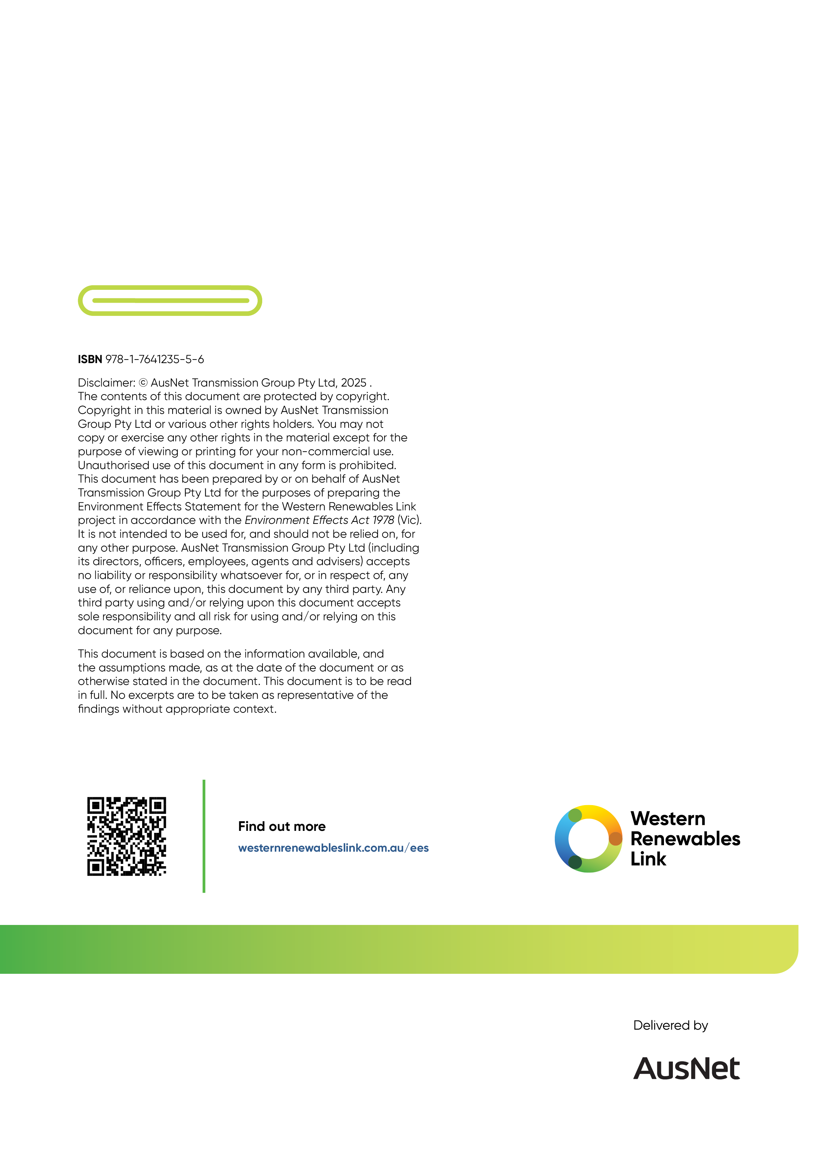

Reference to the transmission line ‘easement’ in this section relates to both the transmission line easement that will be established on freehold land and the transmission line corridor over which consents will be obtained on Crown land.
‘Cut and fill’ removes earth from one place at a construction site and uses it to fill in another place to make the ground more level or create cuttings and embankments. It reduces the need to transport fill material to the construction site.

