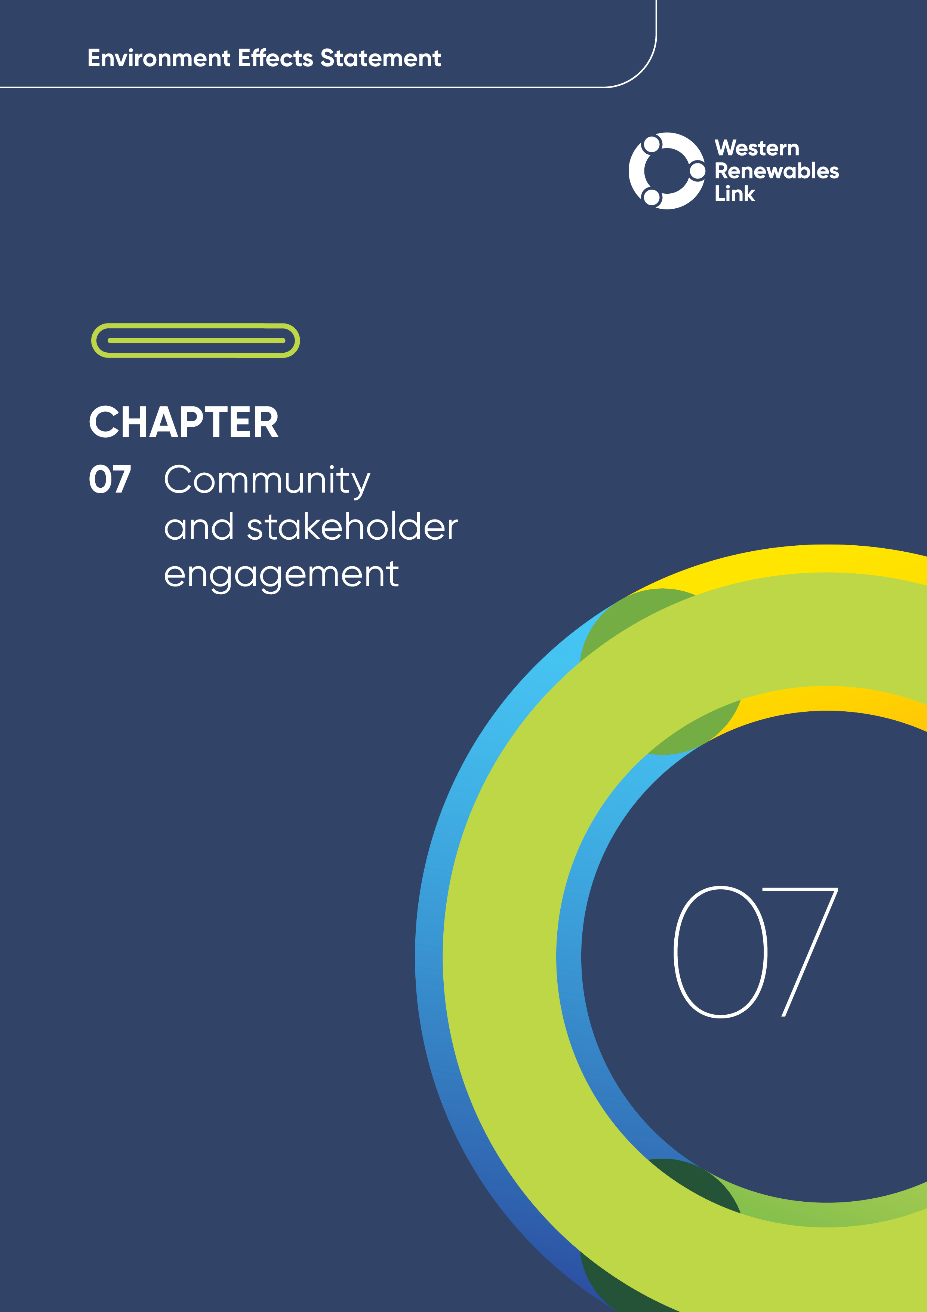

# Community and stakeholder engagement

## Introduction

This chapter addresses scoping requirements specifically relating to stakeholder and community engagement, including:

* Responding to issues, including alternative options, raised through public and stakeholder consultation.
* Preparing a program for community consultation, stakeholder engagement and communications proposed for implementation during the construction and operation of the Project, including opportunities for local stakeholders to seek responses to issues that might arise during Project implementation.

This chapter has been updated using data available on 1 November 2024.

Assessment of alternative options raised through public and stakeholder consultation are presented in **Attachment I: Project development and assessment of alternatives.**

## Engagement approach

Project engagement began in early 2020, during the development stage, and focused on understanding key community points of interest and engagement preferences. The questions and feedback provided by the community during this initial engagement informed the Project team’s communications and engagement approach.

### Traditional Owners

The Project will be built across the traditional lands of the five Registered Aboriginal Parties (RAPs) shown in Figure 7.1:

Figure . Traditional Owners

The Project team has formally engaged with these RAPs and First Peoples – State Relations about the Proposed Route since August 2020. These organisations are also represented on the Technical Reference Group (TRG).

Traditional Owner engagement for the Project is outlined in Table 7.1.

Table . Overview of Traditional Owner engagement

| Form of engagement | Description |
| --- | --- |
| Notice of Intent (NOI) submission | Before the preparation of a Cultural Heritage Management Plan (CHMP) commenced and before any field assessment was conducted, a NOI was submitted to the Victorian Aboriginal Heritage Register and the evaluating authority (a RAP or First Peoples – State Relations) for the CHMP. |
| CHMP inception meetings | These meetings were required as a part of the process for undertaking a CHMP. They were to:   * + Introduce the evaluating authority to the Project   + Discuss the level of disturbance from project-related activities to Aboriginal cultural heritage that may be present   + Discuss and agree on the appropriate method for fieldwork. |
| CHMP Standard Assessment meetings | These meetings can be required as part of the process for undertaking a CHMP. The results of any completed pedestrian surveys were shared with the evaluating authority and agreements made as to any further assessment (such as sub-surface testing and extent testing) to be undertaken. |
| Technical Reference Group (TRG) meetings | The TRG comprises representatives of government agencies, regional authorities, RAPs and municipal councils that have a statutory or policy interest in the Project. These meetings allowed the TRG to advise on matters that should be included in the scoping requirements for the EES, the need for and adequacy of technical reports, and the technical adequacy of the proposed EES and its response to the scoping requirements. |
| EES and CHMP method meetings | These meetings were undertaken with the evaluating authority to discuss the level of field assessment required for the completion of this Impact Assessment and to agree on a method so it could be undertaken in a manner consistent with the CHMP process. |
| EES workshops | These workshops were arranged to discuss the EES process and address questions or concerns from the Traditional Owners and Elders from the various RAPs. Topics included expectations of engagement from the proponent, varied level of assessments and whether the RAP has concerns around fieldwork gaps, as well as expectations around participation from the TRG in reviewing EES documentation. All RAPs attended and participated in these workshops apart from Wadawurrung Traditional Owners Aboriginal Corporation (WTOAC), who declined the offer to attend. |
| Other meetings | Other meetings were undertaken relating to various matters, including the discussion of approaches for Cultural Values Assessments (CVAs). |
| Fieldwork (including inductions) | Fieldwork was required as a part of the process for preparing a CHMP. It was carried out with RAP and Traditional Owner representatives throughout the life of each CHMP and included comprehensive conversations on Country as well as participation in pedestrian surveys and sub-surface excavation programs. Inductions have been undertaken as a part of the fieldwork days and separate to them. Site visits have also been undertaken with Traditional Owner representatives, where relevant, during site visits on Country during the preparation of CVAs. |
| Benefit sharing | Engagement on Traditional Owner benefit sharing has focused on raising awareness ahead of formal negotiations. |
| Social value initiatives | AusNet has identified several social value initiatives for RAPs and one-off engagement has occurred for each of these opportunities to discuss these initiatives. |
| Front line adaptive communication training | In October 2024, specialised training was provided to WTOAC on Country for 30 of the corporation’s cultural heritage field personnel. |
| Liaison Officer funding | AusNet offered each RAP additional funding to support the engagement required to develop the Traditional Owner Benefit Sharing Strategy. |

### Mapping key stakeholders

A stakeholder is an individual, group or organisation with a stake or interest in the outcome of a decision. Depending on their role or position, stakeholders may also influence Project decisions.

The Project team has undertaken extensive research and mapping to identify stakeholders along the Proposed Route, which was progressively refined from an initial Area of Interest (AOI), to an area approximately 100 to 170m wide, encompassing the nominal future easement (and a buffer either side) and the terminal station areas.

This stakeholder mapping process identified many geographically dispersed stakeholders, with diverse interests and concerns. These stakeholders have been categorised into the groups shown in Figure 7.2, with dedicated relationship managers appointed within the Project team to encourage Project input and feedback from these stakeholders.

The stakeholders shown in Figure 7.2 include:

* Members of the community who are impacted by the Project to varying degrees including landholders, neighbouring landholders, community members and organisations
* Government and regulatory authorities including local councils, members of parliament and government entities
* Industry-related stakeholders including industry associations and market participants
* Groups with a specific interest in the Project including community and special interest groups, and formal opposition groups
* Additional stakeholders including members of the TRG and representative forums.

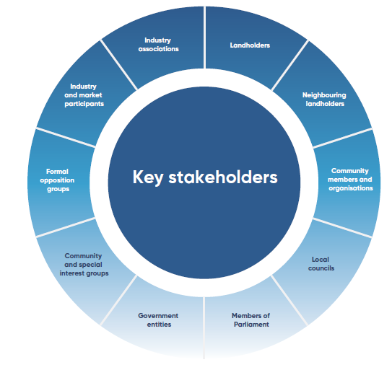

Figure . Key stakeholders

Section 7.4.1 (Table 7.4) shows how engagement tools have been selected and applied to the stakeholders shown in Figure 7.2.

#### Technical Reference Group

The Victorian Department of Transport and Planning (DTP) convened an inter-agency TRG for the Project, comprising representatives of relevant Victorian Government agencies and departments, RAPs and local government authorities.

TRG members have provided valuable feedback on the development of the EES, the EES Consultation Plan (AusNet, 2025a) (Section 7.2.5), the approach to engagement and feedback from communities and other stakeholders. Organisations represented on the TRG are listed in Table 7.2.

Table . Organisations represented on the TRG

|  |  |
| --- | --- |
| Organisations represented on the TRG |  |
| Country Fire Authority (CFA) | Environment Protection Authority Victoria (EPA Victoria) |
| Victorian Planning Authority (VPA) | First Peoples – State Relations |
| Department of Energy, Environment and Climate Action (DEECA) – Energy (formerly DELWP – Energy) | Heritage Victoria |
| DEECA – Grampians Region (formerly DELWP – Grampians Region) | Melbourne Water |
| DTP – Impact Assessment (formerly DELWP – Impact Assessment) | Parks Victoria |
| DTP – Planning (formerly DELWP – Planning) | Southern Rural Water |
| Department of Jobs, Precincts and Regions (DJPR) – Agriculture Victoria | Relevant RAPs:   * + Barengi Gadjin Land Council Aboriginal Corporation   + Dja Dja Wurrung Clans Aboriginal Corporation   + Eastern Maar Aboriginal Corporation   + Wadawurrung Traditional Owners Aboriginal Corporation   + Wurundjeri Woi-wurrung Cultural Heritage Aboriginal Corporation |
| DJPR – Regional Development Victoria | Relevant Catchment Management Authorities (CMAs):   * + Corangamite CMA   + Glenelg Hopkins CMA   + North Central CMA   + Wimmera CMA   + Port Phillip and Western Port CMA |
| DTP (formerly Department of Transport) | Relevant local councils:   * + City of Ballarat   + Hepburn Shire Council   + Melton City Council   + Moorabool Shire Council   + Northern Grampians Shire Council   + Pyrenees Shire Council |
| Energy Safe Victoria |  |

#### Representative engagement forums

Several groups have been established by the Project team to enable structured consultation and subsequent feedback from community representatives. These groups are outlined below.

##### Community Consultation Group

The Project team formed a Community Consultation Group (CCG) to maximise community understanding of the Project and participation in the engagement process. The CCG aimed to provide a transparent discussion forum, enabling AusNet to better understand community concerns and make the Project the best it can be for the community. Membership to the CCG is not a demonstration of support and endorsement of the Project. Members bring a range of community views and input to the group.

In February 2021, an eUpdate was published calling for nominations for three CCGs, based on the western, central and eastern areas of the Project AOI. Ultimately, one group was formed over the AOI due to the small number of nominations received. It has been difficult to recruit and retain CCG members representing all sections of the Project.

At its inception, this group comprised 13 representatives from Melton, Moorabool and Ballarat. An independent Chair was appointed, and the first meeting took place on 28 April 2021.

In the second half of 2021, after a significant number of resignations, the group’s composition and approach was reviewed by the Project team, with further invitations to join the CCG sent to representative groups along the Proposed Route.

Since August 2024, six community members and council representatives have regularly attended the CCG, enabling a cross-section of community groups and interests to be represented. Feedback from the CCG shaped how AusNet disseminated information, designed and developed the Project and conducted assessments for the EES. For example, the CCG has helped shape the engagement program by suggesting locations for pop-ups, sharing communication preferences, reviewing Project fact sheets and providing feedback.

The CCG was formed to support the development and planning stage of the Project and is likely to cease operations prior to the construction and delivery stage of the Project. Engagement channels and groups during delivery will be considered by AusNet and its Principal Contractor.

##### Council Advisory Group

A Council Advisory Group (CAG) was established in 2020 to keep council representatives abreast of Project updates and to gather feedback for dispersal among the Project team. The group includes an officer from each of the six councils along the Proposed Route, and members of the Project team. Information sharing complements the briefings with councils and CEOs routinely offered by the Project team.

To 1 November 2024, there have been 34 meetings of the CAG, with topics ranging from Project and EES updates, to land access, undergrounding, laydown areas, alternative approaches to construction, TRG discussions, and the CCG.

##### Energy Regional Advisory Panel

The Energy Regional Advisory Panel (ERAP) was established in 2021 to guide region specific energy and transmission projects, identify development opportunities, and address local issues and concerns.

With a focus on social licence and community impacts, members represent local government, business, economic development and energy leaders from the Central Highlands, Grampians and Wimmera regions of western Victoria.

In addition to sharing key insights on local energy issues, ERAP members have provided valuable advice and guidance to the Project team regarding the formation and implementation of social value initiatives for the region.

Their advice considers feedback from a group of landholders and farmers who have lived experience outside the Project footprint, and who review all public-facing Project materials for accuracy of information.

### Working with diverse communities

Throughout all stages of engagement, the Project team has sought advice from local communities and councils about community needs and sought to make communication materials accessible for people of all abilities. This has included Culturally and Linguistically Diverse (CALD) communities, people facing time or mobility barriers, people with low literacy, or who do not have the skills or access to technology to engage remotely.

Where required or requested, assistance has been provided to meet the needs of stakeholders and the community. This includes assistance with written materials such as fact sheets and guides and providing hard-copy materials where people face barriers to internet access.

The Project team will continue to work with local government and community groups to understand the needs of their communities and adapt engagement methods appropriately.

### Social value initiatives

There are multiple ways in which benefits will be shared through the delivery of the Project, with four key activation streams (Figure 7.3). These streams include the Project’s Social Value Framework and initiatives, benefit sharing arrangements with Traditional Owners, the Community Benefit Fund, and Victorian Government policy arrangements that the Project will administer.

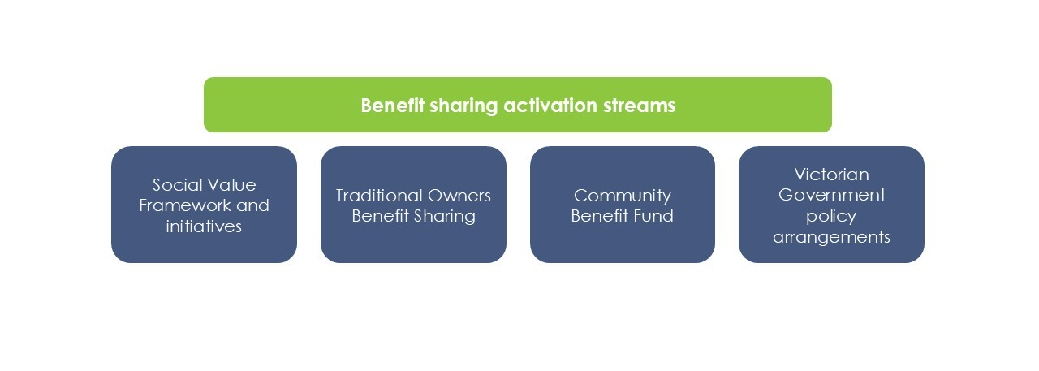

Figure . Benefit sharing activation streams

Social value initiatives for the Project aim to meet specific community needs by addressing local issues such as energy and telecommunications reliability and housing availability. Informed by social research and broad community and stakeholder engagement, these initiatives relate to social procurement, education and community benefit sharing.

The Social Value Framework operates as a list of initiatives the Project can implement in collaboration with key stakeholders. As an example of work already completed, AusNet has conducted an assessment of energy demand and use at Ballarat Community Health’s seven sites. AusNet provided advice on demand management, retailer and tariff selection and the optimal mix of additional infrastructure (solar and batteries).

The Social Value Framework identifies ways in which AusNet can partner with the community to deliver lasting benefits. The Project team is identifying opportunities to use the Project construction stage to deliver economic and community value. Planned programs could include training and skills development programs and building energy resilience by providing support to facilitate community energy projects, as well as support to emergency services, small grant programs and sponsorship programs.

Subject to community appetite and project approval, the Project team will implement a Community Benefit Fund that will be co-designed in partnership with the community and key Project stakeholders. The Community Benefit Fund is a way to give back to the community impacted by the Project in a way that the community concludes is equitable and meaningful, within the approved Community Benefit Fund budget.

The key difference between the Community Benefit Fund and the Social Value Framework is that with the Community Benefit Fund a larger level of control is handed over to the community. The co-design process will decide how and when the funds are administered. With the Social Value Framework, the initiatives are delivered in a strategic way in collaboration with the benefitting stakeholders.

### EES Consultation Plan

Consultation is a key aspect of the environmental assessment process in Victoria.

The Project team has developed an EES Consultation Plan (AusNet, 2025a) outlining the Project consultation program and communication and engagement activities that will be delivered as part of the environmental impact assessment and draft Planning Scheme Amendment (draft PSA) process.

The EES Consultation Plan is a public document, available on the DTP website. It has been prepared in accordance with the Ministerial guidelines for assessment of environmental effects under the *Environment Effects Act 1978 (Vic)* and the EES Consultation Plan Advisory Note (DELWP, 2018). It also aligns with the consultation requirements for the draft PSA proposed as part of the Project, as outlined under *the Planning and Environment Act 1987 (Vic).*

The EES Consultation Plan outlines the guiding principles and objectives of the Project engagement program, identifies key stakeholders, and provides an overview of planned engagement activities and timeframes until completion of the EES process.

Given the EES provides ongoing opportunities for community input, the EES Consultation Plan is reviewed and updated in response to community feedback and as appropriate throughout the development of the Project.

## Engagement overview

### Principles

The Project team is committed to delivering extensive and meaningful engagement in an open, inclusive, accessible and timely manner. Four key principles inform the approach: understanding, openness, respect and responsiveness. The principles guide the design and delivery of all Project communication and engagement activities.

Figure . Engagement principles

### Objectives

Successful coordination and integration of stakeholder, landholder and community engagement, planning and design is critical to achieving successful Project outcomes. The communications and engagement objectives for the Project are to:

* **Facilitate genuine stakeholder and community engagement**, seeking input to minimise impacts, maximise benefits and meet commitments made to the community
* **Strengthen relationships with the community and stakeholders** to foster trust, awareness and understanding of the Project
* **Establish and maintain social licence** to develop, construct and operate through best practice community and stakeholder engagement
* **Provide timely information** to all stakeholders, including the design, planning and approvals, construction and operations processes
* **Minimise impacts to stakeholders** by proactively mitigating potential impacts and promptly responding to stakeholder inputs.

These objectives are relevant for the development, construction, operations and maintenance stages of the Project.

### Challenges

With no recent Victorian community experience of the development of a greenfield transmission project of its size, the Project has faced engagement challenges, including:

* **Information gathering:** Difficulties providing immediate answers to the community in the initial information gathering stages, given the Project is the first of its kind in decades
* **Mental health:** Uncertainty about the Project and delays has impacted mental health and wellbeing in local communities
* **Community distrust:** Distrust of the Project team and, as a result, AusNet more broadly
* **Threats to workforce personnel:** Including incidents that impacted the Project team’s ability to engage the community
* **Social licence:** First major transmission project in decades and varying levels of awareness about the energy transition has added to the challenge of achieving social licence
* **Engagement fatigue:** Extended Project development stage and consultation in the region for other infrastructure projects, including Transgrid's Victoria to New South Wales Interconnector West (VNI West) and VicGrid's Victorian Transmission Plan (VTP) have contributed to engagement fatigue
* **Land access:** Partly due to some people in the community feeling pressured to deny access
* **COVID-19:** Community engagement obstacles caused by lockdowns and restrictions enforced during the COVID-19 pandemic.

Table 7.3 describes how the Project has responded to these challenges.

Table . Engagement challenges and Project response

| Challenge | Project response |
| --- | --- |
| Information gathering | Seeking continuous improvement in providing timely information to the community, the Project team has incorporated the below information sharing platforms:   * + Individual Land Liaison Officers (LLOs) for each landholder along the Proposed Route.   + Project website with materials that have been developed based on questions from the community.   + Dedicated Project hotline and inbox.   + Process requiring acknowledgement of all emails within two business days and detailed responses within 10 business days.   + Regular email updates.   + Online community newsletter. |
| Mental health | The Project team engaged TELUS Health (formerly Benestar) in July 2020 to provide independent, confidential counselling services and support to impacted community members.  Information about this service and other free services were published on the community and landholders page of the Project website and is provided in Project materials.  Representatives from TELUS Health provided support at community engagement sessions delivered in 2020 and the Project team participated in rural health and stress training, delivered by the National Centre for Farmer Health. |
| Community distrust | The approach to stakeholder engagement and communications developed as the Project evolved. There has been a strong emphasis on timely and accurate information through the development of fact sheets, guides and webinars to satisfy stakeholders who require more information. |
| Threats to Project personnel | Changes to the Project’s engagement approach have been necessary where planned engagement activities were unable to proceed due to safety concerns or threats to Project personnel. In these instances, online engagement activities have occurred, or team members have reached out directly to individuals for one-on-one meetings in discreet and safe settings.  Of the 262 reported incidents since March 2021, 27 incidents have been brought to the attention of Victoria Police. The incidents ranged from protests, hazards, physical threats, verbal abuse and threats involving vehicles, to social media. This chapter shows records to 1 November, 2024. |
| Social licence | The Project team has engaged with Project opposition groups by providing information and written responses to correspondence, and meeting directly with representatives. There have also been multiple opportunities for individuals to privately discuss their concerns with the Project team. The Project team will also implement a Community Benefit Fund. |
| Engagement fatigue | The Project website and online resources have continued to expand and diversify to respond to the need for regular Project updates and a broader range of informative fact sheets. Regular consultation with industry representatives has assisted in engagement and consultation programs being delivered at times and in places that avoid other projects’ engagement efforts. |
| Land access | Wherever possible, the Project team sought to gain voluntary landholder consent to access private properties. To succeed, LLOs explained the requirements for land access to individual landholders and addressed their concerns directly, as they arose. Formal letters were also sent to inform landholders about the land access process and to notify of upcoming land access requirements.  Despite the Project team’s efforts, some landholders refused to engage or allow land access. Where landholders did not allow access their property, rights under S93 of the *Electricity Industry Act 2000* were used as a last resort to gain access.  Under the Electricity Industry Act, specifically S93(1), it is lawful for AusNet and its authorised persons to undertake surveys and other necessary activities associated with the Project in accordance with the requirements in the Act and the Essential Services Commission Land Access Code of Practice.  During any type of access to properties, the Project team works with landholders to confirm the approach, activities, timing, and any agreed protocols to be observed while on the land. |
| COVID-19 | Stakeholder and community input was sought via a range of channels, including an online engagement platform that was integrated with the Project website and supported by all-hours interactive feedback.  The engagement platform included an interactive mapping tool, enabling the community to share location-based knowledge and feedback, and participate in online forums, interactive Q&As, and online surveys.  Online and phone meetings were held wherever possible, and important forums such as the TRG, CAG, and CCG were held online.  As Victoria embarked on a ‘COVID-normal’ way of living, a mix of online and in-person engagements were undertaken to provide communities and stakeholders with multiple engagement opportunities. |

More information about these challenges is detailed in **Attachment IV: Stakeholder and community engagement consultation report** (Section 3.2).

## Engagement snapshot

Since engagement for the Project commenced in early 2020, the Project team has sought to raise Project awareness, provide information and gather community and stakeholder feedback and input from people living and working along the Proposed Route. Figure 7.5 provides a snapshot of engagement to 1 November 2024.

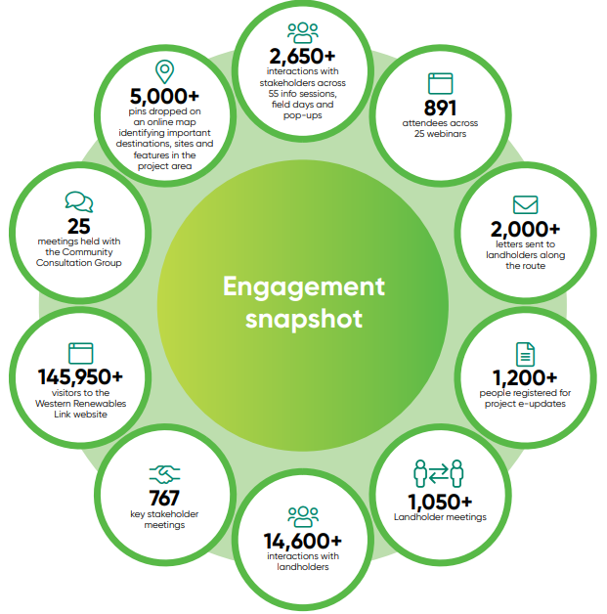

Figure . Engagement snapshot

### Engagement activities

The Project team has taken a tailored approach to engagement so that participants’ needs and preferences are respected. Key tools used for stakeholder, landholder and community engagement are outlined in Table 7.4.

Table . Engagement tools

| Engagement tool | Description |
| --- | --- |
| Community consultation and advisory group meetings | **CCG meetings**  Enables two-way communication between the Project and local communities. The CCG comprises an independent Chair, Project representatives and nine community and council representatives of communities along the Proposed Route. Meetings provide an opportunity to discuss key Project and community issues, share updates and seek local advice. Minutes and presentations from all CCG meetings are published on the Project website.  **Council Advisory Group meetings**  Keeps council representatives abreast of Project updates and enables feedback to be gathered and shared among the Project team. Includes a team member from each of the six councils along the Proposed Route, and members of the Project team. Information sharing in this formal setting complements routine briefings with councils and CEOs.  **Energy Regional Advisory Panel meetings**  Provides guidance on regionally appropriate approaches to energy and transmission projects, to identify energy development opportunities within the regions and to discuss relevant issues and concerns. |
| Land Liaison Officers | A dedicated team of LLOs provide one-on-one consultation with directly impacted landholders throughout all Project stages. LLOs focus on face-to-face meetings and direct email and phone channels and provide a consistent point of contact for landholders. |
| Information / drop-in sessions | Allow community members and landholders to speak directly with the Project team in an informal setting. The widely promoted sessions are attended by technical specialists and supported by a suite of take-home communication materials, such as guides and fact sheets. |
| Agriculture and industry events | Attendance at local events allows relevant stakeholders, community members and landholders to speak directly with the Project team in an informal setting. |
| Community discussion dinners | Discussion dinners presented an opportunity for people to meet various Project specialists, ask direct questions and talk over a meal. |
| Remote one-on-one meetings with technical specialists | Initially a COVID-safe pivot, these sessions are aimed at people who cannot attend in-person sessions. The remote sessions are held on Microsoft Teams and provide one-on-one access to Project specialists. |
| Webinars | Formal online sessions covering a range of Project-related topics. Webinars replaced face-to-face sessions during COVID-19 restrictions and are still used to provide geographically dispersed communities with access to a range of technical specialists. Recordings and transcripts from the webinars are posted on the Project website. |
| Website | A platform for community and other stakeholders to access up-to-date Project information, eUpdates, fact sheets, webinars and FAQs. Interested parties can engage directly via the website’s virtual engagement room, interactive map and Contact Us functions. |
| Virtual engagement room | Enables visitors to visually explore information about the Project at their own pace. |
| Project online map | Online map where layers can be toggled on or off to reveal detailed Project information. Layers include the AOI, multiple corridors, single corridor, Proposed Route (2021), updated Proposed Route (2022 and 2024), and features including Local Government Areas (LGAs), RAP boundaries and land parcels. |
| Social Pinpoint mapping | An interactive online mapping tool used to obtain feedback about what is important to people in their local community. Participants can drop a pin on a location to comment or post a photo. |
| Fact sheets and guides | A suite of Project fact sheets and landholder guides has been developed to keep the community informed of key aspects of the Project. Fact sheets are published on the Project website and distributed via eUpdates and printouts at events. |
| Videos | Project videos have been added to the website and virtual engagement room including ‘Project Introduction’, ‘Designing the Project’, ‘Construction’ and ‘Farming around transmission’ videos. |
| eUpdates | Emails sent to subscribers when Project developments occur. Visitors to the website can subscribe to receive updates to their inbox. These eUpdates are also published online. |
| Newsletter | External newsletter that addresses key themes and questions about the Project. Published monthly between October 2023 and April 2024 and then bi-monthly after that period. |
| Project hotline | A toll-free Project hotline that stakeholders can call to make Project specific enquiries and complaints. The Project hotline is available Monday to Friday, 8.30am to 5.30pm and is advertised on the Project website and in communications materials such as fact sheets and guides. |
| Email and letters | The Project inbox and Post Office Box allow stakeholders to email and write to the Project team. The addresses are published on the website, in Project team members’ email signatures, and in communications materials such as fact sheets and guides.  Stakeholders must register to receive these emails and letters and, when they do, their individual communication preferences are recorded and used to personalise contact. Project communications are customised by audience (e.g., landholders, neighbouring landholders) with a ‘landholder first’ engagement approach. |
| Letterbox drops | Distribution of communication materials to unaddressed mailboxes within 2km of the proposed Project Route. |
| Direct engagement | Meetings, phone calls, texts and email communications with a variety of stakeholders, particularly landholders. |
| Government and key stakeholder briefings | Regular briefings to Commonwealth, State and local governments, members of the opposition, and Victorian public sector departments and agencies. Briefings are delivered by the appropriate members of the Project team with topics tailored to each stakeholder. |
| Social media | The Project uses AusNet’s social media page to promote online and in-person engagement events via paid advertising. |
| Media and advertising | Local press, online and radio advertising to raise Project awareness and promote upcoming activities. Media releases are distributed as needed, and responses to Project media enquiries provided as appropriate. |
| Community engagement surveys | Surveys posted at various Project stages to seek community input on a range of matters. |

### Engagement phases

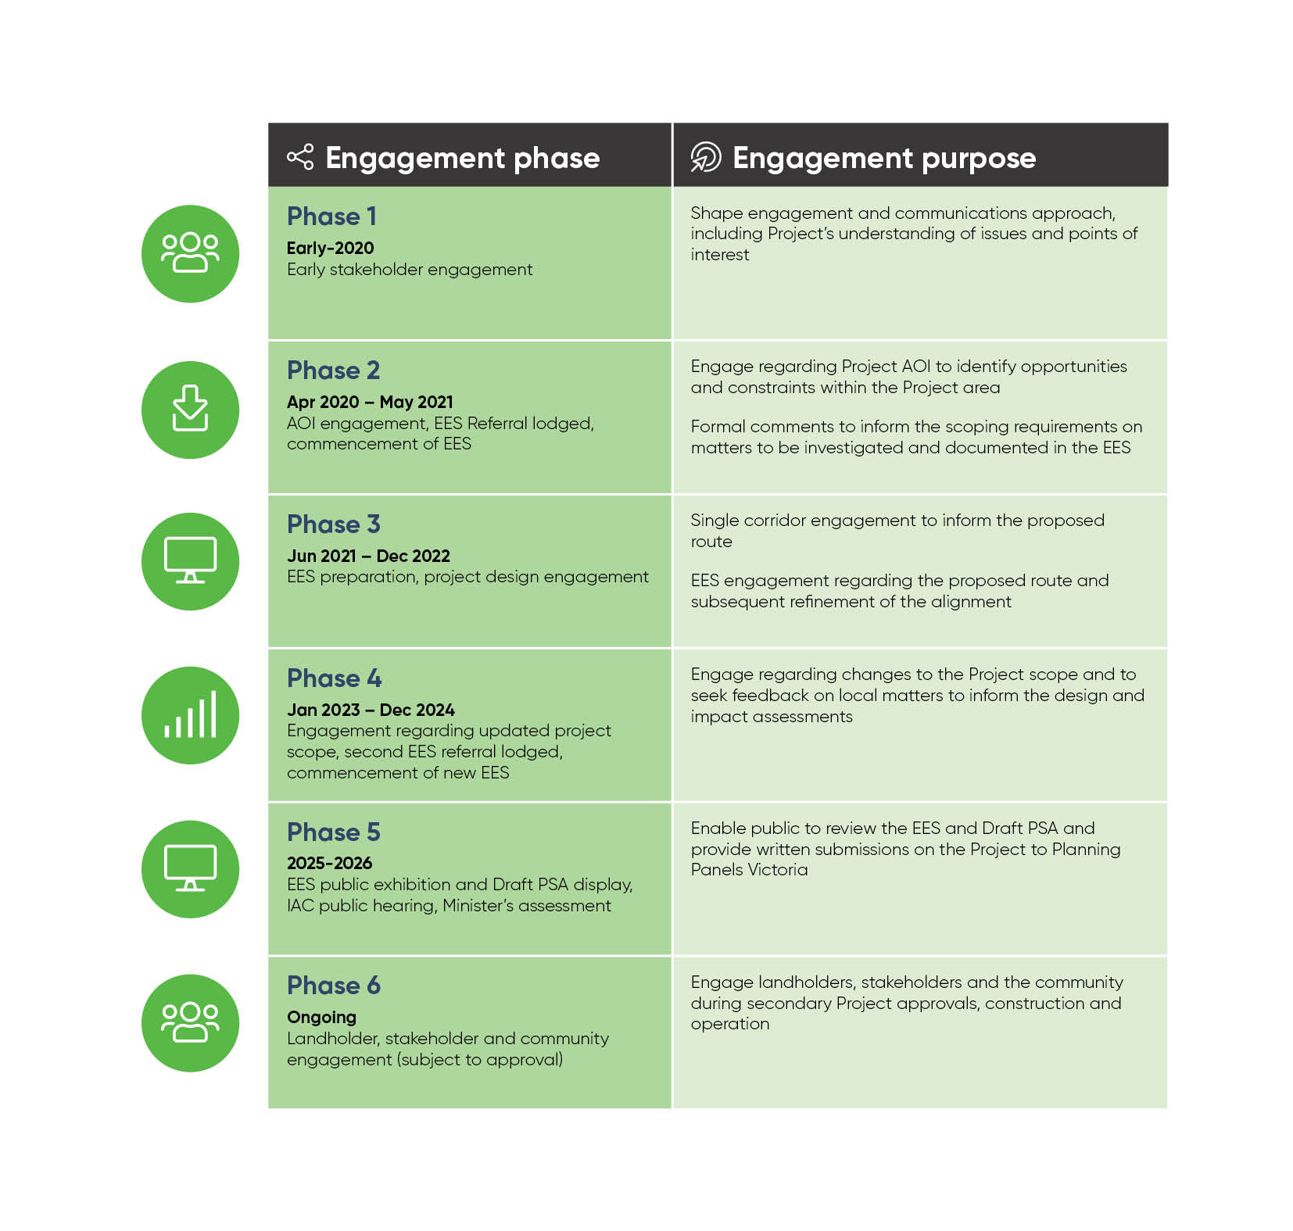Project engagement followed a phased process, as outlined in the EES Consultation Plan (AusNet, 2025a), and has evolved into the engagement phases shown in Figure 7.6.

Figure . Engagement phases

The following table outlines engagement that was delivered in early 2020.

Table . Phase 1 engagement summary

| Timeline | Milestones | Engagement highlights |
| --- | --- | --- |
| Jan-Mar 2020 | * + Early stakeholder engagement | * + Project hotline established   + Project inbox established   + Project website launched   + Initial letters sent to potentially impacted landholders   + Introductory correspondence sent to RAPs and Traditional Owners   + Initial government stakeholder Project briefings   + Initial key stakeholder briefings   + CCG formed |

The following table outlines engagement that was delivered between April and December 2020.

Table . Phase 2A and B engagement summary

| Phase | Timeline | Milestones | Engagement highlights |
| --- | --- | --- | --- |
| 2A | * + 2020: Apr-Jul | * + AOI engagement   + Initial EES referral lodged | * + Community engagement survey   + 6 online community sessions   + 8 community drop-in sessions   + One-on-one meetings with landholders   + Local advertising   + Targeted letterbox drops   + Fact sheets published   + Q&A website function added   + eUpdates published   + Social Pinpoint map published on website   + Key stakeholder meetings   + TRG and CAG formed   + CCG re-formed |
| 2B | * + 2020: Aug-Dec | * + Minister for Planning requires EES   + Commencement of EES engagement   + Exhibition of initial draft EES scoping requirements |

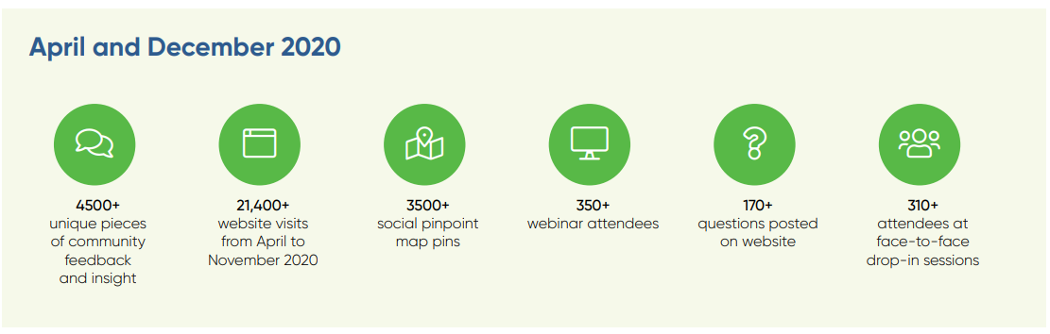

The following table outlines engagement that was delivered between January and May 2021.

Table . Phase 2C engagement summary

| Phase | Timeline | Milestones | Engagement highlights |
| --- | --- | --- | --- |
| 2C | * + 2021: Jan-May | * + EES preparations and technical reports engagement | * + Published EES Consultation Plan   + 10 community drop-in sessions   + Online mapping tool open   + Direct landholder and community engagement   + Regular eUpdates   + Government, industry and representative meetings continued   + ERAP formed |

The following table outlines engagement that was delivered between June and December 2021.

Table . Phase 3A engagement summary

| Timeline | Milestones | Engagement highlights |
| --- | --- | --- |
| 2021: Jun-Dec | * + Single corridor engagement   + Proposed Route engagement | **Single corridor:**   * + Proposed single corridor announced   + Published ‘Environmental Assessment and Key Project Approvals’ fact sheet   + Interactive map updated on Project website to reflect single corridor   + eUpdates continued   + 8 webinars   + 54 online one-on-one meetings booked   + Engagement with landholders within the corridor   **Proposed Route:**   * + Proposed Route identified and announced   + 2 webinars on Proposed Route   + Launched new Project website   + 5 community information sessions   + Fact sheets published:     - Proposed Route     - Bushfire     - Underground construction   + Published landholder guide on Proposed Route   + Published EES existing condition information sheets on 9 topics   + 12 LLOs appointed to individual landholders within the Proposed Route   **Other:**   * + Government, industry and representative meetings continued   + Invitations to join the CCG sent   + CCG rejuvenated with new members across the Project Area |

The following table outlines engagement that was delivered between January and June 2022.

Table . Phase 3B engagement summary

| Timeline | Milestones | Engagement highlights |
| --- | --- | --- |
| 2022: Jan-Jun | * + Proposed Route EES engagement | * + Published updated EES Consultation Plan   + 3 webinars   + Launched virtual engagement room   + Project team commits to Essential Services Commission Transmission Company Land Access Statement of Expectations (SOE)   + Project team receives training on SOE   + Published updated Landholder Guide: Land Access, Easements and Compensation   + Fact sheets published:     - Preliminary EES Information Sheet for Existing Conditions Land Use and Planning     - Transmission Towers and Conductors     - The Electricity Network: Transmission and Distribution   + Landscape and Visual Impact Assessment (LVIA) site visits with landholders   + Face-to-face and online meetings with landholders continue   + Regular eUpdates   + Government, industry and representative group meetings continue |

The following table outlines engagement that was delivered between July and December 2022.

Table . Phase 3C engagement summary

| Timeline | Milestones | Engagement highlights |
| --- | --- | --- |
| 2022: Jul-Dec | * + Landholder engagement regarding Proposed Route changes, site investigations, compensation   + Updated Proposed Route stakeholder and community engagement   + VNI West investigations announcement by AEMO | * + Project team informs stakeholders and landholders of updated Proposed Route   + Letters sent to landholders with tower location and compensation information   + Published new Landholder Guide: Land access for field surveys and investigations   + Fact sheets published:     - Updated Project Overview     - Updated Proposed Route Overview   + Updated map published on website   + Regional visit by CEOs of AEMO and AusNet   + 3 community drop-in sessions   + 7 community discussion dinners   + Coghills Creek community afternoon   + 1 webinar   + Attended Elmore Field Days   + Project team informs landholders of AEMO’s VNI West investigations   + eUpdate issued with information about potential Project changes   + In-person and remote meetings with landholders continued   + LVIA site visits with neighbouring landholders   + Commencement of compensation negotiations   + Government, industry and representative group meetings continued |

The following table outlines engagement that was delivered between January and June 2023.

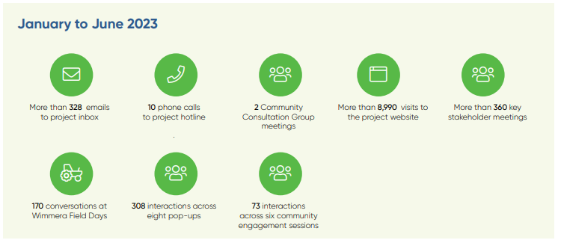Table . Phase 4A engagement summary

| Timeline | Milestones | Engagement highlights |
| --- | --- | --- |
| 2023: Jan-Jun | * + VNI West investigations into options to connect to the Project at a location further west than the Project’s original proposed terminal station location to the north of Ballarat   + VNI West Project Assessment Conclusions Report and requirement for a new terminal station near Bulgana and uprate to 500kV | * + Published new Landholder Guide: Option for Easement Process and Compensation   + Fact sheets published:     - Transmission Line Construction     - Biosecurity   + In-person and remote landholder meetings continued   + Letterbox drop to dwellings within 2km of the Proposed Route between Bulgana and Dean to inform of release of VNI West Consultation Report and encourage engagement with AEMO   + Attended Wimmera Field Days   + Second regional visit by CEOs of AEMO and AusNet   + Regular eUpdates   + Advertised shopping centre pop-ups in local newspapers and online   + 8 pop-ups   + Presented to local councils and CCG on Option for Easement and compensation process   + Hosted industry night for organisational landholders and interested parties on Option for Easement and compensation process   + Government, industry and representative body meetings continued |

The following table outlines engagement that was delivered between July and December 2023.

Table . Phase 4B engagement summary

| Timeline | Milestones | Engagement highlights |
| --- | --- | --- |
| 2023: Jul-Dec | * + Engagement regarding changes to the Project scope   + Second EES referral lodged   + Minister for Planning announces new EES decision made   + Engagement regarding Hepburn Lagoon southern option | * + Hosted MacPherson Park tenants and community information session   + LLOs notified individual landholders along the Proposed Route   + Relevant landholders advised they are no longer on the Proposed Route   + Postcard letterbox drop to dwellings within 2km of Proposed Route   + Project advertising including advertorials in local and regional newspapers, social media and digital advertisements   + Published updated website content   + Published updated fact sheets:     - Landholder Compensation and Payments     - Permitted Vehicle and Equipment Height Information Sheet   + Published CFA Firefighting and transmission line FAQs   + Attended Elmore Field Days   + Published video on Option for Easement   + 13 eUpdates   + 3 Project newsletters   + 6 community information sessions held along the Proposed Route   + 3 shopping centre pop-ups   + 2 community webinars   + Option for Easement proposals presented to approximately 70% of landholders along the Proposed Route   + Government, industry and representative group meetings continued |

The following table outlines engagement that was delivered between January and June 2024.

Table . Phase 4C engagement summary

| Timeline | Milestones | Engagement highlights |
| --- | --- | --- |
| 2024: Jan-Jun | * + Farming and transmission line engagement   + Proposed Route update (north of Waubra)   + Neighbouring landholder engagement   + EES engagement | * + Continued presenting Option for Easement proposals to landholders along the Proposed Route (99% complete)   + Published new fact sheets:     - Terminal Stations     - EES     - Draft PSA   + Attended Wimmera Field Days   + Published updated EES Consultation Plan   + Published updated fact sheet on ‘Permitted Vehicle and Equipment Heights’   + Published updated Landholder Guide: Land access for field surveys and investigations   + Published new Landholder Guide: Easement safety and permitted activities   + Published project transmission line video   + Launched Project transmission line webpage   + 2 community webinars   + Published updated interactive map to reflect Proposed Route north of Waubra   + Commenced targeted program for neighbouring landholders   + 5 eUpdates   + 3 Project newsletters   + Government, industry and representative group meetings continue   + Announced delivery of $940,000 of in-kind services to Ballarat West Employment Zone ($500,000), Ballarat Community Health ($70,000) and North Ballarat Precinct Structure Plan ($370,000) |

The following table outlines engagement that was delivered between July and November 2024.

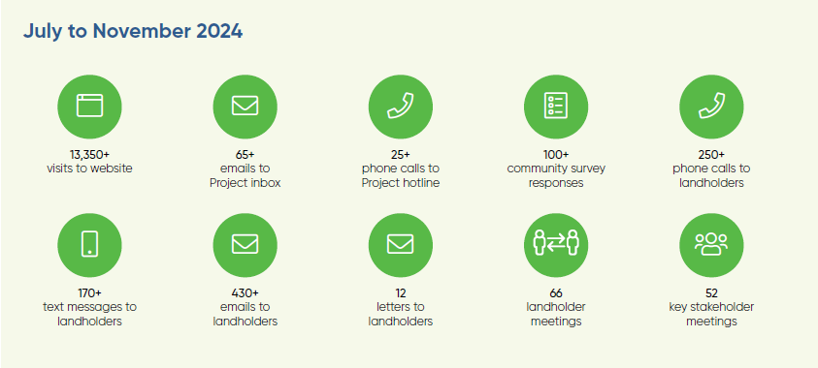Table . Phase 4D engagement summary

| Timeline | Milestones | Engagement highlights |
| --- | --- | --- |
| 2024: Jul-Nov | * + Proposed Route update (Bulgana terminal station works)   + Neighbouring landholder engagement   + EES engagement | * + Published updated website content   + Published updated fact sheet on ‘Updated Proposed Route’   + Published updated Landholder Guide: Easement safety and permitted activities   + Published new field surveys and investigation information sheets on Aboriginal cultural heritage, historic heritage, flora, fauna, and visual impact   + Project advertising including advertorials in local and regional newspapers, social media and digital advertisements   + 8 community pop-up sessions   + Attended Elmore Field Days   + Ongoing meetings with landholders and neighbouring landholders   + Government, industry and representative group meetings continued |

The following table outlines anticipated key milestones for future stages of the Project from 2025 onwards.

Table . Phase 5 and 6 anticipated milestones

|  |  |
| --- | --- |
| Timeline | Milestones |
| Phase 5: 2025-2026 | * + EES public exhibition and draft PSA display   + IAC public hearing   + Minister’s assessment |
| Phase 6: Ongoing | * + Project delivery   + Project operations   + Ongoing engagement subject to Project approval |

## Overview of feedback

### How engagement is shaping the Project

The landholders, broader community and stakeholders have played an important role in shaping the development of the Project. The Project has changed significantly since initial engagement started in 2020, with feedback from stakeholders often leading to direct change.

The feedback gathered has helped influence:

* Engagement approach and communication channels
* Design development
* Proposed Route of the transmission line
* Development of the EES
* Proposed Environmental Performance Requirements (EPRs)
* Proposed construction management planning.

AusNet has sought to understand and address, where possible, stakeholder and community feedback throughout all phases of engagement and in the preparation of the EES. Detailed information regarding key issues and Project responses is included in **Attachment IV: Stakeholder and community engagement consultation report** (Section 5.3).

### Responding to community input

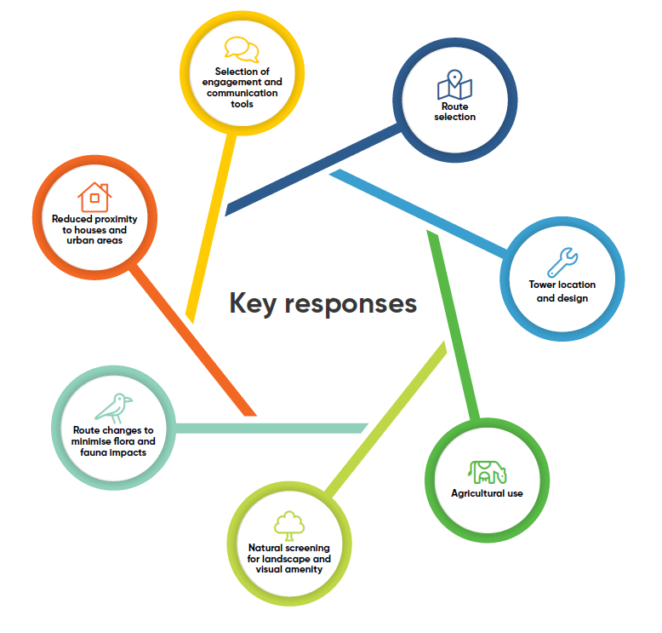

Figure . Key responses

Input from stakeholders, landholders, community and technical specialists has informed the development of the Proposed Route assessed in the EES. The key instances where the Project has been adjusted based on feedback are summarised in Table 7.16.

Table . Project responses

| Feedback | How we have responded |
| --- | --- |
| Route selection | * + Based on community input, including through Social Pinpoint data and early investigations, the AOI was narrowed to an identified corridor to:     - Exclude ‘high constraint’ areas such as Creswick, Newlyn, Ballan, Gordon, Bacchus Marsh, Myrniong and Melton     - Exclude large areas of forested public land that have high environmental and cultural heritage values (such as Long Forest Flora and Fauna Reserve, Werribee Gorge State Park and Creswick Regional Park)     - Include areas where a new transmission line could be located alongside existing electricity infrastructure (such as the Bulgana to Waubra line and Ballarat to Bendigo line).   + Using the Western Freeway to co-locate the Project was investigated by technical specialists in response to community feedback. They found there is insufficient space in the road reserves of the Western Freeway, and it would constrain future road expansion plans for the road that rely on the available space.   + The Proposed Route identification process included avoiding and minimising impacts raised by stakeholders and the community. The impacts related to:     - Large areas of forested public land and other areas of significant vegetation, including grasslands that have high environmental value     - Landscape and visual amenity for residents and tourists     - Sites of Aboriginal cultural heritage significance     - Productive agricultural land     - Heritage sites, including avenues of honour and historic homesteads     - Biolinks created by Landcare and other community groups     - Urban and built-up areas, urban growth areas, rural residential subdivisions and more densely populated areas.   + Input from landholders, community, stakeholders and technical specialists has informed the development of the Proposed Route assessed in the EES.   + Based on landholder and community feedback, and technical specialist advice, the proposed terminal station was relocated from north of Ballarat to Bulgana.   + Refinements have also been made at a localised and individual property scale in consultation with landholders, including between Waubra and Glendaruel (near Tourello), between Bolwarrah and Gordon, and Mt Steiglitz to Korjamnunnip Creek.   + At MacPherson Park, the Proposed Route was moved to align with the park’s northern boundary, to minimise impacts to community groups and businesses in surrounding areas, sporting fields, urban areas and a local school campus.   + The communities, stakeholders and landholders along the Proposed Route provided feedback that an underground transmission line should be considered, particularly where the visual impact of an overhead line is a community concern. Acknowledging the community's advocacy for undergrounding, AusNet:     - Commissioned an independent investigation into underground construction and released an Underground Construction Summary on the Project website in November 2021     - Provided presentations and briefings by technical specialists to councils, TRG, CAG and CCG.     - More information about feedback on undergrounding is detailed in Table 17 in **Attachment IV: Stakeholder and community engagement consultation report.**     - In addition, as part of this EES, AusNet assessed the feasibility of an underground 500kV transmission line, which is documented in **Attachment II: Assessment of feasibility for an underground 500kV transmission line for Western Renewables Link.** This addresses the EES scoping requirements and acknowledges the community interest in undergrounding of the proposed transmission line. |
| Tower location and design | * + Based on landholder feedback, the Project team moved towers in several locations to align the Proposed Route with internal fences, cultivated paddocks and paddock headland areas. This reduced agricultural impacts and optimised access tracks.   + Implemented lower single circuit towers in the design around MacPherson Park to reduce impacts to the Melton Aerodrome.   + AusNet recognises that bushfires are a serious concern in regional Victoria. Landholders and the community have told the Project team that they are concerned the Project may impact firefighting efforts in their area.   + Potential impacts to fire risk and firefighting efforts are a critical consideration for the planning and design of the Project and AusNet engages regularly with the relevant authorities, including the CFA.   + In 2021, AusNet released two fact sheets on managing fire risk and existing bushfire conditions, hosted a bushfire webinar, and addressed bushfire concerns via in-person engagement sessions. In October 2023, the Project team published the CFA's 'Firefighting and Transmission Lines' information sheet on the Project website. |
| Agricultural impacts | * + Adjusted tower locations on individual properties in consultation with landholders to reduce impacts on agricultural operations, including irrigation.   + Provided greater-than-required minimum clearances to improve land use and farming opportunities within easements. This resulted in increased ground to conductor clearances to enable continued use of most farming machinery and vehicles (such as harvesters and large sprayers) within easements along the Proposed Route.   + Added the use of drones as a permitted activity because of landholder and stakeholder feedback that drones are critical to the operation of many agricultural properties. |
| Natural screening for landscape and visual amenity | * + Near Myrniong, the Proposed Route was moved north-east, further away from the town. This reduced the visual scale of the towers in views from the town and impacts to views from Mt Blackwood Road. These changes also reduced impacts on areas of Aboriginal cultural heritage sensitivity. |
| Proposed Route changes to minimise flora and fauna impacts | * + In response to stakeholder suggestions, the Proposed Route was realigned further north along the southern boundary of Merrimu Reservoir to avoid native vegetation and ecological values at Long Forest Flora and Fauna Reserve, and reduce impacts to residential properties in the area. |
| Reduced proximity to houses and urban areas | * + At MacPherson Park, the Proposed Route was moved to align with the park’s northern boundary to minimise impacts to community groups and businesses in surrounding areas, sporting fields, the built-up residential area and a local school campus. |
| Selection of engagement and communication tools | * + Delivered targeted communication materials and engagement programs and activities. For example, one-on-one meetings with subject matter specialists and topic-specific fact sheets that respond to stakeholder and community requests for information |

### Key feedback themes and Project response

The key themes shown in Figure 7.8 have been used to group feedback received from stakeholders and the community throughout the engagement.

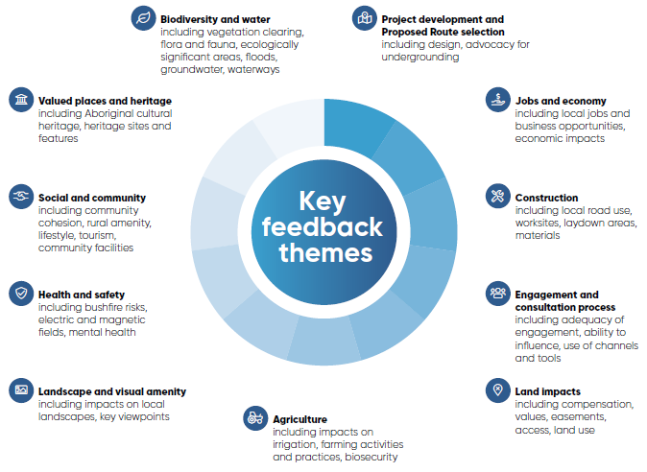

Figure . Key feedback themes

### Key feedback by section

Table . Feedback by section

| Section | Key feedback themes |
| --- | --- |
| Bulgana to Waubra | **Agriculture**: farming practice impacts.  **Land impacts**: using existing easements.  **Health and safety**: cumulative impacts (from existing 220kV line and wind farms) including electric and magnetic fields (EMF) and visual impact.  **Valued places and heritage**: Aboriginal cultural heritage sites.  **Jobs and economy**: economic development opportunities. |
| Waubra to Glendonald | **Project development and Project Route selection**: advocacy for undergrounding, Proposed Route selection and tower placement.  **Agriculture:** land use and operational impacts, including the use of irrigation equipment and aerial spraying, loss of land, biosecurity and risks to potato growing region.  **Health and safety:** EMF, human health, bushfire risk and impact to firefighting operations.  **Landscape and visual amenity:** impacts to viewpoints of Mount Bolton and Mount Beckworth.  **Biodiversity and water:** impacts to groundwater supply.  **Valued places and heritage:** Aboriginal cultural heritage sites. |
| Glendonald to Mount Prospect | **Project development and Proposed Route selection:** former terminal station proposed location, advocacy for undergrounding, Proposed Route selection and tower placement.  **Agriculture:** land use and operational impacts (including the use of irrigation equipment and aerial spraying, loss of land, biosecurity and risks to the potato growing region).  **Health and safety:** bushfire risk and impact to firefighting operations.  **Landscape and visual amenity:** impacts to viewpoints of Mount Prospect and Hepburn Lagoon.  **Biodiversity and water:** impacts to groundwater supply, flora and fauna impacts.  **Valued places and heritage:** Aboriginal cultural heritage sites and historic gold mining sites.  **Social and community:** proximity to houses, tourism impacts, cumulative impacts of new transmission line developments, and new renewable generators |
| Mount Prospect to Long Forest | **Project development and Proposed Route selection:** terminal station proposed location, advocacy for undergrounding, and Proposed Route selection.  **Agriculture:** land use and operational impacts, including the use of irrigation equipment and aerial spraying, and horticulture impacts.  **Health and safety:** bushfire risk and impact on firefighting operations, including EMF and visual impact.  **Landscape and visual amenity:** impacts to views from Darley and Lerderderg State Park.  **Biodiversity and water:** impacts to groundwater supply and flora and fauna impacts (including impacts on Wombat State Forest and Lerderderg State Park).  **Valued places and heritage:** Aboriginal cultural heritage sites, historic sites including Darley military camp and former mining sites, and historical values around Kingston township (Avenue of Honour).  **Social and community:** proximity to houses, impact on rural amenity and lifestyle, community facilities at Merrimu Reservoir, proximity to social and recreational facilities (Coimadai Primary School) and townships of Darley and Myrniong.  **Land impacts:** property devaluation.  **Jobs and economy:** impact on quarry operations. |
| Long Forest to Sydenham | **Project development and Proposed Route selection:** advocacy for undergrounding.  **Landscape and visual amenity:** impacts to local viewpoints.  **Valued places and heritage:** Aboriginal cultural heritage sites, historic heritage sites (including homesteads).  **Social and community:** proximity to houses, impact on residential land uses in peri-urban areas, urban growth boundary, impact on community facilities in the MacPherson Park area (including school, sporting fields and aerodrome).  **Land impacts:** property devaluation.  **Jobs and economy:** Equine industry impacts, including to trainers and horse breeding. |

## Measurement and evaluation

The Project team is committed to continuous improvement of stakeholder, landholder and community engagement throughout the life of the Project, including during the EES process, and the construction and operation stages (subject to approval).

The Project team will monitor and audit findings throughout the Project, including with the Principal Contractor. Information collected will support the planning and delivery of future engagement activities.

Monitoring the effectiveness of engagement will occur at regular intervals through a range of measures. Examples of the types of measures include:

* Compliance with enquiries and complaints protocols
* Regular reviews of engagement plans
* Lessons learned processes
* Tracking of opportunities and issues
* Data review of Project website analytics and media coverage.

AusNet completes a social license assessment annually to gauge progress. This assessment includes both qualitative and quantitative data from within the Project’s LGAs, but also across Victoria. This data is used to inform engagement efforts for the following year and is planned to continue throughout the construction stage. Feedback is also regularly sought through the CCG, as well as via periodic online surveys.

Data relating to participation, reach and effectiveness of communication and engagement will be captured as part of the EES program, enabling the Project team to report against achieving engagement objectives. Such data will be analysed as part of the subsequent social license assessment.

## Future engagement

If the Project is approved by decision-makers, following their consideration of the Minister’s assessment, the Project team will continue to work closely with stakeholders, landholders, neighbouring landholders and the community during the secondary approvals, construction and operation stages.

AusNet requires that its Principal Contractor develop community and stakeholder engagement plans that detail engagement and communications opportunities during the Project delivery stage. As required by EPR EM5, the plans will outline:

* Engagement principles and objectives
* Project stakeholders
* Communication and engagement tools
* Processes and procedures for receiving, responding to and reporting on queries and complaints regarding the Project
* Procedures for regular review, monitoring, reporting, evaluating, and updating the plans.

In accordance with the Project’s Environmental Management Framework, community and stakeholder engagement plans will be reviewed and approved by AusNet so that they align with AusNet’s key values and principles, and commitment to undertaking best practice engagement during delivery of the Project.

Communication tools that will continue to be used in the construction stage include the Project website, inbox and hotline (which will have its hours extended to operate 24/7), eUpdates, fact sheets, social media and videos.

Engagement techniques such as a dedicated LLO for each landholder, community information sessions and pop-ups, webinars and face-to-face meetings will also be retained.

Constant monitoring and evaluation of the communications and engagement approach, activities and tools will continue throughout the Project lifecycle, with improvements made wherever possible.

A fair, transparent and responsive enquiries and complaints process exists and will continue during the construction stage. AusNet and its Principal Contractor will respond in a professional and prompt manner.

More information about future engagement is available in **Attachment IV: Stakeholder and community engagement consultation report.**

