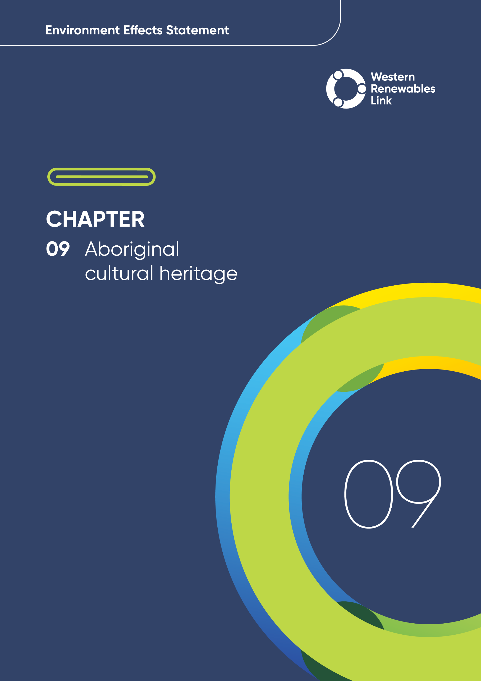

# Aboriginal cultural heritage

This chapter provides an overview of the potential Aboriginal cultural heritage impacts associated with the construction, operation and decommissioning of the Project. This chapter is based on **Technical Report B: Aboriginal Cultural Heritage Impact Assessment**.

Aboriginal people have lived in southern Australia, including what is now Victoria, for thousands of years, leaving behind physical evidence of their activities that survive as cultural heritage places and objects. Aboriginal cultural heritage encompasses both tangible and intangible values. Tangible Aboriginal heritage includes places and objects that are of significant value to Aboriginal Traditional Owner (TO) groups and the wider community. Aboriginal heritage places provide a connection between generations and help to connect landscapes with past and current TO groups. Intangible heritage values include, but are not limited to, landscapes, knowledge, and practices pertaining to and valued by Aboriginal people both past and present.

## Evaluation objective

The scoping requirements identify the following evaluation objective relevant to Aboriginal cultural heritage:

Evaluation objective

Avoid, or minimise where avoidance is not possible, adverse effects on Aboriginal cultural heritage and historic heritage values.

In response to this evaluation objective, impacts of the Project on Aboriginal cultural heritage were assessed and measures to avoid, minimise or manage potential impacts have been identified. These measures are discussed throughout this chapter and have informed the development of Environmental Performance Requirements (EPRs). EPRs set out the environmental outcomes to be achieved through the implementation of mitigation measures during construction, operation and decommissioning to avoid, minimise and manage identified impacts. Cumulative impacts associated with relevant future projects were also assessed.

Further information on how the Project has been designed to avoid and minimise impacts is provided in **Chapter 5: Project development** and **Chapter 6: Project description**.

Other aspects covered in the Environment Effects Statement (EES) evaluation objective and relevant to Aboriginal cultural heritage are addressed in **Chapter 10: Historical heritage**.

## Method

This section summarises the method adopted in **Technical Report B: Aboriginal Cultural Heritage Impact Assessment**, which was informed by **Chapter 4: EES assessment framework** **and approach.** The key steps in assessing the impacts associated with Aboriginal cultural heritage included:

* Defining a study area appropriate for Aboriginal cultural heritage as presented in Figure 9.1. This included an area which extends to the boundary of the Project Land, encompassing all land that could be used for construction. The study area has then been divided into six geographical areas to align with Registered Aboriginal Party (RAP) boundaries; these Study Areas and the boundaries of the relevant RAPs are also presented in Figure 9.1.
* Reviewing applicable Commonwealth and Victorian legislation, and relevant local, state, national and international standards, guidelines and policies.
* Reviewing the Project’s proposed design and construction method.
* Conducting a desktop review to determine the existing Aboriginal cultural heritage conditions, including a review of:
  + The geological and environmental conditions of the study area and its vicinity
  + Prior archaeological assessments to identify known Aboriginal Places (tangible and intangible) that may be present
  + Available ethnohistorical and historical information relating to Aboriginal people and post contact settlers
  + Aboriginal Cultural Heritage Register and Information System
  + Land use history to provide an overview of the key periods of post-contact historical activity
  + Victorian Aboriginal Heritage Register (VAHR)
  + Cultural Heritage Management Plans (CHMP) fieldwork data
  + Registered Aboriginal Party (RAP) statements of significance.
* Developing a preliminary site predictive model of Aboriginal place types (tangible) to understand patterns of occupation and use of the landscape by Aboriginal people using a multi-criteria analysis.
* Consulting with the relevant regulatory authorities and key stakeholders including the RAPs, TO groups and First Peoples – State Relations (FP–SR) (the Victorian government department responsible for work in areas of Aboriginal cultural rights), and reviewing the pins dropped by community members onto the Project’s Social Pinpoint online mapping tool, which identified locations, features and values of importance.
* Conducting field investigations and targeted site inspections / walkovers where required, including Cultural Values Assessments (CVAs) conducted with RAPs and TO groups.
* Conducting a risk screening process to identify the key issues during construction, operation and decommissioning for investigation within the technical report.
* Identifying and assessing the potential impacts on Aboriginal cultural heritage values including tangible and intangible heritage during construction, operation and decommissioning. These impacts were evaluated according to the following ratings, in relation to the extent, magnitude and duration of the impacts:
  + Nil: No impact or disturbance or no measurable effect to a known Aboriginal cultural heritage value.
  + Low: Measurable but insignificant effect to a known Aboriginal cultural heritage value, including minor disturbances (e.g., surface vegetation clearance, excluding Culturally Modified Trees (CMTs); minimal loss of ground surfaces and substrates; or a low impact from discovery only (subsurface deposits identified but no longer impacted by the Project).
  + Moderate: Measurable effect to a known Aboriginal cultural heritage value, including partial loss of ground surfaces and substrates.
  + High: Measurable effect to a known Aboriginal cultural heritage value, including extensive and irreversible loss of ground surfaces and substrates; or vegetation clearance; for example, resulting in the disturbance of CMTs.
  + Severe: Extensive impact and irreversible loss to an Aboriginal cultural heritage value of exceptional value, including loss of ground surfaces and substrates (e.g., a burial) as identified by RAP, TO groups, and / or FP-SR.

Impact ratings considered the historic, scientific, social, and spiritual significance (i.e., significance ranking) of Aboriginal cultural heritage values by assessing their intersection and impact with the Project at the time of assessment. The full definition of each rating is provided in Section 5.5.3 of **Technical Report B: Aboriginal Cultural Heritage Impact Assessment.**

* Identifying relevant future projects that could lead to cumulative impacts when considered together with the Project (refer to **Chapter 4: EES assessment framework and approach** for the full cumulative impact assessment method).
* Developing EPRs in response to the impact assessment to define the required environmental outcomes that the Project must achieve through the implementation of mitigation measures during construction, operation and decommissioning. Measures to reduce the potential impacts were proposed in accordance with the mitigation hierarchy (avoid, minimise, manage, rehabilitate and offset) and have informed the development of EPRs. Alternative mitigation measures could be implemented to comply with the EPRs based on the specific site conditions, available resources, and the Principal Contractor’s expertise.
* Following application of mitigation measures that would comply with the EPRs, determining residual impacts associated with the construction, operation and decommissioning of the Project, and evaluating their significance.

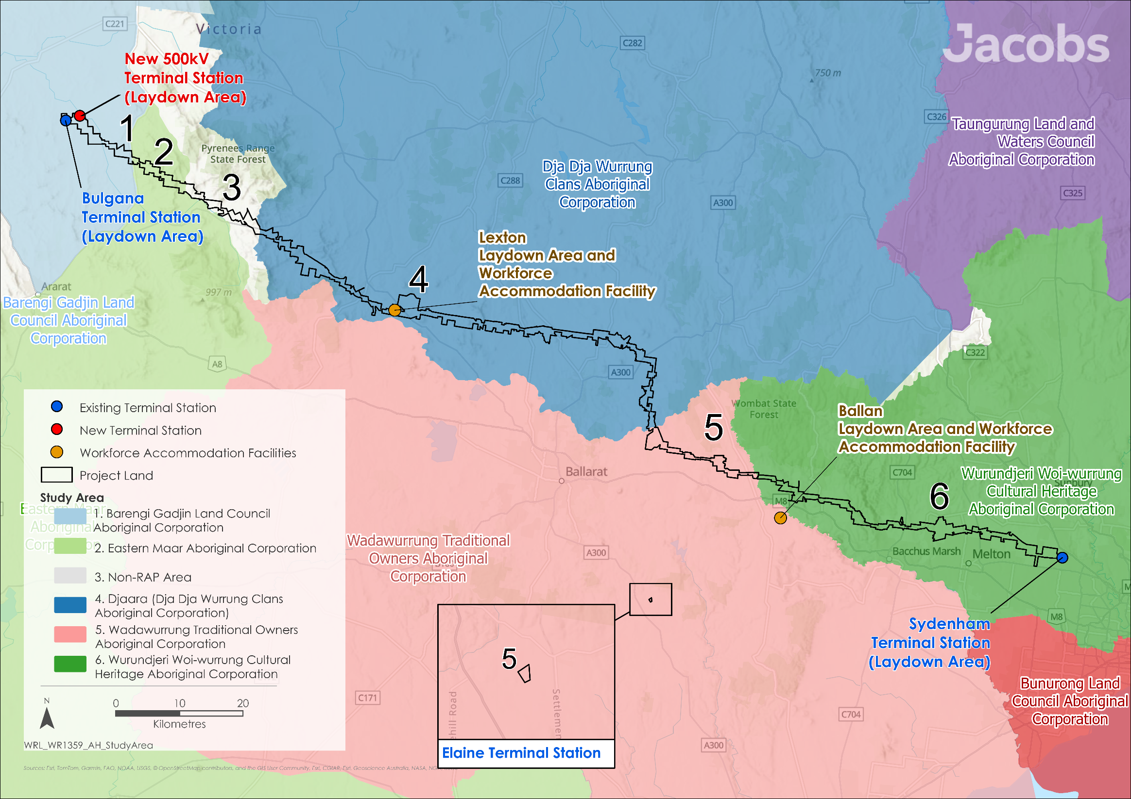

Figure 9.1 Six Study Areas investigated for the Aboriginal Cultural Heritage Impact Assessment

## Existing conditions

* CHMPs and CVAs

The *Aboriginal Heritage Act 2006* specifies that if an EES is required for an activity under the Environment Effects Act, a CHMP must be prepared. CHMPs outline the processes for identifying Aboriginal heritage management measures, with the primary objective of avoiding harm or minimising harm to Aboriginal cultural heritage.

A CVA is an assessment completed in consultation with the Registered Aboriginal Party and Traditional Owner groups, largely targeting intangible heritage values. Its purpose is to identify and understand traditional and contemporary Aboriginal cultural heritage values and meanings held by the Indigenous communities associated with the Project Land, and the ways in which these values can be interpreted in a meaningful and practical way so that they can then be factored into the impact assessment.

This section summarises the existing conditions for Aboriginal cultural heritage according to the following key themes:

* RAPs and TO groups
* Aboriginal cultural heritage values
* Cultural Heritage Management Plans (CHMPs)
* Cultural Value Assessments (CVAs).

The Aboriginal cultural heritage investigations identified previously recorded Aboriginal Places and newly identified Aboriginal cultural heritage values. Nine CHMPs are being prepared concurrently with this EES that correspond to RAP boundaries and/or construction stages for the Project. For example, study area 4 has been split into two CHMPs due to its large size. These CHMPs are being prepared in accordance with the statutory requirements of the *Aboriginal Heritage Act 2006*. Additionally, CVAs for each study area have been prepared to identify tangible and intangible values through consultation with the relevant Aboriginal stakeholders, as well as relevant oral history and broader values incorporating landscapes, biodiversity, and contemporary values. The CHMPs and CVAs have been produced in consultation with the RAPs, TO groups, and FP–SR, and have included desktop research and fieldwork to identify Aboriginal Places, areas of Aboriginal cultural heritage sensitivity and Aboriginal cultural heritage values associated with the study area. The CHMPs and CVAs have been extensively used to identify the existing conditions across the study area. As such, both are discussed in this section to provide further understanding regarding the origin of the existing conditions.

### RAPs and TO groups

The RAPs for the study area are:

* Area 1: Barengi Gadjin Land Council Aboriginal Corporation (BGLCAC)
* Area 2: Eastern Maar Aboriginal Corporation (EMAC)
* Area 3: There is no RAP for this area (TO groups from the BGLCAC, EMAC, and Dja Dja Wurrung Clans Aboriginal Council (DJAARA) are consulted for this area)
* Area 4: DJAARA
* Area 5: Wadawurrung Traditional Owners Aboriginal Corporation (WTOAC)
* Area 6: Wurundjeri Woi-wurrung Cultural Heritage Aboriginal Corporation (WWCHAC).

The extent of the RAP boundaries within the study area is shown in Figure 9.1.

CVAs were completed on Country in consultation with the relevant RAPs and TO groups. These assessments sought to identify and understand traditional and contemporary Aboriginal cultural heritage values and meanings held by the Indigenous community and the ways in which these values can be interpreted. The CVAs helped to identify tangible and intangible cultural values in the study area. At the time of European contact, the study area was occupied and utilised by clans from the Jadawadjali, Djab wurrung, Dja Dja Wurrung, Wadawurrung, and Wurundjeri Woi-wurrung. The BGLCAC represents several TO groups, including the Jadawadjali people in Area 1. The EMAC represents the Djab Wurrung people in Area 2. The DJAARA represents the Dja Dja Wurrung people in Area 4, the WTOAC represents the Wadawurrung people in Area 5, and the WWCHAC represents the Wurundjeri Woi-wurrung people in Area 6. TO groups from the BGLCAC, EMAC, and DJAARA are known to have utilised Area 3. These groups moved about within their lands, procuring and exchanging resources, and gathering together for extended periods of time.

Activities in these lands were varied and often dependent on seasonal conditions. The Jardwadjali trapped eels in Kooyang (late summer), lived in stone huts and congregated in large groups. The Djab wurrung people moved to fishing grounds such as Mount William Swamp in Gariwerd (the Aboriginal name for the Grampians) and Lake Bolac in autumn and hunted for emu and other game at Mirraewuae (a large marsh near Hexham) in midsummer. Each clan of the Dja Dja Wurrung had distinct summer and winter campsites, which allowed them to exploit a variety of resources and develop a system of regional specialisation and exchange. People of the Wadawurrung language group moved around different clan estates to use seasonal resources, promoted grasslands using fire stick farming during the winter months and joined other groups for hunting at Mirraewuae in midsummer. The Wurundjeri Woi-wurrung camped in higher areas of the land near rivers during the winter months and travelled during the spring and summer months to hunt food, gather resources or visit sacred sites. Further details on the historical occupation of the study area, refer to **Technical Report B: Aboriginal Cultural Heritage Impact Assessment**.

### Aboriginal cultural heritage values

Each of the six Study Areas examined in **Technical Report B: Aboriginal Cultural Heritage Impact Assessment** contains specific landforms and landscape features that are sensitive for Aboriginal cultural heritage and hold Aboriginal cultural heritage values. Figure 9.2 and Figure 9.3 displays the indicative locations of Aboriginal Places and areas of potential archaeological sensitivity across the study area, in relation to the six Study Areas discussed in Section 9.3.1. This information is also contained in the technical report, which overlays the specific locations of excavations undertaken during the CHMP fieldwork.

Generally, large scale evidence of diverse and wide-ranging historical activities across the study area, such as huts, weirs and traps, has not survived due to high levels of surface and below-ground disturbance from grazing, gold mining, utility installation, development and other post-colonisation activities. However, archaeological materials (tangible values) are present within the study area with 79 previously recorded Aboriginal Places listed on the VAHR. The majority of these archaeological materials were surface and subsurface artefact scatters (including low density artefact distributions), and to a lesser extent, CMTs (including scarred trees and ring trees), object collections, earth features (including hearths and mounds), quarries and stone features.

Of the 79 previously recorded Aboriginal Places within the study area identified on the VAHR, 10 places have been listed as object collections. Object collections comprise of sites identified in disturbed contexts, reburied or repatriated heritage, private collections, heritage held by various groups, and other items. Object collections were not included in the following assessment as they either do not originate from the Project Land or they are already counted as components of other Aboriginal Places. Aboriginal Places The majority of the remaining 69 identified Aboriginal Places consist of artefact scatters and low-density artefact distributions (LDADs), CMTs and earth features. Five of the 69 previously recorded Aboriginal Places were included in the assessment as the Project intersects their recorded coordinates or their extent. Overall significance rankings of three low and two moderate were assigned to these places. All other previously recorded places (64) were identified as not being intersected by the Project.

Predictive modelling undertaken for the EES indicates that Aboriginal Places are likely to be found on rises, hill slopes and crests, ridgelines and terraces or on elevated landforms within 200m of prior permanent water sources (such as streams, lagoons and swamps). Places are most likely to be culturally scarred trees or stone artefacts. Stone artefacts may be found on the surface or in sub-surface deposits up to 300mm deep. Although rare, Aboriginal Ancestral Remains (burials) have previously been recorded within the broader region, though none are recorded within the study area. On this basis, there is the potential for unregistered burial sites or mortuary trees to be located within the study area, especially near the confluence of waterways or on river or creek flats, terraces, or slopes within 200m of a major watercourse. However, due to the rare occurrence of Aboriginal Ancestral Remains within the broader region, the discovery of any Aboriginal Ancestral Remains within the study area is considered unlikely.

* Significance rankings

The criteria used to determine the significance ranking (i.e., low, moderate, high, or very high) of an Aboriginal cultural heritage value (being places in this instance) consists of assessing its historic, scientific, social and spiritual importance. These four criteria are individually assessed and rated as being either low, moderate, or high. The overall significance ranking determined for each value is derived as an overall score across the four criteria. These rankings are used in the assessment of impacts for the study area.

These rankings were based on professional archaeological experience and do not necessarily reflect the views of TO groups unless such information was obtained during consultation with the relevant Aboriginal stakeholders through the CVA and other consultation.

Additional landscape features that have the potential for Aboriginal cultural heritage comprise swamp and lake deposits, volcanic cones, caves and stony rises. These may have tangible or intangible values, or both. Intangible values include cultural elements that are not physical, but link the practices, representations, expressions, knowledges and skills to places, landmarks, landscape features or broader landscapes which groups and individuals recognise as part of their cultural heritage such as, but not limited to, waterways, rivers, and ridgelines. Cultural landscapes identified as part of the CVAs include the Pyrenees Ranges landscape, Hepburn Lagoon, Wimmera River, Avoca River, Werribee River, Mount Kororoit, and Kororoit Creek.

During the preparation of the CHMPs that inform the Aboriginal Cultural Heritage Impact Assessment, 123 newly identified Aboriginal cultural heritage values have been recorded across the study area. These include artefact scatters and LDADs, CMTs, and earth features, as well as cultural landscapes holding important intangible values. See Figure 9.4 for examples of newly identified Aboriginal cultural heritage values identified during field surveys. Of the 123 newly identified Aboriginal cultural heritage values, 70 were included in the assessment, as all other values were assessed as being outside of the area impacted by the Project. Their assigned significance rankings consisted of 23 low, 30 moderate, five high and 12 very high.

As the fieldwork programs for the CHMPs are running concurrent with the updates to the EES reports, an addendum has been added to **Technical Report B: Aboriginal Cultural Heritage Impact Assessment** (Appendix N) to capture the most up to date results for the Project. Based on the results identified as of February 2025, the addendum identifies a total increase from 123 to 125 newly identified Aboriginal cultural heritage values, with 77 of these values to be impacted by the Project.

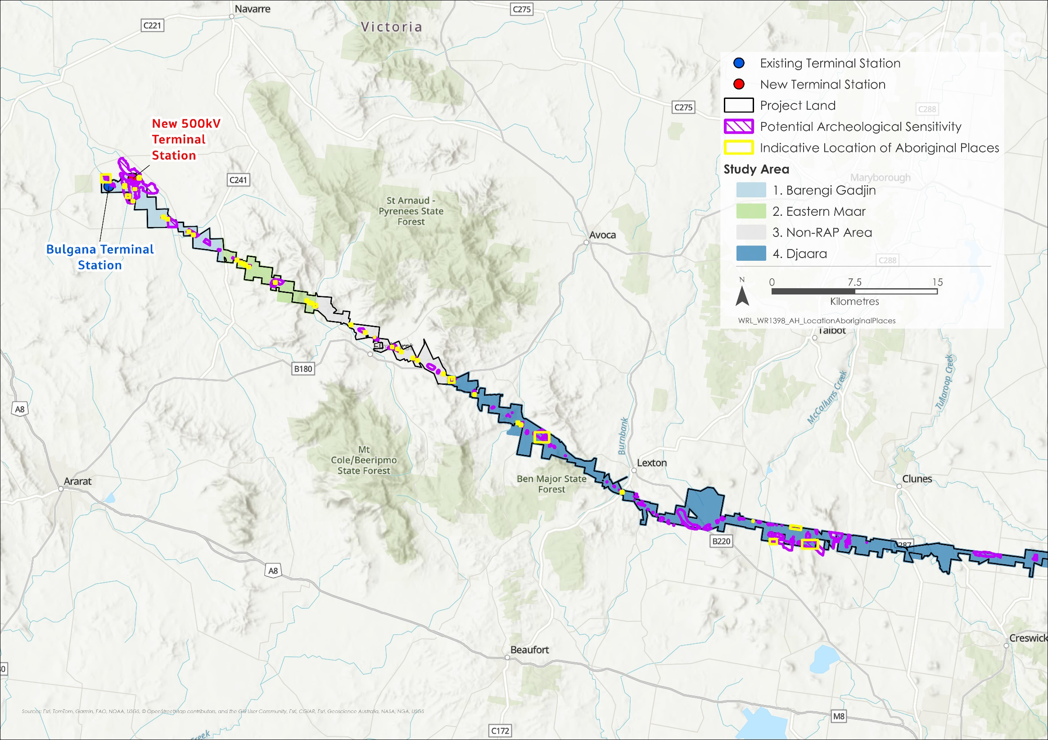

Figure 9.2 Locations of Aboriginal Places and areas of potential archaeological sensitivity across the study area (Project Land) (Map 1 of 2)

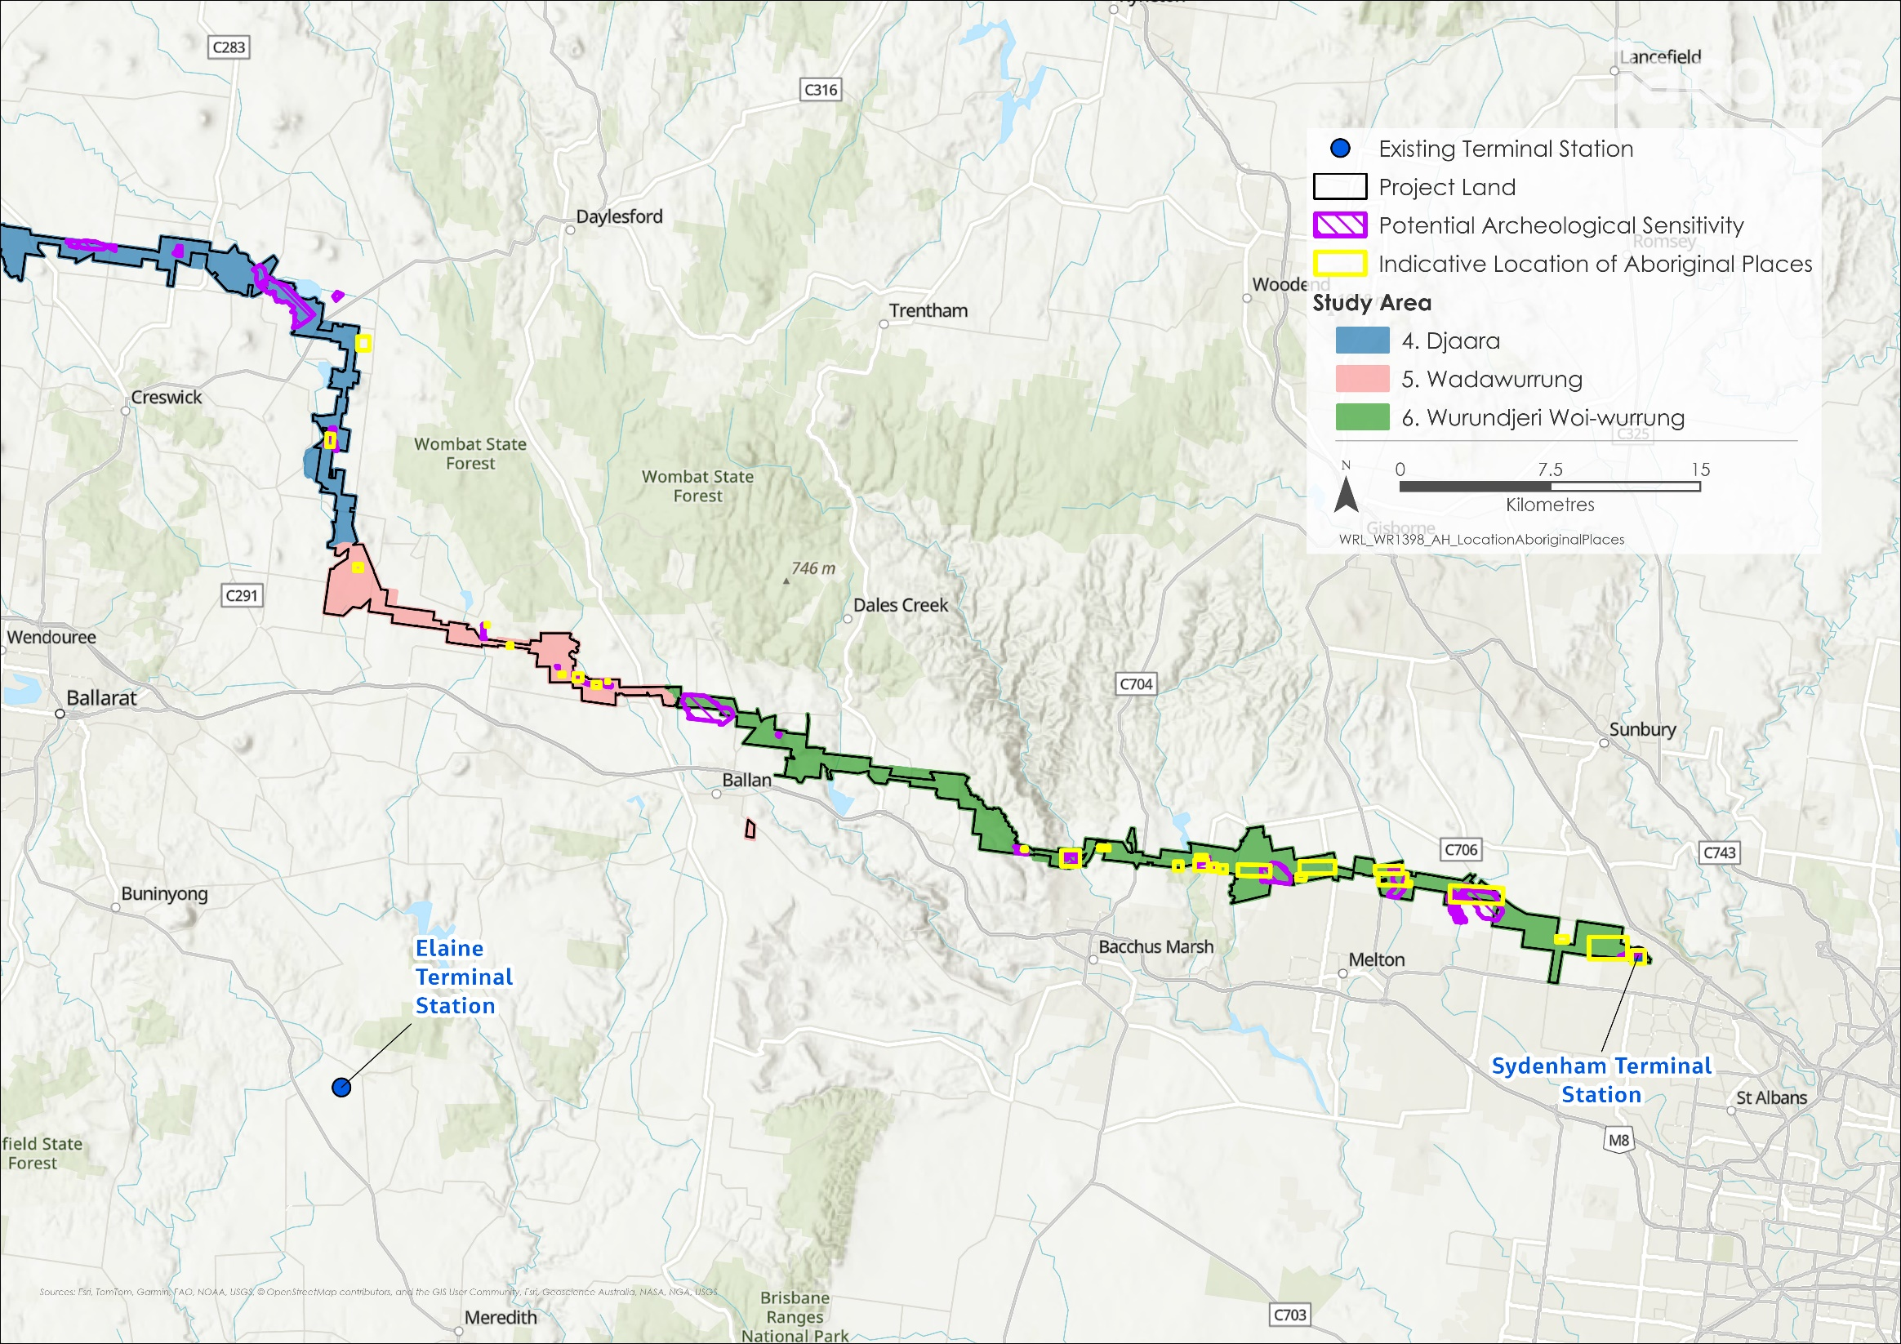

Figure 9.3 Locations of Aboriginal Places and areas of potential archaeological sensitivity across the study area (Project Land) (Map 2 of 2)

|  |  |
| --- | --- |
|  |  |
|  |  |

(Clockwise from top left: Culturally modified tree (scarred tree) along a creekbank (CHMP 17313); hearth and associated artefact scatter adjacent to a drainage channel (CHMP 17321); sample of artefacts from a tower location on the floodplain adjacent to a river (CHMP 18111); representative quartz flake recovered during excavations in CHMP 17313.)

Figure 9.4 Examples of newly identified Aboriginal cultural heritage values identified during field surveys

These newly identified Aboriginal cultural heritage values have now been formally identified and will be added to the VAHR, which means they can be clearly mapped, and measures can be taken to avoid or minimise impacts to them, where possible.

However, there is still likely to be unidentified archaeological material present within the study area. The predictive modelling – combined with the known history of the area and the results of previous studies – indicates a moderate to high potential for additional Aboriginal cultural heritage to be present within the study area.

The CHMPs being prepared across the Project may identify further Aboriginal cultural heritage values. Any additional Aboriginal cultural heritage values identified after the submission of the EES will be assessed and managed through the relevant CHMP process.

### CHMPs

Nine CHMPs are currently being prepared for approval alongside the EES:

* CHMP 17313 (BGLCAC) – Area 1
* CHMP 17321 (EMAC) – Area 2
* CHMP 17312 (Non-RAP - consulting with the BGLCAC, DJAARA, and EMAC) – Area 3
* CHMP 17311 (DJAARA) – Area 4 (Western half)
* CHMP 18101 (DJAARA) – Area 4 (Eastern half)
* CHMP 18108 (WTOAC) – Area 5
* CHMP 20436 (WTOAC) – Area 5 (Ballan Laydown Area) *
* CHMP 18111 (WWCHAC) – Area 6 (Eastern half)
* CHMP 20459 (WWCHAC) – Area 6 (Western half) *

Note: * Indicates CHMPs which have been added by the addendum and can be found in Appendix N of **Technical Report B: Aboriginal Cultural Heritage Impact Assessment**. Refer to Figure 3.2 in **Chapter 3: Legislative framework and approval requirements** which displays the extent of the nine CHMP boundaries within the Project Land.

This chapter should be read in conjunction with **Technical Report B: Aboriginal Cultural Heritage Impact Assessment**, which details the findings of the investigations which have informed the CHMPs to date. These CHMPs serve as the primary mechanism for managing the potential impacts on Aboriginal cultural heritage under the Aboriginal Heritage Act. The CHMPs are being prepared with input and advice from the relevant RAPs, TO groups and FP–SR, and they include both standard and complex assessments that require:

* Standard assessments: Field surveys to examine the condition of previously recorded Aboriginal Places and examine the study area for evidence of Aboriginal cultural heritage. Searching for evidence of Aboriginal cultural heritage involves examining surface exposures for Aboriginal cultural material, inspecting mature native trees for evidence of Aboriginal cultural modification and examining caves and rock shelters for evidence of Aboriginal occupation.
* Complex assessments: Archaeological test excavations to assess whether Aboriginal cultural heritage is present in subsurface contexts that could be impacted by the Project. These excavations also collected data on the stratigraphy of subsurface deposits and soil types throughout the study area.

These surveys and excavations have uncovered newly identified Aboriginal cultural heritage places that require registration on the VAHR.

Fieldwork to inform CHMPs is ongoing across portions of the study area. Fieldwork has been undertaken across the study area in stages, and in some parts is not complete, due to the timing of cropping, delays in access due to waterlogged parcels, requirements of the RAPs and / or land access challenges. These delays mean that only the results of fieldwork completed thus far have been incorporated into the EES; therefore, it is not possible to categorically determine the potential impacts on all Aboriginal cultural heritage values. **Technical Report B: Aboriginal Cultural Heritage Impact Assessment** has therefore included predictive statements that were compiled from the results of the desktop review and fieldwork data up to 5 June 2024, and so provides useful insight into the likely nature of Aboriginal cultural heritage values at locations that have yet to undergo field assessment.

Due to additional CHMP assessment that occurred for the Project from June 2024 to February 2025, the fieldwork coverage for each study area has increased as the result of newly identified Aboriginal cultural heritage and changes have been made to Aboriginal Place registrations during this period. The results provide additional information and greater context for the assessment of impacts on Aboriginal cultural heritage values for the Project. The addendum also summarises changes to the number of CHMPs being prepared for the Project (as noted above). CHMP 18111 (WWCHAC) was divided into two CHMPs, with the westernmost activity area of CHMP 18111 being captured within the new CHMP 20459 activity area. The workforce accommodation facility near Ballan was also extracted from CHMP 18108 (WTOAC) and is now captured by the new CHMP 20436 activity area. These changes will result in the preparation of two additional CHMPs across the study area, bringing the total number of CHMPs directly related to the Project to nine. These findings are presented in an addendum to **Technical Report B: Aboriginal Cultural Heritage Impact Assessment** (Appendix N).

As the CHMPs progress, further Aboriginal values may be identified. These will be subject to assessment as part of each CHMP. When finalised, the CHMPs will identify the potential impacts of the Project on all relevant Aboriginal cultural heritage places and outline site-specific measures that will be undertaken to manage and protect this heritage. Additionally, the CHMPs will contain contingency plans for the unexpected discovery of Aboriginal cultural heritage.

CHMPs must be approved by the relevant RAPs or FP–SR prior to the commencement of construction. The Project is required to follow the management conditions contained in the CHMPs, with compliance overseen by the RAPs and FP–SR.

### CVAs

Five CVAs were prepared for the Project: one each with the BGLCAC, EMAC, DJAARA, WTOAC and WWCHAC. Consultation as part of these CVAs identified broader tangible and intangible Aboriginal cultural values across the study area, and captured any relevant oral history associated with landscapes, biodiversity, and contemporary values the RAPs chose to share. As Study Area 3 has been assessed as a non-RAP area, CVAs prepared for surrounding RAPs (the BGLCAC, EMAC and DJAARA) have incorporated this Study Area. **Technical Report B: Aboriginal Cultural Heritage Impact Assessment** includes the CVAs as appendices.

During the course of conducting the CVAs, Elders from each TO group noted the importance of all remnant mature native vegetation, native fauna and the health of waterways and Country in the study area. When the CVA identified a particular geographic feature as having high cultural significance (categorised as a ‘cultural landscape’ in **Technical Report B: Aboriginal Cultural Heritage Impact Assessment**), recommendations were made to protect it from harm. Some cultural landscapes, such as the Wimmera River, were found to hold significance for more than one TO group.

As an outcome of the CVAs, Elders from various TO groups have requested the following measures be implemented during the construction and operation stages of the Project:

* Tree removal: Elders want to be involved in discussions about any native tree removal and for removed trees to be replaced nearby
* Waterway management: Elders want an increased focus on waterway and water landscape conservation
* Consultation: Elders want to be consulted before impacting significant areas, such as the rise west of the Lerderderg River and Mount Kororoit
* Protection: Elders want mitigation measures to be implemented to avoid harm to culturally sensitive areas, including waterways, mature native trees, stony rises, and hilltops
* Revegetation: Elders support revegetation and rewilding initiatives and wish to be involved in land management
* Economic opportunities: The Elders recommend engagement between AusNet and TO groups to provide economic and cultural opportunities. This includes employment opportunities directly related to the Project and the integration of traditional knowledges with land management activities across the study area, led by TO group businesses.
* Wildlife monitoring: All native species like the wedge-tail eagle, koala, and gang-gang cockatoo should be monitored, and underground boring methods used to protect native animals.

Intangible Aboriginal cultural heritage values as identified above through the CVAs do not necessarily meet the definition of Aboriginal Places under the Aboriginal Heritage Regulations, meaning they are outside of the scope of the CHMPs. Therefore, in order to address the CVA recommendations, consultation is required with the relevant RAP and TO groups through alternative processes (EPR ACH 2). For example, the Project will assist the relevant RAPs or TO groups to submit an application to register specific intangible cultural heritage values, where this is culturally appropriate, in accordance with the *Aboriginal Heritage Act* 2006 (Vic); the Project will recognise RAP / TO groups cultural knowledge of places identified through the CVA process that contribute to intangible values; and the Project commits to consulting with the relevant RAP / TO groups where opportunities present for the joint management of environmental values.

## Project development

Progressive refinement of the Project’s design has avoided or minimised impacts to Aboriginal heritage values, including the relocation, reduction in size, or reshaping of infrastructure such as towers, tower assembly areas, and other infrastructure. For example, impacts to two CMTs have been avoided as the result of design changes in Study Area 1 and Study Area 3. In addition, the Project was relocated to the north in Study Area 4 to avoid potential archaeological sensitivity areas, which were assessed as having high significance cultural values through consultation with DJAARA. In some instances, impacts on areas of potential archaeological sensitivity and extensive artefact scatters have been reduced. This is the case in Study Area 6 in the vicinity of the Lerderderg River and Merrimu Reservoir, respectively, where impacts have been reduced through design changes following consultation with WWCHAC.

Overall, the Project’s design has avoided harm to 14 Aboriginal Places. These places include two CMTs, five LDADs, and seven artefact scatters (one of which is associated with rich cultural landforms and cultural values, and one that is associated with an earth feature). The Project has also minimised harm to a further 14 Aboriginal Places: five LDADs, nine artefact scatters (one of which is associated with a hearth).

The avoidance of known Aboriginal cultural heritage values may inadvertently result in the discovery of previously unknown Aboriginal cultural heritage values. As such, RAP and/or TO group consultation has played an important role in the decision making process for design refinement, where individual concerns and statements of significance allow for the best informed decision. As all tangible Aboriginal cultural heritage values are managed through the CHMP process, it is considered preferable to manage known Aboriginal Places, rather than risk causing harm to unknown Aboriginal cultural heritage during the CHMP complex assessment program.

## Construction impacts

This section outlines the key issues identified through the risk screening process and associated potential impacts during the construction of the Project. The main impacts to Aboriginal cultural heritage will be during the construction stage due to the Project’s impact on known and unknown cultural heritage values, including both tangible and intangible heritage. Construction activities will consist of site investigations and the establishment of terminal stations, transmission lines, access tracks, laydown areas and workforce accommodation facilities and will require ground disturbance activities and vegetation clearance. As the Project is an overhead transmission line, ground disturbance and vegetation clearance activities are comparatively less compared to a project which contemplates a below ground transmission line.

It is highly likely that additional unknown Aboriginal cultural heritage is located within each of the six study areas examined for the Aboriginal Cultural Heritage Impact Assessment. Ground disturbing construction activities have the potential to harm previously recorded Aboriginal Places, newly identified Aboriginal cultural heritage values (both tangible and intangible), and other (unknown/unrecorded) archaeological material through the disturbance of the natural ground surface, subsurface soil profiles, and any vegetation present. Ancestral Remains are a rare occurrence in the region and unlikely to occur in the study area.

The residual impacts include impacts to 75 known Aboriginal cultural heritage values (five previously recorded, 70 newly identified) during construction. Of the five previously recorded Aboriginal Places, which includes three low and two moderate significance rankings, residual impacts of four low and one moderate remain. Of the 70 newly identified Aboriginal cultural heritage values (which include 23 low, 30 moderate, five high and 12 very high significance rankings), 47 low, 10 moderate and 13 high residual impacts remain. Additionally, 10 newly identified places, separate to the places subject to residual impacts, were impacted through discovery and will not be impacted further by the Project. There are no severe impacts on Aboriginal cultural heritage values.

Potential impacts towards Aboriginal cultural heritage at the two workforce accommodation facilities, laydown areas and the new 500kV terminal station near Bulgana have been considered. Of the 75 known Aboriginal cultural heritage values, two low and one high residual impact will occur in these areas. This will consist of one partial impact to a LDAD at the Lexton laydown area and workforce accommodation facility and one completely intersected LDAD at the new 500kV terminal station near Bulgana. Additionally, the design of the new 500kV terminal station near Bulgana intersects an important cultural landscape (Wimmera River) contributing to its overall high impact rating.

Low residual impacts have been associated with LDADs and artefact scatters where the Project infrastructure either partially or completely intersects the Aboriginal cultural heritage value. Moderate residual impacts are typically associated with values that have a moderate significance (artefact scatters and LDADs) that are completely intersected by the Project (n=6). There are also four artefact scatters of high significance that are partially intersected by the Project, and as such the impact has been determined to be moderate. High residual impacts were associated with Aboriginal cultural heritage values that were either fully intersected by the Project and assessed as having a high significance, or partially intersected and assessed as having a very high significance. Further detail surrounding the location of the impacted Aboriginal cultural heritage values in relation to the Project can be found in **Technical Report B: Aboriginal Cultural Heritage Impact Assessment.**

As completion of the standard and complex assessments for the CHMPs continues, further Aboriginal cultural heritage values may be identified after completion of the EES.The potential of harming Aboriginal cultural heritage has, and will continue to be, significantly reduced through the implementation of the CHMPs (EPR ACH1). The CHMPs are being developed and completed with input and advice from the RAPs, TO groups and FP–SR, and will contain specific management conditions that will mitigate impacts on both known and unknown cultural heritage values. General CHMP management conditions required prior to construction are expected to consist of:

* Site inductions
* Cultural heritage awareness training
* Pegging, fencing, or marking in other ways where works are restricted to protect Aboriginal Places
* Salvage excavation or surface collection of some registered Aboriginal Places and associated analysis and reporting where avoidance of harm is not possible
* All required permits, consents and other approvals will be obtained, and the Principal Contractor will adopt and adhere to conditions set by these approvals.

In addition to EPR ACH1, ongoing consultation with relevant RAPs or TO groups will be required to manage and protect intangible cultural heritage values identified through the CVAs (EPR ACH2). Consultation will occur with each RAP or TO group to manage and protect broad and specific intangible cultural heritage values as identified through the CVAs. The consultation process will also address how AusNet will support the submission of intangible value registrations for specific intangible cultural heritage values, if requested by the relevant RAP or TO group, and the recognition of cultural knowledge of places identified through the CVAs through interpretation, commemoration, and celebration of significant associations with a place, as culturally appropriate. Mitigation measures recommended by the CVAs, prior to the commencement of construction, consist of consultation and design planning to avoid and / or minimise impact on waterways, areas of archaeological and cultural sensitivity, remnant vegetation, native fauna, cultural landscapes, and intangible cultural heritage.

During construction, general management conditions contained within the CHMPs will include ongoing checks to monitor compliance with each CHMP (including inspections by the RAP) and contingency plans for the discovery of unknown Aboriginal cultural heritage (EPR ACH1). This includes managing high significance finds, such as Aboriginal Ancestral Remains, in accordance with FP–SR’s Guide on Preparing a Cultural Heritage Management Plan (including stop work instructions). The identification of previously unknown Aboriginal cultural heritage values, even when full access to the site has been granted and all land has been assessed, is not unusual. By implementing EPR ACH1, which requires adherence to all approved CHMPs, potential adverse effects on any currently unknown specific places will be mitigated through compliance with the CHMP management conditions and contingencies in accordance with relevant legislative requirements. Continued consultation with the relevant RAPs or TO groups will be required throughout the Project’s construction to continue avoidance and / or minimisation of impacts (EPR ACH2).

Recommended management conditions post-construction are expected to relate to the custody, curation, and management of Aboriginal cultural heritage (artefacts) identified in the CHMPs or discovered during construction activities (EPR ACH1). Furthermore, ongoing consultation to avoid and / or minimise impacts on intangible cultural heritage and to discuss opportunities for native revegetation and environmental management will be required (EPR ACH2).

In recognising the value that RAP / TO cultural knowledge brings to managing and protecting the land, AusNet will consult with the relevant RAP / TO groups where there are opportunities for the joint management of environmental values (including mature remnant vegetation), maintaining water quality objectives, and rehabilitation goals (EPR ACH2). This includes the potential to tailor written agreements that define the working relationship, expectations and responsibilities in protecting intangible values (EPR ACH2). There is an opportunity for these to align with the management plans outlined in the EPRs BD1 to BD7 in **Technical Report A: Biodiversity Impact Assessment** and EPR SW3 in **Technical Report T: Surface Water Impact Assessment.**

Incorporating results from the cultural heritage assessments into the Project's design has minimised potential negative impacts on tangible Aboriginal cultural heritage values. The design process has been iterative and impacts on Aboriginal cultural heritage values and sensitive areas have been avoided or minimised, so far as reasonably practicable. This is especially the case within areas that support values of high scientific importance such as CMTs, some high-density artefact scatters (for example, knapping floors), multi-component places (for example, artefact scatters and hearths), and cultural landscapes.

Through the implementation of the construction mitigation measures, which will be applied to comply with the EPRs, the Project will avoid or reduce the magnitude and / or extent of impacts on known Aboriginal cultural heritage values, including those identified during fieldwork undertaken for the Project up to 5 June 2024. Residual impacts remain to 75 known Aboriginal cultural heritage places and values (both tangible and intangible) located within the Project Land during the construction stage. Five (5) unavoidable impacts are anticipated to previously recorded Aboriginal Places, one of which is considered to result in a moderate residual impact and four of which are considered to result in a low residual impact. Seventy (70) unavoidable impacts are anticipated towards newly identified Aboriginal cultural heritage values, 13 of which are considered to result in a high level of impact, 10 of which are considered to result in a moderate level of impact, and 47 of which are considered to result in a low level of impact. Of the 75 known Aboriginal cultural heritage places and values, the construction of the Lexton laydown area and workforce accommodation facility, along with the new 500kV terminal station near Bulgana will contribute to one high and two low residual impacts.

The impact assessment for newly identified Aboriginal cultural heritage and changes to Aboriginal Place registrations from June 2024 to February 2025 is presented in the addendum to the **Technical Report B: Aboriginal Cultural Heritage Impact Assessment** (Appendix N). The results for this period found an increase from 123 to 125 previously unregistered Aboriginal values across the Project Land. Of these, a total of 77 Aboriginal cultural heritage values will be impacted by the Project, while 10 Aboriginal cultural heritage values have been impacted through subsurface testing and will not be further impacted due to design changes. While there have been some changes to impacts to Aboriginal cultural heritage values in this period and the number of Aboriginal values has increased, the magnitude of impact for the Project has not increased and remains moderate.

The mitigation measures described above will minimise and then manage the adverse effects on Aboriginal cultural heritage values, which include Aboriginal Places that will undergo archaeological salvage prior to the commencement of the construction stage of the Project. By utilising cultural heritage assessments to inform an iterative design process, the Project has avoided and minimised the potential adverse effects on Aboriginal cultural values as far as reasonably practicable. For Aboriginal Places that cannot be avoided, the CHMPs will result in further knowledge of Aboriginal archaeology in the study area and establish sensitive and appropriate management conditions and salvage requirements that will mitigate and manage the adverse effects on these values.

## Operation impacts

This section outlines the key issues identified through the risk screening process and associated potential impacts during the operation of the Project. Operation of the Project is not expected to result in further impacts on tangible Aboriginal cultural heritage beyond what will occur during construction. No further impacts are expected from vegetation management and clearance within the easement, as these works are not expected to be more extensive than what will occur during construction. Additionally, it is expected that the majority of sensitive areas along the Project would have been identified upon completion of Project’s construction, meaning impacts on these areas can be avoided and minimised. Impacts to tangible Aboriginal cultural heritage will be managed and mitigated throughout the Project’s operation in accordance with the recommendations of each approved CHMP (EPR ACH1). Management conditions are expected to include:

* Having copies of the CHMPs available in site offices within the boundaries of the Project Land. Each CHMP details all general and specific management conditions and contingency plans for the discovery of unexpected finds
* A notification procedure for unexpected finds during operation
* Ongoing consultation with each RAP and FP–SR to maintain dialogue and adherence to the agreed management conditions in the CHMPs.

The Project’s visual presence in the landscape will have a high residual impact on intangible cultural values, specifically where structures are present within cultural landscapes with a high or very high significance ranking, namely the Pyrenees Ranges landscape (study area one); Hepburn Lagoon (study area four); and locations where the Wimmera River (study areas one and three), Avoca River (study area four), Werribee River (study area five), and the Kororoit Creek landscape (study area six) run through the area surrounding the Project. As mentioned in Section 9.3.4, recommendations arising from the CVAs will be followed where possible to protect both broad-scale and specific intangible cultural heritage values identified by RAPs and TO groups (EPR ACH2). During the operation stage of the Project, this is to consist of the following:

* Ongoing consultation with the RAPs and TO groups
* Involvement of RAPs and TO groups in finding ways to improve land management and restore healthy landscapes and ecosystems including cultural burning, revegetation, pest management, and rewilding initiatives.
* Engagement with RAPs or TO groups to provide economic and cultural opportunities.

As mentioned in Section 9.5, as the Project is an overhead transmission line, ground disturbance and vegetation clearance activities are comparatively less compared to a project which contemplates a below ground transmission line. However, the potential for impacts on intangible values related to viewsheds, sightlines and the connection of places across Country exists. Concerns have been raised by the RAPs and TO groups that visual structures interfere with the natural and cultural meanings of Country.

Residual impacts on tangible Aboriginal heritage, outside of areas already disturbed during construction, are low during operation. However, despite the significant reduction in impacts to Aboriginal cultural heritage due to the implementation of the operational mitigation measures, which have been applied to comply with the EPRs, high residual impacts will remain to the six intangible Aboriginal cultural heritage values (cultural landscapes) with high or very high significance rankings.

## Decommissioning impacts

Decommissioning of the Project is unlikely to further impact tangible Aboriginal cultural heritage values, as any further ground disturbing activities are anticipated to occur in areas that have already been disturbed as part of the construction stage.

Following decommissioning, there would no longer be visual impacts from the presence of the transmission line and towers. This would be a benefit to intangible Aboriginal cultural values and landscapes.

The EPRs developed to manage impacts during construction would also be applicable for decommissioning in accordance with the conditions of the time. Decommissioning impacts would also be managed by a Decommissioning Management Plan (EPR EM11) which would include engagement with the relevant RAPs and TO groups, and mitigation measures for Aboriginal cultural heritage values.

Based on this, residual impacts are expected to be low for Aboriginal cultural heritage.

## Cumulative impacts

Cumulative impacts have been assessed by identifying relevant future projects that could contribute to cumulative impacts on Aboriginal cultural heritage values, considering their spatial and temporal relationships to the Western Renewables Link Project. The projects considered as potentially relevant to Aboriginal cultural heritage include:

* Elaine Solar Farm
* Lerderderg River Nature trail
* Lerderderg Wombat National Park
* Melbourne Renewable Energy Hub
* Nyaninyuk Wind Farm
* Sunbury Line Level Crossing Removals
* Sydenham Terminal Station Rebuild
* Toolern Vale Solar Farm
* Victoria to New South Wales Interconnector (VNI) West
* Watta Wella Renewable Energy Project
* Western Irrigation Network Scheme.

These projects will cause substantial ground disturbances, affecting both tangible and intangible cultural values. However, these projects are also required to prepare CHMPs to mitigate and manage impacts.

Regionally, the cumulative impact of relevant future projects is moderate. While some projects have a greater impact on Aboriginal cultural heritage, most aim to preserve some values through design changes. Even when sites are destroyed, all projects have CHMPs in place to manage Aboriginal Places with the RAP, TO group, and / or FP-SR, ensuring as much archaeological information as possible for the place is obtained. The Western Renewables Link Project will contribute to the impact on regional heritage, but not significantly increase the cumulative impact, as the Project specific impacts will be mitigated and managed through the EPRs discussed in this chapter, meeting in turn the Project’s EES scoping requirements. As such, the potential for significant adverse cumulative impacts are expected to be moderate.

## Environmental Performance Requirements

Potential impacts identified through **Technical Report B: Aboriginal Cultural Heritage Impact Assessment** have informed the development of EPRs for the Project. EPRs set out the environmental outcomes to be achieved through the implementation of mitigation measures during construction, operation and decommissioning. While some EPRs are performance based to allow flexibility in how they will be achieved, others include more prescriptive measures that must be implemented. Compliance with the EPRs will be required as a condition of the Project’s approval. Table 9.1 details the proposed EPRs developed for Aboriginal cultural heritage.

Table 9.1 Environmental Performance Requirements

|  |  |
| --- | --- |
| EPR code | Requirement |
| EPR ACH1 | **Comply with Cultural Heritage Management Plans**   1. Implement and comply with Cultural Heritage Management Plans (CHMPs) sponsored by AusNet and approved for the Project under the *Aboriginal Heritage Act 2006*. |
| EPR ACH2 | **Discuss and negotiate Cultural Values Assessment recommendations**   1. AusNet must engage with each of the relevant Registered Aboriginal Parties (RAPs) and Traditional Owner (TO) groups, being Barengi Gadjin Land Council Aboriginal Corporation, Eastern Maar Aboriginal Corporation, Dja Dja Wurrung Clans Aboriginal Corporation, Wadawurrung Traditional Owners Aboriginal Corporation, and Wurundjeri Woi-wurrung Cultural Heritage Aboriginal Corporation to address recommendations, where practicable, arising from each RAP or TO group’s Cultural Values Assessment to avoid or minimise impacts on intangible cultural heritage values from the Project. |

Other EPRs contribute to a reduction in the magnitude, extent and duration of impacts towards Aboriginal cultural heritage values. Additional EPRs related to Aboriginal cultural heritage include:

* EPR BD1 – Complete ecological surveys and finalise design
* EPR BD2 – Develop and implement a Vegetation Management Plan
* EPR BD3 – Develop and implement a Fauna Management Plan
* EPR BD4 – Develop and implement Threatened Fauna Management Plans
* EPR BD5 – Develop and implement a Collision Risk Management Plan
* EPR BD6 – Develop and implement measures to manage riparian and aquatic habitat
* EPR BD7 – Develop and implement an Operational Vegetation and Habitat Management Plan
* EPR EM11 – Develop and implement a Decommissioning Management Plan
* EPR SW3 – Monitor water quality.

Refer to the relevant technical chapters and **Chapter 29: Environmental Management Framework** for full detail of these EPRs.

Once the CHMPs have been approved, their management conditions and contingencies must be complied with to protect and manage registered and unidentified Aboriginal Places and values. General and specific management conditions will be provided in each CHMP to mitigate or minimise harm to known and unknown Aboriginal Places. Implementation of the CHMPs will also avoid and minimise harm to any residual impacts arising from the Project to the extent reasonably practicable. It is expected standard measures would apply, such as inspections by the RAP and regular CHMP compliance reviews by AusNet.

In addition, ongoing consultation should occur with each individual RAP / TO group for the pre-construction, construction, operation, and decommissioning stages of the Project to manage and protect broad and specific intangible cultural heritage values as identified through the CVA process.

The draft Incorporated Document has been informed by the EPRs listed in Table 9.1 and includes conditions to avoid, minimise and manage impacts associated with the workforce accommodation facilities. For Aboriginal cultural heritage, this includes archaeological salvage of Aboriginal cultural heritage material and any other management conditions required by the relevant CHMPs. It is considered that these conditions are sufficient to meet the requirements of any relevant EPR applying to Aboriginal cultural heritage impacts at the workforce accommodation facilities.

The objectives of proposed monitoring programs for the Project required by the EPRs are outlined in **Chapter 29: Environmental Management Framework**.

## Summary of residual impacts

With application of the EPRs, residual impacts associated with Aboriginal cultural heritage range from high to low:

* Residual impacts remain to 75 known Aboriginal cultural heritage places and values (both tangible and intangible) located within the Project Land during the construction stage. Five (5) unavoidable impacts are anticipated to previously recorded Aboriginal Places, one of which is considered to result in a moderate residual impact and four of which are considered to result in a low residual impact. Seventy (70) unavoidable impacts are anticipated towards newly identified Aboriginal cultural heritage values, 13 of which are considered to result in a high level of impact, 10 of which are considered to result in a moderate level of impact, and 47 of which are considered to result in a low level of impact. During construction, management of these impacts will occur through implementation of the CHMPs (EPR ACH1). The addendum to **Technical Report B: Aboriginal Cultural Heritage Impact Assessment** found an increase from 75 to 77 residual impacts on Aboriginal cultural heritage values.
* Of the known Aboriginal cultural heritage places and values, the construction of the Lexton laydown area and workforce accommodation facility, along with the new 500kV terminal station near Bulgana will contribute to one high (cultural landscape) and two low (LDADs) residual impacts.
* Residual impacts to six intangible Aboriginal cultural heritage values (cultural landscapes) during operation are considered to be high. The visual presence of the Project in the landscape will have a high residual impact on intangible cultural values, specifically where structures are present within cultural landscapes.
* Residual impacts to tangible Aboriginal heritage during operation is considered to be low.
* Residual impacts towards Aboriginal cultural heritage during decommissioning are expected to be low.

While the majority of known impacts to Aboriginal cultural heritage values throughout all stages of the Project fall within the low impact rating, when appropriately considering the variable scientific, social, historical, and spiritual significance of each value, the overall residual impact of the Project on Aboriginal cultural heritage across the study area is considered to be moderate. This assessment has been based on a combination of fieldwork data, CVA recommendations, and register searches conducted at the time of this assessment. It is expected that the magnitude of impact for the Project post completion of the CHMP fieldwork programs will not increase.

As mentioned in Section 9.4, the Project development has avoided and minimised potential adverse effects as much as possible. The remaining high and moderate residual impacts are, to some extent, unavoidable considering the Project’s scale and nature, and the fact that the Project will impact the landscape wherever ground disturbing activities occur. However, the Project will be managed through the EPRs described in Section 9.9, which include the implementation of the nine CHMPs currently in preparation. These CHMPs will further reduce harm by the development and implementation of management conditions that are sensitive and appropriate to the Aboriginal place. For Aboriginal Places that cannot be avoided, the CHMPs will establish sensitive and appropriate management conditions and salvage requirements that will result in further knowledge of Aboriginal archaeology in the study area, thereby mitigating the adverse effects on these values. Furthermore, where practicable, the Project will include consideration of recommendations from the CVAs that have been prepared (EPR ACH2). CHMPs and CVAs have been undertaken in close consultation with RAPs, TO groups and FP-SR to account for as many aspects of Aboriginal cultural heritage as possible.

The Project has contributed additional archaeological data on the nature of Aboriginal occupation in the western Victorian region. This data provides information for future protection and planning to prevent harm to Aboriginal Places.

With the implementation of measures to comply with EPRs, it is considered that the Project meets the Aboriginal cultural heritage aspects of the evaluation objective “*to avoid, or minimise where avoidance is not possible, adverse effects on Aboriginal cultural heritage and historic heritage.*”

