AusNet Transmission Group Pty Ltd is an independent subsidiary of AusNet Pty Ltd ABD 45 603 317 559



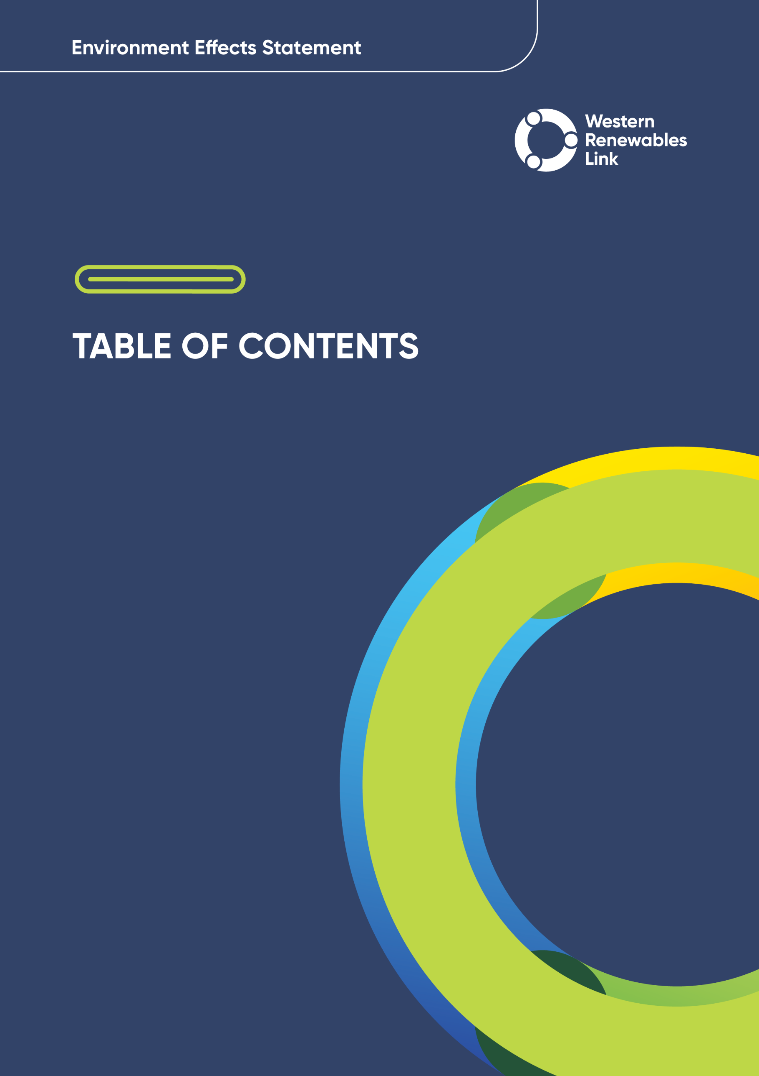

Table of contents

Foreword F-1

Executive summary ES-1

Glossary and abbreviations G&A-1

1. Introduction 1-1
   1. Project overview 1-1
   2. Project need 1-4
   3. Project objectives 1-5
   4. Proponent 1-5
   5. Environment Effects Statement 1-7
   6. Subject matter of the EES 1-9
   7. Matters not addressed in the EES 1-11
   8. Project approvals 1-11
   9. Structure of the EES 1-12
2. Project rationale 2-1
   1. The need for renewable energy 2-1
   2. The need for transmission network augmentations to the NEM 2-4
   3. Project benefits 2-14
   4. Project objectives 2-17
3. Legislative framework and approval requirements 3-1
   1. Introduction 3-1
   2. EES assessment process 3-1
   3. Principal approvals 3-3
   4. Secondary approvals 3-9
   5. Other legislation of relevance 3-11
4. EES assessment framework and approach 4-1
   1. Overview of the EES assessment framework 4-1
   2. Legislation, policy, guidelines and EES evaluation objectives 4-4
   3. Assessment approach 4-7
   4. Environmental Management Framework 4-22
   5. Consultation and engagement 4-23
5. Project development 5-1
   1. Key criteria in Project development 5-2
   2. RIT-T 5-5
   3. Assessment of alternative corrifors and routes 5-12
   4. Siting other Project components 5-58
   5. Alternative transmission structures 5-65
6. Project description 6-1
   1. Project overview 6-3
   2. Project infrastructure 6-5
   3. Easements 6-23
   4. Acquisition of easements 6-28
   5. Land for terminal stations 6-29
   6. Construction activities 6-29
   7. Operation and maintenance activities 6-52
   8. Vegetation clearance during construction and operation 6-55
   9. Decomissioning 6-56
7. Community and stakeholder engagement 7-1
   1. Introduction 7-1
   2. Engagement approach 7-1
   3. Engagement overview 7-9
   4. Engagement snapshot 7-12
   5. Overview of feedback 7-24
   6. Measurement and evaluation 7-29
   7. Future engagement 7-30
8. Biodiversity and habitat 8-1
   1. Evaluation objective 8-1
   2. Method 8-2
   3. Existing conditions 8-7
   4. Avoidance 8-34
   5. Overview of Project impacts on biodiversity 8-35
   6. Construction and operation impact assessment 8-39
   7. Decomissioning impacts 8-65
   8. Cumulative impacts 8-65
   9. Environmental Performance Requirements 8-68
   10. Summary of residual impacts 8-73
   11. Offset requirements 8-76
9. Aboriginal cultural heritage 9-1
   1. Evaluation objective 9-1
   2. Method 9-1
   3. Existing conditions 9-5
   4. Project development 9-13
   5. Construction impacts 9-13
   6. Operation impacts 9-16
   7. Decomissioning impacts 9-17
   8. Cumulative impacts 9-17
   9. Environmental Performance Requirements 9-17
   10. Summary of residual impacts 9-19
10. Historical heritage 10-1
    1. Evaluation objective 10-1
    2. Method 10-1
    3. Existing conditions 10-5
    4. Construction impacts 10-6
    5. Operation impacts 10-14
    6. Decomissioning impacts 10-14
    7. Cumulative impacts 10-14
    8. Environmental Performance Requirements 10-15
    9. Summary of residual impacts 10-16
11. Landscape and visual 11-1
    1. Evaluation objective 11-1
    2. Method 11-2
    3. Existing conditions 11-7
    4. Construction impacts 11-14
    5. Operation impacts 11-15
    6. Decomissioning impacts 11-48
    7. Cumulative impacts 11-48
    8. Environmental Performance Requirements 11-51
    9. Summary of residual impacts 11-53
12. Land use and planning 12-1
    1. Evaluation objective 12-1
    2. Method 12-2
    3. Existing conditions 12-5
    4. Construction impacts 12-28
    5. Operation impacts 12-33
    6. Decomissioning impacts 12-35
    7. Cumulative impacts 12-35
    8. Planning policy and controls 12-35
    9. Environmental Performance Requirements 12-36
    10. Summary of residual impacts 12-37
13. Bushfire 13-1
    1. Evaluation objective 13-1
    2. Method 13-2
    3. Existing conditions 13-6
    4. Construction impacts 13-11
    5. Operation impacts 13-18
    6. Decomissioning impacts 13-21
    7. Cumulative impacts 13-21
    8. Conditions of the draft Incorporated Document and Environmental Performance Requirements 13-22
    9. Summary of residual impacts 13-24
14. Economic 14-1
    1. Evaluation objective 14-1
    2. Method 14-2
    3. Existing conditions 14-5
    4. Economy-wide analysis 14-9
    5. Business impact analysis 14-11
    6. Cumulative impacts 14-13
    7. Environmental Performance Requirements 14-14
    8. Summary of residual impacts 14-17
15. Agriculture and forestry 15-1
    1. Evaluation objective 15-1
    2. Method 15-1
    3. Existing conditions 15-5
    4. Construction impacts 15-12
    5. Operation impacts 15-18
    6. Decomissioning impacts 15-21
    7. Cumulative impacts 15-21
    8. Environmental Performance Requirements 15-22
    9. Summary of residual impacts 15-24
16. Aviation 16-1
    1. Evaluation objective 16-1
    2. Method 16-2
    3. Existing conditions 16-6
    4. Construction impacts 16-9
    5. Operation impacts 16-11
    6. Decommissioning impacts 16-13
    7. Cumulative impacts 16-14
    8. Environmental Performance Requirements 16-15
    9. Summary of residual impacts 16-16
17. EMI and EMF 17-1
    1. Evaluation objective 17-1
    2. Method 17-2
    3. Existing conditions 17-7
    4. Construction impacts 17-11
    5. Operation impacts 17-12
    6. Decomissioning impacts 17-19
    7. Cumulative impacts 17-19
    8. Environmental Performance Requirements 17-19
    9. Summary of residual impacts 17-20
18. Air quality 18-1
    1. Evaluation objective 18-1
    2. Method 18-1
    3. Existing conditions 18-5
    4. Construction impacts 18-8
    5. Operation impacts 18-11
    6. Decomissioning impacts 18-12
    7. Cumulative impacts 18-12
    8. Environmental Performance Requirements 18-13
    9. Summary of residual impacts 18-14
19. Noise and vibration 19-1
    1. Evaluation objective 19-1
    2. Method 19-2
    3. Existing conditions 19-5
    4. Construction impacts 19-9
    5. Operation impacts 19-14
    6. Decomissioning impacts 19-16
    7. Cumulative impacts 19-16
    8. Environmental Performance Requirements 19-17
    9. Summary of residual impacts 19-21
20. Transport 20-1
    1. Evaluation objective 20-1
    2. Method 20-2
    3. Existing conditions 20-10
    4. Construction impacts 20-17
    5. Operation impacts 20-27
    6. Decomissioning impacts 20-27
    7. Cumulative impacts 20-27
    8. Environmental Performance Requirements 20-28
    9. Summary of residual impacts 20-30
21. Social 21-1
    1. Evaluation objective 21-1
    2. Method 21-2
    3. Existing conditions 21-5
    4. Construction and operation impacts – Project workforce 21-15
    5. Construction and operation impacts – Land use and amenity 21-17
    6. Decomissioning impacts 21-30
    7. Cumulative impacts 21-30
    8. Environmental Performance Requirements 21-31
    9. Summary of residual impacts 21-33
22. Geology and soils 22-1
    1. Evaluation objective 22-1
    2. Method 22-2
    3. Existing conditions 22-5
    4. Construction impacts 22-10
    5. Operation impacts 22-12
    6. Decomissioning impacts 22-13
    7. Cumulative impacts 22-13
    8. Environmental Performance Requirements 22-13
    9. Summary of residual impacts 22-16
23. Contaminated land 23-1
    1. Evaluation objective 23-1
    2. Method 23-2
    3. Existing conditions 23-5
    4. Construction impacts 23-9
    5. Operation impacts 23-11
    6. Decomissioning impacts 23-12
    7. Cumulative impacts 23-13
    8. Environmental Performance Requirements 23-13
    9. Summary of residual impacts 23-15
24. Groundwater 24-1
    1. Evaluation objective 24-1
    2. Method 24-2
    3. Existing conditions 24-5
    4. Construction impacts 24-10
    5. Operation impacts 24-16
    6. Decomissioning impacts 24-17
    7. Cumulative impacts 24-17
    8. Environmental Performance Requirements 24-18
    9. Summary of residual impacts 24-10
25. Surface water 25-1
    1. Evaluation objective 25-1
    2. Method 25-1
    3. Existing conditions 25-5
    4. Construction impacts 25-9
    5. Operation impacts 25-12
    6. Decomissioning impacts 25-14
    7. Cumulative impacts 25-14
    8. Environmental Performance Requirements 25-15
    9. Summary of residual impacts 25-18
26. Greenhouse gas 26-1
    1. Evaluation objective 26-1
    2. Method 26-2
    3. Existing conditions 26-4
    4. Construction impacts 26-5
    5. Operation impacts 26-6
    6. Decomissioning impacts 26-8
    7. Cumulative impacts 26-8
    8. Environmental Performance Requirements 26-9
    9. Summary of residual impacts 26-10
27. Matters of National Environmental Significance 27-1
    1. Evaluation objective 27-2
    2. Method 27-2
    3. Existing conditions 27-7
    4. Construction and operation impacts 27-17
    5. Decomissioning impacts 27-40
    6. Cumulative impacts 27-40
    7. Environmental Performance Requirements 27-42
    8. Summary of residual impacts 27-47
    9. Offset requirements 27-49
28. Climate change 28-1
    1. Evaluation objective 28-1
    2. Method 28-2
    3. Existing conditions 28-4
    4. Construction impacts 28-7
    5. Operation impacts 28-8
    6. Environmental Performance Requirements 28-9
    7. Conclusion 28-9
29. Environmental Management Framework 29-1
    1. Purpose of the Environmental Management Framework 29-2
    2. Statutory context and approvals 29-2
    3. Works covered by the Environmental Management Framework 29-6
    4. Works excluded from the Environmental Management Framework 29-6
    5. Roles and responsibiilties 29-7
    6. Risk assessment 29-11
    7. Environmental management documentation 29-12
    8. Evaluating environmental compliance 29-20
    9. Environmental Performance Requirements and conditions of the draft Incorporated Document 29-30
30. Conclusion 30-1
    1. Project design 30-1
    2. Evaluation against the scoping requirements 30-2
    3. Principles of ecologically sustainable development 30-10
    4. Environmental Management Framework 30-14
    5. Next steps 30-15

**References** **30-16**

Technical Reports

Technical Report A: Biodiversity Impact Assessment

Technical Report B: Aboriginal Cultural Heritage Impact Assessment

Technical Report C: Historical Heritage Impact Assessment

Technical Report D: Landscape and Visual Impact Assessment

Technical Report E: Land Use and Planning Impact Assessment

Technical Report F: Social Impact Assessment

Technical Report G: Economic Impact Assessment

Technical Report H: Agriculture and Forestry Impact Assessment

Technical Report I: Air Quality Impact Assessment

Technical Report J: Aviation Impact Assessment

Technical Report K: Bushfire Impact Assessment

Technical Report L: EMI and EMF Impact Assessment

Technical Report M: Greenhouse Gas Impact Assessment

Technical Report N: Climate Change Assessment

Technical Report O: Noise and Vibration Impact Assessment

Technical Report P: Transport Impact Assessment

Technical Report Q: Geology and Soils Impact Assessment

Technical Report R: Contaminated Land Impact Assessment

Technical Report S: Groundwater Impact Assessment

Technical Report T: Surface Water Impact Assessment

Attachments

Attachment I: Project development and assessment of alternatives

Attachment II: Assessment of feasibility for an underground 500kV transmission line for Western Renewables Link

Attachment III: Draft Planning Scheme Amendment

Attachment IV: Stakeholder and community engagement consultation report

Attachment V: Offset Management Strategy

Attachment VI: Map book

